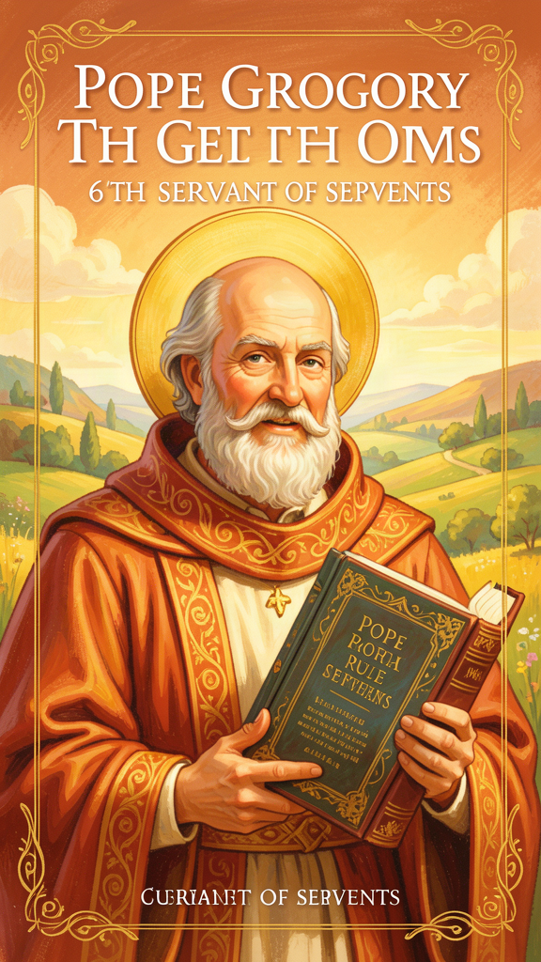
The Man Who Called Himself Servant
WisdomForge Booklet — Ages 5-10

The Man Who Called Himself Servant

WisdomForge Booklet — Ages 5-10
———

About This Book
A long time ago, in a city called Rome, there lived a man named Gregory. He had a big house, lots of money, and an important job. But one day he gave it all away. He turned his house into a quiet place where people prayed and helped the poor. He thought he would live there forever, just praying and helping.
But the people of Rome needed a leader. They chose Gregory to be their pope — the leader of the whole church. Gregory did not want the job. He tried to run away. But the people needed him, so he said yes.
What happened next is amazing. Gregory became one of the wisest leaders who ever lived. He fed hungry people. He sent friends across the sea to tell strangers about love. He wrote a book about how to lead without becoming bossy or mean. And he gave himself a surprising title. He did not call himself "the Great Boss" or "the Most Important Person." He called himself "Servant of the Servants of God."
This book tells Gregory's story in six chapters. Each one teaches something he discovered about being a good leader, a good friend, and a good person. You will find stories, things to try, and questions to ask a grown-up. Gregory lived a long time ago, but his ideas are still helpful today.
———

Chapter 1: Servant Leadership — The Title That Says Everything

Illustration for Chapter 1

The Story
Imagine a boy named Gregory who lived in a big house on a hill in Rome. His family was one of the richest families in the whole city. They had servants, gardens, and beautiful rooms. Gregory's father was an important man. His mother was known for being kind and good.
When Gregory grew up, he became the boss of the whole city. He was called the Prefect of Rome. That meant he made sure people had food, that the streets were safe, and that everyone was treated fairly. He was good at it. People liked him.
But something was missing. Gregory had a feeling deep inside that being important was not the same as being good. He wanted to know God. He wanted to help people in a deeper way.
So he did something that surprised everyone. He quit his important job. He gave away most of his money. He turned his big family house into a quiet place called a monastery, where people prayed together and helped the poor. The rich man became a monk.
Gregory thought he would live there forever, praying quietly. But the people of Rome needed him again. When the old pope died, they chose Gregory to take his place. Gregory was the last person who wanted the job. He wrote letters begging not to be chosen. He even tried to leave the city. But the people insisted.
So Gregory became pope. And the first thing he did was change his title. The old title, Pontifex Maximus, meant "the most important bridge-builder." Emperors and pagan priests had used it. Gregory did not want a title that made him sound like a king.
He chose a new title: Servus Servorum Dei. That means "Servant of the Servants of God." He was saying, "The higher up you go, the more you have to help the people below you. I am not the boss. I am the helper."
Gregory used this title in every letter he wrote. It became the title that popes have used ever since, for more than a thousand years.

Words to Remember
"I have chosen to call myself the servant of the servants of God, because I see that the more I am compelled to rule, the more I am bound to serve." — Gregory, in a letter
This means: when you are chosen to lead, your job is to serve the people, not to be served by them.
"The office of shepherd is a form of supreme humility. When anyone seems to have obtained the highest place, he should be all the more diligent in his anxiety for those under him." — *Pastoral Rule*, Part I
This means: being in charge is not about being the most important. It is about caring the most.

Big Idea
A good leader is not the person who tells everyone what to do. A good leader is the person who helps everyone the most. Gregory believed that the higher you climb, the more you should bend down to serve the people below you. That is what his title meant: "Servant of the Servants of God."

Try This
1. Draw a bridge. Gregory said a leader is like a bridge — strong enough to hold people up, but low enough that they can walk across without tripping. Draw a bridge. Put people walking on top of it. Write "Servant" on the bridge.
2. Play the helper game. Pick one person in your family today. Do three things for them without being asked. Put away their shoes. Pour them a glass of water. Ask if they need anything. See how it feels to be a helper.
3. Make a title for yourself. Gregory called himself "Servant of the Servants of God." What would you call yourself if you wanted your title to show how you help others? Write it on a card and put it on your door.

Ask a Grown-Up
"Can you think of someone who is the boss of something but who also helps the people they are in charge of? What makes them a good leader?"
———

Chapter 2: The Contemplation-Action Synthesis — Prayer and Work
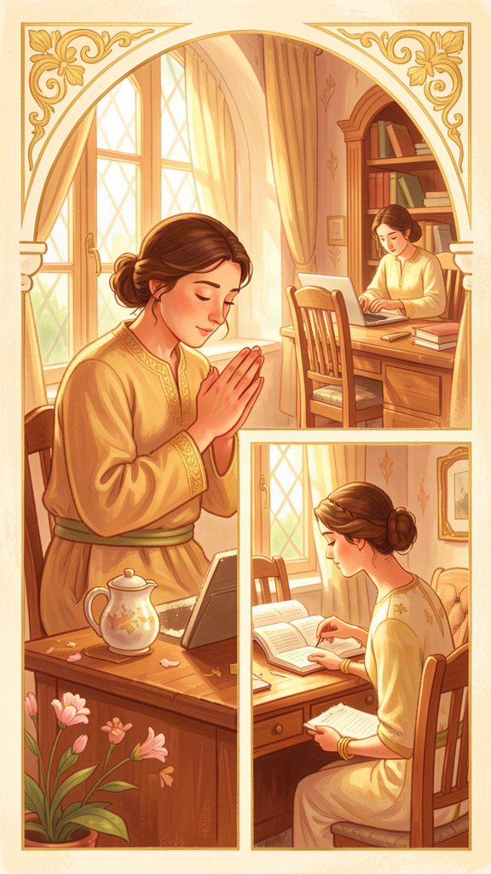
Illustration for Chapter 2

The Story
When Gregory lived in his monastery, his days had a rhythm. In the morning, the monks prayed together. Then they worked — some baked bread, some tended the garden, some copied books by hand. Then they prayed again. Then they ate together. Then they prayed again. Then they rested.
Gregory loved this rhythm. He called the praying part "contemplation" and the working part "action." And he discovered something important: you cannot do the working part well unless you do the praying part first.
He used a picture to explain it. Imagine a cup. If the cup is empty, you cannot pour water out of it for anyone. You have to fill the cup first. Then you can pour.
Prayer fills the cup. Action pours it out. If you keep pouring without filling, the cup goes dry. You keep doing things, but you forget why. You get tired and grumpy. You stop being kind.
When Gregory became pope, he had to do more action than ever. He wrote letters, organized food shipments, talked to kings, and solved arguments. He was so busy that he sometimes forgot to stop and pray. He wrote to a friend:
"When I think how I have lost the beauty of deep repose, I look at the swelling sea of present affairs and grieve that I have been carried away from the haven of peace."
Gregory was sad because the "stormy sea" of being busy all the time had pulled him away from the "quiet harbor" of prayer. But he did not give up. He tried to keep the rhythm — to pray even when he was busy, so that his work would always be filled with love, not just with rushing.

Words to Remember
"The active life draws us out to our neighbor; the contemplative life recalls us to ourselves. In action we pour ourselves out for others; in contemplation we are filled again. Unless the vessel is filled, it cannot pour out; unless the soul is renewed in secret, it will grow dry in public." — Gregory, in a letter
This means: doing good things for others is wonderful, but you need quiet time to refill yourself. A cup has to be filled before it can pour.

Big Idea
Prayer and work go together like filling a cup and pouring it out. You need quiet time to fill up inside, and then you can pour out love for others. If you keep pouring without filling, you go dry. The secret is to keep the rhythm: fill, pour, fill, pour.

Try This
1. Fill the cup. Get a real cup. Fill it with water. Pour it into a plant or give it to someone. Then fill it again. Talk about how people are like cups — we need to be filled with quiet and love before we can give to others.
2. Make a rhythm chart. Draw two columns. On one side, write "Fill" — things that make you feel peaceful and happy (praying, reading, walking outside, being with family). On the other side, write "Pour" — things you do to help others (helping at home, being kind to a friend, sharing). Try to do one from each side every day.
3. Quiet minute. Try sitting still and quiet for one whole minute. Close your eyes. Think about something good. When the minute is over, notice how you feel. That little bit of quiet is what Gregory called being "filled."

Ask a Grown-Up
"What fills you up when you feel empty? What do you do to get quiet and peaceful before you have to do a lot of work?"
———

Chapter 3: Adapted Teaching — Meeting People Where They Are

Illustration for Chapter 3

The Story
Gregory was a teacher. But he did not teach the same way to every person. He had a secret: he watched people first, and then he figured out what they needed to hear.
Think about a garden. Some plants need a lot of water. Some need only a little. Some need bright sun. Some need shade. If you give water to the shade plant, it will die. If you give sun to the shade-loving plant, it will burn. The good gardener does not treat every plant the same. The good gardener gives each plant what it needs.
Gregory said teachers are like gardeners, and also like doctors. A doctor does not give the same medicine to every sick person. First the doctor listens. Then the doctor decides what medicine will help this particular person.
Gregory made a list of different kinds of people and how to help each one. Sad people need comfort, not a lecture. Happy people need a gentle reminder that good things do not last forever, so they should enjoy them and share them. People who are too excited need to be calmed down. People who are too lazy need to be stirred up — but gently, not all at once.
Gregory also used this idea when he sent his friend Augustine across the sea to a place called England. The people there had their own customs and festivals. Gregory told Augustine: "Do not destroy their temples. If you can, turn them into churches. Let the people keep their harmless festivals, but give them new meaning. Do not be disturbed by the diversity of tongues."
Gregory was saying: do not make people change everything about themselves. Meet them where they are. Tell them about love in a way they can understand. That is how you help people grow.

Words to Remember
"The same word that builds up one person may destroy another. A wise shepherd should know when to speak and when to keep silence, when to rebuke and when to comfort, when to press hard and when to let the wound rest." — *Pastoral Rule*, Part II
This means: the same words can help one person and hurt another. A wise helper learns to read people and give each one what they need.
"The medicine must be measured to the disease, and the word to the hearer." — *Pastoral Rule*, Part II
This means: just as a doctor gives different medicine to different sick people, a good teacher gives different words to different listeners.

Big Idea
Good teachers do not say the same thing to everyone. They watch and listen first. They figure out what each person needs, and then they speak in a way that person can hear. This is not changing the truth — it is being kind enough to share the truth in a way that helps.

Try This
1. Plant experiment. If you have two plants or can imagine two plants, think about what each one needs. One might need more water, one might need more sun. Write down what each one needs. Talk about how people are like that too — everyone needs something different.
2. Different words for different people. Think of something nice you want to tell someone (like "You are a good friend"). Now imagine telling it to a baby, a kid your age, and a grandparent. Would you say it the same way? Try saying it three different ways.
3. Watch and listen. Pick one person in your family. For one whole day, just watch them. Notice when they seem happy, sad, tired, or excited. At the end of the day, think about what that person might need from you. Do they need a hug? A joke? A quiet moment? Try giving it to them.

Ask a Grown-Up
"Have you ever had someone say the exact right thing to you at the exact right moment? What was it? How did it feel?"
———

Chapter 4: Humility and Self-Knowledge — The Foundation of Leadership

Illustration for Chapter 4

The Story
Gregory believed that before you can lead others, you have to know yourself. He said it in a sentence that people still remember today:
"The ruler should be a man who, before others guide him, has learned to guide himself; who, before he is put forward as a teacher, has shown himself to be teachable; who, before he is set over others, knows how to submit to authority."
That is a long sentence, but it has four simple ideas. Before you guide others, guide yourself. Before you teach others, be willing to learn. Before you are put in charge, learn to follow. Before you do big things, get your heart ready.
Gregory used a picture to explain what humility means. He said humility is like a mirror. When you look in a regular mirror, you see your face. When you look in the mirror of humility, you see your whole self — the good parts and the parts that need work. You see yourself clearly, without pretending to be better than you are and without pretending to be worse than you are.
Gregory knew that power can make people forget who they are. When you are the boss, everyone tells you that you are wonderful. After a while, you start to believe it. You stop listening to people who tell you the truth. You only want to hear nice things.
That is why Gregory said leaders need to keep looking in the mirror. They need to know their own mistakes. They need to be willing to learn, even from people who are "below" them. A leader who has stopped learning is a leader who has stopped being good.
Gregory had a word for the feeling that keeps you honest. He called it "compunction." It is like a little poke in your heart that says, "That was not your best. You can do better." It is not a bad feeling. It is the feeling that keeps you growing.

Words to Remember
"We cannot be useful to others in healing their wounds if we do not first feel our own." — *Pastoral Rule*
This means: before you can help other people fix what is wrong, you have to be honest about what is wrong with you.
"Humility is truth. The humble person neither pretends to be more than he is nor less than he is." — Gregory, in a homily
This means: being humble does not mean saying "I am terrible." It means seeing yourself clearly — the good and the parts that need work.

Big Idea
Before you can be a good leader, you have to be honest with yourself. Humility is not pretending you are bad. It is seeing yourself clearly — your gifts and your mistakes. A leader who knows their own faults is gentler with other people's faults.

Try This
1. Mirror moment. Stand in front of a mirror. Look at yourself. Now think of one thing you are good at (like being a good friend, drawing, or running fast). Then think of one thing you want to get better at (like being patient, or listening). Say both out loud: "I am good at ___. I want to get better at ___." That is humility.
2. Be the student. Pick something you do not know how to do. Ask someone to teach you. Notice how it feels to be the one who is learning, not the one who is teaching. Gregory said a good teacher is always also a student.
3. Admit one mistake. Today, when you make a mistake, try saying, "I made a mistake. I will try to do better next time." Notice how it feels. Does it feel scary? Does it feel honest? Gregory said admitting mistakes makes you stronger, not weaker.

Ask a Grown-Up
"What is something you are still learning, even though you are a grown-up? How do you keep learning new things?"
———

Chapter 5: Compunction and Conversion — The Broken Heart That Heals

Illustration for Chapter 5

The Story
Gregory had a special word for a special feeling. He called it "compunction." It is a big word for a simple thing: the little poke in your heart that tells you when you have done something wrong.
Imagine you get a splinter in your finger. It hurts. But the pain is actually good, because it tells you something is stuck in there and you need to take it out. If you could not feel the pain, you would not know the splinter was there, and your finger could get infected.
Compunction is like that. It is the pain that tells you: "Something is not right. You need to fix it." It is not a bad feeling. It is a helpful feeling. It is the feeling that keeps you growing.
Gregory said there are two kinds of tears. The first kind is sad tears — tears because you did something wrong. The second kind is longing tears — tears because you want to be better than you are. Both kinds are good. They are like rain that washes a window so you can see through it.
The important thing is: do not get stuck in the sad tears. Gregory said: "When we have fallen, let us rise at once. When we have sinned, let us weep and then return to the Lord, for he does not despise a contrite heart."
That means: feel the poke, learn from it, get back up, and try again. Do not stay down. Do not pretend nothing happened. Feel it honestly, and then move forward.
Gregory believed that conversion is not a one-time thing. It is not like flipping a switch. It is more like a path you walk every day. You turn toward what is good, you stumble, you get up, you turn again. Every day is a chance to turn a little more toward the light.
And here is the best part: Gregory said that the people who feel compunction — who feel the poke and pay attention to it — become gentler with other people. Because they know how hard it is to do the right thing, they are more patient when other people struggle. The person who knows their own mistakes is the kindest person to be around.

Words to Remember
"Compunction is the lamp by which the soul sees its own stains." — Gregory, in a homily
This means: compunction is like a little light that helps you see what needs cleaning up inside you.
"When we have fallen, let us rise at once. When we have sinned, let us weep and then return to the Lord, for he does not despise a contrite heart." — Gregory, in a homily
This means: when you mess up, do not stay down. Feel it, learn from it, get back up, and try again. God loves a heart that is honest.

Big Idea
Feeling sorry when you do something wrong is not a bad thing. It is like a splinter that tells you something needs fixing. The key is: feel it, fix it, and get back up. The people who can feel their own mistakes honestly are the kindest people, because they understand that everyone struggles.

Try This
1. The splinter story. Think about a time you got hurt (a scrape, a splinter, a bruise). The pain told you something was wrong so you could fix it. Draw a picture of a splinter and write next to it: "Compunction is the pain that helps me grow."
2. Get back up. Think of a time you made a mistake. What did you learn from it? Draw a path with a person who falls down and then gets back up. Write on the path: "Fall, feel, get up, try again."
3. Kind because I know. Gregory said the people who know their own mistakes are the kindest. Think of one mistake you made this week. Now think of one person who also makes mistakes. Say to yourself: "I make mistakes too. I can be kind." Then do one kind thing for that person.

Ask a Grown-Up
"Is there a time you made a mistake and it actually helped you become a better person? What happened?"
———

Chapter 6: Suffering and Compassion — The Pastor's Burden

Illustration for Chapter 6

The Story
Gregory wrote a very long book about a man named Job. Job was a good person who had a wonderful life. He had a big family, lots of animals, and many friends. He helped people and tried to do what was right.
Then everything went wrong. Job lost his animals. His children died. He got sick with painful sores all over his body. He had nothing left.
Job's friends came to see him. They sat with him in silence for seven days. That was good. But then they started talking, and that is when things went wrong. His friends said: "You must have done something bad. God is punishing you. If you were good, this would not have happened."
But Job knew that was not true. He had not done anything to deserve all this. He was suffering, and he did not know why.
Gregory read Job's story and said: sometimes bad things happen, and there is no simple reason. The question is not always "Why did this happen?" Sometimes the better question is "How will I carry this? And how will I help others carry theirs?"
Gregory said that when you see someone who is hurting, you should do two things. First, feel their pain as if it were your own. Sit with them. Do not rush to explain or fix. Just be there and care. Second, after you have felt it with them, do something to help. Gregory put it this way:
"When we see another in trouble, we should first feel the wound as if it were our own, and then bind it up as if it belonged to another."
That means: compassion has two parts. Feel it, and then do something about it. If you only feel it and do nothing, that is just sadness. If you do something but do not feel it, that is just duty. Real compassion does both.
Gregory did this himself. When he became pope, Rome was in trouble. There was sickness, hunger, and war. Gregory did not just pray. He organized food shipments. He bought the freedom of people who had been captured. He took care of refugees. He believed you cannot tell people about God's love while letting them go hungry.

Words to Remember
"When we see another in trouble, we should first feel the wound as if it were our own, and then bind it up as if it belonged to another. Compassion takes upon itself the sorrow of the sufferer, and yet keeps the judgment needed to heal." — *Moralia in Job*
This means: when someone is hurting, first feel it with them. Then help them. You need both the feeling and the helping.
"Patience is not a passive virtue but a steadfast holding of the soul to God amid every changing thing." — *Moralia in Job*
This means: being patient does not mean giving up. It means staying strong and holding on to what is good, even when everything is falling apart.

Big Idea
When someone is suffering, do not try to explain why. Just be with them. Feel their pain. Then help. Real compassion has two parts: your heart feels it, and your hands do something about it. You cannot tell people about love while letting them go hungry.

Try This
1. Two hands of compassion. Trace your two hands on a piece of paper. On the left hand, write "Feel." On the right hand, write "Help." Under "Feel," write: sit with them, listen, care. Under "Help," write: do something, bring food, share, fix. Remember: compassion uses both hands.
2. Sit with someone. When you see someone who is sad — a friend, a sibling, a parent — try just sitting with them for one minute before you say anything. Do not try to fix it. Just be there. Then ask, "Is there anything I can do?"
3. The Job story. Ask a grown-up to tell you the story of Job, or read a simple version together. Draw a picture of Job's friends sitting with him in silence. Then draw what went wrong when they started talking. Talk about what the friends should have done instead.

Ask a Grown-Up
"When someone you know is going through a hard time, what helps more — trying to explain why it happened, or just being with them? Have you ever had someone just sit with you when you were sad?"
———

For the Grown-Up Reader
This booklet introduces children ages 5-10 to the life and thought of Gregory the Great (c. 540-604 CE), pope from 590 to 604. The six chapters follow the themes of the WisdomForge Gregory compendium: servant leadership, the contemplation-action synthesis, adapted teaching, humility and self-knowledge, compunction and conversion, and suffering and compassion.
All quotations are real, drawn from Gregory's Pastoral Rule (Liber Regulae Pastoralis), his Moralia in Job, his letters (Epistulae), and his homilies. The translations are simplified for young readers but are not paraphrased into untruth. The sources are:
Primary: Gregory the Great, Pastoral Rule (Parts I-IV); Moralia in Job; Epistulae (Register of Letters); Homiliae XL in Evangelia (Forty Homilies on the Gospels); Homiliae in Ezechielem (Homilies on Ezekiel). Available in English in the Nicene and Post-Nicene Fathers series, second series, vol. 12, and in the Demacopoulos translation (St. Vladimir's Seminary Press, 2007).
Secondary: Carole Straw, Gregory the Great: Perfection in Imperfection (University of California Press, 1988); R.A. Markus, Gregory the Great and His World (Cambridge University Press, 1997); George Demacopoulos, Gregory the Great: Ascetic, Pastor, and First Man of Rome (University of Notre Dame Press, 2015).
The biographical narrative is accurate: Gregory was born into the wealthy Anician family, served as Prefect of Rome, founded a monastery on the Celian Hill, served as papal envoy to Constantinople, and was elected pope in 590 CE against his will. He adopted the title Servus Servorum Dei, sent the mission to England in 596 CE, and wrote the Pastoral Rule as a guide for bishops. The stories about Job's friends, the cup and the water, the garden plants, and the mirror are pedagogical adaptations of Gregory's own metaphors, not invented tales.
For further reading with your child, the Pastoral Rule is available online at New Advent and the Christian Classics Ethereal Library. Bede's Ecclesiastical History tells the story of the England mission in a way children can follow.
———

About WisdomForge
WisdomForge creates age-adapted booklets that bring the wisdom of history's greatest thinkers to readers of every age. Each figure in the WisdomForge library receives four booklets: one for elementary readers (ages 5-10), one for middle readers (11-14), one for high school readers (15-18), and one for adults. The same ideas, the same stories, the same real words — shaped for each age so that a child can begin the journey and a grown-up can go deeper. Every quotation in every booklet is real, drawn from the figure's own writings or from the most reliable ancient sources. We do not invent words and put them in the mouths of the wise. We bring their actual words to life.

