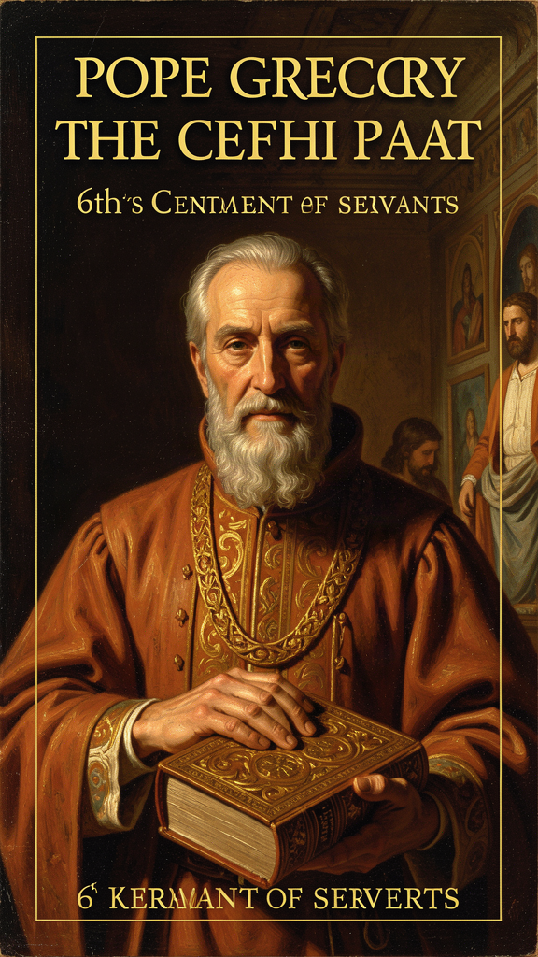
The Bridge and the Storm: Gregory the Great on Leadership, Prayer, and the Soul
WisdomForge Booklet — Ages 15-18

The Bridge and the Storm: Gregory the Great on Leadership, Prayer, and the Soul

WisdomForge Booklet — Ages 15-18
———

About This Book
Gregory the Great was born around 540 CE into one of the wealthiest and most powerful families in Rome. By his early thirties he was Prefect of Rome — the highest civil official in the city. Then he gave it all away. He resigned, turned his family mansion on the Celian Hill into a monastery, and became a monk. He thought he would spend the rest of his life in silence, prayer, and service to the poor.
The church had other plans. He was sent to Constantinople as papal ambassador. He was made abbot of his monastery. And in 590, when the previous pope died of plague, the clergy and people of Rome elected him pope. He was the first monk ever to hold the office. He wrote to the emperor begging to be released. He tried to flee the city. The Romans would not let him go.
For fourteen years he led the church through plague, famine, Lombard invasion, Byzantine neglect, and constant administrative pressure. He fed the hungry, ransomed captives, negotiated with kings, sent missionaries to England, reformed the liturgy, and wrote works that shaped the entire Middle Ages. He called himself Servus Servorum Dei — Servant of the Servants of God — and he meant it.
This booklet explores six ideas that Gregory discovered in the crucible of leadership. Each chapter is a narrative essay that tells the story behind the idea, engages with real arguments and objections, and gives you concrete practices to try. Gregory lived fourteen hundred years ago, but his questions are still urgent: How do you lead without losing your soul? How do you stay busy without going dry inside? How do you teach the truth without crushing the people you are trying to help? How do you stay humble when everyone tells you that you are wonderful? How do you face suffering that has no explanation? And how do you carry the weight of other people's pain without collapsing under it?
Gregory does not offer easy answers. He offers a way of living that is honest, tested, and still surprisingly modern.
———

Chapter 1: Servant Leadership — The Title That Says Everything
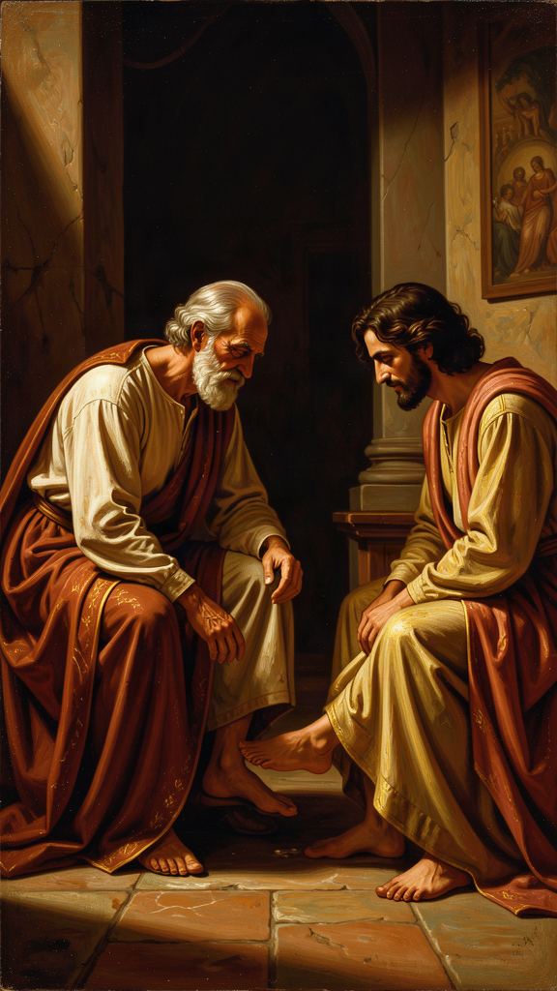
Illustration for Chapter 1

The Story
When Gregory became pope in 590, he inherited a title with heavy baggage. Pontifex Maximus — "the greatest bridge-builder" — had been claimed by Roman emperors and pagan high priests. It suggested that the pope stood at the top of a hierarchy of power, closer to the divine than to ordinary people. Gregory would not use it.
Instead he adopted a phrase that reversed the direction of authority. Servus Servorum Dei means "Servant of the Servants of God." It is not a modest way of saying "I am important." It is a claim about what the office is for. The pope is not above the church; he is answerable to it. The higher the office, the greater the obligation to serve. Gregory used this title in his official correspondence. It became the standard papal style and remains so today, more than fourteen hundred years later.
The title was personal. Gregory had not wanted the papacy. He had wanted to stay in his monastery. When he was forced into office, he insisted that the office be understood as a burden laid on him for the sake of others, not a prize he had won. His letters from this period are remarkable documents of spiritual reluctance:
"I have been subjected to the yoke of pastoral care, a burden which I am not strong enough to bear. In consequence I am so crushed that I cannot raise my neck. For my mind is occupied with secular business that robs it of all contemplation, and when I think how I have lost the beauty of deep repose, I look at the swelling sea of present affairs and grieve that I have been carried away from the haven of peace."
This is not false humility. Gregory had found peace in the monastery and believed that the papacy would damage the inner life he most valued. His acceptance of office was an act of obedience: he served not because he wanted power but because the needs of others required it. The passage also explains the emotional tone of his greatest work, the Pastoral Rule — it was written by a man who knew the cost of leadership.

Leadership as a Dangerous Office
Gregory's first instinct was not to celebrate power but to warn against it. In the Pastoral Rule he writes that the office of shepherd is "a form of supreme humility." The person who seems to have reached the highest place must be "all the more diligent in his anxiety for those under him." Why is leadership dangerous? Gregory gives several reasons.
Praise warps the soul. A leader is constantly told that he is wise, strong, indispensable. After a while he begins to believe it. The love of being praised slowly replaces the love of serving.
Power creates distance. The leader begins to live among flatterers. He hears only what people think he wants to hear. He loses the honest feedback that would keep him humble.
Busyness replaces prayer. A leader is pulled into many tasks. If he is not careful, he starts to speak about God without speaking to God. The words continue; the inner life dries up.
Gregory's answer is not to abolish leadership. It is to redefine it. The leader is a bridge, not a tower. He exists so that others can cross over him toward God and toward the good. A bridge is strong — it holds weight. But it is also low — it does not block the path with its own ego. Gregory's ideal leader is steady, humble, reliable, and oriented toward the good of the people who depend on him.

The Pastor as Bridge
Gregory's favorite image for the leader is a bridge. "The pastor is placed as a bridge between God and the people. He must be firm enough to bear the weight of those who walk upon him, yet low enough to let them pass over him safely." The image combines the two virtues Gregory most wants in a leader: strength and humility. Strength is needed because leadership is hard — the leader must carry responsibility, absorb criticism, make difficult decisions, and protect the weak. Humility is needed because strength without humility becomes domination. The leader must not block the path with his own ego.
A bridge is useful precisely because it does not call attention to itself. It is not the destination. It is the means by which others reach the destination. Gregory's ideal leader is like that: oriented toward the good of the people who depend on him, not toward his own glory.

The Difference Between Service and Servility
Gregory's servant leadership is sometimes misunderstood as being a doormat. It is not. A servant-leader still makes decisions, corrects error, defends the vulnerable, and speaks unwelcome truth. Gregory's letters show him being quite firm with bishops, kings, and emperors when he believes they are wrong.
The difference is the direction of the leader's energy. A tyrant uses people to build himself up. A servant-leader spends himself to build people up. A weak leader avoids conflict because he wants to be liked. A servant-leader faces conflict because he loves the people involved enough to tell them the truth. Gregory's standard is high. He expects the leader to have first "learned to guide himself" before guiding others. This means self-knowledge, teachability, and prayer. A leader who has not done this inner work will eventually serve himself while appearing to serve others.

Scholarly Debate: Was Gregory's Reluctance Genuine?
Modern historians sometimes wonder whether Gregory's reluctance was genuine. In late antique culture, expressions of humility were expected from people assuming high office. Could his letters begging the emperor to block his election have been political theater — a conventional performance of modesty?
The evidence suggests otherwise. Gregory's private letters, not intended for public display, show the same reluctance and grief. He describes the papacy as a "yoke" that crushes him. He grieves the loss of contemplative peace. He feels pulled in too many directions. He is sometimes irritable, always busy, rarely satisfied. This is not the voice of a man performing humility. It is the voice of a man who finds leadership hard and who admits it.
George Demacopoulos argues that Gregory's rhetoric of humility was itself a form of leadership — not necessarily cynical, but effective. R.A. Markus emphasizes the practical pressures that forced Gregory into political roles whether he wanted them or not. The integrated view suggests that Gregory was both pastor and politician, and that the two cannot be separated in his life. The spiritual motive and the political effect were intertwined. He may have acted from love, but his actions also built institutional power.

The Modern Echo
Modern management literature has rediscovered servant leadership, often without knowing its Gregory-shaped origins. Robert Greenleaf's "servant leadership" movement, the emphasis on emotional intelligence, and the critique of top-down corporate cultures all echo Gregory's intuition. But Gregory's version is deeper than a management technique. It is rooted in the conviction that every person is made in God's image and that the leader will one day answer for how he treated them. The title Servus Servorum Dei is not a brand. It is a vow.

Key Quotes
"I have chosen to call myself the servant of the servants of God, because I see that the more I am compelled to rule, the more I am bound to serve." — Gregory, letter
"The office of shepherd is a form of supreme humility. When anyone seems to have obtained the highest place, he should be all the more diligent in his anxiety for those under him." — *Pastoral Rule*, Part I
"The ruler should be a man who, before others guide him, has learned to guide himself; who, before he is put forward as a teacher, has shown himself to be teachable; who, before he is set over others, knows how to submit to authority; who, before he serves the interests of God, has cultivated a life of prayer and contemplation." — *Pastoral Rule*, Part I

The Big Idea
Authority exists for service, not for status. The higher you climb, the more you owe the people below you. Gregory's title — Servant of the Servants of God — was not a slogan but a theological claim about what power is for. The leader is a bridge, not a tower: strong enough to hold people up, low enough to let them cross without tripping over the leader's ego. The difference between service and servility is the direction of the leader's energy — a servant-leader spends himself to build people up; a tyrant uses people to build himself up.

Practice
1. The Bridge Audit. Think of a leadership role you hold — team captain, club officer, student council, older sibling, project lead. Write down three concrete ways you act as a bridge (bearing weight, helping others cross) and three ways you might act as a tower (demanding attention, blocking the path). Show the list to someone who will be honest with you. Ask: "Is this accurate?" Deliverable: one paragraph naming one bridge-behavior to strengthen and one tower-behavior to drop.
2. The Reluctance Test. Gregory believed that wanting power too much makes you unfit for it. Think about a position of responsibility you want or are pursuing. Ask yourself honestly: "Do I want this because of what I can do for others, or because of how it will make me look?" Write a one-paragraph answer. You do not have to share it, but you do have to be honest.
3. The Energy Direction. For one week, track your behavior in one group setting. After each interaction, note: "Did I use this interaction to build myself up, or to build others up?" Rate each interaction 1-5 on each scale. At the end of the week, look at the pattern. What does it tell you?

Reflect
Is servant leadership possible in real politics, business, or school government — or does power always corrupt the idea? Can you name a modern leader who seems to practice it? What would have to change in your own school or community for leaders to be judged not by their title but by whom they serve?
———

Chapter 2: The Contemplation-Action Synthesis — Prayer and Work
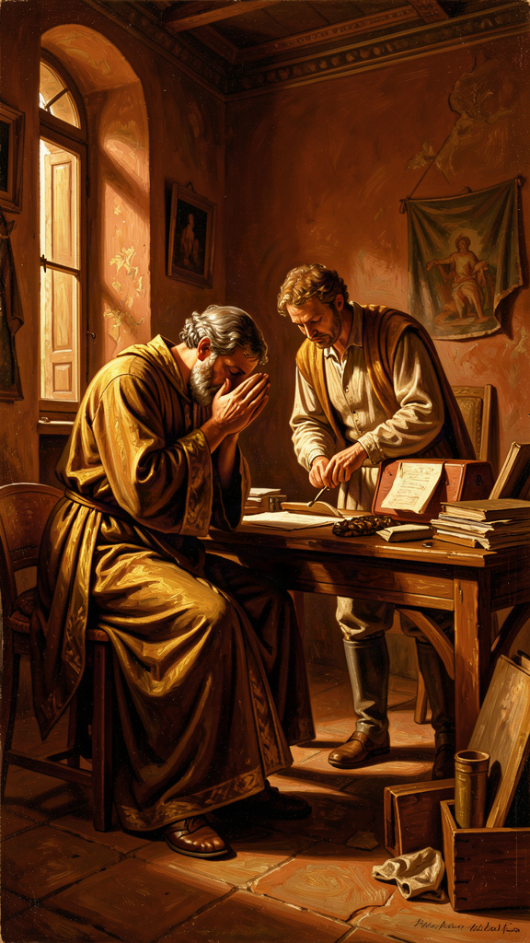
Illustration for Chapter 2

The Story
Gregory wanted to be a monk. He became pope. That single fact shaped everything he wrote about prayer and work.
In the monastery, the highest good is contemplation: gazing on God, reading Scripture, praying in silence, attending to the soul. In the papacy, the demand is action: letters, lawsuits, famine relief, diplomacy, appointments, disputes. Gregory experienced both as real goods. He did not think the monastery was selfish or the papacy worldly. But he felt the tension between them constantly.
His letters describe the papacy as a "stormy sea" and the monastery as a "quiet harbor." He grieves the loss of "deep repose" and complains that secular business robs his mind of contemplation. Yet he also defends the active life as a necessary expression of love. The tension is not resolved by choosing one side. It is resolved by keeping them in the right order.

The Vessel and the Pouring
Gregory's formula is simple: contemplation comes before action. The soul must first be filled in prayer; only then is it sent back to the neighbor in love. He uses the image of a vessel:
"The active life draws us out to our neighbor; the contemplative life recalls us to ourselves. In action we pour ourselves out for others; in contemplation we are filled again. Unless the vessel is filled, it cannot pour out; unless the soul is renewed in secret, it will grow dry in public."
Action without contemplation becomes hollow. The person keeps doing things but loses the inner reason for doing them. Contemplation without action becomes sterile. The person sits in silence but never lets love draw him out to serve. Each needs the other. The test of true contemplation is whether it produces compassion. The test of true action is whether it remains rooted in God.
Gregory is not saying that everyone must be a monk. He is saying that every person who wants to serve others needs some interior life. Without it, service becomes performance. The words continue, but the source has run dry.

Ezekiel: The Prophet Who Is Lifted Up and Sent Down
Gregory's Homilies on Ezekiel develop the contemplation-action theme most fully. Ezekiel is called from the presence of God to speak to a rebellious people. He would rather stay in the vision; God sends him into the world. Gregory sees Ezekiel as a type of every pastor — and of himself.
The prophet's vision of the heavenly chariot represents the soul lifted to God. The command to preach represents the soul sent to the neighbor. Gregory moves back and forth between these poles: lifted up, sent out; filled, poured out. The healthy spiritual life keeps both movements alive.
"The pastor is made a watchman for the house of Israel: he is lifted up to see, and then sent down to speak what he has seen."
This is why burnout is a spiritual problem for Gregory, not merely a practical one. When a person tries to serve without returning to the source, the soul dries out. The work may continue for a while, but it loses its warmth, its wisdom, and its endurance. Eventually the person becomes either cynical or exhausted.
Gregory's answer is rhythm, not balance in the modern sense. There are seasons when action dominates and seasons when withdrawal is necessary. The wise person learns to move between them. The monk who is called to leadership must learn to carry contemplation into the noise of public life. The busy person must learn to steal moments of silence.

How Gregory Managed It
Gregory's own life shows the difficulty of the synthesis. His letters were dictated in batches between prayer and administrative sessions. He tried to keep monastic discipline even as pope: simple food, limited sleep, regular reading of Scripture, care for the poor. He was not always successful. He was often tired, sometimes irritable, frequently overwhelmed.
But the attempt mattered. Gregory demonstrated that contemplation and action could be held together, even if imperfectly. His papacy was not a betrayal of his monastic vocation. It was the extension of that vocation into the world.

Scholarly Debate: Does Gregory Privilege Contemplation Over Action?
Some readers worry that Gregory values contemplation more than action. It is true that he calls contemplation "higher" in one sense: it is the direct encounter with God. But he does not dismiss the active life. He insists that the active life is a form of love that contemplation itself demands. Love of neighbor draws the soul out of silence and into service. A person who sees God rightly cannot ignore the needs of God's creatures. Gregory's ideal is not the monk who never leaves his cell. It is the person whose action is fed by prayer and whose prayer is tested by action.
The debate matters because it affects how we read Gregory's relevance. If he privileges contemplation, his synthesis is only for monks. If he holds them as equal partners with contemplation first, his synthesis applies to anyone who works hard and wants to remain whole. The evidence — his own life, his letters, his homilies — points to the second reading.

Why It Still Matters
Modern readers hear Gregory's theme in many places: the Sabbath, the retreat, the digital detox, the recovery movement, the critique of burnout culture. The idea that sustainable action requires regular return to a deeper source is no longer controversial. What Gregory adds is the theological depth: the source is not just rest but God.
Gregory also avoids two common mistakes. He does not make contemplation an escape from responsibility, and he does not make action a substitute for interior life. Some people use "spirituality" to avoid hard work; others use busyness to avoid looking inward. Gregory's synthesis challenges both.

Key Quotes
"Unless the vessel is filled, it cannot pour out; unless the soul is renewed in secret, it will grow dry in public." — Gregory, letter
"When I think how I have lost the beauty of deep repose, I look at the swelling sea of present affairs and grieve that I have been carried away from the haven of peace." — Gregory, letter
"The ruler should be a man who, before he serves the interests of God, has cultivated a life of prayer and contemplation." — *Pastoral Rule*, Part I

The Big Idea
Prayer and work are not rivals. They are partners in a rhythm: fill, pour, fill, pour. You must be filled before you can pour out. Contemplation without action is sterile self-absorption; action without contemplation is hollow performance. Burnout is what happens when you keep pouring without ever filling. The healthy life keeps both movements alive: lifted up to see, sent down to speak what you have seen.

Practice
1. The Battery Log. For one week, keep a simple log. Each evening, rate your "battery" from 1-10. Then note: what charged you today (filled your cup)? What drained you (poured it out)? At the end of the week, look at the pattern. Are you pouring more than you fill? Deliverable: one paragraph identifying the single most reliable "filling" practice in your life and one concrete way to protect it.
2. The Ezekiel Pattern. Gregory described the pastor as "lifted up to see, and then sent down to speak what he has seen." Try this as a daily rhythm for one week: spend five minutes in silence at the start of your day (lifted up). Then go about your activities. In the evening, write one sentence: what did you "see" in the silence that changed how you acted? Deliverable: seven sentences.
3. The Escapism Check. Gregory warned that contemplation can become an escape from responsibility, and busyness can become an escape from self-knowledge. Which tendency is yours? Do you use quiet to avoid work, or work to avoid quiet? Write a one-paragraph honest assessment. Then identify one practice that would strengthen the weaker side.

Reflect
Is the contemplative life just escapism, or is it necessary for anyone who wants to do good in the world? Can a person do great good without any inner life? What would it look like to build a rhythm of filling and pouring into your own weekly schedule?
———

Chapter 3: Adapted Teaching — Meeting People Where They Are
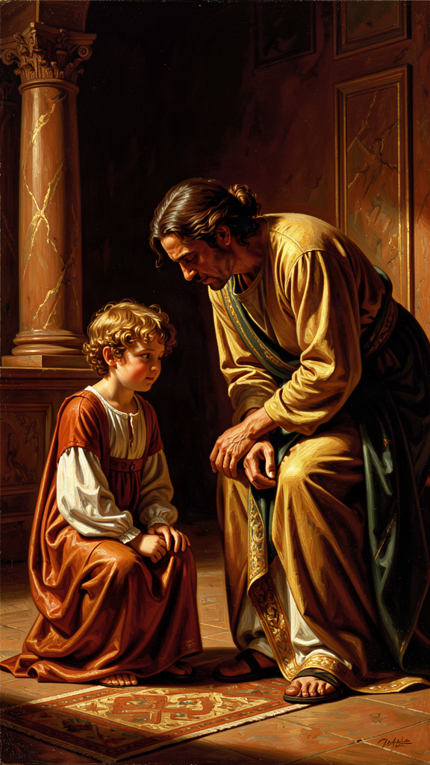
Illustration for Chapter 3

The Story
In Part II of the Pastoral Rule, Gregory faced a practical problem that every teacher, leader, and parent faces. A bishop must teach many different kinds of people: rich and poor, young and old, zealous and lukewarm, cheerful and melancholy, educated and simple. If he speaks the same way to all of them, he will help some and harm others.
A rebuke that wakes up a complacent person may crush a sensitive one. Encouragement that strengthens a discouraged person may inflate a proud one. Silence that gives a wounded soul space to heal may let a rebellious soul harden in its error. The pastor must know not only what is true but what this person can receive right now.
Gregory compares the teacher to a physician. The same medicine does not cure every disease. The doctor must diagnose before prescribing. The teacher must understand before speaking.

The Catalogue of Hearers
Gregory gives a famous catalogue of character types and how each should be addressed. The poor need to be reminded of their dignity. The rich need to be warned against the deceit of wealth. The joyful need to be reminded that fortune changes. The sorrowful need comfort, not correction — Gregory warns against preaching to a grieving person as if grief were a moral failure. The zealous need to be directed toward steadiness. The lukewarm need to be stirred, but gently at first.
The list is not exhaustive, but the principle is clear: the teacher must be a reader of persons. Truth does not change, but the way it is spoken must. The same word that heals one person can wound another. The goal is always the good of the hearer, not the display of the teacher's own wisdom.

When to Speak and When to Be Silent
One of Gregory's most important lessons is the value of silence. The wise shepherd knows when not to speak. Some truths must wait until the hearer is ready. Some wounds must be bound before they can be examined.
Gregory distinguishes between public preaching and private correction. In public, the bishop teaches the whole church. In private, he must address the particular person. Public truth is not the same as personal truth in every moment. A general doctrine may be true, but the timing of its application to a particular soul requires discernment. This makes adapted teaching a moral art, not a technical skill. The goal is always the good of the hearer. The teacher must ask: Will these words help this person grow, or will they harden this person against the truth?

The Mission to England as Adapted Teaching
Gregory's principle of adaptation is not limited to sermons. It shaped his approach to the mission to England. In his instructions to Augustine of Canterbury he told the missionaries to adapt local customs where possible, to avoid destroying pagan temples if they could be converted into churches, and to let the people keep harmless festivals while giving them Christian meaning.
"Do not be disturbed by the diversity of tongues. For the services of holy Church are celebrated throughout the world with diverse languages, but the miracles of holy Church are shown to be one and the same. For the virtue of sacred charity is one, which joins together those of diverse tongues and makes them of one heart in the faith."
This was controversial. Some missionaries believed pagan culture must be completely swept away. Gregory replied that the goal was conversion, not cultural conquest. The same gospel could be expressed in different cultural forms. Adaptation, rightly practiced, was a sign of respect for the people being taught.

Adaptation Is Not Relativism
Gregory's adapted teaching is sometimes misunderstood as moral relativism. It is not. His distinction is between the truth itself and the way the truth is delivered. The truth does not change. The method of communication must change. A doctor does not change the diagnosis because the patient is frightened. But the doctor may change how the diagnosis is explained, when it is delivered, and what support is offered. The medicine is the same; the manner of giving it differs.
Gregory had firm convictions — the Trinity, the incarnation, the authority of Scripture, the moral law. These were not up for negotiation. But within these firm boundaries, there was room for flexibility. Language, music, customs, and festivals could be adapted. The goal was conversion, not cultural destruction. Gregory drew a line between essentials and adiaphora — things that differ. A relativist says, "You can believe what you want." An adapter says, "I want you to receive this truth, so I will speak in a way you can understand." The first abandons the truth; the second serves it.

Scholarly Debate: Adapted Teaching as Manipulation?
A serious objection to Gregory's method is that adapting your message to the hearer can become manipulation. If you change your words based on what you think the other person wants to hear, are you respecting them or controlling them?
Gregory's answer is that adaptation serves the hearer, not the speaker. The teacher who adapts is not trying to be popular. He is trying to be effective in love. The test is the goal: is the adaptation for the good of the hearer or for the comfort of the speaker? If a teacher waters down a hard truth to avoid conflict, that is cowardice. If a teacher finds a way to deliver a hard truth so that it can be received, that is love.
This distinction is important because it separates Gregory's method from mere persuasion. A salesperson adapts the pitch to close the deal. A teacher adapts the message to heal the soul. The outward technique may look similar, but the goal is opposite: the salesperson serves himself; the teacher serves the hearer.

Why It Anticipates Modern Psychology
Gregory's idea sounds modern because it is. Contemporary pastoral counseling, differentiated instruction, emotional intelligence, and motivational interviewing all share his intuition: effective communication depends on understanding the person in front of you. But Gregory adds a dimension modern methods sometimes lack. For him, adapted teaching is an act of charity. The teacher is not merely trying to be effective. He is trying to love. The discipline of attention to the hearer is a discipline of love.

Key Quotes
"The same word that edifies one person may destroy another. A wise shepherd should know when to speak and when to keep silence, when to rebuke and when to comfort, when to press hard and when to let the wound rest." — *Pastoral Rule*, Part II
"The medicine must be measured to the disease, and the word to the hearer." — *Pastoral Rule*, Part II
"When Almighty God brings your mind to the right way, make use of such customs as you find praiseworthy, so that the people may the more readily flock to places to which they are accustomed." — Letter to Mellitus

The Big Idea
Truth does not change, but the way it is delivered must. The same words that heal one person can wound another. Adapted teaching is not relativism — it is love paying attention. The teacher who adapts is not watering down the truth but translating it so that the hearer can receive it. The line between adaptation and compromise is the goal: if you change the message to please the hearer, that is compromise. If you change the delivery to help the hearer, that is love.

Practice
1. Three Audiences Exercise. Choose one truth you believe is important (e.g., "People deserve respect regardless of their background" or "Hard work matters more than talent"). Write three versions of this message: one for a five-year-old, one for a peer your age, and one for someone who disagrees with you. Same truth, different delivery. Deliverable: three paragraphs, each labeled with the target audience.
2. The Silence Experiment. Gregory said the wise shepherd knows when not to speak. Pick one situation this week where you would normally give advice, correct someone, or share your opinion. Instead, say nothing. Just listen. Write one paragraph about what happened. Did the silence help? Did it feel uncomfortable? What did you learn about the other person that you would have missed if you had been talking?
3. The Adaptation Audit. Think of a teacher, coach, or mentor who communicates well. Observe them for one week. How do they change their approach for different people? Write down two specific examples. Then ask yourself: do you adapt your communication to different friends, or do you speak the same way to everyone? What would change if you were more intentional?
4. The Manipulation Check. Gregory distinguished adaptation (serving the hearer) from manipulation (serving the speaker). Think of one conversation where you changed your words to get what you wanted. Now think of one where you changed your words to help the other person hear something they needed. Write one paragraph comparing the two. What was different about your motive?

Reflect
Is adapted teaching respectful or manipulative? When does adjusting your message become dishonest? Can you think of a time when someone adapted their words to you in a way that felt like respect rather than control? What made the difference?
———

Chapter 4: Humility and Self-Knowledge — The Foundation of Leadership
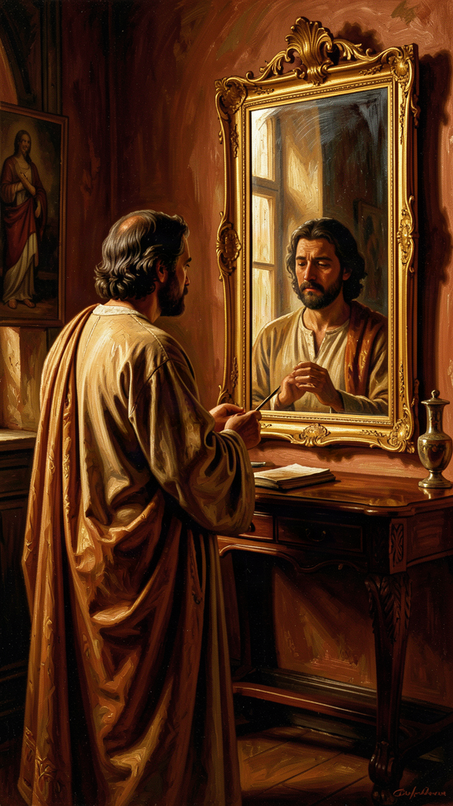
Illustration for Chapter 4

The Story
Gregory's most famous sentence on leadership is a sequence, not a list. In the Pastoral Rule he says the ruler must be someone who has learned to guide himself before guiding others; who has shown himself teachable before being made a teacher; who knows how to submit before being set over others; who has cultivated prayer and contemplation before serving God's interests in public.
The order matters. Each step prepares for the next. A person who cannot guide himself will misguide others. A person who is not teachable cannot teach. A person who has never submitted will rule like a tyrant. A person who does not pray will eventually serve himself while claiming to serve God.
Gregory is not asking for perfection. He is asking for honesty. The leader must know his own temptations, weaknesses, and wounds. Without this self-knowledge, authority becomes dangerous.

Humility Is Not Self-Contempt
Gregory sometimes sounds severe about human nature, but his humility is not the same as self-loathing. For him, humility is the recognition that everything good comes from God and that the self is constantly tempted to pride. A humble person does not deny his gifts. He denies that his gifts make him better than others. He knows that intelligence, charm, energy, and position are given, not earned. He also knows that these gifts can be turned into weapons if he is not watchful.
Gregory's humility is realistic. He expects leaders to be aware of their own sin, not paralyzed by it. The point is not to wallow in guilt but to stay alert. Pride grows in the dark. Humility turns on the light.
"Humility is truth. The humble person neither pretends to be more than he is nor less than he is."
This is a crucial distinction. Pretending to be less than you are is not humility — it is another form of ego, a desire to be thought humble. True humility is simply seeing yourself clearly.

The Dangers of Office
Gregory knew why self-knowledge matters especially for people in authority. Power tends to distort the picture a person has of himself. Flattery, fear, and habit make the leader believe his own press.
In the Pastoral Rule Gregory warns that the shepherd's main battlefield is his own heart. The decay begins subtly. The leader starts to enjoy being consulted. He begins to prefer the company of people who admire him. He speaks about God without speaking to God. His prayers become shorter while his schedule becomes longer.
Gregory calls this spiritual dryness. It happens when the inner life is neglected. The leader may still perform well outwardly, but the source of his service has begun to fail. Self-knowledge is the alarm system that notices the decay before it becomes collapse.

Climbing Without Rising
In the Moralia in Job, Book VI, Gregory comments on the spiritual danger of advancement in rank without advancement in virtue:
"There are some who, while they keep the order of their rank, yet do not keep pace with their improvement. They advance in their offices, but they do not advance in virtue. They consider that they have attained something because they have climbed higher, not noticing that they have climbed without rising."
This is one of Gregory's most quotable lines and one of his most penetrating. He sees that external promotion can mask inner stagnation. A person can move up in the world without moving toward goodness. The phrase "climbed without rising" captures the absurdity of a career that has no moral direction. The test is not how high you have climbed but how much you have grown.

Compunction: The Gift of Tears
Gregory has a special word for the sorrow that keeps the soul honest: compunction. It is not despair. It is a gentle grief over one's own faults and a longing for God. Compunction is the feeling that keeps pride from hardening the heart. The monk who weeps for his sins is not weak. He is awake. Gregory believed that tears of compunction were a gift because they prevented a worse grief: the grief of discovering too late that one has become a hypocrite.
For leaders, compunction is a protection. The person who regularly admits his faults is less likely to pretend to be holy. The person who remembers his dependence on God is less likely to trust in his own competence. The leader who weeps for his own faults is less likely to condemn others with a hard heart. He knows that he needs the same mercy he proclaims.

Teachability Before Authority
One of Gregory's most striking requirements is that the teacher must first be teachable. A person who cannot receive correction has no business giving it. This is because teaching is not just the transfer of information. It is the communication of a way of life. A teacher can only pass on what he himself is still learning.
Gregory applies this to the pope as much as to anyone. The pope must be willing to learn from Scripture, from the church's tradition, from the poor, and from his own mistakes. Authority that has stopped learning has stopped being legitimate.

Scholarly Debate: Is Gregory's Standard Too High?
A common objection to Gregory's Pastoral Rule is that his standard for leaders is impossibly high. No real person can perfectly guide himself, be perfectly teachable, submit perfectly, and pray without ceasing. If the standard is unreachable, is it useful — or is it just a source of guilt?
Gregory's defenders argue that the standard is meant as a direction, not a destination. No leader will achieve perfect self-knowledge or perfect humility. But the leader who aims at these qualities will be better than the leader who does not. The standard is a corrective — it tells you which way to face, even if you cannot walk the whole path. It is also a diagnostic: if a leader cannot see any gap between the standard and his own life, he is precisely the leader Gregory warns against.
Carole Straw reads Gregory's "perfection in imperfection" as the key: Gregory knew he was imperfect, wrote about the ideal from inside his own failure, and believed that the honest struggle itself was a form of growth. The standard is not a club to beat leaders with. It is a mirror to help them see themselves.

Key Quotes
"The ruler should be a man who, before others guide him, has learned to guide himself; who, before he is put forward as a teacher, has shown himself to be teachable; who, before he is set over others, knows how to submit to authority." — *Pastoral Rule*, Part I
"We cannot be useful to others in healing their wounds if we do not first feel our own." — *Pastoral Rule*
"There are some who, while they keep the order of their rank, yet do not keep pace with their improvement. They advance in their offices, but they do not advance in virtue." — *Moralia in Job*, Book VI

The Big Idea
Before you can lead others, you have to know yourself — clearly, honestly, without pretending to be better or worse than you are. Humility is not weakness or self-hatred. It is clear-sightedness: seeing your gifts as gifts and your faults as faults. A leader who knows his own weaknesses is gentler with other people's and braver about facing hard things. The test of growth is not how high you have climbed but how much you have risen. Authority that has stopped learning has stopped being legitimate.

Practice
1. The Mirror Exercise. Gregory said humility is like a mirror — it helps you see yourself clearly. Write down three things: (a) one genuine strength, (b) one genuine weakness, and (c) one way your weakness has affected someone else. Then show the list to one person you trust and ask: "Is this accurate? What would you add or change?" Deliverable: the revised list and one sentence about what the other person saw that you missed.
2. The Climbing-Rising Audit. Gregory distinguished climbing (external advancement) from rising (inner growth). Make two columns. On the left, list your external achievements over the past year (grades, positions, awards, skills). On the right, list your inner growth (patience, honesty, kindness, self-knowledge). Compare the two columns. Are you climbing without rising? Deliverable: one paragraph answering the question honestly.
3. The Teachability Test. Gregory said a teacher must first be teachable. Identify one area where you are the "expert" among your peers. Now find someone who knows more than you and ask them to teach you one thing. Notice your internal reaction: do you feel defensive? Curious? Threatened? Write one paragraph about what it felt like to be the learner. That feeling is what Gregory wants every leader to remember.
4. The Flattery Guard. Gregory warned that flattery distorts a leader's self-image. For one week, notice when someone compliments you. Ask yourself: "Is this accurate, or is this person telling me what I want to hear?" Then find one person who will tell you the truth even when it is uncomfortable. Ask them for one honest piece of feedback. Deliverable: one paragraph about what you learned and how it felt.

Reflect
Is Gregory's standard for leaders too high to be practical? Can any real leader meet it? What happens when someone leads without doing this inner work first? Which of the four qualities — self-guidance, teachability, submission, prayer — is most lacking in leaders you have observed?
———

Chapter 5: Compunction and Conversion — The Broken Heart That Heals

Illustration for Chapter 5

The Story
The Latin word compunctio comes from a root meaning "to prick" or "to pierce." Gregory uses it to describe the prick of conscience that wakes the soul up. A person with compunction feels the gap between what he is and what he ought to be, and that feeling moves him toward God.
Compunction is not the same as guilt. Guilt can be paralyzing; it focuses on the punishment or the shame of what has been done. Compunction is sorrowful but hopeful. It looks at the sin, grieves it, and then turns toward mercy. Gregory also distinguishes compunction from despair. Despair believes that change is impossible. Compunction believes that God is merciful and that the heart can be renewed. The tears of compunction are therefore cleansing, not destructive.

The Two Kinds of Tears
Gregory sometimes speaks of two forms of compunction. The first is sorrow for sin — the soul weeps because it has offended God and harmed others. The second is longing for God — the soul weeps because it is not yet what it was made to be and because it desires the presence of God.
These two sorrows are related. The more a person sees his own faults, the more he longs for the holiness that would heal them. The more he longs for God, the more clearly he sees what in himself resists God. For Gregory, the ideal is not to stop weeping. The ideal is to weep rightly: not with the self-pity that feeds on shame, but with the holy sorrow that opens the heart to grace.

Conversion as Ongoing Return
Gregory's idea of conversion is not limited to a first decision to follow God. It is a continuous movement: the soul turns away from sin and toward God, falls, turns again, falls again, and keeps turning. The Latin word conversio means "turning around." For Gregory, every day offers opportunities for this turning. Small conversions matter as much as dramatic ones. A harsh word repented, a selfish impulse refused, a moment of patience chosen — these are the daily stuff of the converted life.
This is why compunction is essential. Without the prick of conscience, the soul stops turning. It settles into its faults and calls them character. Compunction keeps the movement alive by refusing to let the soul accept its own stagnation.
"When we have fallen, let us rise at once. When we have sinned, let us weep and then return to the Lord, for he does not despise a contrite heart."

Compunction and Leadership
Gregory especially wants leaders to cultivate compunction. A leader who no longer feels sorrow for his sins is dangerous. He begins to believe his own righteousness. He treats correction as insult and advice as rebellion. The Pastoral Rule says that the shepherd must continually examine himself. He must remember that he is a sinner among sinners. His authority does not place him above the need for repentance; it makes his need more urgent, because more people are affected by his sins.
Compunction also protects the leader from hypocrisy. The leader who weeps for his own faults is less likely to condemn others with a hard heart. He knows that he needs the same mercy he proclaims. The person who practices compunction as Gregory intended should become more gentle with others, not more harsh. The opposite of compunction is not joy. It is moral numbness — the inability to feel sorrow for wrongdoing that produces rigid, defensive, and cruel people.

Compunction in Prayer
Gregory connects compunction closely with prayer. True prayer is not merely the recitation of words. It is the soul's response to God's presence, and compunction is one of its most honest forms. A person who prays with compunction does not pretend to be holy. He comes before God as he is. This makes compunction a remedy for what Gregory calls "dryness" in prayer. When prayer feels empty, the cause is often that the soul has stopped being honest with God. Compunction restores honesty. It brings the real self into God's presence.
Gregory also values the bodily signs of compunction: tears, fasting, prostration. He is not superstitious about tears. He simply believes that the body and soul are connected. When the heart is pierced, the eyes may weep. The tears are a sign that something real is happening inside.

Scholarly Debate: Is Compunction Compatible with Mental Health?
Modern readers may find the language of tears and compunction foreign. Is Gregory recommending a kind of religious guilt that psychology would recognize as harmful? Excessive guilt can indeed be destructive. But Gregory's compunction has safeguards that distinguish it from toxic shame.
First, it is always directed toward a merciful God — the sorrow is not endless because it is answered by grace. Second, it produces action: repentance, amendment, love. It does not leave the person stuck in self-accusation. Third, it is balanced by joy in forgiveness and hope in God's mercy. Fourth, the person who practices compunction should become more gentle with others, not more harsh — the opposite of what toxic shame produces.
Gregory's idea is closer to what modern psychology calls healthy guilt or appropriate remorse than to shame. It is the ability to recognize wrongdoing, feel proportionate sorrow, and move toward repair. This capacity is associated with empathy, responsibility, and emotional maturity. The opposite of compunction is not joy but moral numbness — the person who cannot feel sorrow for wrongdoing becomes hard, defensive, and cruel.

Key Quotes
"Compunction is the lamp by which the soul sees its own stains." — Gregory, homily
"The tears of compunction wash away the filth of the mind more effectively than any other discipline." — Gregory, *Moralia in Job*
"The soul that has learned to weep for its sins has learned the first lesson of prayer." — Gregory, *Homilies on the Gospels*

The Big Idea
Honest sorrow over your own faults is not a sickness — it is the feeling that keeps you growing. Compunction is like a splinter: the pain tells you something needs fixing so you can fix it. The key is to feel it, learn from it, get back up, and keep turning toward what is good. Conversion is not a one-time event but a daily turning. The people who can feel their own faults honestly are the kindest people, because they understand that everyone struggles. The opposite of compunction is not joy. It is moral numbness.

Practice
1. "I did" vs. "I am." Gregory distinguished compunction (sorrow for what you did) from self-hatred (condemnation of who you are). Write down one mistake you made this week. Under it write: "I did something wrong." Then write: "I am not my worst moment." Notice the difference between describing the action and judging the person. Deliverable: one paragraph about which feeling — "I did something wrong" or "I am bad" — actually helps you change, and which one makes you give up.
2. The Daily Turn. Gregory said conversion is a daily turning, not a one-time event. For one week, at the end of each day, identify one moment where you turned toward the good (a kind word, a moment of patience, a refused temptation) and one moment where you turned away (a harsh word, a selfish choice, an avoided responsibility). Write one sentence for each. At the end of the week, look at the pattern. Are you turning more or less? Deliverable: seven pairs of sentences.
3. The Kindness Connection. Gregory said the people who know their own sins are the kindest to others. Think of one person who annoys you or whom you judge harshly. Now think of one way you have done something similar to what they are doing. Write one paragraph: "When I judge them for ___, I have done something like ___." Does seeing the connection change how you want to respond to them? Deliverable: one paragraph and one specific action you will take toward that person this week.
4. The Numbness Check. Gregory said the opposite of compunction is not joy but moral numbness. For one week, notice moments when you feel nothing about something you did wrong — when you shrug it off, justify it, or do not even notice. Write down one such moment each day. At the end of the week, ask yourself: am I becoming numb? What would wake me up? Deliverable: one paragraph about what moral numbness looks like in your life and one practice that might restore honest feeling.

Reflect
Is compunction closer to healthy guilt or toxic shame? How can a person keep sorrow honest without being swallowed by it? What is the difference between feeling bad about a mistake and believing you are a bad person? Which one helps you grow?
———

Chapter 6: Suffering and Compassion — The Pastor's Burden
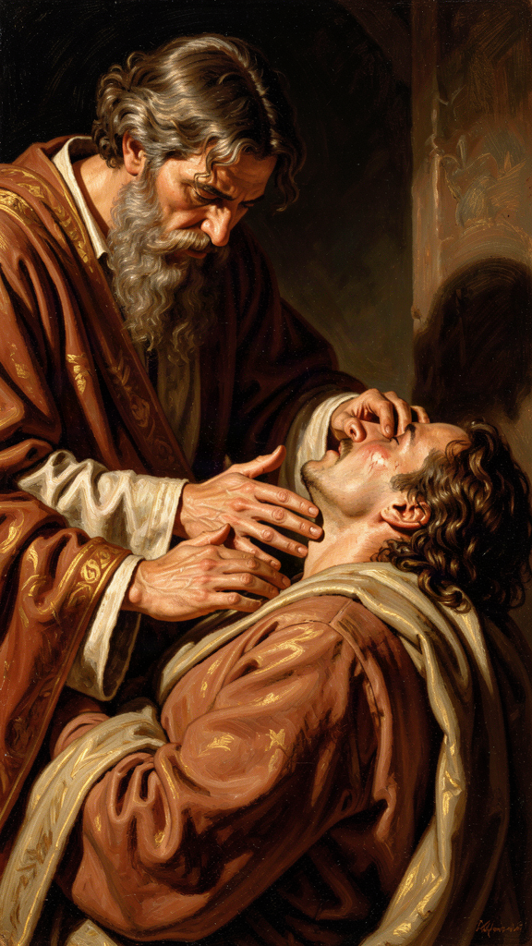
Illustration for Chapter 6

The Story
Gregory's longest work, the Moralia in Job, is a meditation on innocent suffering. Written over many years and completed around 591 CE, it became one of the most influential books of the Middle Ages. Gregory read the Book of Job not only as a story about a righteous man who suffered but as a manual for patience, compassion, and trust under trial.
The Book of Job tells the story of a man who loses everything: children, property, health, reputation. His friends insist he must have sinned. God eventually answers from the whirlwind, not with an explanation but with a vision of divine wisdom and power. Job repents and is restored.
Gregory reads this story on three levels: the literal story of a suffering man, the allegorical figure of Christ and the church, and the moral application to the individual soul. On the moral level, Job becomes a mirror. The reader is invited to see himself in Job's patience, his friends' failures, and God's final speech. The book asks: How do you respond when life collapses around you?

Suffering as Formation
Gregory does not offer a simple explanation for why people suffer. He rejects the easy answer of Job's friends — that suffering is always a punishment for sin. He knows that the innocent suffer and that their suffering requires something more than moral accounting.
For Gregory, suffering is a form of spiritual formation. It strips away illusions. It reveals what a person truly loves. It teaches dependence on God. It also creates compassion. The person who has suffered is better able to enter the suffering of another.
This does not mean Gregory glorifies pain. He is not a masochist. He simply believes that suffering, when endured with faith, can become a school of virtue. The alternative is bitterness: the soul hardens against God and against the world. The question is not whether suffering can be avoided — it cannot — but whether it will make you better or worse.

Compassion: Feeling the Wound, Binding It Up
One of Gregory's most beautiful passages on compassion comes from the Moralia:
"When we see another in trouble, we should first feel the wound as if it were our own, and then bind it up as if it belonged to another. Compassion takes upon itself the sorrow of the sufferer, and yet keeps the judgment needed to heal."
This captures the two movements of compassion. The first is identification: entering the suffering of the other. The second is action: doing what is needed to heal. Compassion is not mere sentiment, and it is not cold efficiency. It is love that feels and then helps.
Gregory also warns against false compassion. Pity that keeps the sufferer helpless is not love. Aid that humiliates the recipient is not love. True compassion respects the dignity of the person it helps and aims at their restoration.

The Duty of the Strong Toward the Weak
Gregory believed that the strong have a special duty toward the suffering. This is not vague humanitarianism. It is grounded in the idea that God has entrusted the weak to the care of the strong, and the strong will answer for how they treated them. The Pastoral Rule applies this directly to bishops and pastors. They must "seek the lost, bind up the wounded, and strengthen the sick." But the principle extends to anyone with resources, influence, or health. Power creates responsibility.
Gregory put this belief into practice during his papacy. His letters record grain shipments to famine-stricken regions, ransoms for captives, care for refugees, and relief for the poor. He did not separate spiritual care from material care. A person cannot hear the gospel on an empty stomach. Administration was not a distraction from pastoral care. It was pastoral care.
"The care of souls is not sufficient if the bodies entrusted to us are allowed to perish." — Gregory, letter
"The goods of the church are the patrimony of the poor." — Gregory, letter

Job's Friends: The Warning Against Easy Explanations
Gregory's example of false compassion is Job's friends. They had explanations but no love. They spoke truth — or what they thought was truth — without entering Job's pain. They sat with him for seven days in silence, which was good. But then they opened their mouths and made everything worse. They told him his suffering was his own fault.
Gregory warns his readers not to imitate them. The first duty of compassion is to be present, not to explain. Sometimes the best thing you can do for a suffering person is sit with them and say nothing. The explanations can wait. The presence cannot. In a world of natural disaster, chronic illness, and systemic injustice, Gregory's question remains urgent: Will we let suffering make us bitter, or will we let it make us compassionate?

Patience as Active Virtue
Gregory's idea of patience is not passive resignation. The patient person does not pretend that pain is pleasant. The patient person keeps the soul fixed on God while everything else changes. Patience is steadiness under pressure. It resists despair. It resists bitterness. It resists the temptation to curse God or abandon goodness. The patient person continues to love, pray, and serve even when there is no reward in sight.
"Patience is not a passive virtue but a steadfast holding of the soul to God amid every changing thing." — *Moralia in Job*

Scholarly Debate: Does Gregory Adequately Address the Problem of Evil?
A serious objection to Gregory's approach is that he does not really explain suffering — he teaches how to live with it. For some readers, that is not enough. They want an answer to the question "Why do innocent people suffer?" Gregory's answer — that suffering is formative, that it tests and purifies the soul — does not address cases of horrific suffering that destroys rather than forms.
Gregory's defenders point out that he does not claim to solve the problem of evil. He rejects the friends' simplistic answer (suffering is always punishment for sin) but does not replace it with a complete theodicy. Instead, he holds the middle: accept the mystery, endure with faith, and love those who suffer. His approach is less a philosophy of suffering than a practice of suffering — a way of carrying what cannot be explained.
This is both a limitation and a strength. It is a limitation because it leaves the intellectual question open. It is a strength because it refuses the two most common errors: the error that says suffering is meaningless (so give up), and the error that says suffering is always a lesson (so be grateful for it). Gregory allows suffering to be mysterious while still demanding a response of faith and love.

Key Quotes
"When we see another in trouble, we should first feel the wound as if it were our own, and then bind it up as if it belonged to another. Compassion takes upon itself the sorrow of the sufferer, and yet keeps the judgment needed to heal." — *Moralia in Job*
"The Lord does not test his own for their destruction, but for their crown." — *Moralia in Job*
"Patience is not a passive virtue but a steadfast holding of the soul to God amid every changing thing." — *Moralia in Job*

The Big Idea
When someone is suffering, the question is not always "Why did this happen?" Sometimes the better question is "How will I carry this? And how will I help others carry theirs?" Real compassion has two parts: your heart feels the other person's pain, and your hands do something about it. Job's friends had explanations but no love. Gregory says: be present first, explain later — if at all. Patience is not passivity. It is the active holding of the soul to what is good when everything else is falling apart.

Practice
1. Two Hands of Compassion. Gregory said compassion has two movements: feel the wound, then bind it up. Think of someone you know who is going through a hard time. Write down what "feeling the wound" would look like (sitting with them, listening, being present) and what "binding it up" would look like (a specific action: bring food, make a call, help with a task). Then do one thing from each list. Deliverable: two paragraphs — one describing the "feel" action and one describing the "help" action, plus what happened when you did them.
2. The Explanation Fast. Gregory warned against Job's friends, who rushed to explain. For one week, whenever someone tells you about a difficulty, practice not explaining. Do not say "everything happens for a reason" or "at least it's not worse" or "here's what you should do." Just listen. After they finish, ask: "Is there anything I can do?" Write one paragraph about what this was like — for you and for them.
3. The Strong-for-the-Weak Audit. Gregory said the strong have a duty to the weak. Identify one way you are "strong" — you have resources, time, health, knowledge, or influence that someone else lacks. Identify one person or group that needs what you have. Write one paragraph naming the resource and the need, and one specific action you will take this week to meet that need. Then do it.
4. The Bitterness Check. Gregory said suffering can make you either bitter or compassionate. Think of one difficult experience in your life. Write one paragraph about whether it made you bitter or compassionate — and why. Then write one sentence about what you would say to someone going through the same thing.

Reflect
Does Gregory explain suffering, or does he teach us how to live with it? Is that enough? What is the difference between saying "everything happens for a reason" and actually sitting with someone who is in pain? Which is harder? Which is kinder?
———

For the Grown-Up Reader
This booklet introduces readers ages 15-18 to the life and thought of Gregory the Great (c. 540-604 CE), pope from 590 to 604. The six chapters follow the themes of the WisdomForge Gregory compendium: servant leadership, the contemplation-action synthesis, adapted teaching, humility and self-knowledge, compunction and conversion, and suffering and compassion.
All quotations are real, drawn from Gregory's Pastoral Rule (Liber Regulae Pastoralis), his Moralia in Job, his letters (Epistulae), his Homilies on Ezekiel, and his Forty Homilies on the Gospels. Sources are cited by work and part number. Translations follow the Demacopoulos translation (St. Vladimir's Seminary Press, 2007) and the Nicene and Post-Nicene Fathers series, second series, vol. 12.
Primary sources used: Gregory the Great, Liber Regulae Pastoralis (Pastoral Rule), Parts I-IV; Moralia in Job (especially Book VI on "climbing without rising" and passages on compassion and patience); Epistulae (Register of Letters), especially letters surrounding his election (Ep. I.5, I.24, I.25), mission instructions to Augustine of Canterbury and Mellitus (Ep. XI.56), and letters on the contemplative life and the burdens of office; Homiliae in Ezechielem (Homilies on Ezekiel); Homiliae XL in Evangelia (Forty Homilies on the Gospels).
Secondary sources consulted: Carole Straw, Gregory the Great: Perfection in Imperfection (University of California Press, 1988); R.A. Markus, Gregory the Great and His World (Cambridge University Press, 1997); George Demacopoulos, Gregory the Great: Ascetic, Pastor, and First Man of Rome (University of Notre Dame Press, 2015); Jeffrey Richards, Consul of God (Routledge, 1980); Conrad Leyser, Authority and Asceticism from Augustine to Gregory the Great (Oxford University Press, 2000); John Moorhead, Gregory the Great (Routledge, 2005).
The biographical narrative is accurate. Gregory was born into the wealthy Anician family, served as Prefect of Rome, founded a monastery on the Celian Hill, served as papal envoy (apocrisiarius) to Constantinople (579-585), and was elected pope in 590. He adopted the title Servus Servorum Dei, sent the mission to England led by Augustine of Canterbury in 596, and wrote the Pastoral Rule as a guide for bishops. The mission instructions to adapt local customs rather than destroy pagan temples are documented in the Letter to Mellitus (Ep. XI.56). The England mission is described in Bede's Ecclesiastical History of the English People, Book I, chapters 23-27.
The scholarly debates engaged in this booklet — the genuineness of Gregory's reluctance, the question of whether he privileges contemplation over action, the charge that adapted teaching is manipulation, the question of whether his leadership standard is too high, the compatibility of compunction with mental health, and the adequacy of his response to the problem of evil — are real debates in Gregory scholarship. Key positions are represented: Demacopoulos on humility as a form of leadership, Markus on practical pressures, Straw on "perfection in imperfection," and the integrated view of the political-pastoral debate.
For deeper engagement, the Pastoral Rule is available online at New Advent and the Christian Classics Ethereal Library. The Demacopoulos translation (2007) is the most accessible modern English version. Selected excerpts from the Moralia in Job are also available online. Gregory's letters can be found in the Martyn translation or the older NPNF selection.
———

About WisdomForge
WisdomForge creates age-adapted booklets that bring the wisdom of history's greatest thinkers to readers of every age. Each figure in the WisdomForge library receives four booklets: one for elementary readers (ages 5-10), one for middle readers (11-14), one for high school readers (15-18), and one for adults. The same ideas, the same stories, the same real words — shaped for each age so that a child can begin the journey and a grown-up can go deeper. Every quotation in every booklet is real, drawn from the figure's own writings or from the most reliable ancient sources. We do not invent words and put them in the mouths of the wise. We bring their actual words to life.

