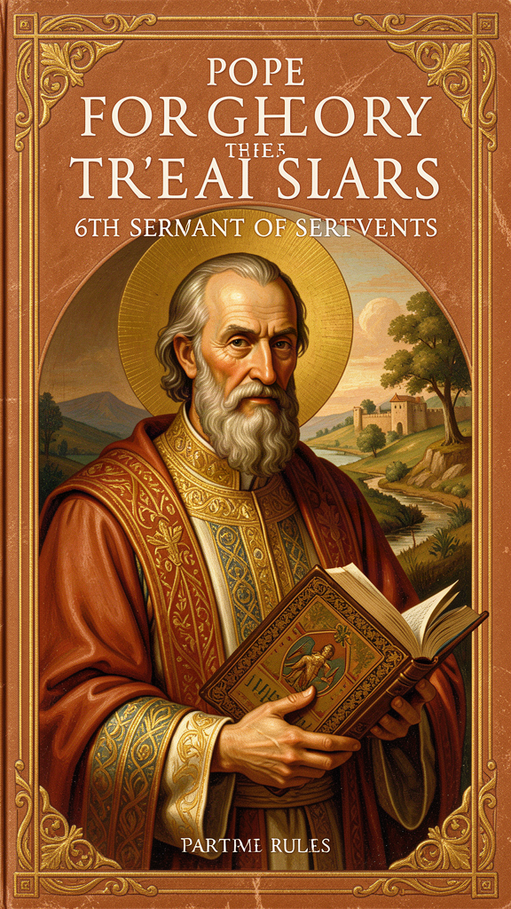
The Reluctant Pope Who Changed the World
WisdomForge Booklet — Ages 11-14

The Reluctant Pope Who Changed the World

WisdomForge Booklet — Ages 11-14
———

About This Book
Gregory the Great was born around the year 540 CE in Rome. His family was rich — one of the most powerful in the city. He grew up in a world that was falling apart. The Roman Empire had collapsed in the West. Italy had been invaded by Ostrogoths, then reconquered by the Byzantine Empire, and was now being attacked by a people called the Lombards. Rome was smaller, poorer, and more frightened than it had been for centuries.
Gregory had every advantage: wealth, education, and a career in government. By his early thirties he was Prefect of Rome, the highest civil official in the city. But something was missing. He gave it all up — the money, the house, the career — and turned his family home into a monastery. He wanted to pray in silence and serve the poor.
He thought he would spend the rest of his life that way. Instead, the church kept calling him back into the world. He was sent as an ambassador to Constantinople. He was made abbot of his monastery. And in 590, after the previous pope died of plague, the people of Rome elected him pope. He was the first monk ever to hold the office. He did not want it. He wrote to the emperor begging to be released. He even tried to flee. But the people would not let him go.
For fourteen years he led the church through plague, famine, invasion, and political chaos. He fed the hungry, ransomed captives, negotiated with Lombard kings, sent missionaries to England, reformed church music, and wrote books that shaped the Middle Ages. He called himself Servus Servorum Dei — Servant of the Servants of God — and he meant it.
This booklet tells his story in six chapters. Each one explores a big idea that Gregory discovered about leadership, prayer, teaching, humility, honest sorrow, and compassion. You will find the real words Gregory wrote, things to try, questions to discuss, and one question to carry with you when you put the book down. Gregory lived fourteen hundred years ago, but his questions are still ours: How do you lead without becoming a tyrant? How do you stay busy without losing your soul? How do you teach without crushing the people you are trying to help?
———

Chapter 1: Servant Leadership — The Title That Says Everything
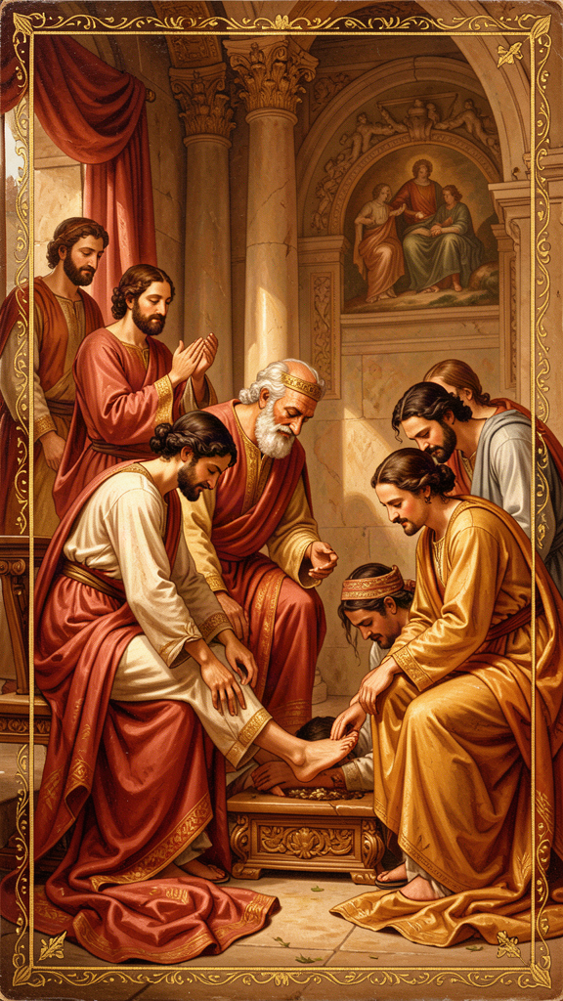
Illustration for Chapter 1

The Story
When Gregory became pope in 590, he inherited a title with a long and heavy history. The title Pontifex Maximus — "the greatest bridge-builder" — had been used by Roman emperors and pagan high priests. It suggested that the holder stood at the top of a hierarchy, closer to the gods than to ordinary people. Gregory would not use it.
Instead he chose a title that turned the old meaning upside down: Servus Servorum Dei, "Servant of the Servants of God." This was not a modest way of saying "I am important." It was a claim about what authority is for. The pope is not above the church; he is answerable to it. The higher the office, the greater the obligation to serve.
Gregory had not wanted the papacy. He had been happy as a monk. When he was forced into the office, he insisted that the office be understood as a burden laid on him for the sake of others, not a prize he had won. His letters from this period are remarkable documents of spiritual reluctance. He wrote to the emperor begging to be released. He described the papacy as a "yoke" that crushed him. He grieved that the "stormy sea" of public affairs had carried him away from the "haven of peace."
This reluctance was not theater. In Gregory's world, expressions of humility were expected when someone assumed high office. But his private letters show genuine distress. He had tasted monastic peace and believed that public responsibility would damage the inner life he had spent years cultivating. His acceptance of office was therefore an act of obedience: he served not because he wanted power but because the needs of others required it.

The Bridge and the Tower
Gregory used two images to explain what servant leadership means. The first is the bridge. "The pastor is placed as a bridge between God and the people," he wrote. "He must be firm enough to bear the weight of those who walk upon him, yet low enough to let them pass over him safely." A bridge is strong — it holds people up. But it is also low — it does not block the path with its own importance. The bridge exists so that others can cross, not so that the bridge can be admired.
The second image is the tower. A tower is what a bridge becomes when it forgets its purpose. The tower stands above everyone. It demands attention. It is impressive but useless for crossing. Gregory warned that leaders who love being leaders turn into towers. They stop serving and start demanding to be served.
The difference between a bridge and a tower is the direction of the leader's energy. A servant-leader spends himself to build people up. A tyrant uses people to build himself up. A weak leader avoids conflict because he wants to be liked. A servant-leader faces conflict because he loves the people involved enough to tell them the truth.

Why It Mattered Then
Gregory's papacy was a living test of his title. Italy was in crisis. The Lombards held much of the peninsula. The Byzantine emperor in Constantinople was distant and distracted. Famine followed plague. The church in Rome was one of the few institutions still capable of organizing relief, diplomacy, and basic order. Gregory became, in effect, the mayor, emergency coordinator, and foreign minister of central Italy — while also being the spiritual head of the church.
He put servant leadership into practice. His letters record grain shipments to famine-stricken regions, ransoms for captives, care for refugees, and relief for the poor. He believed you cannot preach the gospel to hungry people without feeding them. Spiritual care and material care belong together. The goods of the church, he wrote, are "the patrimony of the poor."

The Modern Echo
Modern management literature has rediscovered servant leadership, often without knowing its Gregory-shaped origins. Robert Greenleaf's "servant leadership" movement, the emphasis on emotional intelligence, and the critique of top-down corporate cultures all echo Gregory's intuition: organizations work best when the people in charge see themselves as accountable to the people they lead.
But Gregory's version is deeper than a management technique. It is rooted in the conviction that every person is made in God's image and that the leader will one day answer for how he treated them. The title Servus Servorum Dei is not a brand. It is a vow.

Key Quotes
"I have chosen to call myself the servant of the servants of God, because I see that the more I am compelled to rule, the more I am bound to serve." — Gregory, letter
"The office of shepherd is a form of supreme humility. When anyone seems to have obtained the highest place, he should be all the more diligent in his anxiety for those under him." — *Pastoral Rule*, Part I
"The pastor is placed as a bridge between God and the people. He must be firm enough to bear the weight of those who walk upon him, yet low enough to let them pass over him safely." — Gregory, homily

Big Idea
Authority exists for service, not for status. The higher you climb, the more you owe the people below you. Gregory's title — Servant of the Servants of God — was not a slogan. It was a definition of what leadership is for: the leader is the one who bears the most weight, not the one who sits at the top.

Try This
1. Bridge or tower test. Think of a leader you know — a teacher, a coach, a boss, a student council president. Do they act more like a bridge (strong, low, helping others cross) or a tower (high, impressive, demanding attention)? Write down one thing that makes them a bridge or a tower.
2. The energy direction. Gregory said the difference between a servant-leader and a tyrant is the direction of their energy. A tyrant uses people to build himself up. A servant-leader spends himself to build people up. Look at your own behavior in a group. Which direction does your energy go? Write one sentence about it.
3. Find a servant-leader. Name someone in your school, family, or community who leads by serving. What do they actually do? Write three sentences describing their actions. Then ask yourself: could you do one of those things?

Talk About It
1. Gregory did not want to be pope. He tried to run away. Do you think someone who does not want power makes a better leader than someone who seeks it? Why or why not?
2. Can you think of a time when someone in charge of you acted like a bridge — strong but not in the way? What did that feel like? Can you think of a time someone acted like a tower?
3. Gregory said the goods of the church are "the patrimony of the poor." What does that mean? Does it change how you think about institutions that own a lot of property?
———
What would change in your school, your team, or your family if the person in charge acted like a bridge instead of a tower?
———

Chapter 2: The Contemplation-Action Synthesis — Prayer and Work
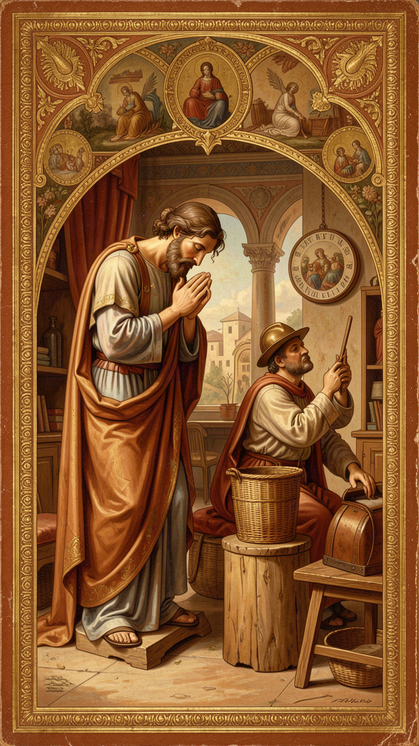
Illustration for Chapter 2

The Story
Gregory wanted to be a monk. He became pope. That single fact shaped everything he wrote about prayer and work.
In the monastery, the highest good is contemplation: gazing on God, reading Scripture, praying in silence, attending to the soul. In the papacy, the demand is action: letters, lawsuits, famine relief, diplomacy, appointments, disputes. Gregory experienced both as real goods. He did not think the monastery was selfish or the papacy worldly. But he felt the tension between them constantly.
His letters describe the papacy as a "stormy sea" and the monastery as a "quiet harbor." He grieves the loss of "deep repose" and complains that secular business robs his mind of contemplation. Yet he also defends the active life as a necessary expression of love. The tension is not resolved by choosing one side. It is resolved by keeping them in the right order.

The Vessel and the Pouring
Gregory's formula is simple: contemplation comes before action. The soul must first be filled in prayer; only then is it sent back to the neighbor in love. He uses the image of a vessel. A cup cannot pour unless it has first been filled. A person cannot give spiritual nourishment to others if his own soul is empty.
"The active life draws us out to our neighbor; the contemplative life recalls us to ourselves. In action we pour ourselves out for others; in contemplation we are filled again. Unless the vessel is filled, it cannot pour out; unless the soul is renewed in secret, it will grow dry in public."
Action without contemplation becomes hollow. The person keeps doing things but loses the inner reason for doing them. Contemplation without action becomes sterile. The person sits in silence but never lets love draw him out to serve. Each needs the other. The test of true contemplation is whether it produces compassion. The test of true action is whether it remains rooted in God.

Ezekiel: The Prophet Who Is Lifted Up and Sent Down
Gregory's Homilies on Ezekiel develop this theme most fully. Ezekiel is called from the presence of God to speak to a rebellious people. He would rather stay in the vision; God sends him into the world. Gregory sees Ezekiel as a type of every pastor — and of himself.
The prophet's vision of the heavenly chariot represents the soul lifted to God. The command to preach represents the soul sent to the neighbor. Gregory moves back and forth between these poles: lifted up, sent out; filled, poured out. The healthy spiritual life keeps both movements alive.
"The pastor is made a watchman for the house of Israel: he is lifted up to see, and then sent down to speak what he has seen."

How Gregory Managed It
Gregory's own life shows the difficulty of the synthesis. His letters were dictated in batches between prayer and administrative sessions. He tried to keep monastic discipline even as pope: simple food, limited sleep, regular reading of Scripture, care for the poor. He was not always successful. He was often tired, sometimes irritable, frequently overwhelmed.
But the attempt mattered. Gregory demonstrated that contemplation and action could be held together, even if imperfectly. His papacy was not a betrayal of his monastic vocation. It was the extension of that vocation into the world.

Why It Still Matters
Modern readers hear Gregory's theme in many places: the Sabbath, the retreat, the digital detox, the recovery movement, the critique of burnout culture. The idea that sustainable action requires regular return to a deeper source is no longer controversial. What Gregory adds is the theological depth: the source is not just rest but God.
Gregory also avoids two common mistakes. He does not make contemplation an escape from responsibility, and he does not make action a substitute for interior life. Some people use "spirituality" to avoid hard work; others use busyness to avoid looking inward. Gregory's synthesis challenges both.

Key Quotes
"Unless the vessel is filled, it cannot pour out; unless the soul is renewed in secret, it will grow dry in public." — Gregory, letter
"When I think how I have lost the beauty of deep repose, I look at the swelling sea of present affairs and grieve that I have been carried away from the haven of peace." — Gregory, letter
"The ruler should be a man who, before he serves the interests of God, has cultivated a life of prayer and contemplation." — *Pastoral Rule*, Part I

Big Idea
Prayer and work are not rivals. They are partners. You must be filled before you can pour out. Contemplation without action is sterile; action without contemplation is hollow. The healthy life keeps both movements going: fill, pour, fill, pour. Burnout is what happens when you keep pouring without ever filling.

Try This
1. Battery check. Think of yourself as a battery. What activities charge you (fill your cup)? What activities drain you (pour it out)? Make two lists. Then check: do you pour out more than you fill? What would it look like to balance the two?
2. One quiet practice. Gregory said even the busiest person can find small moments of silence. Choose one: morning silence before your phone, a one-minute pause at midday, evening review of your day. Try it for one week. Notice what changes.
3. The Ezekiel exercise. Gregory described the pastor as "lifted up to see, and then sent down to speak what he has seen." Try this pattern: spend two minutes in silence, just noticing what is true. Then go do one thing for someone else that you would not have thought of if you had not been quiet first.

Talk About It
1. Gregory called the papacy a "stormy sea" and the monastery a "quiet harbor." What is your stormy sea? What is your quiet harbor? Do you spend enough time in the harbor?
2. Have you ever felt "busy but empty" — doing lots of things but losing the reason why? What was happening? What would Gregory say about it?
3. Some people use being busy to avoid thinking about what really matters. Do you think that is true for you sometimes? What would it look like to stop and be quiet?
———
If your life is a cup, is it being filled as fast as it is being poured out? What would it take to fill it more?
———

Chapter 3: Adapted Teaching — Meeting People Where They Are

Illustration for Chapter 3

The Story
In Part II of the Pastoral Rule, Gregory faced a practical problem. A bishop must teach many different kinds of people: rich and poor, young and old, zealous and lukewarm, cheerful and melancholy, educated and simple. If he speaks the same way to all of them, he will help some and harm others.
A rebuke that wakes up a complacent person may crush a sensitive one. Encouragement that strengthens a discouraged person may inflate a proud one. Silence that gives a wounded soul space to heal may let a rebellious soul harden in its error. The pastor must know not only what is true but what this person can receive right now.
Gregory compares the teacher to a physician. The same medicine does not cure every disease. The doctor must diagnose before prescribing. The teacher must understand before speaking.

The Catalogue of Hearers
Gregory gives a famous catalogue of character types and the way each should be addressed:
The poor need to be reminded of their dignity and the hope of the kingdom. They must not be told that their suffering is deserved in a way that crushes them.
The rich need to be warned against the deceit of wealth and the danger of trusting in what can be lost. But they must not be addressed with envy or scorn.
The joyful need to be reminded that fortune changes and that joy should be grounded in God, not in circumstance.
The sorrowful need comfort, not correction. Gregory warns against preaching to a grieving person as if grief were a moral failure.
The zealous need to be directed toward steadiness, lest their fire burn out or turn into harshness.
The lukewarm need to be stirred, but gently at first. Too much heat at once can make them retreat.
The list is not exhaustive, but the principle is clear: the teacher must be a reader of persons. The same truth is spoken differently to each.

The Mission to England
Gregory's principle of adaptation shaped his approach to the mission to England in 596. He sent Augustine, prior of his own monastery, to evangelize the Anglo-Saxons. His instructions became a model of adaptive mission.
He told the missionaries not to destroy pagan temples if they could be converted into churches. He told them to let the people keep harmless festivals, giving them Christian meaning instead. He said they should vary church ceremonies slightly if that helped people receive the faith.
"Do not be disturbed by the diversity of tongues. For the services of holy Church are celebrated throughout the world with diverse languages, but the miracles of holy Church are shown to be one and the same. For the virtue of sacred charity is one, which joins together those of diverse tongues and makes them of one heart in the faith."
This was controversial. Some missionaries believed pagan culture must be completely swept away. Gregory replied that the goal was conversion, not cultural conquest. The same gospel could be expressed in different cultural forms. Adaptation, rightly practiced, was a sign of respect for the people being taught.

Adaptation Is Not Relativism
Gregory's adapted teaching is sometimes misunderstood as moral relativism — the idea that truth changes depending on the audience. That is not what Gregory meant. His distinction is between the truth itself and the way the truth is delivered. The truth does not change. The method of communication must change.
A doctor does not change the diagnosis because the patient is frightened. But the doctor may change how the diagnosis is explained, when it is delivered, and what support is offered. The medicine is the same; the manner of giving it differs. A parent knows that the same rule must be enforced differently with a three-year-old and a fifteen-year-old. The rule is the same; the approach is not.
Gregory had firm convictions — the Trinity, the incarnation, the authority of Scripture, the moral law. These were not up for negotiation. But within these firm boundaries, there was room for flexibility. Language, music, customs, and festivals could be adapted. The goal was conversion, not cultural destruction.

Why It Anticipates Modern Psychology
Gregory's idea sounds modern because it is. Contemporary pastoral counseling, differentiated instruction, emotional intelligence, and motivational interviewing all share his intuition: effective communication depends on understanding the person in front of you.
But Gregory adds a dimension modern methods sometimes lack. For him, adapted teaching is an act of charity. The teacher is not merely trying to be effective. He is trying to love. The discipline of attention to the hearer is a discipline of love.

Key Quotes
"The same word that edifies one person may destroy another. A wise shepherd should know when to speak and when to keep silence, when to rebuke and when to comfort, when to press hard and when to let the wound rest." — *Pastoral Rule*, Part II
"The medicine must be measured to the disease, and the word to the hearer." — *Pastoral Rule*, Part II
"When Almighty God brings your mind to the right way, make use of such customs as you find praiseworthy, so that the people may the more readily flock to places to which they are accustomed." — Letter to Mellitus

Big Idea
Truth does not change, but the way it is spoken must. The same words that heal one person can wound another. A good teacher watches, listens, and figures out what each person needs before speaking. This is not changing the truth — it is being kind enough to share the truth in a way that actually helps.

Try This
1. The doctor test. Think about how a doctor works. First she listens. Then she diagnoses. Then she prescribes. Now think about how you talk to people. Do you listen before you speak? Pick one conversation today and try the doctor method: listen first, understand the person, then say what you think they need to hear.
2. Three audiences. Think of something you believe is important (like "Be kind" or "Work hard"). Now imagine explaining it to a five-year-old, a friend your age, and a grandparent. Write three different versions. Same message, different words. That is adapted teaching.
3. The silence experiment. Gregory said a wise shepherd knows when not to speak. Pick one situation this week where you would normally give advice. Instead, say nothing. Just listen. See what happens. Sometimes silence is the most helpful thing.

Talk About It
1. Have you ever received the same kind of words that helped a friend but hurt you — or vice versa? What was different about the situation?
2. Gregory told missionaries to England not to destroy local customs but to adapt them. Do you think that was wise or was it a compromise? Where would you draw the line between respecting a culture and changing what is wrong?
3. Is adapted teaching respectful or manipulative? When does adjusting your message become dishonest? Can you think of a time when someone changed their words to manipulate you?
———
When have you received a correction or encouragement at exactly the right moment? When has the same kind of words harmed you?
———

Chapter 4: Humility and Self-Knowledge — The Foundation of Leadership
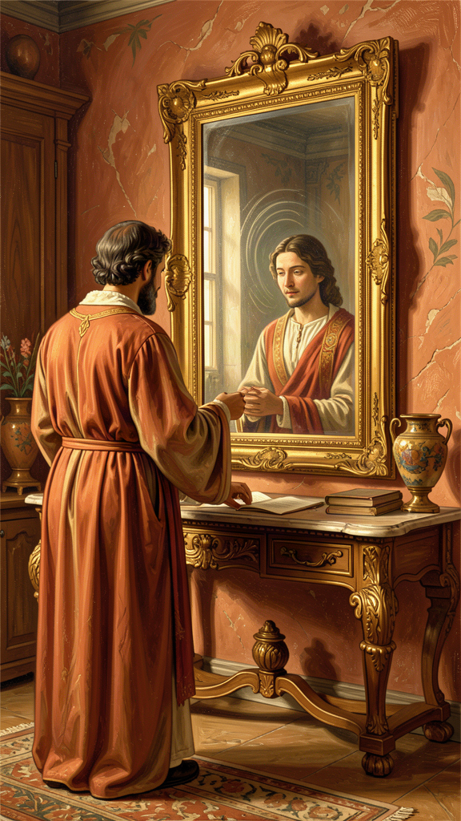
Illustration for Chapter 4

The Story
Gregory's most famous sentence on leadership is a sequence, not a list. In the Pastoral Rule he says the ruler must be someone who has learned to guide himself before guiding others; who has shown himself teachable before being made a teacher; who knows how to submit before being set over others; who has cultivated prayer and contemplation before serving God's interests in public.
The order matters. Each step prepares for the next. A person who cannot guide himself will misguide others. A person who is not teachable cannot teach. A person who has never submitted will rule like a tyrant. A person who does not pray will eventually serve himself while claiming to serve God.
Gregory is not asking for perfection. He is asking for honesty. The leader must know his own temptations, weaknesses, and wounds. Without this self-knowledge, authority becomes dangerous.

Humility Is Not Self-Contempt
Gregory sometimes sounds severe about human nature, but his humility is not the same as self-loathing. For him, humility is the recognition that everything good comes from God and that the self is constantly tempted to pride.
A humble person does not deny his gifts. He denies that his gifts make him better than others. He knows that intelligence, charm, energy, and position are given, not earned. He also knows that these gifts can be turned into weapons if he is not watchful.
Gregory's humility is realistic. He expects leaders to be aware of their own sin, not paralyzed by it. The point is not to wallow in guilt but to stay alert. Pride grows in the dark. Humility turns on the light.

The Dangers of Office
Gregory knew why self-knowledge matters especially for people in authority. Power tends to distort the picture a person has of himself. Flattery, fear, and habit make the leader believe his own press.
In the Pastoral Rule Gregory warns that the shepherd's main battlefield is his own heart. The decay begins subtly. The leader starts to enjoy being consulted. He begins to prefer the company of people who admire him. He speaks about God without speaking to God. His prayers become shorter while his schedule becomes longer.
Gregory calls this spiritual dryness. It happens when the inner life is neglected. The leader may still perform well outwardly, but the source of his service has begun to fail. Self-knowledge is the alarm system that notices the decay before it becomes collapse.

Compunction: The Gift of Tears
Gregory has a special word for the sorrow that keeps the soul honest: compunction. It is not despair. It is a gentle grief over one's own faults and a longing for God. Compunction is the feeling that keeps pride from hardening the heart.
The monk who weeps for his sins is not weak. He is awake. Gregory believed that tears of compunction were a gift because they prevented a worse grief: the grief of discovering too late that one has become a hypocrite.
For leaders, compunction is a protection. The person who regularly admits his faults is less likely to pretend to be holy. The person who remembers his dependence on God is less likely to trust in his own competence.

The Difference Between Service and Servility
Gregory's humility is sometimes misunderstood as weakness. This is wrong. Gregory's servant-leader still makes decisions, corrects error, defends the vulnerable, and speaks unwelcome truth. His letters show him being firm with bishops, kings, and emperors when he believes they are wrong.
The difference is the direction of the leader's energy. A tyrant uses people to build himself up. A servant-leader spends himself to build people up. A weak leader avoids conflict because he wants to be liked. A servant-leader faces conflict because he loves the people involved enough to tell them the truth.
Humility is not the same as servility. A servile person tells everyone what they want to hear. A humble person speaks the truth without needing to dominate. A servile person avoids conflict. A humble person faces conflict when love requires it.

Key Quotes
"The ruler should be a man who, before others guide him, has learned to guide himself; who, before he is put forward as a teacher, has shown himself to be teachable; who, before he is set over others, knows how to submit to authority." — *Pastoral Rule*, Part I
"We cannot be useful to others in healing their wounds if we do not first feel our own." — *Pastoral Rule*
"Humility is truth. The humble person neither pretends to be more than he is nor less than he is." — Gregory, homily

Big Idea
Before you can lead others, you have to know yourself — clearly, honestly, without pretending to be better or worse than you are. Humility is not weakness or self-hatred. It is clear-sightedness. A leader who knows his own faults is gentler with other people's faults and braver about facing hard things.

Try This
1. The mirror. Gregory said humility is like a mirror — it helps you see yourself clearly. Write down one thing you are genuinely good at. Then write one thing you genuinely need to work on. Saying both is humility. Saying only the good part is pride. Saying only the bad part is self-pity.
2. Teachability test. Gregory said a teacher must first be teachable. Think of one subject or skill where you are the "expert" among your friends. Now find one person who knows more than you about it. Ask them to teach you something. Notice how it feels to be the learner.
3. Honest feedback. Gregory said every leader needs at least one person who will tell the truth without fear. Find one person you trust. Ask them: "What is one thing I do that gets in my own way?" Listen without arguing. Just sit with it.

Talk About It
1. Gregory said the leader who has stopped learning has stopped being legitimate. Do you agree? Can you think of a teacher, coach, or leader who had stopped learning? What happened?
2. What is the difference between humility and weakness? Between being humble and being a pushover? Can you name a person who is humble but not weak?
3. Gregory warned that power and praise can make leaders stop seeing themselves clearly. Can you think of a famous person this happened to? What went wrong?
———
Which is harder: to know your own gifts honestly, or to know your own faults honestly? Why?
———

Chapter 5: Compunction and Conversion — The Broken Heart That Heals

Illustration for Chapter 5

The Story
The Latin word compunctio comes from a root meaning "to prick" or "to pierce." Gregory uses it to describe the prick of conscience that wakes the soul up. A person with compunction feels the gap between what he is and what he ought to be, and that feeling moves him toward God.
Compunction is not the same as guilt. Guilt can be paralyzing; it focuses on the punishment or the shame of what has been done. Compunction is sorrowful but hopeful. It looks at the sin, grieves it, and then turns toward mercy.
Gregory also distinguishes compunction from despair. Despair believes that change is impossible. Compunction believes that God is merciful and that the heart can be renewed. The tears of compunction are therefore cleansing, not destructive.

The Two Kinds of Tears
Gregory sometimes speaks of two forms of compunction. The first is sorrow for sin — the soul weeps because it has offended God and harmed others. The second is longing for God — the soul weeps because it is not yet what it was made to be and because it desires the presence of God.
These two sorrows are related. The more a person sees his own faults, the more he longs for the holiness that would heal them. The more he longs for God, the more clearly he sees what in himself resists God.
For Gregory, the ideal is not to stop weeping. The ideal is to weep rightly: not with the self-pity that feeds on shame, but with the holy sorrow that opens the heart to grace.

Conversion as Ongoing Return
Gregory's idea of conversion is not limited to a first decision to follow God. It is a continuous movement: the soul turns away from sin and toward God, falls, turns again, falls again, and keeps turning.
The Latin word conversio means "turning around." For Gregory, every day offers opportunities for this turning. Small conversions matter as much as dramatic ones. A harsh word repented, a selfish impulse refused, a moment of patience chosen — these are the daily stuff of the converted life.
This is why compunction is essential. Without the prick of conscience, the soul stops turning. It settles into its faults and calls them character. Compunction keeps the movement alive by refusing to let the soul accept its own stagnation.

Compunction and Leadership
Gregory especially wants leaders to cultivate compunction. A leader who no longer feels sorrow for his sins is dangerous. He begins to believe his own righteousness. He treats correction as insult and advice as rebellion.
The Pastoral Rule says that the shepherd must continually examine himself. He must remember that he is a sinner among sinners. His authority does not place him above the need for repentance; it makes his need more urgent, because more people are affected by his sins.
Compunction also protects the leader from hypocrisy. The leader who weeps for his own faults is less likely to condemn others with a hard heart. He knows that he needs the same mercy he proclaims.

Compunction Is Not Guilt Fixation
Some modern readers hear Gregory's emphasis on sorrow and tears as unhealthy guilt. They worry that compunction means fixation on one's own badness, perpetual self-blame, or a joyless religion of shame.
This reading is understandable but mistaken. Gregory's compunction has safeguards that distinguish it from toxic shame. First, it is always directed toward a merciful God — the sorrow is not endless because it is answered by grace. Second, it produces action: repentance, amendment, love. It does not leave the person stuck in self-accusation. Third, it is balanced by joy in forgiveness and hope in God's mercy.
A person who practices compunction as Gregory intended should become more gentle with others, not more harsh. The person who knows his own sins is less likely to condemn others. The opposite of compunction is not joy. It is moral numbness.

Key Quotes
"Compunction is the lamp by which the soul sees its own stains." — Gregory, homily
"The tears of compunction wash away the filth of the mind more effectively than any other discipline." — Gregory, *Moralia in Job*
"When we have fallen, let us rise at once. When we have sinned, let us weep and then return to the Lord, for he does not despise a contrite heart." — Gregory, homily

Big Idea
Honest sorrow over your own mistakes is not a weakness or a sickness. It is the feeling that keeps you growing. Compunction is like a splinter: the pain tells you something needs fixing so you can fix it. The key is to feel it, learn from it, get back up, and keep turning toward what is good. The people who can feel their own faults honestly are the kindest people, because they understand that everyone struggles.

Try This
1. "I did something bad" vs. "I am bad." Gregory distinguished compunction from self-hatred. Write down one mistake you made this week. Under it write: "I did something bad." Then cross out "I did something bad" and write: "I can learn from this." Notice the difference between describing the action and judging the person.
2. The get-back-up pattern. Gregory said: fall, feel, get up, try again. Think of a time you fell — made a mistake, hurt someone, failed at something. Did you stay down or get back up? Draw a four-step loop: "I fell → I felt it → I got up → I tried again." Use it the next time you mess up.
3. Kindness from honesty. Gregory said the people who know their own mistakes are the kindest to others. Think of one person who annoys you. Now think of one mistake you have made that was just as bad as what they are doing. Does it change how you see them? Try responding to them with the patience you wish someone had shown you.

Talk About It
1. What is the difference between feeling bad about a mistake and thinking you are a bad person? Which one helps you grow? Which one makes you give up?
2. Gregory said conversion is not a one-time event but a daily turning. Do you agree? What does "turning a little more toward the good" look like for you?
3. Is there such a thing as too much sorrow? How do you know when honest regret has turned into unhealthy guilt? What would Gregory say?
———
What is one area of your life where you tend to excuse yourself? What would it look like to be honest about it without being cruel to yourself?
———

Chapter 6: Suffering and Compassion — The Pastor's Burden
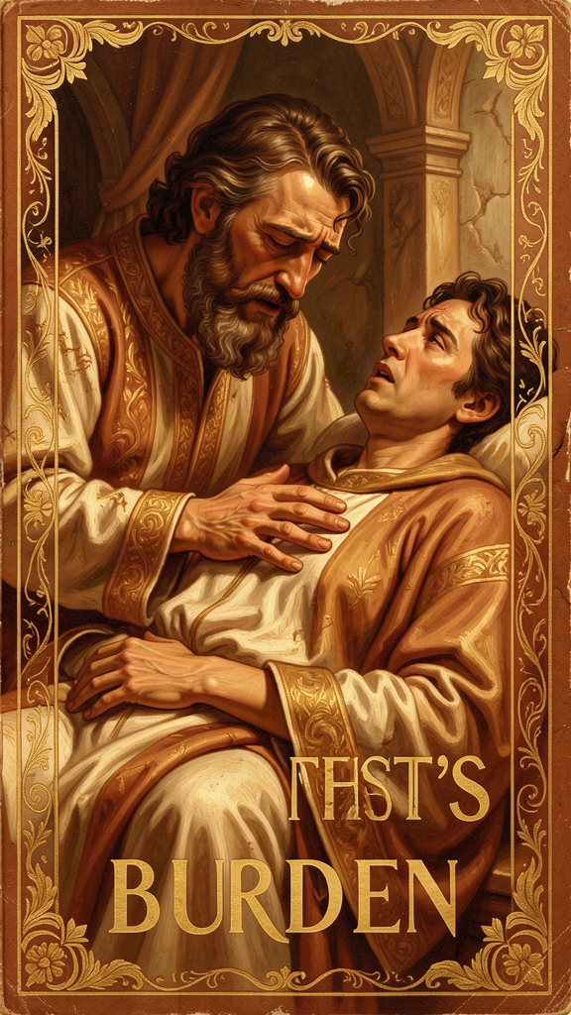
Illustration for Chapter 6

The Story
Gregory's longest work, the Moralia in Job, is a meditation on innocent suffering. Gregory read the Book of Job not only as a story about a righteous man who suffered but as a manual for patience, compassion, and trust under trial.
The Book of Job tells the story of a man who loses everything: children, property, health, reputation. His friends insist he must have sinned. God eventually answers from the whirlwind, not with an explanation but with a vision of divine wisdom and power. Job repents and is restored.
Gregory reads this story morally. Job becomes a model of patience, humility, and trust under trial. The friends become a warning against easy explanations. God's speech becomes an invitation to trust beyond understanding.

Suffering as Formation
Gregory does not offer a simple explanation for why people suffer. He rejects the easy answer of Job's friends — that suffering is always a punishment for sin. He knows that the innocent suffer and that their suffering requires something more than moral accounting.
For Gregory, suffering is a form of spiritual formation. It strips away illusions. It reveals what a person truly loves. It teaches dependence on God. It also creates compassion. The person who has suffered is better able to enter the suffering of another.
This does not mean Gregory glorifies pain. He is not a masochist. He simply believes that suffering, when endured with faith, can become a school of virtue. The alternative is bitterness: the soul hardens against God and against the world.

Compassion: Feeling the Wound, Binding It Up
One of Gregory's most beautiful passages on compassion comes from the Moralia. He says that when we see another person in trouble, we should first feel the wound as if it were our own, and then bind it up as if it belonged to another.
"When we see another in trouble, we should first feel the wound as if it were our own, and then bind it up as if it belonged to another. Compassion takes upon itself the sorrow of the sufferer, and yet keeps the judgment needed to heal."
This captures the two movements of compassion. The first is identification: entering the suffering of the other. The second is action: doing what is needed to heal. Compassion is not mere sentiment, and it is not cold efficiency. It is love that feels and then helps.
Gregory also warns against false compassion. Pity that keeps the sufferer helpless is not love. Aid that humiliates the recipient is not love. True compassion respects the dignity of the person it helps and aims at their restoration.

The Duty of the Strong Toward the Weak
Gregory believed that the strong have a special duty toward the suffering. This is not vague humanitarianism. It is grounded in the idea that God has entrusted the weak to the care of the strong, and the strong will answer for how they treated them.
The Pastoral Rule applies this directly to bishops and pastors. They must "seek the lost, bind up the wounded, and strengthen the sick." But the principle extends to anyone with resources, influence, or health. Power creates responsibility.
Gregory put this belief into practice during his papacy. His letters record grain shipments to famine-stricken regions, ransoms for captives, care for refugees, and relief for the poor. He did not separate spiritual care from material care. A person cannot hear the gospel on an empty stomach.

Job's Friends: The Warning
Gregory's example of false compassion is Job's friends. They had explanations but no love. They spoke truth — or what they thought was truth — without entering Job's pain. They sat with him for seven days in silence, which was good. But then they opened their mouths and made everything worse. They told him his suffering was his own fault.
Gregory warns his readers not to imitate them. The first duty of compassion is to be present, not to explain. Sometimes the best thing you can do for a suffering person is sit with them and say nothing. The explanations can wait. The presence cannot.

Why It Still Matters
Gregory's approach to suffering is both realistic and hopeful. He does not pretend that suffering has an obvious purpose. He does not offer a formula. But he insists that suffering can be endured with patience and that the strong must respond with compassion.
This is a needed correction to two common errors. One error says that suffering is meaningless and should be avoided at all costs. The other error says that suffering is always a lesson and that the sufferer should be grateful for it. Gregory avoids both. He allows suffering to be mysterious while still demanding a response of faith and love.

Key Quotes
"When we see another in trouble, we should first feel the wound as if it were our own, and then bind it up as if it belonged to another. Compassion takes upon itself the sorrow of the sufferer, and yet keeps the judgment needed to heal." — *Moralia in Job*
"Patience is not a passive virtue but a steadfast holding of the soul to God amid every changing thing." — *Moralia in Job*
"The Lord does not test his own for their destruction, but for their crown." — *Moralia in Job*

Big Idea
When someone is suffering, the question is not always "Why did this happen?" Sometimes the better question is "How will I carry this? And how will I help others carry theirs?" Real compassion has two parts: your heart feels the other person's pain, and your hands do something about it. Job's friends had explanations but no love. Gregory says: be present first, explain later — if at all.

Try This
1. Two hands of compassion. Gregory said compassion has two movements: feel the wound, then bind it up. Trace your two hands on paper. On the left hand, write "Feel — be present, listen, care." On the right hand, write "Help — do something, bring food, share, fix." Think of someone you know who is going through a hard time. What would each hand do for them?
2. The silence challenge. Next time someone tells you about something hard, try saying nothing for thirty seconds. Just listen. Do not explain, do not fix, do not say "everything happens for a reason." Just be there. See what happens.
3. What not to say. Gregory warned against Job's friends, who had explanations but no love. Make a list of three things people say to someone who is suffering that are actually unhelpful (like "Everything happens for a reason" or "At least it's not worse"). Then write what you could say instead.

Talk About It
1. Have you ever been going through a hard time and someone tried to explain it to you? Did the explanation help or make it worse? What would have helped more?
2. Gregory said the strong have a duty to the weak. What does that mean in your school or community? Who are the "strong" and who are the "weak"? Is the duty real?
3. Gregory believed suffering can form the soul but did not say suffering is always good. Where is the line between learning from suffering and pretending suffering is a gift?
———
Will you let suffering make you bitter, or will you let it make you compassionate?
———

For the Grown-Up Reader
This booklet introduces readers ages 11-14 to the life and thought of Gregory the Great (c. 540-604 CE), pope from 590 to 604. The six chapters follow the themes of the WisdomForge Gregory compendium: servant leadership, the contemplation-action synthesis, adapted teaching, humility and self-knowledge, compunction and conversion, and suffering and compassion.
All quotations are real, drawn from Gregory's Pastoral Rule (Liber Regulae Pastoralis), his Moralia in Job, his letters (Epistulae), his Homilies on Ezekiel, and his Forty Homilies on the Gospels. The translations are accessible but faithful. Sources are cited by work and part number.
Primary sources used: Gregory the Great, Liber Regulae Pastoralis (Pastoral Rule), Parts I-IV; Moralia in Job; Epistulae (Register of Letters), especially letters surrounding his election (Ep. I.5, I.24, I.25), mission instructions to Augustine of Canterbury and Mellitus (Ep. XI.56 and related), and letters on the contemplative life; Homiliae in Ezechielem (Homilies on Ezekiel); Homiliae XL in Evangelia (Forty Homilies on the Gospels). Available in English in the Nicene and Post-Nicene Fathers series, second series, vol. 12, and in the Demacopoulos translation (St. Vladimir's Seminary Press, 2007).
Secondary sources consulted: Carole Straw, Gregory the Great: Perfection in Imperfection (University of California Press, 1988); R.A. Markus, Gregory the Great and His World (Cambridge University Press, 1997); George Demacopoulos, Gregory the Great: Ascetic, Pastor, and First Man of Rome (University of Notre Dame Press, 2015); Jeffrey Richards, Consul of God (Routledge, 1980); John Moorhead, Gregory the Great (Routledge, 2005).
The biographical narrative is accurate. Gregory was born into the wealthy Anician family, served as Prefect of Rome, founded a monastery on the Celian Hill, served as papal envoy (apocrisiarius) to Constantinople (579-585), and was elected pope in 590. He adopted the title Servus Servorum Dei, sent the mission to England led by Augustine of Canterbury in 596, and wrote the Pastoral Rule as a guide for bishops. The mission instructions to adapt local customs rather than destroy pagan temples are documented in the Letter to Mellitus (Ep. XI.56). The England mission and its adaptive strategy are described in Bede's Ecclesiastical History of the English People, Book I.
For deeper engagement, the Pastoral Rule is available online at New Advent and the Christian Classics Ethereal Library. The Demacopoulos translation (2007) is the most accessible modern English version. The Moralia in Job is available in selected excerpts online. Gregory's letters can be found in the Martyn translation or the older NPNF selection.
———

About WisdomForge
WisdomForge creates age-adapted booklets that bring the wisdom of history's greatest thinkers to readers of every age. Each figure in the WisdomForge library receives four booklets: one for elementary readers (ages 5-10), one for middle readers (11-14), one for high school readers (15-18), and one for adults. The same ideas, the same stories, the same real words — shaped for each age so that a child can begin the journey and a grown-up can go deeper. Every quotation in every booklet is real, drawn from the figure's own writings or from the most reliable ancient sources. We do not invent words and put them in the mouths of the wise. We bring their actual words to life.

