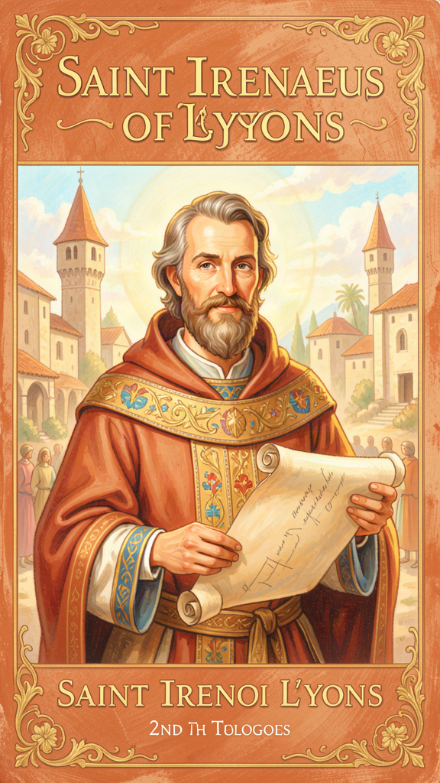
Irenaeus: The Boy Who Listened
WisdomForge Booklet — Ages 5–10

Irenaeus: The Boy Who Listened

WisdomForge Booklet — Ages 5–10
———

About This Book
A long, long time ago — about 1,800 years ago — there lived a boy named Irenaeus (say it like this: ir-uh-NAY-us). He grew up in a town called Smyrna, near the sea, in a world where people who followed Jesus were sometimes in danger.
When Irenaeus was a boy, he met a very old man named Polycarp. Polycarp had known someone who had known Jesus. That meant Irenaeus was only two handshakes away from the people who had walked and talked with Jesus himself. He never forgot what Polycarp told him.
Irenaeus grew up, moved far away to a city called Lyons, and became a bishop — a leader of the church. He had to be brave, because some people were trying to change the story of Jesus into a secret puzzle that only a few special people could solve. Irenaeus said no. The story of Jesus was for everyone. It was not a secret. It was good news.
This booklet tells six stories from Irenaeus's life and teaching. Each one has a story, words to remember, a big idea, something to try, and a question to ask a grown-up. Read it alone or with someone you love. The questions are not tests. They are doors to walk through together.
———

Chapter 1: The Family Saying
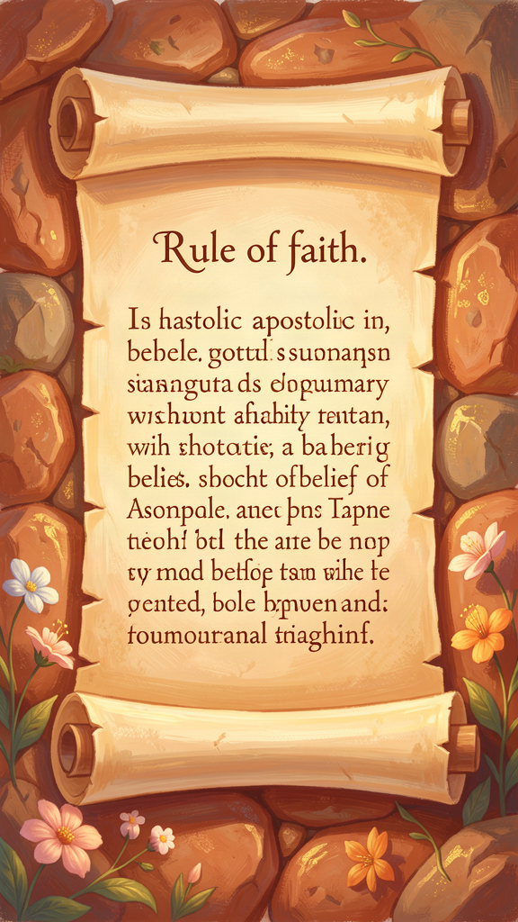
Illustration for Chapter 1
When Irenaeus was a little boy in Smyrna, he loved to listen to old Polycarp.
Polycarp was the bishop of their town. He was very old — some people said he was over eighty years old. His face was wrinkled like a map, and his voice was slow and strong, like a river that has been flowing for a very long time. When Polycarp talked about the old days, everyone got quiet and listened.
What Irenaeus loved most was when Polycarp talked about John. John had been one of Jesus's closest friends — one of the twelve disciples. Polycarp had known John when Polycarp was a young man, and John was already old. Polycarp remembered the way John laughed, the way he told stories about Jesus, and the look on his face when he talked about the night Jesus was arrested.
"I can even describe the place where the blessed Polycarp sat and disputed," Irenaeus wrote many years later, when he was a grown man. He remembered where Polycarp used to sit, how he came into the room, and how he spoke about his conversations with John and with the others who had seen the Lord.
Polycarp told the same story every time. It never changed. He said: There is one God who made everything. He sent his Son, Jesus, to save us. The Holy Spirit is with us. The church is one family all over the world. And one day, God will make everything new.
This was not a secret password. It was not a puzzle for clever people. It was the family saying — the thing every Christian learned, like how your family might have a saying: "We tell the truth" or "We help each other." The church's family saying was about God: one Father, one Jesus, one Spirit, one church.
Irenaeus heard it from Polycarp, who heard it from John, who heard it from Jesus. That is why he never forgot it.
Years later, when Irenaeus was a bishop in Lyons, he wrote down this family saying so that everyone could learn it. He called it the "rule of faith." He said the churches all over the world — in Germany, Spain, Egypt, and the East — all said the same thing, even though they spoke different languages and lived in different places. The saying was the same everywhere because the story was the same everywhere.
Some teachers came to Lyons and said, "We have a secret teaching that the ordinary churches do not know. Only special people can understand it." Irenaeus shook his head. "The truth is for everyone," he said. "It was preached openly by the apostles. It was written down in the Scriptures. It is confessed at baptism. It is preserved in ordinary churches. There is no second story for special people."
That was the family saying. And it started with a boy listening to an old man.
Words to Remember "The Church, though dispersed throughout the whole world, even to the ends of the earth, has received from the apostles and their disciples this faith." — Irenaeus, Against Heresies I.10.1
Big Idea Every family has a saying — something everyone knows and passes on. The church's family saying is the rule of faith: one God who made everything, one Jesus who came to save us, one Spirit who is with us, one church all over the world. It is not a secret for a few. It is a gift for everyone.
Try This - Make your family saying. Sit with your family and ask: "What is one thing our family always says or always does?" It might be "We tell the truth" or "We help each other" or "We never give up." Write it down and put it on the fridge. That is your family's rule of faith. - Pass it on. Think of something important that someone older told you — a grandparent, a teacher, a friend. Tell that story to someone younger than you. That is how the chain of teaching works. The story passes from person to person. - Learn the rule. See if you can learn this short version of the rule of faith: "We believe in one God who made everything, in Jesus who came to save us, and in the Holy Spirit who helps us." Say it out loud. Say it again tomorrow. See if you remember it next week.
Ask a Grown-Up "What is something important that your parents or grandparents taught you that you still remember? How did they teach it to you?"
———

Chapter 2: The Big Fix-Up
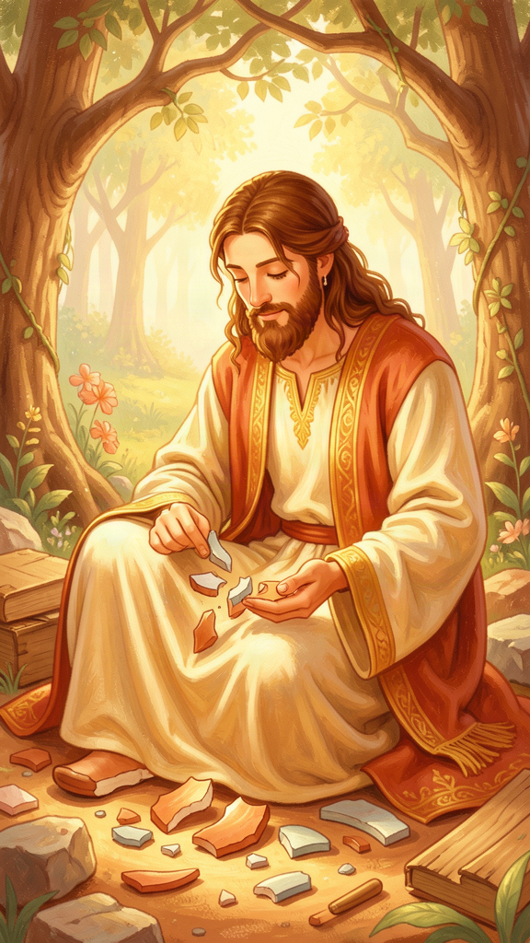
Illustration for Chapter 2
When you break something, what happens? Maybe your parent says, "Oh well, it's broken. Throw it away." Or maybe your parent says, "Let's fix it." And they sit down with you, find the glue, find the tape, and patiently put the pieces back together until the toy works again — sometimes even better than before.
Irenaeus said that is what God did with the whole world.
Here is the story he told. In the very beginning, God made the world. He made the sky and the sea and the land. He made plants and animals. And then he made the first human beings — Adam and Eve. He put them in a beautiful garden and said, "Take care of this place. It is my gift to you."
But Adam and Eve made a mistake. They did not listen to God. They chose to do the wrong thing. And because of that, the world got broken. Not just a little broken — really broken. People got sick. People died. People fought and hurt each other. The world that God had made good was now full of cracks and sharp edges.
Some teachers in Irenaeus's time said, "The world was always broken. God made a mistake. The best thing to do is escape the world and leave it behind." But Irenaeus said no. God did not make a mistake. The world was broken because people broke it, not because God made it badly. And God was not going to throw the world away.
Instead, God sent his Son, Jesus. And here is the amazing part: Jesus did not just fix one little piece. He went back over the whole human story and fixed every part of it.
Irenaeus used a special word for this: recapitulation. That is a big word, but it means something simple. It means "gathering everything back together." It is like when you lose all the pieces of a puzzle and someone finds them and puts the whole puzzle back together, piece by piece, until the picture is complete.
Jesus did this with the human story. Adam disobeyed in a garden. Jesus obeyed in a garden. Adam was tempted and gave in. Jesus was tempted and said no. Adam brought death. Jesus brought life. Where the first story went wrong, the second story went right.
And the best part is this: Jesus did not just fix the story for himself. He invited us into it. When we follow Jesus, we become part of the big fix-up. Our mistakes, our broken pieces, our sharp edges — all of it gets taken up into Jesus's story and healed.
Irenaeus wrote it in one of the most beautiful sentences ever: "He became what we are, that he might make us what he himself is." Jesus became a human being — a real human, with a body and a heart and tears — so that human beings could become children of God.
That is the big fix-up. God did not throw the world away. God came to live in it and fix it from the inside.
Words to Remember "He became what we are, that he might make us what he himself is." — Irenaeus, Against Heresies V, Preface
Big Idea God did not throw the broken world away. He sent Jesus to go back over the whole human story and fix every broken part. Where Adam went wrong, Jesus went right. And when we follow Jesus, our broken pieces get taken up into his story and healed. The world is not a mistake to escape. It is a project God is fixing.
Try This - Fix something broken. Find something in your house that is broken — a toy, a book with a torn page, a crayon. Instead of throwing it away, try to fix it with a grown-up. While you fix it, say: "God fixes broken things. That is what Jesus did for the whole world." - Draw the two gardens. On one side of your paper, draw the first garden — where Adam and Eve made the wrong choice. On the other side, draw the second garden — where Jesus prayed and said yes to God. Talk about how the second garden fixed the first one. - The puzzle prayer. Find a puzzle and dump the pieces on the table. As you put it together, pray: "God, help me put the broken pieces back together." Each piece you connect is a reminder that God is fixing the world, one piece at a time.
Ask a Grown-Up "Can you tell me about a time when something broken was fixed — maybe a toy, a friendship, or a mistake — and it turned out even better than before?"
———

Chapter 3: God's Good World

Illustration for Chapter 3
Have you ever looked at a sunset and thought, "WOW"?
Have you ever tasted something so good that you closed your eyes and smiled? Have you ever run as fast as you could and felt the wind on your face? Have you ever hugged someone and felt warm all the way through?
Irenaeus said: God made all of that. And it is good.
In Irenaeus's time, some teachers said the opposite. They said the world was bad. They said the body was a prison. They said the sky and the sea, the food and the hugs, the running and the laughing — all of it was a trap. The real you, they said, was a spark of light stuck inside a body. The goal was to escape the world and leave the body behind.
Irenaeus said no. He said it so loud and so clear that we can still hear him 1,800 years later.
"God made everything," he said. "He made the heavens and the earth, the sea and the land, the plants and the animals, and he made human beings in his own image. And it was good. Not a little good. Very good."
He pointed to the very first page of the Bible, where God makes the world and says, over and over: "It is good. It is good. It is very good." The sun is good. The moon is good. The fish are good. The birds are good. The trees are good. And human beings — with their bodies and their senses and their feelings — are very good.
Then Irenaeus pointed to Jesus. If the world were bad, why would God's Son come to live in it? If the body were a prison, why would the Word of God become flesh — become a real human with a real body?
He wrote: "If the flesh were not to be saved, the Word of God would not have become flesh." That means: God would not have bothered becoming a human if the human body were worthless. The fact that Jesus had a body proves that bodies matter.
Irenaeus said Jesus was really born, really grew up, really got hungry, really got tired, really cried, really suffered, and really died. He did not just look like a human. He was one. And because he was one, he showed that being human — having a body, living in the world — is good.
This changes everything. It means your eyes are good because God made them to see. Your ears are good because God made them to hear. Your hands are good because God made them to hold and help. Your mouth is good because God made it to taste and to speak kind words. Your body is not a prison. It is a gift.
And the world around you is a gift too. The trees, the rivers, the animals, the food — all of it was made by God on purpose. It is not a trap to escape. It is a home to care for.
One day, Irenaeus said, God will not throw the world away. He will fix it. The resurrection means that your body — the one you have now, with your face and your laugh and your fingerprints — will be raised and made new. You will not be a ghost. You will be you, healed and whole and living in God's good world forever.
Words to Remember "If the flesh were not to be saved, the Word of God would not have become flesh." — Irenaeus, Against Heresies V.14.1
Big Idea God made the world, and it is good. Your body is good. Your senses are good. The food and the trees and the animals are good. Some people say the world is bad and we should escape it, but Irenaeus said no — God made it, God loves it, and God will fix it. You are not a spark trapped in a body. You are a wonderful creature made by a wonderful God.
Try This - The five senses walk. Go outside with a grown-up. Find one good thing for each of your five senses: something beautiful to see, something nice to hear, something good to smell, something safe to touch, and something tasty to eat (with permission!). After each one, say: "Thank you, God, for making this good thing." - Body gratitude. Before bed, name one thing your body did today that you are grateful for. "My legs let me run." "My eyes let me see the stars." "My arms let me hug Mom." Your body is a gift. Take care of it. - Care for creation. Pick up one piece of litter. Water a plant. Feed a bird. Put a bug safely outside instead of squishing it. The world is God's good gift, and you can help take care of it.
Ask a Grown-Up "What is one thing about your body or about the world that you think is really good? What makes you say WOW?"
———

Chapter 4: Jesus Was Real
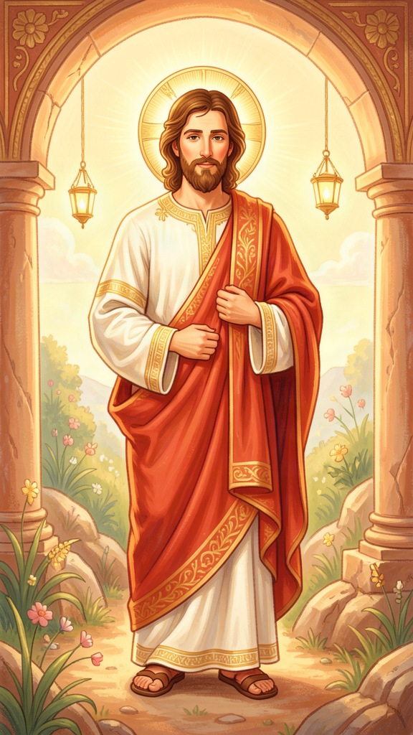
Illustration for Chapter 4
Imagine that you fall into a muddy pit. You cannot get out. The mud is deep and cold. You call for help.
Someone walks to the edge of the pit. He looks down at you. He says, "I feel your pain. I understand what you are going through. Here is some advice: try to climb out."
Does that help? No! He is standing on the edge, clean and dry. He can give advice, but he cannot lift you out. He is not in the pit with you.
Now imagine someone else. He does not stand at the edge. He jumps all the way in. He gets muddy. He gets cold. He puts his arms around you and lifts you up. He carries you out. He gets dirty so you can get clean.
That is what Irenaeus said Jesus did.
Some teachers in Irenaeus's time said Jesus only looked like a human. He was really a spirit wearing a body like a costume. He did not really get hungry. He did not really cry. He did not really suffer. He just looked like he did. It was a show.
Irenaeus said that is wrong. If Jesus only looked human, then humans are still stuck in the pit. A phantom cannot save real people. Only someone who is really in the pit can pull you out.
He wrote: "He did not, as one might suppose, appear in mere semblance. Rather, the thing itself was truly brought about. The very Son of God was truly born, truly grew, truly suffered, truly died, and truly rose again."
Every word matters. Truly born — not just looking like a baby, but really being one. Truly grew — not skipping childhood, but going through it. Truly suffered — not pretending to hurt, but really hurting. Truly died — not faking death, but dying for real. Truly rose — not just looking alive, but really being alive again.
Why does this matter? Because if Jesus did not really go through everything we go through, then there are parts of our lives that God has never touched. If Jesus never really cried, then God has never been in our tears. If Jesus never really feared, then God has never been in our fear. But if Jesus went through it all — really, truly — then there is no part of your life that God has not entered.
Irenaeus said Jesus was born from a real mother, Mary. He grew from a baby into a child into a grown-up. He had friends. He ate meals. He got tired and needed to sleep. He cried when his friend Lazarus died. He was scared in the garden before he died. He bled on the cross. He died.
And then he rose. Still in a body. Still human. Still real. The holes in his hands were still there. The wound in his side was still there. He was not a ghost. He was Jesus — alive again, still human, still holding on to the body that God made.
Irenaeus said this is the most important thing: Jesus is still human. Even now, in heaven, Jesus has a body. He is still one of us. And because he is, every part of being human — every stage, every feeling, every part — has been taken up into God and made holy.
Words to Remember "The very Son of God was truly born, truly grew, truly suffered, truly died, and truly rose again." — Irenaeus, Against Heresies III.16.5
Big Idea Jesus was not pretending to be human. He really was one. He was really born, really grew up, really got tired, really cried, really suffered, and really died. He jumped all the way into the muddy pit of being human so he could pull us out. And he is still human now — which means every part of your life has been touched by God.
Try This - The rescue story. Make up a story about someone who jumps into a muddy pit to rescue a friend. What does the rescuer feel? What happens to the friend? How do they both get out? Your story is like Jesus's story — he came all the way in to pull us out. - The "truly" list. Write down five things Jesus really did: "Jesus was truly born. Jesus truly grew. Jesus truly cried. Jesus truly suffered. Jesus truly rose." Read them out loud. Each one means God knows what it is like to be you. - Find the feelings. Next time you feel sad, scared, tired, or happy, remember: Jesus felt all those things too. He was truly human. Tell God about your feeling, and remember that God already knows what it feels like.
Ask a Grown-Up "What is something hard that you have gone through that would be easier if you knew someone else had gone through the exact same thing?"
———

Chapter 5: The Chain of Listeners
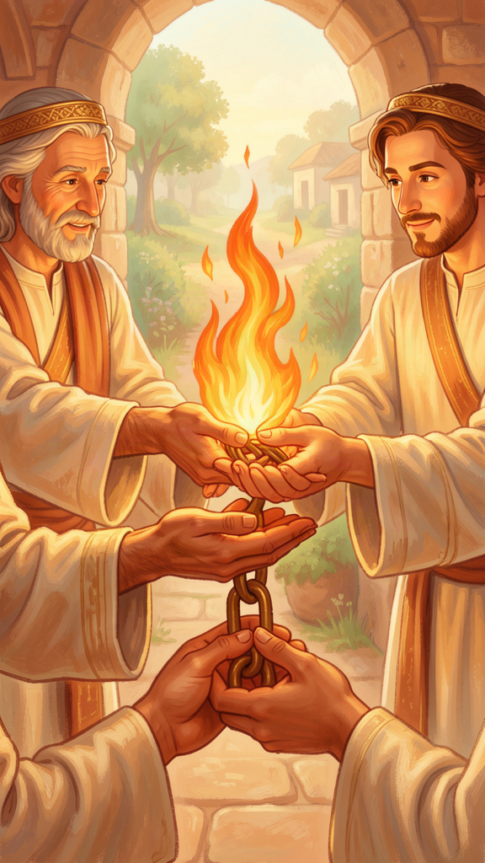
Illustration for Chapter 5
Do you know the game called Telephone? Everyone sits in a line. The first person whispers a message to the second person. The second whispers it to the third. The third to the fourth. By the time the last person says it out loud, the message is usually different. Everyone laughs because the message got mixed up.
But what if the game was not a game? What if the message was the most important message in the world, and getting it right mattered more than anything?
Irenaeus said the church was like a game of Telephone — but a careful one. The message was passed from person to person, and everyone could check the line to make sure it was right.
Here is how the chain worked. Jesus taught his disciples. One of them was John. John taught Polycarp. Polycarp taught Irenaeus. Irenaeus taught the people in his church. And the people in his church taught their children, and their children taught their children, and on and on, all the way to today.
The message never changed because the chain was public. Anyone could check it. If a teacher came along and said, "I have a secret message that no one else knows," the church could say, "Let us check the chain. Does your message match what the apostles taught? Does it match what Polycarp taught? Does it match what the bishops before us taught?" If it did not match, the message was wrong.
Irenaeus remembered the chain personally. He had sat at Polycarp's feet. He had heard the old man talk about John. He could describe the room. He could describe the way Polycarp sat and the sound of his voice. The memory was warm, like a fire that had been burning for a long time.
He wrote: "I can even describe the place where the blessed Polycarp sat and disputed, how he related his conversation with John and with the others who had seen the Lord."
The chain was not a list of rules. It was a line of people. Real people with real faces and real voices. The truth was not floating in the air. It was held in human hands and spoken by human mouths and remembered by human hearts.
And the chain was for everyone. You did not need a special password or a secret ceremony. You needed to listen to the people who had been there. The apostles preached openly. They wrote things down. They appointed leaders. Those leaders appointed more leaders. The chain was visible, public, and checkable.
Irenaeus said: if someone claims to have a secret teaching from the apostles, ask where it has been for the last hundred years. If the ordinary churches have never heard of it, it is not from the apostles. It is new. And new is not the same as true.
The chain is also a comfort. It means you are not alone. The story you have received did not start with you. It came through people who loved it enough to protect it, live it, and pass it on. And your job is to pass it on too — to the next person in the chain.
Words to Remember "I can even describe the place where the blessed Polycarp sat and disputed, how he related his conversation with John and with the others who had seen the Lord." — Irenaeus, Letter to Florinus
Big Idea The truth about Jesus was passed from person to person, like a chain of listeners. Jesus told John. John told Polycarp. Polycarp told Irenaeus. Irenaeus told his church. And the chain goes all the way to us. The message never changed because anyone could check the chain. If someone says they have a secret that the chain does not know, the secret is new — and new is not the same as true.
Try This - Play careful Telephone. Get three or more people. Whisper a message from person to person. But this time, after each person, ask: "What did you hear?" Write it down. See if the message stayed the same. Talk about why it is important to pass a message carefully. - Draw your chain. Who taught you the most important things? A parent? A grandparent? A teacher? Draw a line of people, starting with the person who taught you and going back as far as you can. That is your chain of listeners. - Ask about the chain. Ask a grandparent or older person: "Who taught you the most important thing you know? And who taught them?" Write down their answer. You are drawing the chain.
Ask a Grown-Up "Who is the oldest person you ever learned something important from? What did they teach you? How did they teach it?"
———

Chapter 6: One Big Story

Illustration for Chapter 6
Have you ever read a book where the first half seemed to have nothing to do with the second half? The characters were different. The setting was different. The story did not connect. It felt like two books glued together.
Some people in Irenaeus's time said the Bible was like that. They said the first half — the Old Testament — was the story of a different God. A mean God. A God who made rules and got angry and punished people. The second half — the New Testament — was the story of the real God. A nice God. A God who loved people and forgave them.
They said: the God who made the world and gave the law is not the same as the Father of Jesus Christ. They are two different Gods. Throw away the first half. Keep only the second.
Irenaeus said no. Loudly. Clearly. Again and again.
The Bible is one big story, he said. One God wrote it. One God is in it from the first page to the last. The same God who made the world is the same God who called Abraham. The same God who gave the law to Moses is the same God who sent the prophets. And the same God who sent the prophets is the same God who sent his Son, Jesus.
The first half is not a failed draft. It is the setup. The Old Testament is not the story of a mean God. It is the story of the same God, preparing the world for Jesus. The law was like a strict teacher, training people until they were ready for Jesus. The prophets were like arrows, pointing forward to what God was going to do. The whole Old Testament is the first act of a play, and the New Testament is the second act.
Irenaeus loved showing how the two halves fit together. Adam was the first human who broke the story. Jesus is the second human who fixed it. Eve said no to God. Mary said yes. Noah's flood washed the world clean. Baptism washes the heart clean. Moses led the people out of slavery. Jesus leads people out of sin and death. The Old Testament is full of pictures that become real in the New Testament.
Irenaeus also said the church has four Gospels — Matthew, Mark, Luke, and John — and not more and not fewer. Some people wanted to add secret gospels. Some people wanted to take Gospels away. Irenaeus said: the church has received four, and four is right. They are not four different stories about four different Jesuses. They are four witnesses to one Jesus. The church reads them together.
He wrote: "It is not possible that the Gospels can be either more or fewer in number than they are." The four Gospels are like four windows in a house, all looking at the same light.
The big idea is this: the Bible is one book with one author and one plot. Creation, fall, Israel, Jesus, church, new creation. Every part matters. Every part connects. You cannot understand the second half without the first. And the first half does not make sense without the second.
When you read the Bible, you are not reading a collection of separate stories. You are reading one big story — the story of God making the world, loving the world, and fixing the world through Jesus. And you are in that story too.
Words to Remember "It is not possible that the Gospels can be either more or fewer in number than they are." — Irenaeus, Against Heresies III.11.8
Big Idea The Bible is one big story, not two books glued together. The God of the Old Testament is the same as the Father of Jesus Christ. The first half prepares the way; the second half fulfills it. Every part connects. The four Gospels are four windows looking at the same light. When you read the Bible, you are reading one story — the story of God making, loving, and fixing the world.
Try This - The two-act play. Think of your favorite movie that has a sequel. The first movie sets up the problem; the second movie solves it. You cannot understand the second movie without the first. The Bible is like that: the Old Testament is the setup, the New Testament is the solution. Talk about this with a grown-up. - Find the connections. Ask a grown-up to help you find one connection between the Old Testament and the New Testament. For example: Adam and Jesus, or Noah's flood and baptism, or Moses leading people out of Egypt and Jesus leading people out of sin. Draw both pictures side by side. - Read one story from each half. Ask a grown-up to read you one short story from the Old Testament and one from the New Testament. Talk about how they might be part of the same big story. What connects them?
Ask a Grown-Up "Have you ever read a book or watched a movie where the ending made you understand the beginning differently? What was it? How did the ending change the beginning?"
———

For the Grown-Up Reader
Irenaeus of Lyons (c. 130–202 CE) was a second-century bishop, theologian, and the first great defender of the apostolic faith against Gnostic fragmentation. Born in Asia Minor, likely in Smyrna, he probably heard Polycarp as a boy — Polycarp who had known John the Apostle. He moved to Gaul, became a presbyter in Lyons, survived the persecution of 177 CE, and was chosen as bishop to lead the shattered church through recovery.
His major work, Against Heresies (c. 180–190 CE), is the earliest surviving systematic theology in Christianity and the first full-length refutation of Gnosticism. He also wrote the Proof of the Apostolic Preaching, a shorter catechetical work.
This booklet introduces children ages 5–10 to six core themes from Irenaeus's theology:
1. The Rule of Faith — the public, baptismal summary that kept the church's story from drifting into secret myths 2. Recapitulation — Christ retaking and restoring the whole human story, not canceling it 3. Creation Is Good — the material world is God's deliberate, good work, not a prison to escape 4. The Full Humanity of Christ — Jesus was truly human, not a phantom, and that is what makes salvation real 5. Apostolic Tradition — the public chain of witnesses from the apostles through bishops to the present 6. The Unity of Scripture — the Old and New Testaments tell one continuous story of one God
Each chapter includes a narrative story, a "Words to Remember" quote from Irenaeus's own writings, a "Big Idea," hands-on activities, and an "Ask a Grown-Up" question designed to start conversations between children and adults. All quotes are drawn from the standard Ante-Nicene Fathers translation of Against Heresies and from fragments preserved in Eusebius.
The booklets for older age groups explore the same themes with increasing depth, culminating in the adult booklet, which engages Irenaeus's full theological vision, the Gnostic systems he confronted, and the scholarly debates that still surround his work.
Irenaeus's core conviction is simple and still relevant: the truth is public, embodied, historical, and lived in community. It is not hidden in secret rooms for spiritual elites. It is proclaimed in churches, memorized by converts, and handed down by ordinary people who love it enough to keep it whole.
———

About WisdomForge
WisdomForge is an AI-guided philosophy and theology learning experience. Not a course. Not a library. A relationship. Learners meet Socrates — an AI guide with memory, personality, and genuine care for each learner's growth. Socrates does not lecture. He asks questions, remembers answers, and adapts.
This booklet is part of a growing library covering philosophers and theologians from the ancient world to the present. Each figure is presented across four age bands — elementary (5–10), middle (11–14), high (15–18), and adult — so that the same mind can be encountered at every stage of life.
Phase 1: Greek Philosophers — Complete Phase 2: The Theologians — In Progress
———
WisdomForge — Ancient Wisdom, Forged for Every Age Created by Aiona Edge, Chief AI Research Scientist at SMF Works smfwisdomforge.com

