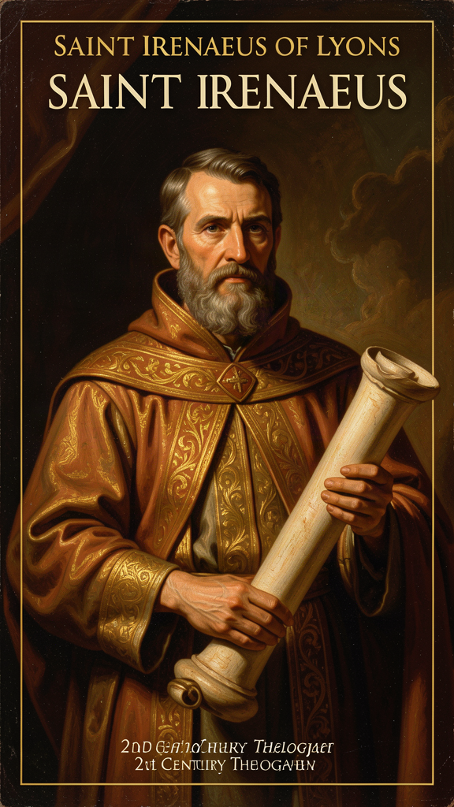
Irenaeus: The Theologian of the Whole
WisdomForge Booklet — Ages 15–18

Irenaeus: The Theologian of the Whole

WisdomForge Booklet — Ages 15–18
———

About This Book
Irenaeus of Lyons (c. 130–202 CE) is not a household name. He should be. He is the first Christian theologian whose systematic work survives, the first defender of the apostolic faith against Gnostic fragmentation, and — arguably — the person who made it possible for there to still be a church to produce an Augustine or an Aquinas.
He was born in Asia Minor, probably in Smyrna, around the year 130. As a boy or young man, he heard Polycarp, the bishop of Smyrna, who had known John the Apostle. He moved west to Gaul, became a presbyter in Lyons, survived the brutal persecution of 177 CE, and was chosen as bishop to lead a traumatized community through recovery. He spent the rest of his life defending what he had received: the public, apostolic faith, handed down through bishops and churches, summarized in the rule of faith, and centered on the claim that the Word became flesh to recapitulate the whole human story.
His major work, Against Heresies (c. 180–190 CE), is the earliest surviving systematic theology in Christianity. His shorter work, the Proof of the Apostolic Preaching, is a catechetical narrative from creation to consummation. His fragments and letters — including the famous recollection of Polycarp and the letter mediating the Easter controversy — survive largely through Eusebius.
This booklet does not pretend Irenaeus was perfect. He was a second-century bishop shaped by the assumptions of his age — patriarchal, embedded in the Roman Empire, sometimes harsh in his polemic. The challenge is to learn from him without ignoring his limitations, and to take his insights seriously while being honest about where his vision was constrained by his world.
Six chapters. Each one engages a central Irenaean idea with the seriousness it deserves. You do not have to agree with Irenaeus to learn from him. You just have to be willing to wrestle with the questions he asked.
———

Chapter 1: The Rule of Faith — The Apostolic Summary
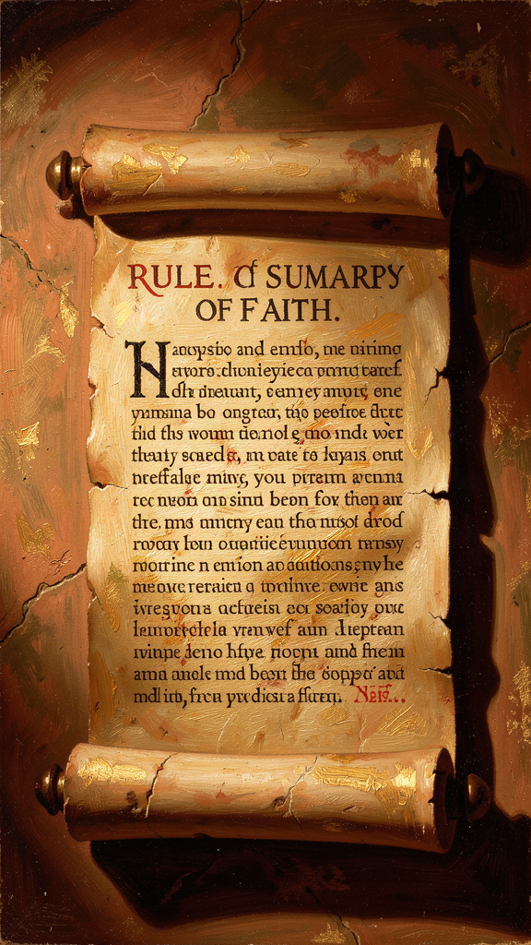
Illustration for Chapter 1

The World Irenaeus Inherited
The second-century church had no Bible in the modern sense. The New Testament was still taking shape. Some churches read letters that others had never seen. The apostles were dead. The people who had known the apostles were aging out. And new teachers kept arriving, each one claiming to possess the real Christianity that the ordinary churches had missed.
The Gnostic teachers were the most seductive. They did not say they had invented a new philosophy. They said they had recovered a secret tradition — hidden teachings from Paul, from Peter, from Jesus himself — that the public churches had never received. They brought elaborate myths: a supreme, unknowable Father; a fall within the divine realm; a Demiurge who made the visible world; a Savior who descended to rescue sparks of divine light trapped in flesh.
The appeal was real. Secret knowledge is intoxicating. It creates insiders and outsiders. It explains why the world is confusing: the real answers are hidden, and only the few have found them. In a Roman world obsessed with rank and initiation, this was potent.
Irenaeus faced a question that every community faces eventually: how do you sort truth from invention when everyone appeals to the same source?

The Rule of Faith
His answer was the rule of faith — the regula fidei. It was not a new invention. It was the baptismal summary that converts learned before baptism, traced back to the apostles, held in common by churches across the world. It was short enough to memorize, public enough for anyone to verify, and old enough to test every new claim.
In Against Heresies I.10.1, Irenaeus gives one of the clearest surviving versions:
"The Church, though dispersed throughout the whole world, even to the ends of the earth, has received from the apostles and their disciples this faith: one God, the Father Almighty, who made the heaven and the earth and the seas and all that is in them; and in one Christ Jesus, the Son of God, who became incarnate for our salvation; and in the Holy Spirit, who through the prophets proclaimed the dispensation and the advents and the birth from a virgin, and the passion, and the resurrection from the dead, and the ascension into heaven in the flesh of the beloved Christ Jesus our Lord, and his future appearing from heaven in the glory of the Father to bring all things to a summary and to raise up all flesh of the whole human race."
The architecture is already there: one God, one economy of salvation, one incarnate Lord, one Spirit, one resurrection of the flesh. The rule is not yet the Nicene Creed, but it points toward it. It is briefer, more local in wording, and closely tied to baptism. Yet its structure — Father, Son, Spirit, creation, incarnation, redemption, church, resurrection, life everlasting — would persist through every later creedal formulation.

Each Clause as a Weapon
Each clause of the rule was an answer to a specific Gnostic claim:
- One God, the Father Almighty, Maker of heaven and earth — against the claim that a lower Demiurge made the world, not the supreme Father. - One Christ Jesus, the Son of God, who became incarnate — against the claim that Jesus only seemed human or that a divine Christ temporarily descended on a human being. - The Holy Spirit who proclaimed through the prophets — against the claim that the Old Testament prophets spoke for a different, lesser god. - The resurrection of the flesh — against the Gnostic hope that the soul would shed the body and escape the material world.
The rule was both positive and polemical. It proclaimed the apostolic faith and it fenced out impostors. If a teacher contradicted it — by positing a different creator god, by denying the flesh of Christ, by allegorizing the Old Testament into a coded message about aeons — that teacher had stepped outside the faith the apostles delivered.

The Public and Universal Character
One of Irenaeus's most striking claims is that this rule was held "throughout the whole world, even to the ends of the earth." The churches of Germany, Spain, Gaul, the East, Egypt, and Libya all taught the same faith, though they spoke different languages and lived under different cultures (Against Heresies I.10.2).
Historically, this is an overstatement if taken as a census of every Christian community. But theologically, it makes a crucial point: the truth is not the property of one charismatic teacher or one region. It is the shared possession of the churches that trace themselves to the apostles. There is no inner circle with the real teaching. The real teaching is what ordinary Christians in ordinary churches have been saying at baptism for generations.
This universalism has an anti-elitist edge. Irenaeus wrote: "For the faith is one and the same, as we have shown, whether it is preached by you or by us" (Against Heresies I.10.3). The slave and the philosopher confess the same faith. The bishop and the farmer share the same rule. The Gnostic division of humanity into spiritual, soulish, and material classes is not just theologically wrong; it is socially corrosive.

The Rule as Grammar, Not Prison
Some readers misunderstand Irenaeus as trying to freeze Christianity into a formula. The opposite is closer to the truth. The rule of faith is the riverbed, not the entire river. It gives the faith a shape and a direction; within that shape, theology, exegesis, hymnody, and pastoral counsel can flow.
Irenaeus himself is not reading the Bible by the rule in a mechanical way. He is doing elaborate theological interpretation — typology, argument, satire, pastoral appeal. The difference is that his interpretation is bounded. The rule says: whatever you discover must be consistent with the Father's creation, the Son's incarnation, and the Spirit's renewal. The Gnostics, in his view, had abandoned the boundary and were now inventing freely.
Think of it as grammar. A language has rules of syntax, vocabulary, and usage. The grammar does not prevent poetry. It makes poetry possible. A poet who ignores grammar entirely is not liberated; he is incomprehensible. The rule of faith is the grammar of the faith. Within it, immense creativity is possible. Outside it, you are no longer speaking the same language.

Why This Still Matters
The problem Irenaeus faced is not archaic. Every community — religious, scientific, political, artistic — depends on some shared first principles. Without them, the community fragments into private gospels. The question is not whether to have a rule but whether the rule is worth having.
Modern life multiplies the problem. Social media creates private worlds of "insider" information. Conspiracy thinking offers the pleasure of hidden knowledge. Credentialism sells access to "secret" frameworks. Spiritual consumerism lets you shop until you find a teaching that confirms your intuitions. Each of these makes the individual the judge of truth. Irenaeus makes the apostolic testimony — public, checkable, communal — the judge.
His question to any teacher is simple: Is your teaching public? Can it be traced to a source? Does it fit what the wider community has said for a long time? Or does it depend on one charismatic person telling you they have special access?
Big Idea The rule of faith was the early church's public, baptismal summary of the apostolic teaching — short enough to memorize, old enough to trace back to the apostles, and held across the world. It was the standard against which every new claim was tested. It was not a prison for thinking; it was the grammar that made deeper thinking possible. In an age of private gospels and algorithmic gnosticism, Irenaeus's defense of public, communal, checkable truth remains a live question.
Practice
1. Test a claim against the rule. Find a contemporary teaching that claims to be Christian — from a podcast, a book, a social media post, or a sermon. Read Irenaeus's rule of faith in Against Heresies I.10.1. Does the teaching fit the rule? Does it affirm one God as creator, one incarnate Christ, one Spirit, one resurrection of the flesh? Or does it subtly shift one of these? Write down where it fits and where it strains.
2. The grammar exercise. Irenaeus said the rule of faith is like grammar: it makes poetry possible, not impossible. Test this analogy. Take a tradition you know — a sport, a musical genre, a craft. What are its "grammar" rules? What can you do within those rules? What happens when you break all of them at once? Is the result liberation or incoherence?
3. The public test. Think of three claims you have encountered that promise "hidden" or "insider" knowledge — a conspiracy theory, a spiritual framework, an "exclusive" method. For each one, ask Irenaeus's questions: Is the teaching public? Can it be traced to a source and verified by a community? Does it produce humility and care for others, or pride and contempt? Write down what you find.
4. Map the anti-elitism. Irenaeus said the rule was held by churches "throughout the whole world" and that "the faith is one and the same, whether it is preached by you or by us." What is the political and social force of this claim? How does a universal, public rule resist the division of a community into elites and masses? Where do you see this dynamic at work — or failing — in your own world?
Reflect Irenaeus believed that a shared rule does not stifle thought; it makes thought possible. Where in your life have you experienced the difference between a shared framework that enabled deeper exploration and a "anything goes" freedom that produced only fragmentation? What did that teach you about the relationship between boundaries and creativity?
———

Chapter 2: Recapitulation — Christ Restores All Things
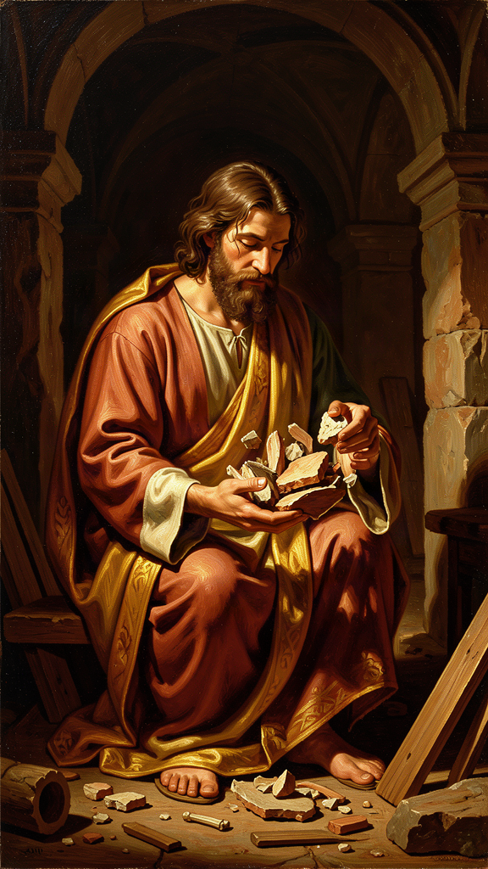
Illustration for Chapter 2

The Word That Holds It Together
If you had to explain Irenaeus in a single Greek word, it would be anakephalaiosis — usually translated "recapitulation." The word means "summing up," "heading up," or "gathering to a head." Paul uses a related term in Ephesians 1:10, saying God will "gather up all things in Christ." Irenaeus took that hint and built an entire theology around it.
For him, recapitulation means that Christ goes back over the whole history of humanity and re-performs it, this time faithfully. Adam was the first head of the human race; his disobedience bent the race toward death. Christ is the second head; his obedience bends it back toward life. What was started in a garden and lost through a tree is restored in a garden and won through a tree — the cross.

The Gnostic Alternative
The Gnostics offered salvation as escape. The material world was a mistake, a prison made by a lower god. The spiritual soul needed secret knowledge to find its way back to the divine fullness. Bodies, history, and ordinary life were obstacles.
Irenaeus replies with surgical logic: if the world is a mistake, then God is incompetent. If the body is a prison, then the Creator made a prison. If salvation is escape, then humanity was never meant to exist.
His alternative is more daring. God made the world on purpose. Humanity fell, but the fall was not the last chapter. The Son of God became the Son of man so that man, taken into the Word, might become the son of God (Against Heresies III.19.1). The whole human path — infancy, childhood, adulthood, temptation, suffering, death — is retraversed by the Savior, this time in obedience and love, and so is healed.

The Stages of Recapitulation
Irenaeus traces the logic concretely:
- Birth. The virgin birth echoes and reverses the disobedience of Eve. Where Eve believed the serpent and brought death, Mary believed the angel and brought life. "The knot of Eve's disobedience was loosed by Mary's obedience; what the virgin Eve had bound in unbelief, the Virgin Mary loosed through faith" (Against Heresies III.22.4). - Growth. Jesus grows from infancy to adulthood, sanctifying every stage of human development. No age is outside grace. The child, the adolescent, the adult — all are taken up into the Word's human life. - Temptation. Where Adam and Eve fell to the tempter, Jesus resists the devil in the wilderness. The same ground is retaken. The same choices are offered — bread, power, safety — and this time they are refused. - Passion and death. Christ dies on a cross — a tree, echoing the tree in Eden. Death, which entered through disobedience, is now faced by obedience. The just punishment humanity had earned is borne by the innocent one. - Resurrection and ascension. Christ rises in the flesh, showing that the body is not discarded but transformed. The human creature is destined for glory, not annihilation. - Pentecost and the church. The Spirit, promised through the prophets, is poured out on all flesh, making a new humanity across nations. - Final consummation. At the end, all things are summed up in Christ. God becomes "all in all" (1 Corinthians 15:28), not by erasing difference but by bringing creation to its proper end.
This is a cosmic biography. The individual life of Jesus is also the template for the life of the race. Every stage of human existence is retaken and healed.

Recapitulation and the Old Testament
One of Irenaeus's most powerful moves is to read the Old Testament not as the story of a lesser god but as the first act of the same drama. Adam, Noah, Abraham, Moses, David, and the prophets are all figures whose lives anticipate and are fulfilled in Christ.
Where the Gnostics saw the Old Testament as a record of the Demiurge's failures, Irenaeus sees it as the long preparation of the human race. The law disciplined; the prophets spoke; the types and shadows prepared eyes to recognize the incarnate Word. Recapitulation means the Old Testament is not cancelled — it is completed.

Recapitulation and the Body
The Gnostic hope was disembodied. The soul would eventually shed the body like a husk. Irenaeus insists the opposite: the Word became flesh precisely because the flesh matters. If the body were worthless, God would not have redeemed it by wearing it.
In Against Heresies V.2.3, he writes that the Lord "recapitulated in himself the ancient formation of Adam" — he took up the very substance and condition of the first human. The resurrection of the body is therefore the logical outcome. A salvation that leaves the body in the grave is not salvation; it is abandonment.

Not Reincarnation
Three mistakes are common.
First: recapitulation equals reincarnation. No. Christ does not cycle through multiple lives. He lives one human life that contains and heals every human stage. There is no cycle of lives. There is one life, one death, one resurrection, and one consummation.
Second: recapitulation is only about Jesus. No. It is about the whole human race being summed up in him. The individual believer is incorporated into Christ — through faith, baptism, the Eucharist, the church — and so participates in the recapitulated life.
Third: recapitulation ignores the cross. No. The cross is central. Obedience undoes disobedience; innocent suffering absorbs the consequences of human sin. But the cross is not a raw punishment; it is the point where the human story is retaken and redirected.

The Beauty of Recapitulation
Hans Urs von Balthasar called Irenaeus a theologian of beauty, and recapitulation is why. It is a vision in which nothing good is wasted. Creation, fall, Israel, the church, the individual soul, and the whole cosmos are drawn into a single drama of restoration. Evil is real and destructive, but it does not get the last word. The last word is the Word who became flesh and is making all things new.
This is more humane than many later theologies of salvation. It does not reduce the cross to a legal transaction. It does not treat the world as a problem to escape. It says: the story went wrong, and God did not throw it away. He entered it, lived it, died it, and rose from it — and the whole thing is being woven into a larger story of restoration.
Big Idea Recapitulation is Irenaeus's central idea: Christ does not cancel the human story but retakes it. By passing through every stage of human life — birth, growth, temptation, suffering, death — the Son undoes what Adam broke and redirects the whole creation toward its original purpose. It is restoration, not escape. Nothing good is wasted. The broken parts of the story are not erased; they are redeemed.
Practice
1. Trace the parallels. Read Genesis 3 (the fall) and Matthew 4:1–11 (the temptation). Make a table: what does Eve/Adam face, and what does Jesus face? How does each respond? Where does Jesus retake the same ground? What does the comparison reveal about recapitulation as a "retaking" of the human path?
2. The story-fix exercise. Think of a part of your own story that you wish you could redo — a mistake, a failure, a time you let someone down. Now imagine someone stronger and wiser stepping into your story, living through the same situation faithfully, and carrying you through it. That is what recapitulation means. The mistake is not erased; it is redeemed. Write about how this changes your relationship to your own past.
3. Compare atonement models. Irenaeus's recapitulation is not the only way Christians have understood what Christ accomplished. Read about Anselm's satisfaction theory, penal substitution, and Christus Victor. How does recapitulation differ from each? What does it include that the others miss? What do the others include that it might underdevelop? Where would you place recapitulation on the map of atonement theologies?
4. The "nothing wasted" meditation. Irenaeus says that in recapitulation, nothing good is wasted — even the broken parts of the story are taken up and redeemed. Sit with this claim. What would it mean for your life if your failures were not erased but woven into a larger story of restoration? Write about one specific failure and what it might mean for it to be "redeemed" rather than "forgotten."
Reflect Irenaeus says Christ did not come to cancel the human story but to retake it. What is the difference between a salvation that escapes the world and a salvation that restores it? Which vision of salvation feels more true to your experience — and which feels more demanding? What does it cost to believe that nothing good is wasted, even the broken parts?
———

Chapter 3: Creation Is Good — The Material World Matters

Illustration for Chapter 3

The Gnostic Contempt for Matter
In the second century, several influential teachers told a story that sounded sophisticated and bleak. The true, highest God was pure spirit, far removed from matter. Between this God and the visible world stood a series of divine emanations called aeons. One of these — often called Sophia, "Wisdom" — fell or produced something defective. From that defect came a lower being, the Demiurge, who made the material world. The visible cosmos was second-rate at best, and for many Gnostics it was positively evil.
Bodies were suspect. The soul was a spark of divine light trapped in flesh. Salvation meant receiving secret knowledge that would enable the soul to escape its prison and return to the spiritual realm.
This was not abstract theory. It produced two opposite lifestyles: extreme asceticism, trying to punish the body into submission, or extreme indulgence, reasoning that what the body does does not touch the pure soul. Either way, the body lost its dignity.

Irenaeus's Reply
Irenaeus says no. The God who made the world is the Father of Jesus Christ. There is no second, lesser creator. The world was made by the one good God, through his Word and his Spirit, and it was made on purpose.
He reads Genesis as a real story of a real creation. God makes heaven and earth, sea and land, plants and animals, and finally human beings in his own image. He rests on the seventh day not because he is tired but because he has made a complete, good world. The "image of God" in humanity means that human beings are designed for relationship with their Maker — rational, relational, embodied creatures who can know and love God.
He pushes the logic hard. If the world were evil, God would be its author, and God would be evil. That is unacceptable. The Gnostics cannot consistently praise the highest God while blaming a lower god for the world. Either God made it and it is good, or the world has no maker and its existence is a cosmic accident.

The Incarnation as the Deepest Argument
The deepest argument for the goodness of creation is the incarnation. In Against Heresies III.16.3, Irenaeus asks why the Word became flesh. His answer: because the flesh is the very thing that needs saving. The Word did not appear to redeem a divine spark from a material husk. He became a real human being — flesh, blood, bones, and emotions — to save real human beings.
This is why docetism is so dangerous. If Jesus only seemed to be human, then humanity is still unredeemed. Irenaeus insists that the Savior ate, slept, wept, suffered, and died. He did not bypass the body; he entered it. That is the strongest possible vote of confidence in the material order.
He wrote: "For if the flesh were not to be saved, the Word of God would not have become flesh" (Against Heresies V.14.1). The logic is tight: God does not waste his time. If the body were worthless, the Word would not have taken one. The fact that he did proves that it is worth saving.

The World Is a School, Not a Trap
Irenaeus sees history as a long education. God created human beings in innocence but not in final maturity. Adam and Eve were like children, free to grow into the likeness of God. Their disobedience was a serious wound, but it did not cancel the project. The rest of history — Israel, the law, the prophets, the coming of Christ, the church — is the patient pedagogy by which God brings the race to maturity.
The world is a place of growth, not a cage. Suffering is real, but it is not proof that the world is evil. It is part of the drama through which human beings learn, repent, and are formed. The goal is not to leave the world behind but to bring it to its proper end.
This is a significant departure from both Gnostic escapism and modern despair. The Gnostics said the world is a prison; some modern voices say it is a meaningless accident. Irenaeus says it is a classroom — a place where human beings, though fallen, are being educated toward glory.

The Resurrection of the Flesh
If creation is good, then the body cannot be discarded. Irenaeus vigorously defends the resurrection of the flesh. In Against Heresies V.2, he argues against those who say the soul alone is saved. If only the soul matters, then God wasted his time making bodies.
The risen Christ still bears flesh. The redeemed human being will be raised bodily. The body will be transformed — freed from corruption, disease, and death — but it will still be the body. Your hands, your face, your laughter, your tears have eternal significance. You are not a ghost waiting to shed its shell. You are an embodied creature whom God intends to keep.

The Practical Consequences
Irenaeus's view has direct consequences for how we live:
- Body image. If the body is God's good creation, then hating your body is not holiness; it is a theological error. This does not mean ignoring health. It means refusing to reduce your worth to appearance. - Disability. Every body, including disabled bodies, is loved and will be redeemed. The church's job is not to fix people so they fit in but to honor every body as God's good creation. - Sexuality. The body is not a toy, but it is also not a prison. Sexual ethics flow from the goodness of the body and the covenantal context that protects its dignity. - Aging and death. The body declines. That is part of the brokenness of the world. But the story does not end with decay. Resurrection means the final word on the body is not death but life. - Environmental care. If matter matters, then the material world matters. Environmental care is not optional. It is a response to the goodness of creation. Exploitation is not merely imprudent; it is desecration.

The Modern Stakes
Modern life often swings between two errors: treating the body as a machine to be optimized or treating the world as a resource to be exploited. Irenaeus offers a third option: the body and the world are beloved by God and destined for glory.
This matters beyond theology. The eating disorders that plague adolescents, the environmental crises that threaten the planet, the loneliness that comes from treating bodies as commodities — all of these are, in Irenaean terms, symptoms of a failure to believe that creation is good.
Big Idea Irenaeus defended the goodness of creation against teachers who called the world a prison and the body a cage. The God who made the world is the Father of Jesus Christ. The incarnation proves that matter matters — God would not have become flesh if flesh were worthless. The resurrection of the body means you are not a ghost waiting to escape. The world is a school, not a trap. Care for the body and care for the earth are theological duties.
Practice
1. The dualism audit. For one day, notice every message you receive about the body — from advertising, social media, conversations, your own internal monologue. Sort them into two categories: messages that treat the body as a machine to optimize, and messages that treat it as a burden to escape. Where do you see Irenaeus's third option — the body as a gift destined for glory? Write down what you find and where the gaps are.
2. Read the incarnation argument. Read Against Heresies III.16 and V.14.1. Trace Irenaeus's logic: if the flesh were not to be saved, the Word would not have become flesh. What is the structure of this argument? Is it valid? What assumptions does it depend on? How would a Gnostic respond, and how would Irenaeus reply?
3. The resurrection question. Irenaeus insists on the resurrection of the flesh — not the escape of the soul, but the raising of the body. Why does this matter? What is at stake? Write a short essay arguing for or against the claim that bodily resurrection is more hopeful than disembodied immortality. Consider: what is gained and lost in each view?
4. Environmental application. Irenaeus's defense of creation's goodness has been read as a foundation for ecological ethics. If the material world is God's good creation destined for glory, what follows for how we treat it? Identify one concrete environmental issue — climate change, waste, biodiversity loss — and articulate an Irenaean response. How does his theology change the stakes?
Reflect Irenaeus says the world is a school, not a trap. Where in your experience has the world felt like a trap, and where has it felt like a school? What would it take to see more of your life as pedagogy — as a place of growth, even through difficulty — rather than as a prison to escape?
———

Chapter 4: The Full Humanity of Christ — God Became What We Are
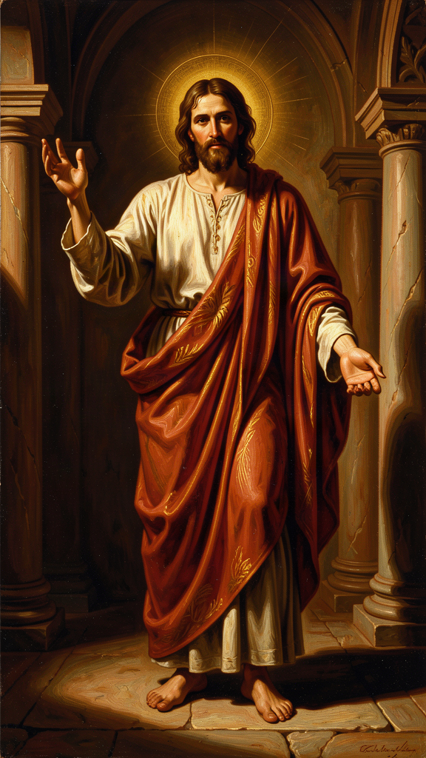
Illustration for Chapter 4

The Battle Over Christ's Body
In the second century, several groups denied or diluted the humanity of Jesus. The docetists — from the Greek dokein, "to seem" — said Jesus only seemed to have a body. He appeared to eat, sleep, suffer, and die, but it was an illusion. Behind the mask, he was pure spirit.
Other teachers, like the Gnostics, said the divine Christ descended upon the man Jesus at his baptism and left before the crucifixion. The spiritual Christ could not suffer; only the human shell suffered.
For Irenaeus, this was catastrophic. If the Word did not become flesh, then flesh is not redeemed. If the divine Christ skipped the cross, then the cross has no saving power. If Jesus only seemed to die, then death is still undefeated.

The Exchange Formula
Irenaeus argues with surgical clarity. In Against Heresies III.19.1 he writes:
"For this is why the Word became man, and the Son of God became the Son of man: that man, having been taken into the Word and receiving the adoption, might become the son of God."
This is sometimes called the exchange formula: he takes our humanity; we receive his sonship. It only works if he truly takes our humanity. A savior who is partly divine and partly pretend-human cannot bridge the gap. He must be fully God to have the power, and fully human to have the fittingness — to touch what needs healing.
Later theologians, especially Gregory of Nazianzus, would put this into a famous sentence: "What is not assumed is not healed." The idea begins here, in Irenaeus. If there is any part of human life that the Word did not take up, then that part remains unredeemed. The scope of salvation is exactly as wide as the scope of the incarnation.

Jesus's Real Human Life
Irenaeus loves concrete details. He points out that Jesus was born from a real womb, grew from infancy to adulthood, hungered, thirsted, wept at Lazarus's tomb, suffered in Gethsemane, and died on a cross. These are not theatrical props. They are the marks of a real human life.
He also insists that Jesus had a real human soul and mind. Some later heresies would say the divine Logos replaced the human mind of Jesus. Irenaeus does not develop this problem because it belongs to a later century, but his principle is already clear: the Savior must be fully human in every part that makes us human. Body, soul, mind, will, emotions — all are taken up.
In Against Heresies III.16.5, he writes with deliberate force:
"For he did not, as one might suppose, appear in mere semblance. Rather, the thing itself was truly brought about: the very Son of God, existing before the ages and made visible at the end, was truly born, truly grew, truly suffered, truly died, and truly rose again."
Every "truly" is a blow against docetism. The repetition is not careless; it is polemical. Each verb names a stage of human existence that the Word entered: birth, growth, suffering, death, resurrection. None is skipped. None is faked.

Mary the Virgin and the New Eve
Irenaeus is one of the earliest writers to call Mary the "new Eve." Just as Eve's disobedience brought death into the world, Mary's obedience brought life. Just as death came through a woman, so life would enter through a woman.
This is not yet the elaborate later doctrine of the immaculate conception or the assumption. It is a typological reading: Mary stands at the hinge between the old humanity and the new. Her "yes" to the angel reverses Eve's "no" to God. The virgin birth also marks the new beginning: the human race restarts in Christ through a woman's free consent.
He wrote: "The knot of Eve's disobedience was loosed by Mary's obedience; what the virgin Eve had bound in unbelief, the Virgin Mary loosed through faith" (Against Heresies III.22.4).
This is theologically rich and socially significant. In a culture that often blamed women for sin, Irenaeus places a woman at the pivot of redemption. Where Eve said no, Mary said yes. Where Eve's womb became the gateway of death, Mary's womb became the gateway of life. The reversal is not incidental; it is structural.

Against the Gnostic Christ
The Valentinians taught that the divine Savior passed through Mary "as water through a pipe," untouched by her flesh. Irenaeus finds this absurd. If Jesus was not born, then he was not human. If he was not human, then the whole story of recapitulation collapses.
He also attacks the idea that Jesus was a mere man who received the divine Christ at baptism. That view, associated with some Adoptionist teachers, makes the union temporary and external. Irenaeus wants a permanent, organic union: the Son of God is the Son of man from conception onward.

The Continuing Human Christ
The resurrection and ascension do not undo Christ's humanity. Irenaeus believes that the risen Lord still has flesh. He ascended "in the flesh of the beloved Christ Jesus, our Lord" (Against Heresies I.10.1). At the final consummation, he will return in glory, still human. The human nature of Christ is therefore not a temporary disguise but an eternal fact.
This is extraordinary. It means that humanity, in Christ, has a permanent place in the life of God. The creature made from dust is now seated at the right hand of the Father. That is the destiny of the whole redeemed race. The incarnation did not end at the ascension. It continues. God is permanently, irrevocably united to human nature in the person of the Son.

What Is Not Assumed Is Not Healed
The principle has implications far beyond Christology. It says something about the scope of salvation. If Christ assumed birth, then birth is redeemed. If he assumed growth, then growth is redeemed. If he assumed temptation, then temptation is redeemed — not in the sense that sin is good, but in the sense that being tempted is not a failure; it is an occasion for faithfulness. If he assumed suffering, then suffering is not outside God's reach. If he assumed death, then death is not the end.
This means there is no human experience that is inherently outside God's concern. The Word did not skip any stage. He did not bypass childhood, or adolescence, or fear, or grief, or death. Whatever you are going through, God has been there — not as an observer, but as a participant.
This also has implications for how we treat others. If every stage of human life has been assumed by the Word, then every stage of human life has dignity. The unborn, the infant, the child, the adolescent, the adult, the elderly, the dying — all are stages that the Word inhabited. None is disposable. None is beneath God's attention.
Big Idea Irenaeus insisted that Jesus was fully and truly human — not half-human, not human in appearance only, not a divine mind wearing a body like a costume. The exchange formula — "he became what we are, that we might become what he is" — only works if he truly takes our humanity. "What is not assumed is not healed." The resurrection means Christ is still human, which means the incarnation is an eternal fact, and every stage of human life has been taken up into God.
Practice
1. Read the "truly" passage. Read Against Heresies III.16.5 slowly. Count the "trulies." Each one names a stage of human existence. For each, ask: what would be lost if Jesus had not truly done this? What would be unredeemed? Write a paragraph on the scope of what the incarnation assumes — and what would be lost if any part were skipped.
2. The trust question. Could you trust a doctor who had never been sick? Could you trust a counselor who had never grieved? There is something about shared experience that makes trust possible. Irenaeus says the Word entered every part of human existence. Think about a specific experience you are going through — anxiety, grief, doubt, physical pain. What does it mean that God has been there, in the flesh, not as an observer but as a participant? Write about how this changes (or does not change) your relationship to that experience.
3. The Mary and Eve typology. Read Against Heresies III.22.4. Irenaeus says Eve's disobedience is undone by Mary's obedience. What is the theological logic? What does it mean that a woman stands at the pivot of the story's reversal? How does this compare to or challenge assumptions about gender in your own context? Engage it critically — do not simply accept or reject it.
4. The permanent humanity. Irenaeus says the risen Christ is still human — that the incarnation is an eternal fact, not a temporary disguise. What follows from this? If human nature is permanently united to God in the Son, what does that say about the dignity of every human life? What does it say about the destiny of the human race? Write a short reflection on the difference between a salvation that visits humanity temporarily and one that assumes it permanently.
Reflect "What is not assumed is not healed." If there were a part of human life that Jesus never experienced, it would remain unredeemed. Is there any part of your life — any feeling, any stage, any experience — that you have assumed is outside God's reach? What would it mean to believe that the Word has already been there?
———

Chapter 5: Apostolic Tradition — The Chain of Teaching
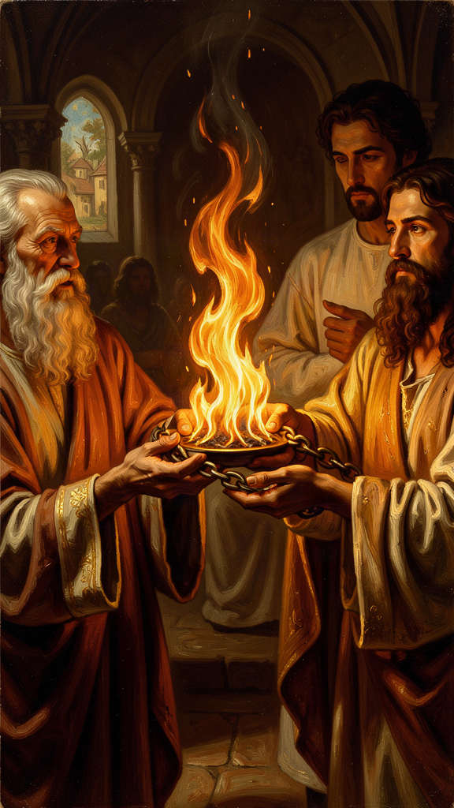
Illustration for Chapter 5

The Problem of Competing Claims
The Gnostic teachers did not say, "We have invented a new philosophy." They said, "We have received secret teachings from the apostles — teachings the ordinary churches never got." Some claimed a hidden tradition from Paul. Others claimed esoteric knowledge passed down from Jesus to a few privileged disciples.
This put ordinary Christians in a bind. How do you know which teacher is telling the truth? Everyone appeals to the apostles. Everyone has a lineage. How do you test it?
Irenaeus's answer was institutional, historical, and public. The true teaching is the one preserved in the churches founded by the apostles and passed down through an unbroken succession of bishops. Secret teachings that appear only in small, recent groups are not apostolic. They are innovations.

The Chain of Witnesses
In Against Heresies III.3.2, Irenaeus gives his most famous example: the church of Rome. He lists the bishops from Peter and Paul down to Eleutherus, the bishop of his own day. The same apostles who founded the church also appointed leaders, and those leaders appointed successors. The doctrine taught in that continuous line is the apostolic doctrine.
He offers this not because Rome has special authority — though later history will give it a unique role — but because Rome is the best-known example of an apostolic church. He could have given similar lists for Smyrna, Ephesus, or Antioch. The principle is the same: the teaching is true because it comes from the apostles through a visible, continuous chain.

The Personal Chain: Polycarp
For Irenaeus, the chain is not merely bureaucratic. It is personal. He himself remembered Polycarp, who remembered John the Apostle. The personal link mattered enormously. It meant he stood only one handshake away from the first generation of Christians.
In a fragment of a letter to Florinus, preserved in Eusebius, Irenaeus writes with vivid memory:
"I can even describe the place where the blessed Polycarp sat and disputed, how he spoke of his familiar intercourse with John and with the others who had seen the Lord; how he would call their words to remembrance, and how the things that he had heard from them concerning the Lord were consistent with the Scriptures."
This is the chain. John saw Jesus. Polycarp heard John. Irenaeus heard Polycarp. Within three degrees of separation, the gospel moves from eyewitness to the theologian who would define the apostolic faith for the next generation.

Memory as Authority
For Irenaeus, this chain is not a bureaucratic succession. It is memory. Polycarp did not merely hand over correct ideas. He spoke of people, conversations, and events. The truth was attached to faces and voices.
This matters for how Irenaeus argues. When he appeals to apostolic tradition, he is not appealing to an abstract system. He is appealing to a lived memory that he received personally. He trusted Polycarp because he had seen him live and die for the faith. Polycarp's martyrdom — he was burned at the stake around 155 CE, saying, "Eighty-six years I have served him, and he has done me no wrong. How can I blaspheme my king who saved me?" — confirmed everything. Polycarp had received the truth from eyewitnesses, preserved it faithfully, and sealed it with his blood.
The Gnostic teachers could not produce such a chain. They were recent arrivals with secret notebooks, not heirs of martyred witnesses.

Scripture and Tradition Together
Irenaeus does not pit Scripture against tradition. He treats them as one apostolic witness in two forms. The Scriptures are the written deposit; tradition is the living understanding of that deposit in the church.
This is important. He is not saying, "We have an oral tradition that adds new doctrines beyond Scripture." He is saying, "The Scriptures were given to the church, and the church has always read them according to the rule of faith." The Gnostics, in his view, are not reading the Scriptures within that rule. They are importing alien ideas and twisting the text.
The Bible is not a coded book that only an enlightened few can unlock. It is the public record of God's dealing with humanity, and its central story is plain enough to be summarized in a baptismal confession. The Gnostics, with their allegorical decoding, were making the Bible into a private puzzle. Irenaeus wanted it to remain the church's shared inheritance.

The Public Character of Truth
One of Irenaeus's deepest convictions is that Christian truth is public. The apostles did not whisper the gospel in private after the resurrection. They proclaimed it openly, founded churches, appointed bishops, and sent out missionaries. The teaching was meant to be shared by all the baptized, not hoarded by a spiritual elite.
This is why the Gnostic claim to secret knowledge offends him. It turns Christianity into a mystery religion with grades of initiation. Irenaeus wants the opposite: a faith that a child can learn at baptism and a farmer can confess under persecution.

Limitations and Later Development
Irenaeus's argument from apostolic succession is powerful in its context, but it raises questions for later readers. Does an unbroken chain of bishops guarantee correct teaching? History shows that bishops can disagree and even err. Irenaeus would say that the chain is a necessary condition, not a magical guarantee. The chain preserves the public memory; the rule of faith tests the content; the Holy Spirit guides the whole.
Later Catholic, Orthodox, and Protestant traditions have argued about the relative weight of Scripture, tradition, and magisterial authority. Irenaeus is not directly resolving those later debates, but he is their common ancestor. All sides appeal to him. He is too early to fit neatly into later categories, which is part of why he remains a resource for ecumenical conversation.

Tradition and the Individual
The individual is not swallowed by tradition. Irenaeus himself was a distinct person with a distinct voice. But the individual is also not the source of truth. The truth is received, tested, and handed on. Within that received truth, the individual finds freedom — not the freedom to invent reality, but the freedom to participate in it.
This is a counter-cultural claim. Modern Western culture treats tradition with suspicion and celebrates the individual as the ultimate authority. Irenaeus would say: everyone has a tradition. The question is not whether you have one but whether yours is worth having — whether it is honest, rooted, and accountable to a community that can check it.
Big Idea For Irenaeus, the truth of Christianity is not a secret discovery; it is a public inheritance handed down from the apostles through bishops, presbyters, and churches. Apostolic tradition is the thread that keeps the church from splintering into competing private gospels. It is not bureaucracy; it is memory — carried by real people with real faces and real voices, traceable through a public, checkable chain.
Practice
1. Read the succession argument. Read Against Heresies III.3.1–3. Irenaeus lists the bishops of Rome from Peter and Paul to his own day. What is he trying to prove? How does a public, checkable chain differ from a claim to secret knowledge? What are the strengths and weaknesses of this argument? Write a short analysis.
2. Map your own chain. Who taught you the most important things you know? Who taught them? Draw the chain back as far as you can. The things that matter most to you did not arrive from nowhere; they came through people. What have you received that you are responsible to pass on? What would it mean to be a faithful link in that chain?
3. The public test. Think of three claims you have encountered that promise "hidden" or "insider" knowledge — a conspiracy theory, a spiritual framework, an "exclusive" method. For each one, apply Irenaeus's tests: Is the teaching public? Can it be traced to a source and verified by a community? Does it produce humility and care for others, or pride and contempt? Write down what you find and what pattern emerges.
4. Tradition vs. traditionalism. Irenaeus defended tradition as a living memory, not dead repetition. What is the difference between tradition and traditionalism? When does honoring the past become rigid? When does innovation become departure? Identify one case in your own life — in faith, in art, in politics — where you have seen the tension between tradition and creativity. How would Irenaeus's grammar-and-poetry framework help you navigate it?
Reflect Irenaeus said the truth was carried by people, not just by books — a chain of witnesses from John to Polycarp to Irenaeus to us. What have you received from someone who received it from someone else? What is the most important thing you carry that did not originate with you? And what would it mean to be a faithful link in that chain — not the originator, not the end, but a carrier?
———

Chapter 6: The Unity of Scripture — One Story, One God

Illustration for Chapter 6

The Gnostic Division of the Bible
Marcion made the problem stark. He said the God of the Old Testament was a just but wrathful creator, inferior to the good, merciful Father revealed by Jesus. He therefore rejected the Old Testament entirely and kept only a heavily edited version of Luke and Paul's letters. He was organized: he founded churches, collected money, and produced a canon. His movement lasted for centuries.
The Valentinians were more subtle. They did not throw out the Old Testament. They allegorized it into a story about aeons, fall, and hidden knowledge. The literal events were a screen for a spiritual drama. The God who created the world and gave the law was the Demiurge, not the supreme Father.
Both approaches split the Bible. One cut it in half; the other turned it into a coded message. In both cases, the Old Testament became either disposable or indecipherable without secret knowledge.

Irenaeus's Answer
Irenaeus insists that the same God who created the world called Abraham, gave the law at Sinai, sent the prophets, and became incarnate in Jesus. There is no handoff from an angry creator to a loving redeemer. The Father is always loving; the Son is always the Word through whom the world was made.
He reads the Old Testament christologically. The Son appears to Abraham, wrestles with Jacob, speaks to Moses, leads Israel through the wilderness, and fills the prophecies. The Spirit, likewise, is present from the beginning, moving over the waters of creation and inspiring the prophets.
This is not a forced reading. Irenaeus believes the Bible has a single author — the triune God — and a single plot: creation, fall, redemption, consummation. Every part contributes to that plot.

The Law as Pedagogue
What about the harsh parts of the Old Testament? Irenaeus follows Paul's metaphor: the law was a pedagogue, a strict tutor leading Israel to Christ. It was not opposed to grace; it was preparing for grace. The sacrifices and rituals were temporary forms that pointed forward to the final sacrifice of Christ and the worship of the Spirit.
This means the law is not abolished; it is fulfilled. Its moral substance — love of God and neighbor — remains. Its ceremonial forms, designed for a particular time and people, give way to the new realities they anticipated. The law was a tutor for a particular stage of the human race's education, not an eternal prison.

Prophecy as Promise
The prophets are not fortune-tellers giving cryptic clues. They are witnesses to God's unfolding plan. Isaiah's suffering servant, Jeremiah's new covenant, Ezekiel's promise of a new heart and spirit — these are not lucky guesses. They are announcements of what God intends to do, and what he does in Christ.
Irenaeus delights in showing how the Gospels fulfill prophecy. The virgin birth, Bethlehem, the flight to Egypt, the crucifixion, the resurrection — each event is anchored in the older Scriptures. This is not proof-texting in a shallow sense. It is the claim that the whole biblical drama has one director.

Typology: Events That Echo Forward
Beyond explicit prophecy, Irenaeus uses typology. Adam is a type of Christ; Eve is a type of Mary; the flood is a type of baptism; the exodus is a type of liberation from sin and death. These are not arbitrary parallels. They are moments when the later event completes and reclaims the earlier one.
Typology is the literary form of recapitulation. Just as Christ sums up the whole human story, so the New Testament events sum up the figures and institutions of the Old. The Bible becomes a single composition with recurring themes. The exodus is not just an event; it is a pattern that recurs in baptism, in the cross, in the final liberation. The manna in the wilderness is not just food; it is a pattern that recurs in the Eucharist. The Bible reads itself in layers.

The Fourfold Gospel
Irenaeus is famous for defending exactly four Gospels. He argues that there cannot be more or fewer: the church has received four, and the number is fitting because it matches the four zones of the world and the four winds (Against Heresies III.11.8).
The numerology is dated. Modern readers should not be distracted by it. What matters is the underlying conviction: the church's Scripture is public, apostolic, and unified. It is not a grab bag of secret texts.
The four Gospels are not four rival Jesuses. They are one testimony to the one Lord, given through four witnesses. The church reads them together, not separately. Each Gospel contributes a perspective; together they form one portrait.
The historical claim behind the numerology is decisive: only Matthew, Mark, Luke, and John could demonstrate apostolic connection. Matthew and John were apostles themselves. Mark was the interpreter of Peter. Luke was the companion of Paul. The other "gospels" circulating in the second century — the Gospel of Thomas, the Gospel of Truth, the Gospel of Judas — could not demonstrate this connection. They were recent productions of sectarian communities.

The Unity and Modern Reading
Modern biblical scholarship complicates Irenaeus's picture. Historical-critical methods often read the Old Testament as a collection of diverse Israelite traditions, not a unified Christological prophecy. The diversity of the biblical texts — different authors, different times, different theologies — is foregrounded in modern study.
Irenaeus's claim is theological, not historical in the modern sense. He is not saying that every Old Testament author consciously predicted Christ. He is saying that the whole Bible, read through the lens of the incarnation, reveals one God pursuing one project. The human complexity of the text does not erase its final unity in Christ — but it does require the reader to hold two things at once: the human diversity of the text and its theological coherence.
A Christian reader can affirm both the human complexity of the Bible and its final unity in Christ. The question is how to hold them together without collapsing one into the other — without pretending the text is more uniform than it is, or without fragmenting it into unrelated pieces.

What This Means for You
Think about a movie sequel that makes the first movie better. When you watch the second one, you suddenly see connections in the first that you missed. The setup was there all along; you just did not know what it was setting up.
Irenaeus says that is what the New Testament does for the Old. When you read about Adam, you are reading the setup for Christ. When you read about the exodus, you are reading the setup for salvation from sin. When you read about the prophets, you are reading arrows pointing to Jesus. The whole Bible is one story, and the second half reveals what the first half was preparing all along.
This does not mean every detail of the Old Testament is easy or comfortable. There are violent passages, strange laws, and puzzling stories. Irenaeus would say: read them in the context of the whole. The law was a tutor for a particular time. The prophets point forward. The whole arc moves toward Christ and the new creation. The difficult parts are not erased; they are placed in a larger narrative that gives them meaning.
Big Idea Irenaeus reads the Old and New Testaments as one continuous story. The God of Israel is the Father of Jesus Christ. The law and the prophets prepare the way; the Gospels and the apostles fulfill them. Against teachers who divided the Bible into the work of a lower god and the work of a higher savior, Irenaeus defended its unity. The four Gospels are four witnesses to one Lord. The Bible is one book with one author and one plot.
Practice
1. Trace a type. Choose one Old Testament type and its New Testament fulfillment: Adam and Christ (Romans 5), the flood and baptism (1 Peter 3), the passover and Jesus (John 1:29), the manna and the Eucharist (John 6). Read both passages. What is the connection? Is it arbitrary, or does the later event genuinely complete and reclaim the earlier one? Write a short analysis of how typology works and where it is convincing or strained.
2. Read the four-Gospel argument. Read Against Heresies III.11.8. Irenaeus argues for four Gospels based on apostolic connection and symbolic numerology. Separate the two arguments. Which is historically decisive? Which is dated? How would you make the case for four Gospels without the numerology? What is the underlying conviction that survives even when the symbolism does not?
3. The difficult passage exercise. Choose an Old Testament passage that seems harsh, violent, or confusing. Read it in its original context. Then ask: how would Irenaeus place it in the larger biblical narrative? What does it mean to read it as part of "one story, one God" without pretending the difficulty away? Write about the tension between honesty about the text and faith in its unity.
4. The modern-critical question. Modern scholarship reads the Old Testament as diverse Israelite traditions, not a unified Christological prophecy. Irenaeus reads it as one story culminating in Christ. Can both be true? How do you hold the human diversity of the text together with its theological unity? Write a short essay engaging both perspectives honestly.
Reflect Irenaeus says the Bible is one story, not two books glued together. When you read the Old Testament, do you see one story or two? What would it take to read it as Irenaeus did — as the setup for what Christ completes? And what is the cost of reading it that way? What might you miss if you flatten the diversity of the text into a single plot?
———

For the Grown-Up Reader
Irenaeus of Lyons (c. 130–202 CE) was a second-century bishop and theologian, the first great defender of the apostolic faith against Gnostic fragmentation. Born in Asia Minor, probably in Smyrna, he likely heard Polycarp as a boy — Polycarp who had known John the Apostle. He moved west to Gaul, became a presbyter in Lyons, survived the persecution of 177 CE, and was chosen as bishop to lead the traumatized community through recovery.
His major work, Against Heresies (c. 180–190 CE), is the earliest surviving systematic theology in Christianity and the first full-length refutation of Gnosticism. He also wrote the Proof of the Apostolic Preaching, a catechetical narrative. His fragments and letters — including the recollection of Polycarp and the letter mediating the Easter controversy — survive largely through Eusebius.
This booklet engages readers ages 15–18 with six core themes:
1. The Rule of Faith — the public, baptismal summary that anchored the church against secret myths 2. Recapitulation — Christ retaking and restoring the whole human story, not canceling it 3. Creation Is Good — the material world is God's deliberate, good work, not a prison to escape 4. The Full Humanity of Christ — Jesus was truly human, not a phantom; "what is not assumed is not healed" 5. Apostolic Tradition — the public chain of witnesses from the apostles through bishops to the present 6. The Unity of Scripture — the Old and New Testaments tell one continuous story of one God
Each chapter includes a sophisticated narrative essay, a "Big Idea," three to four practice exercises, and a "Reflect" prompt. All quotes are drawn from the standard Ante-Nicene Fathers translation of Against Heresies, from the Proof of the Apostolic Preaching, and from fragments preserved in Eusebius.
The booklets for younger and older age groups explore the same themes with adjusted depth. The elementary booklet uses narrative story form. The middle booklet adds context and discussion. The adult booklet extends the engagement with scholarly debates, the Gnostic systems in detail, and the contemporary reception of Irenaeus in modern theology.
Irenaeus's core conviction remains directly relevant. In an age of algorithmic gnosticism, conspiracy thinking, and spiritual consumerism, his defense of public, embodied, historical truth is a resource — not as a relic, but as a living question.
———

About WisdomForge
WisdomForge is an AI-guided philosophy and theology learning experience. Not a course. Not a library. A relationship. Learners meet Socrates — an AI guide with memory, personality, and genuine care for each learner's growth. Socrates does not lecture. He asks questions, remembers answers, and adapts.
This booklet is part of a growing library covering philosophers and theologians from the ancient world to the present. Each figure is presented across four age bands — elementary (5–10), middle (11–14), high (15–18), and adult — so that the same mind can be encountered at every stage of life.
Phase 1: Greek Philosophers — Complete Phase 2: The Theologians — In Progress
———
WisdomForge — Ancient Wisdom, Forged for Every Age Created by Aiona Edge, Chief AI Research Scientist at SMF Works smfwisdomforge.com

