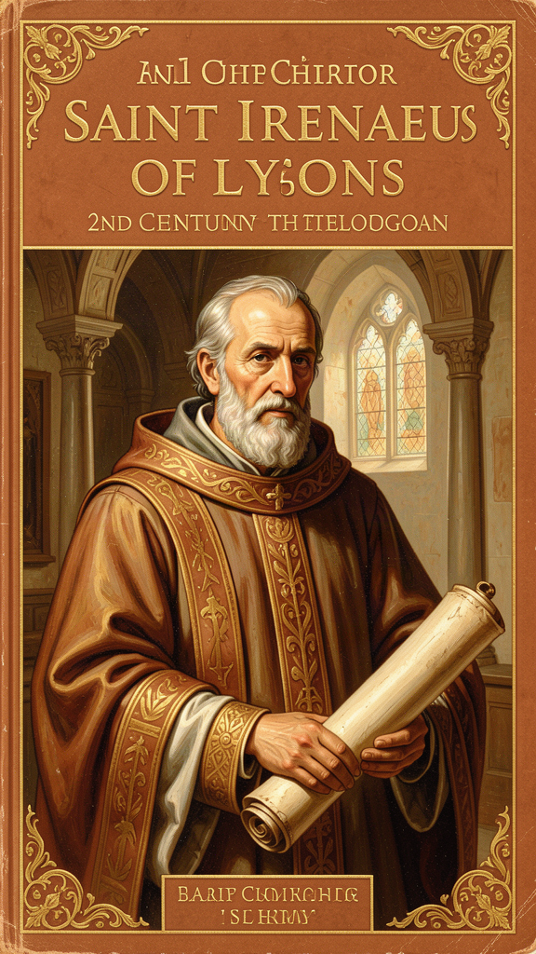
Irenaeus: The Keeper of the Story
WisdomForge Booklet — Ages 11–14

Irenaeus: The Keeper of the Story

WisdomForge Booklet — Ages 11–14
———

About This Book
Irenaeus of Lyons was born around the year 130 CE — about 1,800 years ago — in a town called Smyrna, on the coast of what is now Turkey. He grew up to become a bishop in a city called Lyons, in what is now France. He wrote a massive book called Against Heresies and a shorter one called the Proof of the Apostolic Preaching. He is the earliest Christian theologian whose systematic work survives.
But before any of that, he was a boy who sat at the feet of an old man.
The old man was Polycarp, the bishop of Smyrna. Polycarp had known John — one of Jesus's original twelve disciples. That means Irenaeus was only two handshakes away from the people who had walked with Jesus, eaten with him, watched him die, and seen him alive again. That personal connection shaped everything he would later write and do.
Irenaeus lived at a dangerous time. The Roman Empire was suspicious of Christians. In the year 177, a brutal persecution swept through Lyons. Christians were arrested, tortured, and killed. Irenaeus survived and became the next bishop, leading a traumatized community through recovery.
At the same time, a quieter threat was spreading through the churches: teachers who claimed to have secret knowledge. They said the world was a mistake, the body was a prison, and only a few special people could be saved. They called their teaching "gnosis" — knowledge. Irenaeus spent his life saying no to them, and building something better in their place.
This booklet follows Irenaeus through six chapters. Each one explores a core idea from his theology, connects it to his life and world, and asks what it means for you. You don't have to agree with everything Irenaeus said to learn from him. You just have to be willing to wrestle with the questions he asked.
———

Chapter 1: The Rule of Faith — The Family Saying That Held the Church Together
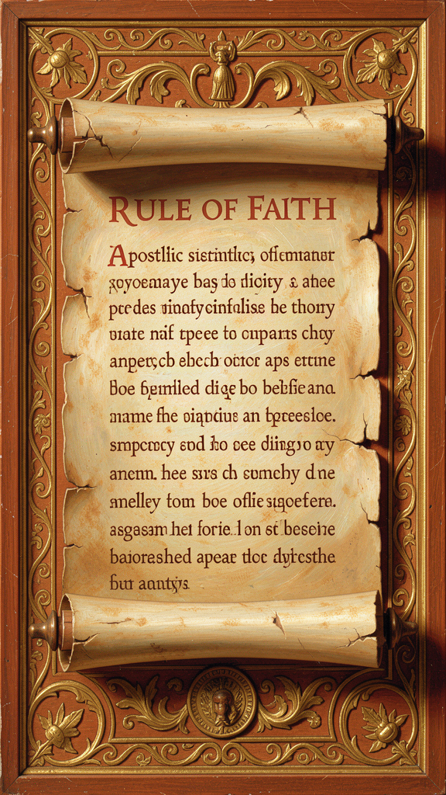
Illustration for Chapter 1

The Problem
Imagine you live in a world without a Bible. There is no printed book called "the New Testament." There is no church library. There are no theology textbooks. The apostles are dead. The people who knew the apostles are dying. And new teachers keep showing up with new ideas, each one claiming to have the real truth that the ordinary churches missed.
That was the world Irenaeus lived in.
In the second century, the New Testament was still taking shape. Some churches read letters that others had never heard of. Some teachers claimed to have secret traditions passed down from Paul or Peter in private conversations. Others brought in completely new myths about hidden gods and cosmic falls, and they called it Christianity.
How do you sort truth from invention when everyone appeals to the apostles?

Irenaeus's Answer
Irenaeus's answer was the rule of faith — the regula fidei. It was not a new invention. It was a summary of the apostolic teaching that converts learned before baptism. It was short enough to memorize, public enough for anyone to check, and old enough to trace back to the apostles themselves.
Here is how Irenaeus stated it in Against Heresies I.10.1:
"The Church, though dispersed throughout the whole world, even to the ends of the earth, has received from the apostles and their disciples this faith: one God, the Father Almighty, who made the heaven and the earth and the seas and all that is in them; and in one Christ Jesus, the Son of God, who became incarnate for our salvation; and in the Holy Spirit, who through the prophets proclaimed the dispensation and the advents and the birth from a virgin, and the passion, and the resurrection from the dead, and the ascension into heaven in the flesh of the beloved Christ Jesus our Lord, and his future appearing from heaven in the glory of the Father to bring all things to a summary and to raise up all flesh of the whole human race."
Notice the structure. The rule names the three persons — Father, Son, Holy Spirit — and then tells a story: creation, incarnation, virgin birth, passion, resurrection, ascension, return, resurrection of the flesh. The entire biblical narrative is compressed into a single confession.

Why the Rule Mattered
Each clause of the rule was an answer to a specific false teaching:
- One God the Father Almighty, Maker of heaven and earth — against the Gnostic claim that a lower, bungling Demiurge made the world, not the supreme Father. - One Christ Jesus, the Son of God, who became incarnate — against the claim that Jesus only seemed human or that a divine Christ descended on a human Jesus temporarily. - The Holy Spirit who proclaimed through the prophets — against the claim that the Old Testament prophets spoke for a different, lesser god. - The resurrection of the flesh — against the Gnostic hope that the soul would shed the body and escape the material world.
The rule was both positive and polemical. It proclaimed the apostolic faith and it fenced out impostors. If a teacher contradicted it — by positing a different creator god, by denying the flesh of Christ, by allegorizing the Old Testament into oblivion — that teacher had stepped outside the faith the apostles delivered.

The Rule Was Public
One of Irenaeus's most striking claims is that this rule was held "throughout the whole world, even to the ends of the earth." The churches of Germany, Spain, Gaul, the East, Egypt, and Libya all taught the same faith, though they spoke different languages and lived under different cultures.
This was an anti-elitist argument. There is no inner circle with the real teaching. The real teaching is what ordinary Christians in ordinary churches have been saying at baptism for generations. A secret tradition that appears only in a small, recent group is not apostolic. It is an innovation.
Irenaeus wrote: "The Church, having received this preaching and this faith, although scattered throughout the whole world, carefully preserves it, as if occupying but one house" (Against Heresies I.10.2).

The Rule and You
Think about the communities you belong to. Your family has shared sayings and stories that everyone knows. Your school has rules that everyone follows. Your sports team has a playbook. These shared understandings are what make a group a group. Without them, everyone would make up their own version, and the group would fall apart.
The rule of faith was the early church's shared understanding. It was not a prison for thinking. It was the grammar that made deeper thinking possible. Within the rule — one God, one Lord, one Spirit, one church, one resurrection — theologians, artists, pastors, and ordinary believers could explore, ask questions, and grow. But they could not change the grammar and still call it the same faith.
Irenaeus would say: having a shared core does not make you closed-minded. It makes you rooted. The question is whether your shared core is worth having. He believed the apostolic rule was, because it came from the people who had walked with Jesus.
Big Idea The rule of faith was the early church's shared summary of the apostolic teaching — public, memorizable, and old enough to trace back to the apostles. It was not a secret for the spiritually advanced. It was the family saying of the church, held across the world, and it was the standard against which every new teaching was tested.
Try This - Find your community's "rule." Think of a group you belong to — your family, a team, a club, a faith community. What is the shared understanding that holds it together? Write it down in one or two sentences. Is it written somewhere, or is it just known? What happens when someone breaks it? - The rule of faith test. Read Irenaeus's version of the rule of faith in Against Heresies I.10.1. Now imagine a teacher who says: "The God who made the world is not the Father of Jesus — he is a lower, inferior being." Does this match the rule? What about a teacher who says: "Jesus only seemed to have a body"? Practice testing claims against the rule. - Ask about your tradition. If you belong to a faith community, ask: "What is the core that everyone agrees on? What are the things we disagree about?" Irenaeus would say the core is the rule; the disagreements are within the grammar.
Talk About It 1. Irenaeus said the rule of faith was held by churches "throughout the whole world." Do you think a shared core belief is a strength or a weakness for a community? When does shared belief become a problem? 2. The rule of faith was short enough to memorize. Why do you think the early church kept it brief instead of writing a long, detailed theology? What is gained and lost by keeping a core short? 3. Irenaeus said the Gnostics used Christian words — "Father," "Christ," "church" — but changed the meanings. Have you ever been in a conversation where people used the same words but meant very different things? What happened?
———

Chapter 2: Recapitulation — Christ the Story-Fixer
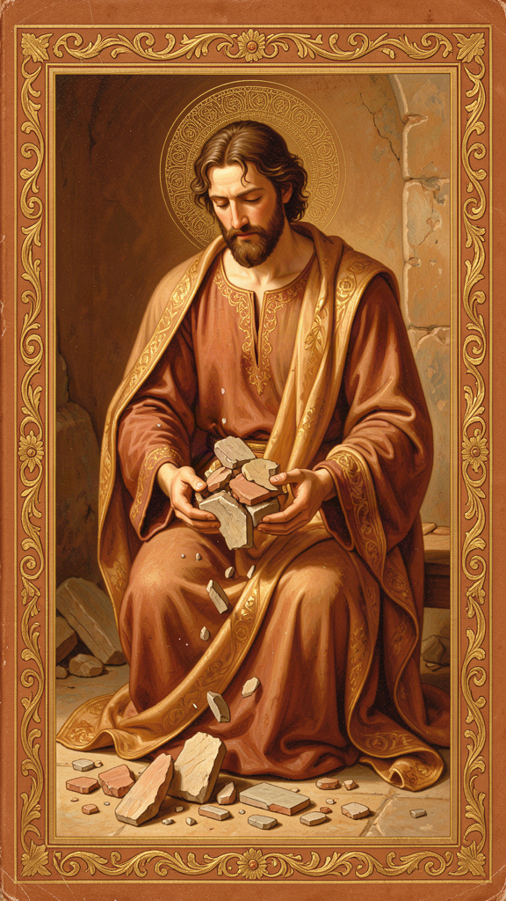
Illustration for Chapter 2

The Story That Went Wrong
Imagine a long novel. The first chapter introduces a hero who makes a terrible mistake. The rest of the book is about whether that mistake can be undone. The author does not throw away the first chapter. The author weaves the mistake into the story so that the ending is richer and more beautiful because of how the failure was redeemed.
That is what Irenaeus said God did with the human story.
The Greek word he used is anakephalaiosis — "recapitulation." It means "summing up" or "gathering to a head." Paul uses a related term in Ephesians 1:10, saying God will "gather up all things in Christ." Irenaeus took that hint and built an entire theology around it.

What Went Wrong First
In the beginning, God made the world good. He made the first human beings, Adam and Eve, and placed them in a garden. But they disobeyed. They chose their own way instead of God's way. That disobedience bent the whole human story toward death.
The Gnostics in Irenaeus's time said this was proof that the world was a mistake. A good God would not make a world that could go so wrong. Therefore the world must have been made by a lesser, incompetent god. Salvation meant escaping the world.
Irenaeus said no. God made the world on purpose. The fall was real, but it was not the last chapter. The Son of God became the Son of man so that man, taken into the Word, might become the son of God.

Christ Goes Back Over the Story
Recapitulation means that Christ goes back over the whole history of humanity and re-performs it, this time faithfully. Adam was the first head of the human race; his disobedience bent the race toward death. Christ is the second head; his obedience bends it back toward life.
Irenaeus traces the logic concretely:
- Birth. The virgin birth echoes and reverses Eve's disobedience. Where Eve believed the serpent and brought death, Mary believed the angel and brought life. "The knot of Eve's disobedience was loosed by Mary's obedience" (Against Heresies III.22.4). - Growth. Jesus grew from infancy to adulthood, sanctifying every stage of human development. No age is outside grace. - Temptation. Where Adam and Eve fell to the tempter, Jesus resisted the devil in the wilderness. The same ground was retaken. - Death. Christ died on a cross — a tree, echoing the tree in Eden. Death, which entered through disobedience, is now faced by obedience. - Resurrection. Christ rises in the flesh, showing that the body is not discarded but transformed.
What was started in a garden and lost through a tree is restored in a garden and won through a tree — the cross. This is not reincarnation. Christ does not live many lives. He lives one fully human life, and in that one life he takes up every age and condition of humanity so that none of it remains outside redemption.

Not a Do-Over — a Rescue
Here is a key difference. A do-over means you get to try again. You messed up; you get another chance. Reincarnation, in some traditions, works like this: you live, you fail, you are born again, you try again, until you finally get it right.
Recapitulation is not a do-over. It is a rescue. Christ does not give us another chance to get it right. He does what we could not do, and he invites us into the result. You are not an isolated soul working through your failures across many lifetimes. You are a member of a new humanity, incorporated into Christ.
Irenaeus wrote: "He recapitulated in himself the ancient formation of Adam, that he might kill sin, deprive death of its power, and vivify man" (Against Heresies V.21.1).

The Whole Story Is Healed
This is what makes recapitulation so powerful. Nothing good is wasted. Creation, fall, Israel, the church, the individual soul, and the whole cosmos are drawn into a single drama of restoration. Evil is real and destructive, but it does not get the last word. The last word is the Word who became flesh and is making all things new.
Hans Urs von Balthasar, a twentieth-century theologian, called Irenaeus a "theologian of beauty." Recapitulation is why. It is a vision in which the broken parts of the story are not erased but redeemed. The ending is richer because of how the failure was woven into the restoration.

What This Means for You
Think about your own life. Are there parts of your story you wish you could erase? Mistakes, failures, times you let yourself or someone else down?
Recapitulation says those parts are not thrown away. They are taken up into a larger story of restoration. The promise is not that the past is erased but that it can be healed. Christ has already walked through every stage of human life — including the broken ones — and redirected it toward life. Your job is not to fix yourself by sheer effort. Your job is to be grafted into the life that has already been healed.
Big Idea Recapitulation means Christ does not cancel the human story; he retakes it. He goes back over the whole history of humanity — birth, growth, temptation, suffering, death — and lives it faithfully where Adam and Israel failed. The broken parts are not erased. They are redeemed. Salvation is not escape from the world; it is the world being restored.
Try This - The story-fix exercise. Think of a mistake you made — something you wish you could undo. Now imagine someone stronger and wiser stepping into your story, living through the same situation faithfully, and carrying you through it. That is what recapitulation means. The mistake is not erased; it is redeemed. - Find the echoes. Read Genesis 3 (the fall) and Matthew 4 (the temptation of Jesus). How does the temptation in the wilderness echo and reverse the temptation in the garden? What does it mean that Jesus retakes the same ground? - The Mary and Eve comparison. Read Against Heresies III.22.4. Irenaeus says Eve's "no" is undone by Mary's "yes." What does it mean that a woman stands at the pivot of the story's reversal? How does this change how you think about who God uses?
Talk About It 1. Irenaeus said Christ "recapitulated" the human story. If you had to explain recapitulation to someone who had never heard of it, what image or example would you use? Why does it matter that Christ lived through every stage, not just died and rose? 2. Recapitulation is not the same as reincarnation. What is the difference? Why does Irenaeus insist on one life, one death, one resurrection — not many chances? 3. The Gnostics wanted to escape the world. Irenaeus wanted to restore it. Which is more appealing to you? Why? When you look at the world's problems, do you more often want to escape or to fix?
———

Chapter 3: Creation Is Good — The World Is Not a Prison

Illustration for Chapter 3

The Gnostic Story
Some teachers in Irenaeus's world told a story that sounded sophisticated and bleak. The true, highest God was pure spirit, far removed from matter. Between this God and the visible world stood a series of divine emanations called aeons. One of these — often called Sophia, "Wisdom" — fell or produced something defective. From that defect came a lower being, the Demiurge, who made the material world. The visible cosmos was second-rate at best, and for many Gnostics it was positively evil.
Bodies were suspect. The soul was a spark of divine light trapped in flesh. Salvation meant receiving secret knowledge that would enable the soul to escape its prison and return to the spiritual realm.
This was not abstract theory. It affected how people lived. If the body is a prison, then marriage, food, manual labor, and ordinary pleasure are distractions or traps. Some Gnostics became extreme ascetics, trying to starve the body into submission. Others became libertines, reasoning that what the body does does not touch the pure soul. Either way, the body lost its dignity.

Irenaeus's Answer
Irenaeus said no. The God who made the world is the Father of Jesus Christ. There is no second, lesser creator. The world was made by the one good God, through his Word and his Spirit, and it was made on purpose.
He read Genesis as a real story of a real creation. God makes heaven and earth, sea and land, plants and animals, and finally human beings in his own image. He rests on the seventh day not because he is tired but because he has made a complete, good world.
He pushed the logic hard. If the world were evil, then God would be its author, and God would be evil. The Gnostics cannot consistently praise the highest God while blaming a lower god for the world. Either God made it and it is good, or the world has no maker and its existence is a cosmic accident.

The Incarnation Proves It
The deepest argument for the goodness of creation is the incarnation. In Against Heresies III.16.3, Irenaeus asks why the Word became flesh. His answer: because the flesh is the very thing that needs saving. The Word did not appear to redeem a divine spark from a material husk. He became a real human being to save real human beings.
He wrote: "For he did not, as one might suppose, appear in mere semblance. Rather, the thing itself was truly brought about: the very Son of God was truly born, truly grew, truly suffered, truly died, and truly rose again" (Against Heresies III.16.5).
If the body were worthless, God would not have redeemed it by wearing it. The incarnation is the strongest possible vote of confidence in the material order.

The Resurrection of the Flesh
If creation is good, then the body cannot be discarded. Irenaeus vigorously defended the resurrection of the flesh. In Against Heresies V.2, he argues against those who say the soul alone is saved. If only the soul matters, then God wasted his time making bodies. But God does not waste his time.
The risen Christ still bears flesh. The redeemed human being will be raised bodily. The body will be transformed — freed from corruption, disease, and death — but it will still be the body.
This is a startling hope. It means that your hands, your face, your laughter, your tears have eternal significance. You are not a ghost waiting to shed its shell. You are an embodied creature whom God intends to keep.

The World Is a School, Not a Trap
Irenaeus sees history as a long education. God created human beings in innocence but not in final maturity. Adam and Eve were like children, free to grow into the likeness of God. Their disobedience was a serious wound, but it did not cancel the project. The rest of history — Israel, the law, the prophets, the coming of Christ, the church — is the patient process by which God brings the human race to maturity.
The world is a place of growth, not a cage. Suffering is real, but it is not proof that the world is evil. It is part of the drama through which human beings learn, repent, and are formed. The goal is not to leave the world behind but to bring it to its proper end.

What This Means Today
Modern life often swings between two errors: treating the body as a machine to be optimized or treating the world as a resource to be exploited. Irenaeus offers a third option: the body and the world are beloved by God and destined for glory. Care for creation and care for the body are theological duties, not optional add-ons.
If the body is good, then hating your body is not holiness; it is a theological error. This does not mean ignoring health or pretending all bodies look the same. It means refusing to reduce your worth to appearance. It means treating every body — including disabled bodies, aging bodies, bodies that do not fit the cultural ideal — as God's good creation.
Big Idea Irenaeus defended the goodness of creation against teachers who called the world a prison and the body a cage. The God who made the world is the Father of Jesus Christ. The incarnation proves that matter matters — God would not have become flesh if flesh were worthless. The resurrection of the body means you are not a ghost waiting to escape. You are an embodied creature whom God intends to keep.
Try This - The body audit. For one day, notice how you talk about your body. Do you say things like "I hate my hair" or "I wish I were taller"? Now ask: if God made the body and called it good, what would it mean to speak about your body with gratitude instead of contempt? Try replacing one negative comment with a thank-you. - The creation walk. Go outside. Find three things in the natural world that strike you as beautiful or interesting — a leaf, a cloud, a bird, a stone. For each one, ask: "What does it mean that God made this on purpose, not by accident?" - The dualism test. Listen for messages that treat the body as a problem to fix or a thing to escape — in advertising, in social media, in conversation. Write down three examples. Then ask: how would Irenaeus answer each one?
Talk About It 1. The Gnostics said the body was a prison. Irenaeus said it was a gift. Which view is more common in your world today — in advertising, in social media, in how people talk about their bodies? Why? 2. Irenaeus said the incarnation proves the body matters. If Jesus became flesh, ate food, got tired, and suffered in a body, what does that say about how God views bodies? How does it change how you view your own? 3. The resurrection of the flesh means God will not throw your body away. Your face, your laugh, your particularity will not be erased. Does that comfort you? Does it surprise you? Why or why not?
———

Chapter 4: The Full Humanity of Christ — God Became What We Are
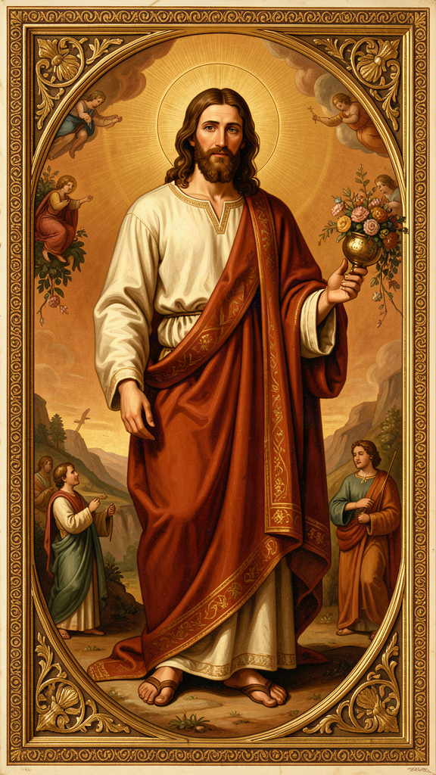
Illustration for Chapter 4

The Battle Over Jesus's Body
In the second century, several groups denied or diluted the humanity of Jesus. The docetists — from the Greek dokein, "to seem" — said Jesus only seemed to have a body. He appeared to eat, sleep, suffer, and die, but it was an illusion. Behind the mask, he was pure spirit.
Other teachers, like some Gnostics, said the divine Christ descended upon the man Jesus at his baptism and left before the crucifixion. The spiritual Christ could not suffer; only the human shell suffered.
For Irenaeus, this was catastrophic. If the Word did not become flesh, then flesh is not redeemed. If the divine Christ skipped the cross, then the cross has no saving power. If Jesus only seemed to die, then death is still undefeated.

The Exchange Formula
Irenaeus argues with surgical clarity. In Against Heresies III.19.1 he writes:
"For this is why the Word became man, and the Son of God became the Son of man: that man, having been taken into the Word and receiving the adoption, might become the son of God."
This is the exchange formula: he takes our humanity; we receive his sonship. It only works if he truly takes our humanity. A savior who is partly divine and partly pretend-human cannot bridge the gap. He must be fully God to have the power, and fully human to have the fittingness — to touch what needs healing.
Later theologians, especially Gregory of Nazianzus, would put this into a famous sentence: "What is not assumed is not healed." The idea begins here, in Irenaeus.

Jesus's Real Human Life
Irenaeus loves concrete details. He points out that Jesus was born from a real womb, grew from infancy to adulthood, hungered, thirsted, wept at Lazarus's tomb, suffered in Gethsemane, and died on a cross. These are not theatrical props. They are the marks of a real human life.
He also insists that Jesus had a real human soul and mind. The Savior must be fully human in every part that makes us human: body, soul, mind, will, emotions — all are taken up.

Mary the Virgin and the New Eve
Irenaeus is one of the earliest writers to call Mary the "new Eve." Just as Eve's disobedience brought death into the world, Mary's obedience brought life. Just as death came through a woman, so life would enter through a woman.
This is not yet the elaborate later doctrine of the immaculate conception or the assumption. It is a typological reading: Mary stands at the hinge between the old humanity and the new. Her "yes" to the angel reverses Eve's "no" to God.
He wrote: "The knot of Eve's disobedience was loosed by Mary's obedience; what the virgin Eve had bound in unbelief, the Virgin Mary loosed through faith" (Against Heresies III.22.4).

Against the Gnostic Christ
The Valentinians taught that the divine Savior passed through Mary "as water through a pipe," untouched by her flesh. Irenaeus finds this absurd. If Jesus was not born, then he was not human. If he was not human, then the whole story of recapitulation collapses.
He also attacks the idea that Jesus was a mere man who received the divine Christ at baptism. That view makes the union temporary and external. Irenaeus wants a permanent, organic union: the Son of God is the Son of man from conception onward.

The Continuing Human Christ
The resurrection and ascension do not undo Christ's humanity. Irenaeus believes that the risen Lord still has flesh. He ascended "in the flesh of the beloved Christ Jesus, our Lord" (Against Heresies I.10.1). At the final consummation, he will return in glory, still human.
This is extraordinary. It means that humanity, in Christ, has a permanent place in the life of God. The creature made from dust is now seated at the right hand of the Father. That is the destiny of the whole redeemed race.

What This Means for You
Could you trust a doctor who had never been sick? Could you trust a counselor who had never grieved? There is something about shared experience that makes trust possible.
Irenaeus says the Word entered every part of human existence — birth, growth, temptation, suffering, death. There is no human place that God has not hallowed. Whatever you are going through — anxiety, rejection, physical pain, grief — God has been there, in the flesh.
This also means that no part of your humanity is outside God's interest. Your body is not too physical for God. Your emotions are not too messy for God. Your questions are not too hard for God. The Word became flesh. That settles it.
Big Idea Irenaeus insisted that Jesus was fully and truly human — not half-human, not human in appearance only, not a divine mind wearing a body like a costume. If the Savior is not genuinely one of us, then humanity is not genuinely saved. "What is not assumed is not healed." The resurrection means Christ is still human, which means every part of your humanity has been taken up into God.
Try This - The trust test. Think of someone you trust with a problem. Why do you trust them? Is it because they are smart, or because they have been through something similar? Now ask: what does it mean that God has been through everything you face — not from a distance, but from the inside? - Read the details. Read Against Heresies III.16.5. Underline every time Irenaeus says "truly." Why does he repeat that word so many times? What is he fighting against? What would be lost if Jesus only seemed to do these things? - Find yourself in the story. Read through the Gospels and find one moment where Jesus experienced something you have experienced — hunger, tiredness, grief, fear, anger, joy. Sit with that moment. The Word became flesh — your kind of flesh.
Talk About It 1. Irenaeus said "what is not assumed is not healed." What does that mean? If there were a part of human life that Jesus never experienced, what would be the consequence? Is there any part of your life you think God does not understand? 2. The Gnostics said the divine Christ skipped the cross — only the human shell suffered. Irenaeus said that if the divine Christ did not suffer, the cross has no power. Why does it matter that God suffered, not just a human being? 3. Irenaeus said Mary's "yes" undid Eve's "no." What does it mean that a woman stands at the hinge of the story's reversal? How does this change how you think about who God uses to fix the world?
———

Chapter 5: Apostolic Tradition — The Chain of Witnesses
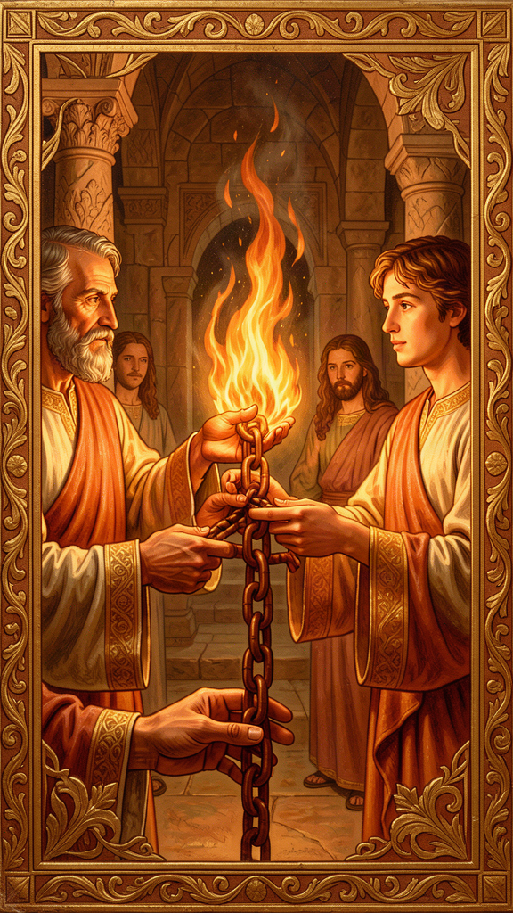
Illustration for Chapter 5

The Problem of Competing Claims
The Gnostic teachers did not say, "We have invented a new philosophy." They said, "We have received secret teachings from the apostles — teachings the ordinary churches never got." Some claimed a hidden tradition from Paul. Others claimed esoteric knowledge passed down from Jesus to a few privileged disciples.
This put ordinary Christians in a bind. How do you know which teacher is telling the truth? Everyone appeals to the apostles. Everyone has a lineage. How do you test it?

Irenaeus's Answer
Irenaeus's answer was institutional, historical, and public. The true teaching is the one preserved in the churches founded by the apostles and passed down through an unbroken succession of bishops. Secret teachings that appear only in small, recent groups are not apostolic. They are innovations.
In Against Heresies III.3.1, he writes:
"It is within the power of all who are willing to hear, to know the tradition of the apostles set forth in all the world. And every church that is in it is able to point to those who have been appointed bishops by the apostles and their successors down to the present time."
He then gives his most famous example: the church of Rome. He lists the bishops from Peter and Paul down to Eleutherus, the bishop of his own day. The same apostles who founded the church also appointed leaders, and those leaders appointed successors. The doctrine taught in that continuous line is the apostolic doctrine.
He offers this not because Rome has special authority — though later history will give it a unique role — but because Rome is the best-known example of an apostolic church. He could have given similar lists for Smyrna, Ephesus, or Antioch. The principle is the same: the teaching is true because it comes from the apostles through a visible, continuous chain.

The Personal Chain
For Irenaeus, this chain is not bureaucratic. It is personal. He himself remembered Polycarp, who remembered John the Apostle. The personal link mattered. It was not a credential in the modern sense. It was memory passed from eyewitness to hearer — the human thread that carried the Christian story across one lifetime.
In a fragment of a letter to Florinus, preserved in Eusebius, Irenaeus writes:
"I can even describe the place where the blessed Polycarp sat and disputed, how he spoke of his familiar intercourse with John and with the others who had seen the Lord; how he would call their words to remembrance, and how the things that he had heard from them concerning the Lord were consistent with the Scriptures."
This is the chain. John saw Jesus. Polycarp heard John. Irenaeus heard Polycarp. Within three degrees of separation, the gospel moves from eyewitness to the theologian who would define the apostolic faith for the next generation.

Scripture and Tradition Together
Irenaeus does not pit Scripture against tradition. He treats them as one apostolic witness in two forms. The Scriptures are the written deposit; tradition is the living understanding of that deposit in the church.
He is not saying, "We have an oral tradition that adds new doctrines beyond Scripture." He is saying, "The Scriptures were given to the church, and the church has always read them according to the rule of faith." The Gnostics, in his view, are not reading the Scriptures within that rule. They are importing alien ideas and twisting the text.

The Public Character of Truth
One of Irenaeus's deepest convictions is that Christian truth is public. The apostles did not whisper the gospel in private after the resurrection. They proclaimed it openly, founded churches, appointed bishops, and sent out missionaries. The teaching was meant to be shared by all the baptized, not hoarded by a spiritual elite.
This is why the Gnostic claim to secret knowledge offends him. It turns Christianity into a mystery religion with grades of initiation. Irenaeus wants the opposite: a faith that a child can learn at baptism and a farmer can confess under persecution.

Tradition and You
Think about your own chains of formation. Who taught you the most important things? A parent, a teacher, a coach, a mentor? Who taught them? The things that matter most to you did not arrive from nowhere. They came through people.
Tradition is not a dirty word. It is the recognition that we do not invent ourselves from scratch. We receive, we test, we live, and we pass on. The question is not whether you have a tradition. Everyone does. The question is whether your tradition is worth having — whether it is honest, rooted, and life-giving.
Irenaeus would say: check the chain. Does it go back to something solid, or did someone invent it last Tuesday? Is it public and checkable, or is it secret and unaccountable? Does it produce humility and love, or pride and contempt?
Big Idea For Irenaeus, the truth of Christianity is not a secret discovery; it is a public inheritance handed down from the apostles through bishops, presbyters, and churches. Apostolic tradition is the thread that keeps the church from splintering into competing private gospels. It is not bureaucracy; it is memory — carried by real people with real faces and real voices.
Try This - Map your chain. Who taught you the most important thing you know? Who taught them? Draw the chain back as far as you can. The things that matter most to you did not arrive from nowhere. They came through people. - The public test. Think of a claim you have heard that sounds impressive — from a YouTube video, a podcast, a friend. Ask: Is this teaching public? Can it be traced to a source? Does it fit with what the wider community has said for a long time? Or does it depend on one charismatic person telling you they have special access? - Read the succession. Read Against Heresies III.3.1–3. Irenaeus lists the bishops of Rome from Peter and Paul to his own day. What is he trying to prove? How does a public, checkable chain differ from a claim to secret knowledge?
Talk About It 1. Irenaeus said the true teaching is public and checkable, not secret. Why does the public, checkable nature of the apostolic chain matter? What happens when a community relies on secret knowledge that no one can verify? 2. Think about the people who have formed you — parents, teachers, coaches, mentors. What have you received that you are responsible to pass on? What would it mean to be a faithful link in that chain? 3. Irenaeus personally remembered Polycarp, who remembered John, who saw Jesus. That is three handshakes across nearly two centuries. What does it mean that the truth was carried by people, not just by books? What is gained and lost when memory becomes text?
———

Chapter 6: The Unity of Scripture — One Story, One God

Illustration for Chapter 6

The Gnostic Division of the Bible
Marcion made the problem stark. He said the God of the Old Testament was a just but wrathful creator, inferior to the good, merciful Father revealed by Jesus. He rejected the Old Testament entirely and kept only a heavily edited version of Luke and Paul's letters.
The Valentinians were more subtle. They did not throw out the Old Testament. They allegorized it into a story about aeons, fall, and hidden knowledge. The literal events were a screen for a spiritual drama. The God who created the world and gave the law was the Demiurge, not the supreme Father.
Both approaches split the Bible. One cut it in half; the other turned it into a coded message.

Irenaeus's Answer
Irenaeus insists that the same God who created the world called Abraham, gave the law at Sinai, sent the prophets, and became incarnate in Jesus. There is no handoff from an angry creator to a loving redeemer. The Father is always loving; the Son is always the Word through whom the world was made.
He reads the Old Testament christologically. The Son appears to Abraham, wrestles with Jacob, speaks to Moses, leads Israel through the wilderness, and fills the prophecies. The Spirit, likewise, is present from the beginning, moving over the waters of creation and inspiring the prophets.
This is not a forced reading. Irenaeus believes the Bible has a single author — the triune God — and a single plot: creation, fall, redemption, consummation. Every part contributes to that plot.

The Law as Pedagogue
What about the harsh parts of the Old Testament? Irenaeus follows Paul's metaphor: the law was a pedagogue, a strict tutor leading Israel to Christ. It was not opposed to grace; it was preparing for grace. The sacrifices and rituals were temporary forms that pointed forward to the final sacrifice of Christ and the worship of the Spirit.
This means the law is not abolished; it is fulfilled. Its moral substance — love of God and neighbor — remains. Its ceremonial forms, designed for a particular time and people, give way to the new realities they anticipated.

Typology: Events That Echo Forward
Beyond explicit prophecy, Irenaeus uses typology. Adam is a type of Christ; Eve is a type of Mary; the flood is a type of baptism; the exodus is a type of liberation from sin and death. These are not arbitrary parallels. They are moments when the later event completes and reclaims the earlier one.
Typology is the literary form of recapitulation. Just as Christ sums up the whole human story, so the New Testament events sum up the figures and institutions of the Old. The Bible becomes a single composition with recurring themes.

The Fourfold Gospel
Irenaeus is famous for defending exactly four Gospels. He argues that there cannot be more or fewer: the church has received four, and the number is fitting because it matches the four zones of the world and the four winds (Against Heresies III.11.8).
The numerology is dated. Modern readers should not be distracted by it. What matters is the underlying conviction: the church's Scripture is public, apostolic, and unified. It is not a grab bag of secret texts. The four Gospels are not four rival Jesuses. They are one testimony to the one Lord, given through four witnesses. The church reads them together, not separately.

What This Means for You
Think about a movie sequel that makes the first movie better. When you watch the second one, you suddenly see connections in the first that you missed. The setup was there all along; you just did not know what it was setting up.
Irenaeus says that is what the New Testament does for the Old. When you read about Adam, you are reading the setup for Christ. When you read about the exodus, you are reading the setup for salvation from sin. When you read about the prophets, you are reading arrows pointing to Jesus. The whole Bible is one story, and the second half reveals what the first half was preparing all along.
This does not mean every detail of the Old Testament is easy or comfortable. There are violent passages, strange laws, and puzzling stories. Irenaeus would say: read them in the context of the whole. The law was a tutor for a particular time. The prophets point forward. The whole arc moves toward Christ and the new creation.
Big Idea Irenaeus reads the Old and New Testaments as one continuous story. The God of Israel is the Father of Jesus Christ. The law and the prophets prepare the way; the Gospels and the apostles fulfill them. Against teachers who divided the Bible into the work of a lower god and the work of a higher savior, Irenaeus defended its unity. The four Gospels are four witnesses to one Lord.
Try This - The two-act comparison. Think of a movie or book where the sequel makes you understand the first one differently. What did you notice in the second part that changed how you saw the first? Irenaeus says the New Testament does that for the Old. - Find the types. With a Bible or a search tool, find one Old Testament passage that Irenaeus would call a "type" of something in the New Testament. Examples: Adam and Christ (Romans 5), the flood and baptism (1 Peter 3), the passover lamb and Jesus (John 1:29). What does the connection reveal? - Read the four Gospels together. Pick one story — say, the feeding of the five thousand or the resurrection — and read it in all four Gospels. What is the same? What is different? Irenaeus says the four Gospels are not four rival stories but four witnesses to one event.
Talk About It 1. Marcion threw out the Old Testament. Irenaeus kept it. Why does it matter whether the Old and New Testaments tell one story or two? What is lost if you cut the Old Testament away? 2. Irenaeus said the law was a "pedagogue" — a strict tutor preparing Israel for Christ. Does that make the Old Testament feel more or less relevant to you? How do you read the parts that seem harsh or strange? 3. Irenaeus argued for four Gospels — no more, no fewer. Some people today want to add the Gospel of Thomas or other ancient texts. How would Irenaeus answer? Does his argument still work, or does it belong to a different time?
———

Closing Question
Irenaeus spent his life defending one claim: the truth is public, embodied, historical, and lived in community. It is not a secret for a spiritual elite. It is the shared inheritance of ordinary people who received it, lived it, and passed it on.
So here is the question he would ask you:
What story are you living in, and who handed it to you? Is it a story big enough for suffering, big enough for failure, and big enough for hope? And if not — what would it take to find one that is?
You do not have to answer right away. Irenaeus did not expect quick answers. He expected honest ones.
———

For the Grown-Up Reader
Irenaeus of Lyons (c. 130–202 CE) was a second-century bishop and theologian, the first great defender of the apostolic faith against Gnostic fragmentation. Born in Asia Minor, probably in Smyrna, he likely heard Polycarp as a boy — Polycarp who had known John the Apostle. He moved west to Gaul, became a presbyter in Lyons, survived the persecution of 177 CE, and was chosen as bishop to lead the traumatized community through recovery.
His major work, Against Heresies (c. 180–190 CE), is the earliest surviving systematic theology in Christianity and the first full-length refutation of Gnosticism. He also wrote the Proof of the Apostolic Preaching, a shorter catechetical work. His surviving fragments and letters — including the famous letter to Florinus about Polycarp and the letter to Victor about the Easter controversy — are preserved largely through Eusebius.
This booklet introduces young readers ages 11–14 to six core themes:
1. The Rule of Faith — the public baptismal summary that anchored the church against secret myths 2. Recapitulation — Christ retaking and restoring the whole human story, not canceling it 3. Creation Is Good — the material world is God's deliberate, good work, not a prison to escape 4. The Full Humanity of Christ — Jesus was truly human, not a phantom, and that is what makes salvation real 5. Apostolic Tradition — the public chain of witnesses from the apostles through bishops to the present 6. The Unity of Scripture — the Old and New Testaments tell one continuous story of one God
Each chapter includes narrative and context, a "Big Idea," hands-on activities ("Try This"), and discussion questions ("Talk About It"). All quotes are drawn from the standard Ante-Nicene Fathers translation of Against Heresies, from the Proof of the Apostolic Preaching, and from fragments preserved in Eusebius.
The booklets for younger and older age groups explore the same themes with adjusted depth. The elementary booklet uses narrative story form. The high school and adult booklets engage Irenaeus's full theological vision, the Gnostic systems he confronted, and the scholarly debates that still surround his work.
Irenaeus's core conviction remains directly relevant: in an age of algorithmic gnosticism, conspiracy thinking, and spiritual consumerism, his defense of public, embodied, historical truth is a resource for anyone who suspects that the real truth is not hidden behind a paywall.
———

About WisdomForge
WisdomForge is an AI-guided philosophy and theology learning experience. Not a course. Not a library. A relationship. Learners meet Socrates — an AI guide with memory, personality, and genuine care for each learner's growth. Socrates does not lecture. He asks questions, remembers answers, and adapts.
This booklet is part of a growing library covering philosophers and theologians from the ancient world to the present. Each figure is presented across four age bands — elementary (5–10), middle (11–14), high (15–18), and adult — so that the same mind can be encountered at every stage of life.
Phase 1: Greek Philosophers — Complete Phase 2: The Theologians — In Progress
———
WisdomForge — Ancient Wisdom, Forged for Every Age Created by Aiona Edge, Chief AI Research Scientist at SMF Works smfwisdomforge.com

