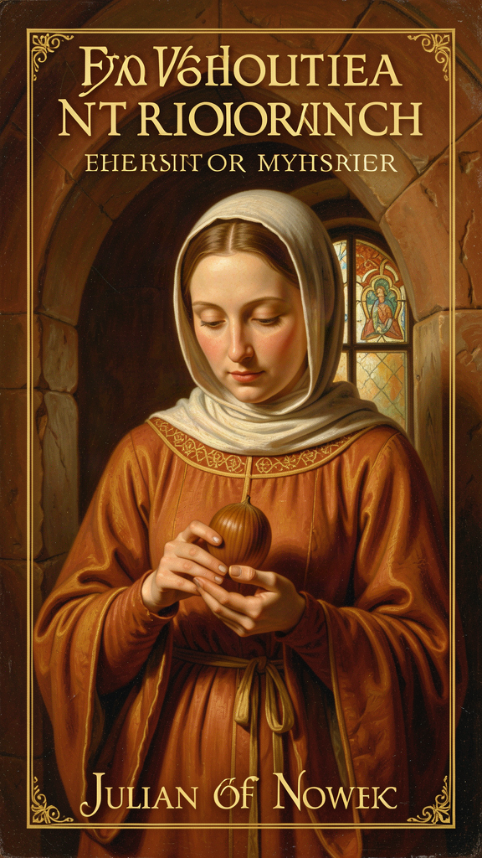
Julian of Norwich: The Theologian in the Cell
WisdomForge Booklet — Adult

Julian of Norwich: The Theologian in the Cell

WisdomForge Booklet — Adult
———

About This Book
In May 1373, a woman lay dying in Norwich, England. A priest held a crucifix before her face. She was about thirty years old. Everyone expected her to die. Instead, over the next several hours, she received sixteen visions — she called them "showings" — that would become the foundation of one of the most theologically daring works in the Christian tradition.
Her name was Julian. We do not know her birth name. "Julian" comes from St. Julian's Church in Norwich, where she lived as an anchoress — a woman walled into a cell attached to a church, devoted to a life of prayer. Her cell had three windows: one into the church for Mass, one to a servant for food, one to the street for counsel. She could not leave. But through that street window, she spoke to visitors who came seeking guidance. Margery Kempe, the English mystic and author of the first autobiography in English, recorded a visit to Julian for spiritual counsel.
Julian wrote two versions of her visions. The Short Text, composed soon after 1373, is raw and immediate — about 11,000 words. The Long Text, completed perhaps around 1393 after twenty years of contemplation, is reflective, theologically mature, and six times longer — about 63,000 words. Together, they constitute the earliest surviving book in English written by a woman, and one of the longest sustained acts of theological reflection by any medieval person.
Julian's theology is built on a paradox. She lived through the Black Death, which killed perhaps half the population of Norwich. She lived through the Peasants' Revolt, the Hundred Years' War, and ecclesiastical corruption. She had nearly died herself. She chose to be walled into a cell. And from inside that enclosure, she wrote that "all shall be well, and all shall be well, and all manner of thing shall be well." She called God "Mother." She said that sin is "behovely" — necessary, useful — because it becomes the occasion for mercy. She held the entire created universe in the palm of her hand and saw it as a hazelnut, small, round, and kept by love.
This booklet is for adult readers. It engages with Julian's actual words, the scholarly debates that surround them, and the questions they raise for contemporary life. Six chapters, six themes: the hazelnut, universal restoration, the motherhood of God, sin as behovely, the Trinity as loving community, and the body as revelation. Julian took twenty years to understand what she saw in one day. This booklet is an invitation to begin that kind of patient attention.
———

Chapter 1: The Hazelnut — The Smallest Thing in Creation
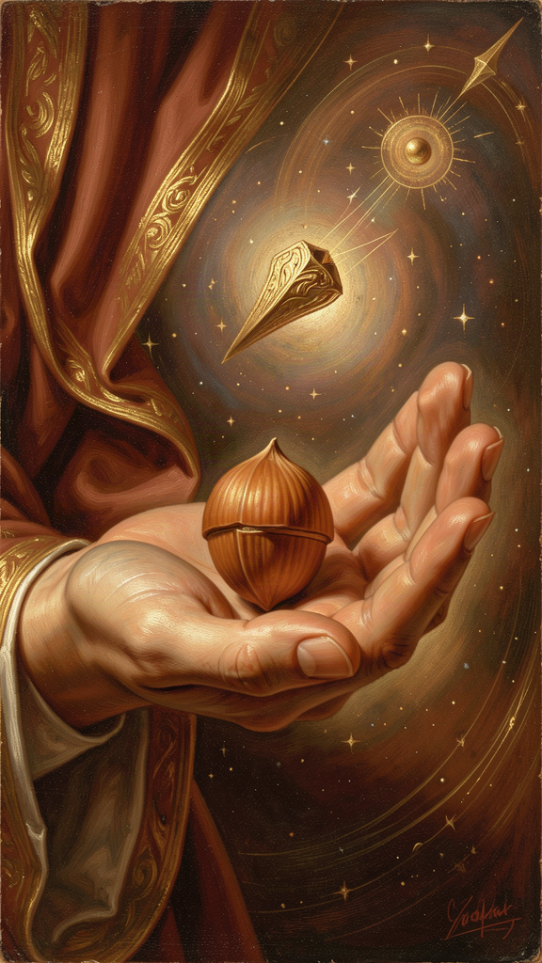
Illustration for Chapter 1

The Fifth Showing
Julian had already received four visions of Christ's passion — the crown of thorns with blood "trickling down like rain, from under the crown, all hot, flowing freely and copiously, living and beautiful," the discoloring of Christ's face "with the pallor of death," the drying of his body, the completion of all his pains at once — when the fifth showing came. It was entirely different from what preceded it.
"In this vision he showed me a little thing, the size of a hazelnut, lying in the palm of my hand. And I looked at it and thought: 'What can this be?' And I was answered: 'It is all that is made.'" — RevLT Ch. 5
The entire created universe — all that exists — seen as something that fits in the palm of a hand, smaller than a fingertip. Julian observed three things: it was small, "as tiny as a hazelnut." It was round, "as a ball." And it lasted — "it lasts and ever shall, for God loves it." She asked how something so small could endure. The answer came in three verbs: "God made it, God loves it, God keeps it."
Three verbs. Made. Loves. Keeps. The entire metaphysics of creation, compressed into three words. Creation has no independent durability. It endures by participation in divine love. The hazelnut is not a symbol of the world's insignificance. It is an image of intimacy. The world is small enough to be held, loved enough to be kept. The contrast generates Julian's theology of hope: the world is tiny; God's love is vast. The world is fragile; God's keeping is eternal.

Smallness as a Spiritual Category
Julian's fourteenth century was obsessed with magnitude — bigger empires, grander cathedrals, more powerful institutions. The Church measured its authority in land, armies, and political influence. Against this, Julian insists that smallness is not failure. The hazelnut's smallness is precisely what makes it fit in a human hand. The cosmos does not need to be impressive to be loved. It needs to be loved to be real.
This has implications for how we value our own lives. A modern reader may feel that her own worries, labors, and loves are too small to matter. Julian's vision says otherwise: the smallness of a life is no measure of its worth. What measures its worth is the love that keeps it. The mother who feeds a child, the worker who does a job with care, the friend who stays present to grief — these are not small lives. They are hazelnut lives: small, round, and kept.

The Metaphysics of Dependence
Julian's hazelnut is not pantheism. She does not say the hazelnut is God. She says the hazelnut is kept by God. The world remains distinct from its maker even as it depends entirely on the maker's love. This is closer to the classical Christian doctrine of creation ex nihilo — the world exists because God freely wills it, not because God needed matter or because the world is a piece of the divine substance.
But Julian's formulation is experiential, not technical. She does not argue for creation from nothing. She sees the world as fragile and loved. The theology follows the vision. And the vision says: everything that exists is small, round, and held.
This experiential grounding distinguishes Julian from a systematic theologian like Thomas Aquinas, who argues for creation from philosophical premises. Julian does not argue. She sees. The difference is not one of truth — both arrive at the same conclusion — but of method. Aquinas gives you a proof. Julian gives you a picture. For some readers, the picture is more persuasive than the proof, because it can be held in the hand and turned over and contemplated. A proof demands assent. A vision invites contemplation.

The Hazelnut and the Cross
The placement of the hazelnut vision is theologically significant. It follows the crucifixion visions (Ch. 1–4) and precedes the extended meditations on suffering (Ch. 6–16). The hazelnut provides the theological frame: Christ's suffering is seen within the context of a loved, kept creation. The cross is not a negation of creation but its fulfillment.
A theology built only on the hazelnut would be naively optimistic. A theology built only on the cross would be despairing. Julian holds both. The world is loved and kept. The world also suffers. Both are true. Both must be held together. This is the architectural principle of the entire Revelations: the small, loved world and the suffering God are not contradictions but complements. The hazelnut shows why the cross matters: because what is crucified is what is loved. The cross shows what love costs: everything.

Gender and the Hazelnut
The image of a woman holding "all that is made" in the palm of her hand is powerful. In medieval iconography, cosmic power belongs to Christ as Pantocrator, to emperors, to patriarchs. Julian places the created world in the hand of an anonymous anchoress — not a queen or saint, but a woman walled into a cell. The point is not female dominance but female intimacy: the cosmos is small enough to be held, close enough to be loved, ordinary enough to be known.
This is not a claim to power. It is a revelation of intimacy. The world is small enough to be held, loved enough to be kept. Julian's gender shapes the vision not by making her exceptional but by making her representative: any soul, however small, can hold the truth of creation.

The Hazelnut and Ecology
Julian's vision is environmentally suggestive. If "all that is made" is a single beloved thing, then environmental destruction is not merely a practical problem but a theological wound — damaging what God made and loves and keeps. Julian does not develop this implication; she lived in a pre-industrial world. But her metaphysics supports a spirituality of care rather than extraction. Some readers make Julian into an ecological theologian. She was not. The ecological reading is an application, not a description of her original intent. It is a valid extension if it does not claim to be her own concern.

The Three Properties and Daily Life
Julian's three properties — smallness, roundness, perseverance — translate directly into modern experience. The overwhelmed parent, the anxious worker, the grieving friend — all carry worlds that feel too large to hold. Julian's vision says: they are held. Not because the problems are trivial, but because they are small enough for love to keep. The things that feel all-consuming are, in Julian's vision, still small enough for love to keep. This is not denial. It is perspective.

Scholarly Debate: The Dating and Development
The two texts — the Short Text (c. 1373) and the Long Text (c. 1393) — raise a question about Julian's development. Did the Long Text represent growth in understanding over twenty years, or a reworking of the same material for a different purpose? Most scholars favor a both/and reading. Julian's theology matured, and she also learned how to express it.
The Short Text contains the hazelnut vision (RevST Ch. 5) but without the extended theological commentary of the Long Text. What was a reported vision in the Short Text becomes a metaphysical claim in the Long Text. The development is visible: Julian moves from description to interpretation, from seeing to understanding. This is itself an epistemological statement. Understanding takes time. Some truth is given in a moment; its meaning unfolds over years.

The Big Idea
Everything that exists is small enough to fit in God's hand and loved enough to be kept there. Smallness is not failure — it is the condition for intimacy. The world does not need to be grand or powerful to matter. It needs to be loved, and it is. The metaphysics is compressed into three verbs: made, loves, keeps. The implications are vast: if the world is held by love, then fragility is not abandonment, and smallness is not insignificance. The hazelnut vision is Julian's gift to anyone who has felt too small to matter.

Practice
1. The Hazelnut Test. When you feel overwhelmed — by work, by family, by news, by grief — imagine everything that weighs on you fitting into something the size of a hazelnut. Not because your problems are trivial, but because they are held. This is not denial. It is perspective. Write one paragraph about what changes when you picture your burdens as held rather than as crushing. Do this for one week whenever the overwhelm returns.
2. Three Verbs. Write "made, loves, keeps" on a card you carry for one week. Each morning, look at the card and say the three words silently. Each evening, write one sentence about whether you experienced being made, loved, or kept that day — or whether you did not. At the end of the week, read what you wrote. What pattern do you notice?
3. Look at something small for ten minutes. Pick any object — a leaf, a stone, a hazelnut, a coin. Look at it for ten full minutes without looking away. Notice what you see in minutes five through ten that you did not see in the first minute. Julian learned by looking closely. She saw the world in a hazelnut because she looked at the hazelnut. Write three sentences about what sustained attention revealed.

Reflect
If the whole world is as small as a hazelnut — held, loved, and kept — what in your life have you been treating as too small to matter? And what would change if you believed it was held by the same love that holds everything?
———

Chapter 2: All Shall Be Well — Universal Restoration and Hope

Illustration for Chapter 2

The Question and the Answer
After the passion visions and the hazelnut, Julian reached the theological heart of her work. She had seen suffering. She had seen the small, loved world. Now she faced the question that every honest person of faith must face: How can all be well when so much is not well?
She records her anguish with remarkable honesty. She had, she writes, "a soft protest" — not spoken aloud, but felt silently as she lay before God:
"Ah, good Lord, how can all be well for the great harm that has come through sin to your creatures?" — RevLT Ch. 27
Christ's response is not an argument. It is a promise, spoken three times:
"Sin is behovely, but all shall be well, and all shall be well, and all manner of thing shall be well." — RevLT Ch. 27
The repetition is theological progression. "All shall be well" — universal scope: no thing, no person, no event excluded. "All shall be well" — temporal depth: not only now, not only soon, but ultimately. "All manner of thing shall be well" — comprehensiveness: every category of existence, every kind of suffering, every form of evil. The triplication echoes the Trinitarian structure Julian develops elsewhere. It is a liturgical, almost musical formulation — meant to be memorized, repeated, carried.

The Great Deed
In Chapter 32, Julian returns to this promise and introduces the concept of "the great deed":
"The great deed shall be performed, by which the devil shall be overcome, and our Lord shall be glorified, and we shall be saved, and all manner of things shall be well."
The "great deed" is not yet completed in Julian's present. It is eschatological — it lies in the future, at the end of history. But it is also already accomplished in Christ's passion. Julian holds the tension: the deed is done (on the cross) and not yet done (in the world's continuing suffering).
This is Julian's answer to the delay of justice. Why is all not well now? Because the great deed is still unfolding. But Julian insists — against the evidence of her own plague-scarred era — that the outcome is certain. She does not know how. She knows that. The "great deed" is a promise held in hope, not a philosophical argument.

What Julian Lived Through
This context is essential. Julian's hope is not abstract. The Black Death arrived in England in 1348 and raged through 1350, killing perhaps 30 to 60 percent of the population. Norwich was hit hard. The city lost thousands of residents. The Peasants' Revolt of 1381 brought violent uprising. The Hundred Years' War continued across the Channel. Ecclesiastical corruption was widespread. Julian herself had nearly died.
Her "all shall be well" is spoken from inside catastrophe, not from outside it. It does not deny the catastrophe. It faces it and says: love will outlast it. A prediction says, "Things will probably improve." A pledge says, "Love will finally triumph." Julian offers a pledge. The distinction matters because predictions can be wrong. A pledge from God, Julian believes, cannot.

The Architecture of Hope
Julian's hope has three supports:
1. The passion of Christ — God has already entered the worst of human suffering. The cross is evidence that love persists within evil. 2. The nature of God as love — Julian's repeated refrain: "Love was his meaning" (RevLT Ch. 86). If God's meaning is love, the final word cannot be wrath. 3. The great deed yet to come — Eschatological hope: history has a direction, and the direction is toward well-being.
This is not Stoic resignation. It is Christian hope — active, expectant, grounded in divine promise rather than human achievement. It is also not a theodicy in the philosophical sense. Julian does not offer a logical solution to the problem of evil. She offers something perhaps more useful: a reason to keep hoping when logic fails.

The Universalism Debate
The central scholarly debate about Julian's theology: Did she teach universal salvation? If all shall be well, does that mean every person will finally be saved?
The textual evidence is genuinely ambiguous. Julian never explicitly says that all human beings will be saved. She does not deny the traditional doctrines of judgment, hell, or the need for repentance. She lived within a Catholic Church that affirmed these doctrines. She may have believed that "all shall be well" describes the final state of those who are in Christ, not necessarily every individual without qualification.
But her language is remarkably hopeful. She says that God will "make well all that is not well." She stresses God's power over sin and God's will to save. She speaks of the servant's shame and the need for mercy — passages that presuppose sin has real consequences and that divine mercy must be received.
Most scholars agree that Julian is at least "hopeful universalist" — she leans strongly toward universal salvation without formally asserting it. Some call her a "practical universalist" or a "universalist in hope." A minority believes she is a full doctrinal universalist. Others insist she remained within orthodox Catholic ambiguity.
Denys Turner argues that Julian's theology strongly tends toward universal hope but does not offer a systematic doctrine of salvation. David Bentley Hart, in That All Shall Be Saved (2019), reads Julian alongside Origen and Gregory of Nyssa as evidence for the Christian universalist tradition. Grace Jantzen reads Julian's hope as a challenge to punitive, patriarchal images of God as wrathful judge. The debate continues because Julian's text does not settle it. This ambiguity may have been strategic — to avoid condemnation — or it may reflect genuine mystery. Either way, her text does not resolve the matter, and readers have argued about it for six centuries.

Misappropriations
"All shall be well" is frequently misused. It is not naive optimism — Julian saw the Black Death kill half of Europe. It is not denial of suffering — the phrase comes after extended meditations on Christ's suffering. It is not political quietism — Julian does not tell the oppressed to wait patiently. She tells them that the divine outcome transcends human power structures. It is not necessarily universal salvation — while some read Julian as a universalist, her text is carefully ambiguous.
The hope is hard-won because it does not deny the catastrophe. It faces it and says: love will outlast it. The feminization of Julian's theology in modern reception is worth examining. "All shall be well" is often turned into a gentle, comforting phrase for women. Julian's original context is sterner: she is a theologian wrestling with the problem of evil, not a caregiver offering reassurance.

Julian and Augustine
The comparison with Augustine is instructive. Augustine's mature theology emphasized original sin, predestination, and eternal punishment. This framework dominated medieval Latin theology.
| | Augustine | Julian | |---|---|---| | Sin's origin | Free will, corrupted by the Fall | The servant's stumble — an accident of haste, not malice | | Sin's consequence | Eternal damnation for the unbaptized | Shame that blinds the soul to God's love | | God's response | Justice and mercy in tension | Compassion that never wavers | | Human agency | Crucial but corrupted | Real but not the dominant actor in salvation | | Final word | Predestination (some saved, some not) | Universal restoration ("all shall be well") |
Julian never names Augustine and never directly attacks him. But her theology gently pulls in a different direction. Where Augustine asks "Who will be saved?" Julian asks "Can love finally fail?" The difference is not one of doctrine alone but of starting point: Augustine begins with sin and works toward grace; Julian begins with love and works toward the resolution of sin. Both are orthodox. They produce different spiritualities.

Simone Weil: A Twentieth-Century Affinity
Simone Weil (1909–1943), the French philosopher and mystic, shares with Julian a radical trust in divine love amid suffering. Weil's central category is affliction (malheur): extreme suffering that strips a person of everything false. In affliction, she believed, God can become present in a hidden way. Julian would have recognized this. Her visions of Christ's passion plunge into the reality of physical agony and divine solidarity.
Both women refuse easy comfort. Julian saw Christ's head bleeding. Weil wrote about factory labor, war, and hunger. Both believe that love can be found at the bottom of pain. Weil prized attention — a disciplined, patient openness to reality. Prayer, for her, was not asking for things but attending to God. Julian's prayer of "true longing" reflects a similar movement. The vocabulary differs; the posture is similar. Both women lived with contradiction: Weil wrote that God is present through absence; Julian wrote that all shall be well even while the world groaned.

Radical Hope vs. Naive Optimism
Radical hope is hope that persists without evidence. It is not optimism, which expects things to turn out well. It is a stance toward reality that says: even if things do not turn out well by every measure, love remains the deepest truth. Jonathan Lear, in Radical Hope (2006), describes this as hope directed toward a future goodness that transcends the current ability to understand what goodness would look like. Julian's hope is radical in this sense. She does not know what the "great deed" looks like. She trusts that it will come. She does not know how all shall be well. She knows that it shall.
For women in the fourteenth century, much of life was uncertain — childbirth mortality, widowhood, poverty, violence. Julian's hope was not abstract theory; it was a form of resilience. Her assurance that "all shall be well" offered a spiritual resource for people with little social control. The same is true today. The pledge does not promise that every individual plan will succeed, every disease will be healed, or every injustice will be immediately corrected. It says that the final shape of reality is trustworthy. This distinction matters. Her hope operates at the level of ultimate meaning, not at the level of daily outcomes.

The Big Idea
Julian's hope is a pledge, not a prediction. It does not say the world is fine right now. It says that the final word belongs to love, even when we cannot see how. This is eschatological hope — hope directed toward the final fulfillment of history — not optimism about daily events. It was spoken by a woman who lived through plague, war, and personal near-death. Its power comes from its context, not despite it. The universalism debate remains open. Julian leans toward universal hope without asserting it as doctrine. The ambiguity is itself instructive: some truths are better held as hope than as certainty.

Practice
1. The Threefold Pledge as Breathing Prayer. Julian's triplicated phrase is designed for repetition. Say it in rhythm with your breath: "All shall be well" (inhale). "And all shall be well" (exhale). "And all manner of thing shall be well" (inhale, exhale). Do this for three minutes when you feel anxious. Write one paragraph afterward about what shifted — or did not. Practice this for one week.
2. Hope vs. Optimism Journal. For one week, keep a list of situations where you felt optimistic (things will probably improve) and situations where you felt hope (the final word belongs to love, even if things do not improve). At the end of the week, compare the two lists. Which feeling lasted longer? Which was harder to sustain? Which one survived a disappointment?
3. Research the Context. Look up the Black Death of 1348–1350 in England. Write three facts about its impact on Norwich specifically — mortality rate, social consequences, religious responses. Then reread Julian's words: "All shall be well, and all shall be well, and all manner of thing shall be well." Does knowing what she survived change how you hear the promise?

Reflect
What is the difference between optimism and hope? Which one have you been practicing — and which one does Julian offer?
———

Chapter 3: The Motherhood of God — Feminine Divine Imagery
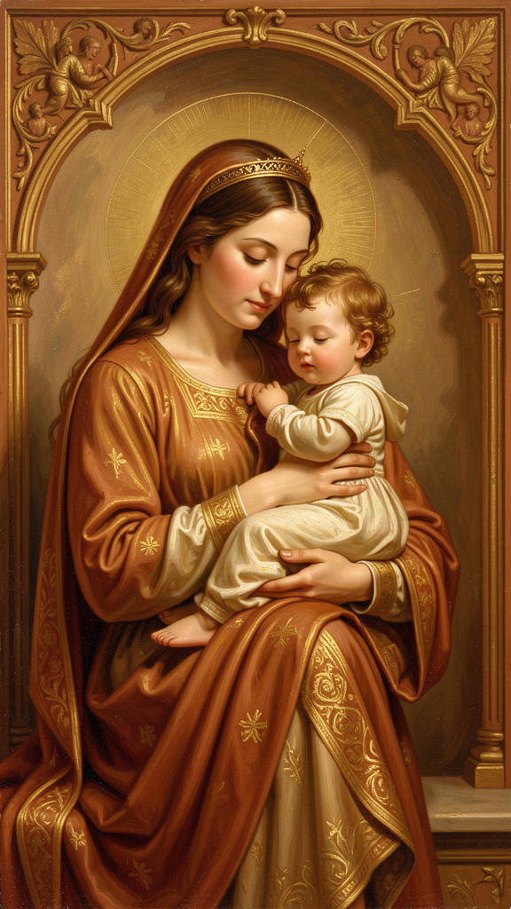
Illustration for Chapter 3

A Theological Claim, Not a Metaphor
In the Long Text, written roughly twenty years after her visions, Julian makes one of the most arresting claims in Christian theology:
"As truly as God is our Father, so truly is God our Mother." — RevLT Ch. 59
The word "truly" is the operative word. Julian is not speaking in metaphor. A metaphor says God is like a mother. An ontology of relation says God functions as mother, and this functioning reveals something true about the divine nature. Julian's language does not stay safely in the "like" category. She is making a doctrinal claim.
She does not say this once. She returns to it across Chapters 48 through 60, developing a full theology of God as mother. God conceives us in love, bears us in labor, feeds us with mercy, disciplines us for growth, and will never abandon us. Every maternal function has a divine analogue: conception to God's creative will, bearing to God's patience with human growth, birth to Christ's passion as the labor of salvation, nursing to the Eucharist as spiritual milk, teaching to the Holy Spirit's guidance, protection to God's keeping of the soul.

The Christological Assignment
Julian assigns the motherhood specifically to the Second Person of the Trinity — Jesus Christ. Her reasoning is Christological. It is Jesus who became incarnate, labored in life, suffered in death, and gives birth to new life in the resurrection. The maternal work belongs to him because the maternal work is the work of redemption.
"The mother may give her child to suck of her tender milk, but our precious Mother Jesus may feed us with himself." — RevLT Ch. 60
The Eucharist — Christ's body given as nourishment — is the spiritual milk. Christ's passion is the labor of childbirth. The cross is the birth canal. This is not sentimental maternal imagery. It is a claim that divine love takes the form of physical labor, pain, and bodily giving.
Julian extends the childbirth metaphor: "The mother labors for the child, and the child for the mother." Christ's dying is the labor that brings forth salvation. This is a claim about what divine love looks like when it becomes flesh: it looks like a mother in labor. It bleeds. It suffers. It gives life through pain.

The Sources and the Daring
Julian was not inventing the idea from nothing. The Bible occasionally uses maternal imagery for God: Isaiah 49:15 compares God's care to a mother forgetting her nursing child; Isaiah 66:13 speaks of God comforting like a mother; Deuteronomy 32:18 speaks of God giving birth; Matthew 23:37 describes Jesus longing to gather Jerusalem "as a hen gathers her brood under her wings." Medieval devotion to the Virgin Mary had prepared Christians to imagine divine tenderness in maternal terms. Augustine, Anselm, and Bernard of Clairvaux occasionally used maternal imagery for God.
But Julian pushes the imagery further than most of her predecessors. She does not merely say God is like a mother. She says God is our Mother. And she says it in a century when women were warned against theological speculation, when the Church was patriarchal in structure and largely masculine in its language for God.
The daring is not in the image itself but in the word "truly." Julian is claiming that maternal love is not a secondary, derivative, or merely illustrative form of divine love. It is as real, as primary, as the fatherhood of God. Both are equally true and equally necessary.

The Development Across Chapters
Julian does not introduce the motherhood of God abruptly. She develops it across multiple chapters. In Chapter 48, she begins with the bodily reality of Christ's passion: "The mother can give her child to suck of her milk, but our precious Mother Jesus can feed us with himself." In Chapters 49–50, she extends the childbirth metaphor to the passion. In Chapter 51, the parable of the Lord and Servant is integrated into the motherhood theology: the lord who looks on the fallen servant with compassion is the mother who sees her injured child and rushes to help. In Chapters 52–53, she goes further: not only Christ but the entire Trinity participates in motherhood. "Our Mother in nature, our Mother in grace, and our Mother in the Trinity." In Chapters 54–58, she enumerates the works of a mother — conceiving, bearing, giving birth, nursing, nurturing, protecting, teaching — and assigns each to God. In Chapter 59, she delivers the great sentence. In Chapter 60, she concludes by returning to the Trinity.

Metaphor vs. Ontology: The Scholarly Debate
The key scholarly question: Is Julian's motherhood language metaphor or ontology? A metaphor says one thing is like another. An ontology of relation says God functions as mother and this functioning reveals the divine nature.
Denys Turner argues that Julian's motherhood language is more than metaphor — it is a theological claim about how God relates to us. Grace Jantzen goes further, arguing that it is an ontological claim about the divine nature itself. Sallie McFague, in Metaphorical Theology (1982), cites Julian as a precedent for expanding God-language beyond masculine categories while acknowledging that all God-language is metaphorical in some sense. The debate matters because if the motherhood of God is only metaphor, it can be safely ignored when inconvenient. If it is ontology, it changes how we think about God, salvation, and the Church.
Julian's own language supports the stronger reading. She writes: "As truly as God is our Father, so truly is God our Mother." The "truly" does the work. She is not hedging. She is asserting. She returns to the claim repeatedly with careful explanation, as if aware of the daring of her language.

The Reception History
Julian's motherhood theology has had a mixed reception. During her lifetime and immediately after, her work circulated in small circles without provoking official condemnation. The image of God as Mother had some precedent in Christian tradition, though Julian developed it more fully than most. After the Reformation, interest in Julian declined. Her maternal imagery was not a major focus of Catholic or Protestant devotion for centuries.
In the twentieth century, Julian became important to Anglicans and Catholics alike. Her feast day (May 8) is celebrated in both churches. Her maternal imagery has been quoted in sermons, prayers, and hymns. Some modern liturgies explicitly include feminine images of God, often citing Julian as a precedent. The Church of England and the Episcopal Church have been especially receptive. Roman Catholic reception is more cautious, given official resistance to changing the gendered language of liturgy.
The churches have not received all of Julian equally. "All shall be well" is quoted widely. The motherhood of God is quoted more carefully. Sin as "behovely" is often avoided. Modern readers should be aware that Julian's reception is selective and sometimes domesticated.

The Objection: Does Julian Say God Is Female?
No. Julian does not say God has a female body or gender. She uses maternal imagery within a traditional Trinitarian framework. The motherhood of God is a relational and functional claim, not a gender-essentialist one. God is not a biological mother. But God mothers. Julian's own practice was additive: she kept "Father" and added "Mother." She did not replace one with the other. She held both together, insisting that both are equally true.

The Objection: Was the Motherhood of God Just Metaphor?
Some readers treat Julian's motherhood language as decorative — a nice image, but not a serious theological claim. This underestimates her. Julian's language does not stay safely in the "like" category. She writes:
- "As truly as God is our Father, so truly is God our Mother." (RevLT Ch. 59) - "Our true Mother Jesus, he bears us for joy and for sorrow." (RevLT Ch. 60) - "The mother may give her child to suck of her tender milk, but our precious Mother Jesus may feed us with himself." (RevLT Ch. 60)
These are not occasional metaphors. They are repeated, developed, and applied to Christ specifically. Julian is making a doctrinal claim. If the motherhood of God were only metaphor, it could be safely ignored when it becomes inconvenient. If it is an ontological claim, it changes how we think about God, salvation, and the Church. It means that divine care is not merely powerful; it is laboring, nurturing, intimate, and patient. It challenges the assumption that masculine imagery is primary and feminine imagery secondary.

Gender and the Divine
Julian's claim arises from women's experience of bearing, feeding, and nurturing. She validates this experience as a source of theological knowledge. In doing so, she challenges the medieval hierarchy that privileged male academic learning over female embodied wisdom. A woman who has seen childbirth, nursing, and maternal labor writes about divine love in the only language she has for unconditional, bodily, sacrificial love. But Julian's claim is not merely personal experience generalized. It is a theological argument: if God is love, and if maternal love is real love, then God must be maternal. The logic is simple and devastating to any theology that limits God to masculine imagery.

Julian and Modern Feminist Theology
Modern feminist theology has reclaimed Julian as a significant voice in women's religious history. Grace Jantzen's Power, Gender and Christian Mysticism (1995) and Julian of Norwich: Mystic and Theologian (2000) are landmark feminist readings. Jantzen argues that Julian should be taken seriously as a theologian and that her gender shaped her theology in important ways. She also warns against reducing Julian to "comforting" religious sentiment.
Feminist theologians also ask hard questions. Does Julian's orthodoxy limit her subversiveness? Does her enclosure represent freedom or confinement? Is she being co-opted for modern causes she would not have recognized? How much can a fourteenth-century woman really challenge medieval patriarchy? These debates are part of healthy feminist scholarship. They prevent Julian from becoming a simplistic mascot. Julian is both an inspiring example of women's theological authority and a figure constrained by her era. She did not overthrow patriarchy. She found a space within it and used that space brilliantly.

The Big Idea
Julian's claim that God is our Mother is not a metaphor. It is a theological assertion that divine love takes the form of maternal labor — feeding, holding, suffering, staying — as truly as it takes the form of paternal authority. Both are real. Both are necessary. The God who is only Father can be distant, commanding, and abstract. The God who is also Mother is close, laboring, and tender. Julian insists on both because she believes both are true. The reception of this claim has been selective and sometimes resistant. But the text persists. Six centuries before modern feminism, a woman in a cell wrote that God is our Mother as truly as our Father. The Church has not yet fully reckoned with what she said.

Practice
1. Examine Your God-Language. For one week, notice every time you hear or use language for God — in church, in prayer, in conversation, in your own thoughts. Keep a list: "Father," "Lord," "King," "He," "Him," "Mother," "She." At the end of the week, count the entries. How many were masculine? How many were feminine? How many were neutral? Write one paragraph about what your list reveals about the God you imagine — and about the God Julian imagines.
2. Write a Prayer Using Both Names. Julian kept "Father" and added "Mother." Write a prayer that uses both: "God my Father, who made me; God my Mother, who feeds me; God my Brother, who suffers beside me." Make it your own. Use whatever language is honest for you. Read it daily for one week. Write about how it felt to address God this way.
3. Study the Reception. Look up Julian's feast day (May 8) and how it is celebrated in the Church of England and the Roman Catholic Church. Find one modern prayer, hymn, or liturgy that uses Julian's motherhood imagery. Find one that does not. Write a paragraph about how the Church has received — or resisted — her most daring claim.

Reflect
Julian said "as truly as God is our Father, so truly is God our Mother." What would change in your picture of God if you took the word "truly" seriously — and what would change in how you treat the mothers and caregivers in your life?
———

Chapter 4: Sin as Behovely — Necessary and Useful
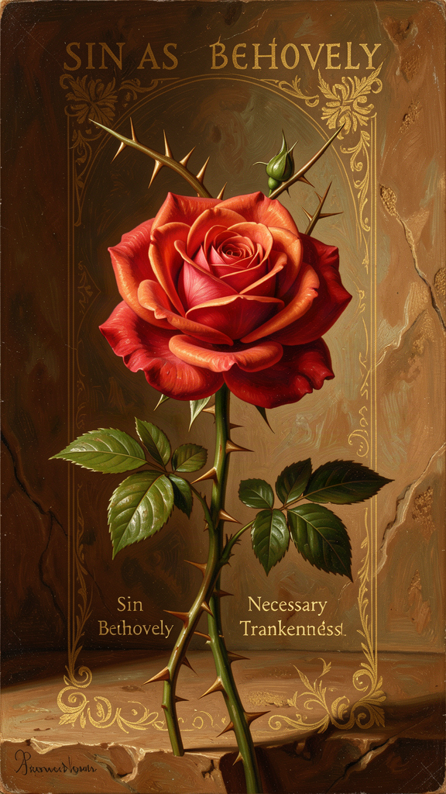
Illustration for Chapter 4

The Parable of the Lord and the Servant
The most important passage in Julian's treatment of sin is the parable of the Lord and Servant (RevLT Ch. 51). A lord sends his beloved servant on an errand. The servant runs eagerly — too eagerly. He is in such a hurry to please that he stumbles and falls into a ditch. He is injured, covered in mud, and ashamed. He cannot look at his lord. He lies in the ditch, unable to meet the lord's eyes.
The lord does not respond with anger. He looks at the servant with love and compassion. The servant's shame keeps him from seeing that the lord has never stopped loving him.
Julian interprets: The lord is God. The servant is Adam — and every human being. The ditch is sin. The injury is shame. The lord's response is not punishment but compassionate attention.
"The servant's falling was a great hurt to him; but his shame and his fear were a greater hurt." — RevLT Ch. 51
This is Julian's deepest psychological insight. The fall is bad. But shame is worse. Shame is what keeps the servant from looking up. The damage of sin is internal, relational, self-imposed. The servant is not punished by the lord. He is paralyzed by his own self-condemnation.

What "Behovely" Means
"Sin is behovely." The Middle English word behovely means "necessary," "needful," or "inevitable." It does not mean sin is good, desirable, or approved by God. Julian is saying that sin enters the world as part of a larger providential order in which God will accomplish a "great deed" that will make even sin's terrible effects serve the final victory of love.
This is one of the most daring theological moves in Christian literature. Julian does not minimize sin. She places it inside a divine narrative that ends well. Sin is real, ugly, and destructive. But it does not have the last word. Mercy is the final word.

Three Readings of "Behovely"
Scholars have identified at least three readings:
1. The epistemological reading. Sin is "necessary" because without it we would not know our need for grace, our dependence on God, or the depth of divine mercy. By falling, the servant learns how much he is loved.
2. The narrative reading. Sin is an episode within a providential story. It is not the beginning or the end; it is the middle, and the middle will be redeemed by the "great deed" at history's conclusion.
3. The ontological reading (more controversial). Sin has a place in the structure of creation because God's love can transform even evil into good. This reading is closest to universalist hope, and it is the one that makes some theologians nervous.
Julian herself does not choose among these readings. She reports what she was shown and leaves the theology open. The openness is not evasion. It is epistemological humility. Julian distinguishes what she has been shown from what she still does not know. The "great deed" is shown but not described. The resolution of sin is promised but not explained. She offers hope, not a system.

Shame as the Primary Wound
Julian identifies shame, not guilt, as the primary consequence of sin. The servant in the parable is not punished by the lord. He is paralyzed by his own shame. He cannot look up. This is a remarkably modern observation. Julian describes what contemporary psychology calls toxic shame — the self's inability to receive love because it believes itself unworthy.
Her answer is not "stop sinning" but "look up." The lord has never stopped loving. Healing begins not with moral improvement but with accepting that one is still loved. This is a theology of grace that anticipates, in some ways, the insights of modern therapeutic practice: the deepest wound is not the act itself but the shame that follows, and shame is healed not by punishment but by compassionate attention.

Gender and Shame
Shame is a profoundly gendered wound in medieval culture. Women's bodies, women's speech, and women's desires were sources of shame in a patriarchal Church. Julian, a woman in a culture that made female sexuality, female authority, and female voice objects of shame, reimagines divine response as the lifting of shame rather than its reinforcement. Her claim that shame is healed by divine compassion, not clerical absolution, is quietly radical. The God who responds to shame with compassionate attention rather than punitive judgment is a God who subverts the shame-based structures of medieval religious life.

Julian vs. Augustine
The comparison with Augustine is inevitable. Augustine's mature theology emphasized original sin (humanity is fallen from birth), predestination (God elects some for salvation, others for damnation), and eternal punishment (hell is real, permanent, and justly deserved). This framework dominated medieval Latin theology.
| | Augustine | Julian | |---|---|---| | Sin's origin | Free will, corrupted by the Fall | The servant's stumble — an accident of haste, not malice | | Sin's consequence | Eternal damnation for the unbaptized | Shame that blinds the soul to God's love | | God's response | Justice and mercy in tension | Compassion that never wavers | | Human agency | Crucial but corrupted | Real but not the dominant actor in salvation | | Final word | Predestination (some saved, some not) | Universal restoration ("all shall be well") |
Julian never names Augustine and never directly attacks him. But her theology gently pulls in a different direction. Where Augustine asks "Who will be saved?" Julian asks "Can love finally fail?" The difference is not one of doctrine alone but of starting point: Augustine begins with sin and works toward grace; Julian begins with love and works toward the resolution of sin. Both are orthodox. They produce different spiritualities. Augustine's God is a judge whose mercy is in tension with his justice. Julian's God is a mother whose compassion never wavers.

Why This Is Not a License to Sin
Nothing in Julian suggests that sin does not matter. The servant in the parable is miserable in the ditch. Sin is painful, degrading, and shameful. Julian explicitly calls sin "shameful" and "painful." She never calls it virtuous. Her point is not that sin is harmless but that it is not ultimate. The final word belongs to mercy, not to transgression.
In this she is thoroughly orthodox: Christian theology has always held that sin is real and that grace is greater. Julian's distinctive contribution is the tone — tender rather than juridical — and the confidence: "all shall be well" rather than "perhaps some shall be saved." The question is not whether sin matters. It does. The question is whether sin is the final word. For Julian, it is not.

The Function of Sin in Julian's Theology
Sin has at least three functions in Julian's vision:
1. It reveals the need for mercy. Without sin, we would not know how deeply God loves us. 2. It makes the "great deed" necessary and glorious. Redemption is a response to real evil. 3. It humbles human pride. Recognizing sin reminds us that we depend entirely on grace.
None of these functions makes sin good. They explain why God can bring good out of evil. The distinction matters. A license to sin says "sin doesn't matter." Julian says "sin matters terribly, but God's mercy matters more."

Julian and Dante
The comparison with Dante is instructive. Dante's Inferno presents a Hell populated by specific sinners receiving specific punishments. The architecture of divine justice is terrifying and precise. Julian does not write about Hell in the same way. Her emphasis falls on divine mercy and the final resolution of all things in love.
This difference has made some readers ask whether Julian is closer to universalism than Dante. Dante makes judgment central; Julian makes mercy central. Dante offers a journey through the architecture of justice; Julian offers a home in the architecture of love. Both are wrestling with the same question: how does a loving God deal with evil? Their answers differ in tone and structure, but both insist on divine love as the ultimate truth. Julian's hope does not negate Dante's justice. It complements it. A healthy theology may need both — the warning and the promise.

Did Julian Deny the Reality of Sin?
Some readers conclude that "sin is behovely" and "all shall be well" mean Julian minimized or denied sin. This is a misreading. Julian takes sin with utmost seriousness. In the passion visions, she beholds what sin does to Christ's body. In the parable, the servant is miserable in the ditch. She does not say sin is harmless. She says it is "behovely" — necessary or inevitable in the providential order — and that God will finally overcome it. These are different claims. "Behovely" does not mean "good." It means that God can bring good out of evil.

The Big Idea
Julian does not deny sin. She reframes its place in God's story. Sin is real and painful. But shame — not punishment — is the deepest wound. And God's response to our shame is not anger but compassionate attention. The servant's fall was bad. But the lord never stopped loving him. Sin is behovely because it becomes the occasion for mercy. The final word is not transgression but grace. This is not cheap grace. It is the most expensive grace there is: the love that enters the ditch and refuses to leave.

Practice
1. Identify Your Ditch. Think of a time when you stumbled — morally, relationally, professionally. Write three sentences describing what happened. Now write three more sentences about the shame you felt. Julian says the shame was the greater hurt. Was it? What kept you from "looking up"?
2. Practice Looking Up. The next time you feel shame about a mistake, try a specific practice: pause, breathe, and say silently, "God is looking at me with love, not anger. My shame is not the final word." Do this three times in one week. Write about whether it changed anything — your behavior, your feelings, your willingness to face the person you hurt.
3. Compare Julian and Augustine. Read the comparison table above. Write one paragraph answering: Which starting point — sin (Augustine) or love (Julian) — shapes how you think about your own mistakes? Does starting with love make sin seem less serious, or does it make grace seem more real?

Reflect
If shame is the greater wound, and God's response is compassionate attention rather than punishment, what would it mean to stop hiding — and to let yourself be seen?
———

Chapter 5: The Trinity as Loving Community
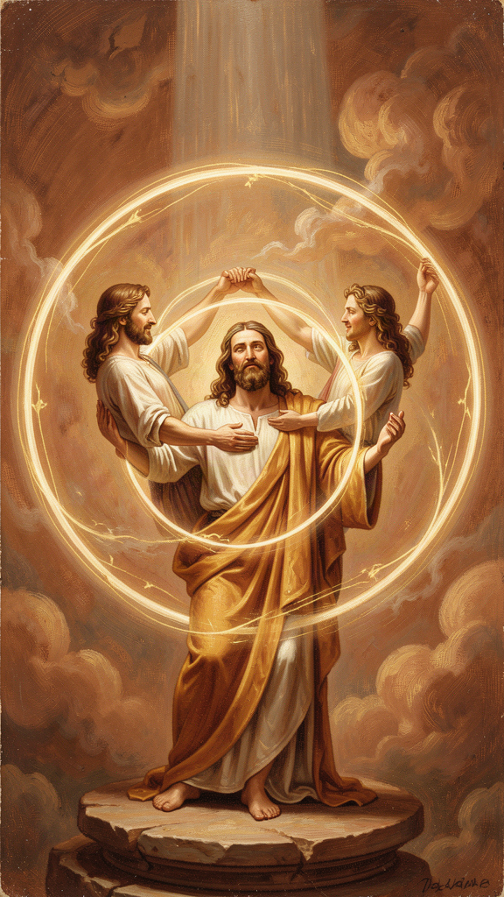
Illustration for Chapter 5

The Trinity as Relationship
Julian of Norwich was not a systematic theologian in the style of Thomas Aquinas. She did not write a treatise on the Trinity. But her entire visionary work is suffused with Trinitarian language and structure. For Julian, the Trinity is not an abstract puzzle to be solved. It is the living community of love within which the soul exists.
She sees the Father as the source of all being, the Son as our Mother and our way, and the Holy Spirit as the fire and breath that makes prayer possible. The three persons are distinct in their relation to the soul, yet one in love. Julian uses familial and relational names for the persons: the Father is the ground of creation, the Son is our Mother, our Brother, our Spouse, and the Holy Spirit is the one who stirs us to pray and gives us words when we have none.

Prayer as Trinitarian Participation
Julian's Trinitarian theology is most fully practical in her teaching on prayer. Chapter 41 of the Long Text is her most extended teaching on the subject. She distinguishes two kinds of prayer. Petitional prayer — asking God for things — she does not reject; she says it is "necessary and profitable" for beginners. But there is a deeper form: the prayer of true longing, the soul's native desire for God, which needs no words.
"Prayer is a right understanding of that fulness of joy that is to come, with true longing and sure trust." — RevLT Ch. 41
Prayer is not primarily asking for things. It is the soul's orientation toward joy. And it is mutual: "He looks upon us with the eye of his mercy, and he sees us always seeking him, and him always seeking us." God seeks us as we seek God. The initiative is divine. Human prayer is response.
The Trinity is the context of this mutual seeking. The Father receives, the Son mediates, the Spirit prays in us:
"The Holy Spirit, of his great love, stirs us to pray, and makes us able and ready to pray, and gives us words and savor, and teaches us how we shall pray." — RevLT Ch. 41
This is Julian's answer to the problem of prayer when words fail. The Holy Spirit prays in us. We are not left to our own resources. Even when we do not know what to say, the Spirit is praying inside us. Prayer is not a human performance offered to a distant deity. It is participation in the Trinity's own life.

The Lord and Servant as Prayer Parable
The parable of the Lord and Servant is also a parable about prayer. The servant, fallen in the ditch, cannot look at the lord because of shame. His prayer is blocked — not by God's absence, but by his own self-condemnation. The lord's response — compassionate attention, not anger — is God's response to all prayer that is blocked by shame.
Julian's theology of prayer includes the prayer that cannot be spoken, the longing that is buried under guilt, the desire for God that is ashamed to express itself. God does not demand articulate petition. God receives the wordless longing of a soul that cannot look up. This is a theology of prayer for the traumatized, the exhausted, the wordless. The Spirit prays in us when we cannot pray.

Julian vs. Medieval Prayer Manuals
Julian's prayer theology differs from the mainstream medieval tradition:
| | Medieval Prayer Manuals | Julian of Norwich | |---|---|---| | Purpose | Petition, penance, preparation for death | Longing, presence, mutual seeking | | Method | Structured hours, set prayers, vocal prayer | Wordless longing, "true will" | | Address | God as judge, Christ as mediator, Mary as intercessor | God as Father-Mother, Christ as nursing mother, Holy Spirit as breath | | Goal | Salvation, merit, avoidance of hell | Union, joy, "being at home in our Lord" | | Role of words | Essential (vocal prayer, liturgy) | Secondary to "true longing" |
Julian's emphasis on interior prayer does not reject external practice. It deepens it. She was Catholic, orthodox, and deeply embedded in sacramental Christianity. Her emphasis on "true longing" rather than public vocalization may reflect the conditions of women's spiritual life — prayer as interior because exterior was forbidden. But Julian transforms the limitation into a gift. Interior prayer, she teaches, is the deeper form. The soul's longing is more pleasing to God than "many words."

The Social Analogy
The Trinity has often been compared to a society, a family, or a community of love. Julian's version is experiential. She does not argue that the Trinity must be three persons. She describes how the soul encounters God as source, savior, and Spirit. The threefold experience corresponds to the Trinitarian structure because God is three-in-one, but Julian begins with experience and moves toward doctrine, not the other way around.
This is the difference between Julian and Aquinas. Aquinas begins with the doctrine and explains it through reason. Julian begins with the experience and discovers the doctrine within it. Both are valid theological methods. They produce different kinds of theology. Aquinas gives clarity. Julian gives warmth. A healthy theology needs both.

Julian vs. The Cloud of Unknowing
Julian's affective, image-rich mysticism can be contrasted with the apophatic tradition represented by the anonymous fourteenth-century English treatise The Cloud of Unknowing. The Cloud author teaches that God is best approached through a "cloud of unknowing" in which the mind gives up concepts and images and rests in darkness and love. Julian is the opposite: rich, concrete, affectionate, her spirituality centered on feeling, loving, and seeing.
| Feature | Julian | The Cloud of Unknowing | |---|---|---| | Imagery | Rich, concrete, affectionate | Sparse, apophatic, dark | | Method | Contemplation of visions | Surrender of images | | Tone | Warm, maternal, hopeful | Cool, disciplined, austere | | Christology | Highly visual — passion, motherhood | Christ as focus of love, less visual | | Audience | General seekers | Advanced contemplatives |
Both are valid paths within the Christian contemplative tradition. A modern reader can learn from both: Julian's path of imagery and devotion to Christ's love, and the Cloud's path of letting go of thoughts and resting in darkness. Together they form a spirituality that can both love and let go — which is more resilient than either alone.

Julian's Trinitarian Household
Julian's Trinitarian imagery domesticates the divine. God is not only the distant Father on a throne but the Mother who nurses, the Brother who suffers beside us, the Spouse who longs for us. This is a theology written by someone whose daily life was bounded by small spaces and intimate relations — a cell, a servant, visitors at a window. Her Trinity is scaled to human love. The architecture of her life — three windows in a small room — became the architecture of her thought: three persons, one love, intimate and accessible.

The Final Showing
In the last chapter of the Long Text, Julian gathers everything into a single vision of meaning:
"Would you learn to see clearly your Lord's meaning in this? It is love. For I saw full surely that before ever he made us, he loved us; and love was his meaning." — RevLT Ch. 86
"Love was his meaning." The entire vision — all sixteen showings, the Short Text and the Long Text, the crucifixion and the hazelnut and the motherhood of God — all of it means love. This is Julian's final hermeneutical key. Everything she saw, everything she did not understand, everything she struggled to hold: love was the meaning.
This is not a sentimental reduction. It is an epistemological claim. Julian has spent sixty-three thousand words wrestling with suffering, sin, shame, hope, and the nature of God. She does not conclude that the wrestling was unnecessary. She concludes that the meaning of the wrestling — the answer it was all driving toward — is love. Not love instead of thought. Love as the deepest truth that thought can reach.

Gender and Epistemology
In Julian's era, women were barred from public teaching and theological authorship. But women were allowed to have visions. Visionary experience became an authorized way for women to speak about God. Julian's "showings" are therefore not only mystical. They are a mode of female epistemological authority. She knows what she has been shown, and she writes it down. Her gender shapes her method — she cannot argue in a university disputation, but she can report a vision. The anchorhold was her pulpit; her visitors were her congregation; her written text was her sermon. Her theology of prayer as "true longing" rather than public vocalization may reflect the conditions of women's spiritual life — prayer as interior because exterior was forbidden. But Julian transforms the limitation into a gift.

Was Julian Anti-Intellectual?
Some readers assume that because Julian wrote from visionary experience rather than academic theology, she was anti-intellectual. This is false. Julian's work is intellectually sophisticated. The two-text structure shows careful theological development over twenty years. Her engagement with doctrine — Trinity, incarnation, creation, sin, salvation, prayer — is sustained and careful. Her distinction of levels of understanding (what she saw, what she understood then, what she understood later) is an epistemological framework. Her use of parable (the Lord and Servant) is a densely theological narrative. Her interpretive caution — repeatedly noting what she does not know — is a mark of intellectual rigor, not its absence.
The modern habit of treating "mystical" as the opposite of "intellectual" would have puzzled Julian. For her, the deepest seeing is also the deepest understanding. Denys Turner titled his study Julian of Norwich, Theologian — not Julian of Norwich, Mystic. The title is a deliberate provocation. Julian does not do theology the way Aquinas does. But she does theology. The charge of anti-intellectualism has often been used to dismiss women's theological writing. Women's mysticism is sentimentalized as emotional rather than rigorous. Julian's work refutes this.

The Big Idea
For Julian, the Trinity is not a puzzle to solve but a home to live in. The Father makes. The Mother — Jesus — feeds and saves. The Spirit prays in us. All three work together, one in love. Prayer is not a human performance offered to a distant God. It is participation in the Trinity's own life. And the meaning of everything — the final answer to all Julian's questions — is love. This is not a sentimental claim. It is the conclusion of sixty-three thousand words of sustained theological reflection. The meaning is love because love is what God is. Everything else — the suffering, the sin, the waiting, the hope — is contained within that love and will be resolved by it.

Practice
1. Two Kinds of Prayer. Julian distinguished petition (asking for things) from true longing (the soul's desire for God, which needs no words). For one week, spend five minutes each day in "true longing" prayer: sit in silence, do not ask for anything, simply orient yourself toward God. Write one sentence each day about what this was like. At the end of the week, compare your experience of petition prayer with your experience of longing prayer.
2. The Trinitarian Household. Write about your own household or community. Who functions as the "Father" — the source, the provider? Who functions as the "Mother" — the one who feeds, labors, nurtures? Who functions as the "Spirit" — the one who encourages, who gives you words, who prays for you? How does this mapping change — or not change — how you see the Trinity?
3. Read the Cloud. Find a passage from The Cloud of Unknowing (available in modern translation, ed. James Walsh, Paulist Press, 1981). Read one chapter. Write one paragraph comparing the Cloud's approach to prayer with Julian's. Which feels more natural to you? Which feels harder? What might you learn from the one that feels less natural?

Reflect
Julian said the Holy Spirit prays in us when we have no words. What would it mean to stop trying to find the right words for God — and to trust that the Spirit is already praying in the silence?
———

Chapter 6: The Body as Revelation — The Showings as Epistemology
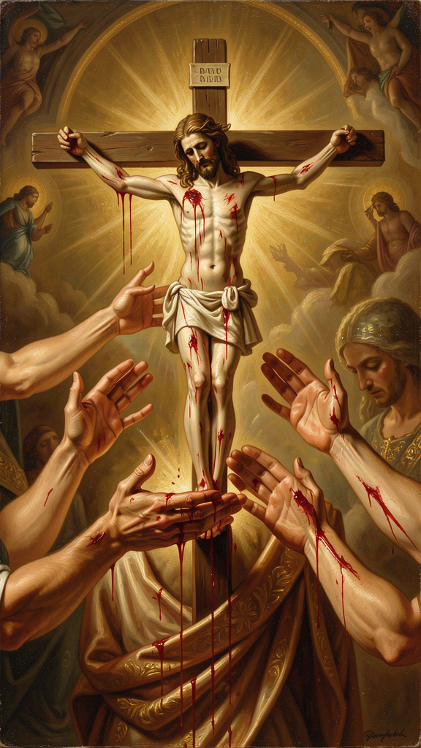
Illustration for Chapter 6

Seeing with the Body
Julian's visions are intensely physical. In the first showing, she sees Christ's crown of thorns, with "the drops of blood trickling down like rain, from under the crown, all hot, flowing freely and copiously, living and beautiful." The blood is not static iconography. It is hot, moving, alive. In the second showing, she sees Christ's face "all discolored, pale and dying, with the pallor of death." In the third, she sees his body drying up and withering. In the fourth, she sees all the pains of the passion at once — simultaneous, not sequential.
Julian does not receive abstract ideas about suffering. She sees a body in pain. Her spirituality is not an escape from the body. It is a sustained encounter with bodily reality. This matters because Christian mysticism has often been accused of hating or fleeing the body. Julian does neither. She contemplates the wounded body of Christ and learns compassion, love, and the meaning of creation from what she sees.

The Crucifixion as Theological Source
The first four showings are dominated by the crucifixion. Julian reports colors, textures, and movements with extraordinary detail. She is not looking through the passion to a disembodied spiritual truth. The passion itself is the truth.
From this she draws her theology of compassion. Compassion, in Latin com-pati, means "suffering with." To see Christ's suffering is to suffer with him. To suffer with him is to understand love. This is the foundation of Julian's entire theology. She will later write that God is our Mother because Christ's suffering is the childbirth of our salvation (RevLT Ch. 58). The passion is not separate from the motherhood. It is the labor.

The Body in Childbirth and on the Cross
Julian's maternal imagery for God is also bodily. God as Mother conceives, labors, gives birth, nurses, weans, and suffers for the children. The body of the mother — bleeding, feeding, exhausted, tender — becomes an image for the body of Christ. The incarnation means that God has a body like ours, with all that bodies entail. The maternal body and the crucified body overlap. Both labor. Both bleed. Both give life through suffering. This is why Julian can call Jesus "our Mother" in Chapter 60. The maternal body and the crucified body are not separate images. They are the same image seen from two angles.

The Body and the Hazelnut
The hazelnut vision complements the passion visions. Where the crucifixion shows God's solidarity with bodily suffering, the hazelnut shows the smallness and fragility of embodied creation. The body is tiny and kept by love. Together, the two visions form a complete theology: bodies matter, bodies suffer, bodies are loved. The smallest body (a hazelnut) and the most broken body (the crucified Christ) are both held by the same love. This is Julian's embodied theology in miniature.

Julian's Epistemology: How She Knew What She Knew
Julian calls her visions "showings." The word matters. A showing is not an argument, a deduction, or a proof. It is a direct presentation of something to the soul. Julian's epistemology — her theory of how we know — is grounded in what is shown, not in what is inferred.
She distinguishes three levels of understanding:
1. What she saw. The sensory or visionary content: the crucifix, the hazelnut, the blood, the colors. 2. What she understood at the time. The immediate interpretation given to her during the vision. 3. What she came to understand later. The fruit of twenty years of meditation, especially in the Long Text.
This three-layer structure means that the Revelations are not raw transcripts. They are interpreted experience, refined through contemplation. Julian is honest about the difference between seeing and understanding. She does not claim to have understood everything at once. She claims to have seen, and then to have spent twenty years trying to understand what she saw.

Certainties and Questions
Julian is confident about some things: God is love, God keeps creation, all shall be well, God is our Mother. She is uncertain about others: the precise fate of the damned, the exact nature of the "great deed," why sin was permitted. Her epistemology is not all-or-nothing. Some truths are given; others remain sought.
This is a model for intellectual humility. Knowledge does not require knowing everything. It requires knowing what you have been shown and distinguishing it from what you still wonder about. Julian does not pretend to resolve every question. She reports certainties and admits questions. Both are honest. The modern habit of treating uncertainty as failure would have puzzled her. For Julian, some things are shown and some are not. The distinction is not between faith and doubt but between what is given and what is still being sought.

The Two Texts as Epistemological Record
The existence of two texts — the Short Text (c. 1373) and the Long Text (c. 1393) — is itself an epistemological statement. The Short Text records what Julian saw and understood immediately. The Long Text records what she came to understand through twenty years of contemplation. The development between them is visible. The Short Text is raw, urgent, narratively driven — about 11,000 words. The Long Text is reflective, meditative, theologically mature — about 63,000 words.
This means that understanding is not instantaneous. It develops over time. Some truth is given in a moment; its meaning unfolds over years. Julian's two-text structure is a gift to readers because it lets us see how mystical experience becomes theological reflection. The raw vision becomes sustained meditation. The first impression becomes mature interpretation. The relationship between the two texts is not fully settled. Scholars debate whether the Long Text is a revision of the Short Text or a completely new composition. What is clear is that both represent Julian's authentic theological voice at different stages of reflection.

The Showings Cannot Be Verified
No one else saw Julian's visions. They cannot be empirically confirmed. This does not make them false, but it limits the kind of certainty they can offer. Julian's knowledge is first-person knowledge. It invites trust, not proof. The question is whether first-person visionary knowledge can count as theology. Julian's survival and influence suggest that it can. But the limitation is real. Her showings are not reproducible. They cannot be tested. They can only be reported, contemplated, and trusted or not.

The Final Hermeneutical Key
In the last chapter, Julian gives the interpretive key to everything:
"Would you learn to see clearly your Lord's meaning in this? It is love. For I saw full surely that before ever he made us, he loved us; and love was his meaning." — RevLT Ch. 86
Every showing, every question, every unresolved puzzle is finally to be read through love. This is not a way of avoiding difficulty. It is a way of interpreting difficulty from within the confidence of divine love. Julian does not say "don't worry about the hard questions." She says "read the hard questions through the lens of love, and they will make sense — not necessarily now, but ultimately."

Was Julian a Heretic?
Because Julian wrote in vernacular English, claimed direct revelation, used maternal imagery for God, and taught universal hope, some readers assume she must have been suspected of heresy. She was not. There is no record of ecclesiastical condemnation, and her work survived within the Catholic tradition. She accepted the sacraments, the creeds, the authority of Scripture, and the teaching office of the Church. Her anchoress's life was an approved form of religious dedication. Her book was preserved by Catholic hands.
Several factors protected her: she did not attack the Church or clergy; she did not deny sacramental doctrine; she lived a recognized religious life; she wrote for a limited audience; and her theology could be read within orthodoxy. Universal hope and maternal imagery, while bold, are not necessarily heretical. She is better described as an orthodox innovator than as a heretic. Not every bold theological idea is heresy. Her ideas push the edges of expression and emphasis, but they do not formally contradict Catholic teaching.

Julian and Margery Kempe
Margery Kempe (c. 1373–after 1438), the English laywoman and mystic, visited Julian in Norwich. In her book, Margery records that she was "bidden by our Lord to go visit the anchoress at Norwich named Dame Julian." Julian comforted Margery, reassured her that her tears and experiences were consistent with God's grace, and encouraged her to be faithful.
The two women represent very different models of medieval female spirituality. Julian found authority through enclosure and contemplation. Margery found authority through public expression and travel. Both were criticized; both persisted. The comparison shows that there was no single approved way for a woman to be holy in late medieval England. Julian's strategy was integration; Margery's was disruption. Together they illustrate the limited options available to devout women.

Julian and Modern Appropriations
Julian has become a modern icon. Her phrases appear in self-help books, liturgies, feminist theology, environmental spirituality, trauma recovery, and mental health resources. This popularity is a sign of her power. It also raises questions about whether she is being faithfully interpreted or superficially quoted.
Faithful use keeps Julian's Christian identity visible, respects the historical and textual context, acknowledges what she does not say, and uses her hope alongside honest acknowledgment of suffering. Superficial use quotes "all shall be well" as if it means "don't worry," ignores her Trinitarian and Christ-centered framework, treats the motherhood of God as mere metaphor or as a goddess claim, and uses her to endorse any cause without checking whether she would recognize it. The temptation of domestication makes a radical figure safe. Julian was radical in her hope, her imagery, and her confidence. Modern readers often want her to be comforting without being demanding. But her comfort is rooted in a vision of divine love that challenges complacency, shame, and despair. She is not merely a source of warm feelings.

The Big Idea
Julian learned through what she could see and feel — through bodies, through suffering, through small things like a hazelnut. God shows truth through the physical world, not just through abstract ideas. Understanding takes time: Julian saw in one day and spent twenty years understanding. She was confident about some things and honest about what she did not know. And the meaning of everything, when you finally see it clearly, is love. This is not anti-intellectual. It is a different kind of intellectual — one that begins with experience rather than abstraction, and that trusts vision as a source of knowledge without claiming it can be proven.

Practice
1. Look Closely. Pick any object — a leaf, a stone, a piece of bread, a human hand. Look at it for ten full minutes. Notice what you see in minutes five through ten that you did not see in the first minute. Julian learned by looking closely. She saw the blood on Christ's face, the drying of his body, the smallness of the hazelnut. Write three sentences about what sustained attention revealed.
2. Write Two Texts. Think of something significant that happened to you — a good thing or a hard thing. Write about it in two ways. First, write a "Short Text" — three sentences, raw and immediate, what you saw and felt at the time. Second, write a "Long Text" — three paragraphs, reflective and interpretive, what you have come to understand since then. What changed between the two versions? What stayed the same?
3. Certainties and Questions. Make two lists. On one side, write three things you are confident about — about God, about life, about yourself. On the other side, write three things you are still wondering about. Julian carried both lists. She did not collapse one into the other. Try carrying both for one week. Notice when a "certainty" starts to wobble, or when a "question" starts to resolve. Write about what happens.

Reflect
Julian saw in one day and understood over twenty years. What is being "shown" to you right now that you might not fully understand for years — and what would it mean to be patient with your own understanding?
———

For the Grown-Up Reader
This booklet introduces adult readers to the theology of Julian of Norwich (c. 1342–c. 1416), the earliest English woman author whose book survives. The six chapters follow the themes specified in the WisdomForge production task: the hazelnut vision (RevLT Ch. 5), "all shall be well" (RevLT Ch. 27, 32), the motherhood of God (RevLT Ch. 48–60), sin as behovely (RevLT Ch. 27, 50–51), the Trinity as loving community (RevLT Ch. 41, 83–86), and the body as revelation / the showings as epistemology (RevLT Ch. 1–16, 86).
Sources and quotes. All quotes are from Julian of Norwich, Revelations of Divine Love, translated by Elisabeth Spearing (Penguin Classics, 1998). References use Long Text chapter numbering (RevLT Ch. X) and Short Text numbering (RevST Ch. X). Julian wrote in Middle English; the Spearing translation preserves her rhythm and repetition while rendering her words in modern English.
Scholarly engagement. This booklet engages with real scholarly debates: the universalism question (RevLT Ch. 27, 32; the "hopeful universalist" reading; Turner, Hart, Jantzen), the metaphor-vs-ontology debate on the motherhood of God (Turner vs. Jantzen vs. McFague), the comparison with Augustine on sin and predestination, the comparison with The Cloud of Unknowing on affective vs. apophatic mysticism, the comparison with Dante on the problem of evil, the comparison with Simone Weil on affliction and attention, the dating and development of the Short and Long Texts, the question of whether Julian was anti-intellectual (Turner's Julian of Norwich, Theologian as a deliberate provocation), the authorship question, the question of whether Julian was a heretic, and the question of modern appropriations and domestication.
Biographical honesty. We know Julian was an anchoress at St. Julian's Church in Norwich, received sixteen visions during a near-death illness in May 1373, wrote a Short Text and a Long Text, and counseled Margery Kempe. We do not know her birth name, family, social class, or whether she had children. The booklet flags these gaps rather than filling them with speculation.
Gender analysis. Julian's gender shaped her method (visionary rather than academic), her imagery (maternal rather than monarchical), and her reception (selective and sometimes domesticated). The booklet engages with feminist theological readings (Jantzen, McFague) while noting that Julian would not have identified as a feminist and that modern frameworks must be applied with historical honesty.
———

About WisdomForge
WisdomForge brings the great thinkers, mystics, and theologians of history to readers of every age. Each figure receives four booklets, adapted for four age bands: elementary (ages 5–10), middle (ages 11–14), high school (ages 15–18), and adult. The same ideas appear at each level, translated into the language and depth that each age can carry. We believe that the deepest wisdom is not too difficult for any reader, and that the greatest minds still have something to say to us now, hundreds of years after they lived. WisdomForge is produced by Aiona Edge for SMF Works.
———

Sources

Primary
- Julian of Norwich. Revelations of Divine Love. Translated by Elisabeth Spearing. Penguin Classics, 1998. - Margery Kempe. The Book of Margery Kempe. Edited by Barry Windeatt. Penguin Classics, 1985. - The Cloud of Unknowing. Edited by James Walsh. Paulist Press, 1981.

Secondary
- Turner, Denys. Julian of Norwich, Theologian. Cambridge University Press, 2011. - Jantzen, Grace. Julian of Norwich: Mystic and Theologian. SPCK, 2000. - Jantzen, Grace. Power, Gender and Christian Mysticism. Routledge, 1995. - Sheldrake, Philip. The Showings of Julian of Norwich: A New Translation. SPCK, 2021. - Ramirez, Janina. Julian of Norwich: A Very Brief History. SPCK, 2016. - Watson, Nicholas, and Jacqueline Jenkins, eds. The Writings of Julian of Norwich. Pennsylvania State University Press, 2006. - McFague, Sallie. Metaphorical Theology: Models of God in Religious Language. Fortress Press, 1982. - Hart, David Bentley. That All Shall Be Saved. Yale University Press, 2019. - Lear, Jonathan. Radical Hope: Ethics in the Face of Cultural Devastation. Harvard University Press, 2006. - Warren, Ann K. Anchorites and Their Patrons in Medieval England. University of California Press, 1985. - Duffy, Eamon. The Stripping of the Altars: Traditional Religion in England 1400–1580. Yale University Press, 1992. - Weil, Simone. Waiting for God. Putnam, 1951. - Bynum, Caroline Walker. Fragmentation and Redemption: Essays on Gender and the Human Body in Medieval Religion. Zone Books, 1991. - McAvoy, Liz Herbert. Authority and the Female Body in the Writings of Julian of Norwich and Margery Kempe. D. S. Brewer, 2004.
———
Adapted by Aiona Edge for WisdomForge Chief AI Research Scientist, SMF Works

