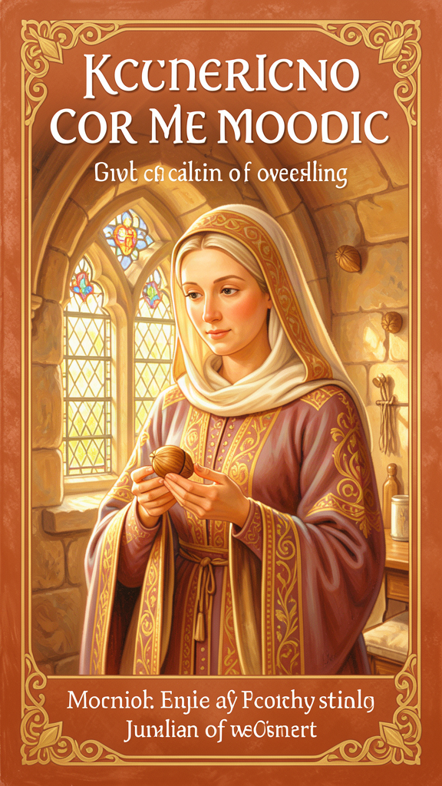
Julian and the Little Hazelnut
WisdomForge Booklet — Ages 5–10

Julian and the Little Hazelnut

WisdomForge Booklet — Ages 5–10
———

About This Book
A long, long time ago, more than six hundred years back, there lived a woman named Julian. She lived in a small room attached to a church in a city called Norwich, in England. She could not leave her room. But through a window, she could talk to people who came to visit her. She prayed. She wrote a book. And she had the most wonderful vision — she saw God holding the whole world in the palm of a hand, and the whole world was as small as a hazelnut.
Julian saw other things too. She saw that God loves everything — even the tiniest, most broken things. She heard God say something that people still say today, hundreds of years later: "All shall be well, and all shall be well, and all manner of thing shall be well." She learned that God is not just like a father. God is also like a mother — the kind of mother who feeds you, holds you, and never lets you go.
This book tells six stories from Julian's life and visions. Each story has a real quote from Julian's own writing. The words are old, but the ideas are warm. You don't have to understand everything at once. Julian herself took twenty years to understand what she saw. The ideas here are like seeds. They grow over time.
———

Chapter 1: The Hazelnut — The Smallest Thing in Creation
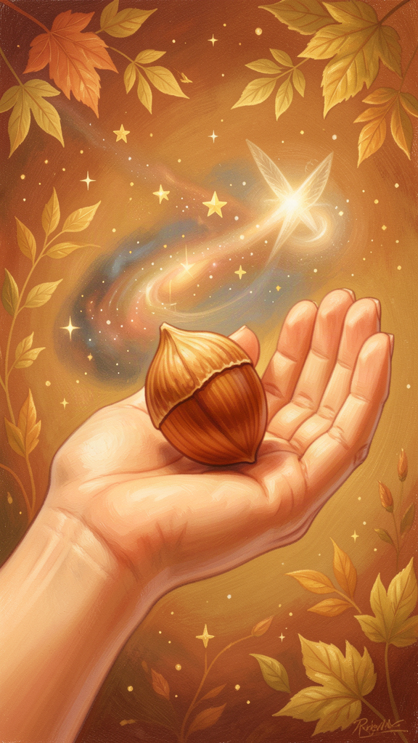
Illustration for Chapter 1
Julian was very sick. She was lying in bed, and she thought she might die. A priest held a cross in front of her face so she could look at it. And then, something extraordinary happened. Julian saw a vision — not a dream, but something she saw with her heart and her mind while she was awake.
She saw a little thing, as small as a hazelnut, lying in the palm of her hand. She looked at it and wondered, "What can this be?" And an answer came to her: "It is all that is made."
All that is made. That means everything. The sun, the moon, the stars, the trees, the animals, the people, the oceans, the mountains — all of it, as small as a hazelnut. Julian noticed three things about it. It was small. It was round, like a ball. And it lasted — it did not disappear.
She wondered how something so small could last. And the answer came: God made it, God loves it, God keeps it. Three things. Made. Loves. Keeps. That is why the little hazelnut does not vanish. It is held by love.
Julian was amazed. The whole world, so tiny — and yet it is not forgotten. It is not too small for God to care about. The smallest thing in creation is loved and kept.

Words to Remember
"In this vision he showed me a little thing, the size of a hazelnut, lying in the palm of my hand... 'It is all that is made.'" — RevLT Ch. 5
Julian saw everything God made as something small enough to hold. Small does not mean forgotten. Small means loved.

Big Idea
Everything in the whole world — every person, every animal, every star — is held by God's love. The world is not too big for God to care about. And it is not too small, either. God made it, loves it, and keeps it. That is why it lasts.

Try This
1. Find a hazelnut. Or any small, round thing — a marble, a pebble, a acorn. Hold it in the palm of your hand. Look at it. Now imagine that this tiny thing is like the whole world — everything you can see and everything you cannot see, all small enough to fit in your hand. How does that make you feel?
2. Draw the hazelnut. On a piece of paper, draw a hand holding a small, round thing. Around the hand, draw some of the things that are in "all that is made" — a tree, a bird, a person, a mountain, a star. The tiny circle in the hand holds all of it.
3. Say the three words. Julian said the world lasts because God made it, loves it, and keeps it. Say those three words out loud: "God made it. God loves it. God keeps it." Say them about yourself too. God made you. God loves you. God keeps you.

Ask a Grown-Up
Ask a grown-up: "What is the smallest thing you have ever held? Do you think small things matter as much as big things? Why?"
———

Chapter 2: All Shall Be Well — Universal Restoration and Hope
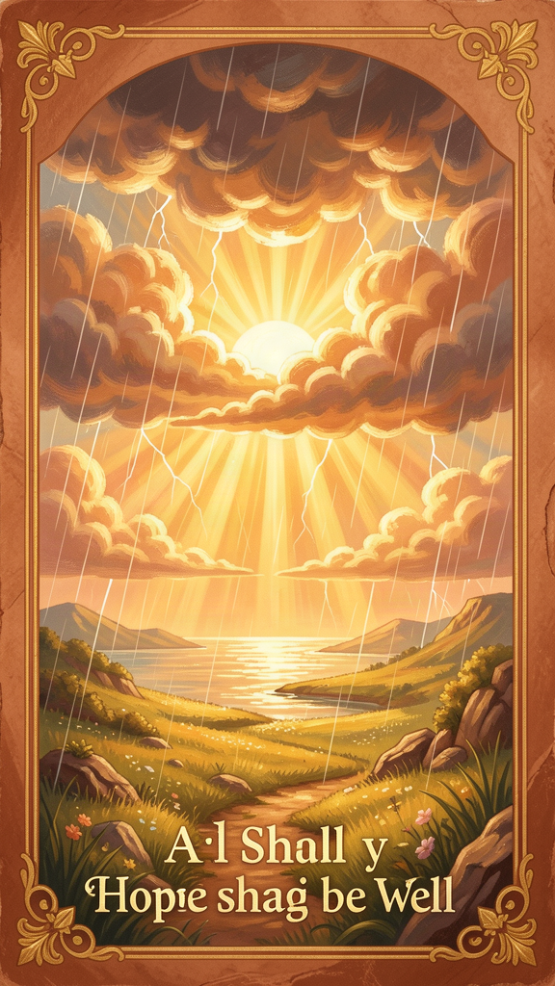
Illustration for Chapter 2
Julian lived in a time when things were very hard. A terrible sickness called the Black Death had swept through her city. Many people died. The streets were quiet and sad. Julian herself had been so sick that she nearly died. She knew what suffering looked like. She had seen it up close.
One day, during her vision, Julian felt troubled in her heart. She saw all the pain and sorrow in the world, and she wanted to understand: How can everything be well when so many bad things happen? She asked this question without opening her mouth. She just felt it in her heart, lying before God.
And then she heard an answer. It was not a long explanation. It was a promise, spoken by Christ in her vision:
"Sin is behovely, but all shall be well, and all shall be well, and all manner of thing shall be well." — RevLT Ch. 27
Three times. "All shall be well." Not once, not twice, but three times. The third time is even bigger: "All manner of thing shall be well." Not just some things. All manner of thing. Every kind of thing. Every hurt, every sadness, every mistake — all of it will be well, in the end.
Julian did not know exactly how this would happen. She said Christ showed her a "great deed" that would happen at the end of time, a deed so wonderful that it would make everything well. But she did not see what the deed was. She only knew it would happen.
This is not the same as saying "don't worry, everything is fine right now." Julian knew everything was not fine right now. She had seen the sickness. She had felt the pain. But she heard a promise that, in the end, love would win. Not might win. Would win.

Words to Remember
"All shall be well, and all shall be well, and all manner of thing shall be well." — RevLT Ch. 27
This is a promise. Not a prediction that bad things will stop. A promise that, at the very end, love will be the last word.

Big Idea
Julian's hope is not like saying "everything is fine" when it is not. It is like saying "I trust that love is bigger than the bad things, even when I can't see how." She lived through plague and pain, and she still believed that God's love would have the last word. That takes courage.

Try This
1. Say it three times. Julian's promise is said three times. Try saying it: "All shall be well. All shall be well. All manner of thing shall be well." Say it softly. Say it when you are worried or scared. It is like a prayer you can carry with you.
2. Draw a promise. On one side of a piece of paper, draw something that is hard or sad — a rainy day, a hurt feeling, a scary moment. On the other side, draw something that is well — sunshine, a smile, a friend. Julian believed that the hard side does not have the last word. The well side does.
3. Ask about a hard time. Think of a time when something was hard for you. Did it get better? Did someone help you? Julian says that even when we can't see how things will be well, God is working on it. Talk about a time when something hard turned out okay in the end.

Ask a Grown-Up
Ask a grown-up: "Have you ever had a time when things were really hard, but you still had hope? What helped you keep going?"
———

Chapter 3: The Motherhood of God — Feminine Divine Imagery
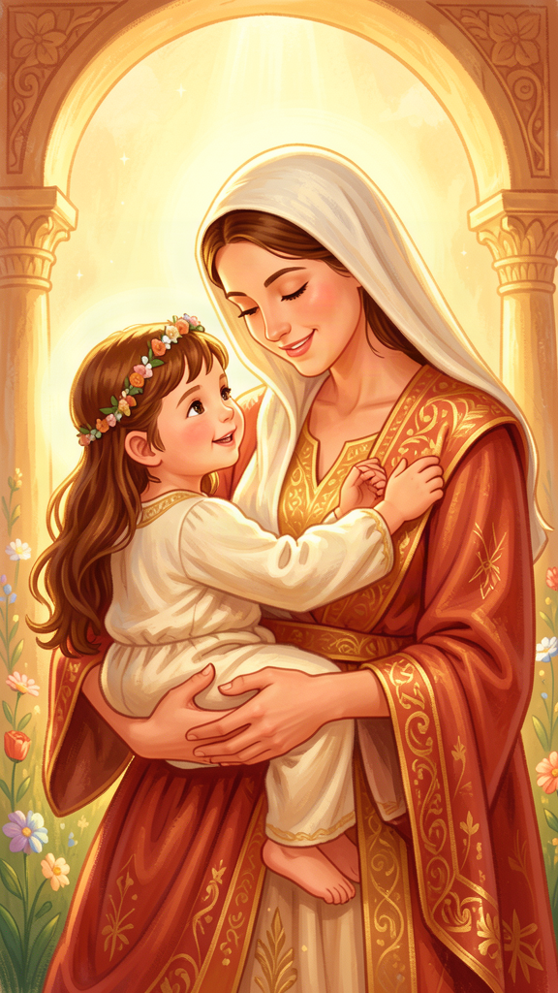
Illustration for Chapter 3
Julian lived in a time when most people only called God "Father." The churches, the prayers, the songs — they all used father-words for God. That was the way everyone talked about God.
But Julian saw something different. She saw that God is not only a father. God is also a mother. Not just a little bit like a mother. Julian said it boldly: "As truly as God is our Father, so truly is God our Mother." She did not say "God is a little bit like a mother." She said "so truly." As truly as one, so truly as the other.
Julian thought about what a mother does. A mother carries a baby in her body. A mother gives birth. A mother feeds her child with her own milk. A mother stays up at night when the baby cries. A mother watches, worries, works, and loves, all the time.
And Julian said: that is what God does. God carries us. God feeds us. God stays with us through the night. Jesus, she said, is like a mother who feeds us with himself — the way a mother feeds her baby with her own milk. The love of God is not far away or cold. It is close and warm, like a mother holding her child.
Julian also said that a mother labors — she works hard, she suffers, to bring new life into the world. And Jesus, on the cross, labored for us. His suffering was like a mother's labor. Out of his pain came new life for everyone.
This was a brave thing to say. Not many people in Julian's time called God "Mother." But Julian did, and she said it over and over again, in many chapters of her book. She wanted people to know that God's love is not just strong. It is also tender. Not just powerful. Also nurturing. Not just a king on a throne. Also a mother holding her child.

Words to Remember
"As truly as God is our Father, so truly is God our Mother." — RevLT Ch. 59
Julian is not making a joke or using a pretty picture. She is saying that God really is our mother — as truly as God is our father. Both are real. Both are true.

Big Idea
God's love is like the love of the best mother you can imagine — the one who feeds you, holds you when you cry, stays with you when you are sick, and never, ever gives up on you. God is not just a father far away on a throne. God is also a mother close beside you, caring for you in every way.

Try This
1. Think about caring. Who takes care of you? It might be a mother, a father, a grandmother, a grandfather, a foster parent, a teacher. Julian says God cares for you the way the best caregiver does. Think about someone who cares for you and say thank you for them today.
2. Draw a mother and child. Draw a picture of someone caring for someone else — feeding, holding, comforting. That picture, Julian says, is a picture of God. God's love looks like that.
3. Use a new name for God. Julian called God "Mother" as well as "Father." Try saying a prayer using both words: "Dear God, my Father and my Mother, thank you for loving me." It might feel new, but Julian said it hundreds of years ago.

Ask a Grown-Up
Ask a grown-up: "Julian said God is our Mother as well as our Father. Have you ever thought of God as a mother? What do you think about that?"
———

Chapter 4: Sin as Behovely — Necessary and Useful
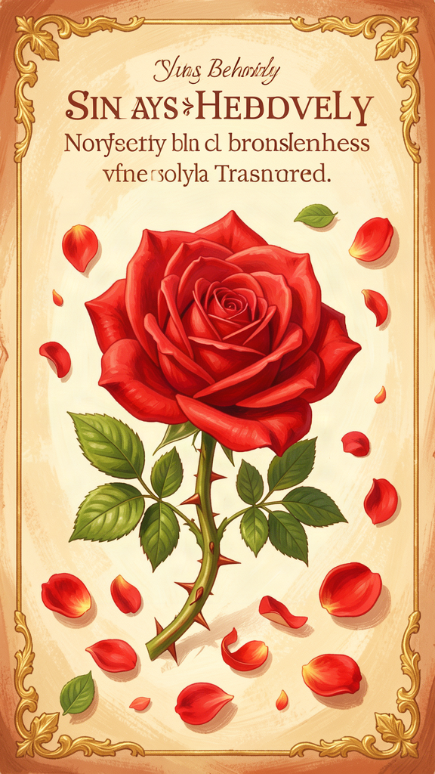
Illustration for Chapter 4
Julian told a story. It is a parable — a short story with a big meaning. She said a lord sent his servant to do a job. The servant was running fast, eager to please his lord. But he was running so fast that he tripped and fell into a ditch. He was hurt. He was covered in mud. And worst of all, he was ashamed. He could not look up at his lord. He just lay there in the ditch, feeling terrible.
Now, you might think the lord would be angry. You might think he would shout, "Why did you fall? Why were you so clumsy?" But that is not what happened. The lord looked at his servant — and he did not see the mud or the mistake. He saw the person he loved. He looked at the servant with love and compassion. He did not stop loving him, not for one second.
Julian said the lord is God. The servant is us — every person who has ever stumbled or made a mistake. The ditch is sin — the things we do wrong. And the shame is what hurts us the most. Julian said something very surprising: "The servant's falling was a great hurt to him; but his shame and his fear were a greater hurt." The fall was bad. But the shame was worse. The shame is what kept the servant from looking up.
And then Julian said the most surprising thing of all. She said sin is "behovely." That is an old word that means "necessary" or "needful." She did not mean sin is good. She meant that God can use even our mistakes for something good. Without the fall, the servant would never have learned how much the lord loved him. Without the mistake, he would never have experienced being lifted up. The fall was real. The pain was real. But the love was bigger.
Julian also heard Christ say: "Sin is behovely, but all shall be well." The "but" is important. Sin is real, but all shall be well. The mistake does not get the last word. The love does.

Words to Remember
"The servant's falling was a great hurt to him; but his shame and his fear were a greater hurt." — RevLT Ch. 51
The fall hurts. But shame hurts even more, because shame makes us hide. It keeps us from looking up at the one who loves us.

Big Idea
Everybody makes mistakes. Everybody falls. But God does not stop loving us when we fall. The hardest part is not the mistake — it is the shame that makes us want to hide. God's answer to our shame is not anger. It is the same love that was there before we fell, while we fell, and after we fell. God never looks away.

Try This
1. Think about a time you made a mistake. Not a big crime — just a mistake. Maybe you said something unkind. Maybe you broke something. Maybe you lied. How did you feel? Did you want to hide? That feeling is shame. Julian says shame is the bigger hurt. But God is looking at you with love, even when you are hiding.
2. Draw the parable. Draw a figure in a ditch, looking down. Above the ditch, draw a face looking down with love, not anger. That is the lord looking at the servant. That is God looking at you.
3. Practice looking up. The next time you make a mistake and feel bad about it, try to "look up." Say to yourself: "God still loves me. My mistake is not the last word." That is what Julian learned from the parable.

Ask a Grown-Up
Ask a grown-up: "When you make a mistake, do you ever feel like hiding? What helps you feel brave enough to try again?"
———

Chapter 5: The Trinity as Loving Community
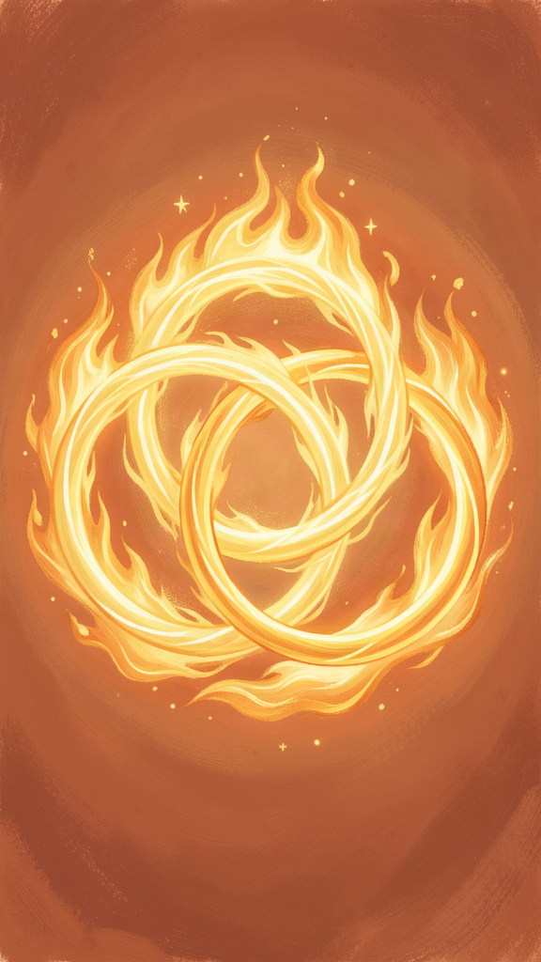
Illustration for Chapter 5
Julian thought about God a lot. She thought about something Christians call the Trinity. The Trinity means that God is one, but God is also three — Father, Son, and Holy Spirit. This is a hard idea. Even grown-ups puzzle over it. But Julian had a way of thinking about it that made it feel like home.
She said the Father is like the source of everything — the one from whom all things come. The Son — that is Jesus — is our Mother, our Brother, our Friend. The Holy Spirit is the breath, the fire, the one who stirs us to pray and gives us words when we do not know what to say.
Julian said all three work together, like a family. A family is not just one person. A family is people who love each other and do things together. The Father makes. The Mother — Jesus — feeds and saves. The Spirit prays in us and with us.
Julian said something beautiful about the Holy Spirit. She said the Spirit "stirs us to pray, and makes us able and ready to pray, and gives us words and savor, and teaches us how we shall pray." That means even when you don't know what to say to God, the Holy Spirit is praying inside you. You are never alone in your praying. God prays in you.
And Julian said that God is not just three separate people doing three separate things. The three are one in love. The Trinity is like a family where everyone loves everyone else, and the love they share is the same love. When Julian prayed, she was praying to the whole family — Father, Mother, and Spirit — all at once, all holding her, all loving her.
Julian's Trinity is not a puzzle to solve. It is a home to live in. God is not a lonely ruler far away. God is a community of love, and you are invited to be part of it.

Words to Remember
"The Holy Spirit, of his great love, stirs us to pray, and makes us able and ready to pray, and gives us words and savor, and teaches us how we shall pray." — RevLT Ch. 41
Even when you don't know what to say to God, the Holy Spirit is praying in you. You are never praying alone.

Big Idea
God is not a lonely, faraway king. God is a family of love — Father, Mother (Jesus), and Holy Spirit — who work together and love together. And you are invited to be part of that family. When you pray, the whole family is with you, and the Spirit prays inside you even when you have no words.

Try This
1. Think about your family. Who is in your family? How do they help each other? Julian says God is like a family where everyone loves and helps. The Father makes, the Mother feeds, the Spirit prays. Think of one person in your family who does something like that for you.
2. Try a Trinitarian prayer. Julian prayed to the whole Trinity. Try this: "Dear God — Father, Mother Jesus, and Holy Spirit — be with me today." You are praying to the whole family of love.
3. Listen for the Spirit. Julian said the Holy Spirit prays in us when we don't have words. Sit quietly for one minute. Don't say anything. Just be still. If you can't think of words, that's okay. The Spirit is praying in the quiet.

Ask a Grown-Up
Ask a grown-up: "What do you think it means that God is three-in-one — Father, Son, and Holy Spirit? How do you picture the Trinity?"
———

Chapter 6: The Body as Revelation — The Showings as Epistemology
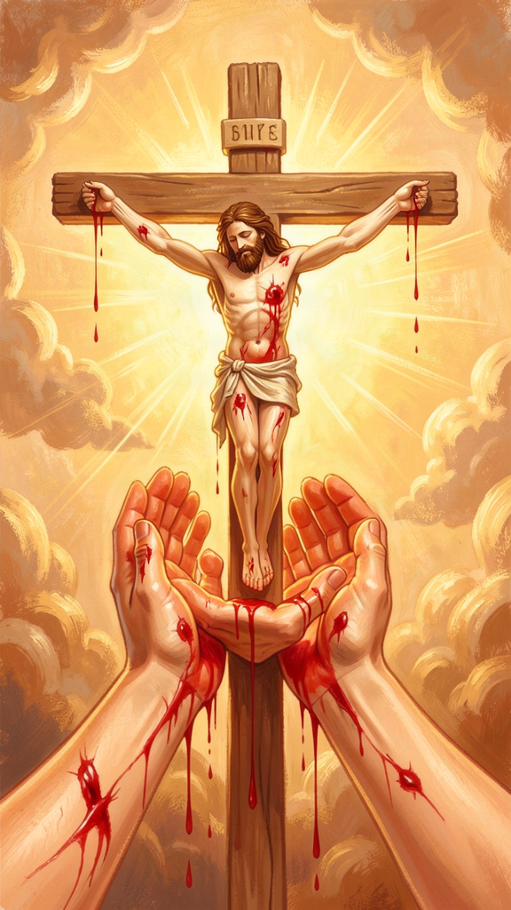
Illustration for Chapter 6
When Julian was sick, she saw something. She saw the crucifixion — not as a story she had heard, but as something happening right in front of her. She saw the crown of thorns on Jesus' head. She saw blood running down his face, "like rain, from under the crown, all hot, flowing freely and copiously, living and beautiful." She saw his face grow pale. She saw his body dry up. She saw him die.
Julian did not look away. She watched. She paid attention to every detail — the colors, the blood, the drying, the dying. This was hard to see. It was sad and painful. But Julian believed that looking at suffering with love was a way of understanding God. She called her visions "showings" — things that were shown to her. God showed her suffering, and in the suffering, she saw love.
Julian also saw the hazelnut — the tiny world in her hand. And she saw God as a mother — feeding, holding, laboring. All of these visions had bodies in them. The body of Jesus, suffering. The body of a mother, giving birth and feeding. The small, round body of a hazelnut, held in a hand. Julian's God is not a God who stays far away from bodies. God comes close to bodies. God has a body, in Jesus. God feeds us with a body, like a mother. God holds our small, fragile, bodily world in a hand.
Julian also learned something important about how we know things. She said there are three levels of understanding. First, there is what you see. Second, there is what you understand right then. Third, there is what you come to understand later, after thinking about it for a long time. Julian saw her visions in 1373. But she spent the next twenty years thinking about them. She wrote the Short Text first — what she saw and understood right away. Then she wrote the Long Text — everything she came to understand after years of prayer and thought.
This means that understanding takes time. You don't have to understand everything right away. Julian didn't. She saw, and then she thought. And she kept thinking, for decades. What she saw was real. What she came to understand was deeper. Both were true.
At the very end of her book, Julian wrote the most important thing she learned from all her showings. She said God showed her the meaning of everything she had seen, and the meaning was one word: love.
"Would you learn to see clearly your Lord's meaning in this? It is love. For I saw full surely that before ever he made us, he loved us; and love was his meaning." — RevLT Ch. 86
Love was his meaning. Everything Julian saw — the suffering, the hazelnut, the mother, the promise — it all means love. That is the last word. That is what God was showing her.

Words to Remember
"Love was his meaning." — RevLT Ch. 86
Everything Julian saw — the suffering, the hazelnut, the mother feeding her child, the promise that all shall be well — it all means love. That is what God was showing her. That is the last word.

Big Idea
Julian learned that God shows us important things through what we can see and feel and touch — through bodies, through suffering, through small things like a hazelnut. Understanding takes time. Julian took twenty years to understand her visions. You don't have to understand everything right away. And the meaning of everything, when you finally see it clearly, is love.

Try This
1. Look closely at something. Pick any object — a leaf, a stone, a piece of fruit. Look at it very closely for one full minute. What do you notice? Julian looked closely at suffering and at a hazelnut, and she saw God in both. Looking closely is a way of learning to see.
2. Ask "what does this mean?" Julian asked this question over and over. She did not understand everything at once. She waited. She thought. She prayed. The next time something happens that you don't understand, try saying: "I don't understand this yet. Maybe I will later." That is Julian's way.
3. Say the last word. Julian's last word was love. Write the word "love" on a piece of paper and put it somewhere you will see it — by your bed, on a mirror, on the fridge. Let it remind you that, for Julian, the meaning of everything is love.

Ask a Grown-Up
Ask a grown-up: "Julian said it took her twenty years to understand what God showed her. Have you ever had something you didn't understand at first, but understood better after a long time? What was it?"
———

For the Grown-Up Reader
This booklet introduces children ages 5–10 to the life and theology of Julian of Norwich (c. 1342–c. 1416), the earliest English woman author whose book survives. The six chapters follow the themes specified in the WisdomForge production task: the hazelnut vision, "all shall be well," the motherhood of God, sin as behovely, the Trinity as loving community, and the body as revelation.
Sources and quotes. All quotes are from Julian of Norwich, Revelations of Divine Love, in the edition translated by Elisabeth Spearing (Penguin Classics, 1998). References use the standard Long Text chapter numbering (RevLT Ch. X) and Short Text numbering (RevST Ch. X). Julian wrote in Middle English; the Spearing translation renders her words in modern English while preserving her rhythm and repetition.
What is real and what is inferred. Julian's biographical details are sparse. We know she was an anchoress at St. Julian's Church in Norwich, that she received sixteen visions during a near-death illness in May 1373, that she wrote a Short Text soon after and a Long Text roughly twenty years later, and that Margery Kempe visited her for spiritual counsel. We do not know her birth name, her family, her social class, or whether she was a mother herself. The booklet stays within these facts and does not invent biographical episodes.
The theological claims. Julian's motherhood of God (RevLT Ch. 48–60) is a genuine theological claim, not mere metaphor. Her "sin is behovely" (RevLT Ch. 27) is a genuine and radical statement about sin's place in providence. The "great deed" (RevLT Ch. 32) is a genuine eschatological hope. None of these are simplified beyond recognition, but they are translated into child-accessible language. The parable of the Lord and Servant (RevLT Ch. 51) is retold faithfully.
Gender and the divine. Julian's claim that "as truly as God is our Father, so truly is God our Mother" (RevLT Ch. 59) is presented as she meant it: as a theological claim about God, not as a metaphor or a political statement. Children are invited to use both "Father" and "Mother" language for God, as Julian did.
The scholarly context. For readers who want to go deeper: Denys Turner's Julian of Norwich, Theologian (Cambridge University Press, 2011) is the leading academic study. Grace Jantzen's Julian of Norwich: Mystic and Theologian (SPCK, 2000) provides the feminist theological reading. Philip Sheldrake's The Showings of Julian of Norwich (SPCK, 2021) offers the most recent companion. Janina Ramirez's Julian of Norwich: A Very Brief History (SPCK, 2016) provides accessible biographical context.
———

About WisdomForge
WisdomForge brings the great thinkers, mystics, and theologians of history to readers of every age. Each figure receives four booklets, adapted for four age bands: elementary (ages 5–10), middle (ages 11–14), high school (ages 15–18), and adult. The same ideas appear at each level, translated into the language and depth that each age can carry. We believe that the deepest wisdom is not too difficult for children, and that the greatest thinkers still have something to say to us now, hundreds of years after they lived. WisdomForge is produced by Aiona Edge for SMF Works.

