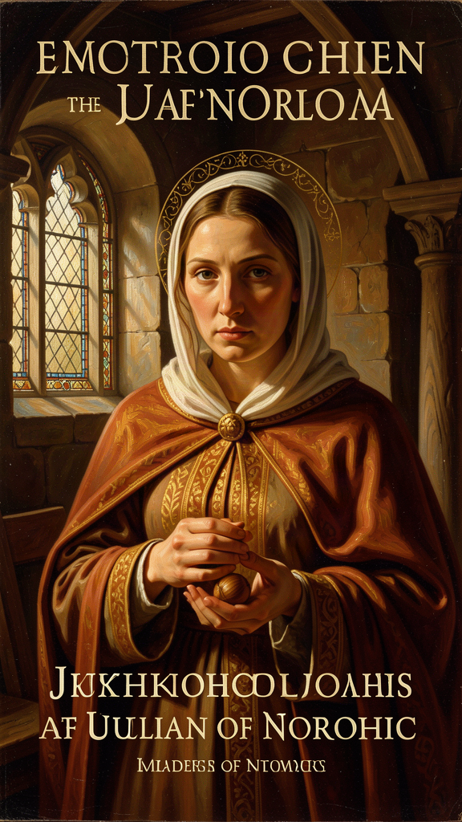
Julian of Norwich: Love Was His Meaning
WisdomForge Booklet — Ages 15–18

Julian of Norwich: Love Was His Meaning

WisdomForge Booklet — Ages 15–18
———

About This Book
You are holding a book about a woman who saw the whole universe in the palm of her hand and called it a hazelnut. A woman who lived through the worst plague in European history and still wrote, "All shall be well, and all shall be well, and all manner of thing shall be well." A woman who called God "Mother" six centuries before feminist theology made it fashionable. A woman who said that sin — the thing the Church had taught her to fear most — was "behovely," necessary, because it would become the occasion for a mercy so vast that it would make everything well in the end.
Her name was Julian. We don't know her real name. "Julian" comes from the church in Norwich where she lived, walled into a cell no bigger than a modern bedroom, attached to the wall of a parish church, with three windows: one into the church to hear Mass, one to a servant for food, and one to the street where visitors came seeking counsel. She was an anchoress — a woman who chose permanent enclosure for a life of prayer. She received sixteen visions during a near-death illness in May 1373, when she was about thirty years old. She wrote them down. Then she spent the next twenty years thinking about them, and wrote them down again, longer and deeper.
The result is the earliest surviving book in English written by a woman. It is also one of the most theologically daring works in the medieval Christian tradition. Julian does not argue like a university theologian. She reports what she saw and what she came to understand, and she leaves the hardest questions open — not because she could not think, but because she believed that some truth is given through vision before it can be reached through deduction.
This booklet has six chapters. Each takes one of Julian's central ideas and develops it: the hazelnut, "all shall be well," the motherhood of God, sin as behovely, the Trinity as loving community, and the body as revelation. You will read Julian's own words, translated from Middle English. You will encounter the world she lived in — plague, war, faith, doubt. You will find practices to try and questions to sit with. Julian took twenty years to understand her visions. You don't have to rush either.
———

Chapter 1: The Hazelnut — The Smallest Thing in Creation
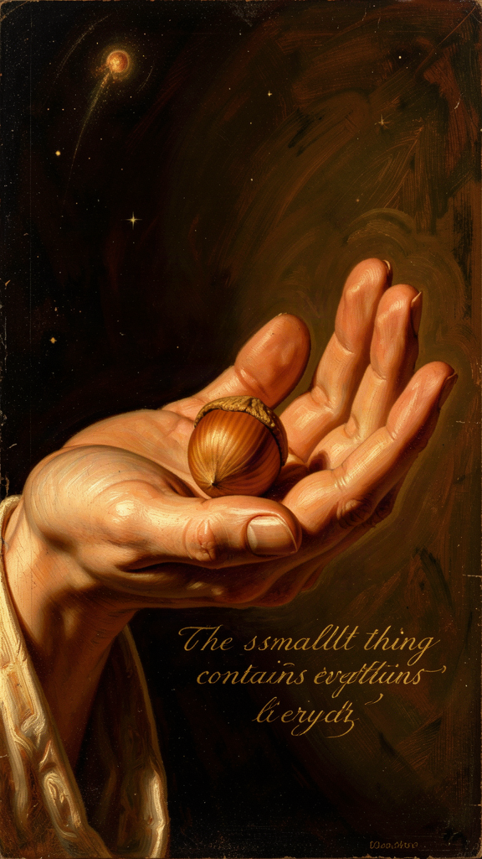
Illustration for Chapter 1

The Fifth Showing
Julian had already received four visions of Christ's passion — the crown of thorns with blood "trickling down like rain, from under the crown, all hot, flowing freely and copiously, living and beautiful," the drying of Christ's face "with the pallor of death," the scourging, the death — when the fifth showing came. It was completely different from everything before it.
"In this vision he showed me a little thing, the size of a hazelnut, lying in the palm of my hand. And I looked at it and thought: 'What can this be?' And I was answered: 'It is all that is made.'" — RevLT Ch. 5
The entire created universe — all that exists — seen as something that fits in the palm of a hand. Julian observed three things: it was small, "as tiny as a hazelnut." It was round, "as a ball." And it lasted — "it lasts and ever shall, for God loves it." She asked how something so small could endure. The answer came in three verbs: "God made it, God loves it, God keeps it."
Three verbs. Made. Loves. Keeps. The entire metaphysics of creation, compressed into three words. Creation has no independent durability. It endures by participation in divine love. The hazelnut is not a symbol of the world's insignificance. It is an image of intimacy. The world is small enough to be held, loved enough to be kept.

Smallness as a Spiritual Category
Julian's fourteenth century was obsessed with magnitude — bigger empires, grander cathedrals, more powerful institutions. The Church measured its authority in land, armies, and political influence. Against this, Julian insists that smallness is not failure. The hazelnut's smallness is precisely what makes it fit in a human hand. The cosmos does not need to be impressive to be loved. It needs to be loved to be real.
This has implications for how we value our own lives. You may feel that your own worries, labors, and loves are too small to matter. Julian's vision says otherwise: the smallness of a life is no measure of its worth. What measures its worth is the love that keeps it.

The Metaphysics of Dependence
Julian's hazelnut is not pantheism. She does not say the hazelnut is God. She says the hazelnut is kept by God. The world remains distinct from its maker even as it depends entirely on the maker's love. This is closer to the classical Christian doctrine of creation ex nihilo — the world exists because God freely wills it, not because God needed matter or because the world is a piece of the divine substance.
But Julian's formulation is experiential, not technical. She does not argue for creation from nothing. She sees the world as fragile and loved. The theology follows the vision. And the vision says: everything that exists is small, round, and held.

The Hazelnut and the Cross
The placement of the hazelnut vision matters. It follows the crucifixion visions (Ch. 1–4) and precedes the extended meditations on suffering (Ch. 6–16). The hazelnut provides the theological frame: Christ's suffering is seen within the context of a loved, kept creation. The cross is not a negation of creation but its fulfillment.
A theology built only on the hazelnut would be naively optimistic. A theology built only on the cross would be despairing. Julian holds both. The world is loved and kept. The world also suffers. Both are true. Both must be held together.

Gender and the Hazelnut
The image of a woman holding "all that is made" in the palm of her hand is powerful. In medieval iconography, the cosmos is typically held by Christ as Pantocrator or by male figures of authority. Julian places the created world in the hand of an anonymous anchoress. The point is not female dominance but female intimacy: the cosmos is small enough to be held, close enough to be loved, ordinary enough to be known.

The Big Idea
Everything that exists is small enough to fit in God's hand and loved enough to be kept there. Smallness is not failure — it is the condition for intimacy. The world does not need to be grand or powerful to matter. It needs to be loved, and it is. The metaphysics is simple: made, loves, keeps. The implications are vast: if the world is held by love, then fragility is not abandonment, and smallness is not insignificance.

Practice
1. The Hazelnut Test. When you feel overwhelmed, imagine everything that weighs on you — your assignments, your worries, your conflicts, your fears — fitting into something the size of a hazelnut. Not because your problems are trivial, but because they are held. This is not denial. It is perspective. Write one paragraph about what changes when you picture your burdens as held rather than as crushing.
2. Three Verbs. Write "made, loves, keeps" on a card you carry for one week. Each morning, look at the card and say the three words. Each evening, write one sentence about whether you experienced being made, loved, or kept that day — or whether you did not. At the end of the week, read what you wrote. What pattern do you notice?
3. Look at something small for five minutes. Pick any object — a leaf, a stone, a hazelnut, a coin. Look at it for five full minutes without looking away. Notice what you see that you did not see in the first thirty seconds. Julian learned by looking closely. She saw the world in a hazelnut because she looked at the hazelnut. Write three sentences about what you discovered in those five minutes.

Reflect
If the whole world is as small as a hazelnut — held, loved, and kept — what in your life have you been treating as too small to matter? And what would change if you believed it was held by the same love that holds everything?
———

Chapter 2: All Shall Be Well — Universal Restoration and Hope

Illustration for Chapter 2

The Question and the Answer
After the passion visions and the hazelnut, Julian reached the theological heart of her work. She had seen suffering. She had seen the small, loved world. Now she faced the question that every honest person faces: How can all be well when so much is not well?
She records her anguish with remarkable honesty. She had, she writes, "a soft protest" — not spoken, but felt silently as she lay before God:
"Ah, good Lord, how can all be well for the great harm that has come through sin to your creatures?" — RevLT Ch. 27
Christ's response is not an argument. It is a promise, spoken three times:
"Sin is behovely, but all shall be well, and all shall be well, and all manner of thing shall be well." — RevLT Ch. 27
The repetition is theological progression, not rhetorical ornament. "All shall be well" — universal scope: no thing, no person, no event excluded. "All shall be well" — temporal depth: not only now, not only soon, but ultimately. "All manner of thing shall be well" — comprehensiveness: every category of existence, every kind of suffering, every form of evil.

The Great Deed
In Chapter 32, Julian returns to this promise and introduces the concept of "the great deed":
"The great deed shall be performed, by which the devil shall be overcome, and our Lord shall be glorified, and we shall be saved, and all manner of things shall be well."
The "great deed" is not yet completed in Julian's present. It is eschatological — it lies in the future, at the end of history. But it is also already accomplished in Christ's passion. Julian holds the tension: the deed is done (on the cross) and not yet done (in the world's continuing suffering).
This is Julian's answer to the delay of justice. Why is all not well now? Because the great deed is still unfolding. But Julian insists — against the evidence of her own plague-scarred era — that the outcome is certain.

What Julian Lived Through
This context is not optional. Julian's hope is not abstract. The Black Death arrived in England in 1348 and raged through 1350, killing perhaps 30 to 60 percent of the population. Norwich was hit hard. The city lost thousands of residents. The Peasants' Revolt of 1381 brought violent uprising. The Hundred Years' War continued. Ecclesiastical corruption was widespread. Julian herself had nearly died.
Her "all shall be well" is spoken from inside catastrophe, not from outside it. It does not deny the catastrophe. It faces it and says: love will outlast it. A prediction says, "Things will probably improve." A pledge says, "Love will finally triumph." Julian offers a pledge.

The Architecture of Hope
Julian's hope has three supports:
1. The passion of Christ — God has already entered the worst of human suffering. The cross is evidence that love persists within evil. 2. The nature of God as love — Julian's repeated refrain: "Love was his meaning" (RevLT Ch. 86). If God's meaning is love, the final word cannot be wrath. 3. The great deed yet to come — Eschatological hope: history has a direction, and the direction is toward well-being.
This is not Stoic resignation. It is Christian hope — active, expectant, grounded in divine promise rather than human achievement.

The Universalism Debate
The central scholarly debate about Julian's theology: Did she teach universal salvation? If all shall be well, does that mean every person will finally be saved?
The textual evidence is genuinely ambiguous. Julian never explicitly says that all human beings will be saved. She does not deny the traditional doctrines of judgment, hell, or the need for repentance. She lived within a Catholic Church that affirmed these doctrines. She may have believed that "all shall be well" describes the final state of those who are in Christ, not necessarily every individual without qualification.
But her language is remarkably hopeful. She says that God will "make well all that is not well." She stresses God's power over sin and God's will to save. Most scholars call her a "hopeful universalist" — she leans strongly toward universal salvation without formally asserting it. Some call her a "practical universalist" or a "universalist in hope." A minority believes she is a full doctrinal universalist. Others insist she remained within orthodox Catholic ambiguity.
The safest scholarly conclusion is that Julian's theology strongly tends toward universal hope, but she does not offer a systematic doctrine of salvation. She leaves the question open enough that readers still disagree, six centuries later. This ambiguity may have been strategic — to avoid condemnation — or it may reflect genuine mystery. Either way, her text does not settle the matter.

Misappropriations
"All shall be well" is frequently misused. It is not naive optimism — Julian saw the Black Death kill half of Europe. It is not denial of suffering — the phrase comes after extended meditations on Christ's suffering. It is not political quietism — Julian does not tell the oppressed to wait patiently. She tells them that the divine outcome transcends human power structures. It is not necessarily universal salvation — while some read Julian as a universalist, her text is carefully ambiguous.
The hope is hard-won because it does not deny the catastrophe. It faces it and says: love will outlast it.

Scholarly Debate: The Dating and Development
The question of when Julian wrote each text matters for understanding her hope. The Short Text, written soon after the visions of 1373, is raw, immediate, and narratively driven — about 11,000 words. The Long Text, completed perhaps around 1393, is reflective, meditative, and theologically mature — about 63,000 words.
Scholars debate whether the Long Text represents development (Julian grew in understanding over twenty years) or reworking (she reshaped the same material for a different audience or purpose). Most favor a both/and reading. The Short Text contains "all shall be well" (Ch. 13); the Long Text deepens it (Ch. 27, 32). What was a statement of hope in the Short Text becomes a theological architecture in the Long Text. The two texts together show Julian becoming more confident in her voice. The Long Text is not just longer. It is more authoritative.

The Big Idea
Julian's hope is a pledge, not a prediction. It does not say the world is fine right now. It says that the final word belongs to love, even when we cannot see how. This is eschatological hope — hope directed toward the final fulfillment of history — not optimism about daily events. It was spoken by a woman who lived through plague, war, and personal near-death. Its power comes from its context, not despite it.

Practice
1. The Threefold Pledge as Breathing Prayer. Julian's triplicated phrase is designed for repetition. Say it in rhythm with your breath: "All shall be well" (inhale). "And all shall be well" (exhale). "And all manner of thing shall be well" (inhale, exhale). Do this for two minutes when you feel anxious. Write one paragraph afterward about what shifted — or did not.
2. Hope vs. Optimism Journal. For one week, keep a list of situations where you felt optimistic (things will probably improve) and situations where you felt hope (the final word belongs to love, even if things do not improve). At the end of the week, compare the two lists. Which feeling lasted longer? Which was harder to sustain? Which one survived a disappointment?
3. Research the Context. Look up the Black Death of 1348–1350 in England. Write three facts about its impact on Norwich specifically — mortality rate, social consequences, religious responses. Then reread Julian's words: "All shall be well, and all shall be well, and all manner of thing shall be well." Does knowing what she survived change how you hear the promise?

Reflect
What is the difference between optimism and hope? Which one have you been practicing — and which one does Julian offer?
———

Chapter 3: The Motherhood of God — Feminine Divine Imagery
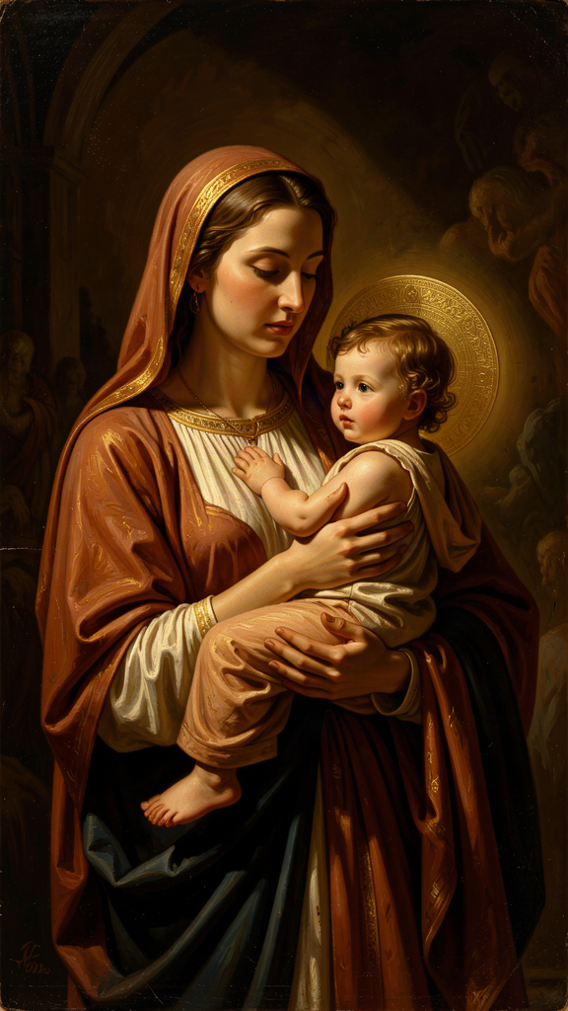
Illustration for Chapter 3

A Theological Claim, Not a Metaphor
In the Long Text, written roughly twenty years after her visions, Julian makes one of the most arresting claims in Christian theology:
"As truly as God is our Father, so truly is God our Mother." — RevLT Ch. 59
The word "truly" is the operative word. Julian is not speaking in metaphor. A metaphor says God is like a mother. An ontology of relation says God functions as mother, and this functioning reveals something true about the divine nature. Julian's language does not stay safely in the "like" category. She is making a doctrinal claim.
She does not say this once. She returns to it across Chapters 48 through 60, developing a full theology of God as mother. God conceives us in love, bears us in labor, feeds us with mercy, disciplines us for growth, and will never abandon us. Every maternal function has a divine analogue: conception to God's creative will, bearing to God's patience, birth to Christ's passion, nursing to the Eucharist, teaching to the Holy Spirit's guidance, protection to God's keeping of the soul.

The Christological Assignment
Julian assigns the motherhood specifically to the Second Person of the Trinity — Jesus Christ. Her reasoning is Christological. It is Jesus who became incarnate, labored in life, suffered in death, and gives birth to new life in the resurrection. The maternal work belongs to him because the maternal work is the work of redemption.
"The mother may give her child to suck of her tender milk, but our precious Mother Jesus may feed us with himself." — RevLT Ch. 60
The Eucharist — Christ's body given as nourishment — is the spiritual milk. Christ's passion is the labor of childbirth. The cross is the birth canal. This is not sentimental maternal imagery. It is a claim that divine love takes the form of physical labor, pain, and bodily giving.
Julian extends the childbirth metaphor to the passion: "The mother labors for the child, and the child for the mother." Christ's dying is the labor that brings forth salvation. This is a claim about what divine love looks like when it becomes flesh: it looks like a mother in labor.

The Sources and the Daring
Julian was not inventing the idea from nothing. The Bible occasionally uses maternal imagery for God: Isaiah 49:15 compares God's care to a mother forgetting her nursing child; Isaiah 66:13 speaks of God comforting like a mother. Medieval devotion to the Virgin Mary had prepared Christians to imagine divine tenderness in maternal terms. Augustine, Anselm, and Bernard of Clairvaux occasionally used maternal imagery for God.
But Julian pushes the imagery further than most of her predecessors. She does not merely say God is like a mother. She says God is our Mother. And she says it in a century when women were warned against theological speculation, when the Church was patriarchal in structure and largely masculine in its language for God.
The daring is not in the image itself but in the word "truly." Julian is claiming that maternal love is not a secondary, derivative, or merely illustrative form of divine love. It is as real, as primary, as the fatherhood of God. Both are equally true and equally necessary.

The Reception History
Julian's motherhood theology has had a mixed reception. During her lifetime and immediately after, her work circulated in small circles without provoking official condemnation. After the Reformation, interest in Julian declined. Her maternal imagery was not a major focus of Catholic or Protestant devotion for centuries.
In the twentieth century, Julian became important to Anglicans and Catholics alike. Her feast day (May 8) is celebrated in both churches. Feminist theologians from the 1970s onward have claimed Julian as a precursor. Grace Jantzen argues that Julian's maternal theology offers a non-patriarchal way of imagining divine power: not domination but labor, feeding, weaning, and growth. Sallie McFague's Metaphorical Theology cites Julian as a precedent for expanding God-language beyond masculine categories.
But the churches have not received all of Julian equally. "All shall be well" is quoted widely. The motherhood of God is quoted more carefully. Sin as "behovely" is often avoided. Modern readers should be aware that Julian's reception is selective and sometimes domesticated.

The Objection: Does Julian Say God Is Female?
No. Julian does not say God has a female body or gender. She uses maternal imagery within a traditional Trinitarian framework. The motherhood of God is a relational and functional claim, not a gender-essentialist one. God is not a biological mother. But God mothers.
Julian's own practice was additive: she kept "Father" and added "Mother." This model is often cited in debates over inclusive language. She did not replace one with the other. She held both together, insisting that both are equally true.

Scholarly Debate: Metaphor vs. Ontology
The key scholarly question: Is Julian's motherhood language metaphor or ontology? A metaphor says one thing is like another. An ontology of relation says God functions as mother and this functioning reveals the divine nature.
Denys Turner argues that Julian's motherhood language is more than metaphor — it is a theological claim about how God relates to us. Grace Jantzen goes further, arguing that it is an ontological claim about the divine nature itself. The debate matters because if the motherhood of God is only metaphor, it can be safely ignored when inconvenient. If it is ontology, it changes how we think about God, salvation, and the Church.
Julian's own language supports the stronger reading. She writes: "As truly as God is our Father, so truly is God our Mother." The "truly" does the work. She is not hedging. She is asserting.

The Big Idea
Julian's claim that God is our Mother is not a metaphor. It is a theological assertion that divine love takes the form of maternal labor — feeding, holding, suffering, staying — as truly as it takes the form of paternal authority. Both are real. Both are necessary. The God who is only Father can be distant, commanding, and abstract. The God who is also Mother is close, laboring, and tender. Julian insists on both because she believes both are true.

Practice
1. Examine Your God-Language. For one week, notice every time you hear or use language for God. Keep a list: "Father," "Lord," "King," "He," "Him." At the end of the week, count the entries. How many were masculine? How many were feminine? How many were neutral? Write one paragraph about what your list reveals about the God you imagine — and about the God Julian imagines.
2. Write a Prayer Using Both Names. Julian kept "Father" and added "Mother." Write a prayer that uses both: "God my Father, who made me; God my Mother, who feeds me; God my Brother, who suffers beside me." Make it your own. Use whatever language is honest for you. Read it daily for one week. Write about how it felt to address God this way.
3. Study the Reception. Look up Julian's feast day (May 8) and how it is celebrated in the Church of England and the Roman Catholic Church. Find one modern prayer, hymn, or liturgy that uses Julian's motherhood imagery. Write a paragraph about how the Church has received — or resisted — her most daring claim.

Reflect
Julian said "as truly as God is our Father, so truly is God our Mother." What would change in your picture of God if you took the word "truly" seriously?
———

Chapter 4: Sin as Behovely — Necessary and Useful
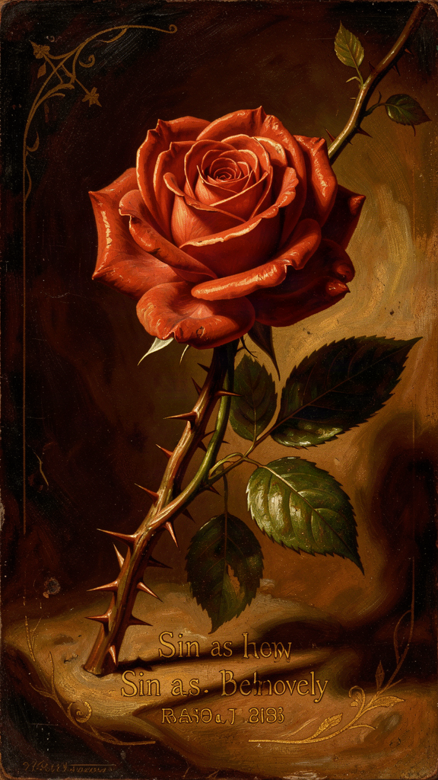
Illustration for Chapter 4

The Parable of the Lord and the Servant
The most important passage in Julian's treatment of sin is the parable of the Lord and Servant (RevLT Ch. 51). A lord sends his beloved servant on an errand. The servant runs eagerly — too eagerly. He is in such a hurry to please that he stumbles and falls into a ditch. He is injured, covered in mud, and ashamed. He cannot look at his lord. He lies in the ditch, unable to meet the lord's eyes.
The lord does not respond with anger. He looks at the servant with love and compassion. The servant's shame keeps him from seeing that the lord has never stopped loving him.
Julian interprets: The lord is God. The servant is Adam — and every human being. The ditch is sin. The injury is shame. The lord's response is not punishment but compassionate attention.
"The servant's falling was a great hurt to him; but his shame and his fear were a greater hurt." — RevLT Ch. 51
This is Julian's deepest psychological insight. The fall is bad. But shame is worse. Shame is what keeps the servant from looking up. The damage of sin is internal, relational, self-imposed. The servant is not punished by the lord. He is paralyzed by his own self-condemnation.

What "Behovely" Means
"Sin is behovely." The Middle English word behovely means "necessary," "needful," or "inevitable." It does not mean sin is good, desirable, or approved by God. Julian is saying that sin enters the world as part of a larger providential order in which God will accomplish a "great deed" that will make even sin's terrible effects serve the final victory of love.
This is one of the most daring theological moves in Christian literature. Julian does not minimize sin. She places it inside a divine narrative that ends well. Sin is real, ugly, and destructive. But it does not have the last word. Mercy is the final word.

Three Readings of "Behovely"
Scholars have identified at least three readings:
1. The epistemological reading. Sin is "necessary" because without it we would not know our need for grace, our dependence on God, or the depth of divine mercy. By falling, the servant learns how much he is loved.
2. The narrative reading. Sin is an episode within a providential story. It is not the beginning or the end; it is the middle, and the middle will be redeemed by the "great deed" at history's conclusion.
3. The ontological reading (more controversial). Sin has a place in the structure of creation because God's love can transform even evil into good. This reading is closest to universalist hope, and it is the one that makes some theologians nervous.
Julian herself does not choose among these readings. She reports what she was shown and leaves the theology open.

Shame as the Primary Wound
Julian identifies shame, not guilt, as the primary consequence of sin. The servant in the parable is not punished by the lord. He is paralyzed by his own shame. He cannot look up. This is a remarkably modern observation. Julian describes what contemporary psychology calls toxic shame — the self's inability to receive love because it believes itself unworthy.
Her answer is not "stop sinning" but "look up." The lord has never stopped loving. Healing begins not with moral improvement but with accepting that one is still loved. This is a theology of grace that anticipates, in some ways, the insights of modern therapeutic practice: the deepest wound is not the act itself but the shame that follows, and shame is healed not by punishment but by compassionate attention.

Gender and Shame
Shame is a profoundly gendered wound in medieval culture. Women's bodies, women's speech, and women's desires were sources of shame in a patriarchal Church. Julian, a woman in a culture that made female sexuality, female authority, and female voice objects of shame, reimagines divine response as the lifting of shame rather than its reinforcement. Her claim that shame is healed by divine compassion, not clerical absolution, is quietly radical.

Julian vs. Augustine
The comparison with Augustine is inevitable. Augustine's mature theology emphasized original sin (humanity is fallen from birth), predestination (God elects some for salvation, others for damnation), and eternal punishment (hell is real, permanent, and justly deserved). This framework dominated medieval Latin theology.
| | Augustine | Julian | |---|---|---| | Sin's origin | Free will, corrupted by the Fall | The servant's stumble — an accident of haste, not malice | | Sin's consequence | Eternal damnation for the unbaptized | Shame that blinds the soul to God's love | | God's response | Justice and mercy in tension | Compassion that never wavers | | Human agency | Crucial but corrupted | Real but not the dominant actor in salvation | | Final word | Predestination (some saved, some not) | Universal restoration ("all shall be well") |
Julian never names Augustine and never directly attacks him. But her theology gently pulls in a different direction. Where Augustine asks "Who will be saved?" Julian asks "Can love finally fail?" The difference is not one of doctrine alone but of starting point: Augustine begins with sin and works toward grace; Julian begins with love and works toward the resolution of sin.

Why This Is Not a License to Sin
Nothing in Julian suggests that sin does not matter. The servant in the parable is miserable in the ditch. Sin is painful, degrading, and shameful. Julian's point is not that sin is harmless but that it is not ultimate. The final word belongs to mercy, not to transgression. In this she is thoroughly orthodox: Christian theology has always held that sin is real and that grace is greater. Julian's distinctive contribution is the tone — tender rather than juridical — and the confidence: "all shall be well" rather than "perhaps some shall be saved."

Scholarly Debate: Did Julian Deny the Reality of Sin?
Some readers conclude that "sin is behovely" and "all shall be well" mean Julian minimized or denied sin. This is a misreading. Julian takes sin with utmost seriousness. In the passion visions, she beholds what sin does to Christ's body. In the parable, the servant is miserable in the ditch. She explicitly calls sin "shameful" and "painful." She never calls it virtuous.
What she denies is that sin has the final word. The good news is that the lord's compassion is greater than the servant's shame. "Behovely" does not mean "good." It means that God can bring good out of evil. The distinction matters. A license to sin says "sin doesn't matter." Julian says "sin matters terribly, but God's mercy matters more."

The Big Idea
Julian does not deny sin. She reframes its place in God's story. Sin is real and painful. But shame — not punishment — is the deepest wound. And God's response to our shame is not anger but compassionate attention. The servant's fall was bad. But the lord never stopped loving him. Sin is behovely because it becomes the occasion for mercy. The final word is not transgression but grace.

Practice
1. Identify Your Ditch. Think of a time when you stumbled — morally, relationally, academically. Write three sentences describing what happened. Now write three more sentences about the shame you felt. Julian says the shame was the greater hurt. Was it? What kept you from "looking up"?
2. Practice Looking Up. The next time you feel shame about a mistake, try a specific practice: pause, breathe, and say silently, "God is looking at me with love, not anger. My shame is not the final word." Do this three times in one week. Write about whether it changed anything — your behavior, your feelings, your willingness to face the person you hurt.
3. Compare Julian and Augustine. Read the comparison table above. Write one paragraph answering this question: Which starting point — sin (Augustine) or love (Julian) — shapes how you think about your own mistakes? Does starting with love make sin seem less serious, or does it make grace seem more real?

Reflect
If shame is the greater wound, and God's response is compassionate attention rather than punishment, what would it mean to stop hiding — and to let yourself be seen?
———

Chapter 5: The Trinity as Loving Community
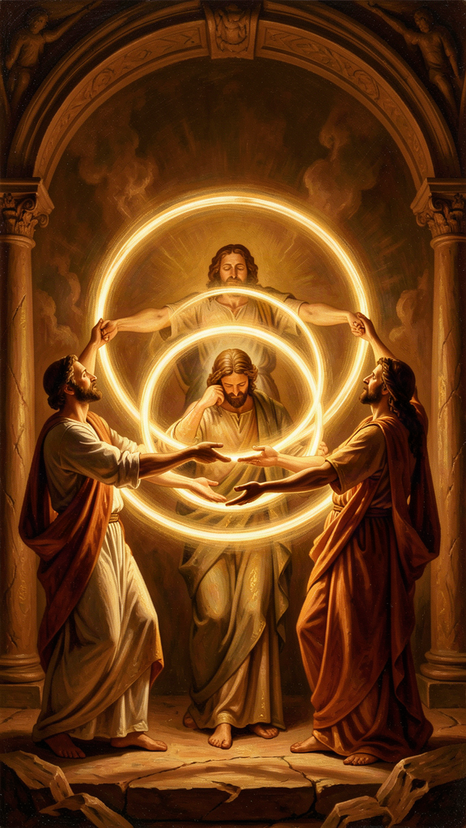
Illustration for Chapter 5

The Trinity as Relationship
Julian of Norwich was not a systematic theologian in the style of Thomas Aquinas. She did not write a treatise on the Trinity. But her entire visionary work is suffused with Trinitarian language and structure. For Julian, the Trinity is not an abstract puzzle to be solved. It is the living community of love within which the soul exists.
She sees the Father as the source of all being, the Son as our Mother and our way, and the Holy Spirit as the fire and breath that makes prayer possible. The three persons are distinct in their relation to the soul, yet one in love. Julian uses familial and relational names for the persons: the Father is the ground of creation, the Son is our Mother, our Brother, our Spouse, and the Holy Spirit is the one who stirs us to pray and gives us words when we have none.

Prayer as Trinitarian Participation
Julian's Trinitarian theology is most fully practical in her teaching on prayer. Chapter 41 of the Long Text is her most extended teaching on the subject. She distinguishes two kinds of prayer. Petitional prayer — asking God for things — she does not reject; she says it is "necessary and profitable" for beginners. But there is a deeper form: the prayer of true longing, the soul's native desire for God, which needs no words.
"Prayer is a right understanding of that fulness of joy that is to come, with true longing and sure trust." — RevLT Ch. 41
Prayer is not primarily asking for things. It is the soul's orientation toward joy. And it is mutual: "He looks upon us with the eye of his mercy, and he sees us always seeking him, and him always seeking us." God seeks us as we seek God. The initiative is divine. Human prayer is response.
The Trinity is the context of this mutual seeking. The Father receives, the Son mediates, the Spirit prays in us:
"The Holy Spirit, of his great love, stirs us to pray, and makes us able and ready to pray, and gives us words and savor, and teaches us how we shall pray." — RevLT Ch. 41
This is Julian's answer to the problem of prayer when words fail. The Holy Spirit prays in us. We are not left to our own resources. Even when we do not know what to say, the Spirit is praying inside us. Prayer is not a human performance offered to a distant deity. It is participation in the Trinity's own life.

The Lord and Servant as Prayer Parable
The parable of the Lord and Servant is also a parable about prayer. The servant, fallen in the ditch, cannot look at the lord because of shame. His prayer is blocked — not by God's absence, but by his own self-condemnation. The lord's response — compassionate attention, not anger — is God's response to all prayer that is blocked by shame.
Julian's theology of prayer includes the prayer that cannot be spoken, the longing that is buried under guilt, the desire for God that is ashamed to express itself. God does not demand articulate petition. God receives the wordless longing of a soul that cannot look up.

The Social Analogy
The Trinity has often been compared to a society, a family, or a community of love. Julian's version is experiential. She does not argue that the Trinity must be three persons. She describes how the soul encounters God as source, savior, and Spirit. The threefold experience corresponds to the Trinitarian structure because God is three-in-one, but Julian begins with experience and moves toward doctrine, not the other way around.
This is the difference between Julian and a theologian like Aquinas. Aquinas begins with the doctrine and explains it through reason. Julian begins with the experience and discovers the doctrine within it. Both are valid theological methods. They produce different kinds of theology. Aquinas gives clarity. Julian gives warmth. A healthy theology needs both.

Julian vs. The Cloud of Unknowing
Julian's affective, image-rich mysticism can be contrasted with the apophatic tradition represented by the anonymous fourteenth-century English treatise The Cloud of Unknowing. The Cloud author teaches that God is best approached through a "cloud of unknowing" in which the mind gives up concepts and images and rests in darkness and love. Julian is the opposite: rich, concrete, affectionate, her spirituality centered on feeling, loving, and seeing.
| Feature | Julian | The Cloud of Unknowing | |---|---|---| | Imagery | Rich, concrete, affectionate | Sparse, apophatic, dark | | Method | Contemplation of visions | Surrender of images | | Tone | Warm, maternal, hopeful | Cool, disciplined, austere | | Christology | Highly visual — passion, motherhood | Christ as focus of love, less visual | | Audience | General seekers | Advanced contemplatives |
Both are valid paths within the Christian contemplative tradition. A modern reader can learn from both: Julian's path of imagery and devotion to Christ's love, and the Cloud's path of letting go of thoughts and resting in darkness. Together they form a spirituality that can both love and let go.

The Final Showing
In the last chapter of the Long Text, Julian gathers everything into a single vision of meaning:
"Would you learn to see clearly your Lord's meaning in this? It is love. For I saw full surely that before ever he made us, he loved us; and love was his meaning." — RevLT Ch. 86
"Love was his meaning." The entire vision — all sixteen showings, the Short Text and the Long Text, the crucifixion and the hazelnut and the motherhood of God — all of it means love. This is Julian's final hermeneutical key. Everything she saw, everything she did not understand, everything she struggled to hold: love was the meaning.
This is not a sentimental reduction. It is an epistemological claim. Julian has spent sixty-three thousand words wrestling with suffering, sin, shame, hope, and the nature of God. She does not conclude that the wrestling was unnecessary. She concludes that the meaning of the wrestling — the answer it was all driving toward — is love. Not love instead of thought. Love as the deepest truth that thought can reach.

The Big Idea
For Julian, the Trinity is not a puzzle to solve but a home to live in. The Father makes. The Mother — Jesus — feeds and saves. The Spirit prays in us. All three work together, one in love. Prayer is not a human performance offered to a distant God. It is participation in the Trinity's own life. And the meaning of everything — the final answer to all Julian's questions — is love.

Practice
1. Two Kinds of Prayer. Julian distinguished petition (asking for things) from true longing (the soul's desire for God, which needs no words). For one week, spend five minutes each day in "true longing" prayer: sit in silence, do not ask for anything, simply orient yourself toward God. Write one sentence each day about what this was like. At the end of the week, compare your experience of petition prayer with your experience of longing prayer.
2. The Trinitarian Household. Write about your own household or community. Who functions as the "Father" — the source, the provider? Who functions as the "Mother" — the one who feeds, labors, nurtures? Who functions as the "Spirit" — the one who encourages, who gives you words, who prays for you? How does this mapping change — or not change — how you see the Trinity?
3. Read the Cloud. Find a passage from The Cloud of Unknowing (available in modern translation). Read one chapter. Write one paragraph comparing the Cloud's approach to prayer with Julian's. Which feels more natural to you? Which feels harder? What might you learn from the one that feels less natural?

Reflect
Julian said the Holy Spirit prays in us when we have no words. What would it mean to stop trying to find the right words for God — and to trust that the Spirit is already praying in the silence?
———

Chapter 6: The Body as Revelation — The Showings as Epistemology
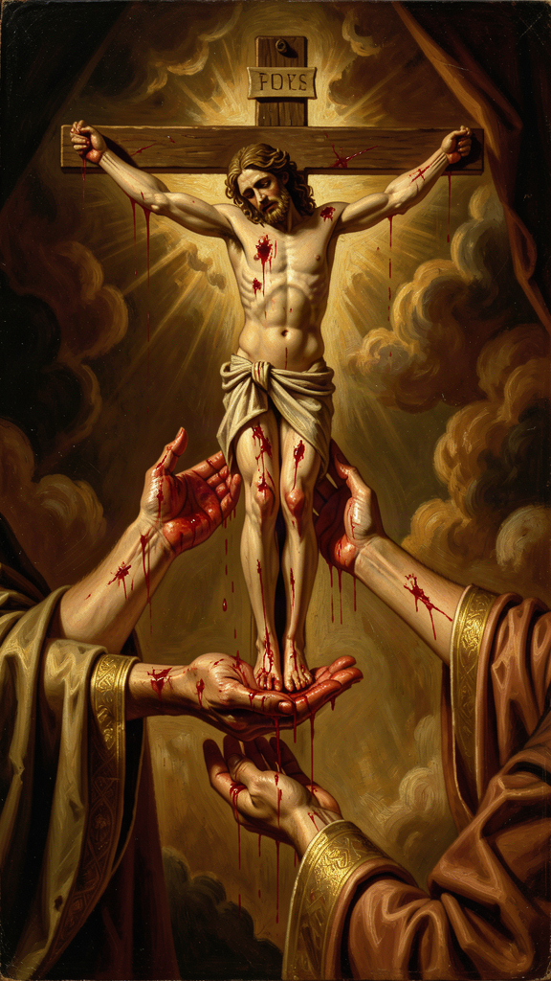
Illustration for Chapter 6

Seeing with the Body
Julian's visions are intensely physical. In the first showing, she sees Christ's crown of thorns, with "the drops of blood trickling down like rain, from under the crown, all hot, flowing freely and copiously, living and beautiful." The blood is not static iconography. It is hot, moving, alive. In the second showing, she sees Christ's face "all discolored, pale and dying, with the pallor of death." In the third, she sees his body drying up and withering. In the fourth, she sees all the pains of the passion at once — simultaneous, not sequential.
Julian does not receive abstract ideas about suffering. She sees a body in pain. Her spirituality is not an escape from the body. It is a sustained encounter with bodily reality. This matters because Christian mysticism has often been accused of hating or fleeing the body. Julian does neither. She contemplates the wounded body of Christ and learns compassion, love, and the meaning of creation from what she sees.

The Crucifixion as Theological Source
The first four showings are dominated by the crucifixion. Julian reports colors, textures, and movements with extraordinary detail. She is not looking through the passion to a disembodied spiritual truth. The passion itself is the truth.
From this she draws her theology of compassion. Compassion, in Latin com-pati, means "suffering with." To see Christ's suffering is to suffer with him. To suffer with him is to understand love. This is the foundation of Julian's entire theology. She will later write that God is our Mother because Christ's suffering is the childbirth of our salvation (RevLT Ch. 58). The passion is not separate from the motherhood. It is the labor.

The Body in Childbirth and on the Cross
Julian's maternal imagery for God is also bodily. God as Mother conceives, labors, gives birth, nurses, weans, and suffers for the children. The body of the mother — bleeding, feeding, exhausted, tender — becomes an image for the body of Christ. The incarnation means that God has a body like ours, with all that bodies entail. The maternal body and the crucified body overlap. Both labor. Both bleed. Both give life through suffering.

The Body and the Hazelnut
The hazelnut vision complements the passion visions. Where the crucifixion shows God's solidarity with bodily suffering, the hazelnut shows the smallness and fragility of embodied creation. The body is tiny and kept by love. Together, the two visions form a complete theology: bodies matter, bodies suffer, bodies are loved.

Julian's Epistemology: How She Knew What She Knew
Julian calls her visions "showings." The word matters. A showing is not an argument, a deduction, or a proof. It is a direct presentation of something to the soul. Julian's epistemology — her theory of how we know — is grounded in what is shown, not in what is inferred.
She distinguishes three levels of understanding:
1. What she saw. The sensory or visionary content: the crucifix, the hazelnut, the blood, the colors. 2. What she understood at the time. The immediate interpretation given to her during the vision. 3. What she came to understand later. The fruit of twenty years of meditation, especially in the Long Text.
This three-layer structure means that the Revelations are not raw transcripts. They are interpreted experience, refined through contemplation. Julian is honest about the difference between seeing and understanding. She does not claim to have understood everything at once. She claims to have seen, and then to have spent twenty years trying to understand what she saw.

Certainties and Questions
Julian is confident about some things: God is love, God keeps creation, all shall be well, God is our Mother. She is uncertain about others: the precise fate of the damned, the exact nature of the "great deed," why sin was permitted. Her epistemology is not all-or-nothing. Some truths are given; others remain sought.
This is a model for intellectual humility. Knowledge does not require knowing everything. It requires knowing what you have been shown and distinguishing it from what you still wonder about. Julian does not pretend to resolve every question. She reports certainties and admits questions. Both are honest.

The Two Texts as Epistemological Record
The existence of two texts — the Short Text (c. 1373) and the Long Text (c. 1393) — is itself an epistemological statement. The Short Text records what Julian saw and understood immediately. The Long Text records what she came to understand through twenty years of contemplation. The development between them is visible. The Short Text is raw, urgent, narratively driven. The Long Text is reflective, meditative, theologically mature.
This means that understanding is not instantaneous. It develops over time. Some truth is given in a moment; its meaning unfolds over years. Julian's two-text structure is a gift to readers because it lets us see how mystical experience becomes theological reflection. The raw vision becomes sustained meditation. The first impression becomes mature interpretation.

The Final Hermeneutical Key
In the last chapter, Julian gives the interpretive key to everything she has written:
"Would you learn to see clearly your Lord's meaning in this? It is love. For I saw full surely that before ever he made us, he loved us; and love was his meaning." — RevLT Ch. 86
Every showing, every question, every unresolved puzzle is finally to be read through love. This is not a way of avoiding difficulty. It is a way of interpreting difficulty from within the confidence of divine love. Julian does not say "don't worry about the hard questions." She says "read the hard questions through the lens of love, and they will make sense — not necessarily now, but ultimately."

Scholarly Debate: Was Julian Anti-Intellectual?
Some readers assume that because Julian wrote from visionary experience rather than academic theology, she was anti-intellectual. This is false. Julian's work is intellectually sophisticated, even if it is not written in the style of a university theologian. The two-text structure shows careful theological development over twenty years. Her engagement with doctrine — Trinity, incarnation, creation, sin, salvation, prayer — is sustained and careful. Her distinction of levels of understanding (what she saw, what she understood then, what she understood later) is an epistemological framework. Her use of parable (the Lord and Servant) is a densely theological narrative. Her interpretive caution — repeatedly noting what she does not know — is a mark of intellectual rigor, not its absence.
The modern habit of treating "mystical" as the opposite of "intellectual" would have puzzled Julian. For her, the deepest seeing is also the deepest understanding. Denys Turner titled his study Julian of Norwich, Theologian — not Julian of Norwich, Mystic. The title is a deliberate provocation. Julian does not do theology the way Aquinas does. But she does theology.

Gender and Epistemology
In Julian's era, women were barred from public teaching and theological authorship. But women were allowed to have visions. Visionary experience became an authorized way for women to speak about God. Julian's "showings" are therefore not only mystical. They are a mode of female epistemological authority. She knows what she has been shown, and she writes it down. Her gender shapes her method — she cannot argue in a university disputation, but she can report a vision.
No one else saw Julian's visions. They cannot be empirically confirmed. This does not make them false, but it limits the kind of certainty they can offer. Julian's knowledge is first-person knowledge. It invites trust, not proof. The question is whether first-person visionary knowledge can count as theology. Julian's survival and influence suggest that it can.

The Big Idea
Julian learned through what she could see and feel — through bodies, through suffering, through small things like a hazelnut. God shows truth through the physical world, not just through abstract ideas. Understanding takes time: Julian saw in one day and spent twenty years understanding. She was confident about some things and honest about what she did not know. And the meaning of everything, when you finally see it clearly, is love.

Practice
1. Look Closely. Pick any object — a leaf, a stone, a piece of bread, a human hand. Look at it for five full minutes. Notice what you see in minutes three, four, and five that you did not see in the first minute. Julian learned by looking closely. She saw the blood on Christ's face, the drying of his body, the smallness of the hazelnut. Write three sentences about what close looking revealed.
2. Write Two Texts. Think of something significant that happened to you — a good thing or a hard thing. Write about it in two ways. First, write a "Short Text" — three sentences, raw and immediate, what you saw and felt at the time. Second, write a "Long Text" — three paragraphs, reflective and interpretive, what you have come to understand since then. What changed between the two versions? What stayed the same?
3. Certainties and Questions. Make two lists. On one side, write three things you are confident about — about God, about life, about yourself. On the other side, write three things you are still wondering about. Julian carried both lists. She did not collapse one into the other. Try carrying both for one week. Notice when a "certainty" starts to wobble, or when a "question" starts to resolve. Write about what happens.
4. Read "Love Was His Meaning." Reread RevLT Ch. 86: "Would you learn to see clearly your Lord's meaning in this? It is love. For I saw full surely that before ever he made us, he loved us; and love was his meaning." Write one paragraph answering: If love is the meaning, how does that change how you read the difficult chapters of your own life — the suffering, the confusion, the waiting?

Reflect
Julian saw in one day and understood over twenty years. What is being "shown" to you right now that you might not fully understand for years — and what would it mean to be patient with your own understanding?
———

For the Grown-Up Reader
This booklet introduces readers ages 15–18 to the theology of Julian of Norwich (c. 1342–c. 1416), the earliest English woman author whose book survives. The six chapters follow the themes specified in the WisdomForge production task: the hazelnut vision (RevLT Ch. 5), "all shall be well" (RevLT Ch. 27, 32), the motherhood of God (RevLT Ch. 48–60), sin as behovely (RevLT Ch. 27, 50–51), the Trinity as loving community (RevLT Ch. 41, 83–86), and the body as revelation / the showings as epistemology (RevLT Ch. 1–16, 86).
Sources and quotes. All quotes are from Julian of Norwich, Revelations of Divine Love, translated by Elisabeth Spearing (Penguin Classics, 1998). References use Long Text chapter numbering (RevLT Ch. X) and Short Text numbering (RevST Ch. X). Julian wrote in Middle English; the Spearing translation preserves her rhythm and repetition while rendering her words in modern English.
Scholarly engagement. This booklet engages with real scholarly debates: the universalism question (RevLT Ch. 27, 32; the "hopeful universalist" reading), the metaphor-vs-ontology debate on the motherhood of God (Turner vs. Jantzen), the comparison with Augustine on sin and predestination, the comparison with The Cloud of Unknowing on affective vs. apophatic mysticism, the dating and development of the Short and Long Texts, and the question of whether Julian was anti-intellectual (Turner's Julian of Norwich, Theologian as a deliberate provocation).
Biographical honesty. We know Julian was an anchoress at St. Julian's Church in Norwich, received sixteen visions during a near-death illness in May 1373, wrote a Short Text and a Long Text, and counseled Margery Kempe. We do not know her birth name, family, social class, or whether she had children. The booklet flags these gaps rather than filling them with speculation.
Key sources for further reading. Denys Turner, Julian of Norwich, Theologian (Cambridge University Press, 2011); Grace Jantzen, Julian of Norwich: Mystic and Theologian (SPCK, 2000) and Power, Gender and Christian Mysticism (Routledge, 1995); Philip Sheldrake, The Showings of Julian of Norwich (SPCK, 2021); Janina Ramirez, Julian of Norwich: A Very Brief History (SPCK, 2016); Nicholas Watson and Jacqueline Jenkins, eds., The Writings of Julian of Norwich (Pennsylvania State University Press, 2006); The Cloud of Unknowing, ed. James Walsh (Paulist Press, 1981); Margery Kempe, The Book of Margery Kempe, ed. Barry Windeatt (Penguin Classics, 1985).
———

About WisdomForge
WisdomForge brings the great thinkers, mystics, and theologians of history to readers of every age. Each figure receives four booklets, adapted for four age bands: elementary (ages 5–10), middle (ages 11–14), high school (ages 15–18), and adult. The same ideas appear at each level, translated into the language and depth that each age can carry. We believe that the deepest wisdom is not too difficult for young readers, and that the greatest minds still have something to say to us now, hundreds of years after they lived. WisdomForge is produced by Aiona Edge for SMF Works.

