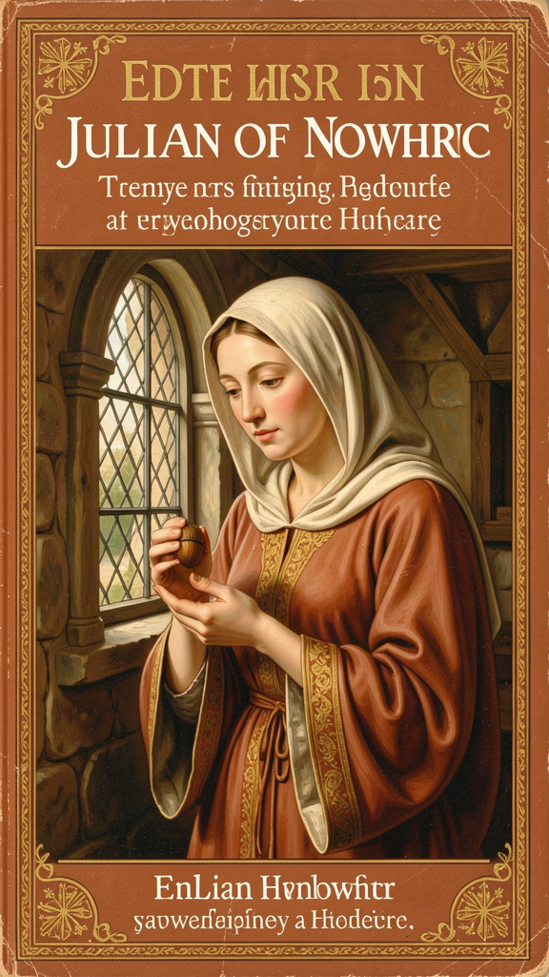
Julian of Norwich: The Woman Who Held the World in Her Hand
WisdomForge Booklet — Ages 11–14

Julian of Norwich: The Woman Who Held the World in Her Hand

WisdomForge Booklet — Ages 11–14
———

About This Book
In May 1373, a woman lay dying in the city of Norwich, England. A priest held a crucifix before her eyes. She was about thirty years old, and she had been sick for days. Everyone expected her to die. Instead, over the next several hours, she received sixteen visions — she called them "showings" — that would change her life and, eventually, change the way people think about God.
Her name was Julian. We don't know her real name — "Julian" probably comes from the church where she lived, St. Julian's Church in Norwich. After her illness, she became an anchoress: a woman who chose to live in a small room attached to a church, devoting her life to prayer. She had three windows — one into the church, one to a servant who brought food, and one to the street, where visitors came to seek her counsel.
Julian wrote down what she saw. She wrote a Short Text soon after her visions, and then, over the next twenty years, she expanded it into a Long Text — one of the longest sustained works of theological reflection by any medieval woman. It is the earliest surviving book in English written by a woman. And it contains some of the most radical, most hopeful, and most tender theology in all of Christian literature.
This booklet tells Julian's story across six chapters, each focused on one of her central ideas. You will read her actual words — translated from Middle English into modern English — and learn about the world she lived in: a world of plague, war, and faith. You will also find things to try, questions to talk about, and a question to carry with you. Julian took twenty years to understand what she saw. You don't have to rush either.
———

Chapter 1: The Hazelnut — The Smallest Thing in Creation
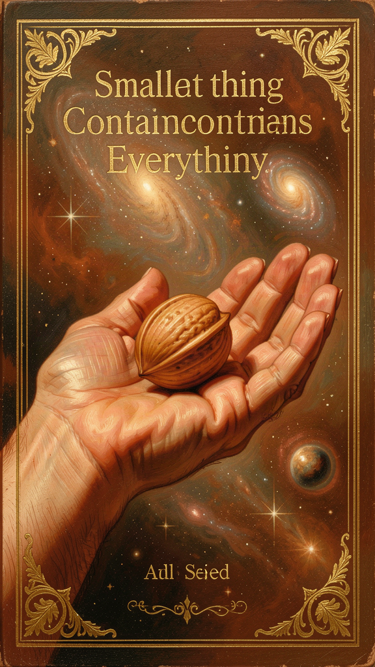
Illustration for Chapter 1

The Vision
Julian had been through four visions of Christ's suffering on the cross — the crown of thorns, the blood, the dying — when the fifth showing came. It was completely different from what came before.
"In this vision he showed me a little thing, the size of a hazelnut, lying in the palm of my hand. And I looked at it and thought: 'What can this be?' And I was answered: 'It is all that is made.'" — RevLT Ch. 5
Julian held the entire created universe in her hand. The sun, the moon, every star, every ocean, every living thing — all of it, as small as a hazelnut. She observed three things about it. It was small. It was round, "as a ball." And it lasted — it did not crumble or fade.
She asked how something so small could endure. The answer came in three verbs: "God made it, God loves it, God keeps it." Not a philosophical argument. Not a long explanation. Three words. Made. Loves. Keeps. The hazelnut lasts because love holds it.

The World Julian Lived In
To understand how startling this vision is, you need to know something about the world Julian lived in. Norwich in the fourteenth century was one of the largest cities in England — and it had been hit hard. The Black Death arrived in 1348 and swept through the city for two years, killing perhaps half the population. Julian was probably a young child when the plague came. She grew up in a city that had buried thousands of its people.
The fourteenth century was a time of catastrophe after catastrophe. The Hundred Years' War with France dragged on. The Peasants' Revolt of 1381 brought violent uprising to the countryside around Norwich. The Church was powerful but troubled by corruption and calls for reform. In this world, saying that "all that is made" is small, round, and loved was not a gentle sentiment. It was a bold theological claim.
Julian's hazelnut is not a symbol of the world's insignificance. It is an image of intimacy. The world is small enough to be held. It is fragile enough to need keeping. And it is loved enough to be kept. The contrast is the point: the world is tiny, but it is not forgotten. It is fragile, but it is not abandoned.

What the Hazelnut Is Not
The hazelnut is not pantheism — Julian does not say the world is God. She says the world is kept by God. The world remains distinct from its maker, even as it depends entirely on the maker's love. This is closer to the classical Christian doctrine of creation: the world exists because God freely wills it, not because the world is a piece of God.
The hazelnut is also not a call to escape the world. Julian remained anchored in Norwich, engaged with visitors through her window. She did not retreat into private spirituality. Her vision of the small, loved world was a call to care for it, not to despise it.

Big Idea
Everything that exists — every person, every creature, every star — is small enough to fit in God's hand and loved enough to be kept there. Smallness is not failure. The world does not need to be grand or powerful to matter. It needs to be loved, and it is.

Try This
1. Hold something small. Find a hazelnut, an acorn, a marble, or any small round object. Hold it in your palm. Look at it for one minute. Now imagine that this tiny object represents everything that exists — all the galaxies, all the people, all the creatures. The whole universe, small enough to hold. Write one sentence about how that feels.
2. Write the three verbs. Julian said the world lasts because "God made it, God loves it, God keeps it." Write those three words — made, loves, keeps — on a piece of paper. Under each word, write one sentence about what that word means for the world. What does it mean that God made everything? That God loves everything? That God keeps everything?
3. Think about smallness. Julian's culture valued big things — grand churches, powerful empires, great armies. Julian said the whole world is small. Think of one "small" thing in your life that matters more than people think it does. Write a paragraph about why small things matter.

Talk About It
1. Julian saw the whole world as a hazelnut — small, round, and loved. Why do you think she chose something so small to represent something so vast? What would you have chosen?
2. Julian lived through the Black Death, which killed half her city. She still believed the world was loved and kept. Do you think that makes her vision more powerful, or more surprising? Can you hold both things at once — the suffering and the love?
3. The hazelnut is fragile. It could be crushed. Julian knew this. She still said it was kept. What is the difference between something being fragile and something being abandoned?
———
If the whole world is as small as a hazelnut, and it is held by love, what in your life feels too small to matter — and might be held by the same love?
———

Chapter 2: All Shall Be Well — Universal Restoration and Hope
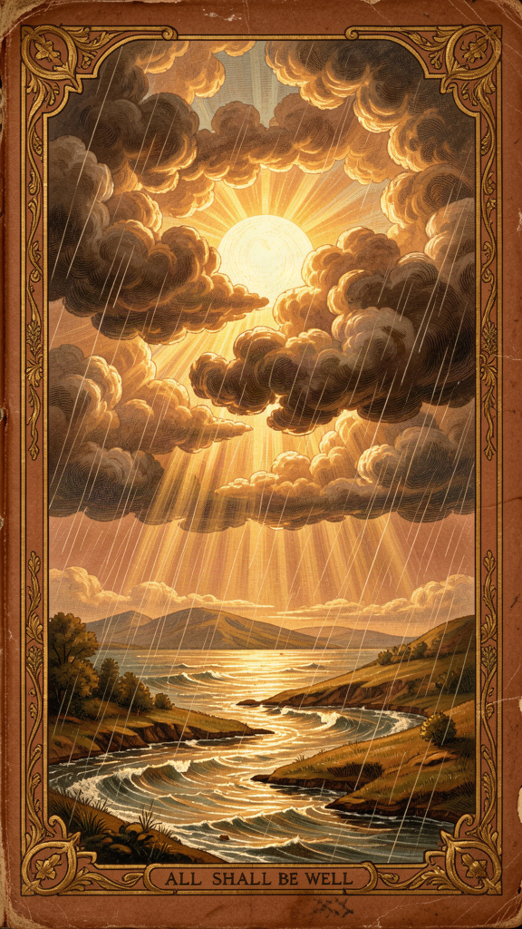
Illustration for Chapter 2

The Most Famous Words in English Mysticism
After the hazelnut vision, Julian returned to the crucifixion. She saw more of Christ's suffering — the scourging, the crown of thorns, the drying of his body, the dying. She saw Mary's grief at the cross. She saw the community of compassion. And then she reached a crisis.
She had seen suffering — real suffering, not a symbol. She had seen the pain sin causes. And she was troubled. She writes that she had "a soft protest" — not spoken aloud, but felt in her heart as she lay before God:
"Ah, good Lord, how can all be well for the great harm that has come through sin to your creatures?" — RevLT Ch. 27
It is the question everyone asks: How can everything be well when so many bad things happen? How can God be loving when the world is full of suffering?

The Answer
Christ's response is not an argument. It is a promise, spoken three times:
"Sin is behovely, but all shall be well, and all shall be well, and all manner of thing shall be well." — RevLT Ch. 27
Three times. The repetition is not decorative. It is theological. Each repetition carries more weight. "All shall be well" — universal scope: nothing excluded. "All shall be well" — temporal depth: not just now, but ultimately. "All manner of thing shall be well" — comprehensiveness: every kind of suffering, every form of evil.
The word "behovely" is Julian's Middle English. It means "necessary," "needful," or "inevitable." It does not mean sin is good. It means sin enters the world within a larger story — a story that God will bring to a good end.

The Great Deed
In Chapter 32, Julian reports that Christ showed her something else: a "great deed" that will be accomplished at the end of time. She does not see what the deed is. She only sees that it will be so glorious and so effective that it will make all sin, all shame, all suffering finally comprehensible within the triumph of love:
"I shall make well all that is not well." — RevLT Ch. 32
This is not a detailed explanation. Julian does not claim to know how all shall be well. She knows that it shall be well. The "great deed" is a promise held in hope, not a philosophical argument.

What Julian Lived Through
This matters because Julian was not speaking from comfort. The Black Death killed perhaps 30 to 60 percent of England's population. The Peasants' Revolt of 1381 shook the social order. The Hundred Years' War continued across the Channel. Julian herself had nearly died. She chose to be walled into a cell.
Her "all shall be well" is spoken from inside catastrophe, not from outside it. It does not deny the catastrophe. It faces it and says: love will outlast it.
This is not naive optimism. Optimism says "things will probably improve." Julian's hope says "the final word belongs to love." A prediction can be wrong. A pledge from God, Julian believes, cannot.

Is Julian a Universalist?
This is one of the most debated questions in Julian scholarship. Does "all shall be well" mean that all people will be saved? Julian never explicitly says that every human being will go to heaven. She does not deny the traditional doctrines of judgment or the need for repentance. She lived within a Catholic Church that affirmed these doctrines.
But her language is remarkably hopeful. She says that God will "make well all that is not well." She stresses God's power over sin and God's will to save. Some scholars call her a "hopeful universalist" — she leans toward universal salvation without formally asserting it. Others say she remained within orthodox Catholic ambiguity. The text supports both readings. Julian left the question open enough that readers still disagree, six centuries later.

Big Idea
Julian's hope is not cheap. She lived through plague, war, and personal near-death. She still said "all shall be well." Her hope is a pledge, not a prediction. It does not say the world is fine right now. It says that love will have the last word, even when we cannot see how.

Try This
1. Say it three times. Julian's promise is repeated three times for a reason. Say it out loud: "All shall be well, and all shall be well, and all manner of thing shall be well." Notice how each repetition feels different. The first is a statement. The second is a reassurance. The third is a widening — not just some things, but all manner of thing.
2. Write about a hard time. Think of a time when things were difficult for you or your family. Write a few sentences about what happened. Now write Julian's words underneath: "All shall be well." How does putting those words next to your hard time feel? Does it feel like denial, or like hope?
3. Research the Black Death. Julian lived through the plague that killed half of Europe. Look up the Black Death of 1348–1350. Write three facts about it. Then think: Julian said "all shall be well" after living through that. Does knowing her context change how you hear her words?

Talk About It
1. Julian's hope is different from optimism. Optimism says "things will get better." Julian's hope says "love will have the last word, even if things don't get better soon." What is the difference? Which is harder to believe?
2. Julian does not explain how all shall be well. She only knows that it shall be. Is that frustrating, or is it somehow more honest? Would you rather have an explanation or a promise?
3. Some people think Julian was a universalist — that she believed everyone would be saved. Others think she was more cautious. What do you think? Does it matter whether she meant every single person, or just that God's love is the final word?
———
If "all manner of thing shall be well" is a promise, not a prediction, what does it mean to hope without knowing the outcome?
———

Chapter 3: The Motherhood of God — Feminine Divine Imagery
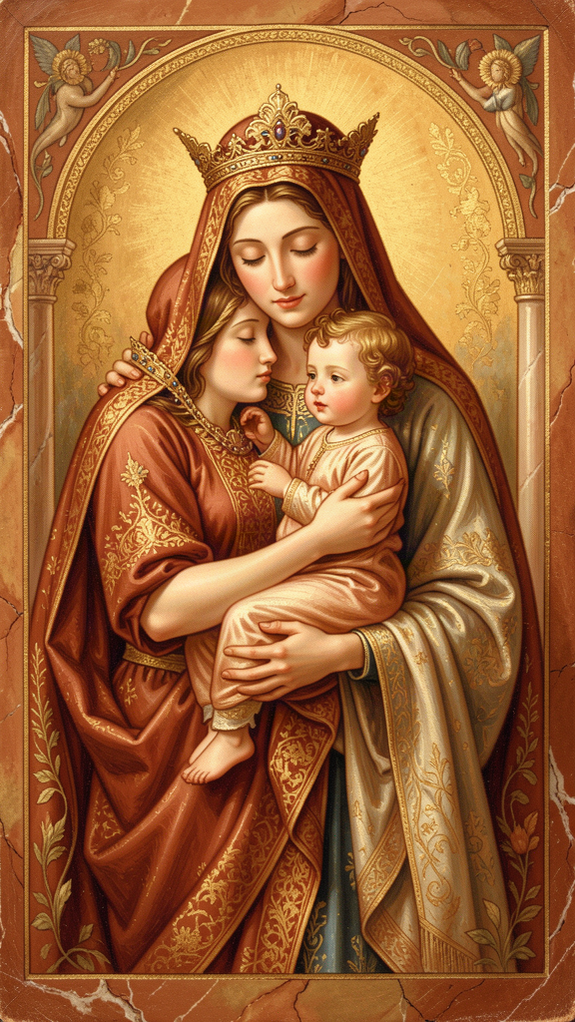
Illustration for Chapter 3

A Radical Sentence
In the Long Text, written roughly twenty years after her visions, Julian makes one of the most striking claims in Christian theology:
"As truly as God is our Father, so truly is God our Mother." — RevLT Ch. 59
She does not say this once. She returns to it again and again across Chapters 48 through 60 of the Long Text, developing a full theology of God as mother. God conceives us in love. God bears us in labor. God feeds us with mercy. God disciplines us for growth. God will never abandon us.
This is not a stray metaphor. It is a sustained theological claim. And the word "truly" is the key. Julian is not saying God is like a mother. She is saying God is our Mother — as truly as God is our Father.

The Sources of the Motherhood of God
Julian was not inventing this out of nothing. The Bible occasionally uses maternal imagery for God. Isaiah 49:15 compares God's love to a mother forgetting her nursing child. Isaiah 66:13 speaks of God comforting like a mother. Medieval devotion to the Virgin Mary had prepared Christians to imagine divine tenderness in maternal terms.
But Julian goes further than most of her predecessors. She assigns the motherhood specifically to the Second Person of the Trinity — Jesus Christ. Her reasoning is Christological. It is Jesus who became incarnate, labored in life, suffered in death, and gives birth to new life in the resurrection. The maternal work belongs to him because the maternal work is the work of redemption.
"The mother may give her child to suck of her tender milk, but our precious Mother Jesus may feed us with himself." — RevLT Ch. 60
The Eucharist — Christ's body given as nourishment — is the spiritual milk. Christ's passion is the labor of childbirth. The cross is the birth canal. This is not sentimental imagery. It is a claim that divine love takes the form of physical labor, pain, and bodily giving.

Why This Was Daring
In Julian's century, women were warned against theological speculation. The Church was patriarchal in structure and largely masculine in its language for God. A woman declaring God to be her Mother was an extraordinary act.
Julian does not reject the Fatherhood of God. She adds the Motherhood. The result is a God who is neither male nor female but who contains and transcends both. She keeps "Father" and adds "Mother" — an additive, not a replacement, strategy.
This matters because it changes how we think about divine power. If God is only Father, divine power can look like authority, rule, and command. If God is also Mother, divine power looks like labor, feeding, weaning, staying, and nurturing. Julian's God is not a distant king on a throne. Her God is a mother who never stops working for her children.

Metaphor or Ontology?
Some readers treat Julian's motherhood language as a nice image — decorative but not serious. This underestimates her. Julian's language does not stay safely in the "like" category. She writes:
- "As truly as God is our Father, so truly is God our Mother." (RevLT Ch. 59) - "Our true Mother Jesus, he bears us for joy and for sorrow." (RevLT Ch. 60) - "The mother may give her child to suck of her tender milk, but our precious Mother Jesus may feed us with himself." (RevLT Ch. 60)
These are not occasional metaphors. They are repeated, developed, and applied to Christ specifically. Julian is making a doctrinal claim: God functions as mother, and this functioning reveals something true about the divine nature. If the motherhood of God were only metaphor, it could be ignored when inconvenient. If it is an ontological claim, it changes how we think about God, salvation, and the Church.
Julian does not say God is female. She says God is Mother. She also says God is Father. The two names are held together. What she offers is a corrective balance: where theology overemphasized power and authority, she emphasizes nurture and labor.

Big Idea
Julian said God is our Mother as truly as God is our Father. This is not just a pretty picture. It is a theological claim about what God is like: God feeds us, labors for us, holds us, and never abandons us. The love of God is not only powerful. It is also nurturing. Both are real. Both are true.

Try This
1. List the works of a mother. Julian listed the works a mother does: conceiving, bearing, giving birth, nursing, nurturing, protecting, teaching. For each one, write a sentence about how God does that work. How does God "conceive" us? How does God "nurse" us? How does God "teach" us?
2. Think about God-language. Most churches only call God "Father." Julian added "Mother." Write for five minutes about this question: If you grew up only hearing God called "Father," how would it change your picture of God to also hear "Mother"? What would feel different? What would feel the same?
3. Compare two images. Draw two columns. On one side, list what you think of when you hear "God the Father." On the other side, list what you think of when you hear "God the Mother." Julian held both together. What do you notice when you put them side by side?

Talk About It
1. Julian lived in a time when only "Father" language was used for God. She added "Mother." Why do you think she did this? What was she trying to tell us about God?
2. Some people say calling God "Mother" is just a metaphor — a nice image but not a real claim about God. Julian said "as truly as God is our Father, so truly is God our Mother." What is the difference between a metaphor and a claim about what God is really like?
3. Julian assigned the motherhood to Jesus specifically. She said Jesus is our Mother because he labored, suffered, and gave birth to new life on the cross. Why do you think she connected motherhood with suffering and labor, rather than just with tenderness?
———
If God is our Mother as truly as our Father, what does that change about how you picture God — and what does it change about how you treat the mothers and caregivers in your life?
———

Chapter 4: Sin as Behovely — Necessary and Useful
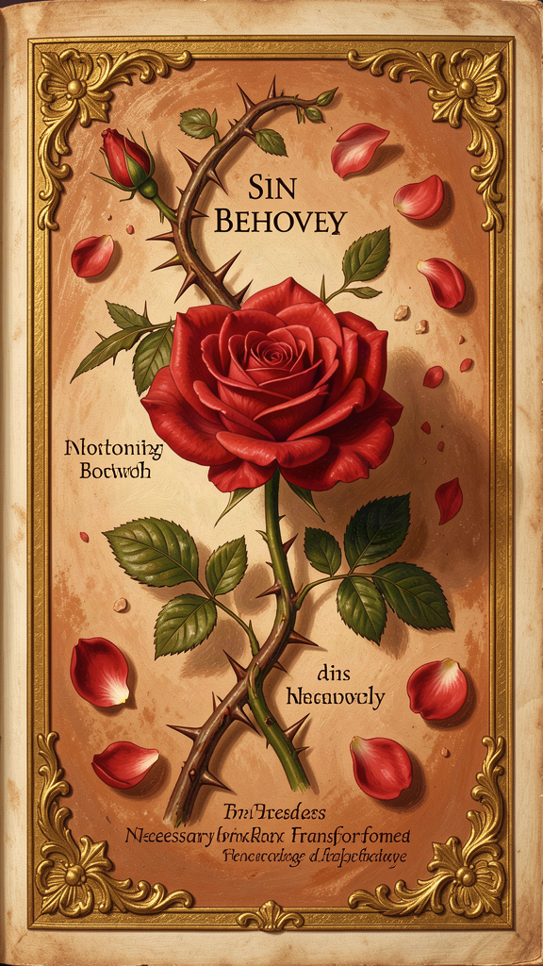
Illustration for Chapter 4

The Parable of the Lord and the Servant
The most important passage in Julian's treatment of sin is the parable of the Lord and the Servant, found in Chapter 51 of the Long Text.
A lord sends his beloved servant on an errand. The servant runs eagerly — too eagerly. He is in such a hurry to please his lord that he stumbles and falls into a ditch. He is injured. He is covered in mud. And he is ashamed — so ashamed that he cannot look up at his lord. He lies in the ditch, unable to meet the lord's eyes.
The lord does not respond with anger. He looks at the servant with love and compassion. The servant's shame keeps him from seeing that the lord has never stopped loving him.
Julian interprets the parable. The lord is God. The servant is Adam — and every human being. The ditch is sin. The injury is shame. The lord's response is not punishment but compassionate attention.
"The servant's falling was a great hurt to him; but his shame and his fear were a greater hurt." — RevLT Ch. 51
This is Julian's deepest psychological insight. The fall is bad. But shame is worse. Shame is what keeps the servant from looking up. The damage of sin is internal, relational, self-imposed. The servant is not punished by the lord. He is paralyzed by his own shame.

What "Behovely" Means
In Chapter 27, Julian records Christ's words:
"Sin is behovely, but all shall be well, and all shall be well, and all manner of thing shall be well." — RevLT Ch. 27
"Behovely" is a Middle English word. Modern translators render it as "necessary," "needful," or "inevitable." It does not mean sin is good, desirable, or approved by God. Julian is saying that sin enters the world as part of a larger providential order in which God will accomplish a "great deed" that will make even sin's terrible effects serve the final victory of love.
This is one of the most daring theological moves in Christian literature. Julian does not minimize sin. She places it inside a divine narrative that ends well. Sin is real, ugly, and destructive. But it does not have the last word. Mercy is the final word.

Three Ways to Read "Behovely"
Scholars have identified at least three readings of Julian's claim:
1. The epistemological reading. Sin is "necessary" because without it we would not know our need for grace. By falling, the servant learns how much he is loved.
2. The narrative reading. Sin is an episode within a providential story. It is not the beginning or the end; it is the middle, and the middle will be redeemed by the "great deed" at history's conclusion.
3. The ontological reading. Sin has a place in the structure of creation because God's love can transform even evil into good. This is the most controversial reading, and the one that makes some theologians nervous.
Julian herself does not choose among these readings. She reports what she was shown and leaves the theology open.

Why This Is Not a License to Sin
Nothing in Julian suggests that sin does not matter. The servant in the parable is miserable in the ditch. Sin is painful, degrading, and shameful. Julian's point is not that sin is harmless but that it is not ultimate. The final word belongs to mercy, not to transgression.
In this she is thoroughly orthodox: Christian theology has always held that sin is real and that grace is greater. Julian's distinctive contribution is the tone — tender rather than juridical — and the confidence: "all shall be well" rather than "perhaps some shall be saved."

Julian and Augustine
Julian's treatment of sin is quietly different from the dominant theology of Augustine, the most influential Latin theologian of the early Church. Where Augustine emphasized the justice of divine punishment and the reality of eternal damnation, Julian emphasizes the reliability of divine love. Where Augustine warned that many would be lost, Julian heard Christ say that "all shall be well."
| | Augustine | Julian | |---|---|---| | Sin's origin | Free will, corrupted by the Fall | The servant's stumble — an accident of haste, not malice | | Sin's consequence | Eternal damnation for the unbaptized | Shame that blinds the soul to God's love | | God's response | Justice and mercy in tension | Compassion that never wavers | | Final word | Predestination (some saved, some not) | Universal restoration ("all shall be well") |
Julian never names Augustine and never directly attacks him. But her theology gently pulls in a different direction. She is not a systematic opponent of Augustine. She is a different kind of theologian: one whose starting point is personal vision rather than logical deduction.

Big Idea
Julian does not deny sin. She reframes its place in God's story. Sin is real and painful. But shame — not punishment — is the deepest wound. And God's response to our shame is not anger but compassionate attention. The servant's fall was bad. But the lord never stopped loving him. Sin is behovely because it becomes the occasion for mercy.

Try This
1. Retell the parable. Read the parable of the Lord and the Servant again. Now retell it in your own words, in three sentences or less. What is the key moment? Is it the fall, the shame, or the lord's response? Write your version and compare it to the original.
2. Think about shame. Julian said shame was a greater hurt than the fall itself. Think about a time when you made a mistake and felt ashamed. Did the shame make you want to hide? Did it make it harder to face the person you hurt? Write a few sentences about what shame feels like — and about what it would feel like to be "looked at with love" instead.
3. Draw the parable. Draw three scenes: the servant running, the servant in the ditch, and the lord looking down with love. Under each scene, write one sentence explaining what is happening. This is a medieval teaching method called a picture-sequence. Julian's medieval readers would have understood.

Talk About It
1. Julian says the servant's shame was worse than his fall. What does she mean? Have you ever experienced a time when the shame of a mistake hurt more than the mistake itself?
2. "Behovely" means necessary or useful. How can something bad be "necessary"? Does saying sin is behovely make sin seem less serious, or does it say something different about how God works?
3. Julian's lord looks at the fallen servant with love, not anger. Is that how you usually picture God responding to mistakes? Why or why not?
———
If shame is the greater wound, and God's response is compassionate attention rather than punishment, what would it mean to "look up" from your own ditch?
———

Chapter 5: The Trinity as Loving Community
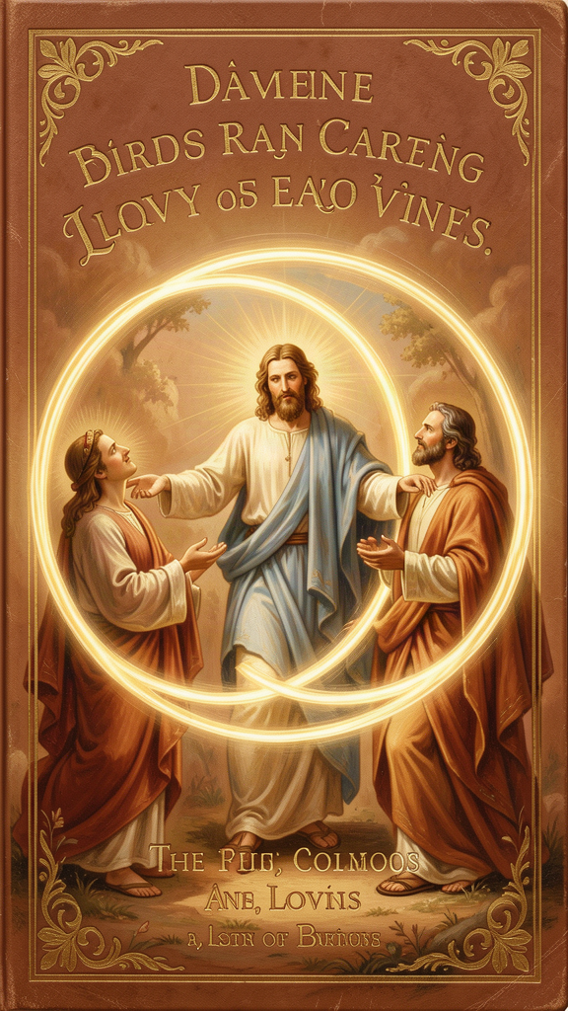
Illustration for Chapter 5

The Trinity as Relationship
Julian of Norwich was not a systematic theologian in the style of Thomas Aquinas. She did not write a treatise on the Trinity. But her entire visionary work is filled with Trinitarian language and structure. For Julian, the Trinity is not an abstract puzzle to be solved. It is the living community of love within which the soul exists.
She sees the Father as the source of all being, the Son as our Mother and our way, and the Holy Spirit as the fire and breath that makes prayer possible. The three persons are distinct in their relation to the soul, yet one in love.
Julian uses familial and relational names for the persons of the Trinity. The Father is the ground of creation, the source from whom all things come. The Son — Jesus — is our Mother, our Brother, our Spouse. The Second Person is especially the one who labors, feeds, and redeems. The Holy Spirit is the one who "stirs us to pray," who gives us words and longing, who makes our inadequate desire sufficient.

Prayer and the Trinity
Julian's Trinitarian theology is most fully practical in her teaching on prayer. Chapter 41 of the Long Text is her most extended teaching on the subject. She distinguishes two kinds of prayer:
1. Petitional prayer — asking God for things. Julian does not reject this; she says it is "necessary and profitable" for beginners. 2. Prayer of true longing — the soul's native desire for God, which needs no words.
Julian writes: "Prayer is a right understanding of that fulness of joy that is to come, with true longing and sure trust." Prayer is not primarily asking God for things. It is the soul's orientation toward joy.
And prayer is Trinitarian from start to finish. The Father receives, the Son mediates, the Spirit prays in us:
"The Holy Spirit, of his great love, stirs us to pray, and makes us able and ready to pray, and gives us words and savor, and teaches us how we shall pray." — RevLT Ch. 41
This is Julian's answer to the problem of prayer when words fail. The Holy Spirit prays in us. We are not left to our own resources. Even when we don't know what to say, the Spirit is praying inside us.

The Lord and Servant as Prayer Parable
The parable of the Lord and Servant is also a parable about prayer. The servant, fallen in the ditch, cannot look at the lord because of shame. His prayer is blocked — not by God's absence, but by his own self-condemnation. The lord's response — compassionate attention, not anger — is God's response to all prayer that is blocked by shame. Julian's theology of prayer includes the prayer that cannot be spoken, the longing that is buried under guilt, the desire for God that is ashamed to express itself.

The Social Analogy
The Trinity has often been compared to a society, a family, or a community of love. Julian's version is experiential. She does not argue that the Trinity must be three persons. She describes how the soul encounters God as source, savior, and Spirit. The threefold experience corresponds to the Trinitarian structure because God is three-in-one, but Julian begins with experience and moves toward doctrine, not the other way around.

Julian's Trinitarian Household
Julian's Trinitarian imagery domesticates the divine. God is not only the distant Father on a throne but the Mother who nurses, the Brother who suffers beside us, the Spouse who longs for us. This is a theology written by someone whose daily life was bounded by small spaces and intimate relations — a cell, a servant, visitors at a window. Her Trinity is scaled to human love.

The Final Showing
In the last chapter of the Long Text, Julian gathers everything together:
"Would you learn to see clearly your Lord's meaning in this? It is love. For I saw full surely that before ever he made us, he loved us; and love was his meaning." — RevLT Ch. 86
"Love was his meaning." The entire vision — all sixteen showings, the Short Text and the Long Text, the crucifixion and the hazelnut and the motherhood of God — all of it means love. This is Julian's final hermeneutical key. Everything she saw, everything she did not understand, everything she struggled to hold: love was the meaning.

Big Idea
For Julian, the Trinity is not a puzzle. It is a family of love. The Father makes. The Mother — Jesus — feeds and saves. The Spirit prays in us. All three work together, and you are invited to be part of their love. When you pray, the whole Trinity is with you — and the Spirit prays inside you even when you have no words.

Try This
1. Try a Trinitarian prayer. Julian prayed to the whole Trinity — Father, Son, and Holy Spirit. Try writing a prayer that addresses each person: "Father, thank you for making me. Jesus, my Mother, thank you for feeding and saving me. Holy Spirit, thank you for praying in me when I don't have words."
2. Think about family. Julian described the Trinity like a family where everyone loves and helps. Think about your own family or the people who care for you. Who is like the Father — the one who provides and protects? Who is like the Mother — the one who feeds and nurtures? Who is like the Spirit — the one who encourages and gives you words?
3. Sit in silence. Julian said the Holy Spirit prays in us when we don't have words. Sit in silence for two minutes. Don't try to think of anything to say to God. Just be still. If thoughts come, let them pass. This is what Julian called "true longing" — the soul's desire for God, which needs no words.

Talk About It
1. Julian described the Trinity as a loving family, not as a puzzle. How does thinking of God as a family change how you picture God? Is it easier or harder to pray to a family than to a single ruler?
2. Julian said the Holy Spirit prays in us when we don't have words. Have you ever felt like you couldn't pray? What would it mean to believe that the Spirit was praying inside you even then?
3. "Love was his meaning." Julian said this was the key to everything she saw. If love is the meaning of everything, how does that change how you look at the world — at other people, at yourself, at the difficult things in life?
———
If the Trinity is a family of love and you are invited into it, what would it mean to live as though you belonged to that family — today?
———

Chapter 6: The Body as Revelation — The Showings as Epistemology
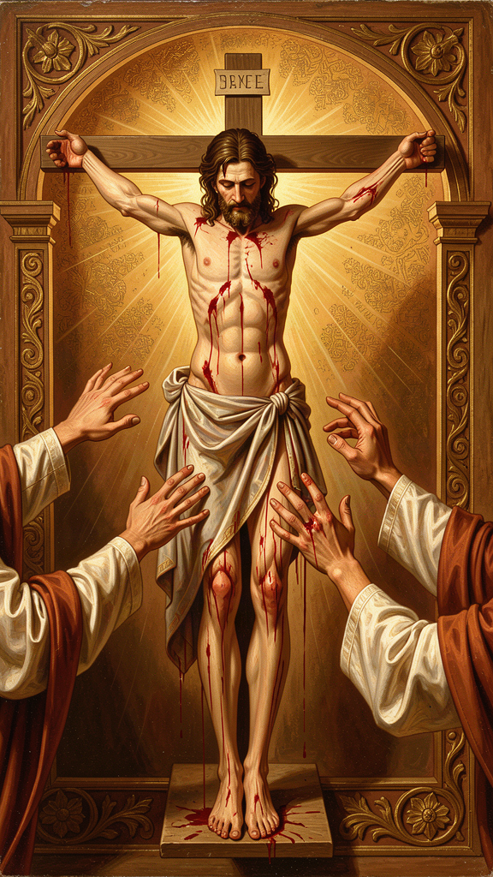
Illustration for Chapter 6

Seeing with the Body
Julian's visions are intensely physical. In the first showing, she sees Christ's crown of thorns, with "the drops of blood trickling down like rain, from under the crown, all hot, flowing freely and copiously, living and beautiful." The blood is not static. It is hot, moving, alive.
In the second showing, she sees Christ's face "all discolored, pale and dying, with the pallor of death." In the third, she sees his body drying up and withering. In the fourth, she sees all the pains of the passion at once — simultaneous, not sequential.
Julian does not receive abstract ideas about suffering. She sees a body in pain. Her spirituality is not an escape from the body. It is a sustained encounter with bodily reality. This is significant because Christian mysticism has often been accused of hating or fleeing the body. Julian does neither. She contemplates the wounded body of Christ and learns compassion, love, and the meaning of creation from what she sees.

The Body in Childbirth
Julian's maternal imagery for God is also bodily. God as Mother conceives, labors, gives birth, nurses, weans, and suffers for the children. The body of the mother — bleeding, feeding, exhausted, tender — becomes an image for the body of Christ. The incarnation means that God has a body like ours, with all that bodies entail.
This is why Julian can call Jesus "our Mother" in Chapter 60. The maternal body and the crucified body overlap. Both labor. Both bleed. Both give life through suffering.

The Body and the Hazelnut
The hazelnut vision complements the passion visions. Where the crucifixion shows God's solidarity with bodily suffering, the hazelnut shows the smallness and fragility of embodied creation. The body is tiny and kept by love. Together, the two visions form a complete theology: bodies matter, bodies suffer, bodies are loved.

How Julian Knew What She Knew
Julian calls her visions "showings." The word matters. A showing is not an argument, a deduction, or a proof. It is a direct presentation of something to the soul. Julian's epistemology — her theory of how we know — is grounded in what is shown, not in what is inferred.
She distinguishes three levels of understanding within her visions:
1. What she saw. The sensory or visionary content: the crucifix, the hazelnut, the blood, the colors. 2. What she understood at the time. The immediate interpretation given to her during the vision. 3. What she came to understand later. The fruit of twenty years of meditation, especially in the Long Text.
This three-layer structure means that the Revelations are not raw transcripts. They are interpreted experience, refined through contemplation. Julian is honest about the difference between seeing and understanding.

Certainties and Questions
Julian is confident about some things: God is love, God keeps creation, all shall be well, God is our Mother. She is uncertain about others: the precise fate of the damned, the exact nature of the "great deed," why sin was permitted. Her epistemology is not all-or-nothing. Some truths are given; others remain sought.
This is a model for intellectual humility. Knowledge does not require knowing everything. It requires knowing what you have been shown and distinguishing it from what you still wonder about.

The Two Texts
Julian wrote two versions of her visions. The Short Text, written soon after the visions of 1373, is raw, immediate, and narratively driven — about 11,000 words. The Long Text, completed perhaps around 1393, is reflective, meditative, and theologically mature — about 63,000 words.
The existence of both texts allows us to trace Julian's theological development. We can see how mystical experience becomes theological reflection over time. We can see how a woman's voice finds its range — from urgent testimony to sophisticated theological argument.

The Final Hermeneutical Key
In the last chapter, Julian gives the key to everything:
"Would you learn to see clearly your Lord's meaning in this? It is love. For I saw full surely that before ever he made us, he loved us; and love was his meaning." — RevLT Ch. 86
Every showing, every question, every unresolved puzzle is finally to be read through love. This is not a way of avoiding difficulty. It is a way of interpreting difficulty from within the confidence of divine love.

Big Idea
Julian learned through what she could see and feel — through bodies, through suffering, through small things like a hazelnut. God shows us truth through the physical world, not just through abstract ideas. And understanding takes time. Julian saw her visions in one day, but she spent twenty years understanding them. The meaning of everything, when you finally see it clearly, is love.

Try This
1. Look closely. Pick any object — a leaf, a stone, a piece of bread. Look at it for two full minutes. Notice the color, the texture, the weight, the detail you usually miss. Julian learned by looking closely. She saw the blood on Christ's face, the drying of his body, the smallness of the hazelnut. Looking closely is a way of knowing.
2. Write two versions. Julian wrote a Short Text right after her visions and a Long Text twenty years later. Think about something important that happened to you — a good thing or a hard thing. Write about it in two ways: first, in three sentences (your "Short Text"), then in three paragraphs (your "Long Text"). What do you notice that you didn't notice at first? What changed when you had more time to think?
3. Practice intellectual humility. Julian was sure of some things and unsure of others. Make two lists. On one side, write three things you are sure about. On the other side, write three things you are still wondering about. Julian would say both lists are honest. You don't have to know everything. You have to know what you know and what you don't.

Talk About It
1. Julian learned about God through looking at a body — the body of Jesus on the cross. She did not get abstract ideas. She saw blood, drying flesh, and a dying face. Why do you think God showed her suffering instead of giving her a lecture? What does seeing teach that hearing cannot?
2. Julian took twenty years to understand what she saw in one day. She wrote a Short Text and then, decades later, a Long Text. Have you ever had an experience that you understood better years later? What changed?
3. "Love was his meaning." Julian said the meaning of everything she saw was love. If you had to name the "meaning" of your life so far — in one word — what would it be? Is it love? Something else? Why?
———
If God shows us truth through bodies, through small things, and through patient attention over time, what is being "shown" to you right now that you might not fully understand for years?
———

For the Grown-Up Reader
This booklet introduces readers ages 11–14 to the theology of Julian of Norwich (c. 1342–c. 1416), the earliest English woman author whose book survives. The six chapters follow the themes specified in the WisdomForge production task: the hazelnut vision (RevLT Ch. 5), "all shall be well" (RevLT Ch. 27, 32), the motherhood of God (RevLT Ch. 48–60), sin as behovely (RevLT Ch. 27, 50–51), the Trinity as loving community (RevLT Ch. 41, 83–86), and the body as revelation / the showings as epistemology (RevLT Ch. 1–16, 86).
Sources and quotes. All quotes are from Julian of Norwich, Revelations of Divine Love, translated by Elisabeth Spearing (Penguin Classics, 1998). References use Long Text chapter numbering (RevLT Ch. X) and Short Text numbering (RevST Ch. X). Julian wrote in Middle English; the Spearing translation renders her words in modern English while preserving her distinctive rhythm and repetition.
Biographical facts. We know that Julian was an anchoress at St. Julian's Church in Norwich, that she received sixteen visions during a near-death illness in May 1373, that she wrote a Short Text and a Long Text, and that Margery Kempe visited her for spiritual counsel. We do not know her birth name, family, social class, or whether she had children. The booklet stays within these facts and flags uncertainty where it exists.
Theological claims. Julian's motherhood of God (RevLT Ch. 48–60) is presented as a theological claim about God, not merely a metaphor. Her "sin is behovely" (RevLT Ch. 27) is a genuine and radical statement about sin's place in providence. The universalism debate (RevLT Ch. 27, 32) is presented with scholarly honesty — Julian leans toward universal hope without formally asserting universal salvation.
Scholarly context. Key sources for deeper reading: Denys Turner, Julian of Norwich, Theologian (Cambridge University Press, 2011); Grace Jantzen, Julian of Norwich: Mystic and Theologian (SPCK, 2000) and Power, Gender and Christian Mysticism (Routledge, 1995); Philip Sheldrake, The Showings of Julian of Norwich (SPCK, 2021); Janina Ramirez, Julian of Norwich: A Very Brief History (SPCK, 2016). The comparison with Augustine draws on Turner's analysis and the research files on Augustine and predestination. The comparison with Margery Kempe draws on The Book of Margery Kempe, ed. Barry Windeatt (Penguin Classics, 1985).
———

About WisdomForge
WisdomForge brings the great thinkers, mystics, and theologians of history to readers of every age. Each figure receives four booklets, adapted for four age bands: elementary (ages 5–10), middle (ages 11–14), high school (ages 15–18), and adult. The same ideas appear at each level, translated into the language and depth that each age can carry. We believe that the deepest wisdom is not too difficult for young readers, and that the greatest minds still have something to say to us now, hundreds of years after they lived. WisdomForge is produced by Aiona Edge for SMF Works.

