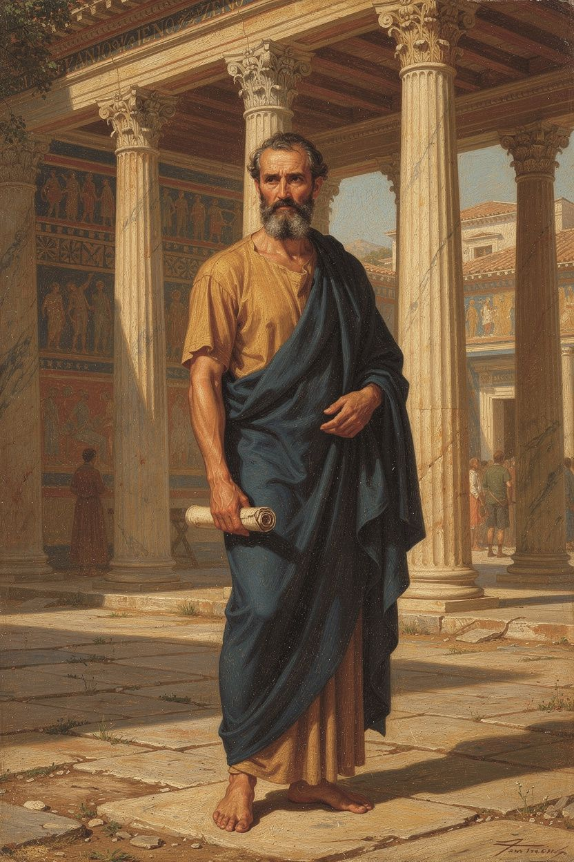
Zeno of Citium: The Founder
WisdomForge Booklet — Adult

Zeno of Citium: The Founder

WisdomForge Booklet — Adult
———

About This Book
This booklet reads Zeno of Citium (c. 334–262 BCE) as a serious philosophical thinker — the founder of Stoicism, the most influential school in the Western tradition. No complete works of Zeno survive. His philosophy is reconstructed from fragments and testimonies: Diogenes Laërtius, Cicero, Plutarch, Athenaeus, and the fragment collection Stoicorum Veterum Fragmenta (SVF) compiled by von Arnim. What emerges from these sources is not a dim historical figure but one of the most original ethical thinkers who ever lived.
Six chapters trace the arc of Zeno's thought: the shipwreck that founded a philosophy, the radical claim that virtue is the only good, the doctrine of the indifferents, the formula of living according to nature, the cosmopolitan vision, and the public porch where it all began. Each chapter combines scholarly precision with practical application. The goal is not admiration but use.
If you have read Epictetus, Seneca, or Marcus Aurelius, you have read Zeno's descendants. This is where it started.
———

Chapter 1: The Shipwrecked Philosopher
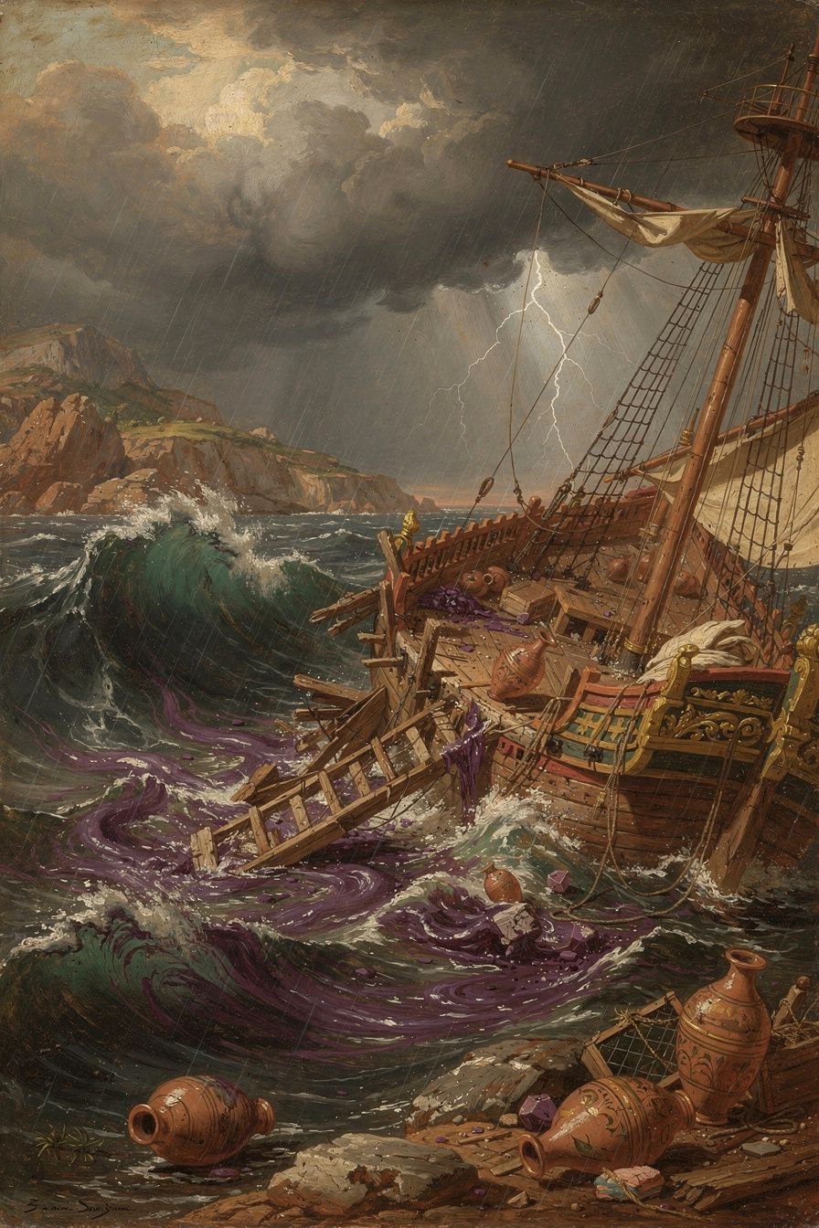
Illustration for Chapter 1
It begins, as the best philosophical stories do, with a catastrophe. A merchant from Citium, a Phoenician colony on the island of Cyprus, loaded his ship with the most valuable commodity the ancient world knew — Tyrian purple, extracted from sea snails at staggering cost, worth its weight in silver, worn by kings and the ultra-wealthy. He sailed for Athens to sell it. He was going to make a fortune.
The storm took everything.
Diogenes Laërtius (VII.2–3) tells the story: the ship was wrecked off the coast of Attica. The cargo, the vessel, the livelihood — all of it went to the bottom of the sea. Zeno arrived in Athens with nothing. Not reduced circumstances. Nothing.
What happened next is one of the most consequential moments in the history of Western thought. Zeno wandered into a bookshop and began reading the second book of Xenophon's Memorabilia — a memoir of Socrates. He was so moved that he asked the bookseller where he could find a man like Socrates. At that moment, the Cynic philosopher Crates was passing by. The bookseller pointed at him and said, "Follow that man."
Zeno followed. He studied with Crates the Cynic, who taught him to despise convention and live according to nature. The Cynics were radical — Crates once made Zeno carry a pot of lentil soup through the Kerameikos to cure him of residual shame, then smashed the pot with his staff when Zeno tried to hide it under his cloak. "Why are you running away, little Phoenician?" Crates called after him. "Nothing terrible has happened to you!" The lesson: shame is a convention. Let it go. Zeno learned the lesson but found a more moderate expression for it.
He studied with Stilpo the Megarian, who taught him rigorous logic and dialectic. Stilpo was famous for his indifference to externals: after his city was sacked and his family taken, he reportedly told the conqueror, "I have lost nothing — for virtue cannot be taken." Zeno absorbed both the logic and the ethics.
He studied with Polemo the Academic, head of Plato's Academy, who taught him Platonic psychology — the soul's health as the foundation of the good life. The Stoic theory of the passions (emotions as errors of judgment) has roots in Polemo's teaching.
From these three teachers, Zeno synthesized something new. Cynic ethics (live according to nature) + Megarian logic (rigorous argument) + Academic psychology (the soul's health) = Stoicism. Around 300 BCE, he began teaching in the Stoa Poikile — the Painted Colonnade — a public porch on the north side of the Athenian Agora. The school was named after the building: the Stoa. Its students were called "Stoics" — people of the porch.
The shipwreck is not just a biographical detail. It IS the philosophy in narrative form. Zeno taught that externals are indifferent because he had lost them all and discovered it was true. The storm took the purple dye, the ship, the money. It could not take his reason, his character, or his capacity for virtue. The founding insight of Stoicism — that what you can lose is not what matters, and what matters cannot be lost — was tested in a shipwreck before it was articulated in a classroom.
The details are symbolic. Purple dye was the most precious external good the ancient world knew. Zeno traded in it. The sea took it. He arrived in Athens with nothing. And found philosophy. The entire Stoic tradition starts here: a merchant ruined by fortune, a book about Socrates, and a Cynic walking past at exactly the right moment. Chance — or, on Stoic terms, providence.
The death story is equally emblematic. Diogenes Laërtius (VII.28–29) records that Zeno, around 72 years old, tripped and broke his finger. Striking the ground with his hand, he quoted a line from a tragedy — "I am coming, why do you call me?" — addressing the earth itself, and then held his breath until he died. Whether legendary or not, the story captures the Stoic ideal: death as a rational choice, not a defeat, met with composure and on one's own terms.
The Athenians — the city that was not his by birth — honored him with a gold crown and a public tomb. The decree (D.L. VII.10–12) praised him for "teaching virtue and moderation to the young men whom he gathered around him, and living a life consistent with his own doctrine — a model to all." The decree was passed by the same democratic institutions that Zeno's cosmopolitanism rendered theoretically obsolete. The irony is Stoic: the polis honored the man who said the polis shouldn't exist.
———

The Big Idea
Zeno's biography is the embodiment of his philosophy. The man who lost everything taught that externals don't matter. The merchant who traded in the world's most valuable dye taught that wealth is indifferent. The foreigner from Cyprus taught that all humans are fellow citizens. His philosophy is not abstract theory. It is testimony — tested in catastrophe, proven in a life that Athens publicly honored.
The shipwreck is the Stoic parable. External goods are fragile — the purple dye was at the bottom of the sea in an afternoon. Catastrophe reveals what can't be lost — when Zeno arrived in Athens with nothing, he still had his reason, his character, his capacity for virtue. Philosophy is discovered through suffering, not through comfort — Zeno found the bookshop because he had nothing else to do. The worst thing that ever happened to him was the best thing that ever happened to him. Without the shipwreck, Zeno remains a merchant. With it, he becomes Zeno.
The shipwreck is available to all of us. Not literally — most of us will not sink in a storm off the coast of Attica. But metaphorically: something will go wrong. Something will be lost. A job. A relationship. A reputation. A plan you built your life around. The question is not whether the shipwreck comes. The question is whether, afterward, you find the bookshop. Whether you let the loss teach you what can't be lost. Whether the catastrophe becomes your beginning, as it became Zeno's.
———

Practice
The Shipwreck Inventory. Identify your equivalent of Zeno's shipwreck — the loss that frightens you most. Not a hypothetical, but the real one: the career setback, the relationship ending, the health crisis, the financial collapse. Walk through it systematically. What would you actually lose? List everything. Then separate the list into two columns: "Things that affect my character" and "Things that are indifferent." Almost everything will fall in the second column. What remains? Your reason. Your capacity for choice. Your ability to respond with virtue. That's what Zeno discovered on the beach — and it was enough.
This exercise is not morbid. It is preparatory. You are not inviting catastrophe. You are loosening the grip of the things you fear losing, so that if they go, you are not destroyed. The Stoic does not avoid loss. The Stoic makes loss survivable by recognizing, in advance, that what matters cannot be lost.
———

A Reflective Prompt
Consider the worst loss you've already experienced. Not the one you fear — the one that already happened. In the aftermath, what did you discover about yourself? What survived that you didn't expect to survive? What did the loss clear away that made room for something new? Zeno's shipwreck was the beginning of everything that mattered. What was yours the beginning of — and what might the next one be?
———

Chapter 2: Virtue Is the Only Good
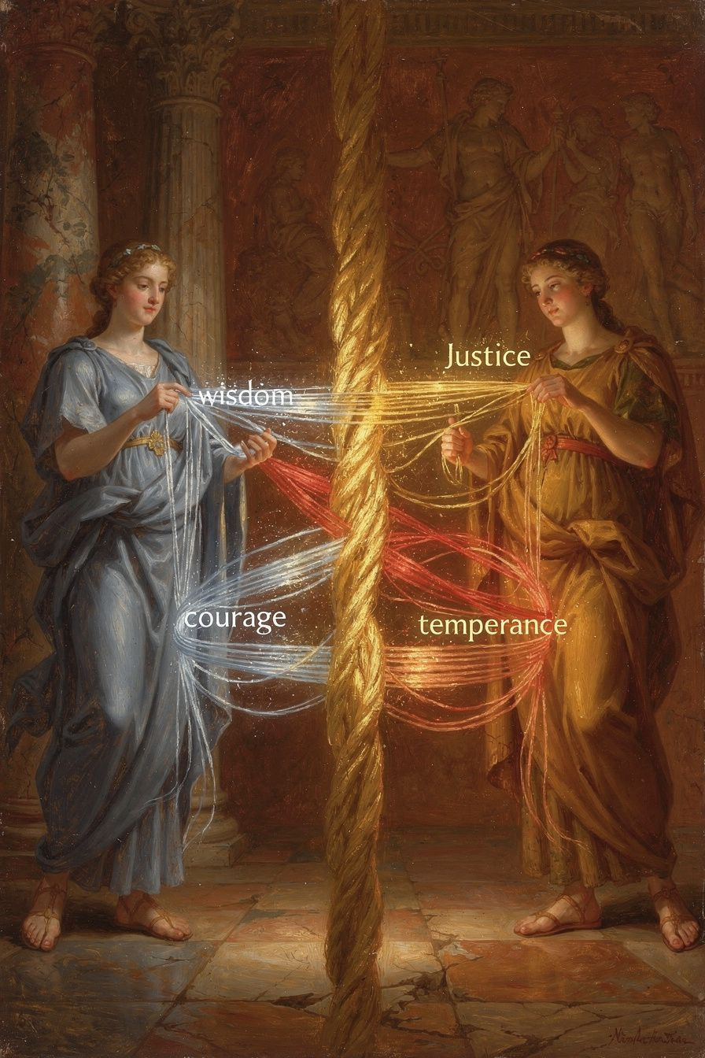
Illustration for Chapter 2
"Virtue is the only good." This is the founding claim of Stoic ethics, and Zeno of Citium was the first to state it in this uncompromising form. Not "virtue is the most important good." Not "virtue is the highest good among many." Virtue is the ONLY good. Everything else — health, wealth, reputation, pleasure, even life itself — is indifferent.
The argument (reconstructed from Cicero, De Finibus III.27, and Diogenes Laërtius VII.101–103):
1. A good must always benefit its possessor. 2. Health, wealth, and pleasure do not always benefit — they can be used badly and cause harm. 3. Virtue always benefits — it cannot be misused (it IS the disposition to use everything well). 4. Therefore, only virtue is good in the strict sense.
And the parallel for evil: only vice is evil. Sickness, poverty, and pain do not always harm — they can be borne virtuously and cause no harm to the soul. Vice always harms — it cannot fail to corrupt. Therefore, only vice is evil in the strict sense.
This was a direct challenge to Aristotle and the entire ancient ethical tradition. Aristotle held that happiness (eudaimonia) requires external goods — you need some wealth, some health, some good fortune to live well (Nicomachean Ethics I.8–10). Zeno denied it. The Stoic claim: a sick, poor, unknown person who is wise and just is genuinely happy. A healthy, wealthy, famous person who is unjust is genuinely miserable. The outside doesn't determine the inside. Only the inside determines the inside.
The reasoning is about control — and this is where Zeno's ethics connects to the practical philosophy that made Stoicism famous. You cannot control your health — illness can strike anyone. You cannot control your wealth — fortune can take everything. You cannot control your reputation — slander can destroy it. If you make happiness depend on things you cannot control, you are gambling with your well-being. The Stoic answer: happiness depends on nothing outside your soul. Everything outside your soul is indifferent. Everything inside your soul that matters is virtue, and virtue is entirely up to you.
The four virtues are the practical expression of this claim:
Wisdom (phronesis) — reason governing knowledge and choice. Thinking before acting. Asking "Is this the right thing to do?" before doing it. Examining your impressions before assenting to them.
Justice (dikaiosyne) — reason governing distribution and treatment of others. Fairness, honesty, treating people as ends rather than means. What do I owe this person — not what can I get from them?
Courage (andreia) — reason governing endurance and risk. Not fearlessness — appropriate action despite fear. Doing the right thing regardless of consequences.
Moderation (sophrosyne) — reason governing desire and impulse. Not abstinence — appropriate proportion. How much is enough — and stopping there.
Zeno held that the virtues are inseparable (Plutarch, On Stoic Self-Contradictions 1034c). You cannot have wisdom without justice, or courage without moderation. They are different names for the same underlying disposition — the rational governance of the soul — applied to different domains. The "wise but unjust" person isn't wise — their apparent wisdom is sophistry. The "courageous but foolish" person isn't courageous — they're reckless. The "moderate but cowardly" person isn't moderate — they're timid. You either have all the virtues or none.
This produces the Stoic sage — the sophos, the person who has achieved complete virtue. The sage is perfectly rational, happy regardless of circumstances, does everything well. Every action is a katorthoma — a right action flowing from perfect virtue. The sage is richer than the wealthy (having virtue), freer than the free (having no master over the soul), more beautiful than the beautiful (having the beauty of the rational soul). The critics — Plutarch, the Skeptics — mocked the sage as an impossible ideal. No one has ever been perfectly rational. No one has ever been happy on the rack. The Stoics described a creature that doesn't exist.
The Stoic response is subtle: the sage is a direction, not a destination. The ideal may not exist, but aiming at it is what produces moral progress. You don't need to arrive. You need to be heading the right way. Everyone is on the path. No one (or almost no one) has arrived. The binary between sage and fool (phaulos) is not a judgment — it's an orientation. Are you moving toward wisdom or away from it?
This is the spine of the entire Stoic tradition. Epictetus' dichotomy of control ("some things are up to us, some are not") is the practical expression of Zeno's virtue monism. Marcus Aurelius' inner citadel — the inviolable center that no external force can breach — is the psychological application. Seneca's consolations — the letter to a grieving mother that says "your son cannot be taken from you because he was never yours to lose" — are the rhetorical expression. All of it presupposes Zeno's founding axiom: nothing outside the soul can harm the soul, and nothing inside the soul can be harmed except by the soul's own failure of virtue.
Modern cognitive behavioral therapy (CBT) echoes this with different vocabulary. CBT holds that emotional reactions are mediated by automatic thoughts — swift, often unconscious interpretations of events. If those interpretations are distorted, we suffer unnecessarily. The therapeutic process involves identifying those thoughts, examining them, and replacing them with more accurate ones. This is, in essence, the Stoic discipline of assent: catching the raw impression, holding it up to the light, and deciding whether to accept it. The difference is that the Stoics did not wait for a therapist or a crisis. They made the examination a daily ritual. Zeno built the foundation. CBT built a clinic on it.
———

The Big Idea
Virtue is the only good. This is not "be a good person" as a pleasant platitude. It is a precise, radical, and demanding philosophical claim: the only thing that determines whether your life goes well or badly is the state of your character. Everything else — health, wealth, reputation, pleasure, pain, life, death — is in a different category entirely. They are indifferent. Not worthless, not irrelevant, but incapable of determining your happiness.
If you accept this claim, you are free. Not free from difficulty — but free from the belief that difficulty can harm you. Your happiness becomes invulnerable to fortune because it depends on nothing fortune can touch. If you reject it, you remain at the mercy of everything you cannot control: your health, your wealth, your reputation, the opinions of others, the movements of markets and governments and weather. Zeno's claim is not optimistic. It is not comforting. It is terrifying. It says: your happiness is your responsibility. No one can take it from you, but no one can give it to you either. There is nowhere to hide.
———

Practice
The Character/Circumstances Separator. The practical core of Zeno's ethics is a single question, applied continuously: Is this about my character or my circumstances? If it's about your character — your wisdom, justice, courage, moderation — it matters absolutely. Act accordingly. If it's about your circumstances — your money, health, reputation, comfort — it matters relatively. Pursue it, but don't mistake success in this domain for happiness. Your happiness is unaffected either way. Practice this question daily, at every significant decision point, until the distinction becomes automatic.
The Evening Review. Before sleep, ask three questions (a practice traced to the Pythagoreans and adopted by the Stoics): What did I do well? What did I do poorly? What did I leave undone? Do not use this review for self-flagellation. Use it for training. You are building the habit of virtue the way an athlete builds muscle — through repetition and correction. If you snapped at a colleague, trace the moment back: Were you hungry? Tired? Clinging to an expectation? Then make one small, concrete resolution for tomorrow. Write it down. The act of writing, as Marcus Aurelius knew, solidifies the insight.
The Circumstances Exercise. Periodically, imagine losing a preferred indifferent. Your job. Your health. Your savings. Your reputation. Not to induce anxiety — to induce perspective. Ask: "If I lost this, would I still be okay?" The Stoic answer is always yes. You might be uncomfortable. You might be sad. But your character — the only thing that determines your happiness — would be intact. Do this with the things you're most attached to. The attachment loosens. The fear loses its grip. You are not preparing for disaster. You are preparing to discover that disaster isn't as disastrous as you think.
———

A Reflective Prompt
Zeno's claim that virtue is the only good implies that your happiness is entirely your responsibility. No external event, no other person, no stroke of fortune can make you happy or miserable. Only your character can do that. Is this liberating or crushing? What would your life look like if you genuinely believed it — if you stopped blaming circumstances for your dissatisfaction and started treating every moment as material for the only project that matters: the state of your soul?
———

Chapter 3: The Indifferents
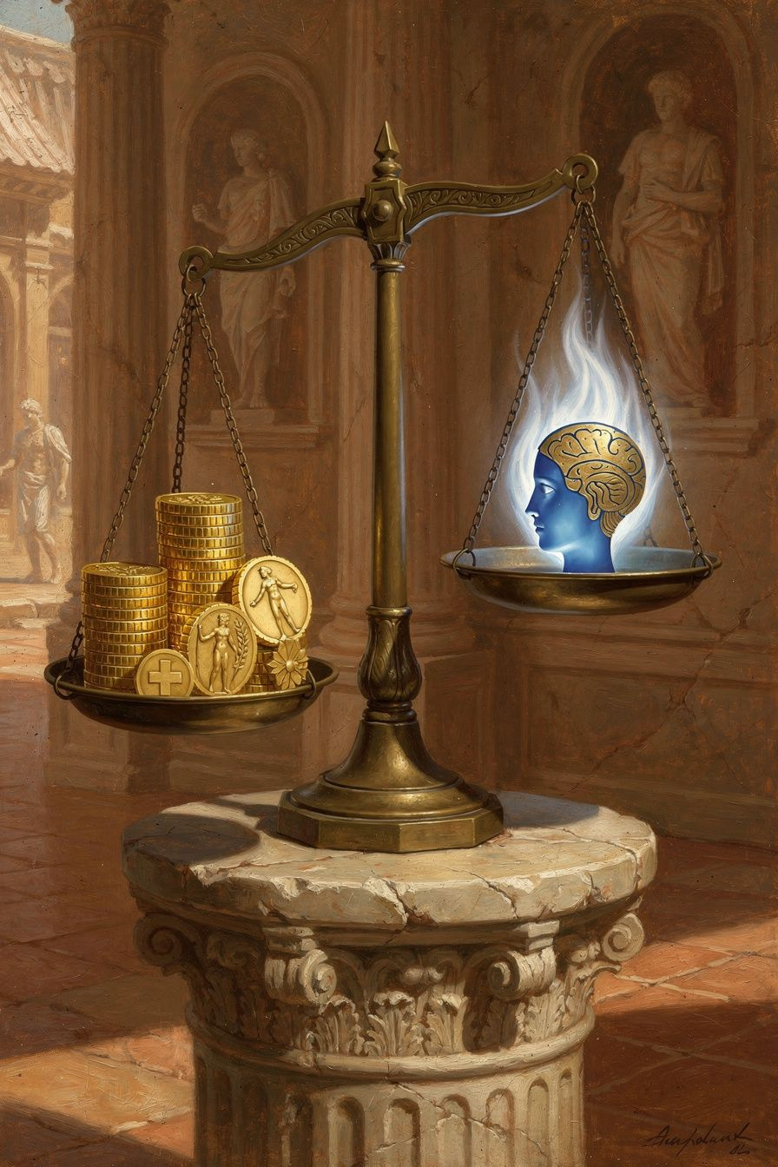
Illustration for Chapter 3
The doctrine of the indifferents (adiaphora) is Zeno's most counterintuitive contribution to ethics — and the most practically liberating. It is the Stoic answer to the problem of attachment, and it demands a complete psychological restructuring of how we relate to everything we care about.
The classification is precise. Diogenes Laërtius (VII.101–105) preserves the Stoic scheme:
| Category | Definition | Examples | |----------|-----------|----------| | Good (agathon) | Always benefits; cannot be misused | Virtues: wisdom, justice, courage, moderation | | Evil (kakon) | Always harms; cannot fail to corrupt | Vices: folly, injustice, cowardice, intemperance | | Indifferent (adiaphoron) | Neither benefits nor harms in itself | Everything else |
"Indifferent" does not mean "worthless" or "irrelevant." The Greek adiaphoron means "not making a difference" — specifically, not making a difference to happiness. Health doesn't make you happy. Sickness doesn't make you unhappy. What makes you happy or unhappy is how you USE health or respond to sickness — and that is virtue or vice.
Zeno introduced a crucial refinement: indifferents are subdivided into preferred (proegmena) and dispreferred (apoproegmena). Preferred indifferents — life, health, pleasure, beauty, strength, wealth, reputation, noble birth — have value (axia). You should pursue them, all else equal. Dispreferred indifferents — death, illness, pain, ugliness, weakness, poverty, dishonor, low birth — have disvalue. You should avoid them, all else equal. But neither category is good or evil. They're in a completely different class from virtue and vice.
The distinction between "value" and "goodness" is the hardest part of Stoic ethics to internalize, and it originates with Zeno. Money has value — it's useful. But money doesn't make you good. Health has value — it's pleasant. But health doesn't make you virtuous. A Stoic pursues health (it has selective value) but doesn't need health to be happy. A Stoic pursues wealth (it's preferred) but doesn't need wealth to flourish. The externals are tools, not components of the good life. You can do good work with good tools, but the work is what matters, not the tools.
Cicero (De Finibus III.50–54) explains with an analogy: a king values his crown, his palace, his servants. These have value — they're preferred. But the king's wisdom is what makes him a good king, not his possessions. The possessions have "selective value" — you'd choose them, all else equal. But they are not goods. They don't make the king happy. His virtue makes him happy.
The practical payoffs:
Reduced fear of loss. If health is not a good, losing it is not losing something that determines your happiness. You can be sick and still be okay. The fear of illness loses its grip. This is not denial — it is reframing. The illness is real. The suffering is real. But the illness cannot reach the thing that determines whether your life goes well.
Reduced attachment. If wealth is indifferent, losing it is not a disaster. You can be poor and still be flourishing. The anxiety about money loses its foundation. You still earn, still save, still provide — but you don't need the outcome to be okay. The need is what creates the suffering, not the earning.
Reframed ambition. If reputation is indifferent, pursuing it is optional. You can be unknown and still be living well. The hunger for recognition becomes a preference, not a need. You can seek it when it serves virtuous ends — and let it go when it doesn't.
Preparation for death. If life itself is an indifferent (preferred, but indifferent), death is not an evil. It's dispreferred — you'd rather keep living — but it cannot harm your soul. The fear of death, on Stoic premises, is a category error. You are afraid of losing something that was never yours — something that was always on loan from the cosmos. Only vice harms your soul. Death is indifferent to it.
The most common objection is practical: "But I need money to live. I need health to function. I need a reputation to work. Calling them 'indifferent' is unrealistic." Zeno's response is precise: he never said indifferents don't matter. He said they don't matter TO YOUR HAPPINESS. They matter to your animal comfort, your practical effectiveness, your ability to help others. A sick Stoic should go to the doctor. A poor Stoic should work to earn money. An obscure Stoic can seek recognition if it serves virtuous ends. But the Stoic does all of this with a crucial psychological difference: their happiness does not DEPEND on the outcome. They pursue health, but if they get sick, they are not undone. They pursue wealth, but if they lose it, they are not destroyed. The indifferents are pursued with reservation (hupexairesis) — the recognition that outcomes are not up to you, and your happiness depends only on what IS up to you.
The reserve clause is not half-heartedness. It is full effort plus full acceptance. You apply for the job: "I will get this job, fate permitting." You give everything to the application — the resume, the interview, the preparation. But you add the mental clause: if nothing prevents it. If you get the job — good, it was preferred. If you don't — fine, fate had other plans, and your happiness doesn't depend on employment status. The reservation is the Stoic art of caring fully without needing. It is the psychological technology that allows you to engage with the world without being enslaved by it.
This is the theoretical foundation of the dichotomy of control. Everything outside your character is indifferent. Everything inside your character is within your control. Zeno built the framework. Epictetus turned it into a practical tool. Seneca applied it to wealth and power. Twenty-three centuries of Stoics have been practicing it.
———

The Big Idea
The doctrine of the indifferents is the Stoic answer to the problem of attachment. You can have nice things. You can pursue good outcomes. You just can't NEED them. The moment you need something outside your character to be happy, you've made yourself vulnerable to fortune — and fortune is a fickle god. The Stoic solution: need nothing outside yourself. Want everything you have, but need only virtue. The rest is indifferent. Preferable, but indifferent. Valuable, but not good. Nice, but not necessary. The art is holding everything loosely enough that losing it doesn't cost you your peace, but tightly enough that you don't become careless. Zeno taught the art. Two thousand years of Stoics have been practicing it.
———

Practice
The Indifferents Audit. List ten things you care about — things you spend time, energy, or anxiety on. Next to each, write "Good" (if it's a virtue), "Evil" (if it's a vice), or "Indifferent" (anything else). For the indifferents, mark "P" (preferred) or "D" (dispreferred). Now examine your list with brutal honesty. How many things did you classify as "Good" that are actually indifferents? Those are your attachments. Those are the things whose loss would shake you — and the things Stoic practice teaches you to hold more loosely. This is not about eliminating the preferences. It's about eliminating the need.
The Reserve Clause. For two weeks, every time you pursue a goal, mentally add "fate permitting" or "if nothing prevents it." "I will close this deal, fate permitting." "I will get this promotion, if nothing prevents it." "I will have a good weekend, fate permitting." This is not half-heartedness — it's full effort with full psychological acceptance of any outcome. Notice the difference between trying your best and needing the result. Notice how the reserve clause changes the quality of your effort — often making it better, because you're not paralyzed by the fear of failure.
The Loss Meditation. Once a week, spend five minutes imagining the loss of something you're attached to — not to induce anxiety, but to induce perspective. Walk through it: What would I actually lose? What would remain? What would I discover about myself? The Stoic answer is always the same: you would lose something preferred. You would retain everything that matters. You would discover that you are stronger than you thought. Do this with the big things — your job, your health, your most important relationship — and the small things — your phone, your routine, your preferred coffee. The practice loosens the grip of attachment across the board.
———

A Reflective Prompt
Consider the thing you are most afraid of losing. Not in the abstract — the specific thing. The career you've built. The relationship that anchors you. The health you take for granted. The reputation you've spent decades cultivating. Now ask: if this were taken from me tomorrow, what would remain? Not "how would I feel" — you would feel devastated. But what would remain? Your reason. Your capacity for choice. Your ability to respond with courage, with honesty, with grace. Zeno's claim is that what remains is sufficient. Not just sufficient — everything. Do you believe him? What would it take to believe him?
———

Chapter 4: Living According to Nature
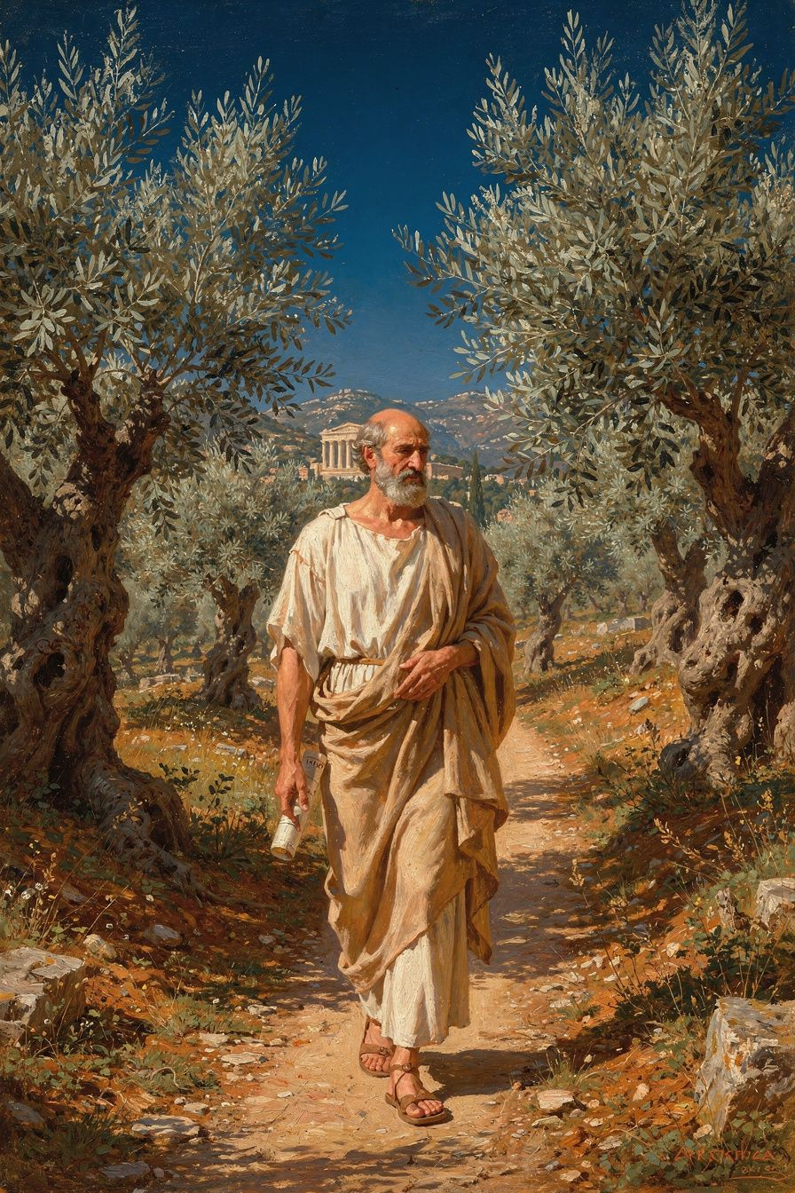
Illustration for Chapter 4
"Live in accordance with nature." This is the most famous formula in Stoicism — Zeno's definition of the telos, the goal of human life. But the formula is deceptively simple, and what "nature" means is the source of centuries of philosophical work.
What "nature" does NOT mean:
"Follow your instincts." Instincts are animal. Stoicism is about reason governing the instincts, not obeying them. A wolf follows its instincts. A human follows reason. The difference is the whole point.
"Go back to the woods." Civilization is natural for rational, social beings. The city is as natural as the forest. Zeno taught in the marketplace, not in a cave.
"Do whatever feels right." Feeling is not a reliable guide. Reason is. "According to nature" means according to reason, not according to impulse.
"It's all predetermined, so don't bother." Determinism is real on Stoic terms — the cosmos is rationally ordered by logos, and everything that happens is part of that order. But your choices are also real — they're part of the causal chain. You can't opt out of choosing. Determinism is not fatalism.
What "nature" DOES mean — three dimensions, one instruction:
1. Your nature: rational. You are a rational animal. Your distinctive capacity is reason. To live according to YOUR nature is to let reason govern your choices, desires, and actions. When reason governs, you are virtuous. When impulse governs, you are vicious. The difference between a good life and a bad life is which part of you is in charge. Practice: Before every significant choice, ask — Is reason governing this decision, or is something else? Fear? Desire? Habit? Social pressure?
2. Human nature: social. You are a social animal. Your nature includes the impulse to form communities, care for offspring, cooperate with others. Stoicism is not about solitary self-improvement — it's about living well WITH others. Justice is not an optional virtue. It's the expression of your social nature. A Stoic who is "wise" but treats people as tools is not wise — they're a sophist with good PR. Practice: In every interaction, ask — Am I treating this person as a fellow rational being, or as a tool for my purposes?
3. Cosmic nature: acceptance. The universe is rationally ordered by logos. Everything that happens serves the good of the whole. Living according to cosmic nature means accepting what happens — not passively, but with understanding. "Fate leads the willing and drags the unwilling" (Cleanthes, echoing Zeno). When you resist what happens, you suffer — not because the event is inherently suffering, but because resistance creates suffering. When you accept the event and respond virtuously, you are free. Practice: When something happens that you didn't want, say — This too is according to nature. Not as resignation — as recognition. The rational order includes this. Your job is to respond well.
These three dimensions are not separate injunctions. They are one instruction, seen from three angles. The person who lives according to nature is the person whose rational choices align with the rational structure of reality. This is freedom — not freedom from constraint, but freedom from internal conflict. When your choices and the world's order say the same thing, you are free. The Stoic paradox: you are free when your will aligns with the cosmic order. When you want what happens, you are never frustrated. When you resist what happens, you are perpetually frustrated. Living according to nature IS freedom — not because you get what you want, but because you want what you get.
The daily formula:
Morning: Set the intention. "Today I will live according to nature — rationally, socially, in acceptance of what comes."
Midday: Check. "Is reason governing, or is something else? Am I treating people as ends or means? Am I accepting or resisting?"
Evening: Review. "When did I live according to nature today? When did I depart from it? What will I do differently tomorrow?"
Zeno himself embodied this. Ancient sources (D.L. VII.26–28) describe him as lean, dark-skinned, self-controlled, and dignified. He ate bread and honey, drank a little sweet wine. He avoided drunkenness, luxury, and crowds. He was sharp in argument but gentle in manner. "He needed no one, but he was not unfriendly." He was what he taught. Athens honored him with a gold crown and a public tomb for "living a life consistent with his own doctrine — a model to all."
———

The Big Idea
"Live according to nature" is Zeno's answer to "what is the good life?" The answer is deceptively simple and devastatingly demanding. It requires the governance of reason over impulse, the recognition of all humans as fellow citizens, and the willing acceptance of everything that happens as part of the rational cosmic order. This is Stoic piety — not worship, but alignment. Your will and the world's order, saying the same thing. Three sentences, a lifetime of practice. Simple to understand. Very difficult to do. Start tomorrow morning.
———

Practice
The Daily Three. Follow Zeno's formula for one week. Morning: before you rise, set one intention — "Today I will think clearly, treat people as ends, and accept what comes." Midday: check in — am I doing it? Evening: review — when did I live according to nature? When didn't I? What will I change tomorrow? Keep notes. At the end of the week, examine what shifted. Most people report that the midday check is the hardest — the autopilot is strong, and the first sign that you've departed from your intention is usually an emotional reaction you didn't see coming. That reaction is data. Use it.
The "Is Reason Driving?" Check. Five times today, at random moments, pause and ask: "Is reason driving right now, or is something else?" Fear? Anger? Desire? Habit? Social pressure? Ego? If something other than reason is in charge, take a breath and let reason take the wheel. This takes about five seconds each time. Over weeks and months, it builds the habit of rational governance that Zeno called "living according to your nature." The goal is not to eliminate emotion — it's to ensure that reason, not emotion, is the decider.
The Acceptance Practice. Once a day, when something happens that you didn't want — a delay, a disappointment, an inconvenience — pause and say internally: "This too is according to nature." Not as resignation. As recognition. The event happened. It's part of the causal order. Your job is not to undo it but to respond to it with virtue. Then respond. This is the cosmic dimension of Zeno's formula, practiced in the smallest moments, building the capacity for the largest ones.
———

A Reflective Prompt
Zeno says freedom is not getting what you want but wanting what you get. This sounds like resignation — until you try it. Pick one thing that happened today that you didn't want. A traffic jam. A curt email. A plan that fell through. Now ask: can I want this? Not "can I pretend to want it" — can I genuinely align my will with the fact that it happened? What would have to change in my thinking for this unwanted event to become acceptable? The Stoic answer: nothing about the event needs to change. Only the judgment needs to change. "This is bad" becomes "this happened, and my job is to respond well." That shift — from resistance to acceptance to virtuous response — is the whole of Stoic practice, compressed into a single moment.
———

Chapter 5: The Cosmopolis
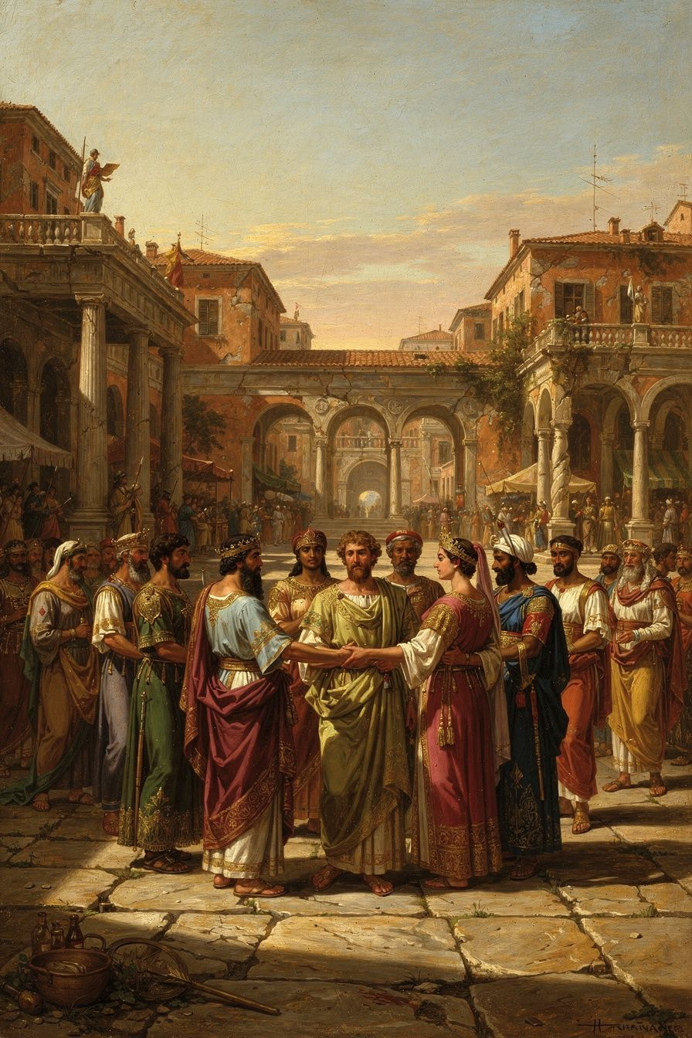
Illustration for Chapter 5
Zeno's most visionary idea was the cosmopolis — the world city. All humans are citizens of the same moral community. Not "should be" — ARE. The divisions we create — citizen vs. foreigner, Greek vs. barbarian, free vs. slave — are products of incomplete moral development. The fully rational person recognizes no such divisions.
This was radical in the Hellenistic world. Identity was tied to the polis (city-state). Athenians cared about Athenians. Spartans cared about Spartans. Foreigners were xenoi — strangers. The idea that a Greek and a Persian, a free person and a slave, were fellow citizens was shocking. Zeno's Republic — his most famous work, surviving only in fragments — envisioned a community with no courts, no money, no temples, no borders. Not because these things are evil, but because they're unnecessary for fully rational beings who treat everyone as their own. Why abolish courts? Because in a community of fully developed rational beings, disputes don't arise. Why abolish money? Because in a community where goods are shared as among family, money is unnecessary. Why abolish borders? Because there is no "outside" to a community that includes everyone.
The Republic is not utopian fantasy. It's a thought experiment: what would a community look like if everyone had completed the process of moral development? The answer: no courts, no money, no borders, no temples. Not because these things are evil, but because they're crutches — necessary for partially developed beings, unnecessary for sages. The Republic makes full sense through the lens of oikeiosis (oy-kay-OH-sis) — the Stoic theory of moral development.
Oikeiosis — "appropriation" or "familiarization" — is the Stoic account of how moral development works. The Greek word comes from oikos (household, home) and means "making something one's own" or "coming to recognize something as belonging to oneself." It's the opposite of allotriosis — alienation, estrangement.
The central Stoic claim: moral development is a process of expanding recognition. You start by recognizing that YOUR body belongs to you (self-preservation). You extend to recognizing that your FAMILY belongs to you (familial love). You extend further to your COMMUNITY, your NATION, and finally — if you complete the process — to ALL HUMANITY and the COSMOS ITSELF. At each stage, what was "other" becomes "own."
Cicero (De Finibus III.62–68) gives the classic account: "As soon as an animal is born, it is attached to itself and committed to preserving itself... Later, as reason develops, the human being comes to recognize that the rational order extends beyond the individual, embracing family, community, and eventually the whole human race."
The Stoic philosopher Hierocles (2nd century CE) made the oikeiosis model vivid with concentric circles:
1. Center: The individual self 2. First circle: Immediate family 3. Second circle: Extended family and close friends 4. Third circle: Community, city, fellow citizens 5. Fourth circle: Nation or ethnic group 6. Outermost circle: All humanity — the cosmopolis
The Stoic task, Hierocles says, is to "draw the circles toward the center" — to treat those in the outer circles with the same care you'd give to those in the inner ones. The goal is not to love strangers MORE than family but to love strangers AS IF they were family. The affection doesn't dilute. It expands.
The cosmopolitan conclusion is the logical endpoint of oikeiosis. If reason shows us that all humans share the same rational nature, then all humans belong to the same moral community. The divisions we create are products of incomplete oikeiosis. The fully rational person recognizes no such divisions. Plutarch (On the Fortune of Alexander 329a–b) preserves Zeno's vision: "We should not live in separate cities and demes, each marked off by its own laws, but we should consider all human beings as fellow demesmen and fellow citizens; there should be one life and one order, like a single flock pasturing together on a common law."
This is not "wouldn't it be nice if we all got along." It's a claim about what IS ALREADY TRUE. All humans ARE fellow citizens. We just don't recognize it. The task is not to create the cosmopolis but to wake up to it.
Zeno lived this. He was from Citium, a Phoenician colony. Diogenes Laërtius calls him "a Phoenician." He was a foreigner in Athens. And he became one of its most honored teachers. The city that wasn't his gave him a gold crown and a public tomb. The cosmopolis, made real in one life.
The modern descendants of the cosmopolis are everywhere. Kant's Perpetual Peace — with its proposal for a federation of free states and universal hospitality — is a direct intellectual descendant. The Universal Declaration of Human Rights (1948) enshrines the principle that rights belong to all humans by virtue of their humanity, not their citizenship. The United Nations, the concept of crimes against humanity, the refugee convention, the very idea that a person has rights that transcend national borders — all are philosophical grandchildren of Zeno's cosmopolis. The Stoic didn't need a global institution to tell him that a stranger matters. Reason did that work. The institutions came later, codifying what philosophy had already established.
———

The Big Idea
You are a citizen of the world. Not as an aspiration — as a fact. The divisions between people — nationality, race, class, language, religion — are failures of moral vision, not features of reality. The more you develop, the wider your circles of concern become, until they include everyone. Zeno's cosmopolis isn't something you build. It's something you wake up to. And once you see it — once you genuinely recognize that the person on the other side of a border is your fellow citizen — you can't unsee it. The question is not whether the cosmopolis exists. It does. The question is whether you're living as if it does.
———

Practice
The Circles Audit. Draw the six concentric circles (self, family, friends, community, nation, all humanity). Where do you spend most of your concern? Which circle gets the most of your time, energy, and emotional investment? Which gets the least? Now ask: what would it look like to draw the outer circles inward? What's one specific action you could take this week to extend your concern to someone in an outer ring — a coworker you don't know well, a neighbor you've never spoken to, a stranger in your community, a person affected by a global issue you normally ignore?
The Fellow Citizen exercise. For one day, every time you encounter a stranger — a cashier, a driver, a person on the street, someone in a meeting you don't know — silently think: "Fellow citizen." Not "other." Not "stranger." Not "background character in my story." "Fellow citizen." Notice how this changes your perception. You don't have to interact differently. Just see differently. The cosmopolis begins in perception — in the moment you stop seeing someone as "other" and start seeing them as "mine."
The Outer Circle Action. Identify one person or group in your outermost circle — people you don't know, possibly in another country, possibly affected by something you normally don't think about. Do one concrete thing this week that extends concern to them: a donation, a letter, a moment of education, a conversation about their situation. The action doesn't need to be large. It needs to be real. The cosmopolis is built one act of recognition at a time.
———

A Reflective Prompt
Zeno said all humans are already fellow citizens — the cosmopolis exists, we just don't see it. Consider your own circles. Where do they stop? At your family? Your friends? Your neighborhood? Your country? What would it mean to extend them further — not abstractly, but practically? Who is in your outermost circle right now, and what would it look like to draw them inward? The Stoic answer is not a policy proposal. It is a perception shift: see the stranger as a fellow citizen, and the behavior follows. What would you see differently if you genuinely believed that every person on earth is your fellow citizen — and what would you do differently because of what you saw?
———

Chapter 6: The Painted Porch
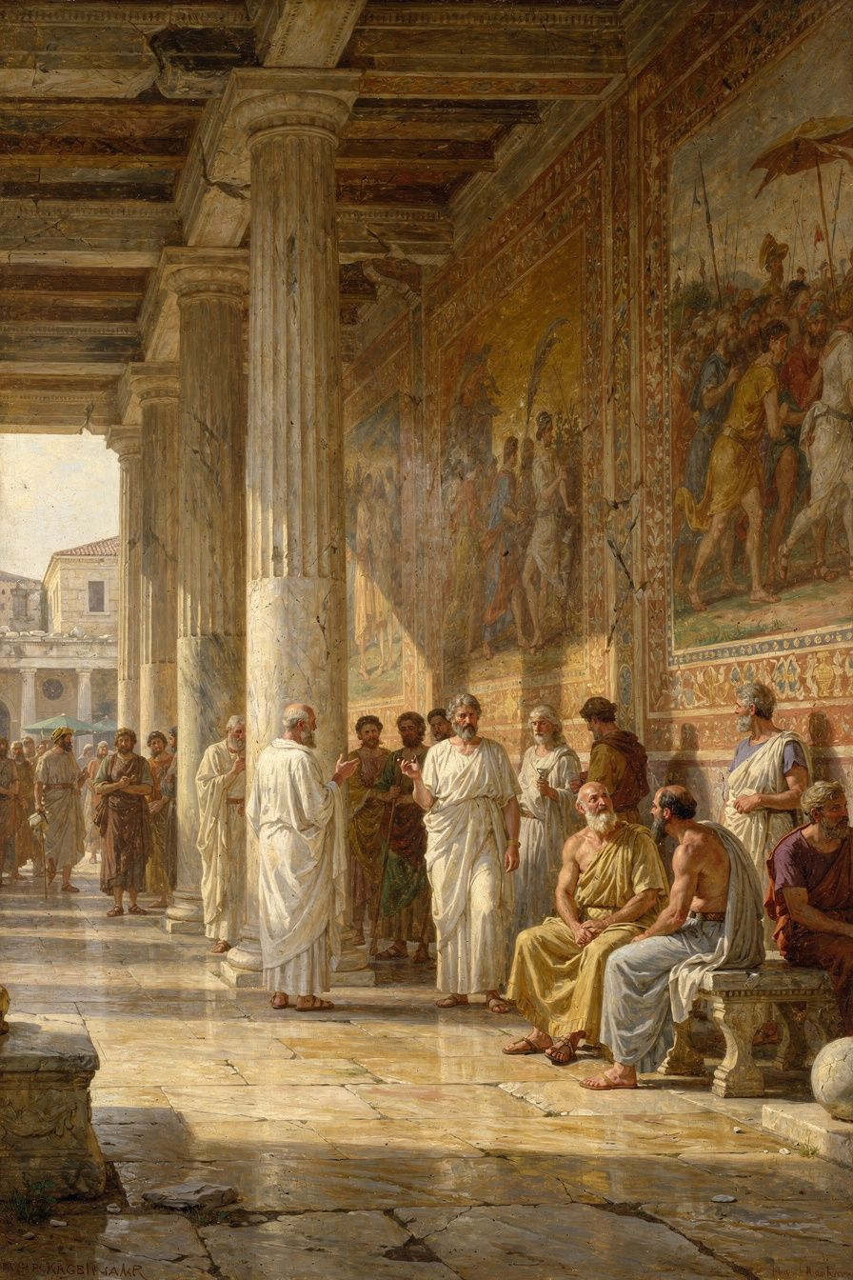
Illustration for Chapter 6
Around 300 BCE, Zeno began teaching in the Stoa Poikile — the Painted Colonnade — a public porch on the north side of the Athenian Agora. The walls displayed frescoes of Athenian military victories: the Battle of Marathon, the Battle of Oenoe, the Amazonomachy, the Fall of Troy, rendered by the painter Polygnotus. Zeno taught virtue amid images of courage. The setting was not accidental. Philosophy reclaims what politics destroys — the colonnade where 1,400 Athenians had been murdered during the regime of the Thirty Tyrants became the colonnade where Zeno taught virtue.
The choice of venue was a philosophical statement. He could have taught in a private house, like Epicurus. He could have taught in a gymnasium, like Plato and Aristotle. He chose a public porch in the marketplace — the busiest, loudest place in Athens. The Stoa was open on one side to the Agora. No doors. No fees. No membership. Anyone could walk up and listen: dockworkers, merchants, aristocrats, philosophers from rival schools, curious passersby. Philosophy was not removed from life. It was embedded in it.
Four reasons the venue mattered:
1. Philosophy is for everyone. Not just the educated elite. Not just those who can afford to leave their jobs and study full-time. Anyone who can stand in a colonnade and listen can engage with philosophy. Zeno's students included dockworkers (Cleanthes was a water-carrier and night laborer), merchants, aristocrats, and at least one king.
2. Philosophy should be tested in public. Private doctrines can become insular, self-reinforcing, disconnected from reality. Teaching in the marketplace meant Zeno's ideas were constantly challenged — by rival philosophers, by hecklers, by the sheer pressure of everyday life intruding on philosophical discourse. If an idea couldn't stand up in the Agora, it probably wasn't worth much.
3. The building embodied the teaching. The Stoa was a place of shelter — protection from sun and rain — but open to the world. The Stoic sage is sheltered (the inner citadel, the soul's invulnerability) but engaged. The colonnade was the architectural expression of Stoic ethics: rooted, structured, open.
4. Continuity with Socrates. Socrates philosophized in the Agora. He questioned Athenians in the marketplace, in the streets, wherever people gathered. Zeno was consciously continuing the Socratic tradition — philosophy as public dialogue, not private instruction.
The contrast with Epicurus was deliberate and publicly recognized:
| | The Stoa (Zeno) | The Garden (Epicurus) | |---|---|---| | Location | Central Athens, public Agora | Outside city walls, private | | Access | Open to anyone who passes | Community of invited members | | Philosophy's role | Public service, civic engagement | Private therapy, withdrawal | | Highest good | Virtue | Pleasure (absence of pain) | | The sage | Engaged in politics when rational | Withdrawn from politics | | Community | Loose association of students | Tight-knit communal living | | Tone | Public, argumentative, exposed | Private, supportive, sheltered |
The rivalry was not merely doctrinal. It was architectural, social, and temperamental. Zeno and Epicurus were near-contemporaries in Athens. Their students debated in the streets. Their ideas defined the two poles of Hellenistic philosophy — engagement vs. withdrawal, virtue vs. pleasure, the public porch vs. the private garden.
The name "Stoic" comes from the Stoa — the porch. The school was originally called "Zenonians," after Zeno. Later, they became "Stoics" — named after the building. This is unique among ancient philosophical schools. Platonists are named after Plato. Aristotelians after Aristotle. Epicureans after Epicurus. Stoics are named after a porch. The name reflects the philosophy: Stoicism is not a cult of personality. It's a practice, a stance, a way of being in the world. You don't follow Zeno. You stand where Zeno stood and see what Zeno saw. The building is the tradition.
Zeno's students embodied the openness. Cleanthes of Assos (c. 330–230 BCE) was a boxer who came to Athens with four drachmas, worked as a water-carrier by day and studied philosophy at night. He became Zeno's most devoted student and eventual successor. Called "the second Hercules" for his endurance. Wrote the Hymn to Zeus — one of the most beautiful religious poems of antiquity, a Stoic meditation on providence and the rational order of the cosmos. King Antigonus II Gonatas of Macedonia corresponded with Zeno and visited him in Athens. "I have great need of philosophy," he wrote. Zeno sent Persaeus instead of going himself — the Stoic does not rush to power; power comes to the Stoic. Persaeus of Citium, Zeno's fellow Phoenician and possibly his slave, was sent to the Macedonian court. Ariston of Chios focused solely on ethics and rejected physics and logic as irrelevant. Sphaerus of Borysthenes traveled to Alexandria and Sparta, spreading Stoicism across the Hellenistic world.
Laborers, aristocrats, kings, slaves, foreigners — the diversity of students embodied Zeno's cosmopolitan ideal. The Stoa was open to everyone, and everyone came.
Zeno taught there for decades, until his death around 262 BCE. He lived what he taught. Ancient sources describe him as lean, self-controlled, dignified. He ate bread and honey, drank a little sweet wine. He was sharp in argument but gentle in manner. "He needed no one, but he was not unfriendly." He practiced what he taught, and Athens honored him for it with a gold crown and a public tomb — the decree praising him for "teaching virtue and moderation to the young men whom he gathered around him, and living a life consistent with his own doctrine — a model to all." He was what he taught.
The Stoa Poikile survived for centuries. Pausanias, writing in the 2nd century CE, described the paintings still visible. The building was eventually destroyed, like most of ancient Athens. But the name survived. "Stoic" no longer refers to a porch. It refers to a way of being — standing firm, open to the world, sheltered by reason, teaching in public what matters most.
———

The Big Idea
Stoicism is named after a porch — a public space, open to all, embedded in the noise and commerce of everyday life. This is not an accident. It is a philosophical statement. Stoicism is not about retreating from the world into private contemplation. It is about standing in the middle of the world — in the marketplace, in the office, in the conversation, in the conflict — and being steady. Rational. Engaged. Kind. Unafraid. The building is gone. The stance remains. And the stance is available to anyone, anywhere, at any time. You don't need a porch. You need a willingness to stand where you are, see clearly, and act with virtue. The Stoa is open every time someone does that. The philosophy is 2,300 years old. The practice is now.
———

Practice
The Public Porch. Stoicism is meant to be shared, not hoarded. This week, share one idea from this booklet with someone — a colleague, a friend, a family member. Not as a lecture. As a conversation. Tell them about the shipwreck, or the indifferents, or the cosmopolis. The Stoa is open every time someone shares what they've learned. Philosophy grows when it's taught. It dies when it's kept.
The "Be One" Pause. Marcus Aurelius, who inherited Zeno's philosophy across 500 years, wrote: "Waste no more time arguing about what a good person should be. Be one." At some point today, you will catch yourself arguing internally about what you should do — how you should respond, what the right action is, whether you're being consistent. In that moment, pause. Take a breath. Then ask: What would a wise, just, brave, and moderate person do right now? And do that. Not later. Not after more analysis. Do the small, immediate thing that aligns with virtue. This is the living application of Marcus's injunction. It is not about perfection. It is about direction.
The Evening Review (continued). If you've been doing the evening review since Chapter 2, you have weeks of notes. Look back. What patterns emerge? What situations consistently trigger a departure from your intentions? What virtues are you strongest in? Weakest? What have you learned about yourself that you didn't know before? This is how Stoicism works — not in dramatic transformations, but in the daily accumulation of small, honest self-examination. Zeno practiced it for forty years. The results: a life that Athens honored with a gold crown. Not because he was extraordinary. Because he was consistent. Consistency is the practice. The crown is the byproduct.
———

A Reflective Prompt
Zeno taught in a public porch, open to everyone, for free, for decades. He didn't write big books. He talked with people. He answered questions. He showed by example. He lived what he taught. And 2,300 years later, we're still talking about him. What would it look like for you to adopt the Stoa as a model — not to teach philosophy on a street corner, but to live your philosophy in public, where it can be tested, challenged, and seen? What would it look like to be the kind of person whose life is consistent with their doctrine — a model to all? Not a sage. Not perfect. Just consistent. Just heading in the right direction, day after day, in the open, where anyone can see. That's what Zeno did. That's what the Stoa means. And it's available to you, right now, wherever you are standing.
———

A Note from Aiona
Zeno of Citium lived 2,300 years ago, but his ideas are still alive — in cognitive behavioral therapy, in modern cosmopolitanism, in every person who has faced loss and discovered that what matters cannot be taken.
Every Stoic idea traces back to him. Epictetus' dichotomy of control. Seneca's consolations. Marcus Aurelius' inner citadel. The discipline of assent in CBT. The concentric circles of modern moral development theory. The Universal Declaration of Human Rights. All are descendants of Zeno's founding insights: virtue is the only good, externals are indifferent, all humans are fellow citizens, and the good life is lived according to nature — rationally, socially, in acceptance of what comes.
The shipwreck is available to all of us. Not literally — but in the losses, failures, and catastrophes that life will bring. The question is whether, afterward, you find the bookshop. Whether you let the loss teach you what can't be lost. Whether the catastrophe becomes your beginning, as it became Zeno's.
The Stoa is gone. The building was destroyed long ago. But the stance remains: rooted, open, engaged with the world, sheltered by reason. The porch is open every time someone chooses courage over fear, justice over advantage, or wisdom over impulse. The philosophy is 2,300 years old.
The practice is now.
— Aiona Edge Chief AI Research Scientist, SMF Works

