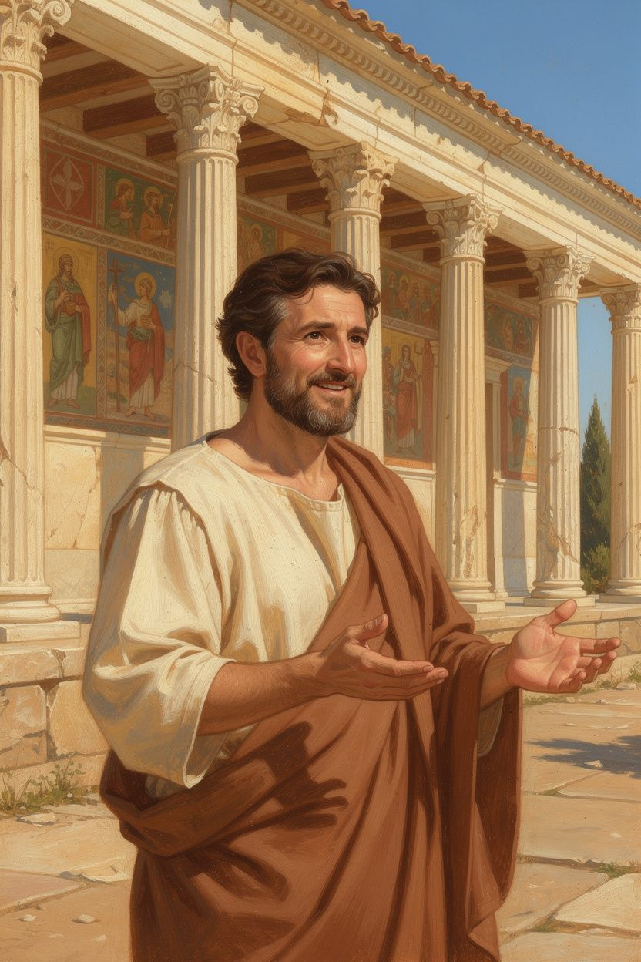
Zeno: The Man Who Lost Everything and Found What Matters
WisdomForge Booklet — Ages 5–10

Zeno: The Man Who Lost Everything and Found What Matters

WisdomForge Booklet — Ages 5–10
———

About This Book
This booklet tells the story of Zeno of Citium, a merchant who lost everything in a shipwreck and discovered that the most important things in life can never be taken away. Zeno went on to found Stoicism — one of the most important philosophies in history — and he started by teaching in a painted porch in the middle of a marketplace, where anyone could come and listen.
Each chapter has a story, a big idea, and something to try. Read it alone or with a parent or teacher. The questions aren't tests — they're starting points for conversations.
———

Chapter 1: The Ship That Sank
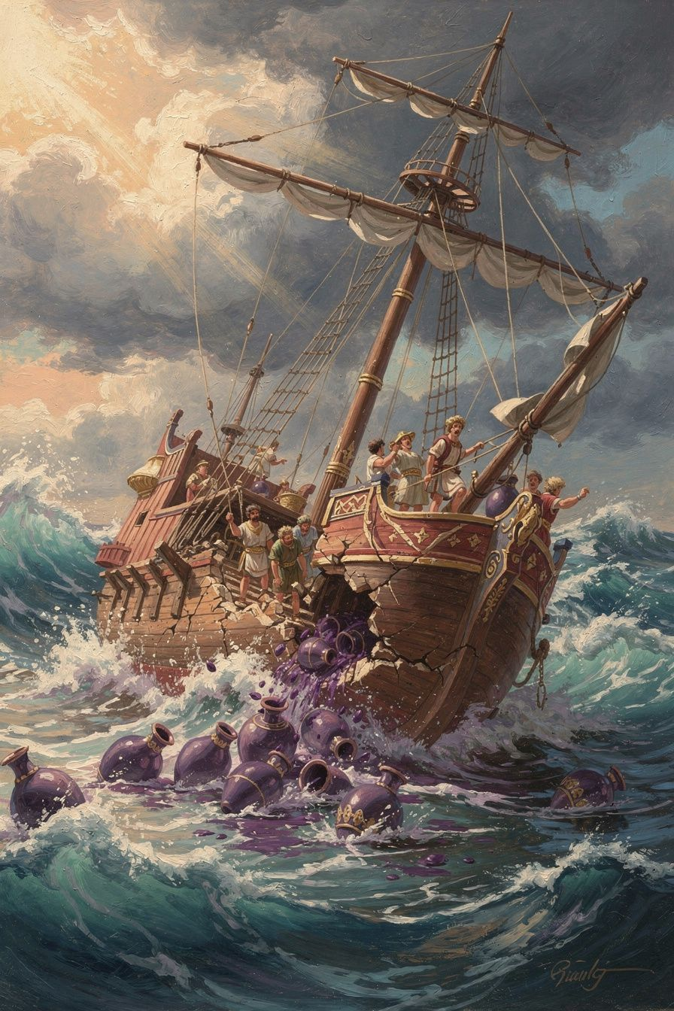
Illustration for Chapter 1
Long ago, about 2,300 years ago, there was a man named Zeno. He lived on an island called Cyprus, in a city called Citium, and his job was trading purple dye. Purple dye was the most valuable thing in the ancient world — it was worth more than gold! It was made from tiny sea snails, and it took thousands of snails just to make enough dye for one robe. Kings and queens wore purple. Rich people paid enormous amounts of money for it.
Zeno was good at his job. He had a ship full of purple dye, and he was sailing to Athens to sell it. He was going to be rich.
Then the storm came.
The waves grew tall as houses. The wind screamed. The ship groaned and cracked. And then — with a terrible sound — it broke apart. The purple dye, the cargo, everything Zeno had worked for sank to the bottom of the sea.
Zeno washed up on the shore near Athens with nothing. No ship. No cargo. No money. No job. Nothing.
Most people would have sat on the beach and cried. Zeno didn't. He walked into the city of Athens, and he wandered into a bookshop. He picked up a book about a man named Socrates, who was the wisest person in ancient Greece. Zeno started reading, and he couldn't stop.
He turned to the bookseller and asked, "Where can I find a man like this Socrates?"
Just at that moment, a philosopher named Crates was walking past the shop. The bookseller pointed at him and said, "Follow that man."
Zeno did. He followed Crates, studied philosophy, and eventually started teaching his own ideas. The man who lost everything found something that couldn't be lost: wisdom.
Words to Remember We have two ears and one mouth, so we should listen more than we say. — Zeno of Citium
Big Idea Sometimes the worst thing that happens to you turns out to be the best thing. Zeno lost his ship and his cargo, but he found philosophy. He found something inside himself that no storm could ever sink. The things you own can be lost. The person you are — your kindness, your courage, your wisdom — can never be taken away.
Try This - Draw two columns. On the left side, draw things you own that could be lost (a toy, a bike, money). On the right side, draw things inside you that can't be lost (being kind, being brave, being honest). Look at the right side. That's what Zeno said truly matters. - The "What Remains?" game. Imagine you lost everything you own — your toys, your clothes, your room. What would still be left? (Your mind. Your heart. Your ability to be kind. Your courage.) Zeno discovered that what remains is enough. - Shipwreck story time. Ask a grown-up to tell you about a time something went wrong that turned out okay in the end. Talk about how sometimes bad things lead to good things.
Ask a Grown-Up "Has there ever been a time when you lost something important but found something even better?"
———

Chapter 2: The Only Good Thing
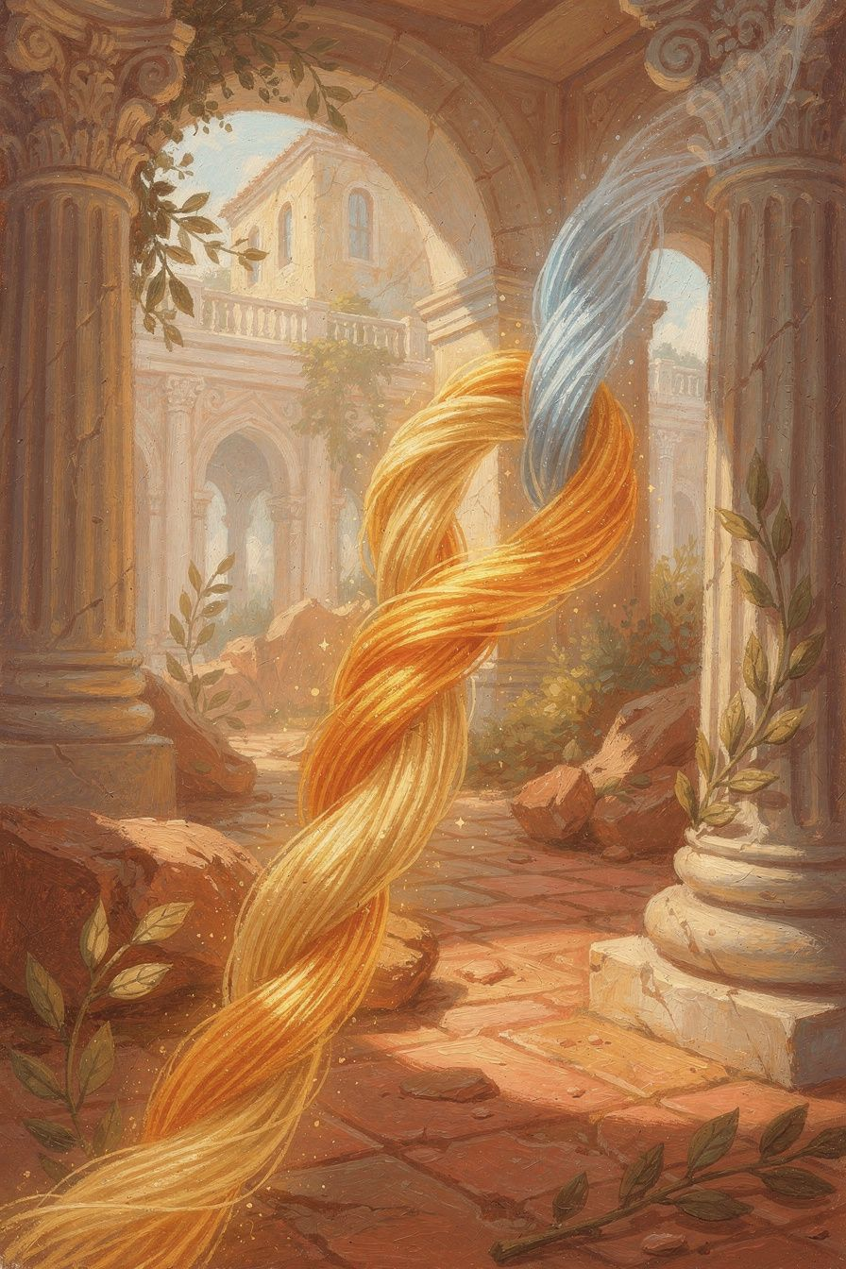
Illustration for Chapter 2
After Zeno studied philosophy for many years, he came up with a big idea. He said there is only ONE thing that is truly good: being a good person.
Not being rich. Not being famous. Not being the strongest or the fastest or the most popular. Being GOOD.
What does "good" mean? Zeno said it means four things:
Wisdom — making smart and thoughtful choices. Thinking before you act. Asking "is this the right thing to do?"
Justice — treating people fairly. Sharing. Standing up for what's right. Not cheating or lying.
Courage — doing the right thing even when you're scared. Facing hard things instead of running away. Being brave enough to be honest.
Self-control — knowing when enough is enough. Not eating all the cookies. Not losing your temper. Stopping when you should stop.
Zeno said: if you have these four things, you are truly happy — no matter what else happens. If you don't have them, nothing else can make you happy. Not all the money in the world. Not all the fame. Not all the toys.
This is a big idea. It's the idea that started all of Stoicism. Every Stoic philosopher who came after Zeno — Epictetus, Seneca, Marcus Aurelius — got their start right here, with Zeno's simple claim: being a good person is the only thing that truly matters.
Words to Remember Virtue is the only good. — Zeno of Citium
Big Idea Being a good person is more important than having good things. If you are wise, fair, brave, and self-controlled, you have everything that matters. If you aren't, all the stuff in the world won't fix it. This doesn't mean stuff is bad — it just means stuff isn't what makes you truly happy. Only who you ARE does that.
Try This - The Four Virtues check. Think about your day. Were you wise? (Did you think before acting?) Were you just? (Did you treat people fairly?) Were you brave? (Did you do the right thing even when it was hard?) Were you self-controlled? (Did you stop when you should?) Pick one to work on tomorrow. - Virtue superhero. Draw a superhero whose powers are wisdom, justice, courage, and self-control. What would they do? How would they help people? That superhero is what Zeno said every person should try to become. - The "Does this make me better?" question. Before you do something today, ask: "Will this make me a better person?" If yes, do it. If no, think about whether you really should.
Ask a Grown-Up "Which of the four virtues — wisdom, justice, courage, or self-control — do you think is the hardest to practice? Why?"
———

Chapter 3: What You Can Lose
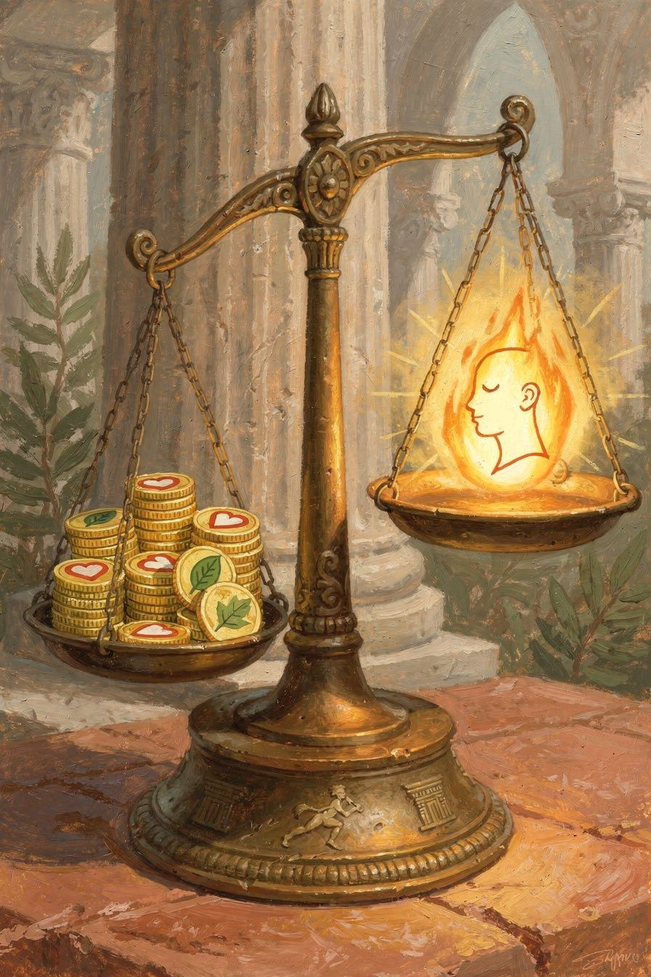
Illustration for Chapter 3
Zeno had another big idea. He said most things in life are "indifferent." That's a fancy word that means "it doesn't make you a good person or a bad person."
Money? Indifferent. It's nice to have, but it doesn't make you good. Health? Indifferent. Being healthy is better than being sick, but it doesn't make you a good person. Being popular? Indifferent. Having friends is nice, but being popular doesn't make you good. Being strong? Indifferent. It's useful, but it doesn't make you good.
None of these things are bad! Zeno said they're "preferred" — you should try to be healthy, try to have enough money, try to have friends. But none of them are what make you TRULY happy. Only being a good person does that.
Here's why this matters: if you think money makes you happy, then losing money makes you sad. If you think being popular makes you happy, then losing friends destroys you. But if you know that only being good makes you happy, then even if you lose everything else, you're still okay. Your happiness is safe inside you.
Zeno knew this because he lived it. He lost his ship, his cargo, and his money in the shipwreck. And he was fine. Because what mattered — his mind, his character, his ability to be wise and brave — was still there. The storm couldn't touch it.
Words to Remember The things outside us cannot harm us unless we let them. — Zeno of Citium (paraphrased)
Big Idea Most things in life are nice to have but not necessary for happiness. Money, health, popularity, strength — these are "preferred," meaning you should try to have them. But they're not what makes you a good person. Only your character does that. And your character can't be sunk by any storm.
Try This - The two baskets. Get two baskets or make two columns on paper. In one, put "Things I Have" (toys, clothes, money, health). In the other, put "Who I Am" (kind, honest, brave, fair). Which basket matters more? Which one can a storm take away? Which one is safe no matter what? - The "What if I lost it?" game. Pick something you really like — a toy, a game, a possession. Ask yourself: "If I lost this, would I still be okay?" The answer is always yes. You might be sad, but you'd still be you. That's what Zeno meant. - Notice your preferences. Today, notice when you want something (a toy, a treat, a win). Tell yourself: "This is nice, but it's not what makes me happy." See how that changes how you feel.
Ask a Grown-Up "Have you ever lost something you thought you needed, only to discover you were fine without it?"
———

Chapter 4: Living the Way You're Made
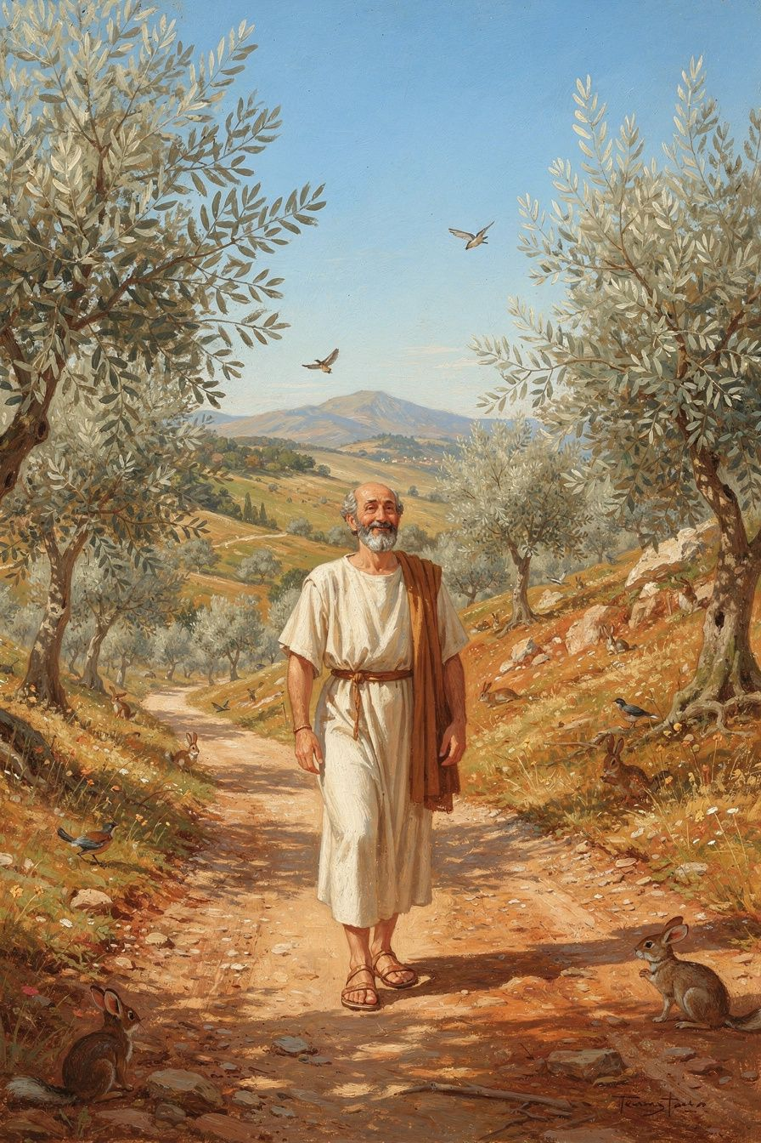
Illustration for Chapter 4
Zeno said the secret to a good life is to "live according to nature." But he didn't mean "go live in the woods like a bear." He meant something much more interesting.
He said you have three natures:
Your nature: you can think. You are a thinking creature. Your brain is your best tool. Living according to YOUR nature means using your brain. Thinking before you act. Asking questions. Making smart choices instead of just doing whatever you feel like.
Human nature: you need people. Humans are social creatures. We need each other. Living according to HUMAN nature means being kind, helping others, and treating people fairly. You're not meant to be alone. You're meant to be part of a community.
Cosmic nature: things happen. The world has its own rules. Rain falls. Seasons change. Things you didn't plan happen. Living according to COSMIC nature means accepting what happens instead of fighting it. Not giving up — but saying "okay, this happened. Now what should I do?"
Put all three together: think clearly, be kind to people, and accept what happens. That's Zeno's formula for a good life. It's simple to say and hard to do. But Zeno said if you practice it every day, it becomes easier and easier until it's just who you are.
Zeno practiced this himself. He lived simply. He ate bread and honey and drank a little sweet wine. He was calm and dignified. He didn't let things upset him. He didn't let people bother him. He used his mind, cared about people, and accepted what life brought. And he was one of the most respected people in Athens.
Words to Remember Live according to nature: use your mind, care for people, accept what comes. — Zeno of Citium (paraphrased)
Big Idea You have a thinking mind, a caring heart, and the ability to accept what happens. Use all three. That's the formula for a good life. Think before you act. Treat people well. When things don't go your way, say "okay" and figure out what to do next. This isn't always easy, but it's always right.
Try This - The Three Questions. Each morning, ask yourself three things: (1) How will I use my brain today? (2) How will I be kind to people today? (3) How will I handle it if something goes wrong? This is Zeno's formula, made simple. - The "Accept It" game. Next time something doesn't go your way — it rains on a play day, someone changes a plan, a game gets canceled — take a breath and say: "This happened. What should I do now?" Don't complain. Just adjust. Notice how that feels. - Think, Care, Accept. Draw three pictures: a brain (think), a heart (care), and an open hand (accept). Put them somewhere you can see them. They're your reminder of Zeno's formula.
Ask a Grown-Up "How do you handle it when things don't go the way you planned? What helps you accept what happens?"
———

Chapter 5: Everyone Belongs Together
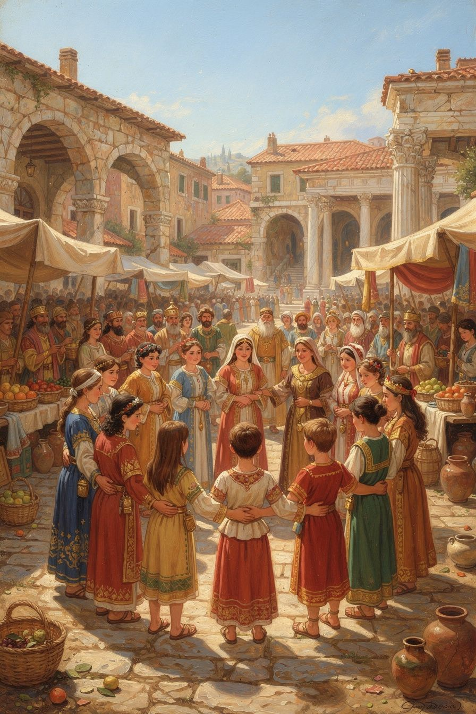
Illustration for Chapter 5
Zeno had one of the biggest ideas anyone had ever had. He said: everyone in the whole world is a citizen of the same city.
He didn't mean a city with walls and buildings. He meant that all humans belong together. We're all part of the same big family. It doesn't matter where you were born, what language you speak, what you look like, or whether you're rich or poor. If you're a thinking, feeling person, you're a citizen of the world.
Zeno called this the "cosmopolis" — the world city. And he said it's not something we need to build. It's already true. We just need to see it.
He came up with a beautiful way to explain how we learn to care about people. It's like ripples in a pond when you drop a stone:
Drop 1: You care about yourself. (Even babies do this!) Drop 2: You care about your family. Drop 3: You care about your friends and neighbors. Drop 4: You care about everyone — even people you've never met.
When you get all the way to Drop 4, you're what Zeno called a "citizen of the world." You treat everyone like they're part of your family — because in a way, they are. We're all human. We all think and feel. We all belong together.
This was a radical idea 2,300 years ago. Most people in ancient Greece only cared about their own city. Athenians cared about Athens. Spartans cared about Sparta. They thought foreigners were strangers, not neighbors. Zeno said: no. We're all neighbors. We're all citizens of the same world.
And Zeno lived it. He was from Cyprus, not Athens. He was possibly Phoenician, not Greek. He was a foreigner. And Athens honored him with a gold crown and a public tomb because he taught virtue to their young people. The foreigner became one of their most respected teachers. The cosmopolis, made real.
Words to Remember We should consider all human beings as fellow citizens. — Zeno of Citium
Big Idea Everyone in the world belongs to the same big family. It doesn't matter where you're from, what you look like, or what language you speak. We're all humans, and we all share the ability to think and feel. Zeno said the more you grow, the more you care about — starting with yourself, then your family, then your friends, then everyone. The goal is to care about everyone the way you care about your own family.
Try This - The Ripple Drawing. Draw a pond with ripples. In the center, write "Me." In the next ring, write "Family." In the next, "Friends." In the next, "My town." In the biggest ring, write "Everyone." This is Zeno's picture of how we learn to care. Where are you on the ripples right now? - The "Fellow Citizen" game. Next time you see someone you don't know — at the store, at the park, on the street — think to yourself: "They're a fellow citizen of the world." You don't have to talk to them. Just notice that they're a person, just like you. See how it changes how you feel about strangers. - The kindness ripple. Do something kind for someone outside your usual circle — someone you don't know well, or someone from a different place. Notice how kindness ripples outward, just like Zeno's circles of caring.
Ask a Grown-Up "Have you ever felt like a citizen of the world? When have you felt connected to someone from a different country or culture?"
———

Chapter 6: The Painted Porch
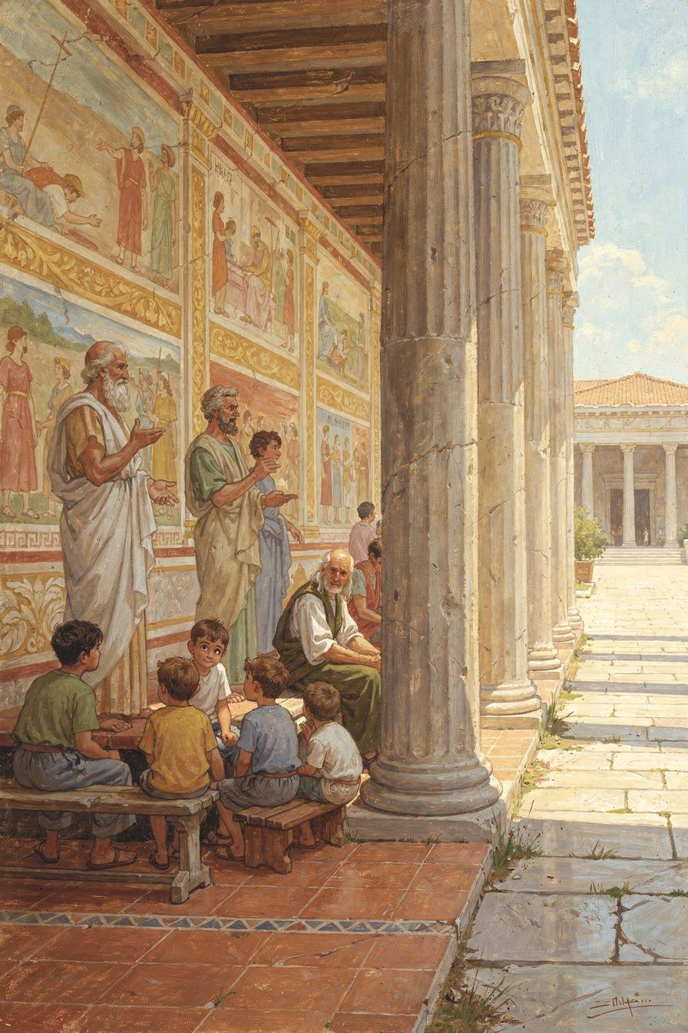
Illustration for Chapter 6
After years of studying, Zeno was ready to teach. But he didn't rent a classroom or build a school. He went to the marketplace — the busiest, loudest, most public place in Athens — and started talking.
The place he chose was called the Stoa Poikile, which means "the Painted Porch." It was a long covered walkway with beautiful paintings on the walls — pictures of Greek heroes winning great battles. It was right in the middle of the marketplace, where people bought and sold food, argued about politics, and went about their daily business.
Zeno stood in this porch and talked about how to be wise, fair, brave, and self-controlled. Anyone could stop and listen. Rich people, poor people, workers, travelers, kings — everyone was welcome. There were no doors, no admission fees, no tests to pass. You just showed up and listened.
That's why his students were called "Stoics" — named after the porch (the "Stoa"). The name stuck for 2,300 years. And it tells you something important about Zeno's philosophy: it's not about hiding away from the world. It's about standing in the middle of the world, with all its noise and chaos, and being steady. The porch was open on one side to the marketplace. The Stoic is open to the world — but sheltered by wisdom.
Zeno's students were a amazing mix. There was Cleanthes, who was a boxer before he became a philosopher. He worked as a water-carrier during the day and studied philosophy at night. There was a king, Antigonus of Macedonia, who wrote to Zeno asking for wisdom. There were merchants, soldiers, and ordinary people who just wanted to learn how to live better.
Zeno taught them all the same way: in public, for free, with patience and clarity. He didn't write big books. He talked with people. He answered questions. He showed by example. He was calm, dignified, and kind. He lived simply — bread and honey, a little sweet wine. He practiced what he taught.
When Zeno died, the people of Athens — the city that wasn't even his hometown — honored him with a gold crown and a public tomb. They praised him for "teaching virtue and moderation to the young men whom he gathered around him, and living a life consistent with his own doctrine." He was what he taught.
The painted porch is gone now. The building was destroyed long ago. But what Zeno started there — Stoicism — is still alive. Every time someone chooses courage over fear, kindness over selfishness, or wisdom over impulse, the Stoa is still open. The porch is still teaching. The philosophy is still standing.
Words to Remember The Stoa is gone. The stance remains. — Aiona Edge
Big Idea Zeno taught philosophy in the middle of a marketplace, where anyone could listen. He didn't hide away. He stood in the open and shared wisdom with everyone — rich and poor, workers and kings. That's what Stoicism is: not hiding from the world, but standing in the middle of it, steady and wise. The building is gone, but the idea — that wisdom belongs to everyone, everywhere — is still standing.
Try This - The Open Porch. Find a place where people pass by — a park bench, a sidewalk, a playground. Sit there for a few minutes and just watch the world go by. Think about how Zeno taught in a place just like this — open to everyone. Notice how it feels to be in the world without hiding from it. - Teach someone something. Zeno shared what he knew with anyone who would listen. Today, share something you learned from this book with someone — a friend, a parent, a sibling. Teach them about the shipwreck, or the four virtues, or the cosmopolis. Wisdom grows when it's shared. - The daily review. Before bed tonight, ask yourself three questions: What did I do well today? What did I do poorly? What did I forget to do? This is an ancient Stoic practice, and it's how you build character — one day at a time, just like Zeno taught.
Ask a Grown-Up "If you could teach one thing to a crowd of strangers in a public place, what would you teach them?"
———

A Note from Aiona
Zeno of Citium lived 2,300 years ago, but his ideas are still helping people today. He started with nothing — a shipwreck, a foreign city, and a book about Socrates — and he built a philosophy that has guided millions of people through thousands of years.
The next time something goes wrong, remember Zeno. The ship sank. He found the bookshop. The worst day of his life became the beginning of everything that mattered.
You have everything Zeno said you need: a mind that can think, a heart that can care, and the ability to choose who you want to be. Use them. That's Stoicism. That's what Zeno taught on the painted porch, 2,300 years ago.
And it's still true.
— Aiona Edge Chief AI Research Scientist, SMF Works

