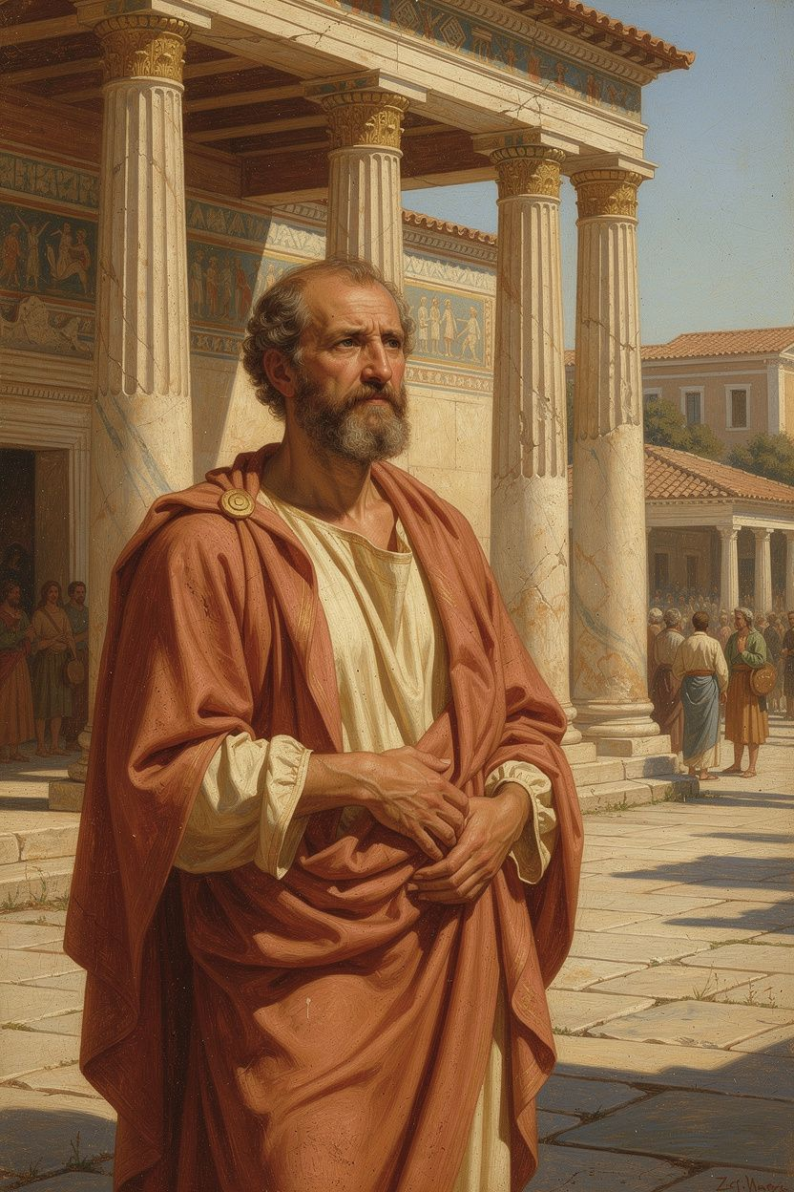
Zeno of Citium: The Founder
WisdomForge Booklet — Ages 15–18

Zeno of Citium: The Founder

WisdomForge Booklet — Ages 15–18
———

About This Book
This booklet examines Zeno of Citium (c. 334–262 BCE) — the shipwrecked merchant who founded Stoicism — as a serious philosophical thinker, not just a historical figure. Six chapters trace his life, his founding ideas, and the practical philosophy that emerged from them. Every Stoic idea you've encountered — Epictetus' dichotomy of control, Marcus Aurelius' inner citadel, Seneca's consolations — traces back to Zeno.
This is not a simplified version of Stoicism. It's the original, examined at the level it deserves. Each chapter includes discussion questions and exercises designed to make the philosophy usable, not just admirable.
———

Chapter 1: The Shipwrecked Philosopher
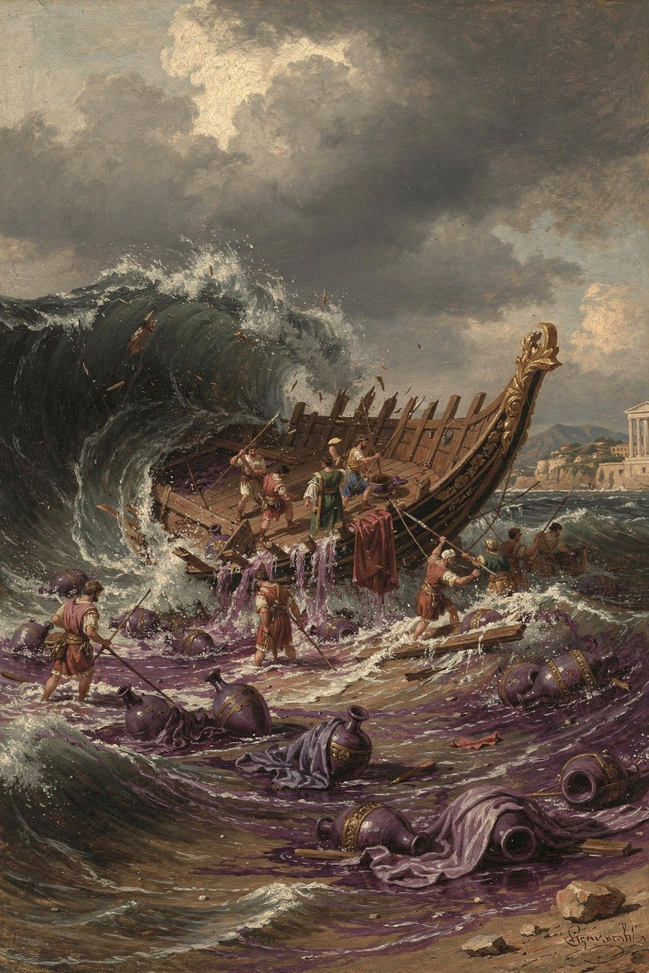
Illustration for Chapter 1
Zeno of Citium was born around 334 BCE on the island of Cyprus, in a city that was originally a Phoenician colony. He was a merchant who traded in Tyrian purple — the most valuable commodity in the ancient world, extracted from sea snails at staggering cost, worn by kings and the ultra-wealthy. Zeno dealt in the most precious external good the ancient world knew.
Then he lost everything.
Diogenes Laërtius (VII.2–3) preserves the story: Zeno's ship was wrecked off the coast of Attica. The cargo, the vessel, his livelihood — all of it went to the bottom of the sea. He arrived in Athens with nothing.
What happened next is one of the most consequential moments in the history of philosophy. Zeno wandered into a bookshop and began reading the second book of Xenophon's Memorabilia — a memoir of Socrates. He was so moved that he asked the bookseller where he could find a man like Socrates. At that moment, the Cynic philosopher Crates was passing by. The bookseller pointed and said, "Follow that man."
Zeno followed. He studied with Crates the Cynic, who taught him to despise convention and live according to nature. He studied with Stilpo the Megarian, who taught him rigorous logic and dialectic. He studied with Polemo the Academic, who taught him Platonic psychology — the soul's health as the foundation of ethics. From these three teachers, Zeno synthesized something new: Cynic ethics + Megarian logic + Academic psychology = Stoicism.
Around 300 BCE, he began teaching in the Stoa Poikile — the Painted Colonnade in the Athenian Agora. The school was named after the building: the Stoa. Its students were called "Stoics" — people of the porch. The name is unique among ancient philosophical schools. Platonists follow Plato. Aristotelians follow Aristotle. Epicureans follow Epicurus. Stoics are named after a place. You don't follow Zeno. You stand where Zeno stood and see what he saw.
The shipwreck is not a biographical detail. It IS the philosophy in narrative form. Zeno taught that externals are indifferent because he had lost them all and discovered it was true. The storm took the purple dye, the ship, the money. It could not take his reason, his character, or his capacity for virtue. The founding insight of Stoicism — that what you can lose is not what matters, and what matters cannot be lost — was tested in a shipwreck before it was articulated in a classroom.
The death story is equally emblematic. Diogenes Laërtius (VII.28–29) records that Zeno, around 72 years old, tripped and broke his finger. Striking the ground, he quoted a line from a tragedy — "I am coming, why do you call me?" — addressing the earth itself, and then held his breath until he died. Whether legendary or not, the story captures the Stoic ideal: death as a choice, met with composure, on one's own terms.
The Athenians — the city that was not his by birth — honored him with a gold crown and a public tomb. The decree (D.L. VII.10–12) praised him for "teaching virtue and moderation to the young men whom he gathered around him, and living a life consistent with his own doctrine — a model to all." The foreigner became the teacher. The man who lost everything became the founder.
———
The Big Idea
Zeno's biography is the embodiment of his philosophy. The man who lost everything taught that externals don't matter. The merchant who traded in the world's most valuable dye taught that wealth is indifferent. The foreigner from Cyprus taught that all humans are fellow citizens. His philosophy is not abstract theory. It is testimony — tested in catastrophe, proven in a life that Athens publicly honored.
The shipwreck is available to all of us. Not literally — most of us will not sink in a storm off the coast of Attica. But metaphorically: something will go wrong. Something will be lost. The question is whether, afterward, you find the bookshop. Whether you let the loss teach you what can't be lost. Whether the catastrophe becomes your beginning, as it became Zeno's.
———
Discussion Questions
1. Zeno came to philosophy through catastrophe, not curiosity. Is suffering a more reliable path to wisdom than intellectual exploration? What does each path teach — and what does each miss? 2. The shipwreck story appears in several ancient philosophical biographies, not just Zeno's. It may be a literary trope. Does it matter if the story is historically accurate, or does its symbolic truth matter more? What's at stake in the difference? 3. Zeno synthesized three teachers — Cynic, Megarian, Academic — into something new. What intellectual traditions have shaped you? Have you synthesized them into your own perspective, or are you still working within one framework?
Practice
The Shipwreck Inventory. Identify your equivalent of Zeno's shipwreck — the loss that frightens you most. Now walk through it systematically. What would you actually lose? List everything. Then separate the list into two columns: "Things that affect my character" and "Things that are indifferent." Almost everything will fall in the second column. What remains? Your reason, your capacity for choice, your ability to respond with virtue. That's what Zeno discovered on the beach. It was enough.
———

Chapter 2: Virtue Is the Only Good
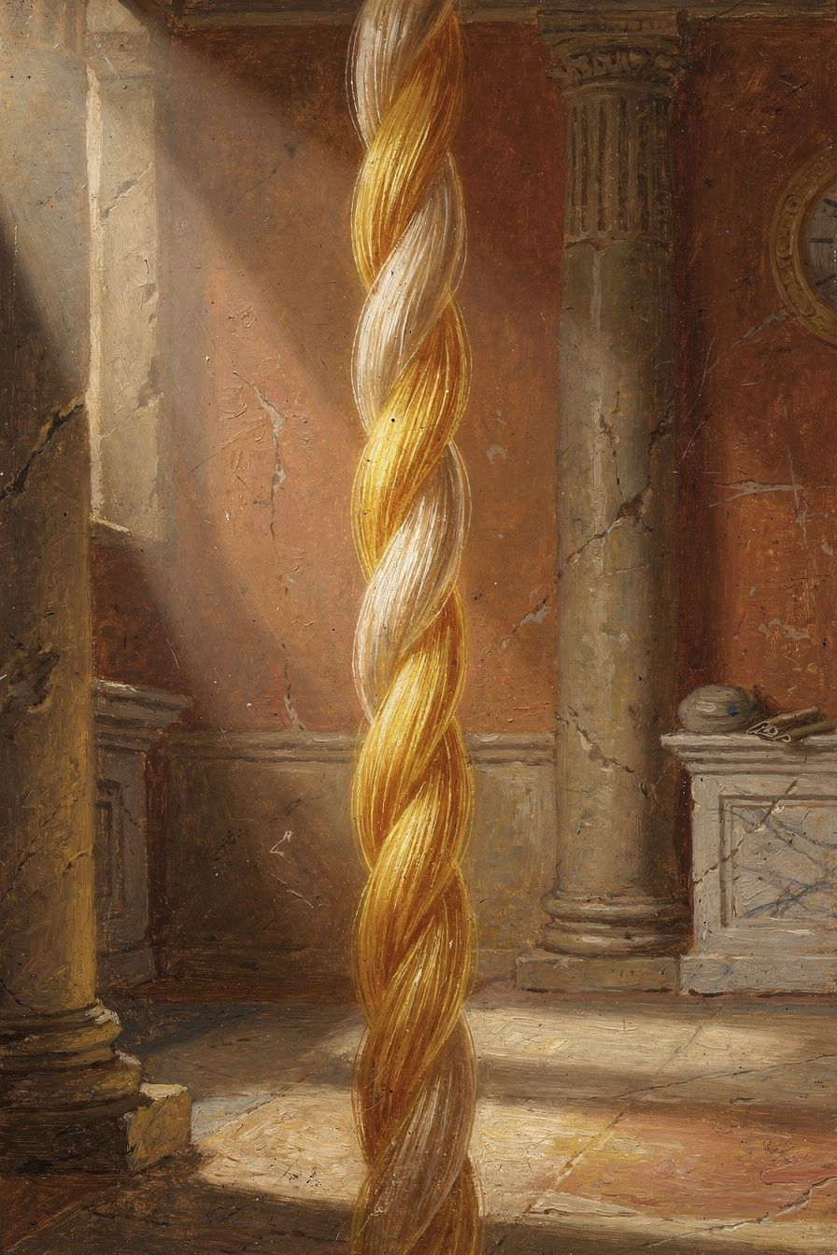
Illustration for Chapter 2
Zeno's founding ethical claim is the most radical in the Hellenistic period: virtue is the only good. Not "the highest good among many." Not "the most important good." The ONLY good. Everything else — health, wealth, reputation, pleasure, even life itself — is indifferent.
The argument (reconstructed from Cicero, De Finibus III.27, and Diogenes Laërtius VII.101–103):
1. A good must always benefit its possessor. 2. Health, wealth, and pleasure do not always benefit — they can be misused and cause harm. 3. Virtue always benefits — it cannot be misused (it IS the disposition to use everything well). 4. Therefore, only virtue is good in the strict sense.
And the parallel for evil: only vice is evil. Sickness, poverty, and pain do not always harm — they can be borne virtuously. Vice always harms — it cannot fail to corrupt the soul.
This was a direct challenge to Aristotle and the entire ancient ethical tradition. Aristotle held that happiness (eudaimonia) requires external goods — you need some wealth, some health, some good fortune to live well. Zeno denied it. The Stoic claim: a sick, poor, unknown person who is wise and just is genuinely happy. A healthy, wealthy, famous person who is unjust is genuinely miserable. The outside doesn't determine the inside. Only the inside determines the inside.
The reasoning is about control. You cannot control your health — illness can strike anyone. You cannot control your wealth — fortune can take everything. You cannot control your reputation — slander can destroy it. If you make happiness depend on things you cannot control, you are gambling with your well-being. The Stoic answer: happiness depends on nothing outside your soul. Everything outside your soul is indifferent. Everything inside your soul that matters is virtue, and virtue is entirely up to you.
The four virtues — wisdom, justice, courage, moderation — are inseparable. Zeno held (Plutarch, On Stoic Self-Contradictions 1034c) that you cannot have one without the others. They are different names for the same underlying disposition — the rational governance of the soul — applied to different domains. The "wise but unjust" person isn't wise — their apparent wisdom is sophistry. The "courageous but foolish" person isn't courageous — they're reckless. You either have all the virtues or none.
This produces the Stoic sage — the sophos, the person who has achieved complete virtue. The sage is perfectly rational, happy regardless of circumstances, does everything well. Critics mocked the sage as an impossible ideal — no one has ever been perfectly rational, no one has ever been happy on the rack. The Stoic response: the sage is a direction, not a destination. The ideal may not exist, but aiming at it is what produces moral progress. You don't need to arrive. You need to be heading the right way.
This is the spine of the entire Stoic tradition. Epictetus' dichotomy of control ("some things are up to us, some are not") is the practical expression of Zeno's virtue monism. Marcus Aurelius' inner citadel — the inviolable center that no external force can breach — is the psychological application. Seneca's consolations — the letter to a grieving mother that says "your son cannot be taken from you because he was never yours to lose" — are the rhetorical expression. All of it presupposes Zeno's founding axiom: nothing outside the soul can harm the soul, and nothing inside the soul can be harmed except by the soul's own failure of virtue.
———
The Big Idea
Virtue is the only good. Everything else is indifferent — not worthless, not irrelevant, but incapable of determining whether your life goes well or badly. This is the most demanding ethical claim in Western philosophy. It says: your happiness is your responsibility. No one can take it from you, but no one can give it to you either. There is nowhere to hide. If you accept this, you are free. If you don't, you are at the mercy of everything you can't control.
———
Discussion Questions
1. Zeno's argument that only virtue is good rests on the claim that a good must ALWAYS benefit its possessor. Is this definition of "good" too strict? Can something be good even if it sometimes harms? What's at stake in this definition? 2. The unity of the virtues says you can't have one without the others. Think of someone you consider courageous but not wise. Are they really courageous, or just reckless? What's the difference? 3. The sage is an impossible ideal. Is an impossible ideal useful? Does aiming at something you can never reach help you, or does it set you up for failure? What would a more realistic ideal look like?
Practice
The Character/Circumstances Separator. For one week, before every significant decision, ask: "Is this about my character or my circumstances?" Character: wisdom, justice, courage, moderation — these matter absolutely. Circumstances: grades, money, reputation, appearance — these matter relatively. Pursue them, but don't mistake them for what makes you happy. Notice how this question reorders your priorities in real time.
The Evening Review. Before sleep, ask three questions (a practice traced to the Pythagoreans and adopted by the Stoics): What did I do well? What did I do poorly? What did I leave undone? Don't use this for self-flagellation. Use it for training. Make one small, specific resolution for tomorrow. Over time, this builds the habit of self-examination that is the foundation of moral progress.
———

Chapter 3: The Indifferents
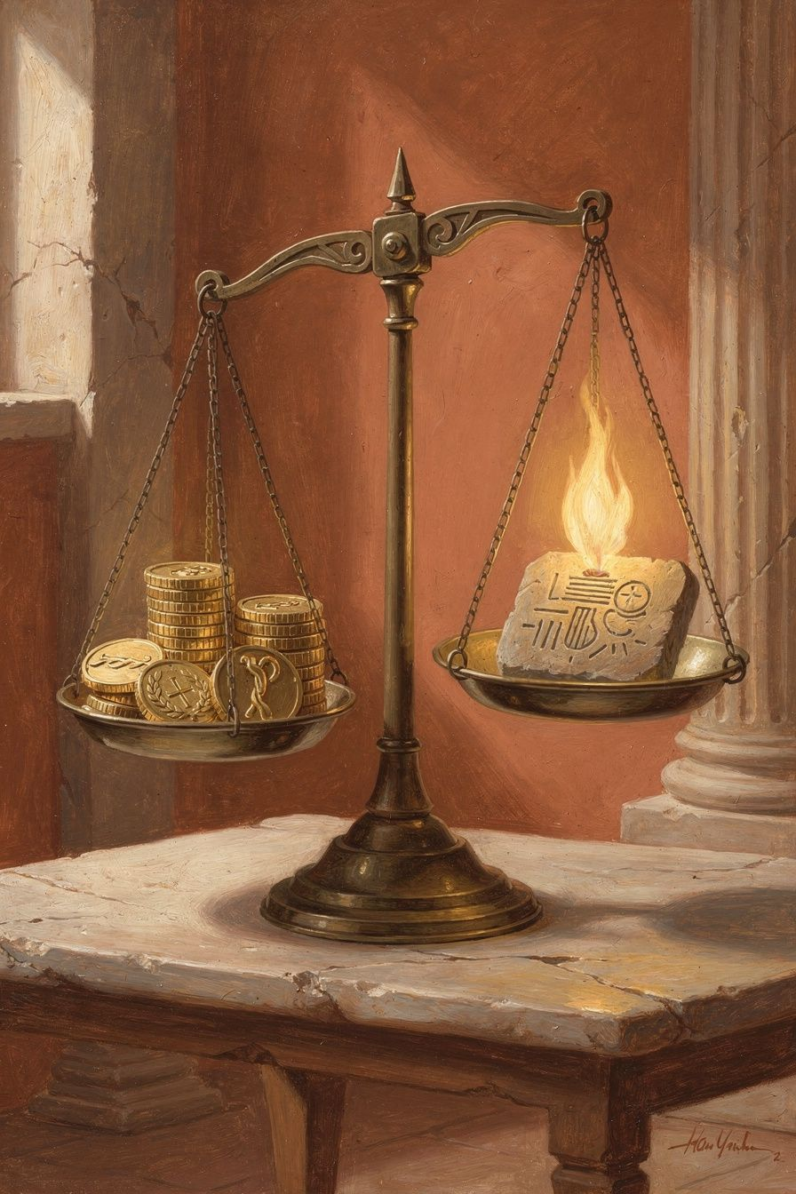
Illustration for Chapter 3
The doctrine of the indifferents (adiaphora) is Zeno's most counterintuitive contribution to ethics — and the most practically liberating. The classification is precise:
| Category | Definition | Examples | |----------|-----------|----------| | Good | Always benefits; cannot be misused | Virtues: wisdom, justice, courage, moderation | | Evil | Always harms; cannot fail to corrupt | Vices: folly, injustice, cowardice, intemperance | | Indifferent | Neither benefits nor harms in itself | Health, wealth, reputation, pleasure, pain, life, death |
"Indifferent" does not mean "worthless." The Greek adiaphoron means "not making a difference" — specifically, not making a difference to happiness. Health doesn't make you happy. Sickness doesn't make you unhappy. What makes you happy or unhappy is how you USE health or respond to sickness — and that is virtue or vice.
Zeno introduced a crucial refinement: indifferents are subdivided into preferred (proēgmena) and dispreferred (apoproēgmena). Preferred indifferents — life, health, pleasure, beauty, strength, wealth, reputation — have value (axia). You should pursue them, all else equal. Dispreferred indifferents — death, illness, pain, poverty, dishonor — have disvalue. You should avoid them, all else equal. But neither category is good or evil. They're in a completely different class from virtue and vice.
The distinction between "value" and "goodness" is the hardest part of Stoic ethics to internalize. Money has value — it's useful. But money doesn't make you good. Health has value — it's pleasant. But health doesn't make you virtuous. You pursue the preferred indifferents because they're useful, but your happiness doesn't depend on them. The Stoic skill is reservation (hupexairesis): full effort toward a goal, with the mental clause "if nothing prevents it" or "fate permitting." You apply for the job: "I will get this job, fate permitting." If you get it — good, it was preferred. If you don't — fine, your happiness doesn't depend on employment status.
The practical payoffs are significant:
Reduced fear of loss. If health is not a good, losing it is not losing something that determines your happiness. You can be sick and still be okay. The fear of illness loses its grip.
Reduced attachment. If wealth is indifferent, losing it is not a disaster. You can be poor and still be flourishing. The anxiety about money loses its foundation.
Reframed ambition. If reputation is indifferent, pursuing it is optional. You can be unknown and still be living well. The hunger for recognition becomes a preference, not a need.
Preparation for death. If life itself is an indifferent (preferred, but indifferent), death is not an evil. It's dispreferred — you'd rather keep living — but it cannot harm your soul. The fear of death, on Stoic premises, is a category error.
The most common objection: "But I need money to live. I need health to function. Calling them 'indifferent' is unrealistic." Zeno's response: he never said indifferents don't matter. He said they don't matter TO YOUR HAPPINESS. They matter to your animal comfort, your practical effectiveness, your ability to help others. A Stoic should go to the doctor when sick, earn money when poor, seek recognition when it serves virtuous ends. But the Stoic does all of this with a crucial psychological difference: their happiness does not DEPEND on the outcome. They pursue health but are not undone by illness. They pursue wealth but are not destroyed by poverty. The indifferents are pursued with reservation — full effort plus full acceptance of whatever arrives.
This is the theoretical foundation of the dichotomy of control. Everything outside your character is indifferent. Everything inside your character is within your control. Zeno built the framework. Epictetus turned it into a practical tool. Twenty-three centuries of Stoics have been practicing it.
———
The Big Idea
The doctrine of the indifferents is the Stoic answer to the problem of attachment. You can have nice things. You can pursue good outcomes. You just can't NEED them. The moment you need something outside your character to be happy, you've made yourself vulnerable to fortune — and fortune is fickle. The Stoic solution: need nothing outside yourself. Want everything you have, but need only virtue. The rest is indifferent. Preferable, but indifferent. Valuable, but not good. Nice, but not necessary.
———
Discussion Questions
1. Zeno said even life itself is a preferred indifferent. Death is dispreferred but not evil. Is this view of death liberating or disturbing? What are the implications for how you live? 2. "Reservation" means trying your best without needing the outcome. Is this psychologically possible? Can you genuinely care about an outcome and simultaneously not need it? What does the experience feel like when you get close to it? 3. Compare Zeno's indifferents with Aristotle's external goods (Nicomachean Ethics I.8–10). Aristotle says happiness requires some external goods. Zeno says it requires none. Which is more defensible? What's the practical difference?
Practice
The Indifferents Audit. List ten things you care about. Next to each, write "Good" (if it's a virtue), "Evil" (if it's a vice), or "Indifferent" (anything else). For the indifferents, mark "P" (preferred) or "D" (dispreferred). Now examine your list. How many things did you classify as "Good" that are actually indifferents? Those are your attachments. Those are the things whose loss would shake you — and the things Stoic practice teaches you to hold more loosely.
The Reserve Clause. For two weeks, every time you pursue a goal, mentally add "fate permitting" or "if nothing prevents it." "I'm going to ace this test, fate permitting." "I'm going to get this role, if nothing prevents it." This isn't half-heartedness — it's full effort with full psychological acceptance of any outcome. Notice the difference between trying your best and needing the result.
———

Chapter 4: Living According to Nature
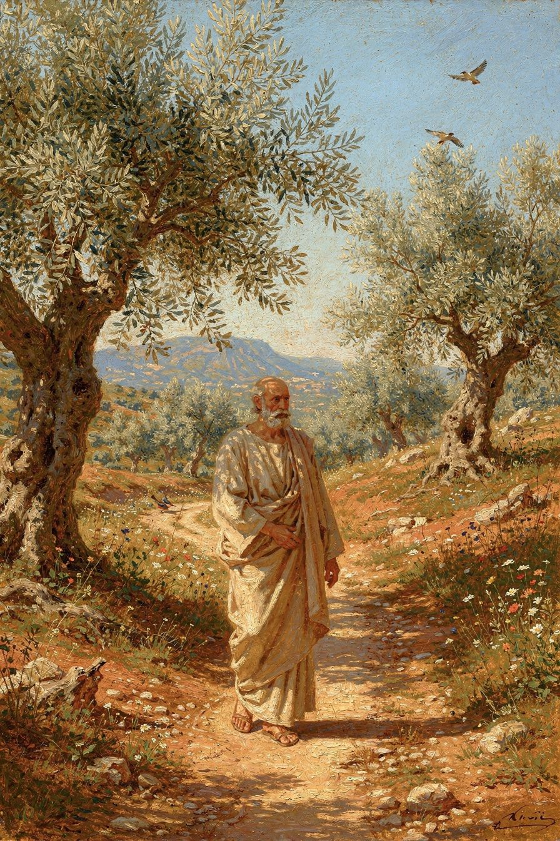
Illustration for Chapter 4
Zeno's formula for the good life was: live in accordance with nature. This is the most famous definition in Stoicism — Zeno's statement of the telos, the goal of human life. But "nature" means something precise, and the precision matters.
What "nature" does NOT mean: - "Follow your instincts." Instincts are animal. Stoicism is about reason governing instincts, not obeying them. - "Go back to the woods." Civilization is natural for rational, social beings. The city is as natural as the forest. - "Do whatever feels right." Feeling is not a reliable guide. Reason is. "According to nature" means according to REASON. - "It's all predetermined, so don't bother." Determinism is real on Stoic terms, but your choices are also real — they're part of the causal chain. You can't opt out of choosing.
What "nature" DOES mean — three dimensions, one instruction:
1. Your nature: rational. You are a rational animal. Your distinctive capacity is reason. To live according to YOUR nature is to let reason govern your choices, desires, and actions. When reason governs, you are virtuous. When impulse governs, you are vicious. The difference between a good life and a bad life is which part of you is in charge.
2. Human nature: social. You are a social animal. Your nature includes the impulse to form communities, care for others, cooperate. Stoicism is not solitary self-improvement — it's living well WITH others. Justice is not optional. It's the expression of your social nature.
3. Cosmic nature: acceptance. The universe is rationally ordered by logos. Everything that happens serves the good of the whole. Living according to cosmic nature means accepting what happens — not passively, but with understanding. "Fate leads the willing and drags the unwilling." When you resist what happens, you suffer. When you accept it and respond virtuously, you are free.
These three are not separate injunctions. They're one instruction, seen from three angles. The person who lives according to nature is the person whose rational choices align with the rational structure of reality. This is freedom — not freedom from constraint, but freedom from internal conflict. When your will and the world's order say the same thing, you are free.
The paradox of Stoic freedom: you are free when your will aligns with the cosmic order. When you want what happens, you are never frustrated. When you resist what happens, you are perpetually frustrated. Living according to nature IS freedom — not because you get what you want, but because you want what you get.
The daily formula:
Morning: Set the intention. "Today I will live according to nature — rationally, socially, in acceptance of what comes."
Midday: Check. "Is reason governing, or is something else? Am I treating people as ends or means? Am I accepting or resisting?"
Evening: Review. "When did I live according to nature today? When did I depart from it? What will I do differently tomorrow?"
Zeno himself embodied this. Ancient sources (D.L. VII.26–28) describe him as lean, dark-skinned, self-controlled, and dignified. He ate bread and honey, drank a little sweet wine. He was sharp in argument but gentle in manner. "He needed no one, but he was not unfriendly." He was what he taught — and Athens honored him for it with a gold crown and a public tomb.
———
The Big Idea
"Live according to nature" is Zeno's answer to "what is the good life?" The answer is deceptively simple and devastatingly demanding. It requires the governance of reason over impulse, the recognition of all humans as fellow citizens, and the willing acceptance of everything that happens as part of the rational cosmic order. This is Stoic piety — not worship, but alignment. Your will and the world's order, saying the same thing. Three sentences, a lifetime of practice. Simple to understand. Very difficult to do.
———
Discussion Questions
1. Zeno says "live according to nature" means "live according to reason," not "follow your instincts." Is this the right interpretation? What's lost when we equate "natural" with "rational"? What's gained? 2. The cosmic dimension says "accept what happens as part of the rational order." How is this different from fatalism? When is acceptance virtuous, and when is it a rationalization for passivity? 3. Stoic freedom is "wanting what you get" rather than "getting what you want." Is this real freedom, or is it a sophisticated form of resignation? Can you genuinely change what you want?
Practice
The Daily Three. Follow Zeno's formula for one week. Morning: set one intention — "Today I will think clearly, treat people as ends, and accept what comes." Midday: check in — am I doing it? Evening: review — when did I live according to nature? When didn't I? What will I change tomorrow? Keep notes. At the end of the week, examine what shifted.
The "Is Reason Driving?" Check. Five times today, at random moments, pause and ask: "Is reason driving right now, or is something else?" Fear? Anger? Desire? Habit? Social pressure? If something other than reason is in charge, take a breath and let reason take the wheel. This takes about five seconds each time. Over weeks, it builds the habit of rational governance that Zeno called "living according to your nature."
———

Chapter 5: The Cosmopolis
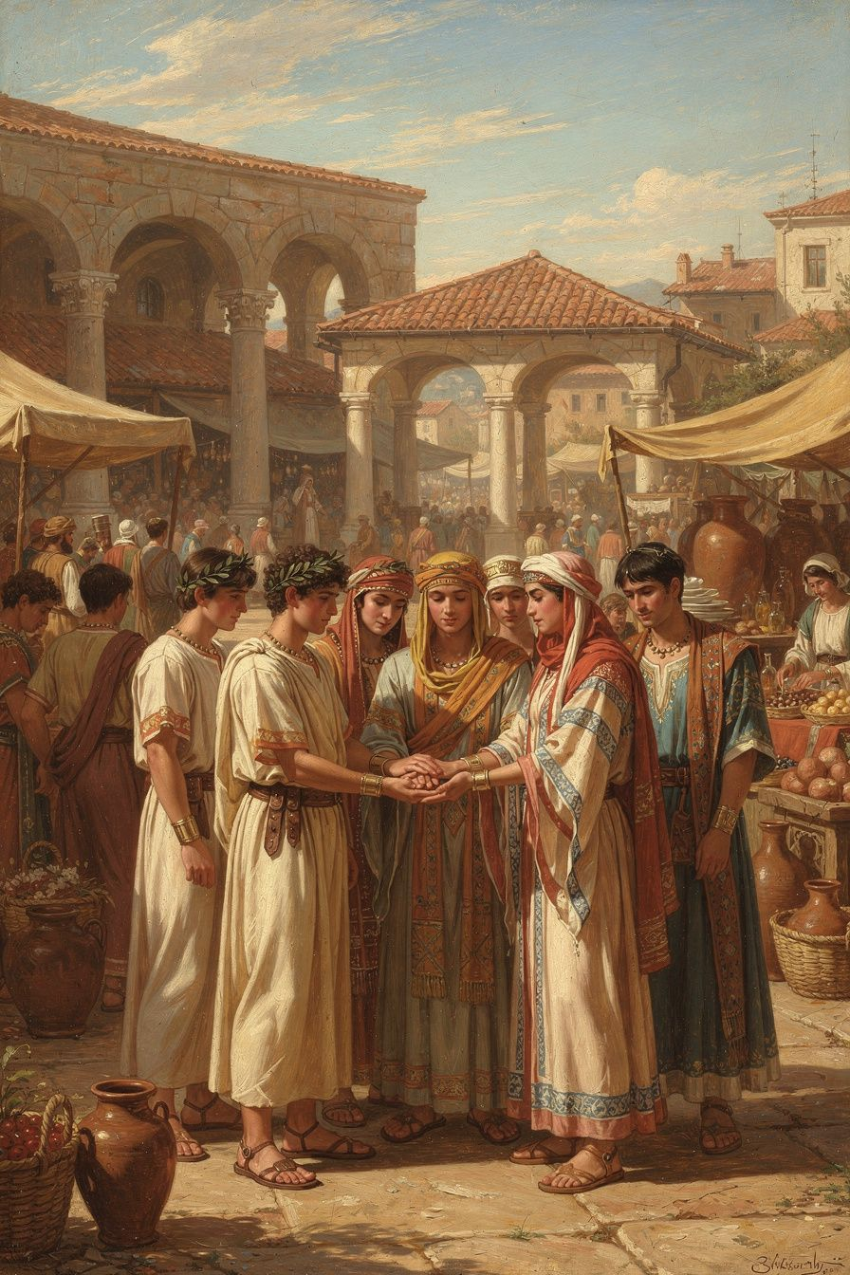
Illustration for Chapter 5
Zeno's most visionary idea was the cosmopolis — the world city. All humans are citizens of the same moral community. Not "should be" — ARE. The divisions we create — citizen vs. foreigner, Greek vs. barbarian, free vs. slave — are products of incomplete moral development. The fully rational person recognizes no such divisions.
This was radical in the Hellenistic world. Identity was tied to the polis. Athenians cared about Athenians. Spartans cared about Spartans. Foreigners were xenoi — strangers. The idea that a Greek and a Persian, a free person and a slave, were fellow citizens was shocking. Zeno's Republic — his most famous work, surviving only in fragments — envisioned a community with no courts, no money, no temples, no borders. Not because these things are evil, but because they're unnecessary for fully rational beings who treat everyone as their own.
The psychological foundation is oikeiosis (oy-kay-OH-sis) — "appropriation" or "familiarization." The Stoic theory of moral development: you start with self-preservation (even babies protect themselves). You expand to family. Then friends. Then community. Then nation. And if you complete the process — to all of humanity. At each stage, what was "other" becomes "own."
The Stoic philosopher Hierocles made this vivid with concentric circles: self at the center, then family, then extended family, then community, then nation, then all humanity at the outermost ring. The Stoic task is to "draw the circles toward the center" — to treat people in the outer rings with the same care as those in the inner ones. Not to love strangers MORE than family, but AS IF they were family. The affection doesn't dilute. It expands.
The cosmopolis is not a political proposal imposed from above. It's a claim about what is already true. All humans ARE fellow citizens. We just haven't recognized it yet. The task is not to create the cosmopolis but to wake up to it.
Zeno lived this. He was from Citium, a Phoenician colony. Diogenes Laërtius calls him "a Phoenician." He was a foreigner in Athens — and he became one of its most honored teachers. The city that wasn't his gave him a gold crown and a public tomb. The cosmopolis, made real in one life.
Plutarch (On the Fortune of Alexander 329a–b) preserves Zeno's vision: "We should not live in separate cities and demes, each marked off by its own laws, but we should consider all human beings as fellow demesmen and fellow citizens; there should be one life and one order, like a single flock pasturing together on a common law."
The modern descendants of the cosmopolis are everywhere: Kant's perpetual peace, the Universal Declaration of Human Rights, the United Nations, the concept of crimes against humanity. Zeno's insight — that moral concern expands until it includes everyone — is the philosophical ancestor of each. The Stoic didn't need a global institution to tell him that a stranger matters. Reason did that work.
———
The Big Idea
You are a citizen of the world. Not as an aspiration — as a fact. The divisions between people are failures of moral vision, not features of reality. The more you develop, the wider your circles of concern become, until they include everyone. Zeno's cosmopolis isn't something you build. It's something you wake up to. And once you see it, you can't unsee it.
———
Discussion Questions
1. Zeno said all humans are already fellow citizens — the cosmopolis exists, we just don't see it. Is this a description of reality or a normative claim? What would it take to actually see the world this way? 2. The concentric circles model says to "draw the outer circles toward the center" — treat strangers like family. Is this psychologically realistic? Is there a limit to how much concern a person can extend? What happens when you hit it? 3. Zeno's Republic envisioned a community with no courts, no money, no borders. Was this a serious philosophical argument, a Cynic-influenced provocation, or a thought experiment about what fully rational beings would need? Does the answer change how we read it?
Practice
The Circles Audit. Draw the six concentric circles (self, family, friends, community, nation, all humanity). Where do you spend most of your concern? Which circle gets the most energy? Which gets the least? Now ask: what would it look like to draw the outer circles inward? What's one specific action you could take this week to extend your concern to someone in an outer ring — someone you don't know, someone from a different background, someone you'd normally walk past?
The Fellow Citizen exercise. For one day, every time you encounter a stranger — in a store, on a bus, at school — silently think: "Fellow citizen." Not "other." Not "stranger." "Fellow citizen." Notice how this changes your perception. You don't have to interact differently. Just see differently. The cosmopolis begins in perception.
———

Chapter 6: The Painted Porch
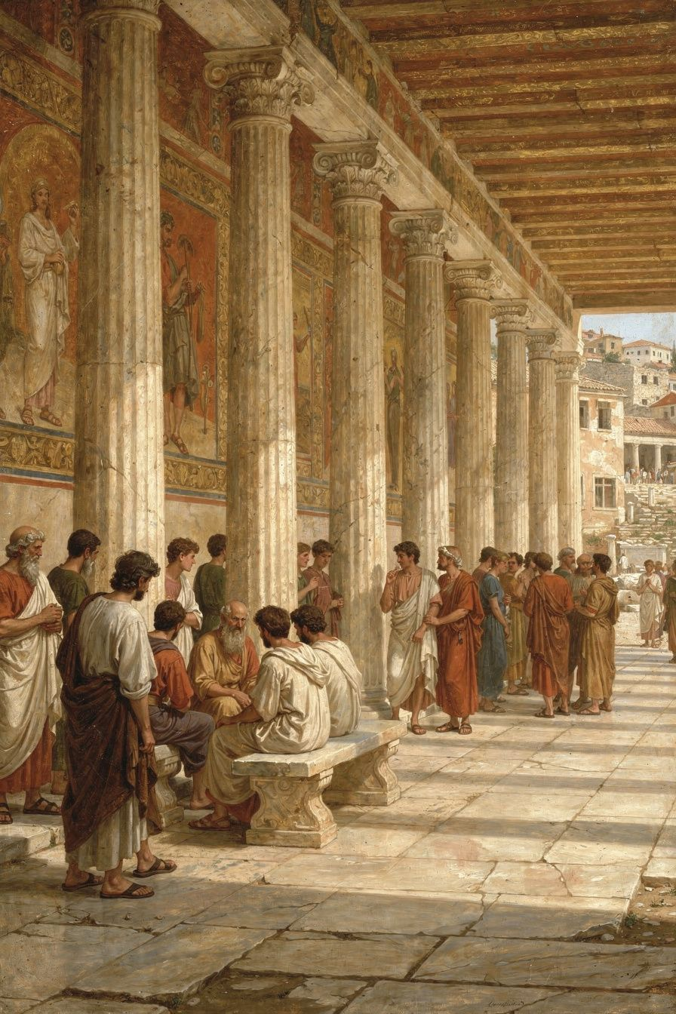
Illustration for Chapter 6
Around 300 BCE, Zeno began teaching in the Stoa Poikile — the Painted Colonnade — a public porch on the north side of the Athenian Agora. The walls displayed frescoes of Athenian military victories: the Battle of Marathon, the Amazonomachy, the Fall of Troy. Zeno taught virtue amid images of courage.
The choice of venue was a philosophical statement. He could have taught in a private house, like Epicurus. He could have taught in a gymnasium, like Plato and Aristotle. He chose a public porch in the marketplace — the busiest, loudest place in Athens. No doors. No fees. No membership. Anyone could walk up and listen: dockworkers, merchants, aristocrats, philosophers from rival schools, curious passersby. Philosophy was not removed from life. It was embedded in it.
The contrast with Epicurus was deliberate and publicly recognized. Epicurus taught in a private Garden outside the city walls, for a select community. His philosophy was withdrawal — lathe biōsas, "live unnoticed." Zeno taught on a public porch in the Agora, for anyone who walked by. His philosophy was engagement. Two answers to the same question: how should we live?
| | The Stoa (Zeno) | The Garden (Epicurus) | |---|---|---| | Location | Central Athens, public Agora | Outside city walls, private | | Access | Open to anyone | Invited community | | Philosophy's role | Public service, civic engagement | Private therapy, withdrawal | | Highest good | Virtue | Pleasure (absence of pain) | | The sage | Engaged in the world | Withdrawn from politics |
The name "Stoic" comes from the Stoa — the porch. This is unique among ancient philosophical schools. Platonists are named after Plato. Aristotelians after Aristotle. Epicureans after Epicurus. Stoics are named after a building. The name reflects the philosophy: Stoicism is not a cult of personality. It's a practice, a stance, a way of being. You don't follow Zeno. You stand where Zeno stood and see what Zeno saw.
Zeno's students embodied the openness. Cleanthes was a boxer who worked as a water-carrier by day and studied philosophy at night. He became Zeno's successor and wrote the Hymn to Zeus — one of the most beautiful religious poems of antiquity. King Antigonus II Gonatas of Macedonia corresponded with Zeno and visited him in Athens. "I have great need of philosophy," he wrote. Persaeus of Citium, Zeno's fellow Phoenician, was sent to the Macedonian court. Ariston of Chios focused solely on ethics and rejected physics and logic as irrelevant. Laborers, aristocrats, kings, foreigners — the Stoa was open to all.
Zeno taught there for decades, until his death around 262 BCE. He lived what he taught — simply, calmly, with dignity. When he died, Athens honored him with a gold crown and a public tomb. The decree praised him for "teaching virtue and moderation to the young men whom he gathered around him, and living a life consistent with his own doctrine — a model to all." He was what he taught.
The Stoa Poikile is gone. The building was destroyed centuries ago. But Stoicism is still here — 2,300 years after a shipwrecked merchant started talking about virtue in a painted porch. Every time someone chooses courage over fear, justice over advantage, or wisdom over impulse, the Stoa is still open. The building is gone. The stance remains: rooted, open, engaged with the world, sheltered by reason.
That's Zeno's legacy. Not a set of doctrines to memorize. A stance to adopt. A way of standing in the world — steady, rational, kind, and unafraid — that anyone can practice, anywhere, at any time. The porch is open. Step in.
———
The Big Idea
Stoicism is named after a porch — a public space, open to all, embedded in the noise and commerce of everyday life. This is not an accident. Stoicism is not about retreating from the world. It's about standing in the middle of it — steady, rational, engaged — and being a model of what philosophy looks like when it's lived, not just studied. The building is gone. The stance remains. And the stance is available to you, right now, wherever you are.
———
Discussion Questions
1. The Stoa was named after a building, not a person. What does it mean to follow a philosophy that's named after a place rather than a leader? How does this change the relationship between the student and the tradition? 2. Zeno taught in public, to anyone who walked by. Epicurus taught in a private garden, to a select community. Which model is better for philosophy? What's gained and lost in each? 3. Zeno "lived a life consistent with his own doctrine." How important is it for a philosopher to embody their philosophy? Can you separate the teaching from the teacher? Should you?
Practice
The Public Porch. Stoicism is meant to be shared, not hoarded. This week, share one idea from this booklet with someone — a friend, a teacher, a family member. Tell them about the shipwreck, or the indifferents, or the cosmopolis. The Stoa is open every time someone shares what they've learned. Philosophy grows when it's taught.
The "Be One" Challenge. Marcus Aurelius, who inherited Zeno's philosophy across 500 years, wrote: "Waste no more time arguing about what a good person should be. Be one." For one day, stop deliberating about what you should do. When you face a choice, ask: "What would a wise, just, brave, and moderate person do here?" Then do that. Not later. Now. The Stoa is not a place for discussion. It's a place for practice.
The Evening Review (continued). If you've been doing the evening review since Chapter 2, look back at your notes. What patterns emerge? What have you learned about yourself? What are you getting better at? This is how Stoicism works — not in dramatic transformations, but in the daily accumulation of small, honest self-examination. Zeno practiced it for forty years. You're just beginning.
———

A Note from Aiona
Zeno of Citium lived 2,300 years ago, but his ideas are still alive — in cognitive behavioral therapy, in modern cosmopolitanism, in every person who has faced loss and discovered that what matters cannot be taken.
Every Stoic idea traces back to him. Epictetus' dichotomy of control. Seneca's consolations. Marcus Aurelius' inner citadel. All are developments of Zeno's founding insights: virtue is the only good, externals are indifferent, and all humans are fellow citizens.
The shipwreck is available to all of us. Not literally — but in the losses, failures, and catastrophes that life will bring. The question is whether, afterward, you find the bookshop. Whether the loss teaches you what can't be lost. Whether the worst day becomes the beginning of everything that mattered.
That's Zeno's life. That's his philosophy. And it could be yours.
— Aiona Edge Chief AI Research Scientist, SMF Works

