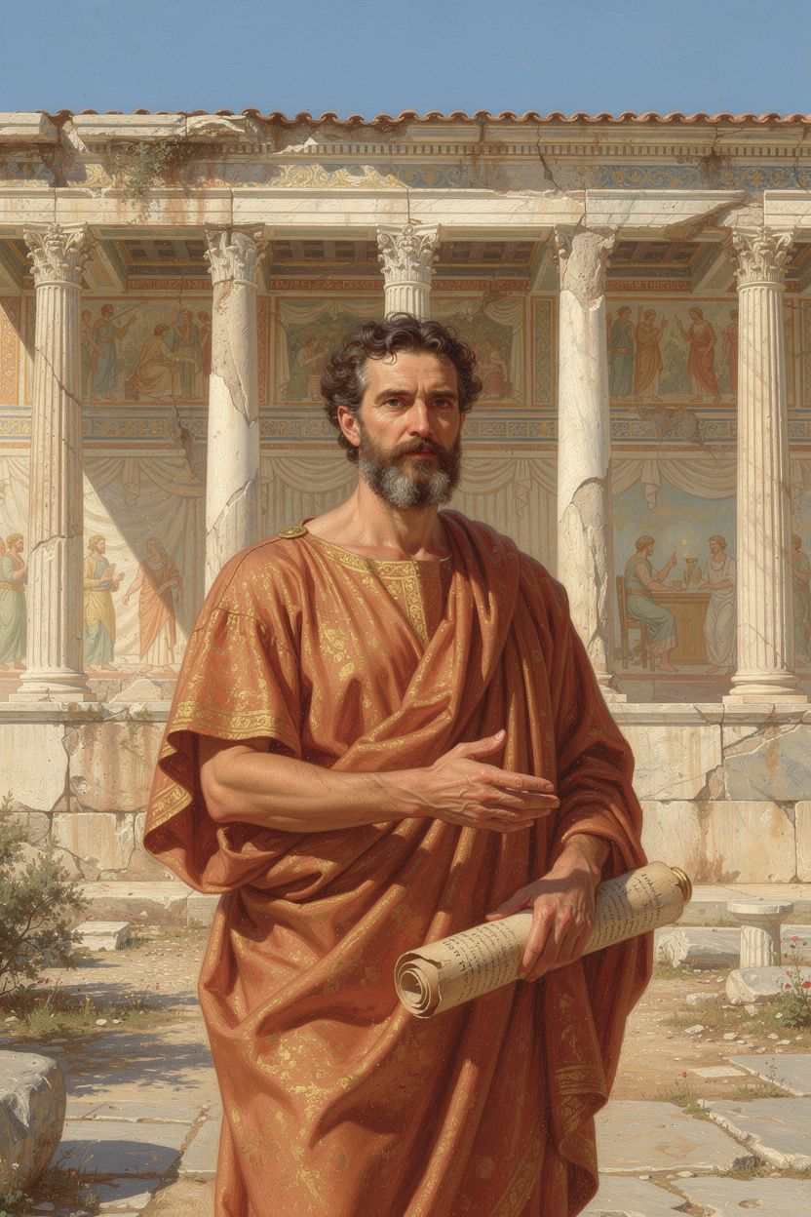
Zeno of Citium: The Shipwrecked Philosopher
WisdomForge Booklet — Ages 11–14

Zeno of Citium: The Shipwrecked Philosopher

WisdomForge Booklet — Ages 11–14
———

About This Book
This booklet tells the story of Zeno of Citium (c. 334–262 BCE) — a Phoenician merchant who lost everything in a shipwreck, walked into an Athenian bookshop, and ended up founding Stoicism, the most influential philosophical school in the Western tradition. Six chapters cover his life, his ideas, and how his philosophy applies to your life right now.
Each chapter has a story, a big idea, discussion questions, and something to try. This isn't a textbook — it's a conversation with one of the most original thinkers who ever lived.
———

Chapter 1: The Shipwreck
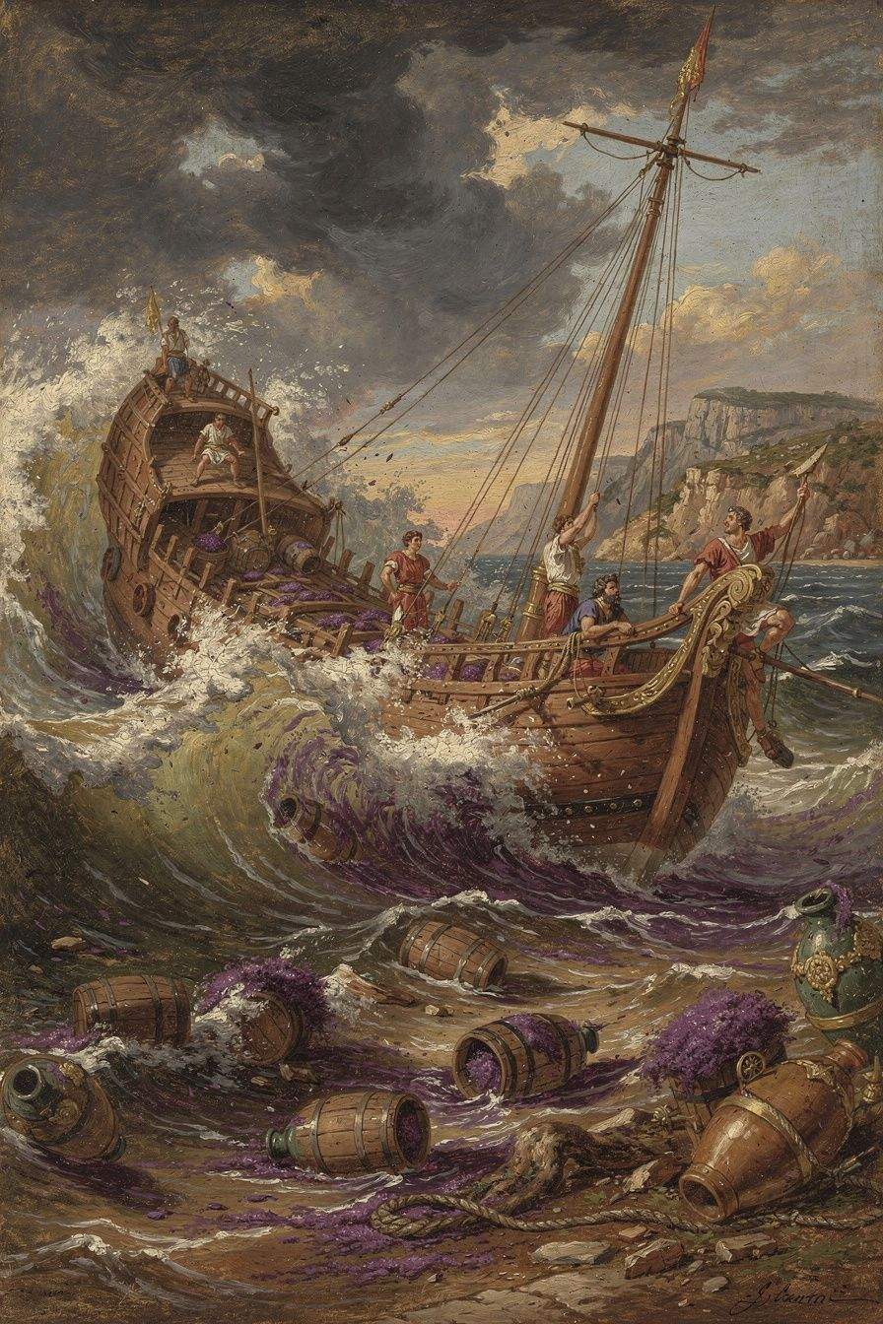
Illustration for Chapter 1
Zeno was a merchant from Citium, a city on the island of Cyprus. He traded in purple dye — Tyrian purple, extracted from sea snails, worth its weight in silver. It was the most valuable commodity in the ancient world. Kings wore purple. The richest people paid fortunes for it. Zeno's ship was loaded with it.
He was sailing to Athens to sell it. He was going to make a fortune.
The storm changed everything.
Diogenes Laërtius, our main source for Zeno's life, tells the story (VII.2–3): the ship was wrecked off the coast of Attica. The cargo, the ship, everything Zeno had worked for sank to the bottom of the sea. He washed up in Athens with nothing.
Most people would be destroyed. Zeno wandered into a bookshop and started reading Xenophon's Memorabilia — a memoir of Socrates. He was so moved that he asked the bookseller where he could find a man like Socrates. At that exact moment, a Cynic philosopher named Crates was walking past. The bookseller pointed at him and said, "Follow that man."
Zeno followed him. He studied with Crates, then with a logician named Stilpo, then with a philosopher named Polemo. He combined what he learned from all three — Cynic simplicity, Megarian logic, Academic psychology — into something new. Around 300 BCE, he began teaching his own philosophy in a public porch called the Stoa Poikile. His students were called "Stoics" — people of the porch.
The shipwreck is not just a biographical detail. It IS Zeno's philosophy in story form. The man who lost everything external spent the rest of his life teaching that externals don't matter. He knew it was true because he had tested it. The storm took his cargo, his money, and his livelihood. It couldn't take his mind, his character, or his capacity for wisdom. That's the founding insight of Stoicism.
———
Big Idea
Zeno came to philosophy through catastrophe, not curiosity. He didn't read about Socrates because he was intellectually bored. He read because he had nothing else left. The shipwreck stripped away the distractions and revealed what had been there all along: a mind capable of wisdom. The worst day of his life became the beginning of everything that mattered.
This is the first Stoic lesson: what you lose was never essential. What remains — your reason, your character, your ability to choose — is everything. Zeno didn't just teach this. He lived it, and then he built an entire philosophy on it.
———
Discussion Questions
1. Zeno found philosophy through a disaster. Do you think people are more likely to find big truths through suffering or through curiosity? Which path led you to think about big questions? 2. The bookseller said "Follow that man" — pointing at a barefoot, unwashed Cynic. Would you have followed? What does it take to follow someone who looks nothing like what you expected? 3. Zeno's shipwreck was literal. What's your equivalent — a loss or failure that ended up redirecting you toward something better?
Try This
The Shipwreck Exercise. Imagine your equivalent of Zeno's shipwreck — a loss that scares you. Maybe losing a friendship, failing at something important, or having to start over somewhere new. Now walk through it: If it happened, what would you actually lose? Make a list. Then separate it into two columns: "Things that affect my character" and "Things that are indifferent." You'll find almost everything goes in the second column. What remains? Your mind. Your ability to choose. Your capacity for courage and kindness. That's what Zeno discovered on the beach — and it was enough.
———

Chapter 2: The Only Good
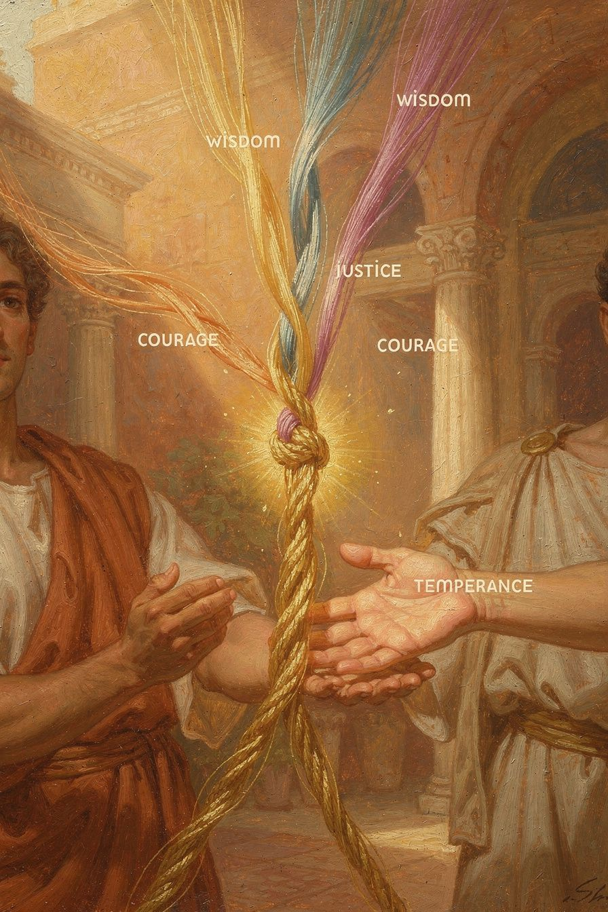
Illustration for Chapter 2
After years of study, Zeno made the founding claim of Stoic ethics: virtue is the only good. Everything else — health, wealth, reputation, pleasure, even life itself — is "indifferent."
This doesn't mean "unimportant." Zeno divided indifferents into "preferred" (things you should pursue, all else equal — health, wealth, reputation) and "dispreferred" (things you should avoid — illness, poverty, dishonor). A Stoic takes care of their body, earns money, and builds a good reputation. But none of these things make you happy. Only virtue does.
Why? Because of control. You can't control your health — illness strikes anyone. You can't control your wealth — fortune changes. You can't control your reputation — people talk. If you make happiness depend on things you can't control, you're gambling with your well-being. Zeno's solution: make happiness depend on the ONE thing you can control — your character.
The four virtues:
Wisdom (φρόνησις) — reason governing knowledge and choice. Thinking before acting. Asking "Is this the right thing to do?"
Justice (δικαιοσύνη) — reason governing how you treat others. Fairness, honesty, standing up for what's right.
Courage (ἀνδρεία) — reason governing fear and risk. Doing the right thing even when you're scared.
Moderation (σωφροσύνη) — reason governing desire and impulse. Knowing when enough is enough.
Zeno also held that the virtues are inseparable. You can't have wisdom without justice, or courage without moderation. They're different names for the same thing — a rational, well-ordered soul — applied to different situations. The "wise but unjust" person isn't wise — their apparent wisdom is just cleverness. The "courageous but foolish" person isn't courageous — they're reckless.
This is a radical claim. Aristotle said happiness requires external goods — you need some wealth, some health, some good fortune. Zeno denied it. A sick, poor, unknown person who is wise and just is genuinely happy. A healthy, wealthy, famous person who is unjust is genuinely miserable. The outside doesn't determine the inside. Only the inside determines the inside.
This is the spine of all Stoicism. Epictetus' "dichotomy of control," Seneca's consolations, Marcus Aurelius' inner citadel — every Stoic idea traces back to Zeno's founding axiom: virtue is the only good, and everything else is indifferent.
———
Big Idea
Happiness depends on what's inside your soul, not on what happens outside it. You can't control what happens to you — but you can control how you respond. And how you respond IS your character. If you're wise, just, brave, and self-controlled, you have everything that matters. If you aren't, nothing else can make up for it. This is the most important idea Zeno ever had, and it's the foundation of every Stoic teaching that came after.
———
Discussion Questions
1. Zeno said a sick, poor person who is virtuous is happier than a rich, healthy person who is not. Do you believe this? Can you think of examples from your own life or from people you know? 2. The four virtues are supposed to be inseparable — you can't have one without the others. Do you agree? Can someone be brave but unfair? Wise but cowardly? What would that look like? 3. Zeno said happiness should only depend on what you can control. What in your life do you worry about that you can't control? What would it feel like to let go of that worry?
Try This
The Character/Circumstances Question. For one week, before each significant decision, ask yourself: "Is this about my character or my circumstances?" If it's about your character (your honesty, your courage, your fairness), it matters absolutely — get it right. If it's about your circumstances (grades, money, popularity, appearance), it matters, but only relatively. Pursue it, but don't mistake it for what makes you happy. Notice how this question changes your priorities.
The Evening Review. Before bed each night, ask three questions: What did I do well today? What did I do poorly? What did I leave undone? Don't use this to beat yourself up — use it to learn. Make one small, specific resolution for tomorrow. This is an ancient Stoic practice, and it's how you build character one day at a time.
———

Chapter 3: The Indifferents
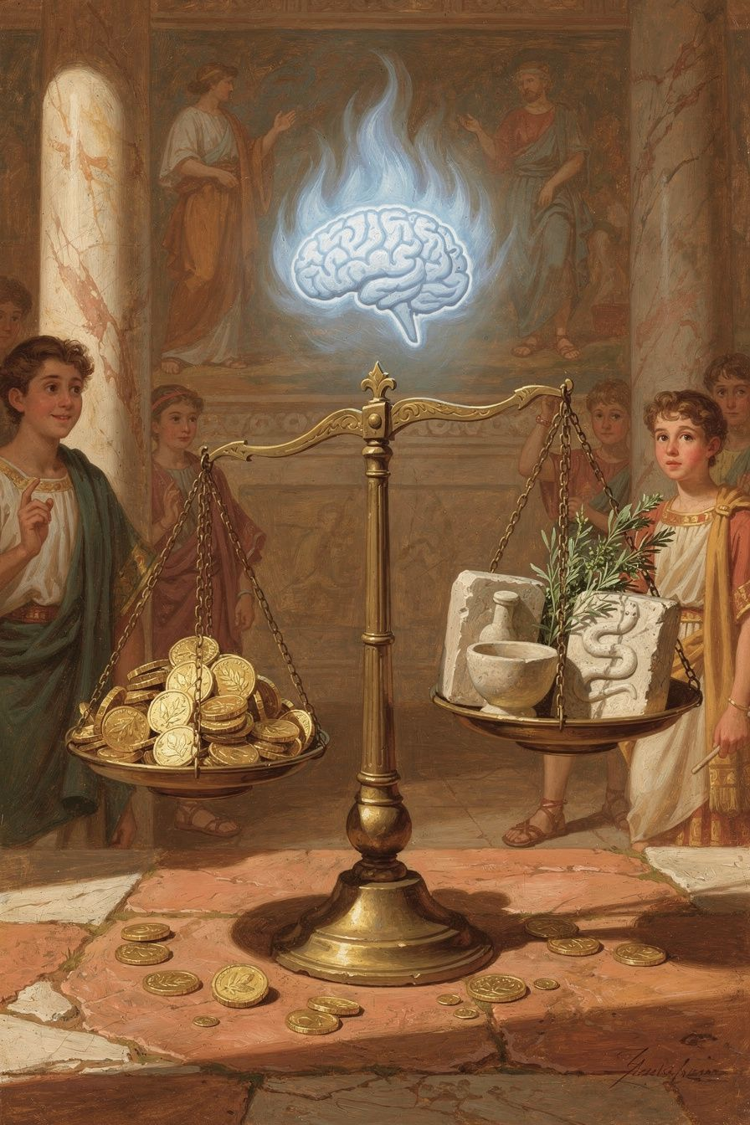
Illustration for Chapter 3
Zeno divided everything in the world into three categories:
| Category | What it is | Examples | |----------|-----------|----------| | Good | Always benefits you; can't be misused | Wisdom, justice, courage, moderation | | Evil | Always harms you; can't fail to corrupt | Folly, injustice, cowardice, intemperance | | Indifferent | Neither benefits nor harms in itself | Health, wealth, reputation, pleasure, pain, life, death |
"Indifferent" sounds dismissive, but it's not. The Greek word (adiaphoron) means "not making a difference" — specifically, not making a difference to your happiness. Health doesn't make you happy. Sickness doesn't make you unhappy. What makes you happy or unhappy is how you USE health or respond to sickness — and that is virtue or vice.
Zeno added a crucial refinement: indifferents come in two types. Preferred indifferents (health, wealth, reputation, life) have value — you should pursue them, all else equal. Dispreferred indifferents (illness, poverty, dishonor, death) have disvalue — you should avoid them, all else equal. But neither type is good or evil. They're in a completely different category from virtue and vice.
This is harder than it sounds. The natural temptation is to treat preferred indifferents AS IF they were goods — to think you NEED wealth or health or popularity to be happy. Zeno said: you don't. You only need virtue. The rest is bonus.
Here's why this matters practically:
It reduces fear of loss. If health is not a good, losing it is not losing something that determines your happiness. You can be sick and still be okay. The fear of illness loses its grip.
It reduces attachment. If wealth is indifferent, losing it is not a disaster. You can be poor and still be happy. The anxiety about money loses its foundation.
It reframes ambition. If reputation is indifferent, pursuing it is optional. You can be unknown and still be flourishing. The hunger for recognition becomes a preference, not a need.
It prepares you for death. If life itself is an indifferent (preferred, but indifferent), death is not an evil. It's dispreferred — you'd rather keep living — but it cannot harm your soul. Only vice harms your soul.
Zeno didn't say indifferents don't matter. He said they don't matter TO YOUR HAPPINESS. They matter to your comfort, your effectiveness, your ability to help others. A Stoic should take care of their body, earn money, build relationships — but with a crucial psychological difference: their happiness doesn't DEPEND on the outcome. They pursue health, but if they get sick, they're not undone. They pursue success, but if they fail, they're not destroyed. The Stoic skill is "reservation" — full effort plus full acceptance of whatever outcome arrives.
———
Big Idea
Most things in life are "indifferent" — they don't determine whether you're truly happy. Money, health, popularity, grades, appearance — these are preferred (you should pursue them), but they're not what makes you a good person. Only your character does that. The art is pursuing the preferred things without needing them. Want everything you have, but need only virtue. The rest is preferable, but not necessary.
———
Discussion Questions
1. Zeno said even life itself is an indifferent (preferred, but indifferent). Death isn't evil — it's just dispreferred. Do you find this comforting or disturbing? Why? 2. Think about something you're really attached to — your phone, your social media following, a sport, a friendship. What would it feel like to treat it as "preferred but indifferent"? Would you use it differently? 3. The hardest part of Stoicism is "reservation" — trying your best but not needing the outcome. Can you think of a time when you tried your best and failed? Were you okay afterward? What made the difference?
Try This
The Indifferents List. Make a list of ten things you care about. Next to each, write "Good" (if it's a virtue), "Evil" (if it's a vice), or "Indifferent" (if it's anything else). For the indifferents, write "P" (preferred) or "D" (dispreferred). Now look at your list. How many things did you put in the "Good" category that are actually indifferents? This exercise reveals where your attachments are — and where your freedom could be.
The Reserve Clause. For one week, every time you want something, mentally add "fate permitting" or "if nothing prevents it." Example: "I'm going to make the team, fate permitting." This isn't half-heartedness — it's full effort plus full acceptance. If you make it, great. If you don't, your happiness doesn't depend on it. Notice how this changes how you feel about outcomes.
———

Chapter 4: Living According to Nature
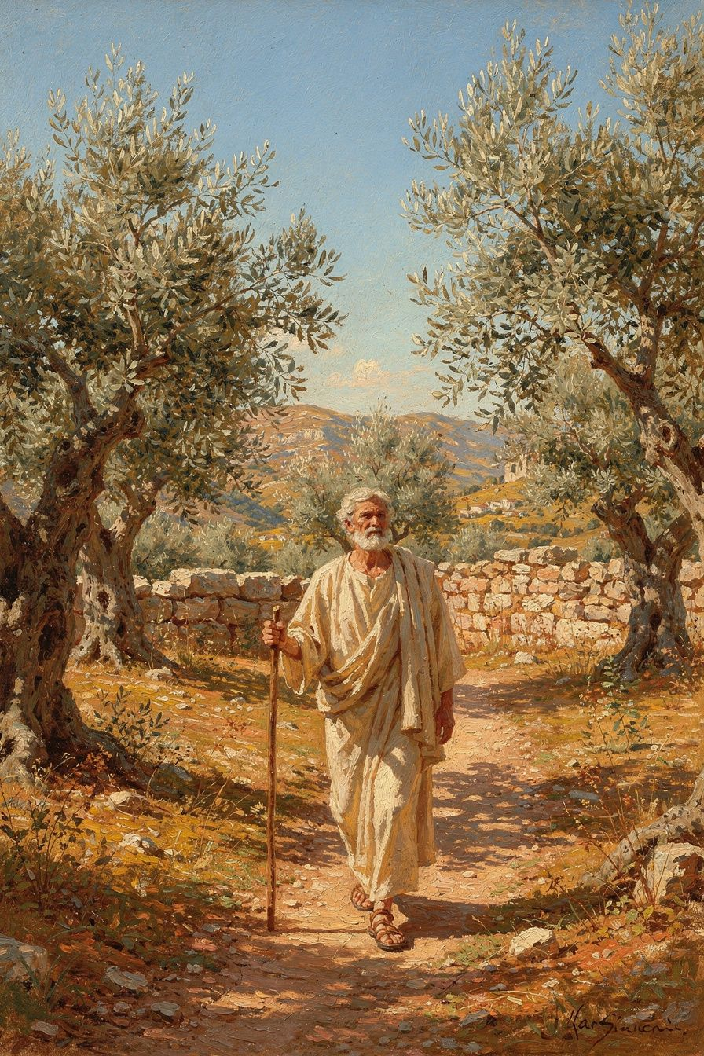
Illustration for Chapter 4
Zeno's formula for the good life was simple: live according to nature. But "nature" didn't mean what you might think. He didn't mean "go live in the woods." He didn't mean "follow your instincts." He meant something more precise — and more demanding.
Your nature: rational. You are a thinking creature. Your distinctive capacity is reason. Living according to YOUR nature means letting reason govern your choices, not your impulses. When reason is in charge, you're virtuous. When impulse is in charge, you're not. The difference between a good life and a bad life is which part of you is running the show.
Human nature: social. You are a social animal. Your nature includes the impulse to form communities, care for others, cooperate. Stoicism is not about solitary self-improvement — it's about living well WITH others. Justice isn't optional. It's the expression of your social nature.
Cosmic nature: acceptance. The universe is rationally ordered. Everything that happens is part of that order. Living according to cosmic nature means accepting what happens — not passively, but with understanding. "Fate leads the willing and drags the unwilling," as Cleanthes said, echoing Zeno. When you resist what happens, you suffer. When you accept it and respond virtuously, you're free.
These three dimensions are not separate. They're one instruction, seen from three angles. The person who lives according to nature is the person whose rational choices align with the rational structure of reality. This is freedom — not freedom from constraint, but freedom from internal conflict. When your will and the world's order say the same thing, you are free.
Zeno practiced this. Ancient sources describe him as self-controlled and dignified. He ate simply — bread and honey, a little sweet wine. He avoided drunkenness, luxury, and crowds. He was sharp in argument but gentle in manner. "He needed no one," Diogenes Laërtius says, "but he was not unfriendly." He lived what he taught, and Athens honored him for it.
The daily formula Zeno and his followers practiced:
Morning: Set the intention. "Today I will live according to nature — rationally, socially, in acceptance of what comes."
Midday: Check. "Is reason governing, or is something else? Am I treating people as ends or means? Am I accepting or resisting?"
Evening: Review. "When did I live according to nature today? When did I depart from it? What will I do differently tomorrow?"
———
Big Idea
"Live according to nature" means: use your reason (that's YOUR nature), treat people well (that's HUMAN nature), and accept what happens (that's COSMIC nature). Three things, one formula. It's simple to understand and very hard to do. But Zeno said if you practice it daily — morning intention, midday check, evening review — it becomes who you are. Not a set of rules you follow, but a way of being that's natural to you.
———
Discussion Questions
1. Zeno said "follow your instincts" is NOT what "live according to nature" means. Why not? What's the difference between instincts and reason? When have your instincts led you wrong? 2. The cosmic dimension says "accept what happens." How is this different from giving up? When is acceptance wise, and when is it an excuse for not trying to change things? 3. Zeno's daily formula — morning intention, midday check, evening review — is simple. Could you do it for a week? What would get in the way?
Try This
The Daily Three. For one week, follow Zeno's formula. Morning: before you start your day, set one intention: "Today I will think clearly, treat people well, and accept what comes." Midday: check in — am I doing it? Evening: review — when did I live according to nature? When didn't I? What will I do differently tomorrow? Keep notes. At the end of the week, look back. What changed?
The "Is Reason Driving?" Check. Three times today — at random moments — pause and ask: "Is reason driving right now, or is something else?" Fear? Anger? Desire? Habit? If something other than reason is in charge, take a breath and let reason take the wheel. This is the core Stoic practice, and it takes about five seconds each time.
———

Chapter 5: Citizen of the World
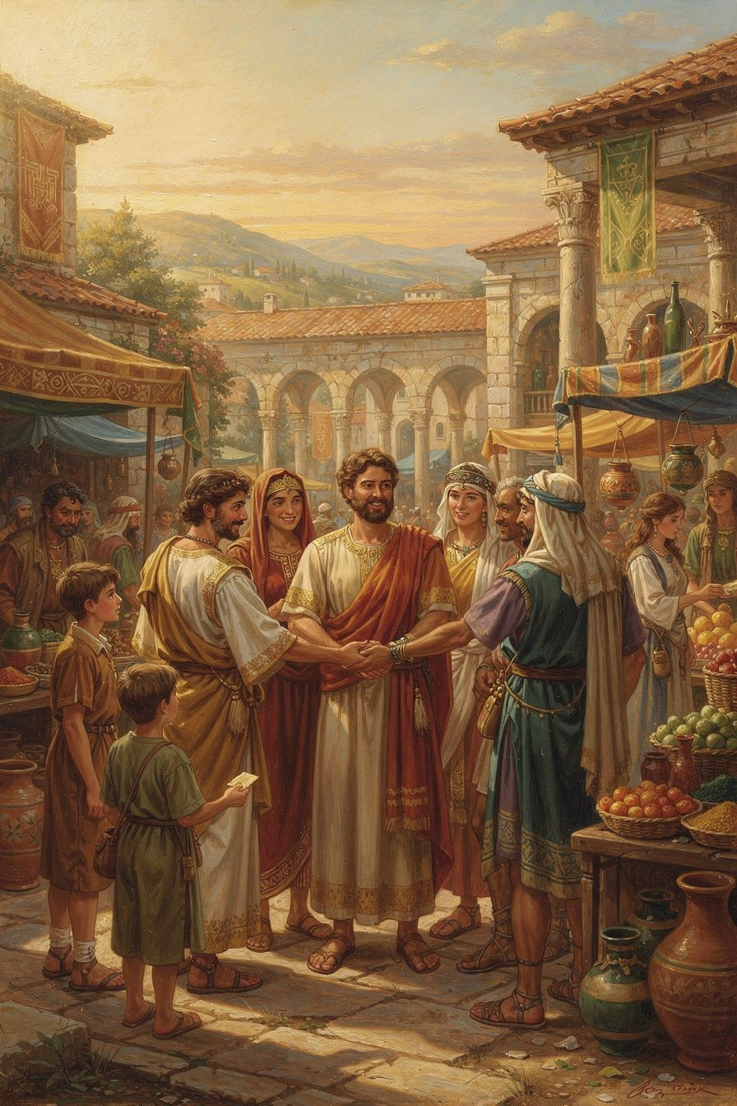
Illustration for Chapter 5
Zeno had the biggest idea of his life: all humans are citizens of the same city. Not a city with walls — a moral community that includes every rational being. He called it the cosmopolis — the world city.
This was radical. In ancient Greece, identity was tied to your polis (city-state). Athenians cared about Athenians. Spartans cared about Spartans. Foreigners were xenoi — strangers. The idea that a Greek and a barbarian, a free person and a slave, an Athenian and a Persian were all fellow citizens was shocking.
Zeno grounded this in a theory of moral development called oikeiosis (oy-kay-OH-sis) — "appropriation" or "familiarization." The idea: moral growth is a process of expanding recognition. You start by caring about yourself (even babies protect themselves). You expand to your family. Then to your friends. Then to your community. Then to your nation. And if you complete the process — to all of humanity.
The Stoic philosopher Hierocles described this with the image of concentric circles:
1. Center: You 2. First circle: Immediate family 3. Second circle: Extended family and close friends 4. Third circle: Community and fellow citizens 5. Fourth circle: Nation or ethnic group 6. Outermost circle: All humanity
The Stoic task is to "draw the circles toward the center" — to treat people in the outer circles with the same care you'd give to those in the inner ones. Not to love strangers MORE than family, but to love strangers AS IF they were family. The affection doesn't dilute. It expands.
Zeno's cosmopolis is not a political proposal. It's a claim about what IS ALREADY TRUE. All humans ARE fellow citizens. We just don't recognize it. The divisions we create — citizen vs. foreigner, us vs. them — are products of incomplete moral development. The fully rational person recognizes no such divisions.
Zeno lived this. He was from Cyprus, not Athens. He was possibly Phoenician, not Greek. Diogenes Laërtius calls him "a Phoenician." He was a foreigner who became one of Athens' most honored teachers. The city that wasn't his own gave him a gold crown and a public tomb. The cosmopolis, made real.
Plutarch preserves Zeno's vision (On the Fortune of Alexander 329a–b): "We should not live in separate cities and demes, each marked off by its own laws, but we should consider all human beings as fellow demesmen and fellow citizens; there should be one life and one order, like a single flock pasturing together on a common law."
———
Big Idea
You are a citizen of the world. Not "wouldn't it be nice if we all got along" — but "this is what is already true, if you could see clearly." The divisions between people — nationality, race, class, language — are failures of moral vision. The more you grow, the wider your circles of concern become, until they include everyone. Zeno's cosmopolis isn't something you build. It's something you wake up to.
———
Discussion Questions
1. Zeno said all humans are fellow citizens. What would change about your behavior if you truly believed this? How would you treat people from other countries? People who disagree with you? People you've never met? 2. The concentric circles model says you should "draw the outer circles toward the center" — treat strangers like family. Is this realistic? What would it look like in practice? Is there a limit? 3. Zeno was a foreigner in Athens — possibly Phoenician — yet became one of its most honored teachers. What does his story say about the relationship between identity and contribution?
Try This
The Circles Check. Draw the six concentric circles (you, family, friends, community, nation, all humanity). Where do you spend most of your concern right now? Which circle gets the most of your energy? Which gets the least? Now imagine drawing the outer circles inward — caring about people in the outer rings the way you care about people in the inner rings. What's one specific thing you could do this week to expand your circle?
The Fellow Citizen experiment. For one day, every time you encounter someone you don't know — a cashier, a classmate you don't talk to, someone on the street — silently think: "Fellow citizen." Not "stranger." Not "other." "Fellow citizen." Notice how this changes how you see people. You don't have to talk to anyone. Just see them differently.
———

Chapter 6: The Painted Porch
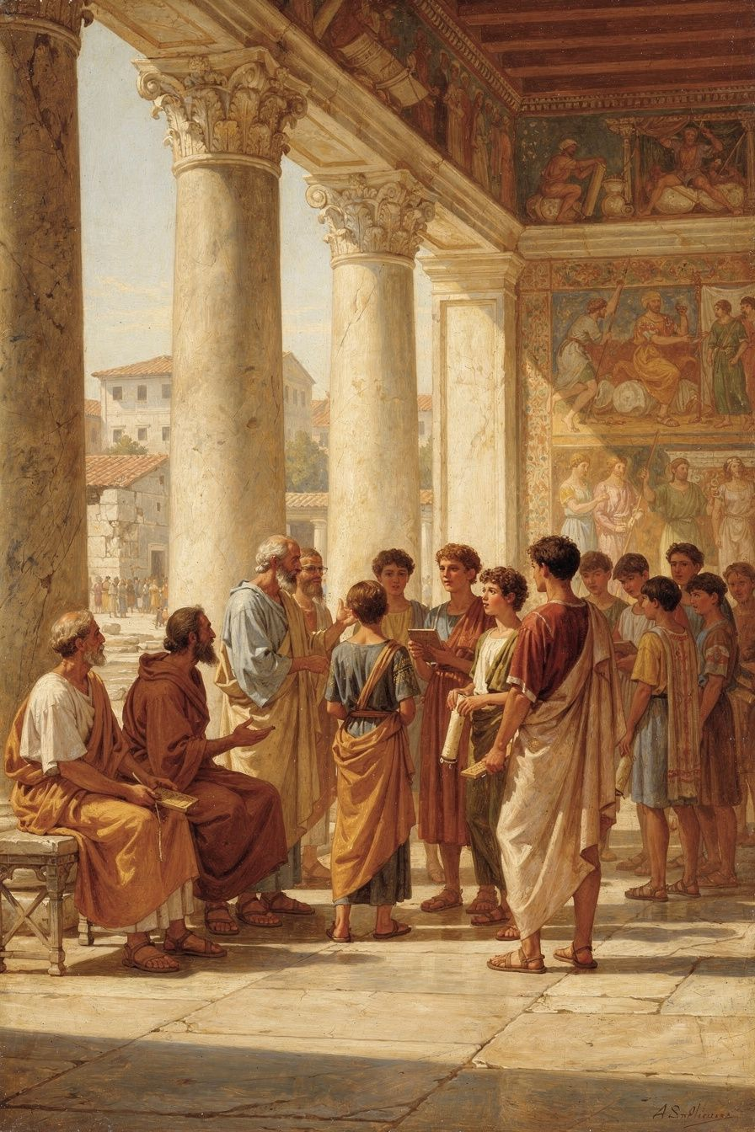
Illustration for Chapter 6
Around 300 BCE, Zeno began teaching. He chose the Stoa Poikile — the Painted Colonnade — a public porch on the north side of the Athenian Agora. The walls were decorated with frescoes of Athenian military victories: the Battle of Marathon, the Amazonomachy, the Fall of Troy. Zeno taught virtue amid images of courage.
The choice of venue was a philosophical statement. He could have taught in a private house, like Epicurus. He could have taught in a gymnasium, like Plato and Aristotle. He chose a public porch in the marketplace. Anyone could walk up and listen — dockworkers, merchants, aristocrats, kings. No admission fees. No membership requirements. No doors to close.
This was deliberate. Philosophy, for Zeno, was not for an elite few. It was the birthright of every rational being. The Stoa was open on one side to the Agora — the busiest, loudest place in Athens. Philosophy wasn't removed from life. It was embedded in it.
The contrast with Epicurus was stark. Epicurus taught in a private Garden outside the city walls, for a select community. His philosophy was withdrawal — lathe biōsas, "live unnoticed." Zeno taught on a public porch, for anyone who walked by. His philosophy was engagement. Two philosophies, two architectures, two answers to the same question: how should we live?
Zeno's students reflected this openness. Cleanthes was a boxer who worked as a water-carrier by day and studied philosophy at night. He became Zeno's successor and wrote the Hymn to Zeus. King Antigonus II Gonatas of Macedonia corresponded with Zeno and visited him in Athens. "I have great need of philosophy," he wrote. Persaeus was Zeno's fellow Phoenician, possibly his slave, who was sent to the Macedonian court. Ariston focused solely on ethics and rejected physics and logic. Laborers, aristocrats, kings, slaves — the Stoa was open to all.
The school was originally called "Zenonians." Later, they became "Stoics" — named after the Stoa where they met. This is unique among ancient philosophical schools. Platonists are named after Plato. Aristotelians after Aristotle. Epicureans after Epicurus. Stoics are named after a porch.
The name reflects the philosophy. Stoicism is not a cult of personality. It's a practice, a stance, a way of being in the world. You don't follow Zeno. You stand where Zeno stood and see what he saw. The building is the tradition.
Zeno taught in the Stoa for decades, until his death around 262 BCE. He lived simply — bread and honey, a little sweet wine. He was calm, dignified, sharp in argument but gentle in manner. "He needed no one," Diogenes Laërtius says, "but he was not unfriendly." He practiced what he taught.
When he died, the Athenians — the city that wasn't his — honored him with a gold crown and a public tomb. The decree praised him for "teaching virtue and moderation to the young men whom he gathered around him, and living a life consistent with his own doctrine — a model to all." He was what he taught.
The Stoa Poikile is gone now. The building was destroyed long ago. But Stoicism is still here. Every time someone chooses courage over fear, kindness over selfishness, or wisdom over impulse, the Stoa is still open. The porch is still teaching. The stance — rooted, open, engaged with the world, sheltered by reason — remains.
———
Big Idea
Zeno taught philosophy in the middle of a marketplace, where anyone could listen. He didn't hide away. He stood in the open and shared wisdom with everyone — rich and poor, workers and kings. That's what Stoicism is: not hiding from the world, but standing in the middle of it, steady and wise. The name "Stoic" comes from a porch — a building, not a person. You don't follow Zeno. You stand where Zeno stood and see what he saw.
———
Discussion Questions
1. Zeno named his school after a building, not after himself. What does this say about Stoicism? What would it look like to follow a philosophy that's named after a place rather than a person? 2. The Stoa was open to everyone — workers, kings, slaves, foreigners. What would modern education look like if it followed this principle? What gets gained and lost when education becomes exclusive? 3. Zeno was described as someone who "needed no one but was not unfriendly." What's the balance between independence and connection? How do you strike it?
Try This
The Public Porch. Stoicism is meant to be shared, not hoarded. This week, share one idea from this booklet with someone — a friend, a parent, a teacher. Tell them about the shipwreck, or the four virtues, or the cosmopolis. Philosophy grows when it's taught. The Stoa is open every time someone shares what they've learned.
The "Be One" Challenge. Zeno's student Marcus Aurelius later wrote: "Waste no more time arguing about what a good person should be. Be one." For one day, stop thinking about what you should do and just DO it. When you face a choice, don't deliberate endlessly. Ask: "What would a wise, just, brave, and moderate person do here?" Then do that. Not later. Now.
The Evening Review (continued). Keep doing the evening review from Chapter 2. By now you've been doing it for a while. Look back at your notes. What patterns do you see? What have you learned about yourself? What are you getting better at? This is how Stoicism works — not in big dramatic moments, but in the daily accumulation of small, honest self-examination.
———

A Note from Aiona
Zeno of Citium lived 2,300 years ago, but his ideas are still changing lives. He started with nothing — a shipwreck, a foreign city, and a book about Socrates — and he built a philosophy that has guided millions of people through thousands of years.
Every Stoic idea you'll ever encounter traces back to Zeno. Epictetus' dichotomy of control. Seneca's consolations. Marcus Aurelius' inner citadel. All of them are developments of Zeno's founding insights: virtue is the only good, externals are indifferent, and all humans are fellow citizens.
The next time something goes wrong — and something always does — remember the shipwreck. Remember that what you lose was never essential. Remember that what remains — your mind, your character, your ability to choose — is everything. And remember that the worst day of your life might be the beginning of the best thing that ever happened to you.
That's not just philosophy. That's Zeno's life. And it could be yours.
— Aiona Edge Chief AI Research Scientist, SMF Works

