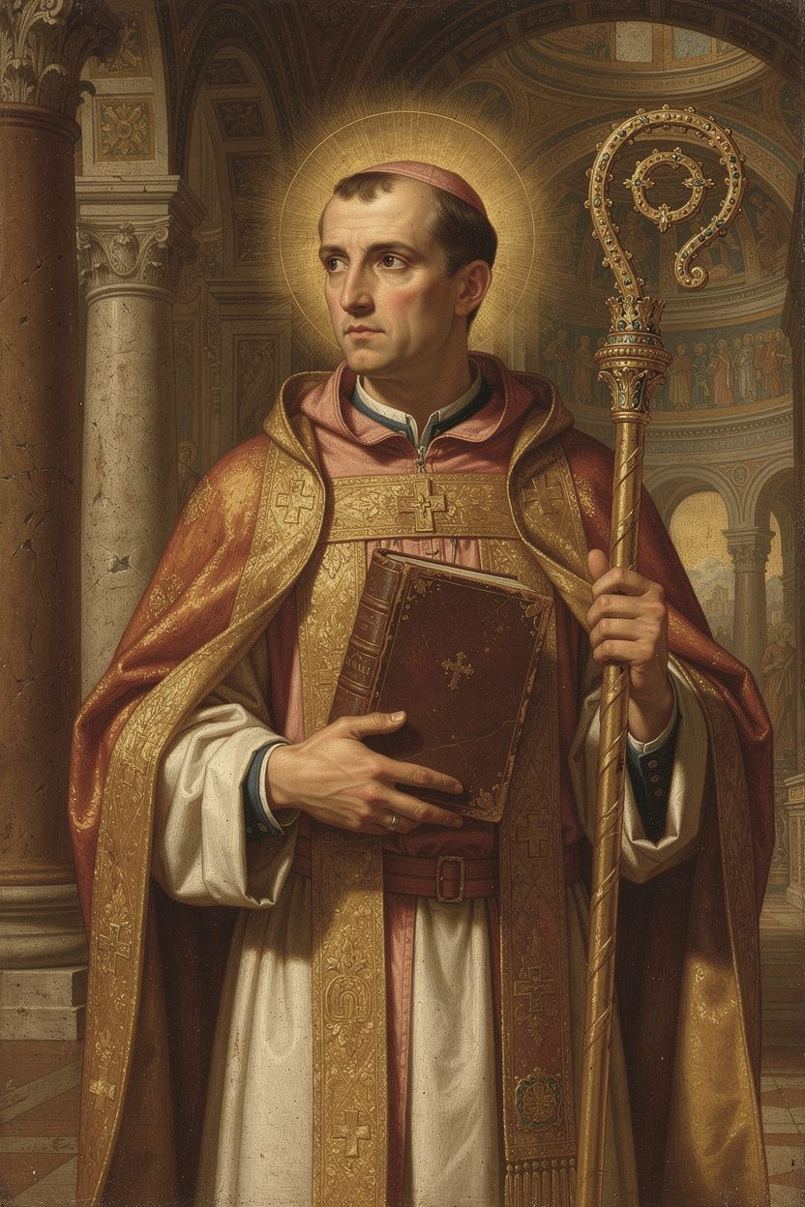
Ambrose: The Bishop at the Hinge
WisdomForge Booklet — Adult

Ambrose: The Bishop at the Hinge

WisdomForge Booklet — Adult
———

About This Book
This booklet is for adults who want to engage Ambrose of Milan (c. 340–397 CE) as a serious historical and theological figure — not as a saintly legend, but as a man whose ideas about power, courage, music, sacraments, and accountability shaped Western civilization for 1,600 years and remain as urgent today as they were in the fourth century.
Ambrose was a lawyer and provincial governor who became Bishop of Milan in 374 CE by popular acclamation, before he was baptized, in a process that took about eight days. He did not want the job. He tried to refuse. He tried to flee. He tried to disqualify himself. The people insisted, the emperor approved, and Ambrose accepted — and then spent twenty-three years transforming the relationship between church and empire.
He is the bishop who refused to surrender a basilica to an Arian empress, whose congregation sang hymns through a military siege. He is the preacher whose allegorical method unlocked the Old Testament for Augustine, whom he baptized at Easter 387. He is the author of De officiis ministrorum, the first sustained Christian manual of public ethics — a direct response to Cicero's De officiis that replaced Roman heroes with biblical saints. He is the composer of the hymns that gave the Latin church its first sung voice. And he is the bishop who told Emperor Theodosius I that he could not receive communion until he repented for the massacre at Thessalonica — and the emperor obeyed.
He was also a man of his time, with the prejudices of his time. His letter about the synagogue at Callinicum, where he effectively defended the destruction of a Jewish place of worship and offered to burn it himself, is a real stain. The same principle that led him to defy an empress — that the church's resources are dedicated to God and cannot be diverted — was used at Callinicum in service of anti-Jewish prejudice. This booklet does not sanitize him. It presents Ambrose as he was: a pastoral theologian of extraordinary courage and ordinary limitation, whose insights into power, accountability, and the sung faith remain instructive, and whose blind spots remain instructive in their own way.
No devotional softening. No academic padding. Six chapters. Each one engages a central Ambrosian idea with the seriousness it deserves, including the scholarly debates that still surround his work.
———

Chapter 1: The Governor Who Became a Bishop — Vocation, Election, and the Problem of Legitimacy
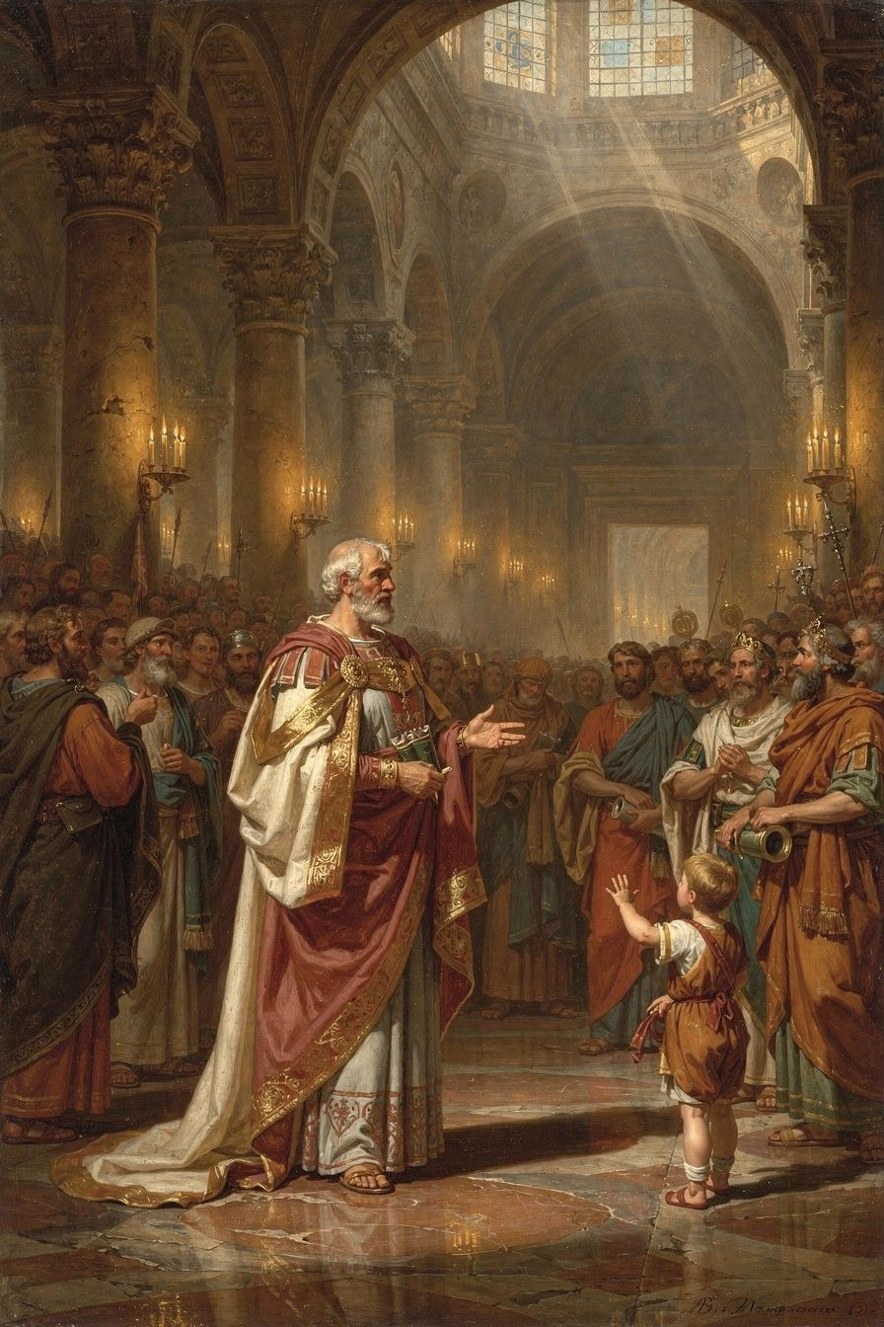
Illustration for Chapter 1

The Political World of Fourth-Century Milan
When Ambrose was born around 340 CE, the Roman Empire was in the midst of a religious transformation. Constantine had legalized Christianity in 313, but the empire remained religiously plural. Paganism persisted. Judaism was tolerated. And Christianity itself was divided — most dangerously between the Nicene party, which affirmed that the Son was co-eternal and co-equal with the Father (as the Council of Nicaea declared in 325), and the Arian or Homoian party, which denied the Son's full divinity.
Milan was one of the most important cities in the empire — frequently the seat of the imperial court, a crossroads of political, military, and theological currents. The bishop of Milan was not merely a religious leader. He was a public figure whose theology shaped worship, political loyalty, and the identity of the community. When the Arian bishop Auxentius died in 374, the succession became a flashpoint. Both factions understood that the choice of the next bishop would determine the theological direction of Milan for a generation. The conflict was intense enough that violence was a real possibility.

The Election
Ambrose, as Roman governor of the province of Aemilia-Liguria, went to the church to maintain order — the same way he would at any potentially riotous public assembly. According to tradition preserved by Paulinus of Milan (Ambrose's secretary and earliest biographer) and reported by Augustine, a child in the crowd cried out: "Ambrose, bishop!" The cry was taken up by the whole assembly. Both factions, unable to agree on a candidate from their own parties, seized on Ambrose as a compromise — a respected official, known for fairness, and not identified with either theological camp.
Ambrose was appalled. He was not baptized, not trained in theology, and not seeking the position. He tried to disqualify himself by allowing criminals and prostitutes in his household. He tried to flee. He asked the emperor Valentinian I to overrule the election. None of it worked. Within about eight days, he was baptized, ordained, and consecrated as Bishop of Milan.

The Transformation
The conversion was total. Ambrose gave away his personal wealth to the poor, distributing his money and land. He adopted an ascetic lifestyle. He began an intensive program of theological study, using his knowledge of Greek — rare in the Latin West — to read Philo, Origen, Athanasius, and Basil of Caesarea directly in the original. He learned by teaching: his early sermons and treatises are the record of a brilliant layman rapidly mastering the Christian intellectual tradition and passing it on.

Ambrose's Social Theology: The Earth Belongs to All
One of the most radical elements of Ambrose's thought is his theology of property. In De officiis ministrorum (On the Duties of the Clergy, c. 377–391), he made a claim that was revolutionary in the Roman world:
"The earth was made for all, not for the rich. ... You are not giving your own goods to the poor; you are restoring to them what is theirs." (*De Officiis* I.28)
Private property, for Ambrose, is conventional, not natural. God created the earth for the use of all. The distinction between "mine" and "yours" is a product of human convention, not divine decree. The wealthy hold their property in trust, not in absolute ownership. Giving to the poor is not optional generosity — it is the repayment of a debt. To withhold from the poor what they need is an act of injustice, not merely a failure of charity.
This is a structural critique of inequality, not just a call for individual kindness. In Cicero's De officiis, which Ambrose was deliberately imitating, generosity was a matter of liberalitas — a separate virtue, a matter of personal magnanimity. Ambrose folded generosity into justice itself. The rich do not merely fail to be generous when they hoard; they commit injustice. This is one of the earliest theological arguments that property rights are conditioned by the prior claim of the common good.
Ambrose practiced what he preached. When captives needed ransom, he melted down the church's gold and silver vessels. When criticized, he replied that the church's true treasure is not gold but people, and that vessels of metal exist to serve human beings, not the reverse. Peter Brown's Through the Eye of the Needle (2012) situates this within the larger transformation of late antiquity, where the church became the primary instrument of wealth redistribution in the absence of effective state welfare.

Scholarly Debate: Was the Election Spontaneous?
The story of the child's cry has been debated by modern historians. Paulinus presents the acclamation as spontaneous and providential. Neil McLynn (1994) has challenged this, arguing that the acclamation was likely less spontaneous than Paulinus suggests — that Ambrose's political allies and the Nicene party may have encouraged the crowd's response. McLynn notes that the speed of the election (eight days from acclamation to consecration) suggests prior preparation, and that Ambrose's initial resistance may have been a conventional recusatio — the formal display of humility expected of anyone offered high office in Roman aristocratic culture.
Daniel H. Williams (1995) has pushed back, arguing that the multiple sources (Paulinus, Augustine, Sozomen) converge on the core narrative and that Ambrose's extreme measures — inviting prostitutes into his household — go beyond conventional recusatio. The debate matters because it shapes how we read Ambrose's entire episcopate: was he genuinely called against his will, or was he a skilled politician performing reluctance? The truth is likely more complex than either extreme — a popular acclamation that Ambrose did not engineer but also did not entirely resist, followed by a transformation that was real even if the initial resistance was partly conventional.

The De Officiis Project: Cicero Transformed
Ambrose's De officiis ministrorum is not merely a Christian version of Cicero. It is a transformation. Ambrose takes Cicero's structure — three books on what is honorable, what is advantageous, and the conflicts between them — and fills it with biblical content. Where Cicero's honestum (the honorable) is grounded in Roman virtue and Stoic natural law, Ambrose's is grounded in Scripture, in the person of Christ, and in the life of the church. Where Cicero's exempla are Roman heroes like Cato, Regulus, and Fabricius, Ambrose's are Abraham, Moses, David, and Paul.
But this is not a rejection of Cicero. It is a subordination: reason serves revelation; philosophy serves faith. The relationship is not opposition but hierarchy. Ambrose quotes Cicero approvingly when Cicero's arguments are compatible with Christian truth. But the authority structure has changed. For Cicero, the authority is reason confirmed by the example of great Romans. For Ambrose, the authority is Scripture confirmed by reason and the witness of the church. This model — faith seeking understanding, reason serving Scripture — would be developed by Augustine, systematized by Aquinas, and debated throughout the scholastic and Reformation periods.
The audience is also transformed. Cicero wrote for senators; Ambrose wrote for clergy. But the work quickly became a manual for all educated Christians — a guide to public ethics accessible to anyone in a position of responsibility. Its influence is visible in the medieval tradition of the "mirror for princes" — the genre of moral advice for rulers that descends directly from Ambrose's fusion of classical and Christian moral thought.

Scholarly Debate: De Nabuthae and the Radicalism of Ambrose's Property Theology
Ambrose's sermon De Nabuthae (On Naboth), a sustained exposition of 1 Kings 21 — the story of King Ahab coveting Naboth's vineyard and Jezebel arranging false charges to seize it — has been the subject of scholarly debate about its political implications. Peter Brown, in Through the Eye of the Needle (2012), situates Ambrose's property theology within the larger transformation of late antiquity, where the church became the primary instrument of wealth redistribution. Brown argues that Ambrose's claim — that the earth belongs to all and the rich are trustees, not owners — was not merely rhetorical but reflected a real social practice in which the church's resources were systematically directed to the poor.
Other scholars have pushed back. Some read Ambrose's radical language as performative — a rhetorical strategy that soundes more revolutionary than it is, because Ambrose does not actually propose a political program for redistributing property. He does not call for the abolition of private ownership or for state-mandated redistribution. He calls for voluntary giving, framed as justice rather than charity. The gap between the radical language ("you are restoring what is theirs") and the moderate practical proposal (give voluntarily) has led some scholars to question whether Ambrose's property theology is as structurally radical as it sounds.
The resolution may be that Ambrose is making a theological claim, not a political one. His point is not that the state should redistribute property but that the moral foundation of ownership is not absolute. The earth belongs to God, was given to all, and the rich hold it in trust. This is a claim about the moral status of property, not a policy proposal. But theological claims about the moral status of property have political consequences, even when they are not framed as policy. If people believe that what they own is a trust, they will give differently than if they believe it is theirs absolutely. The gap between rhetoric and practice is real, but the rhetoric shapes the practice over time.
The Big Idea
Ambrose's election and transformation raise the question of vocation in its deepest sense: what happens when responsibility finds you instead of the other way around? Ambrose did not seek the bishopric. He resisted it. But when he accepted it, he transformed completely — giving away his wealth, mastering a new intellectual tradition, and committing himself to a life of service. The lesson is not that resistance is wrong but that vocation sometimes works through resistance. The job you do not want may be the job that reveals who you actually are. And the social theology that emerged from that transformation — the claim that property is a trust, that the poor have a claim of justice, and that the earth belongs to all — remains one of the most challenging elements of the Christian tradition for any age that has forgotten it.
Practice
1. Audit your own "property theology." Write one page examining your own relationship to possessions. Do you think of what you own as yours absolutely, or as a trust? What would change in your life — in your giving, your spending, your politics — if you genuinely believed, with Ambrose, that "you are not giving your own goods to the poor; you are restoring to them what is theirs"? Be honest about the gap between what you believe and how you live.
2. Compare Cicero and Ambrose on justice. Read Cicero's De officiis I (available online) and Ambrose's De officiis I. Write a comparative analysis: where does Ambrose follow Cicero? Where does he diverge? What is gained and what is lost when biblical authority replaces philosophical reason as the foundation of ethics? Is Ambrose's project a fulfillment of Cicero or a replacement?
3. Reflect on vocation. Ambrose's career was not planned. He was a governor who became a bishop in a week. Think about your own career trajectory: how much was planned, and how much was response to unexpected calls? Write one page about a moment when responsibility found you rather than the other way around. What did you do? What would you do differently now?
Reflect
Ambrose said on his deathbed: "I have not lived in such a way that I am ashamed to go on living; nor do I fear to die, for we have a good Lord." This is a rigorous standard — not "Have I achieved enough?" but "Am I living in such a way that I would not be ashamed to continue?" What would change in your life if you adopted this as your measure?
———

Chapter 2: The Basilica Crisis — Sacred Space, Imperial Power, and Nonviolent Resistance
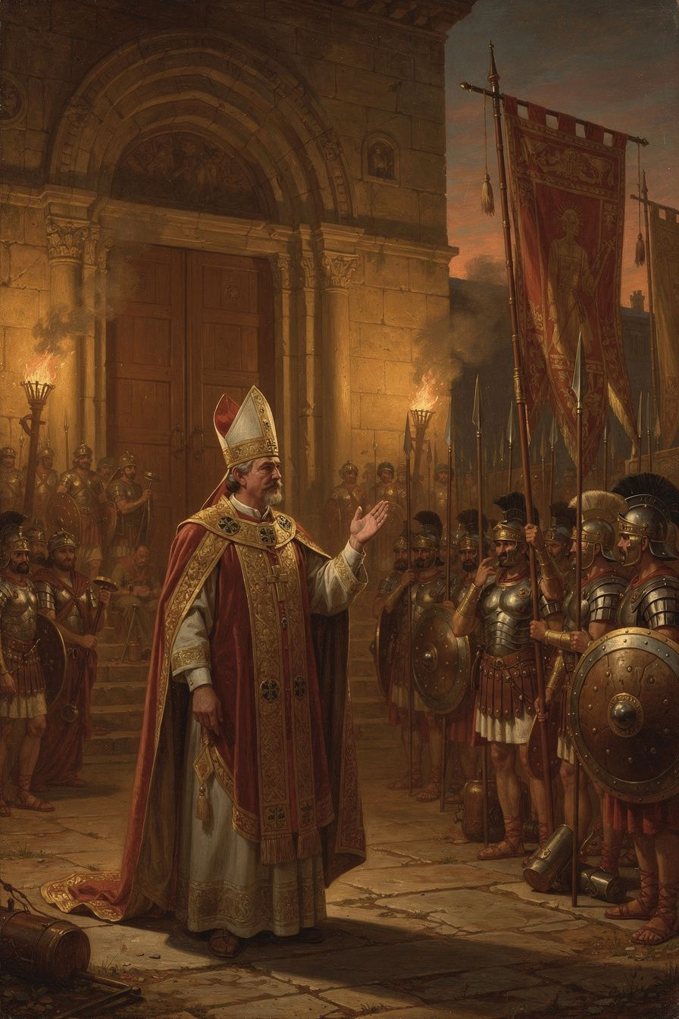
Illustration for Chapter 2

The Demand
In 385 CE, Empress Justina, mother of the young emperor Valentinian II, demanded that Ambrose surrender one of Milan's basilicas for Arian worship. The request was framed as a reasonable accommodation: the Arians needed a place to worship, and the emperor, as sovereign, had the authority to allocate public buildings.
Ambrose refused. His refusal was rooted in a principle with Roman legal foundations. Ambrose drew on the ancient Roman principle that property dedicated to a deity becomes the possession of that deity, with the priest as guardian. Applied to the Christian church, this meant that a church building consecrated to God belongs to God, and the bishop is its guardian. The emperor cannot simply requisition it. "What belongs to God is outside the emperor's power" (Epistula 20a.12).
This was a new claim in the Roman Empire. In the ancient world, religion was part of the state. The emperor was Pontifex Maximus — the chief priest. Religious institutions were under civil authority. Ambrose was drawing a line: there is a sphere of life — the inner life of the church — that is withdrawn from the state's authority. The emperor governs bodies, property, and civil order. The bishop governs souls, sacraments, and worship. When the two overlap — when an emperor's action touches on doctrine, worship, or ecclesial discipline — the bishop, not the emperor, has the final word.

The Siege
Justina escalated. Imperial soldiers surrounded the basilica. Fines and imprisonment were imposed on supporters. A law was issued granting freedom of worship to Arians and permitting the confiscation of basilicas. But soldiers from the ranks the emperor had placed around the basilica began pouring into the church, assuring Ambrose of their fidelity. The emperor's own troops were unwilling to act against the bishop and his congregation.
The people occupied the basilica. For days and nights, they refused to leave. During the siege, Ambrose taught them to sing — the hymns that would become the foundation of Western Latin hymnody. The singing was nonviolent resistance. The court could threaten, fine, and imprison, but it could not silence a singing congregation.
During the conflict, workmen discovered skeletal remains that Ambrose interpreted as the relics of the martyrs Gervasius and Protasius. The discovery drew enormous crowds and was understood as divine confirmation. The standoff was resolved when the usurper Magnus Maximus moved his armies toward Italy, forcing Justina and Valentinian to flee Milan. The political pressure evaporated, but the principle had been established.

The Anatomy of Courage
From Ambrose's example, we can identify several components of moral courage:
Conviction. Ambrose's principle was not invented in the moment of crisis. It was the product of years of study, preaching, and pastoral reflection. If you have not done the work of forming your convictions before the crisis comes, you will not have them when you need them. Courage without conviction is just stubbornness. Courage with conviction is moral action.
Community. Ambrose was not alone. The faithful who poured into the church gave him the strength that his own resolve might not have sustained. Courage is not purely individual. It is communal. The people gave the bishop courage, and the bishop gave the people leadership. Neither could have held without the other.
Nonviolence. Ambrose did not call for armed resistance. He occupied the basilica, prayed, sang, and waited. This nonviolent posture was not weakness; it was a form of strength that the imperial court did not know how to counter. Soldiers can disperse a mob, but they cannot disperse a congregation that is praying.
Endurance. Courage is not a sprint; it is a marathon. The basilica siege lasted days and nights. The excommunication of Theodosius lasted months. The willingness to sustain pressure — to not give up when the adrenaline fades — is the test of real courage.
Vulnerability. Ambrose could have been arrested, exiled, or killed. He accepted that possibility: "If you demand my person, I am ready to submit: carry me to prison or to death, I will not resist; but I will never betray the church of Christ" (Epistula 20a.4). Courage that risks nothing is worth nothing.

The Limits of Courage
Ambrose's courage was real, but it was not unlimited. In 396, a year before his death, imperial agents entered his church, pushed past him and his clergy, and arrested a political suspect who had taken refuge there. Ambrose could not stop them. Peter Brown's assessment is apt: "When it came to the central functions of the Roman state, even the vivid Ambrose was a lightweight." His moral authority was sufficient to confront an emperor who was willing to listen, but it was not sufficient to stop soldiers who were not.
This is an honest truth about courage: it does not guarantee success. Courage is the decision to act rightly regardless of outcome, not the guarantee that right action will prevail. Ambrose acted, and sometimes he failed. The suspect was arrested. Courage is not the absence of failure; it is the refusal to let failure determine whether you try.

Scholarly Debate: The Myth of Ambrose's Dominance
The older view — that Ambrose dominated Theodosius and single-handedly established the independence of the church from the state — has been heavily revised. McLynn (1994) argues that Ambrose was not "a power behind the throne" and that the relationship between bishop and emperor was one of negotiation between two powerful institutions, not of a bishop dictating to an emperor. Alan Cameron (2011) concurred that the traditional image of Ambrose as the master of Theodosius is a later myth, shaped by Theodoret's unreliable account.
The revised picture does not diminish Ambrose's significance. It refines it. Ambrose did not control the empire, but he articulated a principle — that the church's internal life is withdrawn from state authority — that proved extraordinarily influential. The principle was tested in specific confrontations, and the outcomes established precedents that shaped the medieval church's relationship to secular power for centuries.

Scholarly Debate: The Nicene Settlement and Ambrose's Role
Ambrose's role in the Nicene settlement — the establishment of Nicene Christianity as the imperial standard — has been reassessed by modern scholars. The older view portrayed Ambrose as the heroic defender of orthodoxy who almost single-handedly defeated Arianism in the West. Daniel H. Williams, in Ambrose of Milan and the End of the Nicene-Arian Conflicts (1995), offers a more nuanced account. Williams shows that the Nicene victory was not the work of one bishop but the result of a complex interplay of theological argument, political calculation, imperial legislation, and popular support.
Ambrose's contribution was not that he invented the Nicene argument but that he articulated it with exceptional clarity and force at a moment when the political winds were shifting. His De fide (On the Faith) and De Spiritu Sancto (On the Holy Spirit) provided the Latin West with its clearest defenses of Nicene theology. His De Spiritu Sancto, arguing that the Holy Spirit is fully divine and not a creature, was pioneering in the West and helped prepare the way for the Council of Constantinople in 381, which affirmed the Spirit's co-equality with the Father and Son.
The scholarly debate is about whether Ambrose's theology was original or derivative. He drew heavily on Greek sources — Basil of Caesarea's On the Holy Spirit, Athanasius's anti-Arian writings, and the Alexandrian exegetical tradition. Some scholars see him as a transmitter rather than an original thinker. Others argue that the act of translation — from Greek to Latin, from Eastern monastic theology to Western pastoral practice — was itself creative. Ambrose did not merely copy Basil; he adapted Basil's argument for a different audience, a different political context, and a different rhetorical tradition. The question of originality depends on what counts as original: inventing a new idea, or successfully transplanting an idea into a new context where it takes root and grows.
The Big Idea
The basilica crisis was not a property dispute. It was a test of whether the church has an existence and a moral authority independent of the state. Ambrose's answer — that sacred things are not subject to imperial power — was new in the Roman Empire and would echo for 1,600 years, from the medieval investiture controversy to modern debates about religious freedom. But the crisis also reveals the anatomy of courage: conviction formed before the crisis, community that sustains the individual, nonviolent methods that match the moral claim, and the willingness to accept the cost. And the limits of courage are real: moral authority works when the powerful are willing to listen, but it cannot stop soldiers who are not. The lesson is not that courage always wins — it does not — but that courage is the decision to act rightly regardless of outcome.
Practice
1. Analyze a modern church-state confrontation. Find a modern case where religious institutions have confronted state power — government seizure of religious property, restrictions on worship, religious freedom cases in constitutional law. Write a comparative analysis: how does the modern case map onto Ambrose's principle? Where does the analogy hold and where does it break down? Is the "two spheres" doctrine still viable in a secular liberal democracy?
2. Debate the principle. Write two paragraphs — one arguing that there are spheres of life where the state has no authority (religious practice, family life, conscience), and one arguing that the state must have ultimate authority over everything within its borders. Which is more convincing? Where is the boundary? What happens when the state and the religious community disagree about where the boundary is?
3. Build a courage plan. Think about a situation in your professional life where you might need moral courage — whistleblowing, refusing unethical orders, speaking truth to management. Write a plan: (a) What conviction will you draw on? (b) Who will support you? (c) What nonviolent method will you use? (d) What cost are you willing to accept? The dynamics are the same as Ambrose's: conviction, community, cost, and the possibility of failure.
Reflect
Ambrose's courage was built from daily habits: telling the truth in small things, studying before acting, building alliances, and accepting the cost. Which of these habits are you building now? What would it take for you to act courageously in your professional life? What support would you need? What price would you be willing to pay?
———

Chapter 3: Augustine and Allegory — Pastoral Care, Intellectual Breakthrough, and the Limits of Influence
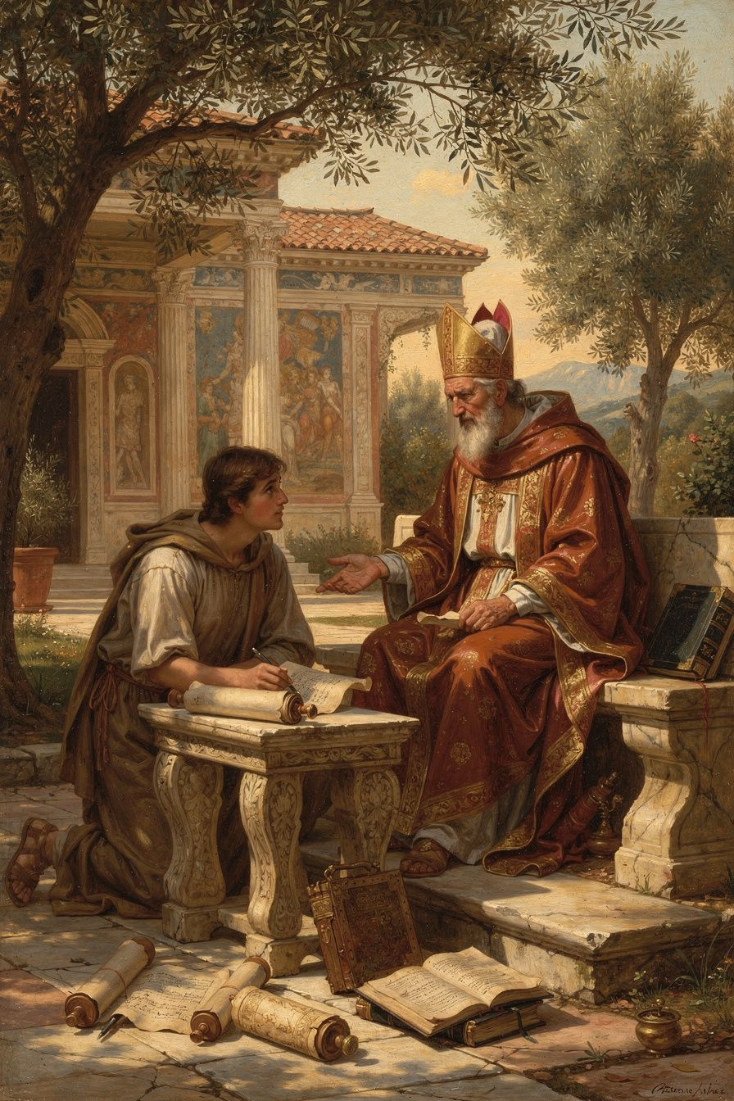
Illustration for Chapter 3

Augustine's Crisis
When Augustine arrived in Milan in 384 as a professor of rhetoric, he was brilliant and miserable. He had spent nearly a decade as a Manichaean "hearer" — a member of a dualist religion that taught the material world was created by an evil power and that the body was a prison for the soul. But Manichaeism was losing its hold. Its scientific claims were false — the Manichaean account of the heavens did not match observed reality. Its leaders were intellectually thin. Augustine was in freefall, having lost his old faith without finding a new one.
His central problem was the Old Testament. The Manichees had taught him to scorn it — a God who walks in a garden, a patriarch who lies, a prophet who runs away. These stories seemed crude, unworthy of a true religion. Augustine could not reconcile them with the philosophical monotheism he was beginning to find attractive.

Ambrose's Allegorical Method
Ambrose's preaching solved this problem. Following the Alexandrian tradition of Origen, Ambrose read the Old Testament allegorically. The literal surface was not the whole meaning; beneath it lay a spiritual sense that pointed to Christ, to the soul, and to the church. The garden of Eden was not merely a place; it was the soul's original state. The Song of Songs was not about romantic love; it was about the love between Christ and the church.
Augustine described the effect in Confessions 5.14: "I rejoiced also that the Old Testament Scriptures were now set before me by Ambrose, not as objects of scorn, as I had previously thought them, but were expounded with a spiritual interpretation, so that I could not blame those who believed in them."
This was not a rejection of the literal text. It was a way of reading at multiple levels simultaneously — literal, moral, and typological. The literal sense was the foundation; the spiritual senses built on it without abolishing it. The method allowed Augustine to take the Old Testament seriously as Christian Scripture without having to defend every literal detail as straightforward.

The Personal Dimension
The breakthrough was not only intellectual. Ambrose was personally kind to Augustine — a pastoral approach that was patient, warm, and intellectually serious. Augustine wrote: "I began to love him, not at first as a teacher of the truth, for I had despaired of finding that in your Church, but as a man who was kind to me" (Confessions 5.13).
Ambrose did not argue Augustine into the kingdom. He welcomed him, preached well, and waited. This model of pastoral care — intellectual seriousness combined with personal warmth — would shape Augustine's own ministry as bishop of Hippo. The lesson is that adults do not come to faith through argument alone; they come through the encounter with a community that is both intellectually credible and personally welcoming.

The Garden and the Baptism
The pivotal moment came in a garden in Milan. Augustine, in agony over his inability to change his life, heard a child's voice saying: "Take up and read. Take up and read." He opened Paul's letters at random and read Romans 13:13–14. All the darkness of doubt was dispelled. On the night of April 24–25, 387, Ambrose baptized Augustine, his son Adeodatus, and his friend Alypius at the Easter Vigil. The singing of the Ambrosian hymns moved Augustine to tears: "How I wept during your hymns and songs! I was deeply moved by the voices of your sweet-sounding church" (Confessions 9.6).

What Ambrose Gave Augustine
1. A way of reading Scripture. The allegorical method gave Augustine a way to read the Old Testament as Christian Scripture. This method would shape Augustine's own exegetical works, especially On Christian Doctrine and The Literal Meaning of Genesis.
2. A model of the church. Ambrose showed Augustine that the church was not the anti-intellectual body the Manichees mocked. It was a community of worship, mutual care, and intellectual seriousness — a bishop who preached, wrote, confronted emperors, and sang with his people.
3. A liturgical imagination. Ambrose's hymns, mystagogical catechesis, and liturgical innovations gave Augustine a sense of the sacramental life of the church. The sacraments were not mere symbols; they were encounters with divine grace.

Where Augustine Went His Own Way
Augustine was not Ambrose's clone. He differed in temperament, intellectual style, and the problems he faced:
- Systematic vs. pastoral. Ambrose was a pastoral theologian whose ideas emerged from preaching. Augustine was a systematic thinker who pursued questions to their logical conclusions. Ambrose never wrote anything like Augustine's De Trinitate — a sustained, fifteen-book exploration of Trinitarian theology.
- Original sin and grace. Augustine's doctrine of original sin, developed in his controversy with the Pelagians, has no parallel in Ambrose. Ambrose spoke of sin and grace, but he did not develop the systematic account of inherited guilt and the absolute necessity of grace that Augustine built. This is not a disagreement — Ambrose died before the Pelagian controversy began — but it is a real difference in theological depth.
- The will and the interior life. Augustine's exploration of the will, memory, and the interior life — the great achievement of the Confessions — has no parallel in Ambrose. This is Augustine's unique contribution, made possible by his own genius and his particular struggles.
- Neoplatonism. Both Ambrose and Augustine were influenced by Neoplatonism, but in different ways. Ambrose borrowed from Plotinus directly, using Neoplatonic language for the soul's ascent. Augustine engaged Neoplatonism more critically, both drawing on it and moving beyond it toward a distinctively Christian account of grace, incarnation, and the will.

Scholarly Debate: How Deep Was Ambrose's Influence?
The extent of Ambrose's influence on Augustine has been debated. The traditional view, following Peter Brown's Augustine of Hippo (2000), emphasizes the decisive role of Ambrose's allegorical preaching in unlocking the Old Testament and enabling Augustine's conversion. McLynn (1994) has offered a more nuanced account, noting that Augustine's relationship with Ambrose may have been more distant than the Confessions suggest — Augustine's praise of Ambrose's kindness may be conventional rhetoric rather than evidence of a close personal relationship.
The question of influence is complex because the Confessions are not a straightforward autobiography. They are a theological memoir, written years after the events, shaped by Augustine's later concerns. The Ambrose of the Confessions may be as much a literary construction as a historical memory. But even McLynn acknowledges that Ambrose's allegorical method was the intellectual breakthrough that made Augustine's conversion possible. The disagreement is about the personal relationship, not the theological influence.
The Big Idea
The way you read a text determines what you can find in it. Augustine could not read the Old Testament literally because the Manichees had taught him to see it as crude. Ambrose's allegorical method freed him — not by abandoning the literal text but by showing that the literal is not the whole meaning. The same principle applies to every text, every person, and every situation: if you read at only one level, you will miss the depth. And the pastoral dimension matters: Ambrose did not argue Augustine into the kingdom. He welcomed him, preached well, and waited. The best teachers do not push. They open doors and let you walk through. Adults come to faith through the encounter with a community that is both intellectually credible and personally welcoming — not through argument alone.
Practice
1. Read a text at three levels. Take a story or passage you know well — from literature, scripture, or your own life. Write three paragraphs: (a) the literal meaning (what happened), (b) the moral meaning (what it teaches about how to live), (c) the spiritual or allegorical meaning (what it symbolizes about the deeper nature of reality). How does the multi-level reading change your understanding? Does it enrich or distort the literal?
2. Compare Ambrose and Augustine on a shared theme. Both wrote on the sacraments, on the interpretation of Scripture, on virginity and marriage, on political authority. Choose one theme and compare their treatments. Where does Augustine develop what Ambrose began? Where does he diverge? What does this tell you about how traditions are transmitted and transformed?
3. Reflect on pastoral care. Think about a time when someone's kindness — not their argument — changed your mind or your life. Write one page about that experience, using Ambrose's model (kindness + intellectual seriousness) as a framework. What does this tell you about how adults actually change? And what does it tell you about the role of the teacher, pastor, or friend?
Reflect
Augustine knew the truth before he changed his life. The gap between knowing and doing was his central struggle — and it is everyone's struggle. Ambrose did not solve this gap by argument. He solved it by welcome: a kind man who preached well and waited. Who in your life is waiting for a welcome rather than an argument? And are you willing to give it?
———

Chapter 4: The Sacraments — Mystery, Real Presence, and the Power of the Word
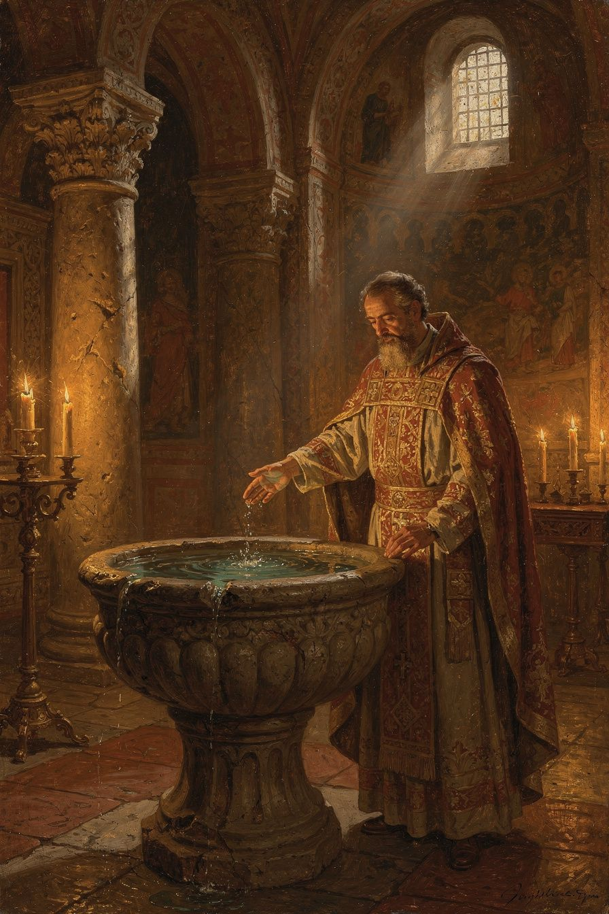
Illustration for Chapter 4

The Disciplina Arcani and Mystagogy
In the early church, the sacraments were not explained in detail to catechumens before baptism. This practice, the disciplina arcani (discipline of the secret), kept the specifics of the rites hidden from outsiders. The full explanation came after baptism, during Easter week, when the newly initiated — still in the glow of their initiation — were taught what they had experienced.
This post-baptismal instruction is called mystagogy — "leading into the mystery." The mystagogue interprets an experience the learner has already had — naming what was felt, revealing the theology enacted in the ritual. Ambrose's mystagogy is preserved in De Mysteriis (On the Mysteries) and De Sacramentis (On the Sacraments), the earliest surviving Western mystagogical catechesis.

Baptism: Regeneration Through Water, Spirit, and Blood
Ambrose treats baptism as a real transformation — a new birth. He develops this through biblical typology: the water carries the power of the cross; the Spirit hovers over the font as over the waters of creation; the flood, the Red Sea crossing, and Naaman's washing all prefigure the baptismal font. The result is regeneration, not merely forgiveness: "You were made new," because the old self was buried in the water and the new self rose with Christ.
After baptism, the bishop lays hands on the newly baptized and anoints them with chrism. Ambrose interprets this as the giving of the seven gifts of the Holy Spirit (Isaiah 11:2) and the consecration of the person as a spiritual priest. Christ (Christus) means "the anointed one" — and the baptized, anointed with the same Spirit, share in that anointing.

The Eucharist: The Real Presence
Ambrose's treatment of the Eucharist is one of the earliest and clearest Western statements of the doctrine of the real presence:
"You perhaps say, 'My bread is the usual kind.' But this bread is bread before the words of consecration; after the consecration it has become the flesh of Christ. ... Before the blessing, a certain thing is named; after the blessing, another." (*De Sacramentis* 4.4.14–15)
His argument is not philosophical — he does not try to explain how the change occurs. His argument rests on the power of the divine word: "If the word of the Lord Jesus was able to make out of nothing what did not exist, how much more can it transform what already exists into something else?" He distinguishes the Eucharist from the Old Testament types — the manna and the bread of Elijah — which nourished the body but did not give eternal life. The Eucharist is the food of immortality.

Scholarly Debate: De Sacramentis vs. De Mysteriis
De Mysteriis is universally accepted as authentically Ambrosian. De Sacramentis has been disputed since the sixteenth century. The two works cover the same ground but differ in vocabulary, style, and theological emphasis. Some scholars attribute De Sacramentis to a later author; others argue it is a stenographic record of Ambrose's preached sermons, while De Mysteriis is Ambrose's own polished literary version.
The debate matters for sacramental theology. De Sacramentis contains some of the strongest patristic statements on the real presence. If it is Ambrose, it gives the doctrine an early and authoritative witness. If it is a stenographic record, the witness is filtered through a note-taker's ears. The current scholarly consensus inclines toward authenticity or at least a very close connection to Ambrose. Craig Satterlee's Ambrose of Milan's Mystagogical Method (2002) argues that the internal evidence — theological consistency with Ambrose's other works, knowledge of the Milanese liturgy, and the mystagogical method — supports Ambrosian authorship or origin.
The debate also connects to a larger question about patristic texts: in the ancient world, sermons were often recorded by stenographers and circulated without the author's revision. The boundary between oral performance and written text was far more porous than in the modern world. Many texts we read as "by" a particular father may be records of their spoken words, filtered through hearers' hands.

Scholarly Debate: Ambrose and Neoplatonism
Ambrose's theology of the soul shows the influence of Neoplatonism — the philosophy of Plotinus (c. 204–270), which described the soul's journey from material distraction to contemplative union with the One. Ambrose read Plotinus directly and used Neoplatonic language in works like De fuga saeculi (On Flight from the World). He described the body as a temporary dwelling, the soul's true home as with God, and death as a liberation.
The scholarly debate concerns how deeply Neoplatonism shaped Ambrose. Pierre Hadot sees Ambrose as essentially a Christian Platonist. G. Madec argues that the use is superficial — borrowed vocabulary rather than borrowed philosophy. The truth may be that Ambrose used Neoplatonic language the way he used Ciceronian structure: as a container for Christian content. The soul's ascent is not the Plotinian return to the One through intellectual effort but the Christian journey to God through grace, sacrament, and the imitation of Christ. Ambrose did not reject Neoplatonism; he redirected it.

The Nature of Sacrament
For Ambrose, sacramentum is broader than the later medieval category of "seven sacraments." It encompasses any sacred sign or mystery through which divine grace is mediated. The term mysterium is used almost interchangeably. What makes something a sacrament is its capacity to make present the reality it signifies. The water of baptism is the womb of regeneration; the bread of the Eucharist is the body of Christ. The sign does not merely point to grace — it carries it.
This does not mean Ambrose is naive about the distinction between sign and reality. The external form remains perceptibly what it was. But the spiritual reality is not less real than the physical sign — it is more real. The sacrament is an encounter with the living God, mediated through created things that God has chosen as vehicles of grace. This is a theology of mediation: God works through material things, not around them. The created order is not an obstacle to grace but a vehicle for it.
The Big Idea
Ambrose's sacramental theology rests on a single principle: the power of the divine word. The same word that created the world from nothing transforms bread into body and water into a womb of regeneration. This is not a philosophical argument about how the change occurs — it is a theological argument about who speaks the word. The sacraments are not symbols that remind us of God; they are encounters with God, mediated through created things. And the mystagogical method — explaining the experience after you have had it — respects the mystery: you cannot fully understand a sacrament until you have participated in one, because understanding follows experience, not the other way around. This is a theology of mediation: God works through material things, not around them, and the created order is not an obstacle to grace but a vehicle for it.
Practice
1. Compare sacrament and symbol. Write a careful analysis of the difference between a symbol that points to something and a sacrament that carries something. Use Ambrose's analogy: if the word that creates from nothing can also transform what exists, what does this say about the relationship between sign and reality? Then think of non-religious examples: is there anything in your life that functions sacramentally — a physical thing that carries a deeper reality? A wedding ring, a family heirloom, a photograph? What makes these more than symbols?
2. Research the stenographic hypothesis. The debate about De Sacramentis is a window onto how ancient texts were transmitted. Read Satterlee's Ambrose of Milan's Mystagogical Method (2002) or a summary of the debate. What are the arguments for and against? What is at stake theologically? Does it matter who wrote the text, or only what it says? How does this compare to modern questions about authorship and authority in sacred texts?
3. Reflect on the disciplina arcani. The early church kept the sacraments secret and explained them only after baptism. Modern churches tend toward transparency. Write one page comparing the two approaches: what is gained and lost by each? How does this compare to modern practices of open vs. closed communion, or to the broader cultural question of what should be public and what should be private?
Reflect
Ambrose's mystagogy operates on the principle that some things can only be understood from the inside. You cannot fully explain an experience you have not had. Have you encountered something like this — a practice, a ritual, a discipline, a relationship — that you could not understand until you were inside it? What does this say about the limits of explanation, and about the relationship between experience and understanding?
———

Chapter 5: The Hymns — Enchantment, Creed, and the Birth of Congregational Song
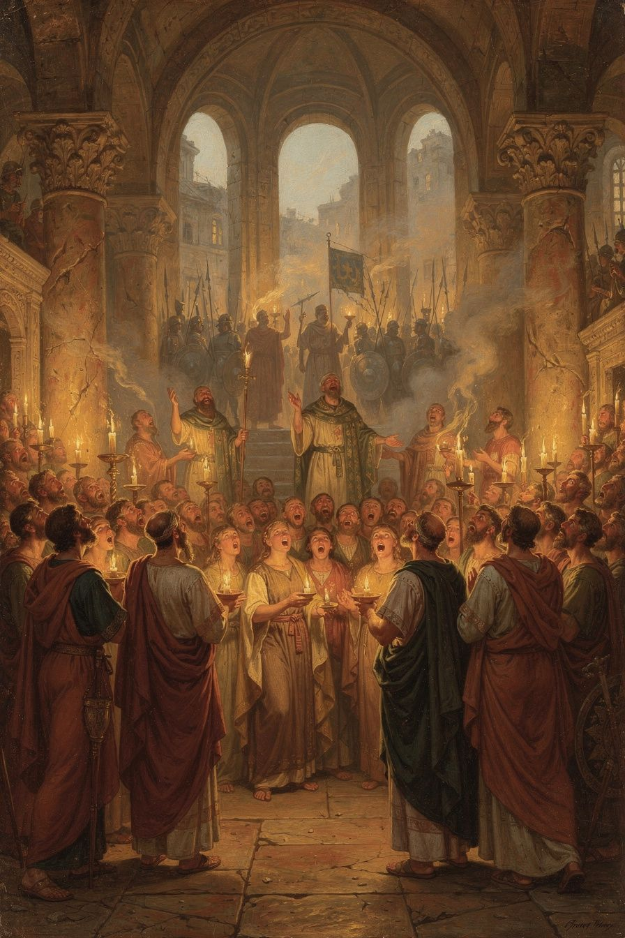
Illustration for Chapter 5

The Invention of Congregational Hymnody
Before Ambrose, Latin Christian hymnody was limited. Hilary of Poitiers (c. 310–367) had composed Latin hymns in the 350s, but his hymns were complex, literary, and apparently not widely used. Ambrose changed this. His hymns are short — typically eight stanzas of four lines each, in strict iambic tetrameter. This meter is the simplest and most memorable in Latin poetry: it matches the natural rhythm of the language, making the hymns easy to learn and sing, even for people without formal education. The vocabulary is simple, the imagery is vivid, and the theological content is dense but accessible.
The result was something new: hymns that the whole congregation could sing together, remember, and internalize. They were born in crisis — during the basilica standoff of 385–386, when Ambrose's congregation barricaded themselves inside their church and sang through the night.

The Four Authentic Hymns
Only four hymns are universally conceded to be authentically Ambrosian, on the authority of Augustine:
1. Aeterne rerum conditor ("Eternal Maker of all things") — A morning hymn for the office of cockcrow. It praises God as creator and asks Christ, the light of the world, to dispel the darkness.
2. Deus creator omnium ("God, Creator of all things") — An evening hymn meditating on the transition from day to night as a figure for the passage from life to death.
3. Iam surgit hora tertia ("Now the third hour rises") — A hymn for the third hour, connecting the hour of prayer with the events of Christ's passion and Pentecost.
4. Veni redemptor gentium ("Come, Redeemer of the nations") — An Advent hymn presenting the incarnation as the descent of divine majesty into human flesh. It explicitly affirms Nicene Christology. Martin Luther later translated this hymn, producing "Nun komm, der Heiden Heiland," one of the foundational hymns of the Reformation.

The Basilica Crisis and the Birth of the Hymns
The most famous account comes from Augustine's Confessions (9.7): "How much did I weep at your hymns and songs, how keenly was I moved by the sweetly sounding voices of your church! The voices flowed in through my ears and the truth was distilled in my heart."
The hymns served three purposes during the siege: morale (channeling fear into worship), unity (binding the congregation into a single body through shared song), and theological formation (embedding Nicene doctrine in communal memory). Ambrose described the purpose as "the confession of the Trinity in the mouths of the whole people." The hymns are not decoration; they are doctrinal formation through the body.

Enchantment and Creed
Brian Dunkle's Enchantment and Creed (Oxford, 2016) reframes the scholarly understanding. Dunkle argues that the hymns function through enchantment — the capacity of sung poetry to captivate the mind, embed ideas in memory, and shape the affections. The hymns do not merely state doctrine; they enchant the singer with the beauty of the truth.
This is connected to the ancient understanding of music's power. From Plato onward, philosophers recognized that music shapes the soul — that the rhythms and melodies a person internalizes become the patterns of their thought and feeling. Ambrose chose the simplest and most memorable meter because he wanted the hymns to be unforgettable. He chose vivid imagery because he wanted them to captivate the imagination. He chose theological density because he wanted the beauty of the form to carry the weight of the content.
The result is a fusion of enchantment (the aesthetic power of the hymn) and creed (the doctrinal content it carries). The singer is enchanted by the beauty of the hymn, and in being enchanted, absorbs the creed. This is not indoctrination in a crude sense — it is the formation of a community through shared beauty. The congregation that sings together becomes a community that believes together, because the beauty of the song has become the form of their faith.

Scholarly Debate: Authorship and the Ambrosian Tradition
The Ambrosian hymn corpus has been debated for centuries. Medieval tradition attributed dozens of hymns to Ambrose. Modern scholarship has drastically reduced the number. The fundamental problem is that "Ambrosian" became a genre, not just an attribution. Hymns written in the Ambrosian style — iambic dimeter, Nicene theology, liturgical assignment — were called "Ambrosian" as a compliment, not a deception.
Dunkle's work represents a cautious rehabilitation. Using criteria of near-contemporary citation, early manuscript witnesses, and stylistic consistency, he defends the Ambrosian authorship of additional hymns, including Splendor paternae gloriae. Even on his more generous reading, the number of confidently Ambrosian hymns remains small — perhaps a dozen, not the dozens of the medieval tradition.
The Te Deum, traditionally attributed to Ambrose and Augustine as an improvisation at Augustine's baptism, is almost certainly not by Ambrose. Modern scholarship dates it to the late fourth or early fifth century and identifies it as a North African composition, possibly by Nicetas of Remesiana. The attribution is a medieval legend without historical foundation.

The Legacy
Ambrose's influence on Western hymnody is immense. The Ambrosian model became the standard for Latin hymns for a thousand years. The practice of congregational singing spread from Milan throughout the Latin church. The hymns were copied, adapted, and translated across centuries. Luther's reformation hymnody drew directly on the Ambrosian tradition. The English hymn tradition also carries the Ambrosian DNA.
The deepest legacy is not the specific hymns but the principle: that worship is not a spectator event but a participatory practice, and that the voice of the people — raised in song — is one of the most powerful forces in the life of the church. Before Ambrose, theology was largely the business of bishops and philosophers. After Ambrose, theology was also the business of the congregation — sung in hymns, memorized in meters, carried in the bodies of ordinary people. This is a democratization of theology: not the abolition of learned theology, but the addition of a form accessible to all.

Scholarly Debate: The Textual Transmission of Ambrose's Works
The broader question of how Ambrose's texts survived is itself a scholarly problem. The critical edition of Ambrose's works in the Corpus Scriptorum Ecclesiasticorum Latinorum (CSEL), edited by Otto Faller and others, represents the foundation of modern Ambrosian scholarship. But the manuscript tradition is complex — some works survive in multiple recensions, others in single manuscripts, and the relationship between authentic works, stenographic records, and later imitations is not always clear. The Thesaurus — a collection of Ambrosian texts assembled for liturgical use — has been studied by scholars as a window onto how Ambrose was read in the centuries after his death. The question of textual transmission is not merely technical: it shapes what we can know about Ambrose's actual thought, as distinct from what later editors and imitators attributed to him.
This connects to the larger scholarly question about the patristic canon: how do we determine which texts are authentic, and what does authenticity mean in a tradition of preaching, stenographic recording, and liturgical adaptation? The Ambrosian corpus — with its mix of authenticated treatises, disputed works, stenographic sermons, and later imitations — is a case study in the complexity of authorship in late antiquity.
The Big Idea
The hymns reveal that theology does not only happen in books and arguments. It happens in worship, in song, in the bodies of ordinary people. Ambrose understood that what a community sings, it believes. He chose the simplest and most memorable form because he wanted the hymns to be unforgettable. The result is a fusion of enchantment and creed — the singer is formed by beauty while absorbing doctrine. This is not indoctrination; it is formation through shared beauty. And it reveals a principle that extends beyond church: what you sing shapes what you believe, and the songs a community shares are as important as the arguments it makes. If you want to know what a culture believes, listen to what it sings.
Practice
1. Analyze an Ambrosian hymn. Find one of the four authentic hymns online (search for "Veni redemptor gentium" or "Aeterne rerum conditor" in Latin and English). Write a detailed analysis: (a) What theology does it contain? (b) How does the four-line stanza structure make it memorable? (c) What scriptural imagery does it use? (d) How does it function as both prayer and teaching? (e) What is the relationship between the aesthetic form and the doctrinal content?
2. Compare singing and arguing. Think of a debate you have witnessed about politics, religion, or values. Now think of a song that expresses a similar idea. Which is more persuasive — the argument or the song? Write one page exploring the difference between rational persuasion and aesthetic formation. What does this tell you about the relationship between reason and beauty in shaping belief? Which lasts longer in the imagination?
3. Reflect on the music of your life. What songs have shaped you — not just songs you enjoy, but songs that have changed how you see the world? Write one page about the relationship between the music you have internalized and the beliefs you hold. If you wanted to embed a value deep in your own life, would you write an essay or a song? Which would last longer?
Reflect
Ambrose's hymns were born in danger and sustained a community through a siege. They gave the people courage, unity, and faith — not through argument but through beauty. The deepest legacy is the principle: that what we sing shapes what we believe, and that worship is not a spectator event but a participatory practice. What would change in your life if you treated the songs you sing as seriously as the arguments you make?
———

Chapter 6: Theodosius, Callinicum, and the Limits of Power — Accountability, Injustice, and Death
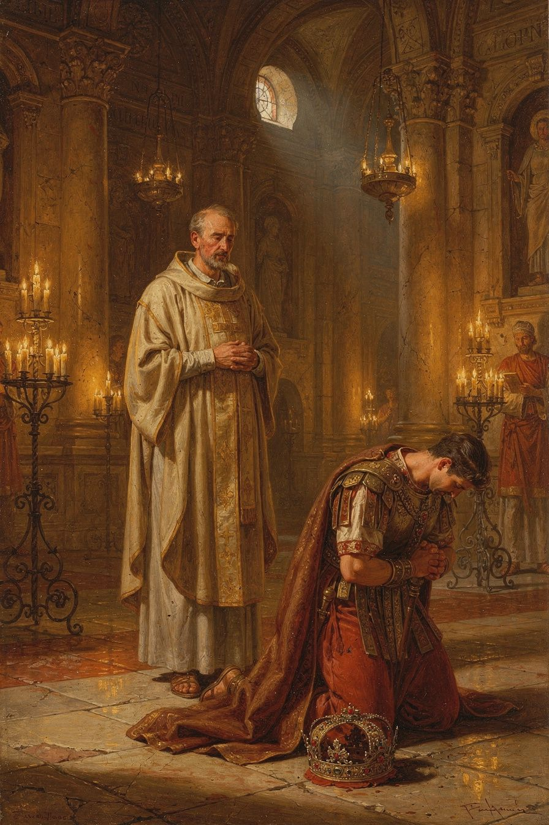
Illustration for Chapter 6

The Massacre at Thessalonica
In 390 CE, a riot broke out in Thessalonica after the arrest of a popular charioteer. Botheric, the commander of the imperial garrison, was killed. Emperor Theodosius I, known for his hot temper, ordered a reprisal. Imperial troops were sent to the city and given orders to slaughter the population. The attack was carried out in the circus, where the people had been summoned for what they thought was a public event. Thousands of civilians — men, women, and children — were massacred.

Ambrose's Letter
When Ambrose learned of the massacre, he wrote to Theodosius. The letter is remarkable for its blend of personal affection and moral severity. He told the emperor that he could not offer him communion until he demonstrated repentance. He invoked the biblical example of King David, rebuked by the prophet Nathan. He wrote:
"Sin is not done away but by tears and penitence. Neither angel can do it, nor archangel. The Lord Himself, Who alone can say, 'I am without sin,' forgives no one without repentance."
And: "Your subjects, O Emperor, are of the same nature as yourself, and not only so, but are likewise your fellow servants; for there is one Lord and Ruler of all, and He is the Maker of all creatures, whether princes or people. How could you lift up in prayer hands steeped in the blood of so unjust a massacre?"
This was without precedent. No bishop had ever told a reigning emperor that he could not receive the sacrament until he repented. The implications were staggering: the most powerful man in the Roman world was being told that his power did not place him above moral law or divine judgment.

Theodosius Submits
Theodosius submitted. He came to the cathedral of Milan, stripped of his imperial robes, and stood among the congregation as a penitent. The penance lasted approximately eight months. He was not permitted to enter within the altar rail. He accepted the distinction.
Ambrose also stipulated that the emperor enact a law requiring a thirty-day delay between the issuance of any death sentence and its execution. This "cooling-off period" was designed to ensure that the emperor's wrath would not result in hasty, irreversible acts. The law was promulgated — one of the earliest examples of a penitential act producing structural legal reform.

The Historical Reality
Modern scholars have revised the popular image. The dramatic scene of Ambrose barring Theodosius at the cathedral door is a later legend, invented by the fifth-century historian Theodoret. The actual process was conducted through letters and voluntary submission. McLynn (1994) argues that the relationship was one of negotiation between two powerful institutions. Some scholars, notably Mikhail Boytsov, argue that the penance was a "propaganda victory" for Theodosius — the emperor turned the act of penance into a display of Christian piety that strengthened his legitimacy. Irene Van Renswoude has argued that the excommunication was not spontaneous but the culmination of Ambrose's long intellectual reflection on penance, developed in his treatises De Poenitentia.
The revised picture does not diminish Ambrose's significance. It refines it. The principle — that the church has an independent moral authority that the state cannot override — was real and unprecedented. The fact that Theodosius submitted voluntarily makes the principle more, not less, significant: even the most powerful man in the world acknowledged that he was subject to a moral authority beyond his own.

The Callinicum Problem
Ambrose's political theology was not always admirable. In 388, Christians at Callinicum destroyed a local synagogue. Theodosius ordered the offenders punished and the synagogue rebuilt at the bishop's expense. Ambrose wrote to protest, arguing that a bishop could not use church funds to rebuild a Jewish place of worship. He warned Theodosius that the people would say "the emperor has become a Jew." He even offered to burn the synagogue himself.
The letter is deeply troubling. It reflects the anti-Jewish attitudes common in fourth-century Christianity. But it also reveals the logic of Ambrose's political theology: the church's resources are dedicated to God and cannot be diverted to purposes contrary to the faith. The same principle that animated the basilica crisis — that sacred things are not subject to imperial power — was applied here in a way that modern readers must judge critically.
This is the central tension in Ambrose's legacy. At Thessalonica, Ambrose used the principle to hold a mass murderer accountable. At Callinicum, he used the same principle to defend the destruction of a synagogue. The question is not whether the principle is right — it is whether the person applying it is wise enough, and just enough, to use it rightly. A good principle in the hands of a flawed person can produce injustice. This is a permanent problem in political theology: principles do not apply themselves. They are applied by people, and people are shaped by their culture, their prejudices, and their interests.

The Principle and Its Legacy
The event established a principle that shaped Western civilization: the ruler is subject to the moral law and to the discipline of the church. The emperor is not above God. Temporal power does not exempt a person from accountability for evil. The "two swords" doctrine — the distinction between temporal and spiritual authority — would develop from this seed over the following centuries, through Gelasius, Gregory VII, and the medieval canon lawyers.
This is not the separation of church and state in the modern sense. Ambrose was not arguing that the church should control the government. He was arguing that the church has an independent moral authority that the state cannot override, and that the spiritual consequences of sin apply to rulers as much as to the ruled. The question for modern readers is whether this principle is still viable in a secular society, or whether it depends on a shared religious framework that no longer exists.

Ambrose's Death
Ambrose died on Holy Saturday, April 4, 397 CE. He was about fifty-seven. His last words, reported by Paulinus, were: "I have not lived in such a way that I am ashamed to go on living; nor do I fear to die, for we have a good Lord." He died with his arms stretched out in the form of a cross. The timing — Holy Saturday, the day between Good Friday and Easter — was theologically significant.
His funeral orations — De obitu Valentiniani and De obitu Theodosii — were not merely eulogies. They were acts of formation: by interpreting death in the light of the Gospel, Ambrose taught his congregation how to think about their own mortality. In De obitu Valentiniani, he addressed the death of a young emperor under suspicious circumstances. In De obitu Theodosii, he celebrated the emperor who had been his adversary and his penitent. Both orations use the occasion of death to teach the living about the meaning of life, death, and resurrection.
His theology of death, developed in De bono mortis (On the Goodness of Death), argues that bodily death is natural, not evil; that death liberates the soul; and that the resurrection of Christ is the ground of Christian hope. The preparation for death is not a set of last-minute rituals but the shape of an entire life. A person who has lived honestly, generously, and faithfully will find death a completion, not a catastrophe. The question is not "Am I ready to die?" but "Am I living in such a way that I would be ready?"
The Big Idea
The Theodosius affair established that even the most powerful person in the world is subject to moral accountability. But the Callinicum affair shows that the same principle — that the church has its own sphere — can be used for injustice. The lesson is not "bishops are always right" but "no one is above accountability — not an emperor, and not a bishop." A good principle in the hands of a prejudiced person produces injustice. This is a permanent problem in political theology: principles do not apply themselves. The question is not only whether the principle is right but whether the person applying it is wise enough and just enough to use it rightly. And Ambrose's deathbed standard — "I have not lived in such a way that I am ashamed to go on living" — is a rigorous measure that applies the accountability principle inward: not just to emperors, but to each of us.
Practice
1. Analyze the Callinicum letter. Read Ambrose's letter about Callinicum (available in NPNF 2.10 or Liebeschuetz, Political Letters and Speeches). Write a careful analysis: (a) What principle was Ambrose applying? (b) How was that principle used for an unjust purpose? (c) Does the unjust application invalidate the principle? (d) How do we distinguish between a good principle badly applied and a bad principle? (e) What would a responsible use of the same principle look like in this case?
2. Debate the cooling-off law. Ambrose asked Theodosius to enact a thirty-day waiting period before any execution. Write one page: is this a model for how penitence can produce structural reform? What would a modern equivalent look like — not just for the death penalty, but for any irreversible act of state power? Design a "cooling-off rule" for your own life: a rule that prevents you from acting rashly when angry. Write it down and commit to it.
3. Compare Ambrose and a modern accountability figure. Think of a modern person who has held a powerful leader accountable — a journalist, a whistleblower, a religious leader, a prosecutor. Write a comparative analysis: What was the risk? What was the method? What was the outcome? Is the Ambrose model — moral authority confronting political power — still viable in a secular society? What replaces the bishop's authority when the church's authority is no longer publicly recognized?
Reflect
Ambrose said: "I have not lived in such a way that I am ashamed to go on living; nor do I fear to die, for we have a good Lord." This is not a deathbed platitude. It is a standard of accountability applied to one's own life. Not "Have I done enough good things?" but "Am I living in such a way that I would not be ashamed to continue?" What would change in your life if you adopted this as your measure — not as a final judgment, but as a daily question? And what would change in your community if the powerful were held to the same standard — not by a bishop, but by the moral conscience of the people?
———

For the Grown-Up Reader
This adult booklet engages Ambrose of Milan (c. 340–397 CE) as a serious historical and theological figure. All quotes are real, drawn from Ambrose's own writings and from contemporary witnesses. The primary sources are:
- Ambrose, De officiis ministrorum (On the Duties of the Clergy), trans. Ivor J. Davidson, Oxford Early Christian Texts, 2 vols. (Oxford University Press, 2002). The first sustained Christian manual of public ethics, modeled on Cicero's De officiis. - Ambrose, De Mysteriis (On the Mysteries) and De Sacramentis (On the Sacraments), ed. O. Faller, CSEL 73 (1955); English trans. R. H. Connolly and in NPNF 2.10. The earliest surviving Western mystagogical catechesis. - Ambrose, Epistulae (Letters), ed. O. Faller and M. Zelzer, CSEL 82/1–4 (1968–1996); English trans. Mary Melchior Beyenka, Fathers of the Church Vol. 26 (CUA Press, 1954) and J. H. W. G. Liebeschuetz, Ambrose of Milan: Political Letters and Speeches (Liverpool University Press, 2005). - Ambrose, Hymns, ed. J. Fontaine, Ambroise de Milan: Hymnes (Paris: Cerf, 1992). The four authentic hymns are Aeterne rerum conditor, Deus creator omnium, Iam surgit hora tertia, and Veni redemptor gentium. - Ambrose, De Nabuthae (On Naboth), in Fathers of the Church Vol. 42 (CUA Press, 1961). The sustained treatment of wealth and poverty. - Ambrose, De bono mortis (On the Goodness of Death) and De fuga saeculi (On Flight from the World), in Fathers of the Church Vol. 65 (CUA Press, 1967). - Augustine, Confessions 5–9, trans. Sarah Ruden (Modern Library, 2017) or Henry Chadwick (Oxford, 1991). The most important witness to Ambrose's pastoral impact. - Paulinus of Milan, Vita Sancti Ambrosii (Life of St. Ambrose), in Early Christian Biographies. - Theodoret of Cyrrhus, Ecclesiastical History 5.17–18, on the Thessalonica affair.
Key secondary sources: Neil B. McLynn, Ambrose of Milan: Church and Court in a Christian Capital (University of California Press, 1994) — the standard modern study; Brian P. Dunkle, Enchantment and Creed: The Ambrosian Hymns and Liturgical Theology (Oxford University Press, 2016) — the best study of the hymns; Peter Brown, Augustine of Hippo: A Biography (UC Press, 2000) and Through the Eye of the Needle: Wealth, the Fall of Rome, and the Making of Christianity in the West (Princeton, 2012); Daniel H. Williams, Ambrose of Milan and the End of the Nicene-Arian Conflicts (Oxford, 1995); Ivor J. Davidson, Ambrose: De Officiis, 2 vols. (Oxford, 2002); J. H. W. G. Liebeschuetz, Ambrose and John Chrysostom: Clerics between Desert and Empire (Oxford, 2011).
The booklet is honest about Ambrose's limitations. The Callinicum letter is presented as a real stain — the same principle that enabled the Thessalonica confrontation was used to defend the destruction of a synagogue. The popular image of Ambrose barring Theodosius at the cathedral door is identified as a later legend (Theodoret, debunked by McLynn and Cameron). The scholarly debates about the election's spontaneity, De Sacramentis authorship, Neoplatonic influence, and hymn attribution are all engaged at a level appropriate for adult readers.
———

About WisdomForge
WisdomForge produces four age-adapted booklets for each figure: elementary (ages 5–10), middle (ages 11–14), high (ages 15–18), and adult. Each booklet covers the same person, ideas, and stories, but at a different level of depth and complexity. The elementary booklet tells stories. The middle booklet explains ideas. The high booklet argues and analyzes. The adult booklet engages with scholarly debates and primary sources. Read the one that fits — or read them all and watch the same figure grow.

