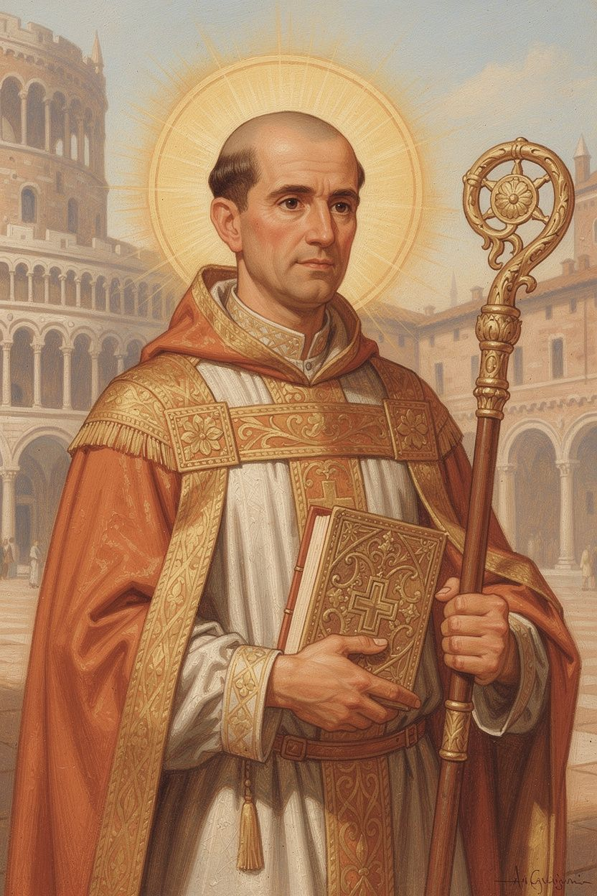
Ambrose: The Bishop Who Said No
WisdomForge Booklet — Ages 5–10

Ambrose: The Bishop Who Said No

WisdomForge Booklet — Ages 5–10
———

About This Book
About 1,700 years ago, in a city called Milan, there lived a man named Ambrose. He was not a bishop. He was not a priest. He was a governor — a very important leader who helped run the city and keep the peace. He was good at his job. People respected him.
Then one day, something surprising happened. He walked into a church to keep order during a noisy argument, and a child's voice called out: "Ambrose, bishop!" The whole crowd started shouting. They wanted him to be their new leader — even though he had not even been baptized yet.
Ambrose said no. He tried to hide. He tried to run away. But the people would not give up. So Ambrose said yes — and everything changed. He gave away his money to poor people. He learned how to read the Bible. He wrote songs that people still sing today. He stood up to a queen who wanted to take his church. He even told an emperor he had to say sorry for doing something terrible.
This booklet tells six stories from Ambrose's life. Each one has a story, words to remember, a big idea, something to try, and a question to ask a grown-up. Read it alone or with someone you love. The questions are not tests. They are doors to walk through together.
———

Chapter 1: The Governor Who Became a Bishop
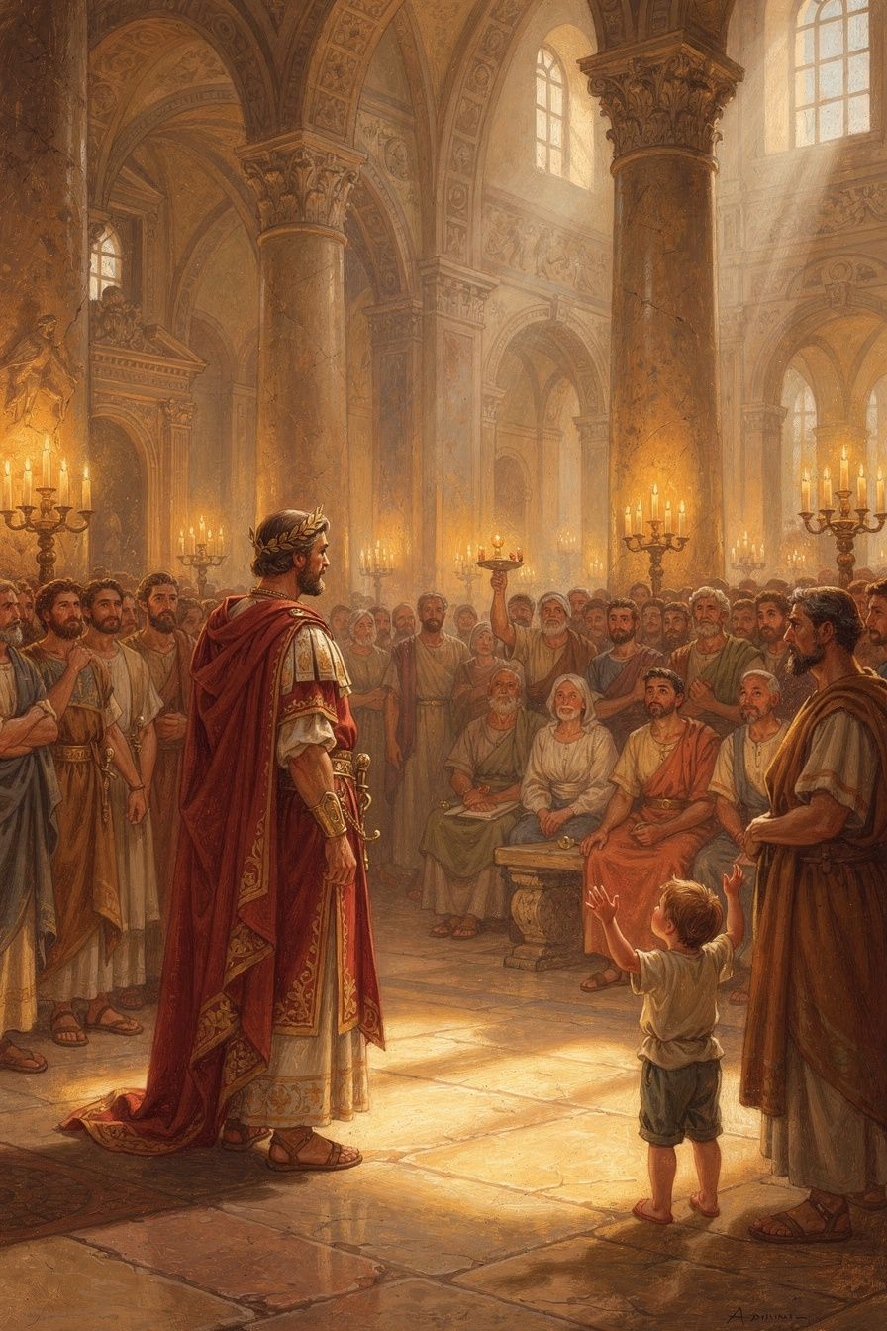
Illustration for Chapter 1
Ambrose lived in a city called Milan, a long, long time ago. Milan was one of the most important cities in the whole Roman Empire. Emperors lived there. Soldiers marched through its streets. And Ambrose was the governor — the person the emperor trusted to keep everything running smoothly.
Ambrose was very good at his job. He was fair. He was smart. He had been trained as a lawyer, so he knew how to listen to both sides of an argument and make a good decision. People liked him because he treated everyone with respect.
One day, the old bishop of Milan died. His name was Auxentius, and the people in the city were split. Some believed one thing about God, and some believed another. The argument got so loud that Ambrose, the governor, went to the church to make sure nobody got hurt.
While he was standing there, trying to calm everyone down, something amazing happened. A child — some people say it was a baby in its mother's arms — cried out in a clear, loud voice: "Ambrose, bishop!"
Everyone heard it. The whole crowd started shouting: "Ambrose! Ambrose! Ambrose for bishop!"
Ambrose was shocked. He was not a priest. He had not been baptized. He did not know theology. He tried everything to get out of it. He offered to let criminals and troublemakers into his house, hoping people would think he was not good enough. He tried to run away. He even asked the emperor to stop it.
But the people would not give up. The emperor said yes. The pope in Rome said yes. Everyone said yes. So Ambrose said yes too.
In just one week, he was baptized, ordained, and made a bishop. He was about thirty-four years old. The governor who came to keep the peace became the bishop who would change the church forever.
Words to Remember "Ambrose, bishop!" — the cry of the people of Milan, 374 CE (reported by Paulinus of Milan, Life of Ambrose)
Big Idea Sometimes the best leaders are the ones who do not want the job. Ambrose did not ask to be a bishop. He did not campaign for it. The people chose him. Sometimes the right person for a big job is the person who feels ready for it the least.
Try This - Think of a time you were asked to do something you didn't feel ready for. Maybe a teacher asked you to read out loud, or a coach put you in the game. How did it feel? What did you do? Draw a picture of that moment. - Learn the name "Ambrose." Say it three times: AM-bro-zee. He lived in Milan, in Italy. Find Milan on a map or globe. It is still a big city today. - Make a list of three things you are good at. Ambrose was good at being fair and listening to people. What are you good at? Sometimes the things you are already good at are the things that prepare you for something new.
Ask a Grown-Up "Have you ever been asked to do something you didn't feel ready for? What did you do? Did you say yes or no?"
———

Chapter 2: The Bishop Who Said No to a Queen
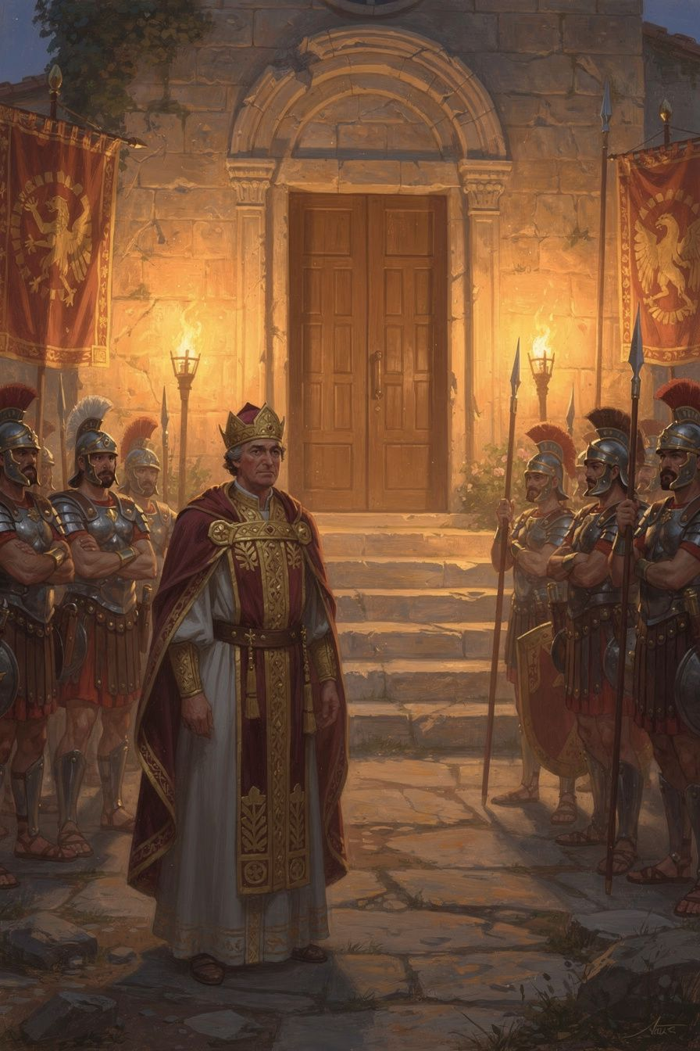
Illustration for Chapter 2
After Ambrose became a bishop, he gave away his money to poor people and lived simply. He studied the Bible and learned how to preach. The people of Milan loved him.
But not everyone was happy.
There was a queen named Justina. She was the mother of the young emperor Valentinian, and she believed differently from Ambrose about God. She wanted Ambrose to give her one of the churches in Milan so her friends could use it.
Ambrose said no.
He did not say no because he was stubborn. He said no because he believed the church belonged to God, not to the emperor. "If you want my own things — my land, my money — I will give them to you," he told the queen's officials. "But the things that belong to God are not yours to take."
Justina was angry. She sent soldiers to surround the church. She made laws against Ambrose. She fined people who supported him. She tried everything she could think of.
But something wonderful happened. When the soldiers came to the church, some of them went inside and told Ambrose they were on his side. They would not hurt him. They would not hurt the people.
The people of Milan came to the church and stayed inside. They would not leave. They were scared, but they were brave together. And Ambrose taught them to sing.
That is when the singing started. Ambrose had written short, simple songs about God — songs that were easy to learn and easy to remember. The people sang them together, night and day, while the soldiers stood outside. The singing made them brave. The singing made them one family. The singing made the soldiers not want to fight.
Eventually, the queen gave up. She had to leave Milan anyway, because a different army was coming. The church was safe. The people had won — not with swords or fighting, but with singing and staying together.
Words to Remember "If you demand my person, I am ready to submit: carry me to prison or to death, I will not resist; but I will never betray the church of Christ." — Ambrose, Letter 21, during the basilica crisis, c. 385–386 CE
Big Idea The church belongs to God, not to the government. Ambrose was brave enough to say no to a queen because he believed some things are too important to give away. When people stand together and stay brave, even soldiers cannot make them do the wrong thing.
Try This - Sing a song together. Ambrose's people sang when they were scared. Pick a song you love and sing it with your family or friends. Notice how singing together makes you feel. - Draw the story. Draw a picture of the church with the people inside singing and the soldiers outside. What do you think the soldiers heard? What do you think the people looked like? - Practice saying no. Think of a time when someone asked you to do something you knew was wrong. Practice saying: "No, that is not the right thing to do." It is hard to say no to someone powerful. Ambrose did it. You can too.
Ask a Grown-Up "Have you ever had to say no to someone who had more power than you? What gave you the courage to do it?"
———

Chapter 3: The Preacher Who Helped a Smart Young Man
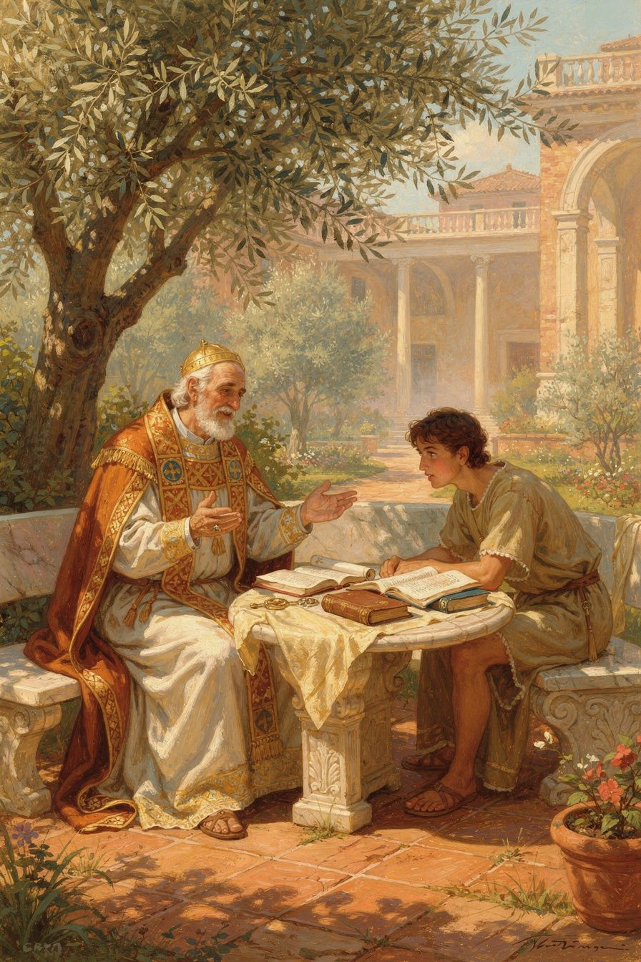
Illustration for Chapter 3
A young man named Augustine came to Milan. He was very smart — one of the smartest people in the whole Roman Empire. He was a teacher of speaking and arguing, which was a very important job back then.
But Augustine was not happy. He was confused about God. He had joined a group called the Manichees who believed the world was made by a bad god and that your body was a trap for your soul. But Augustine was starting to think their ideas did not make sense. The stars and the sun did not move the way the Manichees said they did. Their leaders were not as wise as they claimed.
Augustine went to hear Ambrose preach. At first, he just wanted to see if Ambrose was a good speaker. But something happened that he did not expect.
Ambrose read the Bible in a way Augustine had never heard before. The Manichees said the Old Testament was full of silly stories — a God who walked in a garden, a man who lived in a fish, a prophet who ran away. They said these stories proved the Bible was foolish.
But Ambrose said: "Those stories have a deeper meaning. The garden is about your soul. The fish is about God's patience. The running prophet is about all of us when we try to run away from what God wants us to do."
Augustine was amazed. The Bible was not silly after all. It was deep — deeper than he had ever imagined. The stories were not just stories. They were signs that pointed to something bigger.
Ambrose was also kind. Augustine said: "I began to love him, not at first as a teacher of the truth, but as a man who was kind to me." Ambrose did not push Augustine. He did not argue with him. He welcomed him, listened to him, and let him watch how a bishop lived.
One day, Augustine was sitting in a garden, feeling sad and confused. He heard a child's voice — he could not tell if it was a boy or a girl — saying over and over: "Take up and read. Take up and read." He picked up a book of Paul's letters, opened it at random, and read: "Put on the Lord Jesus Christ, and make no provision for the flesh, to gratify its desires."
Augustine said: "All the darkness of doubt was dispelled." He decided to be baptized. On a spring night in the year 387, Ambrose baptized Augustine in the cathedral of Milan. Augustine's mother, Monica, had been praying for this day for years. She cried tears of joy.
Augustine went on to become one of the most important thinkers in all of history. He wrote books that people still read today — the Confessions, the City of God. And it all started because a bishop was kind to a confused young man and showed him a deeper way to read.
Words to Remember "I began to love him, not at first as a teacher of the truth, for I had despaired of finding that in your Church, but as a man who was kind to me." — Augustine, Confessions 5.13
Big Idea Sometimes the best teaching is not a lecture. It is kindness. Ambrose did not argue Augustine into the church. He welcomed him, showed him a new way to read the Bible, and waited. The best teachers do not push. They open doors and let you walk through.
Try This - Read a story two ways. Pick a story you know — from a book, a movie, or your family. First, tell it the plain way: what happened. Then tell it again: what does it mean? What is the story really about? That is what Ambrose did with the Bible. - Be kind to someone who is confused. Augustine was confused about God. Is there someone in your life who is confused or worried about something? Do not try to fix them. Just be kind. Listen. Ambrose showed that kindness can change a life. - Learn the name "Augustine." Say it: aw-GUS-tin. He was baptized by Ambrose. He became one of the most important teachers in all of history. Find his name on a map — he lived in a place called Hippo, in North Africa.
Ask a Grown-Up "Has anyone ever helped you understand something by being kind instead of by arguing? What was that like?"
———

Chapter 4: The Teacher of the Sacraments
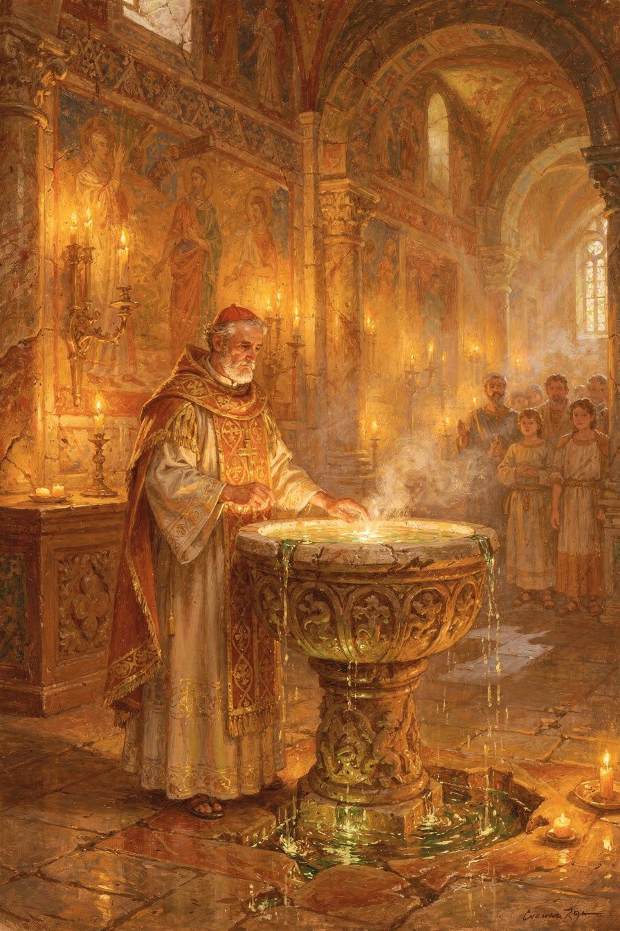
Illustration for Chapter 4
When people in Ambrose's church were baptized, they went under the water and came up again. Ambrose wanted them to understand what had just happened. So he taught them.
He said: "You saw water — but not water alone." The water in baptism is not just water. It is like a new birth. When a baby is born, the water breaks and new life comes into the world. In baptism, the water is like a new beginning — a fresh start, with the old you washed away and a new you coming up out of the water.
Ambrose told the people stories from the Bible about water. He told them about Noah's ark — how the flood waters that destroyed the wicked also lifted the good people to safety. He told them about the Red Sea — how the water that drowned the bad army gave freedom to the good people. He told them about Naaman, who washed in the Jordan River and was healed.
Then he told them about the bread and the wine.
At the special meal called the Eucharist, the priest takes bread and says words over it. Ambrose said: "Before the words, it is bread. After the words, it has become the body of Christ." He did not try to explain how it works. He said: "The same word of God that made the whole world out of nothing can change bread into something new."
Ambrose said this was like the manna — the special bread that fell from heaven when the people of Israel were hungry in the desert. But the manna only fed their stomachs. The Eucharist feeds your soul. It is food that lasts forever.
He also taught them about oil. After baptism, the bishop puts special oil on your head. Ambrose said this is like when athletes in ancient Greece rubbed oil on their bodies before a wrestling match. The oil means you are getting ready for something. You are getting ready to live like Jesus — to wrestle with doing the right thing, to be brave, to be kind, to be a fighter for good.
Ambrose did not write a textbook. He preached. He stood in front of people who had just been baptized — still wet, still excited, still scared — and said: "Let me tell you what just happened to you. You are not the same person you were before. The water changed you. The oil prepared you. The bread will feed you. You are new."
Words to Remember "Before the blessing, a certain thing is named; after the blessing, another. For it is not the voice of a human being, but the voice of God." — Ambrose, De Sacramentis 4.4.14–15
Big Idea Some things are deeper than they look. The water is not just water. The bread is not just bread. They are signs that God is doing something you cannot see but that is very real. Ambrose taught people to look with their hearts, not just with their eyes.
Try This - Think about water. Next time you wash your hands or take a bath, think about the water. What does water do? It cleans. It refreshes. It helps things grow. Now imagine that water can also clean your soul — the part of you that you cannot see. That is what Ambrose taught about baptism. - Make a sign. Draw a simple sign — like a heart or a star. Now tell someone what it means. A sign is something you can see that points to something you cannot see. The water, the bread, and the oil in church are all signs like that. - Ask about a special meal. Does your family have a special meal — a birthday dinner, a holiday feast, a Sunday lunch? What makes it special? The Eucharist is a special meal too. It is the church's family dinner.
Ask a Grown-Up "Have you ever done something that made you feel different afterward — like a graduation, a ceremony, or a special event? What changed?"
———

Chapter 5: The Poet Who Gave the Church Its Voice
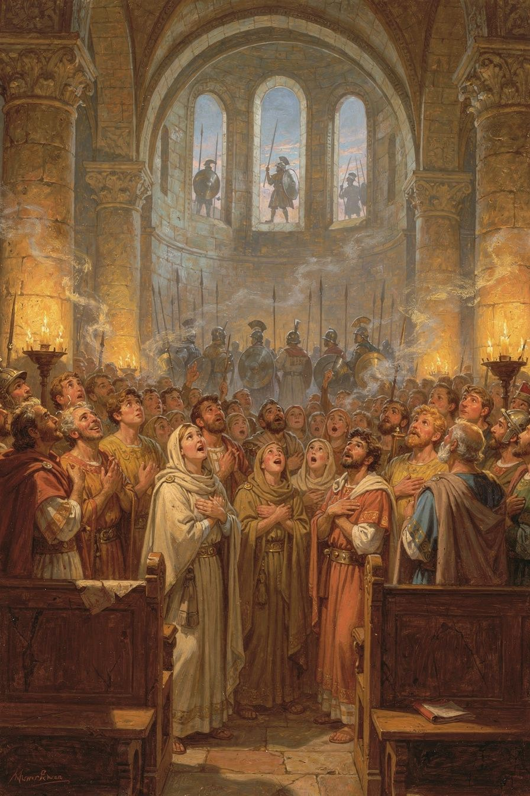
Illustration for Chapter 5
Before Ambrose, churches were mostly quiet. People listened to the bishop talk. They said prayers together. But they did not sing together.
Ambrose changed that. He wrote short, simple songs that everyone could learn. They had four lines each, and the rhythm was easy — like a heartbeat. You did not need to be a trained singer. You just needed to open your mouth and sing.
Here is one of his songs, translated into English:
Come, Redeemer of the nations, Show the birth from Virgin Mary. Let the whole world stand in wonder At such a birth from such a mother.
That song is about Jesus coming into the world. In four short lines, it says: Jesus is God. He was born of a virgin. The whole world should be amazed. It is a tiny prayer and a whole teaching, all at once.
Ambrose wrote these songs during a dangerous time. When the queen sent soldiers to surround the church, the people were trapped inside. They were scared. They did not know what would happen. Ambrose could have given a speech. Instead, he taught them to sing.
The singing did three things.
First, it made them brave. When you sing, you breathe deeper. Your chest opens. Your voice gets stronger. You cannot be as scared when you are singing.
Second, it made them one. Everyone sang the same words at the same time. Their voices joined together. One person singing alone is one voice. A hundred people singing together is something else — something bigger, something that fills the whole room.
Third, it taught them what they believed. The songs were full of the most important teachings: God made the world. Jesus is God. The Spirit is God. The three are one. You did not need a theology lesson. You just needed to sing, and the truth got inside you through your ears and your voice.
Augustine, who was there during the siege, said: "How much I wept at your hymns and songs! The voices flowed in through my ears, and the truth was distilled in my heart." He cried because the singing was so beautiful and so true that it reached a part of him that words alone could not reach.
Ambrose's songs were so good that they spread everywhere. Churches all over the world started singing them. A thousand years later, a man named Martin Luther translated one of Ambrose's songs into German. Today, people still sing Ambrose's words, in every language on earth.
Words to Remember "How much did I weep at your hymns and songs, how keenly was I moved by the sweetly sounding voices of your church!" — Augustine, Confessions 9.7
Big Idea Singing is not just for fun. Singing can make you brave. Singing can bring people together. Singing can teach you what is true. When you sing with other people, you become one voice — and that voice is stronger than any single voice alone.
Try This - Learn a song by heart. Pick a song you love — a hymn, a folk song, a camp song. Learn it so well you can sing it without looking at the words. That is what Ambrose's people did. They learned the songs by heart because the songs were their prayers. - Sing when you are scared. Next time you feel scared — maybe before a test, or in the dark, or before something new — try humming or singing a song. Notice if it changes how you feel. Ambrose taught his people that singing can make fear smaller. - Write a four-line song. Ambrose's songs were only four lines long. Try writing your own. Pick something you believe in — kindness, courage, love, honesty — and write four lines about it. It does not have to rhyme. It just has to be true.
Ask a Grown-Up "What songs were important to you when you were growing up? Did you ever sing when you were scared or sad? What did it feel like?"
———

Chapter 6: The Bishop Who Told an Emperor to Say Sorry
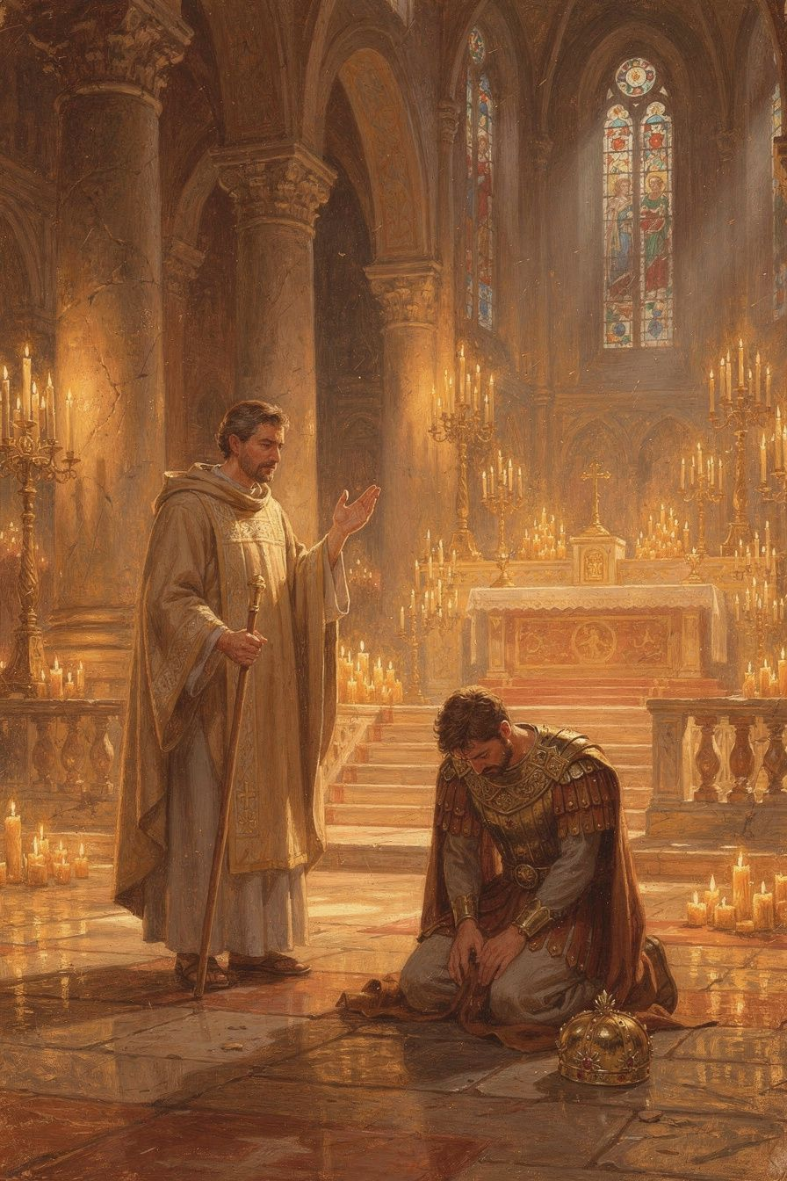
Illustration for Chapter 6
The most powerful man in the world was an emperor named Theodosius. He ruled the entire Roman Empire — every land from Spain to Egypt, from Britain to the edges of Persia. He was a Christian, and he went to church. He listened to sermons. He took his faith seriously.
But Theodosius had a terrible temper.
One day, a riot broke out in a city called Thessalonica. The people there killed one of the emperor's soldiers. Theodosius was furious. He sent his army to the city, and the soldiers killed thousands of people — men, women, and children who had nothing to do with the riot. It was one of the worst things a Christian emperor had ever done.
When Ambrose heard about it, he was heartbroken. He wrote a letter to Theodosius — the most powerful man in the world — and said: "You cannot come to church until you repent."
This was a very brave thing to do. Theodosius could have had Ambrose killed. He could have sent him to prison. He could have taken away his church. Earlier emperors had done worse to bishops who crossed them.
But Ambrose was not afraid. He wrote: "Sin is not taken away except by tears and penitence. Neither angel can do it, nor archangel. The Lord Himself forgives no one without repentance."
He said to the emperor: "Your subjects are of the same nature as yourself. There is one Lord and Ruler of all, and He is the Maker of all creatures, whether princes or people. How could you lift up in prayer hands steeped in the blood of so unjust a massacre?"
Theodosius could have ignored the letter. He could have been angry. Instead, he did something no one expected. He said yes.
He came to church without his royal clothes. He stood with the ordinary people, not on a throne. He prayed. He cried. He waited. For months, he stayed outside the altar area, not allowed to receive the bread and wine, until Ambrose said he was ready.
When Theodosius was finally welcomed back, Ambrose had one more request. He asked the emperor to make a new law: from now on, before anyone could be put to death, thirty days must pass. That way, the emperor could not order a killing in a moment of anger. The "cooling-off" law would prevent another Thessalonica.
Theodosius agreed. He made the law.
Years later, when Theodosius died, Ambrose preached at his funeral. He did not just praise the emperor. He told the truth — that Theodosius had done something terrible, and that he had repented, and that God had forgiven him. Ambrose said: "I have loved him, therefore I shall not abandon him until, by my prayers and tears, I lead him whither he followed the Lord when he was alive."
Ambrose himself died a few years later, on the day between Good Friday and Easter — the day Jesus lay in the tomb. He lay dying, stretched out his arms in the shape of a cross, and prayed. He said: "I have not lived in such a way that I am ashamed to go on living; nor do I fear to die, for we have a good Lord."
Words to Remember "I have not lived in such a way that I am ashamed to go on living; nor do I fear to die, for we have a good Lord." — Ambrose, on his deathbed, 397 CE (reported by Paulinus of Milan, Life of Ambrose 47)
Big Idea Even the most powerful person in the world has to follow the rules. Even an emperor has to say sorry when he does something wrong. Ambrose was brave enough to tell the most powerful man on earth the truth — and Theodosius was humble enough to listen. That is what real courage looks like.
Try This - Practice saying sorry. Think of a time you did something wrong. Did you say sorry? What did it feel like? Theodosius was the most powerful man in the world, and he still had to say sorry. That means saying sorry is not a sign of weakness. It is a sign of strength. - Make a "cooling off" rule. Ambrose asked the emperor to wait thirty days before punishing anyone. Make your own cooling-off rule: when you feel very angry, count to ten before you speak. See if the waiting changes what you want to say. - Draw the story. Draw a picture of the emperor standing with the ordinary people in church, without his crown or his royal clothes. What does it look like when the most powerful person in the world is just a person, praying?
Ask a Grown-Up "Who has the right to tell a leader they are wrong? What would it take for you to say something if a person in charge did something bad?"
———

For the Grown-Up Reader
This booklet introduces children to Ambrose of Milan (c. 340–397 CE), one of the most important figures in early Christian history. The six chapters cover the major events and themes of his life: his dramatic election as bishop, the basilica crisis with Empress Justina, his influence on Augustine of Hippo, his sacramental theology, his hymns, and his confrontation with Emperor Theodosius after the massacre at Thessalonica.
All quotes are real, drawn from Ambrose's own writings and from contemporary witnesses. The paraphrases and narrative retellings are faithful to the sources but adapted for young readers. The most important primary sources are:
- Ambrose, De officiis ministrorum (On the Duties of the Clergy), the first Christian manual of public ethics - Ambrose, Epistulae (Letters), especially Letters 20, 21, and 51 - Ambrose, De Mysteriis and De Sacramentis, the earliest surviving Western mystagogical catechesis - Ambrose, Hymns, including "Veni redemptor gentium" and "Aeterne rerum conditor" - Augustine, Confessions 5–9, the most important witness to Ambrose's pastoral impact - Paulinus of Milan, Vita Sancti Ambrosii (Life of St. Ambrose), the earliest biography
The key secondary sources are Neil B. McLynn's Ambrose of Milan: Church and Court in a Christian Capital (University of California Press, 1994), the standard modern study; Brian P. Dunkle's Enchantment and Creed: The Ambrosian Hymns and Liturgical Theology (Oxford University Press, 2016), the best study of the hymns; and Peter Brown's Augustine of Hippo: A Biography (University of California Press, 2000), for the Ambrose-Augustine relationship.
A note on the Thessalonica episode: the popular image of Ambrose barring Theodosius at the cathedral door is a later legend, debunked by modern historians. The actual process was conducted through letters and Theodosius's voluntary submission. The booklet tells the historically accurate version.
A note on the hymns: only four hymns are universally attributed to Ambrose on the authority of Augustine. The broader Ambrosian tradition includes many more, but the four core hymns are the secure foundation. The booklet does not overstate the number.
———

About WisdomForge
WisdomForge produces four age-adapted booklets for each figure: elementary (ages 5–10), middle (ages 11–14), high (ages 15–18), and adult. Each booklet covers the same person, ideas, and stories, but at a different level of depth and complexity. The elementary booklet tells stories. The middle booklet explains ideas. The high booklet argues and analyzes. The adult booklet engages with scholarly debates and primary sources. Read the one that fits — or read them all and watch the same figure grow.

