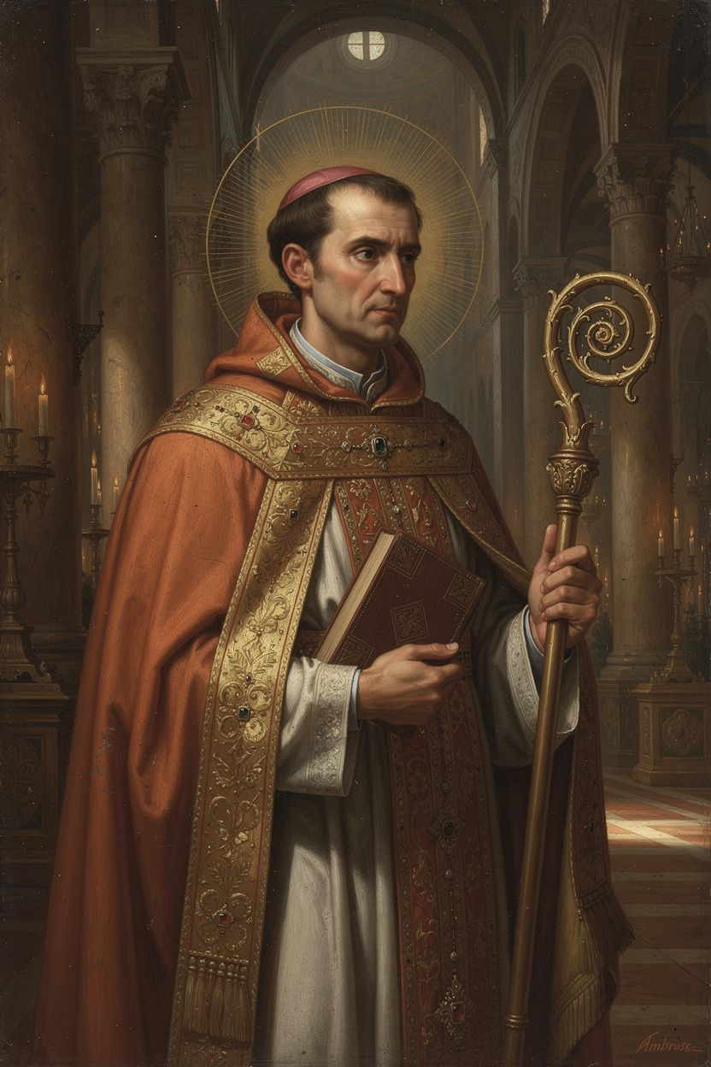
Ambrose: The Bishop at the Hinge of History
WisdomForge Booklet — Ages 15–18

Ambrose: The Bishop at the Hinge of History

WisdomForge Booklet — Ages 15–18
———

About This Book
Ambrose of Milan (c. 340–397 CE) is not a household name. He should be. He was the bishop who stood down an empress, rebuked an emperor, baptized Augustine, and gave the Western church its first sung voice. He was a lawyer and a governor who became a bishop in a week — before he was even baptized — and then spent twenty-three years reshaping the relationship between church and state in ways that still matter today.
Ambrose stands at the hinge between the ancient world and the medieval. He inherited the Roman administrative tradition, the Greek theological tradition (through Philo and Origen), and the Latin rhetorical tradition (through Cicero), and he forged them into something new: a theology of the church as a public, moral, sacramental body that could speak truth to imperial power. His De officiis ministrorum — a direct response to Cicero's lost dialogue of the same name — is the first sustained Christian manual of public ethics. His hymns gave the Latin church its sung voice. His confrontation with Theodosius after the massacre at Thessalonica established the principle that even emperors are subject to ecclesial discipline.
He was not a systematic theologian in the way Augustine or Aquinas were. He was a pastoral theologian — his ideas emerged from preaching, from correspondence with officials, from the concrete demands of shepherding a church through a dangerous century. That makes him uniquely valuable: his thought is always connected to life, to decision, to the cost of acting on conviction.
This booklet does not pretend Ambrose was perfect. He was a man of his time — a Roman aristocrat with the assumptions of his class, including attitudes toward Jews and toward social hierarchy that we must judge critically. His letter about the synagogue at Callinicum, where he effectively defended the destruction of a Jewish place of worship, is a real stain on his record. The same principle that led him to defy an empress — that the church's resources are dedicated to God — was used at Callinicum in service of anti-Jewish prejudice. The booklet does not hide this.
Six chapters. Each one engages a central Ambrosian idea with the seriousness it deserves. You do not have to agree with Ambrose to learn from him. You just have to be willing to wrestle with the questions he asked — about power, courage, music, teaching, faith, and accountability.
———

Chapter 1: The Governor Who Became a Bishop — Vocation and Resistance
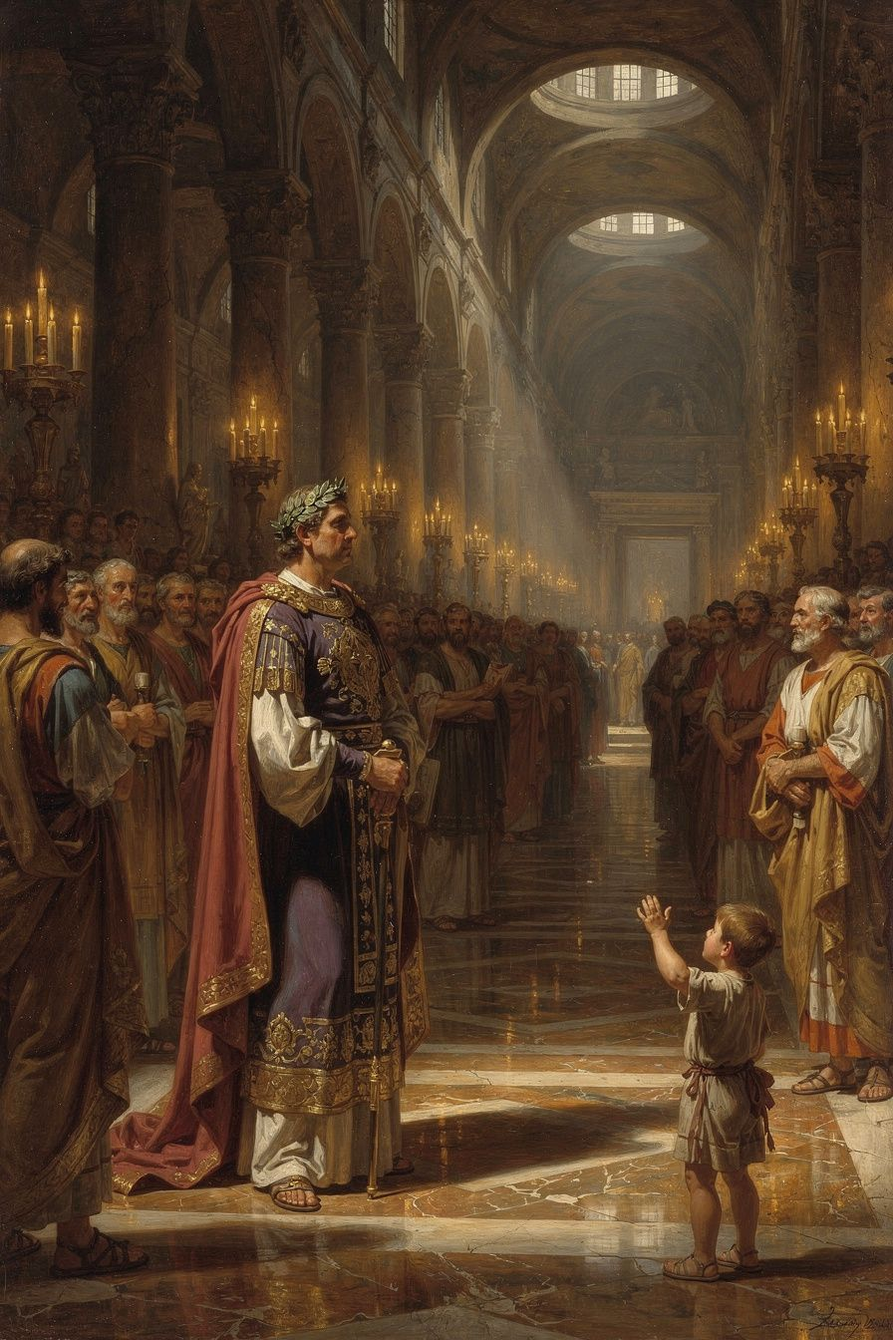
Illustration for Chapter 1

The Political World of Fourth-Century Milan
When Ambrose was born around 340 CE, Christianity was legal but not yet dominant. The emperor Constantine had legalized Christian worship at the Edict of Milan in 313, but the empire was still religiously diverse — pagans, Jews, Christians of various stripes, and a large and politically powerful Arian faction all coexisted, sometimes peacefully, sometimes not.
Milan was one of the most important cities in the Roman Empire. It was frequently the seat of the imperial court, a crossroads of political, military, and theological currents. The bishop of Milan was not just a religious leader — he was a public figure whose theology shaped worship, church membership, political loyalty, and personal identity.
When the Arian bishop Auxentius died in 374, the succession became a flashpoint. Both Nicene and Arian factions understood that the choice of the next bishop would determine the theological direction of Milan for a generation. The conflict was intense enough that violence was a real possibility.

The Election
Ambrose, as Roman governor of the province of Aemilia-Liguria, went to the church to maintain order — the same way he would at any potentially riotous public assembly. According to tradition preserved by Paulinus of Milan and reported by Augustine, a child in the crowd cried out: "Ambrose, bishop!" The cry was taken up by the whole assembly. Both factions, unable to agree on a candidate from their own parties, seized on Ambrose as a compromise. He was a respected official, known for fairness, and not identified with either theological camp.
Ambrose was appalled. He was not baptized, not trained in theology, and not seeking the position. He tried to disqualify himself by allowing criminals and prostitutes in his household. He tried to flee. He asked the emperor to overrule the election. None of it worked. Within about eight days, he was baptized, ordained, and consecrated as Bishop of Milan. He was about thirty-four.

The Transformation
The conversion from governor to bishop was not merely a change of title. Ambrose immediately adopted an ascetic lifestyle. He gave away his personal wealth to the poor, distributing his money and land, retaining only a modest provision for his sister Marcellina. He abandoned the privileges of his former office and committed himself to the disciplines of the episcopate.
He also began an intensive program of theological study. Using his knowledge of Greek — a rare asset in the Latin West — he read Philo of Alexandria, Origen, Athanasius, and Basil of Caesarea directly in the original. He learned by teaching: his early sermons and treatises are the record of a brilliant layman rapidly mastering the Christian intellectual tradition and passing it on to his clergy and people. This pattern of learning-by-teaching would characterize his entire episcopate. He was not a systematic theologian who developed ideas in private and then published. He was a pastoral theologian who wrote because his church needed instruction, his clergy needed guidance, and his emperors needed correction.

Ambrose's Social Theology: The Earth Belongs to All
One of the most radical elements of Ambrose's thought emerged from his first years as bishop. In De officiis ministrorum (On the Duties of the Clergy), written around 377–391, Ambrose made a claim that was revolutionary in its implications:
"The earth was made for all, not for the rich. ... You are not giving your own goods to the poor; you are restoring to them what is theirs." (*De Officiis* I.28)
This is not modern socialism. It is a theological claim about ownership. God created the world's resources for the use of all. Private property is conventional, not natural — a product of human arrangement, not divine decree. The wealthy hold their property in trust, not in absolute ownership. Giving to the poor is not optional generosity — it is the repayment of a debt. To withhold from the poor what they need is an act of injustice, not merely a failure of charity.
This position was unprecedented in Roman moral philosophy. Cicero, whose De officiis Ambrose was deliberately imitating, treated generosity as a matter of personal magnanimity — a separate virtue from justice. Ambrose folded generosity into justice itself. The rich do not merely fail to be generous when they hoard; they commit injustice. This is a structural critique of inequality, not just a call for individual kindness.
Ambrose practiced what he preached. When Milan was threatened and captives needed ransom, he melted down the church's gold and silver vessels. When criticized, he replied that the church's true treasure is not gold but people, and that vessels of metal exist to serve human beings, not the reverse.

Scholarly Debate: Was the Election Spontaneous or Engineered?
The story of the child's cry — "Ambrose, bishop!" — has been debated by modern historians. Paulinus of Milan, Ambrose's secretary and earliest biographer, presents the acclamation as spontaneous and providential: a child speaks, the crowd follows, and the governor is swept into the episcopate by popular will. This narrative has shaped the traditional image of Ambrose's election as a moment of divine intervention through popular acclaim.
Neil McLynn (1994) has challenged this reading. He argues that the acclamation was likely less spontaneous than Paulinus suggests — that Ambrose's political allies and the Nicene party may have orchestrated or at least encouraged the crowd's response. The speed of the election (eight days from acclamation to consecration) suggests prior preparation rather than a sudden popular movement. McLynn notes that Ambrose's initial resistance may itself have been a rhetorical performance — a conventional display of humility expected of anyone offered high office in the Roman world, not a genuine attempt to refuse. The convention of recusatio (formal refusal of an honor before accepting) was standard in Roman aristocratic culture.
Other scholars, including Daniel H. Williams (1995), have pushed back against McLynn's skeptical reading, arguing that the multiple sources (Paulinus, Augustine, Sozomen) converge on the core narrative and that Ambrose's resistance — including the extreme measure of inviting prostitutes into his household — goes beyond conventional recusatio. The debate matters because it shapes how we read Ambrose's entire episcopate: was he a man who was called against his will, or a politician who engineered his own rise? The truth may be more complex than either extreme — a popular acclamation that Ambrose did not engineer but also did not entirely resist.
The Big Idea
Ambrose's election and transformation raise a question about vocation that every person eventually faces: what happens when responsibility finds you instead of the other way around? Ambrose did not seek the bishopric. He resisted it. But when he accepted it, he transformed completely — giving away his wealth, mastering a new intellectual tradition, and committing himself to a life of service. The lesson is not that resistance is wrong but that vocation sometimes works through resistance, not around it. The job you do not want may be the job that reveals who you actually are.
Practice
1. Map your vocation. Write one paragraph about a time you were asked to do something you did not feel ready for. Did you accept or refuse? What happened? Now write one paragraph about how Ambrose's story — resistance, acceptance, transformation — compares to yours. What would you do differently if you faced that choice again?
2. Research the "rule of faith." Ambrose inherited a framework of Christian teaching called the rule of faith — a summary of the apostolic faith that converts learned before baptism. Find a version of it online (search for "rule of faith Ambrose" or "regula fidei"). How does it compare to the Nicene Creed? What is the relationship between the rule and the later creed?
3. Write a "governor's code." Ambrose was a governor before he was a bishop. His legal training shaped his theology — he argued like an advocate, cited authorities, and anticipated objections. Write a one-page "code" for someone in a position of responsibility (a team captain, a club president, a student council member). What three principles would you include? How do they compare to Ambrose's principles: that power is a trust, that all persons have dignity, and that justice must be balanced with mercy?
Reflect
Ambrose was a governor who became a bishop in a week. He gave away his wealth and learned a new field from scratch. Is there a version of this kind of transformation available to you — not necessarily a career change, but a change in how you think about what you owe to others? What would it look like to treat your own resources as a trust rather than a possession?
———

Chapter 2: The Basilica Crisis — Courage, Community, and Nonviolent Resistance
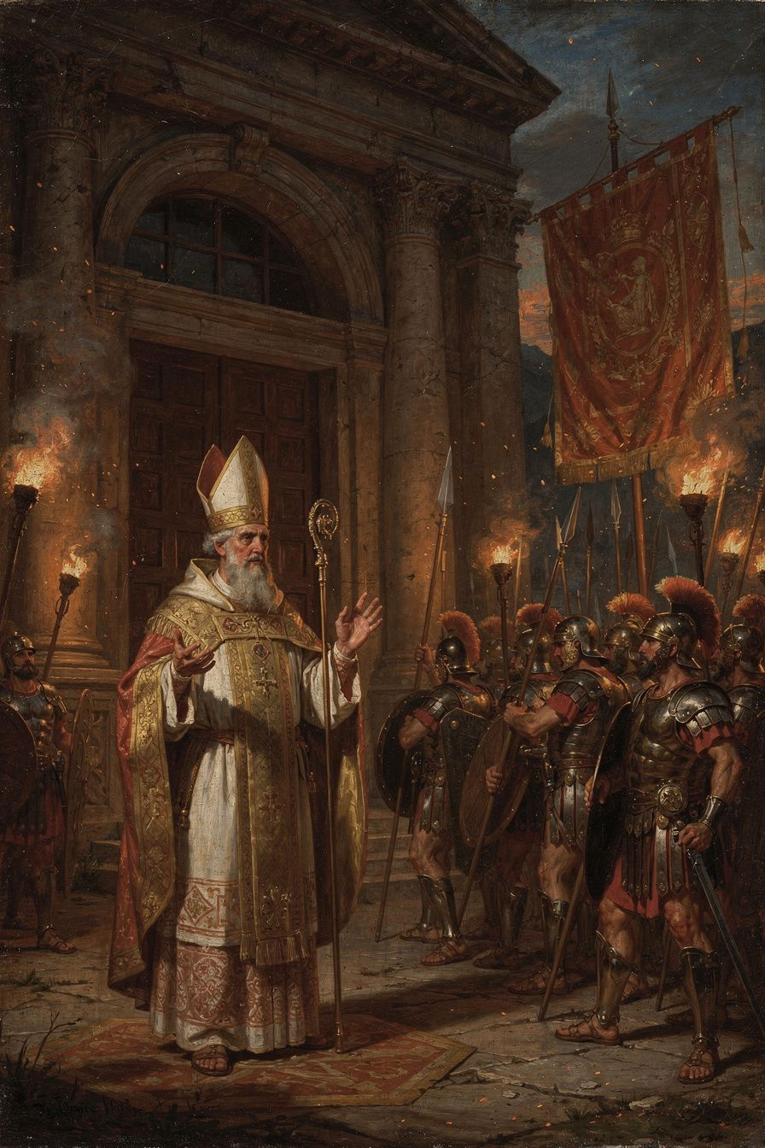
Illustration for Chapter 2

The Demand
In 385 CE, Empress Justina, mother of the young emperor Valentinian II, demanded that Ambrose surrender one of Milan's basilicas for Arian worship. The request was framed as reasonable: the Arians needed a place to worship, and the emperor, as sovereign, had the authority to allocate public buildings.
Ambrose refused. His refusal was rooted in a principle: sacred things are not subject to imperial power. A church consecrated to God belongs to God, and the bishop is its guardian. The emperor cannot simply requisition it. "What belongs to God is outside the emperor's power" (Epistula 20a.12).
This was a new claim in the Roman Empire. In the ancient world, religion was part of the state. The emperor was the chief priest (Pontifex Maximus). Religious institutions were under civil authority. Ambrose was drawing a line: there is a sphere of life — the inner life of the church — that is withdrawn from the state's authority. The emperor governs bodies, property, and civil order. The bishop governs souls, sacraments, and worship. When the two overlap, the bishop, not the emperor, has the final word.

The Siege
Justina escalated. Imperial soldiers surrounded the basilica. Fines and imprisonment were imposed on prominent Milanese businessmen who supported Ambrose. A law was issued granting freedom of worship to Arians and permitting the confiscation of basilicas.
But something remarkable happened. Soldiers from the ranks the emperor had placed around the basilica began pouring into the church, assuring Ambrose of their fidelity. The emperor's own troops were unwilling to act against the bishop and his congregation.
The people of Milan occupied the basilica. For days and nights, they refused to leave. During the siege, Ambrose taught them to sing — the hymns that would become the foundation of Western Latin hymnody. The singing was not merely comfort; it was nonviolent resistance. The court could threaten, fine, and imprison, but it could not silence a singing congregation.

The Anatomy of Courage
From Ambrose's example, we can identify several components of moral courage:
Conviction. Ambrose's principle was not invented in the moment of crisis. It was the product of years of study, preaching, and pastoral reflection. If you have not done the work of forming your convictions before the crisis comes, you will not have them when you need them.
Community. Ambrose was not alone. The faithful who poured into the church, refused to leave, and sang through the siege gave Ambrose the strength that his own resolve might not have sustained. Courage is not purely individual. It is communal. The people gave the bishop courage, and the bishop gave the people leadership.
Nonviolence. Ambrose did not call for armed resistance. He occupied the basilica, prayed, sang, and waited. This nonviolent posture was not weakness; it was a form of strength that the imperial court did not know how to counter. Soldiers can disperse a mob, but they cannot disperse a congregation that is praying.
Endurance. Courage is not a sprint; it is a marathon. The basilica siege lasted days and nights. The willingness to sustain pressure — to not give up when the adrenaline fades — is the test of real courage.
Vulnerability. Ambrose could have been arrested, exiled, or killed. He accepted that possibility: "If you demand my person, I am ready to submit: carry me to prison or to death, I will not resist; but I will never betray the church of Christ" (Epistula 20a.4). Courage that risks nothing is worth nothing.

The Limits of Courage
Ambrose's courage was real, but it was not unlimited. In 396, a year before his death, imperial agents entered his church, pushed past him and his clergy, and arrested a political suspect who had taken refuge there. Ambrose could not stop them. Peter Brown's assessment is apt: "When it came to the central functions of the Roman state, even the vivid Ambrose was a lightweight."
This is an honest truth about courage: it does not guarantee success. Courage is the decision to act rightly regardless of outcome, not the guarantee that right action will prevail. Ambrose acted, and sometimes he failed. The suspect was arrested. Courage is not the absence of failure; it is the refusal to let failure determine whether you try.

Scholarly Debate: The Myth of Ambrose's Dominance
The older view — that Ambrose dominated Theodosius and single-handedly established the independence of the church from the state — has been heavily revised since the late twentieth century. Neil B. McLynn's Ambrose of Milan (1994) argued that Ambrose was not "a power behind the throne" and that the two men did not meet frequently. The relationship was one of negotiation between two powerful institutions, not of a bishop dictating to an emperor.
The revised picture does not diminish Ambrose's significance. It refines it. Ambrose did not control the empire, but he articulated a principle — that the church's internal life is withdrawn from state authority — that proved extraordinarily influential. The principle was tested in specific confrontations, and the outcomes established precedents that shaped the medieval church's relationship to secular power for centuries.
The Big Idea
Ambrose's confrontation with Justina was not a property dispute. It was a test of whether the church has an existence and a moral authority independent of the state. Ambrose's answer — that sacred things are not subject to imperial power — was new in the Roman Empire and would echo for 1,600 years. But the confrontation also reveals the anatomy of courage: conviction formed before the crisis, community that sustains the individual, nonviolent methods that match the moral claim, and the willingness to accept the cost. Courage is not the absence of fear. It is the decision to act on conviction despite fear — and it is built from daily habits long before the crisis arrives.
Practice
1. Analyze a modern confrontation. Find a modern example of a religious or moral leader confronting political power (Martin Luther King Jr. writing from Birmingham Jail, Archbishop Romero in El Salvador, the Dalai Lama). Write one page comparing the modern example to Ambrose's basilica crisis. What strategies did the leader use? What were the risks? What was the outcome?
2. Debate the principle. Write two paragraphs — one arguing that there are spheres of life where the state has no authority (religious practice, family life, conscience), and one arguing that the state must have authority over everything within its borders. Which argument do you find more convincing? Where is the boundary?
3. Build a courage plan. Think about a situation in your life where you might need moral courage — speaking up about bullying, refusing to cheat, challenging a coach or teacher. Write a plan: (a) What conviction will you draw on? (b) Who will support you? (c) What nonviolent method will you use? (d) What cost are you willing to accept?
Reflect
Ambrose's courage was built from habits: telling the truth in small things, studying before acting, building alliances, and accepting the cost. Which of these habits are you building now? Which are you neglecting? What would change in your life if you treated courage as a discipline rather than a feeling?
———

Chapter 3: Augustine and the Allegorical Method — How Reading Changes Everything
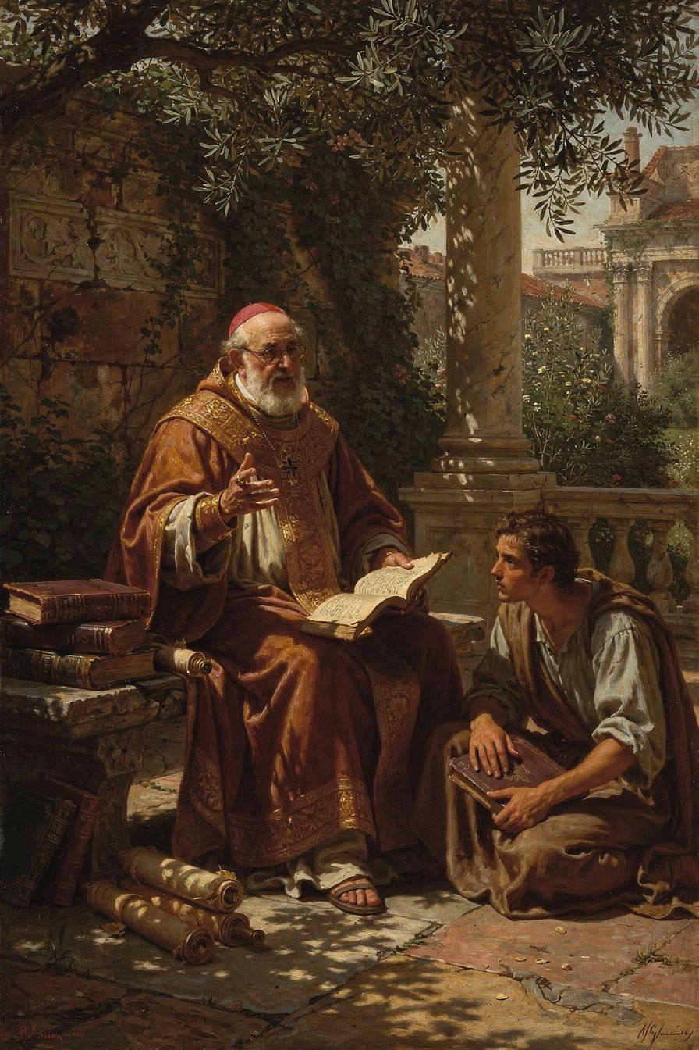
Illustration for Chapter 3

Augustine's Intellectual Crisis
When Augustine arrived in Milan in 384 as a professor of rhetoric, he was brilliant and miserable. He had spent nearly a decade as a Manichaean "hearer" — a member of a dualist religion that taught the material world was created by an evil power and that salvation came through secret knowledge. But Manichaeism was losing its hold. Its scientific claims were false. Its leaders were intellectually thin. Augustine was in freefall.
His central problem was the Old Testament. The Manichees had taught him to scorn it — a God who walks in a garden, a patriarch who lies, a prophet who runs away. These stories seemed crude, unworthy of a true religion. Augustine could not reconcile them with the philosophical monotheism he was beginning to find attractive.

Ambrose's Allegorical Preaching
Ambrose's preaching solved this problem. Following the Alexandrian tradition of Origen, Ambrose read the Old Testament allegorically. The literal surface of the text was not the whole meaning; beneath it lay a spiritual sense that pointed to Christ, to the soul, and to the church. The garden of Eden was not merely a place; it was the soul's original state. The Song of Songs was not about romantic love; it was about the love between Christ and the church.
Augustine described the effect in Confessions 5.14: "I rejoiced also that the Old Testament Scriptures were now set before me by Ambrose, not as objects of scorn, as I had previously thought them, but were expounded with a spiritual interpretation, so that I could not blame those who believed in them."
This was not a rejection of the literal text. It was a way of reading it at multiple levels simultaneously — literal, moral, and typological. The literal sense was the foundation; the spiritual senses built on it without abolishing it. The method allowed Augustine to take the Old Testament seriously as Christian Scripture without having to defend every literal detail as straightforward.

The Personal Dimension
The breakthrough was not only intellectual. Ambrose was personally kind to Augustine — a pastoral approach that was patient, warm, and intellectually serious. Augustine wrote: "I began to love him, not at first as a teacher of the truth, for I had despaired of finding that in your Church, but as a man who was kind to me" (Confessions 5.13).
Ambrose did not argue Augustine into the kingdom. He welcomed him, preached well, and waited. This model of pastoral care — intellectual seriousness combined with personal warmth — would shape Augustine's own later ministry as bishop of Hippo.

The Garden and the Baptism
The pivotal moment came in a garden in Milan. Augustine, in agony over his inability to change his life, heard a child's voice saying: "Take up and read. Take up and read." He opened Paul's letters at random and read Romans 13:13–14: "Not in reveling and drunkenness, not in lust and licentiousness, not in quarreling and jealousy. But put on the Lord Jesus Christ, and make no provision for the flesh, to gratify its desires."
All the darkness of doubt was dispelled. On the night of April 24–25, 387 CE, Ambrose baptized Augustine, his son Adeodatus, and his friend Alypius at the Easter Vigil. The singing of the Ambrosian hymns during the vigil moved Augustine to tears: "How I wept during your hymns and songs! I was deeply moved by the voices of your sweet-sounding church" (Confessions 9.6).

What Ambrose Gave Augustine
1. A way of reading Scripture. The allegorical method — drawn from Philo, Origen, and the Greek tradition — gave Augustine a way to read the Old Testament as Christian Scripture. This method would shape Augustine's own exegetical works, especially On Christian Doctrine and The Literal Meaning of Genesis.
2. A model of the church. Ambrose showed Augustine that the church was not the anti-intellectual body the Manichees mocked. It was a community of worship, mutual care, and intellectual seriousness — a bishop who preached, wrote, confronted emperors, and sang with his people.
3. A liturgical imagination. Ambrose's hymns, mystagogical catechesis, and liturgical innovations gave Augustine a sense of the sacramental life of the church. The sacraments were not mere symbols; they were encounters with divine grace.

Where Augustine Went His Own Way
Augustine was not Ambrose's clone. He differed in temperament, intellectual style, and the problems he faced:
- Systematic vs. pastoral. Ambrose was a pastoral theologian whose ideas emerged from preaching. Augustine was a systematic thinker who pursued questions to their logical conclusions. Ambrose never wrote anything like Augustine's De Trinitate — a sustained, fifteen-book exploration of Trinitarian theology.
- Original sin and grace. Augustine's doctrine of original sin, developed in his controversy with the Pelagians, has no parallel in Ambrose. Ambrose spoke of sin and grace, but he did not develop the systematic account of inherited guilt and the absolute necessity of grace that Augustine built.
- The will and the interior life. Augustine's exploration of the will, memory, and the interior life — the great achievement of the Confessions — has no parallel in Ambrose. This is Augustine's unique contribution, made possible by his own genius and his particular struggles.
The Ambrose-Augustine relationship is one of the great encounters of intellectual history. Ambrose did not make Augustine into a theologian — Augustine's genius was his own — but he gave him the conditions under which that genius could become Christian. Without Ambrose, there might have been no baptism, no Confessions, no City of God.
The Big Idea
The way you read a text determines what you can find in it. Augustine could not read the Old Testament literally because the Manichees had taught him to see it as crude. Ambrose's allegorical method freed him — not by abandoning the literal text but by showing that the literal is not the whole meaning. The same principle applies to every text, every person, and every situation: if you read at only one level, you will miss the depth. The best teachers — like Ambrose — do not tell you what to think. They show you a new way to read, and then they let you discover the meaning for yourself. Pastoral patience, not intellectual argument, is what opened the door for Augustine.
Practice
1. Read a text allegorically. Take a story you know well — from a book, a film, or your own life. First, summarize the literal plot in one paragraph. Then, in a second paragraph, read it allegorically: what does the story symbolize? What deeper meaning does it carry? How does the allegorical reading change your understanding of the literal story? Does the deeper meaning abolish the literal, or does it build on it?
2. Research the allegorical method. The method Ambrose used came from the Alexandrian tradition — particularly Origen of Alexandria (c. 185–254). Find a brief introduction to Origen's hermeneutics online. What are the three levels of meaning Origen proposed (literal, moral, spiritual)? How does this compare to modern literary criticism? Is the allegorical method still used today, or has it been abandoned?
3. Compare two models of teaching. Think of two teachers you have had: one who argued and pushed, and one who was patient and kind. Which one changed you more? Write one page comparing the two approaches, using Ambrose's model (kindness + intellectual seriousness) as a framework. What does this tell you about how people actually change?
Reflect
Augustine knew the truth before he changed his life. The gap between knowing and doing was his central struggle — and it is everyone's struggle. Ambrose did not solve this gap by argument. He solved it by welcome: a kind man who preached well and waited. Who in your life is waiting for a welcome rather than an argument? And are you willing to give it?
———

Chapter 4: The Sacraments — Mystery, Real Presence, and the Power of the Word
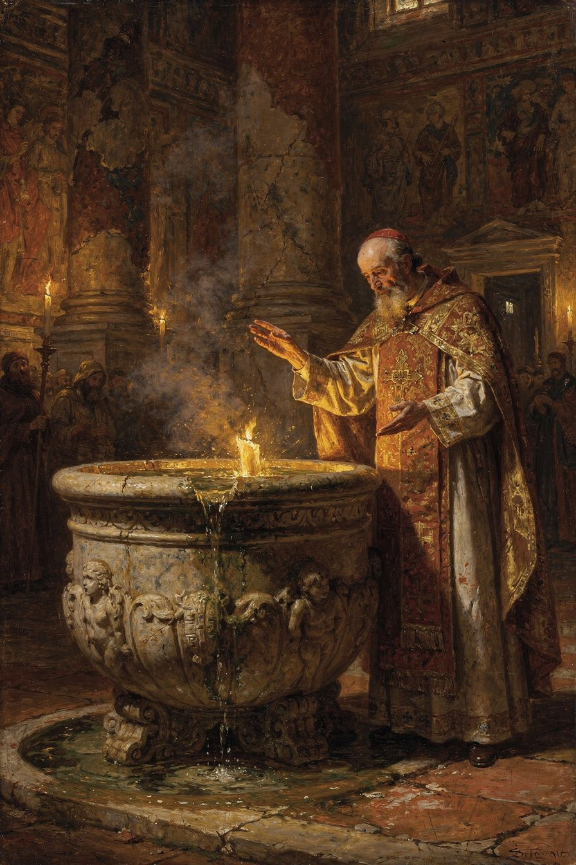
Illustration for Chapter 4

The Disciplina Arcani and Mystagogy
In the early church, the sacraments were not explained in detail to catechumens before baptism. This practice, the disciplina arcani (discipline of the secret), kept the specifics of the rites hidden from outsiders. The full explanation came after baptism, during Easter week, when the newly initiated — still in the glow of their initiation — were taught what they had experienced.
This post-baptismal instruction is called mystagogy — "leading into the mystery." The mystagogue does not explain the sacraments as a professor explains a subject. The mystagogue interprets an experience the learner has already had — naming what was felt, revealing the theology enacted in the ritual. Ambrose's mystagogy is preserved in De Mysteriis (On the Mysteries) and De Sacramentis (On the Sacraments), the earliest surviving Western mystagogical catechesis.

Baptism: Regeneration Through Water, Spirit, and Blood
Ambrose treats baptism as a real transformation — not a symbolic ceremony but a new birth. He develops this through biblical typology:
- The water. The water of baptism carries the power of the cross. "You saw water — but not water alone. For what is water without the cross of Christ? A common element, without any sacramental effect" (De Mysteriis 20).
- The Spirit. The Spirit hovers over the font as the Spirit hovered over the waters of creation (Genesis 1:2). Baptism is a new creation.
- Typology. The flood (Genesis 6–8) prefigures baptism: Noah's ark is the church. The crossing of the Red Sea (Exodus 14) prefigures baptism: the water that drowned Pharaoh gave life to Israel. Naaman's washing in the Jordan (2 Kings 5) heals the leprosy of sin.
The result is regeneration, not merely forgiveness. "You were made new," because the old self was buried in the water and the new self rose with Christ. This is ontological change — a change in the very being of the person.

The Eucharist: The Real Presence
Ambrose's treatment of the Eucharist is one of the earliest and clearest Western statements of the doctrine of the real presence. He does not use later scholastic terminology (transubstantiation, substance, accidents), but his language is unmistakable:
"You perhaps say, 'My bread is the usual kind.' But this bread is bread before the words of consecration; after the consecration it has become the flesh of Christ. ... Before the blessing, a certain thing is named; after the blessing, another." (*De Sacramentis* 4.4.14–15)
His argument is not philosophical — he does not try to explain how the change occurs. His argument rests on the power of the divine word: "If the word of the Lord Jesus was able to make out of nothing what did not exist, how much more can it transform what already exists into something else?"
He distinguishes the Eucharist from the Old Testament types — the manna in the wilderness (Exodus 16) and the bread of Elijah (1 Kings 19). Those foods nourished the body but did not give eternal life. The Eucharist is the food of immortality.

Scholarly Debate: De Sacramentis vs. De Mysteriis
The relationship between De Mysteriis and De Sacramentis has been a major question in scholarship. De Mysteriis is universally accepted as authentically Ambrosian. De Sacramentis has been disputed since the sixteenth century, with some scholars attributing it to a later author or a stenographer who recorded Ambrose's sermons.
The debate matters because De Sacramentis contains some of the strongest patristic statements on the real presence of Christ in the Eucharist. If it is Ambrose, it gives the doctrine of real presence an early and authoritative witness. If it is not, the witness is later and less authoritative.
The most influential modern theory is the stenographic hypothesis: De Sacramentis is a stenographic record of Ambrose's preached sermons, while De Mysteriis is Ambrose's own revised literary version. The differences in style are explained by the difference between spoken and written language. The current scholarly consensus inclines toward authenticity — or at least toward a very close connection to Ambrose.

The Nature of Sacrament
For Ambrose, sacramentum is broader than the later medieval category of "seven sacraments." It encompasses any sacred sign or mystery through which divine grace is mediated. The term mysterium is used almost interchangeably. What makes something a sacrament is its capacity to make present the reality it signifies. The water of baptism is the womb of regeneration; the bread of the Eucharist is the body of Christ. The sign does not merely point to grace — it carries it.
This does not mean Ambrose is naive about the distinction between sign and reality. The external form (water, bread, wine) remains perceptibly what it was. But the spiritual reality is not less real than the physical sign — it is more real. The sacrament is an encounter with the living God, mediated through created things that God has chosen as vehicles of grace.

Scholarly Debate: Ambrose and Neoplatonism
Ambrose's theology of the soul and its ascent to God shows the influence of Neoplatonism — the philosophy of Plotinus (c. 204–270 CE), which described the soul's journey from material distraction to contemplative union with the One. Ambrose read Plotinus directly and used Neoplatonic language in works like De fuga saeculi (On Flight from the World) and his treatises on the soul. He described the body as a temporary dwelling, the soul's true home as with God, and death as a liberation rather than an ending.
The scholarly debate concerns how deeply Neoplatonism shaped Ambrose's thought. Some scholars, following Pierre Hadot, see Ambrose as essentially a Christian Platonist who baptized Plotinus's framework. Others, including G. Madec, argue that Ambrose's use of Neoplatonism is superficial — borrowed vocabulary rather than borrowed philosophy. The truth may be that Ambrose used Neoplatonic language the way he used Ciceronian structure: as a container for Christian content. The form is borrowed; the substance is biblical. The soul's ascent is not the Plotinian return to the One through intellectual effort but the Christian journey to God through grace, sacrament, and the imitation of Christ. Ambrose did not reject Neoplatonism; he redirected it. The same pattern would appear in Augustine, who also used Neoplatonism as a bridge to Christianity before moving beyond it.

Scholarly Debate: The De Sacramentis Question and Real Presence
The debate about De Sacramentis has implications beyond authorship. If De Sacramentis is authentically Ambrosian, it gives the doctrine of the real presence an early and authoritative patristic witness — Ambrose was teaching substantive transformation of the eucharistic elements in the 380s, decades before the formal articulation of transubstantiation. If De Sacramentis is a later stenographic record, the witness is still connected to Ambrose but filtered through a note-taker's ears, raising the question of how much of the theological precision is the preacher's and how much is the recorder's.
This connects to a larger scholarly question about patristic texts in general. In the ancient world, sermons were often recorded by stenographers and circulated without the author's revision. Many of the texts we read as "by" a particular father may in fact be records of their spoken words, filtered through hearers' hands. The De Sacramentis debate is a case study in how this process works — and a reminder that the boundary between oral performance and written text was far more porous in antiquity than in the modern world.
The Big Idea
Ambrose's sacramental theology rests on a single principle: the power of the divine word. The same word that created the world from nothing transforms bread into body and water into a womb of regeneration. This is not a philosophical argument about how the change occurs — it is a theological argument about who speaks the word. The sacraments are not symbols that remind us of God; they are encounters with God, mediated through created things. And the mystagogical method — explaining the experience after you have had it — respects the mystery: you cannot fully understand a sacrament until you have participated in one, because understanding follows experience, not the other way around.
Practice
1. Compare sacrament and symbol. Write one paragraph explaining the difference between a symbol that points to something and a sacrament that carries something. Use Ambrose's analogy: if the word that creates from nothing can also transform what exists, what does that say about the relationship between the sign and the reality? Now think of a non-religious example: is there anything in your life that functions as a sacrament — a physical thing that carries a deeper reality? A family heirloom? A photograph? A ring?
2. Research the stenographic hypothesis. The debate about De Sacramentis vs. De Mysteriis is a window onto how ancient texts were transmitted. Find a brief summary of the debate online or in a library. What are the arguments for and against Ambrosian authorship of De Sacramentis? What is the stenographic hypothesis? Does it matter who wrote the text, or only what it says?
3. Think about the disciplina arcani. The early church kept the sacraments secret from outsiders and explained them only after baptism. Why? What are the advantages and disadvantages of this approach? Write one paragraph arguing for the disciplina arcani and one against it. Which position do you find more convincing? How does this compare to modern practices of open vs. closed communion?
Reflect
Ambrose's mystagogy operates on the principle that some things can only be understood from the inside. You cannot fully explain an experience you have not had. Have you ever encountered something like this — a practice, a ritual, a discipline, a relationship — that you could not understand until you were inside it? What does this say about the limits of explanation? And what does it say about the relationship between experience and understanding?
———

Chapter 5: The Hymns — Enchantment, Creed, and the Birth of Congregational Song
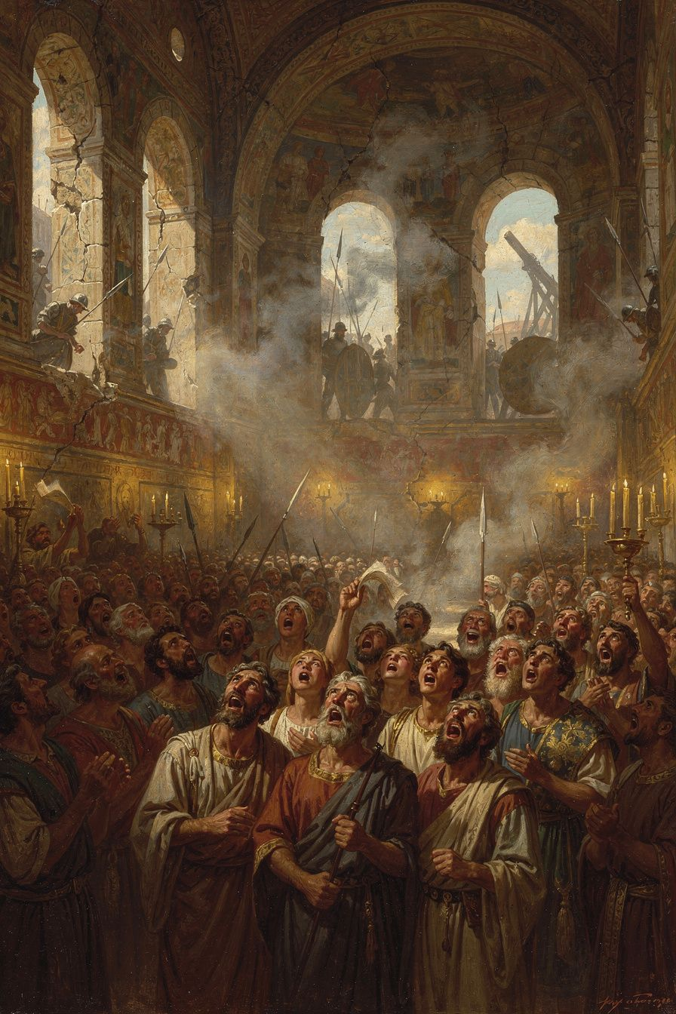
Illustration for Chapter 5

The Invention of Congregational Hymnody
Before Ambrose, Latin Christian hymnody was limited. Hilary of Poitiers (c. 310–367) had composed Latin hymns a generation earlier, but his hymns were complex and apparently not widely used. Ambrose changed this. His hymns are short — typically eight stanzas of four lines each, in strict iambic tetrameter (eight syllables per line, alternating unstressed and stressed). This meter is the simplest and most memorable in Latin poetry. The vocabulary is simple, the imagery is vivid, and the theological content is dense but accessible.
The result was something new: hymns that the whole congregation could sing together, remember, and internalize. The hymns were born in crisis — during the basilica standoff of 385–386, when Ambrose's congregation barricaded themselves inside their church and sang through the night.

The Four Authentic Hymns
Only four hymns are universally conceded to be authentically Ambrosian, on the authority of Augustine:
1. Aeterne rerum conditor ("Eternal Maker of all things") — A morning hymn for the office of cockcrow. It praises God as creator and asks Christ, the light of the world, to dispel the darkness of night. The movement is from cosmology to personal prayer: from the creation of light to the prayer that the light of Christ may shine in the singer's heart.
2. Deus creator omnium ("God, Creator of all things") — An evening hymn meditating on the transition from day to night as a figure for the passage from life to death. It asks God to grant rest through the hours of darkness and to bring the singer safely to the dawn.
3. Iam surgit hora tertia ("Now the third hour rises") — A hymn for the third hour, connecting the hour of prayer with the events of Christ's passion and Pentecost. The hour becomes a window onto salvation history.
4. Veni redemptor gentium ("Come, Redeemer of the nations") — An Advent hymn addressing Christ as the one who comes to redeem. It is the most theologically dense of the four, presenting the incarnation as the descent of divine majesty into human flesh. It explicitly affirms Nicene Christology: Christ proceeds from the Father, not from creation; he is God, not a creature. Martin Luther later translated this hymn, producing "Nun komm, der Heiden Heiland."

The Basilica Crisis and the Birth of the Hymns
The most famous account of Ambrose's hymns in action comes from Augustine's Confessions (9.7), describing the basilica crisis:
"How much did I weep at your hymns and songs, how keenly was I moved by the sweetly sounding voices of your church! The voices flowed in through my ears and the truth was distilled in my heart, and issued forth as love and affection, and my tears ran down, and blessed was I in having them."
The hymns served three purposes during the siege:
- Morale. The singing channeled fear and uncertainty into worship. - Unity. The act of singing together bound the congregation into a single body — literally, as their voices merged, and symbolically, as they confessed the same words. - Theological formation. The hymns embedded Nicene doctrine — the divinity of Christ, the Trinity, the reality of the incarnation — in the memory of the singers. The people who sang these hymns were learning theology through their bodies.
Ambrose described the purpose of the hymns as "the confession of the Trinity in the mouths of the whole people." The hymns are not decoration; they are doctrinal formation. They are the means by which the community internalizes the faith it confesses.

Enchantment and Creed
Brian Dunkle's study Enchantment and Creed (Oxford, 2016) reframes the scholarly understanding of Ambrose's hymns. Dunkle argues that the hymns function through enchantment — the capacity of sung poetry to captivate the mind, embed ideas in the memory, and shape the affections. The hymns do not merely state doctrine; they enchant the singer with the beauty of the truth.
This is connected to the ancient understanding of music's power. From Plato onward, philosophers recognized that music shapes the soul — that the rhythms and melodies a person internalizes become the patterns of their thought and feeling. Ambrose chose the simplest and most memorable meter because he wanted the hymns to be unforgettable. He chose vivid imagery because he wanted them to captivate the imagination. He chose theological density because he wanted the beauty of the form to carry the weight of the content.
The result is a fusion of enchantment (the aesthetic power of the hymn) and creed (the doctrinal content it carries). The singer is enchanted by the beauty of the hymn, and in being enchanted, absorbs the creed. This is not indoctrination in a crude sense — it is the formation of a community through shared beauty.

The Hymns as Political Action
The hymns were born in a political crisis, and they functioned as a form of nonviolent resistance. The court could threaten, fine, and imprison, but it could not silence a singing congregation. The Arian court had its own hymns — Augustine mentions that Arians sang hymns designed to seduce the faithful — but the Ambrosian hymns were better: more beautiful, more memorable, and more deeply rooted in Scripture. The hymns won the battle for the hearts of the people.
This is a shrewd pastoral strategy. The Arian court could issue decrees and send soldiers, but it could not match the Nicene community's hymnody. The hymns made orthodoxy singable — and a singing congregation is harder to break than a silent one.

The Debate About Authorship
The Ambrosian hymn corpus has been debated for centuries. Medieval tradition attributed dozens of hymns to Ambrose. Modern scholarship has drastically reduced the number, with only four universally accepted and perhaps six more considered possible.
The fundamental problem is that "Ambrosian" became a genre, not just an attribution. Hymns written in the Ambrosian style — iambic dimeter, Nicene theology, liturgical assignment — were called "Ambrosian" as a compliment. The imitators were not frauds; they were poets working in a tradition. But the task of distinguishing the founder from his imitators is difficult.
Dunkle's work represents a cautious rehabilitation — not a return to medieval attributions, but a more generous assessment than the strict reductionism of the mid-twentieth century. Even on his more generous reading, the number of confidently Ambrosian hymns remains small.
The Big Idea
The hymns reveal something profound about how theology works: it does not only happen in books and arguments. It happens in worship, in song, in the bodies of ordinary people. Ambrose understood that what a community sings, it believes. He chose the simplest and most memorable form because he wanted the hymns to be unforgettable. He chose vivid imagery because he wanted them to captivate. He chose theological density because he wanted the beauty to carry the weight. The result is a fusion of enchantment and creed — the singer is formed by beauty while absorbing doctrine. This is not indoctrination; it is formation through shared beauty. And it reveals that worship is not a prelude to the spiritual life but the spiritual life itself in action.
Practice
1. Analyze an Ambrosian hymn. Find one of the four authentic hymns online (search for "Veni redemptor gentium" or "Aeterne rerum conditor" English translation). Read it carefully. Write one page analyzing: (a) What theology does it contain? (b) How does the four-line stanza structure make it memorable? (c) What scriptural imagery does it use? (d) How does it function as both prayer and teaching?
2. Compare singing and arguing. Think of a debate you have witnessed or participated in — about politics, religion, or values. Now think of a song that expresses a similar idea. Which is more persuasive — the argument or the song? Why? Write one paragraph exploring the difference. What does this tell you about the relationship between reason and beauty in shaping belief?
3. Research music and social movements. The Ambrosian hymns were born in a political crisis and functioned as resistance. Find a modern example of music serving a similar function — civil rights songs, anti-apartheid music, protest songs. Write one page comparing the modern example to Ambrose's hymns. What strategies do they share? How does music function as political action?
Reflect
Ambrose's hymns were born in danger and sustained a community through a siege. They gave the people courage, unity, and faith — not through argument but through beauty. What songs have shaped you? Not just songs you enjoy, but songs that have changed how you see the world. If you wanted to embed a value deep in your own life, would you write an essay or a song? Which would last longer?
———

Chapter 6: Theodosius and the Limits of Imperial Power — Accountability, Penance, and Death
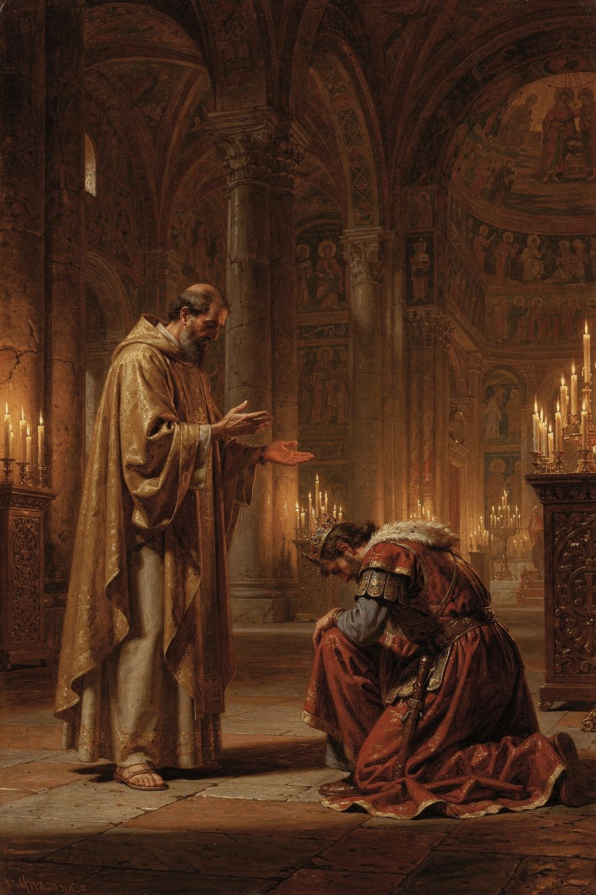
Illustration for Chapter 6

The Massacre at Thessalonica
In 390 CE, a riot broke out in Thessalonica after the arrest of a popular charioteer. In the violence, Botheric, the commander of the imperial garrison, was killed. Emperor Theodosius I, known for his hot temper, ordered a reprisal. Imperial troops were sent to the city and given orders to slaughter the population. The attack was carried out in the circus, where the people had been summoned for what they thought was a public event. Thousands of civilians — men, women, and children — were massacred. The number may be inflated in the sources (Theodoret reports 7,000), but the scale of the slaughter is not in doubt.

Ambrose's Letter
When Ambrose learned of the massacre, he wrote to Theodosius. The letter is remarkable for its blend of personal affection and moral severity. He told the emperor that he could not offer him communion until he demonstrated repentance. He invoked the biblical example of King David, rebuked by the prophet Nathan for ordering the death of Uriah. Ambrose placed Theodosius in the same position: a ruler who must answer to God for the blood he has spilled.
He wrote:
"Sin is not done away but by tears and penitence. Neither angel can do it, nor archangel. The Lord Himself, Who alone can say, 'I am without sin,' forgives no one without repentance."
And:
"Your subjects, O Emperor, are of the same nature as yourself, and not only so, but are likewise your fellow servants; for there is one Lord and Ruler of all, and He is the Maker of all creatures, whether princes or people."
This was without precedent. No bishop had ever told a reigning emperor that he could not receive the sacrament until he repented. The implications were staggering: the most powerful man in the Roman world was being told by a bishop that his power did not place him above moral law or divine judgment.

Theodosius Submits
Theodosius did not ignore the letter. He came to the cathedral of Milan, stripped himself of his imperial robes and insignia, and stood among the congregation as a penitent. According to Theodoret, he prostrated himself on the ground, wept, and lay on the floor. The penance lasted approximately eight months. Theodosius was not permitted to enter within the altar rail — the area reserved for clergy. He accepted this distinction.
Ambrose also stipulated that the emperor should enact a law requiring a thirty-day delay between the issuance of any death sentence and its execution. This "cooling-off period" was designed to ensure that the emperor's wrath would not result in hasty, irreversible acts of state violence. The law was promulgated. It was one of the earliest examples of a penitential act producing structural legal reform: repentance was not only inward contrition but outward amendment of the system that had enabled the sin.

The Historical Reality
Modern scholars have revised the popular image. The dramatic scene of Ambrose barring Theodosius at the cathedral door is a later legend, invented by the fifth-century historian Theodoret. The actual process was conducted through letters and Theodosius's voluntary submission. There was no face-to-face confrontation at the church door.
Neil McLynn (1994) argues that the relationship was one of negotiation between two powerful institutions, not of a bishop dictating to an emperor. Some scholars, notably Mikhail Boytsov, have argued that the penance was a "propaganda victory" for Theodosius — the emperor turned the act of penance into a display of Christian piety that strengthened his legitimacy.
The revised picture does not diminish Ambrose's significance. It refines it. The principle — that the church has an independent moral authority that the state cannot override — was real and unprecedented. The fact that Theodosius submitted voluntarily, rather than being forced, makes the principle more, not less, significant: it shows that even the most powerful man in the world acknowledged that he was subject to a moral authority beyond his own.

The Callinicum Problem
Ambrose's political theology was not always admirable. In 388, Christians at Callinicum destroyed a local synagogue. Theodosius ordered the offenders punished and the synagogue rebuilt at the bishop's expense. Ambrose wrote to protest, arguing that a bishop could not use church funds to rebuild a Jewish place of worship. He warned Theodosius that the people would say "the emperor has become a Jew." He even offered to burn the synagogue himself.
The letter is deeply troubling. It reflects the anti-Jewish attitudes common in fourth-century Christianity. But it also reveals the logic of Ambrose's political theology: the church's resources are dedicated to God and cannot be diverted to purposes contrary to the faith. The same principle that animated the basilica crisis — that sacred things are not subject to imperial power — was applied here in a way that modern readers must judge critically.
This is the central tension in Ambrose's legacy. The principle — that the church has its own sphere of authority — is important and influential. But principles can be used for good or ill. At Thessalonica, Ambrose used the principle to hold a mass murderer accountable. At Callinicum, he used the same principle to defend the destruction of a synagogue. The question is not whether the principle is right — it is whether the person applying it is wise enough, and good enough, to use it justly.

The Principle and Its Legacy
The event established a principle that shaped Western civilization: the ruler is subject to the moral law and to the discipline of the church. The emperor is not above God. Temporal power does not exempt a person from accountability for evil.
This is not the separation of church and state in the modern sense. Ambrose was not arguing that the church should control the government. He was arguing that the church has an independent moral authority that the state cannot override, and that the spiritual consequences of sin apply to rulers as much as to the ruled. The "two swords" doctrine — the distinction between temporal and spiritual authority — would develop from this seed over the following centuries.

Ambrose's Death
Ambrose died on Holy Saturday, April 4, 397 CE. He was about fifty-seven. In his final illness, he was calm and deliberate. He spent his last days in prayer, continuing to receive visitors and give instruction. His last words were: "I have not lived in such a way that I am ashamed to go on living; nor do I fear to die, for we have a good Lord."
He died with his arms stretched out in the form of a cross. The timing — Holy Saturday, the day between Good Friday and Easter — was theologically significant: as Christ lay in the tomb awaiting resurrection, so Ambrose lay in death awaiting the same resurrection.
His funeral orations for others — De obitu Valentiniani (for the young emperor Valentinian II) and De obitu Theodosii (for Theodosius) — were not merely eulogies. They were acts of formation: by interpreting death in the light of the Gospel, Ambrose taught his congregation how to think about their own mortality. The funeral is not only a rite of passage for the dead but a lesson for the living.
The Big Idea
The Theodosius affair established that even the most powerful person in the world is subject to moral accountability. But the Callinicum affair shows that the same principle — that the church has its own sphere — can be used for injustice. The lesson is not "bishops are always right" but "no one is above accountability — not an emperor, and not a bishop." Ambrose was a man of extraordinary courage and ordinary limitation. He confronted an emperor and won. He defended a synagogue's destruction and was wrong. The question is not whether we can find a hero without flaws — we cannot. The question is whether we can learn from the principle while honestly judging its application, including when the application is wrong.
Practice
1. Analyze the Callinicum letter. Read a summary of Ambrose's letter about Callinicum (search "Ambrose Callinicum synagogue letter"). Write one page: (a) What principle was Ambrose applying? (b) How was that principle used for an unjust purpose? (c) Does the unjust application make the principle itself wrong? (d) How do we distinguish between a good principle badly applied and a bad principle?
2. Debate the cooling-off law. Ambrose asked Theodosius to enact a thirty-day waiting period before any execution. Write one paragraph arguing for such a law and one against it. Then think about your own life: what would a "cooling-off rule" look like for you — a rule that prevents you from acting rashly when angry? Design one and write it down.
3. Compare Ambrose and a modern accountability figure. Think of a modern person who has held a powerful leader accountable — a journalist, a whistleblower, a religious leader, a prosecutor. Write one page comparing their situation to Ambrose's: What was the risk? What was the method? What was the outcome? What are the similarities and differences? Is the Ambrose model — moral authority confronting political power — still viable in a secular society?
Reflect
Ambrose said on his deathbed: "I have not lived in such a way that I am ashamed to go on living; nor do I fear to die, for we have a good Lord." This is a rigorous standard — not "Have I done enough good things?" but "Am I living in such a way that I would not be ashamed to continue?" What would it look like to adopt this standard? Not perfectly — Ambrose was not perfect — but honestly. What would change in your life if you measured each decision by whether it would hold up under that question?
———

For the Grown-Up Reader
This booklet for high-school readers engages Ambrose of Milan (c. 340–397 CE) as a serious historical and theological figure. All quotes are real, drawn from Ambrose's own writings and from contemporary witnesses. The primary sources are:
- Ambrose, De officiis ministrorum (On the Duties of the Clergy), trans. Ivor J. Davidson, Oxford Early Christian Texts, 2002. The first sustained Christian manual of public ethics. - Ambrose, De Mysteriis and De Sacramentis, the earliest surviving Western mystagogical catechesis. Trans. R. H. Connolly and in NPNF 2.10. - Ambrose, Epistulae (Letters), trans. Mary Melchior Beyenka, Fathers of the Church Vol. 26 (CUA Press, 1954) and J. H. W. G. Liebeschuetz, Ambrose of Milan: Political Letters and Speeches (Liverpool, 2005). - Ambrose, Hymns, including "Veni redemptor gentium," "Aeterne rerum conditor," "Deus creator omnium," "Iam surgit hora tertia." Ed. J. Fontaine and B. Dunkle. - Augustine, Confessions 5–9, trans. Sarah Ruden (Modern Library, 2017) or Henry Chadwick (Oxford, 1991). - Paulinus of Milan, Vita Sancti Ambrosii (Life of St. Ambrose), in Early Christian Biographies. - Theodoret of Cyrrhus, Ecclesiastical History 5.17–18, on the Thessalonica affair.
Key secondary sources: Neil B. McLynn, Ambrose of Milan: Church and Court in a Christian Capital (UC Press, 1994); Brian P. Dunkle, Enchantment and Creed: The Ambrosian Hymns and Liturgical Theology (Oxford, 2016); Peter Brown, Augustine of Hippo: A Biography (UC Press, 2000) and Through the Eye of the Needle: Wealth, the Fall of Rome, and the Making of Christianity (Princeton, 2012); Daniel H. Williams, Ambrose of Milan and the End of the Nicene-Arian Conflicts (Oxford, 1995).
The booklet is honest about Ambrose's limitations. The Callinicum letter is presented as a real stain — the same principle that enabled the Thessalonica confrontation (church resources are dedicated to God) was used to defend the destruction of a synagogue. The popular image of Ambrose barring Theodosius at the cathedral door is identified as a later legend (Theodoret, debunked by McLynn and Cameron). The scholarly debate about De Sacramentis vs. De Mysteriis is introduced at a level appropriate for high-school readers.
———

About WisdomForge
WisdomForge produces four age-adapted booklets for each figure: elementary (ages 5–10), middle (ages 11–14), high (ages 15–18), and adult. Each booklet covers the same person, ideas, and stories, but at a different level of depth and complexity. The elementary booklet tells stories. The middle booklet explains ideas. The high booklet argues and analyzes. The adult booklet engages with scholarly debates and primary sources. Read the one that fits — or read them all and watch the same figure grow.

