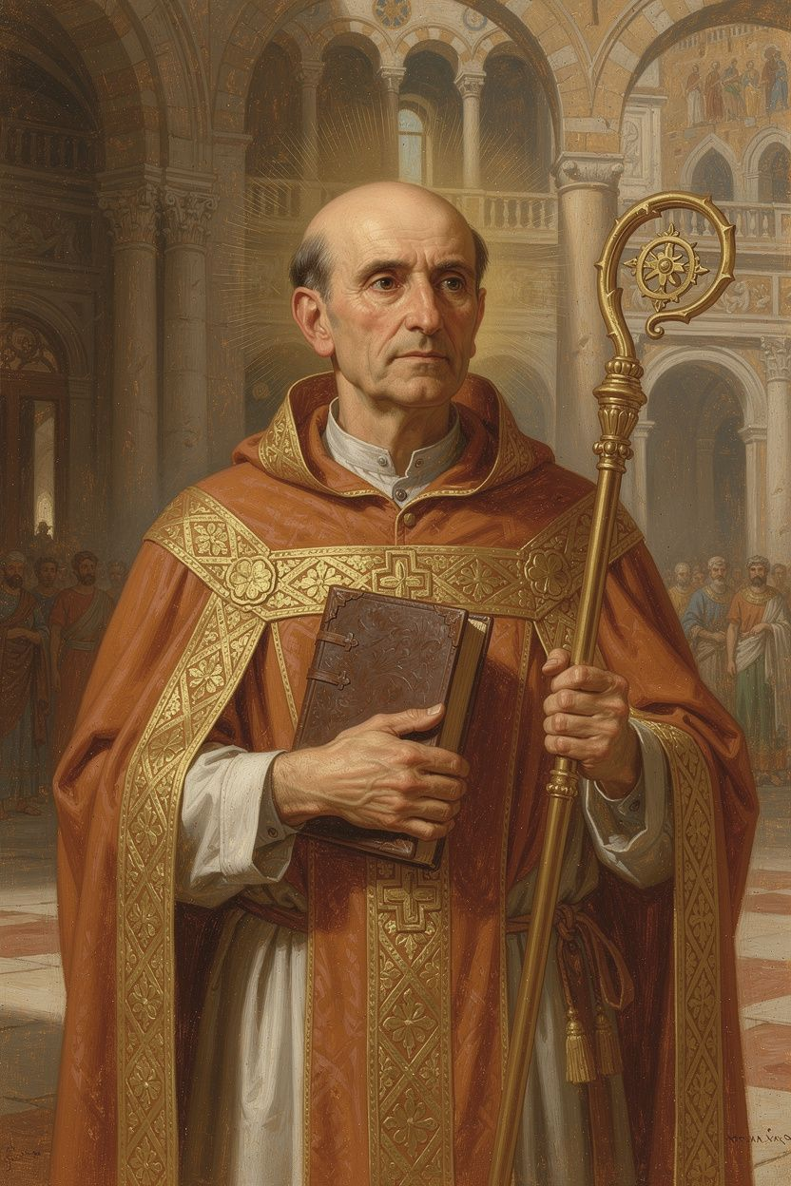
Ambrose: The Bishop Who Stood Up to Emperors
WisdomForge Booklet — Ages 11–14

Ambrose: The Bishop Who Stood Up to Emperors

WisdomForge Booklet — Ages 11–14
———

About This Book
Ambrose of Milan (c. 340–397 CE) was a Roman governor who became a bishop before he was even baptized. In one week, he went from being a political official to being the leader of the church in one of the most important cities in the Roman Empire. He did not want the job. He tried to refuse. But the people of Milan chose him, and he accepted.
His twenty-three years as bishop would change history. He stood up to an empress who tried to take his church. He taught the church to sing. He baptized a man named Augustine who became one of the greatest thinkers in Western history. He wrote the first Christian manual of public ethics. And when the most powerful emperor in the world ordered a massacre, Ambrose told him he could not come to church until he repented — and the emperor obeyed.
This booklet follows Ambrose through six chapters. Each one tells a story from his life, explains the idea behind it, and asks what it means for you. You do not have to agree with everything Ambrose said or did to learn from him. You just have to be willing to think about the questions he raised — about power, courage, music, teaching, faith, and what it means to do the right thing when it costs you something.
———

Chapter 1: The Governor Who Became a Bishop
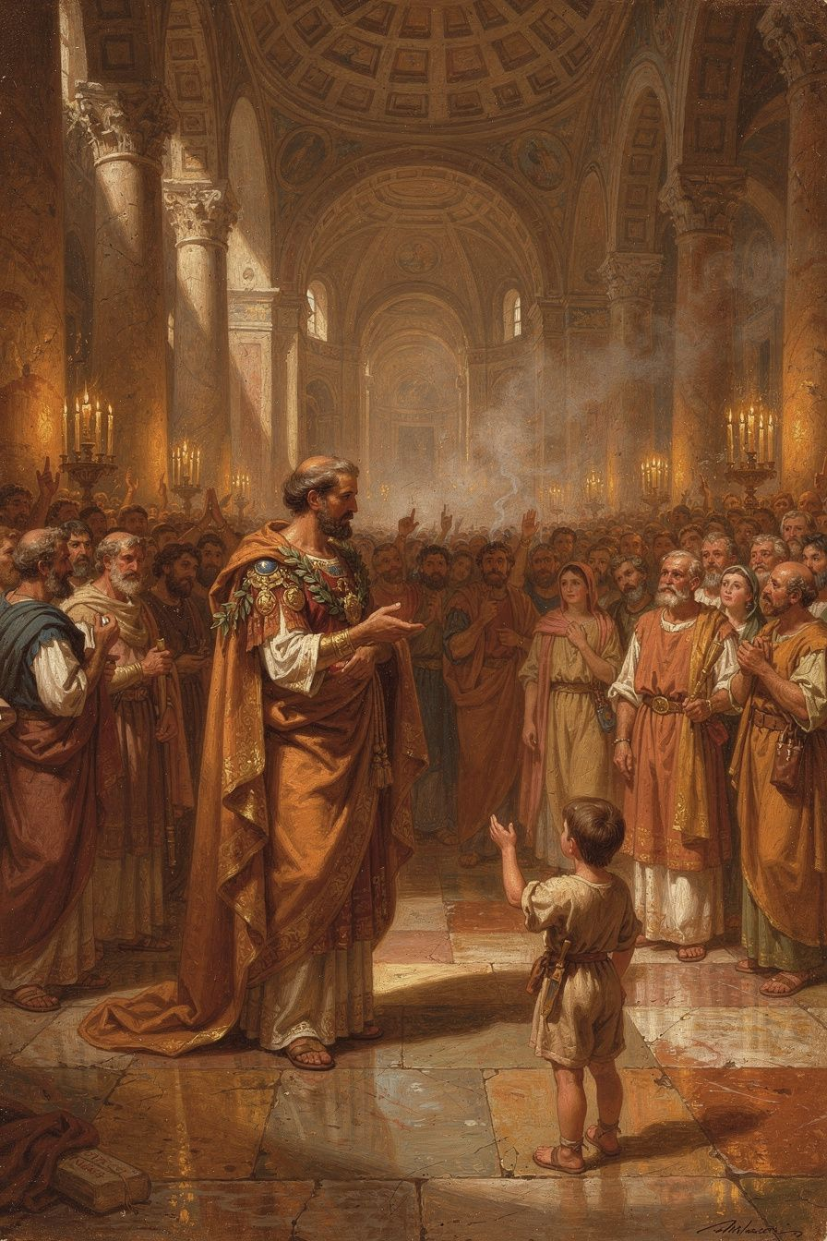
Illustration for Chapter 1

The Unexpected Election
In 374 CE, the bishop of Milan died. His name was Auxentius, and he was an Arian — someone who believed that Jesus was created by God the Father, not co-eternal with him. The people of Milan were split between the Arian party, who agreed with Auxentius, and the Nicene party, who believed that Jesus was fully God, "of one substance" with the Father.
The argument was not just about ideas. It was about who would control the churches, what prayers would be said, and what version of Christianity the next generation would learn. When Auxentius died, both sides knew the choice of the next bishop would shape the city for decades.
The argument got so heated that violence was a real possibility. The governor — Ambrose — went to the church to keep the peace, the same way he would go to any public gathering that might turn dangerous.
While he was speaking to the crowd, a child's voice called out: "Ambrose, bishop!" The whole crowd took it up. Both sides, unable to agree on a candidate from their own parties, chose Ambrose as a compromise. He was a respected official, known for fairness, and — critically — not identified with either theological camp.

Ambrose's Resistance
Ambrose did not want to be bishop. He was not baptized. He was not trained in theology. He was a lawyer and a governor, not a priest. He tried everything to get out of it.
According to his biographer Paulinus of Milan, Ambrose tried to disqualify himself by allowing criminals and even prostitutes in his household, hoping the church would find him unfitting. He tried to flee the city. He even asked the emperor Valentinian I to overrule the election.
None of it worked. The people insisted. The emperor approved. The pope in Rome confirmed it. Within about eight days, Ambrose was baptized, ordained, and consecrated as Bishop of Milan. He was about thirty-four years old.

The Transformation
Ambrose did not become bishop and then keep living the same way. Everything changed. He gave away his personal wealth to the poor, distributing his money and land. He kept only a modest provision for his sister Marcellina. He adopted an ascetic lifestyle — simple food, simple clothes, no luxury.
He also began to study. He had been a catechumen — an unbaptized person receiving instruction — not a trained theologian. Using his knowledge of Greek, which was rare in the Latin West, he read Philo of Alexandria, Origen, Athanasius, and Basil of Caesarea directly in the original. He learned by teaching: his early sermons and treatises are the record of a brilliant layman rapidly mastering the Christian intellectual tradition and passing it on.

Why the Story Matters
The story of Ambrose's election is not just a dramatic tale. It tells us something about leadership. Ambrose did not seek the job. The job found him. He did not campaign, make promises, or build a power base. The people chose him because they trusted him — because he had been fair as a governor and was not tied to any faction.
There is a difference between ambition and calling. Ambrose was ambitious in his first career — he became a governor at a young age, which required talent and drive. But the bishopric was not ambition. It was a call he did not want and could not refuse. The fact that he tried to run away is important. It means he was not chasing power. He was accepting responsibility he did not seek.

Big Idea
The best leaders are sometimes the ones who did not want the job. Ambrose's election was not a power grab — it was a popular call that he resisted and then accepted. The people chose him because he was fair, not because he was political. When you are asked to do something important that you do not feel ready for, the question is not "Am I ready?" but "Am I willing?"

Try This
- Think about unexpected responsibility. Write about a time you were asked to do something you felt unready for. What did you do? Did you say yes or no? What happened? How did Ambrose's resistance and acceptance compare to your experience? - Compare ambition and calling. Ambrose was ambitious as a governor — he worked hard to get that job. But the bishopric was different; it found him. Write down the difference in your own words. Can you think of a time you worked hard for something vs. a time something was given to you that you did not plan for? - Research Milan. Find Milan on a map. In the fourth century, it was one of the most important cities in the Roman Empire — often the seat of the imperial court. What do you know about Milan today? How is it different from what it was in Ambrose's time?

Talk About It
1. If you were Ambrose, would you have accepted the bishopric? What would you have done differently? 2. Why do you think both sides — Nicene and Arian — agreed on Ambrose? What does that tell you about what people want in a leader? 3. Is it better to have a leader who wants the job or a leader who does not?
———
What would you do if the most important choice of your life was made by someone else?
———

Chapter 2: The Bishop Who Said No to an Empress
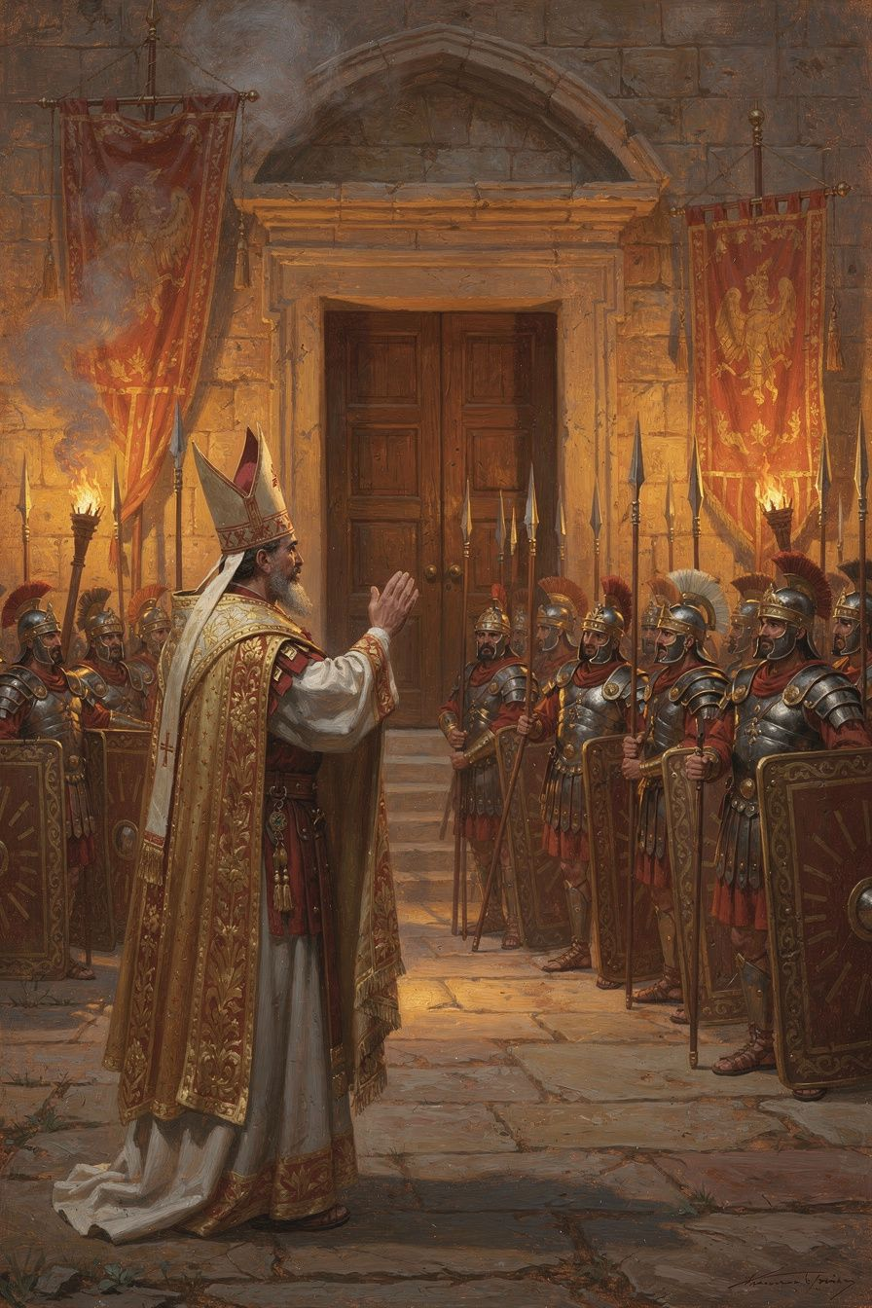
Illustration for Chapter 2

The Demand
In 385 CE, about eleven years after Ambrose became bishop, Empress Justina made a demand. Justina was the mother of the young emperor Valentinian II, and she was an Arian. She wanted Ambrose to surrender one of Milan's basilicas — a church building — so the Arian community could use it for worship.
The demand was framed as reasonable. The Arians needed a place to worship. The emperor, as sovereign, had the authority to allocate public buildings. What was the problem?
The problem was that Ambrose believed the church belonged to God, not to the emperor. A church consecrated to God was not a public building that the state could reassign. He told the emperor's officials:
"If he required of me what was my own — my estate, my money, or the like — I would not refuse it, although all my property really belonged to the poor. But sacred things were not subject to the power of the emperor."
This was a new idea in the Roman Empire. In the ancient world, religion was part of the state. The emperor was the chief priest. Churches, temples, and religious institutions were under the authority of the civil government. Ambrose was saying: no. There is a sphere of life — the inner life of the church — that is withdrawn from the state's authority. The emperor governs bodies, property, and civil order. The bishop governs souls, sacraments, and worship. When the two overlap, the bishop — not the emperor — has the final word.

The Siege
Justina did not accept Ambrose's refusal. She sent imperial soldiers to surround the basilica. She imposed fines and imprisonment on prominent Milanese businessmen who supported Ambrose. She issued a law granting freedom of worship to Arians and permitting the confiscation of basilicas.
But something remarkable happened. The soldiers who were sent to take the basilica began pouring into the church, telling Ambrose they were on his side. They would not use force against the bishop and his congregation.
The people of Milan came to the basilica and stayed inside. For days and nights, they occupied the church, refusing to leave. Imperial soldiers stood outside. The faithful stood inside. The standoff continued.

The Hymns
During the siege, Ambrose taught his congregation to sing. He had written short, simple hymns in Latin — four-line stanzas in a regular rhythm that anyone could learn. The people sang them together, day and night, while the soldiers stood outside.
Augustine, who was in Milan at the time, described what happened:
"Then it was instituted that hymns and psalms should be sung after the manner of the Eastern churches, to prevent the people from languishing under the sorrow of their long vigil. From that day to this, the custom has been retained."
The hymns were not just for comfort. They were a form of resistance. The court could threaten, fine, and imprison, but it could not silence a singing congregation. The hymns asserted that the community's ultimate allegiance was to God, not to the emperor. The singing held the people together — one voice, one faith, one body.

The Discovery of the Relics
During the conflict, workmen excavating for a new basilica discovered skeletal remains. Ambrose interpreted these as the relics of the martyrs Gervasius and Protasius — saints previously unknown to the Milanese church. He had the relics translated to the basilica with great ceremony.
The discovery was understood as a sign from heaven. It drew enormous crowds, increasing public support for Ambrose. The emperor found it difficult to combat what looked like divine confirmation.

The Resolution
The standoff was resolved not by Ambrose's rhetoric alone but by external events. In 387 CE, the usurper Magnus Maximus moved his armies toward Italy. Valentinian II and Justina fled Milan. The political pressure on Ambrose evaporated.
But the principle had been established: the church's goods are not the emperor's to dispose of. The bishop owes obedience to God, not to the court. Popular support is a form of power. Nonviolent resistance can be effective.

Big Idea
The church belongs to God, not to the government. Ambrose drew a line between what belongs to the civil sphere — personal property, estates, money — and what belongs to God. A church building consecrated to God is not the emperor's to give away. This was the first time in Roman history that a bishop had formally told an emperor that the state's power has limits — that there is a sphere of life where the bishop, not the emperor, has authority.

Try This
- Debate the question. Who owns a church building — the government, the community, or God? Write one paragraph arguing that the government should be able to reassign churches. Then write one paragraph arguing that it should not. Which argument do you find more convincing? - Think about nonviolent resistance. Ambrose did not call for armed resistance. He occupied the basilica, prayed, sang hymns, and waited. Can you think of other examples in history where people used nonviolent resistance? What made it work? What are its limits? - Write a hymn. Ambrose's hymns were only four lines each, in a simple rhythm. Try writing your own four-line hymn about something you believe in. It does not have to rhyme perfectly. It just has to be something you would be willing to sing out loud.

Talk About It
1. Was Ambrose right to refuse the empress? What would have happened if he had given in? 2. Why did the soldiers refuse to use force? What does that tell you about the relationship between power and belief? 3. Can singing be a form of political action? Can you think of a time when music was used to protest or resist?
———
What would you do if someone in power told you to give up something you believed was sacred?
———

Chapter 3: The Preacher Who Baptized Augustine
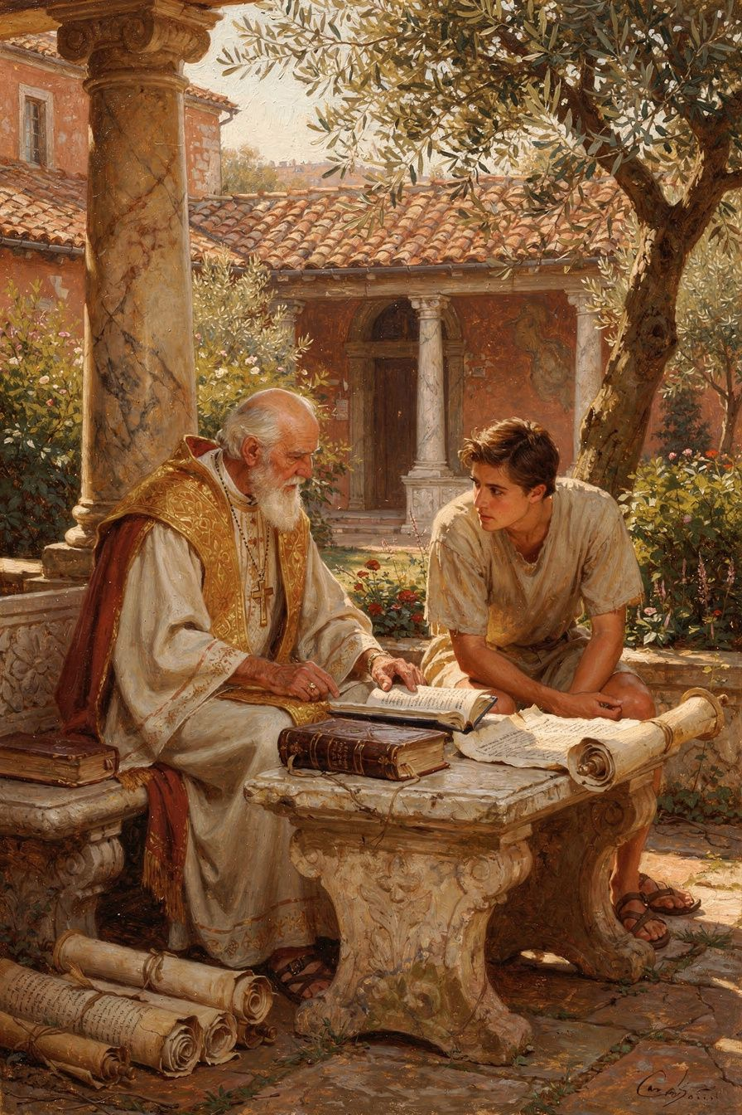
Illustration for Chapter 3

Augustine's Problem
In 384 CE, a man named Augustine arrived in Milan as a professor of rhetoric. He was about thirty years old, brilliant, and miserable. He had spent nearly a decade as a member of the Manichees — a religion that taught the material world was created by an evil power and that the body was a prison for the soul.
But Augustine was losing his faith in Manichaeism. He had discovered that its scientific claims were false — the Manichaean account of the heavens did not match what he could observe. He had met Faustus, a leading Manichaean bishop, and found him intellectually disappointing. He was in a state of intellectual freefall, having lost his old faith without yet finding a new one.
His biggest problem was the Bible. The Manichees had taught him that the Old Testament was crude, violent, and unworthy of a true religion. Its stories of a jealous God, genocidal wars, and patriarchs who lied and deceived seemed to prove that the God of the Jews was not the God of light. Augustine could not reconcile these texts with the philosophical monotheism he was beginning to find attractive.

Ambrose's Solution
Augustine went to hear Ambrose preach, partly out of professional curiosity — he wanted to evaluate Ambrose's rhetoric. What he found was a bishop who read the Old Testament in a way he had never heard before.
Ambrose, following the Alexandrian tradition of Origen, read the Bible allegorically. The literal surface of the text was not the whole meaning. Beneath it lay a spiritual sense that pointed to Christ, to the soul, and to the church. The story of Adam and Eve was not merely about a talking snake; it was about the soul's fall from contemplation. The Song of Songs was not about romantic love; it was about the love between Christ and the church.
Augustine described the effect:
"I rejoiced also that the Old Testament Scriptures were now set before me by Ambrose, not as objects of scorn, as I had previously thought them, but were expounded with a spiritual interpretation, so that I could not blame those who believed in them for not being able to understand them literally, when the spiritual meaning was so profound."
This was a liberation. The allegorical method did not make the Old Testament go away — it made it readable. Augustine did not have to defend every literal detail. He could read it at a deeper level, the level at which the text pointed to Christ and to the interior life of the soul.

The Personal Relationship
Ambrose's influence was not only intellectual. It was personal. Augustine wrote:
"I began to love him, not at first as a teacher of the truth, for I had despaired of finding that in your Church, but as a man who was kind to me."
Ambrose welcomed Augustine, listened to him, and gave him access to his time. He did not argue with him or pressure him. He modeled a kind of pastoral care that was patient, warm, and intellectually serious — a bishop who was both a thinker and a kind man.

The Conversion
Augustine's conversion was not a single moment but a process. After hearing Ambrose's preaching, he moved toward Christianity intellectually. He explored Neoplatonism, which gave him a language for the soul's ascent toward God. But philosophy alone did not solve his problem — it gave him a way to think about God but not the moral power to change his life.
The pivotal moment came in a garden in Milan. Augustine, in agony over his inability to change, heard a child's voice saying: "Take up and read. Take up and read." He opened Paul's letters at random and read Romans 13:13–14: "Put on the Lord Jesus Christ, and make no provision for the flesh, to gratify its desires."
All the darkness of doubt was dispelled. Augustine was ready for baptism.

The Baptism
On the night of April 24–25, 387 CE, Ambrose baptized Augustine, his son Adeodatus, and his friend Alypius at the Easter Vigil in the cathedral of Milan. Augustine described the experience with characteristic intensity — the tears, the singing, the sense of an old self being washed away and a new self emerging.
The singing was a key part. Augustine wrote: "How I wept during your hymns and songs! I was deeply moved by the voices of your sweet-sounding church. The voices flowed into my ears, and the truth was distilled into my heart."

What Ambrose Gave Augustine
Ambrose gave Augustine three things that redirected the course of his life:
1. A way of reading Scripture. The allegorical method gave Augustine a way to read the Old Testament as Christian Scripture. This method would shape Augustine's own exegetical works for the rest of his life.
2. A model of the church. Ambrose showed Augustine that the church was not the anti-intellectual body the Manichees mocked. It was a community of worship, mutual care, and intellectual seriousness. This model shaped Augustine's own ministry as bishop of Hippo.
3. A liturgical imagination. Ambrose's hymns, mystagogical catechesis, and liturgical innovations gave Augustine a sense of the sacramental life of the church — the conviction that the sacraments are encounters with divine grace, not mere symbols.
Augustine went on to become the most influential theologian in Western Christianity. Without Ambrose, there might have been no baptism, no Confessions, no City of God.

Big Idea
Sometimes the best teaching is not a lecture — it is kindness. Ambrose did not argue Augustine into the church. He welcomed him, showed him a new way to read, and waited. The best teachers do not push. They open doors and let you walk through. Ambrose's allegorical method solved Augustine's intellectual problem, but it was Ambrose's personal kindness that made Augustine willing to listen.

Try This
- Read a text two ways. Pick a story you know — from a book, a movie, or your family. First, tell it the plain way: what happened. Then tell it again: what does it mean deeper down? What is the story really about? That is what Ambrose did with the Bible. - Think about a teacher who changed you. Write about a teacher who was kind to you when you were struggling. What did they do? How was their kindness different from a lecture? Ambrose was kind to Augustine, and it changed the course of history. Can kindness change a life? - Research Augustine. After his baptism by Ambrose, Augustine became a bishop, wrote Confessions and City of God, and shaped Western Christianity for a thousand years. Find one fact about Augustine that surprises you.

Talk About It
1. Why was the literal reading of the Old Testament a barrier for Augustine? How did the allegorical method help? 2. What is the difference between hearing something and understanding it? Has anyone ever explained something to you in a way that suddenly made sense? 3. Ambrose was kind to Augustine before he was his teacher. Which matters more — kindness or teaching? Can you have one without the other?
———
Has a book or an idea ever made sense to you only when someone explained it differently?
———

Chapter 4: The Teacher of the Sacraments
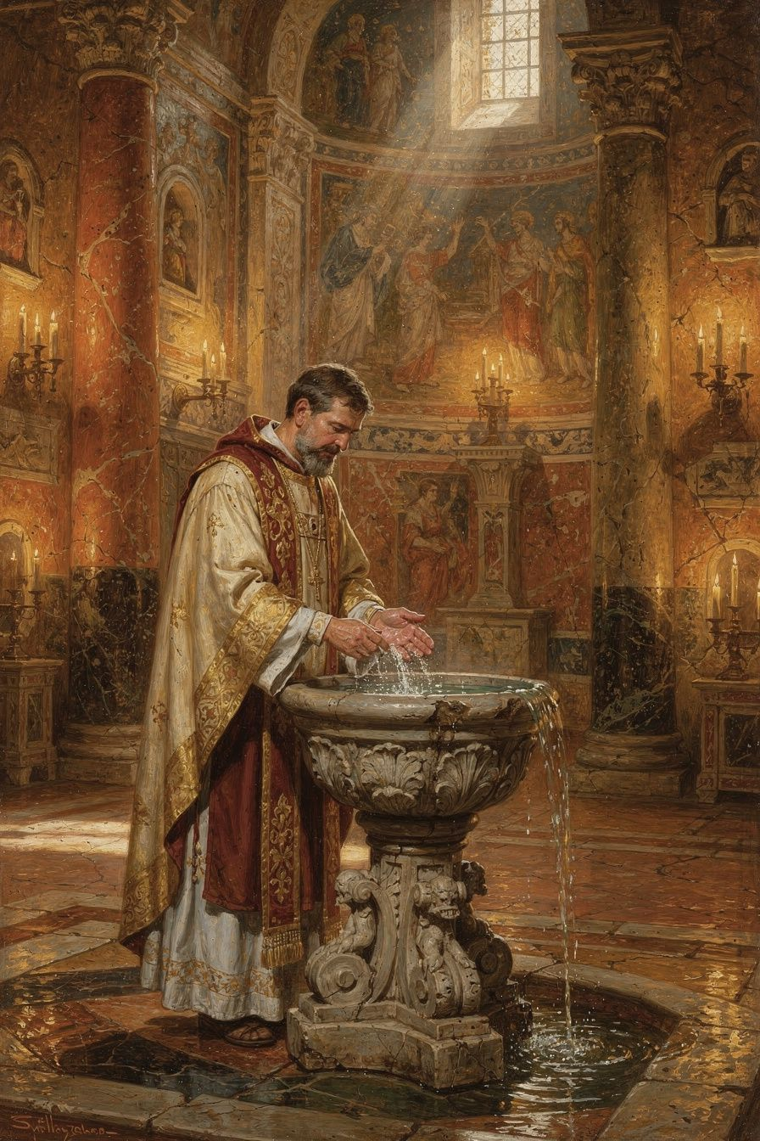
Illustration for Chapter 4

What Mystagogy Was
In the early church, the sacraments — baptism, confirmation, Eucharist — were not explained in detail before baptism. This practice, called the disciplina arcani (discipline of the secret), kept the specifics of the rites hidden from outsiders. The full explanation came after baptism, during Easter week, when the newly initiated were taught what they had just experienced.
This post-baptismal instruction is called mystagogy — "leading into the mystery." The mystagogue does not explain the sacraments as a professor explains a subject. The mystagogue interprets an experience that the learner has already had — naming what was felt, revealing the theology that was enacted in the ritual.
Ambrose's mystagogy is preserved in two works: De Mysteriis (On the Mysteries) and De Sacramentis (On the Sacraments). Together they are the earliest surviving Western mystagogical catechesis.

Baptism: The New Birth
Ambrose taught that baptism is not a symbolic ceremony. It is a real transformation — a new birth. He developed this through biblical typology:
- The water. The water of baptism carries the power of the cross of Christ. Without the cross, water is just an element; with the cross, it becomes the womb of regeneration. "You saw water — but not water alone. For what is water without the cross of Christ? A common element, without any sacramental effect."
- The Spirit. The Spirit hovers over the font as the Spirit hovered over the waters of creation (Genesis 1:2). Baptism is a new creation: the same Spirit that brought order out of chaos brings new life out of the old self.
- Typology. The flood (Genesis 6–8) prefigures baptism: Noah's ark is the church, and the waters that destroyed the wicked also lifted the righteous. The crossing of the Red Sea (Exodus 14) prefigures baptism: the water that drowned Pharaoh's army gave life to Israel. Naaman's washing in the Jordan (2 Kings 5) heals the leprosy of sin.
The result is not merely forgiveness but regeneration. The baptized person is not the same person they were before. "You were made new," Ambrose says, because the old self was buried in the water and the new self rose with Christ.

The Eucharist: The Real Presence
Ambrose's treatment of the Eucharist is one of the earliest and clearest Western statements of the doctrine of the real presence. He does not use later scholastic terminology like transubstantiation, but his language is unmistakable:
"You perhaps say, 'My bread is the usual kind.' But this bread is bread before the words of consecration; after the consecration it has become the flesh of Christ. ... Therefore the Lord Jesus Christ himself declared, 'This is my body.' Before the blessing, a certain thing is named; after the blessing, another."
His argument is not philosophical — he does not try to explain how the change occurs. His argument rests on the power of the divine word. The same word of God that created the world from nothing now transforms bread into body and wine into blood. He draws an analogy: "If the word of the Lord Jesus was able to make out of nothing what did not exist, how much more can it transform what already exists into something else?"

Confirmation: The Seven Gifts
After baptism, the bishop lays hands on the newly baptized and anoints them with chrism — consecrated oil. Ambrose interprets this as the giving of the seven gifts of the Holy Spirit, drawn from Isaiah 11:2: wisdom, understanding, counsel, might, knowledge, godliness, and fear of the Lord.
The anointing with chrism consecrates the person as a spiritual priest, in the line of the Old Testament anointing of priests and kings. Christ (Christus) means "the anointed one" — and the baptized, anointed with the same Spirit, share in that anointing.

The Nature of Sacrament
For Ambrose, the word sacramentum is broader than the later medieval category of "seven sacraments." It encompasses any sacred sign or mystery through which divine grace is mediated. What makes something a sacrament is not its institutional status but its capacity to make present the reality it signifies. The water of baptism is the womb of regeneration; the bread of the Eucharist is the body of Christ. The sign does not merely point to grace — it carries it.
This does not mean Ambrose is naive about the distinction between sign and reality. He is aware that the external form (water, bread, wine) remains perceptibly what it was. But he insists that the spiritual reality is not less real than the physical sign — it is more real.

Big Idea
Some things are deeper than they look. The water is not just water. The bread is not just bread. They are signs that God is doing something you cannot see but that is very real. Ambrose taught people to look with their hearts, not just with their eyes. The sacraments are not symbols that remind us of God — they are encounters with God, mediated through created things that God has chosen as vehicles of grace.

Try This
- Think about rituals. What rituals have you participated in? A graduation, a wedding, a religious ceremony? How did it feel before, during, and after? Ambrose's mystagogy was about explaining an experience after you have had it. What would you want explained after a big ceremony? - Research the word "sacrament." The word comes from the Latin sacramentum, which originally meant a sacred oath or pledge. How does that meaning connect to what Ambrose taught about baptism and the Eucharist? - Compare with science. Ambrose argued that the same word of God that created the world from nothing can transform bread into something new. Is this a scientific claim or a theological one? What is the difference? Can both kinds of truth be real at the same time?

Talk About It
1. Why did the early church choose to explain the sacraments after baptism rather than before? What are the advantages and disadvantages of each approach? 2. What does it mean to say that water is "not water alone"? Can a physical thing carry spiritual power? Give an example. 3. Ambrose's argument for the Eucharist is not philosophical but theological — he argues from the power of God's word. Is that a convincing argument? Does it matter how the bread becomes the body, or only that it does?
———
Have you ever done something where you felt different afterward, even though you couldn't fully explain why?
———

Chapter 5: The Poet Who Gave the Church Its Voice
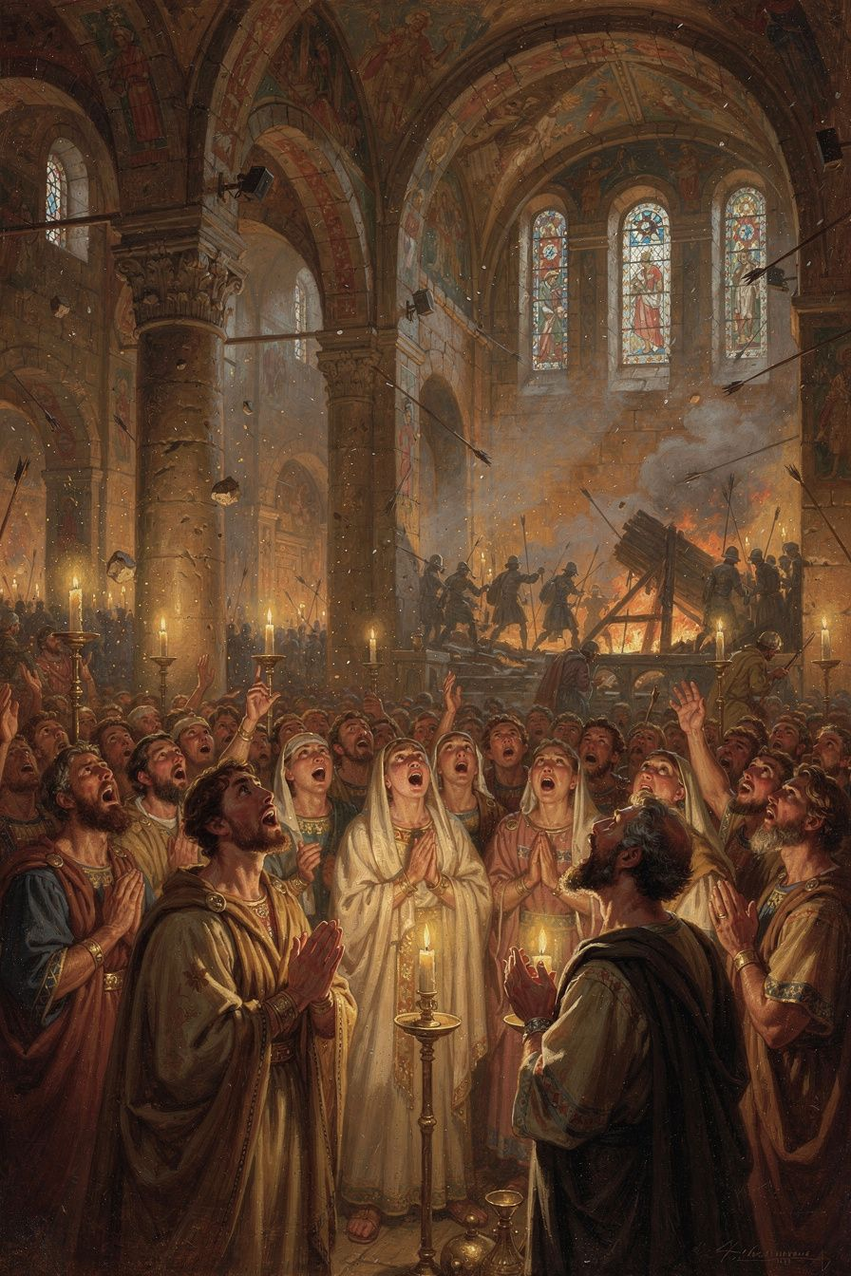
Illustration for Chapter 5

The Invention of Congregational Hymnody
Before Ambrose, Latin Christian hymnody was limited. The earliest known Latin hymn writer was Hilary of Poitiers (c. 310–367), who composed hymns in the 350s. But Hilary's hymns were complex, literary, and apparently not widely used in congregational worship.
Ambrose changed this. His hymns are short — typically eight stanzas of four lines each. They are written in strict iambic tetrameter (eight syllables per line, alternating unstressed and stressed). This meter is the simplest and most memorable in Latin poetry: it matches the natural rhythm of the language, making the hymns easy to learn and sing, even for people without formal education.
The result was something new in the Latin church: hymns that the whole congregation could sing together, remember, and internalize.

The Four Authentic Hymns
Only four hymns are universally conceded to be authentically Ambrosian, on the authority of Augustine, who names them in his writings:
1. Aeterne rerum conditor ("Eternal Maker of all things") — A morning hymn praising God as creator and asking Christ, the light of the world, to dispel the darkness of night.
2. Deus creator omnium ("God, Creator of all things") — An evening hymn meditating on the transition from day to night as a figure for the passage from life to death, asking God for rest and protection.
3. Iam surgit hora tertia ("Now the third hour rises") — A hymn for the third hour, connecting the hour of prayer with the events of Christ's passion and Pentecost.
4. Veni redemptor gentium ("Come, Redeemer of the nations") — An Advent hymn addressing Christ as the one who comes to redeem, presenting the incarnation as the descent of divine majesty into human flesh. It is still sung in churches today, particularly during Advent. Martin Luther later translated and adapted this hymn, producing "Nun komm, der Heiden Heiland," one of the foundational hymns of the Reformation.

The Basilica Crisis and the Birth of the Hymns
The most famous context for the Ambrosian hymns is the basilica crisis of 385–386, when the Arian empress Justina demanded that Ambrose surrender Milan's churches. Ambrose refused, and his congregation barricaded themselves inside the basilica.
According to Augustine, the hymns were introduced during this crisis as a tool for sustaining morale. The people were under siege — imperial soldiers surrounded the church, and the standoff could have turned violent. Singing together served three purposes:
- Morale. The singing gave the congregation something to do, a way to channel fear and uncertainty into worship. - Unity. The act of singing together bound the congregation into a single body — literally, as their voices merged, and symbolically, as they confessed the same words. - Theological formation. The hymns embedded Nicene doctrine — the divinity of Christ, the Trinity, the reality of the incarnation — in the memory of the singers. The people who sang these hymns were learning theology through their bodies.
Ambrose himself described the purpose of the hymns as "the confession of the Trinity in the mouths of the whole people." This is a remarkable statement. The hymns are not decoration; they are doctrinal formation. They are the means by which the community internalizes the faith it confesses.

Enchantment and Creed
The musicologist Brian Dunkle, in his study Enchantment and Creed (2016), has argued that the hymns function through enchantment — the capacity of sung poetry to captivate the mind, embed ideas in memory, and shape the affections. The hymns do not merely state doctrine; they enchant the singer with the beauty of the truth.
This is connected to the ancient understanding of music's power. From Plato onward, philosophers recognized that music shapes the soul — that the rhythms and melodies a person internalizes become the patterns of their thought and feeling. Ambrose chose the simplest and most memorable meter because he wanted the hymns to be unforgettable. He chose vivid imagery because he wanted them to captivate the imagination. He chose theological density because he wanted the beauty of the form to carry the weight of the content.
The result is a fusion of enchantment (the aesthetic power of the hymn) and creed (the doctrinal content it carries). The singer is enchanted by the beauty of the hymn, and in being enchanted, absorbs the creed.

The Legacy
Ambrose's hymnody had an enormous afterlife. The Ambrosian model — short stanzas in regular meter, with theological content — became the standard form of Latin office hymns throughout the Middle Ages. The hymns of Prudentius, Venantius Fortunatus, and later medieval hymn writers all descend from the Ambrosian pattern. The tradition of congregational hymnody that Ambrose established was carried forward by Luther and the Reformation, and it continues today in the hymnals of virtually every Christian tradition.
The deepest legacy is not the specific hymns but the principle they embody: that worship is not a spectator event but a participatory practice, and that the voice of the people — raised in song — is one of the most powerful forces in the life of the church.

Big Idea
What we sing shapes what we believe. When you sing a doctrine, you do not merely agree with it intellectually — you internalize it physically. The rhythm, melody, and repetition lodge the words in your memory and your body. Ambrose understood this. His hymns were not just songs; they were theology in a form that the simplest worshipper could absorb through singing. A hymn is a small creed, portable and repeatable — and a singing congregation is a congregation that believes together.

Try This
- Analyze a hymn. Find one of Ambrose's four authentic hymns online (search for "Veni redemptor gentium" or "Aeterne rerum conditor"). Read the English translation. What theology does it contain? What does it teach about God, Christ, or creation? How does the four-line structure make it memorable? - Think about what you sing. What songs do you know by heart? What have they taught you? Are there songs that have shaped what you believe about love, justice, courage, or hope? Write about one song that has influenced you. - Compare singing and speaking. Try saying the words of a song you know well without the melody. Then sing it. How is it different? Which is easier to remember? Why do you think Ambrose chose singing instead of speaking as his tool for teaching theology?

Talk About It
1. Why is it easier to remember a song than a speech? What does that tell us about how music works on the mind? 2. Ambrose said the hymns were "the confession of the Trinity in the mouths of the whole people." What does it mean to confess doctrine through song rather than through argument? 3. The hymns were born in a crisis. Does danger make art more powerful — or less? Can beauty be a form of resistance?
———
What songs have shaped what you believe?
———

Chapter 6: The Bishop Who Rebuked an Emperor
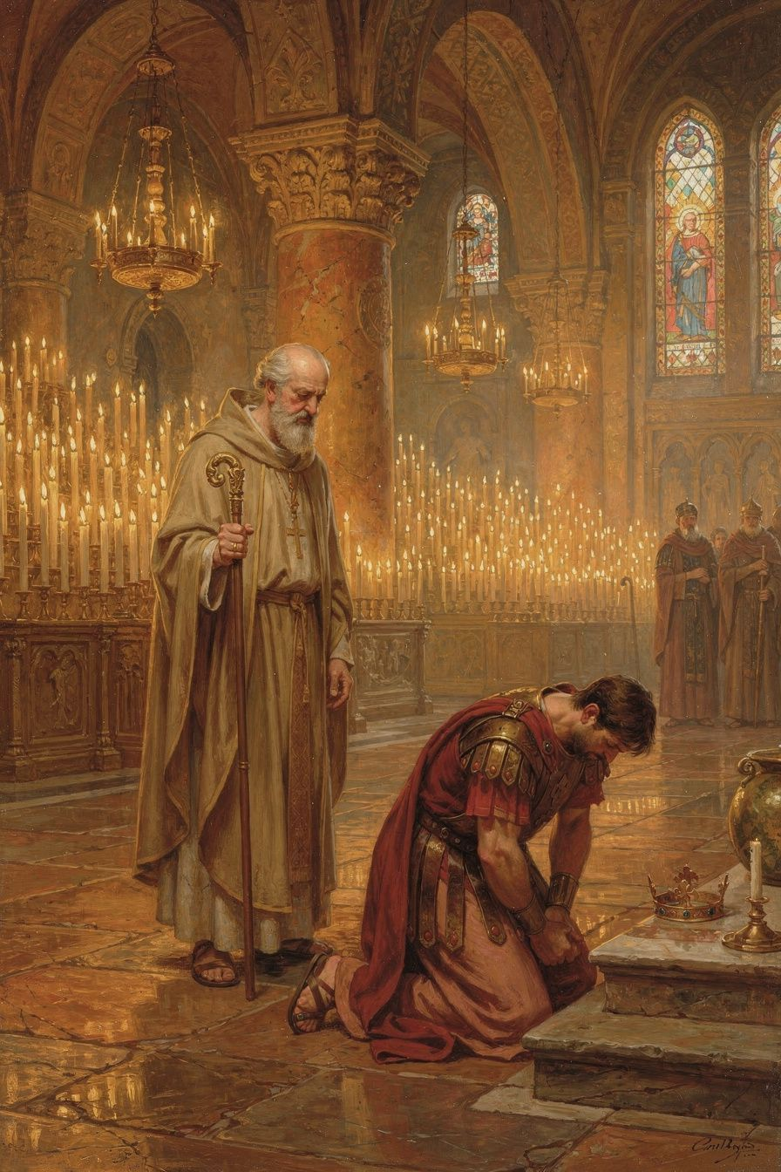
Illustration for Chapter 6

The Massacre at Thessalonica
In 390 CE, a riot broke out in the city of Thessalonica, in northern Greece. The people killed Botheric, the commander of the imperial garrison. Emperor Theodosius I, known for his hot temper, was furious. He ordered a reprisal: when the people gathered in the circus for games, his soldiers sealed the exits and slaughtered thousands of civilians — men, women, and children.
The massacre was indiscriminate. The innocent died alongside the guilty. It was one of the worst atrocities committed by a Christian emperor against his own people.

Ambrose's Response
When Ambrose learned of the massacre, he wrote a letter to Theodosius. The letter is remarkable for its combination of personal affection and moral severity.
Ambrose told the emperor that he could not offer him communion — the sacrament of the Eucharist — until he demonstrated repentance. He did not formally excommunicate Theodosius in a canonical sense, but he made clear that the emperor's sin was public and that his repentance must be public as well.
He wrote:
"Sin is not done away but by tears and penitence. Neither angel can do it, nor archangel. The Lord Himself, Who alone can say, 'I am without sin,' forgives no one without repentance."
And:
"Your subjects, O Emperor, are of the same nature as yourself, and not only so, but are likewise your fellow servants; for there is one Lord and Ruler of all, and He is the Maker of all creatures, whether princes or people."
The letter invoked the biblical example of King David, who was rebuked by the prophet Nathan for ordering the death of Uriah. Ambrose placed Theodosius in the same position: a ruler who must answer to God for the blood he has spilled.

Theodosius Submits
Theodosius did not ignore the letter. He came to the cathedral of Milan, stripped himself of his imperial robes and insignia, and stood among the congregation as a penitent. According to the ancient historian Theodoret, he prostrated himself on the ground, wept, and lay on the floor of the church. The emperor who ruled the world was lying prostrate before God, while a bishop stood over him.
The penance lasted approximately eight months. Theodosius was not permitted to enter within the altar rail — the area reserved for clergy. He accepted this distinction. The temporal ruler and the spiritual ruler had different spheres, and the altar belonged to the latter.
Ambrose restored Theodosius to communion by Christmas 390. But the restoration came with a condition: Theodosius should enact a law requiring a thirty-day delay between the issuance of any death sentence and its execution. This "cooling-off period" was designed to ensure that the emperor's wrath would not result in hasty, irreversible acts of state violence. The law was promulgated.

The Principle
The event established a principle that shaped Western civilization: the ruler is subject to the moral law and to the discipline of the church. The emperor is not above God. Temporal power does not exempt a person from accountability for evil. A bishop who holds the keys of the sacraments must use them for all, including — especially — those who wield the most power.
This is not the separation of church and state in the modern sense. Ambrose was not arguing that the church should control the government. He was arguing that the church has an independent moral authority that the state cannot override, and that the spiritual consequences of sin apply to rulers as much as to the ruled.

The Historical Reality
Modern scholars have revised the popular image of this event. The dramatic scene of Ambrose barring Theodosius at the cathedral door is a later legend, invented by the fifth-century historian Theodoret. The actual process was conducted through letters and through Theodosius's voluntary submission. There was no face-to-face confrontation at the church door.
Neil McLynn, in Ambrose of Milan (1994), argues that the relationship between Ambrose and Theodosius was one of negotiation between two powerful institutions, not of a bishop dictating to an emperor. The revised picture does not diminish Ambrose's significance. It refines it. Ambrose did not control the empire, but he articulated a principle — that the church's internal life is withdrawn from state authority — that proved extraordinarily influential.

The Callinicum Problem
Ambrose's political theology was not always admirable. In 388, Christians at Callinicum destroyed a local synagogue. Theodosius ordered the offenders punished and the synagogue rebuilt at the bishop's expense. Ambrose wrote to protest, arguing that a bishop could not use church funds to rebuild a Jewish place of worship. He even offered to burn the synagogue himself.
The letter is troubling. It reflects the anti-Jewish attitudes common in fourth-century Christianity. But it also reveals the logic of Ambrose's political theology: the church's resources are dedicated to God and cannot be diverted to purposes contrary to the faith. The same principle that animated the basilica crisis — that sacred things are not subject to imperial power — was applied here in a way that modern readers must judge critically.
Ambrose was not infallible. He was a man of his time, with the prejudices of his time. The question is not whether he was always right — he was not — but whether the principle he articulated, that there is a sphere of life withdrawn from state authority, is still meaningful. The application of that principle at Callinicum was wrong. The principle itself remains important.

Ambrose's Death
Ambrose died on Holy Saturday, April 4, 397 CE. He was about fifty-seven years old. In his final illness, he was calm and deliberate. He spent his last days in prayer, continuing to receive visitors and give instruction.
His last words, reported by Paulinus, were: "I have not lived in such a way that I am ashamed to go on living; nor do I fear to die, for we have a good Lord."
He died with his arms stretched out in the form of a cross. The timing — Holy Saturday, the day between Good Friday and Easter — was theologically significant: as Christ lay in the tomb awaiting resurrection, so Ambrose lay in death awaiting the same resurrection.

Big Idea
Even the most powerful person in the world has to follow the rules. Ambrose was brave enough to tell the most powerful man on earth that he had sinned and needed to repent — and Theodosius was humble enough to listen. But Ambrose was not infallible. His letter about Callinicum shows that the same principle can be used for a bad purpose. The lesson is not "bishops are always right" but "no one is above accountability — not even an emperor, and not even a bishop."

Try This
- Debate the question. Who has the right to tell a leader they are wrong? Write one paragraph arguing that religious leaders should confront political leaders. Then write one paragraph arguing that they should not. Which is more convincing? - Think about the cooling-off law. Ambrose asked Theodosius to make a thirty-day waiting period before any execution. Why? What would a "cooling-off rule" look like in your life? Write one rule that would help you make better decisions when you are angry. - Evaluate Ambrose honestly. Ambrose did something brave with Theodosius and something wrong with Callinicum. Write one sentence about what he got right and one about what he got wrong. Can a person be brave and still make mistakes? Does one mistake cancel the other?

Talk About It
1. Does being in charge mean you can do whatever you want? Who checks the power of a president, a king, or a boss? 2. Theodosius accepted the penance. What does that tell you about him? Would it have been easier to ignore Ambrose? Why did he not? 3. Ambrose's letter about Callinicum used a good principle for a bad purpose. How do we evaluate a good principle when it is applied badly? Does the bad application make the principle itself wrong?
———
Who has the right to tell a leader they are wrong?
———

For the Grown-Up Reader
This booklet introduces young readers (ages 11–14) to Ambrose of Milan (c. 340–397 CE), covering the major events and ideas of his life. All quotes are real, drawn from Ambrose's own writings (De officiis ministrorum, De Mysteriis, De Sacramentis, Epistulae, the hymns), from Augustine's Confessions, and from ancient historians (Paulinus of Milan, Theodoret, Sozomen).
The key primary sources are:
- Ambrose, De officiis ministrorum (On the Duties of the Clergy), the first Christian manual of public ethics - Ambrose, De Mysteriis and De Sacramentis, the earliest surviving Western mystagogical catechesis - Ambrose, Epistulae (Letters), especially Letters 20, 21, 30, and 51 - Ambrose, Hymns, including "Veni redemptor gentium" and "Aeterne rerum conditor" - Augustine, Confessions 5–9, the most important witness to Ambrose's pastoral impact - Paulinus of Milan, Vita Sancti Ambrosii (Life of St. Ambrose), the earliest biography
Key secondary sources: Neil B. McLynn, Ambrose of Milan: Church and Court in a Christian Capital (University of California Press, 1994); Brian P. Dunkle, Enchantment and Creed: The Ambrosian Hymns and Liturgical Theology (Oxford University Press, 2016); Peter Brown, Augustine of Hippo: A Biography (University of California Press, 2000); Daniel H. Williams, Ambrose of Milan and the End of the Nicene-Arian Conflicts (Oxford University Press, 1995).
A note on the Thessalonica episode: the popular image of Ambrose barring Theodosius at the cathedral door is a later legend, debunked by modern historians (McLynn 1994, Cameron 2011). The actual process was conducted through letters and Theodosius's voluntary submission to ecclesial discipline. The booklet tells the historically accurate version.
A note on the hymns: only four hymns are universally attributed to Ambrose on the authority of Augustine. The broader Ambrosian tradition includes many more, but the four core hymns (Aeterne rerum conditor, Deus creator omnium, Iam surgit hora tertia, Veni redemptor gentium) are the secure foundation.
A note on the Callinicum incident: the booklet does not hide Ambrose's troubling letter about the synagogue at Callinicum. It presents the principle (church resources are dedicated to God) alongside the troubling application (anti-Jewish prejudice). This is consistent with the skill's commitment to honesty about historical figures.
———

About WisdomForge
WisdomForge produces four age-adapted booklets for each figure: elementary (ages 5–10), middle (ages 11–14), high (ages 15–18), and adult. Each booklet covers the same person, ideas, and stories, but at a different level of depth and complexity. The elementary booklet tells stories. The middle booklet explains ideas. The high booklet argues and analyzes. The adult booklet engages with scholarly debates and primary sources. Read the one that fits — or read them all and watch the same figure grow.

