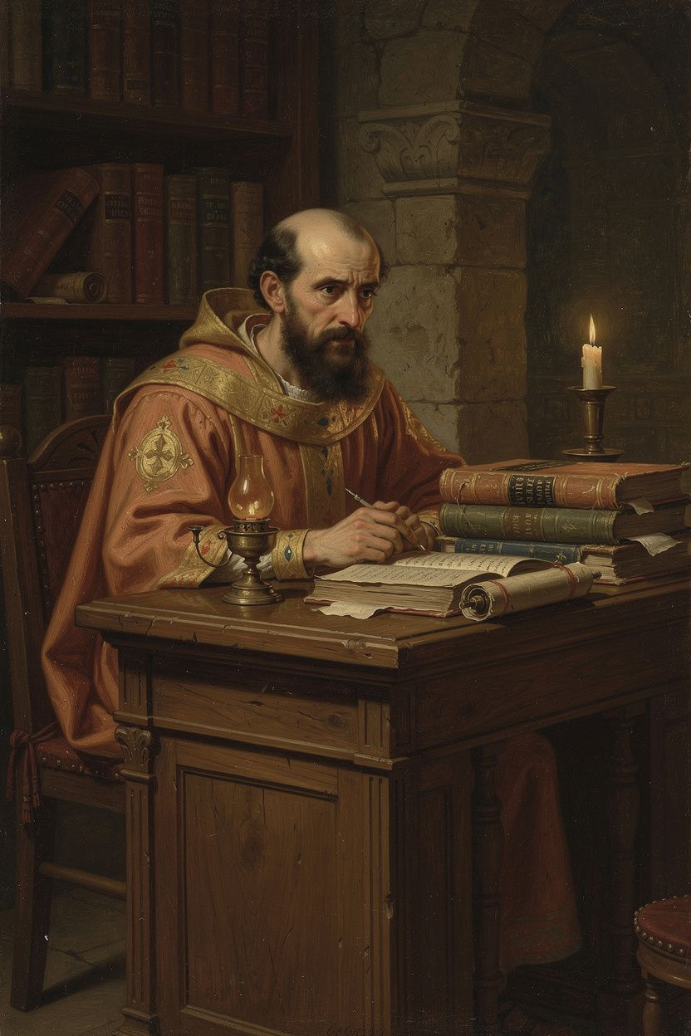
Basil of Caesarea: Theologian of the Spirit, Architect of Love
WisdomForge Booklet — Adult

Basil of Caesarea: Theologian of the Spirit, Architect of Love

WisdomForge Booklet — Adult
———

About This Book
Basil of Caesarea (c. 330–379 CE) lived only forty-nine years, but in that time he gave the Christian church its trinitarian vocabulary, its monastic rules, its first great hospital, and an example of episcopal courage that still inspires. With his brother Gregory of Nyssa and his friend Gregory of Nazianzus — the three known as the Cappadocian Fathers — Basil formulated the distinction between one divine essence (ousia) and three distinct persons (hypostaseis) that became the permanent doctrinal foundation of both Eastern and Western Christianity. He defended the full divinity of the Holy Spirit against the Pneumatomachi in On the Holy Spirit (375 CE). He preached the Hexaemeron (c. 378 CE), the most influential patristic meditation on creation. He wrote monastic rules that shaped Eastern Orthodox monasticism for centuries and influenced Benedict in the West. He built the Basileias, one of the earliest integrated Christian social welfare institutions. And he stood up to the emperor Valens, who threatened him with confiscation, exile, torture, and death.
This booklet is for adult readers. It assumes you can engage with theological argumentation, historical complexity, and scholarly debate. Each chapter includes a narrative essay, a Big Idea that develops the chapter's philosophical core, Practice exercises that put the idea into action, and a Reflect question. The scholarly debates are real and current — they name the disagreements that patristic scholars still have about Basil's theology, and they invite you to join the conversation. The debates include: whether Basil "changed his mind" about the Spirit (Wolfson vs. Hildebrand); whether his social teaching is radical or realistic (Holman vs. Rousseau); the relationship between the Hexaemeron and ancient science; whether Basil's community model differs fundamentally from Benedict's; and the ethics of Basil's self-expenditure — whether his relentless work that killed him at forty-nine was heroic or self-destructive.
Basil was not a system-builder writing from a library. He was a bishop writing from the front lines of a theological war, a monk writing rules for communities he had founded, a pastor writing sermons for congregations that included farmers and emperors, and a friend writing letters that reveal a man who was brilliant, tired, courageous, and deeply human. His theology was forged in controversy, friendship, institutional building, and the daily demands of leading a church through political danger. The result is a body of work that is both intellectually rigorous and deeply practical. Theology, for Basil, was never separate from love — love of God, love of the poor, love of the community, and love of the truth. The six chapters that follow trace the arc of his life and thought, from the Athens classroom to the bishop's office to the deathbed, and from the doctrine of the Trinity to the architecture of a hospital.
———

Chapter 1: The Education That Found Its Purpose
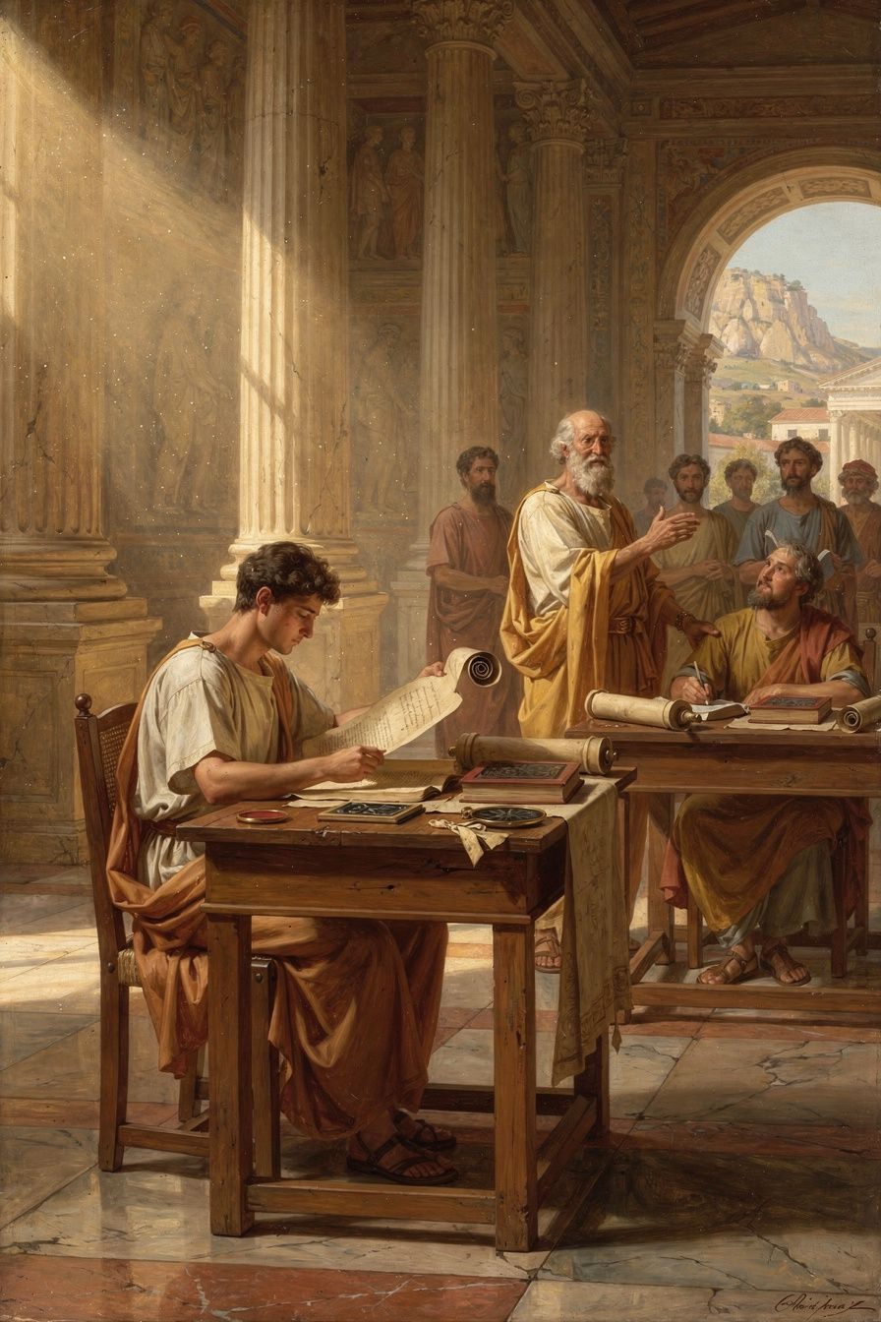
Illustration for Chapter 1
Basil was born around 330 CE in Caesarea, the capital city of Cappadocia, a Roman province in central Asia Minor. His family was one of the most remarkable in Christian history — a dynasty of faith and intellect that produced three bishops and a monastic founder. His father, Basil the Elder, was a rhetorician — a teacher of public speaking and law who gave Basil his early education. His mother, Emmelia, came from a wealthy Cappadocian family and was known for her piety and generosity. His grandmother, Macrina the Elder, had survived the persecutions of the third century and transmitted a fierce faith to the next generation. His older sister, Macrina the Younger, turned the family estate into a monastic community and became the spiritual leader of the family — the one who challenged Basil to take his faith seriously. His younger brother Gregory became one of the three Cappadocian Fathers. His youngest brother Peter also became a bishop.
Basil's education followed the path of an elite Roman youth. He studied under his father in Caesarea, then in Constantinople under the best rhetoricians of the age, then in Athens, the ancient center of learning. In Athens, he studied philosophy (Plato, Aristotle, the Stoics), rhetoric, literature, and probably mathematics and astronomy. He absorbed the tools of Greek intellectual culture that he would later put to use defending Nicene orthodoxy. In Athens, he met Gregory of Nazianzus. Their friendship became one of the great intellectual partnerships of Christian history. Gregory later wrote: "I had heard of him by fame before I knew him by sight, and when I met him, I was bound to him by a tie of affection which cannot be described." Basil called Gregory's friendship as necessary as the sun: "I think that the sun is not so necessary as friends are to mankind."
After Athens, Basil returned to Cappadocia and taught rhetoric — the expected career for an educated young man. He was good at it. Students came to learn from him. He had the respect of his city. By any standard, he was successful. But his sister Macrina challenged him: is the life of a celebrity teacher worthy of a Christian? The question cut deep. Basil was baptized around 357 CE and decided to live differently.
The change was dramatic. Basil gave away his wealth. He traveled through Egypt, Palestine, Syria, and Mesopotamia — the great centers of early monasticism. He visited Pachomian communities in Egypt, hermits in the desert, and monastery founders in Syria. He saw the extremes — the pillar-sitters and the grass-eaters — and he admired their devotion without adopting their methods. When he returned to Cappadocia, he founded his own monastic community on the family estate at Annisa. His vision was distinctively his own: community-based, moderate, integrated with the local church, and committed to serving the poor. He wrote the Moralia (eighty rules for daily conduct) and the early versions of his monastic rules — texts that would shape Eastern Orthodox monasticism permanently and influence Western monasticism through Benedict, who read Basil in Rufinus's Latin translation.
In 362 CE, Basil was ordained a priest by Eusebius, bishop of Caesarea. The relationship was not always smooth — Basil was more capable and more theologically precise than his bishop. But Basil's gifts were indispensable. When Eusebius died in 370 CE, Basil was elected bishop. He was forty years old. He would serve only nine years before his death in 379, but in those nine years he would change the church.
The story of Basil's conversion reveals something about the nature of intellectual vocation. Basil did not abandon his education when he became a committed Christian. He redeemed it. The philosophical categories he learned in Athens — essence, person, operation, nature — became the vocabulary of trinitarian theology. The rhetorical skills he acquired in the schools became the tools of pastoral communication. The friendships he formed in Athens became the network that sustained the Nicene cause. This is the pattern: education does not need to be rejected when one finds faith. It needs to be redirected. The tools remain; the purpose changes. The best education in the Roman world became the instrument of a faith that education alone could not produce.
Basil's conversion was also not a conversion from unbelief to faith. He was raised Christian. His conversion was from cultural Christianity to committed Christianity — from the faith of a successful professional to the faith of a disciple. This is a harder conversion, and a more relevant one for most readers. The challenge is not to acquire faith but to take it seriously — to let it redirect your life, your career, your relationships, and your use of your gifts. Macrina's question — "is being smart enough?" — is not just for Basil. It is for anyone whose gifts have become a source of pride rather than service.
A scholarly debate about Basil's early life concerns the extent to which his encounter with Greek philosophy shaped his theology. Pelikan (in Christianity and Classical Culture, 1993) argues that Basil's use of Platonic and Aristotelian categories represents a genuine synthesis of Christian faith and Greek philosophy — the Cappadocian settlement is, in effect, a Christianized Platonism. Behr (in The Nicene Faith, 2004) argues that Basil used Greek philosophical vocabulary strategically, borrowing the language without adopting the metaphysics. The question matters because it determines how we read the Cappadocian settlement: is it a Christianized Platonism, or is it a distinctively Christian theology expressed in Greek terms? The evidence suggests both: Basil's categories are Greek, but the content they carry — the Trinity, creation ex nihilo, the goodness of matter, the resurrection of the body — is not reducible to its philosophical sources. Basil used the tools of Greek philosophy without being captured by its worldview. This is the model of intellectual engagement that Basil's life embodies: take the best education available, but do not let it determine your conclusions. Let faith redirect the tools; do not let the tools determine the faith.
The Big Idea
Education gives you tools. It does not give you a reason to use them. Basil's education in Athens equipped him with the philosophical vocabulary and rhetorical skill to articulate trinitarian theology. But the education did not produce the theology. The theology came from his faith, his family, and his sister's challenge. The tools of Greek philosophy became powerful when they were directed toward a purpose that education alone could not supply. This is the pattern: knowledge becomes wisdom when it finds its purpose. And the purpose that redirects knowledge is not found in the classroom — it is found in the encounter with a person, a question, or a call that demands more than cleverness.
Practice
1. Audit your own vocation. Write down three things you are good at — a skill, a way of thinking, a professional capacity. For each, write one sentence about what it could be used for beyond personal achievement. If you cannot think of anything, ask: is this capacity looking for a purpose, or is it just accumulating? Basil had the best education in the world and it was purposeless until Macrina challenged him. What would it take for your gifts to find their purpose? 2. Read Gregory of Nazianzus's *Oration* 43. Find the passage where Gregory describes meeting Basil in Athens. What does Gregory emphasize — the intellectual partnership, the emotional bond, or the shared faith? Write a 500-word analysis of the role friendship played in Basil's intellectual development. Consider: how do great intellectual collaborations work? Is the friendship instrumental (they helped each other think) or constitutive (the friendship itself was part of the thinking)? 3. Think about your own "Macrina moment." Was there a person, a question, or an experience that challenged you to take your faith — or your work — more seriously? Write a reflection: what was the question, who asked it, and what changed? If you have not had this moment, what would it take?
Reflect
Macrina asked Basil whether being smart was enough. Who is asking you that question — or who should be? And what would change if you answered honestly?
———

Chapter 2: The Theologian of the Holy Spirit
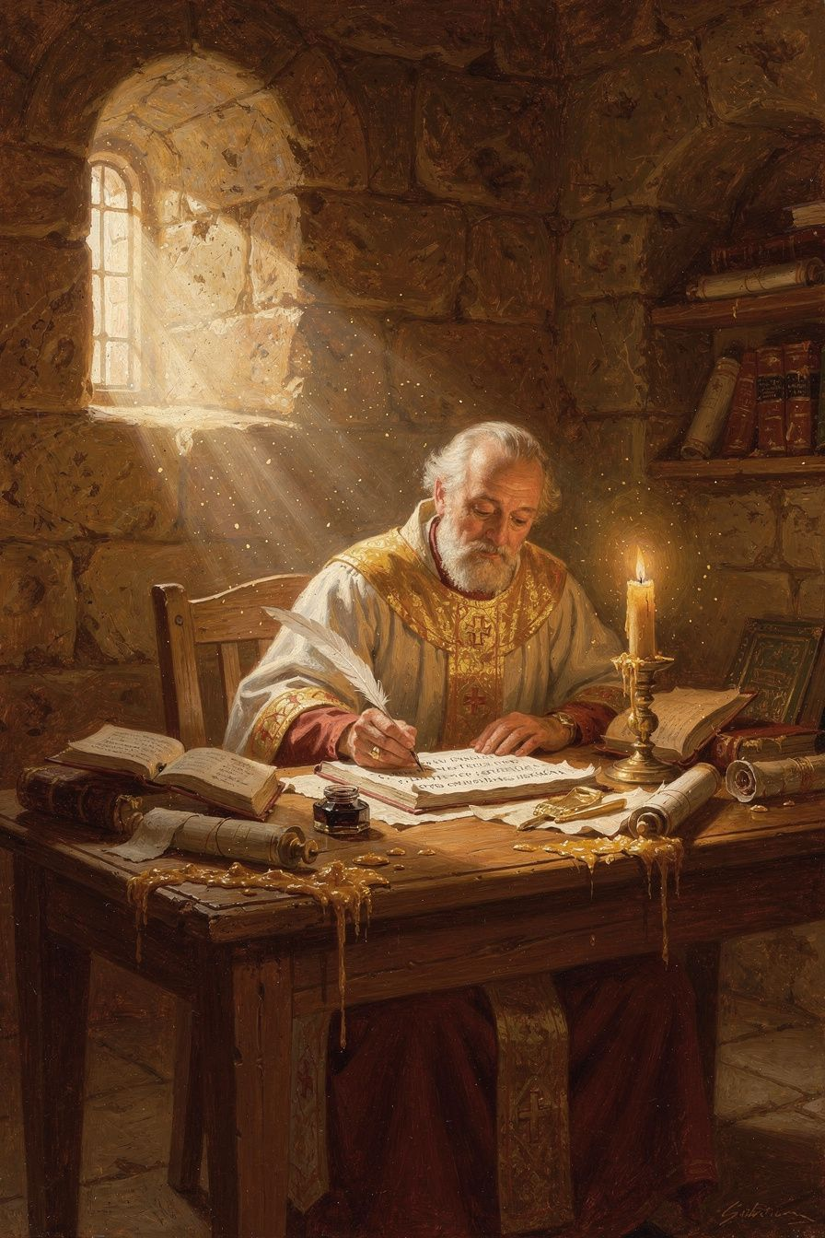
Illustration for Chapter 2
When Basil became bishop of Caesarea in 370 CE, the church was fighting over the identity of Jesus Christ and the Holy Spirit. The Council of Nicaea (325 CE) had declared the Son homoousios — "of one substance" — with the Father. But Nicaea left questions unanswered. What does homoousios mean? How do the three persons relate? And what about the Spirit? Nicaea said nothing definitive about the Holy Spirit's divinity.
A group called the Pneumatomachi — "those who fight against the Spirit" — argued that the Spirit was a creature. They based their argument on biblical prepositions: the Spirit is "sent" by the Son (John 15:26), "given" by the Father (Luke 11:13), "poured out" at Pentecost (Acts 2). Creatures are sent, given, poured. God is not sent. Therefore the Spirit is a creature.
Basil's friend Amphilochius noticed a related problem: Christians used different doxologies. The Pneumatomachi argued that this variety proved the Spirit was inferior. Basil wrote On the Holy Spirit (375 CE) to answer this argument and give the church a coherent account of the Spirit's divinity.
Basil's strategy was to begin not with definitions but with the language the church already uses. He showed that the biblical prepositions — "of," "through," "in" — are not locked to one person of the Trinity. The Father creates through the Son (Hebrews 1:2), but the Father also creates in the Spirit (Psalm 33:6). The Son acts of the Father (John 5:19), but the Spirit also acts through the Son (1 Corinthians 12:3). The variety of prepositions does not prove a hierarchy. It reflects the richness of trinitarian relations — the distinct modes of action of three persons who share one divine nature.
The most powerful argument comes from baptism. Christ commanded baptism "in the name of the Father and of the Son and of the Holy Spirit" (Matthew 28:19). Baptism is the act by which the Christian is joined to God. If the Spirit were a creature, the church would be invoking a creature alongside the Creator — blasphemy. The fact that the church has always baptized in the threefold name proves that the Spirit is on the divine side of the line.
Basil also argues from worship. The doxology — "Glory to the Father and to the Son and to the Holy Spirit" — is a liturgical confession. The church would not give glory to a creature. This is the principle lex orandi, lex credendi: the rule of prayer is the rule of faith. What the church says in worship reveals what it believes. Basil treats the liturgy as a source of theology in its own right, not as a secondary phenomenon needing justification by exegesis. This methodological move has shaped Christian theology ever since. It means that theology is not just an intellectual exercise — it is an interpretation of the church's lived practice. What the church does in worship reveals what it truly believes, sometimes before it can fully articulate why.
Basil describes the Spirit in terms that can only apply to God: Creator of life (Psalm 104:30), source of sanctification (no creature can make another creature holy), omnipresent (Psalm 139:7), all-knowing (1 Corinthians 2:10), goodness itself. The climax: "The Holy Spirit is not a creature, nor a work, but he is proper to the Son and partakes of the same nature as the Son; nor can we ever say that he is other than the living God" (On the Holy Spirit, 22). The word "proper" (idion) is key — the Spirit belongs to the Son by nature, not by adoption or assignment.
Basil's theology of the Spirit also shaped his understanding of the Christian life. The goal is not just moral improvement but union with God — what Eastern Christianity calls theosis or divinization. The Spirit is the one who makes this possible. "By participation in him there is imparted to us at the second creation the being made according to the likeness of God." The Spirit is the bridge between the human soul and the divine life. This idea — that the Christian life is not just about being good but about becoming like God — is one of the central themes of Eastern Christianity, and it flows directly from Basil's pneumatology.
Basil also made a crucial contribution to trinitarian theology by distinguishing between the one divine nature (ousia) and the three persons (hypostaseis). Before Basil, these two Greek words were often used interchangeably — both could mean "substance." Basil gave them distinct technical meanings: ousia refers to what is common (the one divine nature shared by all three persons), hypostasis refers to what is particular (the concrete individual reality of each person). The analogy: Peter, James, and John share one human nature (ousia) but are three distinct persons (hypostaseis). So with the Trinity: the Father, Son, and Spirit share one divine ousia but are three distinct hypostaseis.
This distinction solved the theological problem that had torn the church for half a century. It preserved monotheism (one ousia) while affirming the real distinction of the three persons (three hypostaseis). Against Sabellianism (which collapsed the persons into modes) and tritheism (which separated them into three beings), Basil argued for real distinction within real unity. The persons are distinguished not by different natures or powers but by their relations of origin: the Father is unbegotten, the Son is begotten, the Spirit proceeds. These relations are eternal, not temporal. And the three persons always act together — one divine action by three persons. This is the "monarchy of the Father": the Father is the source of the Godhead, but the three share one divine operation.
The Cappadocian settlement was the work of all three Cappadocians. Gregory of Nazianzus articulated the distinction with poetic precision. Gregory of Nyssa provided the most philosophically sophisticated elaboration in Ad Ablabium: That There Are Not Three Gods. But Basil was the organizer — the one who built the alliances, wrote the rules, and founded the institutions that made the settlement stick. He died two years before the Council of Constantinople (381 CE) ratified it, but without his work, the council would not have had the theological grammar to confess what it confessed.
A significant scholarly debate concerns whether Basil "changed his mind" about the Spirit's divinity. In his earlier Against Eunomius (c. 363–365), Basil is cautious — he affirms the Spirit's importance but does not explicitly call the Spirit homoousios. In On the Holy Spirit (375), his language is forceful. Wolfson (1956) argues this represents genuine intellectual development: Basil moved from a subordinationist view to full divinity. Hildebrand (2018) argues the caution was strategic: Basil always held the Spirit to be fully divine but spoke carefully because the political situation was dangerous — the emperor Valens was Arian, and a premature declaration could split the fragile Nicene coalition. The "both" position holds that Basil's theology developed through controversy: the Pneumatomachian challenge forced him to articulate more clearly what he already believed. The development is in expression, not substance; the strategy is in timing, not doctrine. This debate matters because it determines how we read patristic texts: when we see development in a thinker's expression, should we assume intellectual change or strategic adaptation? The question is not just about Basil — it is about how we read any historical text. When a public figure seems to "change their position" on an issue, are they changing their mind, or changing their rhetoric? The same evidence can support both readings, and the best interpretation is usually the most nuanced: both development and strategy, both intellectual growth and pastoral care.
The Big Idea
Basil's pneumatology rests on a methodological insight: the church's worship is a source of theology. The rule of prayer is the rule of faith. The church does not baptize in the name of a creature. The church does not give glory to a creature. The Spirit does what only God does — creates, sanctifies, gives life — and therefore the Spirit is God. This means that theology is not just an intellectual exercise; it is an interpretation of the church's lived practice. What the church does in worship reveals what it truly believes, sometimes before it can fully articulate why. And the Cappadocian settlement — one ousia, three hypostaseis — gave the church a vocabulary that preserved both monotheism and the real distinction of the persons, a vocabulary still used after sixteen centuries.
Practice
1. Trace the prepositions. Open a Bible and find passages where each preposition (of, through, in) is used of each person of the Trinity. Basil's argument is that the prepositions are shared — they describe different modes of action, not different levels of reality. Document your findings in a table. Does the pattern hold? What does it reveal about the richness of trinitarian language? 2. Read *On the Holy Spirit*, chapters 3–5, 12, and 22–23. Trace Basil's argument from doxology. Why does he start from worship rather than from abstract definitions? Write a paragraph explaining the principle lex orandi, lex credendi in your own words. Then identify one modern example where the way a community practices (in church, in politics, in family life) reveals a belief that its official statements have not yet articulated. 3. Read Basil's Letter 236 and Gregory of Nyssa's *Ad Ablabium*. How does the analogy between human persons and divine persons work? What are its limits? Humans share a nature but have separate wills. The three divine persons share a nature AND a will. Why does this matter for monotheism? Write a 500-word analysis.
Reflect
If the Spirit is God — not a creature, not a helper, but God — what does that change about how you live, how you pray, and how you treat the people the Spirit is making holy?
———

Chapter 3: The Preacher Who Loved Creation
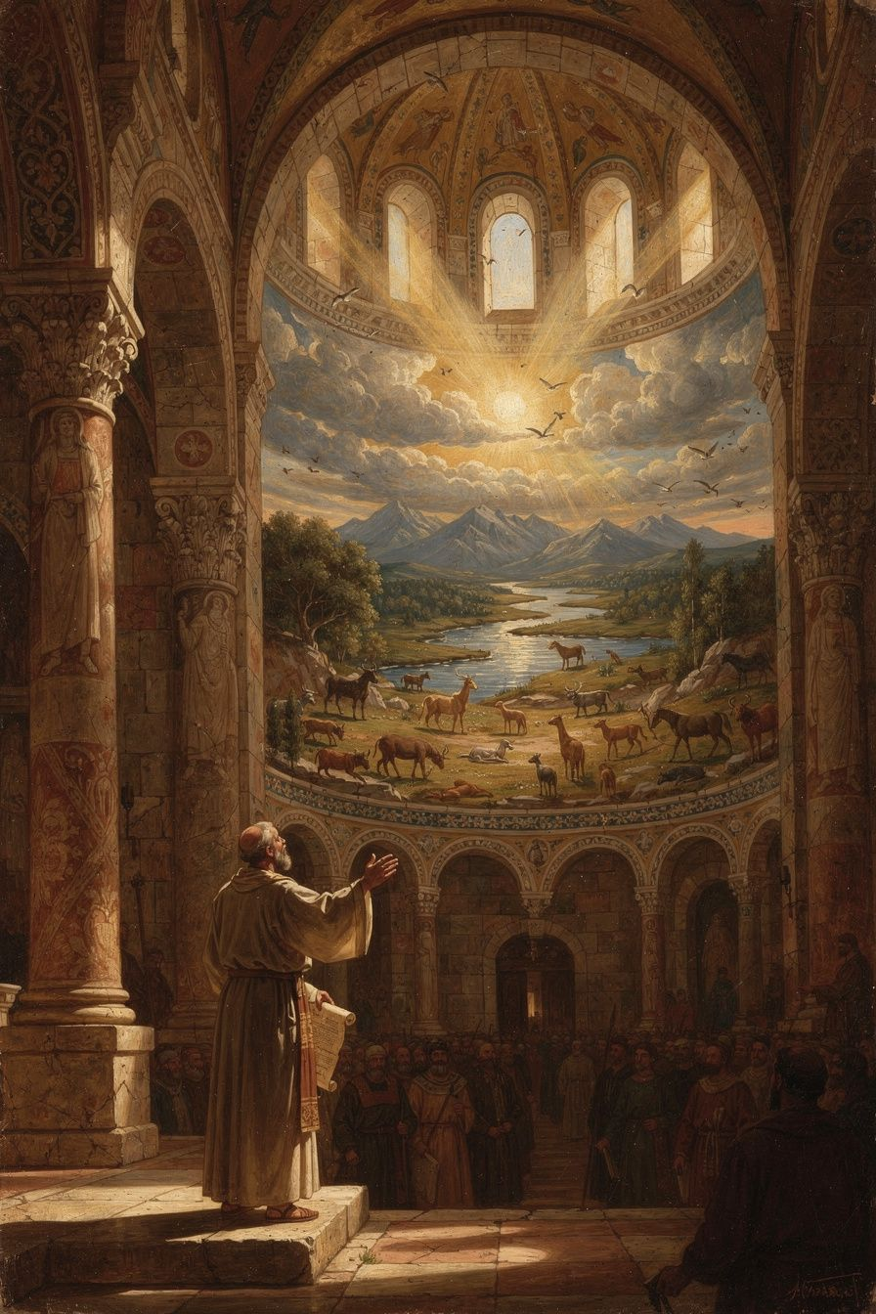
Illustration for Chapter 3
Around 378 CE, the year before his death, Basil preached nine sermons on the six days of creation described in Genesis 1. These sermons — the Hexaemeron (Greek for "six days") — are the most influential Christian meditation on the natural world in the patristic era. They are not a scientific treatise. Basil is a pastor teaching his congregation to read creation as a revelation of God's wisdom, generosity, and beauty.
Basil's congregation in Caesarea lived close to the land. They were farmers, merchants, and craftsmen. Basil spoke about things they already knew: the sun, the moon, the rivers, the plants, the animals. But he taught them to see these familiar things differently. The world is not just dirt and water and sky. It is a book written by God. Everything you see is a message from the Creator: "I made this for you. It is good."
Basil walks through the days of creation in order. Day 1: God speaks, and light appears — instantly, without process. The first light is distinct from the sun and moon created on the fourth day; it is a primal, non-solar quality of the created order itself. Day 3: The earth brings forth vegetation. Basil delights in the variety — the properties of herbs, the usefulness of trees. The earth was pregnant with potential; God's word was the trigger, not a new imposition. Creation is an act of liberation: the earth already contains the seeds of life; God's word activates them. Day 4: The sun is a "great lamp," the moon a companion, the stars "flowers of fire." Basil explicitly rejects astrology: the stars are markers of time, not rulers of fate. Day 6: The creation of the human being — allied to angels by the soul, to animals by the body, bridging the spiritual and the material.
The theological themes are: creation ex nihilo (the world is a free act of divine will, not made from pre-existing matter — against both Platonism and Gnosticism); the goodness of matter (against Platonic dualism that treated the material world as a shadow and Gnostic cosmology that treated it as the product of a lesser deity); providence and purpose (every creature is designed for a purpose, and the order of creation points to a single, purposeful mind); and human freedom (grounded in creation — if the world is God's free act, then creatures within it share in that freedom).
Basil's affirmation of the body was radical in his context. Platonic philosophy treated the body as the soul's tomb (soma sema). Gnostic systems treated the physical world as the product of an ignorant or malevolent lesser deity. Manichaean dualism treated the body as made of dark substance. Against all three, Basil argues from Genesis 1: God made everything, and God called it good — seven times, culminating in "very good" after the creation of the human being, body and soul together. The body is not a punishment, a prison, or an embarrassment. It is a gift, designed by God with dignity and purpose. Its beauty and order glorify the Creator. The body prays (kneeling, standing, singing), serves (working, feeding, caring), and worships (receiving the Eucharist). The spiritual life is not an escape from the body but the body's highest purpose.
This theology of the body has practical consequences that run through all of Basil's work. Care for the sick: if the body is good, then caring for the body is not second-class spirituality but spiritual care. Basil built the Basileias because he believed healing the body is part of the gospel. Moderate asceticism: the body is to be disciplined, not destroyed. "The body should be disciplined, not destroyed. The athlete who breaks his legs before the contest does not win the crown." Social justice: if the material world is good, then material needs matter. The hungry person's body matters. The naked person's body matters. Basil's social homilies flow directly from his theology of creation. If God made the body and called it good, then the person whose body is starving is being denied what God intended.
Basil's theology of the body also connects to his eschatology. The Christian hope is not the escape of the soul from the body (Platonic) but the resurrection of the body to eternal life (biblical). If the body is God's good creation, God will not abandon it. What God made good, God will redeem. The material world itself will be renewed (Romans 8:19–21). The Hexaemeron is not just about origins; it is about destiny.
Basil's anti-astrology argument is worth noting. He grounds human freedom in the doctrine of creation: "If the movement of the stars determines our actions, then we are not free. And if we are not free, then justice and judgment are meaningless." This is a theological defense of human dignity against determinism. Modern forms of determinism — genetic, environmental, neurological, economic — pose the same challenge. Basil's argument applies: if we are not free, then justice is meaningless. But we are free, because God made us free.
A scholarly debate concerns the relationship between the Hexaemeron and ancient science. Some scholars read the sermons as proto-scientific — early attempts at natural philosophy expressed in theological terms. Others read them as purely theological — sermons that use natural observation as illustrations but make no scientific claims. The best reading is neither: Basil is doing something distinct from both science and theology as we construe them. He is doing natural theology as spiritual formation — teaching his congregation to see the world as a gift, not as a machine. This is a third kind of knowledge that does not compete with science but complements it. Science asks "how does it work?"; Basil asks "what does it mean?" Both questions are legitimate. Both can be asked by the same person. The world can be studied mechanically and theologically without contradiction, because they answer different questions. The conflict between science and theology arises only when one tries to answer the other's question — when theology makes scientific claims or science makes theological ones. Basil's Hexaemeron models a way to integrate scientific observation with theological meaning without conflating them.
The Big Idea
Basil teaches that creation is not a machine but a gift. The world is not a closed system running by necessity; it is personally sustained by God every moment. Matter is not evil or inferior; it is good because God made it. The human body is not a prison for the soul but the instrument of the spiritual life. This has consequences for ethics (how you treat the world and your body depends on what you believe they are), for science (natural theology as spiritual formation is a different kind of knowledge from natural science, and the two are complementary, not competitive), for ecology (if the world is a gift, the human is its steward, not its exploiter), and for eschatology (what God made good, God will redeem). The Hexaemeron is not just about origins; it is about destiny — the destiny of the world and of every body in it.
Practice
1. Read *Hexaemeron* Homily 1 and 6. Identify the difference between Basil's approach and a scientific description of the same phenomena. Are they competing or complementary? Write a paragraph: what does Basil add that science cannot? What does science add that Basil does not provide? How might a scientist who is also a person of faith read the Hexaemeron without feeling that their science is threatened? 2. Compare Basil's view of the body with views in contemporary culture. Social media celebrates body-perfection. Transhumanism wants to transcend the body through technology. Body-positivity advocates body-acceptance. Some forms of consumer culture treat the body as a project to be optimized. Which is closest to Basil? Which is furthest? Write a one-page analysis: what would Basil say about each movement? Where does he affirm, and where does he challenge, each view? 3. Do a creation audit. Pick one natural object — a leaf, a stone, a shell, a feather — and examine it closely for ten minutes. Write down everything you notice. Basil's method is not analysis but attention: the world reveals its Maker to those who look at it carefully. What did you notice that you had never noticed before? Did the sustained attention change how you felt about the object? Did it change how you felt about the world? 4. Think about modern determinism. Basil rejected astrology because it would destroy human freedom. What modern forms of determinism (genetic, environmental, neurological, economic) pose a similar challenge? Write a paragraph: how would Basil's argument apply to one modern form of determinism? Is his argument still valid, or does modern science change the picture? What is at stake — morally and politically — in the debate about human freedom?
Reflect
If your body is God's design, not an accident — and if the world is God's gift, not a machine — how does that change how you treat both?
———

Chapter 4: The Bread That Belongs to the Hungry
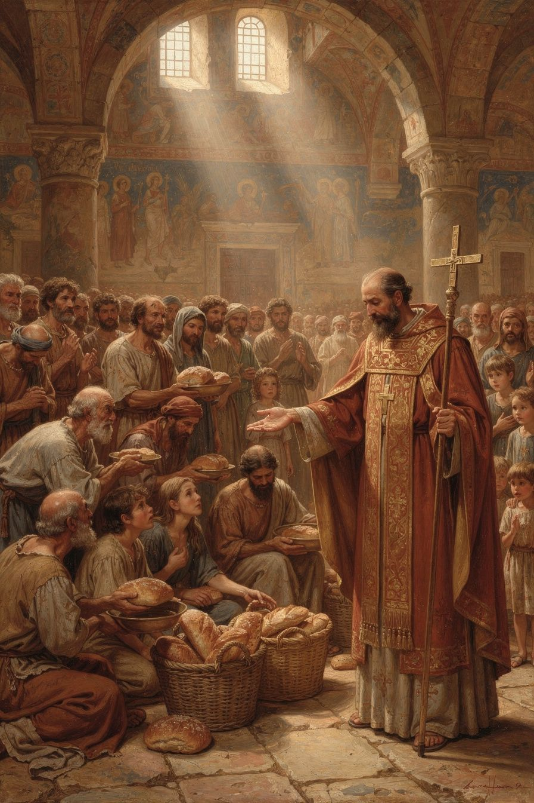
Illustration for Chapter 4
Basil's social teaching is among the most uncompromising in the entire Christian tradition. His homilies on wealth and poverty — "I Will Tear Down My Barns" and "To the Rich" — contain some of the most radical statements about property and obligation ever made by a bishop.
The homily "I Will Tear Down My Barns" is a sermon on Luke 12:16–21, the parable of the rich fool. The rich man's land produces abundantly. He tears down his barns and builds bigger ones. He says to himself: "Soul, you have ample goods laid up for many years; relax, eat, drink, be merry." God says: "Fool! This night your soul is required of you."
Basil's sermon is relentless: "The bread which you hold back belongs to the hungry; the clothing you shut away belongs to the naked; and the money you bury in the earth is the price of redeeming and freeing the wretched." Notice the verb: "belongs." Basil does not say the rich man should be generous and share. He says the goods already belong to the poor. The hungry person has a claim on the bread, not because the rich man chooses to give it, but because the bread was made for the hungry. The rich man is not an owner; he is a steward who has failed in his duty.
In "To the Rich," Basil extends: "If you have taken more than you need, you have taken it from someone who needs it. You have stripped the naked by not clothing them." To have more than you need is, in Basil's view, to have taken it from someone else. Excess is not innocent; it is a form of violence against the poor.
Basil's logic is theological, not political. God created the world for all creatures. The goods of the earth are a common gift. Private property is a human convention, not a divine institution — and a convention distorted by greed and sin. In God's original design, goods were common. Basil cites Acts 4:32: "they had all things in common." The apostolic church practiced community of goods. The monastery that shares property is not an exception but a model.
Basil did not stop at preaching. He built the Basileias — one of the most ambitious social welfare institutions of the ancient world. The complex at Caesarea included a hospital for the sick poor, a hospice for travelers, a shelter for the elderly, an orphanage, a workshop where the unemployed could learn trades, and a kitchen that fed the hungry daily. Gregory of Nazianzus called it "a new city." It was funded partly by Basil's own inheritance (he gave away his family fortune) and partly by the contributions of wealthy Christians whom Basil persuaded — and sometimes publicly shamed — into giving.
Basil also addresses the psychology of wealth. The rich man in the parable says "relax, eat, drink, be merry" — he is talking to himself. Wealth creates a closed world: the rich person talks to their own soul, their own barns, their own plans. The poor disappear from view. Wealth blinds the wealthy to the existence of the people whose suffering is the cost of their comfort. The rich man does not see the hungry person at his gate because he does not look — and he does not look because his wealth has made him self-sufficient, or so he thinks.
Basil also distinguishes between different causes of poverty. People are poor for different reasons: illness, unemployment, exploitation, bad luck, family breakdown. The response must be tailored to the cause. The sick poor need medical care. The unemployed need work. The traveler needs shelter. The orphan needs a family. The Basileias was not a one-size-fits-all charity but an integrated institution that addressed multiple forms of poverty with appropriate responses. It included a workshop where the unemployed could learn trades — Basil did not want to create dependency. He wanted to restore dignity, and dignity comes from contribution.
Basil also made a crucial distinction between the monastery and the church. The monastery is a voluntary community of those who choose to share all things. The church includes people at all stages of commitment. Basil does not require the layperson to renounce property, but the monk does. The community of goods is an ideal for the committed, not a requirement for all. If Basil thought property was inherently evil, he would demand its abolition for everyone — but he does not. Instead, he builds the Basileias as a place where the radical vision is lived, while the surrounding society still has property, inequality, and need. The monastery is a model, not a mandate.
A scholarly debate concerns whether Basil's language represents a literal demand for the abolition of private property or rhetorical provocation. Holman (2001) argues that Basil's language is theology in action — the Basileias is the concrete expression of a theology that treats excess wealth as theft. Rousseau (1994) cautions against reading Basil's most radical language as a literal economic program: Basil was a pastor, not a legislator. The "both" position holds that the theological vision is genuinely radical, the practical strategy is realistic, and the rhetoric is prophetic. The radical vision drives the practice; the realistic practice makes the vision livable; the prophetic rhetoric keeps the vision visible. This debate matters because it raises the question of the ideal: is the Acts 4 community of goods a normative ideal (all Christians should aim for it) or an inspiring memory (monks live it, but not everyone is called to)? How the church answers this question shapes its social engagement. If the ideal is normative, the church is always called toward community of goods. If the ideal is inspirational, the church is called to generous charity within the property system. The answer makes a difference — and Basil's own practice suggests that both are true: the ideal is normative as a direction, not as a requirement, and the church that stops pursuing it has lost something essential.
A related debate concerns the relationship between Basil's social teaching and liberation theology. Some liberation theologians have claimed Basil as a precursor — his language of excess as theft, his institutional response to poverty, his prophetic denunciation of wealth all resonate with liberationist themes. Gustavo Gutiérrez, in A Theology of Liberation (1973), draws on the prophetic tradition including Basil to argue for structural change. Critics argue that this is an anachronistic reading: Basil was not advocating structural revolution but pastoral transformation. The debate is not merely historical. It concerns the question of whether the gospel demands structural change or personal generosity — and Basil's answer, as always, is both: the structure (the Basileias) embodies the vision, and the homily provokes the person. The Basileias is a structural intervention; the homily is a personal challenge. Basil does not choose between them, and neither should we. The question for today is whether the church's social witness should focus on building alternative institutions (the Basileias model) or on advocacy within existing systems (the prophetic homily model). Basil did both, and the combination is stronger than either alone.
The Big Idea
Basil's social teaching flows from his theology of creation. If God made the world for everyone, then the goods of the earth belong to all. Private property is a stewardship, not an absolute right. The rich person who hoards while the poor starve is not stingy but unjust — they are holding what belongs to someone else. The Basileias is the institutional form of this conviction: love needs structures, not just feelings. And the rhetoric is prophetic — Basil's language is designed not to prescribe policy but to provoke the comfortable into awareness. The question is not "How much should I give?" but "Do my neighbors have enough?" And the question is addressed not just to individuals but to institutions: the church that ignores physical suffering has abandoned the gospel.
Practice
1. The coat experiment. Open your closet. Count items you have not worn in the last month. Basil would say: the extra ones belong to someone who is cold. Pick one to donate. Notice the shift — from "I should give" to "it belongs to them." Write a paragraph: is it uncomfortable? Why? What does the discomfort reveal about how you normally think about ownership? 2. Read "I Will Tear Down My Barns" in full. Identify the passages that sound most radical. Are they literal or rhetorical? Research the Holman-Rousseau debate. Write a 500-word analysis: which interpretation is more convincing? What difference does it make for how Christians engage economic justice today? Is Basil's language helpful for modern discussions of wealth inequality, or is it too extreme for a pluralistic society? 3. Track your consumption for one week. What you buy, what you eat, what you use. At the end of the week, write: how aware were you of the people whose labor produced what you consumed? Did paying for things make you feel self-sufficient? Basil would say: wealth makes you blind. What would it take to "see" the people behind your consumption? 4. Design a modern Basileias. If Basil were alive today, what institution would he build? A hospital? A homeless shelter? A job-training center? A community kitchen? Write a one-page proposal for a "Basilian" institution in your community. What services would it provide? How would it be funded? What would it witness to?
Reflect
If the bread belongs to the hungry — what in your life belongs to someone else, and how long will you keep it?
———

Chapter 5: The Community That Stays Hot Together
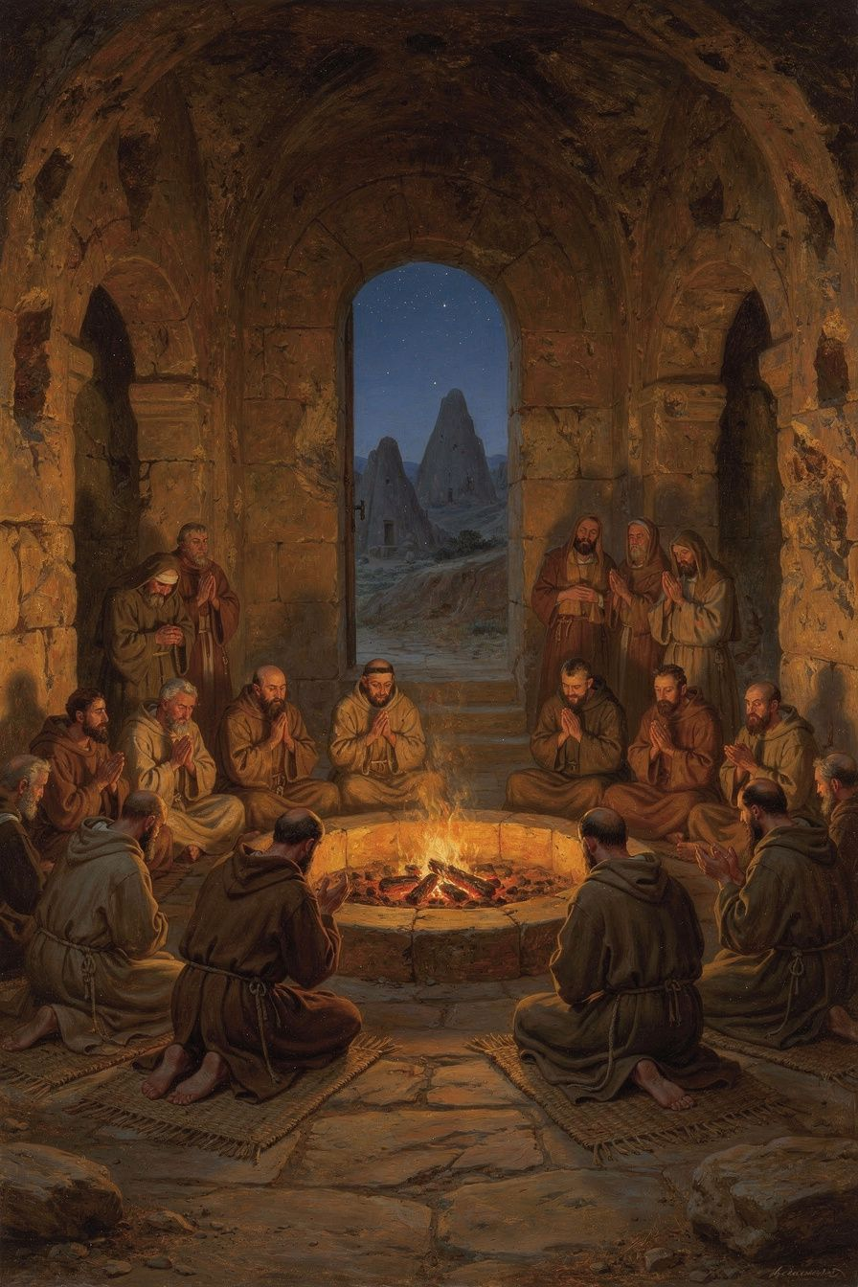
Illustration for Chapter 5
For Basil, the Christian life is not a solo project. It is a life lived in community — with God and with other people. This conviction is theological, not just practical. God is community: the Trinity is a communion of three persons in one nature. If humans are made in the image of God, they are made for relationship. The isolated human is a theological contradiction — a being made for communion living as if communion were unnecessary.
Salvation is communal. The Spirit works through the community. The "body of Christ" (1 Corinthians 12) is not a metaphor but a description: Christians are members of one another. The Spirit gives different gifts to different members, and no member has all the gifts. The Christian who isolates themselves cuts themselves off from the gifts the Spirit gives through others. Even the Lord's Prayer is plural: "Our Father," not "My Father." The entire grammar of the Christian life is plural.
Basil uses the image of a fire. A single coal, taken from the fire and set by itself, goes cold. But a coal left in the fire stays hot. The Christian in community stays warm — encouraged, corrected, sustained. The Christian alone goes cold. This is not just practical advice; it is a theological claim about the nature of the Christian life. The Christian life is inherently communal because God is inherently communal. You cannot image a trinitarian God while living as a monad.
Basil's monastic rules are the most detailed ancient Christian guide to common life. The principles extend beyond the monastery: shared property (private property cultivates possessiveness, which destroys community); obedience (submitting your will to the abbot is practicing the death of self-will, the prerequisite for love); mutual correction (community members correct each other — gently, humbly, but honestly — ignoring faults is not kindness but neglect); shared work (everyone works, by ability not rank, and the surplus goes to the poor); common prayer (the community prays together at fixed times — the monk who prays alone is weaker); care for the sick (the care of the sick takes priority over other obligations — if a monk is caring for a sick brother, he is excused from common prayer and work); and hospitality (the monastery receives guests — travelers, the poor, the sick — hospitality is constitutive, not optional).
Basil warns about the dangers of solitude. The hermit has no one to correct their faults — blind spots remain blind. The hermit has no neighbor to serve — love has no object. The hermit answers to no one — pride grows unchecked. The hermit faces temptation alone — when the will weakens, there is no community to sustain it. This is why Basil rejected the Egyptian hermit model. Anthony the Great lived in the desert, and the Life of Anthony was widely read. But Basil deliberately chose a different model: communities near towns, integrated with the local church, engaged in service. The monastery is in the world, even if it is not of the world.
Basil's monasteries were not closed communities. They were integrated with the church and society: under the bishop's authority, serving the poor, and witnessing to society. The monastery's common life — shared property, mutual service, radical simplicity — is a witness that another way of living is possible. The withdrawal is not from the world but from the world's distortions (greed, ambition, self-will, indulgence). The purpose of the withdrawal is not escape but service — the monk steps back from the rat race not to hide but to build a different kind of life, a life that is visible, generous, and engaged.
Basil also insisted on moderate fasting. Some monks starved themselves to show how holy they were. Basil rejected this. The body is God's good creation; it should be disciplined, not destroyed. Fasting that makes the monk too weak to work, pray, or serve is counterproductive. The goal is a rightly ordered body — appetites under the direction of the soul — not a destroyed body. The faster who is proud of their extreme fasting has gained nothing. The moment you feel superior because of your fasting, the fast has failed. Fasting also has a social dimension: the monk who fasts eats as the poor eat. It is a form of solidarity with the poor. And fasting frees attention: the person whose attention is dominated by food has little left for God.
A scholarly debate concerns whether Basil's community model is fundamentally different from later Benedictine monasticism. Some scholars argue that Benedict (c. 480–547) simply adapted Basil's rules for a Western context. Others argue that Benedict's model — more enclosed, more self-sufficient, less integrated with the surrounding church — represents a genuine departure from Basil's vision of monasteries as base camps rather than fortresses. The debate matters because it affects how we read the later Western monastic tradition: was Benedictine monasticism a development of Basil's vision or a divergence from it? The evidence suggests both: Benedict read Basil and adopted many principles, but the different social context of sixth-century Italy produced a different kind of monastery. The question for today is not which model is "correct" but which serves the world: does your community serve the world, or does it protect itself? The test is whether the doors open outward. Basil's monastery opened outward — to the poor, the sick, the stranger. A monastery that closes its doors has betrayed its vocation, regardless of which rule it follows.
The Big Idea
Basil teaches that community is not optional for the spiritual life — it is the context in which the spiritual life happens. The Trinity is a community. The church is a community. The monastery is a community. The Christian who isolates themselves cuts themselves off from the gifts God gives through others. A coal alone goes cold; a coal in the fire stays hot. And the community that serves the world is not hiding from it but bearing witness to a different way of living. The monastery is a base camp, not a fortress. The test of any community is whether its doors open outward — to the poor, the stranger, the world that needs what the community has received.
Practice
1. Map your communities. Draw a diagram of the communities you belong to: family, church, workplace, friend group, neighborhood. For each, write: does it help you grow? Does it hold you accountable? Does it serve people outside the group? Basil would say: a community that only serves itself has missed its calling. Which of your communities serves beyond itself? 2. Read Basil's *Longer Rules*, Questions 3–7. What are the specific dangers of solitude that Basil identifies? How does the common life address each one? Which of these dangers have you experienced? Write a 500-word response connecting Basil's analysis to your own experience. 3. Try a shared practice for one week. Pick one thing you usually do alone — a meal, a prayer, a walk — and do it with someone else every day for a week. Notice what changes. Write a journal entry: what did the shared experience give you that solitude could not? Was there anything you lost? How does Basil's coal-and-fire image apply? 4. Compare Basil's model with the contemporary "Benedict Option." Research the idea that Christians should form intentional communities to preserve faith and values. How does it compare to Basil's model? Basil would ask: does your community serve the world, or does it protect itself? Write a 500-word comparison.
Reflect
Can a coal stay hot alone — and if not, what does that mean for how you live, how you work, and how you love?
———

Chapter 6: The Bishop Who Stood Up to an Emperor
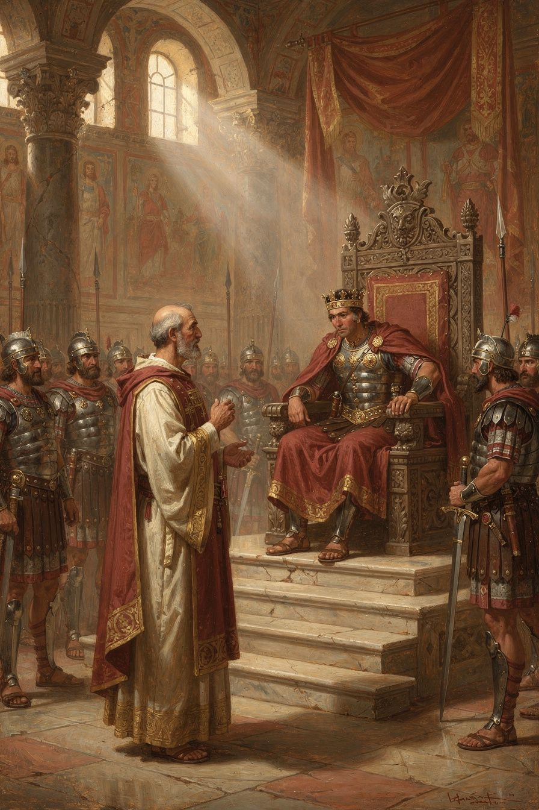
Illustration for Chapter 6
The emperor Valens was an Arian. He believed the Son was not fully God and the Holy Spirit was a created being. He controlled the army, the laws, and the land. He wanted all bishops to agree with him.
The prefect Modestus came to Basil and threatened him with confiscation, exile, torture, and death. Basil's response: "Confiscation means nothing to me, unless you covet these wretched rags and a few books; that is all I possess. As to exile, I am attached to no particular place. I regard the whole earth as belonging to God, and I consider myself as a stranger wherever I may be. As for torture, how will you apply it? I have not a body capable of bearing it. As for death, this will be a benefit to me."
Modestus was stunned. He said he had never met anyone who spoke to him so boldly. Basil replied: "Perhaps that is because you have never had to deal with a bishop."
This exchange is preserved in Gregory of Nazianzus's funeral oration (Oration 43). Gregory may have polished it, but the encounter is historical. Valens did send officials to pressure Basil, and Basil did refuse to compromise.
Basil's courage came from his theology. He believed God was more powerful than any emperor. The truth about the Trinity was not a matter of opinion but of faithfulness. A bishop's job was not to please rulers but to please God. The Stoics taught that the wise person is free because external things cannot touch their inner virtue. Basil added a theological ground: the earth belongs to God, and the Christian is a stranger everywhere. Death is not a threat but a benefit.
The confrontation reveals something about the relationship between theology and political power. Basil did not have an army. He had only his faith and his words. But that was enough — because the authority behind the words was not Basil's but God's. The bishop's power is the power of truth, not the power of force. The confrontation is a theological argument in dramatic form: it demonstrates that the truth about God is not subject to imperial control. The emperor can take your property, exile you, torture you, or kill you — but the emperor cannot change the truth about the Trinity. Basil's calm courage is the practical consequence of his theology: if God is who Basil says God is, then the emperor's threats are empty.
The confrontation also reveals the nature of episcopal authority. When Basil said "Perhaps that is because you have never had to deal with a bishop," he was making a claim about a kind of authority that is not military or political but spiritual and moral. It comes not from the power to coerce but from the willingness to suffer. The bishop who will not bend — who will accept confiscation, exile, torture, or death rather than betray the truth — has a kind of authority that no emperor can match, because it is the authority of a person who has nothing left to lose. Basil's poverty, his homelessness, and his indifference to death made him unassailable. You cannot threaten a man who has already given everything away.
In 372 CE, Valens divided Cappadocia into two provinces to diminish Basil's authority. Basil responded by creating new bishoprics and appointing his brother Gregory of Nyssa and his friend Gregory of Nazianzus to sees in the new province. The two Gregories were not eager — Gregory of Nazianzus especially disliked the politics — but Basil needed them, and they went because their friend asked. This was how Basil worked: he built networks, made alliances, and used his personal relationships to advance the cause. He was a theologian, a monk, and a strategist.
Basil's health was never good. He suffered from liver disease and was frequently exhausted. His letters complain of illness, overwork, and the difficulty of his position. He drove himself to the point of collapse. Gregory later said that Basil's body was worn out by his labors. Basil died on January 1, 379 CE. He was forty-nine. He did not live to see the Council of Constantinople (381 CE) that ratified his theology. But his work was done. He had given the church the theological grammar of the Trinity, the rules for monastic community, the hospital for the poor, and the example of a bishop who would not bend.
The pattern of Basil's life raises a question: what is the cost of greatness? Basil accomplished extraordinary things but at the cost of his health and his life. Was the trade-off worth it? Rousseau (1994) suggests that Basil's relentless activity was both his genius and his limitation — the same drive that produced the theology, the hospital, and the monastic rules also destroyed the body that sustained them. Hildebrand (2018) is more sympathetic, reading Basil's self-expenditure as a deliberate imitation of Christ's self-giving. The debate is not just about Basil — it is about the ethics of achievement and sacrifice. How much should a person give to a cause they believe in? Is there a point where self-sacrifice becomes self-destruction? Basil's life does not answer the question neatly. It shows both the power and the cost of total commitment. The same drive that changed the church also killed the man. Whether that is heroic or tragic depends on what you believe about the relationship between this life and the next — and Basil, for his part, believed that death was "a benefit."
Gregory of Nazianzus preached the funeral oration. He described Basil as one of the great lights of the church — a theologian, a builder, a shepherd, and a friend. Gregory's grief was real: he had lost the person who understood him best. But Gregory also saw that Basil's legacy would endure. The theology was written. The rules were composed. The hospital was built. The example was set. The council would come, and when it did, it would confirm what Basil had already established. The Nicene-Constantinopolitan Creed, still recited in churches worldwide, exists in part because of a man who was willing to say "no" to an emperor and "yes" to the truth.
Basil's legacy extends beyond the creed. His monastic rules still shape Eastern Orthodox monasticism. The Liturgy of St. Basil, used in Eastern Orthodox worship, preserves his liturgical influence. His social teaching — "the bread you hold back belongs to the hungry" — remains one of the most challenging texts in the Christian tradition. His creation theology is being rediscovered by ecological theologians who find in Basil a vision of the world as gift rather than resource. And his example — the bishop who would not bend, the monk who served the poor, the theologian who wrote from a hospital as well as a study — continues to challenge anyone who believes that faith should be comfortable. Basil was not comfortable. He was faithful. And the difference between the two is the difference between a religion that costs nothing and a faith that changes everything.
The Big Idea
Basil's courage was not bravado. It was faith. He believed that the truth about God was more important than his safety, that God was more powerful than any emperor, and that death was not the end but the beginning. His courage came from his theology: if God is real and God is good, then standing for the truth is always the right choice, even when it costs everything. And his life raises a harder question: what are you willing to spend yourself for? What cause, what truth, what love would you give your life to — not because you must, but because you cannot do otherwise? Basil answered that question with his life. The answer cost him everything. Whether the cost was worth it depends on whether the truth he gave his life for is real — and that is a question each reader must answer for themselves.
Practice
1. Read Gregory of Nazianzus's *Oration* 43. What picture of Basil does Gregory paint? What does he emphasize? What does a great life look like through the eyes of a great friend? Write a 500-word analysis. Pay attention to what Gregory includes and what he omits. What does his selection reveal about what he valued most? 2. Think about what courage means. Basil was calm because he believed God was more powerful than the emperor. Write down: what would you stand up for, even if it cost you something? What is worth more than safety or comfort? Name it specifically. Then write: where does the courage to stand come from? Is it character, faith, training, or something else? 3. Compare Basil's courage with other kinds of courage. A soldier shows courage in battle. A whistleblower shows courage in the workplace. A parent shows courage in sacrifice for children. What kind of courage did Basil show? He did not fight. He did not run. He stood and spoke the truth. Is this kind of courage harder or easier than physical courage? Can it be learned? 4. Reflect on the cost of greatness. Basil accomplished extraordinary things but died at forty-nine, exhausted. Was the trade-off worth it? What does Basil's life teach about the relationship between achievement and sacrifice? Write a 300-word reflection. Is there a way to do great things without destroying yourself? Or is self-expenditure sometimes the right choice?
Reflect
What would you stand for, even if it cost you everything — and what does your answer tell you about what you truly believe?
———

For the Grown-Up Reader
This booklet introduces adult readers to Basil of Caesarea (c. 330–379 CE), one of the three Cappadocian Fathers. The six chapters cover Basil's early life and education; his defense of the Holy Spirit's divinity in On the Holy Spirit (375 CE) and the Cappadocian settlement; his creation theology in the Hexaemeron (c. 378 CE); his radical social teaching on wealth and poverty; his monastic rules and theology of community; and his confrontation with the imperial prefect Modestus.
All quotations are from the public-domain translations available at New Advent (www.newadvent.org/fathers). The scholarly debates referenced include: the Pelikan-Behr debate on the relationship between Greek philosophy and Christian theology in Basil's work (chapter 1); the Hildebrand-Wolfson debate on Basil's pneumatological development (chapter 2); the relationship between the Hexaemeron and ancient science (chapter 3); the Holman-Rousseau debate on whether Basil's social teaching is radical or realistic, and the debate about Basil and liberation theology (chapter 4); the relationship between Basil's and Benedict's monastic models (chapter 5); and the ethics of Basil's self-expenditure, drawing on Rousseau and Hildebrand (chapter 6).
Primary sources: Basil, On the Holy Spirit (De Spiritu Sancto), Hexaemeron, Longer Rules, Shorter Rules, Moralia, Letters, "I Will Tear Down My Barns" (Homilia in Luc. 12:16-21), "To the Rich" (Homilia in Divites). Gregory of Nazianzus, Oration 43 (funeral oration for Basil). Gregory of Nyssa, Ad Ablabium: That There Are Not Three Gods, Life of Macrina.
Secondary sources: Hildebrand, Stephen M. Basil of Caesarea. University of Notre Dame Press, 2018. Rousseau, Philip. Basil of Caesarea. University of California Press, 1994. Behr, John. The Nicene Faith, Part 2. SVS Press, 2004. Ayres, Lewis. Nicaea and Its Legacy. Oxford, 2004. Holman, Susan R. The Hungry Are Dying: Beggars and Bishops in Roman Cappadocia. Oxford, 2001. Pelikan, Jaroslav. Christianity and Classical Culture. Yale, 1993. Wolfson, Harry Austryn. The Philosophy of the Church Fathers. Harvard, 1956. Dünzl, Franz. A Brief History of the Doctrine of the Trinity in the Early Church. T&T Clark, 2007. Sterk, Andrea. Renouncing the World Yet Shaping the Church. Baker Academic, 2004. Elm, Susanna. Virgins of God: The Making of Asceticism in Late Antiquity. Oxford, 1994. Crislip, Andrew. From Monastery to Hospital: Christian Monasticism and the Transformation of Healthcare. Johns Hopkins, 2005. Harrison, Verna. Basil of Caesarea's Thought on Human Nature. SVS Press, 2014.
Accessible sources: Hall, Christopher A. Reading Scripture with the Church Fathers. IVP, 1998. Meredith, Anthony. The Cappadocians. SVS Press, 1995. Wilken, Robert Louis. The Spirit of Early Christian Thought. Oxford, 2003.
———

Sources
Primary Sources: - Basil of Caesarea, On the Holy Spirit (De Spiritu Sancto), trans. Stephen M. Hildebrand, SVS Press, 2011. Also in New Advent Fathers 3302 (public domain). - Basil of Caesarea, Hexaemeron, in New Advent Fathers 3201 (public domain). - Basil of Caesarea, Longer Rules (Regulae Fusius Tractatae), in New Advent Fathers 3202. - Basil of Caesarea, Shorter Rules (Regulae Brevius Tractatae), in New Advent Fathers 3202. - Basil of Caesarea, Moralia, in New Advent Fathers 3202. - Basil of Caesarea, Letters, in New Advent Fathers 3202 and 3203. - Basil of Caesarea, "I Will Tear Down My Barns" (Homilia in Luc. 12:16-21), in New Advent Fathers 3202. - Basil of Caesarea, "To the Rich" (Homilia in Divites), in New Advent Fathers 3202. - Gregory of Nazianzus, Oration 43 (funeral oration for Basil), in New Advent Fathers 3022. - Gregory of Nyssa, Ad Ablabium: That There Are Not Three Gods. - Gregory of Nyssa, Life of Macrina.
Secondary Sources: - Hildebrand, Stephen M. Basil of Caesarea. University of Notre Dame Press, 2018. - Rousseau, Philip. Basil of Caesarea. University of California Press, 1994. - Behr, John. The Nicene Faith, Part 2. SVS Press, 2004. - Ayres, Lewis. Nicaea and Its Legacy. Oxford, 2004. - Holman, Susan R. The Hungry Are Dying: Beggars and Bishops in Roman Cappadocia. Oxford, 2001. - Pelikan, Jaroslav. Christianity and Classical Culture. Yale, 1993. - Wolfson, Harry Austryn. The Philosophy of the Church Fathers. Harvard, 1956. - Sterk, Andrea. Renouncing the World Yet Shaping the Church. Baker Academic, 2004. - Harrison, Verna. Basil of Caesarea's Thought on Human Nature. SVS Press, 2014. - Crislip, Andrew. From Monastery to Hospital. Johns Hopkins, 2005.
Quotations adapted by Airia Edge from public-domain translations at New Advent (www.newadvent.org/fathers).
———

About WisdomForge
WisdomForge publishes four versions of each booklet — for ages 5–10, 11–14, 15–18, and adult — so readers at every stage can meet the great thinkers of the classical and Christian tradition. Each version tells the same stories and explores the same ideas, but in language and depth suited to the reader. The booklets are free. Read them. Question them. Discuss them. Do them.

