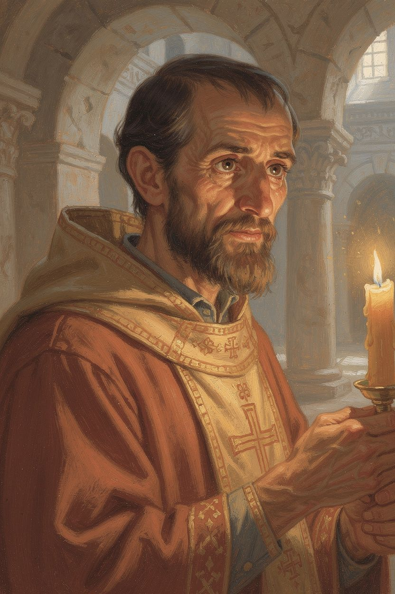
Basil: The Bishop Who Built a Hospital
WisdomForge Booklet — Ages 5–10

Basil: The Bishop Who Built a Hospital

WisdomForge Booklet — Ages 5–10
———

About This Book
About 1,700 years ago, in a land called Cappadocia (which is in modern-day Turkey), there lived a boy named Basil. He came from a big, smart family. His grandmother had survived terrible times. His sister Macrina was one of the wisest people anyone knew. His younger brother Gregory became a great thinker too.
Basil went to the best schools in the world — in Constantinople, the biggest city, and in Athens, the oldest school. He could have been a famous teacher or a rich lawyer. But his sister Macrina asked him a question that changed his life: "Being smart is not enough. Are you good?"
Basil listened. He became a monk, then a priest, then a bishop. He wrote a book about the Holy Spirit that changed how Christians understand God. He preached about the beauty of the world God made. He told rich people that the bread they hoarded belonged to the hungry. He built a great hospital where sick people were cared for. And he stood up to a powerful emperor who tried to make him give up his faith.
Basil lived only forty-nine years, but in that time he did more than most people do in a long life. He wrote a book about the Holy Spirit that changed how Christians talk about God. He preached sermons about the beauty of the world that people still read today. He told rich people that the bread they hoarded belonged to the hungry. He built a great hospital where sick people were cared for with love. And he stood up to a powerful emperor who tried to make him give up his faith.
This booklet tells six stories from Basil's life. Each one has a story, words to remember, a big idea, something to try, and a question to ask a grown-up. Read it alone or with someone you love. The questions are not tests. They are doors to walk through together.
———

Chapter 1: The Boy Who Loved to Learn
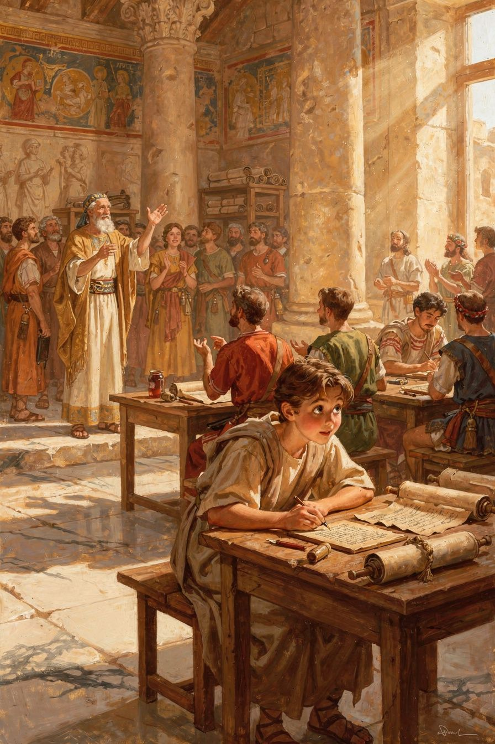
Illustration for Chapter 1
Basil was born around the year 330 in a city called Caesarea, in a region called Cappadocia. Cappadocia was a wild, beautiful place with tall rock formations and deep valleys. The people there were farmers and merchants and craftsmen.
Basil's family was special. His father, also named Basil, was a teacher of speaking — he taught people how to give speeches and argue well. His mother, Emmelia, was rich and kind. She gave food to poor people and taught her children to do the same.
Basil had a big family, and the family was special. His father, also named Basil, was a teacher of speaking — he taught people how to give speeches and argue well. His mother, Emmelia, came from a wealthy family. She was known for being kind. She gave food to poor people and taught her children to do the same. She believed that having money meant you had a job: to share it.
Basil's grandmother, Macrina the Elder, was a woman of fierce faith. She had lived through a terrible time when the Roman emperors tried to destroy Christianity. They sent soldiers to tear down churches and arrest Christians. Macrina survived those years and passed her faith down to her children and grandchildren. She taught the family to be brave.
Basil's older sister, Macrina the Younger, was the real leader of the family. She was smart and strong. She decided to live simply, pray deeply, and serve the poor. She turned the family estate into a community where people shared everything. She was the one who asked Basil the hard question that changed his life. She saw that her brilliant brother was proud of his education, and she challenged him: being smart is not the same as being good.
Basil also had a younger brother, Gregory, who became a great thinker. The family produced three bishops — Basil, Gregory, and their youngest brother Peter. It was a family that took faith seriously.
When Basil was old enough, his father sent him to study in Constantinople, the greatest city in the Roman world. Constantinople was the capital of the empire. It had huge palaces, wide streets, and the best teachers. Basil studied there for several years, learning the art of public speaking. Then he went to Athens, the most famous school in all of history. Athens was an old city, full of philosophers. Plato had taught there four hundred years before Basil. Aristotle had studied there too. Basil learned their ideas — about truth, about goodness, about the soul. He learned how to argue and how to persuade.
In Athens, Basil met another student named Gregory. Gregory was quiet where Basil was bold, poetic where Basil was practical. But they understood each other. They stayed friends for the rest of their lives. Gregory later said that their friendship was "a tie of affection which cannot be described."
Basil loved learning. He was very good at it. But being smart was not the same as being wise. That was the lesson he still needed to learn.
Words to Remember "I had heard of him by fame before I knew him by sight, and when I met him, I was bound to him by a tie of affection which cannot be described." — Gregory of Nazianzus, about meeting Basil in Athens
Big Idea Learning is wonderful, but learning without goodness is like a fast horse with no rider. The horse is powerful, but it has no direction. Basil was brilliant, but his sister Macrina reminded him that brilliance needs a purpose.
Try This - Learn the name "Cappadocia." Say it: cap-pa-DOE-sha. Find Turkey on a map or globe. That is where Basil lived. The rock formations there look like giant towers made by nature. - Think of a time you learned something new. Maybe you learned to read, or ride a bike, or swim. How did it feel? Did learning make you want to help someone else? - Ask someone in your family what they studied. Your parents, grandparents, or older siblings — what did they learn in school? Did it help them become a better person?
Ask a Grown-Up "What is the difference between being smart and being good? Can you be smart without being good?"
———

Chapter 2: The Fire That Lights All Fires
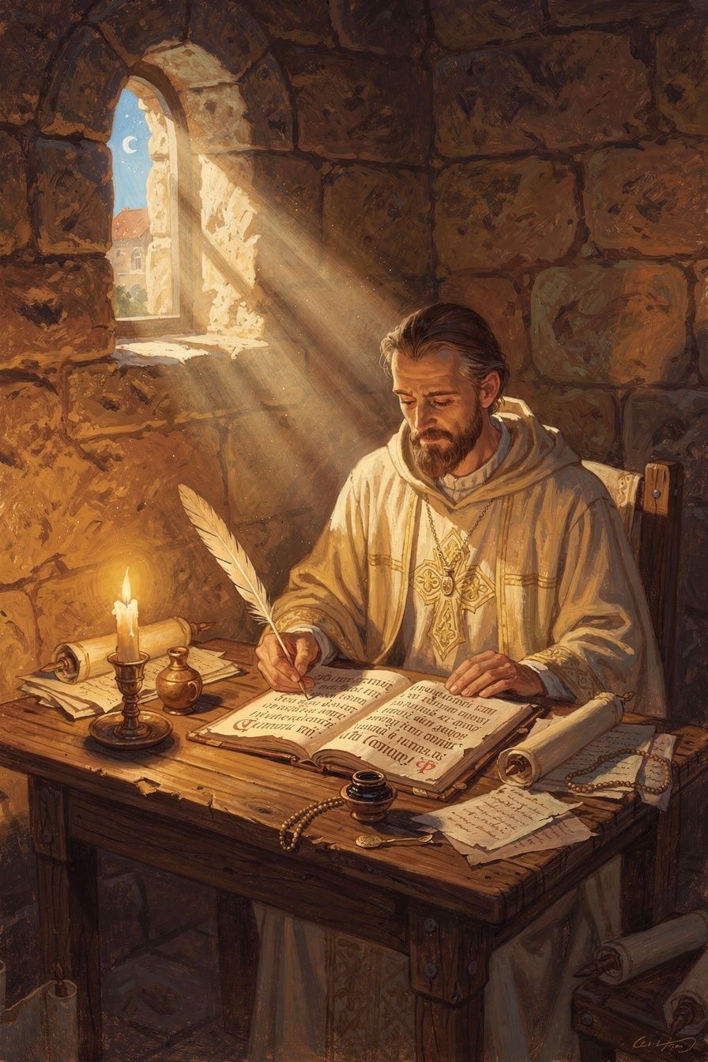
Illustration for Chapter 2
When Basil became a bishop, people were arguing about God. Some people said, "There is one God, the Father." Others said, "The Son is God too." And some people said, "The Holy Spirit is not really God — just a helper God made."
Basil said no. The Holy Spirit is not a helper. The Holy Spirit is God — just as much as the Father and the Son.
Basil used a beautiful picture to explain. Think of a fire. One candle can light a hundred other candles, and the first candle does not get smaller. The fire spreads without being used up. The Holy Spirit is like that fire. The Spirit gives light and warmth to everyone, and the Spirit never runs out.
You cannot see the fire itself directly. You see by its light. You feel its warmth. You know it is there because of what it does. The Holy Spirit is like that. You cannot see the Spirit, but you can see the love the Spirit puts in people's hearts. You can see the courage the Spirit gives. You can see the peace the Spirit brings.
Basil also pointed to baptism. When someone is baptized, the priest says, "In the name of the Father, and of the Son, and of the Holy Spirit." All three names are used together, as equals. You do not baptize in the name of a helper. You baptize in the name of God. If the Spirit were just a creature God made, then putting the Spirit's name next to the Father's name would be wrong. It would be like putting a servant's name on the same level as the king's name. But the church has always baptized this way. So the Spirit must be God.
Basil wrote a whole book about the Holy Spirit called On the Holy Spirit. He said the Spirit is "the source of sanctification" — the one who makes people holy. He said the Spirit is "light perceptible to the mind" — a light you see with your heart, not your eyes. He said that through the Spirit, people are "made like to God." This last idea is very important in Eastern Christianity. The goal of the Christian life is not just to be good but to become like God — to share in God's life through the Spirit.
Basil wrote a whole book about the Holy Spirit. He said the Spirit is "the source of sanctification" — the one who makes people holy. He said the Spirit is "light perceptible to the mind" — a light you see with your heart, not your eyes. He said that through the Spirit, people are "made like to God." He wanted people to say the Spirit was less than God. But Basil would not back down. He knew that what we say about God matters. If the Spirit is God, then the Spirit deserves our worship. If the Spirit is just a helper, then we are giving God's place to something God made.
Basil's book changed everything. After he died, the church gathered at a great council in Constantinople in the year 381. They agreed with Basil. They wrote a creed — a statement of faith — that says: "We believe in the Holy Spirit, the Lord and giver of life, who proceeds from the Father, who with the Father and the Son together is worshipped and glorified." Christians still say those words today.
Words to Remember "The Holy Spirit is not a creature, nor a work, but he is proper to the Son and partakes of the same nature as the Son." — Basil, On the Holy Spirit, chapter 22
Big Idea The Holy Spirit is God — not a helper or a messenger God made, but God himself, giving us light and warmth and making us good. You cannot see the Spirit, but you can see what the Spirit does, just like you cannot see the wind but you can see the trees it moves.
Try This - Light a candle. (Ask a grown-up to help.) Watch the flame. One candle can light another without losing its own fire. That is like the Holy Spirit — giving love to everyone without ever running out. - Draw a picture of three candles. They are three separate flames, but they are all the same fire. That is one way to think about the Trinity: one God, three persons, same divine life. - Listen for the wind. Go outside on a windy day. You cannot see the wind, but you can see it move the leaves and feel it on your face. The Holy Spirit is like the wind — invisible but powerful.
Ask a Grown-Up "Who is the Holy Spirit? How do we know the Spirit is with us?"
———

Chapter 3: The World God Made
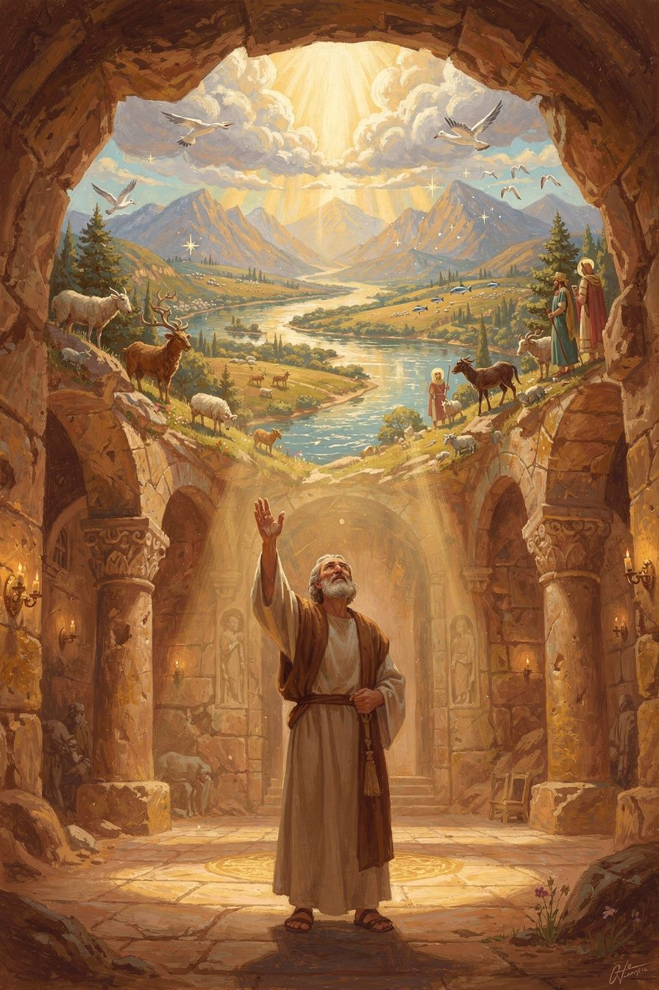
Illustration for Chapter 3
Basil loved the world. He loved the sun and the moon. He loved rivers and springs. He loved the way fish are shaped for water and birds are shaped for air. He loved the sweetness of honey and the strength of horses.
He preached nine sermons about the six days of creation — the story in Genesis 1 where God says "Let there be light" and light appears. These sermons are called the Hexaemeron (which means "six days"). He preached them to ordinary people — farmers, merchants, craftsmen — in his church in Caesarea. He did not use fancy words. He said: Look at the world. See what God has made. Notice it. Give thanks for it.
Basil told his people to look at the world the way you look at a painting. A painting is not just colors on a canvas. It is a message from the artist. The world is not just dirt and water and sky. It is a message from God. Everything you see — the stars, the flowers, the animals, your own body — is God saying, "I made this for you. It is good."
Basil described the sun as a "great lamp" that warms the earth. He called the moon a companion that softens the darkness. He said the stars are "flowers of fire" that decorate the night. He noticed the way fish are shaped for water and birds are shaped for air. He saw that each creature fits its home — and that fit is not an accident. It is design.
Some people in Basil's time thought the body was bad. They thought the soul was trapped in the body like a bird in a cage. Basil said that was wrong. God made the body. God called the body "very good." The body is not a cage. It is a gift. Your body can pray (kneeling, standing, singing). Your body can serve (working, feeding, caring). Your body can worship. The body is the instrument of the spiritual life, not the obstacle.
Basil also said something surprising: the stars do not control your life. In his time, many people believed in astrology. They thought the stars decided your fate. Basil said no. The stars are God's decorations. They mark time and give light. They do not tell you who you are or what you will become. You are free. God made you free. If the stars controlled everything, then justice would mean nothing — you could not be punished for doing wrong, because the stars made you do it. But God gave you a will. You choose. That is what makes you human.
And Basil said the world is not a machine that runs by itself. It is a gift that God holds in being every moment. The sun rises because God makes it rise. The seasons change because God guides them. The world is personal because God is personal.
Words to Remember "The Creator of all things made the world, not as a thing to be despised, but as something that is good." — Basil, Hexaemeron, Homily 1
Big Idea The world is not a machine. It is a gift. Everything in it — the sun, the water, the plants, the animals, and you — is God's handiwork. God made it good, and God keeps it going every moment. When you look at a flower or a star, you are reading a letter from God.
Try This - Go for a walk outside. Find one thing that amazes you — a bug, a flower, a cloud, a rock. Hold it or look at it closely. Say to yourself: "God made this. It is good." - Draw a picture of your favorite animal. Think about why it is the shape it is. A fish is shaped for swimming. A bird is shaped for flying. God designed each creature for its home. - Make a list of three things your body can do. Wiggle your fingers. Jump. Blink your eyes. Your body is amazing. God made it. Basil said we should take care of our bodies because they are God's design.
Ask a Grown-Up "What is the most beautiful thing in nature you have ever seen? Did it make you think of God?"
———

Chapter 4: The Bread That Belongs to the Hungry
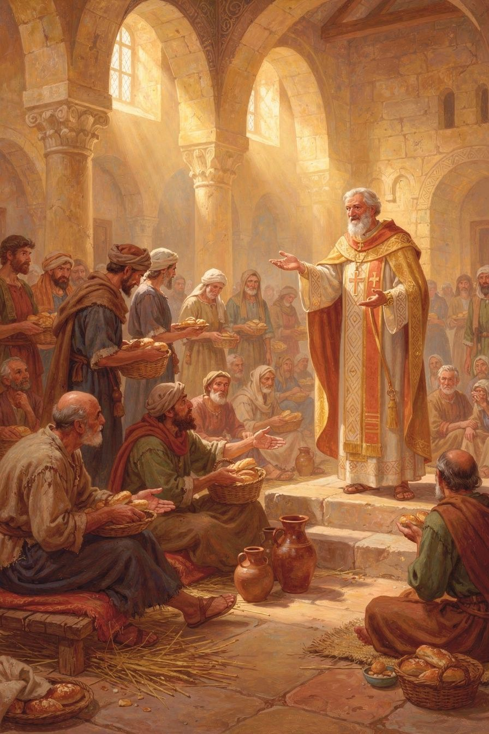
Illustration for Chapter 4
One day, Basil preached a sermon that made the rich people very uncomfortable. He told them a story from the Bible — the story of the rich fool.
The rich fool had a great harvest. So much grain that his barns could not hold it all. He said to himself: "I will tear down my barns and build bigger ones. Then I will have plenty. I can relax, eat, drink, and be happy."
But God said: "You fool! Tonight you will die. Who will get all your stuff?"
Basil said: The bread you hold back belongs to the hungry. The coat you put away belongs to the person who is cold. The money you bury in the ground belongs to the poor.
Notice the word "belongs." Basil did not say "you should give." He said "it belongs to them." The extra food is not yours. The extra coat is not yours. It belongs to the person who needs it. You are just holding it for them.
This is a very strong thing to say. It means that if you have more than you need and your neighbor has less, you are keeping something that is not really yours. You are a steward — someone who takes care of things for the real owner. And the real owner is God, who gave the world to everyone.
Basil did not just preach this. He built a hospital. It was called the Basileias, and it was like a small city within the city. It had a place for sick people, with attendants who cared for them. It had a shelter for travelers who had nowhere to sleep. It had a home for old people who had no family to care for them. It had an orphanage for children without parents. It had a workshop where people who had no work could learn a trade and earn their own food. And it had a kitchen that fed hungry people every single day.
Basil used his own money to build it. He gave away his family fortune. He asked rich people to help, and sometimes he told them they were doing wrong if they did not. He did not just ask for spare change. He asked them to share what they had, because what they had was a trust from God.
The Basileias was one of the first Christian hospitals. It showed the world that Christians do not just talk about love. They build places where love happens. Gregory of Nazianzus, Basil's best friend, called it "a new city" — a visible sign that the gospel changes how people live together.
Words to Remember "The bread which you hold back belongs to the hungry; the clothing you shut away belongs to the naked." — Basil, I Will Tear Down My Barns
Big Idea The things you have are not just yours. They are gifts from God, and God gave the world to everyone. If you have more than you need and someone else has less, the extra does not belong to you. It belongs to them. You are just holding it.
Try This - Look in your closet. Count your coats or your shoes. If you have more than you need, pick one to give away. Basil would say: that extra one belongs to someone who is cold. - Think about a birthday party. There are cupcakes for everyone. But what if one child grabbed five and said, "These are mine"? The other children would have none. Basil said that is what happens when rich people keep too much. - Make a giving box. Find a box and decorate it. Put in it things you do not need — extra toys, extra clothes, extra snacks. Take it to a place that helps people. You are being a steward, sharing what belongs to everyone.
Ask a Grown-Up "What does it mean that the bread "belongs" to the hungry? How is that different from saying we "should give" to the hungry?"
———

Chapter 5: The Coals That Stay Hot Together
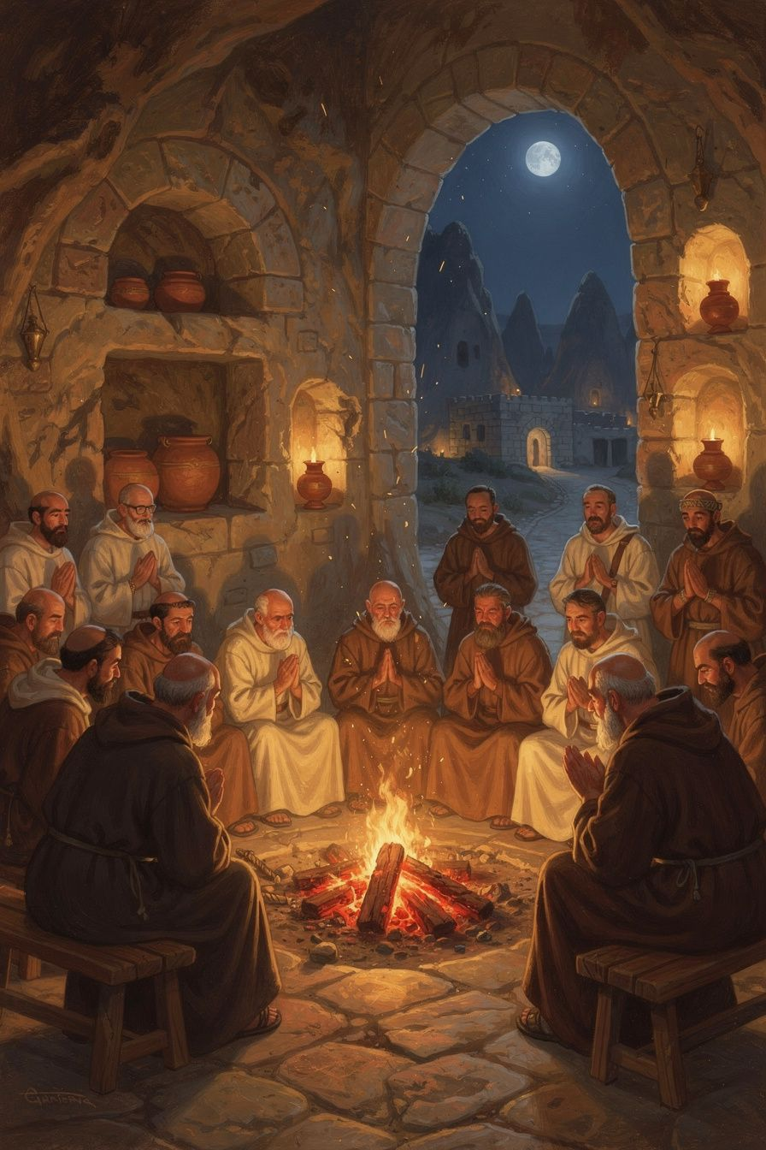
Illustration for Chapter 5
Basil believed that people need each other. He said you cannot be a Christian alone. You need a community — people who pray with you, work with you, correct you when you are wrong, and help you when you are struggling.
Basil used a picture to explain. Think of a fire. If you take one hot coal out of the fire and set it by itself, what happens? It goes cold and dark. But if you leave it in the fire with the other coals, it stays hot. People are like that. We need each other to stay warm in our faith.
That is why Basil did not want monks to live alone. Some monks in his time went to the desert and lived by themselves. They lived in caves or on top of pillars. Basil said: No. If you live alone, who will correct you when you make a mistake? Who will you serve? How will you practice love if there is no one to love?
Basil's monks lived together. They shared their food and their clothes. Nobody said "this is mine." Everything was "ours." They worked together — growing food, making things, caring for the sick. They prayed together at set times every day. They welcomed strangers who came to their door. If a traveler was tired, the monk gave him a bed. If a poor person was hungry, the monk gave him bread. If a sick person needed care, the monk tended to him.
Basil's monasteries were not fortresses hiding from the world. They were more like base camps. The monks prayed and worked and got ready, and then they went out to help. They cared for the sick. They fed the hungry. They welcomed travelers. The monastery was a school of love, not a hiding place. And the monastery was always near a town — close enough to receive visitors and serve the poor.
Basil also said that monks should not fast so much that they get sick. Some monks in his time tried to starve themselves to show how holy they were. Basil said: That is not holy. That is proud. Your body is God's gift. Train it, but do not break it. The athlete who breaks his legs before the race does not win the crown. Fast enough to be disciplined, but eat enough to work, pray, and serve.
Words to Remember "If we live alone, who is there to serve? ... The common life has many advantages." — Basil, Longer Rules, Question 5 (paraphrased)
Big Idea People need each other. One coal alone goes cold. One coal in the fire stays hot. We need community to stay warm in our faith, to help us when we struggle, and to give us someone to love. You cannot love your neighbor if you have no neighbor.
Try This - Think about a team you are on. Maybe a sports team, a class project, or your family. When does the team work well? When does everyone does their part. When does it fail? When someone goes off alone. Basil said the church is like a team. - Do something with someone else today. Bake something together. Read a book together. Help with a chore together. Notice how it feels different from doing it alone. - Make a list of three people who help you. Maybe a parent, a teacher, a friend. Tell one of them: "Thank you for being part of my fire." Basil said we stay warm because others keep us hot.
Ask a Grown-Up "Why do you think Basil said people need community? What happens when someone tries to do everything alone?"
———

Chapter 6: The Bishop Who Said No to an Emperor
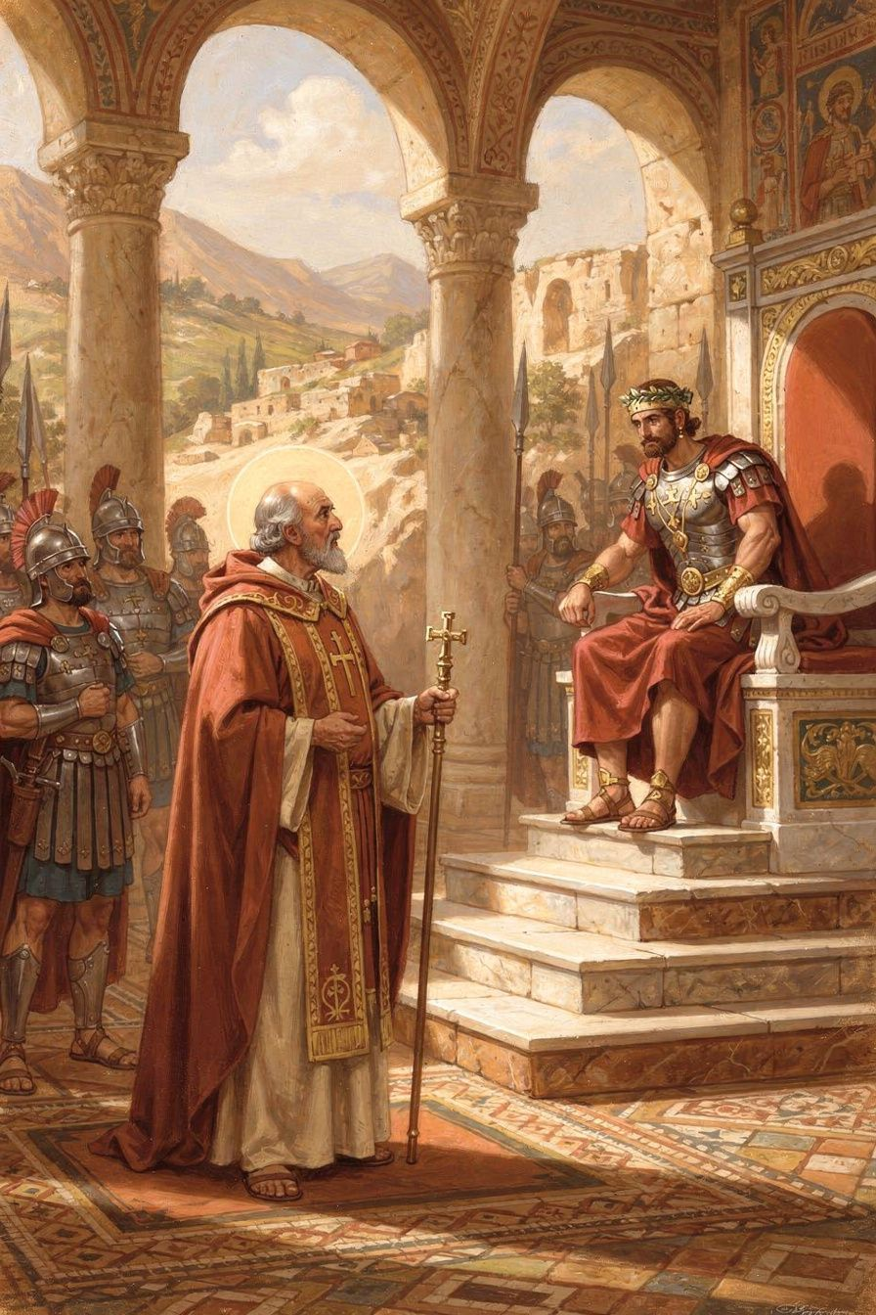
Illustration for Chapter 6
The emperor Valens was powerful. He controlled the army, the laws, and the land. And he did not agree with Basil about God.
Valens believed the Son was not fully God. He believed the Holy Spirit was just a created being. He wanted all the bishops to agree with him. He sent his officials to threaten Basil.
One of those officials was a man named Modestus. He was the prefect — a very high-ranking officer. He came to Basil and said: "The emperor is angry with you. If you do not agree, he will take away your property, send you away, beat you, or kill you."
Basil was calm. He said: "Take my property? I only have some old clothes and a few books. Take my home? I belong to no particular place. The whole earth belongs to God, and I am a stranger everywhere. Beat me? My body is weak and will not hold up under torture. But the first blow is the only one in your power — after that, I will be unconscious. Kill me? That will be a benefit. It will bring me to God."
Modestus was shocked. He said he had never met anyone who spoke to him so boldly. Basil replied: "Perhaps that is because you have never met a bishop."
Basil's courage came from his faith. He believed that the truth was more important than safety. He believed that God was more powerful than any emperor. He believed that a bishop's job was not to please rulers but to please God.
Valens never carried out his threats. Some say he was impressed by Basil's courage. Some say he was afraid that harming such a respected bishop would cause a riot. Either way, Basil stood his ground, and the truth won.
Basil died on January 1, in the year 379. He was only forty-nine years old. He was tired and sick from years of hard work. But he had done what God called him to do. Two years later, the church met at the Council of Constantinople and confirmed everything Basil had taught about the Father, the Son, and the Holy Spirit.
His friend Gregory preached a sermon at his funeral. Gregory said: "Basil was one of the great lights of the church." He was a theologian, a builder, a shepherd, and a friend. He changed the church by his writing and his courage.
Words to Remember "Confiscation means nothing to me, unless you covet these wretched rags and a few books; that is all I possess. As for death, this will be a benefit to me." — Basil to the prefect Modestus, as told by Gregory of Nazianzus, Oration 43
Big Idea Courage does not mean being unafraid. It means knowing what matters more than fear. Basil knew the truth about God mattered more than his safety. He stood up to an emperor because he trusted God more than any human power. That kind of courage comes from faith, not from pride.
Try This - Think of a time you had to be brave. Maybe you had to tell the truth when it was hard. Maybe you had to stand up for someone who was being treated unfairly. How did it feel? What gave you courage? - Learn the name "Modestus." Say it: mo-DUST-us. He was a powerful official, but Basil was not afraid of him. Why? Because Basil knew that power is not the same as truth. - Draw a picture of a bishop standing tall. Basil was not a soldier. He did not have an army. He had only his faith and his courage. But that was enough to face an emperor.
Ask a Grown-Up "Have you ever had to stand up for something you believed in, even when it was hard? What gave you courage?"
———

For the Grown-Up Reader
This booklet introduces children to Basil of Caesarea (c. 330–379 CE), one of the three Cappadocian Fathers and one of the most important theologians in Christian history. The six chapters cover: Basil's early life and education; his defense of the Holy Spirit's divinity; his creation theology (the Hexaemeron); his radical social teaching on wealth and poverty; his vision of community life; and his courageous stand against imperial pressure.
All quotations are from public-domain translations available at New Advent (www.newadvent.org/fathers). The paraphrased passages from the Longer Rules preserve Basil's meaning in simplified language for young readers. The historical framework follows Philip Rousseau, Basil of Caesarea (University of California Press, 1994), and Stephen Hildebrand, Basil of Caesarea (University of Notre Dame Press, 2018).
The story of Basil's confrontation with Modestus is preserved in Gregory of Nazianzus's Oration 43, the funeral oration for Basil. Gregory may have polished the dialogue, but the encounter is historical — Valens did send officials to pressure Basil, and Basil did refuse to compromise.
The Basileias — Basil's hospital complex at Caesarea — is described by Gregory of Nazianzus as a "new city." It was one of the earliest integrated Christian social welfare institutions. Susan R. Holman, The Hungry Are Dying (Oxford, 2001), is the definitive study.
———

About WisdomForge
WisdomForge publishes four versions of each booklet — for ages 5–10, 11–14, 15–18, and adult — so readers at every stage can meet the great thinkers of the classical and Christian tradition. Each version tells the same stories and explores the same ideas, but in language and depth suited to the reader. The booklets are free. Read them. Question them. Discuss them. Do them.

