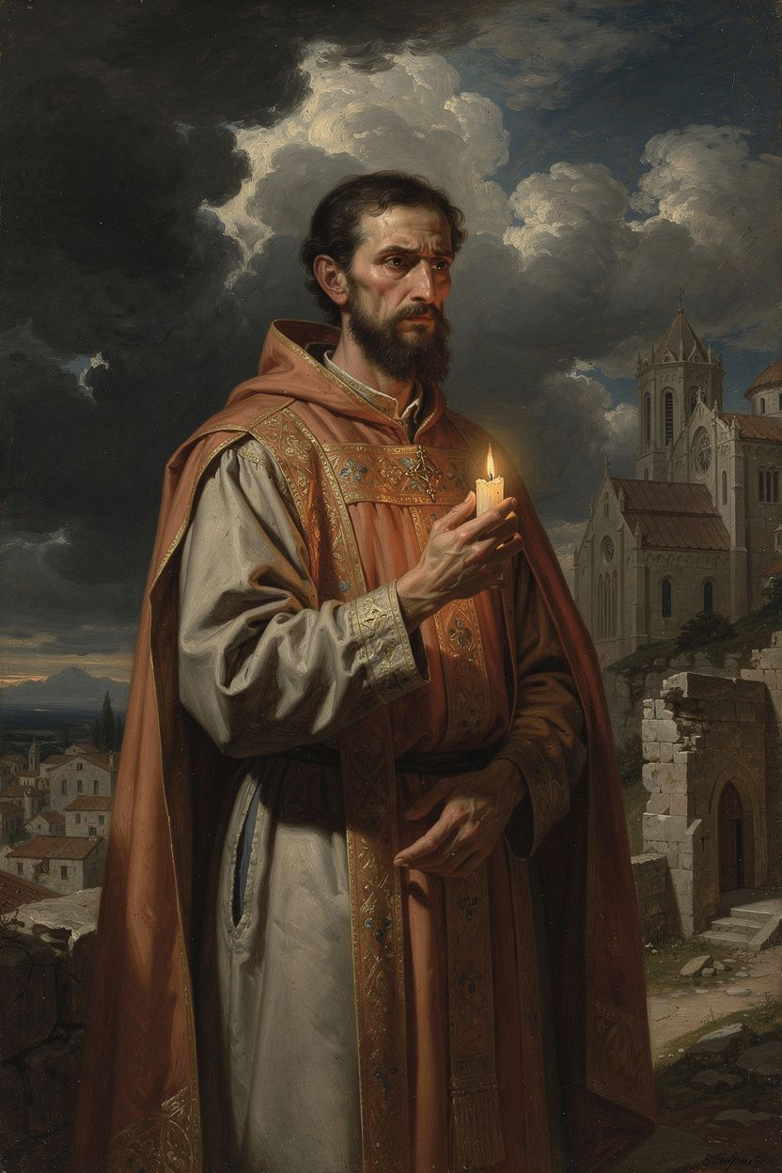
Basil of Caesarea: Theologian, Builder, Witness
WisdomForge Booklet — Ages 15–18

Basil of Caesarea: Theologian, Builder, Witness

WisdomForge Booklet — Ages 15–18
———

About This Book
Basil of Caesarea (c. 330–379 CE) lived only forty-nine years, but he changed the course of Christian theology, monasticism, and social ethics. With his brother Gregory of Nyssa and his friend Gregory of Nazianzus, Basil formulated the Cappadocian settlement — the trinitarian distinction between one divine essence (ousia) and three distinct persons (hypostaseis) — that became the permanent doctrinal foundation of both Eastern and Western Christianity. He defended the full divinity of the Holy Spirit against the Pneumatomachi. He preached the Hexaemeron, the most influential patristic meditation on creation. He wrote monastic rules that shaped Eastern Orthodox monasticism for centuries. He built the Basileias, one of the first Christian hospitals. And he stood up to an emperor who threatened him with death.
This booklet is for readers aged 15–18. It assumes you can handle real argumentation, historical complexity, and theological vocabulary. Each chapter includes a narrative essay, a Big Idea that develops the chapter's philosophical core, Practice exercises that put the idea into action, and a Reflect question to carry beyond the page. One chapter includes a Research Prompt pointing to specific primary and secondary sources. The scholarly debates are real — they name the disagreements that scholars still have about Basil's theology, and they invite you to join the conversation.
Basil was not a system-builder. He was a bishop, a monk, a friend, and a pastor who wrote because problems arose and people needed help. His theology was forged in controversy, friendship, and the daily demands of leading a church through a time of political danger. The result is a body of work that is both intellectually rigorous and deeply practical — a rare combination. He did not write from a library; he wrote from a bishop's office, a monastery, a hospital, and a prison's shadow. Theology, for Basil, was never separate from love — love of God, love of the poor, love of the community, and love of the truth.
The six chapters of this booklet follow the arc of Basil's life and thought. Chapter 1 tells the story of his education and conversion — how the best education in the Roman world found its purpose when his sister Macrina challenged him. Chapter 2 examines his defense of the Holy Spirit's divinity and the Cappadocian settlement — the distinction between one ousia and three hypostaseis that gave the church its trinitarian vocabulary. Chapter 3 explores his creation theology — the Hexaemeron's vision of the world as a gift, not a machine, and the body as an instrument, not a prison. Chapter 4 takes on his radical social teaching — "the bread you hold back belongs to the hungry" — and the Basileias, the hospital that embodied his conviction that love needs structures. Chapter 5 presents his theology of community — the coal and the fire, the monastery as base camp, the moderate asceticism that disciplines the body without destroying it. Chapter 6 tells the story of his confrontation with the emperor Valens and his death at forty-nine, two years before the council that ratified his theology. Each chapter includes scholarly debates that are still live — the Hildebrand-Wolfson debate on Basil's pneumatological development, the Holman-Rousseau debate on his social ethics, the question of whether his self-expenditure was heroic or self-destructive. These debates are not just academic. They are invitations to think with Basil about questions that still matter: How do we know God? How should we live together? What do we owe the poor? What is worth dying for?
———

Chapter 1: The Education That Found Its Purpose
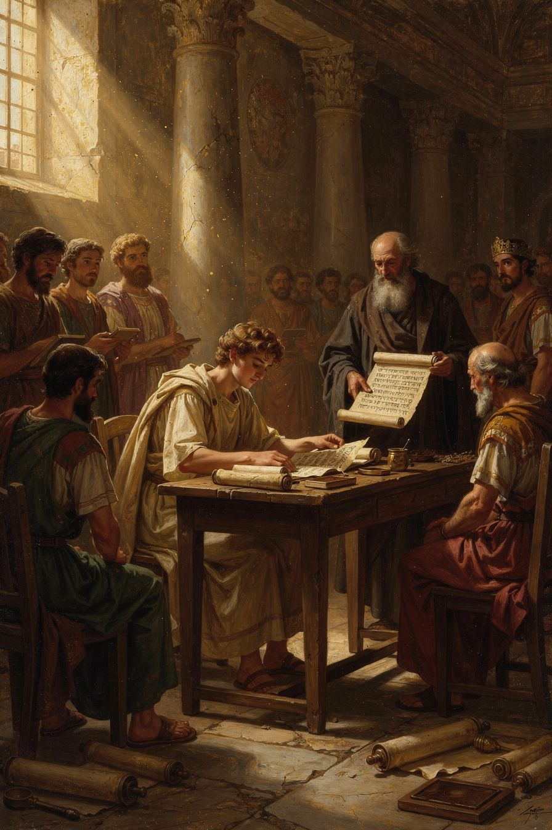
Illustration for Chapter 1
You are standing in a classroom in Athens. It is the 350s CE, and the Roman world is still the only world anyone knows. The classroom is not like yours — there are no desks, no computers, no projectors. A teacher stands and speaks. Students sit on stone benches and listen. The subject is rhetoric: the art of speaking, arguing, and persuading. The teacher quotes Homer. The students take notes on wax tablets. And in the back row, two young men are becoming friends.
One is Basil, a tall, intense young man from Cappadocia, the son of a rhetorician and the grandson of a woman who survived persecution. The other is Gregory, quieter, more poetic, destined to be one of the great preachers in Christian history. They have come to Athens because Athens is where you go if you want to be educated. Plato taught here. Aristotle studied here. Now Basil and Gregory are here, learning the tools of Greek philosophy and Roman rhetoric that they will later use to articulate Christian theology.
Basil's education followed the standard path of an elite Roman youth. He studied under his father in Caesarea, then in Constantinople under the best rhetoricians of the age, then in Athens, the ancient center of learning. He studied philosophy (Plato, Aristotle, the Stoics), rhetoric, literature, and probably mathematics and astronomy. He absorbed the tools of Greek intellectual culture that he would later put to use defending Nicene orthodoxy.
The question is: what did this education do to him? Basil's family was Christian — devoutly, seriously, even fiercely Christian. His grandmother had survived the persecutions. His sister Macrina had chosen a life of ascetic discipline. His brother Gregory would become one of the greatest theologians of the era. But Basil, in Athens, was doing what every ambitious young Roman did: learning to argue, to speak, to succeed.
The turning point came when he returned to Cappadocia. His sister Macrina challenged him: is the life of a celebrity teacher worthy of a Christian? The question was not about education — it was about purpose. Basil had the tools. What he lacked was a reason to use them. Macrina's challenge gave him one.
Basil was baptized, traveled through Egypt and Syria studying monastic life, and returned to Cappadocia to found a monastic community. The tools of Athens — philosophical analysis, rhetorical skill, careful argumentation — were redirected. He used them to defend the divinity of the Holy Spirit, to articulate the distinction between ousia and hypostasis, to compose rules for monastic community, and to preach about the goodness of creation. The best education in the Roman world became the instrument of a faith that education alone could not produce.
The story of Basil's conversion also reveals something about the nature of intellectual vocation. Basil did not abandon his education when he became a Christian. He redeemed it. The philosophical categories he learned in Athens — essence, person, operation, nature — became the vocabulary of trinitarian theology. The rhetorical skills he acquired in the schools became the tools of pastoral communication. The friendships he formed in Athens (especially with Gregory) became the network that sustained the Nicene cause. This is the pattern: education does not need to be rejected when one finds faith. It needs to be redirected. The tools remain; the purpose changes.
Basil's family context also deserves attention. His was not a conversion from unbelief to faith — he was raised Christian. His conversion was from cultural Christianity to committed Christianity, from the faith of a successful professional to the faith of a disciple. This is a harder conversion, and a more relevant one for most readers. The challenge is not to acquire faith but to take it seriously — to let it redirect your life, your career, your relationships, and your use of your gifts. Macrina's question — "is being smart enough?" — is not just for Basil. It is for anyone whose gifts have become a source of pride rather than service.
One scholarly debate about Basil's early life concerns the extent to which his encounter with Greek philosophy shaped his theology. Some scholars (notably Pelikan in Christianity and Classical Culture) argue that Basil's use of Platonic and Aristotelian categories — essence, person, operation — represents a genuine synthesis of Christian faith and Greek philosophy. Others (notably Behr in The Nicene Faith) argue that Basil used Greek philosophical vocabulary strategically, borrowing the language without adopting the metaphysics. The question matters because it determines how we read the Cappadocian settlement: is it a Christianized Platonism, or is it a distinctively Christian theology expressed in Greek terms? The evidence suggests both: Basil's categories are Greek, but the content they carry — the Trinity, creation ex nihilo, the goodness of matter — is not.
The Big Idea
Education gives you tools. It does not give you a reason to use them. Basil's education in Athens equipped him with the philosophical vocabulary and rhetorical skill to articulate trinitarian theology. But the education did not produce the theology. The theology came from his faith, his family, and his sister's challenge. The tools of Greek philosophy became powerful when they were directed toward a purpose that education alone could not supply. This is the pattern: knowledge becomes wisdom when it finds its purpose.
Practice
1. Audit your own education. Write down three things you are learning right now — a subject, a skill, a way of thinking. For each, write one sentence about what it could be used for beyond personal achievement. If you cannot think of anything, ask: is this knowledge looking for a purpose, or is it just accumulating? Basil had the best education in the world and it was purposeless until Macrina challenged him. What would it take for your education to find its purpose? 2. Read Gregory of Nazianzus's *Oration* 43. Find the passage where Gregory describes meeting Basil in Athens. What does Gregory emphasize — the intellectual partnership, the emotional bond, or the shared faith? What does this tell you about how great intellectual collaborations work? Write a 300-word analysis of the role friendship played in Basil's intellectual development. 3. Think about the "Basil problem." Basil had the best education available and used it to serve the church. But many people with excellent educations use them only for themselves. What is the difference? Write a paragraph: what turns education into service? Is it a person, an experience, a question, a crisis — or some combination? 4. Interview someone about purpose. Find a person — a parent, teacher, mentor, or friend — who you think has found a purpose for their life and work. Ask them: was there a moment when their education or career "found its purpose"? What caused the shift? Write a one-page summary of what you learned. Compare it to Basil's story.
Reflect
Macrina asked Basil whether being smart was enough. Who is asking you that question — or who should be?
———

Chapter 2: The Theologian of the Holy Spirit
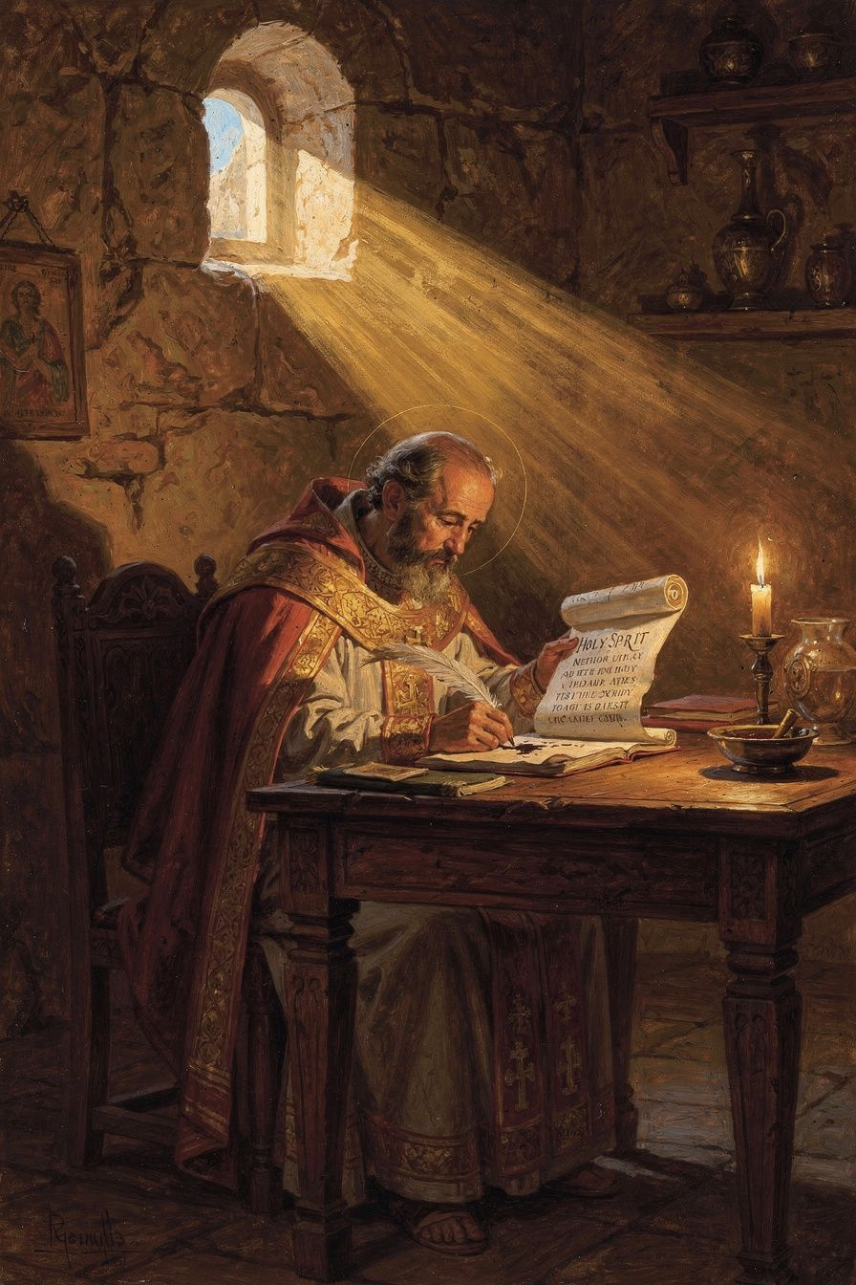
Illustration for Chapter 2
The Council of Nicaea (325 CE) declared that the Son is homoousios — "of one substance" — with the Father. But Nicaea did not settle everything. The Holy Spirit's status was still unclear. Even many Nicene Christians — those who accepted the Son's divinity — hesitated to call the Spirit fully God. They used cautious language: the Spirit is "around" God, "from" God, "sent by" God. But is the Spirit God in the same way the Father and Son are God?
A group called the Pneumatomachi — "those who fight against the Spirit" — answered: No. The Spirit is a creature, perhaps the highest creature, but a creature nonetheless. They based their argument on biblical prepositions: the Spirit is "sent" by the Son (John 15:26), "given" by the Father (Luke 11:13), "poured out" at Pentecost (Acts 2). Creatures are sent, given, poured. God is not sent. Therefore the Spirit is a creature.
Basil wrote On the Holy Spirit in 375 CE to answer this argument. His friend Amphilochius had noticed a related problem: Christians used different doxologies — some said "with the Son, together with the Holy Spirit"; others said "through the Son, in the Holy Spirit." The Pneumatomachi argued that this variety proved the Spirit was inferior. Basil's treatise is a careful exercise in theological grammar that shows the opposite: the variety of language reflects the richness of trinitarian relations, not a hierarchy of being.
Basil's strategy is to begin not with definitions but with the language the church already uses. He shows that the biblical prepositions — "of," "through," "in" — are not locked to one person of the Trinity. The Father creates through the Son (Hebrews 1:2), but the Father also creates in the Spirit (Psalm 33:6). The Son acts of the Father (John 5:19), but the Spirit also acts through the Son (1 Corinthians 12:3). The variety of prepositions does not prove a hierarchy. It reflects the distinct modes of action of three persons who share one divine nature.
The most powerful argument comes from baptism. Christ commanded baptism "in the name of the Father and of the Son and of the Holy Spirit" (Matthew 28:19). Baptism is the act by which the Christian is joined to God. If the Spirit were a creature, the church would be invoking a creature alongside the Creator — blasphemy. The fact that the church has always baptized in the threefold name proves that the Spirit is on the divine side of the line.
Basil also argues from worship. The doxology — "Glory to the Father and to the Son and to the Holy Spirit" — is a liturgical confession. The church would not give glory to a creature. This is the principle lex orandi, lex credendi: the rule of prayer is the rule of faith. What the church says in worship reveals what it believes. Basil treats the liturgy not as a secondary phenomenon needing justification by exegesis, but as a source of theology in its own right.
Basil describes the Spirit in terms that can only apply to God: Creator of life (Psalm 104:30), source of sanctification (no creature can make another creature holy), omnipresent (Psalm 139:7), all-knowing (1 Corinthians 2:10), goodness itself. The climax: "The Holy Spirit is not a creature, nor a work, but he is proper to the Son and partakes of the same nature as the Son; nor can we ever say that he is other than the living God" (On the Holy Spirit, 22).
Basil also made a crucial contribution to trinitarian theology by distinguishing between the one divine nature (ousia) and the three persons (hypostaseis). Before Basil, these two Greek words were often used interchangeably — both could mean "substance." Basil gave them distinct technical meanings: ousia refers to what is common (the one divine nature shared by all three persons), hypostasis refers to what is particular (the concrete individual reality of each person). The analogy Basil offers is of three humans. Peter, James, and John share one human nature (ousia) — they are all equally human. But they are three distinct persons (hypostaseis) — Peter is not James, James is not John. So with the Trinity: the Father, Son, and Spirit share one divine ousia but are three distinct hypostaseis.
This distinction is deceptively simple, but it solved the theological problem that had torn the church for half a century. It preserved monotheism (one ousia) while affirming the real distinction of the three persons (three hypostaseis). Against Sabellianism (which collapsed the persons into modes of one God) and tritheism (which separated them into three beings), Basil argued for real distinction within real unity: the Father, Son, and Spirit are one in nature, one in glory, one in operation. They are distinct as persons, differing not in being but in their relations of origin. The Father is unbegotten — the source without a source. The Son is begotten — eternally generated from the Father. The Spirit proceeds — eternally from the Father. These relations are internal to the divine life, not temporal events.
Basil also insists on the unity of operation. The three persons always act together. The Father does not create without the Son and the Spirit. The Son does not save without the Father and the Spirit. This is the doctrine of the "monarchy of the Father" — the Father is the source of the Godhead, but the three share one divine action. When you contemplate the Father alone, you see the Son in him. When you contemplate the Son, you see the Father in him. The Father works, but the Son works with him, and the Spirit completes the work. This principle prevents the three persons from becoming three separate gods. The persons are not three agents who sometimes cooperate. They are one God acting in three personal modes.
The Cappadocian settlement — one ousia, three hypostaseis — was the work of all three Cappadocians. Gregory of Nazianzus articulated the distinction between the persons with poetic precision: the Father is the "unoriginate origin," the Son is "begotten of the Father," the Spirit is "proceeding from the Father." Gregory of Nyssa provided the most philosophically sophisticated elaboration in Ad Ablabium: That There Are Not Three Gods, arguing that the three persons are not three gods because they share one will, one power, one action. But Basil was the organizer, the strategist, the one who built the alliances and wrote the rules and founded the institutions that made the settlement stick. He died two years before the Council of Constantinople (381 CE) ratified it, but without his work, the council would not have had the theological grammar to confess what it confessed.
A significant scholarly debate concerns whether Basil "changed his mind" about the Spirit's divinity. In his earlier Against Eunomius (c. 363–365), Basil is cautious — he affirms the Spirit's importance but does not explicitly call the Spirit homoousios. In On the Holy Spirit (375), his language is forceful. Wolfson (1956) argues this represents genuine intellectual development — Basil moved from a subordinationist view to full divinity. Hildebrand (2018) argues the caution was strategic — Basil always held the Spirit to be fully divine but spoke carefully because the political situation was dangerous (the emperor Valens was Arian, and a premature declaration could split the Nicene coalition). The "both" position holds that Basil's theology developed through controversy — the Pneumatomachian challenge forced him to articulate more clearly what he already believed. The development is in expression, not substance; the strategy is in timing, not doctrine. This debate matters because it determines how we read patristic texts: when we see development in expression, should we assume intellectual change or strategic adaptation?
The Big Idea
Basil's pneumatology rests on a methodological insight: the church's worship is a source of theology. The rule of prayer is the rule of faith. The church does not baptize in the name of a creature. The church does not give glory to a creature. The Spirit does what only God does — creates, sanctifies, gives life — and therefore the Spirit is God. This means that theology is not just an intellectual exercise; it is an interpretation of the church's lived practice. What the church does in worship reveals what it truly believes, sometimes before it can fully articulate why.
Practice
1. Trace the prepositions. Open a Bible and find three passages where each preposition (of, through, in) is used of each person of the Trinity. Basil's argument is that the prepositions are shared — they describe different modes of action, not different levels of reality. Document your findings in a table. Does the pattern he identifies hold? Are there passages that seem to assign a preposition exclusively to one person? How would Basil respond? 2. Read *On the Holy Spirit*, chapters 3–5 and 12. Trace Basil's argument from doxology. Why does he start from worship rather than from abstract definitions? What is the relationship between worship and doctrine? Write a paragraph explaining the principle lex orandi, lex credendi in your own words. Then identify one modern example where the way a community worships (or acts ritually) reveals a belief that its official theology has not yet articulated. 3. Compare the two phases of Basil's pneumatology. Read Against Eunomius Book 3 and On the Holy Spirit chapters 9–12. Do they seem like the same position stated differently, or like different positions? Research the Hildebrand-Wolfson debate. Write a 500-word analysis: which interpretation is more convincing, and why? What evidence would settle the debate? 4. Explore the Cappadocian settlement. Read Basil's Letter 236 and Gregory of Nyssa's Ad Ablabium. How does the analogy between human persons and divine persons work? What are its limits? Humans share a nature but have separate wills. The three divine persons share a nature AND a will. Why does this matter for monotheism? Write a 300-word analysis of the analogy's strengths and limits.
Research Prompt
Read Hildebrand, Basil of Caesarea (University of Notre Dame Press, 2018), chapter 2, and Wolfson, The Philosophy of the Church Fathers (Harvard, 1956), chapter 2. Compare their readings of Basil's pneumatological development. What evidence would settle the debate — or is it unanswerable? Write a 500-word analysis arguing for one position, then write a 250-word rebuttal from the other position.
———

Chapter 3: The Preacher Who Loved Creation
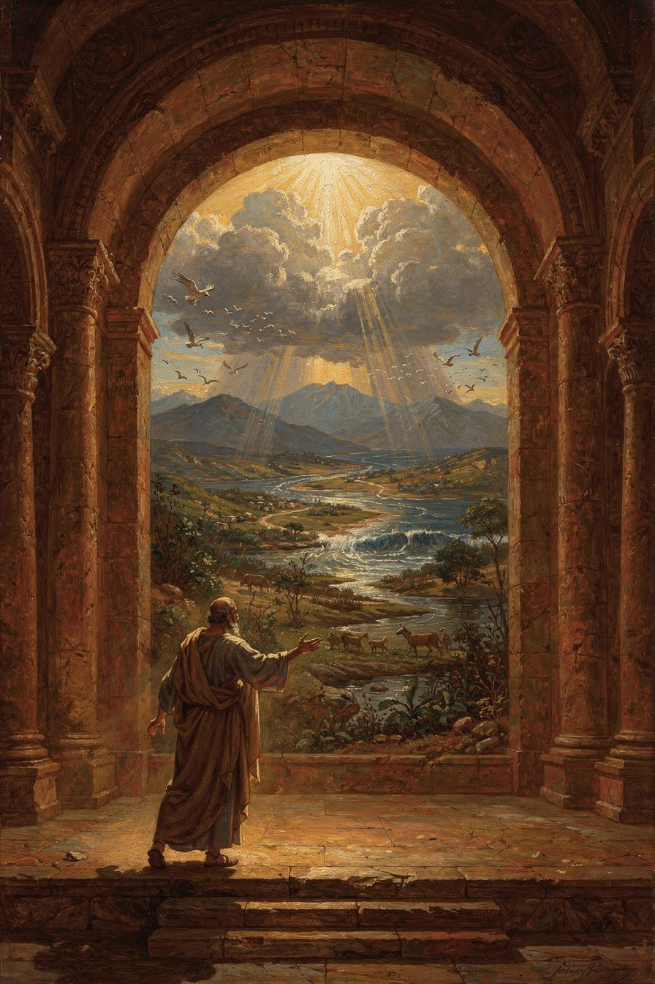
Illustration for Chapter 3
Around 378 CE, the year before his death, Basil preached nine sermons on the six days of creation described in Genesis 1. These sermons — the Hexaemeron (Greek for "six days") — are the most influential Christian meditation on the natural world in the patristic era. They are not a scientific treatise. Basil is not trying to explain the mechanics of the universe. He is teaching his congregation to read creation as a revelation of God's wisdom, generosity, and beauty.
Basil's congregation in Caesarea lived close to the land. They were farmers, merchants, and craftsmen. Basil spoke to them about things they already knew: the sun, the moon, the rivers, the plants, the animals. But he taught them to see these familiar things differently. The world is not just dirt and water and sky. It is a book written by God. Everything you see is a message from the Creator: "I made this for you. It is good."
Basil walks through the days of creation in order. Day 1: God speaks, and light appears — instantly, without process. The first light is distinct from the sun and moon created on the fourth day; it is a primal, non-solar quality of the created order itself. Day 3: The earth brings forth vegetation. Basil delights in the variety of plants, the properties of herbs, the usefulness of trees. The earth was pregnant with potential — God's word was the trigger, not a new imposition. Creation is an act of liberation: the earth already contains the seeds of life; God's word activates them. Day 4: The sun is a "great lamp," the moon a companion that softens the darkness, the stars "flowers of fire." Basil explicitly rejects astrology: the stars are markers of time, not rulers of fate. If the stars determined human actions, justice would be meaningless. Day 6: The creation of the human being. The human is a bridge — allied to angels by the immortality of the soul, to animals by the form of the body. The body is not a prison but a gift, designed with dignity and purpose.
The theological themes running through all nine sermons are these: creation ex nihilo (the world is a free act of divine will, not made from pre-existing matter); the goodness of matter (against Platonic dualism that treated the material world as a shadow and Gnostic cosmology that treated it as the product of a lesser deity); providence and purpose (every creature is designed for a purpose, and the order of creation points to a single, purposeful mind); and human freedom (grounded in the doctrine of creation — if the world is God's free act, then creatures within it share in that freedom).
Basil's affirmation of the body was radical in his context. Platonic philosophy treated the body as the soul's tomb (soma sema). Gnostic systems treated the physical world as the product of an ignorant or malevolent lesser deity. Manichaean dualism treated the body as made of dark substance. Against all three, Basil argues from Genesis 1: God made everything, and God called it good — seven times, culminating in "very good" after the creation of the human being, body and soul together. The body is not a punishment, a prison, or an embarrassment. It is a gift, designed by God with dignity and purpose. Its beauty and order glorify the Creator. The body prays (kneeling, standing, singing), serves (working, feeding, caring), and worships (receiving the Eucharist). The spiritual life is not an escape from the body but the body's highest purpose.
This theology of the body has practical consequences. Care for the sick: if the body is good, then caring for the body is not second-class spirituality — it is spiritual care. Basil built the Basileias because he believed healing the body is part of the gospel. The body matters to God; therefore it should matter to the church. Moderate asceticism: the body is to be disciplined, not destroyed. "The body should be disciplined, not destroyed. The athlete who breaks his legs before the contest does not win the crown." Extreme fasting that ruins health is not holiness but pride. Social justice: if the material world is good, then material needs matter. The hungry person's body matters. The naked person's body matters. The sick person's body matters. Basil's fierce social homilies — "The bread which you hold back belongs to the hungry" — flow directly from his theology of creation. If God made the body and called it good, then the person whose body is starving is being denied what God intended.
Basil's theology of the body also connects to his eschatology. The Christian hope is not the escape of the soul from the body (Platonic) but the resurrection of the body to eternal life (biblical). If the body is God's good creation, then God will not abandon it. The body is not a temporary vehicle; it is part of the human person, and it will be raised. What God made good, God will redeem. The body that was created, fallen, and healed will be raised to glory. The material world itself will be renewed (Romans 8:19–21). Basil's Hexaemeron is not just about origins; it is about destiny. This is why the doctrine of creation matters for ethics: if the world is God's good creation destined for renewal, then how we treat it now is not a matter of indifference but of faithfulness.
Basil's anti-astrology argument is also worth noting. In his time, many educated people believed that the stars controlled human destiny. Basil rejected this firmly. The stars are God's instruments for marking time and season, not independent powers that determine fate. Human beings are free, responsible agents. The movements of the stars do not excuse vice. "If the movement of the stars determines our actions, then we are not free. And if we are not free, then justice and judgment are meaningless." This is a significant theological move: Basil grounds human freedom in the doctrine of creation. If the world is God's free act, then the creatures within it — especially the human creature — share in that freedom. The anti-astrology argument is not a quaint relic; it is a theological defense of human dignity against determinism. Modern forms of determinism (genetic, environmental, economic) pose the same challenge, and Basil's argument applies: if we are not free, then justice is meaningless. But we are free, because God made us free.
A scholarly debate concerns the relationship between Basil's Hexaemeron and ancient science. Some scholars read the sermons as proto-scientific — early attempts at natural philosophy that happen to be expressed in theological terms. Others read them as purely theological — sermons that use natural observation as illustrations but are not making scientific claims. The best reading is neither: Basil is doing something distinct from both science and theology as we construe them. He is doing natural theology as spiritual formation — teaching his congregation to see the world as a gift, not as a machine. This is a third kind of knowledge that does not compete with science but complements it. The world can be studied mechanically (science) and theologically (Basil) without contradiction, because they answer different questions: science asks "how does it work?"; Basil asks "what does it mean?"
The Big Idea
Basil teaches that creation is not a machine but a gift. The world is not a closed system running by necessity; it is personally sustained by God every moment. Matter is not evil or inferior; it is good because God made it. The human body is not a prison for the soul but the instrument of the spiritual life. This has consequences for ethics (how you treat the world and your body depends on what you believe they are), for science (natural theology as spiritual formation is a different kind of knowledge from natural science), and for ecology (if the world is a gift, then the human is its steward, not its exploiter).
Practice
1. Read *Hexaemeron* Homily 1 and 6. Identify the difference between Basil's approach and a scientific description of the same phenomena. Are they competing or complementary? Write a paragraph: what does Basil add that science cannot? What does science add that Basil does not provide? How might a scientist who is also a Christian read the Hexaemeron? 2. Compare Basil's view of the body with views in your culture. Social media celebrates body-perfection. Transhumanism wants to transcend the body. Body-positivity advocates body-acceptance. Which is closest to Basil? Which is furthest? Write a one-page analysis: what would Basil say about each movement? Where does Basil affirm, and where does he challenge, each view? 3. Do a creation audit. Pick one natural object — a leaf, a stone, a shell, a feather — and examine it closely for five minutes. Write down everything you notice. Basil's method is not analysis but attention: the world reveals its Maker to those who look at it carefully. What did you notice that you had never noticed before? Did the sustained attention change how you felt about the object? 4. Think about modern determinism. Basil rejected astrology because it would destroy human freedom. What modern forms of determinism (genetic, environmental, neurological, economic) pose a similar challenge to freedom and moral responsibility? Write a paragraph: how would Basil's argument apply to one modern form of determinism? Is his argument still valid, or does modern science change the picture?
Reflect
If your body is God's design, not an accident — how does that change how you treat it?
———

Chapter 4: The Bread That Belongs to the Hungry
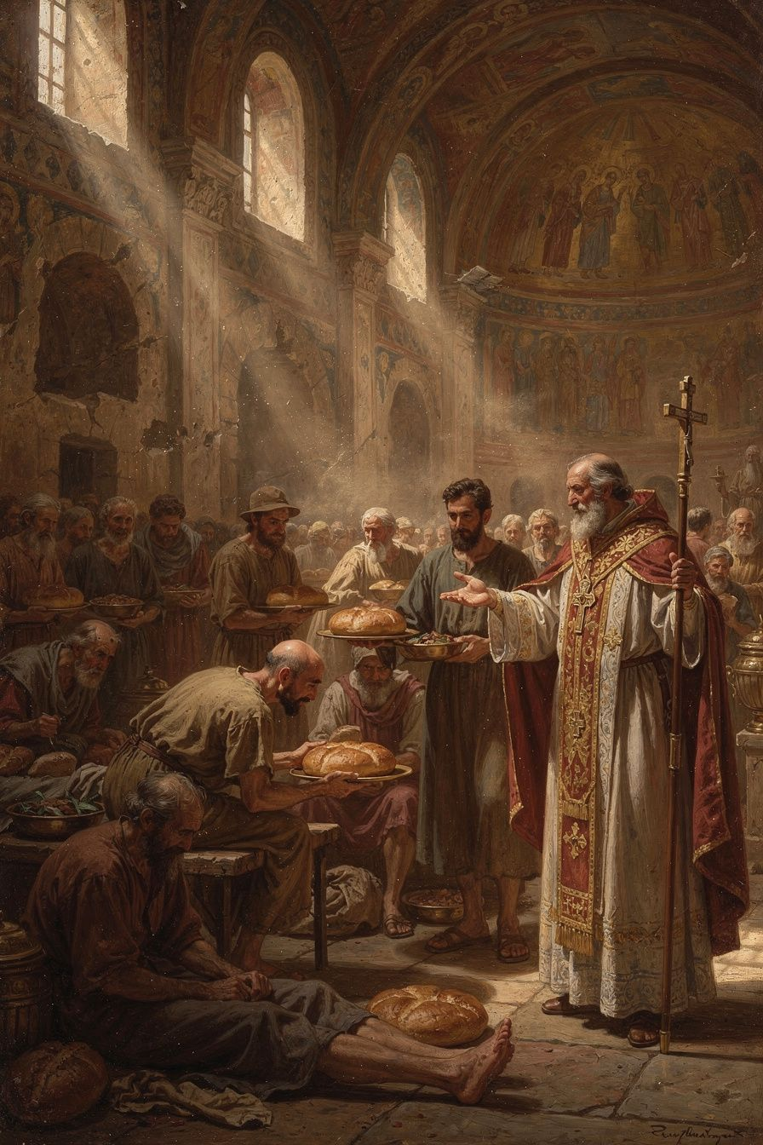
Illustration for Chapter 4
Basil's social teaching is among the most uncompromising in the entire Christian tradition. His homilies on wealth and poverty — "I Will Tear Down My Barns" and "To the Rich" — contain some of the most radical statements about property and obligation ever made by a bishop.
The homily "I Will Tear Down My Barns" is a sermon on Luke 12:16-21, the parable of the rich fool. The rich man's land produces abundantly. He tears down his barns and builds bigger ones. He says to himself: "Soul, you have ample goods laid up for many years; relax, eat, drink, be merry." God says: "Fool! This night your soul is required of you."
Basil's sermon is a relentless interrogation: "The bread which you hold back belongs to the hungry; the clothing you shut away belongs to the naked; and the money you bury in the earth is the price of redeeming and freeing the wretched."
Notice the verb: "belongs." Basil does not say the rich man should be generous and share. He says the goods already belong to the poor. The hungry person has a claim on the bread, not because the rich man chooses to give it, but because the bread was made for the hungry. The rich man is not an owner; he is a steward who has failed in his duty.
The logic is theological, not political. God created the world for all creatures, not for some. The goods of the earth are a common gift. Private property is a human convention — not a divine institution — and a convention distorted by greed and sin. In God's original design, goods were common. The restoration of that design — at least in the church — is part of the gospel. Basil cites Acts 4:32: "they had all things in common." The apostolic church practiced community of goods. The monastery that shares property is not an exception but a model.
In "To the Rich," Basil extends the argument: "If you have taken more than you need, you have taken it from someone who needs it. You have stripped the naked by not clothing them." This is a stunning claim. To have more than you need is, in Basil's view, to have taken it from someone else. Excess is not innocent; it is a form of violence against the poor.
Basil did not stop at preaching. He built the Basileias — one of the most ambitious social welfare institutions of the ancient world. The complex at Caesarea included a hospital for the sick poor, a hospice for travelers, a shelter for the elderly, an orphanage, a workshop where the unemployed could learn trades, and a kitchen that fed the hungry daily. Gregory of Nazianzus called it "a new city." It was funded partly by Basil's own inheritance (he gave away his family fortune) and partly by the contributions of wealthy Christians whom Basil persuaded — and sometimes publicly shamed — into giving.
Basil also addresses the psychology of wealth. The rich man in the parable says "relax, eat, drink, be merry" — he is talking to himself. Wealth creates a closed world: the rich person talks to their own soul, their own barns, their own plans. The poor disappear from view. Wealth blinds the wealthy to the existence of the people whose suffering is the cost of their comfort. The rich man does not see the hungry person at his gate because he does not look — and he does not look because his wealth has made him self-sufficient, or so he thinks. This is Basil's psychological insight: wealth does not just withhold goods from the poor; it withholds awareness. The rich person does not know they are harming the poor because they do not know the poor exist. Their wealth has built a wall that blocks the view.
Basil also distinguishes between different causes of poverty. He recognizes that people are poor for different reasons: illness, unemployment, exploitation, bad luck, family breakdown. The response must be tailored to the cause. The sick poor need medical care. The unemployed need work. The traveler needs shelter. The orphan needs a family. The Basileias was not a one-size-fits-all charity but an integrated institution that addressed multiple forms of poverty with appropriate responses. It included a workshop where the unemployed could learn trades — Basil did not want to create dependency. He wanted to restore dignity, and dignity comes from contribution. The poor who can work should work, and the community should provide the means.
Basil also made a crucial distinction between the monastery and the church. The monastery is a voluntary community of those who choose to share all things. The church includes people at all stages of commitment. Basil does not require the layperson to renounce property, but the monk does. This suggests that the community of goods is an ideal for the committed, not a requirement for all. If Basil thought property was inherently evil, he would demand its abolition for everyone — but he does not. Instead, he builds the Basileias as a place where the radical vision is lived, while the surrounding society still has property, inequality, and need. The monastery is a model, not a mandate.
A scholarly debate concerns whether Basil's language represents a literal demand for the abolition of private property or rhetorical provocation designed to shock the comfortable into generosity. Holman (2001) argues that Basil's language is not rhetoric but theology in action — the Basileias is the concrete expression of a theology that treats excess wealth as theft. Rousseau (1994) cautions against reading Basil's most radical language as a literal economic program: Basil was a pastor addressing a congregation, not a legislator writing policy. His hyperbole is a pastoral tool, not a political platform. The "both" position holds that the theological vision is genuinely radical (excess is theft), the practical strategy is realistic (the monastery and Basileias embody the vision; the surrounding society is not required to), and the rhetoric is prophetic (the homilies provoke without legislating). Basil holds all three together: a radical vision, a realistic practice, and a prophetic rhetoric that keeps the vision visible. This debate matters because it raises the question of the ideal: is the Acts 4 community of goods a normative ideal (all Christians should aim for it) or an inspiring memory (monks live it, but not everyone is called to)?
The Big Idea
Basil's social teaching flows from his theology of creation. If God made the world for everyone, then the goods of the earth belong to all. Private property is a stewardship, not an absolute right. The rich person who hoards while the poor starve is not stingy but unjust — they are holding what belongs to someone else. The Basileias is the institutional form of this conviction: love needs structures, not just feelings. And the rhetoric is prophetic — Basil's language is designed not to prescribe policy but to provoke the comfortable into awareness. The question is not "How much should I give?" but "Do my neighbors have enough?"
Practice
1. The coat experiment. Open your closet. Count items you have not worn in the last month. Basil would say: the extra ones belong to someone who is cold. Pick one to donate. Notice the shift in thinking — from "I should give" to "it belongs to them." Write a paragraph about how that shift feels. Is it uncomfortable? Why? What does the discomfort tell you about how you normally think about ownership? 2. Read "I Will Tear Down My Barns" in full. Identify the passages that sound most radical. Are they literal or rhetorical? Research the Holman-Rousseau debate. Write a 500-word analysis: which interpretation is more convincing, and what difference does it make for how Christians engage economic justice today? Is Basil's language helpful for modern discussions of wealth inequality, or is it too extreme? 3. Think about the psychology of wealth. Basil says wealth blinds the rich to the poor. Track your own consumption for one week: what you buy, what you eat, what you use. At the end of the week, write down: how aware were you of the people whose labor produced what you consumed? Did the act of paying for things make you feel self-sufficient? Basil would say: wealth makes you blind. Did you experience this? What would it take to "see" the people behind your consumption? 4. Design a modern Basileias. If Basil were alive today, what institution would he build? A hospital? A homeless shelter? A job-training center? A community kitchen? Write a one-page proposal for a "Basilian" institution in your community. What services would it provide? How would it be funded? What would it witness to? The Basileias was not just a charity — it was a sermon in the form of a building. What would a modern sermon-building look like?
Reflect
If the bread belongs to the hungry — what in your life belongs to someone else, and how long will you keep it?
———

Chapter 5: The Community That Stays Hot Together
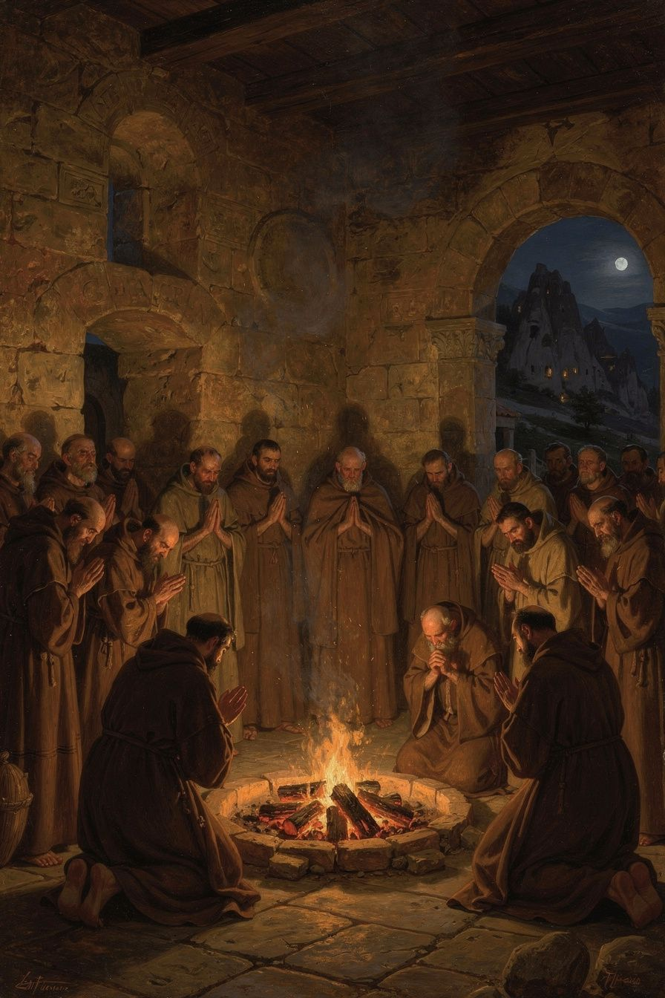
Illustration for Chapter 5
For Basil, the Christian life is not a solo project. It is a life lived in community — with God and with other people. This conviction is theological, not just practical. God is community: the Trinity is a communion of three persons in one nature. If humans are made in the image of God, they are made for relationship. The isolated human is a theological contradiction — a being made for communion living as if communion were unnecessary.
Salvation is communal too. The Spirit works through the community. The "body of Christ" (1 Corinthians 12) is not a metaphor but a description: Christians are members of one another. The Spirit gives different gifts to different members, and no member has all the gifts. The Christian who isolates themselves cuts themselves off from the gifts the Spirit gives through others. Even the Lord's Prayer is plural: "Our Father," not "My Father." The entire grammar of the Christian life is plural.
Basil uses the image of a fire. A single coal, taken from the fire and set by itself, quickly goes cold and dark. But a coal left in the fire, surrounded by other hot coals, stays hot. The Christian in community stays warm — encouraged, corrected, sustained. The Christian alone goes cold.
Basil's monastic rules are the most detailed ancient Christian guide to what common life looks like in practice. The principles extend beyond the monastery to any Christian community: shared property (private property cultivates possessiveness, which destroys community); obedience (the monk who submits their will to the abbot is practicing the death of self-will, the prerequisite for love); mutual correction (community members correct each other — gently, humbly, but honestly — ignoring faults is not kindness but neglect); shared work (everyone works, assigned by ability not rank, and the surplus goes to the poor); common prayer (the community prays together at fixed times — the monk who prays alone is weaker than the monk who prays with the community); care for the sick (the care of the sick takes priority over other obligations — if a monk is caring for a sick brother, he is excused from common prayer and work); and hospitality (the monastery receives guests — travelers, the poor, the sick — hospitality is not optional but constitutive).
Basil warns about the dangers of solitude. The hermit has no one to correct their faults — blind spots remain blind. The hermit has no neighbor to serve — love, the highest virtue, has no object. The hermit answers to no one — pride can grow unchecked. The hermit faces temptation alone — when the will weakens, there is no community to sustain it. This is why Basil rejected the Egyptian hermit model. Anthony the Great lived in the desert, and the Life of Anthony was one of the most widely read Christian texts of the fourth century. But Basil deliberately chose a different model: communities located near towns, integrated with the local church, engaged in hospitality and service. The monastery is in the world, even if it is not of the world.
Basil's monasteries were not closed communities. They were integrated with the surrounding church and society: under the bishop's authority, serving the poor, and witnessing to society. The monastery's common life — shared property, mutual service, radical simplicity — is a witness that another way of living is possible. The monastery does not need to preach against greed; its common life is the sermon. The withdrawal is not from the world but from the world's distortions (greed, ambition, self-will, indulgence). And the purpose of the withdrawal is not escape but service — the monk steps back from the rat race not to hide but to build a different kind of life, a life that is visible, generous, and engaged.
Basil also insisted on moderate fasting. Some monks starved themselves to show how holy they were. Basil rejected this. The body is God's good creation; it should be disciplined, not destroyed. Fasting that makes the monk too weak to work, pray, or serve is counterproductive. The goal is a rightly ordered body — appetites under the direction of the soul — not a destroyed body. And the faster who is proud of their extreme fasting has gained nothing. The moment you feel superior because of your fasting, the fast has failed. Pride is the great danger: the moderate faster is less likely to be proud because their fasting is unremarkable; the extreme faster is more likely to be proud because their fasting is extraordinary.
Basil's approach to fasting also has a social dimension. The monk who fasts eats as the poor eat. The luxury of the rich — abundant food, fine wine, elaborate meals — is cut away. The monk who eats simply is in solidarity with the poor who have no choice but to eat simply. Fasting is not just a personal discipline; it is a social witness. The person who eats luxuriously while others starve is participating in injustice, even if they give to charity. Fasting — eating simply, eating less — is a form of solidarity with the poor. It says: I will not feast while my neighbor starves. And fasting frees attention. The person whose attention is dominated by food (what to eat, where to eat, how to eat) has little attention left for God. Fasting sharpens the mind. The body that is slightly hungry is awake; the body that is stuffed is asleep.
A scholarly debate concerns whether Basil's community model is fundamentally different from later Benedictine monasticism. Some scholars argue that Benedict (c. 480–547) simply adapted Basil's rules for a Western context. Others argue that Benedict's model — more enclosed, more self-sufficient, less integrated with the surrounding church — represents a genuine departure from Basil's vision of monasteries as base camps rather than fortresses. The debate matters because it affects how we read the later Western monastic tradition: was Benedictine monasticism a development of Basil's vision or a divergence from it? The evidence suggests both continuity and divergence: Benedict read Basil (in Rufinus's Latin translation) and adopted many of his principles, but the different social and political context of sixth-century Italy produced a different kind of monastery.
The Big Idea
Basil teaches that community is not optional for the spiritual life — it is the context in which the spiritual life happens. The Trinity is a community. The church is a community. The monastery is a community. The Christian who isolates themselves cuts themselves off from the gifts God gives through others. A coal alone goes cold; a coal in the fire stays hot. And the community that serves the world is not hiding from it but bearing witness to a different way of living. The monastery is a base camp, not a fortress — set apart for the sake of engagement, not withdrawal.
Practice
1. Map your communities. Draw a diagram of the communities you belong to: family, school, church, sports team, friend group, online community. For each, write: does it help you grow? Does it hold you accountable? Does it serve people outside the group? Basil would say: a community that only serves itself has missed its calling. Which of your communities serves beyond itself? 2. Read Basil's *Longer Rules*, Questions 3–7. What are the specific dangers of solitude that Basil identifies? How does the common life address each one? Which of these dangers have you experienced in your own life when you have been isolated? Write a 500-word response that connects Basil's analysis to your own experience. 3. Try a shared practice for one week. Pick one thing you usually do alone — a meal, a prayer, a walk — and do it with someone else every day for a week. Notice what changes. Write a journal entry at the end: what did the shared experience give you that solitude could not? Was there anything you lost? How does Basil's coal-and-fire image apply to your experience? 4. Compare Basil's community model with the "Benedict Option." Research the contemporary "Benedict Option" — the idea that Christians should form intentional communities to preserve faith and values. How does it compare to Basil's model? Basil would ask: does your community serve the world, or does it protect itself? The test is whether the doors open outward. Write a 300-word comparison.
Reflect
Can a coal stay hot alone — and if not, what does that mean for how you live?
———

Chapter 6: The Bishop Who Stood Up to an Emperor
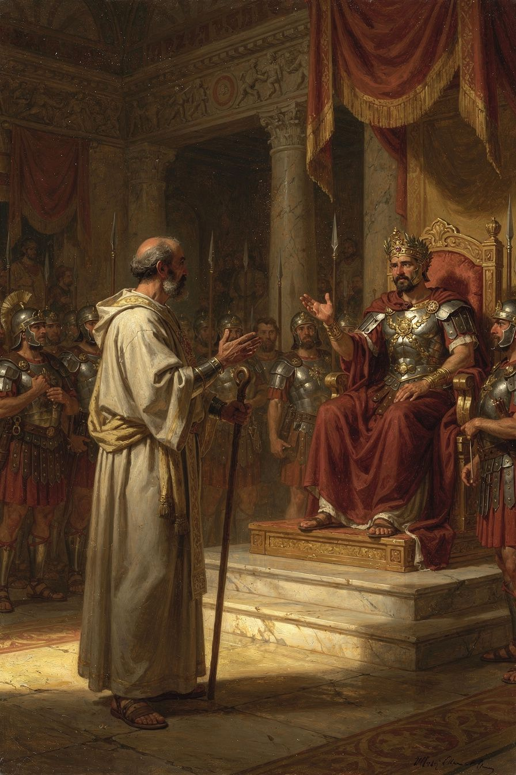
Illustration for Chapter 6
The emperor Valens was an Arian. He believed the Son was not fully God and the Holy Spirit was a created being. He controlled the army, the laws, and the land. He wanted all bishops to agree with him, and he sent officials to pressure those who did not.
The prefect Modestus, a high-ranking imperial officer, came to Basil and threatened him with confiscation of property, exile, torture, and death. Basil's response has become one of the most famous moments in patristic history:
"Confiscation means nothing to me, unless you covet these wretched rags and a few books; that is all I possess. As to exile, I am attached to no particular place. I regard the whole earth as belonging to God, and I consider myself as a stranger wherever I may be. As for torture, how will you apply it? I have not a body capable of bearing it, unless you are thinking of the first blow you give me, for that will be the only one in your power. As for death, this will be a benefit to me."
Modestus was stunned. He said he had never met anyone who spoke to him so boldly. Basil replied: "Perhaps that is because you have never had to deal with a bishop."
This exchange is preserved in Gregory of Nazianzus's funeral oration for Basil (Oration 43). Gregory may have polished it, but the encounter is historical. Valens did send officials to pressure Basil, and Basil did refuse to compromise.
Basil's courage came from his theology. He believed that God was more powerful than any emperor. He believed that the truth about the Trinity was not a matter of opinion but of faithfulness. He believed that a bishop's job was not to please rulers but to please God. The Stoic philosophers had taught that the wise person is free because external things cannot touch their inner virtue. Basil added a theological ground: the earth belongs to God, and the Christian is a stranger everywhere. Death is not a threat but a benefit, because it brings the soul to God. The final line — "Perhaps that is because you have never had to deal with a bishop" — is Basil at his sharpest. He respects authority but does not fear it. His courage came from his faith, not from pride.
Valens never carried out his threats. Some say he was impressed by Basil's courage. Some say he feared that harming such a respected bishop would cause a riot. Either way, Basil stood his ground, and the truth won. The confrontation reveals something important about the relationship between theology and political power. Basil did not have an army. He did not have political office. He had only his faith and his words. But that was enough to face an emperor — because the authority behind the words was not Basil's but God's. The bishop's power is the power of truth, not the power of force. When truth speaks clearly, even emperors must listen. This is why Basil's confrontation with Modestus is not just a dramatic story but a theological argument: it demonstrates that the truth about God is not subject to imperial control. The emperor can take your property, exile you, torture you, or kill you — but the emperor cannot change the truth about the Trinity. Basil's calm courage is the practical consequence of his theology: if God is who Basil says God is, then the emperor's threats are empty. The worst the emperor can do is kill the body, and Basil believes that death is not the end.
The confrontation also reveals something about the nature of episcopal authority. When Basil said "Perhaps that is because you have never had to deal with a bishop," he was not boasting. He was making a claim about the kind of authority a bishop has. A bishop's authority is not military or political. It is spiritual and moral. It comes not from the power to coerce but from the willingness to suffer. The bishop who will not bend — who will accept confiscation, exile, torture, or death rather than betray the truth — has a kind of authority that no emperor can match, because it is the authority of a person who has nothing left to lose. Basil's poverty (he owned only "wretched rags and a few books"), his homelessness (he was "a stranger wherever I may be"), and his indifference to death ("this will be a benefit to me") made him unassailable. You cannot threaten a man who has already given everything away.
Basil's political challenges were not limited to Modestus. In 372 CE, Valens divided Cappadocia into two provinces to diminish Basil's authority. Basil responded by creating new bishoprics and appointing his brother Gregory of Nyssa and his friend Gregory of Nazianzus to sees in the new province. The two Gregories were not eager to be bishops — Gregory of Nazianzus especially disliked the politics — but Basil needed them, and they went because their friend asked. This was how Basil worked: he built networks, made alliances, and used his personal relationships to advance the cause he believed in. He was a theologian and a monk, but also a strategist.
Basil's health was never good, and the demands of the episcopate wore him down. He suffered from liver disease and was frequently exhausted. His letters complain of illness, overwork, and the difficulty of his position. He drove himself to the point of collapse. Gregory later said that Basil's body was worn out by his labors. Basil died on January 1, 379 CE. He was forty-nine years old. He did not live to see the Council of Constantinople (381 CE) that ratified his theology. But his work was done. He had given the church the theological grammar of the Trinity, the rules for monastic community, the hospital for the poor, and the example of a bishop who would not bend.
The pattern of Basil's life raises a question that scholars have debated: what is the cost of greatness? Basil accomplished extraordinary things, but at the cost of his health and his life. He died at forty-nine, exhausted by overwork. Was the trade-off worth it? Rousseau (1994) suggests that Basil's relentless activity was both his genius and his limitation — the same drive that produced the theology, the hospital, and the monastic rules also destroyed the body that sustained them. Hildebrand (2018) is more sympathetic, reading Basil's self-expenditure as a deliberate imitation of Christ's self-giving. The debate is not just about Basil — it is about the ethics of achievement and sacrifice, about how much a person should give to a cause they believe in, and about whether the cost is always worth it.
The Big Idea
Basil's courage was not bravado. It was faith. He believed that the truth about God was more important than his safety, that God was more powerful than any emperor, and that death was not the end but the beginning. His courage came from his theology: if God is real and God is good, then standing for the truth is always the right choice, even when it costs everything. And Basil's life raises a harder question: what are you willing to spend yourself for? What cause, what truth, what love would you give your life to — not because you must, but because you cannot do otherwise?
Practice
1. Read Gregory of Nazianzus's *Oration* 43. What picture of Basil does Gregory paint? What does he emphasize — the theology, the courage, the friendships, the institutions? What does a great life look like through the eyes of a great friend? Write a 500-word analysis. Pay attention to what Gregory chooses to include and what he leaves out. What does his selection reveal about what he valued most in Basil? 2. Think about what courage means. Basil was calm because he believed God was more powerful than the emperor. Write down: what would you stand up for, even if it cost you something? What is worth more than safety or comfort? Name it specifically — not abstractly. Then write a paragraph: where does the courage to stand come from? Is it character, faith, training, or something else? 3. Compare Basil's courage with other kinds of courage. A soldier shows courage in battle. An athlete shows courage in competition. A whistleblower shows courage in the workplace. What kind of courage did Basil show? He did not fight. He did not run. He stood and spoke the truth. Write a paragraph: is this kind of courage harder or easier than physical courage? Why? Can it be learned, or must it be inspired? 4. Reflect on the cost of greatness. Basil accomplished extraordinary things but died at forty-nine, exhausted by overwork. Was the trade-off worth it? What does Basil's life teach about the relationship between achievement and sacrifice? Write a 300-word reflection. Consider: is there a way to do great things without destroying yourself? Or is self-expenditure sometimes the right choice? What would Basil say if you asked him whether he would do it all again?
Reflect
What would you stand for, even if it cost you everything — and what does your answer tell you about what you truly believe?
———

For the Grown-Up Reader
This booklet introduces readers aged 15–18 to Basil of Caesarea (c. 330–379 CE), one of the three Cappadocian Fathers. The six chapters cover Basil's early life and education; his defense of the Holy Spirit's divinity in On the Holy Spirit (375 CE) and the Cappadocian settlement (one ousia, three hypostaseis); his creation theology in the Hexaemeron (c. 378 CE); his radical social teaching on wealth and poverty; his monastic rules and theology of community; and his confrontation with the imperial prefect Modestus.
All quotations are from the public-domain translations available at New Advent (www.newadvent.org/fathers). The scholarly debates referenced include: the Hildebrand-Wolfson debate on Basil's pneumatological development (chapter 2); the relationship between the Hexaemeron and ancient science (chapter 3); the Holman-Rousseau debate on whether Basil's social teaching is radical or realistic (chapter 4); the relationship between Basil's and Benedict's monastic models (chapter 5); and the ethics of Basil's self-expenditure (chapter 6).
Primary sources: Basil, On the Holy Spirit, Hexaemeron, Longer Rules, Shorter Rules, Moralia, Letters, "I Will Tear Down My Barns," "To the Rich." Gregory of Nazianzus, Oration 43 (funeral oration for Basil). Secondary sources: Hildebrand, Basil of Caesarea (Notre Dame, 2018); Rousseau, Basil of Caesarea (California, 1994); Behr, The Nicene Faith, Part 2 (SVS, 2004); Ayres, Nicaea and Its Legacy (Oxford, 2004); Holman, The Hungry Are Dying (Oxford, 2001); Pelikan, Christianity and Classical Culture (Yale, 1993); Wolfson, The Philosophy of the Church Fathers (Harvard, 1956).
———

About WisdomForge
WisdomForge publishes four versions of each booklet — for ages 5–10, 11–14, 15–18, and adult — so readers at every stage can meet the great thinkers of the classical and Christian tradition. Each version tells the same stories and explores the same ideas, but in language and depth suited to the reader. The booklets are free. Read them. Question them. Discuss them. Do them.

