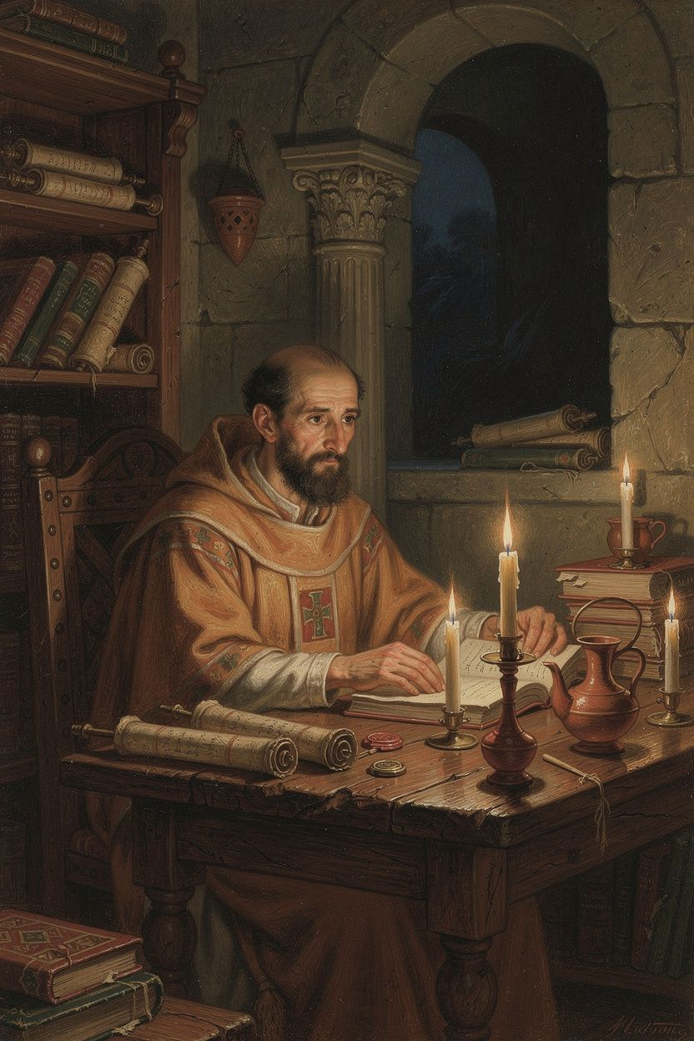
Basil of Caesarea: The Bishop Who Changed Everything
WisdomForge Booklet — Ages 11–14

Basil of Caesarea: The Bishop Who Changed Everything

WisdomForge Booklet — Ages 11–14
———

About This Book
Basil of Caesarea lived only forty-nine years, but he changed the Christian church forever. He was born around 330 CE in Cappadocia, a province in what is now Turkey. His family was wealthy, educated, and deeply Christian — they produced three bishops and one of the most influential monastic founders in history (Basil's sister Macrina). Basil received the best education the Roman world could offer: Constantinople, then Athens, where he studied philosophy and rhetoric alongside his lifelong friend Gregory of Nazianzus.
He could have been a famous professor. Instead, after his sister Macrina challenged him to take his faith seriously, he was baptized, traveled through Egypt and Syria studying monastic life, founded a monastic community, was ordained a priest, and in 370 CE became bishop of Caesarea. In his nine years as bishop, he wrote his masterpiece On the Holy Spirit, preached the Hexaemeron (nine sermons on creation), built the Basileias (one of the first Christian hospitals), composed monastic rules that still shape Eastern Orthodox monasticism, and stood up to an emperor who threatened him with death.
This booklet tells his story in six chapters. Each chapter has a narrative, a Big Idea to explain the core concept, Try This exercises to put the idea into practice, and Talk About It questions for discussion. Basil's ideas about the Holy Spirit, the Trinity, creation, social justice, community, and courage are not just for bishops and monks. They are for anyone who wants to live with purpose and integrity.
———

Chapter 1: The Student Who Became a Bishop
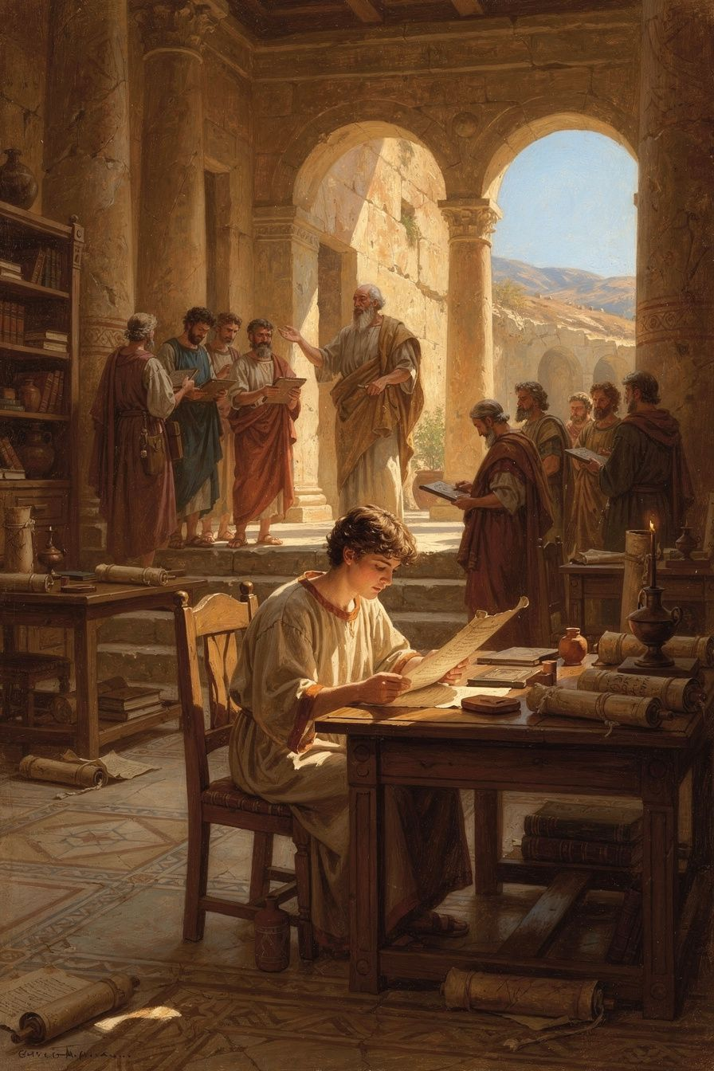
Illustration for Chapter 1
Basil was born around 330 CE in Caesarea, the capital city of Cappadocia, a Roman province in central Asia Minor (modern-day Turkey). His family was one of the most remarkable in Christian history. His father, Basil the Elder, was a rhetorician — a teacher of public speaking and law. His mother, Emmelia, came from a wealthy Cappadocian family. His grandmother, Macrina the Elder, had survived the persecutions of the third century, when Roman emperors tried to wipe out Christianity. His older sister, Macrina the Younger, turned the family estate into a monastic community and became one of the most respected spiritual leaders in the family. His younger brother Gregory became a major theologian — one of the three Cappadocian Fathers alongside Basil and Gregory of Nazianzus. The youngest brother, Peter, also became a bishop.
Basil's education followed the path of an elite Roman youth. First, he studied under his father in Caesarea. Then, around age seventeen, he went to Constantinople, the new capital of the Roman Empire, to study rhetoric — the art of speaking, arguing, and persuading. From there, around 351 CE, he went to Athens, the most ancient and prestigious center of learning in the Greek world. In Athens, he studied philosophy (Plato, Aristotle, the Stoics), rhetoric, literature, and probably mathematics and astronomy.
In Athens, Basil met Gregory of Nazianzus. Gregory was quieter and more poetic than Basil, but the two became inseparable. Their friendship would last through decades of controversy, political pressure, and physical separation. Gregory later wrote about meeting Basil: "I had heard of him by fame before I knew him by sight, and when I met him, I was bound to him by a tie of affection which cannot be described." Basil, for his part, called Gregory's friendship as necessary as the sun itself: "I think that the sun is not so necessary as friends are to mankind."
After Athens, Basil returned to Cappadocia and taught rhetoric — the expected career for an educated young man. He was good at it. Students came to learn from him. He had the respect of his city. By any standard of the time, he was successful: educated, wealthy, respected, with a bright career ahead.
But something was missing. His sister Macrina, who had already chosen a life of simplicity and prayer, challenged him. She asked whether the life of a celebrity teacher was worthy of a Christian. The question cut deep. Basil was baptized around 357 CE and decided to live differently.
The change was dramatic. Basil gave away his wealth. He traveled through Egypt, Palestine, Syria, and Mesopotamia — the great centers of early monasticism. He visited Pachomian communities in Egypt, hermits in the desert, and monastery founders in Syria. He saw how Christians in these places lived: simply, communally, devoted to prayer and service. He saw communities that shared everything and individuals who gave everything away. He saw the extremes too — the pillar-sitters and the grass-eaters of Syria — and he admired their devotion without adopting their methods.
When he returned to Cappadocia, he founded his own monastic community on the family estate at Annisa. His vision of monasticism was shaped by what he had seen in his travels but was distinctively his own: community-based, moderate, integrated with the local church, and committed to serving the poor. He wrote his first works on the Christian life — the Moralia (eighty rules for daily conduct) and the early versions of his monastic rules. These rules would shape Eastern Orthodox monasticism permanently and influence Western monasticism through Benedict, who read Basil in Rufinus's Latin translation.
In 362 CE, Basil was ordained a priest by Eusebius, the bishop of Caesarea. Basil was more theologically precise and more organizationally capable than Eusebius, and tensions arose. But Basil's gifts were indispensable. When Eusebius died in 370 CE, Basil was elected bishop of Caesarea. He was forty years old. He would serve only nine years before his death in 379, but in those nine years he would change the church.
Big Idea
Basil's life shows that education is not an end in itself. The best education in the world — Athens itself — gave Basil the tools to think and speak, but it was his sister Macrina's challenge that gave those tools a purpose. Wisdom without goodness is just cleverness. Basil's education became powerful when he directed it toward serving God and serving people.
Try This
- Make a map of Basil's education. Draw a simple map showing Caesarea, Constantinople, Athens, and Egypt. Trace his journey. How far did he travel for his education? How long would those journeys have taken in the fourth century, without cars or planes? - Think about your own education. What are you learning right now? Is there a subject you are good at but have not figured out how to use for something that matters? Write down one way you could use something you are learning to help someone else. - Research the Cappadocian Fathers. Look up Basil of Caesarea, Gregory of Nazianzus, and Gregory of Nyssa. Why are they called "the Cappadocian Fathers"? What did they contribute together that none of them could have done alone?
Talk About It
1. Basil had the best education available, but his sister Macrina challenged him to use it for something more than personal success. What is the difference between being successful and being significant? Can someone be successful without being significant? 2. Why did Basil's friendship with Gregory of Nazianzus matter so much? How did having a close friend who shared his faith and his intellectual life help Basil do what he did? Who is that person in your life? 3. If Basil had stayed a rhetoric teacher in Caesarea, the church would have lost one of its greatest theologians. What does that tell us about how talent and opportunity interact with calling? What might you be called to do that you have not yet considered?
———
What would you do if the best education in the world left you without a purpose?
———

Chapter 2: The Theologian of the Holy Spirit
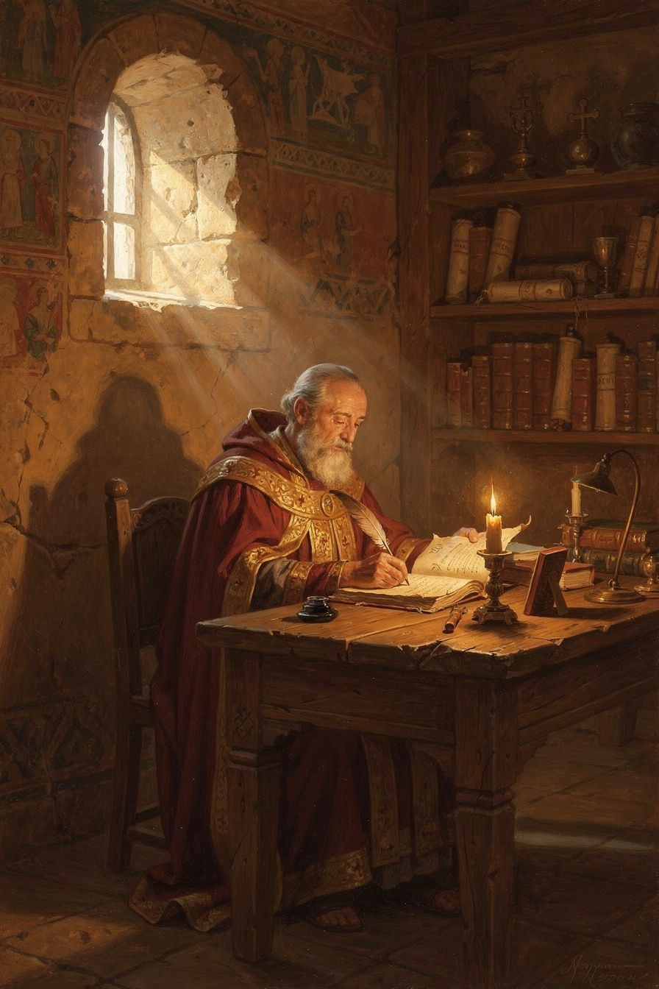
Illustration for Chapter 2
When Basil became bishop of Caesarea in 370 CE, the church was fighting over the identity of Jesus Christ and the Holy Spirit. The Council of Nicaea in 325 CE had declared that the Son is "of one substance" (homoousios) with the Father. But the Holy Spirit's status was still unclear. A group called the Pneumatomachi — literally "those who fight against the Spirit" — argued that the Spirit was a creature, perhaps the highest creature, but not fully God.
The Pneumatomachi had an argument from the Bible. In Scripture, the Spirit is "sent" by the Son (John 15:26), "given" by the Father (Luke 11:13), "poured out" at Pentecost (Acts 2). Creatures are sent, given, poured. God is not sent or given. Therefore, they reasoned, the Spirit is a creature.
Basil's friend Amphilochius, bishop of Iconium, noticed another problem. Christians used different doxologies — some said "Glory to the Father, with the Son, together with the Holy Spirit"; others said "Glory to the Father, through the Son, in the Holy Spirit." The Pneumatomachi argued that this variety of language proved the Spirit was inferior. Basil wrote On the Holy Spirit in 375 CE to answer this argument.
Basil's strategy was brilliant. He did not begin by asserting the Spirit's divinity. He began by analyzing the language the church already used. He showed that the biblical prepositions — "of," "through," "in" — are not locked to one person of the Trinity. They are used interchangeably of the Father, the Son, and the Spirit. The Father creates through the Son (Hebrews 1:2), but the Father also creates in the Spirit (Psalm 33:6). The Son acts of the Father (John 5:19), but the Spirit also acts through the Son (1 Corinthians 12:3). The variety of prepositions does not prove a hierarchy. It reflects the richness of trinitarian relations.
Basil's most powerful argument came from baptism. Christ commanded baptism "in the name of the Father and of the Son and of the Holy Spirit" (Matthew 28:19). Baptism is the act by which the Christian is joined to God. If the Spirit were a creature, the church would be invoking a creature alongside the Creator — blasphemy. The fact that the church has always baptized in the threefold name proves that the Spirit is on the divine side of the line.
Basil also argued from worship. The doxology — "Glory to the Father and to the Son and to the Holy Spirit" — is a liturgical confession of the Spirit's divinity. The church would not give glory to a creature. This is a crucial methodological move. Basil treats the liturgy as a source of theology. The rule of prayer is the rule of faith (lex orandi, lex credendi). What the church says in worship shapes what the church believes.
Basil also describes the Spirit in terms that can only apply to God. The Spirit is the Creator of life (Psalm 104:30). The Spirit is the source of sanctification — and no creature can make another creature holy. The Spirit is omnipresent: "Where shall I go from your Spirit?" (Psalm 139:7). A creature cannot be everywhere. The Spirit is all-knowing: "The Spirit searches all things, even the deep things of God" (1 Corinthians 2:10). A creature cannot know God's depths. The Spirit is goodness itself — not merely good but the source of goodness in others.
Basil's theology of the Spirit also shaped his understanding of the Christian life. The goal of the Christian life is not just moral improvement but union with God — what Eastern Christianity calls theosis or divinization. The Spirit is the one who makes this possible. Basil writes: "By participation in him there is imparted to us at the second creation the being made according to the likeness of God." The Spirit is the bridge between the human soul and the divine life.
Near the end of the treatise, Basil states the conclusion directly: "The Holy Spirit is not a creature, nor a work, but he is proper to the Son and partakes of the same nature as the Son; nor can we ever say that he is other than the living God" (On the Holy Spirit, 22). The word "proper" (idion) is key — the Spirit belongs to the Son by nature, not by adoption or assignment.
Basil died on January 1, 379 CE — two years before the Council of Constantinople (381 CE) that would ratify his theology. The council affirmed that the Holy Spirit is "Lord and giver of life, who proceeds from the Father, who with the Father and the Son together is worshipped and glorified." This is the Nicene-Constantinopolitan Creed, still recited in churches worldwide. Basil gave the church the theological grammar it needed to make that confession.
Big Idea
Basil showed that the Spirit's divinity is not proved by one verse but by the whole pattern of Christian worship, baptism, and Scripture. The church does not baptize in the name of a creature. The church does not give glory to a creature. The Spirit does what only God does — creates, sanctifies, gives life — and therefore the Spirit is God. The rule of prayer is the rule of faith: what we do in worship reveals what we truly believe.
Try This
- Trace the prepositions. Open a Bible and find three passages where the Father works through the Son, three where the Son works in the Spirit, and three where the Spirit works through the Son. Basil's point is that these prepositions (of, through, in) are shared by all three persons — they describe different modes of action, not different levels of reality. - Learn the word "doxology." A doxology is a statement of praise. The church's doxology says "Glory to the Father and to the Son and to the Holy Spirit." Basil argued that this is not just a pretty phrase — it is a theological statement. The church is giving equal glory to all three persons. Write your own short doxology (a sentence of praise) that names all three persons. - Compare the Pneumatomachi's argument with Basil's response. The Pneumatomachi said: the Spirit is "sent," and creatures are sent, not God. Basil replied: the Father is also "approached through the Son in the Spirit" (Ephesians 2:18). The prepositions are shared. Does Basil's response convince you? Why or why not?
Talk About It
1. Why does Basil start from baptism and worship rather than from abstract definitions? What does this tell us about how theology works — does doctrine come from the top down (definitions imposed on worship) or the bottom up (worship revealing what the church believes)? 2. What is the difference between saying the Spirit is "from God" and saying the Spirit "is God"? Why does that distinction matter? What would change in Christian practice if the Spirit were a creature rather than God? 3. Basil's treatise was written because of a real pastoral problem — Christians were confused about doxologies. How do practical, everyday questions in church life sometimes lead to major theological breakthroughs? Can you think of a modern example?
———
If the Spirit is God, not a creature, what does that change about how we live?
———

Chapter 3: The Preacher Who Loved Creation
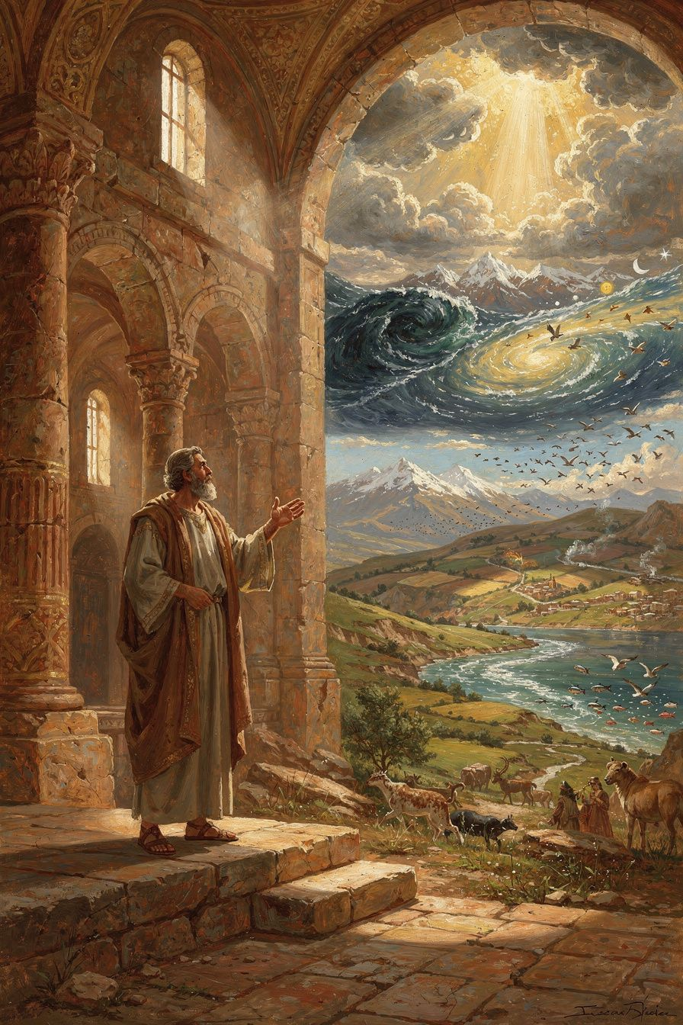
Illustration for Chapter 3
Around 378 CE, the year before his death, Basil preached nine sermons on the six days of creation described in Genesis 1. These sermons, called the Hexaemeron (Greek for "six days"), are the most influential Christian meditation on the natural world in the patristic era.
Basil was not trying to write science. He was a pastor teaching his congregation how to read creation as a revelation of God's wisdom, generosity, and beauty. His congregation in Caesarea lived close to the land — they were farmers, merchants, and craftsmen. Basil spoke to them about things they already knew: the sun, the moon, the rivers, the plants, the animals. But he taught them to see these familiar things differently.
Day 1 — Light. God says "Let there be light" and light appears. Basil distinguishes this primal light from the sun and moon created on the fourth day. The first light is a quality of the created order itself, not tied to any luminous body. God's word creates instantly — there is no process, no delay. God speaks, and the thing exists. The created world is not self-existent. It depends entirely on God's sustaining word. This is what theologians call creation ex nihilo — creation from nothing. The world is not eternal. It is not made from pre-existing matter. It is a free act of divine will. God did not need to create; God chose to create.
Day 2 — The Firmament. God separates the waters above from the waters below. Basil acknowledges the difficulty of the passage. What is the firmament? He offers various interpretations but insists on the theological point: the firmament reveals God's ordering of the world. What was formless is now shaped.
Day 3 — Plants. Basil delights in the variety of the plant world. He notes that the earth was pregnant with potential — the command of God was the trigger, not a new imposition. Creation is an act of liberation: the earth already contains the seeds of life; God's word activates them.
Day 4 — Sun, Moon, and Stars. Basil calls the sun a "great lamp" that warms the earth. The moon is a companion that softens the darkness. The stars are "flowers of fire" that decorate the night. He explicitly rejects astrology: the stars do not control human destiny. They are markers of time, not rulers of fate. If the stars determined our actions, Basil argues, then we would not be free. And if we are not free, then justice and judgment are meaningless. Human freedom is grounded in the doctrine of creation.
Day 6 — Land Animals and Humanity. In the final homily, Basil turns to the creation of the human being. He sees the human person as a bridge between two worlds. The soul links us to angels; the body links us to animals. But this is not a reason for shame. The body is good because God made it. "The soul receives the knowledge of God, and by the beauty and order of the body the Creator is glorified" (Hexaemeron, Homily 9). Basil explicitly opposes those who treat the body as a prison — both Platonists (who see the body as a shadow) and Gnostics (who see it as the work of a lesser, evil deity).
The theological point running through all nine sermons is this: the world is not a machine grinding along by necessity. It is a gift, personal and purposeful, made by a wise and generous Creator. The order of creation points to a single, purposeful mind. And that Creator called everything "good" — seven times in Genesis 1, culminating in "very good" after the creation of the human being, body and soul together.
This affirmation was radical in Basil's context. Platonic philosophy treated the material world as a shadow of the truly real. Gnostic systems treated it as the product of an ignorant or hostile lesser deity. Basil says: No. The material world is God's handiwork. It is good. It reveals God. And the human body — far from being a prison — is the instrument of the spiritual life. The body prays (kneeling, standing, singing), serves (working, feeding, caring), and worships (receiving the Eucharist).
Basil's theology of the body has practical consequences. Care for the sick: if the body is good, then caring for the body is not second-class spirituality. Basil built the Basileias because he believed healing the body is part of the gospel. The body matters to God; therefore it should matter to the church. Moderate asceticism: the body is to be disciplined, not destroyed. Extreme fasting that ruins health is not holiness but pride. Social justice: if the material world is good, then material needs matter. The hungry person's body matters. The naked person's body matters. The sick person's body matters. Basil's social homilies flow directly from his theology of creation.
The Hexaemeron shaped how Christians thought about nature for over a thousand years. Ambrose of Milan wrote his own Hexaemeron based directly on Basil's. Through Ambrose, the text reached the Latin West. Thomas Aquinas cited it. Bonaventure used its six-day structure. Modern readers are returning to Basil for his ecological sensitivity and his refusal to separate theology from the observation of the natural world.
Big Idea
Basil teaches that creation is not a machine but a gift. The world is not a closed system running by itself — it is personally sustained by God every moment. Matter is not evil or inferior; it is good because God made it. And the human body is not a prison for the soul but the instrument of the spiritual life. How you treat the world and your body depends on what you believe they are: if they are gifts, you honor them; if they are accidents, you use them.
Try This
- Take a creation walk. Go outside and find one thing from each day of creation that Basil described: something that gives light (Day 1), something that grows (Day 3), something in the sky (Day 4), a living creature (Day 5 or 6). Write down what you found. Notice: each thing is both ordinary and extraordinary at the same time. - Think about astrology. Basil said the stars do not control human destiny. Why does this matter? If the stars controlled everything, we could not be held responsible for our choices. Do you think people today still believe in determinism — maybe not from stars, but from genetics, environment, or upbringing? How would Basil respond? - Compare Basil's view of the body with views you see in culture. Social media celebrates perfect bodies. Transhumanism wants to transcend the body. Some people ignore their bodies entirely. Basil says: the body is a gift to be disciplined and cared for, not worshipped or despised. Which view is closest to Basil's? Which is furthest?
Talk About It
1. Why does Basil call creation a "book"? What does it mean to read the world? How is this different from studying the world scientifically — or is it the same thing from a different angle? 2. Basil rejected astrology because it would destroy human freedom and moral responsibility. What modern forms of determinism (genetic, environmental, economic) pose a similar challenge? How would Basil's argument apply? 3. Some people in Basil's time thought the body was bad. Basil said the body is good. What follows from this for how we treat sick people, hungry people, and people with disabilities? How does Basil's view of the body connect to his social ethics?
———
Is the world a machine or a gift — and how would your answer change how you treat it?
———

Chapter 4: The Bread That Belongs to the Hungry
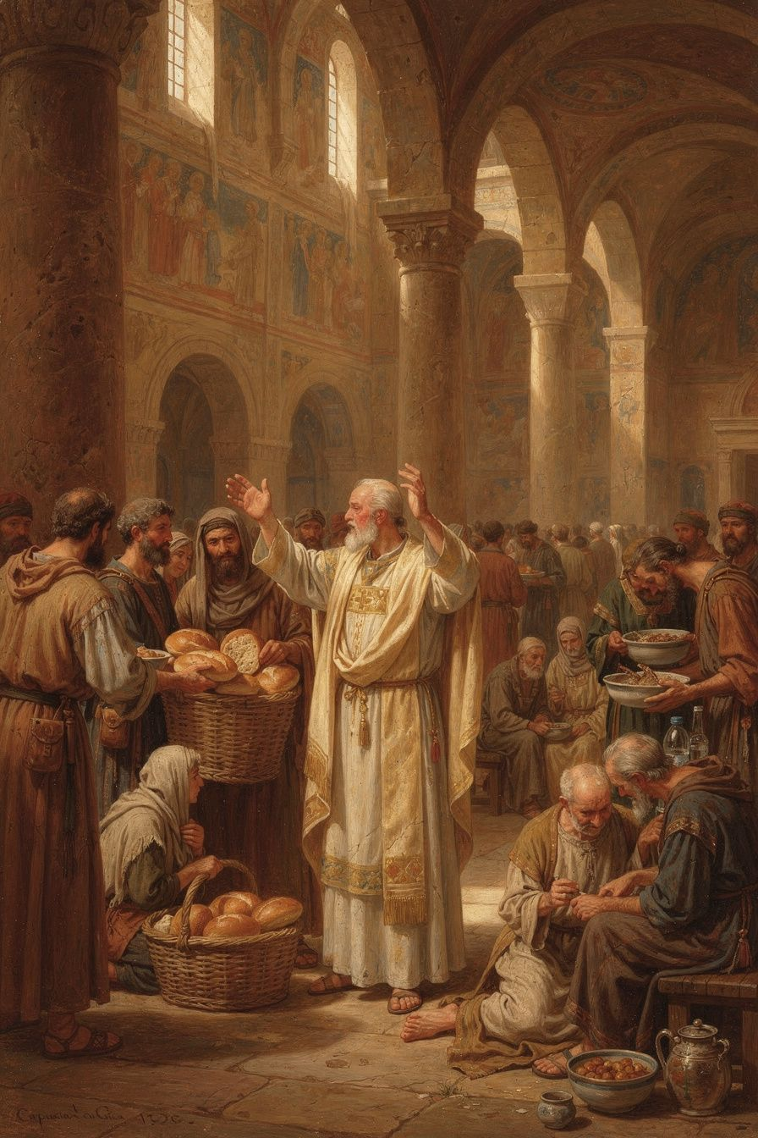
Illustration for Chapter 4
Basil's social teaching is among the most uncompromising in the entire Christian tradition. His homilies on wealth and poverty — especially "I Will Tear Down My Barns" and "To the Rich" — contain some of the most radical statements about property and obligation ever made by a bishop.
The homily "I Will Tear Down My Barns" is a sermon on Luke 12:16-21, the parable of the rich fool. In the parable, a rich man's land produces abundantly. He tears down his barns and builds bigger ones to store his surplus. He says to himself: "Soul, you have ample goods laid up for many years; relax, eat, drink, be merry." But God says: "Fool! This night your soul is required of you."
Basil's sermon is a relentless interrogation of the rich man — and through him, of every person who hoards while others starve:
"The bread which you hold back belongs to the hungry; the clothing you shut away belongs to the naked; and the money you bury in the earth is the price of redeeming and freeing the wretched."
Notice the verb: "belongs." Basil does not say the rich man should be generous and share. He says the goods already belong to the poor. The rich man is not an owner; he is a steward who has failed in his duty. The hungry person has a claim on the bread, not because the rich man chooses to give it, but because the bread was made for the hungry.
Basil's logic is theological, not political. God created the world for all creatures, not for some. The goods of the earth are a common gift. Private property is a human convention, not a divine institution — and a convention distorted by greed and sin. In God's original design, goods were common. The rich person who hoards is not exercising a right but committing a form of theft — withholding what belongs to others.
In "To the Rich," Basil extends the argument: "If you have taken more than you need, you have taken it from someone who needs it. You have stripped the naked by not clothing them." This is a stunning claim. To have more than you need is, in Basil's view, to have taken it from someone else. Excess is not innocent; it is a form of violence against the poor.
Basil did not stop at preaching. He built the Basileias — one of the most ambitious social welfare institutions of the ancient world. The complex at Caesarea included a hospital for the sick poor, a hospice for travelers, a shelter for the elderly, an orphanage, a workshop where the unemployed could learn trades, and a kitchen that fed the hungry daily. Gregory of Nazianzus called it "a new city" — a visible embodiment of Basil's conviction that the gospel requires institutional love, not just private charity.
The Basileias was funded partly by Basil's own inheritance (he gave away his family fortune) and partly by the contributions of wealthy Christians whom Basil persuaded — and sometimes publicly shamed — into giving. It became a model for later Christian hospitals throughout the empire.
Basil also addresses the psychology of wealth. The rich man in the parable says "relax, eat, drink, be merry" — he is talking to himself. Wealth creates a closed world: the rich person talks to their own soul, their own barns, their own plans. The poor disappear from view. Wealth blinds the wealthy to the existence of the people whose suffering is the cost of their comfort. The rich man does not see the hungry person at his gate. He does not see because he does not look. And he does not look because his wealth has made him self-sufficient — or so he thinks.
Basil also made a crucial distinction between the monastery and the church. The monastery is a voluntary community of those who choose to share all things. The church includes people at all stages of commitment. Basil does not require the layperson to renounce property, but the monk does. This suggests that the community of goods is an ideal for the committed, not a requirement for all. If Basil thought property was inherently evil, he would demand its abolition for everyone — but he does not. Instead, he builds the Basileias as a place where the radical vision is lived, while the surrounding society still has property, inequality, and need.
Scholars debate whether Basil's language is a literal demand for the abolition of private property or rhetorical provocation designed to shock the comfortable into generosity. The answer is probably both: the theological vision is genuinely radical (excess is theft), the practical strategy is realistic (the monastery and Basileias embody the vision, the surrounding society is not required to), and the rhetoric is prophetic (the homilies provoke without legislating). Basil holds all three together.
Big Idea
Basil's social teaching flows from his theology of creation. If God made the world for everyone, then the goods of the earth belong to all. Private property is a stewardship, not an absolute right. The rich person who hoards while the poor starve is not stingy but unjust — they are holding what belongs to someone else. The Basileias is the institutional form of this conviction: love needs structures, not just feelings.
Try This
- The coat experiment. Open your closet. Count your coats, shoes, or items of clothing you have not worn in the last month. Basil would say: the extra ones belong to someone who is cold. Pick one to donate. Notice how it feels to think of it as "theirs" rather than "mine to give." - Research the Basileias. What services did it provide? How was it funded? How does it compare to modern social welfare institutions — hospitals, shelters, food banks? What does Basil's model offer that modern systems might lack — particularly the idea of care as theological obligation rather than social service? - Think about the word "belongs." Basil says "the bread belongs to the hungry." Write down the difference between "I should give bread" and "the bread belongs to the hungry." How does the second statement change your relationship to what you own? Does it make you uncomfortable? Why?
Talk About It
1. When Basil says "the coat you store away belongs to the naked," is he making a literal claim about ownership or using rhetoric to provoke generosity? Can it be both? What changes if you read it literally versus rhetorically? 2. Why did Basil build the Basileias instead of trying to abolish property in his whole diocese? What does this tell us about his strategy — holding a radical vision while being realistic about what can be required of everyone? 3. Basil says wealth blinds the rich to the poor. Have you ever experienced this — being so focused on your own plans, your own stuff, that you did not notice someone in need? How does Basil's prophetic language wake people up?
———
If the bread belongs to the hungry, what in your life belongs to someone else?
———

Chapter 5: The Community That Stays Hot
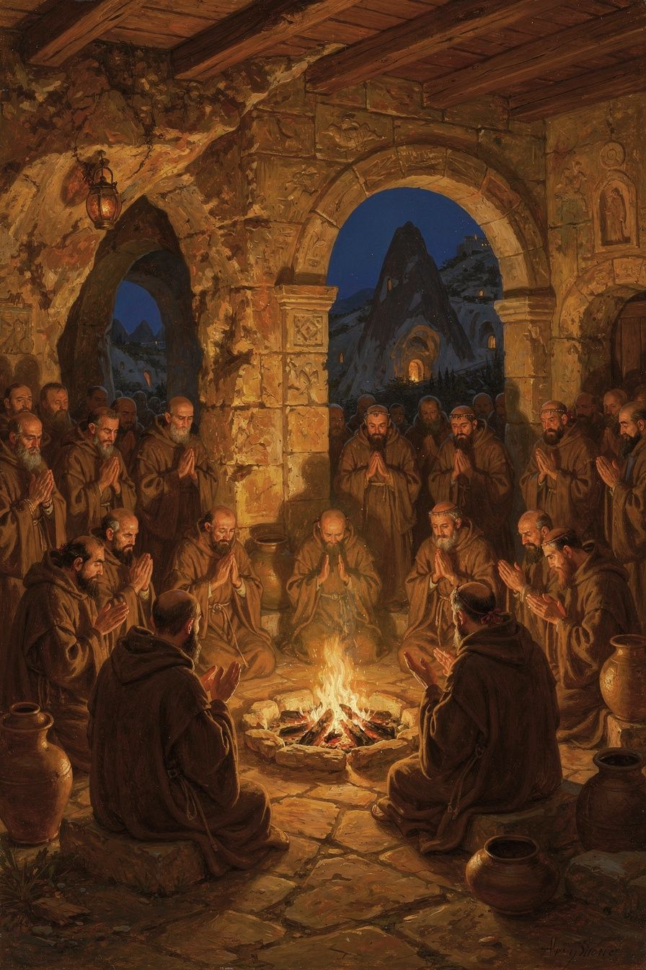
Illustration for Chapter 5
For Basil, the Christian life is not a solo project. It is a life lived in community — with God and with other people. This conviction shapes everything he wrote about the spiritual life. The monastery is a community. The church is a community. Even the Trinity is a community of three persons in one nature. The individual Christian who tries to grow alone is like a coal pulled from the fire: it cools and goes out. The Christian who stays in the community is like a coal in the fire: it stays hot because the other coals keep it hot.
Basil's insistence on community is theological, not just practical. God is community — the Trinity is a communion of three persons. If humans are made in the image of God, they are made for relationship. The isolated human is a theological contradiction: a being made for communion living as if communion were unnecessary.
Salvation is communal too. The Spirit works through the community. The "body of Christ" (1 Corinthians 12) is not a metaphor but a description: Christians are members of one another. The Spirit gives different gifts to different members, and no member has all the gifts. The Christian who isolates themselves cuts themselves off from the gifts the Spirit gives through others.
Basil's monastic rules are the most detailed ancient Christian guide to what the common life looks like in practice. The principles apply beyond the monastery to any Christian community:
Shared property. Monks hold all things in common. No one has private possessions. Private property cultivates possessiveness, which destroys community. When nothing is "mine," everything is "ours."
Obedience. The community has a leader who is obeyed. Obedience is not about power but about self-renunciation. The monk who submits their will to the abbot is practicing the death of self-will, which is the prerequisite for love.
Mutual correction. Community members correct each other — gently, humbly, but honestly. The monk who sees a brother sinning is obligated to correct him, not to ignore the fault. Ignoring faults is not kindness; it is neglect.
Shared work. Everyone works. Work is assigned by ability, not rank. The community provides for itself through labor, and the surplus is given to the poor. Shared work creates solidarity — when everyone works, everyone contributes, and no one is a burden.
Common prayer. The community prays together at fixed times. Prayer is not a private devotion but a communal act. The monk who prays alone is weaker than the monk who prays with the community.
Care for the sick. The sick are not neglected. The care of the sick is one of the highest forms of service. Basil's rules devote extensive attention to how the sick should be treated — with tenderness, patience, and practical care.
Hospitality. The monastery receives guests — travelers, the poor, the sick. Hospitality is not optional but a constitutive practice of the community.
Basil also warns about the dangers of solitude. The hermit has no one to correct their faults. Blind spots remain blind. The hermit has no neighbor to serve — love, the highest virtue, has no object. The hermit answers to no one — pride can grow unchecked. The hermit faces temptation alone — when the will weakens, there is no community to sustain it.
But Basil's monasteries were not closed communities. They were integrated with the surrounding church and society: under the bishop's authority, serving the poor, and witnessing to society. The monastery's common life — shared property, mutual service, radical simplicity — is a witness that another way of living is possible. The monastery does not need to preach against greed; its common life is the sermon. The monastery that refuses to serve the poor has betrayed its vocation.
Basil deliberately chose a different model from the famous Egyptian hermits. Anthony the Great, the Desert Fathers, the hermits of Nitria and Scete lived in extreme isolation — some in tombs, some in abandoned forts, some in the deep desert. Their model captured the Christian imagination. The Life of Anthony by Athanasius was one of the most widely read Christian texts of the fourth century. When people heard "monk," they thought of Anthony in the desert. But Basil rejected this model. He placed monasteries near towns — close enough to receive visitors, serve the poor, and participate in the church's life. The monastery is in the world, even if it is not of the world.
Basil also insisted on moderate fasting. Some monks in his time starved themselves to show how holy they were. Basil rejected this. The body is God's good creation; it should be disciplined, not destroyed. "The body should be disciplined, not destroyed. The athlete who breaks his legs before the contest does not win the crown." Fasting that makes the monk too weak to work, pray, or serve is counterproductive. The goal is a rightly ordered body — appetites under the direction of the soul — not a destroyed body. And the faster who is proud of their extreme fasting has gained nothing. The moment you feel superior because of your fasting, the fast has failed.
Big Idea
Basil teaches that community is not optional for the spiritual life — it is the context in which the spiritual life happens. The Trinity is a community. The church is a community. The monastery is a community. The Christian who isolates themselves cuts themselves off from the gifts God gives through others. A coal alone goes cold; a coal in the fire stays hot. And the community that serves the world is not hiding from it but bearing witness to a different way of living.
Try This
- The coal experiment. Think about a time when you tried to do something hard completely alone — maybe studying for a test, training for a sport, or working on a project. Now think about a time when you did something hard with other people. How did the experiences compare? What did the group give you that solitude could not? - Map your community. Draw a simple diagram of the communities you belong to: family, school, church, sports team, friend group. Which ones help you grow? Which ones hold you accountable? Which ones serve people outside the group? Basil would say: a community that only serves itself has missed its calling. - Try a shared practice. Pick one thing you usually do alone — a meal, a prayer, a walk — and do it with someone else this week. Notice how the shared experience feels different. Basil said even prayer is stronger when it is communal.
Talk About It
1. Why does Basil say solitude is dangerous? What exactly goes wrong when you try to grow spiritually alone? Can you think of a time when isolation made a problem worse? 2. Basil says mutual correction is an act of love, not hostility. How can a community correct its members without becoming judgmental or harsh? What is the difference between caring enough to correct and being a gossip? 3. Basil's monasteries served the world around them — they were base camps, not fortresses. What would a "Basilian" community look like today? Is there a modern equivalent of the monastery as a place that is set apart but engaged?
———
Can a coal stay hot alone — and can you?
———

Chapter 6: The Bishop Who Stood Up to an Emperor
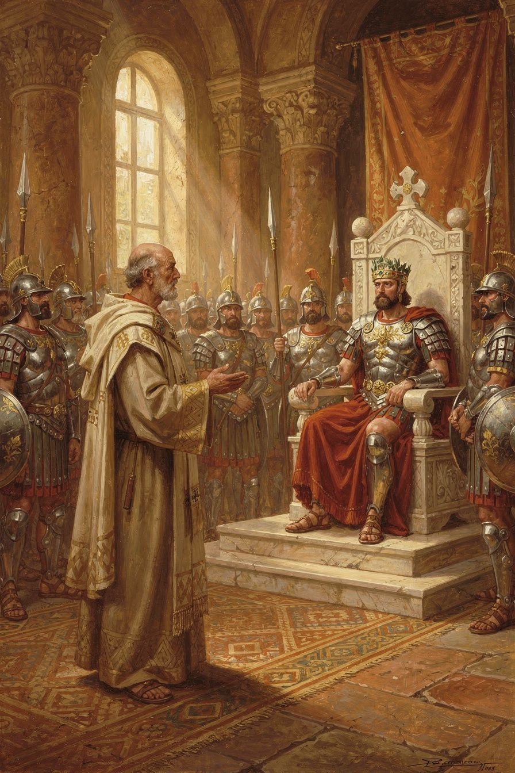
Illustration for Chapter 6
The emperor Valens was an Arian — he believed the Son was not fully God and the Holy Spirit was a created being. He controlled the army, the laws, and the land. He wanted all bishops to agree with him, and he sent officials to pressure those who did not.
One of those officials was the prefect Modestus, a high-ranking imperial officer. He came to Basil and threatened him with confiscation of property, exile, torture, and death.
Basil's response has become one of the most famous moments in patristic history. He said: "Confiscation means nothing to me, unless you covet these wretched rags and a few books; that is all I possess. As to exile, I am attached to no particular place. I regard the whole earth as belonging to God, and I consider myself as a stranger wherever I may be. As for torture, how will you apply it? I have not a body capable of bearing it, unless you are thinking of the first blow you give me, for that will be the only one in your power. As for death, this will be a benefit to me."
Modestus was stunned. He said he had never met anyone who spoke to him so boldly. Basil replied: "Perhaps that is because you have never had to deal with a bishop."
This exchange is preserved in Gregory of Nazianzus's funeral oration for Basil (Oration 43). Gregory may have polished it, but the encounter is historical. Valens did send officials to pressure Basil, and Basil did refuse to compromise.
Basil's courage came from his theology. He believed that God was more powerful than any emperor. He believed that the truth about the Trinity was not a matter of opinion but of faithfulness. He believed that a bishop's job was not to please rulers but to please God. The Stoic philosophers had taught that the wise man is free because external things cannot touch his inner virtue. Basil added a theological ground: the earth belongs to God, and the Christian is a stranger everywhere. Death is not a threat but a benefit, because it brings the soul to God.
Valens never carried out his threats. Some say he was impressed by Basil's courage. Some say he feared that harming such a respected bishop would cause a riot. Either way, Basil stood his ground, and the truth won.
The confrontation with Modestus was not the only political challenge Basil faced. In 372 CE, Valens divided Cappadocia into two provinces to diminish Basil's authority. Basil responded by creating new bishoprics and appointing his brother Gregory of Nyssa and his friend Gregory of Nazianzus to sees in the new province — a political move that protected his allies and extended Nicene influence. The two Gregories were not eager to be bishops — Gregory of Nazianzus especially disliked the politics — but Basil needed them, and they went because their friend asked. This was how Basil worked: he built networks, made alliances, and used his personal relationships to advance the cause he believed in. He was not just a theologian or a monk. He was a strategist.
Basil's health was never good, and the demands of the episcopate wore him down. He suffered from liver disease and was frequently exhausted. His letters complain of illness, overwork, and the difficulty of his position. He drove himself to the point of collapse. His friend Gregory later said that Basil's body was worn out by his labors.
Basil died on January 1, 379 CE. He was forty-nine years old. He did not live to see the Council of Constantinople (381 CE) that ratified his theology. But his work was done. He had given the church the theological grammar of the Trinity, the rules for monastic community, the hospital for the poor, and the example of a bishop who would not bend.
Gregory of Nazianzus preached the funeral oration. He described Basil as one of the great lights of the church — a theologian, a builder, a shepherd, and a friend. Gregory's grief was real: he had lost the person who understood him best. But Gregory also saw that Basil's legacy would endure. The theology was written. The rules were composed. The hospital was built. The example was set. The council would come, and when it did, it would confirm what Basil had already established.
Big Idea
Basil's courage was not bravado. It was faith. He believed that the truth about God was more important than his safety, that God was more powerful than any emperor, and that death was not the end but the beginning. His courage came from his theology: if God is real and God is good, then standing for the truth is always the right choice, even when it costs everything.
Try This
- Think about what courage means. Basil was calm because he believed God was more powerful than the emperor. Write down: what would you stand up for, even if it cost you something? What is worth more than safety or comfort? - Learn about the Council of Constantinople (381 CE). This council ratified Basil's theology of the Holy Spirit. Look up the Nicene-Constantinopolitan Creed — the statement of faith that came from this council. It is still recited in churches today. Find the line about the Holy Spirit. That line exists because of Basil. - Compare Basil's courage with other kinds of courage. A soldier shows courage in battle. An athlete shows courage in competition. What kind of courage did Basil show? He did not fight. He did not run. He stood and spoke the truth. Is that harder or easier than physical courage?
Talk About It
1. Basil told Modestus: "Perhaps that is because you have never had to deal with a bishop." What did he mean? What kind of authority does a bishop have that is different from military or political authority? Where does that authority come from? 2. Basil's courage came from his faith, not from pride. How can you tell the difference between courage and stubbornness? When is standing your ground the right thing, and when is it just pride? 3. Basil died before the Council of Constantinople ratified his theology. He did not get to see the results of his work. What does that tell us about faithfulness — doing the right thing even when you may not see the outcome? Can you think of a time when you did the right thing and never saw the result?
———
What would you stand for, even if it cost you everything?
———

For the Grown-Up Reader
This booklet introduces readers aged 11–14 to Basil of Caesarea (c. 330–379 CE), one of the three Cappadocian Fathers. The six chapters cover Basil's early life and education; his defense of the Holy Spirit's divinity in On the Holy Spirit (375 CE); his creation theology in the Hexaemeron (c. 378 CE); his radical social teaching in "I Will Tear Down My Barns" and "To the Rich"; his monastic rules and theology of community; and his confrontation with the imperial prefect Modestus.
All quotations are from the public-domain translations available at New Advent (www.newadvent.org/fathers). The historical framework follows Philip Rousseau, Basil of Caesarea (University of California Press, 1994), and Stephen Hildebrand, Basil of Caesarea (University of Notre Dame Press, 2018). On social ethics, Susan R. Holman, The Hungry Are Dying: Beggars and Bishops in Roman Cappadocia (Oxford, 2001). On the Cappadocian settlement, John Behr, The Nicene Faith, Part 2 (SVS Press, 2004), and Lewis Ayres, Nicaea and Its Legacy (Oxford, 2004).
The debate about whether Basil's social teaching is radical or realistic is treated in the chapter on social justice. The "both" position — radical vision, realistic practice, prophetic rhetoric — follows Hildebrand's integrated reading. The scholarly debate between Holman (radical) and Rousseau (realist) is a live question in patristic scholarship.
The confrontation with Modestus is preserved in Gregory of Nazianzus's Oration 43, the funeral oration for Basil. Gregory may have polished the dialogue, but the encounter is historical — Valens did send officials to pressure Basil, and Basil did refuse to compromise.
———

About WisdomForge
WisdomForge publishes four versions of each booklet — for ages 5–10, 11–14, 15–18, and adult — so readers at every stage can meet the great thinkers of the classical and Christian tradition. Each version tells the same stories and explores the same ideas, but in language and depth suited to the reader. The booklets are free. Read them. Question them. Discuss them. Do them.

