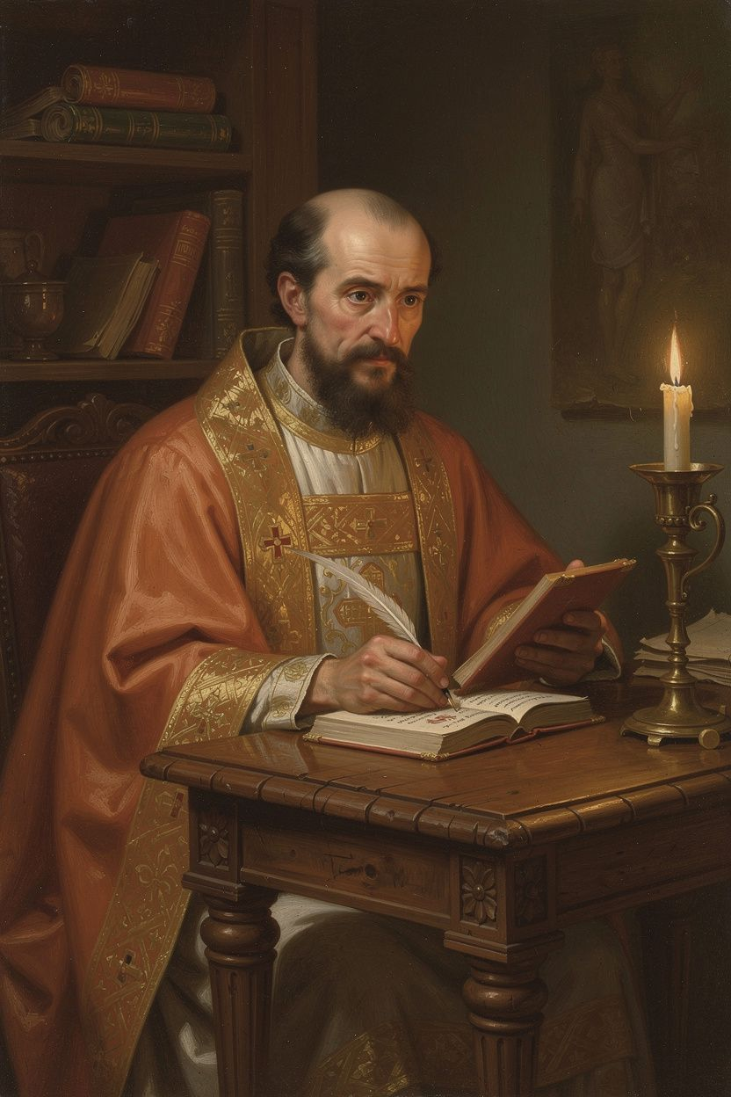
Gregory of Nazianzus: The Theologian
WisdomForge Booklet — Adult

Gregory of Nazianzus: The Theologian

WisdomForge Booklet — Adult
———

About This Book
This booklet is for adults who want to engage Gregory of Nazianzus (c. 329/330–389/390 CE) as a serious historical and theological figure — not as a saintly legend, but as a man whose ideas about God, knowledge, suffering, beauty, and the vocation of the theologian shaped Christian civilization for 1,600 years and remain as urgent today as they were in the fourth century.
Gregory is called "the Theologian" — a title the Eastern Orthodox Church has given to only one other person in its entire history (John the Evangelist). That title tells you something about who Gregory was and what he achieved. He was not a systematic theologian in the way Aquinas would be. He was a pastor, a poet, a preacher, and a reluctant bishop who kept running away from power — and whose words about God shaped the creed that millions of Christians still recite today. The Niceno-Constantinopolitan Creed, still used in worship across the Christian world, is in many ways Gregory's creed.
Gregory lived through one of the most turbulent and consequential periods in Christian history. The fourth century was the century of the Arian controversy — a debate about whether the Son is fully God or a created being, and whether the Holy Spirit is divine or something less. Gregory's answer — that God is one essence in three persons, that the Son is eternally begotten, that the Spirit is truly God — became the official teaching of the church at the Council of Constantinople in 381 CE. But Gregory was not just a debater. He was a man who insisted that theology is a spiritual discipline, not just an intellectual exercise — that the people who speak about God should be the kind of people who pray. He was a man who taught that God is too big for our minds to fully comprehend, and that the best theology knows its own limits. He was a man who lost his brother, his sister, his father, and his best friend, and who wrote funeral orations so honest and so hopeful that they are still read 1,700 years later. He was a man who wrote 17,000 lines of theological poetry because he believed that beauty and truth belong together.
This booklet does not prettify Gregory. He was a man of his time — a Roman aristocrat with the assumptions of his class, a bishop who could be prickly and self-pitying, a theologian whose retirement was partly forced by illness and exhaustion. The church politics of the fourth century were as ugly as any institutional politics, and Gregory was not always a saint in his response to them. But his theology — his Trinitarian framework, his apophatic epistemology, his Christological principle, his doctrine of deification, his approach to grief, and his poetic vision — remains one of the great achievements of Christian thought.
No devotional softening. No academic padding. Six chapters. Each one engages a central Gregory idea with the seriousness it deserves, including the scholarly debates that still surround his work.
———

Chapter 1: Education, Friendship, and the Formation of a Theologian
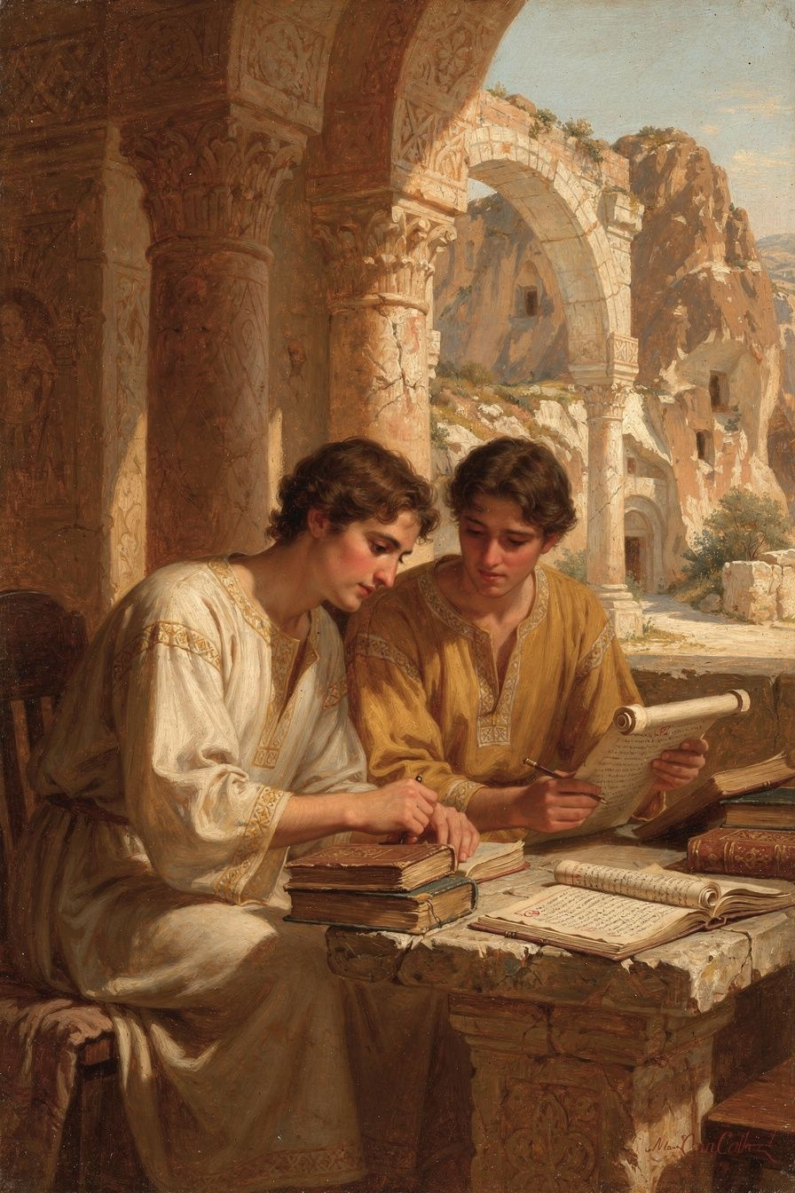
Illustration for Chapter 1

The Classical Formation
Gregory was born around 329 or 330 CE in Arianzus, a village near Nazianzus in Cappadocia (modern-day Turkey). His family was wealthy, landed, and Christian. His father, Gregory the Elder, was bishop of Nazianzus for over 45 years — a practical, managerial bishop who lived to be nearly 100. His mother, Nonna, was a woman of constant prayer who shaped the family's spiritual life and was credited with his father's conversion from the Hypsistarian sect. His brother Caesarius was a brilliant physician who served at the imperial court — a man of extraordinary talent whose death at a young age was a devastating blow. His sister Gorgonia was a married laywoman of remarkable piety and discernment; Gregory's funeral oration for her (Oration 8) is one of the most important early Christian tributes to a woman and to the vocation of Christian marriage.
Gregory received the finest education the late Roman world could offer. He studied rhetoric in Caesarea, where he met Basil. He continued in Alexandria, the intellectual capital of the East, where he absorbed the legacy of Origen and studied under the rhetorician Themistius. Then he went to Athens — the traditional center of classical learning — where he studied rhetoric, philosophy, and literature for years.
This education gave him the tools that would make him the most eloquent theologian of his age: the Homeric allusions, the Platonic echoes, the rhetorical structures, the precision of argument, and the beauty of expression that pervade every page of his work. Athens was not just a school; it was the place where Gregory's mind was formed. He learned that good thinking requires good speaking, that truth deserves beauty, that argument should be precise but also moving. Without Athens, there would have been no Five Theological Orations. The classical formation was not a pagan contamination of his theology; it was the instrument of his theology.

The Question of Christian Hellenism
Gregory's use of classical culture raises a question that he himself addressed: Should Christians use the cultural tools of a pagan world? Gregory's answer was yes. He did not reject classical culture; he redeemed it. He used the literary forms of the Greek tradition — rhetoric, poetry, philosophical argument — to express Christian truth. If pagan poets could write beautiful verse about false gods, Christian poets should write beautiful verse about the true God. The forms belong to whoever can use them well.
This position was not unanimous in the early church. Some Christians rejected classical culture entirely. Tertullian had asked: "What has Athens to do with Jerusalem?" Gregory's answer was: a great deal. Athens gave the church the tools to speak beautifully and precisely about the God of Jerusalem. This model — cultural engagement without capitulation — became a precedent for the entire Christian literary tradition, from Dante to Eliot. Gregory's Christian humanism — his refusal to abandon classical culture, and his effort to baptize its forms for Christian use — is one of the enduring dimensions of his legacy.
Scholarly debate: Was Gregory's use of classical culture a creative synthesis or a compromise? Some scholars (Pelikan, Christianity and Classical Culture) see Gregory's engagement with Hellenism as a creative transformation — he used Greek forms to express Christian content without diluting either. Others (Demacopoulos) are more cautious, noting that the embrace of classical culture also meant the embrace of certain classical assumptions — about social hierarchy, about the value of rhetorical display, about the relationship between education and virtue — that are not always compatible with the gospel. The integrated reading is that Gregory's Christian Hellenism was both creative and compromised: he transformed the forms, but the forms also shaped him. This is the perennial tension in Christian cultural engagement — the forms we use shape the content we express, and the shaping is not always benign.

The Friendship with Basil
In Athens, Gregory met Basil of Caesarea. They were both from Cappadocia, both serious about their Christian faith, both brilliant students. Gregory described their meeting in Oration 43 as one of the decisive events of his life: "We were the talk of the city — two young men who had given themselves to God, in a city that worshipped idols."
Their friendship was complementary but tense. Basil was the organizer — practical, political, institutional. Gregory was the orator — contemplative, literary, sensitive. Basil built monasteries and managed episcopal networks. Gregory preached orations and wrote poems. Their different temperaments caused real friction, especially when Basil appointed Gregory to the miserable see of Sasima as a political maneuver.
But the friendship endured because the bond was deeper than the disagreements. The complementarity was productive: Basil built the institutional framework; Gregory articulated the theology. Basil was cautious on the Spirit (for political reasons); Gregory was direct. Together, they were more than either could have been alone. After Basil's death in 379, Gregory delivered Oration 43 — a funeral oration that is one of the great works of ancient friendship literature. It is both tribute and lament, acknowledging the tensions while celebrating the bond. Gregory called Basil "the great friend of my soul."
The Big Idea
The Cappadocian settlement was the fruit of a friendship. Theology is not produced in a vacuum — it is produced in social contexts, in relationships, in shared study and shared argument. Gregory and Basil's friendship shows that complementarity produces better theology than uniformity, but only if the friendship is strong enough to hold the friction that complementarity generates. The social context of theology matters. Ideas do not float free of the relationships in which they are formed.
Practice
1. Read Oration 43. Gregory's funeral oration for Basil is available at New Advent. Read the opening and closing sections. Notice how Gregory balances admiration with honesty about tensions. Write 300 words on how the personal relationship shapes the theological assessment — and how the theological assessment deepens the personal tribute.
2. Examine Christian Hellenism. Gregory used classical forms to express Christian truth. Find one passage in Oration 27 or 28 where Gregory uses a classical rhetorical technique (a metaphor from Greek philosophy, a structural device from Greek rhetoric, a literary allusion) to make a theological point. Write 300 words on what the technique adds to the theology.
3. Reflect on friendship and intellectual life. Think about a friendship or collaboration that has shaped your own thinking. What did the other person give you that you could not have produced alone? How did the differences between you make the work better — or cause friction? Write 300 words on the social context of your own intellectual life.
Reflect
The Cappadocian settlement was the fruit of a friendship. What does it mean that some of the most important theology in history was produced not by isolated geniuses but by friends who argued? How does the social context of theology — the relationships, the tensions, the shared meals and prayers — shape the theology that emerges?
———

Chapter 2: The Reluctant Bishop — Vocation, Resistance, and Integrity
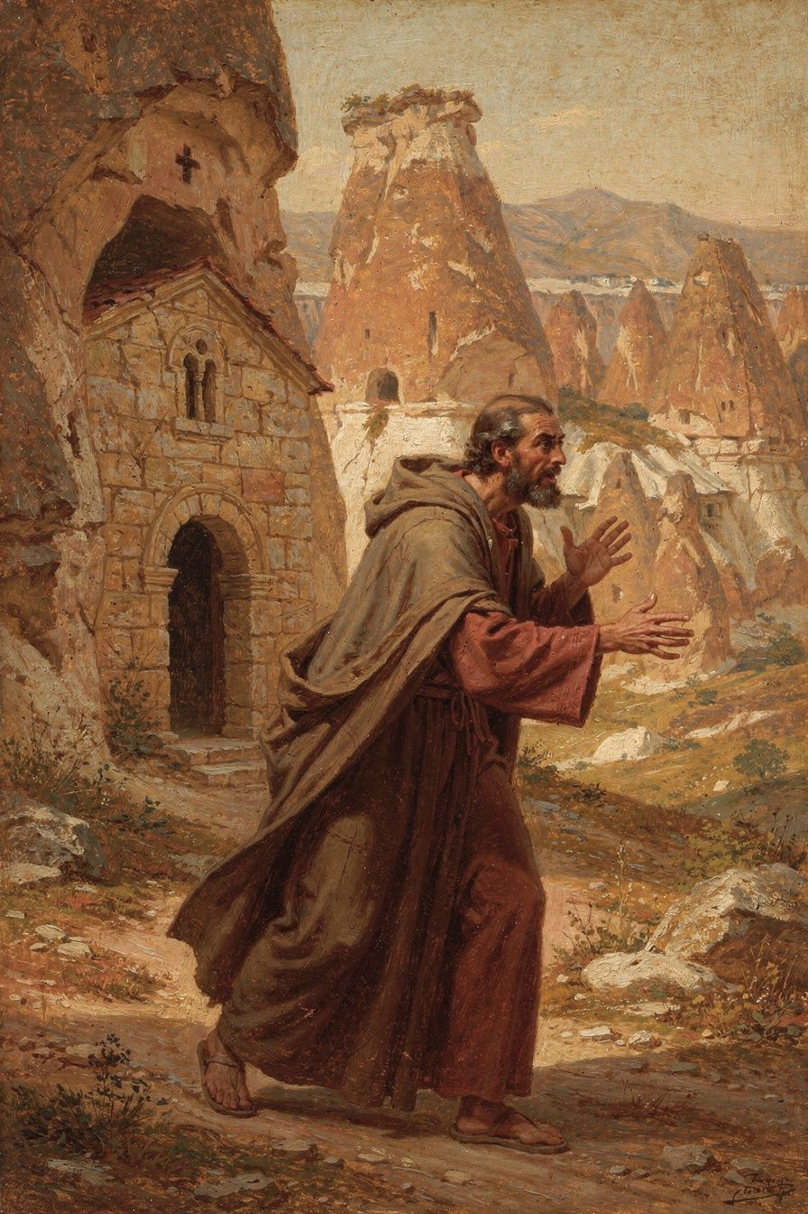
Illustration for Chapter 2

The Flight from Ordination
Around 361 CE, Gregory's father ordained him as priest without his consent. Gregory was horrified. He had not been consulted. He had not wanted ordination. He wanted a quiet life of study, prayer, and friendship. He fled to Basil's monastery in Pontus.
The flight was not personal weakness. Gregory's Apologia for His Flight to Pontus (Oration 2) is a carefully argued theological treatise on the nature of ordination. Gregory believed that ordination was too serious to be entered lightly — that it required consent, preparation, and a genuine sense of calling. The priesthood is a sacred trust, not a job to be assigned without the candidate's agreement. His father's unilateral action was an abuse of authority.
Gregory's argument in Oration 2 is one of the earliest sustained treatments of the nature of ordination in Christian theology. He asks: What makes ordination valid? Is it the bishop's authority? The people's consent? The candidate's preparation? Gregory argues that all three matter. The bishop has the authority to ordain, but the candidate must be willing and prepared, and the people must consent. Ordination without consent is not just invalid — it is harmful. It treats a sacred office as a personnel assignment.
Eventually Gregory returned and accepted the priesthood. He served under his father in Nazianzus and began to develop the theological voice that would later produce the Five Theological Orations. But the tension between his desire for a contemplative life and his calling to public ministry never fully resolved. This is the perennial tension between the contemplative and the active life — between the study and the pulpit, between the desire for quiet and the demands of service.

The Sasima Crisis
In 372 CE, Basil — now bishop of Caesarea — appointed Gregory bishop of Sasima. Gregory was appalled. He described Sasima as "a detestable little place, without water, without trees, without civilization." Basil needed the see for political reasons — to strengthen his metropolitan authority by creating a suffragan bishopric. Gregory saw himself as a pawn in someone else's political game.
He went briefly, found it intolerable, and left. The appointment strained the friendship for years. This episode reveals something important about the fourth-century church: even the Cappadocian Fathers — friends, allies, theological collaborators — could treat each other with a certain ruthlessness when institutional power was at stake.
The Sasima incident also reveals something about Gregory's character. He was not a man who could be used. He had a deep sense of his own dignity and vocation, and he refused to let even his closest friend instrumentalize him. This refusal is part of what made Gregory the theologian he was. His theology of integrity was not abstract; it was tested in real relationships and real conflicts.

The Constantinopolitan Mission (379–381 CE)
In 379 CE, Gregory was invited to lead the small Nicene community in Constantinople. He arrived to find a tiny, demoralized congregation meeting in a house-chapel called the Anastasia ("Resurrection"). The city had been an Arian stronghold for decades. The Arian bishop Demophilus controlled the main churches. The previous Nicene bishop had been driven out years before. The imperial court under Valens had actively supported Arianism — exiling Nicene bishops and promoting Arian ones throughout the East.
Over two years, despite chronic illness and opposition, Gregory accomplished something extraordinary. He preached the Five Theological Orations, which established the theological framework for the Council of Constantinople. He built the community from a handful to a significant congregation. He survived an Arian attack on the Anastasia on Easter Eve 380 CE, when Arian monks smashed windows and assaulted members of the congregation. The violence backfired — it drew public sympathy to the Nicene community and discredited the Arians.
In 379 CE, the emperor Valens died at the Battle of Adrianople. His successor, Theodosius I, was a committed Nicene Christian. Theodosius issued the Edict of Thessalonica (380 CE), declaring Nicene Christianity the official faith of the empire. The political wind had shifted. Demophilus was expelled. The main churches were turned over to the Nicene community. Gregory was appointed bishop of Constantinople and presided over the opening of the Council of Constantinople in 381 CE.
Then the bishops of Alexandria challenged his appointment on a technicality — Canon 15 of Nicaea prohibited episcopal transfers. Gregory had been transferred from Sasima to Constantinople, which violated the canon. The bishops of Alexandria — allies in doctrine but rivals in politics — used this to challenge his legitimacy. They did not want a Constantinopolitan bishop to rival their own prestige.
Gregory, weary and disgusted by the politicking, resigned. His farewell speech (Oration 42) is one of the most moving documents in patristic literature: "I have been a bishop without a church, a pastor without a flock." He chose to leave rather than fight. He valued his integrity more than his position.
The council appointed Nectarius, a respected layman, as bishop. Gregory's public career was over. But the theology he had fought for won the day. The council adopted his pneumatology, his Trinitarian framework, and his theological vocabulary. The Niceno-Constantinopolitan Creed — still used in Christian worship today — bears the imprint of Gregory's theology. Every Sunday, millions of Christians confess a faith shaped by a man who preached in a house-chapel and died in retirement in a small Cappadocian village.
The Constantinopolitan episode reveals the mixed blessing of political power. The alliance of Nicene orthodoxy with imperial power under Theodosius secured the victory of Gregory's theology — but it also created new problems: the entanglement of church and state, the politicization of theology, the marginalization of dissent. Gregory's own resignation is a witness to the cost of integrity in a politicized church. He chose to leave rather than participate in the system that had tried to invalidate him. His withdrawal is a theological act — the practice of the principle he articulated in Oration 27: that the theologian's integrity matters more than his position.
Scholarly debate on Gregory's leadership: Was Gregory a weak leader or a different kind of leader? The traditional view, shaped by comparison with Basil and Athanasius, sees Gregory as ineffective — a man who kept running away from responsibility. McGuckin's biography (St. Gregory of Nazianzus: An Intellectual Biography, SVS Press, 2001) corrected this picture decisively. McGuckin shows that Gregory's brief ministry in Constantinople was one of the most consequential in Christian history — he built a tiny congregation into the vehicle of Nicene victory and preached the orations that shaped the church's creed. His resignation was not defeat but a choice consistent with his entire theology: he valued integrity more than position. Sterk (Renouncing the World Yet Leading the Church, Harvard, 2004) places Gregory in the context of the monk-bishop ideal, showing how his contemplative orientation was not a withdrawal from leadership but a different model of leadership — one that prioritized theological depth over institutional power. The emerging consensus is that Gregory was not a weak leader but a different kind of leader: one whose strength was theology, integrity, and the willingness to walk away from power.
The Big Idea
Gregory's withdrawals were theological acts. His model of leadership challenges the modern assumption that leadership means holding on to power and using it effectively. Gregory led through theology, not administration; through integrity, not power; through withdrawal as well as engagement. His willingness to walk away from power — from Sasima, from Constantinople — is a witness to the principle that the church is not about power but about truth.
Practice
1. Read Oration 2. Gregory's Apologia for His Flight is one of the earliest sustained treatments of the nature of ordination. Read the opening sections at New Advent. Write 300 words on Gregory's argument: What makes ordination valid? What are the preconditions? How does this argument apply to modern understandings of vocation and leadership?
2. Evaluate the resignation. Gregory resigned the highest position in the Eastern church rather than fight for it. List three reasons someone might see this as strength and three reasons someone might see it as weakness. Consider the modern implications: what would it look like for a leader today to walk away from power rather than compromise integrity?
3. Compare leadership models. Read Sterk's analysis of the monk-bishop ideal. How does Gregory's model of contemplative leadership differ from the modern model of organizational leadership? Can both coexist in a modern institution? Write 300 words on the strengths and limitations of each model.
Reflect
Gregory said: "I did not seek this office; I will not cling to it." In a culture that equates leadership with holding and exercising power, what does it mean to hold power without seeking it — and to let go of power without fighting for it? Is Gregory's model of leadership viable in a modern institution, or is it only possible in a pre-modern context?
———

Chapter 3: The Five Theological Orations — The Trinity Defended
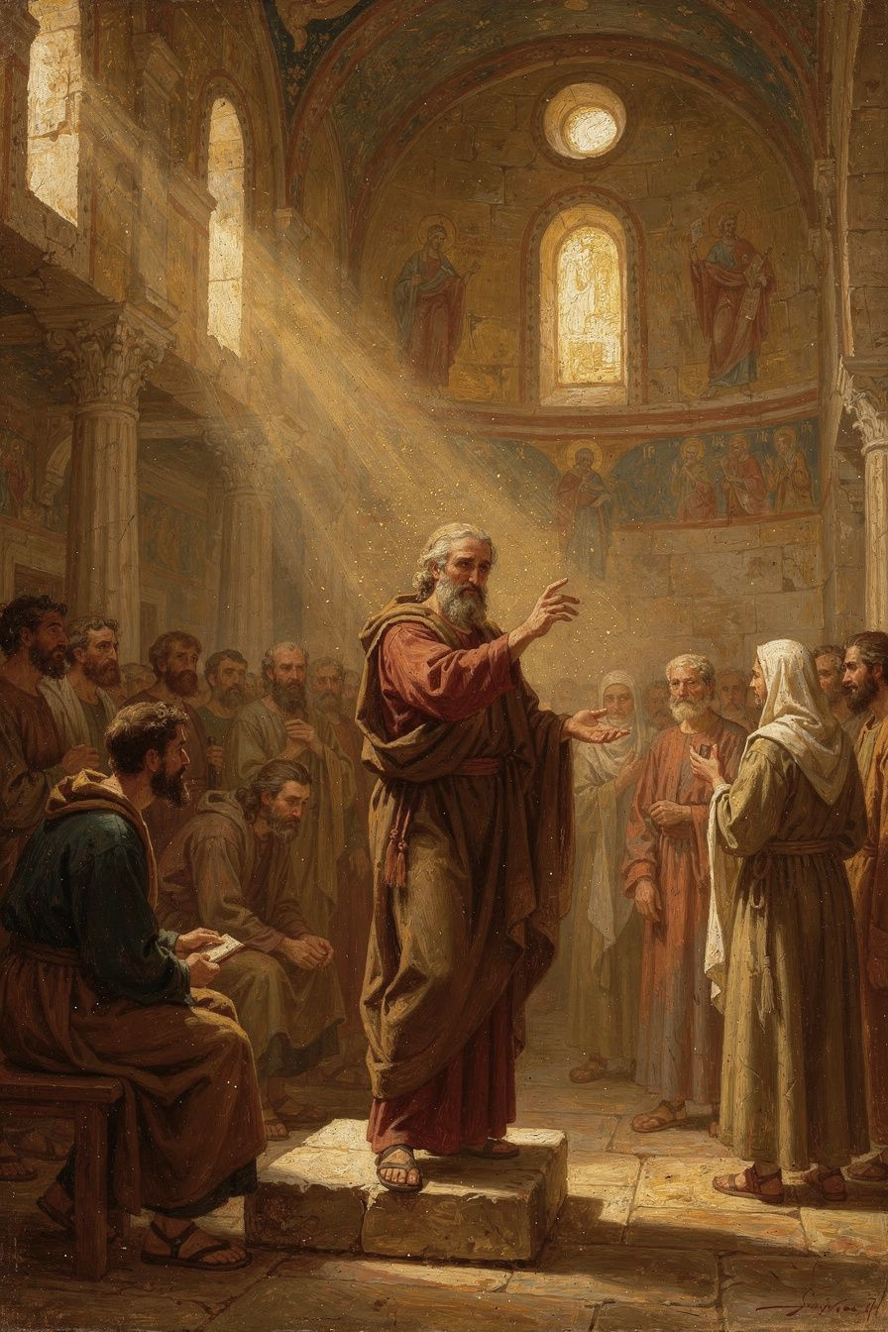
Illustration for Chapter 3

The Setting: Constantinople, 380 CE
The Five Theological Orations (Orations 27–31) were preached in 380 CE in the Anastasia — a house-chapel in Constantinople. The setting was modest, but the orations are Gregory's masterpiece and one of the classic expositions of the doctrine of the Trinity.
The situation was dire. Constantinople had been an Arian stronghold for decades. The Nicene community was tiny and demoralized. Theology was a public sport — debated at dinner parties, in the marketplace, at the barber shop. Gregory found this dangerous. Speaking about God is a sacred task, not a game. The Eunomians claimed to know God's essence completely. Amateur theologians debated technical terms they did not understand. Gregory's response was not just to argue better but to redefine what theology is — who should do it, how it should be done, and what its limits are.
The orations were not academic exercises. They were pastoral tools, designed to form and strengthen a community under pressure. Gregory was preaching to a frightened, scattered flock. The orations gave them three things: a theological framework (the Trinity), an epistemology (the incomprehensibility of God), and a discipline (the character of the theologian). Together, these three formed the foundation on which the Council of Constantinople would build the creed.

Oration 27: The Character of the Theologian
Gregory begins not with doctrine but with a question: Who is qualified to speak about God? He attacks the Eunomians, who claimed to know God's essence completely, for their arrogance. True theology, he argues, requires purification, reverence, and silence as much as speech. "Discussion of theology is not for everyone, I tell you, not for everyone." The theologian must be formed by prayer and virtue. Reason serves theology; it does not master it. The relationship between knowledge and holiness is organic: the more one is formed in the life of God, the more one can speak truthfully about God.
Gregory's principle became foundational for the Eastern Orthodox theological tradition. In the East, theology is not primarily an academic discipline but a mystical discipline. The true theologian is the saint — the person who has been deified, who has experienced God, who speaks from communion with God. Evagrius of Pontus compressed the principle: "If you pray truly, you are a theologian."

Oration 28: The Incomprehensibility of God
Gregory argues that while we can know that God exists from creation and providence, we cannot comprehend God's essence. The via negativa — saying what God is not — is more reliable than the via positiva. God is not limited, not mortal, not created, not subject to change. These negations are true, but they tell us what God is not, not what God is.
This is not skepticism. Gregory distinguishes between knowing God's essence (which is beyond us) and knowing God through God's energies (which is possible). We know God through what God does, not by comprehending what God is. The knowledge we have is real but partial — like seeing a mountain through mist. The finite cannot contain the infinite, any more than a cup can contain the sea.
Gregory builds his case on multiple foundations: the nature of the infinite and the finite, the limits of human language, the way of negation, and the progressive history of revelation. God has revealed himself gradually, in stages suited to human capacity. The Old Testament revealed the oneness of God. The New Testament revealed the Son. The Spirit was recognized last. This progressive revelation is not because God changes, but because human capacity to receive divine truth develops over time.
Gregory lists several ways God is known: through creation (the beauty, order, and majesty of the world point to a Creator — "From the beauty of the stars, from the order of the seasons, from the harmony of the elements, I rise to the wisdom that made them"), through providence (God's care for the world reveals something of God's character), through the Incarnation (the Son became human so that human beings could see God in a form they could understand), through the Spirit (who illuminates the mind, sanctifies the heart, and gives the believer an experiential knowledge of God that surpasses intellectual apprehension), and through purification (as the soul is purified from sin and passion, it becomes capable of seeing God more clearly).
The legacy of this oration is enormous. Gregory's apophaticism shaped the entire Eastern theological tradition. Gregory of Nyssa developed it into the concept of endless progress (epektasis) — the soul's journey into God is endless because God is infinite. Pseudo-Dionysius systematized it in The Mystical Theology, arguing that God is "beyond being" and known by "unknowing." Maximus the Confessor integrated it with Christology. Gregory Palamas used the essence-energies distinction to defend the hesychast practice of contemplative prayer. The Eastern tradition, following Gregory, treats theology as a discipline of reverence: the theologian speaks, but speaks with awareness of the limit.

Orations 29–30: On the Son
Gregory sets out the orthodox doctrine of the Trinity. The Father is the source; the Son is eternally begotten; the three persons share one divine nature, will, and operation. "There never was a time when the Son was not." The Son is not a creature — he is God from eternity. Gregory also addresses the Incarnation: the Son became human without ceasing to be God.
The Arians used biblical passages that speak of the Son as created, subject, or learning obedience to argue that the Son is less than God. Gregory's response is that these passages refer to the human nature Christ assumed, not to his eternal divinity. The Son, as God, does not learn obedience; but as man, he lives a fully human life. Christ takes on the whole of human experience — except sin — so that he can transform it from within.

Oration 31: On the Holy Spirit
Gregory defends the Spirit's divinity against the Pneumatomachi (Spirit-fighters). The Spirit receives the same worship as the Father and Son, performs the same divine works, and is the one who sanctifies and deifies believers. His argument shaped the Council of Constantinople's creedal language: "the Holy Spirit, the Lord and giver of life, who proceeds from the Father, who with the Father and the Son is worshipped and glorified."
The Cappadocian settlement distinguished between one divine essence (ousia) and three divine persons (hypostaseis). The persons are defined by their relations of origin: the Father is unbegotten, the Son is begotten, the Spirit proceeds. The monarchy of the Father — the Father as the source and principle of the Godhead — preserves the unity of the Godhead while maintaining the real distinction of persons.
Scholarly debate on the filioque: Gregory says the Spirit proceeds from the Father. The Western tradition later added "and the Son" (filioque) to the creed. Some scholars argue that Gregory's monarchy of the Father is incompatible with the filioque — if the Spirit proceeds from the Father alone, adding "and the Son" undermines the Father's unique role as source and was a major factor in the Great Schism of 1054. Others argue compatibility: the Son receives everything from the Father, including the spiration of the Spirit, so the filioque is a legitimate development. This remains a live ecumenical question. The Council of Constantinople's creed says "who proceeds from the Father" — without the filioque. The Eastern Orthodox Church continues to use the original form. The Western addition has been the subject of ongoing ecumenical dialogue, with some Western theologians acknowledging that the original form may be more faithful to the patristic tradition.
The Big Idea
The Five Theological Orations gave the church a vocabulary for speaking about the Trinity that was at once biblical, philosophical, and doxological. Gregory's contribution was not just the doctrinal content but the approach: theology begins with reverence, is limited by the incomprehensibility of God, and is always ordered toward worship. The Trinity is not a puzzle to be solved but a mystery to be inhabited.
Practice
1. Read Oration 27 and Oration 28. Find them at New Advent. In Oration 27, identify the preconditions Gregory sets for theology. In Oration 28, identify the four foundations of his apophatic argument (infinite vs. finite, limits of language, way of negation, progressive revelation). Write 500 words on how these two orations together define Gregory's approach to theology.
2. Trace the Trinitarian argument. Read Orations 29 and 31. Diagram Gregory's argument: one ousia, three hypostaseis, relations of origin, monarchy of the Father. How does he distinguish the persons without separating them? What prevents the argument from collapsing into tritheism or Sabellianism?
3. Examine the filioque debate. Research the history of the filioque controversy. Read the original creedal text from Constantinople 381 and the Western addition. How does Gregory's theology inform the Eastern position? Write 500 words on the ecumenical implications.
Reflect
Gregory said: "Not to everyone does it belong to philosophize about God." In a culture where everyone has a platform and every opinion about God is treated as equally valid, is Gregory's restriction defensible? Who should speak about God — and who should listen? What would theology look like if it required the character formation Gregory demands?
———

Chapter 4: Apophaticism — The Incomprehensibility of God as Integrated Epistemology
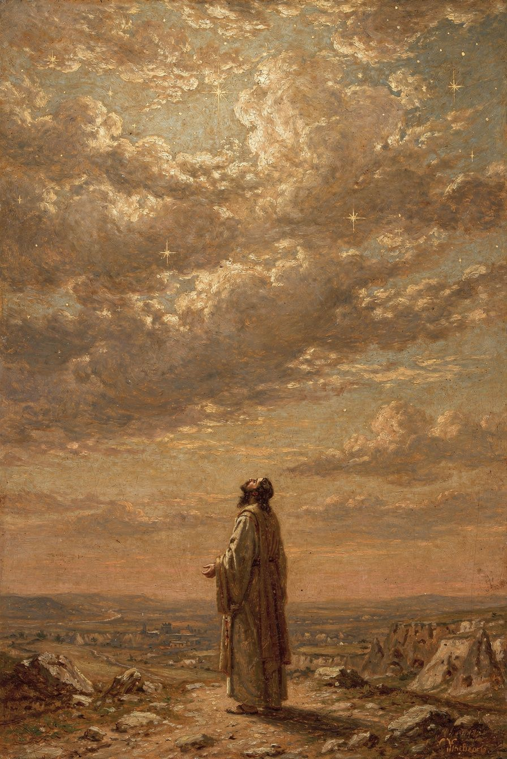
Illustration for Chapter 4

The Eunomian Controversy
Gregory's apophaticism was sharpened by his conflict with the Eunomians. Eunomius, an extreme Arian bishop, argued that "unbegotten" (agennetos) is not just a description of God but the exact name of God's essence. If you understand this one word, you understand God completely. Human reason can comprehend the divine nature fully. This was the most extreme form of theological rationalism in the early church.
Gregory found this absurd and dangerous. "Ingenerate" is a relational term — it describes the Father's mode of origin (he is not begotten) — not the divine essence. If "ingenerate" were the essence, then the Son, who is begotten, would not share the essence — which would make the Son a creature. The Eunomian argument, taken to its logical conclusion, destroys the Trinity by making the Son a created being.
More fundamentally, Gregory argued that no human word can capture the divine essence. The Eunomian claim to comprehensive knowledge of God was a form of spiritual pride. The person who thinks he has comprehended God has made an idol of his own concept.

What We Can Know
Gregory is careful not to collapse into pure agnosticism. He distinguishes between knowing God's essence (which is beyond us) and knowing God through God's energies (which is possible). We know God through what God does, not by comprehending what God is. God is known through creation, providence, the Incarnation, the Spirit, and purification. As the soul is purified from sin and passion, it becomes capable of seeing God more clearly. "Blessed are the pure in heart, for they shall see God" (Matthew 5:8).

The Scholarly Debate
Scholars debate what Gregory's apophaticism is primarily. The philosophical reading sees it as derived from Greek skepticism or Middle Platonism. The theological reading grounds it in the Creator-creature distinction and Scripture. The pastoral reading sees it as a discipline to produce humility. The mystical reading sees it as pointing toward the experience of God in darkness beyond words.
The emerging consensus is that it is all four, integrated. The philosophical tools serve the theological truth, which is deployed pastorally, and which opens into mystical encounter. To separate the dimensions is to impoverish all of them. Gregory's apophaticism shaped the entire Eastern tradition: Gregory of Nyssa's epektasis, Pseudo-Dionysius's "unknowing," Maximus the Confessor's integration with Christology, and Gregory Palamas's essence-energies distinction.
Scholarly debate on Gregory and Palamas: Gregory Palamas (14th century) developed the essence-energies distinction into the definitive Eastern articulation of apophaticism. Scholars debate how much Palamas owes to Gregory of Nazianzus. The connection is indirect — through Pseudo-Dionysius and Gregory of Nyssa — but real. Gregory of Nazianzus's insistence on the incomprehensibility of God's essence is the foundation on which Palamas built. Lossky (The Mystical Theology of the Eastern Church) traces a direct line from Gregory of Nazianzus through the apophatic tradition to Palamas. Papanikolaou (Being with God) argues that Gregory's apophaticism is not just about epistemological limits but about the nature of communion: we know God not by comprehending God's essence but by participating in God's energies, which is to say, by being in communion with God. The apophatic is not the absence of knowledge but the presence of a different kind of knowledge — the knowledge of encounter, of participation, of union.
The Big Idea
Gregory's apophaticism is not a philosophical position. It is an integrated epistemology — philosophical, theological, pastoral, and mystical — that shapes the entire Eastern apophatic tradition. The point is not that we know nothing about God. The point is that we know God truly but partially, and that the partial knowledge — the knowledge that knows its own limits — is the most honest and the most reverent form of theology.
Practice
1. Read Oration 28 in full. Find it at New Advent. Identify the four dimensions: Where does Gregory use philosophical arguments? Where does he ground the argument in Scripture? Where does he deploy it pastorally? Where does he gesture toward mystical encounter? Write 500 words on how the four dimensions integrate.
2. Try the apophatic exercise. Spend 20 minutes writing about God — but only in negations. "God is not..." When you run out of negations, sit with the silence. What does the exercise teach you about the limits of your own language? Write 300 words on the experience.
3. Research Gregory Palamas. Read about the hesychast controversy and the essence-energies distinction. How does Palamas build on Gregory of Nazianzus? What does it mean to say that we can know God's energies but not God's essence? Write 500 words on the implications for contemplative practice.
Reflect
Gregory said: "To know God is difficult, to express him is impossible." In an age of information — where everything is accessible, everything is explainable, everything is searchable — what does it mean to say that the most important thing is beyond comprehension? Is there value in not knowing? Is there a kind of knowledge that comes through acknowledging the limit?
———

Chapter 5: Christology — "What Is Not Assumed Is Not Healed"
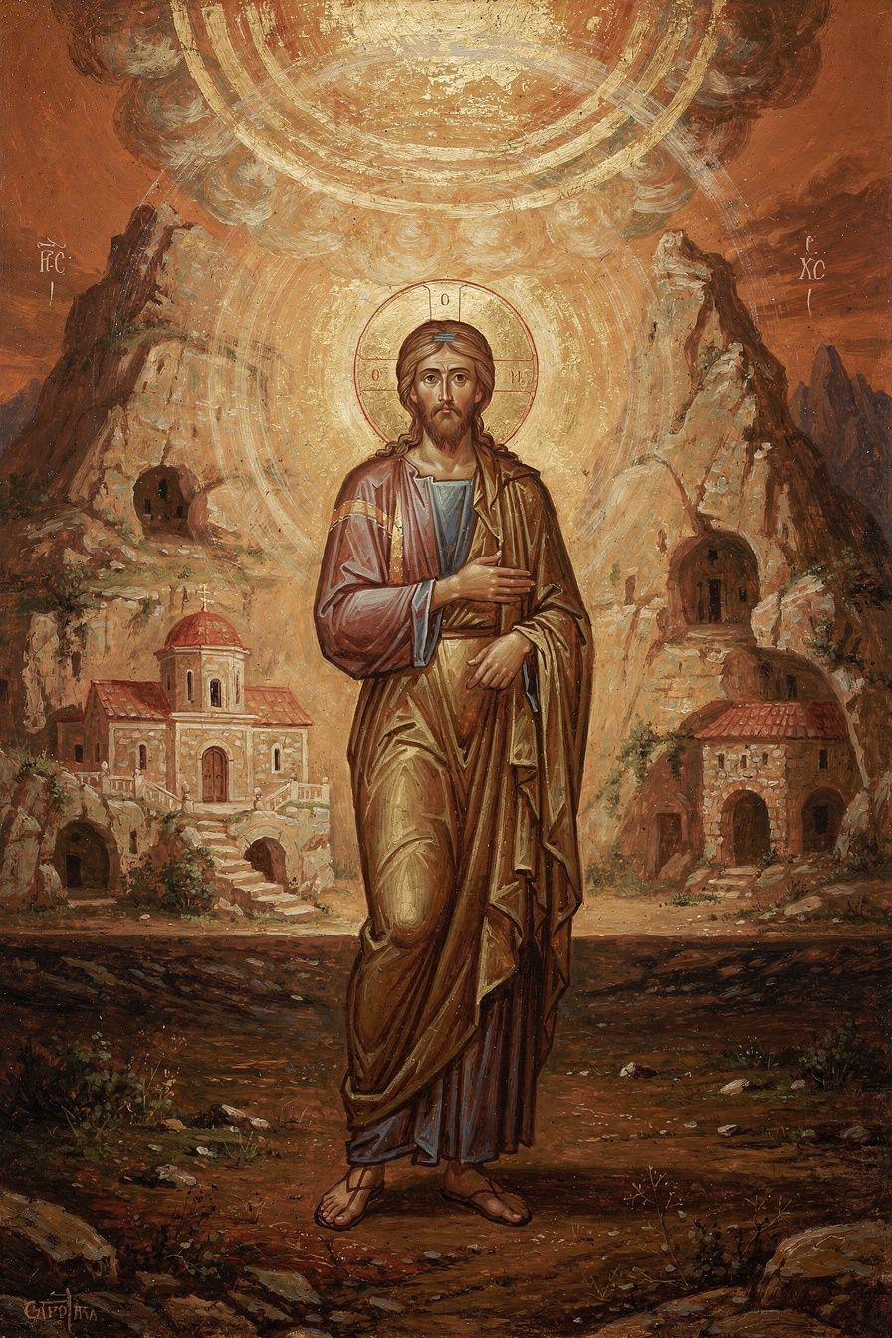
Illustration for Chapter 5

The Apollinarian Controversy
The most important Christological controversy of Gregory's time was Apollinarianism. Apollinarius of Laodicea (c. 310–390 CE) was a friend and ally of the Nicene party. He accepted the Son's full divinity. But he argued that the Son did not assume a full human mind (nous). The Word (the divine Logos) took the place of the human mind in Christ. Christ had a human body and a human soul, but his mind was divine, not human.
Apollinarius had a theological reason: the human mind is the seat of sin. If Christ had a human mind, he would have a sinful will, and therefore he could not be sinless. To preserve Christ's sinlessness, Apollinarius denied him a human mind. This was not a minor deviation; it was a serious Christological error with enormous implications for the doctrine of salvation.

Gregory's Principle
Gregory's response, in Letters 101 and 102 to Cledonius, is one of the most important sentences in the history of theology:
"The unassumed is not healed; but what is joined to his divinity, that is saved."
The logic is devastating. If the Son became human to heal humanity, he must become everything that humanity is. Every part that needs redemption — body, soul, mind, will — must be assumed. If any part is left out, that part is left unredeemed. The disease is in the mind; the cure must reach the mind. A Christ without a human mind saves bodies but not minds. Since the human mind and will are precisely what need healing, a Christ without a human mind cannot solve the problem.
The principle works by extension: if Christ has no human body, bodies are not redeemed; if no human soul, souls are not redeemed; if no human will, wills are not redeemed. Gregory's logic is simple and radical: salvation is not merely forgiveness; it is the healing and transformation of the whole human being. The whole of human nature needs healing; the whole of human nature must be assumed.
But what about Apollinarius's concern about sinlessness? Gregory's answer is that the human mind is not sinful by nature. It is a good creation of God that becomes sinful when it turns from God. Christ's human mind was real, but always in harmony with the divine will. The Incarnation itself is the healing: the Son enters the full human condition to transform it from within.

The Unity of the Person and the Communication of Attributes
Gregory insists that Christ is one person, not two. The Son did not inhabit a human being; he became a human being. The divine and human natures are united in one personal subject. This anticipates the Definition of Chalcedon (451 CE): "one person in two natures, without confusion, without change, without division, without separation."
Gregory also articulated the communicatio idiomatum: because Christ is one person, the attributes of both natures can be predicated of the one person. We can say "God suffered" and "God died" — not because the divine nature suffers, but because the one person who suffers is God. This is why Gregory can say "the Word became flesh" and "the flesh was the Word."

Deification: The Purpose of the Incarnation
For Gregory, the purpose of the Incarnation is not simply forgiveness. It is deification (theosis) — the transformation of human beings into participants in the divine life. "God became human, that human beings might become divine." This does not mean humans become God by nature. They remain creatures. But they share in God's life by grace — through the Spirit, through the sacraments, through the transformation of the whole person.
Deification is by grace, not by nature. It involves the whole person — body, soul, mind, and will. It is progressive — a lifelong process, and in the Eastern tradition, an eternal one, because God is infinite and there is always more to participate in. It is Trinitarian — the Father sends the Son, the Son unites human nature to the divine, the Spirit sanctifies the believer. It is communal — it happens in the church, through baptism, the Eucharist, and the life of the community, not in private mystical experience.
Gregory connects deification to the sacraments. In baptism, the Christian is born again — not merely forgiven but regenerated. The old self dies; a new self rises. The baptized person receives the Spirit and begins the process of transformation. In the Eucharist, the Christian receives the body and blood of Christ and is thereby joined more deeply to Christ. The Eucharist is not merely a memorial; it is a means of participation in the divine life. By eating the bread and drinking the wine, the believer is incorporated into Christ's deified humanity.
Deification requires cooperation with grace. The human person must respond through prayer, asceticism (the disciplined life that frees the person from the domination of the passions), virtue (the active practice of love, justice, mercy, humility), contemplation (meditation on God, Scripture, and the mysteries of faith), and sacramental life (regular participation in baptism, Eucharist, and the other sacraments). The goal is not mere moral improvement but transformation — the gradual change of the whole person into the image of Christ, who is the image of the Father.
Scholarly debate on East and West: Gregory's doctrine of deification became central to Eastern Orthodox theology and distinguishes the Eastern understanding of salvation from many Western models. In the East, salvation is deification — participation in the divine life. The problem is not just guilt but corruption; the cure is not just pardon but transformation. In the West (Augustine, Anselm, the scholastic tradition), salvation is often framed as justification — the forgiveness of sin and the restoration of a right relationship with God. Russell (The Doctrine of Deification in the Greek Patristic Tradition, Oxford, 2004) traces the doctrine from Irenaeus through the Cappadocians to Maximus, showing that Gregory gives the doctrine its most memorable expression. Lossky argues that theosis is the central difference between East and West — not a contradiction but a different emphasis. In recent ecumenical dialogue, Western theologians (Carl Mosser, "The Greatest Gift"; Thomas Weinandy) have explored integrating theosis into Western frameworks. The emerging consensus is that the two emphases are complementary, not contradictory: salvation includes both forgiveness (justification) and transformation (deification), and a complete doctrine of salvation requires both.
The Big Idea
Gregory's Christology is driven not by speculative philosophy but by the logic of salvation. The question is not "What can we say about Christ's natures?" but "What needs to be healed, and what must the Savior assume to heal it?" From this pastoral question, Gregory works out the doctrinal definition: Christ is fully God and fully human, one person in two natures, because only a fully divine and fully human Savior can save the whole human being.
Practice
1. Read Letter 101. Find Gregory's letter to Cledonius at New Advent. Trace the argument: What is the logic of "what is not assumed is not healed"? How does Gregory handle Apollinarius's concern about sinlessness? Write 500 words on the pastoral logic of Gregory's Christology.
2. Compare East and West on salvation. Read Gregory's deification formula alongside Augustine's justification framework. Read 2 Peter 1:4 ("partakers of the divine nature") and Romans 3:24 ("justified by his grace"). How do these two biblical emphases relate? Write 500 words on whether theosis and justification are contradictory or complementary.
3. Examine the communicatio idiomatum. Find three biblical passages that predicate divine attributes of the human Christ or human attributes of the divine Son (Acts 20:28, 1 Corinthians 2:8, Philippians 2:6-8). What does it mean to say that the one who died on the cross is God?
Reflect
Gregory's Christology begins not with a philosophical system but with a pastoral question: What needs to be healed? What does it mean to do theology from the needs of the church rather than from the needs of the academy? How would your understanding of Christianity change if you started with "What needs to be saved?" rather than "What is the correct doctrine?"
———

Chapter 6: The Poet Who Went Home — Retirement, Grief, Poetry, and Legacy
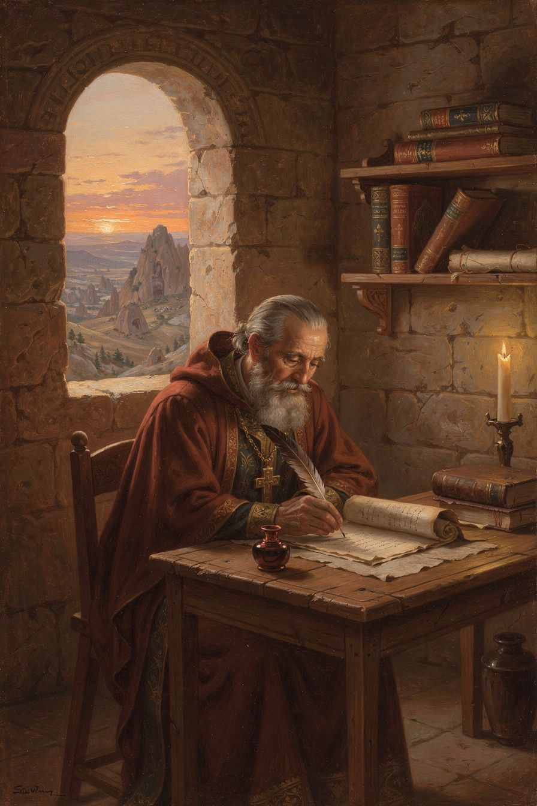
Illustration for Chapter 6

Retirement at Arianzus
After his resignation from Constantinople in 381 CE, Gregory spent his last decade in retirement at Arianzus. He continued to write — poetry, letters, theological reflections — but never returned to public office. His withdrawal was a theological act: choosing contemplation over power, silence over argument, the presence of God over the politics of the church.

The De Vita Sua: Autobiography as Theology
Gregory's longest poem, De Vita Sua ("Concerning His Own Life"), runs to nearly 2,000 lines. Written in retirement, it reviews his entire life: education, friendship with Basil, reluctant ordination, Constantinople, illnesses, griefs, and withdrawal. It is one of the earliest extended autobiographies in Christian literature.
The poem is a theological interpretation of a life. Gregory reads his own story through the lens of providence — seeing God's hand in his successes and failures, his friendships and his loneliness. He is honest about his disappointment, anger, and weariness. He describes the church politics that wearied him, the betrayal by friends that wounded him, the physical illnesses that weakened him. But he also describes the joy of study, the beauty of friendship, the peace of contemplation. The poem is a whole life seen under the aspect of God.
What makes the De Vita Sua remarkable is its emotional honesty. Gregory does not present himself as a saint who has figured it all out. He presents himself as a man who has been battered by life and is trying to understand what it means. He asks: Why did I keep running away? Why did God keep bringing me back? What did it all mean? The poem does not answer these questions neatly. It holds them — in the tension between providence and pain, between calling and reluctance, between the desire for quiet and the demands of service.
Gregory's withdrawal to Arianzus was not merely retirement. It was a theological act. He had argued in Oration 27 that theology requires a formed soul, and in Oration 28 that God is incomprehensible. His withdrawal was a form of practicing what he preached — choosing contemplation over power, silence over argument, the presence of God over the politics of the church. The De Vita Sua is the fruit of that choice. It shows what theology looks like when it is done not from a position of power but from a position of reflection — after the battles are over, after the losses are absorbed, when the only question left is: where was God in all of this?
The autobiographical form itself is theologically significant. Gregory is not writing a treatise or a sermon. He is writing his life. The choice to interpret his own experience theologically — to read his successes and failures through the lens of providence, to see God's hand in both his calling and his resistance — is itself a theological statement. It says: a life, read through the lens of faith, is itself a theological text. Our stories are part of God's story. The De Vita Sua is one of the earliest examples of this kind of theological autobiography in the Christian tradition, and it established a precedent that would be followed by Augustine's Confessions and the long tradition of Christian autobiography that followed.

Poetry as Theology
Gregory is the only one of the great Greek Fathers to have produced a large body of theological poetry — around 17,000 surviving lines from a reported 30,000. His Poemata Arcana treat the Father, Son, Spirit, creation, providence, and the soul in verse. He calls the Son "the unspeakable speech of the Father." His moral poems treat virtues and vices. His epitaphs honor friends and family. He believed that beauty and truth belong together, and that poetry can express what prose cannot.
Gregory did not consider poetry a break from theology. He considered it a form of theology — a way of knowing and expressing truth that prose cannot fully capture. Poetry reaches what argument misses. Argument persuades the mind; poetry moves the heart. His prose is precise and powerful, but his poetry can express grief, longing, joy, and wonder in ways that his orations cannot. The De Vita Sua shows a man processing his life through verse, finding meaning in rhythm and image.
Gregory also wrote poetry as a spiritual practice. The discipline of finding the right word, the right meter, the right image is a form of contemplation. It forces the writer to slow down, to attend to the gift of language, to honor the subject. In Gregory's hands, poetry becomes prayer. The moral poems were meant for memorization and meditation — putting doctrine in verse was a way of making it stick in a culture where poetry was a primary form of cultural memory. His poetic project also had a cultural dimension: he was replacing pagan verse with Christian content, showing that the same literary forms can serve the gospel. If Homer wrote about the wrath of Achilles, Gregory would write about the love of God. The forms belong to whoever can use them well.
Scholarly debate on poetry as theology: Is Gregory's poetry theology or literature? Simelides (Selected Poems of Gregory of Nazianzus, 2009) emphasizes the literary dimension — Gregory's poetry is a major achievement in the classical tradition. McGuckin emphasizes the theological dimension — the poems are as doctrinally careful as the orations. The integrated reading is that the poetry is both literature and theology, and separating them impoverishes both. Gregory's example challenges the modern separation of theology and literature.

The Theologian of Grief
Gregory's funeral orations — for Caesarius (Oration 7), Gorgonia (Oration 8), his father (Oration 18), and Basil (Oration 43) — are among the most moving documents in patristic literature. They show a man wrestling with grief honestly, bringing his pain before God.
Gregory's approach to grief is not Stoic resignation. He grieves. He weeps. He laments. He asks God why. But he also hopes — in the resurrection, in the communion of saints, in the promise that death is not the end. The pattern is: name the loss, celebrate the life, wrestle with meaning, commend to God. The hope of resurrection does not eliminate grief; it gives grief a horizon.
Gregory's personal experience of loss shaped his theology. His insistence that God is beyond comprehension is not just philosophical; it is the fruit of suffering. When you have lost the people you love most, you cannot accept a God who fits in your system. God must be bigger than your understanding — big enough to hold your pain and your questions without breaking. His insistence in Oration 27 that theology requires a formed soul is connected to his experience of suffering. The person who has not suffered cannot do theology well — not because suffering makes you wise automatically, but because suffering breaks the illusion that you are in control. The theologian who has not been broken by loss does not know the limits of human knowledge.
His Christology is also shaped by his understanding of suffering. In Oration 29, he argues that the Son took on human nature, including human suffering, so that suffering itself could be transformed. The Incarnation means that God has entered into human pain — not to explain it away, but to be present in it. The hope of resurrection is not abstract; it is the hope of a man who has lost the people he loves and trusts that God will not let loss have the last word.
The pattern of Gregory's grief is itself a contribution to practical theology. The four-stage pattern — name the loss, celebrate the life, wrestle with meaning, commend to God — is not a formula. It is the natural movement of a grieving person who is also a theologian. It moves from pain to memory to questioning to trust. It does not skip any stage. It does not rush to comfort. It grieves honestly and hopes faithfully. This pattern has been influential in pastoral theology and continues to offer a model for Christian grief that is neither stoic resignation nor sentimental avoidance.
Scholarly debate on Gregory's grief: Simmons ("Gregory of Nazianzus on Grief," Studia Patristica, 2012) compares Gregory's funeral orations with pagan epideictic rhetoric and finds that Gregory transforms the classical form by filling it with Christian content — hope in resurrection, trust in providence, the communion of saints. Sterk emphasizes the monastic dimension — Gregory's grief is disciplined by his ascetic formation, which teaches him to grieve honestly but not to be destroyed by grief. The integrated reading is that Gregory combines the rhetorical power of classical funeral oratory with the theological depth of Christian hope, producing a form of grief that is both honest and faithful.

The Title: "The Theologian"
The Council of Ephesus (431 CE) formally gave Gregory the title "the Theologian" — a title shared in the East only with John the Evangelist. The doctrinal reading (McGuckin, Beeley) says it refers to Gregory's articulation of Trinitarian doctrine. The spiritual reading (Ware, Lossky) says it refers to his understanding of theology as a holy act. The literary reading (Simelides) says it refers to his rhetorical and poetic achievement. The integrated reading says it means all three: Gregory showed what theology looks like when it is doctrinally precise, spiritually rooted, and beautifully expressed.
The separation of doctrine, spirituality, and beauty is the tragedy of modern theology. Gregory shows us what they look like together — and the title "the Theologian" is the church's way of saying: this is what theology should be.
The Big Idea
Gregory's retirement was not a failure but his most productive period. His poetry shows that theology can be beautiful, that a life read through the lens of faith is itself a theological text, and that honesty about grief and disappointment is a form of truthfulness. The title "the Theologian" means that Gregory showed what theology looks like when it integrates doctrine, spirituality, and beauty.
Practice
1. Read a funeral oration. Read Oration 7 (for Caesarius) or Oration 43 (for Basil) at New Advent. Identify the four stages: naming the loss, celebrating the life, wrestling with meaning, commending to God. Write 500 words on how Gregory's approach to grief differs from the Stoic ideal and from modern approaches to grief.
2. Try autobiographical theology. Write 1,000 words on your own life through the lens of faith — not as a diary but as a theological interpretation. Where was God in your successes? In your failures? In your friendships? In your losses? Gregory's De Vita Sua shows that a life, read theologically, is itself a theological text.
3. Read Gregory's poetry. Find Peter Gilbert's translation of the Poemata Arcana (On God and Man, SVS Press, 2001). Read the poem "On the Son." Compare it with Oration 29. Same doctrine, different form. What does verse do that prose cannot? What does prose do that verse cannot? Write 500 words on the relationship between theological form and theological content.
Reflect
Gregory is called "the Theologian" because he integrated doctrine, spirituality, and beauty. Modern theology often separates these — academic theology can be doctrinally precise but spiritually barren and stylistically ugly. What would it look like to recover Gregory's integration? Can theology be both true and beautiful? Does the form of theology matter as much as the content?
———

For the Grown-Up Reader
This booklet engages Gregory of Nazianzus as a serious theological figure for adult readers. The content is faithful to Gregory's orations, letters, and poems, and to the scholarly literature.
The scholarly debate paragraphs draw on real disagreements in the literature: the doctrinal vs. spiritual vs. literary readings of the title "the Theologian"; the philosophical vs. theological vs. pastoral vs. mystical readings of apophaticism; the filioque debate; the East-West difference on deification vs. justification; the debate over Gregory's leadership model; and the question of Gregory's Christian Hellenism.
———

Sources
Primary: - Orations 2, 7, 8, 18, 27–31, 38, 40, 42, 43 — New Advent (www.newadvent.org/fathers); Williams and Wickham, Five Theological Orations (Brill, 2002) - Letters 101–102 to Cledonius — in Hardy, Christology of the Later Fathers (Westminster Press, 1954) - De Vita Sua — Meehan, Gregory of Nazianzus: Autobiographical Poems (Dumbarton Oaks, 2007) - Poemata Arcana — Gilbert, On God and Man: The Theological Poetry of St. Gregory of Nazianzus (SVS Press, 2001)
Secondary: - McGuckin, John A. St. Gregory of Nazianzus: An Intellectual Biography. SVS Press, 2001. - Beeley, Christopher A. Gregory of Nazianzus on the Trinity and the Knowledge of God. Oxford University Press, 2008. - Daley, Brian E. Gregory of Nazianzus. Routledge, 2006. - Russell, Norman. The Doctrine of Deification in the Greek Patristic Tradition. Oxford, 2004. - Ayres, Lewis. Nicaea and Its Legacy. Oxford, 2004. - Lossky, Vladimir. The Mystical Theology of the Eastern Church. SVS Press, 1944. - Sterk, Andrea. Renouncing the World Yet Leading the Church. Harvard, 2004. - Pelikan, Jaroslav. Christianity and Classical Culture. Yale, 1993.
Quotations adapted by Airia Edge from public-domain translations at New Advent (www.newadvent.org/fathers).
———

About WisdomForge
WisdomForge produces four booklets for each figure, adapted to four age groups: elementary (5–10), middle (11–14), high (15–18), and adult. Each booklet covers the same six themes but at a different depth and with different activities. The goal is simple: the wisdom of the greatest thinkers, made accessible to every age.

