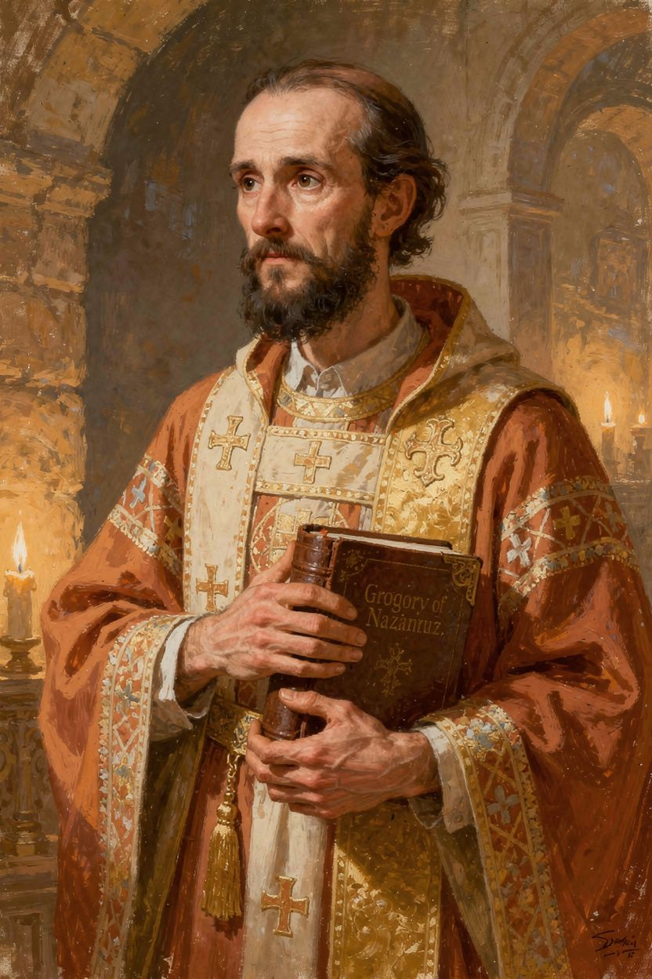
Gregory: The Man Who Talked About God
WisdomForge Booklet — Ages 5–10

Gregory: The Man Who Talked About God

WisdomForge Booklet — Ages 5–10
———

About This Book
A long, long time ago — about 1,700 years — there lived a man named Gregory. He loved books. He loved his friends. He loved quiet. But most of all, he loved God.
Gregory did not want to be a leader. He did not want to be a bishop. He did not want to stand up in front of crowds and give speeches. He just wanted to read, and pray, and think about God in peace.
But God had other plans. Gregory became a priest, then a bishop, then the most important speaker about God in the whole church. He helped the church understand that God is Father, Son, and Holy Spirit — one God, three persons. He taught that God is too big for our minds to fully understand. He wrote poems about God that are still read today.
This booklet tells six stories from Gregory's life. Each one has a story, words to remember, a big idea, something to try, and a question to ask a grown-up. Read it alone or with someone you love. The questions are not tests. They are doors to walk through together.
Gregory lived in the fourth century — about 1,700 years ago. He was born in a place called Cappadocia, which is in modern-day Turkey. He studied in the greatest schools in the world. He became a priest against his will. He led a tiny church in the biggest city on earth. He helped the church understand who God is. He wrote poems that are still read today. And the church gave him a title that almost no one else has: "the Theologian." That means he was the best at talking about God — not because he was the smartest, but because he loved God the most.
———

Chapter 1: The Boy Who Loved Books
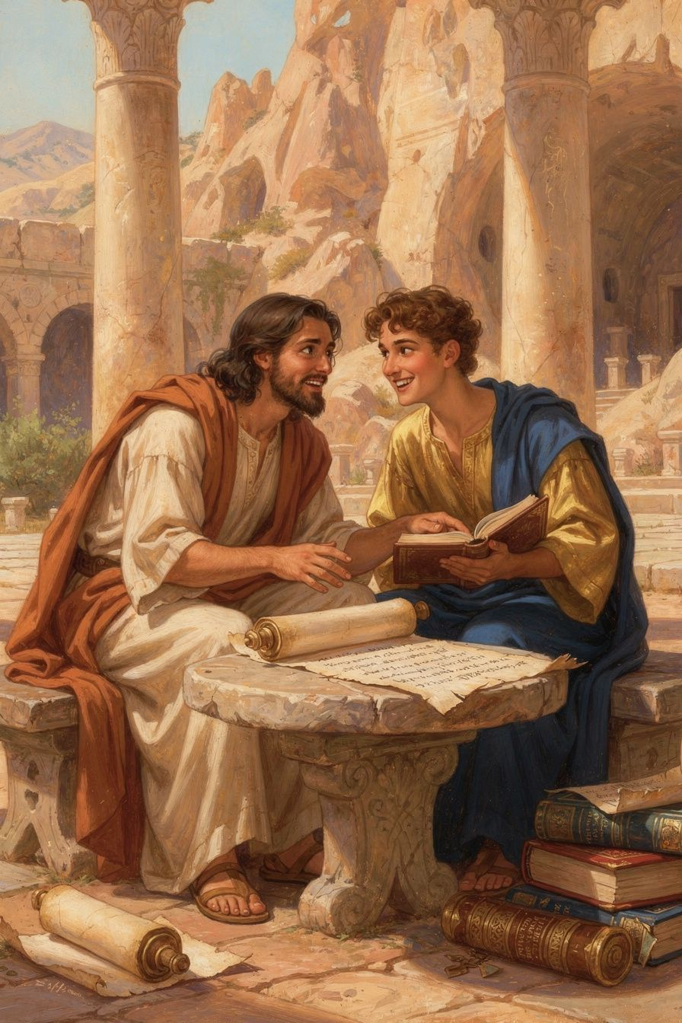
Illustration for Chapter 1
Gregory was born in a small village called Arianzus, in a part of the Roman Empire called Cappadocia. His family was wealthy. His father was the bishop of the nearby town of Nazianzus. His mother, Nonna, was a woman who prayed all the time and taught Gregory about God from the time he was tiny.
Gregory's family was special in another way too. His brother Caesarius was a brilliant doctor who worked for the emperor. His sister Gorgonia was a kind, wise woman who was married and had children. Gregory loved all of them very much, and when they died, he wrote speeches about them that showed how much they meant to him. His family was not perfect — Gregory and his father sometimes argued about what Gregory should do with his life. But they loved each other, and that love shaped everything Gregory did. He studied in Caesarea, then in Alexandria, and then in Athens — the most famous school in the ancient world. In Athens, Gregory studied reading, writing, speaking, and thinking. He loved every minute of it.
In Athens, Gregory met a boy named Basil. Basil was serious and organized. Gregory was a poet and a dreamer. They were very different, but they became best friends. Gregory said they were "the talk of the city — two young men who had given themselves to God, in a city that worshipped idols." Other students were out having fun at parties. Gregory and Basil were studying, praying, and talking about God.
Gregory loved his time in Athens. He loved the books, the teachers, the arguments, and his friend Basil. He wanted to stay there forever, reading and thinking.
In Athens, Gregory learned something he never forgot: how to speak well. He learned how to use words carefully, how to make people listen, how to tell a story that makes people think and feel at the same time. Later, this skill would make him one of the greatest speakers the church has ever had.
He also learned something about friendship. Gregory and Basil did not agree about everything. Basil was practical and organized. Gregory was a dreamer and a poet. But they respected each other, and their differences made them stronger together. Gregory said that their friendship was "not the bond of blood but the bond of the Spirit."
But eventually, Gregory had to go home. He said goodbye to Athens, to the libraries, to the teachers — and to Basil. He did not know it yet, but the things he learned in Athens would change the world.
Words to Remember "We were the talk of the city — two young men who had given themselves to God, in a city that worshipped idols." — Gregory, remembering his student years with Basil in Athens (Oration 43)
Big Idea The best friendships are friendships that help you grow. Gregory and Basil were very different, but they pushed each other to be better. A friend who helps you love God and love learning is a treasure.
Try This - Think about your best friend. What makes them a good friend? Do they help you be better? Draw a picture of you and your friend doing something you love together. - Find Athens on a map or globe. Athens is in Greece, and it is still a big city today. Gregory traveled very far to study there — by boat and on foot, not by car or plane! - Learn the name "Gregory." Say it three times: GREG-or-ee. He lived in Cappadocia, which is in modern-day Turkey. Find Turkey on a map.
Ask a Grown-Up "Who is your best friend? What makes them special to you?"
———

Chapter 2: The Man Who Ran Away
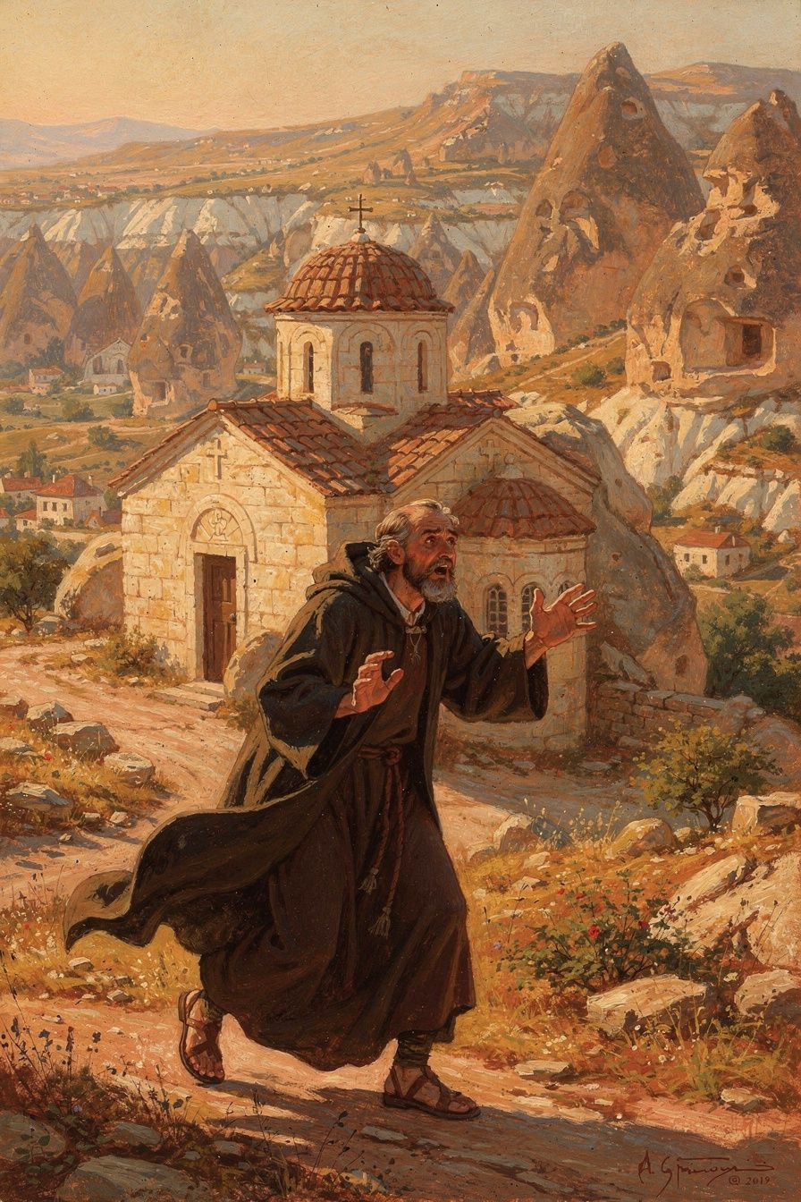
Illustration for Chapter 2
When Gregory came home from Athens, he wanted a quiet life. He wanted to read books, pray, and spend time with his friend Basil in a monastery. He thought that was what God wanted for him.
But his father had other plans. Gregory's father was the bishop of Nazianzus, and one day, without asking Gregory, he made him a priest. Just like that. No warning. No asking. Gregory was horrified.
He ran away. He went to Basil's monastery in Pontus, far away from Nazianzus. He stayed there for a while, praying and thinking. Was being a priest really what God wanted? Was he good enough for such a big job? Gregory was not sure.
Eventually, Gregory went back. He accepted the priesthood and served under his father. But he never forgot the feeling of being forced into something he was not ready for. He wrote a whole speech about it, called the Apology for His Flight. In it, he said that being a priest is too important to be done carelessly. You have to be ready. You have to be the right kind of person. You cannot just be pushed into it.
Years later, the same thing happened again. His friend Basil, who was now a bishop, told Gregory to go be bishop of a tiny, horrible town called Sasima. Gregory was angry. Sasima had no water, no trees, and no civilization. He felt like Basil was using him as a pawn in a game. He went there briefly, found it terrible, and left.
Gregory kept running away from leadership. But every time he ran, God brought him back. And every time he came back, he did better work than the time before.
Gregory's story reminds us of something important: being a leader does not mean you are always brave. Sometimes you are scared. Sometimes you want to run. But what matters is that you come back. Gregory came back every time — and each time, he brought something new with him. He brought his honesty, his prayers, and his beautiful words about God. He showed that even a person who runs away can be used by God to do great things.
Words to Remember "Not to everyone, my friends, does it belong to philosophize about God." — Gregory, Oration 27 (meaning: talking about God is serious business, not a game)
Big Idea Sometimes the people who are best at something do not want to do it. Gregory did not want to be a leader. But when he said yes, he changed the whole church. Sometimes God calls us to do things that scare us — and that is exactly why we should do them.
Try This - Think of a time you were asked to do something you didn't want to do. Maybe a teacher asked you to read out loud, or a parent asked you to help with a chore. How did it feel? What did you do? Did you say yes or no? - Pretend you are Gregory. You love books and quiet, but people keep asking you to be a leader. Write down what you would say to them. Would you say yes? Would you say no? What would you ask them? - Learn the word "priest." A priest is someone who leads a church and helps people pray. Gregory did not want to be one, but he became one of the best.
Ask a Grown-Up "Have you ever run away from something that was hard? Did you go back? What happened?"
———

Chapter 3: The Tiny Church That Won
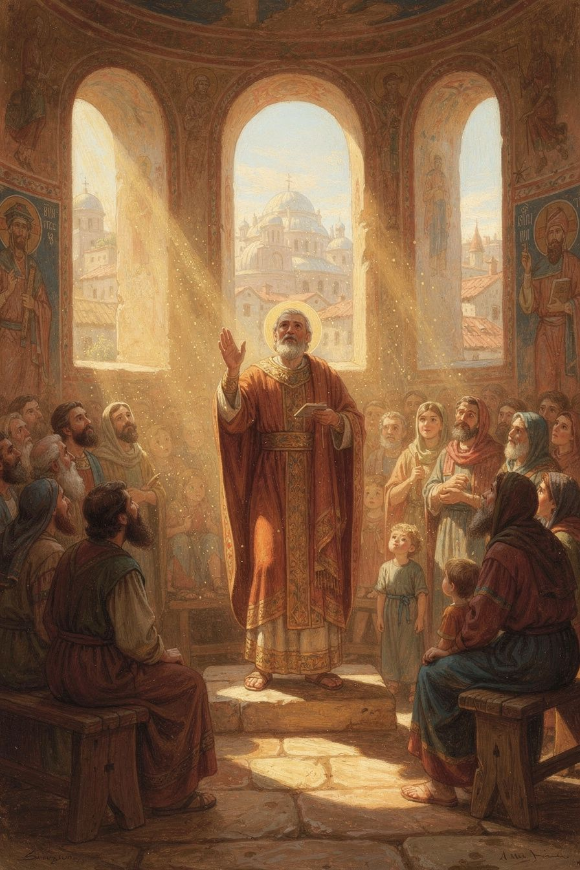
Illustration for Chapter 3
The biggest adventure of Gregory's life happened in a city called Constantinople. Constantinople was the capital of the Roman Empire — the biggest, most important city in the whole world.
But there was a problem. Most of the people in Constantinople believed the wrong thing about God. They believed that Jesus was not fully God — that he was a created being, like an angel, not the Son of God. The people who believed the right thing — that Jesus is fully God — were a tiny group. They had no church building. They met in a house and called it the Anastasia, which means "Resurrection."
Gregory was invited to come lead this tiny group. He arrived in Constantinople a stranger. He was sick. He was tired. He had no church, no money, and very few people on his side.
But Gregory could preach. He stood up in the little house-church and preached five speeches about God — the Five Theological Orations. He explained that God is Father, Son, and Holy Spirit. One God, three persons. The Son is not a creature. The Spirit is not a creature. All three are God, forever.
People came to hear him. More and more people came. The little house-church filled up. One night, enemies attacked the church and smashed the windows. But the attack made people feel sorry for Gregory's group, and even more people joined.
Gregory's five speeches were so good that people still call them the Five Theological Orations. In them, Gregory explained three big things. First, that God is one God in three persons — Father, Son, and Holy Spirit. Second, that God is too big for our minds to fully understand. Third, that the people who talk about God should be the kind of people who pray and live good lives. These three ideas changed the church forever.
Then a new emperor came to power — a man named Theodosius who believed the right thing about God. The wrong-thinking bishops were sent away. Gregory was made bishop of Constantinople. The tiny church had won.
But there is a sad part to the story. When the big church leaders met together at a council, they told Gregory he could not be bishop anymore. They said he had broken a rule by moving from one town to another. Gregory was tired and sick. He did not fight them. He said: "I did not seek this office; I will not cling to it." He said goodbye to the church he loved and went home.
Even though Gregory left, the truth he preached won. The council agreed with Gregory's teaching about God. The creed they wrote — the words the church still says today — was shaped by Gregory's words. The man who lost his job won the argument. The bishop who went home in sadness changed the church forever.
Words to Remember "Christ is born, glorify Him! Christ is from heaven, go to meet Him!" — Gregory, Oration 38 (his Christmas sermon, full of joy)
Big Idea What matters is not how big you are, but whether you are right. Gregory's church was tiny. The other side had all the power. But Gregory had truth, and truth is stronger than power. Sometimes the smallest voice says the most important thing.
Try This - Build a tiny church. Use blocks, pillows, or whatever you have. Gregory's church was so small it was in a house. But it changed the world. The size of the building doesn't matter — the size of the faith does. - Learn the name "Constantinople." Say it: CON-stan-ti-NO-pol. It was the capital of the Roman Empire. Today, the city is called Istanbul, and it is in Turkey. - Think about a time you were the only one who believed something. Maybe everyone else said one thing, and you knew it was wrong. How did it feel? What did you do?
Ask a Grown-Up "Have you ever been the only one who was right about something? How did it feel? Did you speak up?"
———

Chapter 4: Talking About God Carefully
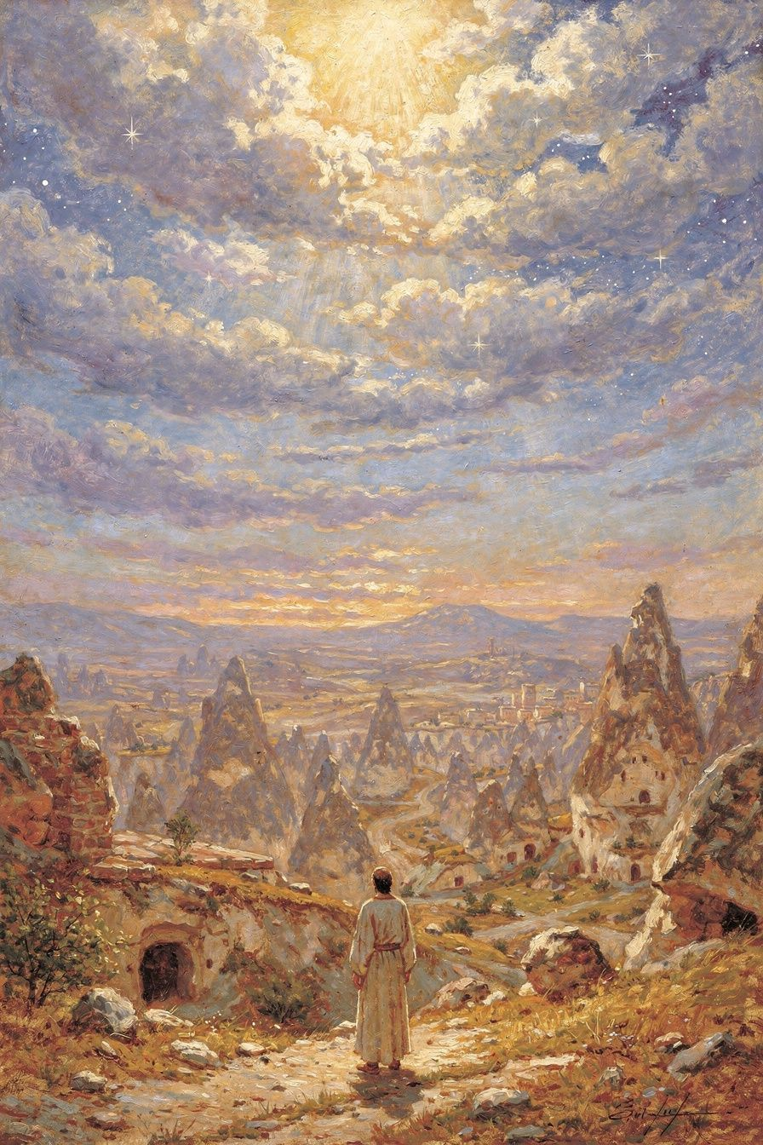
Illustration for Chapter 4
Gregory was famous for talking about God. But he also said something surprising: not everyone should talk about God. And those who do talk about God should do it very carefully.
In Gregory's time, people argued about God everywhere — at dinner, at the barber shop, in the market. Everyone had an opinion. Gregory thought this was dangerous. Talking about God is not like talking about sports or the weather. God is too big, too holy, and too wonderful to be treated like a game.
Gregory said that the people who talk about God should be the kind of people who pray, who are kind, who are humble. If you are not the right kind of person, your talk about God will be wrong — even if your words sound smart. You need a clean heart to see God clearly.
Gregory also said that God is too big for our minds to fully understand. You can know God is real. You can know what God does — you can see God's love in the world, in people who are kind, in the beauty of nature. But you cannot fully understand what God is. God is like the sun: you can see the light, feel the warmth, watch things grow — but you cannot stare directly at it. The light is too bright for your eyes.
This does not mean we know nothing about God. Gregory said we can know God truly, like you know a friend. But we cannot fully understand God, because God is bigger than any mind.
Gregory also said something wonderful: we should think about God more often than we breathe. Every breath you take, you could be thinking about God. Not with big, difficult words. Just with your heart. Gregory said the best kind of knowing God is not like knowing a math fact. It is like knowing a friend. You know a friend by spending time with them. You know God by praying, by loving, by being kind, by paying attention to the beautiful things in the world.
Gregory's idea about God being too big for our minds changed the church. It taught people to be humble — to know that even the smartest person cannot fully understand God. And it taught people to worship. If God is too big for words, the best thing we can do is not talk, but pray.
Words to Remember "We ought to think of God even more often than we draw our breath." — Gregory, Oration 27
Big Idea Talking about God is a serious, wonderful thing — not a game for dinner parties. The best people to talk about God are the ones who actually know God, not just know about God. And even the best talkers know that God is too big for words.
Try This - Try the sun test. Go outside on a sunny day. Look at the light on the trees, on the ground, on your hands. But don't look directly at the sun — it's too bright! Gregory said God is like that. We see God's light in the world, but we can't fully see God. - Think about what it means to know someone. You know your mom or dad, right? But do you know everything about them? Do you know what they are thinking right now? You know them truly, but not fully. Gregory said knowing God is like that. - Write down one thing you know about God. Just one. Gregory said we know God truly, even if not fully. What is one thing you are sure of?
Ask a Grown-Up "What do you think it means to know God? Is it different from knowing about God?"
———

Chapter 5: God Became Human
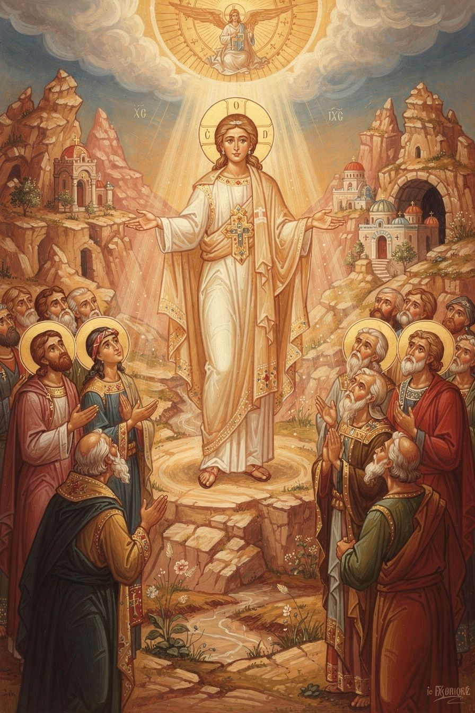
Illustration for Chapter 5
One of the most important things Gregory taught was about Jesus. Who is Jesus? Gregory's answer was simple and powerful: Jesus is fully God and fully human.
Some people in Gregory's time said Jesus was God wearing a human body, like a costume. They said Jesus did not have a human mind — his mind was just the mind of God. Gregory said no. If Jesus does not have a human mind, then human minds are not saved. If Jesus does not have a human will, then human wills are not healed.
Gregory wrote a famous sentence that the church has never forgotten: "What Christ did not assume, he did not heal." This means: Jesus had to become everything that we are — body, mind, will, feelings — so that everything about us could be healed. Every part of us that needs saving, Jesus took on.
Gregory also said something beautiful about why Jesus came: "God became human, that human beings might become divine." This does not mean we become God. It means God shares his life with us. A coal on its own is dark and cold. But put it in a fire, and it glows — hot and bright. The coal is still a coal, but now it is full of fire. Gregory said God wants to do that with us — fill us with God's love and light so we shine.
This is the heart of Gregory's teaching: God came all the way down to us so that we could be lifted all the way up to God.
Gregory lost many people he loved. His brother Caesarius died young. His sister Gorgonia died not long after. His best friend Basil died. His father died. Gregory wrote speeches for each of them when they died, and in those speeches he was honest about his sadness. He cried. He asked God why. But he also believed that death is not the end — that the people he loved were with God, and that one day he would see them again. Gregory's faith was not just ideas in his head. It was the thing that held him when his heart was breaking.
Words to Remember "God became human, that human beings might become divine." — Gregory, Oration 29
Big Idea Jesus is fully God and fully human. He took on everything we are — body, mind, feelings — so that everything about us could be healed. God came down to us so we could go up to God.
Try This - Try the coal experiment. (Ask a grown-up to help!) Watch a fire or look at a picture of glowing coals. The coals are still coals, but they glow with the fire's light. Gregory said that's what God does with us — fills us with God's light while we stay ourselves. - Think about a doctor who becomes a patient. A doctor can't heal a sickness from outside. She has to understand what it feels like from inside. Jesus is like that: God came into our world — our bodies, our feelings, our sadness — to heal us from inside. - Draw a picture of God coming down. Gregory said God came all the way down to us. Draw a ladder or a bridge from heaven to earth. Jesus is the bridge.
Ask a Grown-Up "What does it mean that Jesus was fully God AND fully human? Why does it matter that he had a human mind, not just a divine mind?"
———

Chapter 6: The Poet Who Went Home
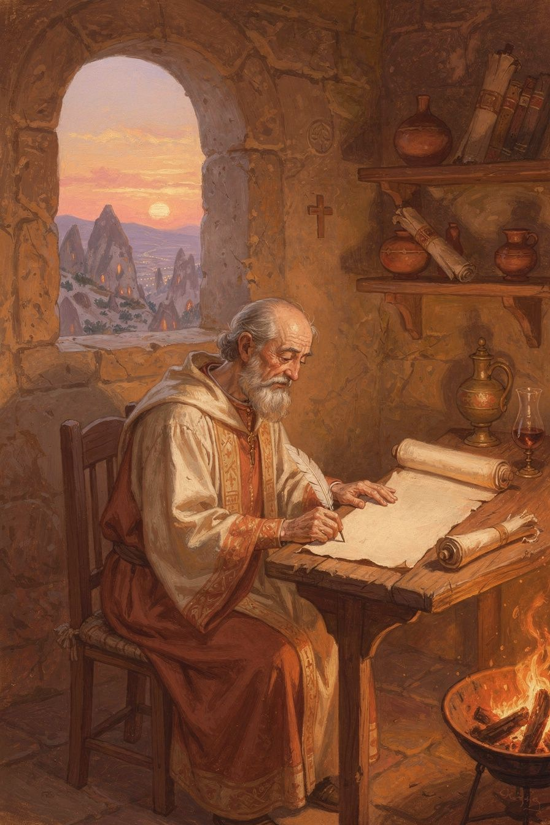
Illustration for Chapter 6
After all his adventures — the preaching, the council, the arguments — Gregory went home. He was tired. He was sick. He was tired of church politics. So he went back to his little village of Arianzus, and he spent his last years writing poetry.
Gregory was the only one of the great church leaders who wrote poetry. He wrote poems about God, about creation, about his own life. He wrote about his friend Basil, his brother Caesarius, his sister Gorgonia — all the people he had loved and lost. He wrote about his own mistakes and his own grief.
His longest poem is called De Vita Sua — "Concerning His Own Life." In it, he looks back at everything that happened to him and asks: where was God in all of this? He sees God's hand in his successes and his failures, his friendships and his loneliness, his times of influence and his times of quiet.
Gregory was given a special title by the church: "the Theologian." Only one other person in the Eastern church has this title — John, who wrote the Gospel. The title means that Gregory was the best at talking about God. But Gregory would have said: the best talking about God comes from spending time with God, not from being clever.
Gregory died around 389 or 390 CE, in his little village, surrounded by his books and his poems. He had wanted a quiet life. He never got it. But the words he left behind — his orations, his letters, his poems — are still read today, 1,700 years later. The boy who loved books became the man the church calls "the Theologian."
Gregory's life teaches us something important: you do not have to be the loudest or the strongest to make a difference. Gregory was shy. He was sick. He kept running away. But he loved God, he loved his friends, he loved beautiful words, and he told the truth. That was enough. That changed the church forever. And the poems he wrote at the end of his life — quiet, honest, beautiful — are among the greatest gifts the church has ever received.
Words to Remember "I had two great loves in life: wisdom and the friend of wisdom." — Gregory, De Vita Sua (meaning: he loved learning and he loved his friend Basil)
Big Idea Gregory wanted a quiet life, but God gave him an extraordinary one. He used his last years to write poetry — beautiful words about God that are still read today. The best way to talk about God is with beauty, truth, and love.
Try This - Write a short poem about something you love. Gregory wrote poems about God, about his friends, about his life. What do you love? Write four lines about it. It doesn't have to rhyme — just be honest. - Think about what you want people to remember about you. Gregory is remembered as "the Theologian" — the person who talked about God better than anyone. What would you like people to remember about you? - Look at a poem or a song you love. Gregory believed that beautiful words help us know God. What is a song or poem that makes you feel close to something bigger than yourself?
Ask a Grown-Up "If you could have a special title — like 'the Musician' or 'the Builder' or 'the Helper' — what would you want it to be? Why?"
———

For the Grown-Up Reader
This booklet introduces children to Gregory of Nazianzus (c. 329/330–389/390 CE), one of the most important theologians in Christian history. The stories are simplified but faithful to Gregory's life and thought as preserved in his orations, letters, and poems.
Key sources used: - Oration 27 (the character of the theologian), Oration 28 (the incomprehensibility of God), Oration 29 (the deity of the Son), Oration 31 (the deity of the Spirit), Oration 38 (the Nativity), Oration 42 (the farewell), Oration 43 (on Basil) — all available in English at New Advent (www.newadvent.org/fathers). - Letter 101 to Cledonius — the "what is not assumed is not healed" principle. - De Vita Sua — Gregory's autobiographical poem. - John McGuckin, St. Gregory of Nazianzus: An Intellectual Biography (SVS Press, 2001) — the definitive biography. - Christopher Beeley, Gregory of Nazianzus on the Trinity and the Knowledge of God (Oxford, 2008) — the leading scholarly study.
The quotes have been simplified for young readers but are based on real passages. The "coal in the fire" image for deification is Gregory's own (used in the research files). The "sun" image for apophaticism is Gregory's own. The "doctor who becomes a patient" image for the Incarnation appears in the research files' age-specific guidance.
A note on the Trinity: The Trinity is introduced lightly here — one God, three persons. The Cappadocian distinction between ousia (essence) and hypostasis (person) is not named in this booklet. It is introduced in the middle booklet and developed in the high and adult booklets.
A note on "becoming divine": Gregory's formula "God became human, that human beings might become divine" is the doctrine of theosis (deification). It does not mean humans become God by nature. The coal-in-fire image helps children understand: the coal is still a coal, but it glows with the fire's energy. This is faithful to Gregory's meaning.
———

About WisdomForge
WisdomForge produces four booklets for each figure, adapted to four age groups: elementary (5–10), middle (11–14), high (15–18), and adult. Each booklet covers the same six themes but at a different depth and with different activities. The goal is simple: the wisdom of the greatest thinkers, made accessible to every age.

