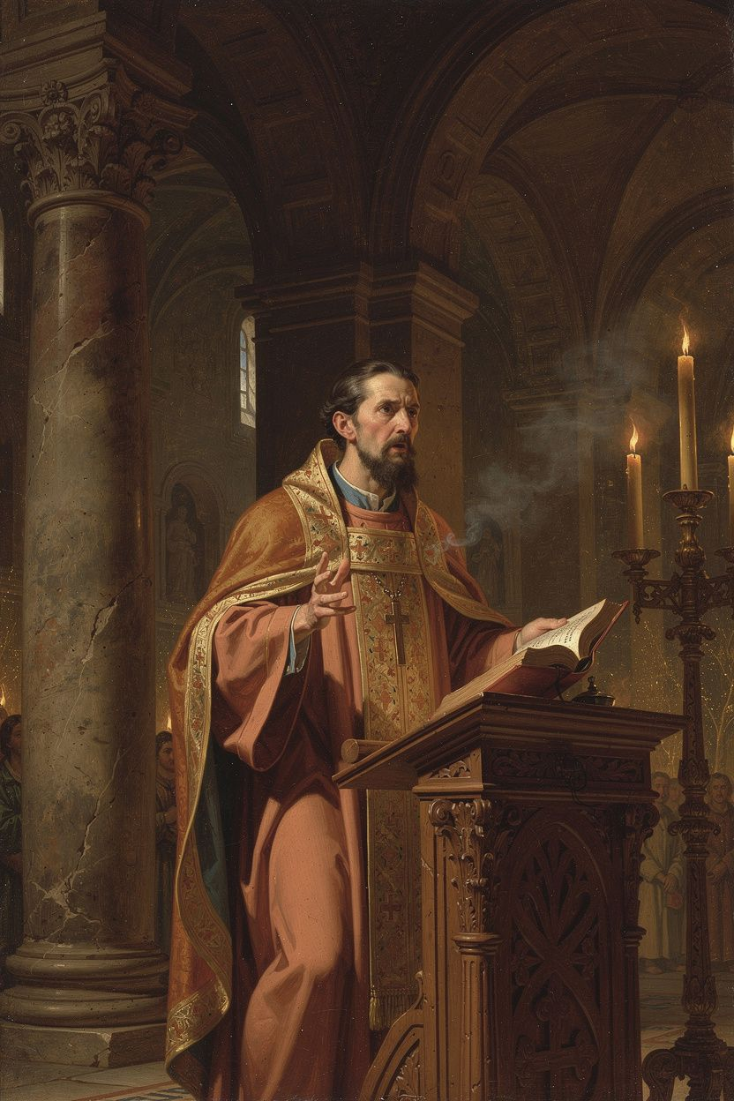
Gregory of Nazianzus: The Theologian
WisdomForge Booklet — Ages 15–18

Gregory of Nazianzus: The Theologian

WisdomForge Booklet — Ages 15–18
———

About This Book
Gregory of Nazianzus (c. 329/330–389/390 CE) is called "the Theologian" — a title the Eastern Orthodox Church has given to only one other person in its entire history (John the Evangelist). That title tells you something about who Gregory was and what he achieved. He was not a systematic theologian in the way Aquinas would be. He was a pastor, a poet, a preacher, and a reluctant bishop who kept running away from power — and whose words about God shaped the creed that millions of Christians still recite today.
Gregory lived through one of the most turbulent and consequential periods in Christian history. The fourth century was the century of the Arian controversy — a debate about whether the Son is fully God or a created being, and whether the Holy Spirit is divine or something less. Gregory's answer — that God is one essence in three persons, that the Son is eternally begotten, that the Spirit is truly God — became the official teaching of the church at the Council of Constantinople in 381 CE. The Niceno-Constantinopolitan Creed is, in many ways, Gregory's creed.
But Gregory was more than a debater. He was a man who insisted that theology is a spiritual discipline, not just an intellectual exercise — that the people who speak about God should be the kind of people who pray. He was a man who taught that God is too big for our minds to fully comprehend, and that the best theology knows its own limits. He was a man who wrote poetry about God — 17,000 lines of it — because he believed that beauty and truth belong together. He was a man who lost his brother, his sister, his father, and his best friend, and who wrote funeral orations so honest and so hopeful that they are still read 1,700 years later.
This booklet is not devotional literature. It is a serious engagement with Gregory's thought — his Trinitarian theology, his apophaticism, his Christology, his doctrine of deification, his approach to grief, and his poetry. Six chapters. Each one engages a central Gregory idea with the seriousness it deserves, including the scholarly debates that still surround his work. You do not have to agree with Gregory to learn from him. You just have to be willing to wrestle with the questions he asked — about God, about knowledge, about suffering, about beauty, and about what it means to speak truthfully about the most important things.
———

Chapter 1: The Education and the Friendship — Formation in Athens
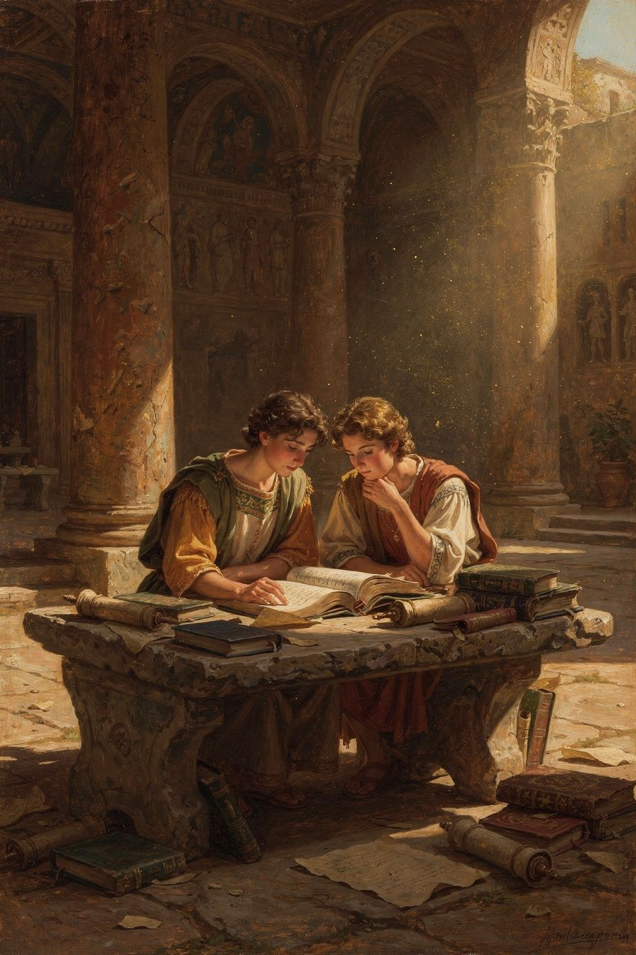
Illustration for Chapter 1

The Classical Formation
Gregory was born around 329 or 330 CE in Arianzus, a village near Nazianzus in Cappadocia (modern-day Turkey). His family was wealthy, landed, and Christian. His father, Gregory the Elder, was bishop of Nazianzus for over 45 years — a practical, managerial bishop who lived to be nearly 100. His mother, Nonna, was a woman of constant prayer who shaped the family's spiritual life and was credited with his father's conversion. His brother Caesarius was a brilliant physician at the imperial court — a man of extraordinary talent whose death at a young age was a devastating blow. His sister Gorgonia was a married laywoman of remarkable piety and discernment; Gregory's funeral oration for her (Oration 8) is one of the most important early Christian tributes to a woman and to the vocation of Christian marriage.
Gregory received the finest education the late Roman world could offer. He studied rhetoric in Caesarea, where he met Basil. He continued in Alexandria, the intellectual capital of the East, where he absorbed the legacy of Origen and studied under the rhetorician Themistius. Then he went to Athens — the traditional center of classical learning — where he studied rhetoric, philosophy, and literature for years. This education gave him the tools that would make him the most eloquent theologian of his age: the Homeric allusions, the Platonic echoes, the rhetorical structures, the precision of argument, and the beauty of expression that pervade every page of his work.
Athens was not just a school. It was the place where Gregory's mind was formed. He learned that good thinking requires good speaking, that truth deserves beauty, that argument should be precise but also moving. He read Homer, Plato, and the great Greek orators. He mastered the art of rhetoric — the art of persuading through structured speech, vivid imagery, and emotional power. Without Athens, there would have been no Five Theological Orations. The classical formation was not a pagan contamination of his theology; it was the instrument of his theology. Gregory's later insistence that theology should be beautiful — that the form of theological speech matters as much as the content — is a direct fruit of his Athens education.
This raises a question that Gregory himself addressed: Should Christians use the cultural tools of a pagan world? Gregory's answer was yes. He did not reject classical culture; he redeemed it. He used the literary forms of the Greek tradition — rhetoric, poetry, philosophical argument — to express Christian truth. If pagan poets could write beautiful verse about false gods, Christian poets should write beautiful verse about the true God. The forms belong to whoever can use them well. This model — cultural engagement without capitulation — became a precedent for the entire Christian literary tradition, from Dante to Eliot.

The Friendship with Basil
In Athens, Gregory met Basil of Caesarea. They were both from Cappadocia, both serious about their Christian faith, both brilliant students. Gregory described their meeting in Oration 43 as one of the decisive events of his life: "We were the talk of the city — two young men who had given themselves to God, in a city that worshipped idols."
Their friendship was complementary but tense. Basil was the organizer — practical, political, institutional. Gregory was the orator — contemplative, literary, sensitive. Basil built monasteries and managed episcopal networks. Gregory preached orations and wrote poems. Their different temperaments caused real friction, especially when Basil appointed Gregory to the miserable see of Sasima as a political maneuver. Gregory was furious and never fully forgave Basil for treating him as a pawn.
But the friendship endured because the bond was deeper than the disagreements. After Basil's death in 379, Gregory delivered Oration 43 — a funeral oration that is one of the great works of ancient friendship literature. It is both tribute and lament, acknowledging the tensions while celebrating the bond. Gregory called Basil "the great friend of my soul."
The complementarity was productive in a specific way. Basil built the institutional framework; Gregory articulated the theology. Basil established the episcopal networks; Gregory preached the orations that shaped the creed. Basil was cautious on the Spirit (for political reasons); Gregory was direct. Basil was the organizer; Gregory was the voice. Together, they were more than either could have been alone. The tension in complementarity kept each from going to his extreme. Basil's politics kept Gregory engaged; Gregory's theology kept Basil honest.
The friendship also shows that theology is not produced in a vacuum. The Cappadocian settlement was the fruit of a friendship — of shared study, shared prayer, shared argument, shared meals. The social context of theology matters. Ideas do not float free of the relationships in which they are formed. Gregory and Basil's friendship is a model for how theology can be a communal activity, not just an individual one.
The Big Idea
The Cappadocian settlement — the doctrine of the Trinity that shaped the church — was not produced by isolated scholars. It was produced by friends: in conversation, in argument, in shared purpose. Gregory and Basil's friendship shows that theology is a communal activity, not just an individual one. Their differences made the theology stronger, not weaker. Complementarity produces better work than uniformity — but it also produces friction, and the friendship must be strong enough to hold the friction.
Practice
1. Read Oration 43. Find Gregory's funeral oration for Basil at New Advent (www.newadvent.org/fathers/310243.htm). Read the opening sections and the closing. Notice how Gregory balances admiration with honesty about tensions. Write 200 words on how Gregory's personal relationship with Basil shapes the theological assessment.
2. Compare two models of collaboration. Think of a friendship or partnership in your own life where you and the other person are very different. List three ways the differences strengthen the collaboration and three ways they cause friction. Is the friction worth it?
3. Trace the classical influence. Gregory's education in Athens gave him the rhetorical tools that shaped the Five Theological Orations. Pick one passage from Oration 27 or 28 (available at New Advent) and identify one rhetorical technique — a metaphor, a parallel structure, a biblical allusion used in a classical rhetorical frame.
Reflect
The Cappadocian settlement was the fruit of a friendship. What does it mean that some of the most important theology in history was produced not by isolated geniuses but by friends who argued? How does the social context of theology — the relationships, the tensions, the shared meals and prayers — shape the theology that emerges?
———

Chapter 2: The Reluctant Bishop — Vocation, Resistance, and Integrity
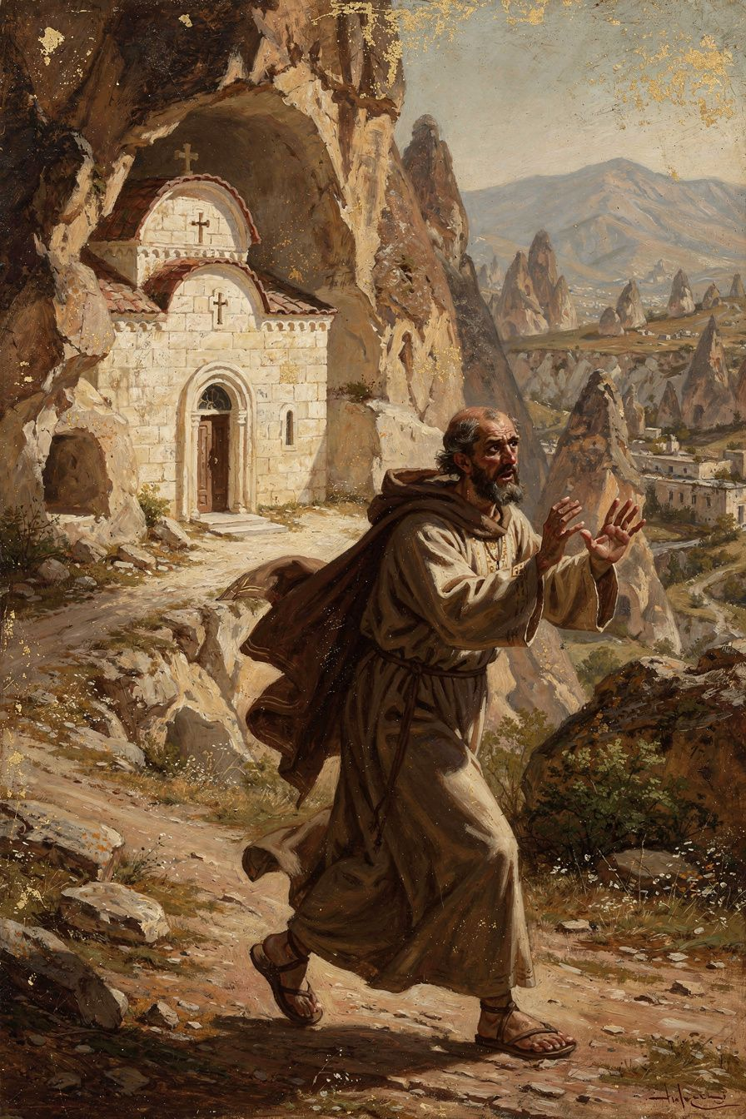
Illustration for Chapter 2

The Flight from Ordination
Around 361 CE, Gregory's father ordained him as priest without his consent. Gregory was horrified. He had not been consulted. He had not wanted ordination. He wanted a quiet life of study, prayer, and friendship. He fled to Basil's monastery in Pontus.
The flight was not personal weakness. Gregory's Apologia for His Flight to Pontus (Oration 2) is a carefully argued theological treatise on the nature of ordination. Gregory believed that ordination was too serious to be entered lightly — that it required consent, preparation, and a genuine sense of calling. His father's unilateral action was, in Gregory's view, an abuse of authority. The priesthood is a sacred trust, not a job to be assigned without the candidate's agreement.
Gregory's argument in Oration 2 is one of the earliest sustained treatments of the nature of ordination in Christian theology. He asks: What makes ordination valid? Is it the bishop's authority? The people's consent? The candidate's preparation? Gregory argues that all three matter. The bishop has the authority to ordain, but the candidate must be willing and prepared, and the people must consent. Ordination without the candidate's consent is not just invalid — it is harmful. It treats a sacred office as a personnel assignment.
Eventually Gregory returned and accepted the priesthood. He served under his father in Nazianzus and began to develop the theological voice that would later produce the Five Theological Orations. But the tension between his desire for a contemplative life and his calling to public ministry never fully resolved. This tension is not unique to Gregory; it is the perennial tension between the contemplative and the active life, between the study and the pulpit, between the desire for quiet and the demands of service.

The Sasima Crisis
In 372 CE, Basil — now bishop of Caesarea — appointed Gregory bishop of Sasima. Gregory was appalled. He described Sasima as "a detestable little place, without water, without trees, without civilization." Basil needed the see for political reasons — to strengthen his metropolitan authority by creating a suffragan bishopric in a strategically located (if miserable) town. Gregory saw himself as a pawn in someone else's political game.
He went briefly, found it intolerable, and left. The appointment strained the friendship for years. Gregory's letters from this period show real pain and frustration. This episode reveals something important about the fourth-century church: even the Cappadocian Fathers — friends, allies, theological collaborators — could treat each other with a certain ruthlessness when institutional power was at stake. The church was not just a community of faith; it was a political institution, and the politics could be ugly.
The Sasima incident also reveals something about Gregory's character. He was not a man who could be used. He had a deep sense of his own dignity and vocation, and he refused to let even his closest friend instrumentalize him. This refusal — the willingness to say no, even to Basil — is part of what made Gregory the theologian he was. His theology of integrity was not abstract; it was tested in real relationships and real conflicts.

The Constantinopolitan Mission and the Resignation
In 379 CE, Gregory was invited to lead the small Nicene community in Constantinople. He arrived to find a tiny, demoralized congregation meeting in a house-chapel called the Anastasia ("Resurrection"). The city had been an Arian stronghold for decades. The Arian bishop Demophilus controlled the main churches. The previous Nicene bishop had been driven out years before. The imperial court under Valens had actively supported Arianism — exiling Nicene bishops and promoting Arian ones throughout the East.
Over two years, despite chronic illness and opposition, Gregory accomplished something extraordinary. He preached the Five Theological Orations, which established the theological framework for the Council of Constantinople. He built the community from a handful to a significant congregation. He survived an Arian attack on the Anastasia on Easter Eve, 380 CE, when Arian monks smashed windows and assaulted members of the congregation. The violence backfired — it drew public sympathy to the Nicene community and discredited the Arians.
In 379 CE, the emperor Valens died at the Battle of Adrianople. His successor, Theodosius I, was a committed Nicene Christian. Theodosius issued the Edict of Thessalonica (380 CE), declaring Nicene Christianity the official faith of the empire. The political wind had shifted. Demophilus was expelled. The main churches were turned over to the Nicene community. Gregory was appointed bishop of Constantinople and presided over the opening of the Council of Constantinople in 381 CE.
Then the bishops of Alexandria challenged his appointment on a technicality — Canon 15 of Nicaea prohibited episcopal transfers. Gregory had been transferred from Sasima to Constantinople, which violated the canon. The bishops of Alexandria — allies in doctrine but rivals in politics — used this to challenge his legitimacy. They did not want a Constantinopolitan bishop to rival their own prestige.
Gregory, weary and disgusted by the politicking, resigned. His farewell speech (Oration 42) is one of the most moving documents in patristic literature: "I have been a bishop without a church, a pastor without a flock." He chose to leave rather than fight. He valued his integrity more than his position.
The council appointed Nectarius, a respected layman, as bishop. Gregory's public career was over. But the theology he had fought for won the day. The council adopted his pneumatology, his Trinitarian framework, and his theological vocabulary. The Niceno-Constantinopolitan Creed — still used in Christian worship today — bears the imprint of Gregory's theology. Every Sunday, millions of Christians confess a faith shaped by a man who preached in a house-chapel and died in retirement in a small Cappadocian village.
Scholarly debate: Was Gregory's resignation a defeat or a victory? Some scholars (McGuckin) see it as the tragic consequence of church politics — Gregory was robbed of the position he had earned. Others (Daley) see it as a deliberate choice consistent with Gregory's entire theology: he had always said that office without integrity is abuse, and he lived that principle by walking away. The integrated reading is that it was both: a personal defeat and a theological victory. Gregory lost the bishopric, but the theology he had fought for won the council. His resignation is itself a theological act — the practice of the principle he articulated in Oration 27: that the theologian's integrity matters more than his position.
The Big Idea
Gregory's withdrawals were not cowardice. They were theological acts — expressions of his conviction that ministry requires integrity, that office without calling is abuse, and that the contemplative life is the ground of all true service. His model of leadership is different from the modern model: he led through theology, not administration; through integrity, not power; through withdrawal as well as engagement. His willingness to walk away from power — from Sasima, from Constantinople — is a witness to the principle that the church is not about power but about truth.
Practice
1. Read Oration 2. Gregory's Apologia for His Flight is one of the earliest sustained treatments of the nature of ordination. Read the opening sections at New Advent. Write 200 words on Gregory's argument: Why is ordination too serious for casual entry? What are the preconditions he identifies?
2. Evaluate the resignation. Gregory resigned the highest position in the Eastern church rather than fight for it. List three reasons someone might see this as strength and three reasons someone might see it as weakness. Which interpretation do you find more convincing?
3. Compare leadership models. Make a two-column comparison: Basil's model (organizational, political, institutional) vs. Gregory's model (theological, contemplative, integrity-based). Which model does modern culture value more? Which model does the church need more? Can both coexist?
Reflect
Gregory said: "I did not seek this office; I will not cling to it." What does it mean to hold power without seeking it — and to let go of power without fighting for it? Is Gregory's model of leadership viable in a modern institution, or is it only possible in a pre-modern context?
———

Chapter 3: The Five Theological Orations — The Trinity Defended
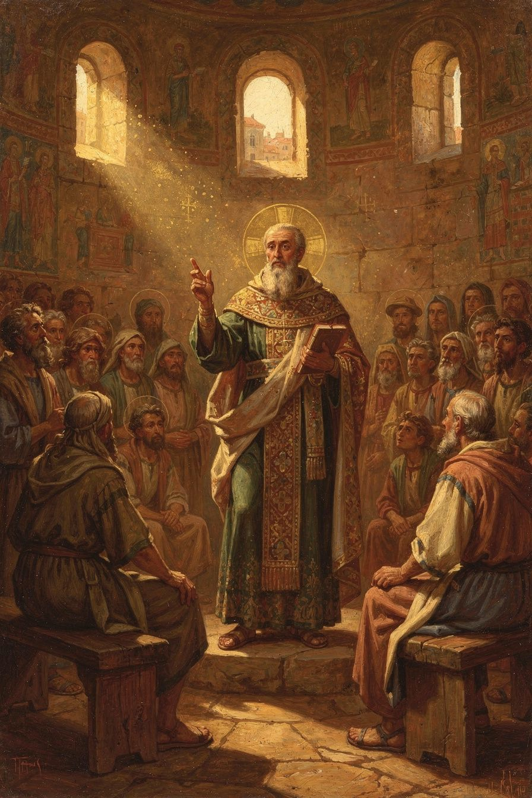
Illustration for Chapter 3

The Setting: Constantinople, 380 CE
The Five Theological Orations (Orations 27–31) were preached in 380 CE in the Anastasia — a house-chapel in Constantinople. The setting was modest, but the orations are Gregory's masterpiece and one of the classic expositions of the doctrine of the Trinity.
The situation was dire. Constantinople had been an Arian stronghold for decades. The Nicene community was tiny and demoralized. Theology was a public sport — debated at dinner parties, in the marketplace, at the barber shop. Gregory found this dangerous. Speaking about God is a sacred task, not a game. The Eunomians claimed to know God's essence completely. Amateur theologians debated technical terms they did not understand. Gregory's response was not just to argue better but to redefine what theology is — who should do it, how it should be done, and what its limits are.
The orations were not academic exercises. They were pastoral tools, designed to form and strengthen a community under pressure. Gregory was not writing a treatise for scholars; he was preaching to a frightened, scattered flock. The orations gave them three things: a theological framework (the Trinity), an epistemology (the incomprehensibility of God), and a discipline (the character of the theologian). Together, these three formed the foundation on which the Council of Constantinople would build the creed.

Oration 27: The Character of the Theologian
Gregory begins not with doctrine but with a question: Who is qualified to speak about God? He attacks the Eunomians, who claimed to know God's essence completely, for their arrogance. True theology, he argues, requires purification, reverence, and silence as much as speech. "Discussion of theology is not for everyone, I tell you, not for everyone." The theologian must be formed by prayer and virtue. The audience must be serious. The time must be right. The topic must be proportioned to human capacity.
This is not anti-intellectualism. Gregory was one of the best-educated men of his age, trained in Athens, fluent in rhetoric and philosophy. He did not reject reason; he used it brilliantly. But he subordinated reason to reverence. Reason serves theology; it does not master it. The relationship between knowledge and holiness is organic: the more one is formed in the life of God, the more one can speak truthfully about God. Theology is not merely information about God; it is wisdom about God, and wisdom requires virtue.
Gregory's principle became foundational for the Eastern Orthodox theological tradition. In the East, theology is not primarily an academic discipline but a mystical discipline. The true theologian is the saint — the person who has been deified, who has experienced God, who speaks from communion with God. Evagrius of Pontus, a younger contemporary of Gregory, compressed the principle into a single sentence: "If you pray truly, you are a theologian."
Scholarly debate: Is Gregory's restriction on who may theologize elitist or protective? Scholars like Demacopoulos argue that Gregory is not restricting theology to a social elite but protecting it from trivialization. The restriction is not about class or education but about character. The point is not that only bishops or monks can do theology, but that theology done without reverence, without prayer, without moral formation produces bad theology — arguments that sound clever but are spiritually empty. Christopher Beeley reads Oration 27 as a manifesto for the integration of theology and spirituality: Gregory is not saying that only the holy can speak about God, but that the quality of one's theology is affected by the quality of one's life.

Oration 28: The Incomprehensibility of God
Gregory argues that while we can know that God exists from creation and providence, we cannot comprehend God's essence. Our language about God is necessarily partial. The via negativa — saying what God is not — is more reliable than the via positiva. God is not limited, not mortal, not created, not subject to change. These negations are true, but they tell us what God is not, not what God is.
This is not skepticism. Gregory believes we can know God truly — but partially, like seeing a mountain through mist. God is infinite; our minds are finite. The finite cannot contain the infinite, any more than a cup can contain the sea. The knowledge we have is real but incomplete — and the incompleteness is not a failure but the appropriate form of knowledge for finite beings before an infinite God.
Gregory builds his case on multiple foundations. From the nature of the infinite and the finite: God is infinite; the human mind is finite. The finite cannot contain the infinite. From the limits of language: human language was developed to describe created things. When we apply words like "good," "wise," "powerful" to God, we stretch them beyond their ordinary meaning. We speak analogically, not literally. From the way of negation: it is easier to say what God is not than what God is. From the history of revelation: God has revealed himself gradually, in stages suited to human capacity. The Old Testament revealed the oneness of God. The New Testament revealed the Son. The Spirit was recognized last. This progressive revelation is not because God changes, but because human capacity to receive divine truth develops over time.
The legacy of this oration is enormous. Gregory's apophaticism shaped the entire Eastern theological tradition. Gregory of Nyssa developed it into the concept of endless progress (epektasis) — the soul's journey into God is endless because God is infinite. Pseudo-Dionysius systematized it in The Mystical Theology, arguing that God is "beyond being" and known by "unknowing." Maximus the Confessor integrated it with Christology. Gregory Palamas used the essence-energies distinction to defend the hesychast practice of contemplative prayer. The Eastern tradition, following Gregory, treats theology as a discipline of reverence: the theologian speaks, but speaks with awareness of the limit.

Orations 29–30: On the Son
Gregory sets out the orthodox doctrine of the Trinity. The Father is the source and origin; the Son is eternally begotten; the three persons share one divine nature, will, and operation. "There never was a time when the Son was not." The Son is not a creature — he is God from eternity. Gregory also addresses the Incarnation: the Son became human without ceasing to be God. The human and divine natures are united in the one person of Christ.
The Arians used biblical passages that speak of the Son as created, subject, or learning obedience to argue that the Son is less than God. Gregory's response is that these passages refer to the human nature Christ assumed, not to his eternal divinity. The Son, as God, does not learn obedience; but as man, he lives a fully human life. The phrase "bearing all me and mine in Himself" is the key: Christ takes on the whole of human experience — except sin — so that he can transform it from within.

Oration 31: On the Holy Spirit
Gregory defends the Spirit's divinity against the Pneumatomachi (Spirit-fighters), who denied the Spirit's divinity. His argument shaped the Council of Constantinople's creedal language: "the Holy Spirit, the Lord and giver of life, who proceeds from the Father, who with the Father and the Son is worshipped and glorified."
Gregory argues that the Spirit receives the same worship as the Father and Son, performs the same divine works (sanctification, illumination, deification), and is the one who draws believers into the life of God. "The Holy Spirit is truly Spirit, coming forth from the Father and receiving of the Son." The Spirit is not a creature but God. His famous image of the three lights captures the Trinitarian vision: "The Father was the True Light. The Son was the True Light. The Spirit was the True Light. Was and Was and Was, but Was One Thing. Light thrice repeated; but One Light and One God."
The Cappadocian settlement distinguished between one divine essence (ousia) and three divine persons (hypostaseis). The persons are defined not by what they are (they share one nature) but by their relations of origin: the Father is unbegotten, the Son is begotten, the Spirit proceeds. These relations are eternal — there was never a time when the Father was without the Son or the Spirit. The monarchy of the Father — the Father as the source and principle of the Godhead — preserves the unity of the Godhead (one source) while maintaining the real distinction of persons (three relations). It prevents the three persons from becoming three independent gods, while avoiding the collapse of the three into one.
Scholarly debate on the filioque: Gregory says the Spirit proceeds from the Father. The Western tradition later added "and the Son" (filioque) to the creed. Scholars debate how this relates to Gregory's theology. Some argue that Gregory's monarchy of the Father is incompatible with the filioque — if the Spirit proceeds from the Father alone, adding "and the Son" undermines the Father's unique role as source. Others argue that Gregory's theology is compatible with the Western position, since the Son receives everything from the Father, including the spiration of the Spirit. This debate was a major factor in the Great Schism between East and West in 1054 CE and remains a live ecumenical question.
The Big Idea
The Five Theological Orations gave the church a vocabulary for speaking about the Trinity that was at once biblical, philosophical, and doxological. Gregory's contribution was not just the doctrinal content but the approach: theology begins with reverence, is limited by the incomprehensibility of God, and is always ordered toward worship. The Trinity is not a puzzle to be solved but a mystery to be inhabited. The theologian who speaks about God must do so with the humility that God's incomprehensibility demands.
Practice
1. Read Oration 27. Find it at New Advent. Identify the preconditions Gregory sets for theology: Who is qualified? When is the right time? What is the right attitude? Write 200 words on whether these preconditions are elitist or protective.
2. Trace the Trinity argument. Read Oration 29 and Oration 31. Make a diagram of Gregory's Trinitarian argument: one ousia, three hypostaseis, relations of origin, monarchy of the Father. How does he distinguish the persons without separating them? What prevents the argument from collapsing into tritheism or Sabellianism?
3. Examine the via negativa. Try the apophatic exercise: list ten things God is not. Now try to list ten things God is. Which list was easier? Gregory says the first list is always more reliable. Why? What does this tell you about the limits of human language about God?
Reflect
Gregory said: "Not to everyone does it belong to philosophize about God." In a culture where everyone has a platform and every opinion about God is treated as equally valid, is Gregory's restriction defensible? Who should speak about God — and who should listen? What would theology look like if it required the character formation Gregory demands?
———

Chapter 4: The Incomprehensibility of God — Apophaticism as Epistemology
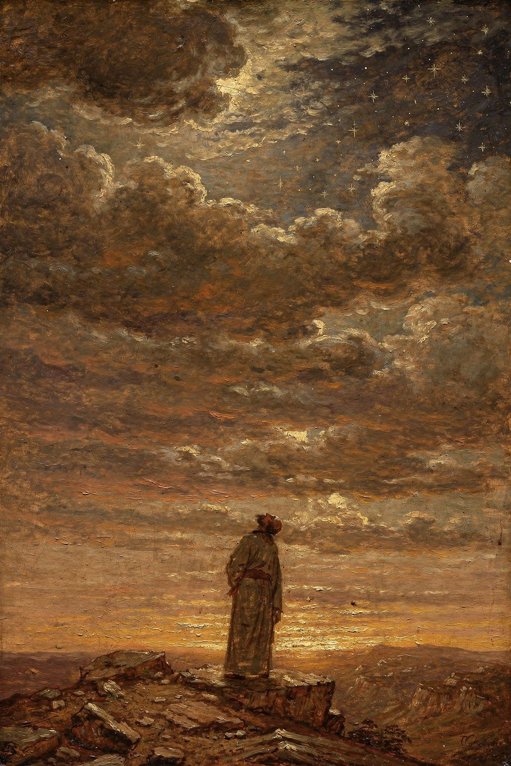
Illustration for Chapter 4

The Eunomian Controversy
Gregory's apophaticism was sharpened by his conflict with the Eunomians. Eunomius, an extreme Arian bishop, argued that "unbegotten" (agennetos) is not just a description of God but the exact name of God's essence. If you understand this one word, you understand God completely. Human reason can comprehend the divine nature fully. This was the most extreme form of theological rationalism in the early church.
Gregory found this absurd and dangerous. "Ingenerate" is a relational term — it describes the Father's mode of origin (he is not begotten) — not the divine essence. The Father is ingenerate; the Son is begotten; the Spirit proceeds. But all three share the same divine essence. If "ingenerate" were the essence, then the Son, who is begotten, would not share the essence — which would make the Son a creature. The Eunomian argument, taken to its logical conclusion, destroys the Trinity by making the Son a created being.
More fundamentally, Gregory argued that no human word can capture the divine essence. "Ingenerate" is a useful term, but it tells us something about the Father's relation, not the fullness of what God is. The Eunomian claim to comprehensive knowledge of God was, for Gregory, a form of spiritual pride. The person who thinks he has comprehended God has made an idol of his own concept. The result is not knowledge but the illusion of knowledge — which is worse than ignorance, because it does not know its own limits.

What We Can Know
Gregory is careful not to collapse into pure agnosticism. He distinguishes between knowing God's essence (which is beyond us) and knowing God through God's energies (which is possible). We know God through what God does, not by comprehending what God is. Gregory lists several ways God is known: through creation (the beauty and order of the world point to a Creator), through providence (God's care for the world reveals something of God's character), through the Incarnation (the Son became human so that human beings could see God in a form they could understand), through the Spirit (who illuminates the mind and sanctifies the heart), and through purification (as the soul is purified from sin and passion, it becomes capable of seeing God more clearly).

The Paradox: Known Yet Incomprehensible
Gregory holds both truths together: God is knowable and God is incomprehensible. God is knowable because God reveals himself — in creation, in Scripture, in the Incarnation, in the Spirit. God is incomprehensible because the finite mind cannot contain the infinite. The knowledge we have is real but partial — like seeing a mountain through mist, or hearing a symphony from the next room. The partial knowledge is not a failure; it is the appropriate form of knowledge for finite beings before an infinite God.
Gregory distinguishes between knowing God's essence (which is beyond us) and knowing God through God's energies (which is possible). We know God through what God does, not by comprehending what God is. This distinction became foundational for Eastern Orthodox theology — shaping Gregory of Nyssa's concept of endless progress (epektasis), Pseudo-Dionysius's "unknowing," and Gregory Palamas's essence-energies distinction.

The Scholarly Debate
Scholars debate what Gregory's apophaticism is primarily. Some read it as philosophical — derived from Greek skepticism or Middle Platonism. Others read it as theological — rooted in the Creator-creature distinction and Scripture. Others read it as pastoral — a discipline to produce humility and guard against overconfidence. Others read it as mystical — pointing toward the experience of God in darkness beyond words. The emerging consensus is that it is all four, integrated. The philosophical tools serve the theological truth, which is deployed pastorally, and which opens into mystical encounter. To separate the dimensions is to impoverish all of them.
The Big Idea
Gregory's apophaticism is not a philosophical position. It is an integrated epistemology — philosophical, theological, pastoral, and mystical — that shapes the entire Eastern apophatic tradition. The point is not that we know nothing about God. The point is that we know God truly but partially, and that the partial knowledge — the knowledge that knows its own limits — is the most honest and the most reverent form of theology. The theologian who knows what she does not know is wiser than the theologian who thinks she has captured God in a concept.
Practice
1. Read Oration 28. Find it at New Advent. Identify the four dimensions: Where does Gregory use philosophical arguments (the infinite vs. the finite)? Where does he ground the argument in Scripture (Exodus, Corinthians)? Where does he deploy it pastorally (against the Eunomians)? Where does he gesture toward mystical encounter (the darkness where God is)?
2. Try the apophatic exercise. Spend 15 minutes writing about God — but only in negations. "God is not..." When you run out of negations, sit with the silence. What does the exercise teach you about the limits of your own language? Write 200 words on the experience.
3. Research Gregory Palamas. Gregory's distinction between essence and energies shaped the hesychast controversy in the 14th century. Look up Gregory Palamas and the essence-energies distinction. How does Palamas build on Gregory of Nazianzus? What does it mean to say that we can know God's energies but not God's essence?
Reflect
Gregory said: "To know God is difficult, to express him is impossible." In an age of information — where everything is accessible, everything is explainable, everything is searchable — what does it mean to say that the most important thing is beyond comprehension? Is there value in not knowing? Is there a kind of knowledge that comes through acknowledging the limit?
———

Chapter 5: Christology — "What Is Not Assumed Is Not Healed"
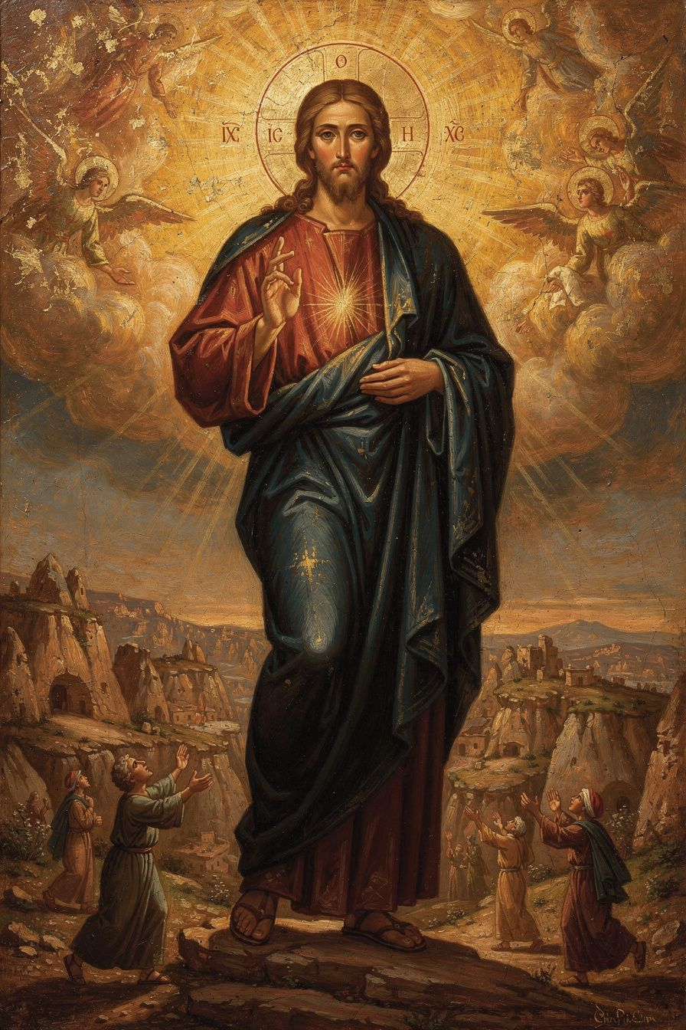
Illustration for Chapter 5

The Apollinarian Controversy
The most important Christological controversy of Gregory's time was Apollinarianism. Apollinarius of Laodicea (c. 310–390 CE) was a friend and ally of the Nicene party. He accepted the Son's full divinity. But he argued that the Son did not assume a full human mind (nous). The Word (the divine Logos) took the place of the human mind in Christ. Christ had a human body and a human soul, but his mind was divine, not human.
Apollinarius had a theological reason: the human mind is the seat of sin. The human mind is the will that turns from God. If Christ had a human mind, he would have a sinful will, and therefore he could not be sinless. To preserve Christ's sinlessness, Apollinarius denied him a human mind. This was not a minor deviation; it was a serious Christological error with enormous implications for the doctrine of salvation.

Gregory's Principle
Gregory's response, in Letters 101 and 102 to Cledonius, is one of the most important sentences in the history of theology:
"The unassumed is not healed; but what is joined to his divinity, that is saved."
The logic is devastating. If the Son became human to heal humanity, he must become everything that humanity is. Every part that needs redemption — body, soul, mind, will — must be assumed. If any part is left out, that part is left unredeemed. The disease is in the mind; the cure must reach the mind. A Christ without a human mind saves bodies but not minds. Since the human mind and will are precisely what need healing — they are the seat of sin, the thing that turns from God — a Christ without a human mind cannot solve the problem.
The principle works by extension in every direction. If Christ has no human body, bodies are not redeemed. If Christ has no human soul, souls are not redeemed. If Christ has no human mind, minds are not redeemed. If Christ has no human will, wills are not redeemed. Gregory's logic is simple and radical: salvation is not merely forgiveness; it is the healing and transformation of the whole human being. Therefore Christ must be fully human, as well as fully divine. The whole of human nature needs healing; the whole of human nature must be assumed.
But what about Apollinarius's concern about sinlessness? Gregory's answer is that the human mind is not sinful by nature. It is a good creation of God that becomes sinful when it turns from God. Christ's human mind was real, but always in harmony with the divine will. The unity of the person — the one person of the Son — ensured that the human mind was always ordered to God. The Incarnation itself is the healing: the Son enters the full human condition to transform it from within. He takes on mortality, suffering, and temptation — not because he shares the guilt of sin, but because he enters the world of sin to heal it from inside.

The Unity of the Person and the Communication of Attributes
Gregory insists that Christ is one person, not two. The Son did not inhabit a human being; he became a human being. The divine and human natures are united in one personal subject. This anticipates the Definition of Chalcedon (451 CE), which defined Christ as "one person in two natures, without confusion, without change, without division, without separation."
Gregory also articulated what later theology calls the communicatio idiomatum: because Christ is one person, the attributes of both natures can be predicated of the one person. We can say "God suffered" and "God died" — not because the divine nature suffers, but because the one person who suffers is God. This is why Gregory can say "the Word became flesh" and "the flesh was the Word" in the same breath.

Deification: The Purpose of the Incarnation
For Gregory, the purpose of the Incarnation is not simply forgiveness. It is deification (theosis) — the transformation of human beings into participants in the divine life. "God became human, that human beings might become divine." This does not mean humans become God by nature. They remain creatures. But they share in God's life by grace — through the Spirit, through the sacraments, through the transformation of the whole person. Deification is by grace, not by nature. The distinction is crucial: God is God by nature; humans are deified by grace.
Key features of Gregory's understanding of deification: It involves the whole person — body, soul, mind, and will. The body is sanctified through the sacraments; the mind is illumined by the Spirit; the will is aligned with God's will. It is progressive — not a one-time event but a lifelong process, and in the Eastern tradition, an eternal one, because God is infinite and there is always more to participate in. It is Trinitarian — the Father sends the Son, the Son becomes human and unites human nature to the divine, the Spirit sanctifies the believer and draws the believer into communion with the Father and the Son. It is communal — it happens in the church, through baptism, the Eucharist, and the life of the community, not in private mystical experience.
This doctrine became central to Eastern Orthodox theology and distinguishes the Eastern understanding of salvation from many Western models. In the East (Gregory, Athanasius, the Cappadocians), salvation is deification — participation in the divine life. The problem is not just guilt but corruption; the cure is not just pardon but transformation. In the West (Augustine, Anselm, the scholastic tradition), salvation is often framed as justification — the forgiveness of sin and the restoration of a right relationship with God. The problem is guilt; the problem is legal. These are not necessarily contradictory, but they emphasize different aspects. In recent ecumenical dialogue, both traditions have recognized that the other's emphasis can complement their own. Western theologians like Carl Mosser and Thomas Weinandy have explored ways to integrate theosis into Western frameworks.
Scholarly debate: Does Gregory's deification doctrine imply that human nature is fundamentally corrupt, or fundamentally good? Some scholars (Russell) argue that Gregory's view of human nature is positive — the human person is the image of God, wounded but not destroyed by sin. Deification is the restoration and fulfillment of human nature, not its replacement. Others (Lossky) emphasize the gap between Creator and creature more strongly — deification is a participation in divine life that transcends human nature entirely. The integrated reading is that both are true: human nature is good (created by God) but wounded (by sin), and deification heals the wound and fulfills the nature.
The Big Idea
Gregory's Christology is driven not by speculative philosophy but by the logic of salvation. The question is not "What can we say about Christ's natures?" but "What needs to be healed, and what must the Savior assume to heal it?" From this pastoral and soteriological question, Gregory works out the doctrinal definition: Christ is fully God and fully human, one person in two natures, because only a fully divine and fully human Savior can save the whole human being. The goal is not just forgiveness but transformation — deification, the sharing of God's life by grace.
Practice
1. Read Letter 101. Find Gregory's letter to Cledonius at New Advent. Trace the argument: What is the logic of "what is not assumed is not healed"? How does Gregory handle Apollinarius's concern about sinlessness? Write 250 words on the pastoral logic of Gregory's Christology.
2. Compare East and West. Research the difference between the Eastern understanding of salvation as deification (theosis) and the Western understanding as justification. Read 2 Peter 1:4 ("partakers of the divine nature") and Romans 3:24 ("justified by his grace"). How do these two biblical emphases relate? Are they contradictory or complementary?
3. Examine the communicatio idiomatum. Gregory says we can predicate divine attributes of the human Christ and human attributes of the divine Son. Find three biblical passages that do this (e.g., "God purchased the church with his own blood" — Acts 20:28). What does it mean to say that the one who died on the cross is God?
Reflect
Gregory's Christology begins not with a philosophical system but with a pastoral question: What needs to be healed? What does it mean to do theology from the needs of the church rather than from the needs of the academy? How would your understanding of Christianity change if you started with the question "What needs to be saved?" rather than "What is the correct doctrine?"
———

Chapter 6: The Poet Who Went Home — Retirement, Grief, and Legacy
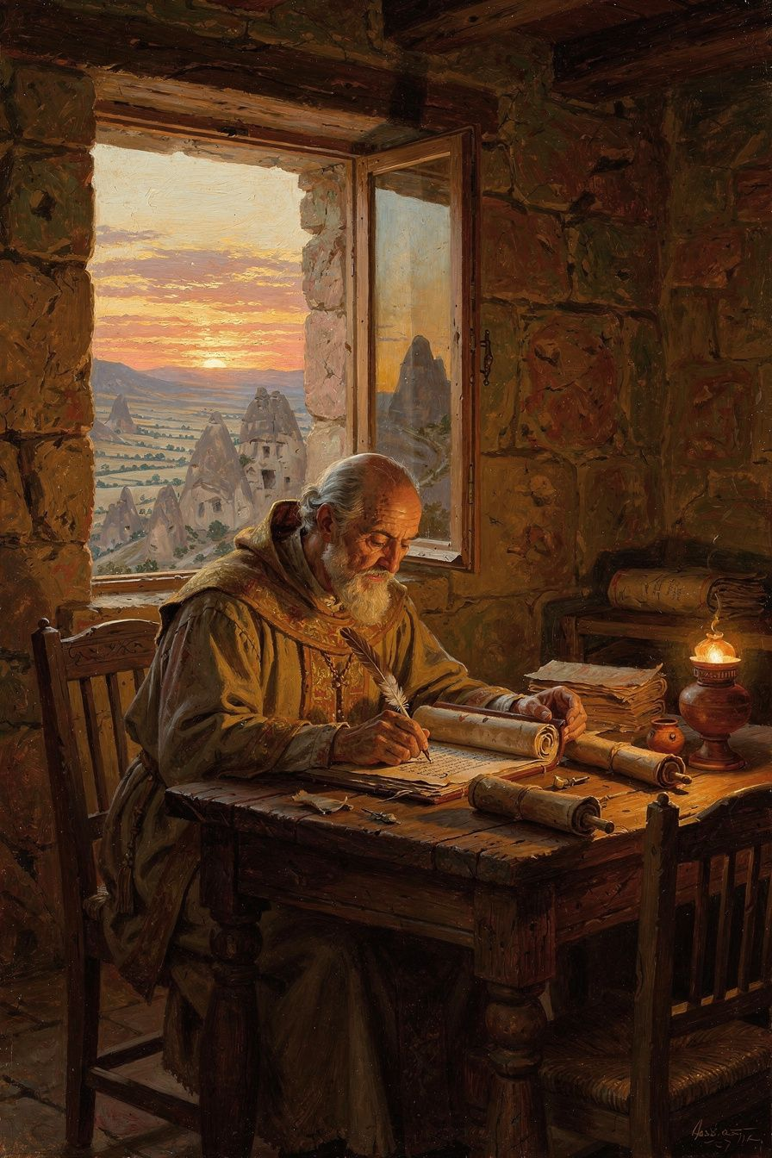
Illustration for Chapter 6

Retirement at Arianzus
After his resignation from Constantinople in 381 CE, Gregory spent his last decade in retirement at Arianzus. He continued to write — poetry, letters, theological reflections — but never returned to public office. His withdrawal was a form of practicing what he preached: choosing contemplation over power, silence over argument, the presence of God over the politics of the church.

The De Vita Sua: Autobiography as Theology
Gregory's longest poem, De Vita Sua ("Concerning His Own Life"), runs to nearly 2,000 lines. Written in retirement, it reviews his entire life: education, friendship with Basil, reluctant ordination, Constantinople, illnesses, griefs, and withdrawal. It is one of the earliest extended autobiographies in Christian literature and one of the most personal.
The poem is not a diary. It is a theological interpretation of a life. Gregory reads his own story through the lens of providence — seeing God's hand in his successes and failures, his friendships and his loneliness. He is honest about his disappointment, anger, and weariness. He describes the church politics that wearied him, the betrayal by friends that wounded him, the physical illnesses that weakened him. But he also describes the joy of study, the beauty of friendship, the peace of contemplation. The poem is a whole life seen under the aspect of God.
What makes the De Vita Sua remarkable is its emotional honesty. Gregory does not present himself as a saint who has figured it all out. He presents himself as a man who has been battered by life and is trying to understand what it means. He asks: Why did I keep running away? Why did God keep bringing me back? What did it all mean? The poem does not answer these questions neatly. It holds them — in the tension between providence and pain, between calling and reluctance, between the desire for quiet and the demands of service.
Gregory's withdrawal to Arianzus was not merely retirement. It was a theological act. He had argued in Oration 27 that theology requires a formed soul, and in Oration 28 that God is incomprehensible. His withdrawal was a form of practicing what he preached — choosing contemplation over power, silence over argument, the presence of God over the politics of the church. The De Vita Sua is the fruit of that choice. It shows what theology looks like when it is done not from a position of power but from a position of reflection — after the battles are over, after the losses are absorbed, when the only question left is: where was God in all of this?

Poetry as Theology
Gregory is the only one of the great Greek Fathers to have produced a large body of theological poetry — around 17,000 surviving lines from a reported 30,000. His Poemata Arcana treat the Father, Son, Spirit, creation, providence, and the soul in verse. He calls the Son "the unspeakable speech of the Father." His moral poems treat virtues and vices. His epitaphs honor friends and family. He believed that Christian truth should be expressed in the full range of literary forms — that beauty and truth belong together, and that poetry can express what prose cannot.
Gregory did not consider poetry a break from theology. He considered it a form of theology — a way of knowing and expressing truth that prose cannot fully capture. Poetry reaches what argument misses. Argument persuades the mind; poetry moves the heart. His prose is precise and powerful, but his poetry can express grief, longing, joy, and wonder in ways that his orations cannot. The De Vita Sua shows a man processing his life through verse, finding meaning in rhythm and image.
Gregory also wrote poetry as a spiritual practice. The discipline of finding the right word, the right meter, the right image is a form of contemplation. It forces the writer to slow down, to attend to the gift of language, to honor the subject. In Gregory's hands, poetry becomes prayer. The moral poems were meant for memorization and meditation — putting doctrine in verse was a way of making it stick in a culture where poetry was a primary form of cultural memory.
Scholarly debate: Is Gregory's poetry theology or literature? Some scholars (Simelides) emphasize the literary dimension — Gregory's poetry is a major achievement in the classical tradition, and its theological content is secondary to its literary art. Others (McGuckin) emphasize the theological dimension — the poems are as doctrinally careful as the orations, and the poetry is a different form of the same rigor. The integrated reading is that both are true: the poetry is both literature and theology, and separating them impoverishes both. Gregory's example challenges the modern separation of theology and literature — he shows that good theology can also be beautiful, and that the form of theology matters as much as the content.

The Theologian of Grief
Gregory's funeral orations — for Caesarius (Oration 7), Gorgonia (Oration 8), his father (Oration 18), and Basil (Oration 43) — are among the most moving documents in patristic literature. They show a man wrestling with grief honestly, bringing his pain before God.
Gregory's approach to grief is not Stoic resignation. The Stoic ideal is to accept loss without being disturbed. Gregory rejects this. He grieves. He weeps. He laments. He asks God why. In Oration 7, he says: "Why has death taken the best of men in the flower of his age?" This is not a rhetorical question; it is a real cry of pain. But he also hopes — in the resurrection, in the communion of saints, in the promise that death is not the end. The pattern is: name the loss, celebrate the life, wrestle with meaning, commend to God. It does not skip any stage or rush to comfort. The hope of resurrection does not eliminate grief; it gives grief a horizon. Gregory grieves and hopes at the same time.
Gregory's personal experience of loss shaped his theology in specific ways. His insistence that God is beyond comprehension is not just philosophical; it is the fruit of suffering. When you have lost the people you love most, you cannot accept a God who fits in your system. God must be bigger than your understanding — big enough to hold your pain and your questions without breaking. His insistence in Oration 27 that theology requires a formed soul is connected to his experience of suffering. The person who has not suffered cannot do theology well — not because suffering makes you wise automatically, but because suffering breaks the illusion that you are in control. The theologian who has not been broken by loss does not know the limits of human knowledge.
His Christology is also shaped by his understanding of suffering. In Oration 29, he argues that the Son took on human nature, including human suffering, so that suffering itself could be transformed. The Incarnation means that God has entered into human pain — not to explain it away, but to be present in it. The hope of resurrection is not abstract; it is the hope of a man who has lost the people he loves and trusts that God will not let loss have the last word.
Scholarly debate: Is Gregory's approach to grief distinctively Christian, or does it share features with other ancient approaches? Some scholars (Simmons) compare Gregory's funeral orations with pagan epideictic rhetoric and find that Gregory transforms the classical form by filling it with Christian content — hope in resurrection, trust in providence, the communion of saints. Others (Sterk) emphasize the monastic dimension — Gregory's grief is disciplined by his ascetic formation, which teaches him to grieve honestly but not to be destroyed by grief. The integrated reading is that Gregory combines the rhetorical power of classical funeral oratory with the theological depth of Christian hope, producing a form of grief that is both honest and faithful.

The Title: "The Theologian"
The Council of Ephesus (431 CE) formally gave Gregory the title "the Theologian" — a title shared in the East only with John the Evangelist. Scholars debate its meaning. The doctrinal reading (McGuckin, Beeley) says it refers to Gregory's articulation of Trinitarian doctrine — the Five Theological Orations as the definitive Eastern statement of who God is in himself. The spiritual reading (Ware, Lossky) says it refers to his understanding of theology as a holy act — Oration 27 as a manifesto for the integration of theology and holiness. The literary reading (Simelides) says it refers to his rhetorical and poetic achievement — the demonstration that theology is a literary art as well as a doctrinal science.
The integrated reading, which most scholars now hold, says it means all three: Gregory is "the Theologian" because he showed what theology looks like when it is done right — doctrinally precise, spiritually rooted, and beautifully expressed. The three are not separate achievements; they are one integrated achievement. The doctrinal precision is the fruit of the spiritual depth, and both are expressed in beautiful language. The title "the Theologian" means: Gregory shows what theology looks like when it is done right.
The debate matters because it reveals different understandings of what theology is. Is theology primarily doctrine, primarily spirituality, or primarily literature? The integrated reading says theology is all three, and that separating them impoverishes all of them. The separation of doctrine, spirituality, and beauty is the tragedy of modern theology. Gregory shows us what they look like together — and the title "the Theologian" is the church's way of saying: this is what theology should be.
The Big Idea
Gregory's retirement was not a failure but his most productive period. His poetry shows that theology can be beautiful, that a life read through the lens of faith is itself a theological text, and that honesty about grief and disappointment is a form of truthfulness. The title "the Theologian" means that Gregory showed what theology looks like when it integrates doctrine, spirituality, and beauty — when the truth is not just correct but also holy and beautiful.
Practice
1. Read a funeral oration. Read Oration 7 (for Caesarius) or Oration 43 (for Basil) at New Advent. Identify the four stages: naming the loss, celebrating the life, wrestling with meaning, commending to God. Write 250 words on how Gregory's approach to grief differs from the Stoic ideal of equanimity.
2. Try autobiographical theology. Write 500 words on your own life through the lens of faith — not as a diary but as a theological interpretation. Where was God in your successes? In your failures? In your friendships? In your losses? Gregory's De Vita Sua shows that a life, read theologically, is itself a theological text.
3. Read a poem. Find a translation of Gregory's Poemata Arcana (Peter Gilbert's On God and Man, SVS Press 2001, is the best English translation). Read the poem "On the Son." Compare it with Oration 29. Same doctrine, different form. What does verse do that prose cannot? What does prose do that verse cannot?
Reflect
Gregory is called "the Theologian" because he integrated doctrine, spirituality, and beauty. Modern theology often separates these — academic theology can be doctrinally precise but spiritually barren and stylistically ugly. What would it look like to recover Gregory's integration? Can theology be both true and beautiful? Does the form of theology matter as much as the content?
———

For the Grown-Up Reader
This booklet engages Gregory of Nazianzus as a serious theological figure for advanced high school students. The content is faithful to Gregory's orations, letters, and poems, and to the scholarly literature.
Key sources used: - Primary: Orations 2, 7, 8, 18, 27–31, 38, 40, 42, 43; Letters 101–102 to Cledonius; De Vita Sua; Poemata Arcana. All available in English at New Advent (www.newadvent.org/fathers) and in print: Williams/Wickham (Five Theological Orations, Brill 2002), Gilbert (poetry, SVS Press 2001), Meehan (autobiographical poems, Dumbarton Oaks 2007), Hardy (Christology of the Later Fathers, Westminster 1954). - Secondary: McGuckin, St. Gregory of Nazianzus: An Intellectual Biography (SVS Press, 2001); Beeley, Gregory of Nazianzus on the Trinity and the Knowledge of God (Oxford, 2008); Daley, Gregory of Nazianzus (Routledge, 2006); Russell, The Doctrine of Deification in the Greek Patristic Tradition (Oxford, 2004); Ayres, Nicaea and Its Legacy (Oxford, 2004); Lossky, The Mystical Theology of the Eastern Church (SVS Press, 1944).
The scholarly debate paragraphs draw on real scholarly disagreements: the doctrinal vs. spiritual vs. literary readings of the title "the Theologian" (McGuckin, Beeley, Ware, Lossky, Simelides); the philosophical vs. theological vs. pastoral vs. mystical readings of apophaticism; the East-West difference on salvation as deification vs. justification. These are not invented debates; they are live scholarly conversations.
A note on the high school audience: The high booklet does not simplify the theology. It presents Gregory's Trinitarian theology, apophaticism, Christology, and deification doctrine at full depth, with the scholarly debates that surround them. The Practice exercises are designed for a 15–18 year old who can read primary sources at New Advent and write short analytical responses. The Reflect questions push toward personal and philosophical engagement, not just comprehension.
———

About WisdomForge
WisdomForge produces four booklets for each figure, adapted to four age groups: elementary (5–10), middle (11–14), high (15–18), and adult. Each booklet covers the same six themes but at a different depth and with different activities. The goal is simple: the wisdom of the greatest thinkers, made accessible to every age.

