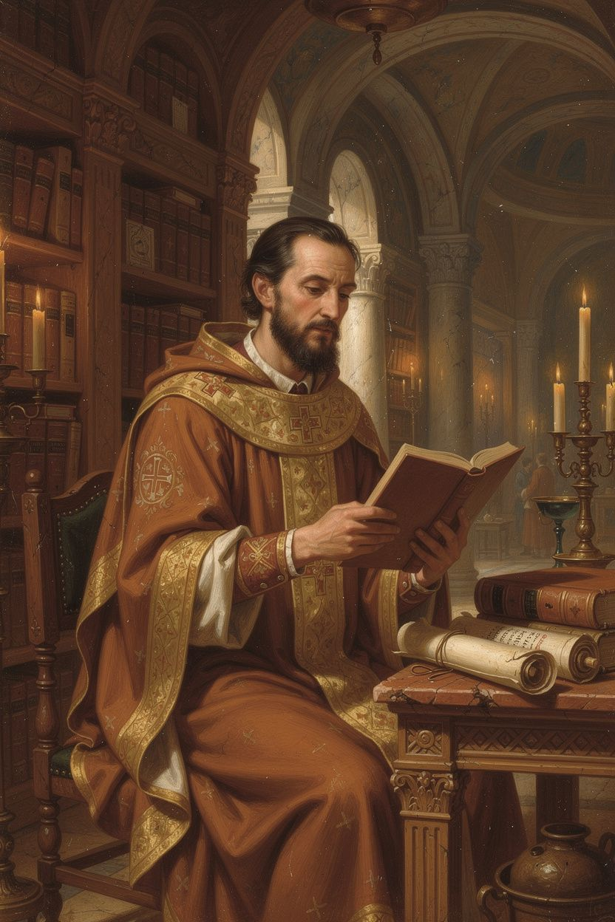
Gregory of Nazianzus: The Reluctant Theologian
WisdomForge Booklet — Ages 11–14

Gregory of Nazianzus: The Reluctant Theologian

WisdomForge Booklet — Ages 11–14
———

About This Book
Gregory of Nazianzus (c. 329/330–389/390 CE) is one of the most important figures in Christian history — and one of the most overlooked. He was a poet, a preacher, a scholar, and a bishop who never wanted to be a bishop. The Eastern Orthodox Church gave him a title that only one other person has ever held: "the Theologian." (The other is John the Evangelist, who wrote the Gospel of John.)
Gregory lived in the fourth century, during one of the most intense periods of theological conflict in history. The church was divided over a question that mattered enormously: Who is Jesus? Is he fully God, or is he a created being? Is the Holy Spirit God, or something less? Gregory's answer — that God is Father, Son, and Holy Spirit, one in nature and three in persons — became the official teaching of the church, codified at the Council of Constantinople in 381 CE.
But Gregory was not just a debater. He was a man who loved books, loved his friend Basil, and loved quiet. He kept running away from leadership — and every time he came back, he did his best work. He insisted that theology is not a game for dinner parties. He taught that God is too big for our minds to fully understand. He wrote poetry about God that is still read 1,700 years later. And he wrote some of the most honest speeches about grief and loss in all of ancient literature.
This booklet tells his story in six chapters. Each one has a narrative, a Big Idea, something to Try, and questions to Talk About. You do not need to agree with Gregory to learn from him. You just need to be willing to wrestle with his questions — about God, about leadership, about suffering, and about what it means to speak truthfully about the most important things.
———

Chapter 1: The Student and the Friend
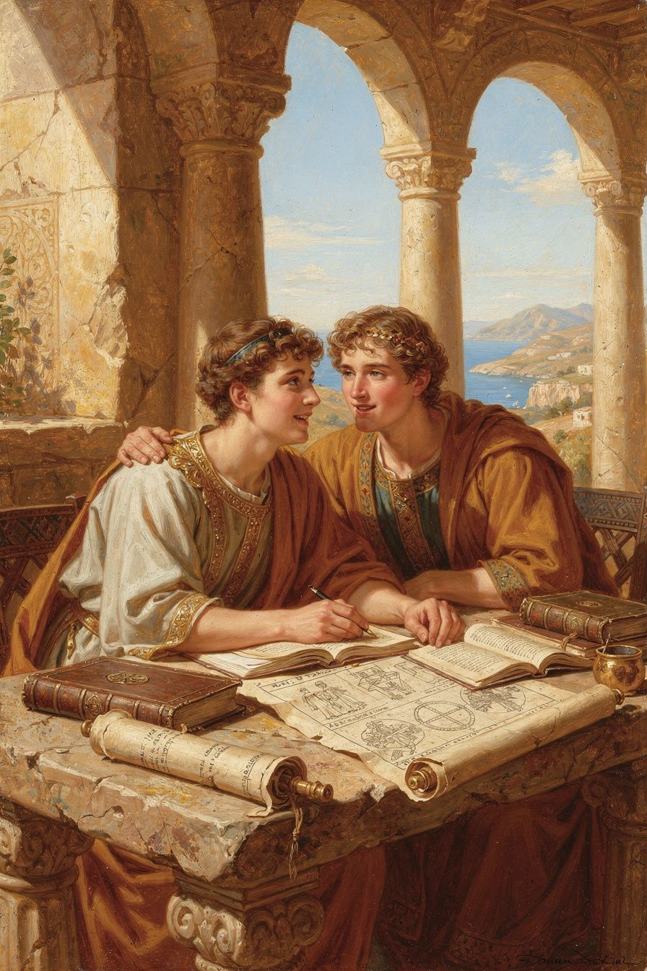
Illustration for Chapter 1

Education in the Ancient World
Gregory's family was special in another way too. His brother Caesarius was a brilliant physician who served at the imperial court — a man of extraordinary talent whose death at a young age was a devastating blow to Gregory. His sister Gorgonia was a married woman known for her piety, charity, and spiritual discernment. Gregory's funeral oration for her (Oration 8) is one of the most important early Christian tributes to a woman and to the vocation of Christian marriage. His father, Gregory the Elder, lived to be nearly 100 and served as bishop for over 45 years. His mother, Nonna, was credited with his father's conversion and shaped the family's deep faith.
Gregory loved all of his family members very much, and when they died — Caesarius first, then Gorgonia, then his father, then his closest friend Basil — he wrote speeches about them that showed how much they meant to him. These funeral orations are not just tributes; they are theological works that interpret death and loss in the light of faith. They show a man who brings his grief honestly before God, without pretending the pain is not real.
His family was not perfect — Gregory and his father sometimes argued about what Gregory should do with his life, especially when his father ordained him as priest without asking. But they loved each other, and that love shaped everything Gregory did.
Gregory received the best education the ancient world could offer. He studied rhetoric in Caesarea, the provincial capital of Cappadocia. He continued his studies in Alexandria, the intellectual capital of the East, where he absorbed the philosophical traditions of the city. Then he went to Athens — the most famous center of learning in the ancient world.
In Athens, Gregory studied for years. He learned rhetoric (the art of persuasive speaking), philosophy, and literature. He read Homer, Plato, and the great Greek orators. This training gave him the tools to become one of the most eloquent writers in Christian history. Without Athens, there would have been no Five Theological Orations.

The Friendship with Basil
In Athens, Gregory met Basil of Caesarea. They were both from Cappadocia. They were both serious about their Christian faith. They were both brilliant students. But they were very different in temperament: Basil was practical, organized, and political; Gregory was contemplative, literary, and sensitive.
Gregory described their friendship in language that has become famous: "We were the talk of the city — two young men who had given themselves to God, in a city that worshipped idols." While other students were enjoying the pleasures of Athens, Gregory and Basil were studying, praying, and talking about philosophy and theology.
Their friendship lasted until Basil's death in 379 CE. It was not always easy. Basil was political and sometimes used Gregory as a pawn in church politics. The worst moment came when Basil appointed Gregory bishop of Sasima — a miserable town with no water, no trees, and no civilization — purely to strengthen Basil's own metropolitan authority. Gregory was furious and never fully forgave Basil for this.
But the friendship endured because it was deeper than the disagreements. Gregory's funeral oration for Basil (Oration 43) is one of the great works of ancient friendship literature. It is honest about the tensions but celebrates the bond. Gregory called Basil "the great friend of my soul."

The Cappadocian Fathers
Gregory and Basil were part of a larger movement. Together with Basil's younger brother, Gregory of Nyssa, they are known as the "Cappadocian Fathers." The three of them developed the theological framework that the church adopted at the Council of Constantinople: one divine essence (ousia) in three divine persons (hypostaseis).
The key distinction they made was between "what" and "who." What is God? One divine nature. Who is God? Three persons — Father, Son, and Spirit. The three persons share one nature, one power, one will, and one operation. They are not three gods, because they share one essence. They are not three masks of one God, because their personal distinctions are real and eternal.
Gregory expressed this with a famous image: "The Father was the True Light. The Son was the True Light. The Spirit was the True Light. Was and Was and Was, but Was One Thing. Light thrice repeated; but One Light and One God." Three lights, one light. Three persons, one God.
The Cappadocian settlement resolved two dangers. Tritheism (three gods) was avoided because the three share one nature. Sabellianism (one God in three temporary roles) was avoided because the three persons are eternally distinct. The Father did not become the Son; the Son did not become the Spirit. They are three real persons, in eternal relation, sharing one divine life. The Cappadocian settlement — the doctrine of the Trinity that shaped the church — was not produced by isolated scholars. It was produced by friends: in conversation, in argument, in shared purpose. Their differences made the theology stronger, not weaker. Friendship can sustain difference.
Try This
- Think about your closest friendship. What makes it strong? Are you and your friend similar or different? Write down three things that make your friendship work — even if you disagree sometimes. - Research question: Look up Cappadocia on a map. Find Athens. Gregory traveled from Cappadocia to Alexandria to Athens to study — all by boat and on foot. How long would that journey take today by plane? How long would it have taken in the fourth century? - Compare Gregory and Basil. Make a two-column list: Gregory's traits on one side, Basil's on the other. How did their differences complement each other? How did their differences cause tension?
Talk About It
1. Gregory said his friendship with Basil was "the bond of the Spirit, not the bond of blood." What does that mean? Can a friendship be deeper than family? 2. Why did Basil's appointment of Gregory to Sasima strain the friendship? Was Gregory right to be angry? Would you have stayed friends with someone who did that to you? 3. Gregory's funeral oration for Basil is both a tribute and a lament. Why is it important to celebrate a friend's life after they die? What would you say about your closest friend?
———
What does it mean to be called to something you don't want to do?
———

Chapter 2: The Reluctant Priest
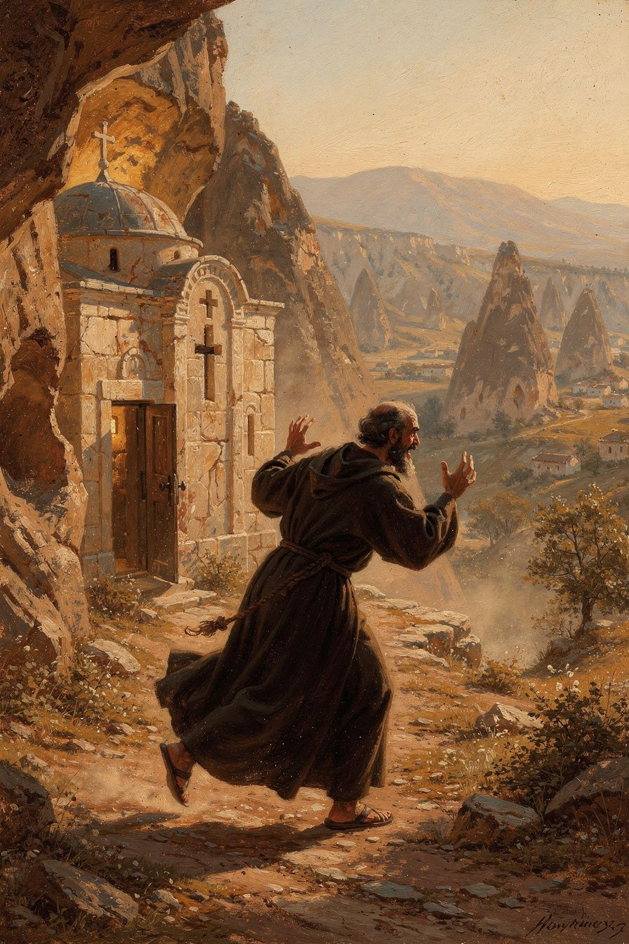
Illustration for Chapter 2

The Flight from Ordination
After Athens, Gregory returned to Cappadocia. He wanted a quiet life of study, prayer, and friendship. He spent time in Basil's monastic community in Pontus, where they read Origen together and compiled the Philokalia, an anthology of Origen's writings.
But around 361 CE, Gregory's father — the bishop of Nazianzus — ordained him as priest. Gregory had not been consulted. He had not wanted ordination. He saw it as a betrayal — his father forcing him into public ministry when he wanted contemplative quiet.
Gregory fled. He went to Basil's monastery in Pontus. This was not just personal weakness. Gregory believed that ordination was too serious to be entered lightly. His Apologia for His Flight to Pontus (Oration 2) is one of the most important early texts on the nature of ordination and the burden of pastoral responsibility. Gregory argued that the priesthood is a sacred trust, not a job to be given without the candidate's consent and preparation.
Eventually, Gregory returned and accepted the priesthood. He served under his father in Nazianzus and began to develop his theological voice. But the tension between his desire for a quiet life and his calling to public ministry never fully resolved.

The Sasima Crisis
In 372 CE, Basil — now bishop of Caesarea — appointed Gregory as bishop of Sasima. Gregory was appalled. He described Sasima as "a detestable little place, without water, without trees, without civilization." He felt that Basil was using him as a pawn in ecclesiastical politics — creating bishoprics to strengthen his metropolitan authority.
Gregory went to Sasima briefly, found it intolerable, and left. The appointment strained the friendship between Gregory and Basil for years. Gregory described the pain and frustration in his letters and later in Oration 43, his funeral oration for Basil.
This episode reveals something important about the fourth-century church: even the Cappadocian Fathers — friends, allies, theological collaborators — could treat each other with a certain ruthlessness when institutional power was at stake. The church was not just a community of faith; it was a political institution, and the politics could be ugly.

An Alternative Model of Leadership
Gregory's repeated withdrawals from office were not cowardice. They were theological acts — expressions of his conviction that ministry requires integrity, that office without calling is abuse, and that the contemplative life is the ground of all true service.
Gregory's model of leadership is different from the modern model. He led through theology, not administration. He led through integrity, not power. He led through withdrawal as well as engagement — the rhythm of contemplation and action. His honesty about his reluctance, his grief, and his failures is itself a form of leadership. It says: leaders are human; they struggle; they need grace.
This model challenges our assumptions. Modern culture values the active, organizational leader — the one who builds things, manages people, never stops. Gregory's kind of leadership looks passive by comparison. But his brief ministry in Constantinople (379–381 CE) was one of the most consequential in Christian history. He built a tiny congregation into the vehicle of Nicene victory, preached the orations that shaped the church's creed, and presided over the council that ratified the faith. His resignation was not defeat but a choice — the choice to leave rather than compromise his integrity in political maneuvering.
Gregory was not a weak leader. He was a different kind of leader, whose strength lay in theology, preaching, and integrity rather than in administration and politics. His willingness to walk away from power — from Sasima, from Constantinople — is itself a witness. It says: the church is not about power; it is about truth. A leader who clings to office at all costs is not leading; he is occupying.
Big Idea
Gregory's flight from ordination was not weakness — it was a theological protest. He believed that being a priest or bishop is too important to be entered without consent, preparation, and a genuine sense of calling. His reluctance is a challenge to any culture that treats leadership as a prize to be grabbed rather than a burden to be carried.
Try This
- Read Gregory's argument. In Oration 2, Gregory says ordination is too serious for casual entry. Write down three reasons someone might refuse a leadership role. Are those reasons weakness or strength? - Think about a time you were pushed into something. Maybe a teacher pushed you into a role, or a parent made you do something you weren't ready for. How did it feel? Did you say yes or no? What happened? - Compare two kinds of leaders. Make a list: one column for the "organizer" leader (like Basil), one for the "contemplative" leader (like Gregory). What are the strengths of each? What are the weaknesses?
Talk About It
1. Was Gregory right to run away from ordination? Is it ever okay to refuse something God seems to be calling you to? 2. The Sasima appointment strained Gregory's friendship with Basil. Have you ever had a friendship tested by a disagreement about what is fair? How did you resolve it? 3. Gregory led through theology and integrity rather than administration and power. Which kind of leader do you respect more? Can both kinds be effective?
———
Is it braver to fight for power or to walk away from it?
———

Chapter 3: The Tiny Church in the Big City
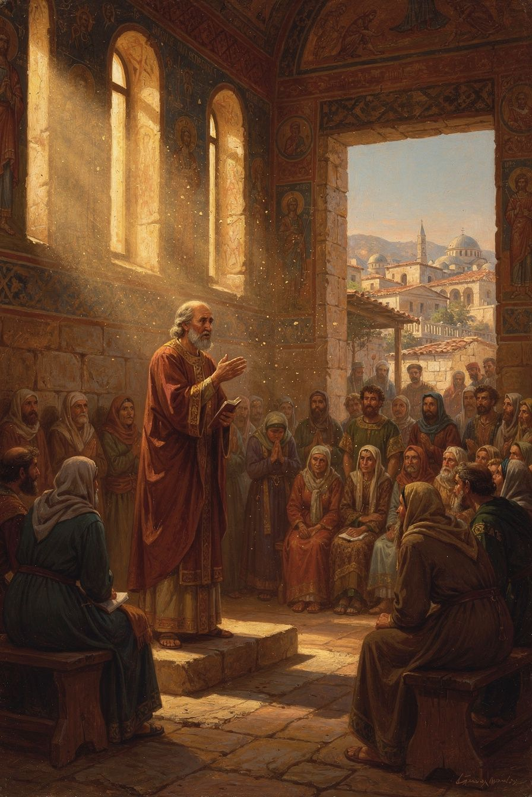
Illustration for Chapter 3

Constantinople, 379 CE
In 379 CE, Gregory was invited to lead the small Nicene Christian community in Constantinople — the capital of the Roman Empire and one of the greatest cities in the world. The situation was dire. Constantinople had been an Arian stronghold for decades. The Arian bishop Demophilus controlled the main churches. The Nicene community was tiny, scattered, and demoralized. They had no church building. They met in a private home they called the Anastasia — "Resurrection" — a name of hope and defiance.
Gregory arrived as a stranger, sick and tired, with no church, no money, and very few supporters. But he had his voice. And his voice would change everything.
The situation was desperate in another way too. In Constantinople, theology was a public sport. Gregory complained that people discussed the Trinity at dinner parties, in the marketplace, at the barber shop. Everyone had an opinion about the nature of the Son and the Spirit. The Eunomians claimed to know God's essence completely. Amateur theologians debated technical terms they did not understand. Gregory found this dangerous — not because theology is only for experts, but because speaking about God is a sacred task that should be done with reverence, not as entertainment. This conviction would shape the very first of his Five Theological Orations.

The Five Theological Orations
In 380 CE, Gregory preached the Five Theological Orations (Orations 27–31) in the little house-chapel of the Anastasia. These orations are his masterpiece and one of the great achievements of Christian theology.
Oration 27: The Character of the Theologian. Gregory begins not with doctrine but with a question: Who is qualified to speak about God? He attacks the Eunomians, who claimed to know God's essence completely. True theology, he argues, requires purification, reverence, and silence as much as speech.
Oration 28: The Incomprehensibility of God. Gregory argues that while we can know that God exists from creation and providence, we cannot comprehend God's essence. Our language about God is partial. The via negativa — saying what God is not — is more reliable than the via positiva — saying what God is.
Oration 29: On the Son. Gregory sets out the orthodox doctrine of the Trinity. The Father is the source; the Son is eternally begotten; the three persons share one divine nature. "There never was a time when the Son was not."
Oration 30: On the Son (continued). Gregory defends the Son's full divinity against Arian objections and addresses the Incarnation: the Son became human without ceasing to be God.
Oration 31: On the Holy Spirit. Gregory defends the Spirit's divinity against the Pneumatomachi (Spirit-fighters). The Spirit receives the same worship as the Father and Son, performs the same divine works, and is the one who sanctifies and deifies believers.

The Political Shift and the Council
In 379 CE, the emperor Valens died at the Battle of Adrianople. His successor, Theodosius I, was a committed Nicene Christian. Theodosius issued the Edict of Thessalonica (380 CE), declaring Nicene Christianity the official faith of the empire. The political wind had shifted. For the first time, a Roman emperor had officially declared a specific form of Christianity as the imperial faith. This was both a victory and a problem — it secured the Nicene faith but also entangled it with political power, a tension that Gregory himself would experience firsthand.
When the Council of Constantinople met in 381 CE, it expanded the Creed of Nicaea to include a clear affirmation of the Spirit's divinity: "And [we believe] in the Holy Spirit, the Lord and giver of life, who proceeds from the Father, who with the Father and the Son is worshipped and glorified." This language directly reflects Gregory's pneumatology from Oration 31. The Spirit is "Lord" (divine), "giver of life" (divine works), "proceeds from the Father" (eternal relation), and receives "worship" (divine honor). The creed that millions of Christians still recite today bears the imprint of Gregory's theology.
But Gregory was not at the council to see his victory. He had been made bishop of Constantinople, but the bishops of Alexandria challenged his appointment on a technicality — he had been transferred from Sasima, which violated Canon 15 of Nicaea. Gregory, weary and disgusted by the politicking, resigned. His farewell speech (Oration 42) is one of the most moving documents in patristic literature: "I have been a bishop without a church, a pastor without a flock."
Big Idea
Gregory's ministry in Constantinople shows that theology can change history. His preaching in a house-chapel helped prepare the way for a council that shaped the church's creed for centuries. The Niceno-Constantinopolitan Creed — still used in worship today — is in many ways Gregory's creed. But the same episode shows the cost of integrity: Gregory resigned the highest position in the church rather than cling to power he had not sought.
Try This
- Read part of a creed. Find the Niceno-Constantinopolitan Creed online. Read the section about the Holy Spirit. Notice the language: "the Lord and giver of life, who proceeds from the Father, who with the Father and the Son is worshipped and glorified." This is Gregory's theology in the church's words. - Imagine being Gregory. You have a tiny congregation in the biggest city on earth. The other side has all the big churches and political power. But you have better arguments and the courage to keep going. Write a short journal entry as Gregory on the night before he preaches the first Theological Oration. - Research the Anastasia. "Anastasia" means "Resurrection." Why do you think the Nicene community named their house-church "Resurrection"? What were they saying about themselves and their situation?
Talk About It
1. Gregory's five speeches changed the church's understanding of God. Can words really change history? What other speeches or writings can you think of that changed the world? 2. Gregory resigned from the highest position in the church rather than fight for it. Was that strength or weakness? Would you have fought or walked away? 3. The Council of Constantinople was both a theological victory and a political event. What happens when political power and religious truth get mixed together? Is it good, bad, or both?
———
Can a tiny group with the truth defeat a big group with the power?
———

Chapter 4: Talking About God the Right Way
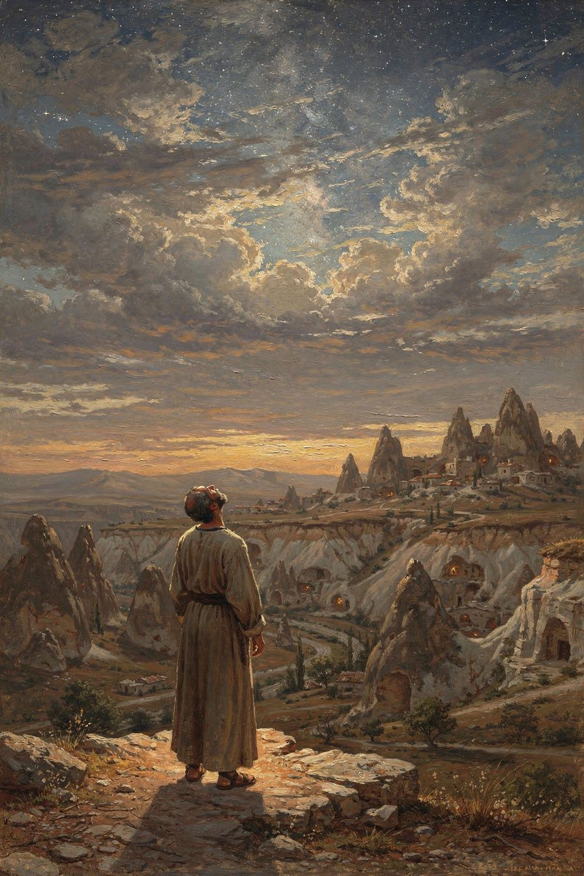
Illustration for Chapter 4

Theology Is Not for Everyone
One of Gregory's most distinctive ideas is that theology — speaking about God — is not something anyone can do at any time. In Oration 27, he says: "Discussion of theology is not for everyone, I tell you, not for everyone — it is not such a cheap and low thing. Nor is it for just any occasion or any audience."
This sounds elitist at first. But Gregory is not saying that only certain people are allowed to think about God. He is saying that speaking about God is a sacred task that requires the right kind of person, the right preparation, and the right attitude. The theologian must be purified, reverent, and humble. The audience must be serious. The time must be right. The topic must be proportioned to human capacity.
Gregory was writing against two extremes. The Eunomians claimed to know God's essence completely — that "unbegotten" is the exact name of God's nature. Gregory found this arrogant and dangerous. On the other side, some treated theology as a hobby — something to debate at dinner parties, like politics or sports. Gregory found this trivializing.

The Incomprehensibility of God
In Oration 28, Gregory argues that God is ultimately incomprehensible. We can know that God exists from creation and providence. We can know something of God through the Incarnation and the Spirit. But we cannot fully comprehend God's essence.
Gregory uses the image of Moses on Mount Sinai: even the greatest prophet only saw the "back parts" of God. God is like the sun: we can see the light, feel the warmth, watch things grow — but we cannot stare directly at it. The light is too great for our eyes.
This is not skepticism. Gregory believes we can know God truly — but partially, like seeing a mountain through mist or hearing a symphony from the next room. The knowledge we have is real but incomplete. God is infinite; our minds are finite. The finite cannot contain the infinite, any more than a cup can contain the sea.

The Way of Negation
Gregory argues that it is easier to say what God is not than what God is. God is not limited, not mortal, not created, not subject to change. These negations are true and meaningful. But they tell us what God is not, not what God is.
This "way of negation" (the via negativa) became a foundation of Eastern Orthodox theology. It shaped Gregory of Nyssa, Pseudo-Dionysius, Maximus the Confessor, and Gregory Palamas. The Eastern tradition treats theology as a discipline of reverence: the theologian speaks, but speaks with awareness of the limit.
Gregory was not writing in a vacuum. His apophaticism was sharpened by his conflict with the Eunomians, who claimed that "unbegotten" is the exact definition of God's essence — that if you understand this one word, you understand God completely. Gregory found this absurd and dangerous. "Ingenerate" is a useful term, he argued, but it describes the Father's mode of origin (he is not begotten), not the fullness of what God is. The Eunomian claim to comprehensive knowledge of God was, for Gregory, a form of spiritual pride — the very thing Oration 27 warns against.
The paradox at the heart of Gregory's theology is this: God is knowable and God is incomprehensible. We can know God truly, because God reveals himself — in creation, in Scripture, in the Incarnation, in the Spirit. But we cannot fully comprehend God, because the finite mind cannot contain the infinite. The knowledge we have is real but partial — like seeing a mountain through mist, or hearing a symphony from the next room. The partial knowledge is not a failure; it is the appropriate form of knowledge for finite beings before an infinite God.
Big Idea
Gregory teaches that theology is a spiritual discipline, not just an intellectual exercise. The best people to talk about God are those who pray, who are humble, who live good lives. And even the best theologians know that God is too big for their minds. This is not ignorance; it is intellectual humility — the recognition that the infinite cannot be captured by finite concepts.
Try This
- Try the via negativa. Write down five things God is NOT. (Examples: God is not limited. God is not created. God is not mortal.) Now try to write down five things God IS. Which list was easier? Gregory says the first list is always easier. Why do you think that is? - Think about who should talk about God. Gregory says the theologian should be someone who prays and lives well. Do you agree? Would you trust a person who talks brilliantly about God but lives selfishly? Why or why not? - Look at the sun (carefully!). Go outside on a sunny day. Look at the light on the trees and the ground. But don't look directly at the sun — it's too bright. Gregory said God is like that: we see God's light in the world, but we can't fully see God. Try to explain this idea to someone in your own words.
Talk About It
1. Gregory says theology is "not for everyone." Is he being elitist, or is he making a different point? Who SHOULD talk about God? 2. Gregory says God is "incomprehensible" but also that we can "know God truly." How can both of these be true at the same time? Is it possible to know someone truly without fully understanding them? 3. The via negativa says it's easier to say what God is not than what God is. Try it: what is God NOT? What does it tell you about God when you focus on what God is not?
———
If God is too big for our minds, why do we keep trying to talk about God?
———

Chapter 5: Who Is Christ? The Principle That Changed Everything
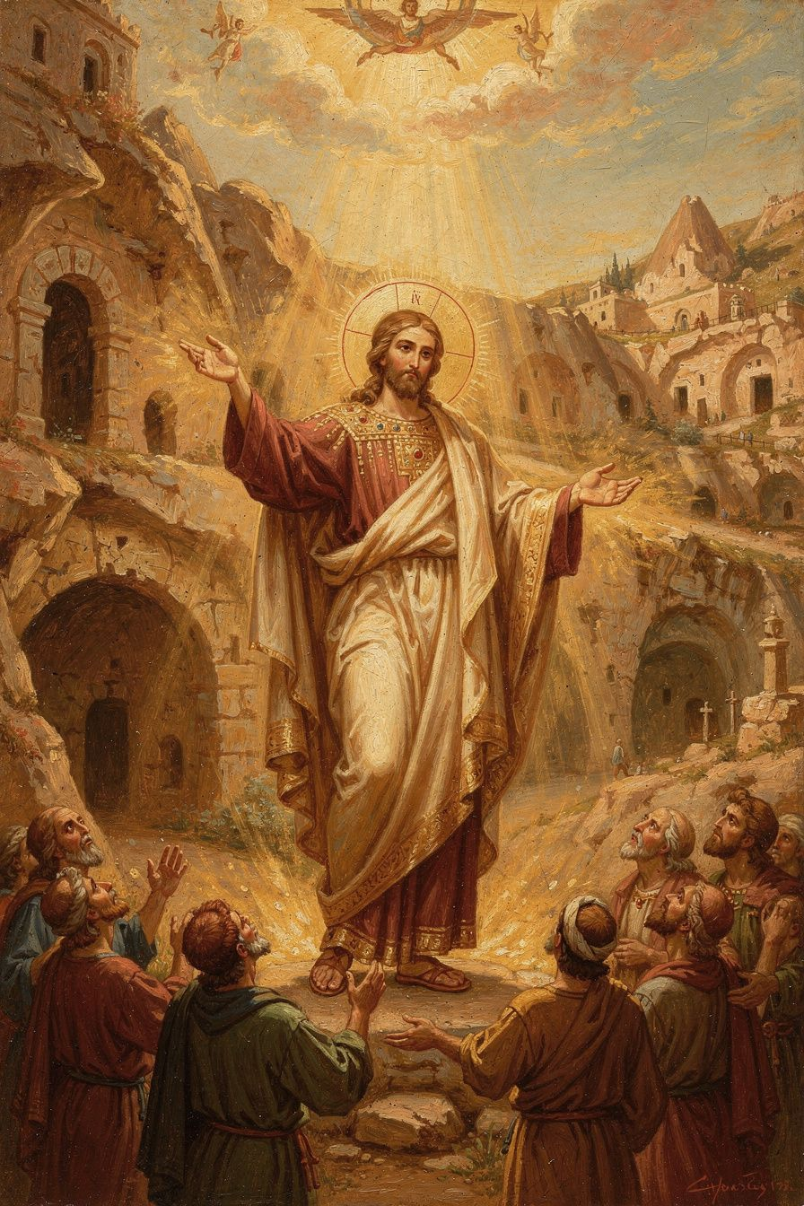
Illustration for Chapter 5

The Apollinarian Controversy
The most important Christological controversy of Gregory's time was Apollinarianism. Apollinarius of Laodicea accepted that the Son is fully God. But he argued that the Son did not assume a full human mind. In Apollinarius's view, the Word (the divine Logos) took the place of the human mind in Christ. Christ had a human body and a human soul, but his mind was divine, not human.
Apollinarius had a reason for this. He believed the human mind is the seat of sin. If Christ had a human mind, he would have a sinful will, and therefore he could not be sinless. To preserve Christ's sinlessness, Apollinarius denied him a human mind.

Gregory's Response: "What Is Not Assumed Is Not Healed"
Gregory saw the problem immediately. If Christ has no human mind, then human minds are not redeemed. The whole point of the Incarnation is that the Son assumes the full human nature — everything that needs healing — so that the whole human being is saved.
Gregory's response is one of the most important sentences in the history of theology:
"The unassumed is not healed; but what is joined to his divinity, that is saved."
The logic is devastating. If the Son became human to heal humanity, he must become everything that humanity is. Every part that needs redemption — body, soul, mind, will — must be assumed. If any part is left out, that part is left unredeemed. A Christ without a human mind saves bodies and emotions but not minds. Since the human mind is precisely what needs healing — it is the seat of sin, the thing that turns from God — a Christ without a human mind cannot solve the problem. The disease is in the mind; the cure must reach the mind.
But what about Apollinarius's concern? If Christ has a human mind, does he not also have a sinful will? Gregory's answer is that the human mind is not sinful by nature. The human mind is a good creation of God. It becomes sinful when it turns from God. Christ's human mind was a real human mind, but it was always in harmony with the divine will. The unity of the person — the one person of the Son — ensured that the human mind was always ordered to God. The Incarnation itself is the healing: the Son takes on the full human condition, including mortality and suffering, not because he shares the guilt of sin, but because he enters the world of sin to transform it from within.

The Unity of the Person
Gregory also insists that Christ is one person, not two. The Son of God did not inhabit a human being; he became a human being. The person who was born of Mary, who suffered, who died, who rose — that person is the eternal Son. The divine and human natures are united in one personal subject.
This formula — two natures, one person — anticipates the Definition of Chalcedon (451 CE), which became the standard Christological confession of the universal church. Gregory did not use the exact Chalcedonian language ("without confusion, without change, without division, without separation"), but his theology pointed directly toward it. His principle ("what is not assumed is not healed") is the theological engine that drives the church toward the Chalcedonian Definition. Without Gregory, the church might not have arrived at the mature Christological confession it did.
Gregory also articulated what later theology calls the communicatio idiomatum — the communication of attributes. Because Christ is one person, the attributes of both natures can be predicated of the one person. We can say "God suffered" and "God died" — not because the divine nature suffers, but because the one person who suffers is God. This is why Gregory can say, in the same breath, "the Word became flesh" and "the flesh was the Word." The properties of the divine nature belong to the person; the properties of the human nature belong to the same person. The one subject is both.

The Purpose: Deification
For Gregory, the purpose of the Incarnation is not simply the forgiveness of sin. It is deification (theosis) — the transformation of human beings into participants in the divine life. His most famous single sentence is: "God became human, that human beings might become divine."
This does not mean humans become God by nature. They remain creatures. But they share in God's life by grace — through the Spirit, through the sacraments, through the transformation of the whole person. A coal on its own is dark and cold. Put it in a fire, and it takes on the fire's heat and light. The coal is still a coal — but it now glows. In the same way, humans do not stop being human when they are deified. They remain human, but they are filled with God's life.
This concept became central to Eastern Orthodox theology and is one of the key differences between Eastern and Western understandings of salvation. In the East (Gregory, Athanasius, the Cappadocians), salvation is deification — participation in the divine life. The problem is not just guilt but corruption: human nature is diseased, and the cure is transformation. In the West (Augustine, Anselm, the scholastic tradition), salvation is often framed as justification — the forgiveness of sin and the restoration of a right relationship with God. The problem is guilt and the problem is legal: humanity owes a debt it cannot pay.
These are not necessarily contradictory. Both traditions affirm the centrality of Christ, the need for grace, and the work of the Spirit. But they emphasize different aspects. Gregory's deification is more transformative; the Western justification is more forensic. In recent ecumenical dialogue, both traditions have recognized that the other's emphasis can complement their own.
Big Idea
Gregory's principle — "what is not assumed is not healed" — means that Christ must be fully human as well as fully divine. Every part of us that needs saving, he took on. The goal is not just forgiveness but transformation: God became human so that humans might share in God's life.
Try This
- Trace the logic. Write down Gregory's argument in your own words: If Christ doesn't have a human mind, then human minds aren't saved. If Christ doesn't have a human will, then human wills aren't healed. Do you agree with this logic? Can you find a flaw in it? - Try the coal image. Gregory says deification is like a coal in a fire: the coal is still a coal, but it glows with the fire's energy. Think of another image that explains the same idea — something that takes on a new quality without losing what it is. Share your image with the group. - Research the Council of Chalcedon. Gregory's Christology shaped the Council of Chalcedon (451 CE), which defined Christ as "one person in two natures." Look up the Chalcedonian Definition. How does it reflect Gregory's principle?
Talk About It
1. Apollinarius denied Christ a human mind to keep him sinless. Gregory said this means human minds aren't saved. Which argument makes more sense to you? Why? 2. Gregory said "God became human, that humans might become divine." Does this mean humans become God? What is the difference between being divine "by nature" and "by grace"? 3. The coal-in-the-fire image shows that deification doesn't erase your identity — you're still you, but filled with God. What would it look like in daily life to be "filled with God's life"?
———
If Christ had to take on everything we are to heal us, what does that say about how much God loves us?
———

Chapter 6: The Poet Who Went Home
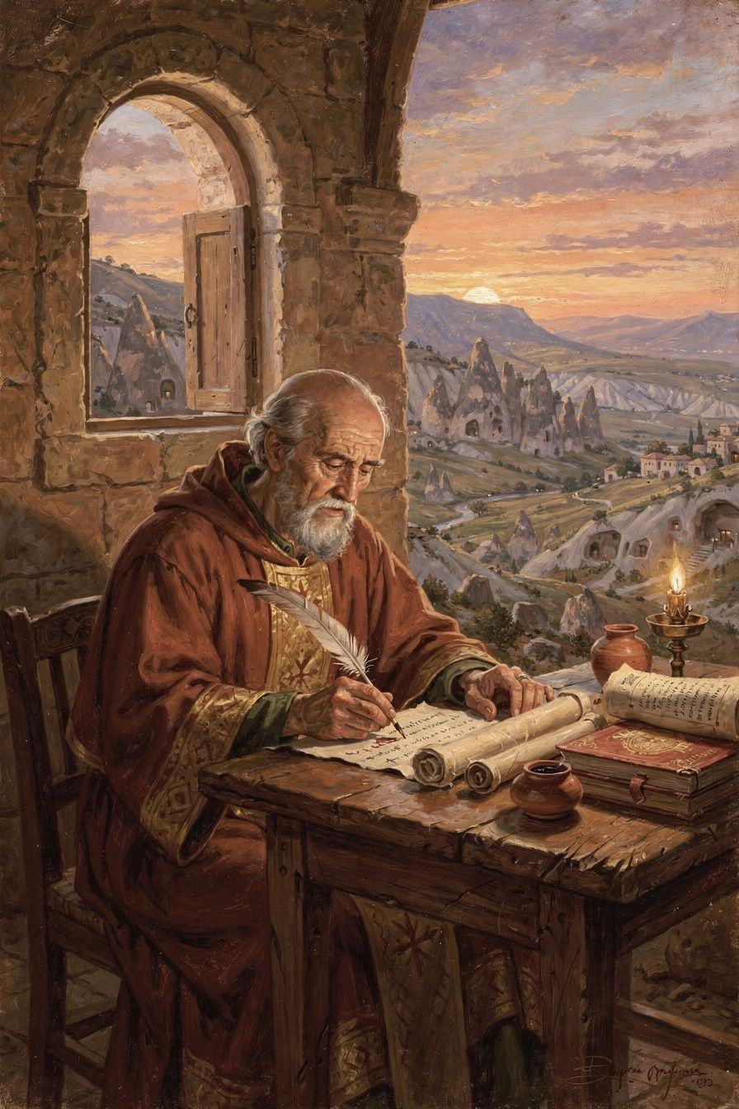
Illustration for Chapter 6

Retirement at Arianzus
After his resignation from Constantinople in 381 CE, Gregory went home to Arianzus. He spent his last decade in retirement — writing poetry, corresponding with friends, and struggling with chronic illness. He never returned to public ministry.
This was not idle withdrawal. Gregory's retirement produced his most personal and enduring work. The De Vita Sua ("Concerning His Own Life"), his longest poem at nearly 2,000 lines, is a theological interpretation of his entire life — his education, his friendship with Basil, his reluctant ordination, his stormy time in Constantinople, his illnesses, his griefs, and his final withdrawal. It is one of the earliest extended autobiographies in Christian literature.
In the poem, Gregory reads his own story through the lens of providence — seeing God's hand in his successes and failures, his friendships and his loneliness, his moments of influence and his times of obscurity. The poem is remarkable for its emotional honesty. Gregory does not hide his disappointment, his anger, his weariness. He describes the church politics that wearied him, the betrayal by friends that wounded him, the physical illnesses that weakened him. But he also describes the joy of study, the beauty of friendship, the peace of contemplation. The poem is a whole life seen under the aspect of God.
His retirement was not merely withdrawal. Gregory had argued in Oration 27 that theology requires a formed soul, and in Oration 28 that God is incomprehensible. His withdrawal was a form of practicing what he preached — choosing contemplation over power, silence over argument, the presence of God over the politics of the church. He corresponded with friends and church leaders, followed church affairs from a distance, and produced the most personal theology of his career.

Poetry as Theology
Gregory is the only one of the great Greek Fathers to have produced a large body of theological poetry. Around 17,000 lines of his verse survive, from a reported original output of perhaps 30,000 lines. His poetry is not a break from theology; it is a form of theology. He believed that Christian truth should be expressed in the full range of literary forms — not just prose argument.
His Poemata Arcana ("Secret" or "Mystical Poems") treat the Father, Son, Holy Spirit, creation, providence, and the soul in verse. He calls the Son "the unspeakable speech of the Father" — a phrase that captures the paradox of the Word. The Son is the Father's self-expression, yet that expression exceeds human capacity to articulate. His moral poems treat the virtues and vices — patience, humility, generosity, anger, greed. His epitaphs honor friends and family with tenderness. His verse epistles show a man who believed that beauty and truth belong together.
Gregory also wrote poetry as a spiritual practice. The discipline of finding the right word, the right meter, the right image is a form of contemplation. It forces the writer to slow down, to attend to the gift of language, to honor the subject. In Gregory's hands, poetry becomes prayer.

The Theologian of Grief
Gregory's funeral orations — for his brother Caesarius (Oration 7), his sister Gorgonia (Oration 8), his father (Oration 18), and his friend Basil (Oration 43) — are among the most moving documents in patristic literature. They show a man wrestling with grief honestly, bringing his pain before God.
Gregory's approach to grief is not Stoic resignation. The Stoic ideal is to accept loss without being disturbed. Gregory rejects this. He grieves deeply. He weeps. He laments. He asks God why. But he also hopes — in the resurrection, in the communion of saints, in the promise that death is not the end. His grief is theological because it is brought before God. He does not suffer in silence; he suffers in the presence of the One who can hear.
The pattern is: name the loss, celebrate the life, wrestle with meaning, commend to God. It does not skip any stage. It does not rush to comfort. It grieves honestly and hopes faithfully. The hope of resurrection does not eliminate the grief; it gives the grief a horizon. Gregory grieves and hopes at the same time.
Gregory's personal experience of loss shaped his theology in specific ways. His insistence that God is beyond comprehension is not just philosophical; it is the fruit of suffering. When you have lost the people you love most, you cannot accept a God who fits in your system. God must be bigger than your understanding — big enough to hold your pain and your questions without breaking. His apophaticism and his grief are connected: the experience of loss drove him to a theology that makes room for mystery.

The Title: "The Theologian"
The Council of Ephesus (431 CE) formally gave Gregory the title "the Theologian" — a title shared in the East only with John the Evangelist. Scholars debate what the title means. Some say it refers to Gregory's articulation of Trinitarian doctrine. Others say it refers to his spiritual approach — theology as a holy act. Others say it refers to his literary achievement — theology as beautiful speech.
Most scholars now hold an integrated reading: the title means all three. Gregory is "the Theologian" because he showed what theology looks like when it is done right — doctrinally precise, spiritually rooted, and beautifully expressed. The separation of doctrine, spirituality, and beauty is the tragedy of modern theology. Gregory shows us what they look like together.
Big Idea
Gregory's retirement was not a failure — it was his most productive period. His poetry shows that theology can be beautiful, that a life read through the lens of faith is itself a theological text, and that honesty about grief, disappointment, and weariness is not a weakness but a form of truthfulness. The title "the Theologian" means that Gregory showed what theology looks like when it is done with precision, holiness, and beauty all together.
Try This
- Write a short poem about your life. Gregory's De Vita Sua is a theological reading of his own life. Try writing 8-10 lines about something that has happened to you, and ask: where was God in this? It doesn't have to rhyme — just be honest. - Read a funeral oration. Find Oration 7 (for his brother Caesarius) or Oration 43 (for Basil) online at New Advent. Read the opening paragraphs. Notice how Gregory is honest about his sadness but also finds hope. What do you think of his approach to grief? - Think about the title "the Theologian." If you could have a title that describes what you are best at, what would it be? Gregory's title meant he was the best at talking about God. What would your title be?
Talk About It
1. Gregory wrote poetry as well as prose. Why might someone write theology as poetry? What can poetry express that prose cannot? 2. Gregory's funeral orations are honest about grief but also full of hope. Is it okay to be sad even when you believe in God? Does faith make grief easier or harder? 3. Gregory is called "the Theologian" — a title only one other person has. What do you think earned him this title? Was it his arguments, his spirituality, his poetry — or all three?
———
What would it look like to do theology with precision, holiness, and beauty all at once?
———

For the Grown-Up Reader
This booklet introduces young readers to Gregory of Nazianzus through six themes: education and friendship, reluctant leadership, the Constantinopolitan mission, the discipline of theology, Christology, and the poetic retirement. The content is faithful to Gregory's orations, letters, and poems, and to the scholarly literature.
Key sources used: - Primary: Orations 2, 7, 8, 18, 27–31, 38, 40, 42, 43; Letters 101–102 to Cledonius; De Vita Sua; Poemata Arcana. All available in English at New Advent (www.newadvent.org/fathers) and in print translations by Williams/Wickham (Five Theological Orations, Brill 2002), Gilbert (poetry, SVS Press 2001), and Meehan (autobiographical poems, Dumbarton Oaks 2007). - Secondary: McGuckin, St. Gregory of Nazianzus: An Intellectual Biography (SVS Press, 2001); Beeley, Gregory of Nazianzus on the Trinity and the Knowledge of God (Oxford, 2008); Daley, Gregory of Nazianzus (Routledge, 2006); Russell, The Doctrine of Deification in the Greek Patristic Tradition (Oxford, 2004).
The quotes have been simplified for young readers but are based on real passages. The "coal in the fire" image for deification is Gregory's own (from the research files' age-specific guidance). The "sun" image for apophaticism is Gregory's own (Oration 28). The "lifeguard/doctor" image for the Incarnation appears in the research files.
A note on the Trinity: The Cappadocian distinction between ousia (essence) and hypostasis (person) is introduced lightly. The chapter on the Constantinopolitan mission explains the Three Theological Orations' content without technical philosophical vocabulary.
A note on deification: The doctrine of theosis is introduced through the coal-in-fire image, which faithfully represents Gregory's meaning: deification is by grace, not nature. Humans remain human; they share in God's life by the gift of the Spirit.
———

About WisdomForge
WisdomForge produces four booklets for each figure, adapted to four age groups: elementary (5–10), middle (11–14), high (15–18), and adult. Each booklet covers the same six themes but at a different depth and with different activities. The goal is simple: the wisdom of the greatest thinkers, made accessible to every age.

