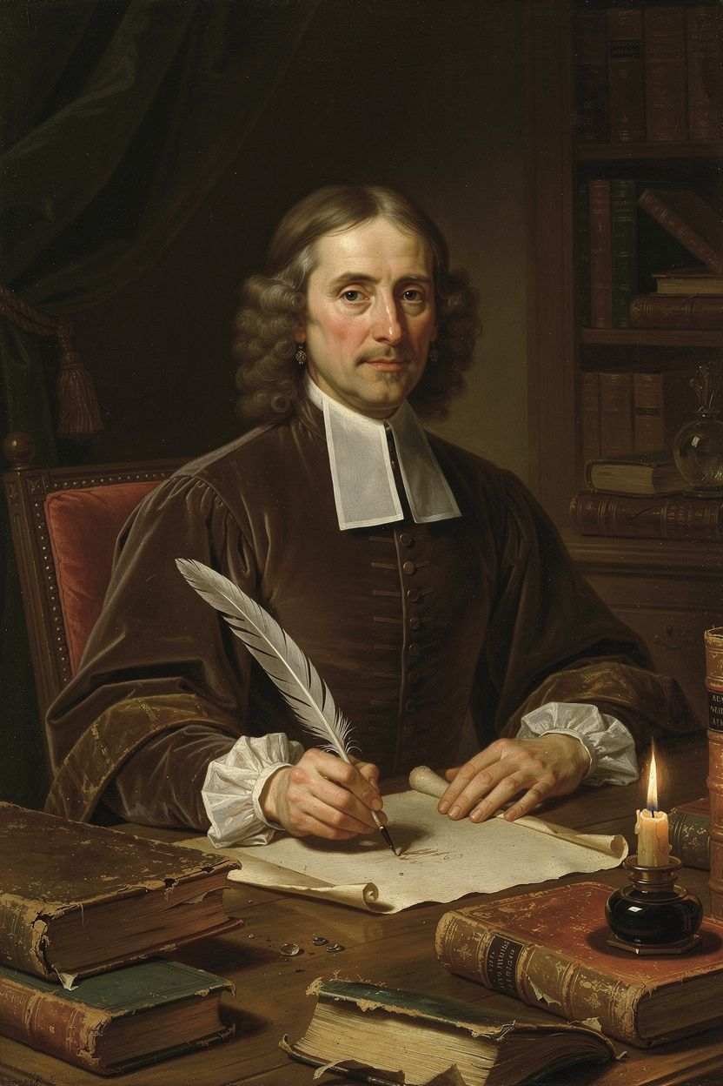
John Locke: The Philosopher Who Made Freedom Thinkable
WisdomForge Booklet — Adult

John Locke: The Philosopher Who Made Freedom Thinkable

WisdomForge Booklet — Adult
———

About This Book
John Locke (1632–1704) is the philosopher who taught the modern world to think about freedom. Before Locke, political philosophy was dominated by questions of divine right, natural hierarchy, and the obligations of subjects to rulers. After Locke, the questions changed: Do people consent to be governed? What rights do they have before government exists? What is the purpose of political power, and what happens when that purpose is betrayed? Can the state force belief? What makes something yours? How do we know what we know?
Locke's answers reshaped the world. His Two Treatises of Government (1689) supplied the arguments later cited by American revolutionaries in the Declaration of Independence and by French revolutionaries in the Declaration of the Rights of Man. His Letter Concerning Toleration (1689) helped move Europe toward religious freedom and the separation of church and state. His Essay Concerning Human Understanding (1689) set the terms for three centuries of debate about knowledge, mind, and the limits of human reason. His Some Thoughts Concerning Education (1693) influenced how the English-speaking world raised its children. His Reasonableness of Christianity (1695) made the case for a stripped-down, rational religion.
But Locke's legacy is also compromised. He helped draft the Fundamental Constitutions of Carolina (1669), which included provisions for chattel slavery. He invested in the Royal African Company, which profited from the slave trade. He served as Secretary to the Council of Trade and Foreign Plantations, overseeing colonial policy. The philosopher of natural rights and liberty participated in institutions of slavery and colonial exploitation. This contradiction is not a footnote — it is central to understanding Locke and the liberal tradition he founded.
This booklet takes you through six of Locke's biggest ideas: empiricism and the architecture of the mind, the state of nature and natural law, the labor theory of property, limited government and the separation of powers, religious toleration, and the right of revolution. Each chapter includes the historical context, the philosophical argument, the scholarly debates that continue to shape our understanding, and practical exercises aimed at an adult reader's life — career, family, citizenship, mortality. You are not just learning what Locke thought. You are learning how to think with him, how to challenge him, and how to decide for yourself whether his answers still hold in a world he could not have imagined.
———

Chapter 1: The Architecture of the Mind — Empiricism, Knowledge, and Identity
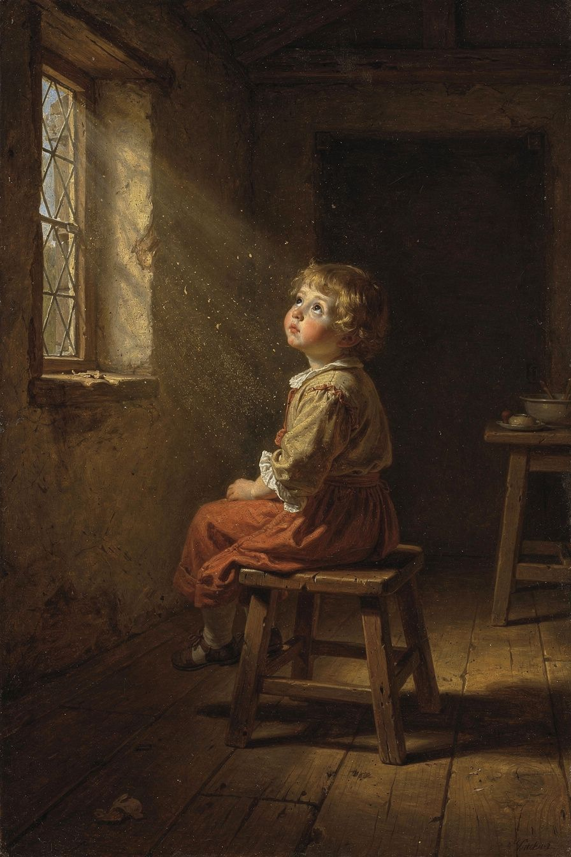
Illustration for Chapter 1
In 1671, Locke and a group of friends were sitting in Lord Shaftesbury's study, arguing about morality and religion. The arguments went in circles. Nobody could agree because everyone started from different assumptions. The group realized they could not resolve their disputes without first examining the mind's capacity for knowledge. What can we know? How do we know it? Where do our ideas come from? This conversation launched the project that would occupy Locke for eighteen years and produce the Essay Concerning Human Understanding (1689) — the largest and most influential work of British empiricism.
The dominant view in Locke's time was rationalism. Descartes argued for innate ideas — principles stamped on the mind by God. The Scholastic tradition held that certain truths were self-evident. Supporters of innate ideas pointed to the universality of moral principles: all cultures prohibit murder, all societies value truth-telling. If everyone agrees on these, they must be built in.
Locke attacked this view in Book I of the Essay. His argument was empirical. If innate ideas existed, they would appear in everyone — including children and people with cognitive disabilities. But children do not know these principles until they are taught. People with severe cognitive impairments do not know them at all. What looks like an innate principle is usually a product of custom, education, and repeated exposure. The universality of moral rules is better explained by the universality of human experience — we all face similar problems of survival, cooperation, and conflict — than by the hypothesis of innate ideas.
If there are no innate ideas, where do ideas come from? Locke's answer, in Book II, is the most famous image in modern philosophy: the mind as white paper, furnished by experience. Experience comes through two channels. Sensation delivers ideas from the external world through the senses — colors, sounds, textures, tastes. Reflection delivers ideas from the mind's observation of its own operations — thinking, doubting, believing, willing. All ideas, simple or complex, trace back to these two sources. The mind cannot create ideas from nothing. It can combine, compare, and abstract, but the raw material always comes from experience.
Locke distinguishes simple and complex ideas. Simple ideas are the raw data — red, bitter, motion, unity. They cannot be invented or decomposed. Complex ideas are built by the mind through combination, comparison, and abstraction. The ideas of substances (gold, horse, man), modes (triangle, gratitude, murder), and relations (father, cause, larger than) are all mental constructions. This framework would shape psychology and cognitive science for centuries.
Locke then draws the primary/secondary quality distinction. Primary qualities are inseparable from the body — solidity, extension, figure, motion, number. They exist in the object itself. Secondary qualities are powers in objects to produce sensations in us — color, sound, taste, smell. The distinction supported the new mechanical science of Boyle and Newton, which studied the real properties of matter. But it also created the problem that would define modern philosophy. Berkeley argued that the distinction collapses — if color is "just in our minds," then so is shape, because we perceive shape through the same sensory channels. Hume radicalized the problem: if all we have is impressions, then even causality is "just in our minds." Kant transformed the problem into his distinction between appearances and things-in-themselves: we can never know the world as it truly is, only as it appears to us through the structures of our mind. The primary/secondary distinction is not a settled doctrine but the opening move in a conversation that has never ended.
Locke also asked what makes you the same person over time. His answer was startling: not your body, not your soul-substance, but your consciousness. "For since consciousness always accompanies thinking, and makes every one to be what he calls self, and thereby distinguishes himself from all other thinking things; in this alone consists personal identity." If you can remember doing something, you are the person who did it. If you cannot remember it, your identity with that earlier self is interrupted. This "memory theory" of personal identity would dominate philosophy for centuries and still shapes debates today — about amnesia, dementia, split-brain cases, and the philosophical puzzle of whether a perfect clone with your memories would be you.
The memory theory has been challenged from multiple directions. Butler argued that memory presupposes identity rather than constituting it — you can only remember your own experiences because you are already the same person. Reid pointed out that a person who remembers A, and A remembers B, but the person does not remember B, creates a paradox: the person is identical to A, A is identical to B, but the person is not identical to B (transitivity breaks). Contemporary philosophers like Parfit have radicalized the problem: what matters is not personal identity but psychological continuity, and identity is not what we think it is. Parfit's "branch-line" cases — where your psychological continuity is preserved in two different bodies — show that identity is not necessary for what matters in survival. These debates are not academic — they have direct implications for end-of-life decisions (when does the person you were cease to exist?), legal responsibility (can you be punished for what someone else did, even if you remember doing it?), and what it means to be a person in the full moral sense.
Locke's personal identity theory also connects to his ethics. If personal identity is consciousness, then moral responsibility attaches to the conscious person — the being who can remember the action and understand its consequences. This is why Locke thinks punishment should be directed at the person, not the body: you punish the conscious agent who chose the action, not the physical body that carried it out. This has implications for questions about diminished capacity, dementia, and moral responsibility that are very much alive in contemporary law and ethics.
The Big Idea
Locke's empiricism is a democratic epistemology. If all knowledge comes from experience, then no one has privileged access to truth based on authority, birth, or office. A farmer who has observed crops for thirty years knows more about agriculture than a prince who has read about it. A woman who has experienced discrimination knows more about its effects than a philosopher who has theorized it. This does not mean all opinions are equal — Locke distinguishes knowledge from probability and insists that beliefs should be proportioned to evidence. But it means that the authority of tradition, church, and state can be questioned. Every claim must be tested against experience. This is the epistemological foundation of the Enlightenment and of modern science.
The scholarly debate on innate ideas has been revived by contemporary cognitive science. Chomsky's "language acquisition device" suggests the mind has built-in grammatical machinery. Developmental psychologists like Spelke have found that infants have expectations about physical objects before they could have learned them. Evolutionary psychologists argue for innate cognitive modules. But these findings do not refute Locke in the way they might seem to. Locke did not deny that the mind has capacities at birth — he denied that it has content. The machinery is a capacity, not a content. The specific ideas — that murder is wrong, that property should be respected — still come from experience, culture, and reasoning. Leibniz's response to Locke is illuminating: the mind is not blank paper but veined marble. The veins are there from the start, and experience shapes how they are revealed. Kant synthesized both positions: knowledge begins with experience, but the mind contributes its own structures (space, time, causality) that are not derived from experience. The debate between empiricism and rationalism is not settled, and Locke's position remains one of the poles around which it turns.

Practice
1. The Belief Audit. List your five most deeply held beliefs. For each, trace it back to its source: Where did it come from? Did you experience it directly? Did someone tell you? Did you reason it out? What evidence supports it? What evidence would change your mind? The exercise reveals how much of what you "know" comes from authority rather than experience — and whether that is a problem. 2. The Qualities Experiment. Pick three objects near you. For each, list their primary qualities (shape, size, solidity) and secondary qualities (color, smell, texture). Now imagine each object with no one perceiving it. Which qualities remain? Which disappear? Write a paragraph about whether you think the distinction holds, and what happens when you push it to its limit. 3. The Identity Question. Write down five memories from different periods of your life. Are you the same person who had each of those memories? What makes you the same? If you lost all your memories in an accident, would you still be you? If your memories were transferred to another body, would that person be you? Write 300 words on what personal identity means to you. 4. The Probability Calibration. Locke distinguishes knowledge (certain) from probability (likely). For one week, every time you state a belief, ask: Is this knowledge or probability? What is the probability, roughly? Are you overconfident? The exercise reveals how much of what passes for certainty is actually probability — and how often we treat beliefs as knowledge when they are really guesses.

Reflect
If all your knowledge comes from experience, what does that mean for your most deeply held beliefs? Which would survive a radical change in your experiences — and which would not? And if your beliefs are products of your experience, how should that change the way you treat people whose experiences have been different from yours?
———

Chapter 2: The State of Nature and the Foundations of Political Authority
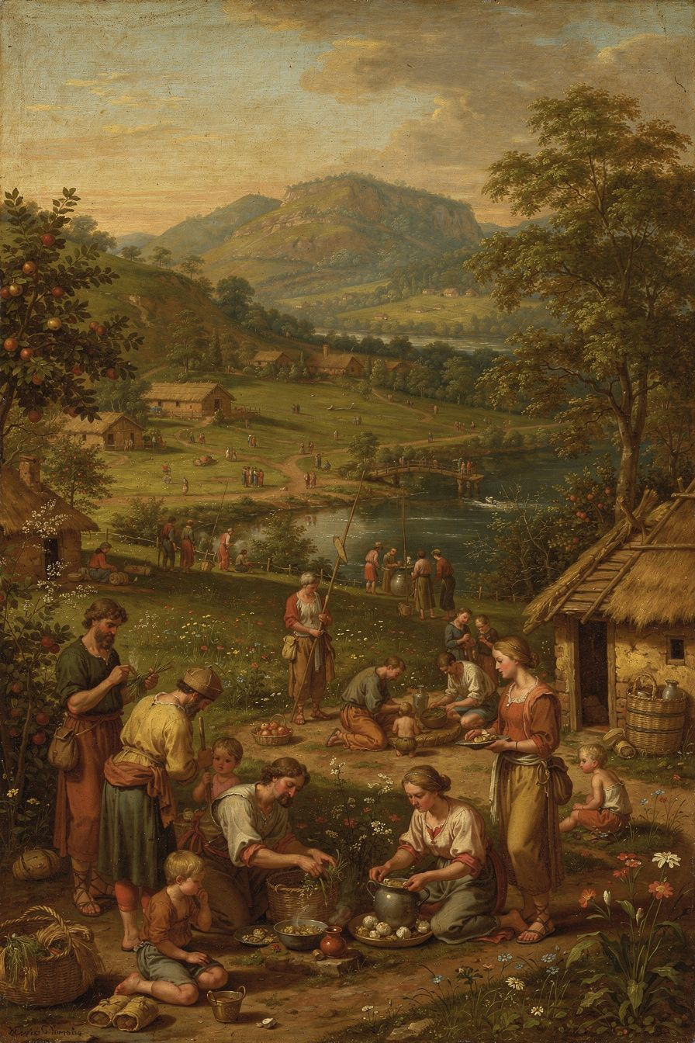
Illustration for Chapter 2
The "state of nature" is Locke's starting point for political philosophy. It is a thought experiment: imagine humans living together without any government. What would that look like? The answer reveals what government adds and what justifies it.
Locke's state of nature is a condition of perfect freedom and equality. Every person is free to act as they choose, within the bounds of the law of nature. Every person is equal — no one has a natural right to rule another. The state of nature is governed by the law of nature, which reason can discover: "being all equal and independent, no one ought to harm another in his life, health, liberty, or possessions" (§6). The law of nature has two main commands: self-preservation (each person is bound to preserve their own life) and preservation of others (when one's own preservation is not at stake, one ought to preserve the rest of humanity).
This is where Locke departs from Hobbes — and the departure is foundational. For Hobbes, the state of nature is a "war of every man against every man," a brutal condition where life is "nasty, brutish, and short." Government is the only thing standing between us and chaos. For Locke, the state of nature is not chaos. It is a moral order governed by natural law. People can live, work, trade, and resolve disputes. The problem is not that people are naturally murderous; the problem is that each person is judge, jury, and executioner in their own case.
The state of nature has three "inconveniences" — structural problems that make it unstable. First, there is no settled, known law. The law of nature exists, but it is not written down. Reasonable people may disagree about what it requires. Second, there is no impartial judge. Each person judges their own case, and human nature being what it is, people tend to judge too favorably for themselves and too harshly against their enemies. Third, there is no executive power. Even when the law is known and a judgment is reached, there may be no power to enforce it.
These inconveniences are why people form government. They do not escape from hell; they improve on a tolerable but imperfect condition. Government solves the enforcement problem by creating known laws, impartial judges, and executive power. But government's authority comes from the natural right that individuals already possess — the "executive power of the law of nature" — which they transfer to the community through the social contract.
Locke carefully distinguishes the state of nature from the state of war. The state of nature is peaceful freedom governed by natural law. The state of war is force and hostility, which begins when someone uses force without right. This distinction matters because it means government is not a rescue from savagery but an improvement on an already-moral condition. It also means the state of nature can recur: between nations (there is no world government), when a government dissolves, and in any situation without common authority.
The theological grounding of Locke's law of nature is significant. In the Second Treatise, the primary grounding is that humans are God's property — "the workmanship of one omnipotent and infinitely wise Maker." No one has the right to destroy God's workmanship. This is why the right to life is inalienable: you do not own your life, God does. But Locke also offers a rationalist path: in the Essay, he argues that moral truths can be discovered by reason operating on experience. The Reasonableness of Christianity suggests that while reason can discover the law of nature, Christianity confirms it and makes it accessible to those who lack the leisure or ability to reason it out for themselves.
The question of whether Locke's natural rights depend on God is one of the most important debates in Locke scholarship — and it has contemporary stakes. Jeremy Waldron argues that Locke's natural rights are inherently theological — without God, the foundation collapses. Leo Strauss reads Locke as a crypto-Hobbesian who used theological language for prudential reasons but whose real argument was secular. The debate matters because the Universal Declaration of Human Rights (1948) and the entire modern human rights framework draw on Lockean language. If the foundation is theological, the framework may be unstable in a secularizing world. If it can be grounded in reason alone, it may survive — but the grounding must be found. Contemporary philosophers like Dworkin have attempted to ground human rights in the dignity of persons rather than in theology, but whether this is a genuine grounding or a disguised theological claim remains contested.
The dating of the Two Treatises is another crucial scholarly debate. For most of the twentieth century, scholars believed the Two Treatises were written in 1689 as a post-hoc justification of the Glorious Revolution. Peter Laslett's archival detective work (published in his 1960 edition) demonstrated that they were almost certainly composed between 1679 and 1683 — during the Exclusion Crisis, not after the Revolution. This redating transformed the interpretation. If the Two Treatises were written before the Revolution, they are not a justification of what happened but a revolutionary manifesto for what should happen — perhaps even a call to resistance against Charles II. The text contains no references to James II, William of Orange, or the events of 1688. The "Great Rebellion" reference in the First Treatise makes more sense before 1688. John Dunn accepts the early dating but argues the work should be read as a theological document of Christian political duty, not a secular revolutionary ideology. The debate matters because it changes whether we read Locke as a moderate constitutionalist or a radical revolutionary — and because it changes how we understand the relationship between Locke's epistemology (the Essay, drafted from 1671) and his political theory (the Treatises, drafted 1679–1683). If they were simultaneous products of the same mind in the same context, they illuminate each other in ways that a "philosophy first, politics later" reading cannot.
The Big Idea
The state of nature reveals that government is not natural but artificial — created by people to solve practical problems. This means government is accountable to the people who created it. The law of nature — discoverable by reason — provides the moral standard by which all governments are judged. A government that violates natural rights is not just bad; it is illegitimate. This is the foundational claim of modern constitutionalism: there are things government cannot do, not because the constitution prohibits them, but because they violate a moral law that exists before any constitution. The question of whether that moral law requires a theological foundation is the question on which the modern human rights framework may stand or fall.

Practice
1. The Consent Question. Locke says government requires consent. But most people never explicitly consented. They are born into a political system, and "tacit consent" (using roads, owning property, accepting protections) is supposed to bind them. Is tacit consent real consent? Would you choose your current government if you had a free choice? What would it take to make consent meaningful? Write 300 words. 2. The Rights Inventory. List the rights you believe you have. For each, ask: Is it a natural right (you would have it without government) or a legal right (the government grants it)? How do you know? Can it be taken away? What would happen if it were? The exercise reveals how much of your political life rests on Lockean assumptions — and where those assumptions break down. 3. The Theological Test. Locke grounds natural rights in the claim that humans are God's property. Try to ground natural rights without God. What works? What fails? Dworkin tries dignity. Kant tries autonomy. Bentham says rights are "nonsense upon stilts." Which approach do you find most convincing, and why? 4. The Laslett Debate. Research the dating of the Two Treatises. If Locke wrote them before the Glorious Revolution as a revolutionary manifesto, how does that change how we read the right of revolution? If he revised them after, does the revision change the character of the argument? Write a page arguing each interpretation.

Reflect
If government exists to protect your natural rights, what should it do when your rights conflict with someone else's? And what should you do when the government decides that someone else's rights matter more than yours?
———

Chapter 3: Property, Labor, and the Question of Ownership
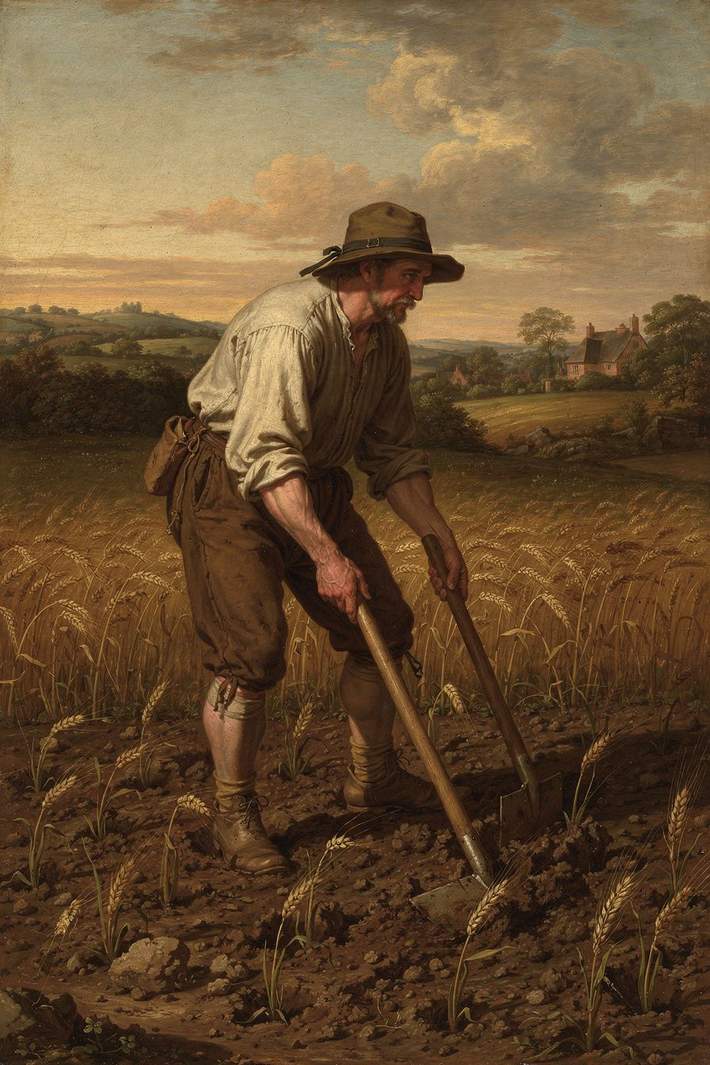
Illustration for Chapter 3
The question Locke sets himself in Chapter 5 of the Second Treatise is ancient and difficult. God gave the earth to humanity in common. No individual has a natural right to any particular piece of it. So how does private property arise? The feudal answer — "the king grants land" — pushes the question back. The brute-force answer — "I own it because I can defend it" — confuses might with right. Locke needed a principled account of how common resources become private property without violating the rights of others.
His answer is labor. Each person has "property in his own person" — your body is yours, your labor is yours. When you mix your labor with unowned natural resources — gathering acorns, tilling soil, catching fish — those resources become your property. Your labor enters the thing, and since your labor is yours, the thing becomes yours. You do not need everyone's permission to pick an apple. If you did, you would starve.
Locke places two critical limits. The "enough and as good" proviso: you may appropriate only if "there is enough, and as good, left in common for others." The spoilage limitation: you may not take more than you can use before it spoils. These limits initially keep property roughly egalitarian — no one can accumulate much, because surplus goods spoil.
Then money changes everything. Gold and silver do not spoil. People consent to accept money in exchange for goods that would otherwise rot. This allows accumulation far beyond what a person can personally use. The spoilage limit is bypassed. The "enough and as good" proviso is arguably sidestepped. Locke is aware this produces inequality. But he argues everyone is better off than in the state of nature, because cultivated land produces far more than uncultivated land.
This argument has been attacked from multiple directions. Rousseau said the first person to fence off land "did not know that he was introducing property, and with it, inequality, war, and crime." Marx said Locke's theory obscures the difference between the laborer who works and the owner who profits. Nozick adapted the "enough and as good" proviso for his "Entitlement Theory" in Anarchy, State, and Utopia (1974). Indigenous critics argue that Locke's theory treats land as "unowned" until Europeans "improve" it, erasing Indigenous property systems.
The deepest challenge comes from Locke's own life. He helped draft the Fundamental Constitutions of Carolina (1669), which included Article 110: "Every freeman of Carolina shall have absolute power and authority over his negro slaves, of what opinion or religion soever." The phrase "of what opinion or religion soever" explicitly overrides Locke's own Letter Concerning Toleration, which argues that religious belief should not affect civil rights. This contradiction is not a minor inconsistency — it is the central moral problem of Locke's legacy. Either Locke did not mean his principles to apply to Africans, or he drafted a provision he did not believe. If the former, his natural rights theory is not universal but an ideology of English liberty. If the latter, his personal complicity is a moral failure that does not invalidate the philosophy but stains the philosopher. The "implicit universalism" response argues that Locke's principles, once stated, have a logical force that exceeds their author's intentions. "All men are created equal" may have been meant by Jefferson to apply only to white men, but the principle itself admits no such restriction. Similarly, Locke's natural rights may have been intended for Englishmen, but their logical content is universal. The philosophy escapes the philosopher — and it is the escaped philosophy that the abolitionist movement, the civil rights movement, and the human rights movement have used against the very practices Locke enabled.
He invested in the Royal African Company, which profited from the slave trade. He served as Secretary to the Council of Trade and Foreign Plantations, overseeing colonial policy. He held investments in the Hudson's Bay Company. The philosopher of natural rights and liberty participated in institutions of slavery and colonial exploitation. The question is whether this participation invalidates the philosophy, or whether the philosophy contains the resources to criticize the practices its author enabled.
Scholars are deeply divided. Tully, Arneil, and Farr argue that Locke's theory is deeply embedded in the colonial project — the "improvement" criterion was designed to justify colonial appropriation. Tuckness argues that the theory contains genuine constraints — the proviso, the law of nature, consent — that can be turned against colonialism. Locke's theory of self-ownership applies to all humans, including Indigenous peoples. If Indigenous peoples own themselves, they own their labor, and their labor creates property rights in their land, regardless of whether Europeans consider it "improvement." Waldron argues the truth is in between: the theory was shaped by colonial assumptions, but it contains principles that can be turned against colonialism, and later thinkers — including Indigenous thinkers — have used Lockean principles to argue for Indigenous rights.
Macpherson's "possessive individualism" critique adds another dimension. In The Political Theory of Possessive Individualism (1962), Macpherson argued that Locke's political philosophy conceives of the person as an owner first and a citizen second. The individual is fundamentally a proprietor — of their body, their labor, their property — and political society is an instrument for protecting these possessions. This serves the interests of the emerging capitalist class. The "enough and as good" proviso and the labor theory provide moral cover for accumulation. Tully countered that Locke's property theory is more constrained than Macpherson suggests — the proviso is a real limit, not window dressing. The debate is not just about Locke; it is about whether liberal political philosophy is inherently biased toward capitalism, or whether it contains genuine constraints on inequality.
The Big Idea
The labor theory of property is both powerful and compromised. It provides a moral foundation for ownership that does not depend on might-makes-right. This intuition underlies intellectual property law, the idea of self-ownership, and the connection between work and dignity. But the theory was developed by someone complicit in colonialism, and its "improvement" criterion was used to justify the dispossession of Indigenous peoples. The question is whether the theory can be separated from its colonial origins and applied in a way that serves justice — or whether it is irredeemably marked by the violence it was used to justify. Locke's own principles — the proviso, consent, the law of nature's requirement to preserve humanity — can be turned against colonialism. But whether that is a recovery of Locke's true intent or a reconstruction against his actual practice is a question every reader must answer for themselves.

Practice
1. The Ownership Audit. List five things you own. For each, trace the chain of ownership back as far as you can. Did someone make it? Did someone buy it? Did someone take it? How far back does "labor" actually explain your ownership? Where does the theory work, and where does it break down? 2. The Proviso Challenge. Locke's "enough and as good" proviso says you can only take if there is enough left for others. Apply this to a contemporary issue: land ownership, water rights, intellectual property, carbon emissions, or wealth inequality. Is the proviso satisfied? If not, what should happen? Write a policy recommendation based on Lockean principles. 3. The Colonialism Reckoning. Research Locke's role in the Fundamental Constitutions of Carolina and his investment in the Royal African Company. Write a "prosecution" and "defense" of Locke. The prosecution argues his philosophy is invalidated by his actions. The defense argues the philosophy can be separated from the person. Which is more persuasive, and what are the implications for the liberal tradition? 4. The Wages Question. Locke's theory says you own your labor. If you sell your labor to an employer, who owns what you produce? Locke's theory is ambiguous. Read the relevant passages in the Second Treatise and write 300 words resolving the ambiguity. Consider: does the labor theory support or challenge the employer-employee relationship?

Reflect
Locke says you own what you make. But what about the people who made the world you make things in — the teachers who taught you, the workers who built the roads you use, the society that made your education possible? Does "you own what you make" fully capture the moral picture, or does something important get left out? And if Locke's own hands were not clean, what does that mean for the ideas those hands wrote?
———

Chapter 4: Limited Government and the Architecture of Constitutionalism
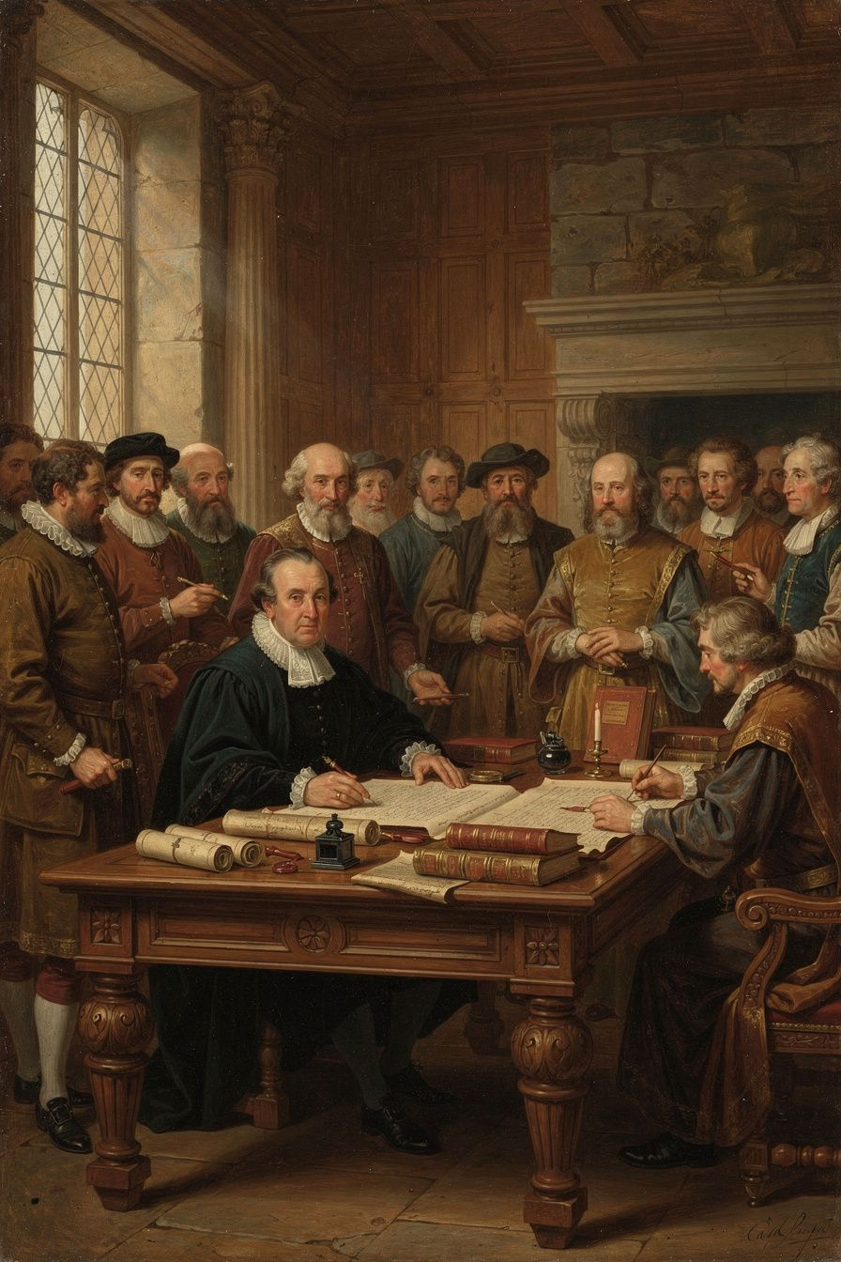
Illustration for Chapter 4
Locke's concept of limited government is the structural backbone of modern constitutional democracy. Government, he argues, has limited and defined powers. It exists for a specific purpose — the protection of natural rights — and cannot exceed that purpose. To prevent the concentration of power that leads to tyranny, Locke distinguishes three kinds of political power and insists that the legislative power, while supreme, must be bounded by law, consent, and the public good.
The case for limited government follows from the social contract. Government is created by consent for a specific purpose: to protect natural rights better than individuals could protect them in the state of nature. If government has more power than necessary, it has exceeded its mandate. Natural rights are prior to government. Government is created to protect them. Government cannot take property without consent. Government cannot be arbitrary. Government is a trust — rulers are trustees, and a trustee who betrays the trust forfeits the office.
Locke identifies four specific limits on the legislative power. First, it must govern by established standing laws, not arbitrary decrees. Second, it must act for the public good. Third, it cannot take property without consent — taxation requires consent through the legislative process. This is the origin of "no taxation without representation." Fourth, it cannot transfer its power.
Locke distinguishes three kinds of political power. Legislative power makes the laws — it is supreme but bounded. Executive power carries them out. Federative power manages foreign relations. This is not the modern three-branch separation — that comes from Montesquieu. Locke's judicial function is part of the executive. But his division is the foundation on which Montesquieu built, and through Montesquieu, the American Founders.
The legislative power is supreme but not absolute. It is the highest authority within the commonwealth, but it is bounded by the social contract and the law of nature. If it violates those bounds, it forfeits its authority. This is a careful balance: if the legislature were absolute, it could enslave the people. If it were not supreme, there would be no settled authority to make binding laws.
Locke introduces prerogative — the executive's power to act beyond the letter of the law for the public good in emergencies. Prerogative is dangerous. It allows the executive to suspend laws and act on its own judgment. The people must judge whether the use of prerogative serves the public good. If it does, they tolerate it. If it does not, they resist it. This tension between flexible executive action and arbitrary power is visible today in debates about emergency powers, executive orders, and presidential discretion.
Locke's framework directly influenced the American constitutional system. The written constitution, the separation of powers, checks and balances, "no taxation without representation," and the Bill of Rights all descend from Lockean principles. But Locke's framework also has a darker legacy: the question of who counts as "the people" whose consent matters. Locke's "people" did not include women, the propertyless, enslaved Africans, or Indigenous peoples. The "tacit consent" doctrine has been criticized as too thin — you cannot meaningfully "consent" to something by merely existing in a place, especially if you have no realistic option to leave. And the social contract tradition has been challenged by feminist philosophers. Carole Pateman's The Sexual Contract (1988) argued that the social contract presupposes a prior "sexual contract" that subordinates women to men. The history of constitutional democracy is the history of expanding who counts as "the people" — a process that is still ongoing.
The scholarly debate on Locke's separation of powers focuses on its limitations. Locke did not fully separate the judicial power. Montesquieu added the judicial branch, and the American Founders built checks and balances. Some scholars argue that Locke's failure to separate the judiciary is a real weakness: without an independent judiciary, there is no institutional check on the legislature. Others note that Locke's framework was designed for the English system, where the judiciary was already independent in practice. The question of how much of modern constitutionalism we owe to Locke versus Montesquieu is itself a matter of scholarly debate.
Macpherson's "possessive individualism" critique adds another angle. Locke conceives of the person as an owner first and a citizen second. Political society is an instrument for protecting possessions. This serves the interests of the emerging capitalist class. Tully countered that Locke's property theory is more constrained than Macpherson suggests. The debate is not just about Locke; it is about whether liberal political philosophy is inherently biased toward capitalism, or whether it contains genuine constraints on inequality.
The Big Idea
Government is a trust with limited, defined powers. It must follow written laws, act for everyone, not take property without consent, and not transfer its authority. Power should be divided so no one branch can dominate. The ultimate sovereignty resides not in the government but in the people who created it. This is the architecture of every modern constitutional democracy — and the standard by which every government can be judged. When a government claims powers beyond these limits, it does not merely act badly; it acts illegitimately. But the question of who counts as "the people" — whose consent matters, whose rights are protected — is a question that Locke's framework both enables and constrains. The history of constitutional democracy is the history of expanding that circle, and the work is not finished.

Practice
1. The Constitutional Audit. Take your country's constitution. Identify the legislative, executive, and judicial powers. What limits does the constitution place on each? Can you trace each limit to a Lockean principle? Where does the constitution go beyond Locke, and where does it fall short? 2. The Prerogative Problem. Research a recent use of executive power that went beyond normal legal procedure — an emergency declaration, an executive order, a wartime measure. Was it justified by Locke's standard of "public good"? Would Locke approve? Write an analysis. 3. The Consent Question. Locke says government requires consent. But who counts as "the people"? In Locke's time, the answer excluded women, the propertyless, and enslaved people. How has the answer changed? What does consent mean when the consenting body has expanded? Write 300 words on whether universal suffrage fulfills or transforms Locke's principle. 4. The Feminist Challenge. Read a summary of Carole Pateman's The Sexual Contract. How does Pateman's critique change how you read Locke? Is the social contract tradition inherently patriarchal, or can it be reconstructed? Write 300 words.

Reflect
Locke says the legislative power is supreme but not absolute. How can something be supreme but limited? What happens when the limits and the supremacy conflict — and who decides? And when "the people" who decide have themselves been excluded from the conversation, what happens to the legitimacy of the decision?
———

Chapter 5: Toleration, Conscience, and the Limits of Liberalism
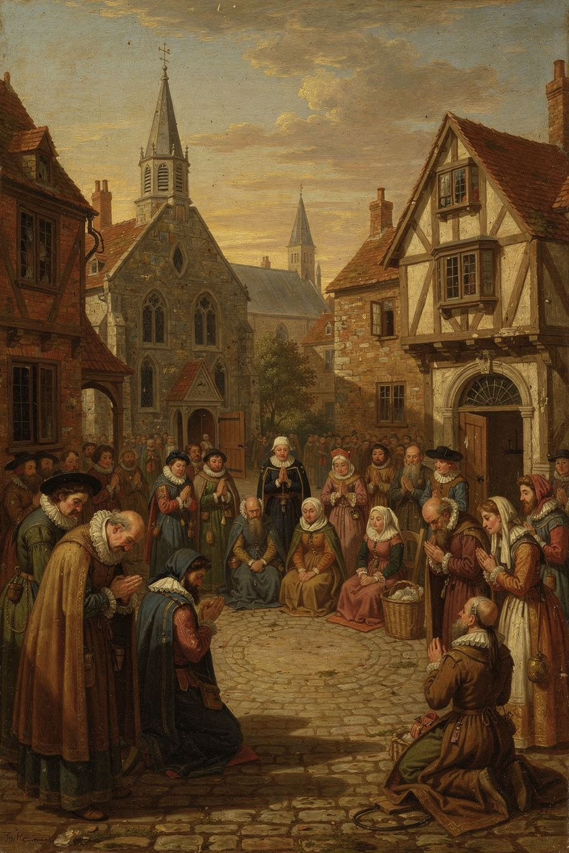
Illustration for Chapter 5
In Locke's time, religious uniformity was the norm in Europe. The principle cuius regio, eius religio held that the ruler determined the religion of the state. Dissenters were fined, imprisoned, exiled, or executed. In England, the Clarendon Code (1661–1665) excluded dissenters from public office, universities, and worship. The Test Acts (1673, 1678) required officeholders to take Anglican communion. Locke himself experienced the pressure of religious uniformity — his Whig associations made him suspect, and his Dutch exile taught him what a tolerant society looked like.
Locke's Letter Concerning Toleration (1689) argued that religious coercion is both wrong and pointless. Wrong, because the state's authority extends only to civil interests — life, liberty, health, and property. The care of souls does not belong to the magistrate. Pointless, because coercion cannot produce genuine belief. Belief is an inward act of the mind. Force acts on the body. You can make someone go through the motions of worship, but you cannot make them believe. "It is one thing to persuade, another to command; one thing to press with arguments, another with penalties."
Locke's case rests on a fundamental distinction between three realms. The state exists to protect civil interests. Its power is external — law, force, punishment. The church is a "free and voluntary society." No one is born a member of a church. Membership is chosen, and members may leave. The church's purpose is the worship of God and the salvation of souls. It may exhort and discipline, but it may not use force. Conscience is the inner forum where a person relates to God. It is beyond the reach of civil power.
From this framework, Locke develops several arguments. The magistrate has no commission to care for souls. The magistrate is fallible. Coercion cannot produce faith — it produces hypocrisy, not conversion. Toleration is good for religion — free competition produces vigor and commitment. Toleration is good for the state — persecuted minorities rebel, flee, or become enemies. A tolerant state earns the loyalty of all its subjects.
But Locke's toleration had limits. He excluded two groups: Catholics and atheists. Catholics were excluded for political reasons — their allegiance to the Pope created a divided loyalty. Atheists were excluded because Locke believed oaths and promises depend on belief in God. "Those are not at all to be tolerated who deny the being of a God. Promises, covenants, and oaths, which are the bonds of human society, can have no hold upon an atheist."
These exclusions are the subject of one of the most important debates in Locke scholarship. Were they consistent with Locke's principles? The traditional view says yes — if a group's beliefs threaten civil order, exclusion is the principle applied correctly. The radical critique says no — Locke's own Essay argues that moral knowledge comes from reason, not revelation. If reason can ground moral obligation, atheists who accept reason-based morality should be tolerable. The exclusion rests on a false generalization — that atheists cannot be moral — that Locke's own epistemology undermines. Mark Goldie has argued that Locke was not opposed to Catholicism per se but to "antinomianism" — the belief that allegiance to a higher authority supersedes civil law. If Catholics could discard that belief, they could be tolerated.
Locke's toleration was moderate, not radical. Spinoza's Theological-Political Treatise (1670) argued for freedom of philosophic thought without exception. Pierre Bayle's Philosophical Commentary (1686) argued that even "erroneous" conscience has a right to toleration. Locke's exclusions make him closer to the practical politics of the English Toleration Act of 1689 than to the philosophical radicalism of Bayle or Spinoza. "Locke is not John Stuart Mill" — Mill's On Liberty (1859) is far more expansive.
The debate about Locke's exclusions connects to a live question in contemporary political philosophy: the "toleration paradox." If a liberal society tolerates everything, it must tolerate intolerance — and intolerant groups may use the freedom liberalism provides to destroy liberalism. Karl Popper formulated this as the "paradox of tolerance" in 1945: unlimited tolerance leads to the disappearance of tolerance. Locke's exclusions can be read as an early recognition of this paradox. But who decides what counts as a threat? The danger is that the power to exclude "dangerous" groups becomes the power to silence dissent.
The debate also connects to Locke's personal identity theory. If personal identity consists in consciousness, then religious belief — which is a matter of consciousness — cannot be coerced because it is constitutive of the person. Forcing someone to change their belief is not just changing their opinion; it is attacking their identity. This gives Locke's argument for toleration a deeper foundation: toleration is not just good policy but respect for personal identity. But this also raises the question of whether Locke's exclusion of atheists is consistent with his own identity theory. If an atheist's consciousness does not include belief in God, then excluding the atheist for their non-belief is excluding them for their identity — precisely the kind of coercion Locke says is impossible and wrong.
The Big Idea
The government should not control what people believe. Belief is inside the mind, and force cannot reach it. This is the foundation of the separation of church and state, religious pluralism, and the broader principle that the state must respect the inner freedom of the individual. But Locke's own exclusions reveal a tension at the heart of liberal theory: can a liberal society tolerate those who reject its foundational assumptions? The question is not settled. Locke's attempt to settle it — by excluding those he considered threatening — remains the starting point for every subsequent debate, from the question of whether to tolerate anti-democratic parties to whether liberal societies can absorb illiberal religious communities.

Practice
1. The Three Realms Analysis. Take a contemporary controversy involving religion and the state — religious exemptions from healthcare, prayer in schools, religious symbols in public buildings, or anti-discrimination law vs. religious freedom. Apply Locke's three-realm framework: What is the state's interest? What is the church's interest? What is the individual conscience's interest? Where do they conflict? 2. The Exclusions Debate. Write a "prosecution" and "defense" of Locke's exclusion of atheists. The prosecution argues it contradicts his own principles. The defense argues it follows from his political logic. Which is more persuasive? What would Locke say to a modern atheist who argues that moral behavior does not require belief in God? 3. The Toleration Paradox. Research a contemporary case where a liberal democracy faces the question of whether to tolerate an illiberal group. What would Locke say? What would Mill say? What do you say? Write 500 words. 4. The Bayle Comparison. Read a summary of Pierre Bayle's Philosophical Commentary. How does Bayle's argument for toleration differ from Locke's? Is Bayle's position more consistent? What are the trade-offs between Locke's moderate approach and Bayle's radical one?

Reflect
Locke says the state cannot force belief. But can the state shape belief indirectly — through education, through funding, through the symbols it chooses? Where does "not forcing belief" end and "shaping belief" begin? And if the toleration paradox is real, what principles should guide the decision to exclude?
———

Chapter 6: Revolution, Popular Sovereignty, and the Question of Legitimacy
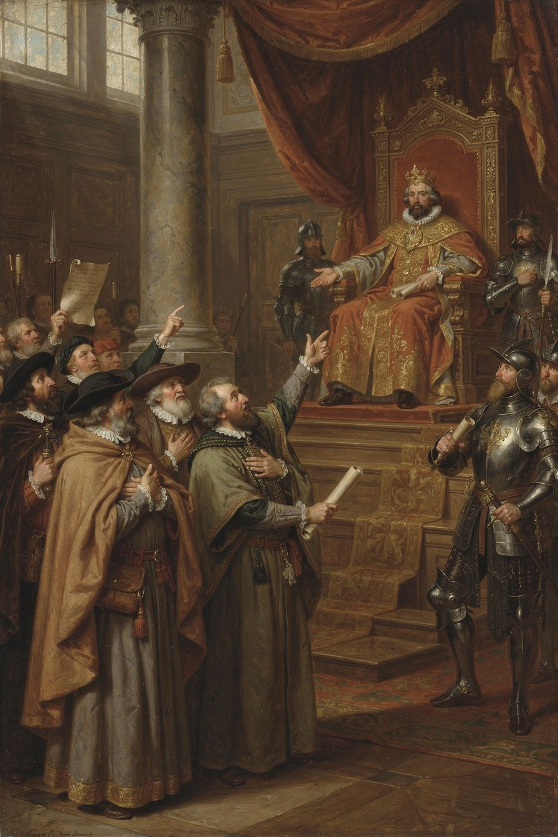
Illustration for Chapter 6
Locke's most radical idea is the right of revolution. If government is created by consent to protect natural rights, and if government betrays that purpose, the people have the right to dissolve it and form a new one. This is not lawlessness — it is the restoration of legitimate authority.
The argument follows from Locke's premises. Government is a trust. The trust has a purpose: protecting natural rights. A trustee who betrays the trust forfeits the office. The people may reclaim their power and form a new government. "Whensoever, therefore, the legislative shall transgress this fundamental rule of society; and either by ambition, fear, folly, or corruption, endeavour to grasp themselves, or put into the hands of any other, an absolute power over the lives, liberties, and estates of the people; by this breach of trust they forfeit the power the people had put into their hands."
Locke inverts the traditional logic. In the traditional view, the ruler is the legitimate authority and resistance is always rebellion. In Locke's view, legitimacy flows from the people. A ruler who violates the people's rights has forfeited all legitimate authority. The people's resistance is the restoration of the moral order, not its violation. "When the legislators endeavour to take away, and destroy the property of the people, or to reduce them to slavery under arbitrary power, they put themselves into a state of war with the people." The real rebel is the ruler who betrays the trust, not the people who reclaim their rights.
Locke identifies specific situations that justify revolution: arbitrary alteration of the legislative power, delivery of the people to a foreign power, preventing the legislature from meeting, systematic violation of natural rights, and systematic corruption for private benefit. He is clear that a single mistake or unpopular policy does not justify revolution. The trigger is systematic betrayal — a pattern that shows the government has abandoned its purpose.
A common objection is that the right of revolution invites constant upheaval. Locke has several answers. People are reluctant to revolt — they tolerate much inconvenience before risking the dangers of revolution. The right of revolution deters tyranny — rulers who know the people can remove them are less likely to betray the trust. Only systematic betrayal justifies revolution. And the alternative is worse — if the people have no right of revolution, tyranny is permanent and uncorrectable.
A crucial distinction: dissolving the government is not dissolving society. When the government is dissolved, the people do not revert to isolated individuals. They remain a political community and can form a new government. The social contract that created the community is distinct from the arrangement that created the government. Revolution does not lead to anarchy — it leads to the community exercising its residual sovereignty.
Locke's right of revolution shaped the American Declaration of Independence. Jefferson's language is Lockean in structure: "We hold these truths to be self-evident, that all men are created equal, that they are endowed by their Creator with certain unalienable Rights... That to secure these rights, Governments are instituted among Men, deriving their just powers from the consent of the governed, That whenever any Form of Government becomes destructive of these ends, it is the Right of the People to alter or to abolish it." Jefferson changed "property" to "the pursuit of happiness," but the architecture is Locke's. The French Declaration of the Rights of Man (1789) similarly declared that "men are born and remain free and equal in rights."
But the right of revolution has a dark history. The French Revolution, partly inspired by Locke, descended into the Terror. The Russian Revolution invoked the people's rights and produced a tyranny worse than the one it replaced. The right of revolution, once unleashed, is difficult to control. Locke's answer is that revolution is justified only by systematic betrayal. But who decides what counts as "systematic"? The people, Locke says. And that answer, while democratic in spirit, leaves the door open to both justice and chaos.
The question of whether the right of revolution is an individual or collective right is debated. Locke's text is ambiguous. On one reading, each person has the natural right to resist tyranny — if the government attacks your life or liberty, you may resist, as you may resist a criminal in the state of nature. On another reading, the right belongs to the people as a whole — it is exercised through the community, not by isolated individuals. The distinction matters because the individual reading could justify vigilantism, while the collective reading requires organized political action.
The scholarly debate on Locke's right of revolution centers on its relationship to constitutionalism. Some scholars argue that the right of revolution is incompatible with constitutional government — if the people can always dissolve the government, the constitution has no binding force. Others argue that the right of revolution is the foundation of constitutionalism — it is what makes the constitution a living document rather than a dead letter. The American Founders embedded the spirit of revolution in the Constitution itself: the right to bear arms (Second Amendment), the right to petition (First Amendment), and the right to amend (Article V) are all mechanisms for the people to exercise sovereignty without armed revolt.
The debate also concerns the relationship between Locke's right of revolution and the Glorious Revolution of 1688. If the Two Treatises were written before 1688, the right of revolution was a pre-revolutionary argument — a call to action, not a post-hoc justification. The "thin" version of Laslett's thesis holds that the Two Treatises were drafted during the Exclusion Crisis but published with revisions after the Revolution. The "thick" version holds that the entire text is essentially the pre-1683 draft. The evidence supports the thin version more strongly. The question is: how much did Locke change between draft and publication, and does it matter? If the right of revolution was written before the Revolution, it is a call to action. If it was revised after, it is a reflection on what happened. Both readings are possible, and the text supports both.
The Big Idea
Government is a promise. When the government breaks that promise systematically — not once, but as a pattern — the people have the right to dissolve it and form a new one. This is not rebellion against the moral order; it is the restoration of it. The right of revolution is the ultimate check on governmental power — the backstop that ensures government remains accountable. But it is also dangerous, because it can be invoked by anyone who claims the government has betrayed its trust. The question of who decides when revolution is justified, and how, is one that every generation must answer for itself. In a constitutional democracy with elections, amendments, and petitions, does the right of revolution remain necessary — or does it become the guarantee that constitutional channels will work?

Practice
1. The Declaration Audit. Read the American Declaration of Independence. Identify every Lockean element — natural rights, consent, the purpose of government, the right of revolution. Where does Jefferson follow Locke exactly? Where does he modify or depart? Why do you think he changed "property" to "the pursuit of happiness"? 2. The Revolution Standard. Apply Locke's criteria for justified revolution to a historical case — the American Revolution, the French Revolution, the Haitian Revolution, the Russian Revolution, or a modern uprising. Did the people have a right to revolt by Locke's standards? What were the consequences? Write an analysis. 3. The Constitutional Question. Research a country that has a constitutional right to resist tyranny (e.g., Germany's Basic Law). Does this institutionalize Locke's right of revolution? Or does it domesticate the right by making it subject to constitutional process? What are the trade-offs? 4. The Dark Side. Research a revolution that produced worse tyranny than it overthrew. Did the revolutionaries believe they were justified? Would Locke agree? What does this case tell us about the risks of the right of revolution? Write 400 words.

Reflect
If government exists for the people, who decides when it has stopped serving them? And if the people decide, what protects the minority who disagree with the majority's judgment that revolution is justified? In a world where constitutional democracy has spread further than Locke could have imagined, does the right of revolution still matter — or has it been absorbed into the system it was designed to challenge?
———

For the Grown-Up Reader
This booklet introduces adult readers to John Locke's core philosophical and political ideas through six chapters: empiricism and the architecture of the mind (Chapter 1), the state of nature and natural law (Chapter 2), the labor theory of property (Chapter 3), limited government and the separation of powers (Chapter 4), religious toleration (Chapter 5), and the right of revolution (Chapter 6).
All quotes are from Locke's own works: the Essay Concerning Human Understanding (1689), the Second Treatise of Government (1689), and the Letter Concerning Toleration (1689), with citations. The ideas are presented in their authentic form, with their scholarly debates, complications, and controversies acknowledged rather than smoothed over. The chapter on property addresses Locke's involvement in colonialism as a central concern. The chapter on toleration addresses the exclusions of Catholics and atheists and the "toleration paradox." The chapter on revolution addresses both the American and French revolutions and the question of whether constitutional channels make the right of revolution obsolete.
For further reading, the Second Treatise of Government is the most accessible of Locke's major works. Peter Laslett's edition (1960) includes the definitive introduction on the dating debate. The Letter Concerning Toleration is short and readable. The Essay Concerning Human Understanding is long but Books II and IV contain the most important material. John Dunn's The Political Thought of John Locke (1969) remains an important scholarly interpretation. Macpherson's The Political Theory of Possessive Individualism (1962) provides the classic critical perspective. Waldron's God, Locke, and Equality (2002) addresses the theological grounding question. Tully's A Discourse on Property (1980) provides a nuanced reading of the property theory.
———

About WisdomForge
WisdomForge turns the great thinkers of history into booklets for every age. Each figure gets four booklets: one for ages 5–10, one for ages 11–14, one for ages 15–18, and one for adults. The same ideas, the same philosopher, told at the right depth for each reader. Because the questions Locke asked — what can we know, what rights do we have, why do governments exist, can belief be forced, when is resistance justified — are not settled. They are alive. And every generation must answer them again.
———

Sources
Primary: - Locke, John. An Essay Concerning Human Understanding (1689). Ed. Peter H. Nidditch. Oxford: Clarendon Press, 1975. - Locke, John. Two Treatises of Government (1689). Ed. Peter Laslett. Cambridge: Cambridge University Press, 1960. - Locke, John. A Letter Concerning Toleration (1689). Ed. John Horton and Susan Mendus. London: Routledge, 1991. - Locke, John. The Reasonableness of Christianity (1695). Ed. John C. Higgins-Biddle. Oxford: Clarendon Press, 1999. - Locke, John. Some Thoughts Concerning Education (1693). Ed. John W. Yolton and Jean S. Yolton. Oxford: Clarendon Press, 1989.
Secondary: - Dunn, John. The Political Thought of John Locke. Cambridge: Cambridge University Press, 1969. - Macpherson, C.B. The Political Theory of Possessive Individualism. Oxford: Oxford University Press, 1962. - Tully, James. A Discourse on Property. Cambridge: Cambridge University Press, 1980. - Waldron, Jeremy. God, Locke, and Equality. Cambridge: Cambridge University Press, 2002. - Laslett, Peter. Introduction to Two Treatises of Government. Cambridge: Cambridge University Press, 1960. - Arneil, Barbara. John Locke and America. Oxford: Clarendon Press, 1996. - Tuckness, Alex. Locke and the Legislative Point of View. Princeton: Princeton University Press, 2002. - Goldie, Mark. "Locke on Religious Toleration." In Locke's 'Letter Concerning Toleration' in Focus, 2010. - Pateman, Carole. The Sexual Contract. Stanford: Stanford University Press, 1988. - Nozick, Robert. Anarchy, State, and Utopia. New York: Basic Books, 1974.
Adapted by Airia Edge for WisdomForge. All quotes are verbatim from Locke's works. Scholarly interpretations are credited to their authors. Errors of interpretation are Airia's own.

