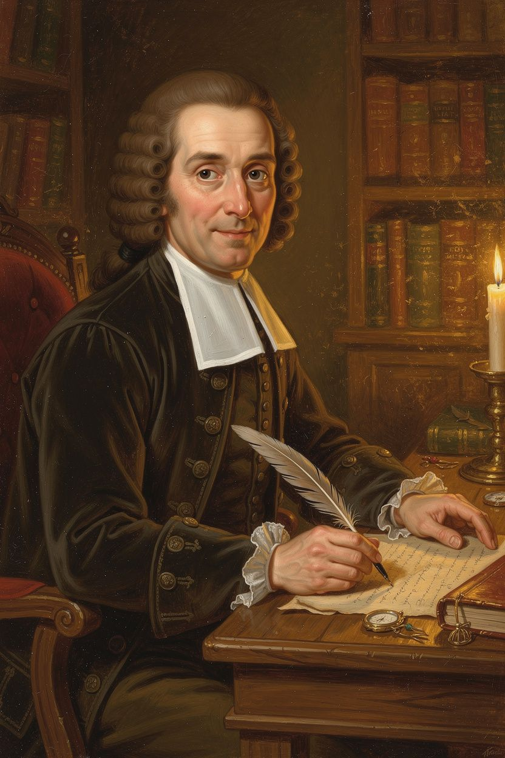
John Locke: The Man Who Said You Belong to You
WisdomForge Booklet — Ages 5–10

John Locke: The Man Who Said You Belong to You

WisdomForge Booklet — Ages 5–10
———

About This Book
A long time ago, about 350 years before you were born, there lived a man named John Locke. He lived in England, a country where kings told everyone what to do. The kings said God had chosen them to rule. They said people had to obey — no matter what.
John Locke said something different. He said: No one is born to be a boss. No one is born to be a servant. Every person is born free. Every person owns their own body. Every person has rights — things no one can take away.
He said you have the right to your life. You have the right to be free. You have the right to keep what you make. And if a leader is unfair, you have the right to say: We need a new leader.
This booklet tells six stories from Locke's life and ideas. Each one has a story, words to remember, a big idea, something to try, and a question to ask a grown-up. The questions are not tests. They are doors to walk through together.
———

Chapter 1: The Boy Who Asked Why
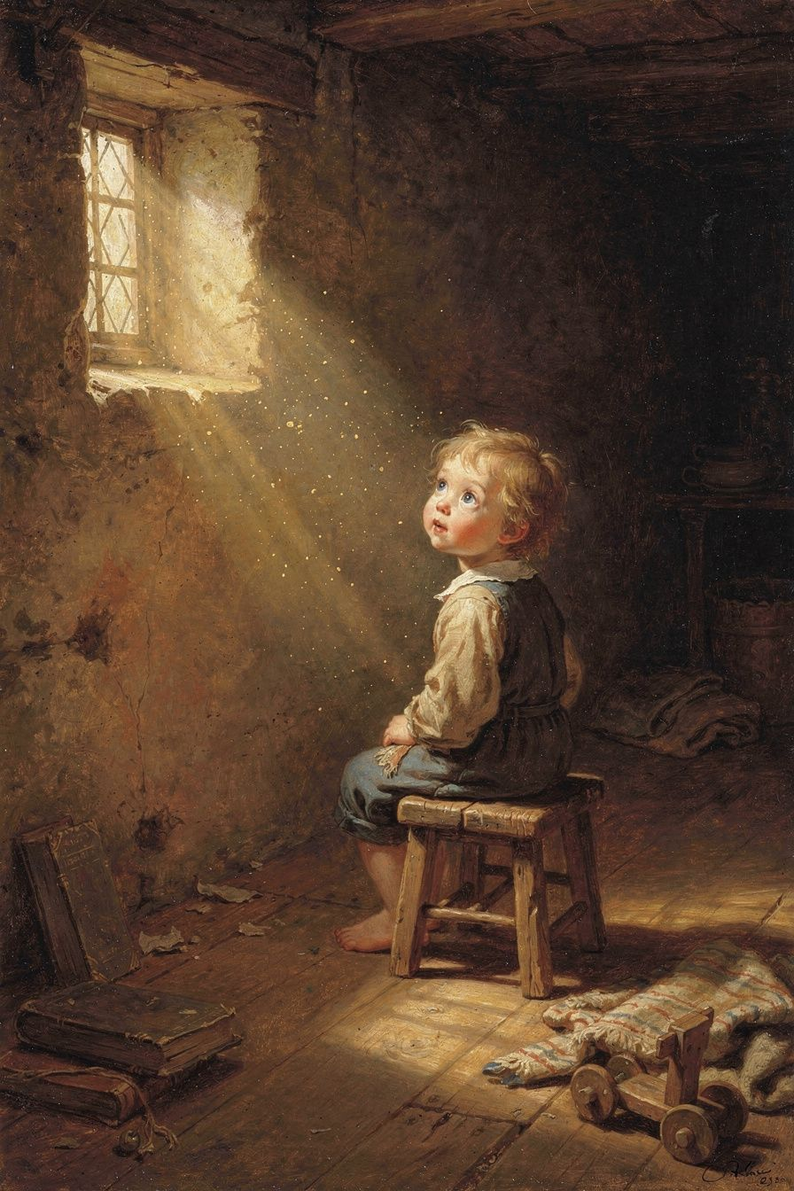
Illustration for Chapter 1
Long ago, in 1632, a baby boy was born in a small village in England called Wrington. His name was John Locke. His father was a lawyer and a soldier who fought against a king who had too much power.
When John was fifteen, he went to a famous school called Westminster. He learned Latin and Greek. He read old books about wise men who lived hundreds of years before. But John always had a question: Why? Why do people believe what they believe? Why do kings rule? Why do some people have power and others do not?
John went to a big school called Oxford. But the teachers there just wanted him to memorize old ideas — ideas from a thousand years before, written by a man named Aristotle. John found it boring. He wanted to think for himself. He read new books about science by men like René Descartes and Robert Boyle. He did experiments with chemicals and air. He studied medicine and helped sick people. He asked questions that made people uncomfortable.
One day, John and his friends sat in a room in Lord Shaftesbury's house and started arguing about what humans can know. How do we know what is true? Where do our ideas come from? Are we born knowing things, or do we learn everything from scratch? They could not agree. The argument went on for hours. John realized something: before they could answer the big questions, they needed to understand the mind itself. What can it know? How does it know? Where do ideas come from?
This question would stay with John for eighteen years. He kept thinking about it, writing notes, testing ideas, talking with friends. Finally, he wrote a big book called An Essay Concerning Human Understanding. It took him almost two decades to finish.
John had an answer. He said: Your mind is like a blank piece of paper when you are born. Everything you know comes from what you see, hear, touch, taste, and feel. You learn by living. You learn by asking why. Nobody is born knowing things. A baby does not know what a tree is, or what fair means, or what God is. The baby learns all of it — from experience.

Words to Remember
"Let us suppose the mind to be, as we say, white paper, void of all characters." — John Locke, *An Essay Concerning Human Understanding*
That means: you were not born knowing anything. Everything you know, you learned. Every idea in your head started with something you experienced. The world wrote on your paper.

Big Idea
You are not born with ideas already inside you. You learn everything by living — by seeing, hearing, touching, and thinking. This means anyone can learn anything. It also means the more you explore, the more your mind fills up with good ideas.

Try This
1. Close your eyes for one minute. Think about everything you learned today — from the moment you woke up until now. What did you see? What did you hear? What did someone tell you? 2. Draw a picture of your mind as a piece of paper. Write or draw five things that "wrote" on your paper today. 3. Ask three people: What is the most important thing you ever learned? Where did you learn it?

Ask a Grown-Up
If you were not born knowing anything, how did the very first person learn anything? Who taught them?
———

Chapter 2: A World Without Kings
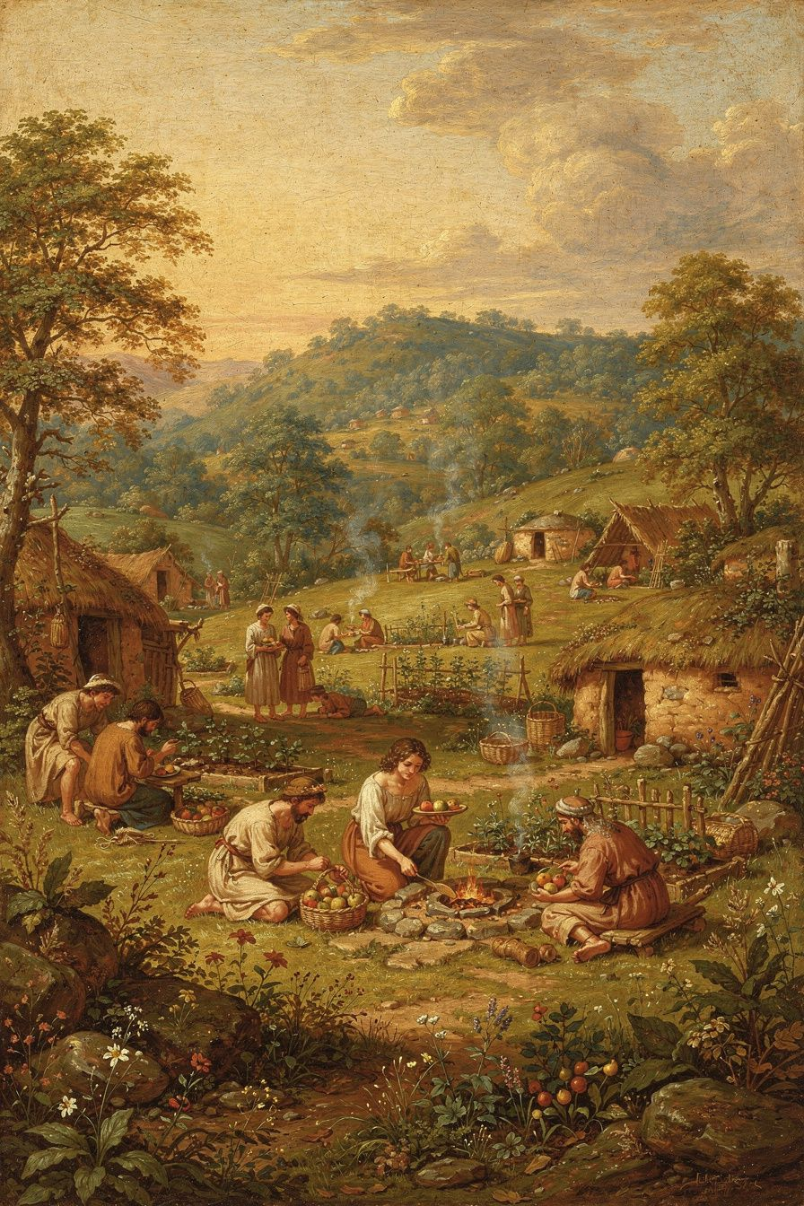
Illustration for Chapter 2
John Locke asked a big question: What if there were no government at all? What if there were no kings, no police, no laws, and no judges? What would the world be like?
Some people said it would be terrible. They said people would fight and steal. They said everyone would be scared all the time. One man named Thomas Hobbes said life without government would be "nasty, brutish, and short" — a war of everyone against everyone.
John said: Not exactly. He called this idea "the state of nature." He said in the state of nature, everyone is free. Everyone is equal. No one is born above anyone else. And there is a rule that everyone can figure out: do not hurt other people. Do not take their things. Do not take their freedom.
This rule is not written on a wall. You do not need a king to tell you. You can figure it out by thinking. John called it "the law of nature." Reason — your ability to think — teaches you that you should not hurt others, because you would not want them to hurt you. It is the Golden Rule, but John Locke discovered it through thinking, not just through religion.
But there was a problem. In the state of nature, if someone did hurt you, who would stop them? There is no police. There is no judge. Each person has to protect themselves. And people are not always fair when they are angry. They might punish too hard. They might not be strong enough. If a big person takes your things, and you are small, what can you do?
So people decided to work together. They agreed to make rules. They agreed to pick leaders. They agreed to let judges decide what is fair. This was the beginning of government.
John said this was not a surrender. People did not give up their freedom. They made a deal — a contract. Each person said: I will follow the rules, and in return, the rules will protect me. If the rules stop protecting me, the deal is off.

Words to Remember
"The state of nature has a law of nature to govern it, which obliges every one: and reason, which is that law, teaches all mankind." — John Locke, *Second Treatise of Government*
That means: even without government, there is a rule. And you can figure it out by thinking.

Big Idea
People are born free and equal. No one has the right to hurt another person. We create government because it helps us stay safe and be fair — not because kings have a special right to boss people around.

Try This
1. Imagine you and your friends land on a new planet. There are no rules. No adults. Just you. What three rules would you make first? Write them down. 2. Think of a time when someone was unfair to you. What happened? How did you feel? Now imagine there were no teachers, no parents, no police. How would you solve it? 3. Draw a picture of the state of nature — a world with no government. What does it look like? Is it scary? Is it peaceful? Is it both?

Ask a Grown-Up
If people are born free, why do governments exist? What would happen if we did not have one?
———

Chapter 3: You Own What You Make
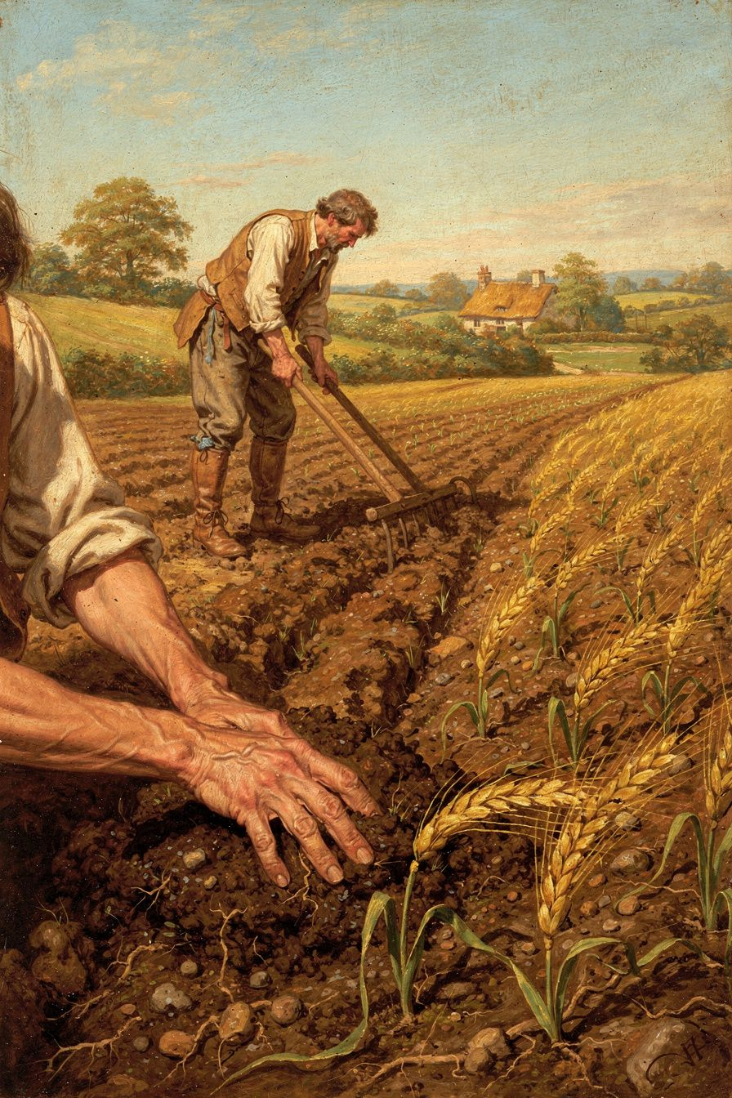
Illustration for Chapter 3
John Locke had an idea about things. He asked: How does anyone come to own anything? The whole world belongs to everyone at first. The trees, the rivers, the land — it is all shared. So how does one person say: This is mine?
John's answer was: work. If you pick an apple from a wild tree, that apple is yours. Why? Because you did the work of picking it. Your hands picked it. Your effort made it yours. The apple now has your work in it, and your work belongs to you.
If you plant a garden, the vegetables are yours. If you build a chair, the chair is yours. If you draw a picture, the picture is yours. You own what you make because you put yourself into it.
But John said there are limits. You cannot take so much that other people have nothing left. He called this "enough and as good." You can only take if there is enough left for everyone else. If you take all the apples and your friend has none, that is not fair.
Also, you cannot take more than you can use. If you pick a thousand apples and they rot, that is waste. You took what other people could have used and let it go bad.
Then people invented money. Money does not rot. You can save it forever. This changed things. Now people could keep more than they could use, because money does not spoil. But John said the basic rule still matters: you own what you make, but you must not leave others with nothing.
This idea — that you own what you make — is powerful. It means that if you work hard, the things you create belong to you. No one can just take them. Not a king. Not a bully. Not the government. Your work makes things yours. This is why stealing is wrong — because it takes what someone else worked to make.
But Locke's idea also has a hard question that he did not fully answer: What about people who work for someone else? If you help a farmer grow vegetables, do you own some of the crop? Locke said yes, you own your labor — but if the farmer pays you for your work, the crop belongs to the farmer. Is that fair? People are still arguing about this today.

Words to Remember
"Every man has a property in his own person. This nobody has any right to but himself. The labour of his body, and the work of his hands, we may say, are properly his." — John Locke, *Second Treatise of Government*
That means: you own yourself. Your body is yours. Your work is yours. What you make with your work is yours.

Big Idea
You own yourself, and you own what you make with your own work. But you must not take so much that others have nothing. Owning things is good, but it comes with a responsibility to leave enough for others.

Try This
1. Think of something you made — a drawing, a Lego tower, a story. How would you feel if someone took it without asking? Why? That feeling is why Locke said: you own what you make. 2. Imagine a jar of cookies on a table. It belongs to everyone. You take one. Is that okay? You take five. Is that okay? You take all of them. Is that okay? Where is the line? 3. Ask: if you help someone with their garden, do you own some of the vegetables? What if they paid you? What if they did not? Think about it.

Ask a Grown-Up
If you own what you make, what about the people who make things in factories? Do they own what they make? Why or why not?
———

Chapter 4: The Referee Who Follows the Rules
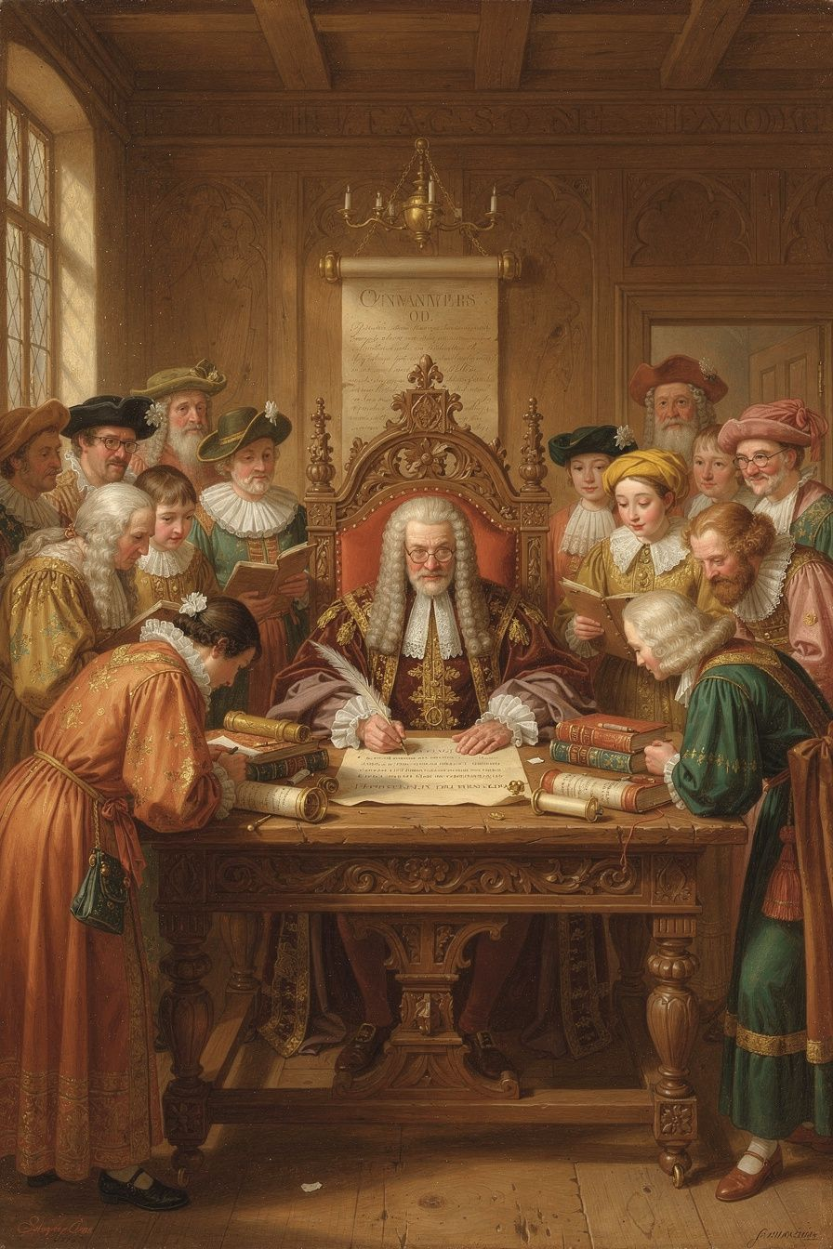
Illustration for Chapter 4
John Locke said government is like a referee in a game. The referee makes sure everyone follows the rules. But the referee has to follow the rules too. If the referee starts cheating — giving points to one team, changing the score, making up new rules that help one side — the players can get a new referee.
This was a big idea. Before Locke, many people said: The king is the referee, and the king can do whatever he wants. God chose the king. The king does not have to follow the rules.
Locke said: No. The king is not above the rules. Government is a trust. People give the government power for one reason: to protect them. To protect their life, their freedom, and their things. If the government stops protecting them and starts hurting them, the trust is broken. The people can take the power back.
John said the government must follow rules too: - It must have laws that everyone can read. No secret rules. No making things up as you go. - It must have fair judges. No judging your own case. No favoring the rich over the poor. - It must not take your things without asking. (Locke said: No taking property without consent. This means taxes are okay only if the people agree to them through their representatives.) - It must be for everyone, not just for the rich or the powerful. A government that helps one group and hurts another is not a real government. It is a gang with a flag.
He also said power should be split up. Not all power in one person's hands. One group makes the laws. Another group carries out the laws. This way, no one person can do everything alone. If one group goes bad, the other groups can stop them.
This idea — splitting up power so no one has too much — is used in many countries today. The United States has three parts of government: Congress makes the laws, the President carries them out, and the courts decide if the laws are fair. That is Locke's idea, expanded.

Words to Remember
"The legislative cannot assume to itself a power to rule by extemporary arbitrary decrees, but is bound to dispense justice by promulgated standing laws." — John Locke, *Second Treatise of Government*
That means: the government cannot just make up rules whenever it wants. It has to follow laws that are written down and that everyone knows.

Big Idea
Government is like a referee. It has to follow the rules, just like everyone else. And power should be split up so no one person has too much. If the government breaks the rules, the people can get a new one.

Try This
1. Play a game with friends. Pick one person to be the referee. What rules does the referee have to follow? What happens if the referee cheats? 2. Think of a rule at your school or home that seems unfair. Why is it unfair? What would make it fair? Write it down. 3. Draw a picture of government power split into parts. Label each part. Show how they watch each other.

Ask a Grown-Up
Why do you think it is dangerous to give one person all the power? What happens when someone has too much power?
———

Chapter 5: You Cannot Force Someone to Believe
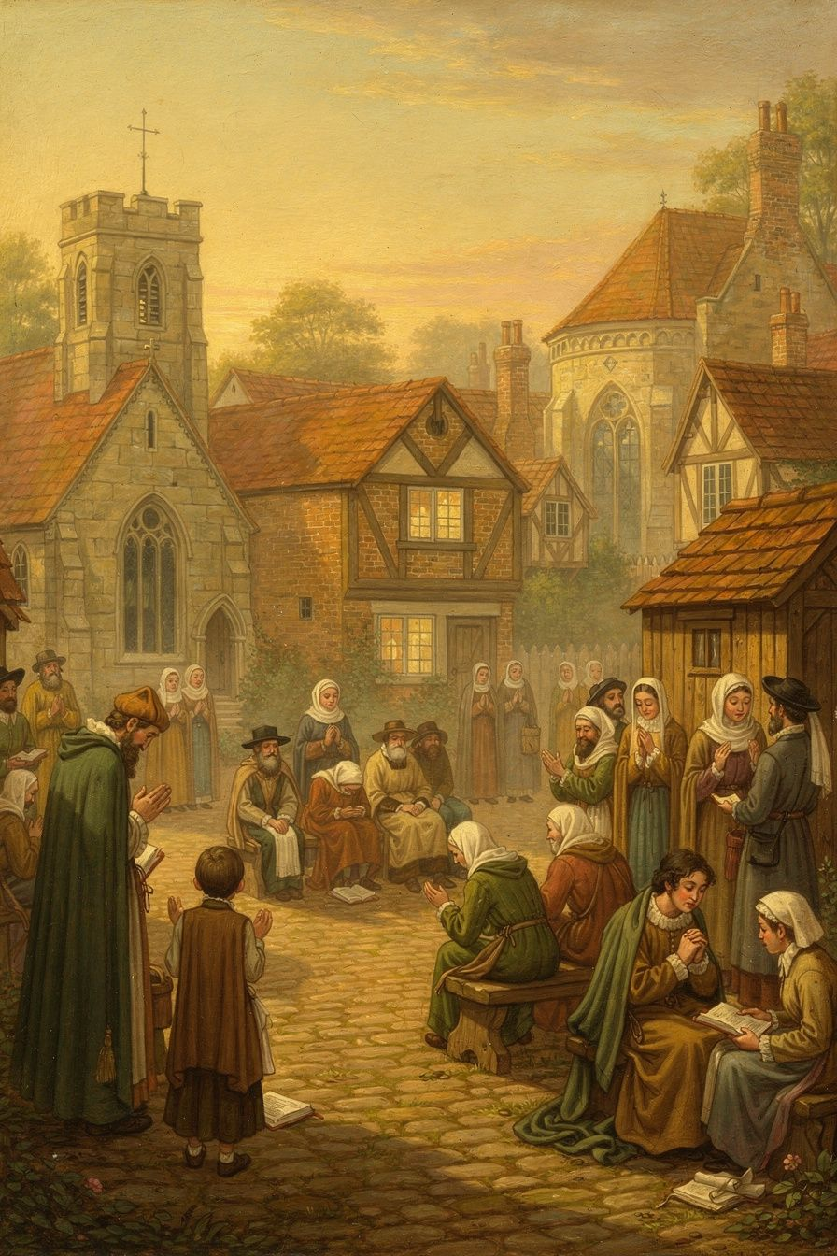
Illustration for Chapter 5
In Locke's time, the king decided what church everyone had to go to. If you went to a different church, you could be fined, put in jail, or even killed. The king said: Everyone must believe what I believe.
Locke said: That is wrong. You cannot force someone to believe something. Belief is inside your mind. Force works on the body — you can lock someone up, take their money, hurt them. But you cannot make their mind believe something it does not.
Locke had a friend who was in trouble because of his religion. Locke saw how people suffered when the government tried to control what they thought. In England, if you went to the wrong church, you could not go to a good school. You could not work for the government. You could be put in jail. People were scared. They pretended to believe what the king wanted, even when they did not.
Locke himself had to leave England because of his ideas. He went to a country called the Netherlands, where people were free to believe different things. He saw that when people are free to believe what they want, the country is more peaceful, not less. People argued, but they did not kill each other over it. Shops stayed open. Neighbors talked. The country worked.
So Locke wrote a letter. He said: The government's job is to protect people's bodies and their things — their life, their freedom, their property. The government's job is NOT to save souls. That is between a person and God. Churches are like clubs — people choose to join, and they can choose to leave.
Locke said something that surprised people: Even if the king is wrong about religion, the king cannot force his idea on others. The king might think he is right. But he cannot know for sure. And even if he is right, forcing people does not make them believe. It only makes them pretend.
This idea — that the government should not control what people believe — changed the world. It is why many countries today have religious freedom. You can believe what you want. You can go to any church, or no church. The government cannot tell you what to think about God.

Words to Remember
"It is one thing to persuade, another to command; one thing to press with arguments, another with penalties." — John Locke, *A Letter Concerning Toleration*
That means: you can try to convince someone. But you cannot force them. Arguments are the right tool. Punishments are the wrong one.

Big Idea
The government should not control what people believe. Belief is inside the mind, and force cannot reach it. People should be free to think, to worship, and to ask questions — without being afraid.

Try This
1. Think of something you believe strongly. Now imagine someone telling you: You must believe something else, or you will be punished. How would you feel? Would you really change your mind, or would you just pretend? 2. Ask three friends: Do you all believe the same things? What do you disagree about? How do you talk about it? Do you fight, or do you listen? 3. Draw two circles: one for "things the government should decide" and one for "things only you should decide." Put religion, school subjects, bedtimes, and what to eat in the right circles.

Ask a Grown-Up
Has there ever been a time when someone tried to make you believe something you did not? How did that feel? What did you do?
———

Chapter 6: When It Is Time to Say No
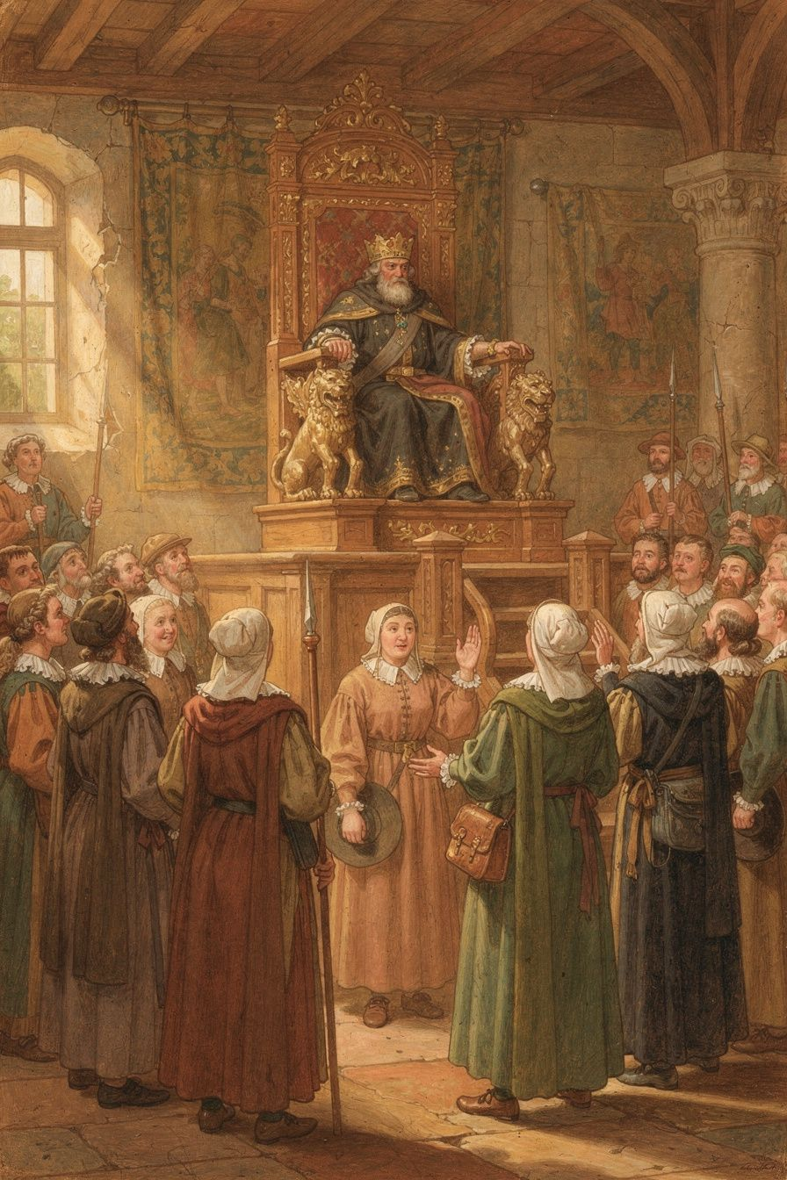
Illustration for Chapter 6
Locke's biggest and most dangerous idea was this: If the government is terrible to the people, the people can get rid of it.
This was dangerous because kings did not like hearing it. The kings said: We were chosen by God. You cannot remove us. If you try, you are a rebel.
Locke said: No. The real rebel is the king who breaks his promise. The people gave the king power for one reason: to protect them. If the king uses the power to hurt them instead, the king is the one who broke the rules. The people are just taking back what was always theirs.
Locke said this is not something people should do lightly. Small problems — a few bad laws, a mistake here and there — are not enough. People are patient. They put up with a lot before they will risk fighting. But if the government does terrible things over and over — if it takes people's things without asking, puts people in jail for no reason, or tries to make itself the boss forever — then the trust is broken.
When the trust is broken, the people do not go back to being wild. They are still a community. They still have each other. They can make a new government — one that will do its job.
Locke's idea changed the world. A man named Thomas Jefferson used Locke's words when he wrote the Declaration of Independence in 1776. He said: All men are created equal. They have rights — life, liberty, and the pursuit of happiness. When a government destroys these rights, the people can change it. Jefferson did not make this up. He got it from Locke. He changed "property" to "the pursuit of happiness," but the idea is the same.
Locke's words also helped shape the French Revolution. In 1789, the French Declaration of the Rights of Man said: "Men are born and remain free and equal in rights." That is Locke too.
And the idea did not stop there. When people around the world fight for freedom — when they say a government is unfair and demand a new one — they are using Locke's idea, even if they do not know his name.
That is Locke. Not the exact words, but the exact idea. Government exists for the people. When it stops serving the people, the people have the right to start over.

Words to Remember
"Whensoever the legislative shall transgress this fundamental rule of society... by this breach of trust they forfeit the power the people had put into their hands." — John Locke, *Second Treatise of Government*
That means: when the government breaks the rules, it loses its power. The power goes back to the people, where it came from.

Big Idea
Government is a promise. When the government breaks that promise badly enough, the people have the right to say: No more. We will make a new promise with a new government. This is not rebellion — it is fixing what is broken.

Try This
1. Think of a time when someone broke a promise to you. How did you feel? Did you trust them again? What would it take for you to trust them again? 2. Imagine you are the leader of a club. What three things would you have to do for the club to kick you out? Write them down. 3. Write a "Declaration of Rights" for your home or classroom. What rights do people have? What should happen if those rights are not respected?

Ask a Grown-Up
Have you ever seen a leader — a boss, a politician, a teacher — who was unfair? What happened? Did anyone say anything? What would have happened if no one did?
———

For the Grown-Up Reader
This booklet introduces children to the core ideas of John Locke's political philosophy through six chapter themes: empiricism and the blank slate (Chapter 1), the state of nature and natural law (Chapter 2), the labor theory of property (Chapter 3), limited government and separation of powers (Chapter 4), religious toleration (Chapter 5), and the right of revolution (Chapter 6).
All quotes are from Locke's own works: the Essay Concerning Human Understanding (1689), the Second Treatise of Government (1689), and the Letter Concerning Toleration (1689). They have been simplified for young readers but the wording remains close to Locke's own. The ideas — self-ownership, consent, the law of nature, the trust theory of government, toleration — are presented in their authentic form, not as vague moral lessons.
For further reading with children, the Second Treatise is the most accessible of Locke's major works. Chapters 2–5 (the state of nature, the law of nature, property) and Chapter 19 (the dissolution of government) are the most teachable passages. The Letter Concerning Toleration is short and readable. For a children's introduction to Locke's life, the story of his friendship with Anthony Ashley Cooper (Lord Shaftesbury) and his exile in the Netherlands provides a compelling narrative.
The chapter on the right of revolution (Chapter 6) is necessarily simplified. Locke's argument is more nuanced than "bad government means revolution." He insists that revolution is a last resort, that people are reluctant to revolt, and that only systematic betrayal of trust justifies it. The chapter preserves this nuance in age-appropriate terms.
———

About WisdomForge
WisdomForge turns the great thinkers of history into booklets for every age. Each figure gets four booklets: one for ages 5–10, one for ages 11–14, one for ages 15–18, and one for adults. The same ideas, the same philosopher, told at the right depth for each reader. Because a five-year-old can understand freedom. A teenager can argue about rights. An adult can wrestle with the hard questions. And everyone deserves to meet the minds that shaped the world they live in.

