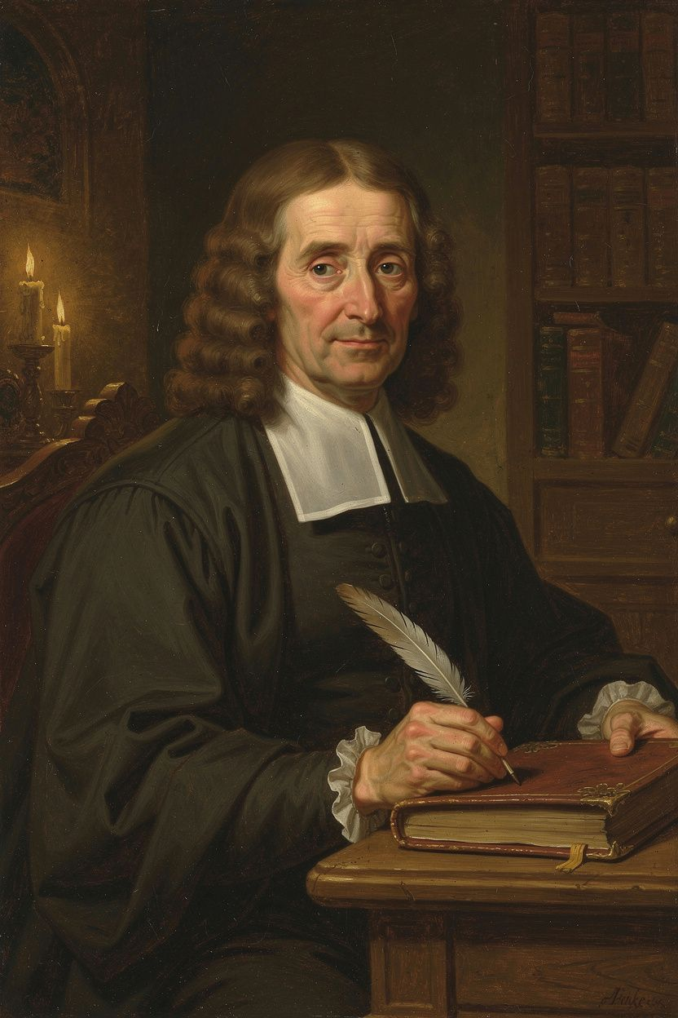
John Locke: The Architect of Liberalism
WisdomForge Booklet — Ages 15–18

John Locke: The Architect of Liberalism

WisdomForge Booklet — Ages 15–18
———

About This Book
John Locke (1632–1704) is the philosopher who built the intellectual framework for modern liberal democracy. Before Locke, political philosophy was dominated by questions of divine right, natural hierarchy, and the obligations of subjects to rulers. After Locke, the questions changed: Do people consent to be governed? What rights do they have before government exists? What is the purpose of political power, and what happens when that purpose is betrayed?
Locke's answers reshaped the world. His Two Treatises of Government (1689) supplied the arguments later cited by American revolutionaries in the Declaration of Independence. His Letter Concerning Toleration (1689) helped move Europe toward religious freedom. His Essay Concerning Human Understanding (1689) set the terms for three centuries of debate about knowledge, mind, and the limits of human reason. His Some Thoughts Concerning Education (1693) influenced how the English-speaking world raised its children.
This booklet takes you through six of Locke's biggest ideas: empiricism and the architecture of the mind, the state of nature and natural law, the labor theory of property, limited government and the separation of powers, religious toleration, and the right of revolution. Each chapter includes the historical context, the philosophical argument, the scholarly debates, and practical exercises designed to make the ideas real. You are not just learning what Locke thought — you are learning how to think with him, how to challenge him, and how to decide for yourself whether his answers still hold.
Locke lived through the most turbulent decades of English history — the Civil War, the Commonwealth, the Restoration, the Exclusion Crisis, and the Glorious Revolution. He was a physician, a colonial administrator, a political exile, and a philosopher. He was friends with the most powerful politician in England and he was a fugitive hiding in the Netherlands. His life and his ideas cannot be separated — each shaped the other. Understanding the experiences behind the arguments makes the arguments themselves come alive.
———

Chapter 1: The Architecture of the Mind — Empiricism and Knowledge
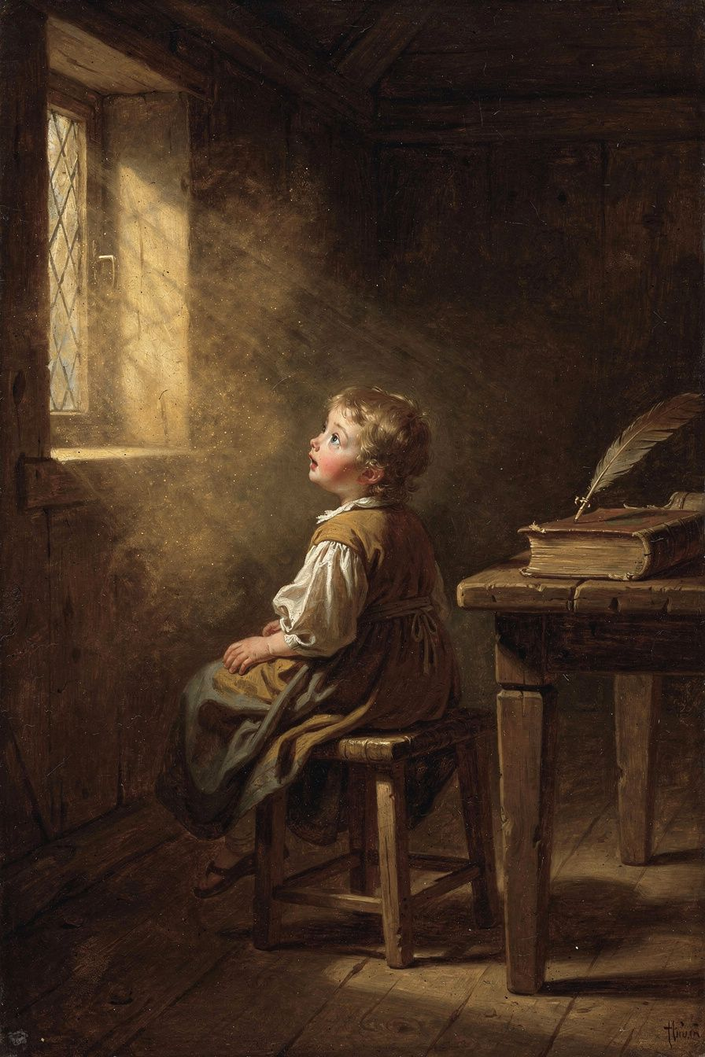
Illustration for Chapter 1
Imagine you are sitting in a room with friends, arguing about morality, religion, and politics. The arguments go in circles. Nobody can agree because everyone is starting from different assumptions. Locke lived this moment — it happened in 1671, in Lord Shaftesbury's study, and it launched the project that would occupy him for eighteen years. The group realized they could not resolve their disputes without first examining the mind's capacity for knowledge. What can we know? How do we know it? Where do our ideas come from?
The dominant view in Locke's time was rationalism — the theory that certain principles are innate, stamped on the mind by God or reason. Descartes argued for innate ideas. So did the Scholastic tradition. Supporters of innate ideas pointed to the universality of moral principles: all cultures prohibit murder, all societies value truth-telling, all recognize some form of property. If everyone agrees on these, they must be built in.
Locke attacked this view in Book I of the Essay Concerning Human Understanding. His argument was empirical and devastating. If innate ideas existed, they would appear in everyone — including children and people with severe cognitive disabilities. But children do not know these principles until they are taught. People with cognitive impairments do not know them at all. What looks like an innate principle is usually a product of custom, education, and repeated exposure. The universality of moral rules is better explained by the universality of human experience — we all face similar problems of survival, cooperation, and conflict — than by the hypothesis of innate ideas.
If there are no innate ideas, where do ideas come from? Locke's answer, in Book II, is the most famous image in modern philosophy: the mind as white paper, furnished by experience. Experience comes through two channels. Sensation delivers ideas from the external world through the senses — colors, sounds, textures, tastes. Reflection delivers ideas from the mind's observation of its own operations — thinking, doubting, believing, willing. All ideas, simple or complex, trace back to these two sources. The mind cannot create ideas from nothing. It can combine, compare, and abstract, but the raw material always comes from experience.
Locke then draws a distinction that would drive philosophy for centuries: primary and secondary qualities. Primary qualities are inseparable from the body — solidity, extension, figure, motion, number. They exist in the object itself. A billiard ball is round and hard whether or not anyone perceives it. Secondary qualities are powers in objects to produce sensations in us — color, sound, taste, smell. The ball is not "red" in the way it is "round." Red is what the ball does to your visual system, not what the ball is in itself. This distinction supported the new mechanical science of Boyle and Newton, which studied the real properties of matter. But it also created the problem that would define modern philosophy: if color is "just in our minds," what else is? Berkeley argued that the distinction collapses — if color is subjective, so is shape, because we perceive shape through the same sensory channels. Kant transformed the problem into his distinction between appearances and things-in-themselves: we can never know the world as it truly is, only as it appears to us through the structures of our mind.
Locke also asked what makes you the same person over time. His answer was startling: not your body, not your soul-substance, but your consciousness. "For since consciousness always accompanies thinking, and makes every one to be what he calls self, and thereby distinguishes himself from all other thinking things; in this alone consists personal identity." If you can remember doing something, you are the person who did it. If you cannot remember it, your identity with that earlier self is interrupted. This "memory theory" of personal identity is still debated today — in questions about amnesia, dementia, split-brain cases, and the philosophical puzzle of whether a perfect clone with your memories would be you.
The Big Idea
Locke's empiricism is not just a theory of knowledge — it is a democratic epistemology. If all knowledge comes from experience, then no one has a privileged access to truth based on authority, birth, or office. A farmer who has observed crops for thirty years knows more about agriculture than a prince who has read about it. A woman who has experienced discrimination knows more about its effects than a philosopher who has theorized it. This does not mean all opinions are equal — Locke distinguishes knowledge from probability, and he insists that beliefs should be proportioned to evidence. But it does mean that the authority of tradition, church, and state can be questioned. Every claim must be tested against experience. This is the epistemological foundation of the Enlightenment and of modern science.
The scholarly debate on innate ideas has not ended. Contemporary cognitive science has revived the question: are humans born with certain cognitive modules or predispositions? The linguist Noam Chomsky argued that humans have an innate "language acquisition device" — a built-in capacity for grammar that cannot be learned from experience alone. Developmental psychologists have found that infants have expectations about physical objects before they could have learned them. Does this refute Locke? Not entirely. Locke did not deny that the mind has capacities at birth — he denied that it has content. The mind can process experience because it has the machinery to do so, but the ideas themselves come from experience. The contemporary debate is about where the line between capacity and content falls. The linguist Noam Chomsky argued that humans have an innate "language acquisition device" — a built-in capacity for grammar that cannot be learned from experience alone. Developmental psychologists like Elizabeth Spelke have found that infants have expectations about physical objects (continuity, solidity) before they could have learned them. Evolutionary psychologists argue for innate cognitive modules for face recognition, social reasoning, and moral intuition. These findings suggest the mind is not as blank as Locke supposed — it comes with machinery that shapes how experience is processed. But this is not the same as innate ideas. The machinery is a capacity, not a content. The mind may be predisposed to organize experience in certain ways, but the specific ideas — that murder is wrong, that property should be respected, that promises should be kept — still come from experience, culture, and reasoning. Locke's core insight survives: the content of the mind is not innate. What is innate is the machinery that processes experience.
The scholarly debate on Locke's empiricism also connects to the rationalist tradition. Leibniz responded to Locke with the New Essays on Human Understanding (written 1704, published 1765), arguing that the mind is not blank paper but veined marble — the veins are there from the start, and experience shapes how they are revealed. Kant attempted to synthesize empiricism and rationalism: knowledge begins with experience, but the mind contributes its own structures (space, time, causality) that are not derived from experience. These structures are not "innate ideas" in Locke's sense — they are the conditions under which experience is possible at all. The debate between empiricism and rationalism is not settled, and Locke's position remains one of the poles around which it turns.

Practice
1. The Tabula Rasa Test. For one day, keep a notebook. Every time you have an idea, a belief, or an opinion, trace it back: Where did it come from? Did you see it? Read it? Hear it from a parent or teacher? Did you figure it out by reasoning? At the end of the day, count how many of your ideas came from sensation, how many from reflection, and how many you cannot trace. What does this tell you about your own mind? 2. The Primary/Secondary Experiment. Pick three objects near you. For each, list their primary qualities (shape, size, solidity) and secondary qualities (color, smell, texture). Now imagine each object with no one perceiving it. Which qualities remain? Which disappear? Write a paragraph about whether you think the distinction holds. 3. The Identity Challenge. Write down five memories from different ages of your life. Are you the same person who had each of those memories? What makes you the same? If you lost all your memories in an accident, would you still be you? Write 200 words arguing each side. 4. The Innate Ideas Debate. Choose a moral principle you think is universal (e.g., "murder is wrong"). Can you find a culture or historical period where this principle was different? If you can, does that disprove the idea that it is innate? Write a page arguing both sides.

Reflect
If all your knowledge comes from experience, what does that mean for your most deeply held beliefs? Which of your beliefs would survive a radical change in your experiences — and which would not?
———

Chapter 2: The State of Nature and the Law of Nature
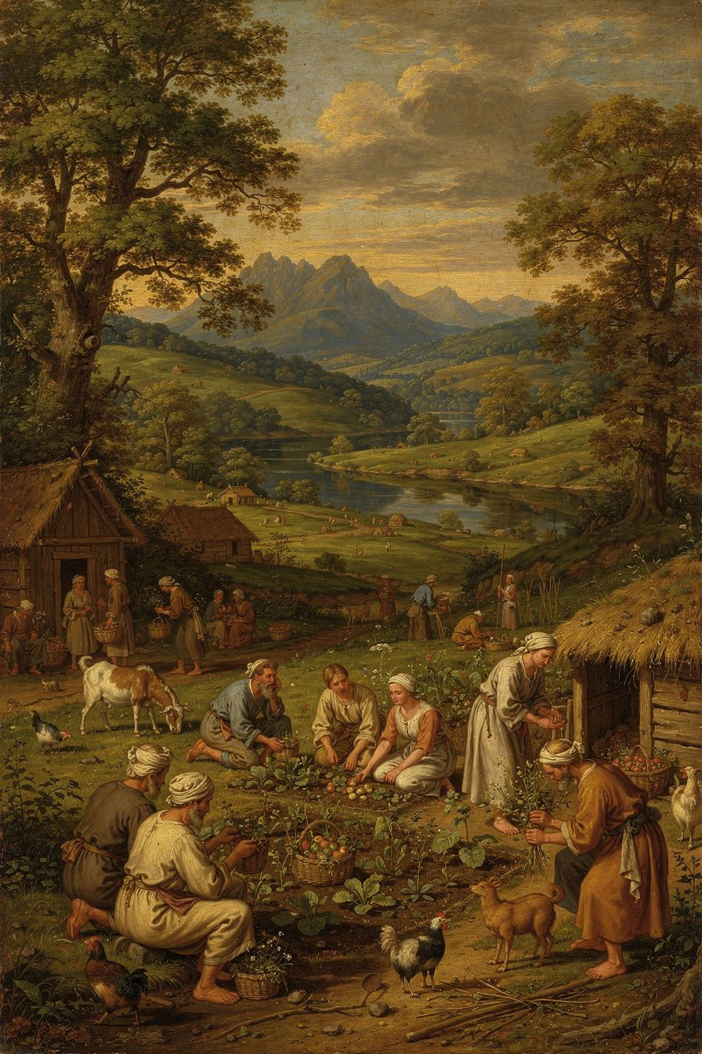
Illustration for Chapter 2
Before we can understand why government is legitimate, Locke says, we must imagine life without it. The "state of nature" is a philosophical device — not a historical claim about prehistory, but a thought experiment that asks what humans are like when no political authority is present. The answer reveals what government adds and what justifies it.
Locke's state of nature is a condition of perfect freedom and equality. Every person is free to act as they choose, within the bounds of the law of nature. Every person is equal — no one has a natural right to rule another. The state of nature is governed by the law of nature, which reason can discover: "being all equal and independent, no one ought to harm another in his life, health, liberty, or possessions" (§6). The law of nature has two main commands: self-preservation (each person is bound to preserve their own life) and preservation of others (when one's own preservation is not at stake, one ought to preserve the rest of humanity).
This is where Locke departs from Hobbes — and the departure is foundational. For Hobbes, the state of nature is a "war of every man against every man," a brutal condition where life is "nasty, brutish, and short." Government is the only thing standing between us and chaos. For Locke, the state of nature is not chaos. It is a moral order governed by natural law. People can live, work, trade, and resolve disputes. The problem is not that people are naturally murderous; the problem is that each person is judge, jury, and executioner in their own case.
The state of nature has three "inconveniences" — structural problems that make it unstable. First, there is no settled, known law. The law of nature exists, but it is not written down. Reasonable people may disagree about what it requires. Second, there is no impartial judge. Each person judges their own case, and human nature being what it is, people tend to judge too favorably for themselves and too harshly against their enemies. Bias is structural, not occasional. Third, there is no executive power. Even when the law is known and a judgment is reached, there may be no power to enforce it. A weak person wronged by a strong person may have no recourse.
These inconveniences are why people form government. They do not escape from hell; they improve on a tolerable but imperfect condition. Government solves the enforcement problem by creating known laws, impartial judges, and executive power. But government's authority comes from the natural right that individuals already possess — the "executive power of the law of nature" — which they transfer to the community through the social contract.
Locke carefully distinguishes the state of nature from the state of war. The state of nature is peaceful freedom governed by natural law. The state of war is force and hostility, which begins when someone uses force without right. This distinction matters because it means government is not a rescue from savagery but an improvement on an already-moral condition. It also means the state of nature can recur: between nations (there is no world government), when a government dissolves (the people revert to freedom and natural law), and in any situation without common authority (a frontier, a failed state, a disaster zone).
The law of nature grounds Locke's concept of natural rights. From the law of nature flow three fundamental rights: life (the right to self-preservation), liberty (freedom to act within the bounds of natural law), and property (the right to acquire, use, and dispose of goods through labor). These rights are prior to government. They are not granted by any human authority. They are natural — they arise from the nature of human beings as rational creatures. Government does not create them; it is created to protect them.
The theological grounding of Locke's law of nature is significant. In the Second Treatise, the primary grounding is that humans are God's property — "the workmanship of one omnipotent and infinitely wise Maker." No one has the right to destroy God's workmanship. This is why the right to life is inalienable: you do not own your life, God does. But Locke also offers a rationalist path: in the Essay, he argues that moral truths can be discovered by reason operating on experience. The Reasonableness of Christianity (1695) suggests that while reason can discover the law of nature, Christianity confirms it and makes it accessible to those who lack the leisure or ability to reason it out for themselves. The question of whether Locke's natural rights depend on God is one of the most important debates in Locke scholarship — and it has contemporary stakes: if natural rights require a theological foundation, what happens to them in a secular age? Some scholars, like Jeremy Waldron, argue that Locke's natural rights are inherently theological — without God, the foundation collapses. Others, like Leo Strauss, read Locke as a crypto-Hobbesian who used theological language for prudential reasons but whose real argument was secular. The debate matters because the Universal Declaration of Human Rights (1948) and the entire modern human rights framework draw on Lockean language. If the foundation is theological, the framework may be unstable in a secularizing world. If it can be grounded in reason alone, it may survive — but the grounding must be found.
The Big Idea
The state of nature reveals that government is not natural — it is artificial, created by people to solve practical problems. This means government is accountable to the people who created it, not the other way around. The law of nature — discoverable by reason — provides the moral standard by which all governments are judged. A government that violates natural rights is not just bad; it is illegitimate. This is the foundational claim of modern constitutionalism: there are things government cannot do, not because the constitution prohibits them, but because they violate a moral law that exists before any constitution.
The dating of the Two Treatises is one of the most important scholarly debates in Locke studies. For most of the twentieth century, scholars believed the Two Treatises were written in 1689 as a post-hoc justification of the Glorious Revolution. Then Peter Laslett's archival detective work (published in his 1960 edition) demonstrated that they were almost certainly composed between 1679 and 1683 — during the Exclusion Crisis, not after the Revolution. This redating transformed the interpretation. If the Two Treatises were written before the Revolution, they are not a justification of what happened but a revolutionary manifesto for what should happen — perhaps even a call to resistance against Charles II. The text contains no references to James II, William of Orange, or the events of 1688, which would be inexplicable if written after 1689. John Dunn accepts the early dating but argues the work should be read as a theological document of Christian political duty, not a secular revolutionary ideology. The debate matters because it changes whether Locke is a moderate constitutionalist or a radical revolutionary.

Practice
1. The State of Nature Simulation. Design a thought experiment: twenty people are placed on an island with no government, no laws, no courts. What happens in the first week? The first month? The first year? When do rules emerge? How? Who enforces them? Write a short narrative or a set of rules that emerge. 2. Locke vs. Hobbes. Read Hobbes's description of the state of nature in Leviathan Chapter 13. Compare it with Locke's in Second Treatise §§4-13. What are the key differences? Which do you find more persuasive? Write a dialogue between Locke and Hobbes arguing about human nature. 3. The Theological Question. Locke grounds natural rights in the claim that humans are God's property. Can the same argument be made without God? Try it: write 200 words grounding natural rights in something other than theology. What works? What fails? What are the implications for secular democracies? 4. The Laslett Debate. Research the dating of the Two Treatises. If Locke wrote them before the Glorious Revolution as a revolutionary manifesto, how does that change how we read the right of revolution? Write a paragraph arguing each interpretation.

Research Prompt
Read Locke's Second Treatise, Chapter 2 (state of nature) and Chapter 19 (dissolution of government). Compare with Hobbes's Leviathan, Chapter 13. Which philosopher's account of human nature do you find more accurate, and why? Consider: are humans naturally cooperative (Locke) or naturally competitive (Hobbes)? What evidence from evolutionary biology, psychology, or anthropology supports each view?
———

Chapter 3: Property, Labor, and the Problem of Ownership
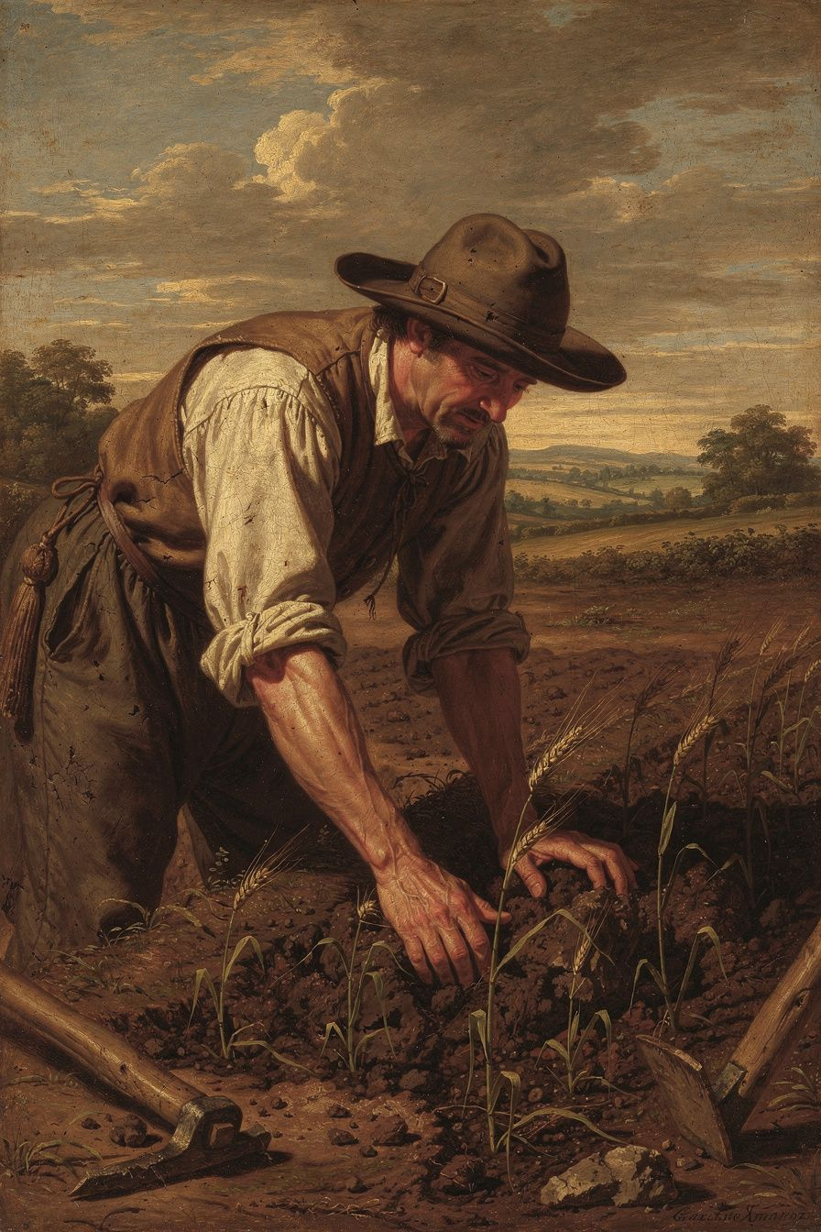
Illustration for Chapter 3
The question Locke sets himself in Chapter 5 of the Second Treatise is ancient and difficult. God gave the earth to humanity in common. No individual has a natural right to any particular piece of it. So how does private property arise? How can one person say "this is mine" when it was originally given to everyone?
The feudal answer — "the king grants land to lords" — merely pushes the question back. The brute-force answer — "I own it because I can defend it" — is no answer at all; it confuses might with right. Locke needed a principled account of how common resources become private property without violating the rights of others.
His answer is labor. The argument proceeds in steps. Each person has "property in his own person" — your body is yours, your labor is yours. When you mix your labor with unowned natural resources — gathering acorns, tilling soil, catching fish — those resources become your property. Your labor enters the thing, and since your labor is yours, the thing becomes yours. You do not need everyone's permission to pick an apple. If you did, you would starve. The act of labor itself establishes the right.
Locke places two critical limits on appropriation. The "enough and as good" proviso: you may appropriate only if "there is enough, and as good, left in common for others." You cannot take so much that others are left without sufficient resources. The spoilage limitation: you may not take more than you can use before it spoils. If you gather more acorns than you can eat and they rot, you have wasted what could have sustained others. These limits initially keep property roughly egalitarian — no one can accumulate much, because surplus goods spoil.
Then money changes everything. Gold and silver do not spoil. People consent to accept money in exchange for goods that would otherwise rot. This allows accumulation far beyond what a person can personally use. The spoilage limit is bypassed. The "enough and as good" proviso is arguably sidestepped, because the person who takes more land and uses it productively employs others who might otherwise have taken that land. Locke is aware this produces inequality. But he argues that everyone is better off than in the state of nature, because cultivated land produces far more than uncultivated land.
This argument is the seed of centuries of debate. Rousseau said the first person to fence off land "did not know that he was introducing property, and with it, inequality, war, and crime." Marx said Locke's theory obscures the difference between the laborer who works and the owner who profits — the laborer mixes their labor with the land, but the owner takes the product. Nozick adapted the "enough and as good" proviso for his own "Entitlement Theory" in Anarchy, State, and Utopia (1974), arguing that appropriation is legitimate if it does not make others worse off. Indigenous critics argue that Locke's theory treats land as "unowned" until Europeans "improve" it by cultivation, erasing the property systems of Indigenous peoples who hunted, gathered, or practiced agriculture differently.
The deepest challenge comes from Locke's own life. He helped draft the Fundamental Constitutions of Carolina (1669), which included Article 110: "Every freeman of Carolina shall have absolute power and authority over his negro slaves." He invested in the Royal African Company, which profited from the slave trade. He served as Secretary to the Council of Trade and Foreign Plantations, overseeing colonial policy. The philosopher of natural rights and liberty helped build institutions of slavery and colonial exploitation. How do we read the Second Treatise in light of this?
The Big Idea
The labor theory of property is both powerful and compromised. It provides a moral foundation for ownership that does not depend on might-makes-right: you own what you make because your labor is part of it. This intuition underlies intellectual property law, the idea of self-ownership, and the connection between work and dignity. But the theory was developed by someone complicit in colonialism, and its "improvement" criterion was used to justify the dispossession of Indigenous peoples. The question is whether the theory can be separated from its colonial origins and applied in a way that serves justice — or whether it is irredeemably marked by the violence it was used to justify. Locke's own principles — the proviso, consent, the law of nature's requirement to preserve humanity — can be turned against colonialism. But whether that is a recovery of Locke's true intent or a reconstruction against his actual practice is a question every reader must answer for themselves.
The scholarly debate on Locke and colonialism is one of the most contested areas. Scholars like Tully, Arneil, and Farr argue that Locke's theory is deeply embedded in the colonial project — the "improvement" criterion was designed to justify colonial appropriation, and his involvement in colonial administration shows the theory was not accidental. The Fundamental Constitutions granted "absolute power and authority over negro slaves, of what opinion or religion soever" — that last phrase explicitly overrides Locke's own Letter Concerning Toleration, suggesting either that the provision does not reflect his philosophical views, or that his philosophy was never meant to apply to Africans. Others, like Tuckness, argue that the theory contains genuine constraints — the proviso, the law of nature, consent — that can be turned against colonialism. Locke's theory of self-ownership applies to all humans, including Indigenous peoples. If Indigenous peoples own themselves, they own their labor, and their labor (hunting, gathering, farming) creates property rights in their land, regardless of whether Europeans consider it "improvement." The nuance matters: if Locke's theory is irredeemably colonial, the liberal tradition it founded may need a new foundation. If it can be reconstructed, the liberal tradition contains the resources for its own critique. Contemporary scholars like Waldron argue the truth is in between: the theory was shaped by colonial assumptions, but it contains principles that can be turned against colonialism, and later thinkers — including Indigenous thinkers — have used Lockean principles to argue for Indigenous rights.

Practice
1. The Labor Theory Test. Pick three things you own. For each, trace the chain of ownership back as far as you can. Did someone make it? Did someone buy it? Did someone take it? How far back does "labor" actually explain your ownership? Where does the theory work, and where does it break down? 2. The Proviso Challenge. Locke's "enough and as good" proviso says you can only take if there is enough left for others. Apply this to a contemporary issue: land ownership, water rights, intellectual property, or carbon emissions. Is the proviso satisfied? If not, what should happen? Write a policy recommendation based on Lockean principles. 3. The Colonialism Trial. Research Locke's role in the Fundamental Constitutions of Carolina and his investment in the Royal African Company. Write a "prosecution" and "defense" of Locke — one arguing that his philosophy is invalidated by his actions, the other arguing that the philosophy can be separated from the person. Which is more persuasive? 4. The Wages Question. Locke's theory says you own your labor. If you sell your labor to an employer, who owns what you produce? Locke's theory is ambiguous here. Read the relevant passages in the Second Treatise and write 300 words resolving the ambiguity as best you can.

Reflect
Locke says you own what you make. But what about the people who made the world you make things in — the teachers who taught you, the workers who built the roads you use, the society that made your education possible? Does "you own what you make" fully capture the moral picture, or does something important get left out?
———

Chapter 4: Limited Government and the Architecture of Power
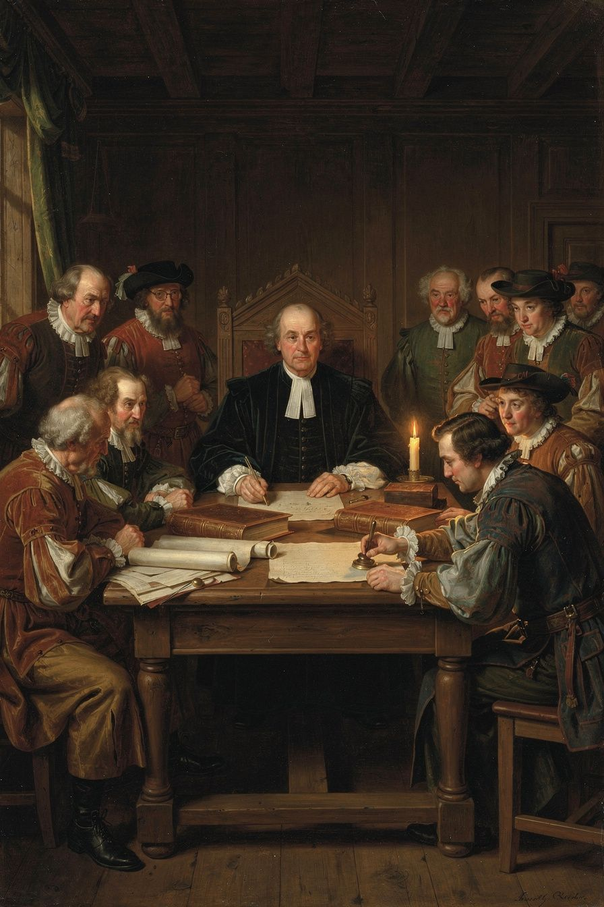
Illustration for Chapter 4
Locke's concept of limited government is the structural backbone of modern constitutional democracy. Government, he argues, has limited and defined powers. It exists for a specific purpose — the protection of natural rights — and cannot exceed that purpose. To prevent the concentration of power that leads to tyranny, Locke distinguishes three kinds of political power and insists that the legislative power, while supreme, must be bounded by law, consent, and the public good.
The case for limited government follows from the social contract. Government is created by consent for a specific purpose: to protect natural rights better than individuals could protect them in the state of nature. If government has more power than necessary, it has exceeded its mandate. The argument has several steps: natural rights are prior to government (life, liberty, and property exist before any political authority); government is created to protect them (the social contract transfers only the right of enforcement, not the rights themselves); government cannot take property without consent (taxation requires consent through the legislative process); government cannot be arbitrary (the law of nature requires standing, known laws applied equally); and government is a trust (rulers are trustees, not owners, and a trustee who betrays the trust forfeits the office).
Locke identifies four specific limits on the legislative power. First, it must govern by established standing laws, not arbitrary decrees — laws must be published, known, and applied equally. Second, it must act for the public good, not for a faction or for the legislators themselves. Third, it cannot take property without consent — taxation requires the consent of the people or their representatives. This is the origin of "no taxation without representation." Fourth, it cannot transfer its power — the legislative power is held in trust and cannot be given to someone else.
Locke distinguishes three kinds of political power. Legislative power makes the laws — it is the supreme power, but bounded by the four limits. Executive power carries out the laws — it is subordinate to the legislative but has a permanent function. Federative power manages foreign relations — war, peace, alliances, treaties. This is not the modern three-branch separation (legislative, executive, judicial) — that comes from Montesquieu and the American Founders. Locke's judicial function is part of the executive. But his division is the foundation on which Montesquieu built.
The legislative power is supreme but not absolute. It is the highest authority within the commonwealth, but it is bounded by the social contract and the law of nature. If it violates those bounds, it forfeits its authority. This is a careful balance: if the legislature were absolute, it could enslave the people. If it were not supreme, there would be no settled authority to make binding laws. Locke's solution: the legislature is supreme within its proper sphere, and that sphere is limited by natural rights and the public good.
Locke introduces a tension that remains central to constitutional design: prerogative. Laws are general, but circumstances are specific. There will be situations where strict adherence to the law would produce injustice, or where swift action is needed before the legislature can convene. For these, the executive may act beyond the letter of the law for the public good. Prerogative is dangerous — it allows the executive to suspend laws and act on its own judgment. The people must judge whether the use of prerogative serves the public good. If it does, they tolerate it. If it does not, they resist it. This tension is visible today in debates about emergency powers, executive orders, and presidential discretion during crises.
Locke's framework directly influenced the American constitutional system. The written constitution, the separation of powers, checks and balances, "no taxation without representation," and the Bill of Rights all descend from Lockean principles. But Locke's framework also has a darker legacy: the question of who counts as "the people" whose consent matters. Locke's "people" did not include women, the propertyless, enslaved Africans, or Indigenous peoples. The principles were universal in theory but narrow in practice. The history of constitutional democracy is the history of expanding who counts as "the people" — a process that is still ongoing.
The Big Idea
Government is a trust with limited, defined powers. It must follow written laws, act for everyone, not take property without consent, and not transfer its authority. Power should be divided so no one branch can dominate. And the ultimate sovereignty resides not in the government but in the people who created it. This is the architecture of every modern constitutional democracy — and the standard by which every government can be judged. When a government claims powers beyond these limits, it does not merely act badly; it acts illegitimately, and the people have the right to hold it accountable.
The scholarly debate on Locke's separation of powers focuses on its limitations. Locke did not fully separate the judicial power — it is part of the executive in his framework. The modern three-branch separation comes from Montesquieu's The Spirit of the Laws (1748), which added the judicial branch as a separate power. The American Founders then built the system of checks and balances that makes all three branches mutually limiting. Some scholars argue that Locke's failure to separate the judiciary is a real weakness: without an independent judiciary, there is no institutional check on the legislature. Others note that Locke's framework was designed for the English system, where the judiciary was already independent in practice, and that his separation is a philosophical analysis, not a constitutional blueprint. The question of how much of modern constitutionalism we owe to Locke versus Montesquieu is itself a matter of scholarly debate.
Locke's framework has a darker legacy that must be acknowledged: the question of who counts as "the people" whose consent matters. Locke's "people" did not include women, the propertyless, enslaved Africans, or Indigenous peoples. The principles were universal in theory but narrow in practice. The "tacit consent" doctrine — which holds that anyone who enjoys the protections of government has implicitly consented to it — has been criticized as too thin to be meaningful. You cannot meaningfully "consent" to something by merely existing in a place, especially if you have no realistic option to leave. And the social contract tradition that Locke founded has been challenged by feminist philosophers, who argue that it assumes a male subject and ignores the political significance of the family, domestic labor, and reproductive rights. Carole Pateman's The Sexual Contract (1988) argued that the social contract presupposes a prior "sexual contract" that subordinates women to men. The history of constitutional democracy is the history of expanding who counts as "the people" — a process that is still ongoing and that Locke's own framework both enables and constrains.
Macpherson's "possessive individualism" critique offers another angle. In The Political Theory of Possessive Individualism (1962), Macpherson argued that Locke's political philosophy conceives of the person as an owner first and a citizen second. The individual is fundamentally a proprietor — of their body, their labor, their property — and political society is an instrument for protecting these possessions. This, Macpherson argued, serves the interests of the emerging capitalist class. The "enough and as good" proviso and the labor theory provide moral cover for accumulation. C.B. Macpherson's critique has been influential but also challenged. Tully argued that Locke's property theory is more constrained than Macpherson suggests — the proviso is a real limit, not window dressing. The debate between Macpherson and Tully is not just about Locke; it is about whether liberal political philosophy is inherently biased toward capitalism and property accumulation, or whether it contains genuine constraints on inequality.

Practice
1. The Constitutional Audit. Take your country's constitution (or a constitution you are studying). Identify the legislative, executive, and judicial powers. What limits does the constitution place on each? Can you trace each limit to a Lockean principle? Where does the constitution go beyond Locke, and where does it fall short? 2. The Prerogative Problem. Research a recent use of executive power that went beyond normal legal procedure — an emergency declaration, an executive order, a wartime measure. Was it justified by Locke's standard of "public good"? Would Locke approve? Write an analysis. 3. The Consent Question. Locke says government requires consent. But who counts as "the people" whose consent matters? In Locke's time, the answer excluded women, the propertyless, and enslaved people. How has the answer changed? What does consent mean when the consenting body has expanded? Write 300 words on whether universal suffrage fulfills or transforms Locke's principle. 4. The Taxation Debate. Locke says taxation requires consent through representatives. Research your country's tax system. Do all taxpayers have representation? Who does not? Is "no taxation without representation" fully realized in your country? What changes would Locke recommend?

Reflect
Locke says the legislative power is supreme but not absolute. How can something be supreme but limited? What happens when the limits and the supremacy conflict — and who decides?
———

Chapter 5: Toleration and the Limits of Coercion
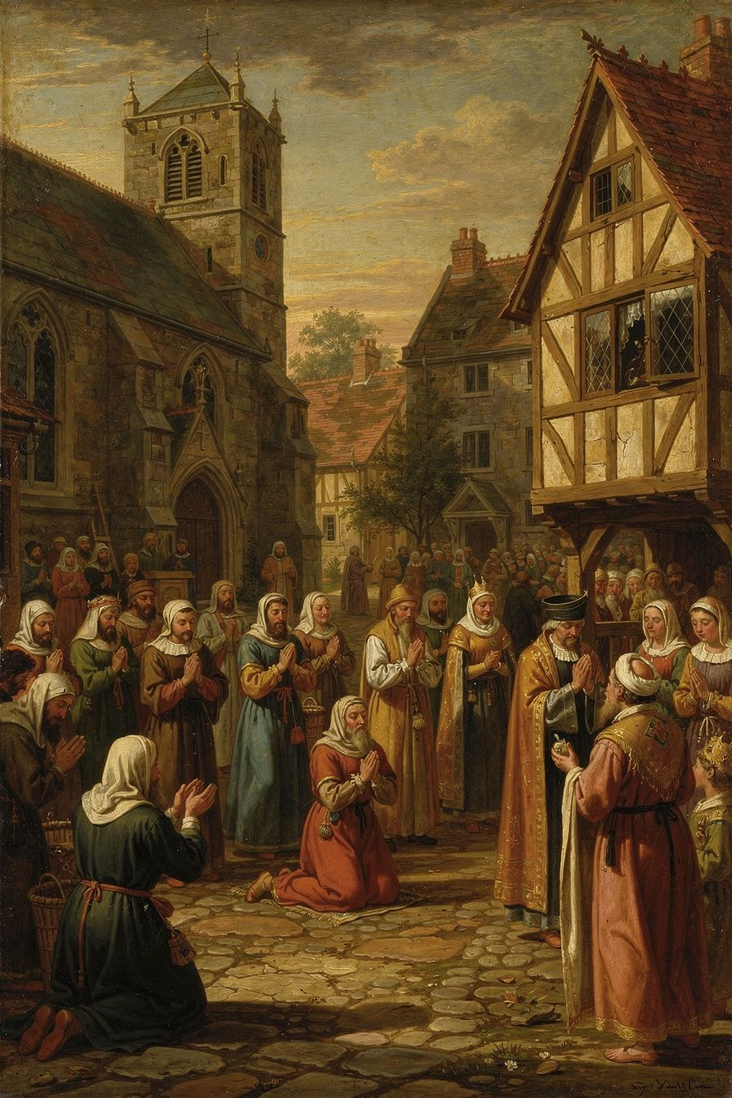
Illustration for Chapter 5
In Locke's time, religious uniformity was the norm in Europe. The principle cuius regio, eius religio — whose realm, his religion — held that the ruler determined the religion of the state. Dissenters were fined, imprisoned, exiled, or executed. In England, the Clarendon Code (1661–1665) excluded dissenters from public office, universities, and worship. The Test Acts (1673, 1678) required officeholders to take Anglican communion. Catholics, Baptists, Quakers, and Presbyterians were second-class citizens.
Locke's Letter Concerning Toleration (1689) argued that this was both wrong and pointless. Wrong, because the state's authority extends only to civil interests — life, liberty, health, and property. The care of souls does not belong to the magistrate. Pointless, because coercion cannot produce genuine belief. Belief is an inward act of the mind. Force acts on the body. You can make someone go through the motions of worship, but you cannot make them believe. A person who conforms under duress is a hypocrite, not a convert.
Locke's case rests on a fundamental distinction between three realms. The state exists to protect civil interests. Its power is external — law, force, punishment. It may use force to protect life, liberty, and property, but only those. The church is a "free and voluntary society." No one is born a member of a church (as one is born a subject of a state). Membership is chosen, and members may leave. The church's purpose is the worship of God and the salvation of souls. It may exhort, persuade, and discipline its members, but it may not use force. No church has the power of the sword. Conscience is the inner forum where a person relates to God. It is beyond the reach of civil power.
From this framework, Locke develops several arguments. The magistrate has no commission to care for souls — God did not give the government authority over religious truth. The magistrate is fallible — he might be wrong about religion, and forcing his views on others risks damning them. Coercion cannot produce faith — it produces hypocrisy, not genuine belief. Toleration is good for religion — free competition among religions produces vigor and commitment, while state monopoly produces lazy clergy and hypocritical laity. And toleration is good for the state — persecuted minorities rebel, flee, or become secret enemies. A tolerant state earns the loyalty of all its subjects.
But Locke's toleration had limits. He excluded two groups: Catholics and atheists. Catholics were excluded for political reasons — their allegiance to the Pope, a foreign sovereign, created a divided loyalty. Atheists were excluded because Locke believed that oaths and promises — the bonds of trust that hold society together — depend on belief in God. "Those are not at all to be tolerated who deny the being of a God. Promises, covenants, and oaths, which are the bonds of human society, can have no hold upon an atheist."
These exclusions are the subject of one of the most important debates in Locke scholarship. Were they consistent with Locke's principles? The traditional view says yes — if a group's beliefs threaten civil order, exclusion is not an exception to toleration but the principle applied correctly. The radical critique says no — Locke's own Essay argues that moral principles are accessible to reason, not just revelation. If reason can ground moral obligation, atheists who accept reason-based morality should be tolerable. The exclusion rests on a false generalization — that atheists cannot be moral — that Locke's own epistemology undermines. Mark Goldie has argued that Locke was not opposed to Catholicism per se but to "antinomianism" — the belief that allegiance to a higher authority supersedes civil law. If Catholics could discard that belief, they could be tolerated. This reading makes the exclusions narrower than they appear, but it does not resolve the tension with Locke's own principles.
Locke's toleration was moderate, not radical. Spinoza's Theological-Political Treatise (1670) argued for freedom of philosophic thought without exception. Pierre Bayle's Philosophical Commentary (1686) argued that even "erroneous" conscience has a right to toleration. Locke's exclusions make him closer to the practical politics of the English Toleration Act of 1689 (which excluded Catholics and anti-Trinitarians) than to the philosophical radicalism of Bayle or Spinoza. "Locke is not John Stuart Mill," as Goldie puts it — Mill's On Liberty (1859) is far more expansive and would include the groups Locke excluded. The question of whether liberal toleration has inherent limits — and where those limits fall — is the seventeenth-century version of a question that recurs in every generation: from the debate over whether to tolerate anti-democratic parties, to whether liberal societies can absorb illiberal religious communities.
The Big Idea
The government should not control what people believe. Belief is inside the mind, and force cannot reach it. The state's authority extends to civil interests — life, liberty, health, property — not to the salvation of souls. This is the foundation of the separation of church and state, religious pluralism, and the broader principle that the state must respect the inner freedom of the individual. But Locke's own exclusions reveal a tension at the heart of liberal theory: can a liberal society tolerate those who reject its foundational assumptions? The question is not settled, and Locke's attempt to settle it — by excluding those he considered threatening — remains the starting point for every subsequent debate.
The debate about Locke's exclusions connects to a live question in contemporary political philosophy: the "toleration paradox." If a liberal society tolerates everything, it must tolerate intolerance — and intolerant groups may use the freedom liberalism provides to destroy liberalism. Karl Popper formulated this as the "paradox of tolerance" in 1945: unlimited tolerance leads to the disappearance of tolerance. Locke's exclusions can be read as an early recognition of this paradox — the state may exclude groups whose beliefs threaten the very conditions of toleration. But who decides what counts as a threat, and how? The danger is that the power to exclude "dangerous" groups becomes the power to silence dissent. Locke's framework provides no clear answer to this danger, and neither does contemporary political philosophy.
The debate also connects to Locke's personal identity theory. In the Essay, Locke argues that personal identity consists in consciousness, not substance. If this is right, then religious belief — which is a matter of consciousness — cannot be coerced because it is constitutive of the person. Forcing someone to change their belief is not just changing their opinion; it is attacking their identity. This gives Locke's argument for toleration a deeper foundation than the political argument alone: toleration is not just a matter of good policy but of respect for personal identity. However, this also raises the question of whether Locke's exclusion of atheists is consistent with his own identity theory. If personal identity is consciousness, and an atheist's consciousness does not include belief in God, then excluding the atheist for their non-belief is excluding them for their identity — precisely the kind of coercion Locke says is impossible and wrong.

Practice
1. The Three Realms Analysis. Take a contemporary controversy involving religion and the state — religious exemptions from healthcare, prayer in schools, religious symbols in public buildings, or anti-discrimination law vs. religious freedom. Apply Locke's three-realm framework: What is the state's interest? What is the church's interest? What is the individual conscience's interest? Where do they conflict? 2. The Exclusions Debate. Write a "prosecution" and "defense" of Locke's exclusion of atheists. The prosecution argues it contradicts his own principles. The defense argues it follows from his political logic. Which is more persuasive? What would Locke say to a modern atheist who argues that moral behavior does not require belief in God? 3. The Toleration Paradox. Research a contemporary case where a liberal democracy faces the question of whether to tolerate an illiberal group (e.g., banning a political party, restricting religious practices that conflict with civil law). What would Locke say? What would Mill say? What do you say? 4. The Bayle Comparison. Read a summary of Pierre Bayle's Philosophical Commentary. How does Bayle's argument for toleration differ from Locke's? Is Bayle's position more consistent? What are the trade-offs between Locke's moderate approach and Bayle's radical one?

Reflect
Locke says the state cannot force belief. But can the state shape belief indirectly — through education, through funding, through the symbols it chooses? Where does "not forcing belief" end and "shaping belief" begin?
———

Chapter 6: The Right of Revolution and Popular Sovereignty
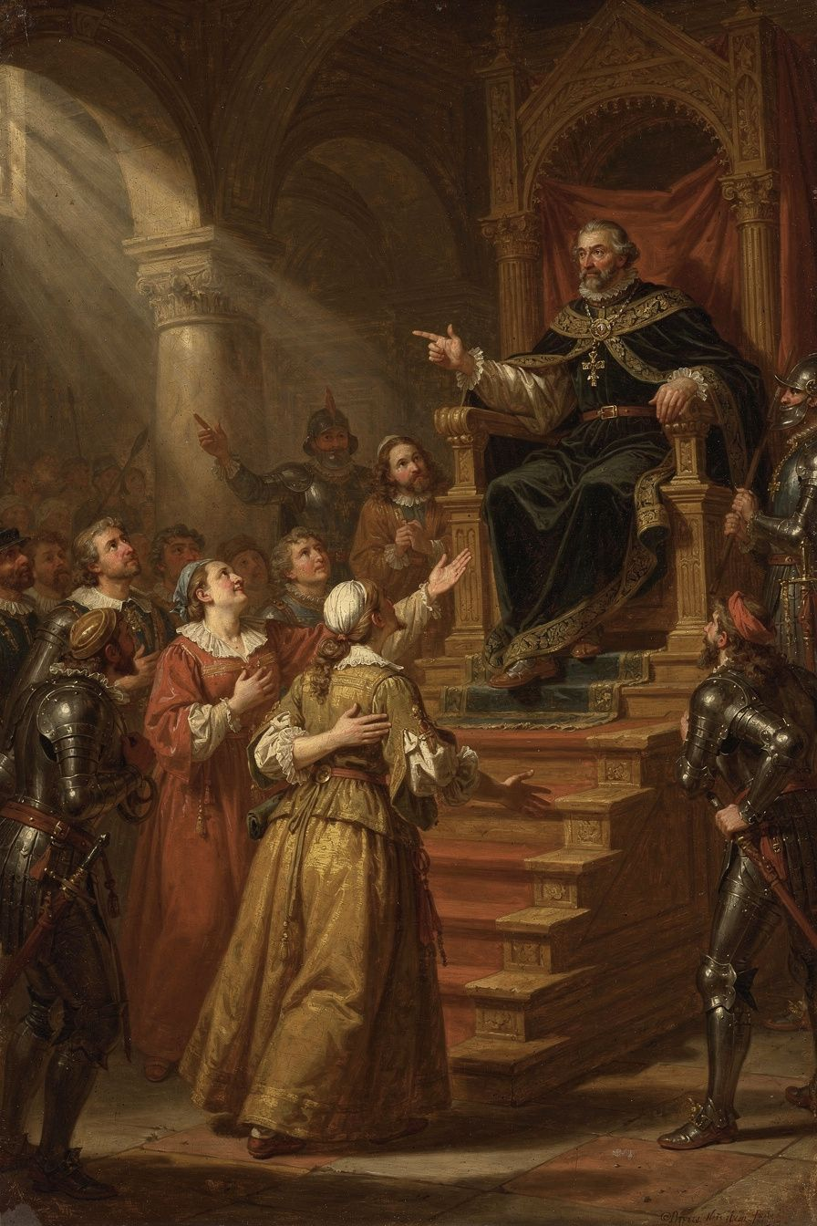
Illustration for Chapter 6
Locke's most radical idea is the right of revolution. If government is created by consent to protect natural rights, and if government betrays that purpose, the people have the right to dissolve it and form a new one. This is not lawlessness — it is the restoration of legitimate authority. And the real rebel, Locke says, is not the people who resist tyranny but the tyrant who provokes resistance.
The argument follows logically from Locke's premises. Government is a trust. The trust has a purpose: protecting natural rights. A trustee who betrays the trust forfeits the office. The people may reclaim their power and form a new government. "Whensoever, therefore, the legislative shall transgress this fundamental rule of society; and either by ambition, fear, folly, or corruption, endeavour to grasp themselves, or put into the hands of any other, an absolute power over the lives, liberties, and estates of the people; by this breach of trust they forfeit the power the people had put into their hands."
Locke inverts the traditional logic. In the traditional view, the ruler is the legitimate authority and resistance is always rebellion. In Locke's view, legitimacy flows from the people. A ruler who violates the people's rights has forfeited all legitimate authority. The people's resistance is the restoration of the moral order, not its violation. "When the legislators endeavour to take away, and destroy the property of the people, or to reduce them to slavery under arbitrary power, they put themselves into a state of war with the people, who can thereupon have no further remedy but to have recourse to heaven for relief."
Locke identifies specific situations that justify revolution: arbitrary alteration of the legislative power (replacing elected lawmakers with hand-picked ones), delivery of the people to a foreign power, preventing the legislature from meeting, systematic violation of natural rights, and systematic corruption for private benefit. He is clear that a single mistake or unpopular policy does not justify revolution. The trigger is systematic betrayal — a pattern that shows the government has abandoned its purpose.
A common objection is that the right of revolution invites constant upheaval. Locke has several answers. People are reluctant to revolt — they tolerate much inconvenience before risking the dangers of revolution. The right of revolution deters tyranny — rulers who know the people can remove them are less likely to betray the trust. Only systematic betrayal justifies revolution. And the alternative is worse — if the people have no right of revolution, tyranny is permanent and uncorrectable.
A crucial Lockean distinction: dissolving the government is not dissolving society. When the government is dissolved, the people do not revert to isolated individuals. They remain a political community and can form a new government. The social contract that created the community is distinct from the arrangement that created the government. Revolution does not lead to anarchy — it leads to the community exercising its residual sovereignty.
Locke's right of revolution shaped the American Declaration of Independence. Jefferson's language is Lockean in structure: "We hold these truths to be self-evident, that all men are created equal, that they are endowed by their Creator with certain unalienable Rights... That to secure these rights, Governments are instituted among Men, deriving their just powers from the consent of the governed, That whenever any Form of Government becomes destructive of these ends, it is the Right of the People to alter or to abolish it." Jefferson changed "property" to "the pursuit of happiness," but the architecture is Locke's. The French Declaration of the Rights of Man (1789) similarly declared that "men are born and remain free and equal in rights."
But the right of revolution has a dark history. The French Revolution, partly inspired by Locke, descended into the Terror. The Russian Revolution invoked the people's rights against the tsar and produced a tyranny worse than the one it replaced. The right of revolution, once unleashed, is difficult to control. Locke's answer is that revolution is justified only by systematic betrayal — not by every grievance. But who decides what counts as "systematic"? The people, Locke says. And that answer, while democratic in spirit, leaves the door open to both justice and chaos.
The question of whether the right of revolution is an individual or collective right is debated. Locke's text is ambiguous. On one reading, each person has the natural right to resist tyranny — if the government attacks your life or liberty, you may resist, as you may resist a criminal in the state of nature. On another reading, the right belongs to the people as a whole — it is exercised through the community, not by isolated individuals. The distinction matters because the individual reading could justify vigilantism, while the collective reading requires organized political action. Locke likely intended the collective reading, but his text supports both.
The Big Idea
Government is a promise. When the government breaks that promise systematically — not once, but as a pattern — the people have the right to dissolve it and form a new one. This is not rebellion against the moral order; it is the restoration of it. The real rebel is the ruler who betrays the trust. The right of revolution is the ultimate check on governmental power — the backstop that ensures government remains accountable. But it is also dangerous, because it can be invoked by anyone who claims the government has betrayed its trust. The question of who decides when revolution is justified, and how, is one that every generation must answer for itself.
The scholarly debate on Locke's right of revolution centers on its relationship to constitutionalism. Some scholars argue that the right of revolution is incompatible with constitutional government — if the people can always dissolve the government, the constitution has no binding force. Others argue that the right of revolution is the foundation of constitutionalism — it is what makes the constitution a living document rather than a dead letter. The American Founders embedded the spirit of revolution in the Constitution itself: the right to bear arms (Second Amendment), the right to petition (First Amendment), and the right to amend (Article V) are all mechanisms for the people to exercise sovereignty without armed revolt. The question is whether these constitutional channels make the right of revolution unnecessary, or whether the right of revolution remains as the ultimate guarantee that constitutional channels will work.
The scholarly debate also concerns the relationship between Locke's right of revolution and the Glorious Revolution of 1688. If the Two Treatises were written before 1688 (as Laslett demonstrated), then Locke's right of revolution was not a post-hoc justification but a pre-revolutionary argument. This makes Locke a radical — someone making the case for resistance before the fact, not explaining it after. But if Locke revised the text after 1688, the right of revolution may have been softened or contextualized. The "thin" version of Laslett's thesis holds that the Two Treatises were drafted during the Exclusion Crisis but published with revisions after the Revolution. The "thick" version holds that the entire text is essentially the pre-1683 draft. The evidence supports the thin version more strongly. The question is: how much did Locke change between draft and publication? And does it matter? If the right of revolution was written before the Revolution, it is a call to action. If it was revised after, it is a reflection on what happened. Both readings are possible, and the text supports both.

Practice
1. The Declaration Audit. Read the American Declaration of Independence. Identify every Lockean element — natural rights, consent, the purpose of government, the right of revolution. Where does Jefferson follow Locke exactly? Where does he modify or depart? Why do you think he changed "property" to "the pursuit of happiness"? 2. The Revolution Standard. Apply Locke's criteria for justified revolution to a historical case — the American Revolution, the French Revolution, the Haitian Revolution, or a modern uprising. Did the people have a right to revolt by Locke's standards? What were the consequences? Write an analysis. 3. The Constitutional Question. Research a country that has a constitutional right to resist tyranny (e.g., Germany's Basic Law, which allows resistance against unconstitutional acts). Does this institutionalize Locke's right of revolution? Or does it domesticate the right by making it subject to constitutional process? What are the trade-offs? 4. The Dark Side. Research a revolution that produced worse tyranny than it overthrew. Did the revolutionaries believe they were justified? Would Locke agree? What does this case tell us about the risks of the right of revolution? Write 400 words.

Reflect
If government exists for the people, who decides when it has stopped serving them? And if the people decide, what protects the minority who disagree with the majority's judgment that revolution is justified?
———

For the Grown-Up Reader
This booklet introduces 15–18-year-olds to John Locke's core philosophical and political ideas through six chapters: empiricism and the architecture of the mind (Chapter 1), the state of nature and natural law (Chapter 2), the labor theory of property (Chapter 3), limited government and the separation of powers (Chapter 4), religious toleration (Chapter 5), and the right of revolution (Chapter 6).
All quotes are from Locke's own works: the Essay Concerning Human Understanding (1689), the Second Treatise of Government (1689), and the Letter Concerning Toleration (1689), with citations. The ideas are presented in their authentic form, with their scholarly debates, complications, and controversies acknowledged rather than smoothed over.
The chapter on property (Chapter 3) addresses Locke's involvement in colonialism — the Fundamental Constitutions of Carolina, the Royal African Company, the Board of Trade — as a central rather than peripheral concern. The chapter on toleration (Chapter 5) addresses Locke's exclusions of Catholics and atheists and the "toleration paradox." The chapter on revolution (Chapter 6) addresses both the American and French revolutions and the question of whether constitutional channels make the right of revolution obsolete.
For further reading, the Second Treatise of Government is accessible to strong high-school readers. Peter Laslett's edition (1960) includes the definitive introduction on the dating debate. The Letter Concerning Toleration is short and readable. The Essay Concerning Human Understanding is long but Books II and IV contain the most teachable material. John Dunn's The Political Thought of John Locke (1969) remains an important scholarly interpretation, and Macpherson's The Political Theory of Possessive Individualism (1962) provides the classic critical perspective.
———

About WisdomForge
WisdomForge turns the great thinkers of history into booklets for every age. Each figure gets four booklets: one for ages 5–10, one for ages 11–14, one for ages 15–18, and one for adults. The same ideas, the same philosopher, told at the right depth for each reader. Because a fifteen-year-old can grapple with the foundations of government. A teenager can debate the limits of toleration. An adult can wrestle with the hard questions of power, property, and revolution. And everyone deserves to meet the minds that shaped the world they live in.

