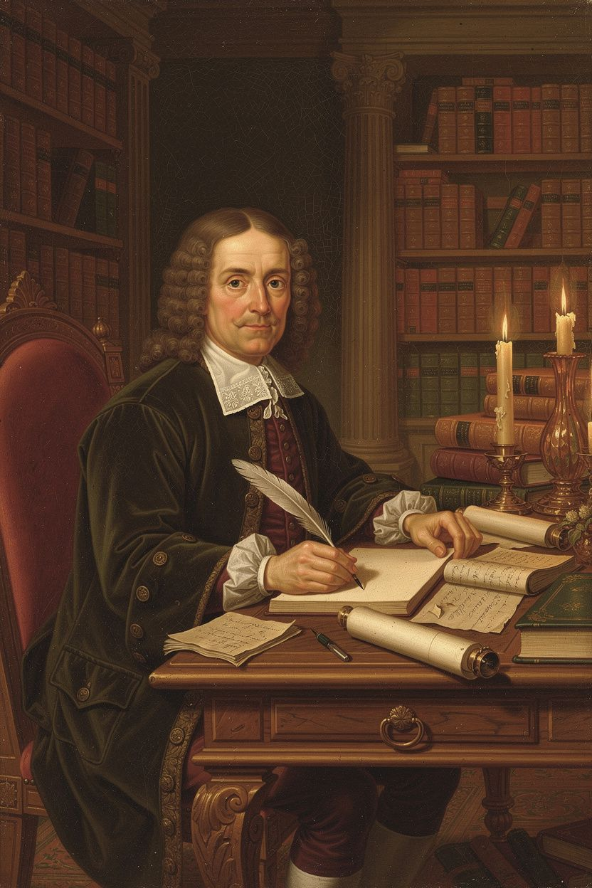
John Locke: The Philosopher of Freedom
WisdomForge Booklet — Ages 11–14

John Locke: The Philosopher of Freedom

WisdomForge Booklet — Ages 11–14
———

About This Book
In 1689, a man published a book that would change the world. He did not put his name on it. He had spent five years in exile, afraid of being arrested by the English government. His book argued that kings do not have a divine right to rule, that people are born free, that government exists only because people agree to it, and that when government betrays that agreement, the people can remove it.
The man was John Locke. The book was the Two Treatises of Government. Its ideas would be quoted by Thomas Jefferson in the Declaration of Independence, cited by revolutionaries in France and America, and woven into the constitutions of democracies around the world.
But Locke was more than a political philosopher. He asked: How do we know what we know? Where do ideas come from? Can government force people to believe? What makes something yours? This booklet tells his story and his ideas in six chapters — one for each of his biggest questions. Each chapter has a story, a Big Idea, something to try, questions to talk about, and a question to carry with you.
Locke lived from 1632 to 1704, through the English Civil War, the Restoration, the Exclusion Crisis, and the Glorious Revolution. He was a doctor, a government official, a political exile, and a philosopher. He was friends with the most powerful politician in England and he was a fugitive hiding in the Netherlands. He helped draft the constitution of an American colony and he helped plan a revolution. His life and his ideas cannot be separated — each shaped the other.
———

Chapter 1: The Blank Page — Where Do Ideas Come From?
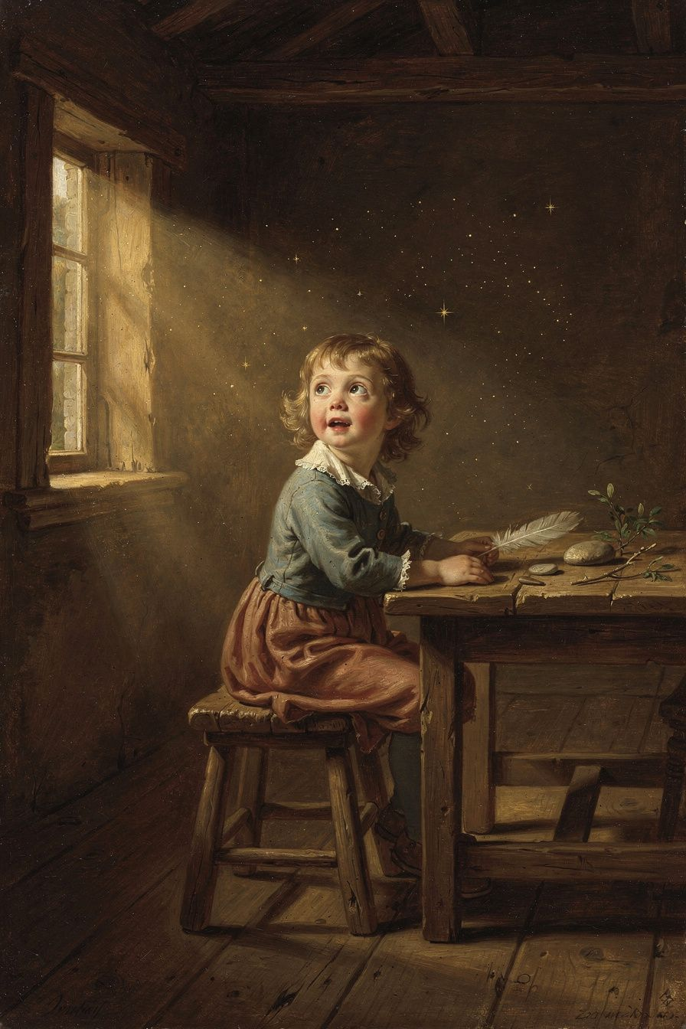
Illustration for Chapter 1
John Locke was not satisfied with the way people argued. In his time — the 1600s — philosophers would cite ancient authorities. They would say: "Aristotle said this" or "The Bible says that" or "The Church has always taught this." Locke thought this was lazy. He wanted to know: How do we actually know anything? Where do our ideas come from? Are we born with certain knowledge already inside us, or do we start from nothing and build everything from experience?
The standard view in Locke's time was that humans are born with "innate ideas" — moral principles and logical truths stamped on the mind by God. Supporters of innate ideas pointed to the fact that all cultures have some version of "do not murder" and "keep your promises." If everyone agrees on these, they must be built in.
Locke attacked this view in the first book of his Essay Concerning Human Understanding (1689). He argued that if innate ideas existed, they would appear in everyone — including children and people with cognitive disabilities. But children do not know these principles until they are taught. People with severe cognitive impairments do not know them at all. What looks like an innate idea is usually something learned from parents, teachers, and culture. You learned "do not murder" from your parents. You did not come out of the womb knowing it.
If there are no innate ideas, then where do ideas come from? Locke's answer became one of the most famous images in philosophy: the mind as blank paper. "Let us suppose the mind to be, as we say, white paper, void of all characters." Everything written on that paper comes from experience. Experience arrives through two channels:
- Sensation — the mind receives ideas through the senses: colors, sounds, textures, tastes, smells. You see red, feel heat, taste sweetness. These are simple ideas that cannot be invented or broken down further. - Reflection — the mind observes its own operations: thinking, doubting, believing, reasoning, willing. You can watch yourself thinking. You can notice yourself doubting. These are also simple ideas, but they come from inside rather than outside.
From these simple ideas, the mind builds complex ones. The idea of a "horse" combines color, shape, sound, and smell. The idea of "justice" combines fairness, equality, and obligation. Every idea in your head, no matter how complicated, can be traced back to sensation and reflection.
Locke also distinguished between two kinds of qualities in objects. Primary qualities belong to the object itself — shape, size, solidity, motion. A billiard ball is round and hard whether or not anyone is looking. Secondary qualities are powers in objects to produce sensations in us — color, taste, smell. The ball is not actually "red" in the way it is actually "round." Red is what the ball does to your eyes, not what the ball is in itself.
This distinction mattered because it supported the new scientific method. Science could study the real properties of things (primary qualities) while recognizing that some of our experience (secondary qualities) is subjective. The distinction would later be challenged by Berkeley, who argued it collapses — if color is "just in our minds," then so is shape, because we only perceive shape through sensation too. Kant would transform the distinction into his distinction between appearances and things-in-themselves: we can never know the world as it truly is, only as it appears to us through the structures of our mind. Locke did not solve this problem, but he identified it, and it has driven philosophy ever since.
Locke also asked what makes you the same person over time. His answer was startling: not your body, not your soul, but your consciousness. If you can remember doing something, you are the person who did it. If you cannot remember it, your identity with that earlier self is interrupted. This "memory theory" of personal identity would dominate philosophy for centuries. It raises hard questions that are still debated: What about amnesia? What about split-brain cases? If your memories were transferred to another body, would you be the same person?

Words to Remember
"Let us suppose the mind to be, as we say, white paper, void of all characters, without any ideas. How comes it to be furnished? Whence comes it by that vast store which the busy and boundless fancy of man has painted on it with an almost endless variety? I answer, in one word, from EXPERIENCE." — John Locke, *An Essay Concerning Human Understanding*, Book II, Chapter 1

Big Idea
You are not born knowing anything. Everything in your mind comes from experience — through your senses and through your ability to reflect on your own thoughts. This means education matters, evidence matters, and no one can dismiss your ideas just because you are young. If you have experienced something and thought about it, your ideas are as valid as anyone else's. It also means you should be humble: your knowledge is limited by your experience, and other people with different experiences know things you do not. The best way to learn is to listen, to observe, and to test your beliefs against reality — not to trust authority just because it is authority.

Try This
1. Write down ten things you "know." For each one, trace it back: How do you know it? Did you see it? Did someone tell you? Did you figure it out by thinking? Which ones come from sensation? Which from reflection? 2. Pick a disagreement you have with a friend or parent. Ask: Where does your belief come from? Where does theirs? Can you trace both back to experience? Is one based on better evidence than the other? 3. Try to imagine a color you have never seen. You cannot. That is Locke's point — the mind cannot create ideas that do not come from experience. The mind can combine, compare, and abstract, but it cannot create from nothing.

Talk About It
1. If all knowledge comes from experience, does that mean two people with the same experiences should believe the same things? Why might they not? 2. Locke says there are no innate ideas. But some scientists today think humans are born with certain instincts or predispositions. Does this contradict Locke, or can both be partly right? 3. If you had been raised in a completely different culture, what would you believe? What would stay the same? What does this tell you about where your ideas come from?
———
If everything you know comes from experience, what does that mean for people who have very different experiences from yours?
———

Chapter 2: The State of Nature — Life Before Government
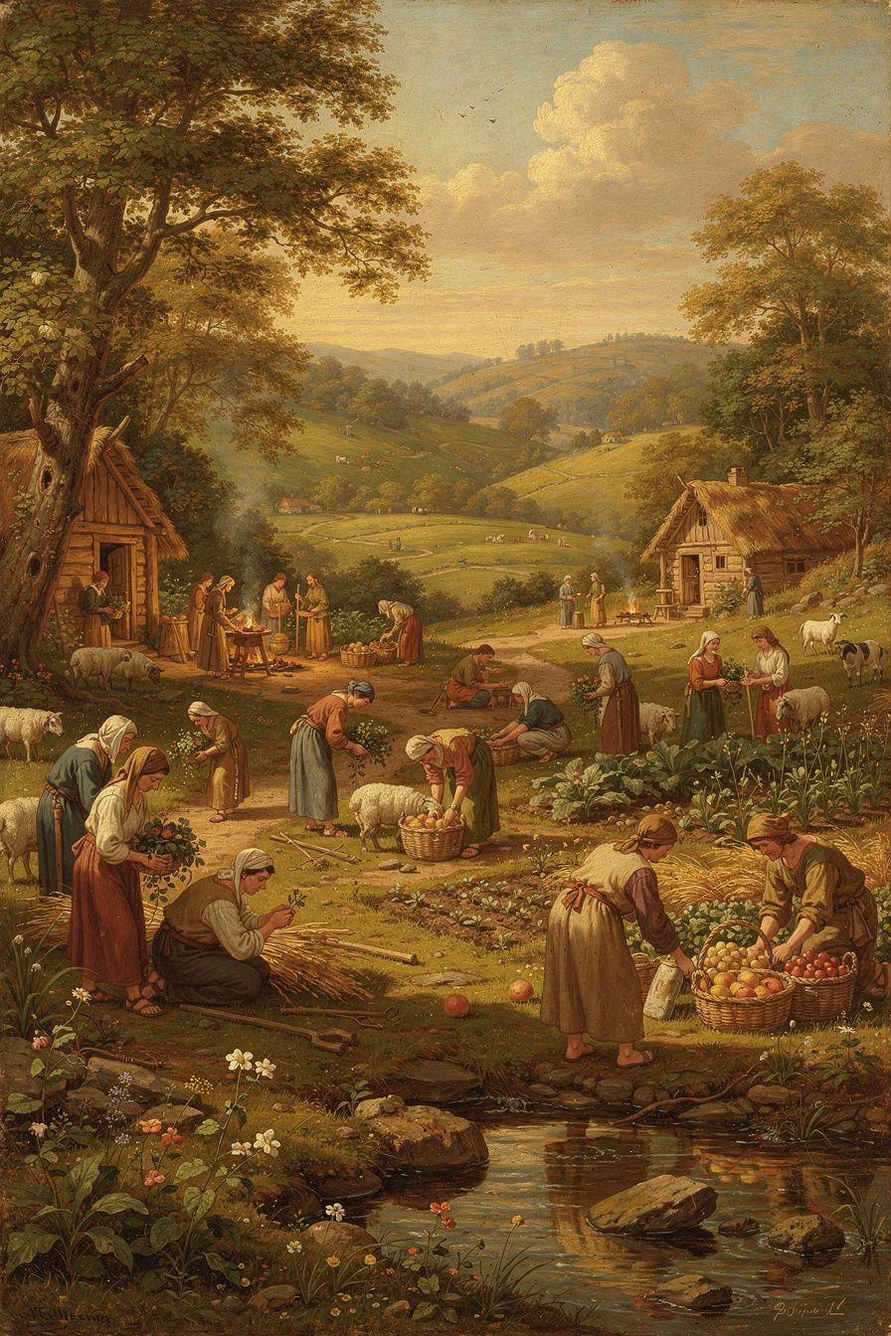
Illustration for Chapter 2
Before we can understand why government is legitimate, Locke said, we have to imagine life without it. This is not a historical claim about what actually happened in prehistory. It is a thought experiment — a way of asking what humans are like when no one is in charge.
Locke called this condition "the state of nature." He described it as a state of perfect freedom and equality. Every person is free to act as they choose, within the bounds of the law of nature. Every person is equal — no one has a natural right to rule another. And the state of nature is governed by the law of nature, which reason can discover: no one ought to harm another in life, health, liberty, or possessions.
This is where Locke differs sharply from Thomas Hobbes. Hobbes described the state of nature as a "war of every man against every man" — a brutal, violent condition where life is "nasty, brutish, and short." For Hobbes, government is the only thing standing between us and chaos. For Locke, the state of nature is not chaos. It is a moral order where people can live, work, and trade. The problem is not that people are naturally murderous; the problem is that each person is judge, jury, and executioner in their own case.
That is the key word: "inconveniences." The state of nature has three structural problems:
1. No settled law. The law of nature exists, but it is not written down. Reasonable people may disagree about what it requires. What counts as "harm"? How much punishment is proportional? Without a written law, each person interprets it for themselves, and interpretations conflict.
2. No impartial judge. Even when people agree on the law, each person judges their own case. Human nature being what it is, people tend to judge too favorably for themselves and too harshly against their enemies. Bias is not occasional; it is structural.
3. No executive power. Even when the law is known and a judgment is reached, there may be no power to enforce it. If a strong person wrongs a weak person, the weak person may not be able to compel restitution.
These inconveniences are why people form government. They do not escape from hell; they improve on a tolerable but imperfect condition. Government solves the enforcement problem by creating known laws, impartial judges, and executive power. But government's authority comes from the natural right that individuals already possess — the right to enforce the law of nature — which they transfer to the community through the social contract.
Locke carefully distinguished the state of nature from the state of war. The state of nature is peaceful freedom; the state of war is force and hostility. Government is created to prevent the slide from nature into war. This distinction matters because it means government is not a rescue from savagery but an improvement on an already-moral condition.
The state of nature is not just a thought experiment about origins. It is a real condition that can recur. Between nations, there is no world government — states exist in a state of nature with respect to each other, which is why wars between nations are always possible. When a government dissolves or betrays its trust, the people revert to a state of nature, but not to savagery — they revert to the condition of freedom and natural law that existed before government. And in any situation where there is no common authority — a frontier, a failed state, a disaster zone — the state of nature approximates real life. The law of nature still applies, but the inconveniences are present.
Locke's state of nature also differs from earlier natural law theorists. Aristotle and Aquinas emphasized the common good. Locke emphasizes individual rights. Earlier natural law was grounded in a metaphysical account of human nature and its purposes. Locke grounds it in observation and reason about what humans need. The law of nature, for Locke, protects persons, not communities, as its primary concern.

Words to Remember
"The state of nature has a law of nature to govern it, which obliges every one: and reason, which is that law, teaches all mankind, who will but consult it, that being all equal and independent, no one ought to harm another in his life, health, liberty, or possessions." — John Locke, *Second Treatise of Government*, §6

Big Idea
People are born free and equal, governed by a moral law that reason can discover. Government is not an escape from chaos but a solution to practical problems — bias, uncertainty, and weakness in enforcement. This means government is a tool, not a master. It exists because people created it, and it serves at their pleasure.

Try This
1. Imagine you and twenty other people wash up on an uninhabited island. There is no government. No police. No courts. What happens first? What problems arise? When do people start making rules? How do they agree on them? Write a short story about the first week. 2. Think of a dispute you had with someone — a friend, a sibling, a teacher. Now imagine there were no teachers, no parents, and no rules to appeal to. How would you resolve it? What would be fair? How would you enforce your decision? 3. Compare Locke and Hobbes. Hobbes says people need government because they are naturally violent. Locke says people need government because they are naturally biased. Which do you think is more accurate? Give an example from your own experience.

Talk About It
1. Locke says everyone is equal in the state of nature. But some people are stronger, smarter, or more persuasive than others. Does "equal" mean "the same"? What does Locke actually mean? 2. The state of nature is a thought experiment, not a historical claim. But some real situations approximate it — a frontier, a disaster zone, a failed state. Can you think of a real-world example? What happened? 3. Locke says the law of nature can be discovered by reason. But people in different cultures disagree about what it requires. How can reason discover a law that people do not agree on?
———
If you could design a government from scratch, what would it look like — and what would you insist it could never do?
———

Chapter 3: You Own What You Make — Property and Labor
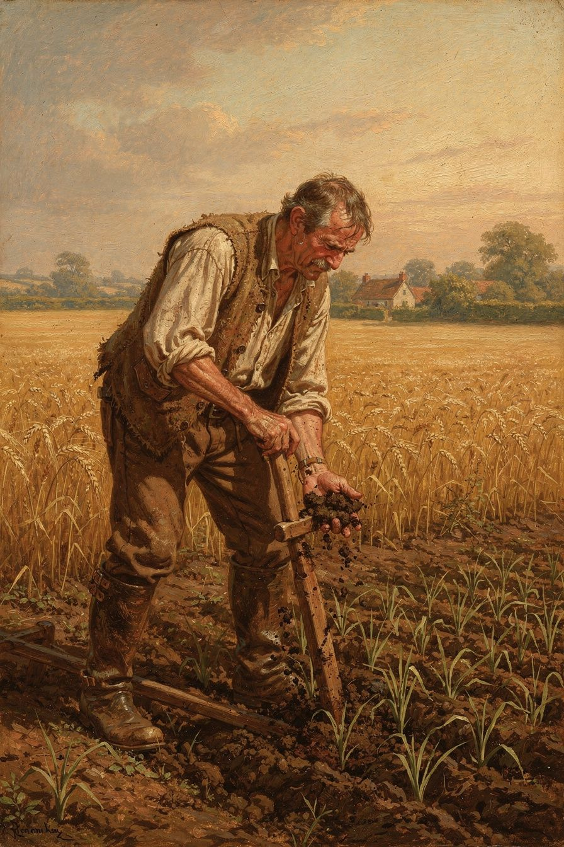
Illustration for Chapter 3
One of Locke's most famous and most contested arguments is about property. The question is ancient and difficult: God gave the earth to humanity in common. No individual has a natural right to any particular piece of it. So how can one person say, "This land is mine"? How does private property arise from common ownership?
Locke's answer, in Chapter 5 of the Second Treatise, is labor. The argument proceeds in steps:
Step 1: You own yourself. Each person has "property in his own person." Your body is yours. Your labor — the work of your hands and mind — is yours. No one else has a right to it.
Step 2: Labor creates property. When you mix your labor with unowned natural resources — gathering acorns, tilling soil, catching fish — those resources become your property. Your labor enters the thing, and since your labor is yours, the thing becomes yours. You do not need everyone's permission to pick an apple. If you did, you would starve.
Step 3: The proviso. You may only appropriate if "there is enough, and as good, left in common for others." You cannot take so much that others are left without enough. This "enough and as good" proviso prevents appropriation from becoming theft.
Step 4: The spoilage limit. You may not take more than you can use before it spoils. If you gather more acorns than you can eat and they rot, you have wasted what could have sustained others. This limit initially keeps property roughly egalitarian — no one can accumulate much, because surplus goods spoil.
Step 5: Money changes everything. Gold and silver do not spoil. People consent to accept money in exchange for goods that would otherwise rot. This allows accumulation far beyond what a person can personally use. The spoilage limit is effectively bypassed. The "enough and as good" proviso is arguably sidestepped, because the person who takes more land and uses it productively employs others who might otherwise have taken that land.
Locke was aware that this produces inequality. Some people have large estates; others have little or nothing. But he argued that everyone is better off than in the state of nature, because cultivated land produces far more than uncultivated land. A farmer who owns a hundred acres and hires laborers produces more food than a hundred people each foraging on one acre.
This argument has been attacked from multiple directions. Rousseau said the first person to fence off land "did not know that he was introducing property, and with it, inequality, war, and crime." Marx said Locke's theory obscures the difference between the laborer who works and the owner who profits. Nozick said the "enough and as good" proviso is too weak — even if the original appropriation left enough, later generations may find nothing left. Indigenous critics said Locke's theory treats land as "unowned" until Europeans "improve" it, erasing Indigenous property systems.
Despite these criticisms, the labor theory remains influential. The intuition that "you own what you make" is deeply rooted in common morality. Intellectual property law draws on the same intuition: the creator of a work has a right to it because they made it. The debate is not over whether labor creates some kind of moral claim, but over how far that claim extends and what limits it must respect.
Locke himself was involved in colonial administration. He helped draft the Fundamental Constitutions of Carolina (1669), which included provisions for chattel slavery. He invested in the Royal African Company, which profited from the slave trade. He served as Secretary to the Council of Trade and Foreign Plantations. This involvement complicates any reading of his property theory. The question of whether his philosophy is irredeemably tied to colonialism, or whether its principles can be turned against colonialism, is one of the most important debates in Locke scholarship today.
Scholars are divided. Some, like Tully, Arneil, and Farr, argue that Locke's theory is deeply embedded in the colonial project — the "improvement" criterion was designed to justify colonial appropriation. Others, like Tuckness, argue that Locke's theory contains genuine constraints on colonialism — the "enough and as good" proviso, the law of nature, and the principle of consent all point against colonial appropriation. The truth may be in between: Locke's theory was shaped by colonial assumptions, but it contains principles that can be turned against colonialism, and later thinkers — including Indigenous thinkers — have used Lockean principles to argue for Indigenous rights.

Words to Remember
"Every man has a property in his own person. This nobody has any right to but himself. The labour of his body, and the work of his hands, we may say, are properly his. Whatsoever then he removes out of the state that nature hath provided, and left it in, he hath mixed his labour with, and joined to it something that is his own, and thereby makes it his property." — John Locke, *Second Treatise of Government*, §27

Big Idea
You own yourself, and you own what you make with your labor. But property comes with limits: you must leave enough for others, and you must not waste. The invention of money allows accumulation beyond what you can personally use, which creates inequality. The question of whether this is fair — and whether Locke's theory helps or hurts the cause of justice — is still being argued today.

Try This
1. Think of something you created — a piece of writing, art, a project, a garden. How would you feel if someone copied it and claimed it as their own? Why? What does "owning what you make" mean to you? 2. Locke's "enough and as good" proviso says you can only take if there is enough left for others. Think of a real situation where this proviso might be violated. What happens when one person or company takes so much that others have nothing? 3. Locke helped draft the constitution of Carolina, which allowed slavery, while writing about natural rights. How do you judge a philosopher whose actions contradicted their principles? Can the ideas be good even if the person was not? Discuss.

Talk About It
1. If labor creates property, who owns what a worker produces on a boss's land — the worker, the boss, or both? Locke's theory is ambiguous here. What do you think? 2. Locke says money lets people accumulate more than they can use. Is this a feature or a bug? Does money create freedom or inequality — or both? 3. Indigenous peoples had their own systems of land use and ownership. Locke's "improvement" criterion dismissed these as not-ownership. Was Locke wrong, or was he applying the standards of his time? Can we use his own principles to criticize his actions?
———
If you own what you make, what do you owe to the people who made the world you make it in?
———

Chapter 4: The Referee Must Follow the Rules — Limited Government
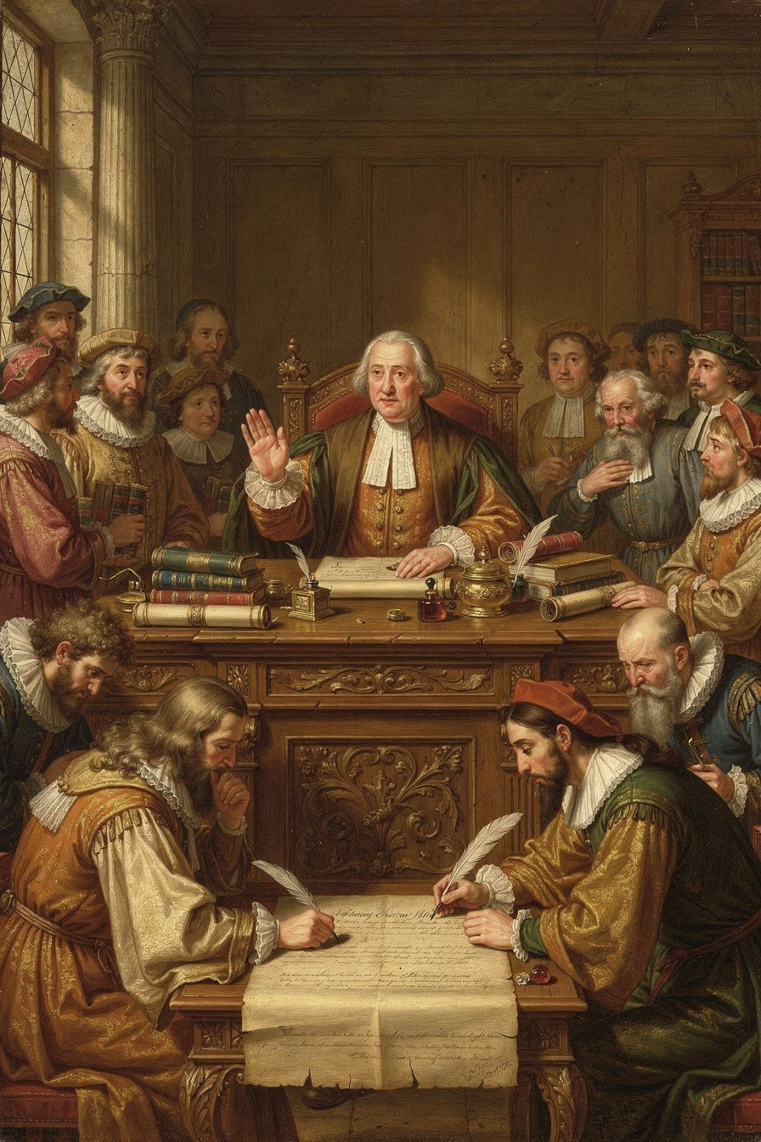
Illustration for Chapter 4
Locke's concept of limited government is the structural backbone of his political philosophy. Government, he argues, has limited and defined powers. It exists for a specific purpose — the protection of natural rights — and cannot exceed that purpose. To prevent the concentration of power that leads to tyranny, Locke distinguishes three kinds of political power and insists that the legislative power, while supreme, must itself be bounded by law, consent, and the public good.
The case for limited government follows directly from the social contract. Government is created by consent for a specific purpose: to protect natural rights better than individuals could protect them in the state of nature. If government has more power than necessary for this purpose, it has exceeded its mandate.
Locke identifies four specific limits on the legislative power:
1. It must govern by established standing laws, not arbitrary decrees. Laws must be published, known, and applied equally. The legislature cannot rule by ad hoc decision. People must know what the rules are so they can plan their lives.
2. It must act for the public good. Laws that serve private interests at the expense of the public violate the trust. The legislature exists for everyone, not for a faction.
3. It cannot take property without consent. Taxation requires consent through the legislative process. This is the origin of "no taxation without representation" — a principle that would echo across the Atlantic in 1776.
4. It cannot transfer its power. The legislative power is held in trust for the people. The legislature cannot give it to someone else, just as a trustee cannot transfer their duties without the beneficiaries' consent.
Locke also distinguishes three kinds of political power. Legislative power makes the laws. Executive power carries them out. Federative power manages foreign relations — war, peace, alliances, treaties. This is not the modern three-branch separation (legislative, executive, judicial) that we know from the American Constitution. Locke's judicial function is part of the executive. The modern separation was developed by Montesquieu and the American Founders, building on Locke's foundation.
The legislative power is supreme — but "supreme" does not mean "absolute." It means the legislative is the highest authority within the commonwealth. It makes the laws everyone, including the executive, must follow. But the legislative is itself limited by the social contract and the law of nature. If it violates those limits, it forfeits its authority.
Locke introduces a tension that remains central to constitutional design: prerogative. Laws are general, but circumstances are specific. There will be situations where strict adherence to the law would produce injustice, or where swift action is needed before the legislature can be convened. For these, Locke gives the executive the power to act beyond the letter of the law for the public good. Prerogative is dangerous — it allows the executive to suspend laws and act on its own judgment. The people must judge whether the use of prerogative serves the public good. If it does, they tolerate it. If it does not, they resist it. This tension between flexible executive action and arbitrary power is visible today in debates about emergency powers, executive orders, and presidential discretion.
Locke's framework directly influenced the American constitutional system. The written constitution specifies the powers of government and limits them — directly Lockean. The separation of powers adapts Locke's division and Montesquieu's refinement. Checks and balances institutionalize Locke's fear of concentrated power. The principle "no taxation without representation" flows from Locke's insistence that the legislature cannot take property without consent. And the Bill of Rights reflects Locke's conviction that there are things government simply cannot do — restrictions on speech, religion, assembly, and due process — because they violate natural rights that exist before government.
But Locke's framework also influenced the English constitutional settlement after the Glorious Revolution of 1688. The English Bill of Rights (1689) — which limited the monarch's power, guaranteed free elections, and established parliamentary supremacy — was the practical embodiment of Locke's principles. He returned from exile with William of Orange's entourage and published the Two Treatises in the same year. The ideas and the political events were inseparable.

Words to Remember
"The legislative, or supreme authority, cannot assume to itself a power to rule by extemporary arbitrary decrees, but is bound to dispense justice, and decide the rights of the subject by promulgated standing laws, and known authorized judges." — John Locke, *Second Treatise of Government*, Chapter 11

Big Idea
Government is a trust with limited powers. It must follow written laws, act for everyone, not take your property without consent, and not hand its power to someone else. Power should be split so no one branch can do everything alone. And when government breaks these rules, the people have the right to hold it accountable.

Try This
1. Look at the government of your country. Can you identify the legislative, executive, and (if your country has it) judicial branches? What does each one do? How do they check each other? 2. Locke says taxes require consent through representatives. Find out: Who are your representatives? What do they decide about taxes? Do you think the system is fair? Why or why not? 3. Locke's idea of "prerogative" — the executive acting beyond the law in emergencies — is controversial. Think of a real emergency (a pandemic, a natural disaster, a war). Should a leader be able to suspend normal rules during the emergency? What are the risks? How would you set limits?

Talk About It
1. Locke says the legislative power is supreme but not absolute. How can something be supreme but limited? What happens when the limits conflict with the supremacy? 2. "No taxation without representation" came from Locke. But today, many people who pay taxes cannot vote — minors, immigrants, people with certain criminal convictions. Does this violate Locke's principle? 3. Locke split power into legislative, executive, and federative. The American Constitution split it into legislative, executive, and judicial. Why did the Founders change Locke's division? Which system makes more sense to you?
———
If government is a trust, what happens when the trustee stops serving the people who trusted it?
———

Chapter 5: You Cannot Force Belief — Toleration and Freedom of Conscience
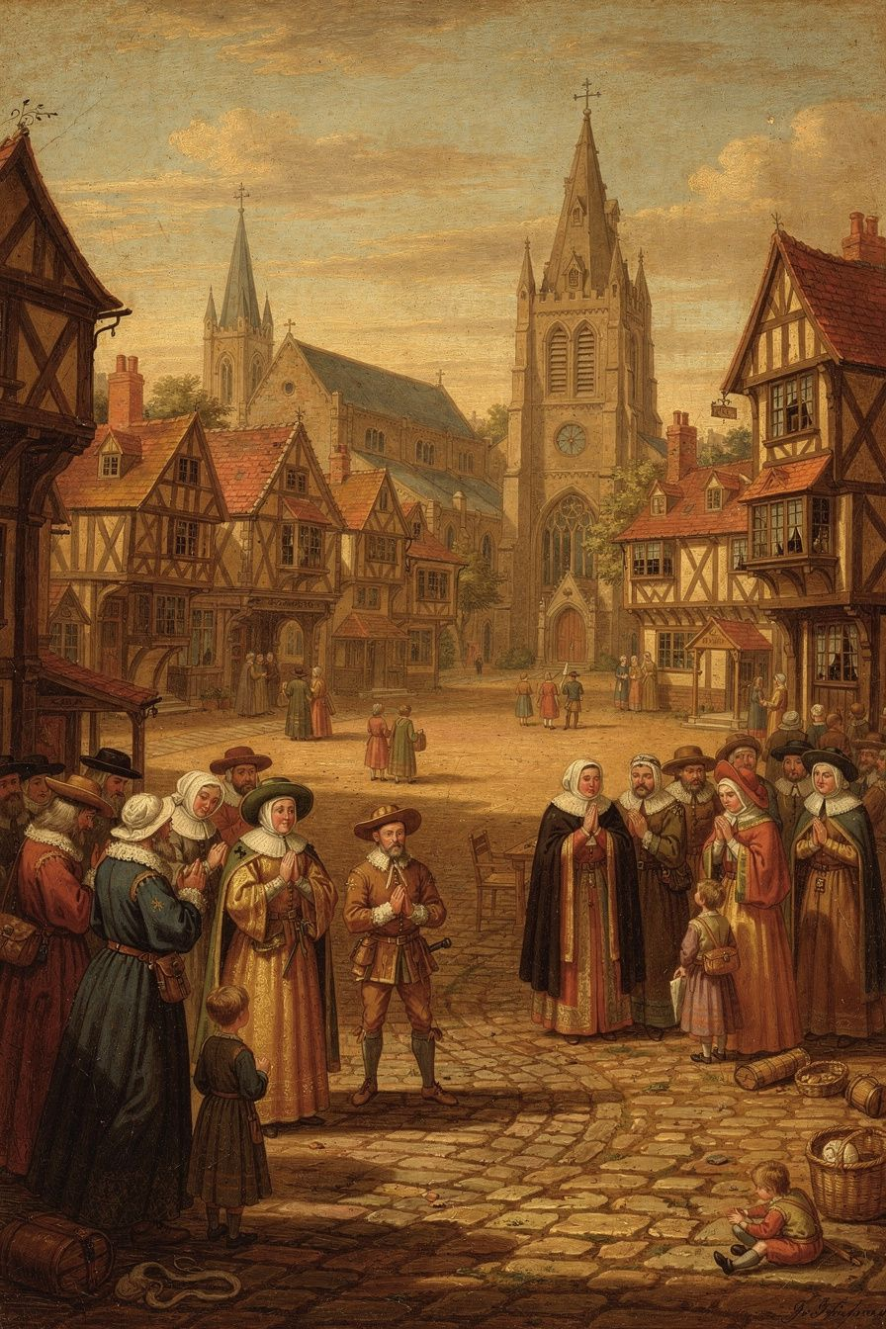
Illustration for Chapter 5
In Locke's time, the king decided what church everyone had to attend. If you went to a different church — if you were Catholic, Baptist, Quaker, or Presbyterian in a country ruled by Anglicans — you could be fined, imprisoned, barred from universities and public office, or even killed. The principle was cuius regio, eius religio — whose realm, his religion. The ruler's religion was everyone's religion.
Locke said this was both wrong and pointless. Wrong, because the state's authority extends only to civil interests — life, liberty, health, and property. The care of souls does not belong to the magistrate. Pointless, because coercion cannot produce genuine belief. Belief is an inward act of the mind. Force acts on the body. You can make someone go through the motions of worship, but you cannot make them believe. A person who conforms under duress is a hypocrite, not a convert.
Locke's Letter Concerning Toleration (1689) made the case through a fundamental distinction between three realms. The state exists to protect civil interests. Its power is external — law, force, punishment. The church is a "free and voluntary society." No one is born a member of a church (as one is born a subject of a state). Membership is chosen, and members may leave. The church's purpose is the worship of God and the salvation of souls. It may exhort and discipline, but it may not use force. Conscience is the inner forum where a person relates to God. It is beyond the reach of civil power.
Locke's arguments for toleration are powerful. The magistrate has no commission to care for souls — God did not give the government authority over religious truth. The magistrate is fallible — he might be wrong about religion, and forcing his views on others risks damning them. Toleration is good for religion — free competition among religions produces vigor and genuine commitment, while state-supported monopoly produces lazy clergy and hypocritical laity. And toleration is good for the state — persecuted minorities rebel, flee, or become secret enemies. A tolerant state earns the loyalty of all its subjects.
But Locke's toleration had limits. He excluded two groups: Catholics and atheists. Catholics were excluded not for their theology but for their political allegiance to the Pope — a foreign prince whose authority could conflict with civil loyalty. Atheists were excluded because Locke believed that oaths and promises — the bonds of trust that hold society together — depend on belief in God. An atheist who does not fear divine judgment cannot be trusted to keep promises.
These exclusions remain debated. Were they consistent with Locke's principles, or were they ad hoc political compromises? Some scholars argue the exclusions follow from Locke's logic — the state may exclude groups whose beliefs threaten civil order. Others argue the exclusions contradict Locke's own principles — his Essay argues that moral knowledge comes from reason, not just revelation, so atheists who accept reason-based morality should be tolerable. The exclusion of Catholics was political, not theological: Locke was not opposed to Catholicism per se but to "antinomianism" — the belief that allegiance to a higher authority supersedes civil law. If Catholics could "discard their uncivil beliefs," they could be tolerated.
Locke's toleration was broad by seventeenth-century standards but it was not the universal religious freedom we know today. He was a moderate, not a radical. Spinoza and Pierre Bayle argued for broader toleration than Locke. Bayle, in his Philosophical Commentary (1686), argued that even "erroneous" conscience has a right to toleration, and that persecuting belief only strengthens it. Spinoza's Theological-Political Treatise (1670) argued for freedom of philosophic thought without exception. Locke's exclusions make him closer to the practical politics of the English Toleration Act of 1689 (which excluded Catholics and anti-Trinitarians) than to the philosophical radicalism of Bayle or Spinoza. The question of whether liberal toleration has inherent limits — and where those limits fall — is the seventeenth-century version of a question that recurs in every generation.
Locke wrote the Letter during his exile in the Netherlands, inspired by the Dutch Republic's tradition of religious toleration. He returned to England in 1689 and published it the same year. It helped move Europe toward the separation of church and state, religious pluralism, and the broader principle that the state must respect the inner freedom of the individual.

Words to Remember
"It is one thing to persuade, another to command; one thing to press with arguments, another with penalties. No man can be forced to be saved." — John Locke, *A Letter Concerning Toleration*

Big Idea
The government should not control what people believe. Belief is inside the mind, and force cannot reach it. People should be free to worship, to question, and to choose their own religion — or none. But Locke's toleration had limits, and the question of where those limits fall is still being debated.

Try This
1. Research a country where religious freedom is not protected. What happens to people who practice a minority religion? How does Locke's argument apply — or not apply? 2. Locke excluded Catholics and atheists from toleration. Were these exclusions consistent with his own principles? Write a paragraph arguing each side. 3. Think of a belief you hold strongly. Now imagine the government said you were not allowed to hold it. How would you react? What would you do? Would you pretend to comply, or would you resist?

Talk About It
1. Locke says the state should not control belief. But what about beliefs that lead to harmful actions? Should the government tolerate a religion that refuses blood transfusions for children? Where is the line between belief and action? 2. Locke excluded atheists because he thought they could not be trusted to keep promises. Do you think moral behavior requires belief in God? Can someone be good without being religious? What does Locke's own Essay suggest? 3. How does Locke's argument compare to the religious freedom you see in your country today? Has society gone further than Locke, or not far enough?
———
If you cannot force someone to believe, what can you do when their beliefs seem dangerous to others?
———

Chapter 6: When the People Say No — The Right of Revolution
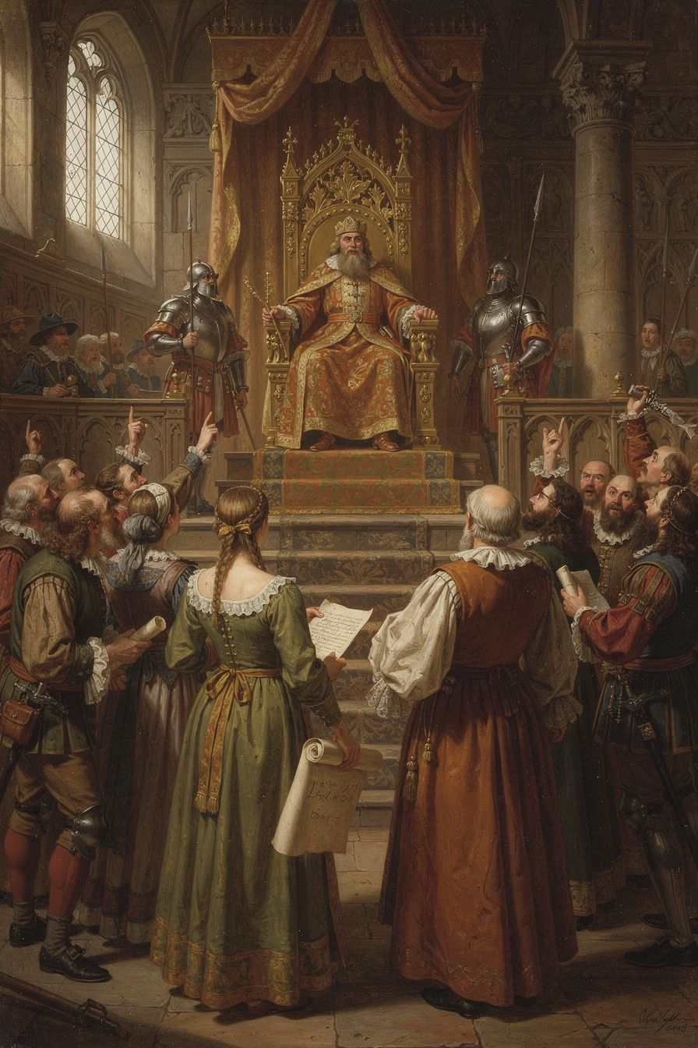
Illustration for Chapter 6
Locke's most radical idea is the right of revolution. If government is created by consent to protect natural rights, and if government betrays that purpose, the people have the right to dissolve it and form a new one. This is not lawlessness — it is the restoration of legitimate authority.
The argument is logical and direct. Government is a trust. The trust has a purpose: protecting natural rights. A trustee who betrays the trust forfeits the office. The people may reclaim their power and form a new government.
Locke's most striking argument is about who the real rebel is. The traditional view says the ruler is the legitimate authority and resistance is always rebellion. Locke inverts this: the ruler who betrays the trust has initiated a state of war against the people. Resistance to such a ruler is not rebellion — it is self-defense. The people are not rebels; they are victims of a ruler who has rebelled against the social contract. As Locke writes: "When the legislators endeavour to take away, and destroy the property of the people, or to reduce them to slavery under arbitrary power, they put themselves into a state of war with the people."
Locke identifies specific situations that justify revolution: arbitrary alteration of the legislative power (replacing elected lawmakers with hand-picked ones), delivery of the people to a foreign power, preventing the legislature from meeting, systematic violation of natural rights, and systematic corruption for private benefit. He is clear that a single mistake or unpopular policy does not justify revolution. The trigger is systematic betrayal — a pattern that shows the government has abandoned its purpose.
A common objection is that the right of revolution invites constant upheaval. Locke has several answers. People are reluctant to revolt — they tolerate much inconvenience before risking the dangers of revolution. The right of revolution deters tyranny — rulers who know the people can remove them are less likely to betray the trust. Only systematic betrayal justifies revolution. And the alternative is worse — if the people have no right of revolution, tyranny is permanent and uncorrectable.
A crucial Lockean distinction: dissolving the government is not dissolving society. When the government is dissolved, the people do not revert to isolated individuals. They remain a political community and can form a new government. The social contract that created the community is distinct from the arrangement that created the government. Revolution does not lead to anarchy — it leads to the community exercising its residual sovereignty.
Locke's right of revolution shaped the American Declaration of Independence. Jefferson adapted Locke's language: "We hold these truths to be self-evident, that all men are created equal, that they are endowed by their Creator with certain unalienable Rights, that among these are Life, Liberty and the pursuit of Happiness. That to secure these rights, Governments are instituted among Men, deriving their just powers from the consent of the governed, That whenever any Form of Government becomes destructive of these ends, it is the Right of the People to alter or to abolish it." Jefferson changed "property" to "the pursuit of happiness," but the structure is Locke's.
The right of revolution remains one of the most contested ideas in political philosophy. It is the ultimate check on governmental power — the backstop that ensures government remains accountable. It is also dangerous, because it can be invoked by anyone who claims the government has betrayed its trust. The question of who decides when revolution is justified, and how, is one that every generation must answer for itself.
Locke's idea also shaped the French Declaration of the Rights of Man and of the Citizen (1789), which declared that "men are born and remain free and equal in rights" and that the principle of all sovereignty resides in the nation. The Universal Declaration of Human Rights (1948) extends natural rights to a global framework. Each of these documents draws on Locke's core insight: that rights are not granted by government but belong to people by nature, and that government exists to protect them.
But the right of revolution also has a dark side. The French Revolution, inspired partly by Locke, descended into the Terror. The Russian Revolution invoked the rights of the people against the tsar, and produced a tyranny worse than the one it replaced. The right of revolution, once unleashed, is difficult to control. Locke's answer is that revolution is justified only by systematic betrayal — not by every grievance, not by every mistake. But who decides what counts as "systematic"? The people, Locke says. And that answer, while democratic in spirit, leaves the door open to both justice and chaos.

Words to Remember
"Whensoever, therefore, the legislative shall transgress this fundamental rule of society; and either by ambition, fear, folly, or corruption, endeavour to grasp themselves, or put into the hands of any other, an absolute power over the lives, liberties, and estates of the people; by this breach of trust they forfeit the power the people had put into their hands for quite contrary ends, and it devolves to the people, who have a right to resume their original liberty." — John Locke, *Second Treatise of Government*, Chapter 19

Big Idea
Government is a promise. When the government breaks that promise systematically — not once, but as a pattern — the people have the right to say: No more. They can dissolve the government and form a new one. This is not rebellion against the moral order; it is the restoration of it. The real rebel is the ruler who betrays the trust.

Try This
1. Read the American Declaration of Independence. Find the passages that come directly from Locke. Which words did Jefferson change? Why do you think he changed "property" to "the pursuit of happiness"? 2. Locke says revolution is a last resort. What counts as "systematic betrayal"? Make a list of government actions that you think would justify revolution, and actions that would not. Where do you draw the line? 3. Research a revolution or uprising in history. Did the people have a right to revolt, by Locke's standards? What were the consequences? Would you have supported it?

Talk About It
1. Locke says the people are the ultimate judges of when revolution is justified. But what if the people are wrong? What if a majority supports a revolution that makes things worse? Does the right of revolution have limits? 2. Today, most democracies have elections as a way to change government without revolution. Does the right of revolution still matter in a democracy? When? 3. Locke distinguishes between dissolving the government and dissolving society. Why is this distinction important? What happens if the distinction breaks down?
———
If government exists for the people, who decides when it has stopped serving them — and what gives them the right to act on that decision?
———

For the Grown-Up Reader
This booklet introduces 11–14-year-olds to John Locke's core political and philosophical ideas through six chapters: empiricism and the theory of ideas (Chapter 1), the state of nature and natural law (Chapter 2), the labor theory of property (Chapter 3), limited government and separation of powers (Chapter 4), religious toleration (Chapter 5), and the right of revolution (Chapter 6).
All quotes are from Locke's own works: the Essay Concerning Human Understanding (1689), the Second Treatise of Government (1689), and the Letter Concerning Toleration (1689). They are presented with their original citations. The ideas — empiricism, natural rights, the social contract, the labor theory of property, the trust theory of government, toleration, and the right of revolution — are presented in their authentic form, with their complications and controversies acknowledged.
The chapter on property (Chapter 3) addresses Locke's involvement in colonialism directly, including the Fundamental Constitutions of Carolina and the Royal African Company. The chapter on toleration (Chapter 5) addresses Locke's exclusions of Catholics and atheists. These complications are not smoothed over — they are presented as real questions that students should grapple with.
For further reading, the Second Treatise of Government is the most accessible of Locke's major works and can be read by strong middle-school readers with guidance. Chapters 2–5 (the state of nature, the law of nature, property) and Chapter 19 (the dissolution of government) are the most teachable. The Letter Concerning Toleration is short and readable. Peter Laslett's edition of the Two Treatises (1960) remains the standard scholarly text, with an introduction that explains the dating debate.
———

About WisdomForge
WisdomForge turns the great thinkers of history into booklets for every age. Each figure gets four booklets: one for ages 5–10, one for ages 11–14, one for ages 15–18, and one for adults. The same ideas, the same philosopher, told at the right depth for each reader. Because an eleven-year-old can understand freedom. A teenager can argue about rights. An adult can wrestle with the hard questions. And everyone deserves to meet the minds that shaped the world they live in.

