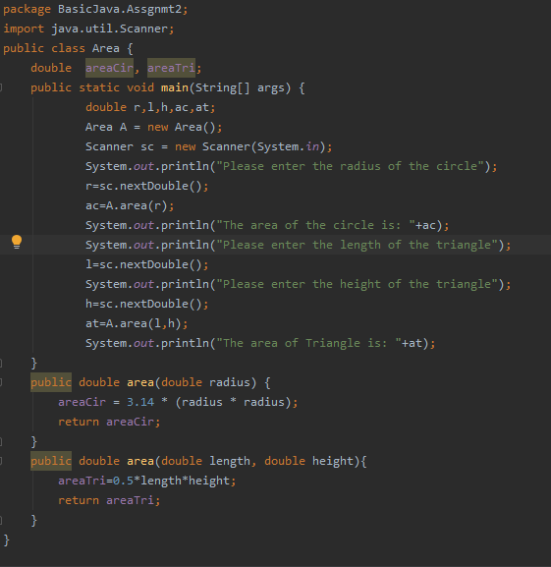

OUTPUT:

Please enter the radius of the circle

2

The area of the circle is: 12.56

Please enter the length of the rectangle

5

Please enter the height of the rectangle

2

The area of Triangle is: 5.0

Process finished with exit code 0

PROGRAM2:Factorial

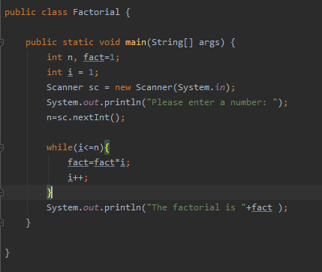

OUTPUT:

Please enter a number:

5

The factorial is 120

Process finished with exit code 0

PROGRAM3:

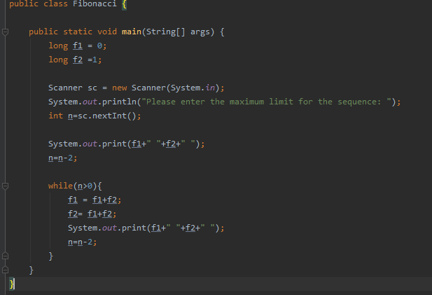

OUTPUT:

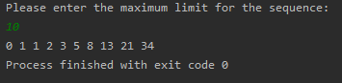

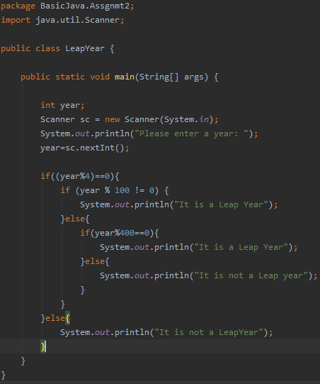

OUTPUT:

