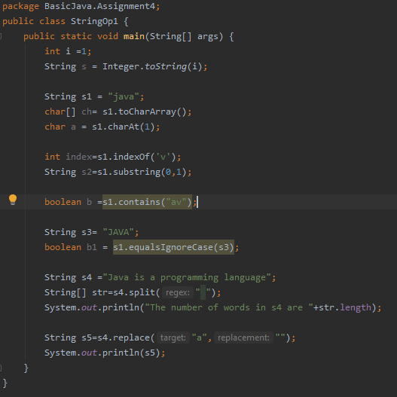

OUTPUT:

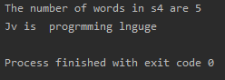

Difference between equals(),== and compareTo():

Equals(): The equals() method checks for the equality of value of two objects. The return type of this method is Boolean

==: The == operator checks for the equality of memory location of two objects in a heap. The return type of this method is Boolean

compareTo():The compareTo() method compares two strings lexicographically. If the values are equal it returns zero. The result is a negative integer if this String object lexicographically precedes the argument string. The result is a positive integer if this String object lexicographically follows the argument string.

StringBuffer vs StringBuilder: objects of StringBuffer and StringBuilder are mutable. StringBuffer and StringBuilder are similar, but StringBuilder is faster and preferred over StringBuffer for the single-threaded program. If thread safety is needed, then StringBuffer is used.