Q 1. What is multithreading, serialization and Generics in Java

Ans. Multithreading refers to a process of executing two or more threads simultaneously for maximum utilization of CPU.

Serialization is a mechanism where an object can be represented as a sequence of bytes that includes the object's data as well as information about the object's type and the types of data stored in the object.

After a serialized object has been written into a file, it can be read from the file and deserialized that is, the type information and bytes that represent the object and its data can be used to recreate the object in memory.

**Generics** means **parameterized types**. The idea is to allow type (Integer, String, … etc., and user-defined types) to be a parameter to methods, classes, and interfaces. Using Generics, it is possible to create classes that work with different data types. An entity such as class, interface, or method that operates on a parameterized type is a generic entity.

Q 2. what is linked list , data set, error?

Ans. A **linked list** consists of nodes where each node contains a data field and a reference(link) to the next node in the list.

A DataSet provides a type safe view of the data returned from the execution of a SQL Query. It is a subinterface of java.util.List. A DataSet is also a parameterized type. The parameter type is a *data class* describing the columns for the rows returned by invoking a method on a Query interface decorated by a Select annotation. The *data class* must have an access modifier of public.

In Java, an error is **a subclass of Throwable that tells that something serious problem is existing** and a reasonable Java application should not try to catch that error. Generally, it has been noticed that most of the occurring errors are abnormal conditions and cannot be resolved by normal conditions.

Q3. What are iterators, explain with an example

An Iterator is an object that can be used to loop through collections, like [ArrayList](https://www.w3schools.com/java/java_arraylist.asp) and [HashSet](https://www.w3schools.com/java/java_hashset.asp). It is called an "iterator" because "iterating" is the technical term for looping.To use an Iterator, you must import it from the java.util package.

Q4. Explain for each loop

Ans: The for each loop is used to traverse through an array and print the elements. It is simpler to write than a regular for loop.

Syntax:

For(<Type> element : array){

//perform operations on element

}

Q5. What is boxing and unboxing in Java? Explain with an example

**The automatic conversion of primitive data types into its equivalent Wrapper type is known as boxing and opposite operation is known as unboxing**.

**class** BoxingExample{

**public** **static** **void** main(String args[]){

**int** a=50;

    Integer a2=**new** Integer(a);//Boxing

        Integer a3=5;//Boxing

        System.out.println(a2+" "+a3);

 }

}

-------------------------------------------------------------------------------

**class** UnboxingExample1{

**public** **static** **void** main(String args[]){

    Integer i=**new** Integer(50);

**int** a=i;

        System.out.println(a);

 }

}

Q6. What are wrapper class? Give me an example

Ans. The **wrapper class in Java** provides the mechanism to convert primitive into object and object into primitive.

**int** a=20;

Integer i=Integer.valueOf(a);//converting int into Integer explicitly

Integer j=a;//autoboxing, now compiler will write Integer.valueOf(a) internally

Q7. What are the different types of interface? (Ans List, set, Queue)

Ans. List, Set and queue are interfaces that extend the Collection interface. Map is a separate interface

Q8. Will java supports multiple inheritance?

A class cannot extend more than one class but it can implement multiple interfaces

Q9. What is the difference between final and finally?

Ans. Final is a keyword in java. It can be used for class, method and attribute. The values of final variable will remain constant. The final methods cannot be overridden by subclasses. The final classes cannot be extended.

Finally is also a keyword. it is used when an exception occurs to close connections and release the resources before the execution of program ends.

Syntax:

Try{

//exception occurs here

}catch{

//catches exceptions

]finally{

Executes some important code to release resources

}

Q10. What are collection APIs, give me an example

Ans. The Java Collections API **provide Java developers with a set of classes and interfaces that makes it easier to work with collections of objects**, e.g. lists, maps, stacks etc. Rather than having to write your own collection classes, Java provides these ready-to-use collection classes for you.

Q11. What is the difference between throw, throwable and throws?

Ans. Throw is a keword in java. It is used by a method to throw exception.

Throws is a keyword in java which is used to declare that a method is throwing an exception.

Throwable is a class which extends the Object class. It is in turn extended by Error and Exceptions

Q12. What is the difference between Error and exception?

Ans. Exceptions and errors both are subclasses of Throwable class. The error indicates a problem that mainly occurs due to the lack of system resources and our application should not catch these types of problems. Some of the examples of errors are system crash error and out of memory error. Errors mostly occur at runtime that's they belong to an unchecked type.

Exceptions are the problems which can occur at runtime and compile time. It mainly occurs in the code written by the developers.  Exceptions are divided into two categories such as checked exceptions and unchecked exceptions.

Q13What is the difference between throws and throwable?

Ans. Throws is a keyword in java which is used to declare that a method is throwing an exception.

Throwable is a class which extends the Object class. It is in turn extended by Error and Exceptions.

Q14. What are java exceptions? Give me an example

Ans. An exception is an event that occurs during the execution of a program which would result in disruption

of normal flow of program. They are of two types, checked and unchecked.

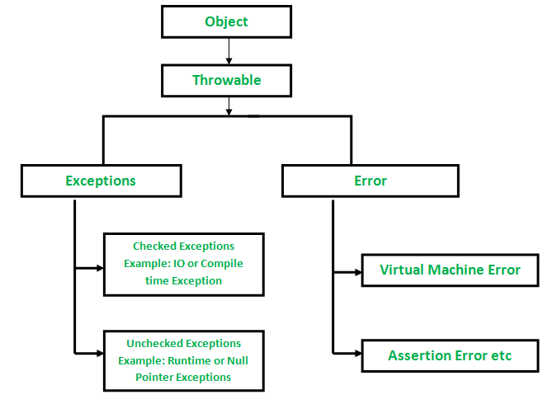

Checked Exceptions:

Theseare the exceptions that are checked at compile time. If some code within a method throws a checked exception, then the method must either handle the exception or it must specify the exception using the [*throws*keyword](https://www.geeksforgeeks.org/throw-throws-java/).

Unchecked exceptions: These are the exceptions that are not checked at compile time. The programmer needs to specify or catch those exceptions

Q15. What are access modifiers? Give me an example?

Ans. Access modifiers define the visibility of methods and attributes in java.

Types of access modifiers: public, private, protected and default.

Public🡪Can be accesed in any package

Private🡪accessed only inside the class containing it

Protected🡪Can be accessed within the same package or subclasses in different package

Default🡪can be accessed within the same package

Q16. Why Java is Platform independent?

Ans. Java is platform-independent **because it uses a virtual machine**. The Java programming language and all APIs are compiled into bytecodes. Bytecodes are effectively platform-independent. The virtual machine takes care of the differences between the bytecodes for the different platforms.

Q17. What is an interface?

Ans. Interface is a framework or template which can be implemented by child class. It contains ‘public static final’ variables and methods

without body which needs to be implemented by child class .

Q18. What is an abstract class?

An abstract class can have zero or more abstract methods i.e methods without implementation. Such class and such method should be declared with keyword ‘abstract’.The class extending the abstract class should implement the abstract method in super class or declare itself as abstract too.

Q19. What is set in java?

Ans. The set interface is present in [java.util](https://www.geeksforgeeks.org/java-util-package-java/) package and extends the [Collection interface](https://www.geeksforgeeks.org/collections-in-java-2/) is an unordered collection of objects in which duplicate values cannot be stored

Ans. Set is a collection of unique elements.

Q20. What is a vector in Java?Ans. Vector implements a dynamic array that means it can grow or shrink as required. Like an array, it contains components that can be accessed using an integer index. They are very similar to [ArrayList](https://www.geeksforgeeks.org/arraylist-in-java/), but Vector is synchronized and has some legacy methods that the collection framework does not contain.

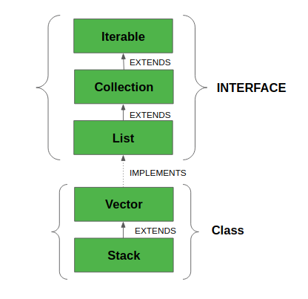

Q21. What is the difference between hash map and Hash table?

* Ans. HashMap is non-synchronized. It is not thread-safe and can’t be shared between many threads without proper synchronization code whereas Hashtable is synchronized. It is thread-safe and can be shared with many threads.
* HashMap allows one null key and multiple null values whereas Hashtable doesn’t allow any null key or value.
* HashMap is generally preferred over HashTable if thread synchronization is not needed.

Q22. What is the difference between array and array list?

Ans. Array is a collection of primitive or non primitive data. The elements of an array are of same type. Also,

Array has fixed length. The elements of array can be accessed through index of the array.

ArrayList is a class that extends List interface of Collection framework. It can hold objects only. The size of a arrayList can be changed dynamically. There are different methods like add,get,set,remove,size,clear, etc. to access and perform opertions on the elements.

Q23. What is the difference between String and String buffer

Ans. The String class is immutable whereas StringBuffer is mutable. String class is slower while performing concatenation operation and StringBuffer is fast.The Strings are saved in String pool while the StringBuffer is saved on heap.String class has the equals() method from Object class and StringBuffer doesn’t have it.

Q24. Why string is Immutable?

Ans. . The key benefits of keeping this class as immutable are caching, security, synchronization,

and performance

.

Q25. What is method overloading and Method overriding?

Ans: Overloading: if you have methods of same name that differ in the number of parameters or type of parameters, it

is called overloading. It is related to compile time polymorphism.

Overriding: If the types of parameters, the number of parameters and the return types for a method are all same as of a

method in superclass its called overriding. It is needed when we need a specific implementation of a method in super class.

Class X {

Public void printArray(){

}

}

Class Y extends class X{

Public void printArray(){

}

}

Q26. What is Polymorphism and encapsulation?

Ans. Polymorphism: It means an object in java can take many forms. There are mainly two types of polymorphism,

1. compile time polymorphism(overloading)

2. runtime polymorphism(overriding)

The reference of super class can be used for an object of child class.

Encapsulation: In encapsulation the variables of a class are hidden from user and only methods can be used to operate on those variables.

This can be done by declaring private variables and accessing them through getter and setter methods of the same class.

Q27. What is JVM and explain me the Java memory allocation

Ans. Java virtual machine is a specification that provides runtime environment in which java bytecode can be executed.

JVM is platform dependent.

Q28. Write to test scenarios to test Pencil

Q29. Write test cases for how to test just the withdrawing functionality from ATM ( Minimum 10 test cases required )

Q30. Write a method to implement *, - , / operations. You should use only the + operator

public void operations(int a, int b){

int temp = a;

for(int i=0;i<=b;i++){

a+=b;

}

System.out.println(“The product of two numbers is ”+a);

A=temp;

for(int i=1;i<=b;i++){

a=a-b;

}

System.out.println(“a divided by b is equal to ”+a);

A=temp;

for(int i=1;i<=b;i++){

a=a-1;

}

System.out.println(“The difference of a and b is equal to ”+a);

}

Q31. You are given two sorted arrays, A and B, and A has a large enough buffer at the end to hold B. Write a method to merge B into A in sorted order.

Q32. Read a file content and write it to a new file in reverse order.(reverse line 1-10 to line 10-1)

**Ans. private** String **readFromInputStream**(InputStream inputStream) **throws** IOException {

**StringBuilder** resultStringBuilder = **new** **StringBuilder**();

**try** (**BufferedReader** br = **new** **BufferedReader**(**new** **InputStreamReader**(inputStream))) {

String line;

**while** ((line = br.readLine()) != null) { resultStringBuilder.append(line).append("\n"); } } **return** resultStringBuilder.toString(); }

Q33. What are different ways to create String Object?

Ans. 1.Literal way: String s =”java”;

2.Object way: String s = new String(“java”);