**TABLEAU VISUALIZATIONS BY CLAIRE NDOFOR**

Given the large dataset we have, it was very helpful to have a tool like tableau that helps you visualize the data and compare columns based on the outcome. These visualizations gave me more understanding of how each column is affected by another

1. Cityname and temp: Here we can easily see that the temperature difference between these 4 cities is not a huge one

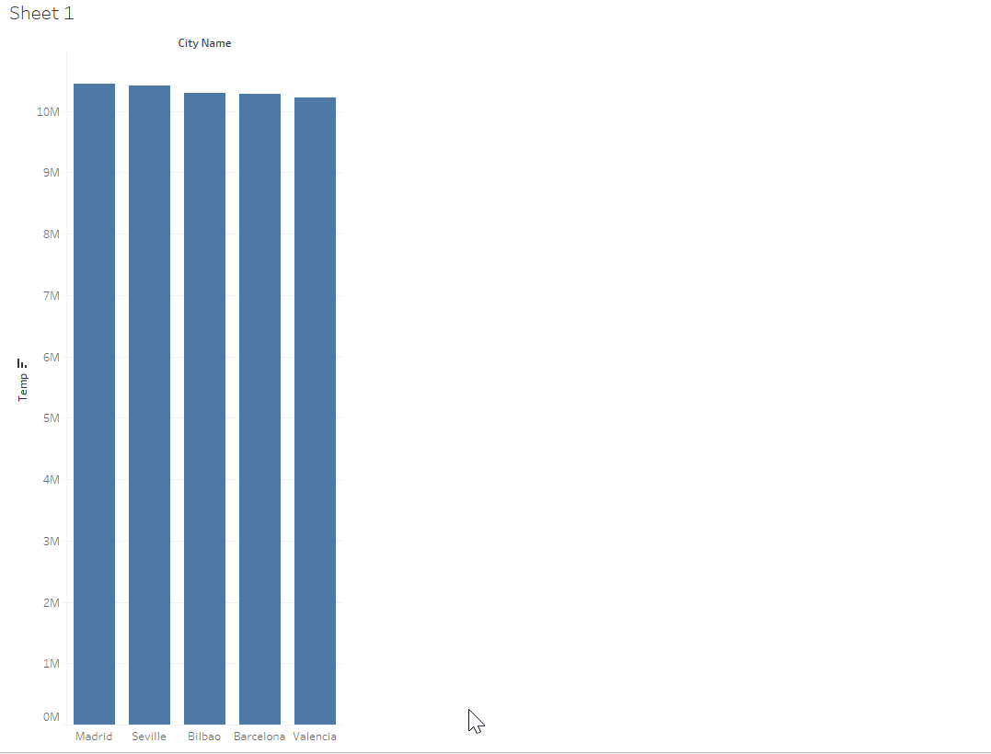

1. Minimum temperature vs cityname

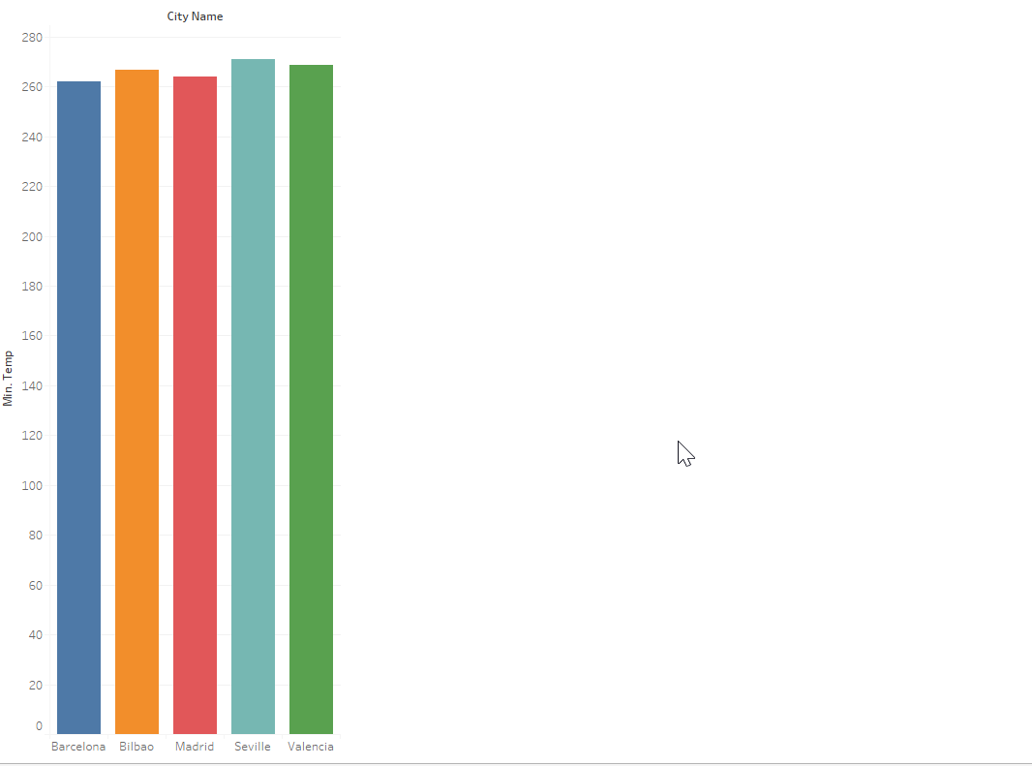

1. Weather description vs rain . This can be helpful in the sense that we weather forecasters can have an idea of how much rain needs to fall in order to describe the weather as clear for example

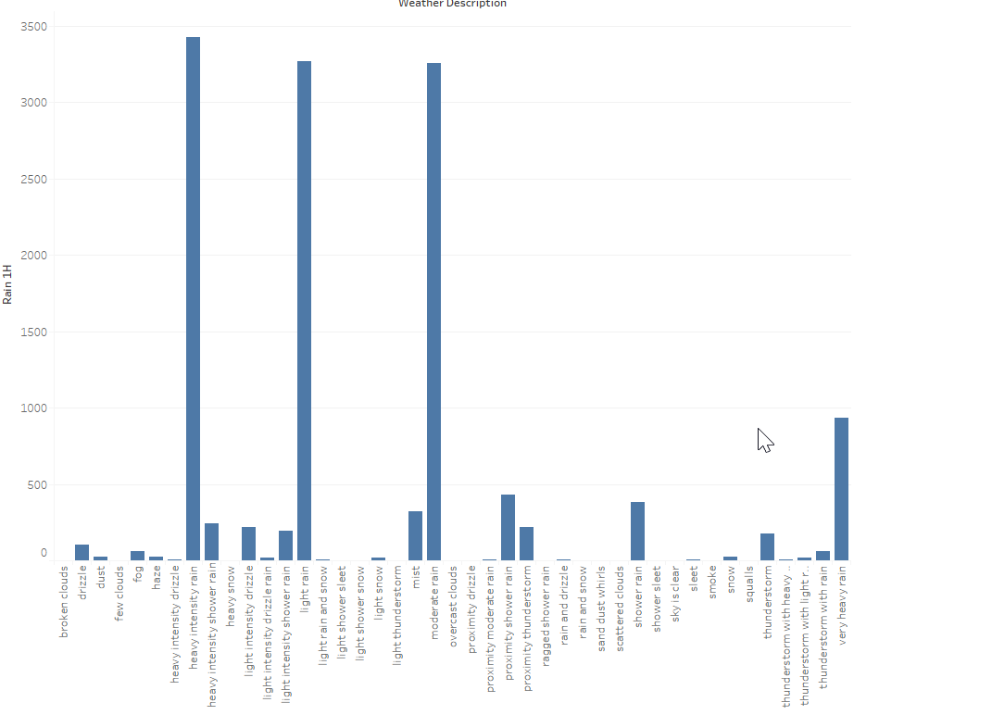

1. A clearer view of weather describtion

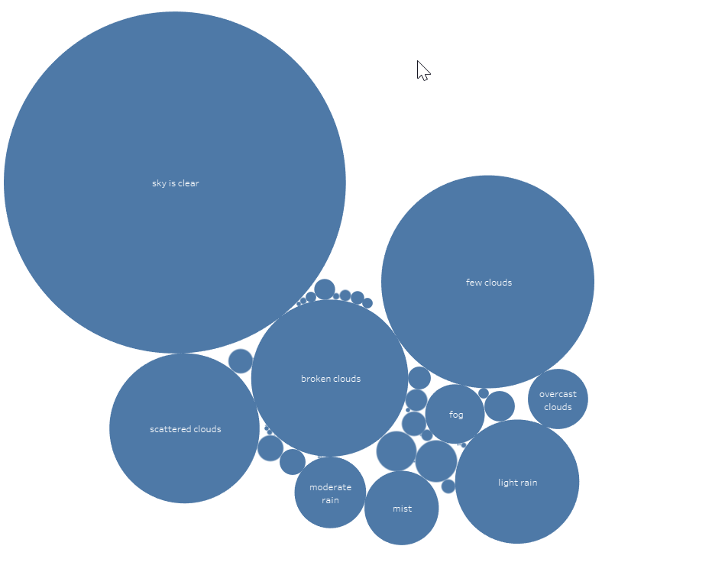

1. Main Weather vs Humidity:

From the chart we can see clearly how humidity determines how the weather will turn out

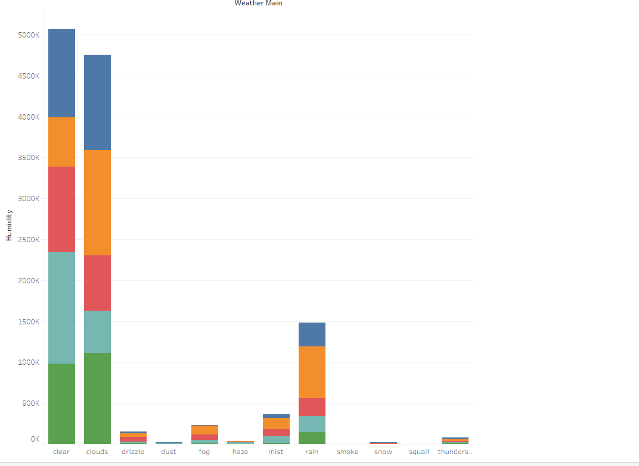

1. Snow vs cityname

