Plant Care Tracker

Shelby Mohar

University of Missouri – Kansas City

Table of Contents
Vision Statement 3
Requirements 4
Product Backlog 5
Sprint #1 6
Review 6
Retrospective 6
Sprint #2 7
Review 7
Retrospective 7
Sprint #3 8
Review 8
Retrospective 8
Sprint #4 9
Review 9
Retrospective 9
Sprint #5 10
Review 10
Retrospective 10
Sprint #6 11
Review 11
Retrospective 11

Vision Statement

My app, which will temporarily be called “Plant Care Tracker” until I come up with a snazzier official name, will help the user manage their plant care. As the proud parent of over twenty plants, I have a lot to keep track of. Beyond the specific watering requirement of each species, some of my plants require unique and diligent care either due to illness or simply because they are persnickety. To assist in this tedious process, my app will have several key features that will help to streamline plant care:

Plant Profiles
Similar to a class in OOP, the app will allow the user to create “profiles” for their plants. This feature will have the option of creating a single profile for all plants of the same species, or perhaps all plants in a certain location (for example, the plants in the shadowy back room might require less water than the ones on the sunny front porch), or a profile per individual plant. These profiles will keep track of when the plant(s) was previously watered, when the next time the plant needs to be watered, and any special care notes. I would like each plant to be able to have its own “profile” picture. I would also like to implement a photo-album feature to which the user can add pictures of the plant(s) to the profile and even share to social media (perhaps an element for future development).

Water Reminder
The key feature will be a notification system that will alert the user that it’s time to water a plant. The user can specify what time of day they would like to receive a watering notification. Much like an alarm app, I envision that this feature will have a Snooze element if the user needs to postpone watering but would like to be reminded again later that day. I will also include a Confirmation element so the user can confirm that they actually watered the plant, and didn’t simply Snooze the notification away. This element will have the option of automated scheduling through which the next watering notification is automatically set based on a pre-specified plan (i.e. water ever three days), or it can be set manually if plant care changes.

Sick Plant
This may a feature saved for future development. I would like the user to have to option of adding a temporary specialized care routine for a plant that might be sick (brown spots on leaves, bugs, etc.). The user selects a symptom from a dropdown list of problems, and the app then adds an additional care routine to that plant in addition to the watering schedule (spray with soap/oil mix every other day, cut watering schedule in half, etc.)

Requirements
A discussion of what your application is required to have in functionality. It should identify user roles and goals/actions, and what the key features of the app should be.
Actor | Goal
User | Create a plant profile
User | Add a watering schedule for a plant profile
User | Set a reminder to water a plant
User | Add notes to a plant profile
User | Add photos to plant profile and browse photos
User | Add profile picture for plant
User | Snooze a watering reminder
User | Confirm a watering reminder

Product Backlog
This will be updated throughout the semester as new PBIs are added, larger items are broken into smaller ones, and completed items removed.

Story ID | Story | Story Points  (in est. hours) | Priority | Status
001 | Create a plant profile | 10 | 1 | incomplete
002 | Add a watering schedule for a plant profile | 5 | 2 | incomplete
003 | Set a reminder to water a plant | 7 | 3 | incomplete
004 | Add notes to a plant profile | 2 | 4 | incomplete

Sprint #1 (Basic Framework)

Sprint Backlog
Story ID | Story / Task | Estimated  Hours | Actual  Hours
001A | Set up Git | 1 | .1
001B | Main Screen | 3 | 3
001C | Framework | 4 | 3
001D | Persistent storage | 5 | 5
001E | Profile creation | 4 | 2
001F | Profile details | 3 | 0
Velocity: 3

Review
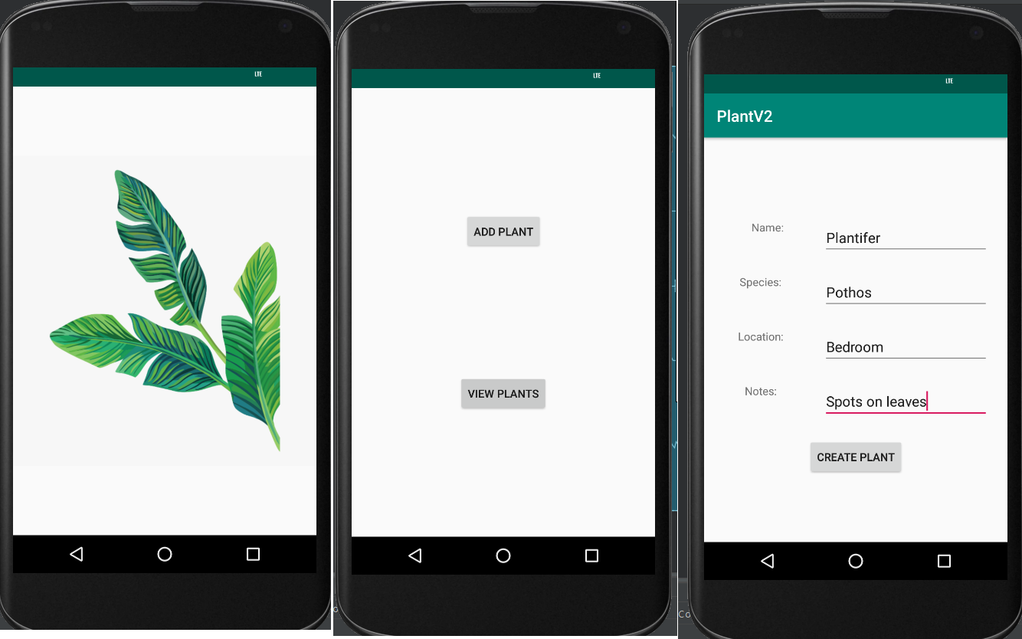

This first sprint saw the implementation of basic functionality.
- Splash screen. When the user starts the app, it immediately launches a splash screen to both introduce the user to the app as well as to give the app time to load dependencies in the future
- Home screen. Two main buttons are added, “Add Plant” to add a plant, and “View Plants”. Only “View Plants” has functionality. When clicked, it takes the user to a new activity that takes text from the user about a specific plant.
That being said, the app thus fair has only basic functionality. I had hoped to have found a way to implement a persistent storage system so the user could create plant profiles that remained in memory after the user exited the app, but have not yet figured it out. I also explored the use of Android’s JetPack module “Navigation” to link the activities of my app, but was not able to get it to work. Furthermore, I keep having problems with formatting in the XML files that is causing serious delays. I also switched mid-sprint from using Java to Kotlin – I came to the decision that in order to best use the latest modules, it would be best to use Kotlin. Furthermore, Kotlin require less code to achieve the same results with Java.

Retrospective
What went well:
Not much, I’m afraid. The learning curve is dreadful – not only am I working in a new environment and new language, it has proven very difficult to find instructional videos or guidelines that help with what I need. There seems to be two speeds as far as instructional support goes: very basic to extremely technical. Thankfully, I have at least basic functionality.
What didn’t go well:
Nearly everything. From formatting within the XML file and trying to wrangle ConstraintLayout, to being unable to implement persistent storage with Room. I accomplished very little of what was on my sprint backlog, despite having spent over 13 hours this week on it. Switching from implementing in Java to Kotlin cut my productivity in half, as I essentially had to start the project over even though I was able to reference the Java code. For my next sprint, I will break down the user stories even further, as to make sure I can actually accomplish what I set out to do. I’m not going to bother much with aesthetics just yet, as my goal will be functionality first.

Sprint #2 (Persistent State)

Sprint Backlog
Story ID | Story / Task | Estimated  Hours | Actual  Hours
001E | Profile Creation – create class that  saves instances of individual plants | 4
001D | Set up persistent storage | 5
001G | Enable plant profile instances to be saved  in persistent storage | 2
001H | Create screen for user to view created plants  saved in persistent storage | 5

Review

[Screenshots, etc go here. This is where you discuss the product, describing what was done this sprint (potentially shippable product increment) and what was planned for the sprint but was not done. ]

Retrospective
[This is where you discuss the process. What went well (and are you planning to do more of that?) What didn’t go so well (and do you have a way to do less of that)? What changes are you planning to make in how you plan & carry out the next sprint?]

Sprint #3

Sprint Backlog
Story ID | Story / Task | Estimated  Hours | Actual  Hours

Review

[Screenshots, etc go here. This is where you discuss the product, describing what was done this sprint (potentially shippable product increment) and what was planned for the sprint but was not done. ]

Retrospective
[This is where you discuss the process. What went well (and are you planning to do more of that?) What didn’t go so well (and do you have a way to do less of that)? What changes are you planning to make in how you plan & carry out the next sprint?]

Sprint #4

Sprint Backlog
Story ID | Story / Task | Estimated  Hours | Actual  Hours

Review

[Screenshots, etc go here. This is where you discuss the product, describing what was done this sprint (potentially shippable product increment) and what was planned for the sprint but was not done. ]

Retrospective
[This is where you discuss the process. What went well (and are you planning to do more of that?) What didn’t go so well (and do you have a way to do less of that)? What changes are you planning to make in how you plan & carry out the next sprint?]

Sprint #5

Sprint Backlog
Story ID | Story / Task | Estimated  Hours | Actual  Hours

Review

[Screenshots, etc go here. This is where you discuss the product, describing what was done this sprint (potentially shippable product increment) and what was planned for the sprint but was not done. ]

Retrospective
[This is where you discuss the process. What went well (and are you planning to do more of that?) What didn’t go so well (and do you have a way to do less of that)? What changes are you planning to make in how you plan & carry out the next sprint?]

Sprint #6

Sprint Backlog
Story ID | Story / Task | Estimated  Hours | Actual  Hours

Review

[Screenshots, etc go here. This is where you discuss the product, describing what was done this sprint (potentially shippable product increment) and what was planned for the sprint but was not done. ]

Retrospective
[This is where you discuss the process. What went well (and are you planning to do more of that?) What didn’t go so well (and do you have a way to do less of that)? What changes are you planning to make in how you plan & carry out the next sprint?]

