# Multiple Star Astrometry

Multiple Star Astrometry 1

Year in Review 3

Analyses: Stars 5

Analysis: Double Stars 7

## Year in Review

This year was clearly the year of the Snake. I invested a lot of time in learning Python for astronomical applications. I began using it as a scripting language, but by the end of the year had begun to teach myself object-oriented design and had implemented object-oriented code for double stars.

## Analyses: Stars

Last Updated 8/14/2014

TBD

Very good links:

<http://zuserver2.star.ucl.ac.uk/~msw/lines.html>

<http://stsdas.stsci.edu/elcat/>

Balmer ratios!!! <http://ned.ipac.caltech.edu/level5/Glossary/Jaschek/H.html>

### Analysis: Double Stars

Last Updated 8/14/2014

My database of visual double star observations continues to grow and mature. Many stars show clear orbital motion and in fact errors compared to the WD6 ephemerides show decreasing cumulative errors over time. The table below provides an update and summary of stars observed this calendar year. Notable missed observations include: Castor, Zeta Cancer, and Xi Ursa Majoris.

Link to the WDS catalog text file (without Frames): <http://ad.usno.navy.mil/wds/Webtextfiles/wdsweb_summ.txt>

|  |  |  |  |
| --- | --- | --- | --- |
| **Star** | **First Obs Date** | **2014 Obs Dates** | **Notes** |
| Zet Her | 2008.537 | 2014.611 | Has swept through 50 degrees of PA. Difficult to measure this year despite excellent seeing due to asymmetric diffraction ring brightness. |
| 70 Oph | 2008.537 | 2014.611 | Orbital motion exquisitely clear, very tight fit to WD6 prediction. |
| Lam Oph | 2009.512 | 2014.611 | Accomplished a third measurement this year and so can start to fit data points. |
| Tau Oph | 2009.512 | 2014.611 | First measurement this year. |
| BU 648 | 2008.637 | 2014.611 | Clear orbital motion, has swept through 18 degrees of PA. |
| Eps 1 Lyr | 2007.501 | 2014.611 | Slow mover with good separation. Orbital motion is not clear at this time. |
| Eps 2 Lyr | 2007.501 | 2014.611 | Slow mover with good separation. Orbital motion is not clear at this time. |
| Eps 1-2 Lyr |  | 2014.611 |  |

Future work could include:

1. Rigorously reassessing the errors around each measurement for use in weighted fits.
2. Documenting the residuals from the fits.
3. Using weighted fits rather than simple averages for the comparisons to the WD6 predictions.
4. Completing Python codes to move all plotting analysis (not data reduction and measurement) out of Excel

**Zeta Hercules**

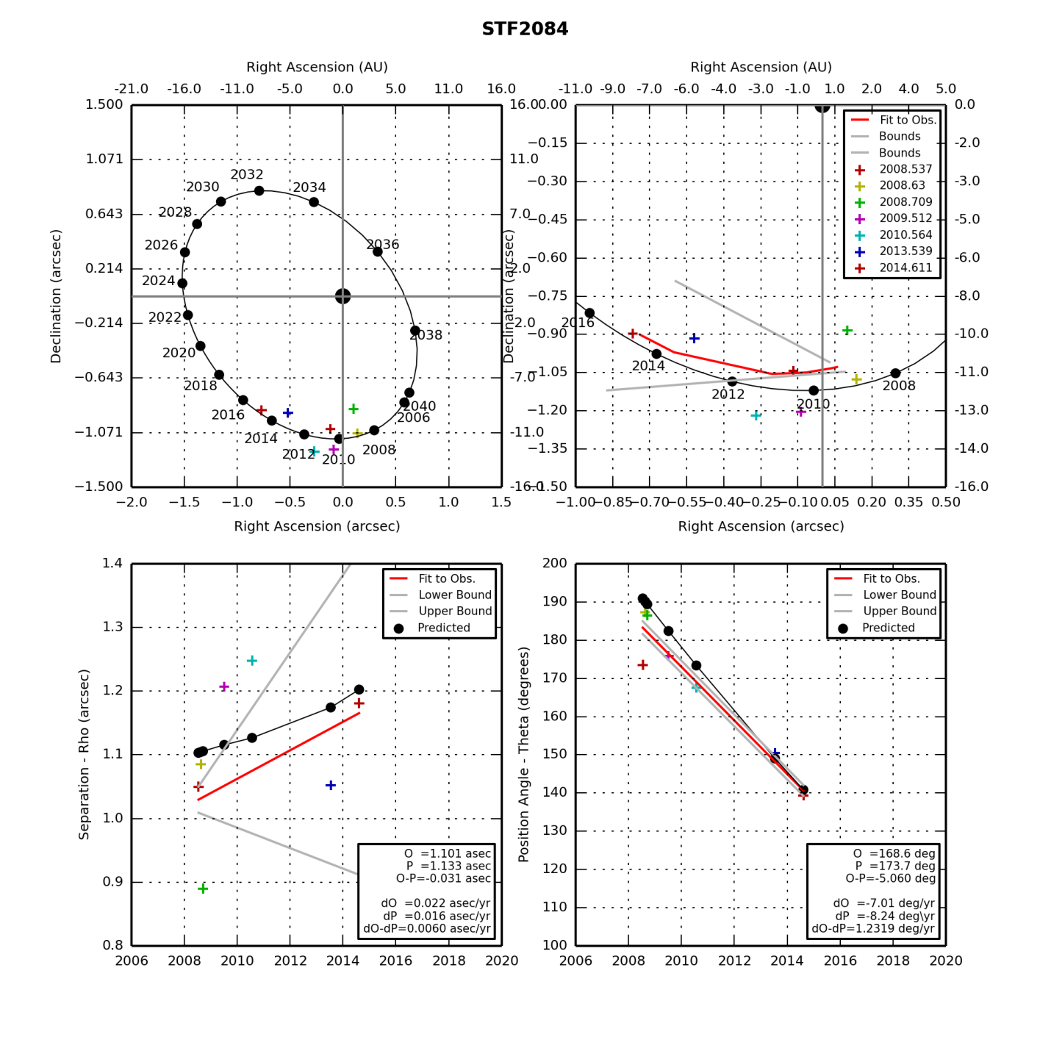

STF2084.png (created by StevesBinaryPlotterV05.py on 12/19/2014)

**70 Ophiuchus**

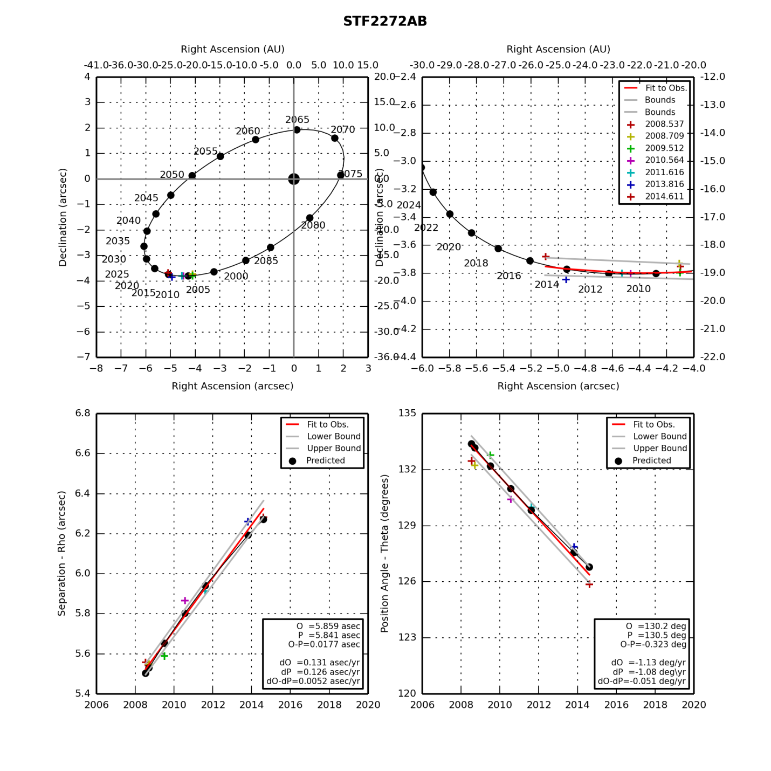

STF1110AB.png (created by StevesBinaryPlotterV05.py on 12/19/2014)

**Lambda Ophiuchus**

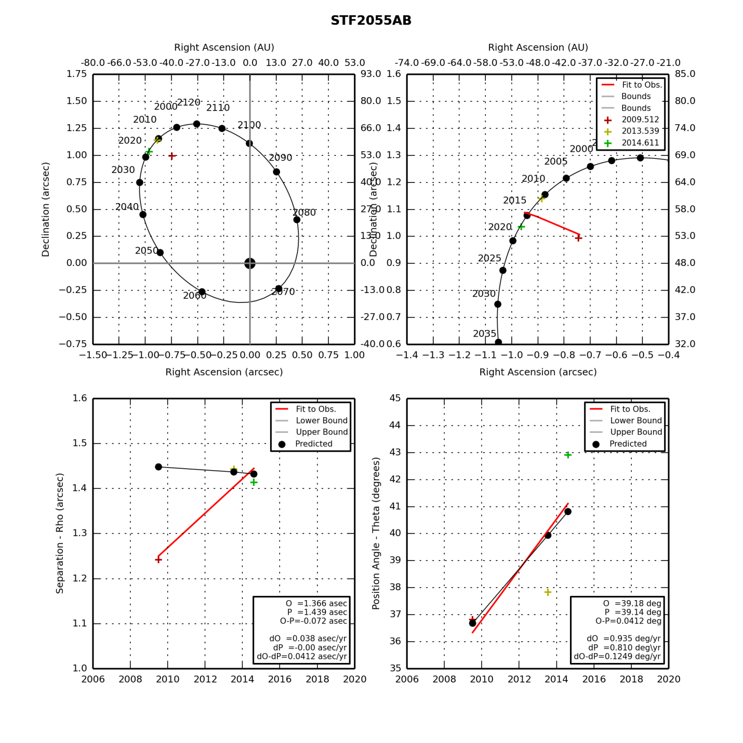

STF2055AB.png (created by StevesBinaryPlotterV05.py on 12/19/2014)

**Tau Ophiuchus**

|  |  |  |  |  |  |  |  |  |  |  |  |  |  |  |  |  |  |  |  |  |  |  |  |  |  |  |  |  |  |
| --- | --- | --- | --- | --- | --- | --- | --- | --- | --- | --- | --- | --- | --- | --- | --- | --- | --- | --- | --- | --- | --- | --- | --- | --- | --- | --- | --- | --- | --- |
|  | |  |  |  |  | | --- | --- | --- | --- | | **Parameter** | **Value** | **Rate** | **Units** | | PA(O) |  |  | deg(/yr) | | PA(P) |  |  | deg(/yr) | | PA (O-P) |  |  | deg(/yr) | | Sep(O) |  |  | asec(/yr) | | Sep(P) |  |  | asec(/yr) | | Sep (O-P) |  |  | asec(/yr) | |

**BU 648**

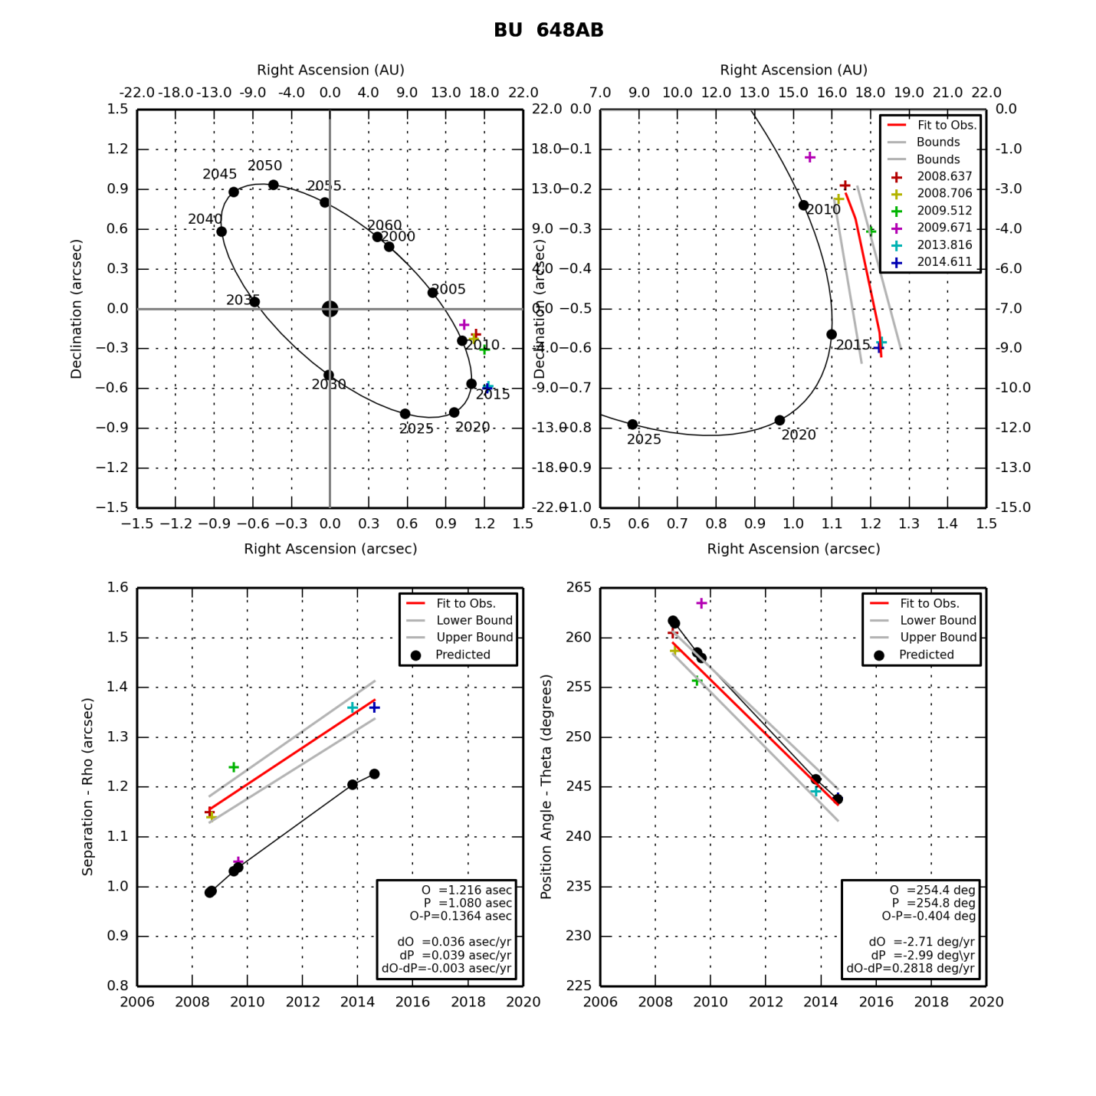

BU 648AB.png (created by StevesBinaryPlotterV05.py on 12/19/2014)

**Epsilon 1 Lyrae**

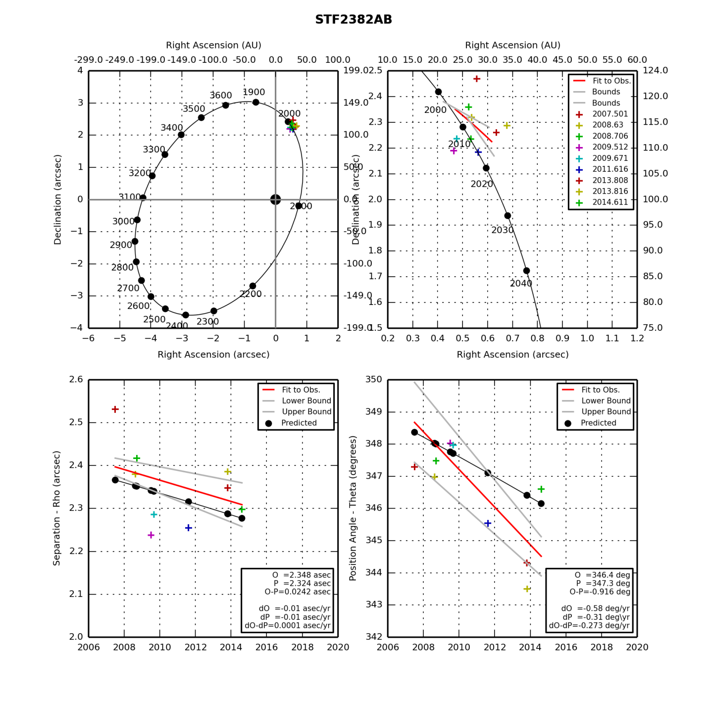

STF2382AB.png (created by StevesBinaryPlotterV05.py on 12/19/2014)

**Epsilon 2 Lyrae**

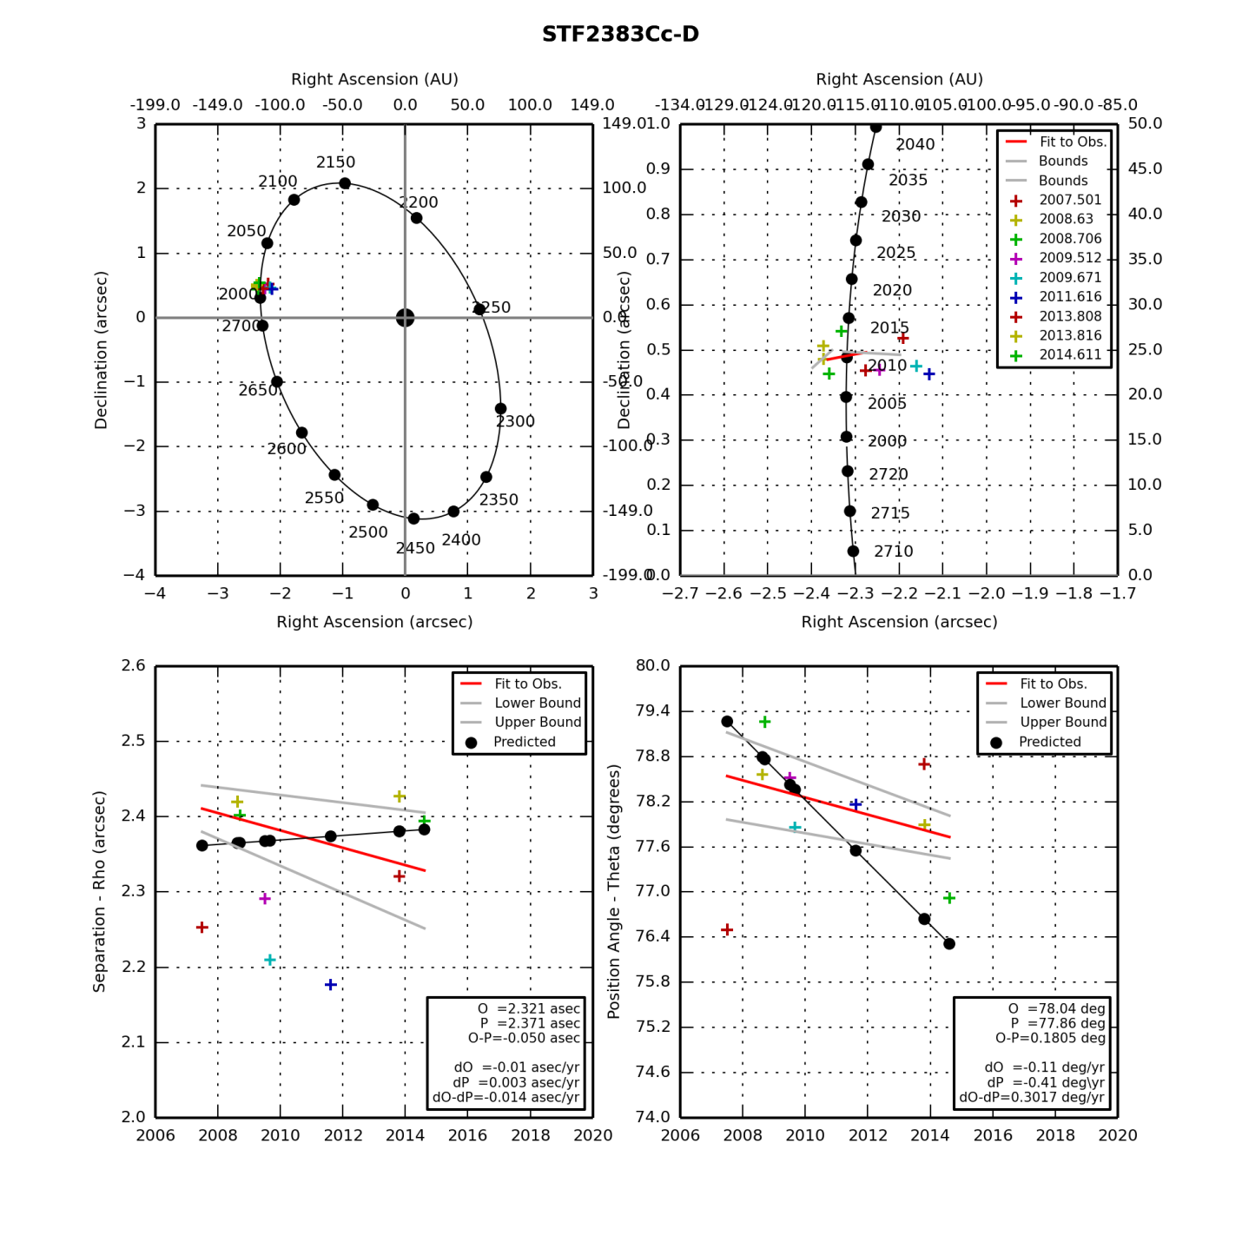

STF2383Cc-D.png (created by StevesBinaryPlotterV05.py on 12/19/2014)