# 2017 Observing Notes

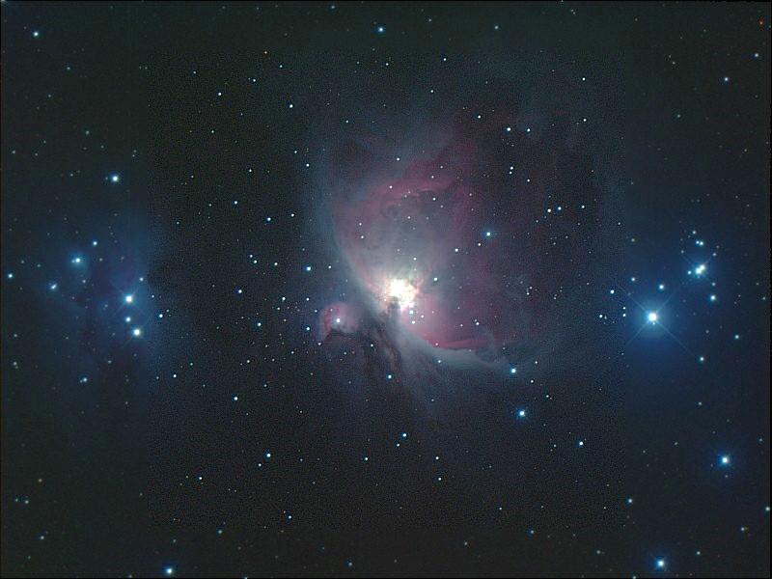

2017 Observing Notes 1

Year in Review 3

January 5

Winter 2018 Planning 5

References 6

## Year in Review

TBD

## January

### Winter 2018 Planning

Last Updated 12/20/2017

* Observations – January 1 first visibility times; Dark around 5:30pm
  + Imaging – wide field
    - 10:00pm – M45 Pleiades
    - 10:30pm – NGC1499 California Nebula
    - 12:00am – Simeis 147
  + Video – 4500mm
    - 9:00pm – M42 – more CRGB with wider coverage. Maybe try narrow band…
  + Imaging – 1260mm
    - 6:00pm – M33 – **1260mm** (need **all narrow band images**)
    - 9:00pm – M42 – **1260mm** (NII)
    - 10:00pm – M1 Crab Nebula – **1260mm** (need **all narrow band images**)
* Analysis
  + M31 Multispectral Analysis *ala* M33, M81, M101 etc.
  + Solar Eclipse Movies, ratio analysis, etc.
  + Questions for OPT:
    - NII filter
    - GoTo Mounts
    - Motorized Focuser
    - Custom Filters

### 2018-Jan-02 (Jan-03 UT): M33 SII

Last Updated 1/3/2018

Very clear – transparency =4/5. Used tube extender to protect corrector plate for C8 from frost and condensation. This did not seem to affect the flat fielding results using files that were obtained without the extender.

|  |  |
| --- | --- |
|  |  |
| M33-20180103UT-672SII-sum01h31m00s-Flattened-LogLog-HalfSize.jpg | M33-201XXXXXUT-672SII-sum02h08m00s-Flattened-LogLog-HalfSize.jpg |
|  |  |
| M33-20161XXXUT-XXX-SHO-ColBal-HalfSize-Aligned.jpg | M33-201XXXXXUT-SHO-ColBal-GaussSmooth2pix-HalfSize.jpg |

## References

Buratti, B. J., Bauer, J. M., Hicks, M. D., Hillier, J. K., Verbiscer, A., Hammel, H., . . . Foust, J. (2011). Photometry of Triton 1992-2004: Surface volatile transport and discovery of a remarkable opposition surge. *Icarus, 212*, 835-846.

Danehkar, A., Karovska, M., Maksym, W. P., & Montez, R., Jr. (2017). Mapping Excitation in the Inner Regions of the Planetary Nebula NGC 5189 using HST WFC3 Imaging. *ArXiv e-prints, 1711*. Retrieved from <http://adsabs.harvard.edu/abs/2017arXiv171111111D>

Mallama, A., Krobusek, B., & Pavlov, H. (2017). Comprehensive wide-band magnitudes and albedos for the planets, with applications to exo-planets and Planet Nine. *Icarus, 282*, 19-33.

Parker, R. A. R. (1964). Physical Conditions in the Cygnus Loop and Some Other Possible Supernova Remnants. *The Astrophysical Journal, 139*, 493.

Pascu, D., Storrs, A. D., Wells, E. N., Hershey, J. L., Rohde, J. R., Seidelmann, P. K., & Currie, D. G. (2006). HST BVI photometry of Triton and Proteus. *Icarus, 185*, 487-491.