1. Cross-region: how to send flag changes to SDK in different regions.
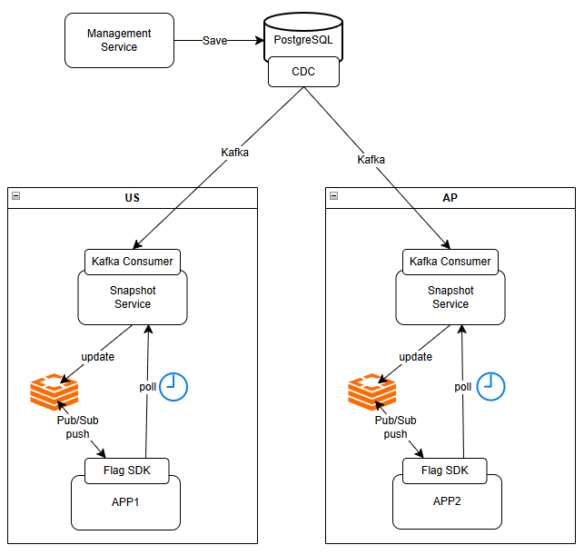
Management Service and DB can be deployed in any region such as US.
- Management Service save flags in the PostgreSQL
- When any changes in PostgreSQL, CDC will detect and send Kafka event with flag changes to different regions.
- In US region, Kafka consumer receives flag changes, store them in Redis cache.
- SDK service subscribes to Redis, any app flag changes will update SDK local cache. (push)
- SDK service will poll the app flag snapshot from snapshot service every minute. (poll)

2. Caching strategy (Push + Poll)
- Redis caches all app flag snapshots.
- SDK service subscribes to Redis to update flag changes for this app. (Push)
- SDK service will poll the app flag snapshot from snapshot service every min. (poll)

3. SDK Service
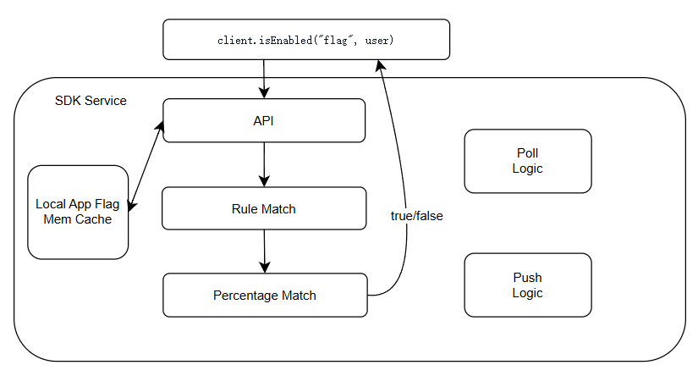
SDK evaluates logic
- SDK service will cache the app flags in the local mem cache.
- The isEnabled API load all local app flags, handle rule match
- If type=”PCT”, run the percentage match.
- Finally return the true/false result.

- Flag definitions:
{
"version": "v42.7",
"flags": [
{ "key":"new_checkout", "definition": { "type":"pct_rollout", "pct":20, "salt":"a3f9", "rules":[...] }},
{ "key":"vip_discount", "definition": { "type":"true/false" }},
{ "key":"admin_debug", "definition": { "type":"targeting", "rules":[...] }}
]
}
Type | Example | Description
Boolean | { "type": "true/false" } | Simple on/off toggle
Pct | { "type": "pct", "pct": 10, "salt": "a3f9",  "rules": [{ "attr": "role", "op": "eq", "value": "admin" }] } | If user role=admin, only 10% will return true
targeting | { "type": "targeting",  "rules": [{ "attr": "role", "op": "eq", "value": "admin" }] } | If user role=admin, return true; else return false;

- Rule Match
Ex. region = "us-east-1" and role = "admin"
If 2 rules are matched and type= targeting; return true;
else return false;
If 2 rules matched and type= pct, go to Percentage Match

- Percentage Match
hash({userId}:{salt}:{flagKey}) % 100 < pct=50%, return true;
else return false;
API:
API | Description
client.isEnabled("flag", user) | return true/false
Rule conditions are fields in user info, like user.role; user.isBeta=true.
Also, there are fixed rule conditions in isEnabled API, like env, app, region, tenant and so on.

4. Management Service
API:
API | Description
POST /api/v1/flags | create
PUT /api/v1/flags/{key} | Update, version optimistic lock;
GET /api/v1/flags | Search with pagination
GET /api/v1/flags/{key} | Get Flag
DELETE /api/v1/flags/{key} | Soft delete (state → archived)
POST /api/v1/flags/{key}/rollout | Update Rollout: 0%→10%→50%→100%
POST /api/v1/flags/{key}/targeting | change targeting rules
GET /api/v1/explain?flag=new_checkout&user=U123&at=2026-06-24T14:00:00Z | Explain why flag is true/false by user info

5. Snapshot Service
API:
GET /api/v1/snapshot
Parameters: Env=prod/qa/dev; App=app1/app2
Return all flags for the {app} in the {Env}.

6. observability strategy
SDK Service:
Metric | Purpose
flag_calls{flag, result} | how often each flag gets checked, and how often it's on
flag_eval_us | how long one evaluation takes (should be <10μs)
cache_age_sec | how stale the local snapshot is
snap_bytes | snapshot size
sdk_ver | catch instances running old SDKs

Snapshot API
Metric | Alert
api_ms{app} | p99 > 100 (Redis slow or overloaded)
cache_hit_pct | < 80 (too many cold starts)
data_fresh_ms | > 5000 (Redis not being updated, check Consumer)
resp_kb | too large for one app (too many flags bound)

Management API
Metric | Alert
writes{op} | track frequency, capacity planning
write_ms | p99 > 500 (PG slow query)
lock_conflicts | > 0 means two ops edited the same flag
kafka_ms | time from PG commit to Kafka ack

Cross-region replication
Hop | Metric | Alert
CDC | cdc_ms | > 5000
Kafka | consumer_lag{region} | keeps growing → Consumer is down
Consumer | proc_ms | > 1000
Redis | snap_ver{region} | version gap across regions > 3

7. explainability model
GET /api/v1/explain?flag=new_checkout&user=U123&at=2026-06-24T14:00:00Z

→ 200
{
"enabled": false, ← what U123 saw at that time
"reason": "user bucket=15, but at 14:00 flag was 10% rollout, 15 ≥ 10 → false",
"flag_version": 41, ← which version was in effect at the time
"user_context": { "region": "us-west-2", "tenant": "enterprise" } ← U123's profile at that time
}

How to get explain?
We search the flag with version at that time, then re-run the evaluation with the user info at that time.
The result now should be the same as the old one.
This API can return more explain info in the response.

