The Shift — Musical System Map
Score documentation for a generative, interactive VR composition
Semiha Paksoy · MUS 442 Senior Project II · Sound Installation and Multimedia Project · June 2026

1. How to Read This Document
The Shift is composed as a set of generative, interactive musical systems rather than as a fixed score. The music is created at runtime by rule systems whose parameters are written in the project’s code, and it is performed jointly by the systems and the player. Conventional staff notation can therefore capture the pitch material, but not the piece itself.
This document is the project’s notation: a system map that specifies, for each scene, the pitch reservoir, the time structure, the sounding objects, and the rules that map player interaction to musical events. All numeric values (tempi, loop periods, pitch sets, step durations) are taken directly from the implemented Unity scripts — FactoryMusicDirector, StreetAmbienceDirector, MetroMusicDirector, ConcertAudioDirector, RadialSequencer, and SequencerFinaleDirector. A performer who followed these rules on acoustic or electronic instruments would produce a recognizable performance of the work; the Unity build realizes them exactly.

2. Shared Musical Language
All four scenes draw from a single pitch reservoir — the minor pentatonic scale rooted on A — and a single timing authority, Unity’s sample-accurate DSP clock (AudioSettings.dspTime). Every scheduled event in the project is quantized to a scene-specific sixteenth-note grid on this clock.
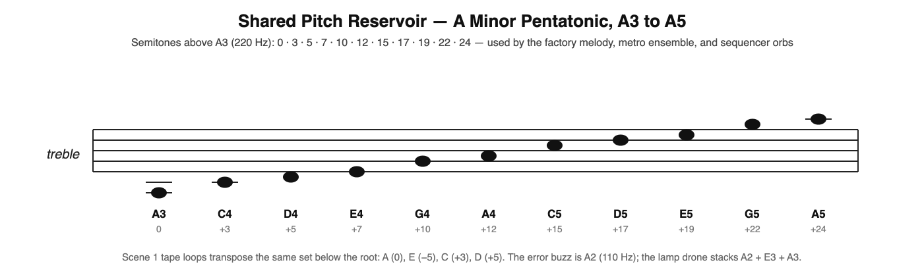
- Pentatonic degree set: {0, 3, 5, 7, 10} semitones, extended over two octaves.
- Reference pitches: A2 = 110 Hz (error buzz, drone root), A3 = 220 Hz (sequencer reference).
- Interaction events (sorting, trash deposits, orb placements) never sound immediately: they are scheduled on the next grid step, so the player is always in time.

3. The Four-Scene Arc
Each scene changes the player’s musical role: executor of the factory’s score, free improviser, participant inside an autonomous ensemble, and finally composer — whose finished composition reveals itself as the factory clock.
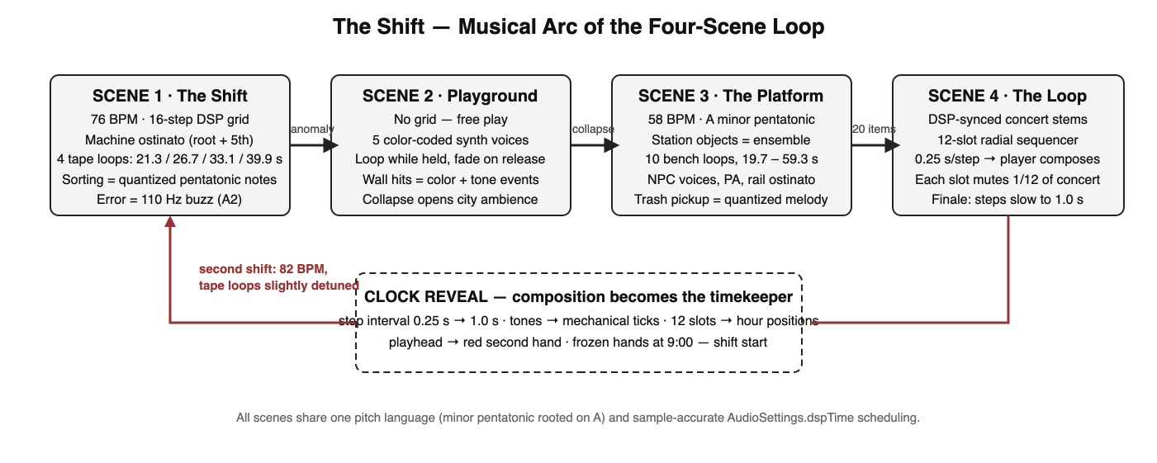

4. Scene 1 — The Shift (Factory)
The factory score is assembled at load time from machine recordings in Resources/scene_1_sound_design. The recordings are sliced into percussive transients, tonal loop material, and steam breaths; the slices are then scheduled as an ostinato plus four incommensurate tape loops in the manner of Brian Eno’s Music for Airports.
Parameter | Value
Tempo | 76 BPM (second shift: 82 BPM); sixteenth-step = 0.197 s
Ostinato | 16-step grid: root on steps 1 and 9, low fifth on 5 and 13, octave accent at bar end
Tape loops | Periods 21.3 / 26.7 / 33.1 / 39.9 s at 0 / −5 / +3 / +5 semitones (A, E, C, D)
Sort feedback | Correct: next pentatonic melody note, register rises with quota. Wrong: error figure over a 110 Hz (A2) buzz
Second shift | Tempo +6 BPM; half of the tape loops slightly detuned
Mix | Ostinato 0.65 · tape loops 0.45 · steam 0.35 · melody notes 1.0 (shared RMS reference across scenes)

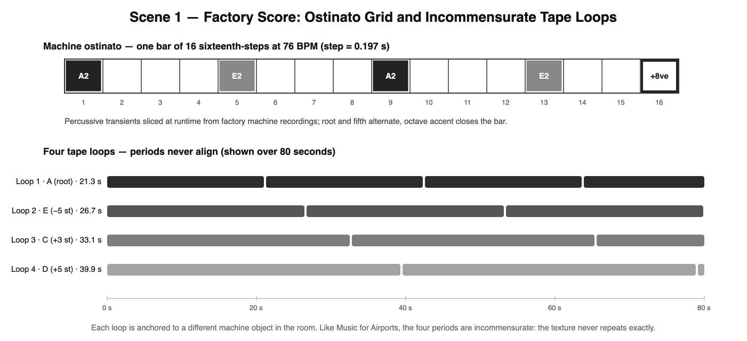

5. Scene 2 — The Colorful Playground
The playground abandons the grid: it is the only scene without a tempo. Twenty cubes (five colors × four) are the instruments. Each color is bound to one synth recording from Resources/scene_2_sound_design, loudness-normalized so no color dominates.
Rule | Behavior
Grab | The cube’s color loop starts from its body (3D source) and plays while held
Release | The loop fades out — sound is tied to touch, not possession
Throw / impact | Collision sound scaled by impact velocity; above 0.3 m/s the wall takes the cube’s color
Color voices | Red, Blue, Green, Yellow, Purple — one synth timbre each
Progression | 20 total wall hits collapse the room; the enclosed synth space opens into procedural city ambience (StreetAmbienceDirector: rumble, car passes, intermittent voices, shop radio)

6. Scene 3 — The Platform (Metro)
The station is a distributed ensemble: every significant object class carries a musical layer, all locked to one 58 BPM DSP grid in A minor pentatonic, but each repeating at its own incommensurate period. The result is a texture that is always coherent and never identical — the musical image of the commuter cycle.
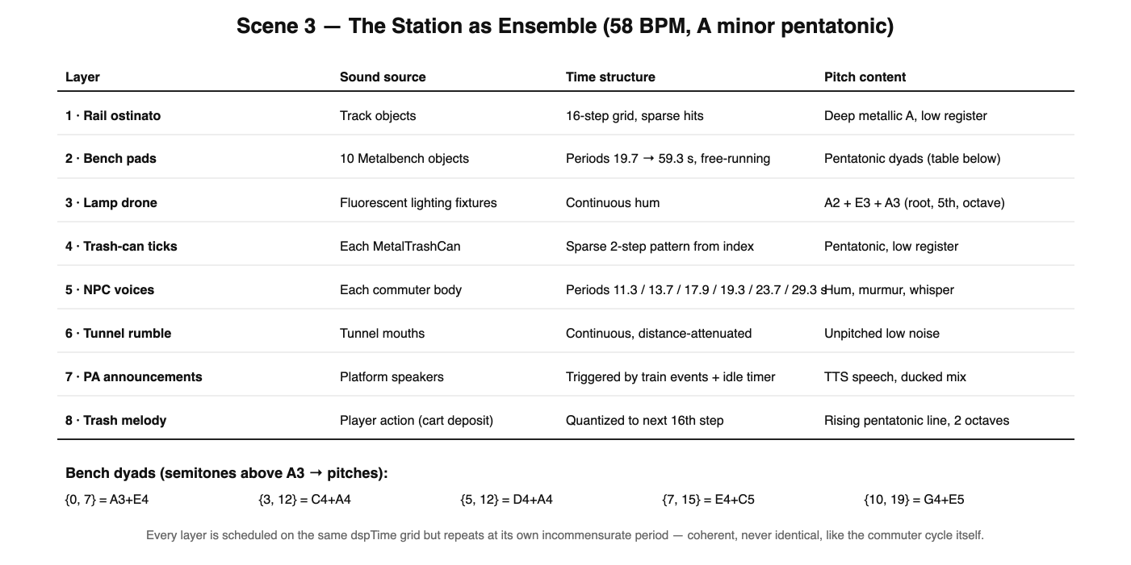
The player’s contribution is the trash-collection melody: each item deposited in the cart plays the next note of a rising two-octave pentatonic line, quantized to the grid. Twenty items complete the scene.

7. Scene 4 — The Concert / The Loop

7.1 Concert Stems
ConcertAudioDirector starts all stems on a single dspTime timestamp. Some stems are 2D stereo (heard as a mix), others are 3D sources placed on stage objects (drum kit, instruments, speaker stacks). Stems are normalized to a common RMS target — the measured spread of the source material was 14 dB (drums −18.7, bass −24.3, FX −32.4 LUFS) — so per-stem volumes act as offsets above an equal floor.

7.2 The Radial Sequencer
The finale instrument is a twelve-slot ring — deliberately the geometry of a clock face. The player grabs sample orbs, previews them, and places them into slots. The DSP-locked playhead sounds each filled slot as it passes; each filled slot also mutes one twelfth of the concert, so completing the composition silences the band.
Orb # | Semitones above A3 | Pitch | Timbre family
0 | 0 | A3 | 1 of 6 synth timbres; timbre = orb index mod 6
1 | 5 | D4 | —
2 | 10 | G4 | —
3 | 15 | C5 | —
4 | 19 | E5 | —
5 | 24 | A5 | —
6 | 3 | C4 | —
7 | 7 | E4 | —
8 | 12 | A4 | —
9 | 17 | D5 | —
10 | 22 | G5 | —
11 | 0 | A3 | —

Step interval: 0.25 s (a playful 3-second loop). All orb tones are generated procedurally at load — the sequencer needs no audio assets.

7.3 The Clock Reveal
When all twelve slots are filled and the loop completes one full revolution, SequencerFinaleDirector takes over: the step interval slides from 0.25 s to exactly 1.0 s, tickDominance rises from 0 to 1 so tones become mechanical ticks, colors drain to the Scene 1 wall-clock palette, numbers 1–12 fade in, the playhead becomes a red second hand, and frozen hands appear at 9:00 — shift start. After six seconds of pure ticking, Scene 1 reloads at 82 BPM.
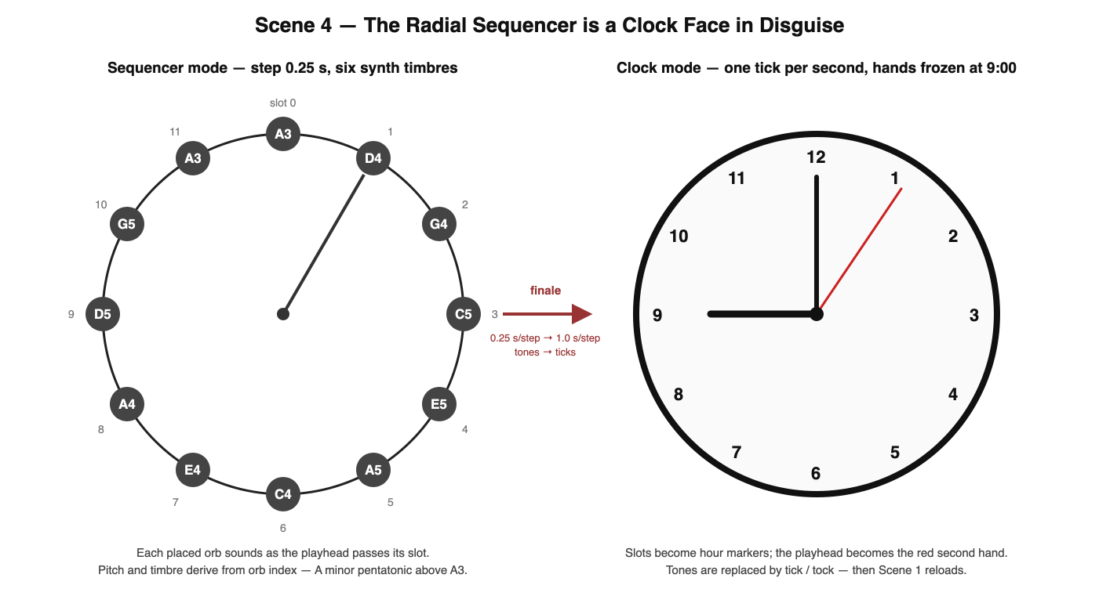

8. Interaction-to-Music Summary
Scene | Player gesture | Musical result
1 · Factory | Correct sort / wrong sort | Quantized rising pentatonic note / error figure on A2 buzz
2 · Playground | Grab, throw, wall hit | Color synth loop; velocity-scaled impact; wall repaint tone
3 · Metro | Deposit trash in cart | Next note of quantized pentatonic melody (20 notes)
4 · Concert | Place orb in slot | New voice in the loop; concert ducks by 1/12
4 · Finale | Complete the ring | Composition decelerates into the factory clock; ticks replace tones

Authorship: all musical systems, their parameters, and their narrative integration were designed and implemented by Semiha Paksoy. Source recordings (machine sounds, synth colors, TTS announcements, concert stems) are production materials shaped entirely by these systems.

