Department of Computer Science and Engineering

Course Code: CSE3204 | Credits: 1
Course Name: Microprocessors | Semester: Fall24

Lab 03
Basic I/O, Advanced arithmetic operations and Flags

Topic Overview:
Instructions used to communicate with peripherals are called interrupts. There are many interrupts each dealing with a particular task. Students will familiarize themselves with the basic input output mechanisms of the assembly language. They will be looking into one of the most common interrupts, INT 21H and inquire how this very interrupt can be used for single key input, single key output and multiple characters output. Additionally, they’ll perform some arithmetic operations upon taking inputs from the user.

Lesson Fit:
There is prerequisite to this lab. Students must have a basic idea on the following concepts:
  - Registers
  - Some basic operations such as MOV, ADD, SUB, MUL and DIV
  - Character encoding using ASCII

Learning Outcome:
After this lecture, the students will be able to:
  - Perform I/O operations to make their assembly programs more interactive
  - Write more dynamic assembly programs
  - Familiarize themselves with how flag register works

Anticipated Challenges and Possible Solutions
  - Students may find it difficult to map ASCII values to decimal/hex

Solutions:
    - Looking at the ASCII table may help

Activity Detail
  - Hour: 1

Discussion: Basic input and output
In order to carry out basic I/O operation, function specific values need to be kept in AH register before calling INT 21h which is used for a system call. The function dispatcher maps the value to carry out specific function.

AH = 1; single character input AH = 2; single character output AH = 9; string output

Single Key Input mov ah,1
int 21h
The program will wait for the user to give an input. It will be saved in AL.

Single Character Output
The item to be printed must be in DL

mov dl,5 mov ah,2 int 21h
The hexadecimal values of new line is 0Ah and line feed is 0Dh

Displaying a String
A string is an array of characters. Previously we have defined variables and arrays.

m db "a$"
m1 db "hello$"
The values of variables and arrays are stored in the data segment of the memory. In order to fetch them we need the offset address (offset + segment). To print a string we need to store 9 in AH. While 9 is in AH, int 21h expects DX to hold the offset address of the array/variable.

LEA is the name of the instruction that provides the offset address. LEA stands for Load Effective Address. The syntax for using LEA is: LEA destination, source. Source is the memory address (the array or the variable) whose offset address will be saved in the destination. The destination is a general register. e.g. for printing the string "hello":

m1 db "hello$" LEA DX,m1
mov AH,9 int 21h
Our first program will read a character from the keyboard and display it at the beginning of the next line.
We start by displaying a question mark: MOV AH, 2 ;display character function MOV DL, '?' ;character is '?'

INT 2lh ;display character

The second instructlon moves 3Fh, the ASCII code for "?", into DL. Next we read a character:

MOV AH, l ;read character function INT 2lh ;character in AL
Now we would like to display the character on the next line. Before doing so, the character must be saved in another register. (We'll see why in a moment.)

MOV BL,AL ;save it in BL

To move the cursor to the beginning of the next line, we must execute a carriage return and line feed. We can perform these functions by putting the ASCII codes for them in DL and executing INT 21h.
MOV AH,2 ;display character function MOV DL,0DH ;carriage return
INT 2lh ;execute carriage return MOV DL,0AH ;line feed
INT 2lh ;execute line feed

The reason why we had to move the input character from AL to BL is that the INT 21h function, changes AL.
Finally we are ready to display the character:

MOV DL,BL ;get character INT 2lh ;and display it
Here is the complete program:

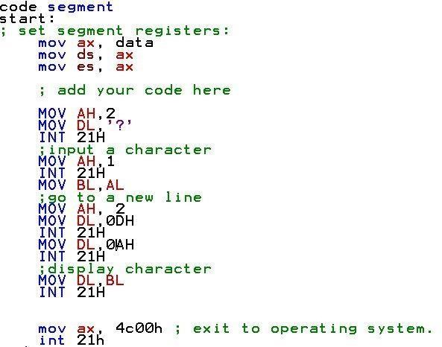

Problem Task: Task 01-Task04 (Page 8)

Hour: 2
Discussion:
Check the problem tasks while the students continue with the rest.
Problem Task: Task 05 – 08 (Page 8-9)

Hour: 3
Discussion: Flag register
There is one special type of register called the flag register. It contains flags. Flags are bits of information which indicate the state of the processor. Decisions are made by the processor based on the flags. Flags are of two types:

- Status Flags: The processor uses these flags to reflect the result of an operation.
- Control Flags: These are used to enable/disable certain operations of the CPU.

Bit number 10, 9 and 8 are control flags and the rest non-empty bits are status flags. The empty bits have no significance.

Status Flags
Carry Flag (CF): CF = 1 when there is a carry out from the MSB during addition or a borrow into the MSB during subtraction.
Parity Flag (PF): PF = 1 when the low byte of a result of an operation contains even number of ones.
Auxiliary Flag (AX): AX = 1 when there is a carry out from bit number 3 to bit number 4 on addition or borrow into bit number 3 during subtraction. (Note that the bit number starts from 0)
Zero Flag (ZF): ZF = 1, if the result of an operation in 0.
Sign Flag (SF): SF = 1 when the MSB of a signed number is 1.
Overflow Flag (OF): OF = 1 when there is an overflow. There are 3 types of overflows:
- Signed Only, Unsigned Only and Both. To understand overflow, you must know by now that 1111b have 2 different meanings in the context of unsigned and signed numbers. If you are not clear about this please read the DLD book.
An example of unsigned overflow where the maximum number of bits is 4, 1111 + 1000 = 10111
Here the MSB gets discarded and thus data loss. As example of signed overflow where the maximum range is 8 bits. For signed numbers the MSB represents the sign. 1 for negative and 0 for positive. 0111 1111 + 0111 1111 = 1111 1110 Both the operands start with 0 therefore both are positive numbers. Addition of 2 positive numbers has to positive. But if we look the answer, it starts with 1 therefore the number is a negative number.

How instructions affect flags:

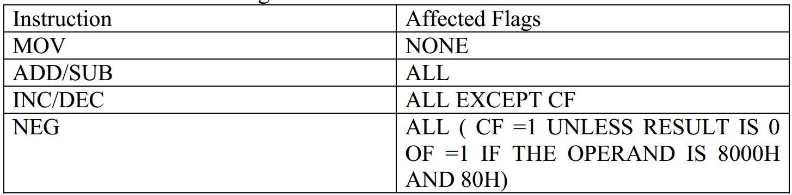
It has been previously mentioned that the processor takes decisions based on the flags. In this section we will see how these decisions are made. In JAVA, decisions are made using "if" conditions. If the condition is satisfied then a portion of code runs and if not, the program jumps to another section of code. In assembly this whole system is done by two operations -- compare and jump. The jump can be a condition dependent and also independent.

