MY FIRST CHAT BOT :PYTHON PROJECT

MERMONT--DOMINGUEZ SOPHIE
YOUSSAME MBILI JOY
L1INT4-2023
My First Chat Bot

Mermont--Dominguez Sophie
Youssame Mbili Joy
L1INT4-2023

--Table of contents—

- Introduction 1
- Functional Presentation 1
- Technical Presentation 2
- Difficulties Faced 4
- Result presentation 5
- Conclusion 6

--Introduction to the projet--
This project explores text analysis concepts for creating a question-answering system. It employs a method based on word frequency to generate intelligent responses from a text corpus. The algorithm involves data pre-processing, where documents are cleaned and tokenised. A TF-IDF matrix is constructed, associating each word with a vector reflecting its occurrence across documents. When a question is asked, the chatbot calculates a TF-IDF vector and assesses its similarity to word vectors in the corpus. The system then selects the best answer based on TF-IDF similarity scores, considering words most similar to the question. Ultimately, the chatbot provides the selected answer as the response. The focus is on designing a system adept at answering questions by leveraging word frequency in the corpus.
--Functional Presentation--
1.extract_president_names(file_names):Returns a list of the names of each president from the speech file names.
2.clean_text(path, speech):Converts the speeches to lowercase and removes punctuation.
3.count_word_occurrences(text):Counts the number of times a word is present in a text.
4.calculate_tf(path):Returns the term frequency of each word in a text.
5.in_doc(directory):Returns a dictionary with the number of speeches each word is present in, used in calculate_idf().
6.calculate_idf(path):Returns a dictionary with the IDF score of each word for a given speech.
7.calculate_tf_idf_matrix_all(directory):Returns a TF-IDF matrix for all speeches in the directory.
8.display_least_important_words(tf_idf_matrix):Displays the list of least important words.
9.display_highest_tfidf_words(tf_idf_matrix):Displays word(s) with the highest TF-IDF score.
10.calculate_tf_idf_matrix_with_presidents(directory, president):Returns a TF-IDF matrix of each speech for a given president in a given directory.
11.most_repeated_words_by_president(directory, president):Returns the most repeated word said by a given president.
12.word_frequence_comparison(directory, target_word):Returns a list of who says the target word more in its speeches.
13.calculate_tf_idf_matrix_with_target_word(directory, president, target_word):Returns a TF-IDF matrix of each speech for a given president with respect to a target word.
14.president_speaking_about_nation_the_most(tf_idf_matrix, president_name):Indicates the most repeated word(s) by a given president.
15.word_frequence_comparison(directory, target_word):Returns a list of who says the target word more in its speeches.
16.calculate_tf_idf_matrix_with_first_mention(directory, president, target_words):Returns a TF-IDF matrix with the first mention of target words.
17.first_president_to_mention_climate_or_ecology(tf_idf_matrix, target_words):Identifies the first president to talk about 'Climate' and/or 'Ecology'.
18.words_mentioned_by_all_presidents(tf_idf_matrix, unimportant_words):Returns words mentioned by all presidents, excluding unimportant words.
19. main program:that provides a menu to interact with different functionalities.
20.question_token(question):Tokenizes a question, returning a cleaned version as a list of words.
21.allcorpus(directory):Returns all the speeches as a single string.
22.tokens_in_corpus(token_list, directory):Returns a list of tokens that are in the corpus.
23.tf_idf_matrix_fix_separated_by_document(directory):Returns a TF-IDF matrix that depends on each independent document.
--Technical presentation—
1. Data Pre-processing:
--Text cleaning involves removing punctuation and converting letters to lowercase.
--The text is split into words or tokens.
This step ensures a standardized format for subsequent analysis.
2. Creating a TF-IDF Matrix:
--For each unique word, calculate Term Frequency (TF) and Inverse Document Frequency (IDF).
--Create a TF-IDF vector for each word, resulting in a matrix where rows represent words, and columns represent documents.
3. Question Representation:
--Pre-process the user's question similarly to the data, ensuring consistency.
--Calculate a TF-IDF vector for the question using the same vocabulary as the documents. 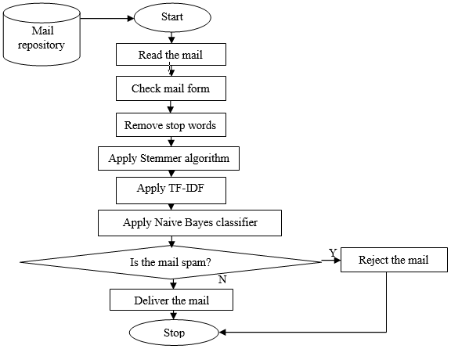←(example)

4. Similarity Calculation:
--Use cosine similarity or another measure to quantify the similarity between the question vector and word vectors in the corpus.(This step identifies relevant words in the corpus.)
5. Selecting the Best Answer:
--Based on TF-IDF similarity scores, determine words most similar to the question.
--Select the answer with the highest frequency of these similar words. 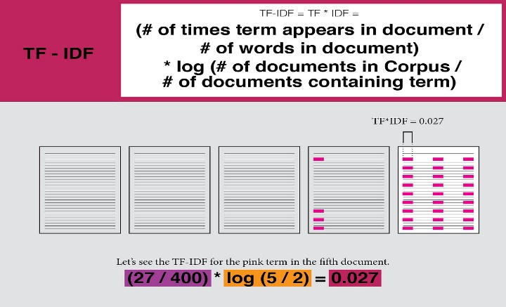
6. Text Analysis and TF-IDF Calculation:
--Calculate TF for each word's frequency in a document.
--Determine IDF, measuring a word's importance across multiple documents.
--Combine TF and IDF to obtain the TF-IDF score for each word in each document.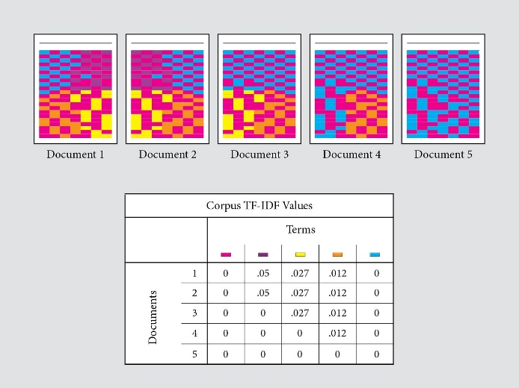

TF-IDF : A visual explainer and Python Implementation on Presidential Inauguration Speeches

Difficulties Faced and solutions created:

Results presentation:

--Conclusion--

The project has been a valuable learning experience on multiple fronts. From a technical perspective, we have deepened our understanding of text processing, TF-IDF algorithms, and practical applications of natural language processing. Collaborating as a duo highlighted the importance of effective communication and task coordination. Time management skills were very important while, problem-solving became a daily practice as we encountered and overcame technical challenges. Feedback integration played a crucial role in refining the project and improving team performance. Overall, the project provided a comprehensive platform for technical development.

