webODV Data Extractor HowTo

Sebastian Mieruch, Alfred Wegener Institute, Bremerhaven, GERMANY (sebastian.mieruch@awi.de)

This document describes briefly the basic functionality of the webODV Data Extractor.

Five step navigation

To extract data you have to follow these five steps indicated on the top pager bar. The pages do not have to be visited by order, rather you can jump between them. Klick with the left mouse button or use the keyboards arrow keys for navigation.

1. Select stations

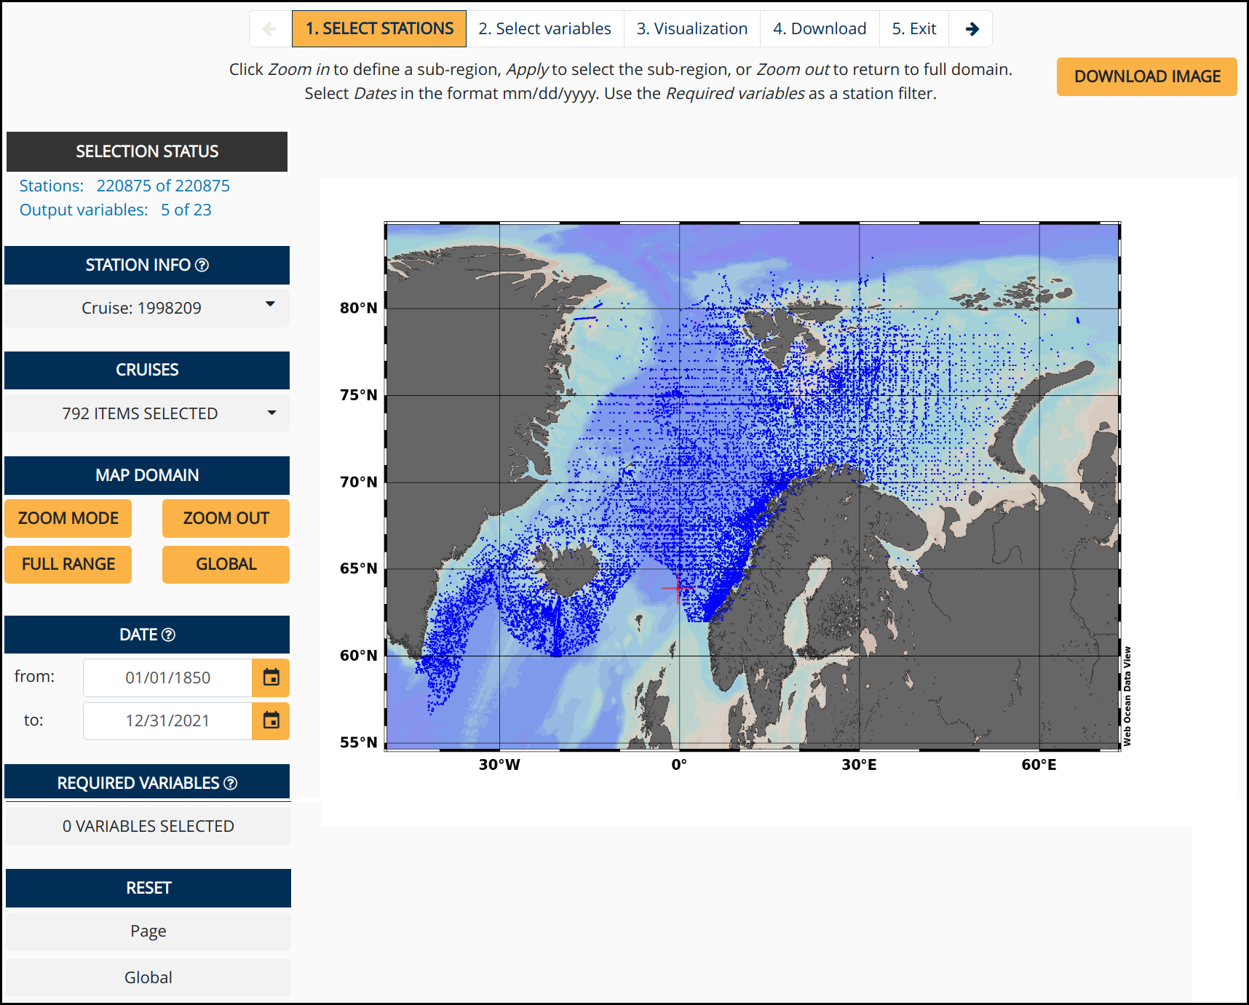

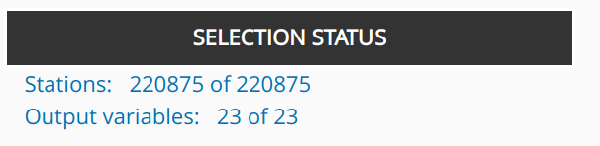

This info box informs about the number of selected stations and output variables. A download of data with selecting zero stations or variables is not possible and error messages will appear in the case.

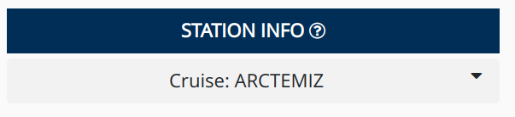

This dropdown menu provides information (meta data) about a clicked station (blue dot) in the map.

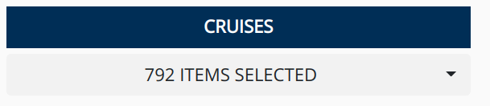

A dropdown for selecting and deselecting cruises by names. Options are to Select All or Deselect All.

Additionally a search function is provided as explained below:

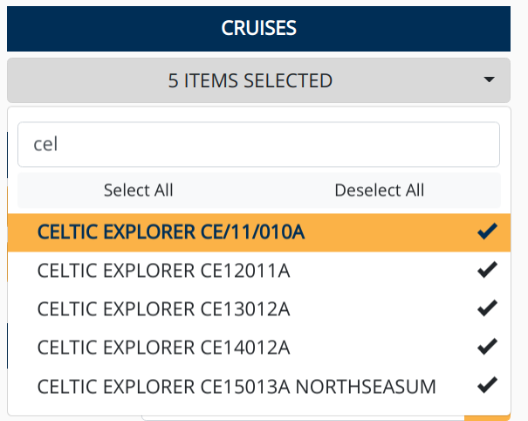

To start with the search function it makes sense to first Deselect All. Then the list of search results is updated in real-time while typing. A click on Select All checks then only the search results, which is the desired selection.

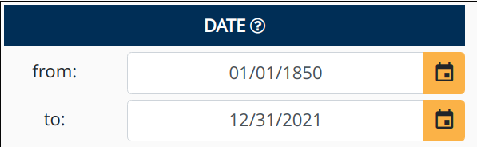

Select a date in the format mm/dd/yyyy by directly editing within the field or use the calender widget. Range: 01/01/1850-12/31/2021. Click on the widget's top line to switch between years, click again to switch between decades and so on.

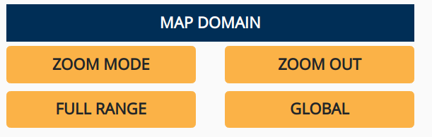

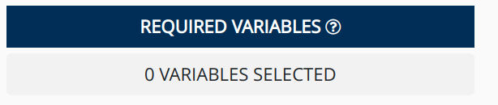

A click on ZOOM MODE activates the zoom function within the map as shown below:

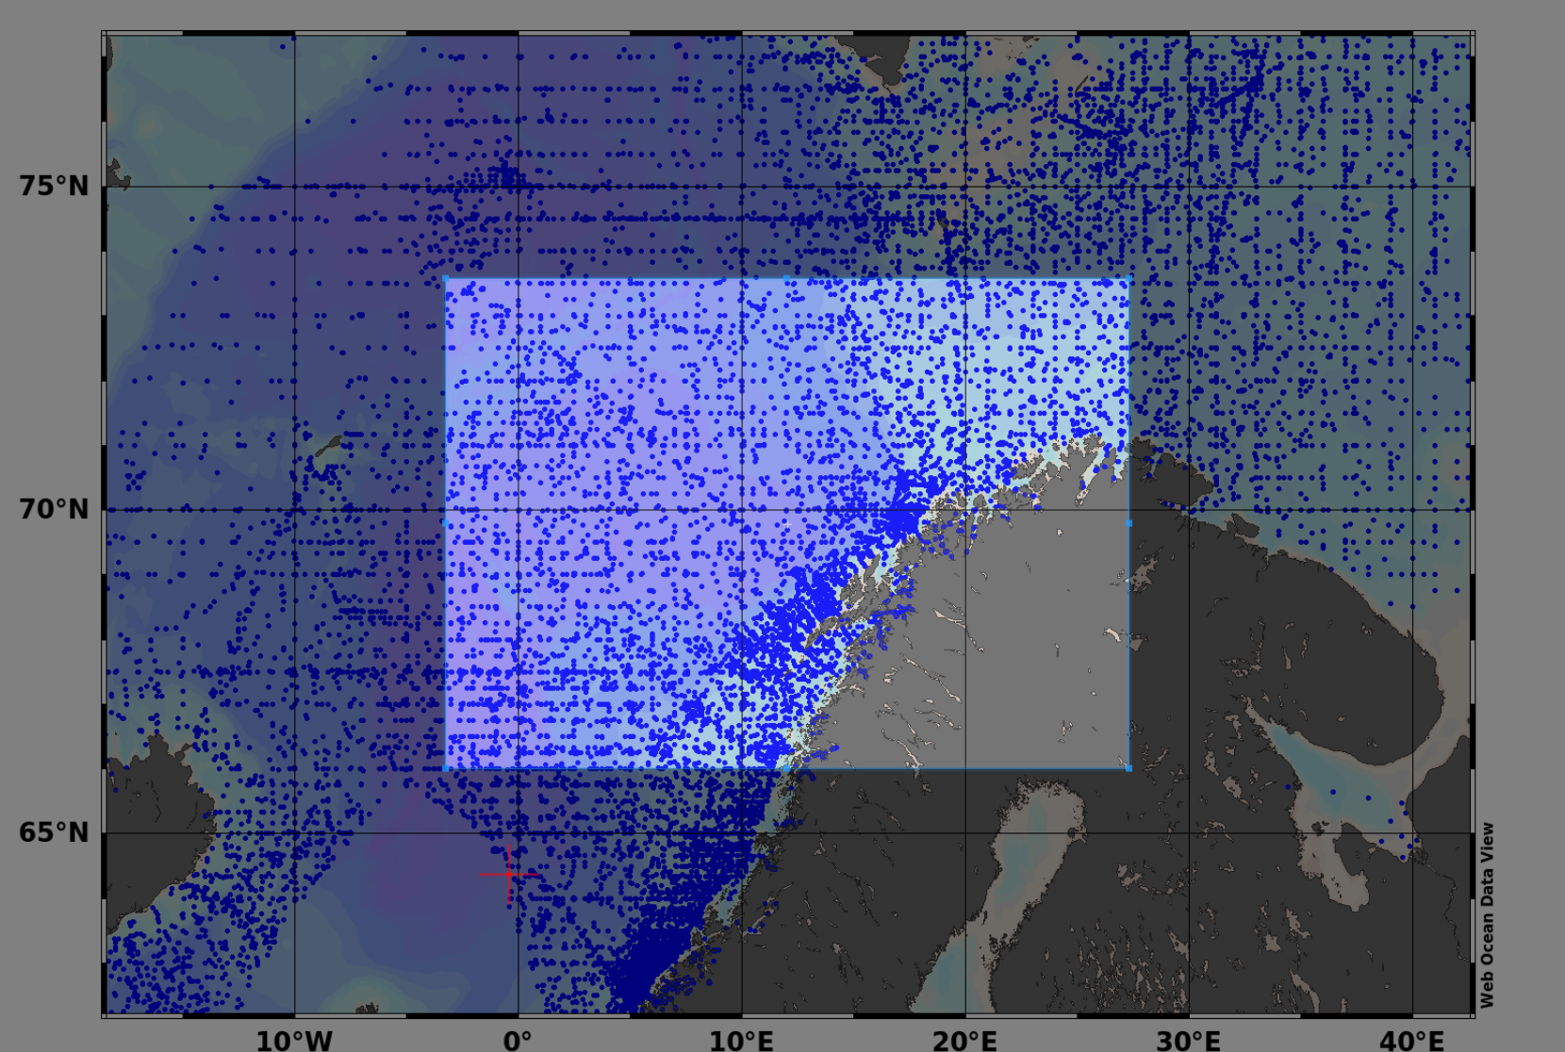

The size of the new zoom rectangle can be changed by moving edges or corners of the rectangle with clicking and dragging the mouse. New rectangles can be created by clicking into the map, while holding the left mouse button and dragging.
ZOOM OUT automatically zooms out of the selected region. FULL RANGE creates a map including all stations, but no “station free” area. GLOBAL displays a global map.

A click on the Required Variables button opens a pop up window similar to the one shown below:

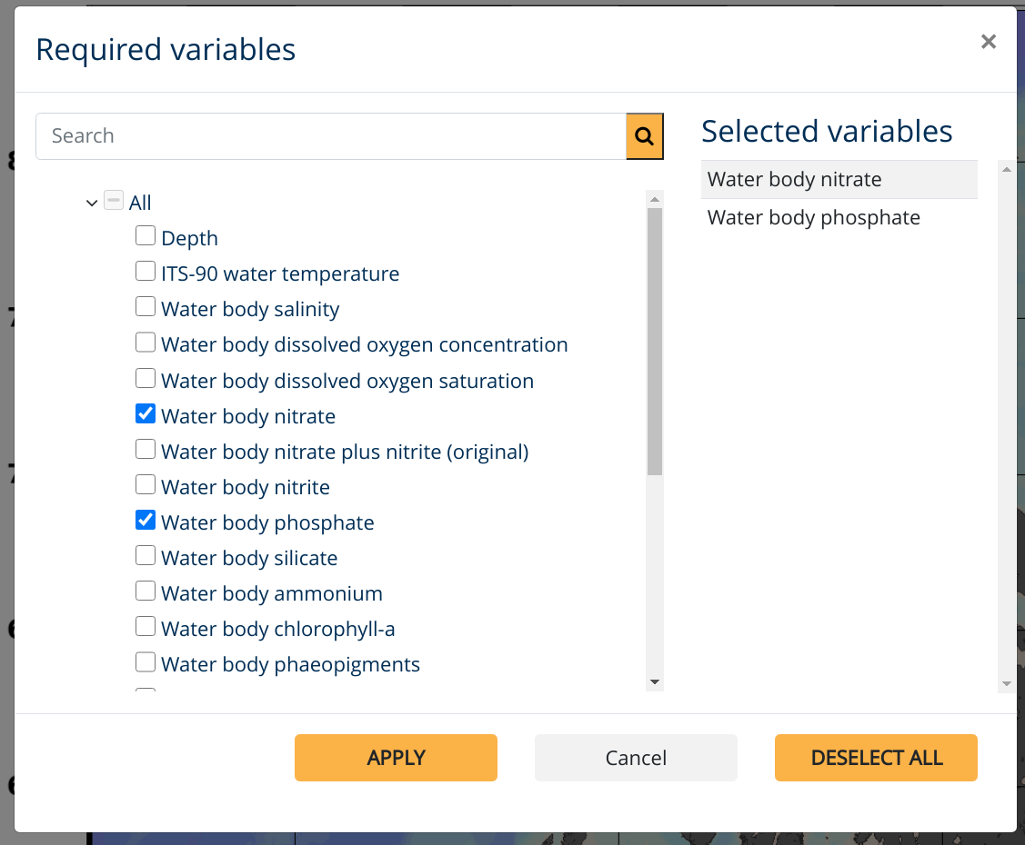

A treeview (https://github.com/hummingbird-dev/hummingbird-treeview) is used to display all available variables for filtering the stations shown on the map.
Select one or more variables from the tree to exclude stations not containing data for these variables. Only stations containing data for all selected Required variables are accepted and shown on the map. Warning: Selecting too many required variables easily leads to zero matching stations.

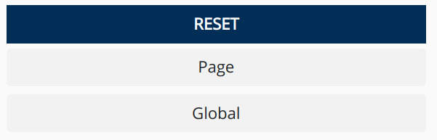

Finally, two reset buttons are provided. The Page button resets the current page to default values, wheres the Global button resets all settings of the Extractor back for this dataset.

2. Select variables

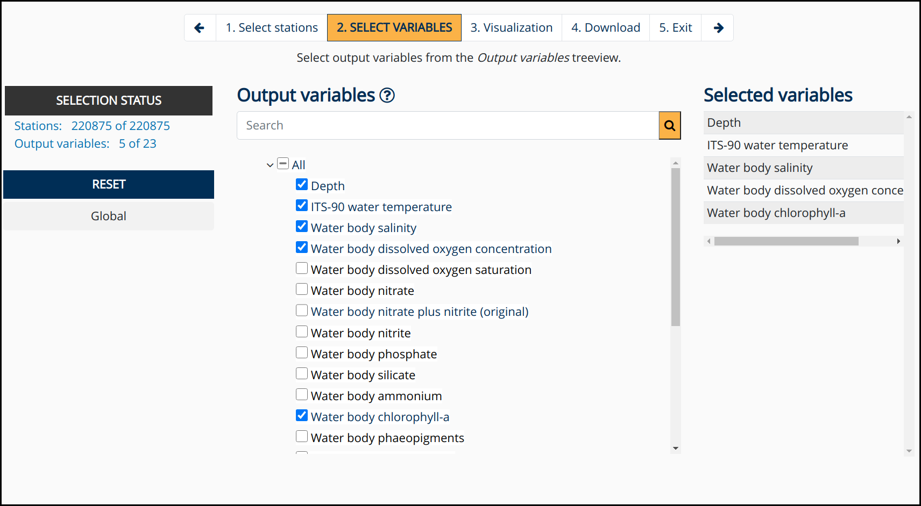
The second page provides the variable selection for the final download. Disabled grey variable items indicate that these variables are not available for the station selection. Note that the Required Variables on page one are used to filter the stations to those which include the selected variables. Now we define the variables for the final download. That means that not all stations must include the selelected variables, but at least one.

3. Visualization

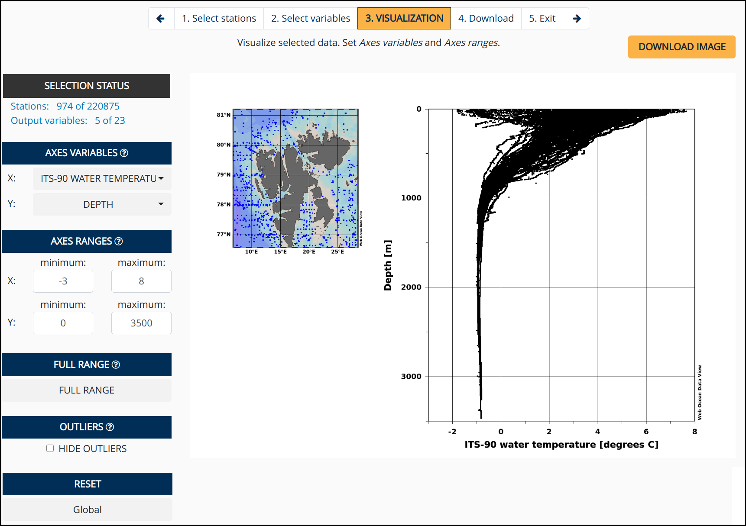

4. Download

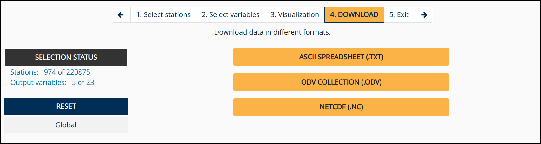
5. Exit



