webODV Data Extractor HowTo

Sebastian Mieruch, Alfred Wegener Institute, Bremerhaven, GERMANY (sebastian.mieruch@awi.de)

Last change 2021-04-20.

This document describes briefly the basic functionality of the webODV Data Extractor.

General

We restrict the number of your webODV data extractor sessions or instances to 4, i.e. you can only use this number of extractor instances simultaneously, e.g. in different browser tabs. For downloading data in the background we restrict the number of processes to 4. Your session will be automatically closed after 1 h of inactivity. If this happens, we will save the current state of the extractor and inform you by a pop-up message. At the moment the current state of the extractor will be saved in your browser, i.e. it will be restored in a follow up session in the same browser as long as you do not delete your browser’s cache.

1. Select cruises / domain / time range

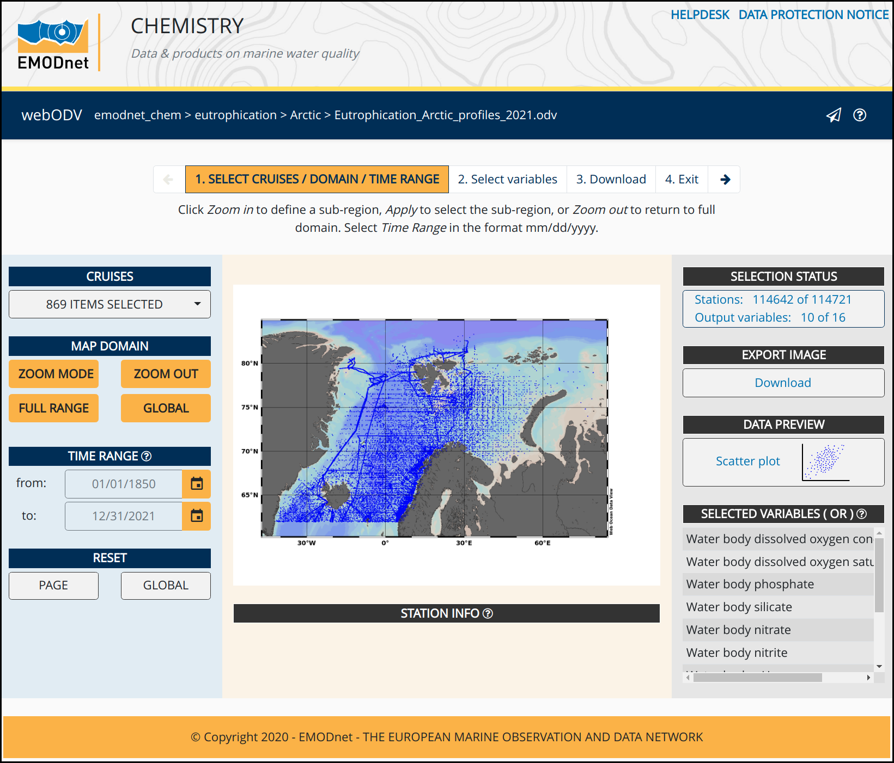

To extract data you have to follow the four steps indicated on the top pager bar. The pages do not have to be visited by order, rather you can jump between them. Click with the left mouse button or use the keyboards arrow keys for navigation.

SELECTION STATUS

This info box informs about the number of selected stations and output variables. A download of data with selecting zero stations or variables is not possible and error messages will appear in the case.

EXPORT IMAGE

Download the current map as a high quality .png image.

DATA PREVIEW

Switch to the visualisation layout and create a scatter plot of the data. Select x and y axes variables, set axes ranges and hide/show outliers.

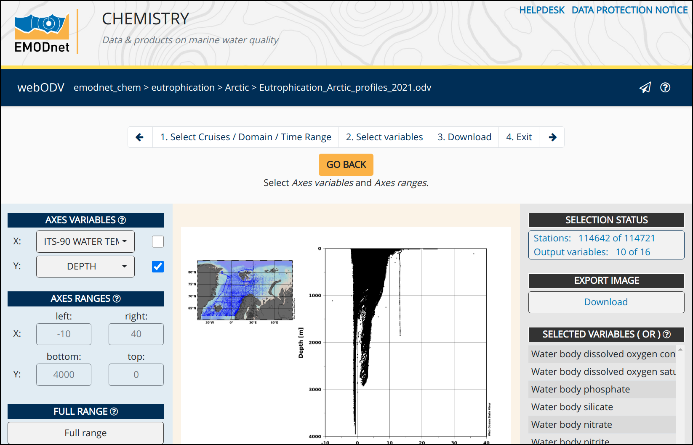

SELECTED VARIABLES (OR)

This list shows the currently selected variables, whereas the actual selection takes place on page two. The OR or AND in brackets indicates the selection mode and is explained below in the context of variable selection.

STATION INFO

This dropdown menu provides information (meta data) about a clicked station (blue dot) in the map.

CRUISES

A dropdown for selecting and deselecting cruises by names. Options are to Select All or Deselect All.

Additionally a search function is provided as explained below:

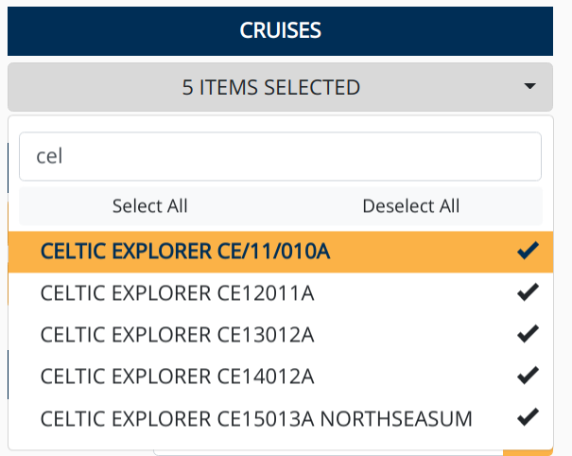

To start with the search function it makes sense to first Deselect All. Then the list of search results is updated in real-time while typing. A click on Select All checks then only the search results, which is the desired selection.

MAP DOMAIN

A click on ZOOM MODE activates the interactive zoom function within the map. The size of the new zoom rectangle can be changed by moving edges or corners of the rectangle with clicking and dragging the mouse. New rectangles can be created by clicking into the map, while holding the left mouse button and dragging.
ZOOM OUT automatically zooms out of the selected region. FULL RANGE creates a map including all stations, but no “station free” area. GLOBAL displays a global map.

TIME RANGE

Select a date in the format mm/dd/yyyy by directly editing within the field or use the calender widget. Range: 01/01/1850-12/31/2021. Click on the widget's top line to switch between years, click again to switch between decades and so on.

RESET

Finally, two reset buttons are provided. The Page button resets the current page to default values, wheres the Global button resets all settings of the Extractor back for this dataset.

2. Select variables

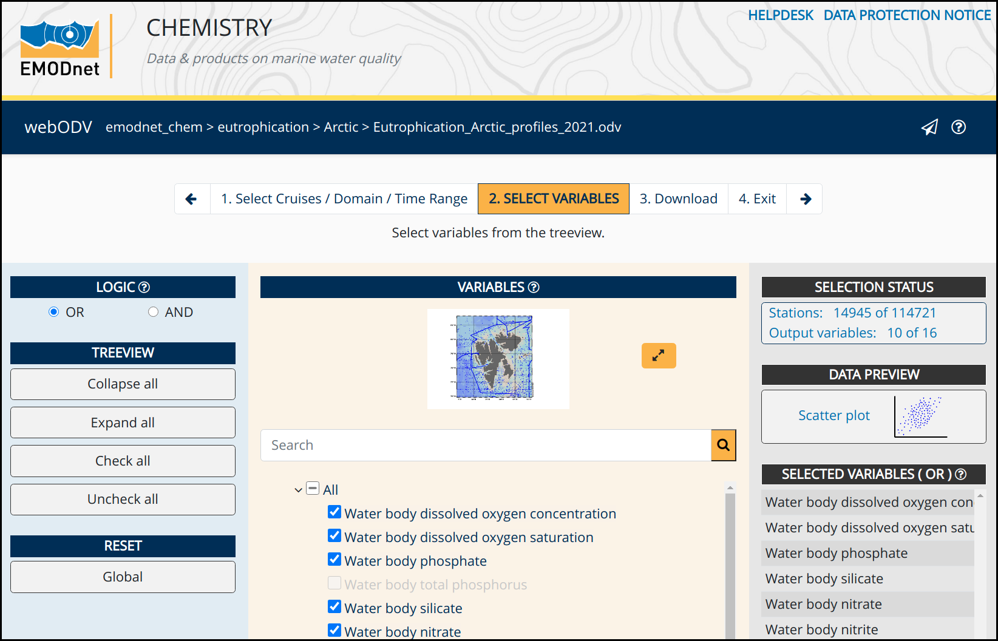
The second page provides the variable selection for the final download. Disabled gray items indicate that these variables are not available for the station selection. Two modes are available for the variable selection:
OR mode: In this case all stations in the map are shown, which have data for one OR more of selected variables.
AND mode: Only stations are shown, that have data for ALL of the selected variables.

Note that the stations in the map change dynamically according to the selected variables.

Additional variables, hidden here in the treeview on page 2, will be provided automatically in the final downloaded file, which are important and needed for further analyses. These additional variables are e.g. depth, temperature, salinity, time or sediment grain size parameters, depending on the type of collection.

4. Download

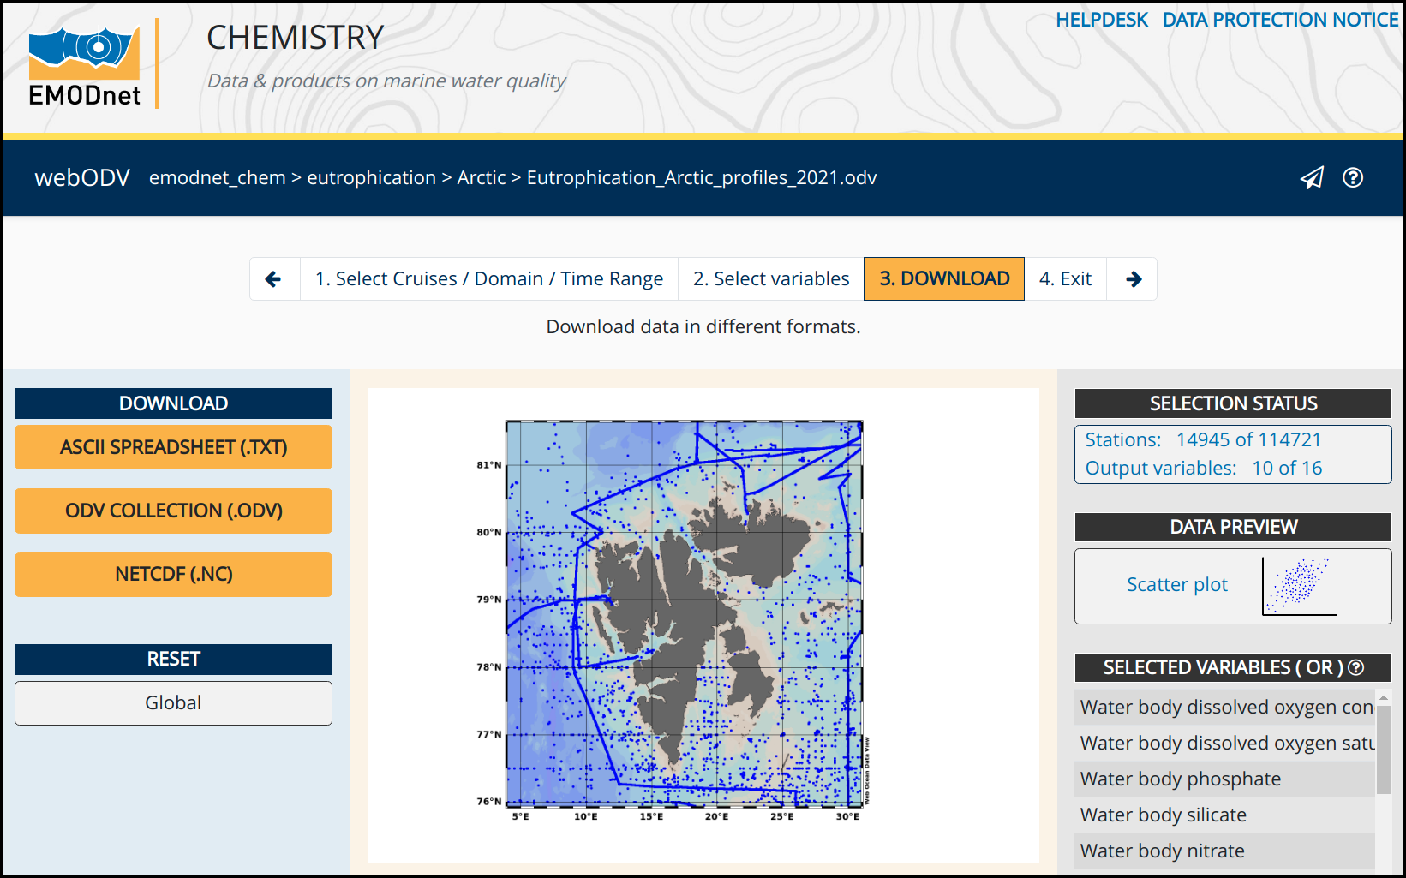
The download page allows to download the selected data in different formats, ASCII SPEADSHEET (.txt), ODV COLLECTION (.odv) or NETCDF (.nc). Prior to downloading the data, users have to authenticate with MarineID, which is shown in a pop up:

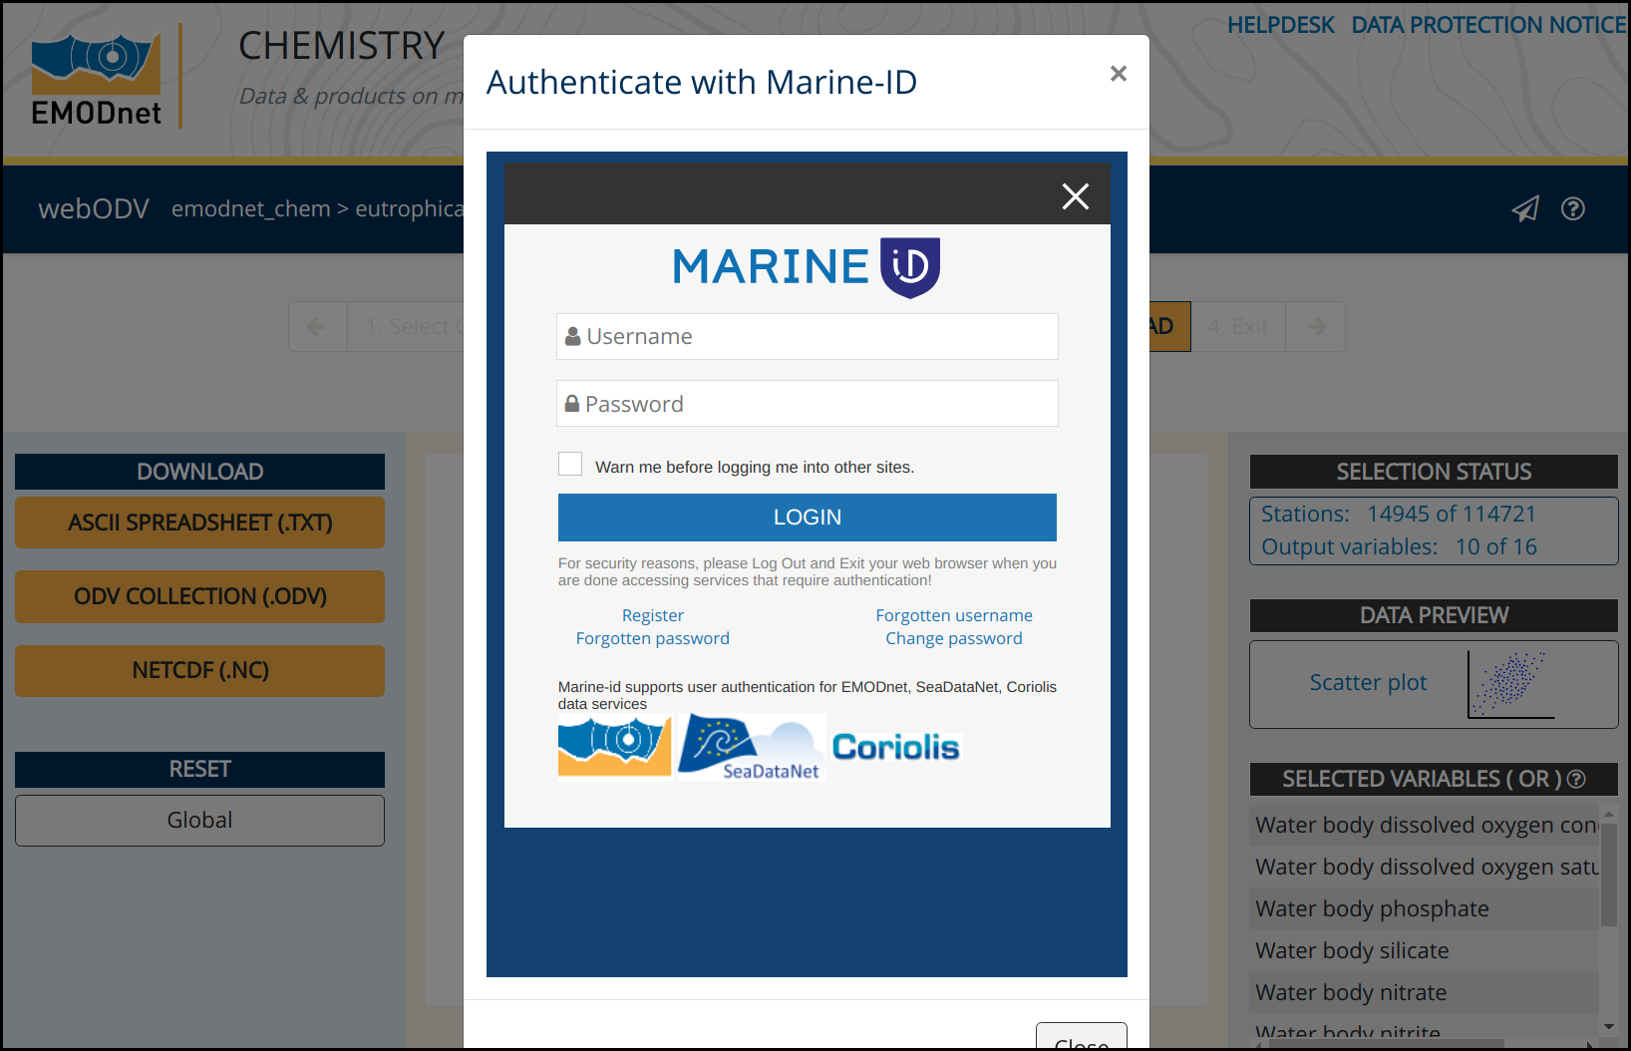
In the user is not already registered at MarineID, account creation is now possible.
After loggin in, we will ask for the reason of downloading this dataset as shown below:

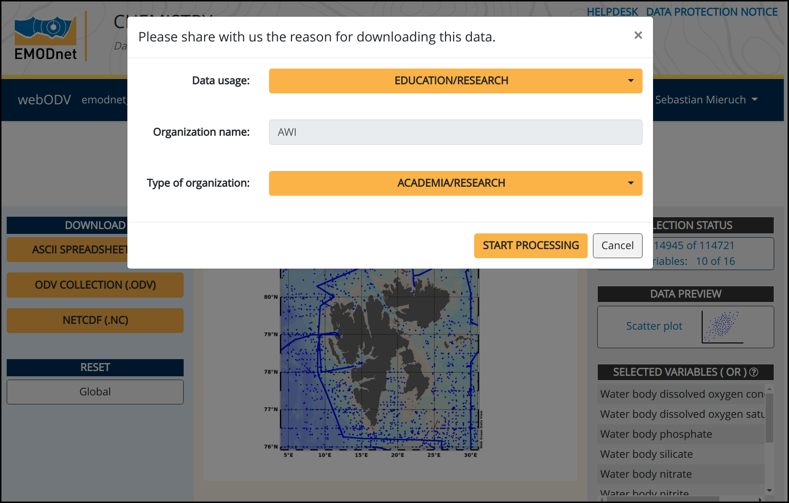

By hitting the “START PROCESSING” button, the download process starts in the background. As soon as the data are ready for download the user is informed by email, which includes the download link. Note that the email address provided at MarineID is used. Finally the data can be downloaded as a .zip file.

5. Exit

The last page simply brings the user back to the webODV homepage.

