webODV Data Extractor HowTo

Sebastian Mieruch, Alfred Wegener Institute, Bremerhaven, GERMANY (sebastian.mieruch@awi.de)

This document describes briefly the basic functionality of the webODV Data Extractor.

General

We restrict the number of your webODV data extractor sessions or instances to 4, i.e. you can only use this number of extractor instances simultaneously, e.g. in different browser tabs. Your session will be automatically closed after 1 h of inactivity. If this happens, we will save the current state of the extractor and inform you by a pop-up message. At the moment the current state of the extractor will be saved in your browser, i.e. it will be restored in a follow up session in the same browser as long as you do not delete your browser’s cache.

1. Select stations

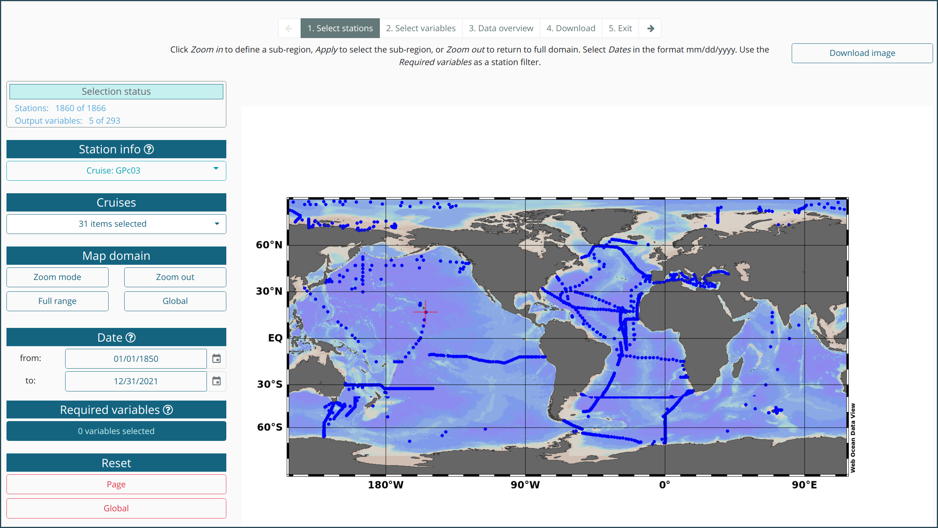

To extract data you have to follow the five steps indicated on the top pager bar. The pages do not have to be visited by order, rather you can jump between them. Click with the left mouse button or use the keyboards arrow keys for navigation.

SELECTION STATUS

This info box informs about the number of selected stations and output variables. A download of data with selecting zero stations or variables is not possible and error messages will appear in the case.

STATION INFO

This dropdown menu provides information (meta data) about a clicked station (blue dot) in the map.

CRUISES

A dropdown for selecting and deselecting cruises by names. Options are to Select All or Deselect All.

Additionally a search function is provided as explained below:

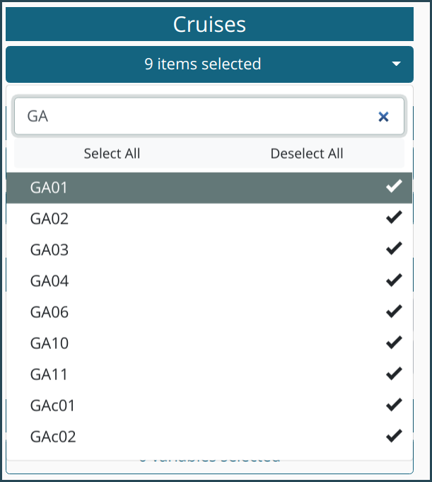

To start with the search function it makes sense to first Deselect All. Then the list of search results is updated in real-time while typing. A click on Select All checks then only the search results, which is the desired selection.

DATE

Select a date in the format mm/dd/yyyy by directly editing within the field or use the calender widget. Range: 01/01/1850-12/31/2021. Click on the widget's top line to switch between years, click again to switch between decades and so on.

MAP DOMAIN

A click on ZOOM MODE activates the interactive zoom function within the map. The size of the new zoom rectangle can be changed by moving edges or corners of the rectangle with clicking and dragging the mouse. New rectangles can be created by clicking into the map, while holding the left mouse button and dragging.
ZOOM OUT automatically zooms out of the selected region. FULL RANGE creates a map including all stations, but no “station free” area. GLOBAL displays a global map.

REQUIRED VARIABLES

This option is used to filter stations by variables, i.e. only those stations are shown that include the selected variables.
A click on the Required Variables button opens a pop up window similar to the one shown below:

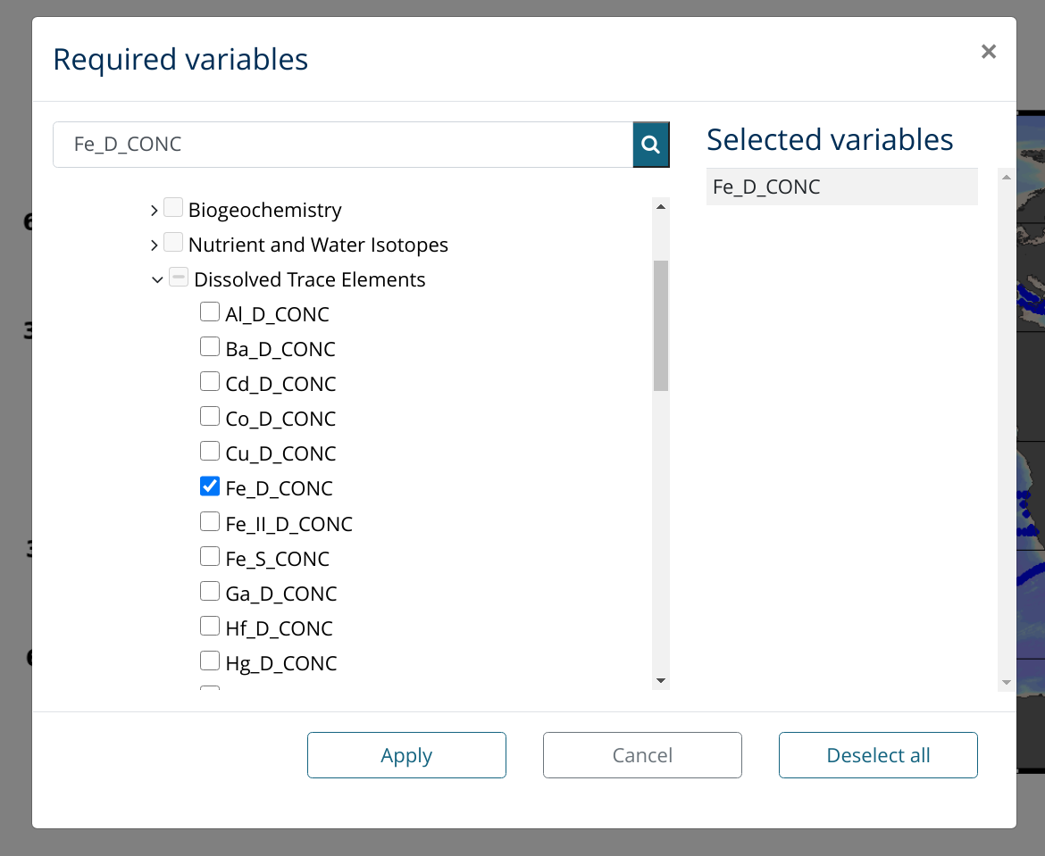

A treeview (https://github.com/hummingbird-dev/hummingbird-treeview) is used to display all available variables for filtering the stations shown on the map.
Select one or more variables from the tree to exclude stations not containing data for these variables. Only stations containing data for all selected Required variables are accepted and shown on the map. Warning: Selecting too many required variables easily leads to zero matching stations.

RESET

Finally, two reset buttons are provided. The Page button resets the current page to default values, wheres the Global button resets all settings of the Extractor back for this dataset.

2. Select variables

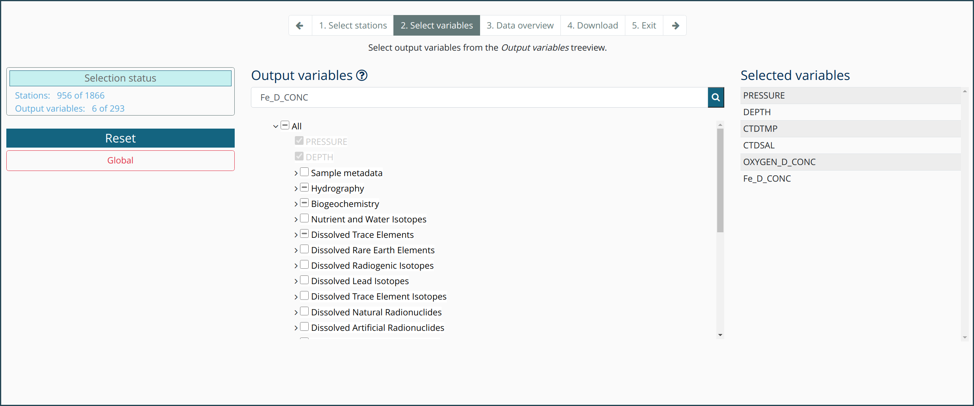
The second page provides the variable selection for the final download. Disabled gray items indicate that these variables are not available for the station selection. Note that the Required Variables on page one are used to filter the stations to those which include the selected variables. Now we define the variables for the final download. That means that not all stations must include the selected variables, but at least one.

3. Data overview

Page three provides basic data overview of the selected data in a scatter plot. If a very large number of samples has been selected, generating of the scatter plot can take time. In these cases a pop up is shown to ask the user whether to continue to the scatter plot or cancel.

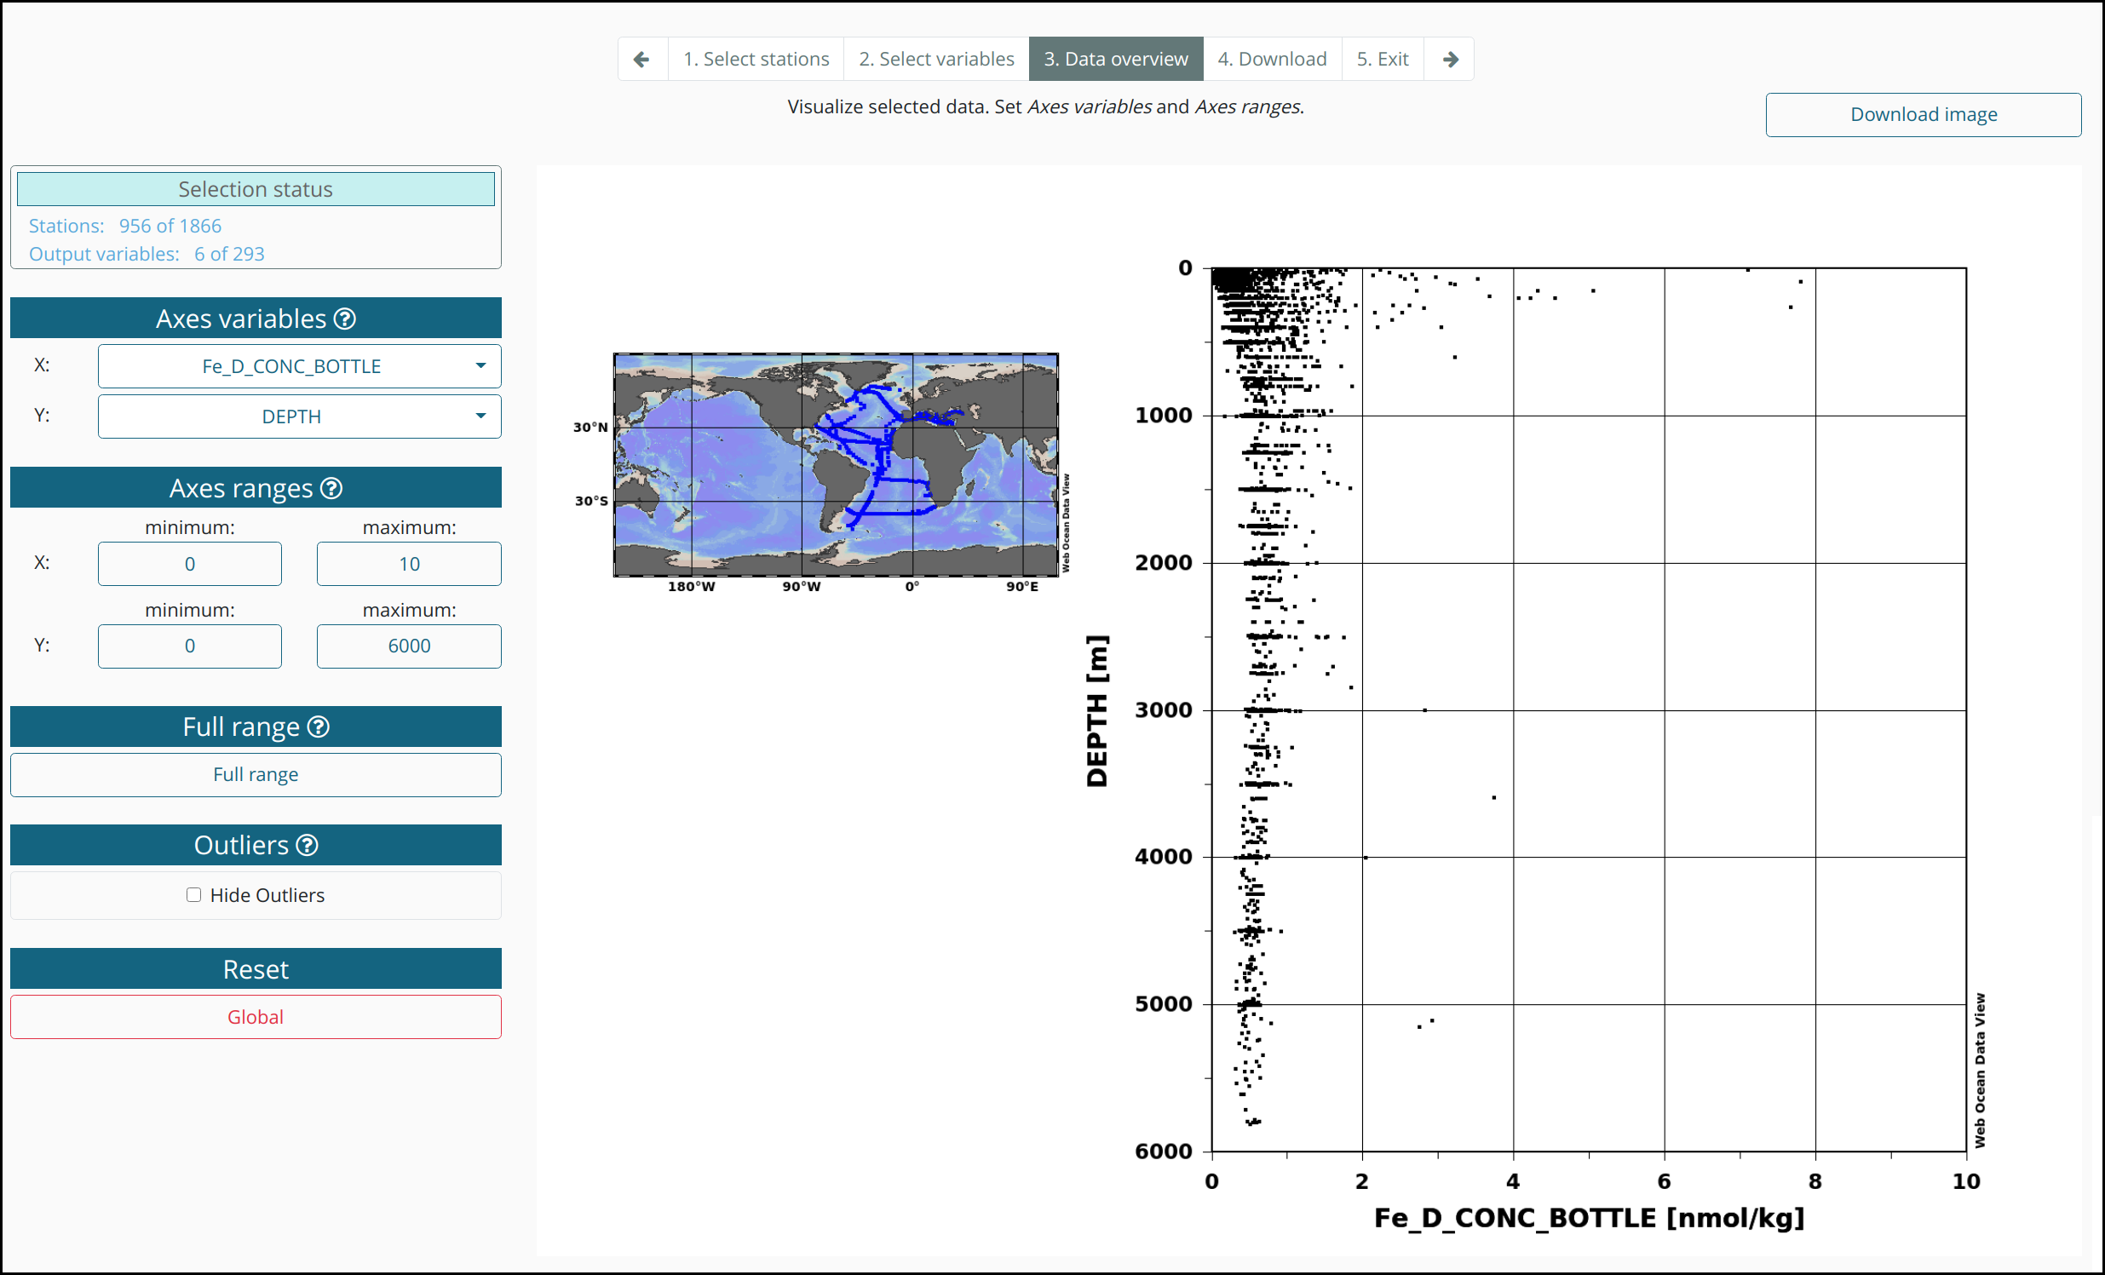
AXES VARIABLES

Select X and Y axis variables for the scatter plot using this dropdown. A search function within the lists is provided.

AXES RANGES

Set minimum and maximum ranges of the X and Y axes.

FULL RANGE

X and Y axes are set automatically to cover the full data range.

OUTLIERS

Activate this check box to hide outliers, which have been identified / flagged in the ODV collection as "bad" or "probably bad" data.

4. Download

The download page allows to download the selected data in different formats, ASCII SPEADSHEET (.txt), ODV COLLECTION (.odv) or NETCDF (.nc). Prior to downloading the data, users have to fill out the data agreement form shown in a pop up:

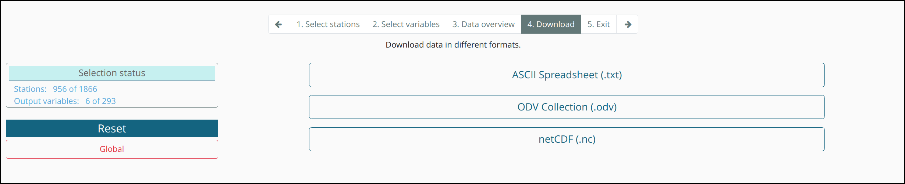

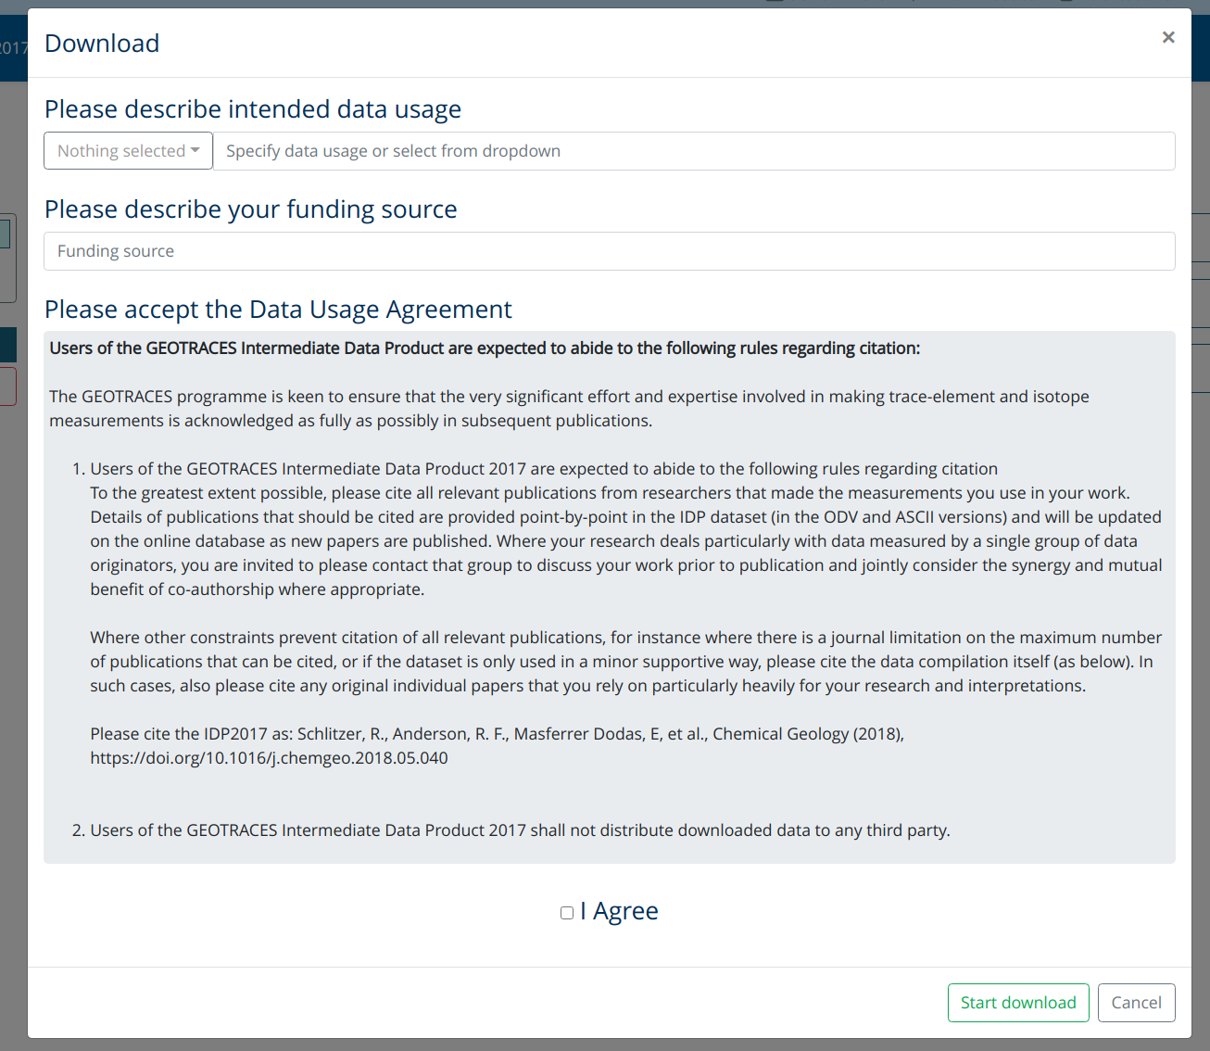

Finally the data download starts automatically and a .zip file is provided.

5. Exit

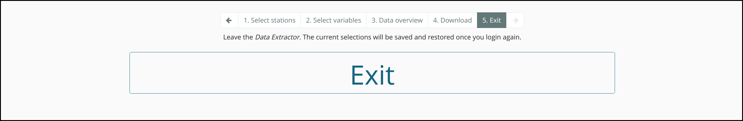
The last page simply brings the user back to the webODV homepage.

