Documentation of
Space Wars team project

Crated by Spike Dog team

Members

- Нено Джамбазов
- Кирил Тошев
- Петьо Костаков
- Пламена Мучева
- Стоян Михайлов

Project purpose

Creating a console game which represents war with space ships.

Class diagram
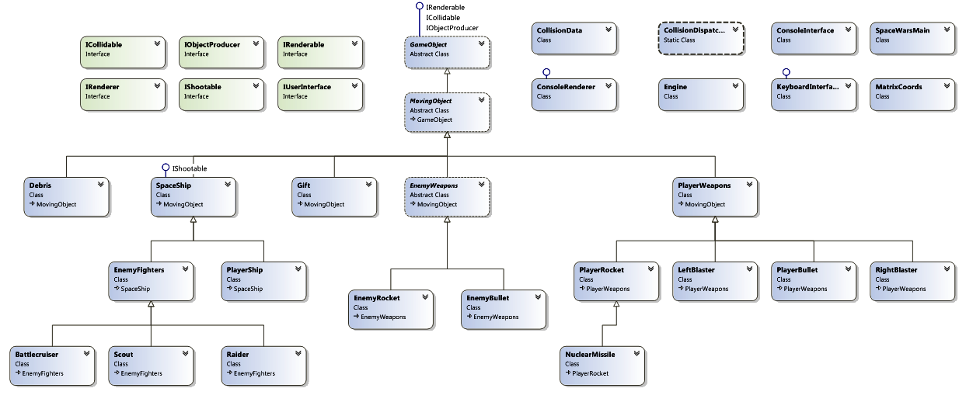

TFS repository

https://spikedog.visualstudio.com/

