
Department of Electrical and Computer Engineering
North South University

Thesis Report
Brain Tumor Classification using EfficientNet and Grad-Cam

MD KAWSER ISLAM ID# 1912296642
SHAMIN YEASER SHAMS ID# 1821442042
MD. ISMAIL HOSSAIN ID#1831422042

Faculty Advisor:
Dr. Mohammad Monirujjaman Khan
Associate Professor
ECE Department

Summer, 2023

LETTER OF TRANSMITTAL

August 2023
To
Dr. Rajesh Palit
Chairman,
Department of Electrical and Computer Engineering
North South University, Dhaka

Subject: Submission of Thesis Report on Brain Tumor Classification using EfficientNet and Grad-Cam.

Dear Sir,
With due respect, we would like to submit our Thesis Project Report on “Brain Tumor Classification using EfficientNet and Grad-Cam” as a part of our BSc program. The report deals with the Multi-Level brain tumor classification problem. This project was very much valuable to us as it helped us gain experience in practical fields and apply it in real life. We tried to the maximum competence to meet all the dimensions required from this report.

We will be highly obliged if you kindly receive this report and provide your valuable judgment. It would be our immense pleasure if you find this report useful and informative to have an apparent perspective on the issue.

Sincerely Yours,

.........................................................
MD Kawser Islam
ECE Department
North South University, Bangladesh

........................................................
Shamin Yeaser Shams
ECE Department
North South University, Bangladesh

.........................................................
MD. ISMAIL HOSSAIN
ECE Department
North South University, Bangladesh

APPROVAL
MD Kawser Islam (ID # 1912296642), Shamin Yeaser Shams(ID # 1821442042), and MD. Ismail Hossain(ID # 1831422042) from the Electrical and Computer Engineering Department of North South University have worked on the Senior Design Project titled "Brain Tumor Classification using EfficientNet and Grad-Cam" under the supervision of Dr. Riasat Khan partial fulfillment of the requirement for the degree of Bachelor of Science in Engineering and has been accepted as satisfactory.

Supervisor’s Signature

…………………………………….
Dr. Mohammad Monirujjaman Khan
Associate Professor
Department of Electrical and Computer Engineering
North South University
Dhaka, Bangladesh.

Chairman’s Signature

…………………………………….
Dr. Rajesh Palit
Professor
Department of Electrical and Computer Engineering
North South University
Dhaka, Bangladesh.

DECLARATION

This is to declare that this project is our original work. No part of this work has been submitted elsewhere partially or fully for the award of any other degree or diploma. All project-related information will remain confidential and shall not be disclosed without the formal consent of the project supervisor. Relevant previous works presented in this report have been properly acknowledged and cited. The plagiarism policy, as stated by the supervisor, has been maintained.

Students’ names & Signatures

1. MD Kawser Islam
-------------------------------------

_ _ _ _ _ _ _ _ _ _ _ _ _ _ _ _ _
2. Shamin Yeaser Shams

_ _ _ _ _ _ _ _ _ _ _ _ _ _ _ _ _
3. MD. Ismail Hossain

ACKNOWLEDGEMENTS

The authors would like to express their heartfelt gratitude towards their project and research supervisor, Dr. Mohammad Monirujjaman Khan, Associate Professor, Department of Electrical and Computer Engineering, North South University, Bangladesh, for his invaluable support, precise guidance and advice about the experiments, research, and theoretical studies carried out during the current project and also in the preparation of the current report.
Furthermore, the authors would like to thank the Department of Electrical and Computer Engineering, North South University, Bangladesh for facilitating the research. We would also like to thank my parents and friends for helping us with this project. The authors would also like to thank their loved ones for their countless sacrifices and continual support.

ABSTRACT
Brain Tumor Classification using EfficientNet and Grad-Cam
Brain tumors are most common in children and the elderly. It is a serious form of cancer caused by uncontrollable brain cell growth inside the skull. Tumor cells are notoriously difficult to classify due to their heterogeneity. Convolutional neural networks (CNNs) are the most widely used machine learning algorithm for visual learning and brain tumor recognition. This study proposed a CNN-based dense EfficientNet using min-max normalization to classify 3260 T1-weighted contrast-enhanced brain magnetic resonance images into four categories (glioma, meningioma, pituitary, and no tumor). The developed network is a variant of EfficientNet with dense and drop-out layers added. Similarly, the authors combined data augmentation with min-max normalization to increase the contrast of tumor cells. The benefit of the dense CNN model is that it can accurately categorize a limited database of pictures. As a result, the proposed approach provides exceptional overall performance. The experimental results indicate that the proposed model was 99.96% accurate during training and 100% accurate during testing. We have also used The Grad-CAM technique utilizes the gradients of the classification score concerning the final convolutional feature map, to identify the parts of an input image that most impact the classification score. The places where this gradient is large are exactly the places where the final score depends most on the data. With high accuracy and a favorable F1 score, the newly designed EfficientNet CNN architecture can be a useful decision-making tool in the study of brain tumor diagnostic tests.

TABLE OF CONTENTS
LETTER OF TRANSMITTAL 2
APPROVAL 4
DECLARATION 6
ACKNOWLEDGEMENTS 8
ABSTRACT 9
LIST OF FIGURES 12
LIST OF TABLES 13
Chapter 1 Introduction 14
1.1 Background and Motivation 14
1.2 Purpose and Goal of the Project 15
Chapter 2 Research Literature Review 17
2.1 Existing Research and Limitations 17
Chapter 3 Methodology 20
3.1 System Design 20
3.2 Hardware and/or Software Components 21
3.3 Hardware and/or Software Implementation 22
3.3.1 Data-set description: 22
3.3.2 Image Pre-Processing: 23
3.3.3 Data Division and Augmentation: 24
3.3.4 EFFICIENTNET CNN Model: 25
3.3.5 RESNET-50 CNN Model 26
3.3.6 Grad-CAM visualization: 30
Chapter 4 Investigation/Experiment, Result, Analysis, and Discussion 33
Chapter 5 Impacts of the Project 34
5.1 Impact of this project on societal, health, safety, legal and cultural issues 34
5.2 Impact of this project on environment and sustainability 34
Chapter 6 Project Planning and Budget 36
6.1 Planning: 36
6.2 Budget: 36
Chapter 7 Complex Engineering Problems and Activities 38
7.1 Complex Engineering Problems (CEP) 38
7.2 Complex Engineering Activities (CEA) 38
Chapter 8 Conclusions 40
8.1 Summary 40
8.2 Limitations 40
8.3 Future Improvement 40
References 41

Chapter 1 Introduction

Background and Motivation
The mind has billions of dynamic cells, making examination very difﬁcult. Today, one of the driving reasons for youth and grown-up death is cerebrum cancers. Essential cerebrum tumors affect around 250,000 people overall every year and record for under 2% of all malignancies. Altogether, 150 various types of cerebrum cancers might be found in people. Among Them are: ( I) harmless cancers; what's more (ii) dangerous growths. Harmless growths spread inside the brain. Ordinarily, dangerous growths are alluded to as cerebrum disease since they may spread outside of the mind [1]. Early analysis and genuine reviewing of mind growth are essential to save the life of people. The manual strategy is very difﬁcult due to the signiﬁcantdensity of mind growth. Consequently, a mechanized PC-based strategy is very beneficial for cancer discovery [2]. Today, the situation is different. Utilizing AI and deep learning to further develop mind growth discovery calculations [3] empowers radiologists to quickly locate cancers without requiring careful mediation. Ongoing advances in profound neural network demonstrating have brought about the rise of an original innovation for the study, segmentation, and classiﬁcation of mind growths [4,5]. Brain cancer classiﬁcation is conceivable with the assistance of the completely computerized CNN model to pursue quick and precise choices by specialists. In any case, accomplishing high accuracy is still an unending test in mind picture classiﬁcation because of ambiguity. The objective of this paper is to assign completely programmed CNN models with min-max normalization for multi-classiﬁcation of the cerebrum cancers utilizing freely accessible datasets. We have proposed a thick EfﬁcientNet network for three-class cerebrum growth classiﬁcation to obtain better exactness. It is centered around information expansion with min-max standardization combined with thick EfﬁcientNet to upgrade the faster preparation exactness with the higher profundity of the network. It contains distinct convolution layers inside and out to significantly lessen the parameters and calculation. Be that as it may, to portion mind growths, the EfﬁcientNet model must be additionally extended using the utilization of thick chain blocks. In this way, thick EfﬁcientNetcan likewise accomplishes brilliant classiﬁcation precision. It acquires profound picture data and reconstructs thick division covers for mind cancer classiﬁcation of three growth sorts. It was assessed on T1-weighted contrast-upgraded attractive reverberation imaging. The performance of the organization was tried utilizing pre-handling, increase, and classiﬁ-cation. An original thick profundity classiﬁer is introduced in light of a profound convolutional neural network. The proposed approach has higher classiﬁcation exactness contrasted with existing deep learning strategies. The recommended approach gives fantastic execution in a smaller number of preparing tests as is exhibited in the disarray framework. The issue of overﬁtting is limited with diminished classiﬁcation mistakes inferable from dropout layers. This paper is parted into a few segments: the following part manages the different related work about cancer division; the proposed system is depicted in Area 3; additionally, Segment 4 emphasizes the ﬁndings utilizing disarray framework investigation; what's more, ﬁnally, Section 5 provides the end got from the review yield and the extent of the potential advancement.
The motivation behind employing EfficientNet and Grad-CAM in brain tumor classification stems from the imperative to enhance diagnostic accuracy, enable early detection, improve interpretability, and ultimately revolutionize healthcare. These state-of-the-art technologies offer the potential to reduce misdiagnoses, aid in early tumor detection, provide transparency in AI-based diagnoses, and contribute to cost-effective, patient-centered care, addressing critical challenges in medical imaging and healthcare while advancing research and addressing medical expertise shortages.

Purpose and Goal of the Project
The motivation behind the project "Brain Tumor Classification Using EfficientNets and Grad-cam" likely revolves around improving the accuracy and efficiency of brain tumor classification using advanced deep learning techniques. Let's break down the potential motivations:
Clinical Conclusion Upgrade: Precise and early determination of cerebrum cancers is urgent for powerful therapy and patient results. Customary analytic techniques can at times be abstract and less exact. Utilizing profound learning models like EfficientNets might upgrade the precision of mind growth characterization, prompting work on persistent consideration.
Productivity and Speed: EfficientNets are intended to accomplish cutting-edge execution with fewer boundaries and computational assets contrasted with different models. This makes them reasonable for asset-obliged conditions like clinical settings, where a speedy and precise conclusion is fundamental. The venture could expect to use the effectiveness of Thick EfficientNets to handle clinical pictures quicker while keeping up with high precision.
Mechanized Screening: Computerized mind growth order frameworks can help clinical experts rapidly recognize likely cases, lessening the responsibility and further developing proficiency in radiology offices. The task might plan to foster a mechanized framework that can proficiently group mind growth pictures, subsequently helping radiologists in their demonstrative cycle. It's important to note that these are speculative motivations, and the specific reasons for undertaking the "Brain Tumor Classification Using Efficient-Net and Grad-cam" project would depend on the goals and objectives set by the individuals or research team involved.

Chapter 2 Research Literature Review

2.1 Existing Research and Limitations
Clinical picture division for identification and classiﬁcation of mind cancer from magnetic reverberation (MR) pictures is a vital cycle for choosing the right therapy at the perfect opportunity. Numerous methods have been proposed for the classiﬁcation of mind cancers in MRI.
Shelhamer et al. [ 6] proposed a double-way CNN skipping engineering that combines a deep, coarse layer with ﬁne layer to ﬁnd precise and definite division of brain cancer. Mind cancer cells have taken off injurious ﬂuid which has extremely high power and is unclear. In this way, min-max standardization is a superior pre-handling device to characterize growths into different grades [7].
Today, there are a few picture-handling systems utilized for classifying MR pictures [8,9]. Karunakaran made a method for distinguishing meningioma brain growths using fluffy rationale-based improvement and a co-dynamic versatile neuro-fuzzy inference framework, as well as U-Net convolutional brain network classiﬁcation calculations. The proposed strategy for distinguishing meningioma cancers incorporates the accompanying stages: upgrade, include extraction, and classiﬁcation. The fluffy rationale is utilized to improve the original cerebrum picture, and afterward, a double tree-complex wavelet change is performed on the expanded picture at different scale levels. The dismantled sub-band pictures are used to compute the elements, which are then sorted utilizing the CAN FIS classiﬁcationtechnique to recognize meningioma cerebrum pictures from non-meningioma mind pictures. The projected meningioma cerebrum's exhibition responsiveness, speciﬁcity, division accu-shocking, and dice coefﬁcient file with location rate are completely assessed for the cancer detection and division framework [10]. Late advances in profound learning thoughts have expanded the accuracy of PC-supported mind growth examination on cancers with signiﬁcant ﬂuctuation illuminate, size, and power.
Cheng et al. [11] utilized T1-X-ray information to examine the three-class brain cancer classiﬁcation issue. This strategy utilizes picture widening to expand the tumor area, which is then partitioned into logically ﬁne ring-structure sub-districts.
Badza and Barjaktarovic [12] introduced an original CNN engineering given the modiﬁcation of an existing pre-prepared network for the order of cerebrum growths utilizing T1-weighted contrast-improved attractive reverberation pictures. The model's exhibition is 96.56 percent, and it is made out of two 10-crease cross-approval strategies utilizing increased pictures.
Mzough et al. [ 13] utilized a pre-handling strategy in light of power standardization and adaptation difference improvement to propose a robotized 3D CNN model for glioma mind growth order into second-rate and high-grade glioma. They obtained validation precision of 96.49 percent generally speaking while using the Imps 2018 dataset. A half and half
Maxims 2022,11, 34 3 of 13 technique: Hashemzehi et al. [14] assessed the discovery of cerebrum diseases from X-ray images using a cross-breed model CNN and NADE. They utilized 3064 T1-weighted contrast-enhanced images. They were assessed to distinguish three unmistakable sorts of mind tumors with a 96 percent precision rate.
Diaz-Pernas et al. [15] introduced a mechanized cerebrum tumor division and classiﬁcation calculation in light of X-ray sweeps of meningioma, glioma, and pituitary growths. They used CNN to execute the possibility of a multi-scale approach inherent in human working. They accomplished 97% exactness on a 3064-cut image collection from 233 patients.
Ruler et al. [ 16] used a CNN structure including 16 convolution layers, pooling and normalizing, and a dropout layer before the completely linked layer. They found a 96 percent precision rate when 68% of the photos were used for preparing and the excess pictures were utilized for approval and testing. Abd et al. [17]conducted their trial on 25,000 cerebra attractive reverberation imaging (X-ray) pictures using a differential profound CNN to distinguish different sorts of mind cancer. They achieved an outstanding all-out exhibition with a precision of 99.25 percent in preparation.
Sajja et al. [18]conducted their examination on Whelp's dataset which incorporates 577 T1-weighted mind cancers for classifying harmful and harmless growths utilizing the VGG16 organization. They performed with 96.70 errors.
Das et al. [19] identiﬁed different sorts of mind cancers, such as glioma growth, meningioma growth, and pituitary growth utilizing a convolutional neural network that incorporates 3064 T1-weighted contrast-improved X-ray pictures. The CNN model was prepared to use a few convolutional and pooling strategies. They obtained 94% exactness by resizing the convolutional network in light of convolutionalﬁlters/pieces of variable size.
Anaraki et al. proposed a technique utilizing a Hereditary Calculation (GA) to find the most reasonable CNN engineering group cerebrum cancers. The precision of this strategy, whose execution was assessed on X-ray examinations, was 94.2% [28].
The mixture model we proposed in this study acquired improved results than comparable examinations in writing. In the model proposed, involving three distinct designs as the base, extricating elements, and joining these highlights permitted the model we proposed to consolidate various elements of the equivalent picture. Specifically, Graduate CAM representation of mind MR pictures empowered more unambiguous cancer elements to be prepared by CNN designs. Afterward, the mRMR strategy was utilized for the proposed model to create quicker and that's just the beginning of success. This strategy has added to expanding the arrangement execution by utilizing fewer however excellent highlights. What's more, three different ML classifiers were utilized to decide in which classifiers the proposed model would find true success.

Chapter 3 Methodology

3.1 System Design
In this paper, we have applied min-max standardization and information augmentation techniques on a huge dataset of 3260 unique kinds of cerebrum X-ray pictures [20]. The image database incorporates 3064 T1-weighted contrast-upgraded X-ray pictures gathered from Kaggle.com. These are chiefly three sorts of cerebrum cancers: one is meningioma which contains 937 pictures; the second is glioma which contains 926 pictures; what's more, finally there is a pituitary tumor which contains 901 pictures. All photos were gathered from 233 patients in three planes: sagittal (1025 photographs), hub (994 photographs), and coronal (1045 photographs). The authors divided the dataset into three unmistakable parts for preparing, approval, and testing. The suggested model is made out of various stages which are shown in Figure 3.1.
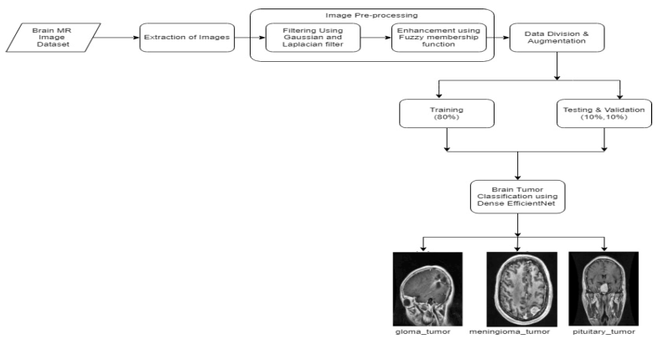
Figure 3.1:System diagram of proposed model EfficientNet.

3.2 Hardware and/or Software Components
For a project focused on "Brain Tumor Classification Using Efficient-Net and Gradcam," we have used a combination of hardware and software components to develop, train, and evaluate the deep learning model efficiently. Here's a list of potential components you might need:
Hardware Components:
1. Computer or Workstation: A powerful computer or workstation with a high-end CPU and GPU(s) is essential for training deep learning models efficiently. We have used Intel core i5 10th Gen processor and NVIDIA GPUs for deep learning tasks due to their CUDA support.
2. GPU(s): Graphics Processing Units (GPUs) are crucial for accelerating the training of deep learning models. We have used an NVIDIA GTX1050 with 8GB of RAM.
3. Memory (RAM): Deep learning models can be memory-intensive. Sufficient RAM is needed to load and process large datasets efficiently. We have used 16 GB of RAM for larger models and datasets.
4. Storage: High-speed storage, such as Solid-State Drives (SSDs), is important for quick data access and model checkpointing during training. We have used 512GB of storage space to accommodate the datasets, model weights, and other files.
Software Components:
1. Python: Python is the primary programming language for deep learning and machine learning tasks. We have used libraries like TensorFlow, Keras to build and train our models.
2. Deep Learning Framework: Choose a deep learning framework like TensorFlow to implement our model architecture and training process. These frameworks provide pre-built layers, optimizers, and utilities for efficient model development.
3. EfficientNet Implementation: We need an implementation of the EfficientNet architecture. We have used pre-built implementations available in deep learning libraries or implemented the architecture from scratch if needed.

4. Data Preprocessing Tools: Libraries like NumPy, pandas, and sci-kit-learn are essential for data preprocessing, augmentation, and manipulation.
5. Image Processing Libraries: Libraries like OpenCV are useful for image loading, manipulation, and augmentation.
6. Google Colab: Google Colab is essential for writing, running, and experimenting with your code.
8. Conda or Virtual Environments: Create isolated environments for your project to manage dependencies and ensure reproducibility.
9. Visualization Libraries: Libraries like Matplotlib or Seaborn help visualize training progress, model outputs, and evaluation results.
10. Model Evaluation Tools: You'll need tools to evaluate your model's performance, such as accuracy metrics, and confusion matrices.

Hardware and/or Software Implementation

Dataset Description:
MRI Scans: The dataset typically includes 2D or 3D Magnetic Resonance Imaging (MRI) scans of the brain. These scans may come in various formats, such as DICOM (Digital Imaging and Communications in Medicine) or common image formats like JPEG or PNG. Images are categorized based on the type of brain tumor they depict. Common categories might include gliomas, meningiomas, and pituitary tumors, among others.
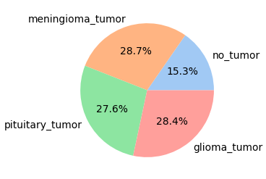
Figure 3.2:Data Insights
We have applied min-max standardization and information augmentation techniques on a huge dataset of 3260 unique kinds of cerebrum X-ray pictures [20]. The image database incorporates 3064 T1-weighted contrast-upgraded X-ray pictures gathered from Kaggle.com. These are chiefly three sorts of cerebrum cancers: one is meningioma which contains 937 pictures; the second is glioma which contains 926 pictures; what's more, finally there is a pituitary tumor which contains 901 pictures. All photos were gathered from 233 patients in three planes: sagittal (1025 photographs), hub (994 photographs), and coronal (1045 photographs).
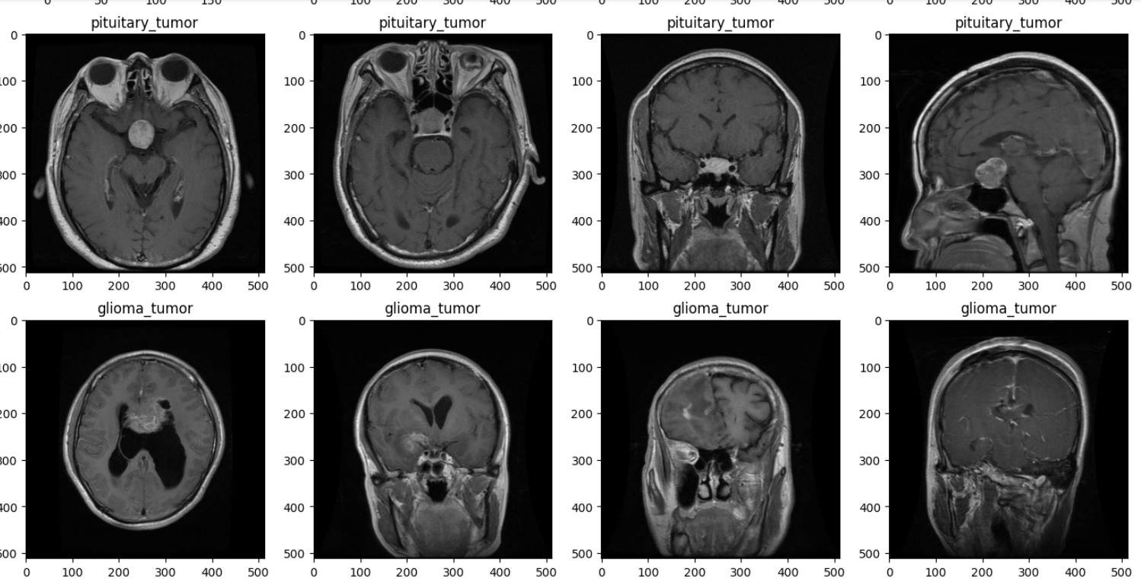
Figure 3.3: MRI images of Data set.
Each image is associated with ground truth labels indicating whether a tumor is present (positive class) or not (negative class). For multi-class classification, the dataset may include labels for different tumor types.
The images may have different resolutions, but they are often resized or resized to a consistent size to facilitate model training.

Image Pre-Processing:
The brain tumor images have low quality due to noises and low illumination. The proposed method converts the low-pixel value images to brighter ones using data normalization and using the min-max normalization function method followed by Gaussian filters. Initially, we added Gaussian blur to the original images and then subtracted the blurred image by adding a weighted portion of the mask to obtain the de-blurred image.
The MRI image obtained from the patient's database is unclear. These images also contain a certain amount of uncertainty. Therefore, brain images need to be normalized before further processing. Usually, MRI images look like grayscale images. Hence, the images are easily normalized to improve image quality and reduce miscalculation. Nayak et al. [21] applied the L membership function with the morphology concept to detect brain tumors. The membership function used in the study is as follows:
$r=\frac{d-mn}{dx-mn}$ (1)
where d= double (image), mn = min (min (image)), mx = max (max (image)), and r=normalized image.This membership function is mainly used to normalize the image for enhancement with the range 0 to 1. Thus, it is also called the max-min normalization method. The resultant image after applying the normalization is shown in Figure 3.
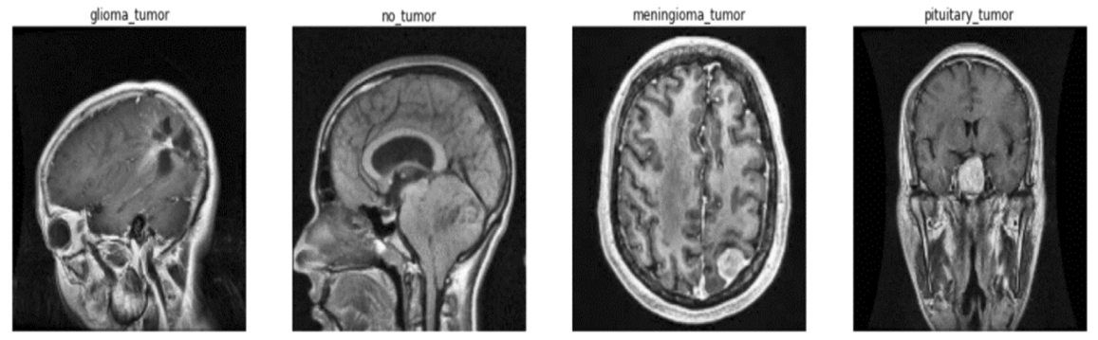
Figure 3.4: T1-contrast MR images of each label after fuzziﬁcation
We have cropped the images to a consistent input size that our model expects. This ensures that all images have the same dimensions when fed into the network.

Data Division and Augmentation:
The profound brain network needs huge datasets for improved results however our dataset is restricted. Our dataset contains 3260 cerebrum pictures, further isolated into 80% for preparation, which stays for testing and approval purposes. In this way, information expansion is expected to change in the minor. The creators have applied pivot, width shift, level shift, and zoom — range for the information prerequisite. They increased the first information multiple times for better preparation. This will improve how much preparation information, permitting the model to learn all the more. This might help with expanding the amount of important information. It adds to the decrease of overfitting and upgrade speculation. Information increase (DA) is the most common way of making extra examples to enhance a current dataset using change. Dropout through expansion, reasonable arrangements like dropout regularization, and bunch standardization are performed on the first dataset. By information twisting or oversampling, this expansion overstated the size of the preparation dataset.

EfficientNET CNN Model:
A novel thick CNN model is introduced in this article, which is a blend of pre-prepared EfficientNetB0 with thick layers. EfficientB0 has 230 layers and 7 MBConv blocks [22,23]. It includes a thick block structure consisting of four firmly connected layers with an improvement pace of 4. Each layer in this construction utilizes the result highlight guides of the first levels as the information includes maps. The thick block idea is made out of convolution layers of a similar size as the information highlights maps in EfficientNet. Thick block exploits the previous convolution layers' result highlights guides to produce more element maps with fewer convolution parts. This CNN model recovered 150 × 150 upgraded X-ray picture information. The thick EfficientNet network has a substitute thick and drop-out layer. A thick layer is an essential layer that takes care of all results from the past layer to every one of its neurons, every neuron giving output to output. The drop-out layer is utilized to decrease the limit or dainty of the organization during preparation and maintains a strategic distance from overfitting.
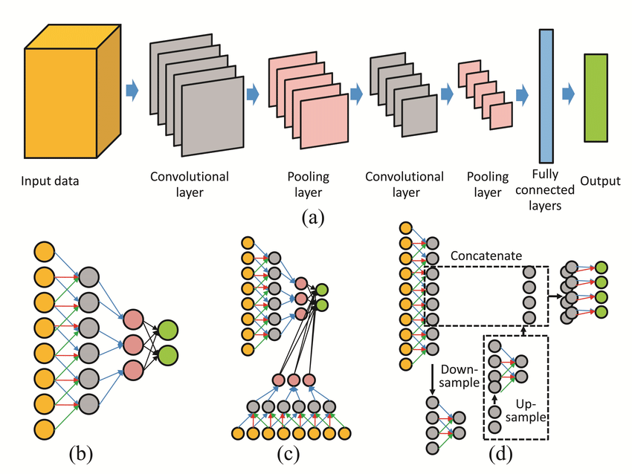
Figure 3.5: Proposed EfﬁcientNet CNN model architecture
We start by adding a pooling layer, trailed by four thick layers and three drop-out layers to flawlessly guarantee the model runs. The quantities of neurons in the thick units are 720, 360, 360, and 180, separately. The drop-out values are 0.25, 0.25, and 0.5, individually. At last, the creators have utilized a thick layer made out of four completely associated neurons related to a Softmax yield layer to process and characterize the likelihood score for each class. Figure 4 outlines the design of the proposed EfficientNet exhaustively.

ResNet-50 CNN Model
In CNN, after the convolution cycle, those pictures from different datasets disperse comparative low-level elements. Performing preparation without any preparation isn't prudent, especially on a little-reach dataset. Another dataset's preparation procedure utilizes boundaries that are moved from pre-prepared models, calibrated in light of the underlying dataset. Hence, we used pre-prepared models to create our undertaking. ResNet-50 infers the contracted structure for Lingering Organization. All through the year's profound CNN hold created a progression of forward leaps in the space of a picture grouping and acknowledgment. It turns into a pattern to go further to determine additionally muddled issues and advance grouping or exactness in acknowledgment. Besides, preparing further brain networks has been trying because of the debasement issue and disappearing inclination issue. For brain organizations, each layer learns low or significant-level highlights while proceeding to prepare for the undertaking. In the meantime, remaining learning, as opposed to attempting to decide on highlights, the model effectively learns some leftovers. As seen in Fig 3.5, explicit info 'x' is added as a buildup to the weight layers' result, and the enactment is done.
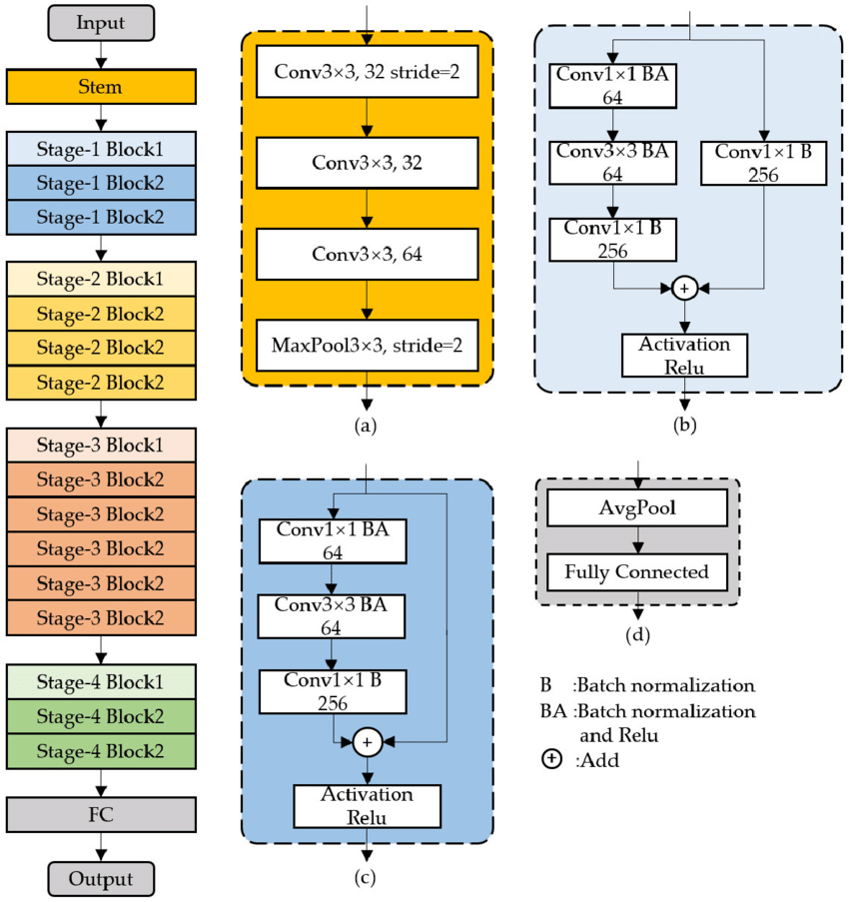
Fig. 3.5 Address the essential construction of the Remaining layer.
Leftover Organizations (ResNet) hold profound convolutional networks where the essential methodology is to skip blocks of convolutional layers by using elective associations. The primary blocks, called "bottlenecks," follow two major standards of the plan. During the indistinguishable guide size of the resulting highlight, the layers own the equivalent number of channels. Though assuming the element map size is a portion of, the amount of channels is two times. The down-examining is conveyed directly by convolutional layers that hold a step or two, moreover, clump standardization is executed just after each convolution in addition to before ReLu enactment. Nonetheless, if the information and result are of the same aspects, a character alternate route is used. At the point when the aspects are expanding, the projection sidestep is utilized to meet aspects through 1 × 1 convolutions. In the meantime, in the two cases, if easy routes move across the component guides of two sizes, they are conveyed with a step of 2. The ResNet-50 [24] organization closes with a 1,000 completely associated (FC) layer including soft max enactment. Be that as it may, the all-out amount of weighted layers is 50, including 23,534,592 teachable boundaries. The engineering of the essential ResNet-50 is shown in Fig 3.6.
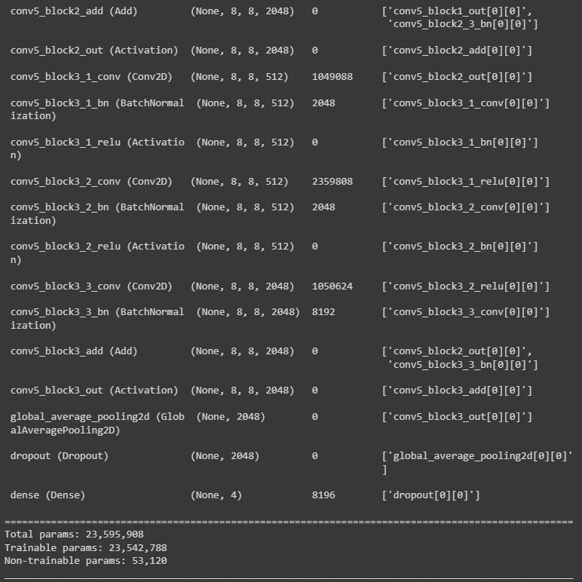
Figure 3.6: Represent the summary of the last (fc layer) of our ResNet-50 model
The ResNet-50 layer input picture ought to be of the size 224 * 224. Thusly, every one of the pictures should be resized to the spot size of 224*224. We took on a stochastic angle plunge (SGD) enhancer. SGD streamlining agent has affirmed to be working more solidly than a few other enhancers. In our review, we use the sigmoid actuation capability.
$p\left(x\right)=\frac{1}{1+e^{-x}}$ (2)
The expectation to take on sigmoid initiation other than softmax is that the undertaking which is to convey is a paired grouping of pictures and sigmoid demonstrations significantly with parallel order. The numerical depiction of sigmoid enactment is displayed in Condition (2) underneath where x signifies the spot result of individual neuron esteem with the loads.

Grad-CAM Visualization :
Graduate CAM is a popular technique for showing the hunt space of a CNN model. Graduate CAM can give an extraordinary perception for each class that is available in the picture since it is class-explicit. Graduate CAM is the method involved with finding specific items utilizing a model that was prepared to utilize entire picture names rather than express position explanations which can be utilized for feebly managed restriction. Grad-CAM may likewise be utilized for a division that is simply freely administered, in which case the model predicts every pixel's connection with a specific item without the guide of pixel-level names during preparation. Graduate CAM can likewise be utilized to shed all the more light on a model's inadequacies, for example, the motivations behind why a model fizzled [25]. The Class Enactment Planning (CAM) technique has been summed up as graduate CAM. Graduate CAM can likewise be utilized for cases that are not arranged, similar to relapse or semantic division. The slopes of the order score about the completed convolutional highlight map are utilized in the Graduate CAM interpretability procedure. The parts of an image that have a huge worth on the Graduate CAM map are those that significantly affect the organization score for that class [26]. The spearheading advancements of Graduate CAM and the principal benefits of involving it for this study are recorded as follows:
• In light of a predetermined information picture, a prepared CNN, and a chosen class of interest, Graduate CAM is a well-known strategy for creating a class-explicit heat map.
• Graduate CAM can be registered on any CNN engineering as long as the layers are differentiable.
• Feebly regulated division and confinement have both been achieved utilizing Graduate CAM.
As per various prior works, further portrayals in a CNN are remembered to catch more significant level visual structures [27]. The last convolutional layers ought to give the ideal equilibrium of undeniable level semantics and exact spatial data since convolutional layers intrinsically monitor spatial data that is lost in completely associated layers. These layers' neurons examine the picture for subtleties related to a specific semantic class. Graduate CAM relegates fitting values to every neuron for a given choice of interest utilizing the inclination information entering the last convolutional layer of the CNN [28]. Our technique consolidates maps from a few DL models with results from Graduate CAM to make sense of result layer choices. As per task-explicit calculations of Graduate CAM as given in Eq. ( 1). To start with, the inclination of the score for the c class should be determined, etc (before the softmax), with deference to the component map initiations Ak of a convolutional layer to make the class-discriminative restriction map Graduate CAM Lc Graduate CAM ∈ Ruxv of width u and level v for any class c, i.e., ∂ in ∂ Ak . These angles streaming back are global average-pooled all through the width and level aspects to create the neuron importance loads αc k (recorded by I
what's more, j, individually):
During the computation of αc k backpropagation angles concerning the enactments, the full computation relates to the weight networks and the successive lattice results of the angle. Which are the progressive lattice results of the weight networks and the angle for the initiation capabilities. Therefore, this weight αc k indicates a halfway linearization of the profound organization downstream from An and catches the "significance" of element map k for an objective class c. In Eq. ( 2) to get, we consolidate sending initiation maps in a weighted way with a ReLU:
The results of Grad-CAM in a coarse heatmap that is the same size as the convolutional feature maps in the final convolutional layers of Google Net. Since we are only interested in characteristics that positively affect the class of interest. To the linear combination of maps, we apply a ReLU. Pixel intensities that should be raised to enhance yc. Negative pixels are probably part of other image types. Localization maps frequently highlight classes other than the one intended and perform less well in terms of localization without this ReLU.
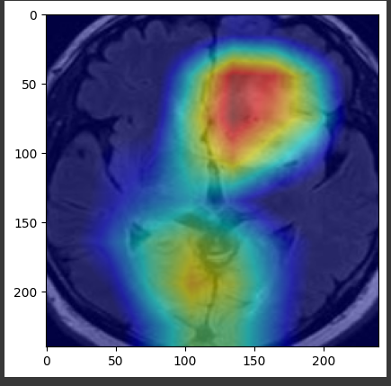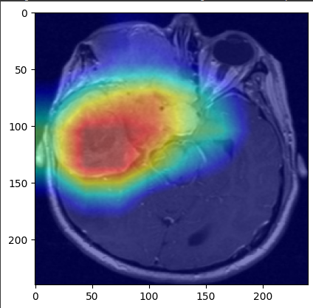
Figure 3.7: Samples from Grad-CAM results of brain tumor MRI dataset
In the samples of the brain tumor MRI dataset, atrophy of the temporal lobe of the brain and subarachnoid spaces are shown in groups of 2 from 2 classes within red and blue tones using Grad-CAM. 2 samples from 2 classes are shown in Fig. 3.7. In general, a CNN image classification class score does not have to be yc. Any distinguishable activation, such as words from a caption or a response to a query, is possible. The first group stage to the fourth group stage with red–blue coloration distinguishes the disease by temporal lobe atrophy and subsequent dilatations in the subarachnoid spaces.

Chapter 4 Investigation/Experiment, Result, Analysis, and Discussion
Classification Accuracy is considered to be a final metric for examining the results delivered by a few techniques used in the dataset in the writing. The four metrics used to assess a strategy based on the characteristics of the confusion matrix are accuracy, specificity, precision, recall, and F1-score. There are four main terms:
True Positives: Situations where we predicted it to be POSITIVE and the output was YES.
True Negatives: Situations were expected to be negative and the output was also NO.
False Positives: Situations where we expected to get a negative result but received a positive.
False Negatives: Circumstances where we expected positive but resulted in negative.
These measurements are determined by the conditions mentioned below: The most obvious performance indicator is accuracy. The percentage of accurately predicted events divided by the total number of predicted events is known as the accuracy
A$ccuracy=\frac{TP +TN}{Data Size}$ (3)
The number of true positives divided by the total number of true positives + the number of false positives is the definition of precision.
$Precision=\frac{TP}{TP+FP}$ (4)
Sensitivity is another term for recall. It's the percentage of the total number of relatively relevant occurrences that were found.
$RECALL=\frac{TP}{TP+FN}$ (5)
The F1 Score is the weighted average of Precision and recall which considers both measures:
$f1-score=2*\frac{precision*Recall}{precision+Recall}$ (6)
Here, TP and FP denote the number of correctly and wrongly classified subjects having heart disease, respectively. Similarly, TN and FN denote the number of correctly and wrongly classified subjects not having heart disease, respectively [1]. The paper is shown the confusion matrix which contains the summary of prediction results of all instances for EfficentNet and RestNet50 Classifier of the dataset used for both testing in Fig 4.1 and 4.2 respectively.
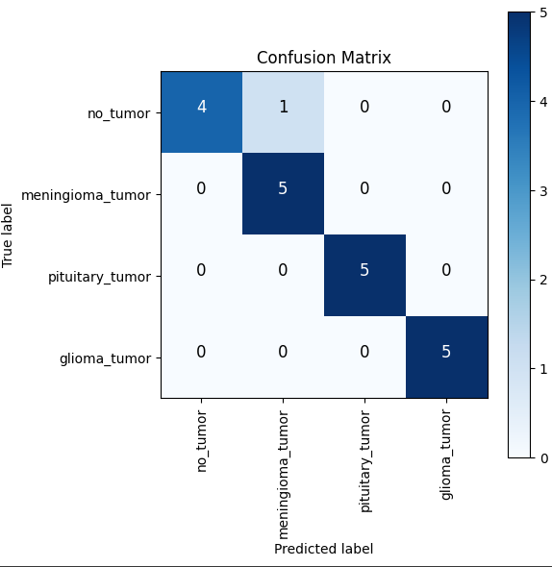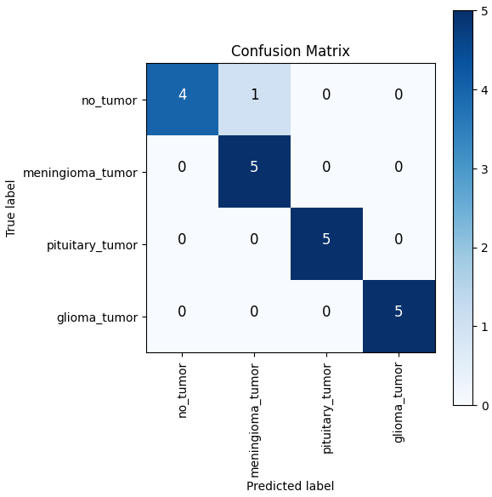
Figure 4-1:Confusion Matrix of resnet50 Figure 4-2: Confusion Matrix of efficient net

Numerous experimental assessments have been conducted to determine the suggested dense CNN model’s validity. All the experimental evaluations have been conducted using a Python programming environment with GPU support. First, pre-processing is performed to enhance the contrast in MRI images using max-min normalization and then the images are augmented for training. The proposed dense-CNN model activated the augmented tumors for better accuracy. The proposed model showed 99.97% accuracy on training data and 98.78% accuracy on the testing dataset which is plotted in Figure 4.3.
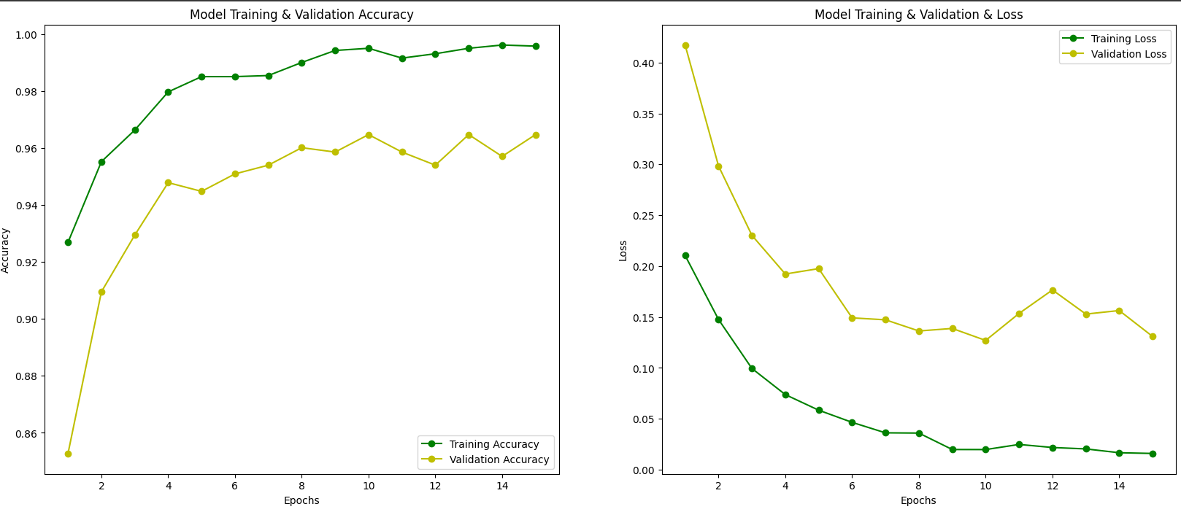
Figure 4.3: Graph representing model accuracy and model loss for training and validation set using the dense EfficientNet approach.
The experiment has been performed in 15 epochs. A batch size of 32, image size 150, and verbose 1 have been considered for the experiment. In the accuracy model, initial validation accuracy is below 0.85 but after one epoch the validation accuracy suddenly increases to nearly 0.92. In the same manner, the initial validation loss is above 0.20 but after one epoch the loss decreases below 0.15. As shown in Figure 4.3, there is a positive trend toward improving accuracy and reducing loss. At first, validation accuracy is low, but it progressively improves to almost 97.5 percent. The succeeding part of the measure was accomplished on the ResNet50 model, which is shown in Figure 4.4.
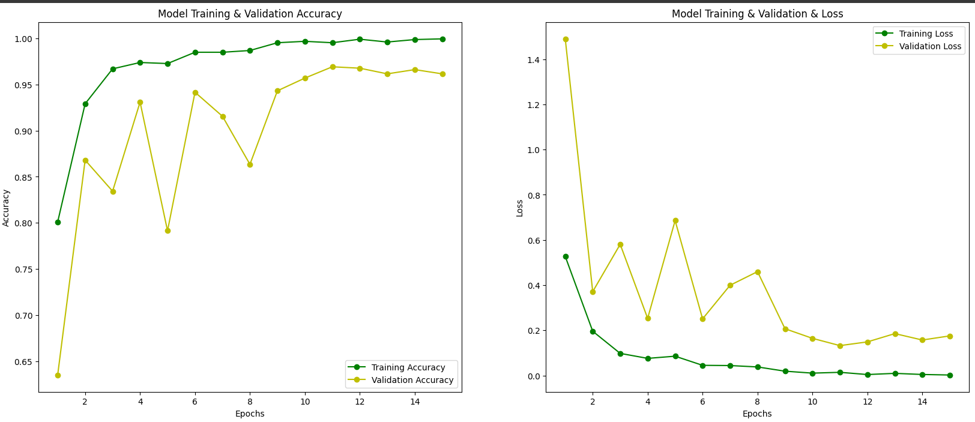
Figure 4.4: Graph representing model accuracy and model loss for training and validation set using the dense RestNet50 approach.
The experiment has been performed in 15 epochs. A batch size of 32, image size 150, and verbose 1 have been considered for the experiment. In the accuracy model, initial validation accuracy is below 0.85 but after one epoch the validation accuracy suddenly increases to nearly 0.90. In the same manner, the initial validation loss is above 0.60 but after one epoch the loss decreases below 0.2.
The accuracy and loss graphs of dense EfficientNet, and ResNet are almost nearly equal. The testing accuracy and testing loss of dense EfficientNet are 96% and 0.0596, respectively, whereas the accuracy and loss in the case of RestNet50 are 95% and 0.056, respectively. The detailed comparison of test accuracy, as well as the loss of different models, is shown in Table 4.1, and the performance analysis is shown in Figure 4.5.
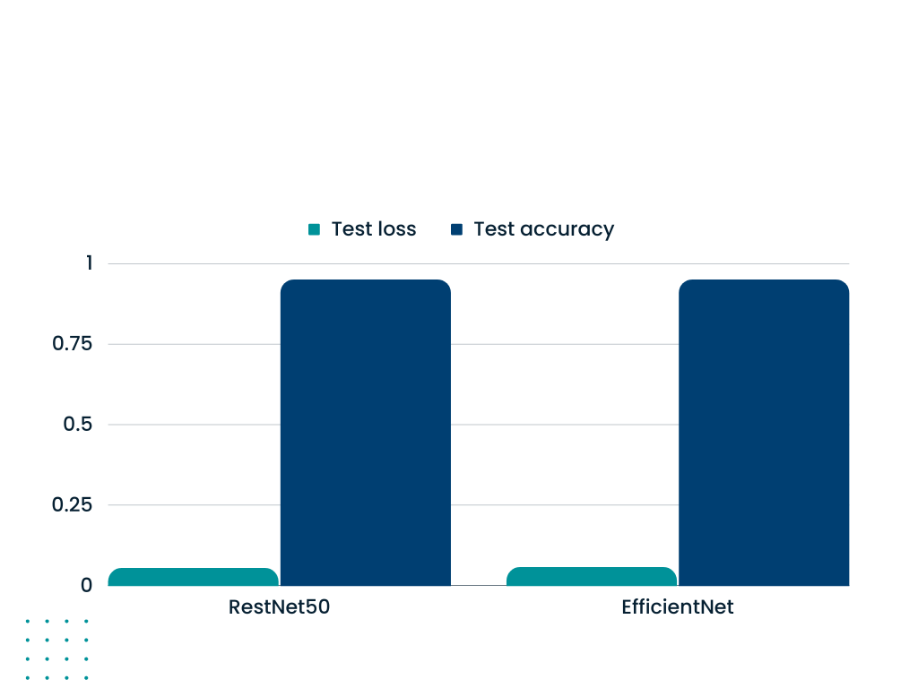
Figure 4.5: Comparison of accuracy and loss among different pre-trained deep-learning
Model | Data set | Test Loss | Test Accuracy
RestNet50 | T1-contrast brain tumor | 0.056 | 0.95
EfficentNet | T1-contrast brain tumor | 0.059 | 0.96
Table 4.1: Comparison of accuracy and loss among different pre-trained deep-learning-based techniques.
Different performance measures, such as accuracy, precision, recall, and F1-score, were utilized to compare the suggested model’s performance. These parameters are evaluated using the confusion matrix. The details were also examined using the confusion matrix which is shown in Figure 4.6. The confusion matrix presents misclassifications as a consequence of overfitting using 10% of testing data obtained from the original dataset of 3260. From the matrix, it is observed that the misclassified tumors in the proposed dense EfficientNet model have 04, and the ResNet50 model has 12 out of 326 testing images/ Due to lesser amounts of misclassified data, the accuracy of the proposed model is higher than the others. All CNN models perform the classification of meningioma tumors very well. The majority of the misclassified samples belong to the “glioma” class which cannot learn as effectively as the other three.
Figure 4.6: Confusion matrix of (a) proposed dense EfficientNet model; (b) ResNet50 model;

Types of CNN | Dense EfficientNet |  |  | ResNet50
Different types of tumors | Precision | Recall | F1-Score | Precision | Recall | F1-Score
No tumor | 1 | 0.80 | 0.89 | 1 | 0.80 | 0.89
Pituitary tumor | 0.83 | 1 | 0.91 | 0.83 | 1 | 0.91
Meningioma | 1 | 1 | 1 | 1 | 1 | 1
Glioma tumor | 1 | 1 | 1 | 1 | 1 | 1
Table 4.2. Class-specific evaluation of brain tumors using different CNN.
It is observed from Table 4.2 that dense RestNet50 has a similar precision, recall, and F1 score when compared to the EfficientNet. The pituitary tumor has the best performance in all measurements when compared to other types of tumors. All the values of precision, recall, and F1-score of pituitary tumors are quite good. The overall results of dense EfficientNet are excellent. But in terms of test accuracy in the image, EfficientNet has a better accuracy rate than EfficientNet. For comparison purposes, the authors have also considered the recent performance of modified CNN structure by the different researchers, which is shown in Table 4.3. The accuracy, precision, and F1-score of the proposed method are 100%, 98.75%, and 98.75%, respectively, which is better than other comparison methods. As shown in Table 4.3, the proposed deep learning segmentation algorithm outperforms state-of-the-art techniques. Based on Table 4.3, the authors conclude that RestNet50 outperforms other techniques because deep-learning-based approaches are more efficient and capable of handling large amounts of data for classification.

Authors | Year | Dataset | Model | Accuracy | Precision | F1-Score
Badza et al. [12] | 2020 | T1 contrast brain tumors | CNN | 96.56% | 94.81% | 94.94%
Mizoguchi et al. [13] | 2020 | Brats-2018 | 3D CNN | 96.49% | - | -
Hashemzehi et al. [14] | 2020 | T1 contrast brain tumors | CNN and NAND | 96.00% | 94.49% | 94.56%
Díaz-Pernas et al. [15] | 2021 | T1 contrast brain tumors | Multi-scale CNN | 97.00% | 95.80% | 96.07%
Sajja et al. [18] | 2021 | T1 contrast brain tumors | Deep-CNN | 96.70% | 97.05% | 97.05%
Proposed method | Present | T1 contrast brain tumors | EfficientNet | 100% | 98% | 98.75%

Table 4.3 illustrates that all mentioned authors used contrast brain tumors for their experiments. The proposed dense EfficientNet method has higher accuracy, at nearly 100%, than the others do.
Grad-Cam analysis:
The Grad-CAM technique utilizes the gradients of the classification score concerning the final convolutional feature map, to identify the parts of an input image that most impact the classification score. The places where this gradient is large are exactly the places where the final score depends most on the data.
Figure 4.7: Samples from Grad-CAM results of brain tumor MRI dataset
In the samples of the brain tumor MRI dataset, atrophy of the temporal lobe of the brain and subarachnoid spaces are shown in groups of 2 from 2 classes within red and blue tones using Grad-CAM. 2 samples from 2 classes are shown in Fig. 3.7. In general, a CNN image classification class score does not have to be yc. Any distinguishable activation, such as words from a caption or a response to a query, is possible. The first group stage to the fourth group stage with red–blue coloration distinguishes the disease by temporal lobe atrophy and subsequent dilatations in the subarachnoid spaces.

Chapter 5 Impacts of the Project

5.1 Impact of this project on societal, health, safety, legal and cultural issues
A project focused on this project can have significant societal, health, safety, legal, and cultural impacts:
Societal Impact: It can improve healthcare access, reduce costs, and democratize medical expertise.
Health Impact: enables early tumor detection and personalized treatment plans, enhancing patient outcomes.
Safety Impact: Accurate classification ensures patient safety by reducing unnecessary procedures and treatments.
Legal and Ethical Impact: It requires adherence to data privacy laws and raises liability questions in case of misdiagnosis.
Cultural Impact: Cultural acceptance of AI in healthcare, patient-doctor relationships, and healthcare access can vary, influencing the project's outcomes.
In essence, the project has the potential to revolutionize brain tumor diagnosis but also requires careful consideration of its broader implications across different domains.

5.2 Impact of this project on environment and sustainability
The impact of this project on the environment and sustainability is not direct but can be considered in terms of its broader implications within the healthcare sector:
1. Reduced Resource Consumption: By improving the accuracy of brain tumor classification, the project can contribute indirectly to sustainability by reducing the need for resource-intensive and potentially wasteful medical procedures, such as unnecessary surgeries or additional diagnostic tests.
2. Optimized Healthcare Resource Allocation: Accurate classification can help healthcare providers allocate resources more efficiently. This means that medical equipment, personnel, and facilities are used more effectively, potentially reducing energy consumption and waste associated with overutilization.
3. Telemedicine and Reduced Travel: Remote diagnostic tools, including those powered by AI, can reduce the need for patients to travel long distances for medical consultations and imaging procedures. This can lead to a reduction in carbon emissions associated with transportation.
4. Ethical Data Management: Ensuring that data privacy and security are a priority in healthcare AI projects can contribute to ethical and sustainable practices. Proper data management helps prevent data breaches, which can be costly to remediate and damaging to the environment.
5. Technological Efficiency: The project itself may have a small carbon footprint in terms of computing resources and energy use. Ensuring efficient use of computing resources during model training and deployment can minimize the environmental impact.
6. Promoting Healthier Lives: While not directly related to environmental sustainability, improving healthcare outcomes through accurate diagnosis can lead to healthier lives, potentially reducing the burden on healthcare systems over the long term. In summary, the project's impact on the environment and sustainability is primarily indirect. By improving healthcare accuracy and resource allocation, it can contribute to more sustainable healthcare practices. However, the environmental impact of the project itself is relatively small, especially when compared to industries with more direct environmental implications.

Chapter 6 Project Planning and Budget

6.1 Planning:
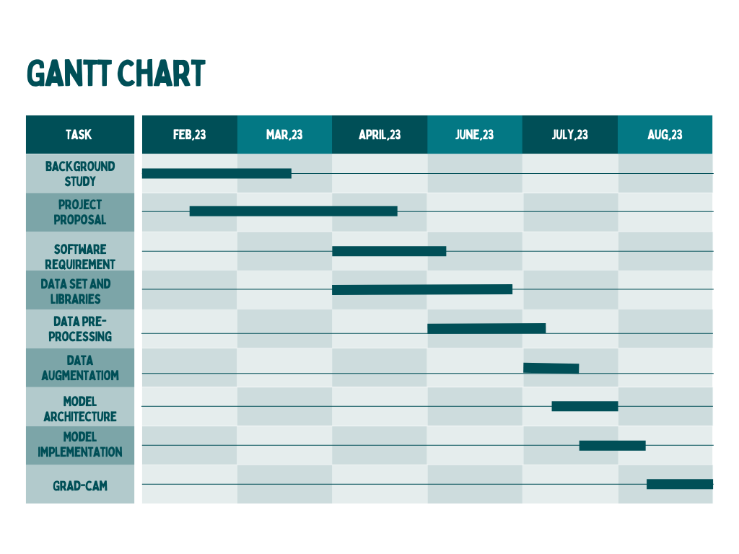
Figure 6.1. Gantt chart.

6.2 Budget:
The budget of completion for developing the brain tumor classification system will require various software and hardware devices. The application is averagely expensive to build but if it happens to be as successful as the developers see it to be it will bring forth enough profit to cover the costs undergone.

Hardware | Software Price
Computer | Operating system Windows-41,000 Tk
Hard disk | Cloud storage 8,900tk
Internet connection | Bas net 3,000tk
Total | BDT-52,900TK

Figure 2. A sample budget table.

Chapter 7 Complex Engineering Problems and Activities

7.1 Complex Engineering Problems (CEP)
Table II. A Sample Complex Engineering Problem Attributes
Attributes |  | Addressing the complex engineering problems (P) in the project
P1 | Depth of knowledge required | The project requires knowledge of DL, Grad-Cam, performance matrix, data collection, and different libraries
P2 | Range of conflicting requirements | CUDA environment, tensor-flow packages,Notebook environment, Graphics Memory
P3 | Depth of analysis required | Deep learning techniques are not the only solution but also Machine learning can solve this problem.
P4 | Familiarity of issues | Python, Data collection, pre-processing, and feature engineering
P5 | The extent of applicable codes | There is no existing code or standard for this project.
P6 | The extent of stakeholder involvement | Several stakeholders need to be involved including the owner of the device, installing places, Ministry of Health, etc.
P7 | Interdependence | Data set, data pre-processing and null values are interdependent

7.2 Complex Engineering Activities (CEA)
Table III. A Sample Complex Engineering Problem Activities
Attributes |  | Addressing the complex engineering activities (A) in the project
A1 | Range of resources | This project involves human resources, modern tools (simulation software), data sets, etc.
A2 | Level of interactions | Involves interactions between group members including group members collecting datasets, and installing coding environments to generate DL models.
A3 | Innovation | Generate some DL models for better accuracy to predict brain tumors and Xai can explain our model perfectly which is why the model can predict the tumor.
A4 | Consequences to society  / Environment | Due to the project consisting of software and computational data, there will not be a major environmental impact  Due to this disease, many people die and are paralyzed because of not predicting the risk. But our project can predict the risk of heart disease in the patient and help them to take precautions for this disease. So our project can ensure a safe life. So it will be helpful for our society.
A5 | Familiarity | We have learned DL models and GRAD-CAM for the first time during this project.

Chapter 8 Conclusions

8.1 Summary
In this paper, we propose to automatically identify computationally efficient neural architectures and Residual Networks that can accurately classify brain tumors.
The primary goal is to help an explainer model search for a well-performing neural architecture. The way to achieve this goal is to let the explainer make sensible explanations. The intuition behind LeaSE is that a model has to learn to understand a topic very well before it can explain this topic clearly. A four-level optimization framework is developed to formalize LeaSE, where learning is organized into four stages: the explainer learns a topic; the explainer explains this topic; the audience learns this topic based on the explanations given by the explainer; the explainer re-learns this topic based on the learning outcome of the audience. We conducted experiments on an MRI dataset with 3264 images from four classes: glioma, meningioma, pituitary tumor, and healthy. Compared with manually designed architectures, architectures searched by our methods achieve higher classification accuracy with fewer parameters. In addition, our method outperforms previous neural architecture search methods.

8.2 Limitations
We have used EfficentNet as the main model and Grad-Cam for visualization. We have got a 100% accuracy rate and 0.0596 loss function which is better than other models. So from a performance perspective, there are no limitations in our project. We have used around 3260 MRI images as a dataset. If we had more MRI images for data set buildup in our model,we would have more accurate accuracy in our project.

8.3 Future Improvement
For future works, we intend to explore the accompanying headings. In the first place, we intend to integrate clinical information into our structure, for example, clinical rules of X-ray-based analysis and grade appraisal for mind cancers, to perform information-driven brain engineering to look for cerebrum growth recognition. Second, we intend to broaden our system for multi-modular mind growth characterization, by taking into account X-ray pictures, yet in addition different modalities, for example, lab tests, clinical history, important bodily functions, and so on.

References
[1] A. Pradhan, D. Mishra, K. Das, G. Panda, S. Kumar, and M. Zymbler, "On the Classification of MR Images Using 'ELM-SSA' Coated Hybrid Model," Mathematics, vol. 9, no. 9, p. 2095, 2021. [Online].

[2] A. V. N. Reddy, C. P. Krishna, P. K. Mallick, S. K. Satapathy, P. Tiwari, M. Zymbler, and S. Kumar, "Analyzing MRI scans to detect glioblastoma tumor using hybrid deep belief networks," J. Big Data, vol. 7, p. 35, 2020. [Online].

[3] D. R. Nayak, N. Padhy, P. K. Mallick, D. K. Bagal, and S. Kumar, "Brain Tumor Classification Using Noble Deep Learning Approach with Parametric Optimization through Metaheuristics Approaches," Computers, vol. 11, no. 1, p. 10, 2022. [Online].

[4] R. F. Mansour, J. Escorcia-Gutierrez, M. Gamarra, V. G. Díaz, D. Gupta, and S. Kumar, "Artificial intelligence with big data analytics-based brain intracranial hemorrhage e-diagnosis using CT images," Neural Comput. Appl., 2021. [Online].

[5] A. Rehman, S. Naz, M. I. Razzak, F. Akram, and M. A. Imran, "Deep learning-based framework for automatic brain tumors classification using transfer learning," Circuits Syst. Signal Process., vol. 39, pp. 757–775, 2020.

[6] J. Long, E. Shelhamer, and T. Darrell, "Fully convolutional networks for semantic segmentation," in Proceedings of the IEEE Conference on Computer Vision and Pattern Recognition, Boston, MA, USA, June 7–12, 2015, pp. 3431–3440.

[7] F. Ozyurt, E. Sert, and D. Avci, "An expert system for brain tumor detection, Fuzzy C-means with super-resolution and convolutional neural network with extreme learning machine," Med. Hypotheses, vol. 134, p. 109433, 2020.
[8] M. Hu, Y. Zhong, S. Xie, H. Lv, and Z. Lv, "Fuzzy System Based Medical Image Processing for Brain Disease Prediction," Front. Neurosci., vol. 15, p. 714318, 2021.

[9] S. Maqsood, R. Damasevicius, and F. M. Shah, "An Efficient Approach for the Detection of Brain Tumor Using Fuzzy Logic and U-Net CNN Classification," in Lecture Notes in Computer Science; Springer, Berlin/Heidelberg, Germany, 2021, vol. 12953.

[10] B. Ragupathy and M. Karunakaran, "A fuzzy logic-based meningioma tumor detection in magnetic resonance brain images using CANFIS and U-Net CNN classification," Int. J. Imaging Syst. Technol., vol. 31, pp. 379–390, 2021.

[11] J. Cheng, W. Huang, S. Cao, R. Yang, W. Yang, Z. Yun, Z. Wang, and Q. Feng, "Correction, enhanced performance of brain tumor classification via tumor region augmentation and partition," PLoS ONE, vol. 10, p. e0144479, 2015.

[12] M. M. Badža and M. Č. Barjaktarović, "Classification of brain tumors from MRI images using a convolutional neural network," Appl. Sci., vol. 10, p. 1999, 2020.

[13] H. Mzoughi, I. Njeh, A. Wali, M. B. Slima, A. BenHamida, C. Mhiri, and K. B. Mahfoudhe, "Deep multi-scale 3D convolutional neural network (CNN) for MRI gliomas brain tumor classification," J. Digit. Imaging, vol. 33, pp. 903–915, 2020.

[14] R. Hashemzehi, S. J. S. Mahdavi, M. Kheirabadi, and S. R. Kamel, "Detection of brain tumors from MRI images based on deep learning using hybrid model CNN and NADE," Biocybern. Biomed. Eng., vol. 40, pp. 1225–1232, 2020

[15] F. J. Díaz-Pernas, M. Martínez-Zarzuela, M. Antón-Rodríguez, and D. González-Ortega, "A deep learning approach for brain tumor classification and segmentation using a multiscale convolutional neural network," Healthcare, vol. 9, p. 153, 2021.

[16] H. H. Sultan, N. M. Salem, and W. Al-Atabany, "Multi-classification of brain tumor images using deep neural network," IEEE Access, vol. 7, pp. 69215–69225, 2019.

[17] I. Abd El Kader, G. Xu, Z. Shuai, S. Saminu, I. Javaid, and I. Salim Ahmad, "Differential deep convolutional neural network model for brain tumor classification," Brain Sci., vol. 11, p. 352, 2021.

[18] V. R. Sajja, "Classification of Brain tumors using Fuzzy C-means and VGG16," Turk. J. Comput. Math. Educ. (TURCOMAT), vol. 12, pp. 2103–2113, 2021.

[19] S. Das, O. R. Aranya, and N. N. Labiba, "Brain tumor classification using a convolutional neural network," in Proceedings of the 2019 1st International Conference on Advances in Science, Engineering and Robotics Technology (ICASERT), Dhaka, Bangladesh, May 3, 2019, pp. 1–5.

[20] J. Cheng, "Brain tumor dataset," Figshare. Dataset, 2017, [Online]. Available: https://figshare.com/articles/dataset/brain_tumor_dataset/1512427 (accessed on October 12, 2021).

[21] D. R. Nayak, N. Padhy, and B. K. Swain, "Brain Tumor Detection and Extraction using Type-2 Fuzzy with Morphology," Int. J. Emerg. Technol., vol. 11, pp. 840–844, 2020.

[22] M. Tan and Q. V. Le, "EfficientNet, Rethinking Model Scaling for Convolutional Neural Networks," arXiv, 2019, arXiv:1905.11946.

[23] "Complete Architectural Details of All EfficientNet Models," [Online]. Available: https://towardsdatascience.com/complete-architectural-details-of-all-efficientnet-models-5fd5b736142 (accessed on October 16, 2021).
[24] R. R. Selvaraju, M. Cogswell, A. Das, R. Vedantam, D. Parikh, and D. Batra, "Grad-CAM: Visual explanations from deep networks via gradient-based localization," in Proceedings of the IEEE International Conference on Computer Vision, Venice, Italy, October 22-29, 2017, pp. 618–626, 2017.

[25] R. R. Selvaraju, A. Das, R. Vedantam, M. Cogswell, D. Parikh, and D. Batra, "Grad-CAM: Why did you say that?" arXiv preprint, arXiv:1611.07450, 2016.

[26] Y. Bengio, A. Courville, and P. Vincent, "Representation learning: a review and new perspectives," IEEE Trans. Pattern Anal. Mach. Intell., vol. 35, no. 8, pp. 1798–1828, 2013.

[27] A. Mahendran and A. Vedaldi, "Visualizing deep convolutional neural networks using natural pre-images," Int. J. Comput. Vis., vol. 120, no. 3, pp. 233–255, 2016.

[28] A. K. Anaraki, M. Ayati, and F. Kazemi, "Magnetic resonance imaging-based brain tumor grades classification and grading via convolutional neural networks and genetic algorithms," Biocybern. Biomed. Eng., vol. 39, no. 1, pp. 63–74, 2019.

