In this assignment, the main program will manipulate the data inside data.txt. There are four operations available: when running the program, you can input the numbers 0, 1, 2, 3 on the console to perform large heap sorting, small heap sorting, data insertion, and print the data from the file, respectively.

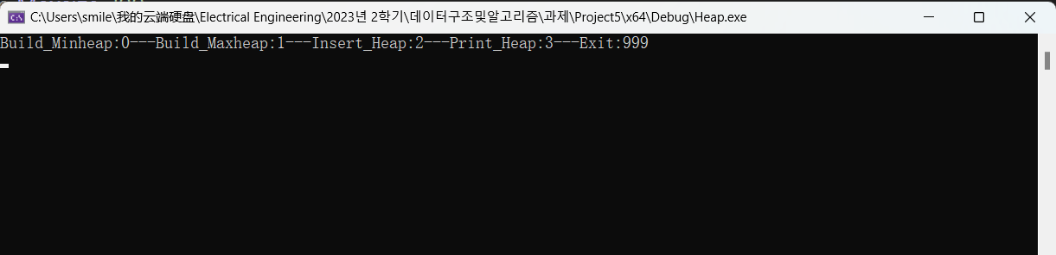

Inputting 0 will execute the Build_Heap function. This function opens the data.txt file, reads the data into an array, performs min-heap sorting, and finally copies the sorted array back to the data.txt file.

As shown below, the first number indicates the size of the data, while the rest represent the data: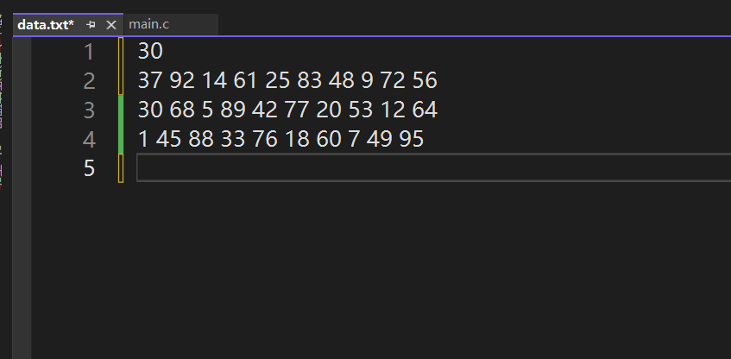

When you input 0 in the console, the program will perform a min-heap sort on the data in data.txt.

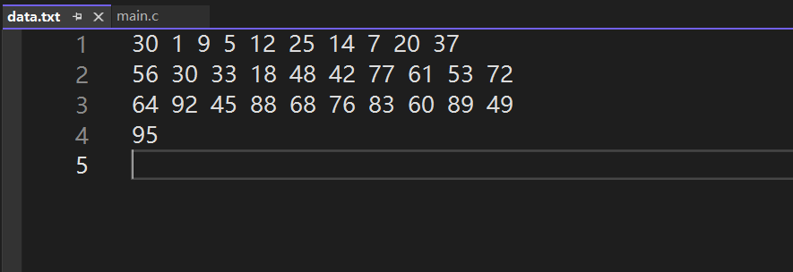

Inputting 1 will execute the Build_Heap function. This function opens the data.txt file, reads the data into an array, performs a max-heap sort, and finally copies the sorted array back to the data.txt file.

As shown below, the first number indicates the size of the data, while the rest represent the data: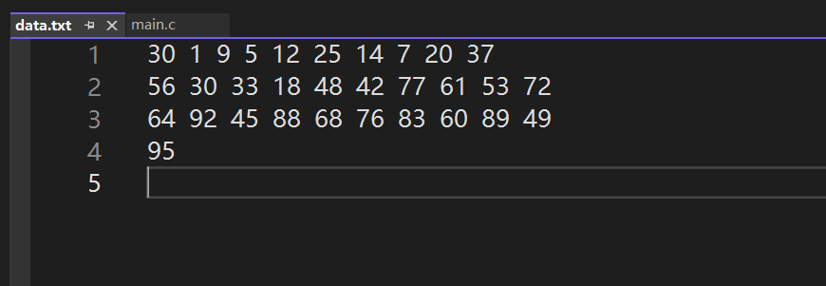

When you input 1 in the console, the program will perform a max-heap sort on the data in data.txt.

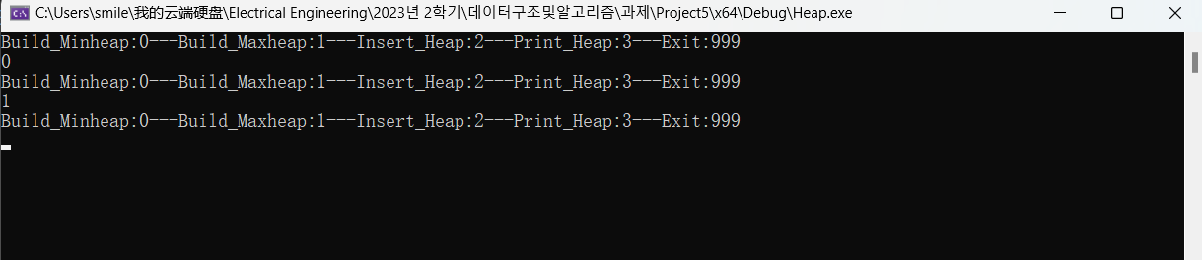

The result is as follows:

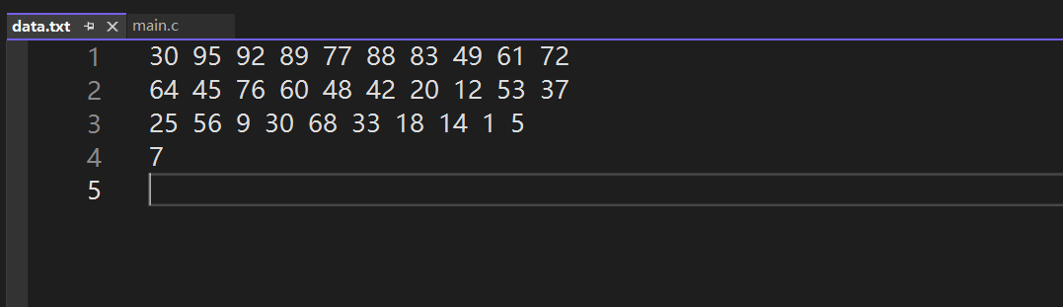

Inputting 2 will execute the Insert_Heap function. This function first copies the data from data.txt into an array. Then, it inserts the desired data into the array, performs a large heap sort on the array, and finally copies the sorted data back to the data.txt file.

The original data is as follows, with the first number indicating the size of the data and the rest representing the data:

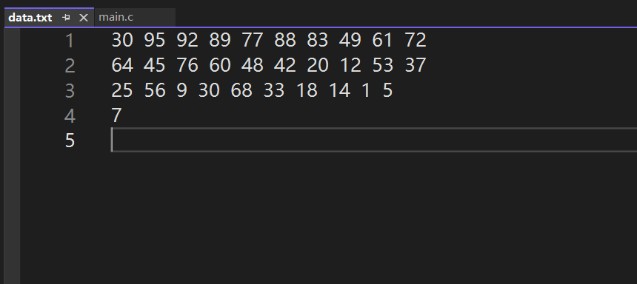

Inputting 2 and inserting 56：

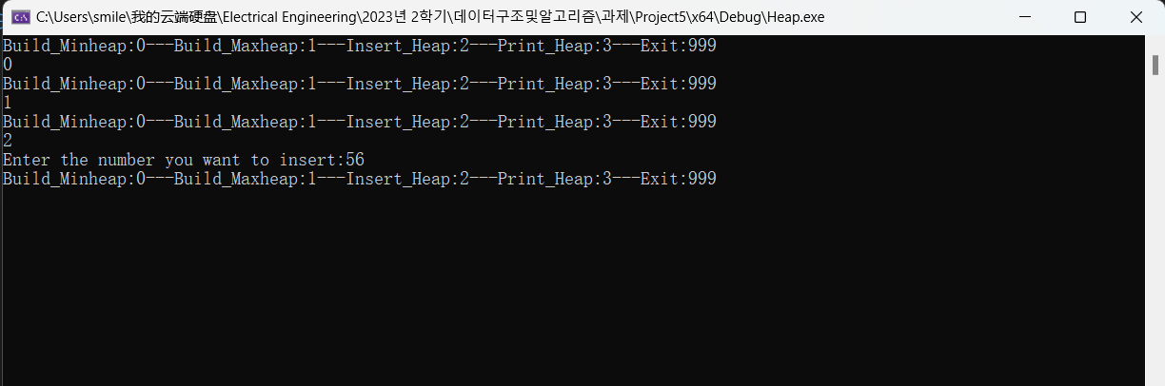

The sorted data is as follows:

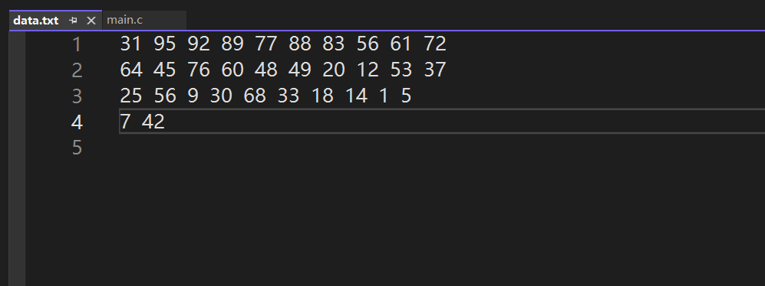

Inputting 3 will execute the Print_Heap function, which will print the data from data.txt.