Quick Sort is a sorting algorithm that involves selecting a pivot element and comparing it with other elements to create a temporary sequence. The algorithm repeats this process by selecting another pivot until the entire sequence is sorted. In the programming, the algorithm chooses the lowest position number in the array as the initial pivot.

The first step is to divide the array into two parts: the left side of the pivot, where elements are smaller than the pivot, and the right side, where elements are larger than or equal to the pivot. This division is achieved using an exchange function. The algorithm then recursively applies itself to both the left and right subarrays.

Run the program and it will prompt you to enter numbers for sorting. You can enter up to a maximum of 16 numbers, and the input process concludes when you press Enter after entering 0.

Enter 37 12 56 23 9 41 72 5 68 30 14 61 49 18 44 88. Taking 37 as the pivot and arrange the sequence:

18 12 14 23 9 30 5 37 68 72 41 61 49 56 44 88.

Second call QuickSort:5 12 14 9 18 30 23 37 68 72 41 61 49 56 44 88

5 12 14 9 18 30 23 37 68 72 41 61 49 56 44 88

5 9 12 14 18 30 23 37 68 72 41 61 49 56 44 88

5 9 12 14 18 23 30 37 68 72 41 61 49 56 44 88

5 9 12 14 18 23 30 37 44 56 41 61 49 68 72 88

5 9 12 14 18 23 30 37 41 44 56 61 49 68 72 88

5 9 12 14 18 23 30 37 41 44 49 56 61 68 72 88

The result will be:

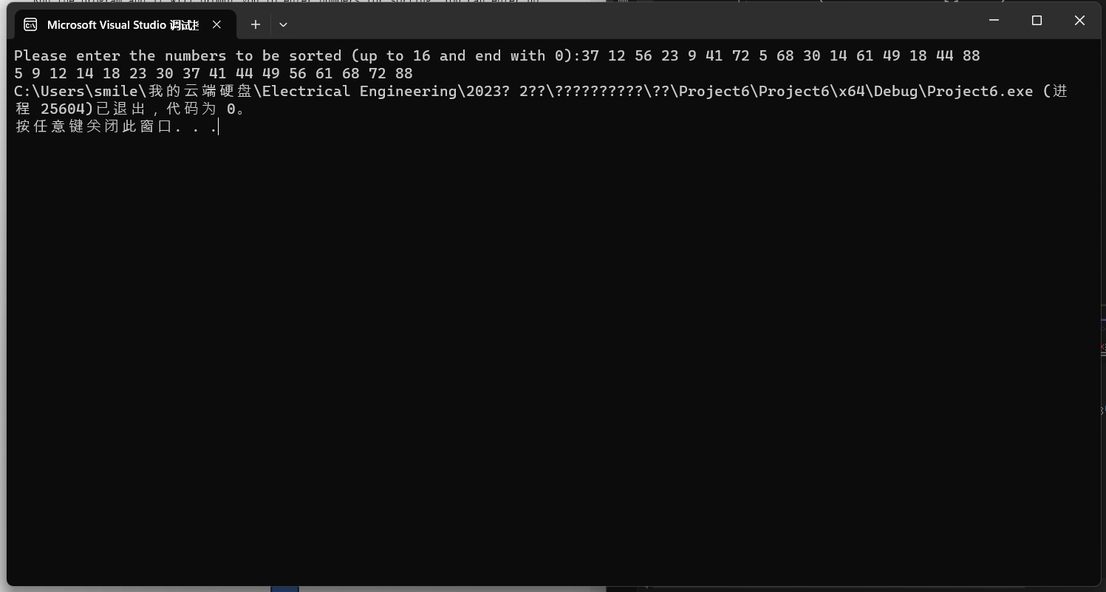

If each selected "pivot" results in a highly uneven division of the sequence to be sorted, it leads to an increase in recursive depth, reducing the efficiency of the algorithm. On the contrary, if each selected "pivot" results in a uniformly divided sequence, the recursion depth is minimized, and the algorithm's efficiency is maximized. The average time complexity is O(nlogn).