**DL Practical No. 3**

**Code :**

import numpy as np

import pandas as pd

import matplotlib.pyplot as plt

from sklearn.preprocessing import MinMaxScaler

from tensorflow.keras.models import Sequential

from tensorflow.keras.layers import SimpleRNN, Dense

**# Step 1: Load and clean training data**

df_train = pd.read_csv(r'C:\Users\ASUS\Downloads\Google_stock_price\Google_Stock_Price_Train.csv')

# Convert 'Open' to float if it's a string with commas

if df_train['Open'].dtype == 'object':

df_train['Open'] = df_train['Open'].str.replace(',', '').astype(float)

**# Step 2: Scale training data**

training_set = df_train['Open'].values.reshape(-1, 1)

scaler = MinMaxScaler(feature_range=(0, 1))

training_set_scaled = scaler.fit_transform(training_set)

**# Step 3: Create sequences for RNN**

X_train, y_train = [], []

time_step = 60

for i in range(time_step, len(training_set_scaled)):

X_train.append(training_set_scaled[i-time_step:i, 0])

y_train.append(training_set_scaled[i, 0])

X_train, y_train = np.array(X_train), np.array(y_train)

X_train = X_train.reshape((X_train.shape[0], X_train.shape[1], 1))

**# Step 4: Build and train the RNN model**

model = Sequential()

model.add(SimpleRNN(units=50, activation='tanh', return_sequences=False, input_shape=(X_train.shape[1], 1)))

model.add(Dense(1))

model.compile(optimizer='adam', loss='mean_squared_error')

model.fit(X_train, y_train, epochs=20, batch_size=32)

**# Step 5: Load and clean test data**

df_test = pd.read_csv(r'C:\Users\ASUS\Downloads\Google_stock_price\Google_Stock_Price_Test.csv')

if df_test['Open'].dtype == 'object':

df_test['Open'] = df_test['Open'].str.replace(',', '').astype(float)

real_stock_price = df_test['Open'].values.reshape(-1, 1)

**# Step 6: Prepare test input**

total_data = pd.concat((df_train['Open'], df_test['Open']), axis=0)

inputs = total_data[len(total_data) - len(df_test) - time_step:].values

inputs = inputs.reshape(-1, 1)

inputs_scaled = scaler.transform(inputs)

X_test = []

for i in range(time_step, len(inputs_scaled)):

X_test.append(inputs_scaled[i-time_step:i, 0])

X_test = np.array(X_test)

X_test = X_test.reshape((X_test.shape[0], X_test.shape[1], 1))

**# Step 7: Predict**

predicted_stock_price = model.predict(X_test)

predicted_stock_price = scaler.inverse_transform(predicted_stock_price)

**# Step 8: Plot the results**

plt.figure(figsize=(12, 6))

plt.plot(real_stock_price, color='blue', label='Real Google Stock Price')

plt.plot(predicted_stock_price, color='red', label='Predicted Google Stock Price')

plt.title('Google Stock Price Prediction using RNN')

plt.xlabel('Time')

plt.ylabel('Stock Price')

plt.legend()

plt.grid(True)

plt.show()

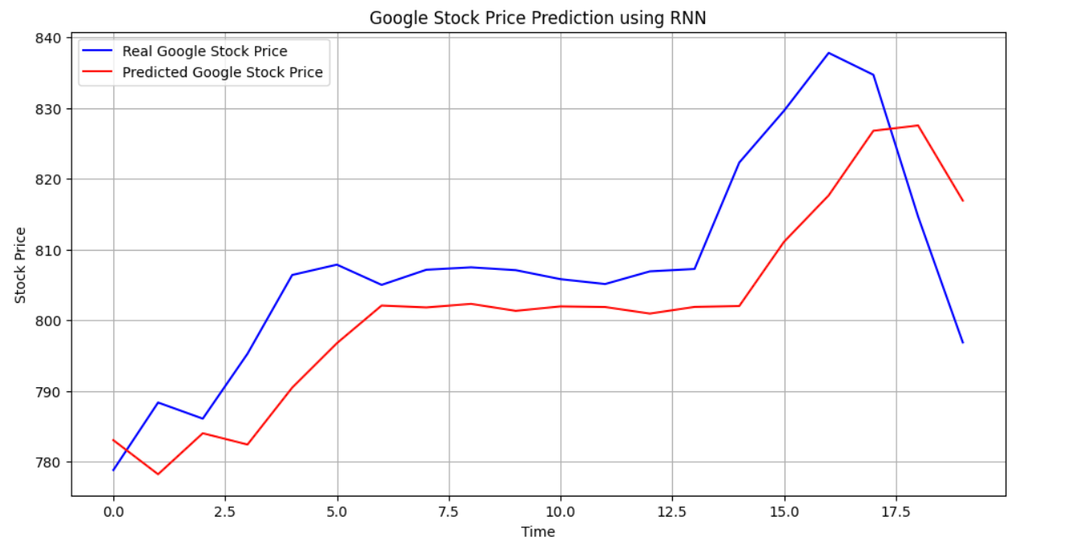**Output -**