Design and apply context-aware access
controls based on user identity, device
posture, location, and application risk

List of Teammates

S.NO | NAME | COLLEGE | CONTACT
1 | KALAIYARASI K | PIONEER COLLAGE OF ARTS AND SCIENCE | smilekalai143@gmail.com
2 | AKASH M | PIONEER COLLAGE OF ARTS AND SCIENCE | akashka446@gmail.com
3 | DHARSHINI R | PIONEER COLLAGE OF ARTS AND SCIENCE | dharshani2815@gmail.com
4 | BALA SUNDAR C | PIONEER COLLAGE OF ARTS AND SCIENCE | kbdbala7@gmail.com

Introduction
In today’s digital landscape, organizations increasingly rely on cloud services, mobile devices, and remote connectivity to conduct business operations. While these technologies improve productivity and accessibility, they also introduce significant security challenges. Traditional security models rely heavily on perimeter-based defenses such as firewalls and network segmentation. However, these approaches assume that users and devices inside the network can be trusted, which is no longer a valid assumption in modern environments.
To address these challenges, security frameworks are shifting toward context-aware and adaptive access control systems. Context-aware access control evaluates multiple contextual attributes before allowing a user to access an application or resource. Instead of granting access solely based on login credentials, the system considers factors such as user identity, device security posture, geographic location, and the sensitivity or risk level of the requested application.
User identity verification ensures that the person requesting access is authenticated through secure methods such as multi-factor authentication. Device posture assessment checks whether the device meets security requirements, including updated operating systems, antivirus protection, and compliance policies. Location-based checks help detect suspicious login attempts from unusual or high-risk regions. Additionally, application risk classification allows the system to apply stricter controls when users attempt to access critical or sensitive systems.
This project aims to design and implement a context-aware access control model that integrates these contextual factors to make dynamic and intelligent access decisions. The proposed system enhances organizational security by continuously evaluating trust levels and adjusting permissions accordingly. By implementing such a framework, organizations can reduce the risk of data breaches while enabling secure access to resources from diverse environments.

Abstract
With the rapid growth of cloud computing, remote work, and distributed IT environments, traditional perimeter-based security models are no longer sufficient to protect organizational resources. Modern cybersecurity approaches emphasize context-aware access control, which dynamically evaluates multiple factors before granting or denying access to systems and applications. This project focuses on designing and implementing a context-aware access control framework that considers key attributes such as user identity, device posture, geographic location, and application risk level.
The proposed system evaluates these contextual signals in real time to make intelligent authorization decisions. By integrating identity verification, device compliance checks, location awareness, and risk assessment mechanisms, the framework ensures that only trusted users with secure devices can access sensitive applications. The system also adapts access privileges depending on the risk level of the application being requested. This approach helps organizations strengthen security, reduce unauthorized access, and support flexible working environments. The project demonstrates how context-aware policies can enhance protection in modern enterprise networks while maintaining usability for legitimate users.

Use Case Scenarios with Solutions
1. Remote Employee Accessing Company Email
Scenario:
An employee tries to access the organization’s email system from a personal laptop while working remotely from home.
Context Factors Evaluated:
- User Identity: Verified through username, password, and multi-factor authentication (MFA).
- Device Posture: System checks if the device has updated antivirus software, OS patches, and encryption enabled.
- Location: Login attempt from the employee’s usual home location.
- Application Risk: Email system has medium risk.
Access Control Decision:
- Access is granted if identity is verified and the device meets security requirements.
- If the device is not compliant, the system allows limited access via a secure web interface.
Solution:
Implement MFA authentication, device compliance checks, and conditional access policies that allow secure remote email access only from compliant devices.

2. Login Attempt from an Unusual Geographic Location
Scenario:
A user account that normally logs in from India attempts to access corporate resources from another country.
Context Factors Evaluated:
- User Identity: Valid credentials are entered.
- Device Posture: Device appears compliant.
- Location: Login from a high-risk or unfamiliar country.
- Application Risk: Internal HR application.
Access Control Decision:
- System flags the login as suspicious.
- Additional authentication is required before granting access.
Solution:
Use location-based risk detection and enforce step-up authentication (extra MFA verification) or temporarily block access until the user confirms the login attempt.

3. Accessing Sensitive Financial Application
Scenario:
A finance manager attempts to access a financial management system containing sensitive company data.
Context Factors Evaluated:
- User Identity: Verified as finance manager.
- Device Posture: Corporate laptop with security compliance.
- Location: Inside corporate network.
- Application Risk: High-risk financial application.
Access Control Decision:
- Access is allowed but requires strong authentication and session monitoring.
Solution:
Apply strict access policies, including:
- Multi-factor authentication
- Role-based access control
- Continuous session monitoring
- Activity logging for audit purposes

4. Employee Using an Unsecured Public Wi-Fi Network
Scenario:
An employee attempts to access internal applications from a public Wi-Fi network at an airport.
Context Factors Evaluated:
- User Identity: Valid login credentials.
- Device Posture: Device compliant.
- Location/Network: Public or unsecured network detected.
- Application Risk: Internal project management tool.
Access Control Decision:
- Access allowed only through a secure connection.
Solution:
Require the user to connect through a Virtual Private Network (VPN) before accessing internal resources.
The system blocks direct access from unsecured networks.

5. Non-Compliant Device Attempting to Access Company Resources
Scenario:
An employee attempts to access company applications from a device that does not meet security standards (outdated OS and no antivirus).
Context Factors Evaluated:
- User Identity: Valid employee.
- Device Posture: Device fails compliance checks.
- Location: Trusted office network.
- Application Risk: Medium risk.
Access Control Decision:
- Access denied or restricted until the device becomes compliant.
Solution:
Implement device posture enforcement policies that:
- Block access from non-compliant devices
- Redirect the user to a device remediation portal
- Allow access only after security updates are installed

STAGE 1:
TITLE:
Design and apply context-aware access controls based on user identity, device posture, location, and application risk
OVERVIEW:
In modern digital environments, organizations increasingly rely on cloud platforms, mobile devices, and remote work infrastructure. Traditional security models that rely only on network boundaries or passwords are no longer sufficient to protect sensitive data and applications. As a result, organizations are adopting context-aware access control systems that evaluate multiple contextual factors before granting or denying access to resources.
This project focuses on designing a context-aware access control framework that makes dynamic access decisions based on several important parameters: user identity, device posture, geographic location, and application risk level. Instead of granting access simply after successful login, the system continuously analyzes these contextual elements to determine whether access should be allowed, restricted, or denied.
The first factor, user identity, ensures that the person requesting access is authenticated through secure methods such as strong passwords, multi-factor authentication (MFA), or identity verification systems. This helps confirm that only legitimate users are attempting to access organizational resources.
The second factor, device posture, evaluates the security status of the device used for access. The system checks whether the device has updated operating systems, active antivirus protection, security patches, and compliance with organizational security policies. Devices that do not meet these requirements may receive restricted access or be blocked completely.
The third factor, location awareness, analyzes the geographic location or network environment from which the access request originates. If the login attempt occurs from an unusual location, unknown network, or high-risk region, the system may trigger additional security verification or deny access to prevent potential cyber threats.
The fourth factor, application risk level, categorizes applications based on the sensitivity of the data they contain. For example, financial systems and administrative dashboards are considered high-risk applications and therefore require stricter access policies compared to low-risk systems like public information portals.
By combining these contextual signals, the proposed system can make intelligent and adaptive access control decisions. This approach helps organizations improve security, reduce unauthorized access, and protect critical data while still allowing employees to work flexibly from different locations and devices.
Overall, the project demonstrates how context-aware access control mechanisms can enhance modern cybersecurity strategies by implementing dynamic, risk-based authentication and authorization policies that adapt to changing user behavior and environmental conditions.

LIST OF VULNERABILITY:
S.NO | VULNERABILITY NAME | CWE NO
1 | Broken Access Control | CWE 40
2 | Security Misconfiguration | CWE 16
3 | Software Supply Chain Failures | CWE 6
4 | Cryptographic Failures | CWE 32
5 | Injection | CWE 37
6 | Insecure Design | CWE 39
7 | Authentication Failures | CWE 36
8 | Software or Data Integrity Failures | CWE 14
9 | Security Logging and Alerting Failures | CWE 5
10 | Mishandling of Exceptional Conditions | CWE 24

Vulnerability Reports:
. Vulnerability Name: Broken Access Control
CWE: 284
OWASP Category: A01:2021 – Broken Access Control
Description:
Broken Access Control occurs when a web application fails to properly enforce restrictions on authenticated users. Attackers can exploit these weaknesses to access unauthorized data, modify permissions, or perform actions outside their privileges.
Business Impact:
Attackers may access confidential information, modify other users’ data, or perform administrative functions. This can lead to data leakage, financial loss, and loss of user trust.
Vulnerability Path:
http://testfire.net/
Vulnerability Parameter:
http://testfire.net/admin
Steps to Reproduce:
• Access the web application login page.
• Login using a normal user account.
• Manually change the URL to an admin page such as /admin.
• If access is granted without proper authorization checks, the vulnerability exists.
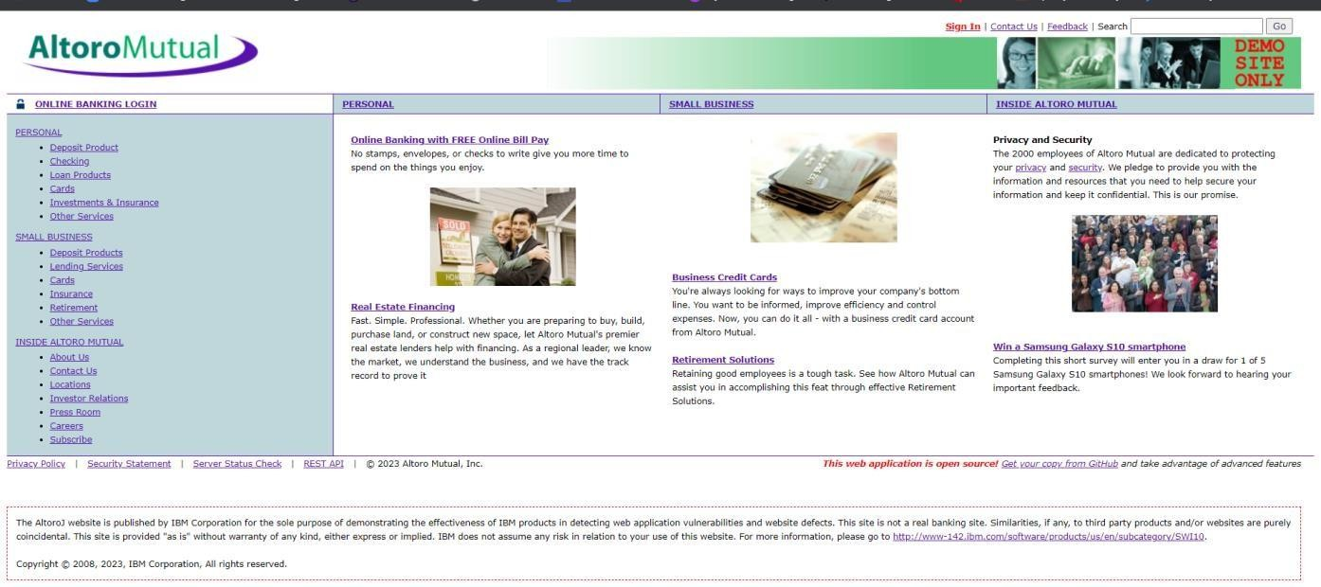
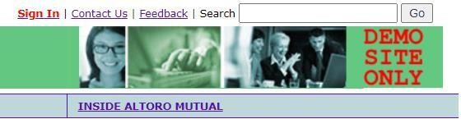
Recommendation:
• Implement proper role-based access control (RBAC).
• Verify user authorization at both client and server sides.
• Use secure session management mechanisms.
2. Vulnerability Name: Security Misconfiguration
CWE: 16
OWASP Category: A05:2021 – Security Misconfiguration
Description:
Security misconfiguration occurs when security settings are improperly configured or left as default. This includes unnecessary services, default credentials, exposed error messages, and unpatched software.
Business Impact:
Attackers may exploit misconfigured systems to gain unauthorized access, extract sensitive data, or execute malicious commands.
Vulnerability Path:
http://testfire.net/
Vulnerability Parameter:
Exposed configuration files or verbose error messages.
Steps to Reproduce:
• Access the application.
• Trigger an error by entering invalid data.
• Observe detailed server error messages revealing system information.

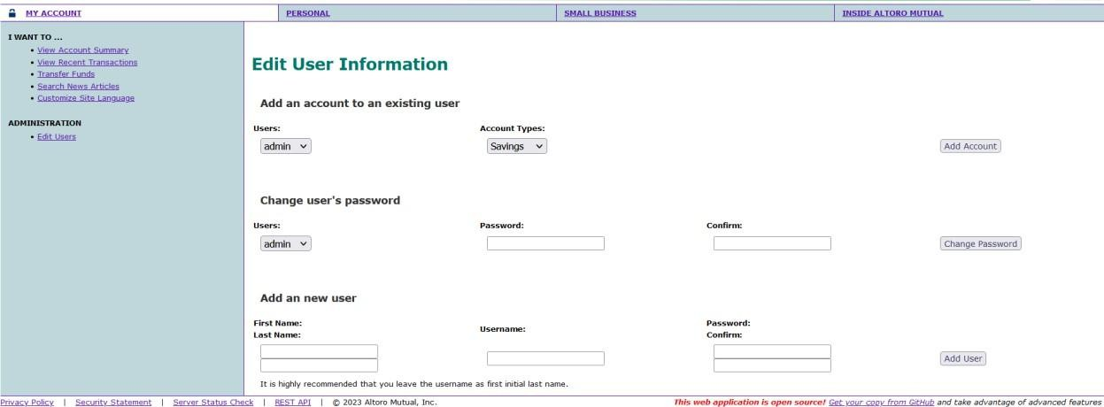

Recommendation:
• Disable unnecessary services and features.
• Remove default accounts and passwords.
• Configure proper error handling to hide sensitive details.
• Regularly update and patch systems.

3. Vulnerability Name: Software Supply Chain Failures
CWE: 829
OWASP Category: A06:2021 – Vulnerable and Outdated Components
Description:
This vulnerability occurs when an application uses third-party libraries or components that contain known security vulnerabilities.
Business Impact:
Attackers can exploit vulnerabilities in outdated libraries to compromise the application and gain access to sensitive information.
Vulnerability Path:
Application dependency components.
Vulnerability Parameter:
Outdated third-party libraries.
Steps to Reproduce:
• Scan the application using a vulnerability scanner.
• Identify outdated or vulnerable libraries.
• Compare versions with public vulnerability databases.
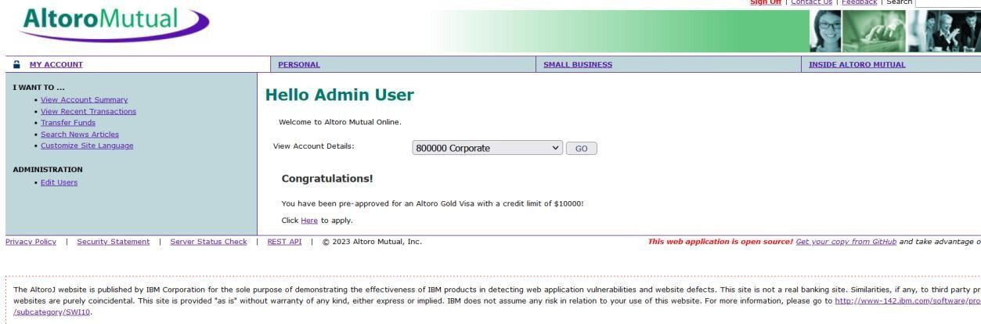
Recommendation:
• Regularly update third-party libraries.
• Use dependency management tools.
• Monitor vulnerability databases for updates.

4. Vulnerability Name: Cryptographic Failures
CWE: 327
OWASP Category: A02:2021 – Cryptographic Failures
Description:
Cryptographic failures occur when sensitive data is not properly encrypted or when weak encryption algorithms are used.
Business Impact:
Sensitive information such as passwords, personal data, and financial records may be exposed to attackers.
Vulnerability Path:
http://testfire.net/
Vulnerability Parameter:
Data transmitted without encryption.
Steps to Reproduce:
• Monitor network traffic using a proxy tool.
• Observe sensitive information

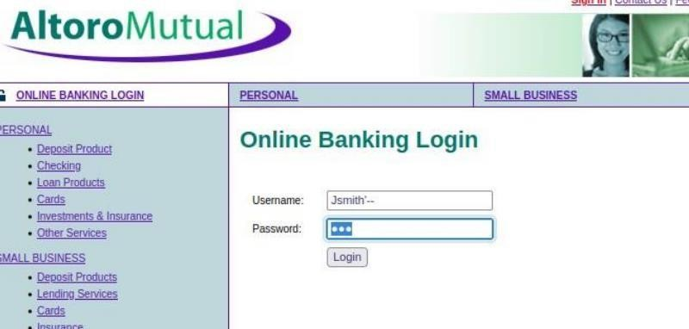

Recommendation:
• Use strong encryption algorithms such as AES.
• Implement HTTPS using TLS.
• Protect sensitive data during storage and transmission.

5. Vulnerability Name: Injection
CWE: 89
OWASP Category: A03:2021 – Injection
Description:
Injection vulnerabilities occur when untrusted data is sent to an interpreter as part of a command or query.
Business Impact:
Attackers can manipulate queries to access unauthorized data or execute malicious commands on the database.
Vulnerability Path:
http://testfire.net/login.jsp
Vulnerability Parameter:
Username or password fields.
Steps to Reproduce:
• Access the login page.
• Enter the payload ' OR '1'='1 in the username field.
• If login succeeds without valid credentials, the system is vulnerable.
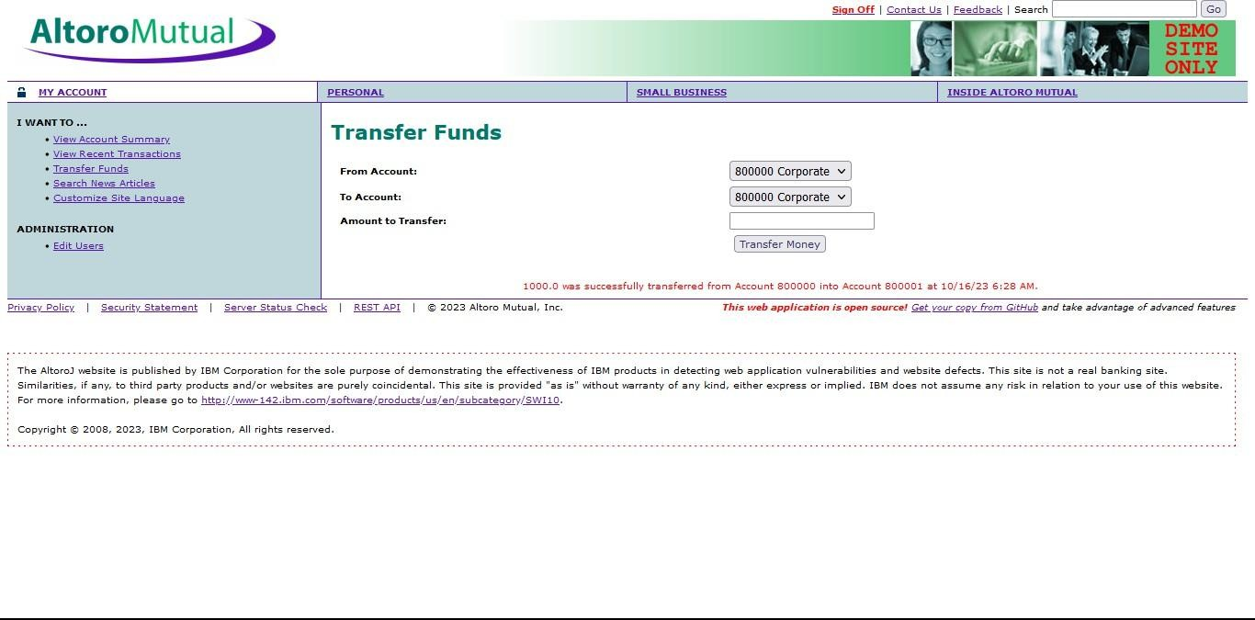

Recommendation:
• Use prepared statements and parameterized queries.
• Validate and sanitize all inputs.
• Use ORM frameworks where possible.

6. Vulnerability Name: Insecure Design
CWE: 657
OWASP Category: A04:2021 – Insecure Design
Description:
Insecure design refers to flaws in the architecture or design of an application that make it vulnerable to attacks.
Business Impact:
Attackers may exploit design weaknesses to bypass security controls or access restricted functionality.
Vulnerability Path:
Application workflow.
Vulnerability Parameter:
Business logic flaws.
Steps to Reproduce:
• Analyze the application workflow.
• Identify missing security checks during critical operations.
• Attempt unauthorized actions without proper validation.

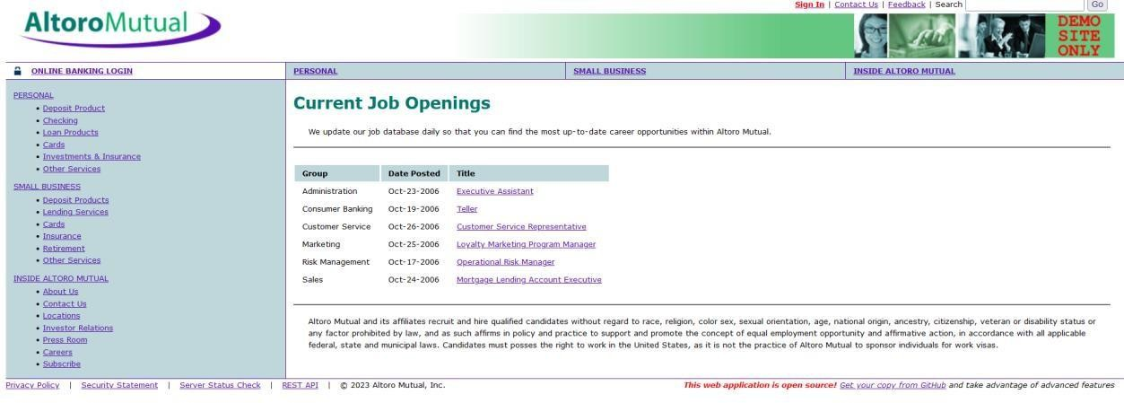

Recommendation:
• Apply secure design principles.
• Conduct threat modeling during development.
• Perform security testing throughout the development lifecycle.

7. Vulnerability Name: Authentication Failures
CWE: 287
OWASP Category: A07:2021 – Identification and Authentication Failures
Description:
Authentication failures occur when authentication mechanisms are incorrectly implemented, allowing attackers to compromise passwords or session tokens.
Business Impact:
Attackers may gain unauthorized access to user accounts and sensitive data.
Vulnerability Path:
http://testfire.net/login.jsp
Vulnerability Parameter:
Weak password authentication.
Steps to Reproduce:
• Attempt multiple login attempts using different passwords.
• If no account lockout mechanism exists, brute-force attacks are possible.
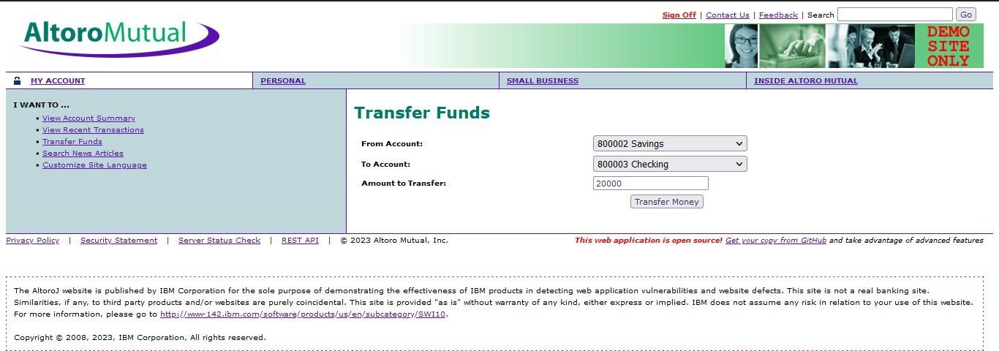

Recommendation:
• Implement strong password policies.
• Enable account lockout mechanisms.
• Use multi-factor authentication (MFA).

8. Vulnerability Name: Software or Data Integrity Failures
CWE: 345
OWASP Category: A08:2021 – Software and Data Integrity Failures
Description:
This vulnerability occurs when software updates or critical data are not properly verified for integrity.
Business Impact:
Attackers may inject malicious code into software updates or manipulate application data.
Vulnerability Path:
Software update mechanism.
Vulnerability Parameter:
Unverified update packages.
Steps to Reproduce:
• Analyze software update processes.
• Check whether digital signatures are verified.
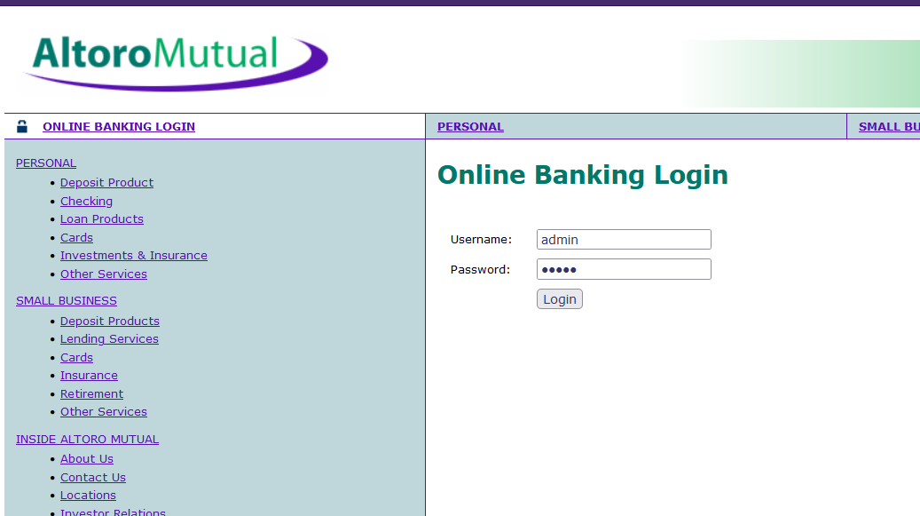

Recommendation:
• Use digital signatures for updates.
• Validate software integrity before installation.
• Secure the CI/CD pipeline.

9. Vulnerability Name: Security Logging and Monitoring Failures
CWE: 778
OWASP Category: A09:2021 – Security Logging and Monitoring Failures
Description:
This vulnerability occurs when security-related events are not logged or monitored properly.
Business Impact:
Attackers may perform malicious activities without detection, leading to prolonged system compromise.
Vulnerability Path:
Application logging system.
Vulnerability Parameter:
Missing logs for login attempts.
Steps to Reproduce:
• Perform multiple login attempts.
• Check system logs for recorded activities.


Recommendation:
• Implement centralized logging systems.
• Monitor logs regularly.
• Configure alerts for suspicious activities.

10. Vulnerability Name: Mishandling of Exceptional Conditions
CWE: 703
OWASP Category: Security Error Handling Issues
Description:
This vulnerability occurs when applications improperly handle errors or exceptional conditions, exposing sensitive information.
Business Impact:
Attackers may gain insights into system architecture, database structure, or internal processes.
Vulnerability Path:
Application error pages.
Vulnerability Parameter:
Invalid inputs causing server errors.
Steps to Reproduce:

• Enter invalid or unexpected input in application forms.
• Observe detailed error messages displayed by the server.

Recommendation:
• Implement proper error handling mechanisms.
• Display generic error messages to users.
• Log detailed errors securely on the server side.

NESSUS SCAN REPORT:
NESSUS SCAN REPORT:
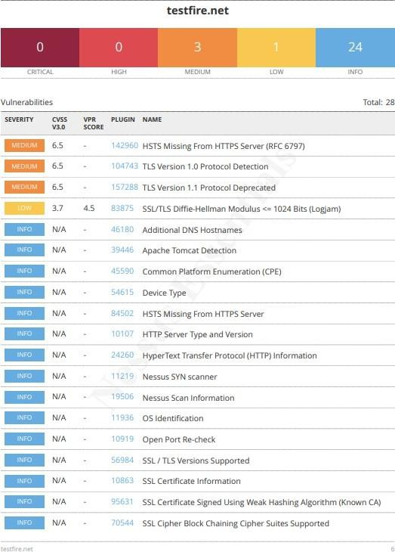
Nessus Scan Report:

Stage – 2
Overview
An overview of a Nessus vulnerability scan generally includes the following important steps and processes.
1. Preparation
Define Objectives:
First, determine the scope and objectives of the scan. Identify which systems, applications, or networks need to be assessed and what types of vulnerabilities should be detected.
System Access:
Ensure that the necessary permissions and access rights are available to scan the target systems or networks.

2. Configuration
Set Up Scan Policy:
Create a scan policy that defines the parameters of the scan. This includes the vulnerability checks to perform, scanning frequency, and specific configurations.
Define Target Assets:
Specify the IP addresses, hostnames, or network ranges of the systems that need to be scanned.

3. Scanning
Initiate Scan:
Start the Nessus scan using the configured policy and defined target assets. Nessus will systematically analyze the target systems and identify vulnerabilities using its plugins and predefined policies.

4. Vulnerability Identification
Nessus performs a comprehensive security assessment by checking for vulnerabilities, misconfigurations, open ports, and other potential security issues. During the scan, vulnerabilities are categorized according to severity levels, which helps security teams prioritize remediation activities.

5. Reporting
After the scan is completed, Nessus generates detailed reports that list all discovered vulnerabilities. These reports typically include:
- Severity level of each vulnerability
- Recommended remediation actions
- Supporting evidence and technical details
Reports can also be exported in various formats such as PDF, HTML, or CSV.

6. Remediation
Review Findings:
IT and security teams analyze the Nessus reports to identify and prioritize vulnerabilities.
Remediation Steps:
Corrective actions are taken to fix or mitigate the vulnerabilities. These actions may include:
- Installing software patches
- Updating configurations
- Implementing additional security controls

7. Follow-Up
Regular Scanning:
Organizations should perform periodic Nessus scans to continuously monitor the security status of their infrastructure. This helps detect new vulnerabilities and track improvements.
Integration:
Nessus can also be integrated with other security tools or workflows to automate vulnerability management and response processes.

8. Compliance Auditing
If compliance checks are included in the scan policy, the results should be reviewed to ensure that systems comply with required security standards and regulations.

9. Documentation
Maintain proper records of scan results, remediation activities, and compliance reports. Documentation is important for audits and security reporting.

10. User Training
Ensure that IT administrators and security professionals are trained to effectively use Nessus and interpret scan results.

About Nessus
Nessus is a widely used vulnerability scanning tool designed to identify security weaknesses in computer systems and networks. Security professionals and organizations rely on Nessus to evaluate the security posture of their infrastructure and proactively detect vulnerabilities that attackers might exploit.
The following are key features of Nessus:
1. Vulnerability Assessment
Nessus performs vulnerability assessments by scanning target systems or networks to identify security weaknesses such as missing patches, misconfigurations, weak passwords, and other potential risks.

2. Network Scanning
Nessus can scan various types of network devices including:
- Servers
- Routers
- Switches
- Firewalls
It examines open ports, network services, and software running on target systems.

3. Plugin Architecture
Nessus uses a plugin-based architecture, allowing it to detect a wide variety of vulnerabilities. These plugins are updated regularly to include the latest vulnerability checks.

4. Compliance Auditing
Nessus can also evaluate systems against security standards and regulatory requirements such as:
- PCI-DSS
- CIS Benchmarks
This helps organizations ensure their systems meet compliance requirements.

5. Customization
Nessus scans can be customized based on organizational needs. Users can define scan policies, select target systems, and choose specific vulnerability categories to scan.

6. Reporting
Nessus provides detailed reports highlighting vulnerabilities, severity levels, and recommended remediation steps. These reports help security teams prioritize vulnerabilities.

7. Scanning Frequency
Organizations typically perform regular Nessus scans to continuously monitor their security posture and stay protected from emerging threats.

8. Integration
Nessus can be integrated with other security platforms to automate vulnerability scanning and management processes.

9. Licensing
Nessus provides both free and commercial versions.
The free version has limited features, while the commercial version offers advanced functionality and support.

10. User-Friendly Interface
Nessus includes a web-based interface, making it easy for both security professionals and IT administrators to operate the tool.

It is important to note that Nessus only identifies vulnerabilities; it does not fix them automatically. The responsibility for remediation lies with the organization's IT and security teams.

Vulnerability Summary
S.No | Vulnerability Name | Severity | Plugins
1 | Cross-Site Scripting (Stored) | Low | Web Application Scanner
2 | Broken Access Control | Medium | SSH Weak HMAC Algorithms Supported
3 | SQL Injection | Medium | N/A
4 | Broken Authentication | Low | HSTS Missing from Server
5 | Insecure Direct Object Reference | Info | Service Detection
6 | Security Misconfiguration | Low | SSL Cipher Block Chaining Cipher Suites
7 | Cross-Site Request Forgery | Low | HTTP Form-Based Authentication Detected
8 | Cleartext Transmission of Sensitive Information | Medium | Cleartext Transmission of Sensitive Information over HTTP
9 | Clickjacking | Info | HTML Rendering Layer Vulnerability
10 | Web Server Allows Password Auto-Completion | Low | SSL/TLS Diffie-Hellman Modulus ≤1024 Bits (Logjam)
Target Website: testfire.net
Target IP Address: 54.83.41.36
Vulnerability Reports
1. Vulnerability Name: Cross-Site Scripting (Stored)
Severity: Low
Plugin: Web Application Scanner
Port: N/A
Description
Cross-Site Scripting (XSS) occurs when a malicious script is injected into a trusted web application. In stored XSS, the malicious script is permanently stored in the application database, message boards, comment sections, or logs. When users access the affected page, the script executes in their browser.
Solution
• Use parameterized or prepared statements when interacting with databases.
• Sanitize and validate all user inputs before storing them in the database.
• Apply proper output encoding before displaying user-generated data.
• Implement security libraries or frameworks to prevent script execution.
Business Impact
Stored XSS can affect multiple users because the malicious script remains stored in the application. Attackers can steal session cookies, perform actions on behalf of victims, or access sensitive user data. If privileged users execute the malicious script, attackers may gain administrative privileges or confidential information.

2. Vulnerability Name: Broken Access Control
Severity: Medium
Plugin: SSH Weak HMAC Algorithms Supported
Port: N/A
Description
Broken access control occurs when authorization checks are not properly enforced. As a result, attackers can access resources or perform actions that should be restricted.
Solution
• Implement strong authentication and authorization mechanisms.
• Apply role-based access control (RBAC) to restrict permissions.
• Use secure session management techniques such as session expiration and token regeneration.
• Validate authorization checks on both client and server sides.
Business Impact
Broken access control may allow attackers to access confidential data, modify system settings, or perform administrative operations. This can lead to data breaches, financial loss, operational disruption, and reputational damage.

3. Vulnerability Name: SQL Injection
Severity: Medium
Plugin: N/A
Port: 80 / 443
Description
SQL Injection occurs when an application builds SQL queries using untrusted user input without proper validation or sanitization. Attackers can manipulate queries to access or modify database data.
Solution
• Use prepared statements and parameterized queries.
• Validate and sanitize user input before using it in database queries.
• Use stored procedures to separate SQL logic from application code.
• Implement strict input validation to enforce expected data formats.
Business Impact
SQL injection can lead to unauthorized access to databases, modification or deletion of data, and disclosure of sensitive information. It can result in data breaches, financial losses, legal penalties, and damage to the organization’s reputation.

4. Vulnerability Name: Broken Authentication
Severity: Low
Plugin: HSTS Missing from HTTPS Server
Port: 443
Description
Broken authentication vulnerabilities occur when authentication mechanisms are improperly implemented. Attackers may exploit weaknesses in session management or credential handling to gain unauthorized access.
Solution
• Implement multi-factor authentication (MFA).
• Enforce strong password policies.
• Securely store credentials using hashing algorithms.
• Deploy intrusion detection systems to monitor suspicious login activity.
Business Impact
Authentication vulnerabilities can allow attackers to compromise user accounts, steal personal information, or access sensitive organizational resources. This may lead to data breaches and loss of customer trust.

5. Vulnerability Name: Insecure Direct Object Reference (IDOR)
Severity: Info
Plugin: Service Detection
Port: 80 / 443
Description
Insecure Direct Object Reference occurs when an application exposes internal object identifiers, such as database keys or file references, without proper authorization checks.
Solution
• Implement proper access control validation.
• Use indirect object references instead of exposing database IDs.
• Apply parameterized queries and input validation.
• Monitor unauthorized access attempts and implement account lockout mechanisms.
Business Impact
Attackers can manipulate identifiers to access unauthorized resources or modify data belonging to other users. This can lead to exposure of sensitive information and compromise system integrity.

6. Vulnerability Name: Security Misconfiguration
Severity: Low
Plugin: SSL Cipher Block Chaining Cipher Suites
Port: 443
Description
Security misconfiguration occurs when system components such as servers, databases, or applications are improperly configured, exposing them to potential attacks.
Solution
• Implement strict configuration management policies.
• Follow vendor security guidelines when configuring systems.
• Perform regular security audits and compliance checks.
• Remove unnecessary services and default credentials.
Business Impact
Improper configurations can expose sensitive resources, making systems vulnerable to unauthorized access and attacks. This may result in service disruption, data leakage, and reputational damage.

7. Vulnerability Name: Cross-Site Request Forgery (CSRF)
Severity: Low
Plugin: HTTP Form-Based Authentication Detected
Port: 8080 / 443
Description
CSRF is an attack that tricks authenticated users into executing unwanted actions on a web application. Attackers typically exploit user trust through malicious links or scripts.
Solution
• Implement CSRF tokens for each request.
• Use SameSite cookies to restrict cross-site requests.
• Enable built-in CSRF protection features in web frameworks.
• Implement a Content Security Policy (CSP).
Business Impact
Successful CSRF attacks may cause unauthorized transactions, modification of user data, or compromise of administrative functions.

8. Vulnerability Name: Cleartext Transmission of Sensitive Information
Severity: Medium
Plugin: Cleartext Transmission of Sensitive Information over HTTP
Port: 443
Description
Sensitive information transmitted over unencrypted channels can be intercepted by attackers through network sniffing.
Solution
• Use secure encryption protocols such as TLS/SSL.
• Implement HTTPS for all web communications.
• Avoid transmitting sensitive information through insecure networks.
• Apply encryption and data masking techniques during transmission.
Business Impact
Cleartext transmission exposes sensitive information such as login credentials, financial data, or personal information. This can result in data breaches and identity theft.

9. Vulnerability Name: Clickjacking
Severity: Info
Plugin: HTML Rendering Layer Vulnerability
Port: 80 / 443
Description
Clickjacking occurs when attackers trick users into clicking hidden elements on a webpage. This is done by embedding a malicious page inside an invisible frame.
Solution
• Set the X-Frame-Options HTTP header to DENY or SAMEORIGIN.
• Implement frame-busting scripts to prevent framing attacks.
• Apply Content Security Policy (CSP) headers.
Business Impact
Clickjacking can trick users into performing unintended actions such as clicking malicious buttons or authorizing unauthorized transactions.

10. Vulnerability Name: Web Server Allows Password Auto-Completion
Severity: Low
Plugin: SSL/TLS Diffie-Hellman Modulus ≤1024 Bits (Logjam)
Port: 443
Description
Password auto-completion and weak cryptographic implementations may expose user credentials or reduce data security.
Solution
• Disable password auto-completion on sensitive forms.
• Implement strong encryption algorithms.
• Use secure cryptographic libraries and update them regularly.
• Apply proper key management practices.
Business Impact
Weak cryptographic mechanisms and password exposure may lead to unauthorized access, data compromise, and loss of user trust.

Stage – 3
Title
Design and Apply Context-Aware Access Controls Based on User Identity, Device Posture, Location, and Application Risk

Introduction
Context-aware access control represents one of the most advanced implementations of the Zero Trust security architecture. Traditional security models rely heavily on static authentication mechanisms such as usernames and passwords. However, in modern enterprise environments where users access resources from multiple devices and locations, this approach is insufficient to protect sensitive data and systems.
Context-aware access control introduces a dynamic and intelligent decision-making mechanism that evaluates multiple contextual signals before granting access to an application. Instead of relying on a single authentication factor, the system evaluates factors such as user identity, device security posture, geographic location, and application risk level. Based on these parameters, the system decides whether to allow access, deny access, restrict functionality, or request additional verification.
This adaptive approach ensures that the security system continuously evaluates risk levels and responds accordingly, creating a flexible yet highly secure access control environment.

Integration with Identity and Security Infrastructure
The implementation of context-aware access control requires seamless integration with the organization’s identity and security infrastructure. Solutions such as Zscaler Private Access (ZPA) act as an access broker between users and applications.
ZPA integrates with Identity Providers (IdP) such as:
- Microsoft Azure Active Directory
- Okta
These integrations use authentication protocols such as Security Assertion Markup Language (SAML) to verify user identity and enforce strong authentication mechanisms like Multi-Factor Authentication (MFA).
When a user authenticates, the system retrieves detailed identity attributes including:
- User role
- Department
- Access privileges
- Group membership
For example, a policy could allow only members of the Finance-Payroll group to access a payroll management application. This ensures that access permissions are aligned with organizational roles and responsibilities.

Device Posture Verification
A verified user identity alone is not sufficient if the device being used is compromised. Therefore, device posture assessment plays a crucial role in context-aware security.
The system continuously evaluates the health and security status of the endpoint device through integration with Endpoint Detection and Response (EDR) and Mobile Device Management (MDM) platforms such as:
- CrowdStrike Falcon
- SentinelOne
- Jamf
- Microsoft Intune
Device posture checks typically evaluate the following parameters:
- Disk encryption status (BitLocker or FileVault)
- Antivirus protection status and updates
- Operating system patch level
- Firewall status
- Detection of rooted or jailbroken devices
- Risk scores from EDR security tools
If a device fails these checks, the policy engine may:
- Block application access completely
- Provide limited remediation access
- Redirect the user to update security settings
This ensures that insecure devices cannot compromise critical systems.

Location and Network Context
The geographic and network location of the user also plays an important role in access decisions.
For example, a finance manager accessing the payroll system from a trusted office network presents minimal risk. However, the same login attempt from an unknown country or anonymized network could indicate suspicious activity.
Context-aware access control policies can evaluate factors such as:
- Geographic location of the user
- Known corporate networks
- Home or trusted IP addresses
- Public Wi-Fi networks
- Use of anonymizing VPN services
Based on these conditions, the system may enforce additional security measures such as:
- Step-up authentication
- Restricted application permissions
- Temporary access denial
This approach prevents unauthorized access attempts originating from suspicious locations.

Application Risk Classification
Not all enterprise applications have the same level of sensitivity. Therefore, context-aware systems classify applications based on their risk levels.
Applications are typically categorized into:
Risk Level | Example Applications
Low Risk | Internal wikis, employee portals
Medium Risk | Internal collaboration tools
High Risk | Customer databases, financial systems
Critical Risk | Source code repositories, payment systems
By classifying applications according to their importance and sensitivity, security policies can be tailored accordingly.
For example:
- Low-risk applications may require only basic authentication.
- High-risk applications may require multiple contextual checks, such as verified identity, secure device posture, trusted location, and time-based restrictions.
This ensures that critical business resources receive stronger protection.

Policy Implementation
Within ZPA, administrators can configure access policies using conditional logic.
Example policy rule:
Policy Example 1
Allow access if:
- User belongs to a specific group
- Device posture is compliant
- Location is not restricted
- Application risk level is low
Policy Example 2
Allow access to a high-risk application only if:
- User belongs to an authorized group
- Device security level is highly secure
- Access is from a corporate network
- Login occurs during business hours
If the user attempts access remotely, the system may require step-up authentication such as hardware token verification.
Through these layered policies, organizations implement the core principle of Zero Trust Architecture:
“Never trust, always verify.”

Conclusion
Stage 1: Conclusion
Web application testing is an essential process that ensures the reliability, functionality, and security of web-based software systems. By evaluating user interfaces, functionality, performance, and security vulnerabilities, organizations can identify potential issues before they impact end users.
This process improves the overall quality of web applications and strengthens their resistance to cyber threats. As online services continue to grow, effective web application testing remains a critical factor in delivering secure and reliable digital experiences.

Stage 2: Conclusion
The vulnerability assessment conducted using Nessus Vulnerability Scanner provided valuable insights into the security status of the tested website. The scan identified multiple vulnerabilities categorized according to severity levels, enabling security teams to prioritize remediation activities.
Recommended corrective measures include applying software patches, updating configurations, and implementing stronger security controls. The report also emphasizes adherence to security standards and best practices, including guidelines from OWASP Foundation.
Overall, the report highlights the importance of continuous monitoring, periodic vulnerability assessments, and proactive security practices to maintain a strong cybersecurity posture.

Stage 3: Conclusion
The deployment of Zscaler Private Access represents a significant transition from traditional network-based security models to a modern identity-centric Zero Trust architecture.
By implementing least-privilege access policies and making private applications invisible to the public internet, this solution significantly reduces the risk of unauthorized access and lateral movement within the network.
Additionally, the platform enhances security while providing a seamless and efficient access experience for remote and distributed employees. The elimination of traditional VPN dependency simplifies IT infrastructure management while improving visibility into user activity.
Overall, the implementation establishes a scalable and secure foundation for future digital transformation initiatives.

Future Scope
Stage 1 – Future Scope of Web Application Testing
The future of web application testing is rapidly evolving as internet usage and digital platforms continue to expand.
Key developments include:
- Increased demand for testing due to the growth of online services
- Integration of advanced technologies such as AI, IoT, and blockchain
- Greater focus on cybersecurity and data protection
- Increased need for cross-browser and mobile compatibility testing
- Enhanced performance testing to handle high user traffic

Stage 2 – Future Scope of Vulnerability Testing
The field of vulnerability assessment is expected to grow significantly due to increasing cybersecurity threats and the expansion of digital infrastructures.
Future developments may include:
- AI-driven vulnerability detection using machine learning algorithms
- Security testing for IoT devices and mobile applications
- Security validation for blockchain and cryptocurrency platforms
- Security evaluation of serverless computing architectures
- Protection of containerized environments using tools like Docker and Kubernetes
These advancements will improve the ability to detect and mitigate emerging cyber threats.

Stage 3 – Future Scope of Context-Aware Access Control
The implementation of ZPA creates opportunities for further security enhancements within the organization.
Future improvements may include:
- Integration with Zscaler Internet Access (ZIA) to build a unified Secure Access Service Edge (SASE) platform
- Advanced device posture analysis using real-time EDR risk scoring
- Secure remote access for third-party vendors with time-limited permissions
- Micro-segmentation of IoT and Operational Technology (OT) devices
- AI-based behavioral anomaly detection using machine learning models
- Protection of multi-cloud workloads across Amazon Web Services, Microsoft Azure, and Google Cloud Platform
- Automated access provisioning and deprovisioning through identity provider integration
- Implementation of Digital Experience Monitoring (DEM) for improved user performance monitoring
Topics Explored
- Zscaler
- Zero Trust Architecture
- Zscaler Private Access
- Virtual Private Network
- Malware Information Sharing Platform
- College Network Infrastructure
- Deployment of Security Operations Center (SOC)
- Threat Intelligence
- Incident Response
Tools Explored
- Nessus Vulnerability Scanner

